CONTENTS
- BUSINESS DESCRIPTION ......................................................................................................... 3
1.1 Business background ............................................................................................................ 3
1.2 Problems. Current Situation .................................................................................................. 3
1.3 The benefits of implementing a database .............................................................................. 3
- MODEL DESCRIPTION .............................................................................................................. 4
2.1 Definitions & Acronyms ......................................................................................................... 4
2.2 Logical Scheme ..................................................................................................................... 4
2.3 Objects .................................................................................................................................. 5

1 BUSINESS DESCRIPTION
1.1 BUSINESS BACKGROUND
The project is designed for mountain climbing clubs and international alpine federations. The core activity involves organizing professional expeditions, tracking successful ascents, and managing climber biographies and equipment logistics.

1.2 PROBLEMS. CURRENT SITUATION
Currently, most climbing records are kept in disparate spreadsheets or paper logs. This leads to:
- Data redundancy: Mountain names and heights are repeated in every record.
- Difficulty in tracking history: It is hard to quickly find all peaks climbed by a specific person.
- Inaccurate equipment management: No clear system to track which gear was used for which climb.
1.3 THE BENEFITS OF IMPLEMENTING A DATABASE. PROJECT VISION
The implementation of a relational database (3NF) will provide:
- Integrity: Automatic verification that a climber or mountain exists.
- Analytics: Easy reporting on the most popular mountains or the most active climbers.
- Scalability: The ability to add new routes and roles without changing the core architecture.

2 MODEL DESCRIPTION
2.1 DEFINITIONS & ACRONYMS
- PK (Primary Key): Unique identifier for a record.
- FK (Foreign Key): A field that links to a PK in another table.
- 3NF (Third Normal Form): A database design standard that minimizes redundancy.
- Junction Table: A table used to implement Many-to-Many relationships.

2.2 LOGICAL SCHEME
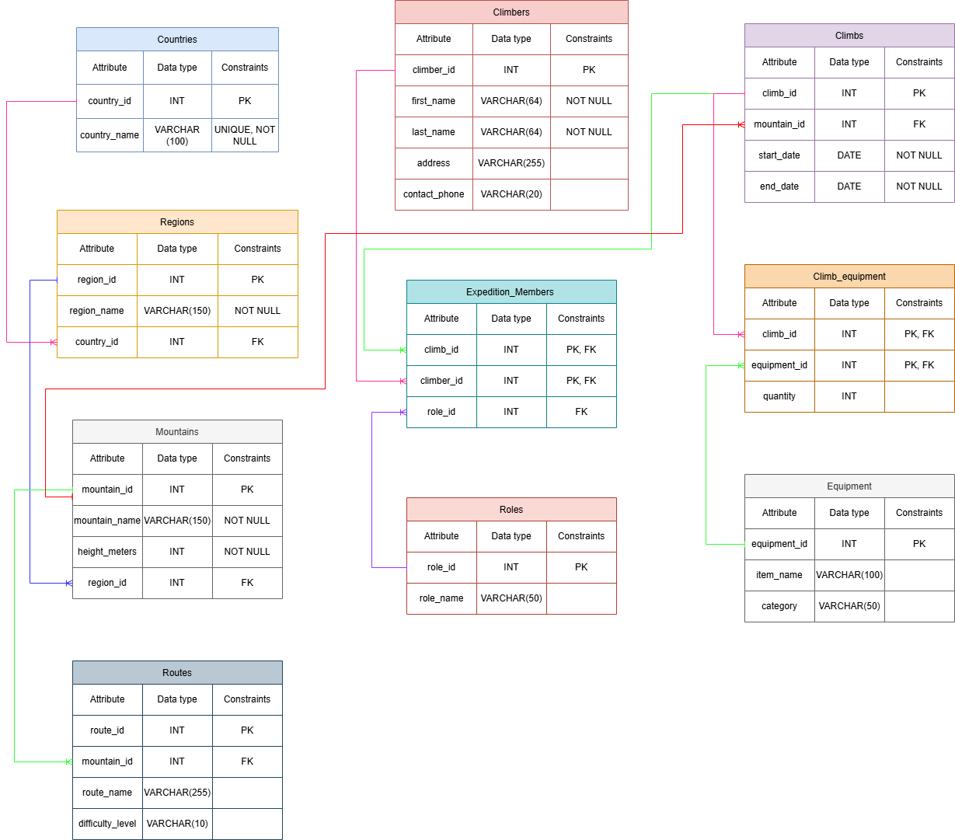

2.3 OBJECTS
Table 1: Climbers
Description: Stores personal details of individuals.
Table Name | Field name | Field Description | Data Type
Climbers | climber_id | Unique identifier for climber, PK | Int
 | first_name | Climber's given name | Varchar(100)
 | last_name | Climber's surname | Varchar(100)
 | address | Residential address | Varchar(255)
Table 2: Mountains
Description: Stores names and physical attributes of peaks.
Table Name | Field name | Field Description | Data Type
Mountains | mountain_id | Unique identifier for mountain, PK | Int
 | mountain_name | Name of the peak | Varchar(150)
 | height_meters | Elevation above sea level | Int
 | region_id | Link to geographical area, FK | Int

Table 3: Expedition_Members (Junction Table)
Description: Links climbers to specific climbs (M:M relationship).
Table Name | Field name | Field Description | Data Type
Expedition_Members | climb_id | Link to the climb, PK/FK | Int
 | climber_id | Link to the climber, PK/FK | Int
 | role_id | Link to participant's role, FK | Int

Table 4: Regions
Description: Stores geographical areas or mountain ranges within a country
Table Name | Field name | Field Description | Data Type
Regions | region_id | Unique identifier for region, PK | Int
 | region_name | Name of the area (e.g., Tian Shan) | Varchar(150)
 | country_id | Link to the country, FK | Int

Table 5: Regions
Description: Stores geographical areas or mountain ranges within a country.
Table Name | Field name | Field Description | Data Type
Regions | region_id | Unique identifier for the region, PK | Int
 | region_name | Name of the area (e.g., Alps, Himalayas) | Varchar(150)
 | country_id | Link to the country, FK | Int

Table 6: Climbs
Description: Records specific expedition events to a certain mountain.
Table Name | Field name | Field Description | Data Type
Climbs | climb_id | Unique identifier for the expedition, PK | Int
 | mountain_id | Link to the mountain climbed, FK | Int
 | start_date | Date when the climb began | Date
 | end_date | Date when the climb ended | Date

Table 7: Routes
Description: Details about specific paths to reach a mountain summit.
Table Name | Field name | Field Description | Data Type
Routes | route_id | Unique identifier for the route, PK | Int
 | mountain_id | Link to the mountain, FK | Int
 | route_name | Name of the specific route | Varchar(255)
 | difficulty | Grade of climbing difficulty | Varchar(10)

Table 8: Roles
Description: Reference list of possible positions within an expedition team.
Table Name | Field name | Field Description | Data Type
Roles | role_id | Unique identifier for the role, PK | Int
 | role_name | Title of the role (e.g., Leader, Guide) | Varchar(50)

Table 9: Equipment
Description: Catalog of climbing gear available for use.
Table Name | Field name | Field Description | Data Type
Equipment | equipment_id | Unique identifier for the gear item, PK | Int
 | item_name | Name of the equipment | Varchar(100)
 | category | Type of gear (e.g., Safety, Camping) | Varchar(50)

Table 10: Climb_Equipment (Junction Table)
Description: Links equipment items to specific climbs with quantity tracking (M:M).
Table Name | Field name | Field Description | Data Type
Climb_Equipment | climb_id | Link to the climb, PK/FK | Int
 | equipment_id | Link to the equipment, PK/FK | Int
 | quantity | Number of items taken on the climb | Int

COMMENTS ON TABLE RELATIONSHIPS
- Many-to-Many: Implemented via Expedition_Members (Climbers ↔ Climbs) and Climb_equipment (Climbs ↔ Equipment).
- One-to-Many: Used for geographical hierarchy (Countries → Regions → Mountains).

EXAMPLE WITH DATA (Climbers table)

climber_id | first_name | last_name | address
1 | Murat | Kass | Almaty, Kazakhstan
2 | Roza | Tul | Shymkent, Kazakhstan

EXAMPLE WITH DATA (Climbs table)

climb_id | mountain_id | start_date | end_date
101 | 5 | 2024-05-01 | 2024-05-20
102 | 12 | 2024-08-10 | 2024-08-15

