Process Design Document (PDD)

LATAM_Certificates
RPA Process

Version 1.0

Document History
Date | Version | Name | Designation | Comments
April 18, 2023 | 1.0 | Karin Kascakova | Developer | Created the updated PDD
 |  |  |  | Created the initial PDD draft

Distribution List
Name | Department | Designation
Paola Andrea Venegas | Customer Service | Senior Representative
Fabio Oliveira | Customer Service | Manager

Document Sign-Off Requirements
Name | Department | Designation | Approved Date
Paola Andrea Venegas | Customer Service | Senior Representative
Fabio Oliveira | Customer Service | Manager

Table of Contents
Contents
1. Introduction 4
1.1 Purpose of the Document 4
1.2 Objectives 4
1.3 Key Contacts 4
1.4 Minimum Prerequisites for Automation 5
2 As-Is Process 5
2.1 Description 5
2.2 Process Overview 5
2.3 Applications Used in the Process 5
2.4 As-Is Workflow Diagram 6
3 To-Be Process 6
3.1 Description 6
3.2 Process Overview 6
3.3 Applications Used in the Process 15
3.4 TO BE PROCESS - Workflow Diagram 16
4 User/Functional Requirements 16
5 In Scope for RPA 16
6 Out of Scope for RPA 16
7 UiPath Automated Process details 17
8 Exception Management 17
9 Reporting/Metrics 17
10 Business Validations 17
10.1 RPA Bot Data Validations & Compliance checks 17
10.2 Tracking & Audit Trail 17
11 Business Assumptions 18
12 BOT Preventive Controls 18
13 Reference Content 18

Introduction

1.1 Purpose of the Document

The Process Design Document (PDD) describes the approving of new supplier forms business process and activities chosen for automation using the UiPath Robotic Process Automation (RPA) technology.
This document describes the sequence of steps performed as part of the RPA process, as well as the conditions and requirements prior to its automation. This design document serves as a reference for developers to collect the details required for robotic automation of the business process.

1.2 Objectives

The objective of this process automation is linked to the project business case and is mainly intended to:
- Reduce redundant activities by SMEs
- Reduce manual errors
- Adding escalation capabilities
- Improve overall performance and reliability
- Improve user experience

1.3 Key Contacts

The specifications document includes concise and complete requirements of the business process, and it is built based on the inputs provided by the process Subject Matter Expert (SME) / Process Owner.
The Process Owner is expected to review it and provide signoff for accuracy and completion of the steps, context, impact, and complete set of process exceptions. The main business contacts and key stake holders are listed in the table below.
Role | Name | Contact details  (email, phone number) | Notes
Process SME / Reviewer | Paola Andrea Venegas | paolaandrea_venegas@edwards.com | Point of contact for questions related to business process and exceptions
Process Owner/ Approver for production | Fabio Oliveira | fabio_oliveira@edwards.com | Process changes, escalations

1.4 Minimum Prerequisites for Automation

- Test Data to support development.
- Access to APEX production environment needs to be provided for development purposes.
- Access to QlikView[Power BI] Production Kit to Components Dashboard needs to be provided for development purposes.
- User access and user accounts creations (licenses, permissions, restrictions to create accounts for robots)
- Credentials (User ID and password) required to logon to machines and applications
- The provided development and testing environments are exact replicas of the production environment in terms of data, navigations, and UI elements
- Edwards Users manage their own passwords and need to request User Accounts and appropriate privileges to access RPA bot service accounts.

As-Is Process

Description
Twice a day a scheduled BI Publisher report is acquired from mailbox in a form of an attachment. This BI Publisher report includes all information about current orders. From this report a CS rep retrieves necessary document numbers, which are then used to download all needed documents to create the customer package. The document numbers are: unique Lot Serial numbers, unique Description numbers, and unique Certificate numbers.
With unique lot Serial numbers the CS rep logs into QlikView and opens Kit to Components dashboard. For every Lot serial number they filter the Kit Lot # field using the Lot serial number. This generates an overview table of all the kit components. This table is used to fill out the Certificate of Sterility Word template. This document is then saved as a PDF document.
Next, with the unique Description numbers the CS rep logs into APEX and navigates to Archived Orders/Shop Order. For every description number they search on tis page and download the full document as a PDF. This PDF is then stored in a shared network folder.
Lastly, the CS rep in APEX navigates to Archived records/Sterilization Certification. For every unique Certificate number they search on this page a Sterilization certificate is found. This document is saved as a PDF and stored in a shared network folder.
All of these documents together create the customer document package, which is then sent to the customer.

Process Overview

Applications Used in the Process
The table includes a comprehensive list of all the applications that are used as part of the process automated, at various steps in the flow.
# | Application name & version | System  Language | Thin/Thick  Client | Environment/  Access method | Comments
1 | Microsoft Outlook 365 | English | Thin | Exchange Mail Server | To send emails
2 | APEX | English | Thin | Web Browser | To download Shop Order documents and Sterilization Certifications
3 | QlikView | English | Thin | Web Browser | To download Kit Detail
4 | Excel | English | Thick Client | Windows Application | Config, master table
5 | Word | English | Thick Client | Windows Application | Templates, Creating documents

As-Is Workflow Diagram

To-Be Process

Description
Process runs on Robotic Enterprise Framework (REF). REF is documented in a separate document. Twice a day a scheduled BI Publisher report is acquired from mailbox in a form of an attachment. This BI Publisher report includes all information about current orders. From this report robot retrieves necessary document numbers, which are then used to download all needed documents to create the customer package. The document numbers are: unique Lot Serial numbers, unique Description numbers, and unique Certificate numbers.
With unique lot Serial numbers the robot logs into QlikView and opens Kit to Components dashboard. For every Lot serial number they filter the Kit Lot # field using the Lot serial number. This generates an overview table of all the kit components. This table is used to fill out the Certificate of Sterility Word template. This document is then saved as a PDF document.
Next, with the unique Description numbers the robot logs into APEX and navigates to Archived Orders/Shop Order. For every description number they search on this page and download the full document as a PDF. This PDF is then stored in a shared network folder.
Lastly, the robot in APEX navigates to Archived records/Sterilization Certification. For every unique Certificate number they search on this page a Sterilization certificate is found. This document is saved as a PDF and stored in a shared network folder.
This solution will replace manual downloading reports from Salesforce production and uploading them into Salesforce test environments.

Process Overview
General information about the process selected for RPA prior to automation.
# | Item | Description
1 | Process full name | LATAM_Certificates
2 | Process Area | Customer Document Package Creation
3 | Department | Customer Service
4 | Process short description  (operation, activity, outcome) | Dispatcher Bot downloads the BI Publisher report from email attachment. If the report includes more than 1 order it splits it into multiple pieces. It then stores the report in a shared network folder.  Performer Bot processes each order report. It looks for all document numbers it is supposed to download form APEX and QV. It downloads the documents, saves them in a shared network folder, and then it creates the customer documentation.
5 | Role(s) required for performing the process
6 | Process schedule and frequency | Mon to Sun at 4 PM and 10 PM CET
7 | # of items processes /reference period | 14/ week
8 | Average handling time daily | 15Min/Transaction
9 | Peak period (s) | NA
10 | Transaction Volume During Peak period | NA
11 | Total # of FTEs supporting this activity | 1
12 | Level of exception rate | No expected exceptions but depends on the input and applications Environment.
13 | Input data | Saida1.xlsx
14 | Output data | email notification/report to business, documentation stored in a shared network folder

3.2.1 Process Overview Details-
- Download Tissue Traceability BI Publisher Report from Email - Bot to check its mailbox and retrieves all unread emails from BI Publisher (bipublisher@edwards.com). Each email contains a single report attached to it. The bot saves the report in a shared drive folder \\AWFR-PDBPIFSX01\BPI_Team_Share\RPA\Bot Accounts\SVC-RPA-BPI-LATAMP1\LATAM Certificates Bot\Prod\1_GetReport

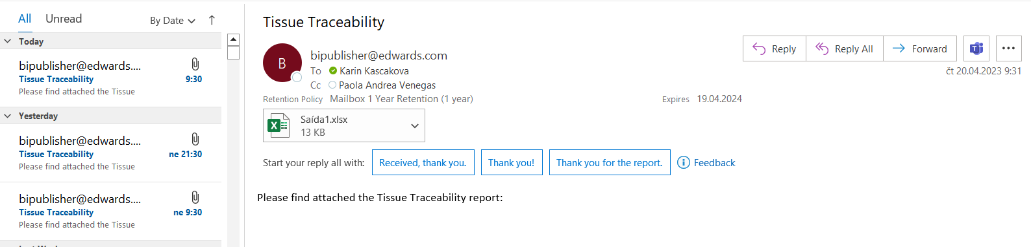

- If more than 1 order is in report, split it – check if there is more than 1 order in the BI Publisher report and if yes, split the report. Save the split reports to a shared drive folder \\AWFR-PDBPIFSX01\BPI_Team_Share\RPA\Bot Accounts\SVC-RPA-BPI-LATAMP1\LATAM Certificates Bot\Prod\2_TissueTraceability

- Signin APEX –
http://apex/
Fill in username and password, click Sign In

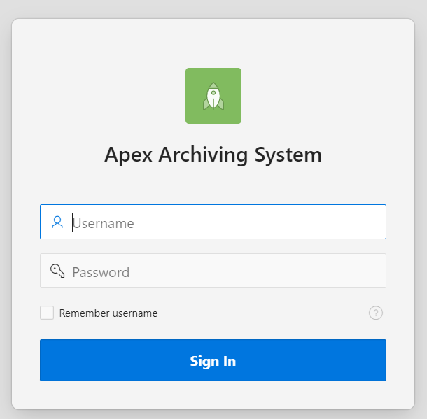

- Signin QlikView –
https://app.powerbi.com/groups/a3da187c-91bb-448e-8f3c-02bef1781ae1/reports/c99d7cff-1420-4018-a725-cff9abe4e082/ReportPagebe75dac5-1f41-49e2-a22d-fef5e8d0e4b3?experience=power-bi
If necessary fill in Username and Password for SSO

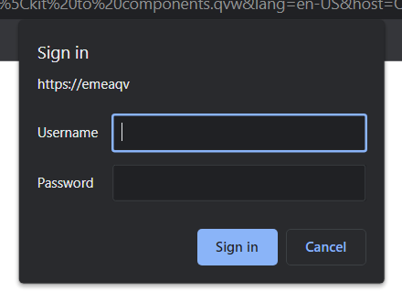

- Retrieve unique document numbers from Tissue Traceability report – For every highlighted column (Lot serial number, Description, and Certificate) the bot retrieves a list of unique document numbers and stores it in its internal memory for later processing.

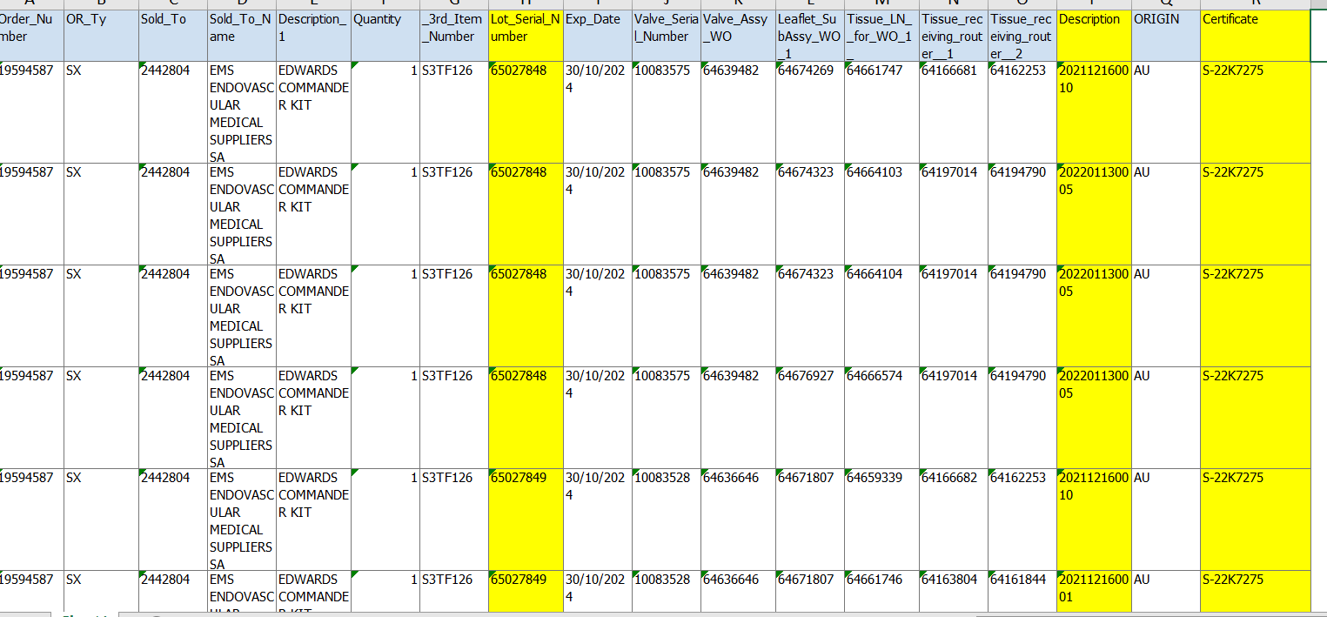

- Download Kit detail from QlikView dashboard Kit to Component – In the filters field type the first unique Lot Serial number into field Kit Lot# and click search. This searches for the Kit detail that the bot will download by clicking on the Excel butting, filling out the download path, and saving the excel. Repeat for all unique Lot Serial numbers.

- Download Tissue declaration from APEX – In APEX navigate to Archived records/Shop Order. In Shop Order Number enter the first unique Description number and click Search. Click on the Shop Order Number. In File Attachments section click on the pdf document. This starts the download process. The bot fills out the download path and saves the pdf document. Repeat for all unique Description numbers.

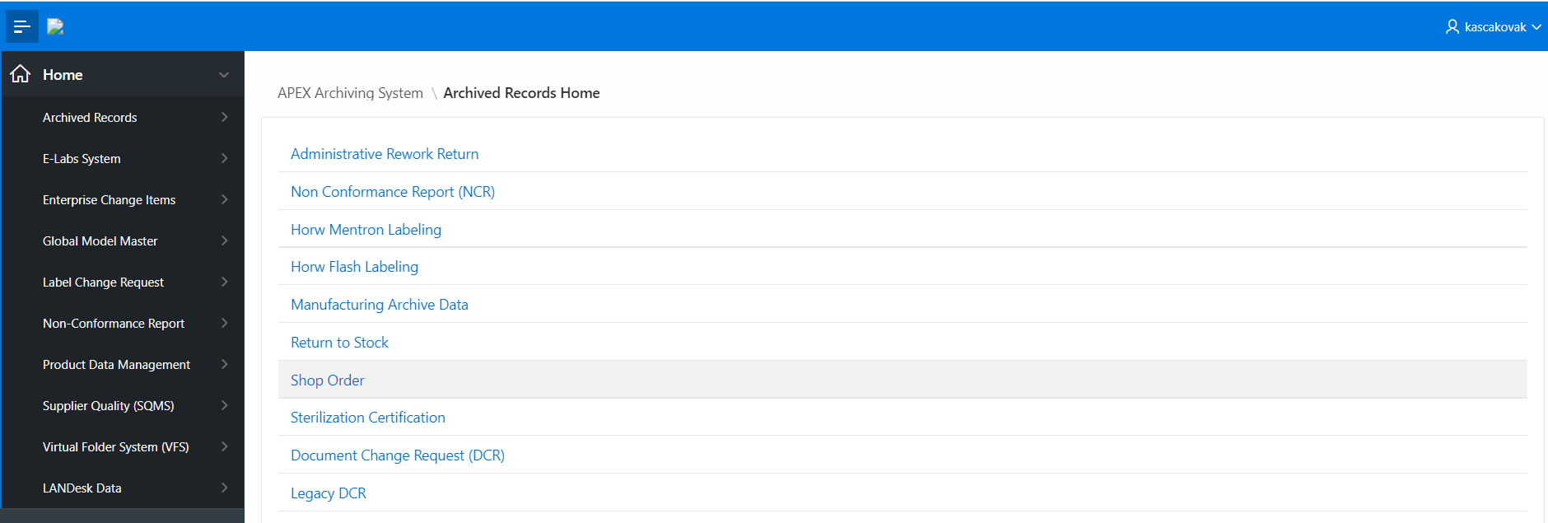

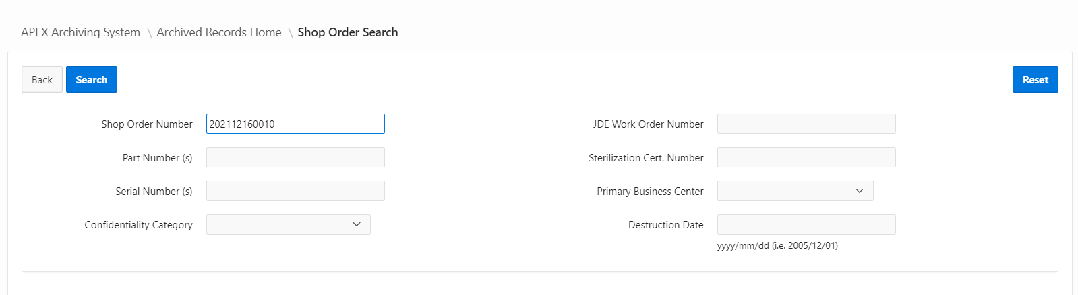

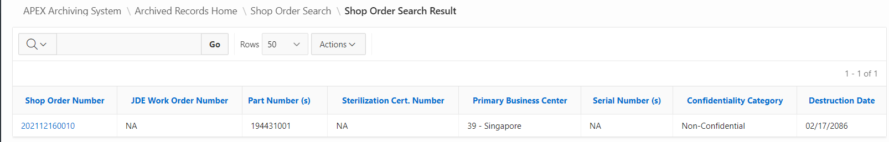

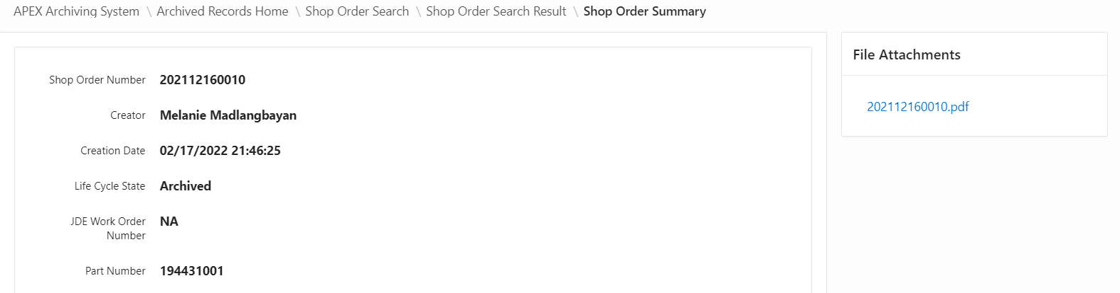

- Download Sterilization Certification from APEX – In APEX navigate to Archived records/Sterilization Certification. In Sterilization Certification Number field enter the first unique Certificate number and click Search. Click on the CERT number. In Attaches section click on the sterilization certification number. This starts the download process. The bot fills out the download path and saves the pdf document. Repeat for all unique sterilization certification numbers.

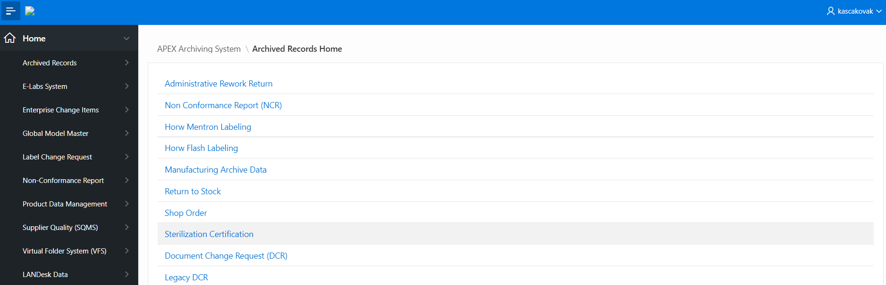

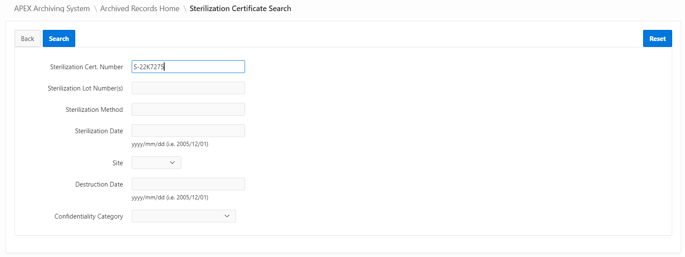

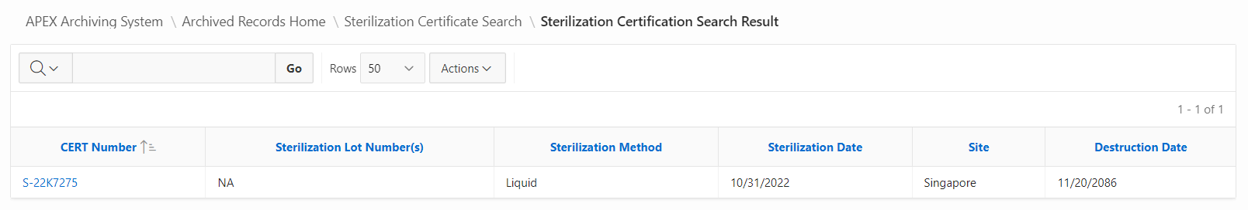

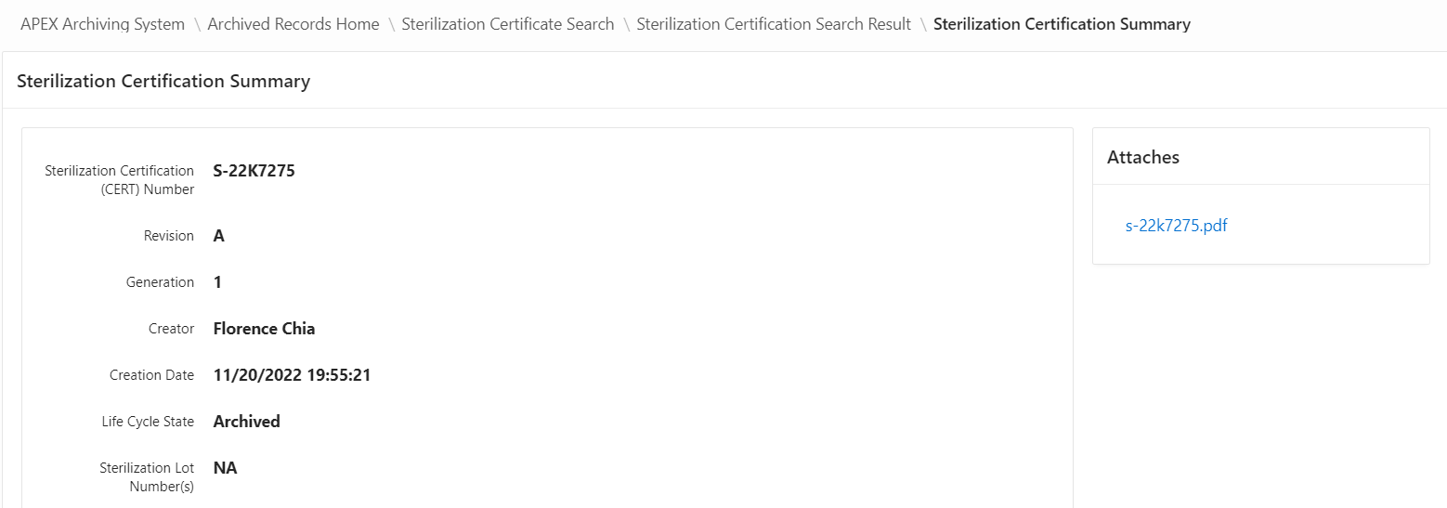
- Create Declaration of Traceability – Bot trims the Tissue Traceability report to include only relevant columns. This table is then pasted in a Word template to create the Declaration of Traceability. The Word document is also exported to PDF for easier sharing with the customer.

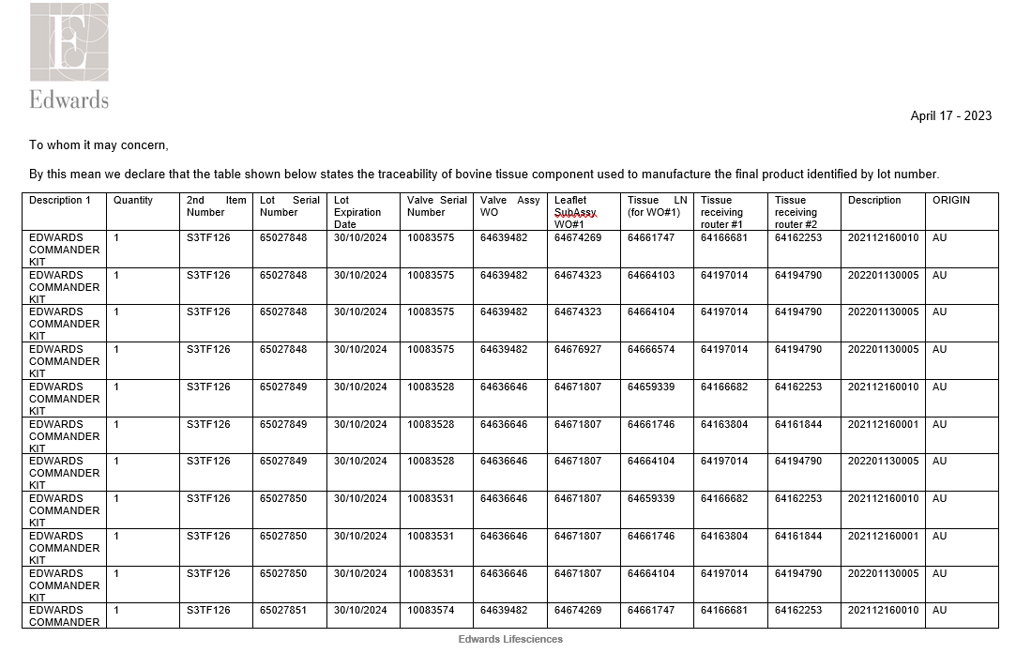

- Create Certificate of Sterility – Bot loops through all downloaded Kit Detail excel documents from QlikView and pastes the tables into a Word template to create the Certificate of Sterility document. The Word document is also exported to PDF for easier sharing with the customer.

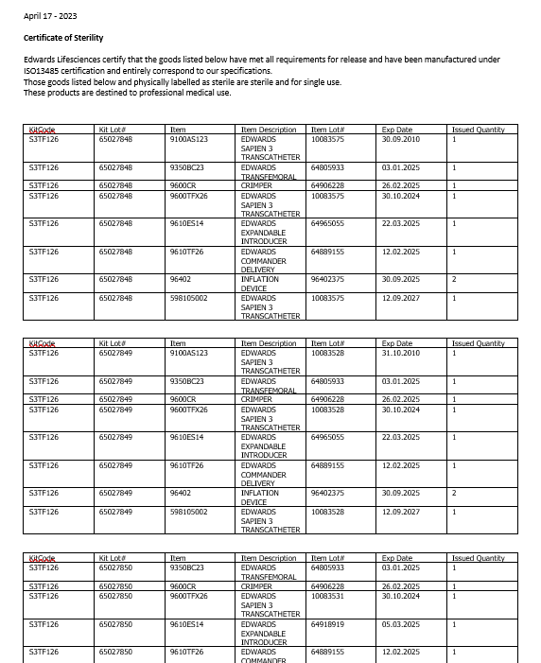

Applications Used in the Process
The table includes a comprehensive list of all the applications that are used as part of the process automated, at various steps in the flow.
# | Application name & version | System  Language | Thin/Thick  Client | Environment/  Access method | Comments
1 | Microsoft Outlook 365 | English | Thin | Exchange Mail Server | To send emails
2 | APEX | English | Thin | Web Browser | To download Shop Order documents and Sterilization Certifications
3 | QlikView | English | Thin | Web Browser | To download Kit Detail
4 | Excel | English | Thick Client | Windows Application | Config, master table
5 | Word | English | Thick Client | Windows Application | Templates, Creating documents

*Add more rows to the table to include the complete list of applications.

TO BE PROCESS - Workflow Diagram
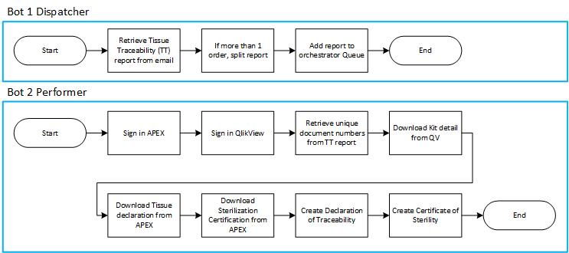

User/Functional Requirements

- Access to APEX prod application
- Access to QlikView prod application – Kit to Components Dashboard
- Access to Shared Drive \\AWFR-PDBPIFSX01\BPI_Team_Share\RPA\Bot Accounts\SVC-RPA-BPI-LATAMP1\LATAM Certificates Bot\Prod
- User is notified about any dropouts, exceptions, and successful transactions

In Scope for RPA

The activities and exceptions in this process that are in the scope for RPA, are listed below:
- Full scope for RPA – process is to be 100% automated.

Out of Scope for RPA

- Infrastructure (hardware and network connectivity, performance, security patches, maintenance, etc.)
- Licensing of RPA software (UiPath)
- Salesforce Administration & Support

UiPath Automated Process details

- Robots type: unattended
- Number of BOTs = 2
- Level of human intervention required: Low
- Use of Orchestrator: Yes
- Exceptions recorded in automation process: Yes
- Errors identified in the automation process: Yes
- Challenges identified in the automation process: TBD

Exception Management
Please see document below for Application and Business Exceptions –

Reporting/Metrics
# | Report type | Update frequency | Details | Monitoring Tool to visualize the data
1 | Process logs | Weekly | Provides details on the process runs for a given period and average run duration | Orchestrator
2 | Transaction logs | Weekly | Number of transactions run by this process for a given period and the average duration of the transaction | Orchestrator
3 | Error logs | Weekly | Average number of errors by type per day and per week | Orchestrator

Business Validations

RPA Bot Data Validations & Compliance checks

Salesforce production report needs to stay as initiated (in the same format, location), in case of change of reports format code needs to be updated. In case of any exception, business is notified by email.

Tracking & Audit Trail
NA

Business Assumptions
- Any exceptions Bot will communicate to users via email. For every request sent to the robot there is a response back to the user (business exception, system exception, successful transaction)

BOT Preventive Controls

  - Service account username and password
    - DEV: SVC-RPA-BPI-Dev02
    - PROD: SVC-RPA-BPI-LATAMP1
    - Password: Stored in CyberArk
  - Service account credential management – SME
  - Access to -
  - Privilege - * BOT = read only
  - Package/build - Orchestrator
  - Bot server details
    - DEV - SVC-RPA-BPI-Dev02
    - PROD - SVC-RPA-BPI-LATAMP1

Reference Content

- Workflows

- Test scripts –

