# Google Analytics Report

This is an example paragraph in the document.

MATPLOTLIB - Metrics Comparison

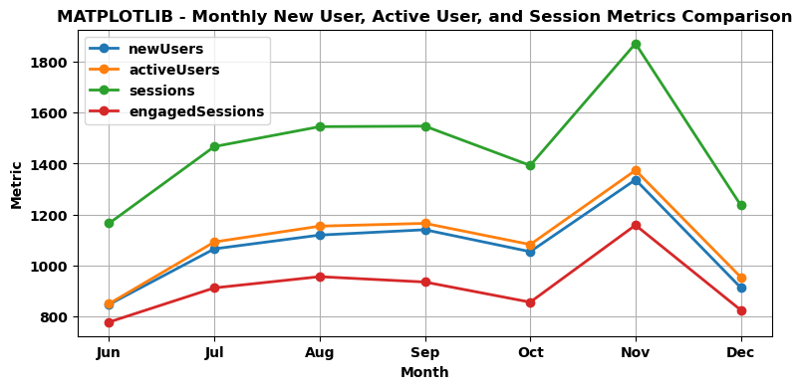

SEABORN - Metrics Comparison

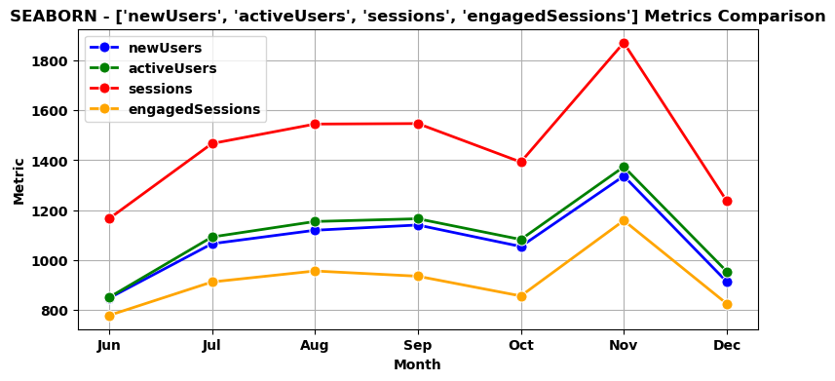

# Monthly Basic Metrics

|  |  |  |  |  |  |
| --- | --- | --- | --- | --- | --- |
| month | activeUsers | newUsers | sessions | engagedSessions | bounceRate |
| Jun | 851 | 848 | 1166 | 779 | 0.33 |
| Jul | 1093 | 1066 | 1467 | 913 | 0.38 |
| Aug | 1155 | 1120 | 1545 | 957 | 0.38 |
| Sep | 1166 | 1141 | 1547 | 936 | 0.39 |
| Oct | 1083 | 1055 | 1393 | 857 | 0.38 |
| Nov | 1374 | 1337 | 1871 | 1159 | 0.38 |
| Dec | 955 | 914 | 1237 | 826 | 0.33 |

# Top Landing Pages by Active Users

|  |  |  |
| --- | --- | --- |
| landingPage | activeUsers | bounceRate |
| / | 4073 | 0.19901820413172427 |
| /non-surgical-procedures/morpheus8 | 841 | 0.53135313531353134 |
| /shop-skincare | 439 | 0.54838709677419351 |
| /sona-md-kamloops | 412 | 0.59082217973231355 |
|  | 410 | 0.16768916155419222 |

# Events Comparison

|  |  |
| --- | --- |
| eventName | activeUsers |
| page_view | 7518 |
| session_start | 7513 |
| first_visit | 7511 |
| user_engagement | 5496 |
| thank_you | 307 |

Event-wise Distribution of Active Users

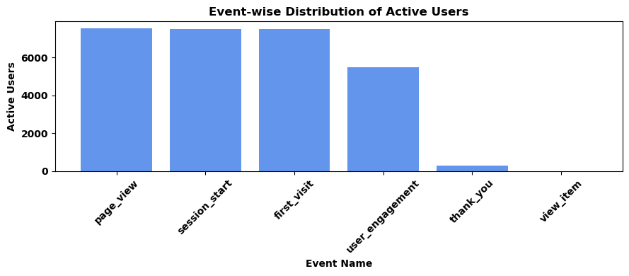

# Monthly Average Session Duration

|  |  |  |  |
| --- | --- | --- | --- |
| month | sessionMedium | averageSessionDuration | activeUsers |
| Jul | email | 299 | 6 |
| Oct | referral | 283 | 33 |
| Jun | organic | 196 | 646 |
| Nov | (not set) | 196 | 6 |
| Nov | organic | 192 | 934 |
| Sep | referral | 189 | 52 |
| Aug | organic | 186 | 872 |

Heatmap of Average Session Duration by Session Medium and Month

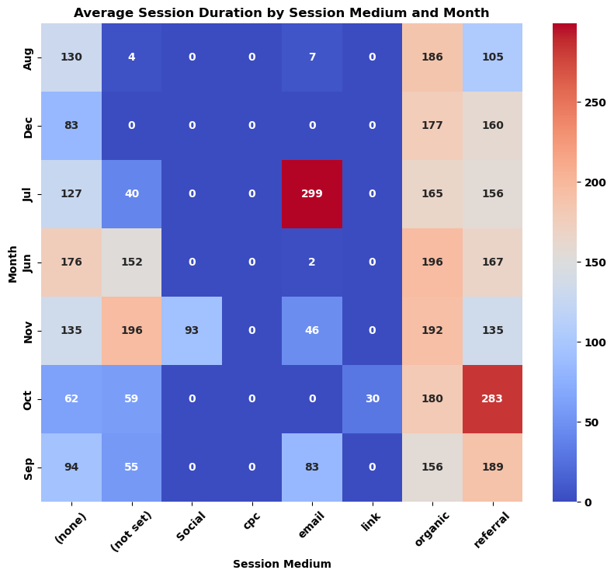

# Insights on Data Trends and Patterns

To analyze the Average Session Duration by Session Medium and Month, we can first calculate the average duration for each medium across the months. Here are the average session durations for each medium:  
  
- (none): 111.71  
- (not set): 63.14  
- Social: 13.29  
- cpc: 0.00  
- email: 59.71  
- link: 4.29  
- organic: 183.29  
- referral: 178.00  
  
Next, we can identify some insights and trends from the data:  
  
1. Organic and referral sessions have the highest average session durations at 183.29 and 178.00 respectively.  
2. Email and (none) sessions also show relatively high average durations compared to other mediums.  
3. CPC, Social, and Link sessions have very low average durations, with some mediums even having zeroes indicating no recorded duration.  
4. Across different months, there is variability in average session durations for each medium, indicating potential seasonality or changes in user behavior over time.  
  
In summary, the data shows variations in average session durations across different mediums, with organic and referral sessions generally having longer durations compared to other mediums. It would be useful to further investigate the reasons behind these trends and patterns, potentially leading to strategic decisions for optimizing session durations and engagement on different platforms.

Pairplot of Average Session Duration by Session Medium and Month

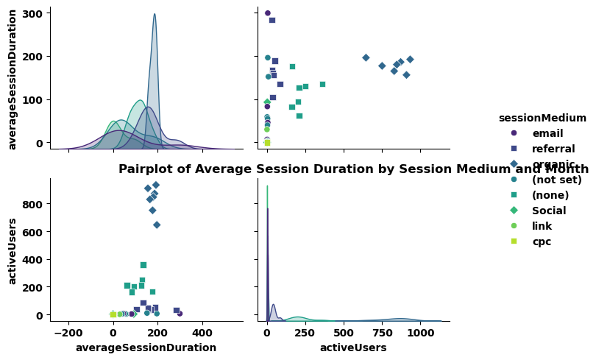

Average Session Duration by Session Medium

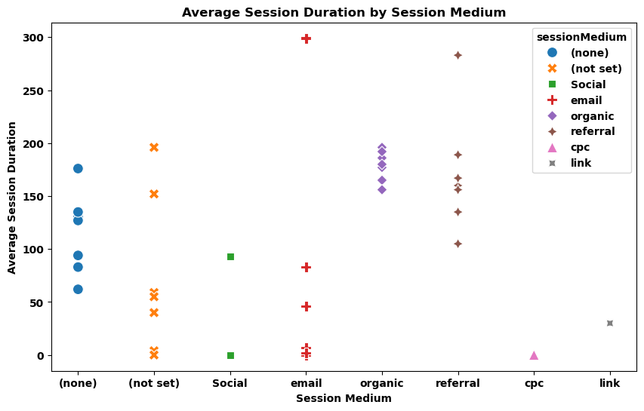

# Mobile Device Model Data

|  |  |
| --- | --- |
| mobileDeviceModel | activeUsers |
| iPhone | 3953 |
| Chrome | 888 |
| Safari | 729 |
| Edge | 172 |
| iPad | 95 |

Top 10 Mobile Device Models by Active Users

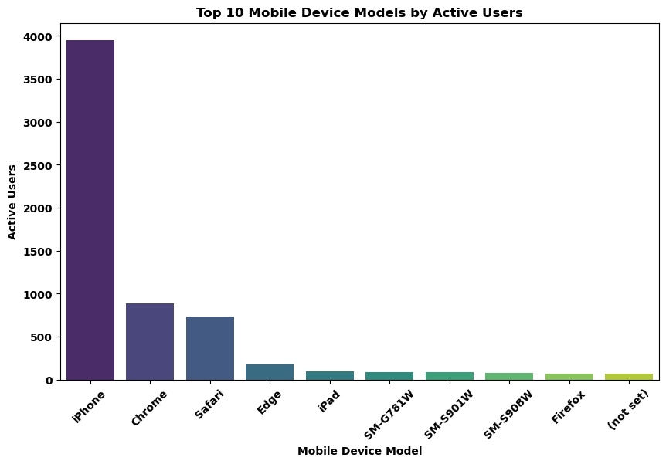

### 1. Dominate Mobile Device Models in Terms of Active Users:  
- The top 5 mobile device models in terms of active users are:  
 1. iPhone: 3953 active users  
 2. Chrome: 888 active users  
 3. Safari: 729 active users  
 4. Edge: 172 active users  
 5. iPad: 95 active users  
   
- As we can see, iPhone is the most dominant mobile device model among the active users, followed by Chrome and Safari.  
  
### 2. Significance of Web Browsers in the Context of Active Users:  
- Web browsers like Chrome, Safari, and Firefox have significant active user bases, which indicates a diverse user preference for browsing on mobile devices.  
- Chrome with 888 active users and Safari with 729 active users are among the top 3 in terms of active users, suggesting their popularity.  
  
### 3. Suggestions for Areas of Further Analysis:  
- Analyze the trends in active users for different mobile device models over time to identify potential growth or decline patterns.  
- Explore the user demographics associated with each mobile device model to understand the target audience better.  
- Investigate the correlation between mobile device models and user engagement metrics to optimize user experience.  
- Compare active users by mobile device models across different regions to identify regional preferences.  
- Conduct a deep dive analysis into user behavior based on the web browser used to access the platform, providing insights for browser compatibility and optimization.  
  
By further exploring these areas, you can gain a more comprehensive understanding of user preferences, behavior, and trends within the dataset.