1.14
Присылаю вам в ответ правки по документу - это поверхностный обзор, который уже выявил серьезные ошибки.
Красный - серьезные ошибки.
Желтые - малые ошибки, опечатки, уточнения.
Ваша задача - устранить, изменить тексты, выделенные красным и желтым цветом, переписать.
Сейчас этот документ похож на черновик, на бесплатную работу.

1.15
@Vladimir Morning dear, pls check the communication protocol
1.15.1 Communication protocol

1.15
Спасибо большое за ваши исправления, стало значительно лучше.
Добавил еще немного замечаний.
1.15.2 Communication protocol

1.21
pls check it
1.21.1 Communication protocol

1.21
1. In the description of the sensitivity zones for commands 0x03 and 0x83, describe what happens if the device has 6 coils. What happens to zones 7, 8, 9, 10, and 11? Are they equal to 0 or do they not exist?
2. Move the zone mode descriptions from pages 19 and 34 to Appendix 4.

1.22
@Vladimir
1.22.1 Communication protocol

1.22
Accepted.
1.22.2 Communication protocol

2.26
к сожалению некоторые программы не скачать просто так по exe - они скачиваются в рамках установщика Microsoft.

3.04 @Charlie_ZAX Sales
We will start the test as soon as we receive the new computer tomorrow or the day after tomorrow, and we will keep you updated on the progress

3.10
We are willing to communicate this issue in writing. Conducting a conference call with the two programmers might be challenging for resolving the issue, as it involves a significant amount of complex technical terminology that is difficult to translate. Therefore, please feel free to write to us directly if you have any questions.
Here’s what our programmers wrote:
The following equipment was tested today: PC X1100 PRO (2 units), PC V900, and 1800 GOST.
As of 13:15 UTC on March 10, 2026, the status of these devices is as follows:
1. The device will respond to requests sent to the IP address 255.255.25.55.
2. The length of the response message is 0x14 bytes, which is inconsistent with the description in the document “1.22.2 Russian Security Gate Communication Protocol.docx,” where the length of such messages is specified as 0x37 bytes.
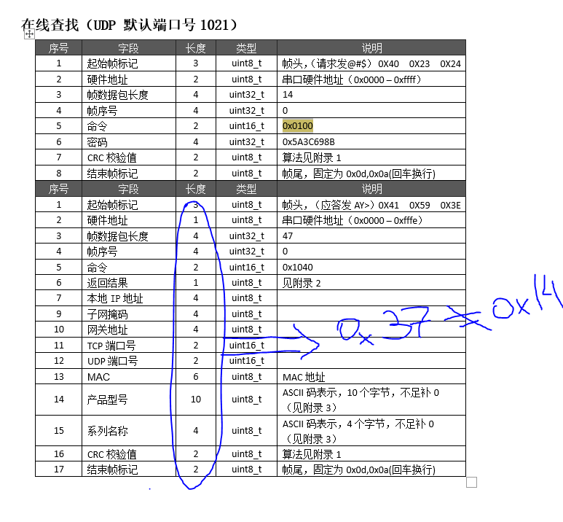
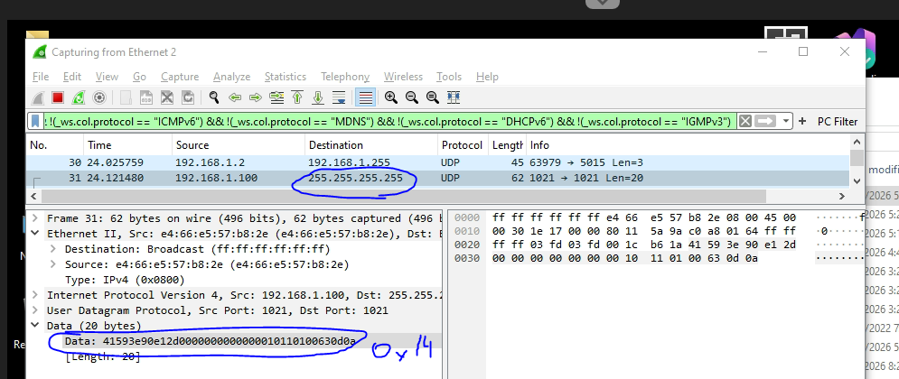

3.11
Dear @Vladimir , we have revised two parts in the communication protocol, pls check the updated file
3.11.1 Communication protocol

3.11
You've fixed the lower computer; it now responds not to IP 255.255.255.255, but to the IP of the sender's higher computer. Its good.
But, you've also changed the destination UDP port. Previously, all communication worked only over a static, predefined network port of the UDP. Now it responds to both the sender's IP and the port of our sending program.
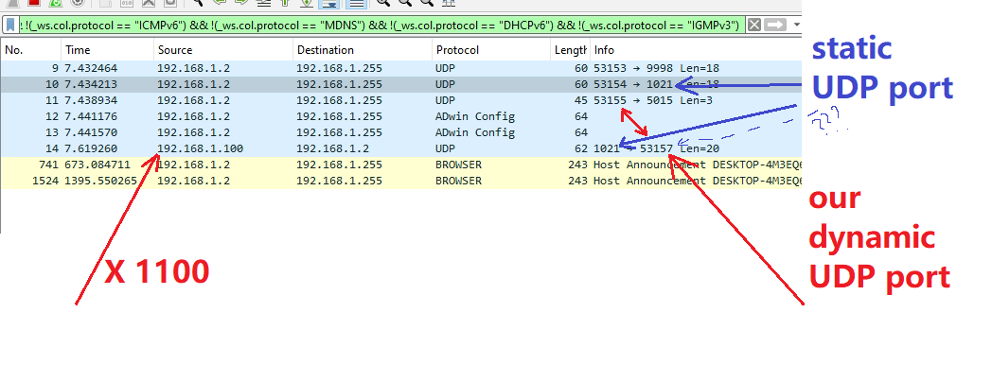

3.12
@爱德华 Eduard Stroganov 一直接好的，随时等待客户工程师测试、谢谢.

3.16
В четверг 12.03.26 вам было указано на ошибку в документации. Мы всё еще ждем ВАШИХ исправлений в документации. Мы ждем документацию БЕЗ логических ошибок. На данный момент ваша документация содержит МНОГО грубейших логических ошибок, которые очень сильно увеличивает время тестирования устройств, а в некоторых случаях это приводит к НЕВОЗМОЖНОСТИ тестирования.
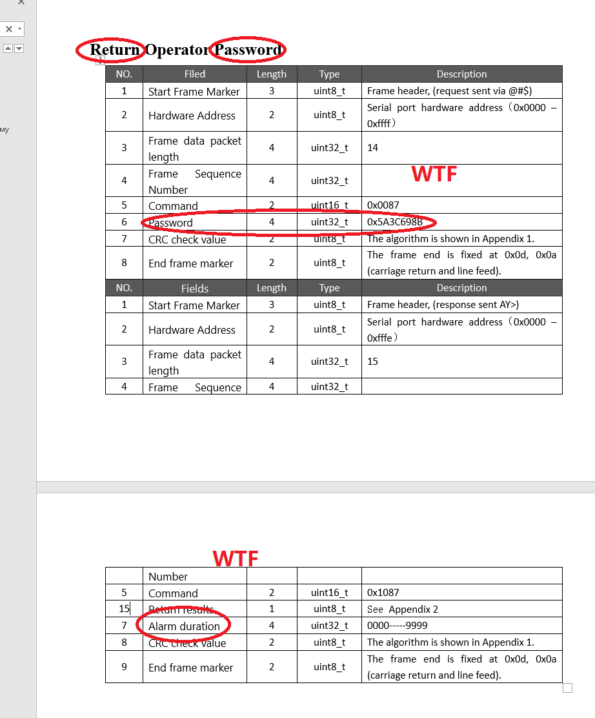

3.16
已修改错误文档并更新了版本。马上发出
Dear Vladimir, pls check the updated one
3.16.1 Communication protocol

3.16
Вы исправляете только те ошибки, на которые указываю Я.
Причем иногда игнорируете.
Если ошибки документации будут исправляться таким методом - я нахожу ошибки, пишу вам, бы исправляете, я синхронизирую документы - тестирование по этой документации будет занимать значительно больше времени, если бы вы сразу сами исправили документации согласно своим изменения в прошивке.
Вы до сих пор не исправили эту ошибку, о которой я вам написал еще 12.03.26.
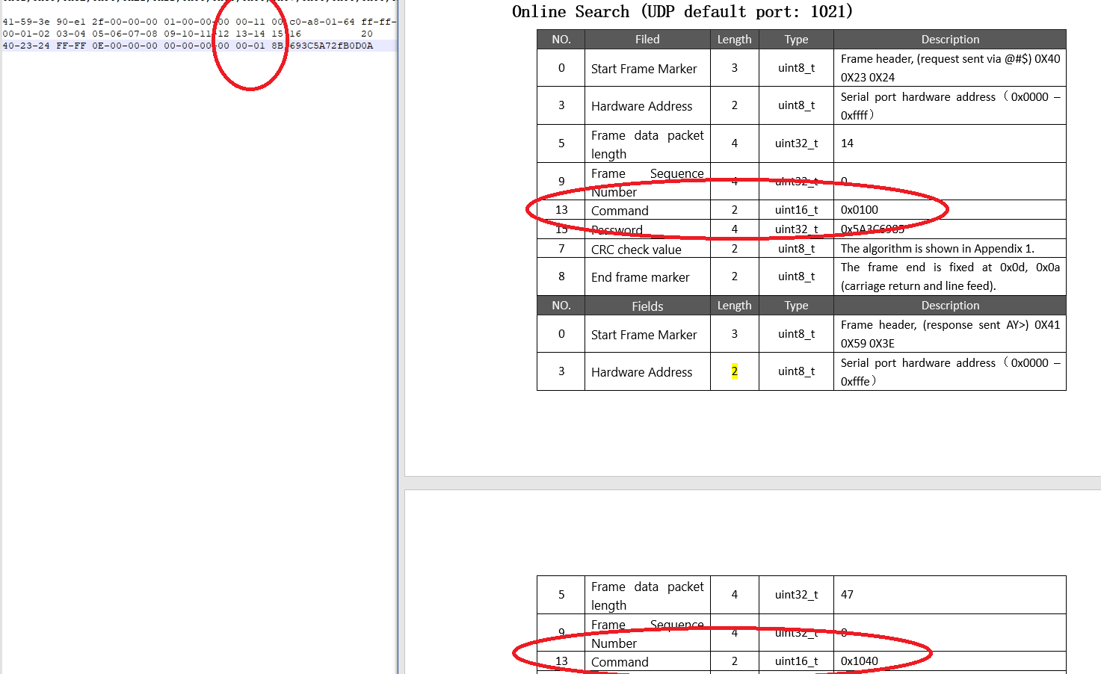

3.18 @Charlie_ZAX Sales
Good day Vladimir, we have double-checked the document and corrected the errors we found, I have marked them in green
3.18.1 Communication protocol

3.19
Dear @贺顺军
This is a test result—a device error! Our test may be incorrect, but it was created in accordance with documentation version 3.18.
I'm demonstrating the error.
Apparently, it LOOKS like there really is an error in your code.
The image shows that if you calculate the CRC sum from "00-00-00-00-83-00-8B-69-3C," you'll get the CRC sum of "C4-41," which will be considered correct, even though it's incorrect because the data is invalid.
However, if you calculate the CRC sum from the correct data "00-00-00-00-83-00-8B-69-3C-5A," you'll get the CRC sum of 5A-67, which will be considered an incorrect CRC sum, even though it's not. 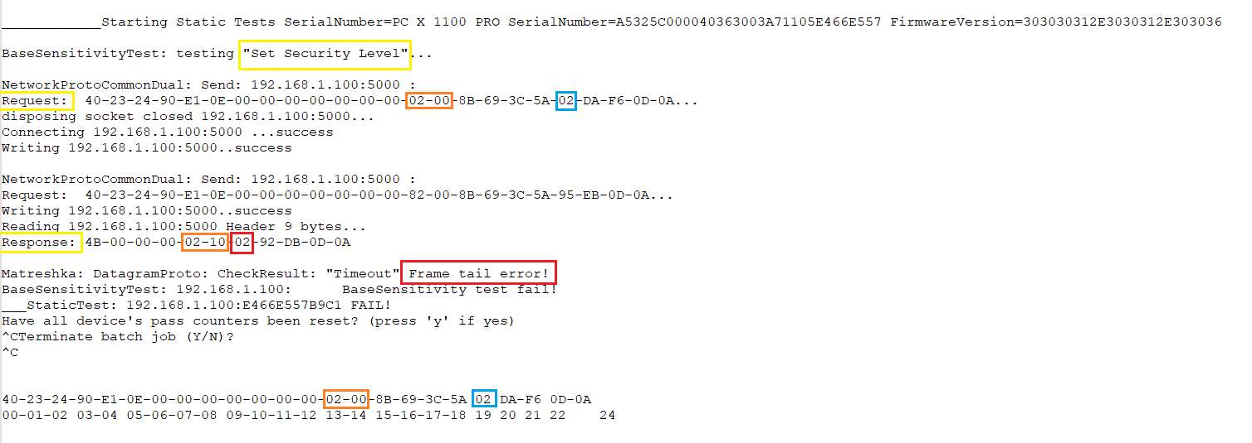

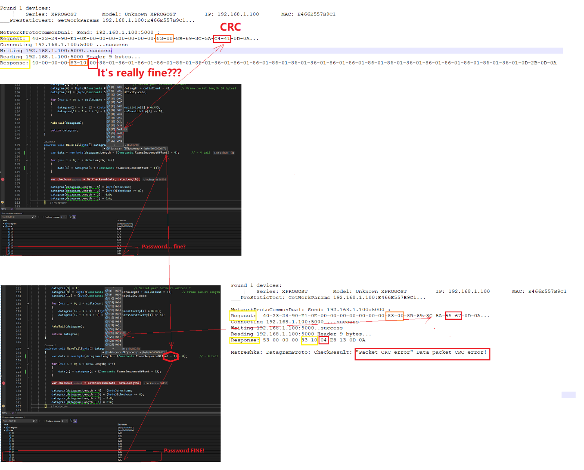

3.23 @贺顺军
@Vladimir Hello! @Eduard Stroganov Hello! Please continue with the software testing today. Thank you!

3.23

@斌
"Restore Factory Settings" ERROR:
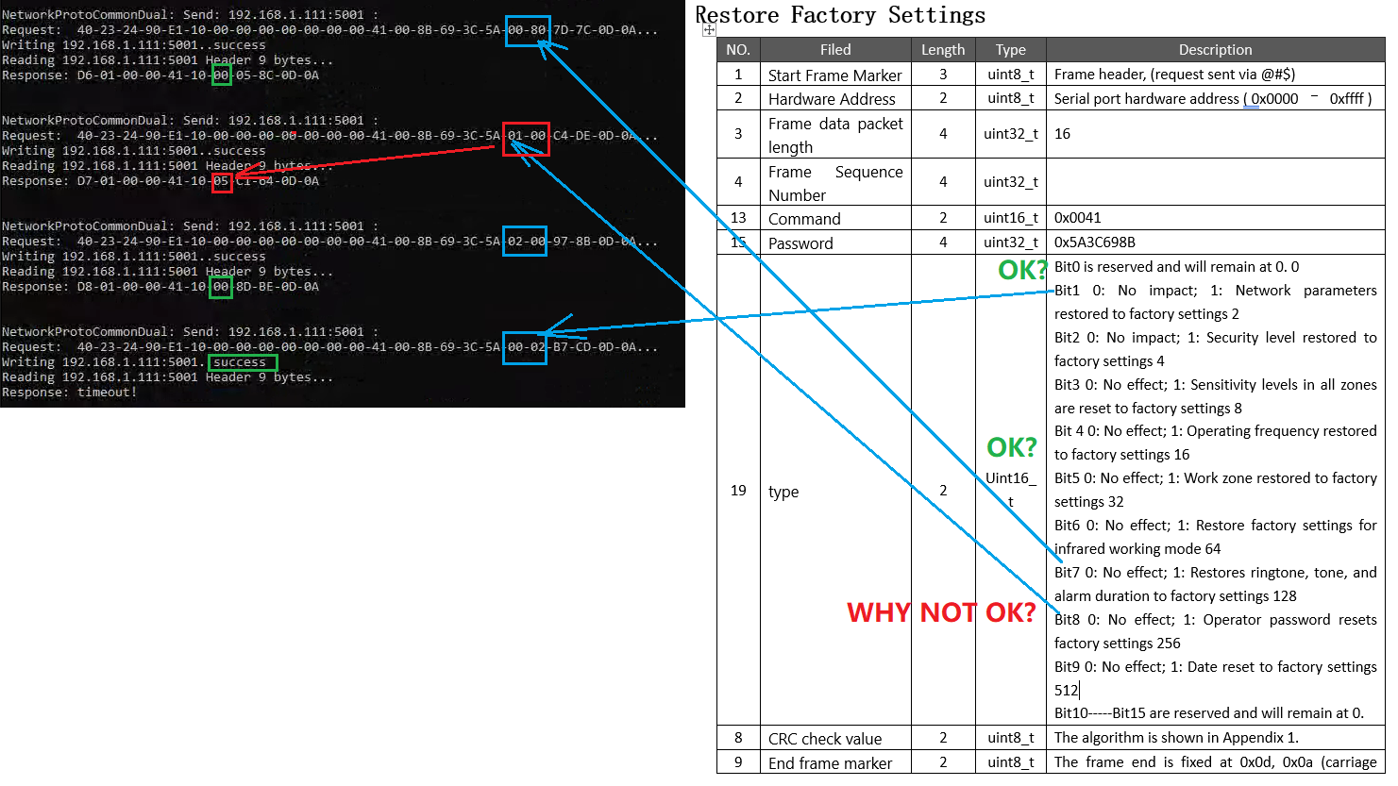
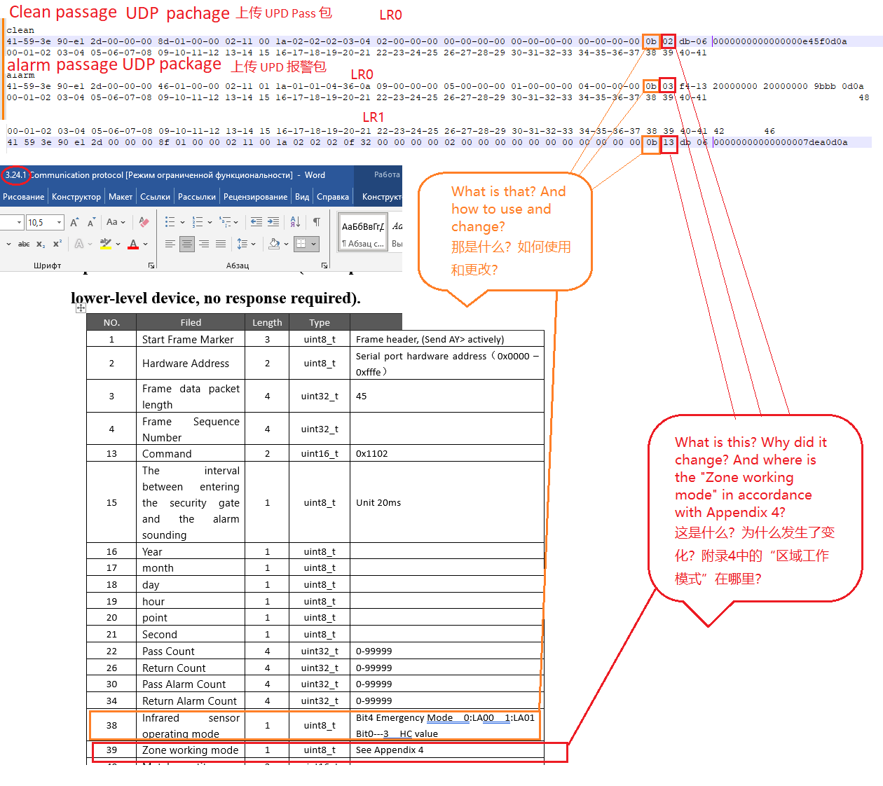

3.25 @斌
文档中的错误已优化，待复测
Извините, здесь в документе и программе всё перепутали местами. Сейчас так правильно. Завтра (сегодня) исправим документ.
3.25.1 Communication protocol

3.25
*1 TCP Request
*2 Old UDP Response
*3 Current UDP Response
*4 Question 1 = Why are the 8 bytes of zone alarm information request not the same as the corresponding 8 bytes of response? And what are these 99 bytes?
*5 Question 2 = Why did this 15th byte change and what does it mean? Is he needed? Is he useful?
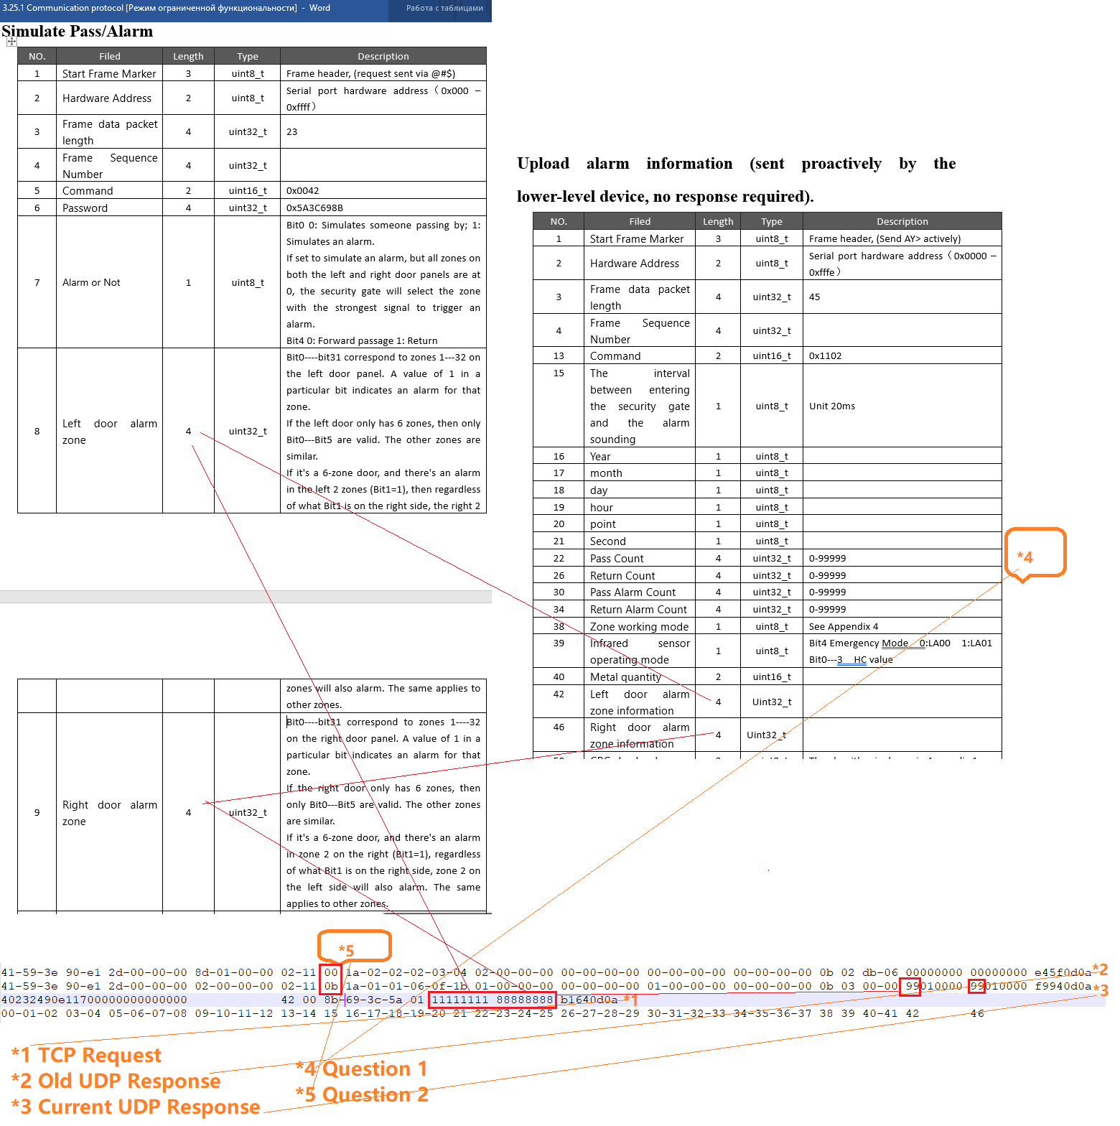

3.25 @斌
@Vladimir 问题2：第15字节是从进门触发红外开始到报警经过的时间
问题1还在找原因中
@Vladimir Question 2: The time interval between the activation of the infrared sensor upon entering the premises and the triggering of the alarm.
Issue 1 is still being investigated for a cause.
@Vladimir V900和V1800将会出现类似问题，目前正在参照X600和x1100更新固件版本，正在完善中
@Vladimir The V900 and V1800 will experience similar issues. Firmware updates are currently being developed based on the X600 and x1100, and improvements are being made.

3.26 @斌
目前未完成，大概还需要一天时间，完成了会第一时间通知你
It’s not yet complete; it will likely take another day. Once it’s finished, I’ll notify you immediately.
if the devices come with factory static IP addresses, how do you plan for group testing in this case?

3.30 @贺顺军
@Vladimir 您好！ @爱德华 Eduard Stroganov 您好！今天请帮忙继续测试联网软件，谢谢！
@Vladimir Hello! @Eduard Stroganov Hello! Please assist with continuing the testing of the network software today. Thank you!

3.30
Your devices have gone crazy, check them and power off!
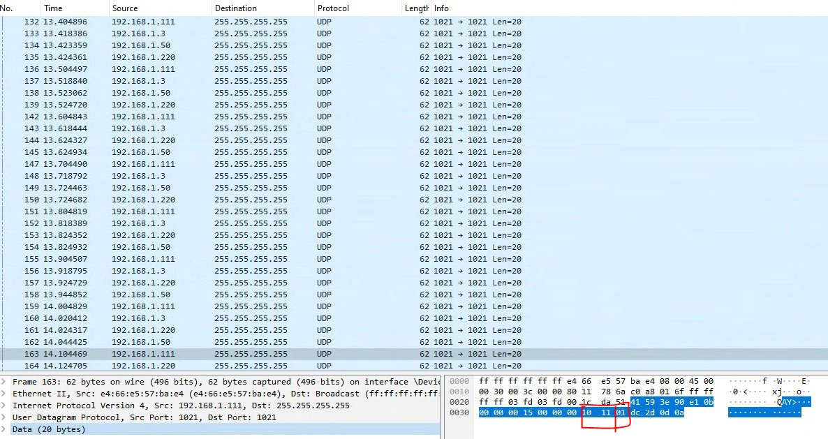

4.2
You didnt disabled this feature!
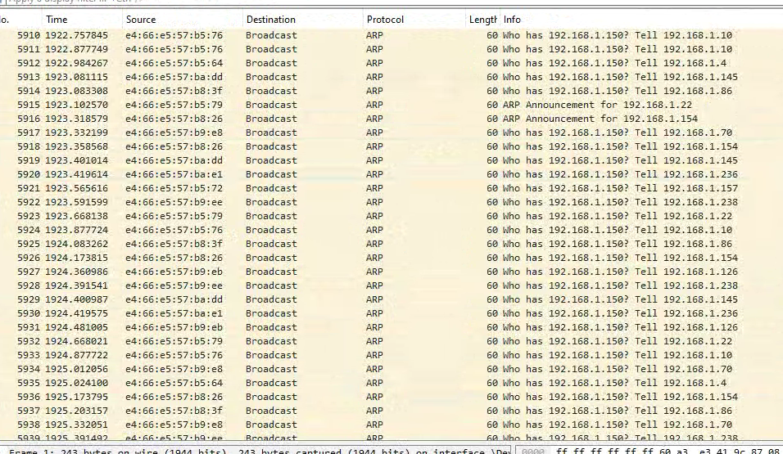

4.2 @斌
@Vladimir 这项我们还没有找到原因。请您协助再测试一遍，是在什么情况下出现故障的
@Vladimir 这项我们还没有找到原因。请您协助再测试一遍，是在什么情况下出现故障的
@Vladimir We have yet to determine the cause of this issue. Could you please help us retest and identify the circumstances under which the fault occurred?

4.6
You connected 23 devices, not 24! Again.
With a large number of devices connected simultaneously, a device loses its response or the TCP connection is interrupted (the device doesn't respond to the command within 5 seconds).
With 11 devices connected, this happens 50/50; sometimes all devices pass all tests, sometimes they don't.

4.7 @Charlie_ZAX Sales
is it possible for you to conduct other tests while our engineers are fixing the bugs? we know that the testing of networking function has many steps, We would like to know which step we are on now and how many more steps we need to test after this one

4.8 @贺顺军
@Vladimir 您好！工程师还在分析对策昨天晚上的问题，谢谢！
@Vladimir Hello! The engineers are still analyzing solutions for the issue from last night. Thank you!

4.9 @斌
@Vladimir 我们现在面临两个问题：
①修改IP后无法连接
②远程重启超时
为何之前通过的测试现在会失败呢？
答：这可能是设备数量的增加24台，引起的故障（我们能否降低12台设备数量进行测试，说明问题的根源）
@Vladimir 我们现在面临两个问题：
①修改IP后无法连接
②远程重启超时
为何之前通过的测试现在会失败呢？
答：这可能是设备数量的增加24台，引起的故障（我们能否降低12台设备数量进行测试，说明问题的根源）
@Vladimir We currently face two issues:
① Unable to connect after changing the IP address.
② Remote reboot timeout.
Why would a test that was previously passed now fail?
A: This could be attributed to an increase in the number of devices, which now totals 24. (Could we reduce the number of devices to 12 for testing to identify the root cause of the issue?)

4.9
Ethernet (network) settings test is now disabled! This is a device reboot test that does not depend on the network! The network settings test is the most difficult and last. To proceed to it you need to successfully pass all other tests!

4.9 @斌
好的，我们已经保留证据，优先处理它
Alright, we have preserved the evidence and will prioritize its handling.

4.9
Нет. Сегодня ничего не изменилось. Но в общех хуже чем в прошлую пт.

4.13 @斌
@Vladimir @爱德华 Eduard Stroganov 爱德华，您好，我们找到了故障原因
①设备消失：端口错误导致，下发端口错误、恢复出厂后读取端口错误（默认端口5000）。
② IP 配置方面：(计算机的ARP缓存导致)，手动清除ARP缓存后故障消失。需要上位机增加清除计算机ARP缓存指令。
@Vladimir @Edward Eduard Stroganov Edward, hello. We have identified the cause of the issue:
① Equipment Disappearance: Caused by port errors. Error messages regarding the assigned port, and errors after restoring the device to its factory settings (default port 5000).
② IP configuration issues: Caused by the ARP cache on the computer. The problem resolved after manually clearing the ARP cache. It is necessary for the upper-level system to include a command to clear the ARP cache on computers.

4.15
One device has error. Report in progress
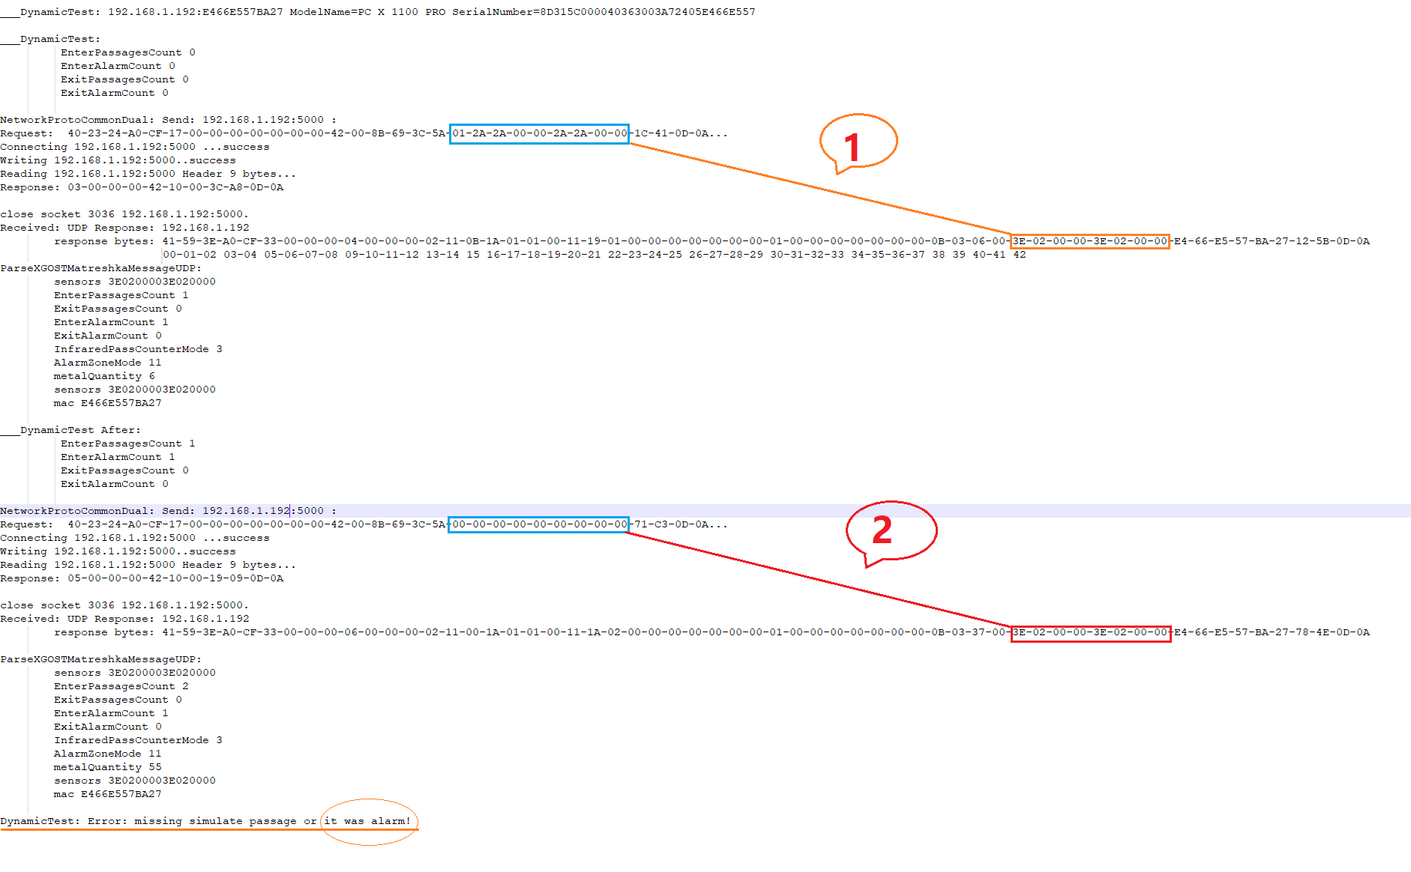

4.16 @斌
@Vladimir 我们找到了192.168.1.192，并找到了原因，现已经修复。
@Vladimir We located 192.168.1.192 and identified the cause. The issue has now been resolved.

