COLLEGE OF NURSING INFORMATION MANAGEMENT SYSTEM (CNIMS)
Comprehensive Ecosystem User Workflow Manual & Operating Procedures Guide
Document Parameter | Official Specification
System Name | CNIMS Portal v1.0 (Livewire 4 + Tailwind CSS + Laravel 13)
Regulatory Accreditation | Nursing and Midwifery Council of Nigeria (NMCN) Accredited
Academic Session Coverage | 2025/2026 Active Session & Multi-Term Lifecycle
Governing Roles Covered | 14 Authenticated Ecosystem Personas + Public Visitor Gateway
System Modules Documented | Admissions, Academics, Registry, Clinical Wards, OSCE, Bursary, Audit
Security & Audit Standard | Role-Based Access Control (RBAC), Dual-Factor, Immutable Audit Trail
Document Classification | Institutional Operating Manual / Official Technical Documentation

1. Executive System Overview & Ecosystem Architecture
The College of Nursing Information Management System (CNIMS) is an institutional-grade, purpose-built academic, clinical, and financial management portal tailored specifically to the stringent regulatory requirements of nursing and midwifery education in Nigeria. Fully aligned with the standards of the Nursing and Midwifery Council of Nigeria (NMCN), the ecosystem manages the entire lifecycle of healthcare professionals from prospective application through graduation and credential verification.
Unlike generic higher education ERPs, the CNIMS ecosystem integrates specialized clinical workflows that reflect real-world healthcare education, including:
- Automated Admissions Screening: Dual-sitting O'Level credit verification across WAEC and NECO examination bodies with mandatory science subjects (English, Mathematics, Biology, Chemistry, Physics).
- Entrance CBT Screening Engine: Seamless scheduling of applicants into Computer-Based Test (CBT) halls, automated seating generation, and entrance examination scoring.
- Strict Financial Clearance Gates: Enforces fee clearance gates prior to course registration and semester examination attendance, preventing financial leakage.
- Hierarchical Course Registration: Automated credit limits (minimum 15, maximum 24 credits per semester), course prerequisites, and multi-tier approval by the Head of Department (HOD).
- Hospital Rotation Placements: Assignment of student cohorts to accredited teaching hospitals (e.g., Ahmadu Bello University Teaching Hospital, Barau Dikko Teaching Hospital) and specialized ward units (ICU, Pediatric, Male Surgical, Post-Natal).
- Digital Preceptor Logbook: Daily bedside logging of invasive and non-invasive clinical procedures by students, with real-time digital verification, comments, and competence grading by registered Preceptors.
- OSCE Clinical Examination Scoring: Multi-station Objective Structured Clinical Examination tablet interface with criterion-based rubric scoring and automated examiner tallying.
- Automated GPA/CGPA Board: Continuous Assessment (CA) and Semester Examination score sheets with multi-tier moderation, GP/CGPA calculation, and official Senate-level publishing.
- Public Credential Verification: Instant QR-code and document reference verification of graduate certificates for hospitals, licensing boards, and international verification bodies.
1.1 Complete Role-Based Access Control (RBAC) Governance Matrix
The CNIMS security architecture utilizes a fine-grained, modular Role-Based Access Control (RBAC) engine comprising 14 distinct roles mapped across institutional domains. The table below delineates the functional responsibilities and access boundaries of every persona in the ecosystem:
Role Identifier | Official Title | Primary User Persona | Core Access Scope & Domain
super_admin | Super Administrator | Prof. Fatima Bello | Unrestricted system control, audit logs, security overrides, impersonation
admin | Institutional Admin | Dr. Aliyu Mohammed | Operational administration, staff management, department catalog setup
registrar | Registrar | Dr. Amina Abubakar | Admissions screening, O'Level vetting, matriculation, student registry
dean | Dean of Nursing & Midwifery | Prof. Sani Garba | Executive academic oversight, faculty exam moderation, curriculum review
hod | Head of Department (HOD) | Dr. Emmanuel Adeyemi | Departmental courses, lecturer assignment, registration sign-offs, CA audit
academic_officer | Academic Officer | Mr. Victor Olawale | Academic session states, term calendar, course catalog, student promotions
lecturer | Academic Lecturer | Mrs. Grace Danladi | Continuous assessment (CA) entry, exam score submission, OSCE assessor
clinical_coordinator | Clinical Coordinator | Nurse Hauwa Sambo | Hospital facilities, ward postings, capacity quotas, OSCE exam setup
clinical_instructor | Clinical Preceptor | Nurse Ibrahim Yakubu | Ward shift supervision, bedside logbook reviews, OSCE rubric scoring
exam_officer | Examination Officer | Mr. Chidi Eze | Score consolidation, GPA/CGPA computation, exam results publishing
finance_officer | Finance Officer | Mr. Tunde Lawal | Payment reconciliation, bank teller audits, registration clearances
bursar | Bursar | Mrs. Kemi Ojo | Institutional fee schedules, multi-item tuition breakdowns, fiscal audits
student | Student Nurse / Midwife | Jane Okon | Course enrollment, logbook submission, results slip, fee payments
applicant | Prospective Applicant | Blessing Danjuma | Application submission, CBT slip, admission acceptance, acceptance fee
public | Public Visitor / Verifier | General Public | Program discovery, application wizard, certificate verification, status tracking

2. End-to-End Inter-Role Ecosystem Lifecycle
The power of the CNIMS ecosystem lies in its interconnected workflows where the output of one persona seamlessly feeds into the operational responsibilities of the next. The operational lifecycle of a student from prospective inquiry to certified nurse unfolds across seven coordinated phases:
Phase 1: Prospective Application, Dual O'Level Screening & CBT Examination
- 1. Candidate Application:Prospective applicant visits the Public Portal (`/apply`), completes the 7-step Application Wizard, inputs WAEC/NECO examination numbers, and pays the NGN 15,000 application fee.
- 2. O'Level Verification:Registrar logs into the Admissions Screening Hub (`/admin/admissions`), verifies dual-sitting O'Level credits, validates science combinations, and shortlists eligible candidates.
- 3. CBT Exam Scheduling:Academic Officer and Registrar configure CBT examination centers, halls, and seating rosters, triggering automated CBT exam invitations.
- 4. Scoring & Admission:Entrance Exam Scores (out of 100) are entered into the system. Registrar issues provisional admission offers with unique admission letter reference numbers.
Phase 2: Acceptance, Bursary Invoicing & Student Matriculation
- 1. Admission Offer Acceptance:Admitted candidate logs into the Applicant Portal (`/applicant/dashboard`), reviews the provisional offer, and pays the NGN 35,000 acceptance fee invoice.
- 2. Financial Reconciliation:Finance Officer verifies the transaction reference (`/admin/finance`) and marks the acceptance fee invoice as paid.
- 3. Dossier Generation:Registrar executes matriculation, generating the permanent institutional Student Matriculation Number (e.g. `CON/2026/00101`) and establishing the official Student Dossier (`/admin/students`).
Phase 3: Financial Clearance & Semester Course Registration
- 1. Session Invoicing:Bursar sets up session fee structures with itemized tuition, hospital posting levy, library, and examination fees (`/admin/finance`).
- 2. Bursary Clearance Gate:Student Nurse pays semester fees through the Student Portal (`/student/fees`). Finance Officer verifies the payment and issues course registration financial clearance.
- 3. Course Selection:Student Nurse selects courses for the active term (`/student/courses`), verifying prerequisite fulfillment and credit caps (15 to 24 units).
- 4. HOD Approval:Head of Department (HOD) reviews the course registration slip (`/admin/students`), verifies academic balance, and grants departmental approval.
Phase 4: Academic Instruction, Continuous Assessment & Examinations
- 1. CA Score Entry:Lecturers deliver semester lectures, conduct tests and clinical assignments, and input Continuous Assessment (CA) scores (out of 30 or 40) into the Score Entry Sheet (`/admin/examinations`).
- 2. Exam Scoring:Semester examinations are conducted. Lecturers enter exam scores (out of 70 or 60). The system computes total scores, letter grades (A, B, C, D, E, F), and grade points.
- 3. Moderation & Publishing:HOD moderates departmental scores. Examination Officer and Dean review faculty-wide distributions. Examination Officer publishes approved results.
- 4. Result Checking:Student Nurse instantly accesses their printable semester result slip and updated CGPA (`/student/results`).
Phase 5: Teaching Hospital Rotations & Digital Preceptor Logbooks
- 1. Rotation Scheduling:Clinical Coordinator creates clinical rotation postings (`/admin/clinical`), maps cohorts to affiliated hospital facilities and specialized wards, and assigns Clinical Preceptors.
- 2. Ward Rotation Participation:Student Nurses report to assigned hospital wards and perform required clinical procedures (e.g., IV cannulation, catheterization, aseptic wound dressing).
- 3. Digital Procedure Logging:Student Nurse logs each procedure into the digital logbook (`/student/clinical`), documenting procedure date, anonymized patient reference, competency level, and clinical reflection.
- 4. Preceptor Sign-Off:Clinical Preceptor reviews submitted logs (`/admin/clinical/logbook`), inspects aseptic technique reflection, enters clinical feedback, and signs off the entry.
Phase 6: Objective Structured Clinical Examination (OSCE)
- 1. OSCE Exam Setup:Clinical Coordinator sets up OSCE examination sessions, stations, clinical scenarios, allocated times, and rubric criteria (`/admin/osce`).
- 2. Tablet Rubric Scoring:During the live exam, clinical examiners and preceptors use the tablet interface to score candidates against weighted rubrics (e.g., hand hygiene, patient verification, medication safety).
- 3. OSCE Score Compilation:Scores are locked and verified by the Examination Officer for official Council compliance.
Phase 7: Graduation, Certification & Public Verification
- 1. Graduation Clearance:Upon fulfilling all academic credit requirements and clinical hours, final transcripts and nursing certificates are generated.
- 2. Public Verification:External hospitals, healthcare organizations, and licensing boards instantly verify credential authenticity via the Public Verification Portal (`/verify-certificate`).

3. Detailed User Workflows, Interfaces & Operating Procedures
3.1 Public Visitor / Prospective Student / Verification Agent
The Public Portal serves as the primary external gateway to the College of Nursing and Midwifery Sciences. It caters to prospective candidates researching healthcare programs, active applicants monitoring their admission journey, and external healthcare employers verifying credential authenticity.
Key Responsibilities & Capabilities:
- Review accredited academic programs, degrees awarded (RN, RM), curriculum duration, and admission requirements.
- Initiate new applications through the multi-step admissions wizard.
- Track application screening progress in real-time using application reference numbers.
- Verify official academic certificates and graduation dossiers using cryptographic document references.
Workflow 1: Exploring Accredited Academic Programmes
1. The visitor navigates to the portal landing page (`/`), which highlights institutional accreditation by the Nursing and Midwifery Council of Nigeria (NMCN), 100% Council pass rate, affiliated teaching hospitals, and digital logbook systems.
2. The visitor clicks 'Academic Programmes' (`/programmes`) to view active departments, program duration, degree designations (RN for Basic Nursing, RM for Post-Basic Midwifery), and admission guidelines.
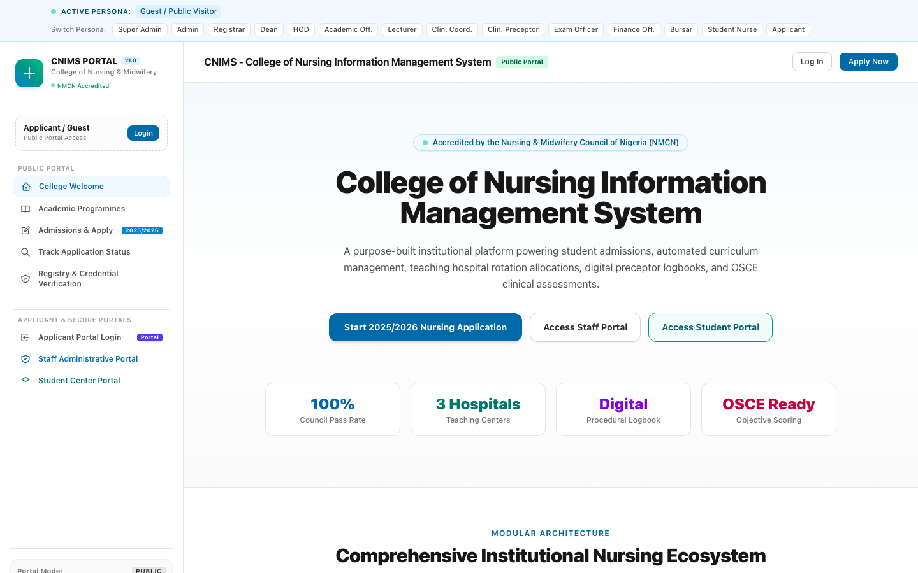
Figure 1: CNIMS Public Portal Homepage — Institutional Landing & Accreditation Overview
The public landing page highlights NMCN accreditation badges, key college statistics (100% Council Pass Rate, 3 Teaching Hospitals, Digital Procedural Logbook, OSCE Ready), quick action buttons for admissions, staff and student portals, and modular architectural features.
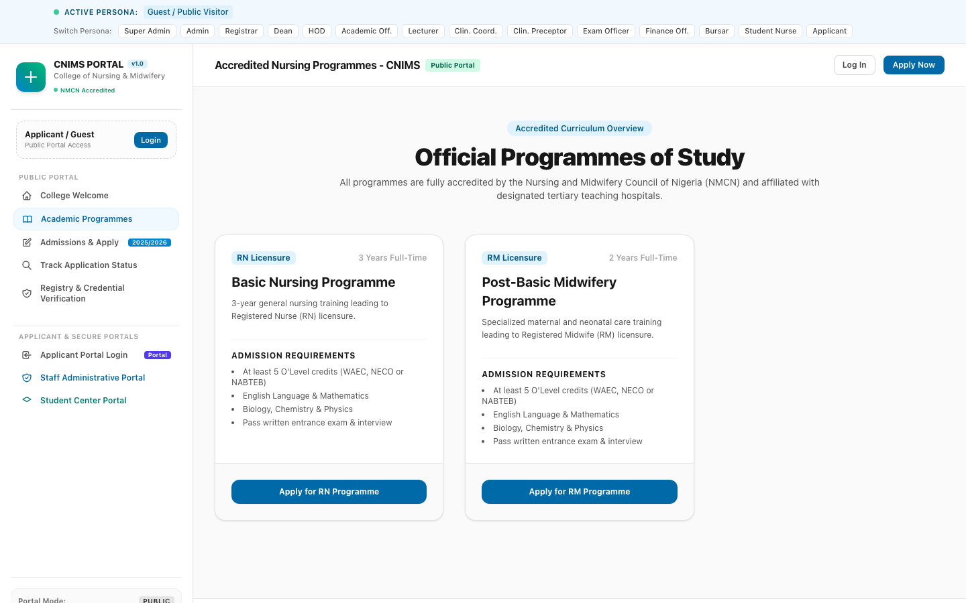
Figure 2: Accredited Academic Programmes Directory (`/programmes`)
The public programmes directory displays active departments (Department of Nursing Sciences), degree options (Basic Nursing RN, Post-Basic Midwifery RM), curriculum durations, program overviews, and direct 'Apply Now' CTAs.
Workflow 2: Public Status Tracking & Certificate Verification
1. Applicants can navigate to 'Track Application Status' (`/application-status`), enter their application number (e.g. `APP/2026/00101`) and secure access code, and view their live status without logging in.
2. Employers, state hospital management boards, and international bodies navigate to 'Registry & Credential Verification' (`/verify-certificate`), enter an official certificate number or student matriculation number, and instantly receive verified student dossier details, graduation class, and NMCN license numbers.
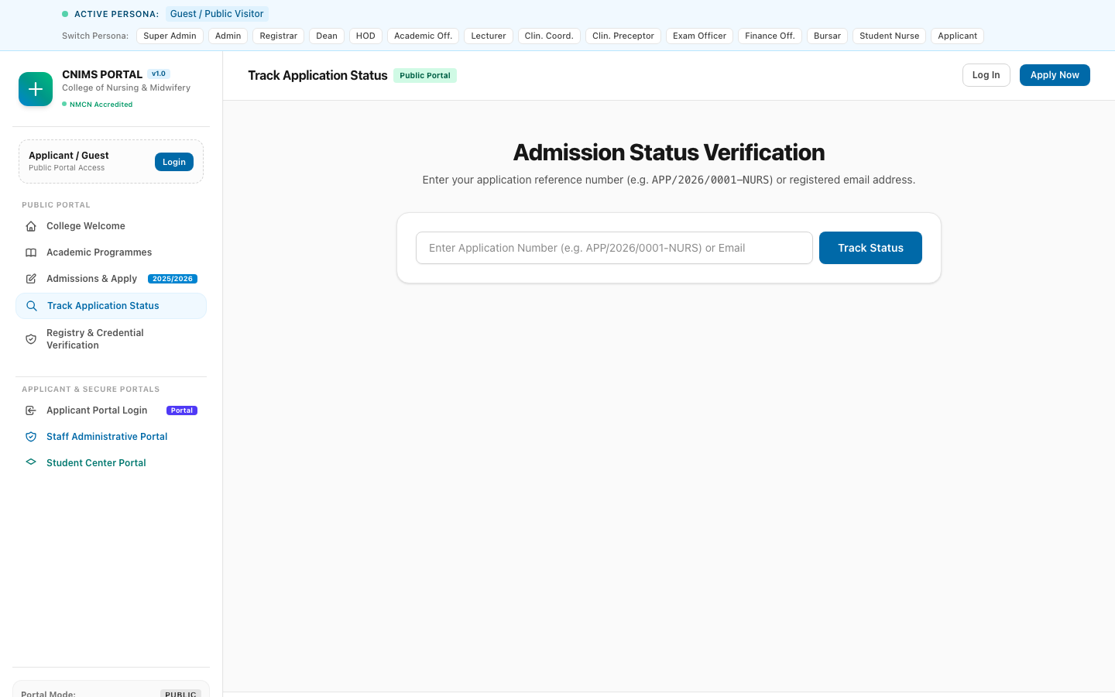
Figure 3: Public Application Status Tracker (`/application-status`)
The tracker interface allows applicants to monitor submission verification, CBT screening invitation, exam scores, and provisional admission offers using their unique access code.
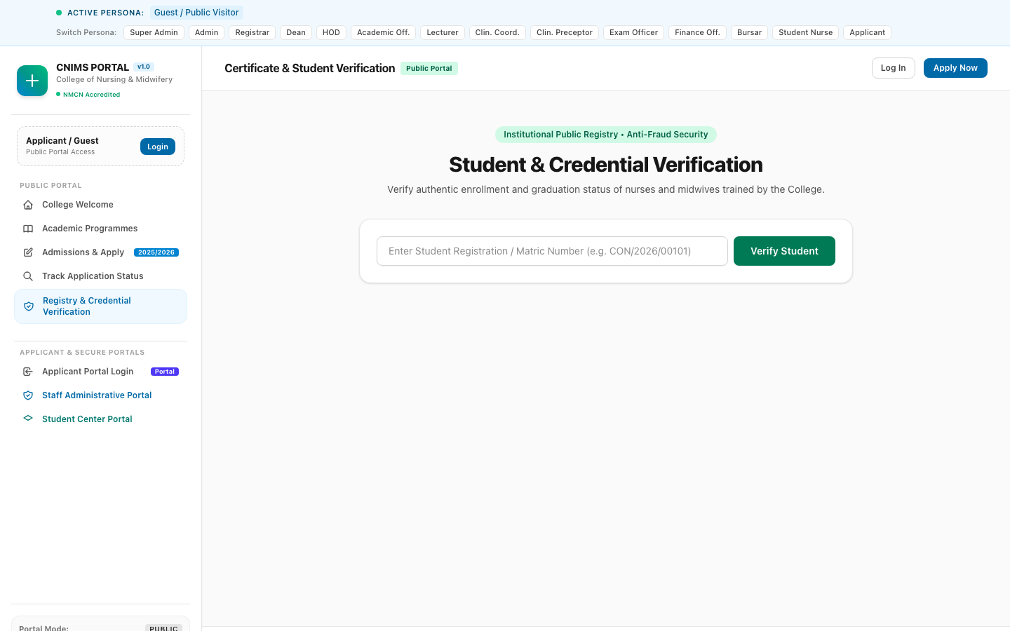
Figure 4: Public Certificate & Credential Verification Portal (`/verify-certificate`)
The credential verification tool provides instantaneous validation of official transcripts, nursing diplomas, and matriculation records, preventing credential falsification.

3.2 Prospective Applicant (Persona: Blessing Danjuma)
The Prospective Applicant represents candidates seeking admission into basic nursing or midwifery training. The portal guides the applicant through an intuitive 7-step wizard, entrance examination scheduling, admission offer review, and acceptance fee payment.
Persona Profile:
- Full Name: Blessing Danjuma
- Contact: applicant@cnims.edu.ng | +234 814 789 0123
- Application Number: APP/2026/00101 | Access Code: CNIMS-SEC-7721
- Target Programme: Basic Nursing Programme (3-Year RN)
- Current Lifecycle Stage: Admitted (Acceptance Fee Pending)
Step-by-Step Operating Workflow:
- Step 1: Programme Selection & Bio-Data: Applicant accesses `/apply` and selects their desired program (Basic Nursing).
- Step 2: Bio-Data Entry: Applicant fills personal bio-data, state of origin (Kaduna), LGA (Chikun), date of birth, emergency contact, and residential address.
- Step 3: Dual-Sitting O'Level Entry: Applicant inputs secondary school details and examination records. The portal supports dual sittings across WAEC and NECO. Blessing inputs Sitting 1 (WAEC 2023) and Sitting 2 (NECO 2024), combining English, Mathematics, Biology, Chemistry, and Physics.
- Step 4: JAMB UTME Credentials: Applicant inputs JAMB UTME registration number (`202610984721FA`), aggregate score (224), and subject breakdown (English 62, Biology 58, Chemistry 54, Physics 50).
- Step 5: Document Uploads: Applicant uploads certified copies of O'Level statement of results, birth certificate, local government indigene certificate, and passport photograph.
- Step 6: Application Fee Settlement: System generates an application processing invoice for NGN 15,000. Applicant completes payment via bank transfer or card, generating receipt `REC-APP-2026-00101`.
- Step 7: Final Submission & Confirmation: Applicant reviews the consolidated summary and submits the application. A unique Application Number (`APP/2026/00101`) and Secret Access Code (`CNIMS-SEC-7721`) are issued.
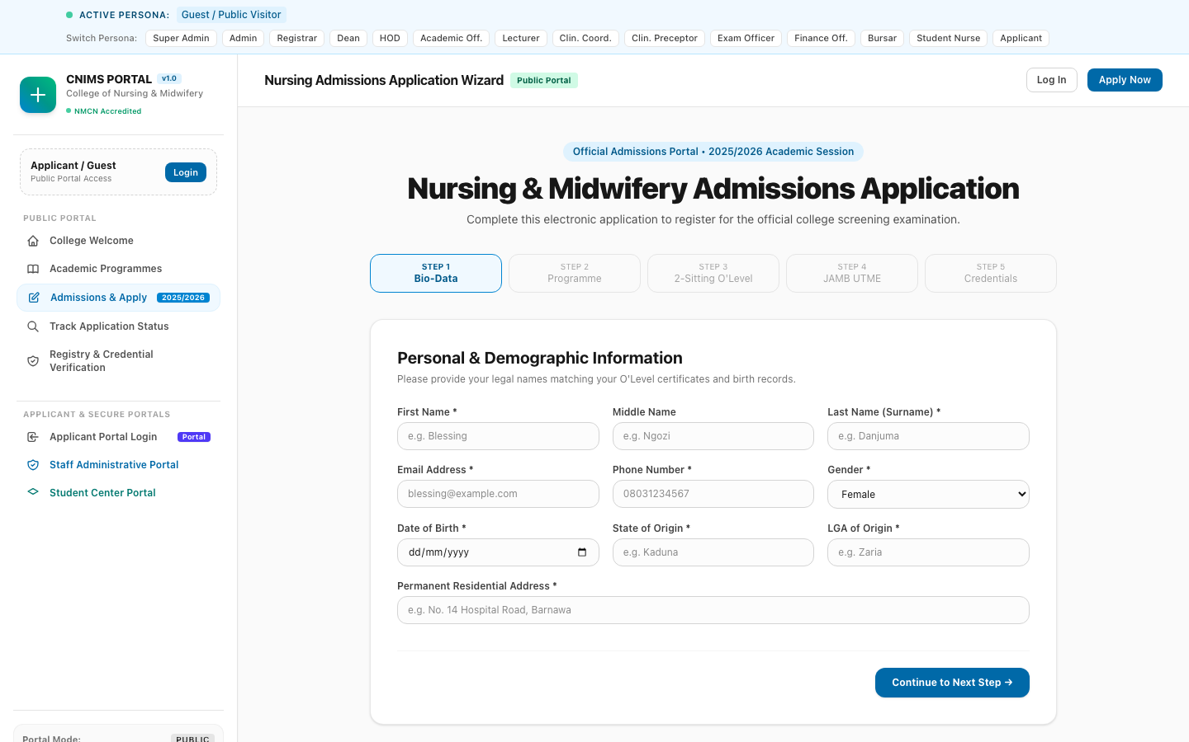
Figure 5: 7-Step Admissions Application Wizard (`/apply`)
The application wizard captures comprehensive biographical information, secondary education history, dual-sitting O'Level grades, JAMB credentials, and application fee invoices.
Step-by-Step Operating Workflow (Post-Submission & Admission):
- Step 8: Secure Portal Login: Applicant navigates to `/applicant/login`, enters their application number and secure access code or registered email/password.
- Step 9: Reviewing Admission Offer: Applicant accesses their personalized dashboard (`/applicant/dashboard`). The dashboard displays their admission status banner: 'Congratulations! You have been offered provisional admission into Basic Nursing Programme'.
- Step 10: CBT Performance Review: The dashboard presents their Entrance CBT Examination performance (78.50% - Distinction) and venue details ('CNIMS CBT Center, ICT Complex, Hall A, Seat CBT-A-042').
- Step 11: Acceptance & Fee Settlement: Applicant reviews the admission terms and conditions and clicks 'Accept Offer'. An acceptance fee invoice for NGN 35,000 is generated with a strict 14-day payment deadline.
- Step 12: Admission Letter Download: Upon payment confirmation, the official Admission Letter (Ref: `CNIMS/ADM/2026/00101`) and Matriculation Dossier Checklist are unlocked for PDF download.
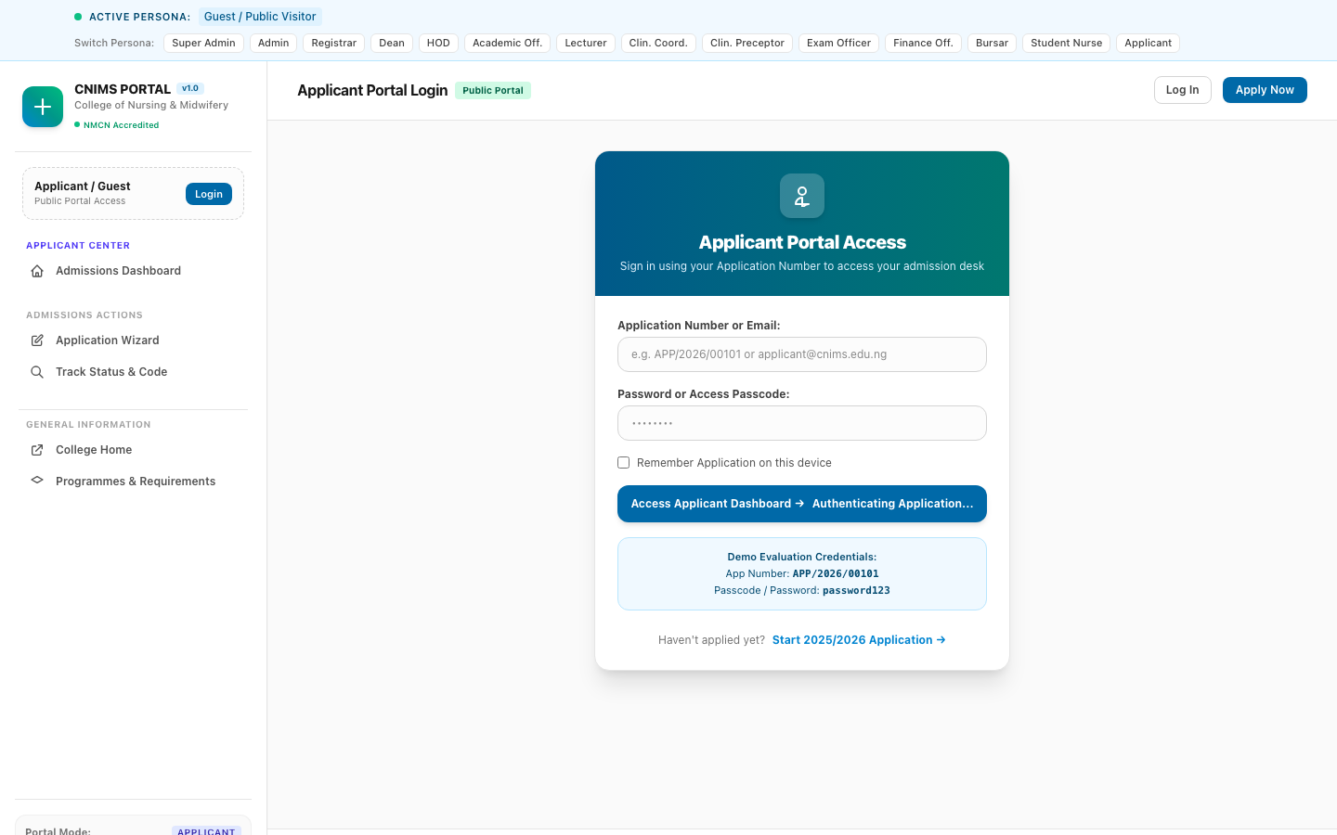
Figure 6: Prospective Applicant Secure Login Screen (`/applicant/login`)
Dedicated login gateway allowing prospective candidates to access their application file using either email/password or application number and access code.
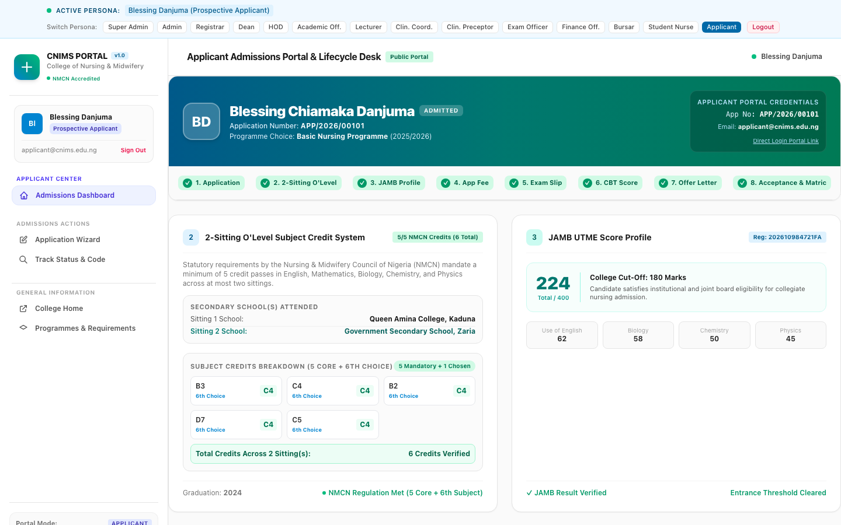
Figure 7: Applicant Admission Offer Dashboard (`/applicant/dashboard`)
The dashboard displays the active admission offer banner, CBT exam score (78.50%), seat number, provisional admission letter reference (`CNIMS/ADM/2026/00101`), acceptance deadline, and acceptance fee invoice.
[ADMISSION ACCEPTANCE POLICY] Candidates who do not complete acceptance fee payment within the stipulated 14-day window forfeit their provisional admission slot, which is automatically returned to the Registrar's waitlist quota.

3.3 Super Administrator (Persona: Prof. Fatima Bello)
The Super Administrator possesses master institutional authority across all academic, financial, clinical, and security systems. This role is responsible for institutional governance, security auditing, role delegation, and executive performance oversight.
Persona Profile:
- Full Name: Prof. Fatima Bello
- Official Email: admin@cnims.edu.ng
- Assigned Roles: super_admin (Full Unrestricted Matrix)
- Governance Domain: Institutional Operations & Security Compliance
Key Responsibilities & Workflows:
- 1. Executive KPI Monitoring:Monitors institutional KPIs in real time: Enrolled Students, Total Applications, Active Hospital Rotations, and Year-to-Date Fee Revenue.
- 2. RBAC & Access Control:Maintains user security, assigns RBAC roles, grants modular permissions, and oversees staff credential provisioning.
- 3. Institutional Audit Trail Review:Inspects the immutable system audit trail (`/admin/audit-logs`) to monitor security events, score alterations, fee reversals, and admissions status changes.
- 4. Multi-Persona Impersonation & Verification:Utilizes the integrated demo persona switcher to verify operational workflows across student, staff, and applicant views.
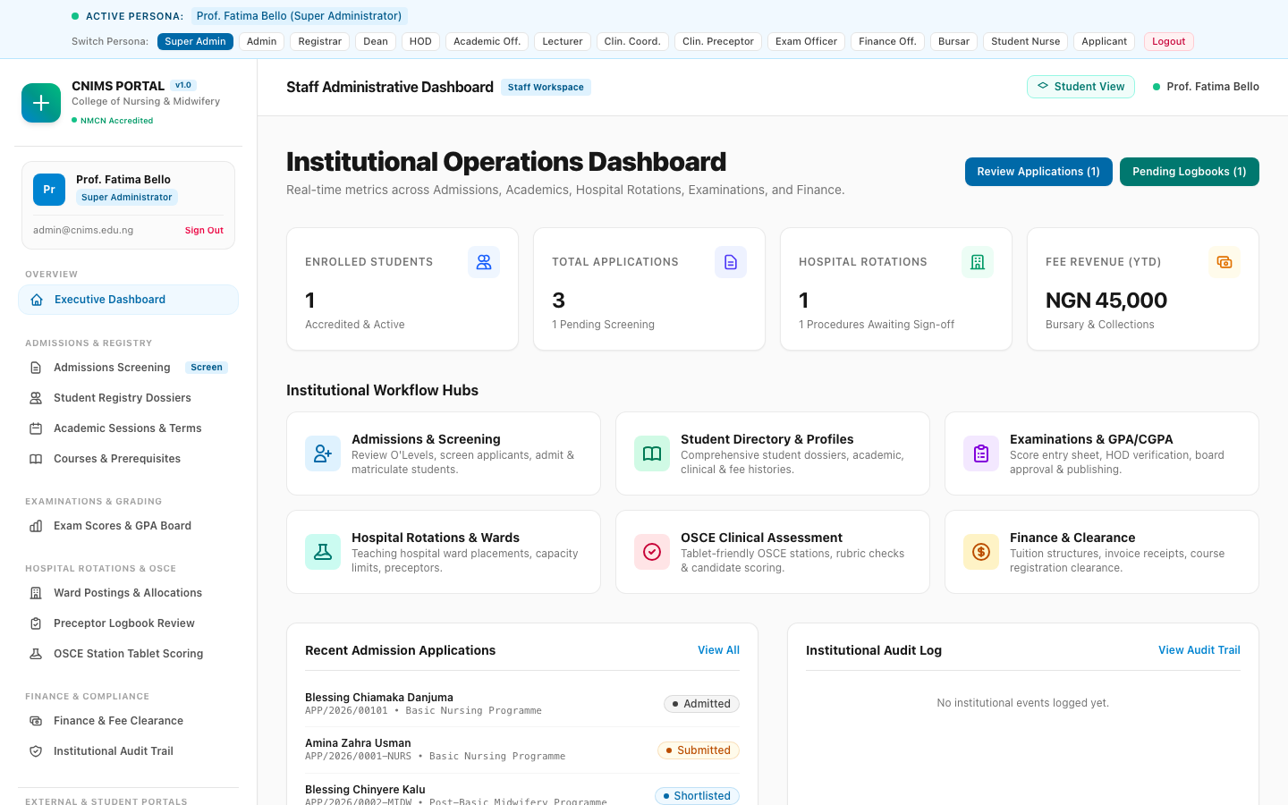
Figure 8: Super Administrator Operations Dashboard (`/admin`)
The executive dashboard displays live institutional metrics (Enrolled Students: 1, Applications: 3, Hospital Rotations: 1, Revenue: NGN 45,000), workflow hubs, quick review triggers, and live applicant feeds.
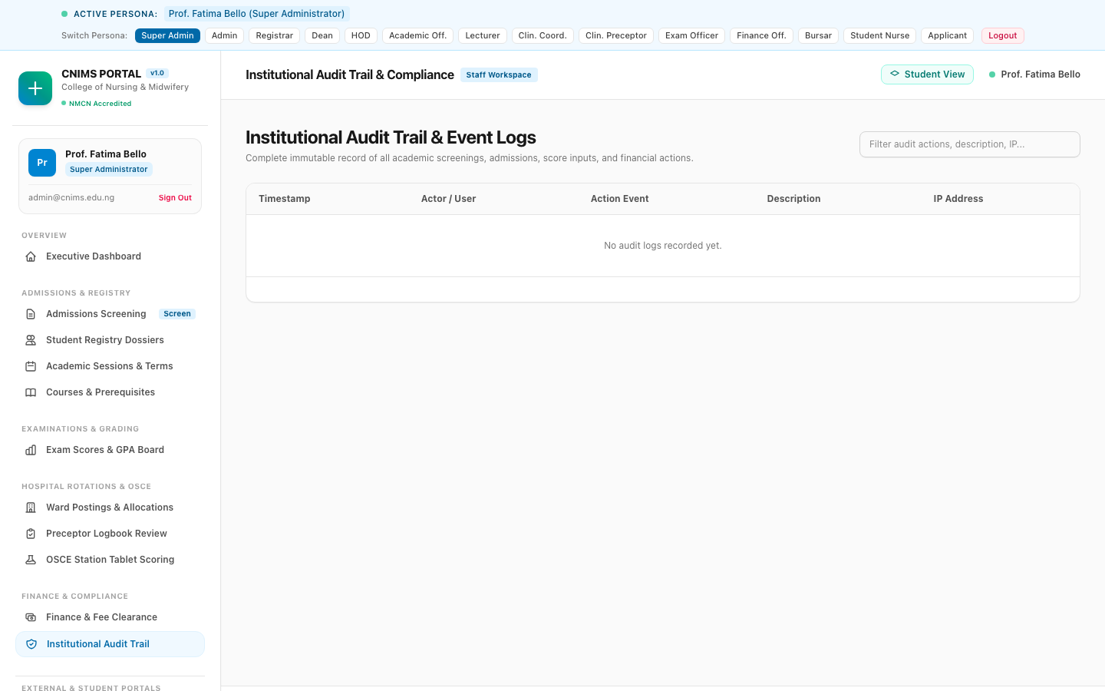
Figure 9: Institutional Security Audit Trail (`/admin/audit-logs`)
The audit viewer provides an immutable log of system actions, recording timestamps, user identity, IP addresses, affected models, and detailed event descriptions for accreditation compliance.

3.4 Registrar (Persona: Dr. Amina Abubakar)
The Registrar is the chief administrative and academic records custodian of the College. The Registrar manages applicant screening, evaluates O'Level qualification combinations, manages CBT shortlists, issues official admission offers, and oversees the central student registry.
Persona Profile:
- Full Name: Dr. Amina Abubakar
- Official Email: registrar@cnims.edu.ng
- Assigned Role: registrar
- Operational Domain: Admissions, Academic Registry & Student Dossiers
Step-by-Step Operating Workflow:
- Workflow 1: Reviewing Application Rosters: Registrar logs in and navigates to the Admissions Management Hub (`/admin/admissions`). The system displays all submitted applications categorized by programme and status.
- Workflow 2: Dual-Sitting O'Level Vetting: Registrar filters candidates by minimum credit threshold. For each applicant, the Registrar inspects Sitting 1 and Sitting 2 O'Level grades, ensuring valid credits in English, Mathematics, Biology, Chemistry, and Physics.
- Workflow 3: CBT Examination Shortlisting: Registrar selects qualified candidates and clicks 'Shortlist for CBT'. The system assigns CBT examination halls, dates, and seat numbers.
- Workflow 4: Admission Decision & Letter Issuance: Following CBT score compilation, the Registrar reviews candidates scoring above the departmental cutoff (e.g. >= 60%) and clicks 'Admit Candidate'.
- Workflow 5: Reference Generation: The system generates an official Admission Letter Reference (e.g. `CNIMS/ADM/2026/00101`), sets a 14-day acceptance deadline, and notifies the applicant.
- Workflow 6: Student Matriculation: Once acceptance fees are verified, the Registrar accesses the Student Registry (`/admin/students`), assigns a permanent matriculation number, and activates the student's institutional dossier.
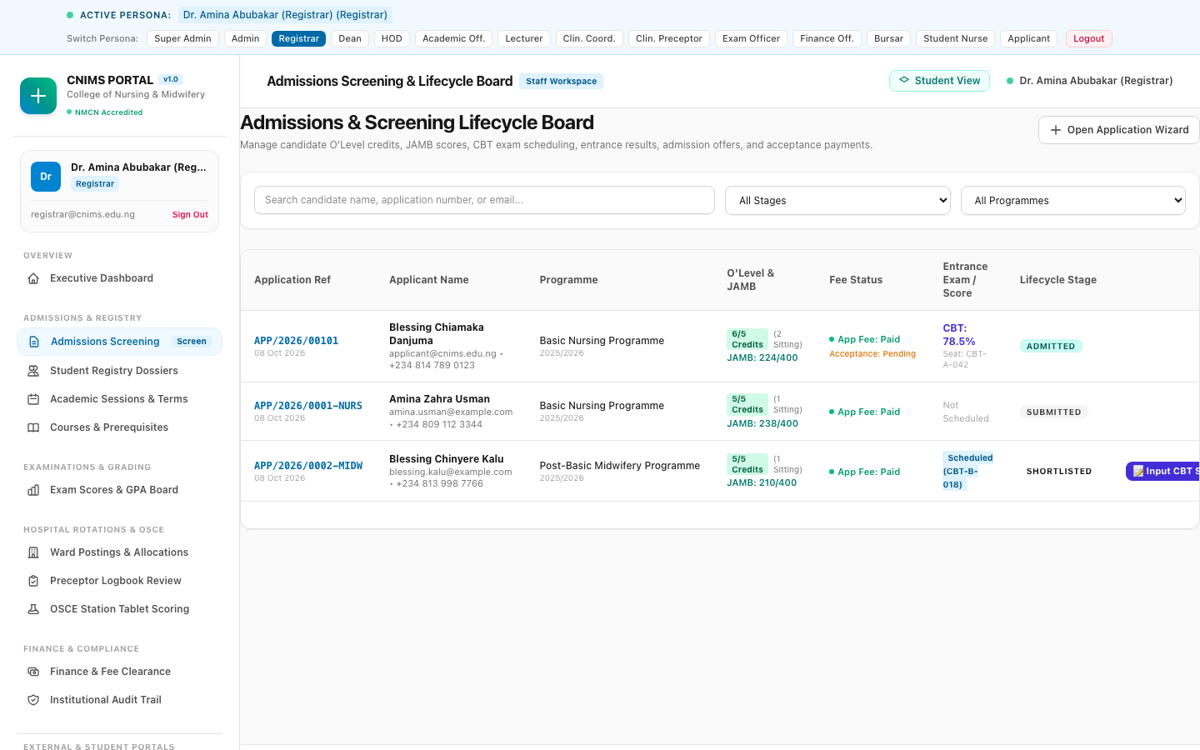
Figure 10: Registrar Admissions Screening & Processing Hub (`/admin/admissions`)
The admissions management table features candidate search, programme filtering, status badges (Admitted, Shortlisted, Submitted), O'Level credit verification indicators, and action menus for screening and admission.
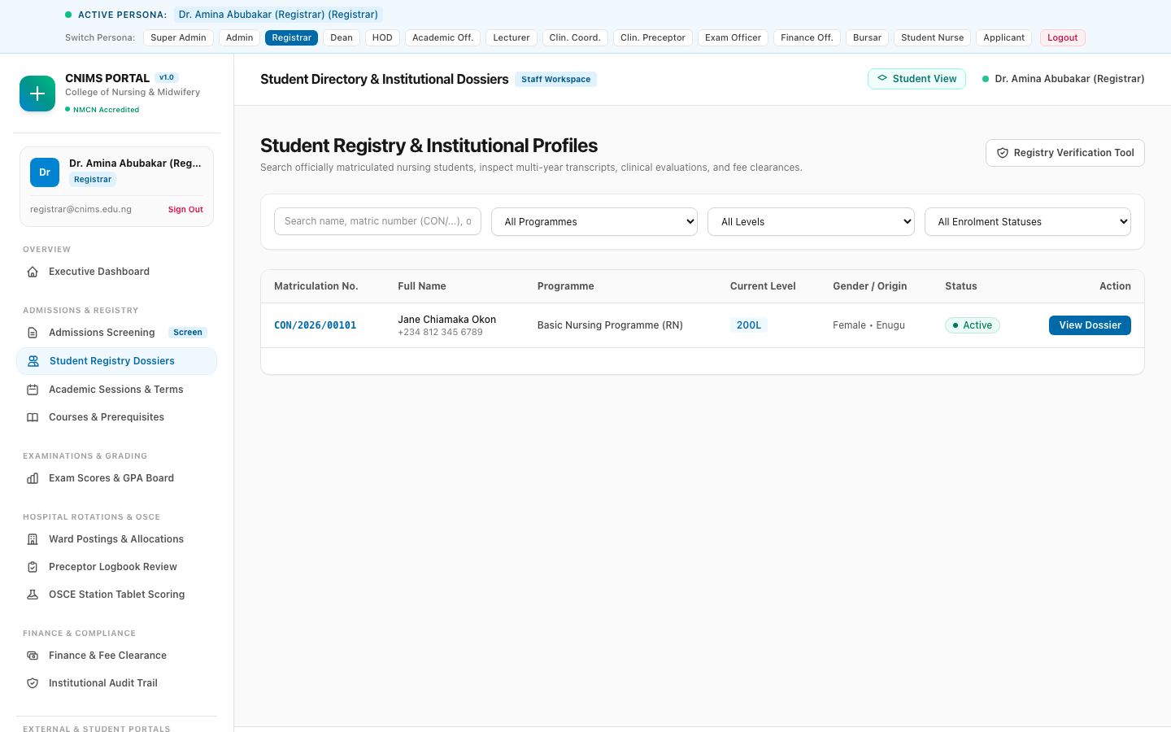
Figure 11: Registrar Student Registry & Dossier Directory (`/admin/students`)
The central student directory provides search by matriculation number, filtering by department and level, status toggles (Active, Graduated, Suspended), and direct access to comprehensive student dossiers.
[REGULATORY COMPLIANCE MANDATE] NMCN regulations strictly prohibit admitting any candidate who does not possess at least 5 credit passes in English, Mathematics, Biology, Chemistry, and Physics across no more than two sittings. The CNIMS system automatically flags any non-compliant combination.

3.5 Academic Officer (Persona: Mr. Victor Olawale)
The Academic Officer manages the institutional academic calendar, academic session states, term transitions, and semester course registration windows.
Persona Profile:
- Full Name: Mr. Victor Olawale
- Official Email: academic.officer@cnims.edu.ng
- Assigned Role: academic_officer
- Operational Domain: Academic Sessions, Term Calendars & Registration Windows
Step-by-Step Operating Workflow:
- Workflow 1: Academic Calendar Monitoring: Academic Officer navigates to the Session Manager (`/admin/sessions`). The active session (`2025/2026`) and its operational status are displayed.
- Workflow 2: Registration Window Activation: At the start of a semester, the Academic Officer transitions the session state to 'Registration Open', defining registration start and late registration penalty dates.
- Workflow 3: Session State Transitions: Once the enrollment period concludes, the Academic Officer transitions the session to 'In Session', locking student course registration modifications.
- Workflow 4: Examination Period Coordination: At the end of lectures, the session state is shifted to 'Examinations', and subsequently to 'Result Processing' to allow lecturers and examiners to compile score sheets.
- Workflow 5: Term Conclusion & Archive: Upon Senate approval, the session is moved to 'Concluded', and graduating students are transitioned to alumni records.
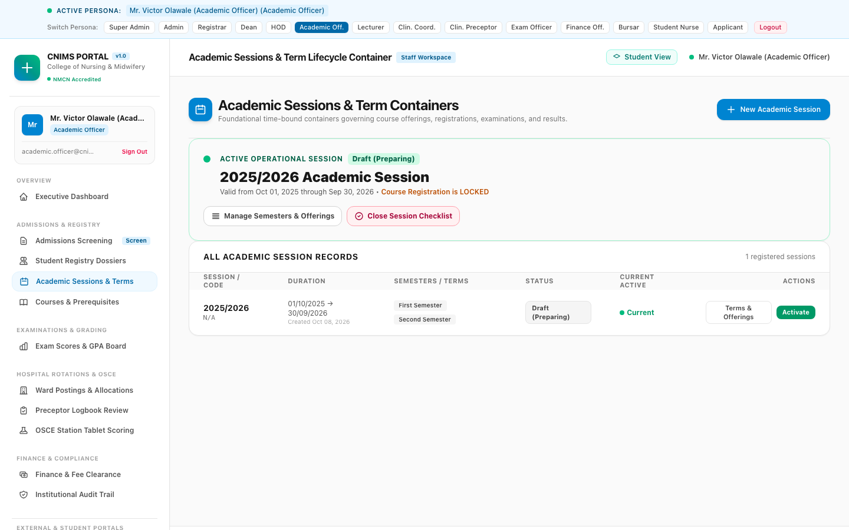
Figure 12: Academic Session Lifecycle & Term Transitions (`/admin/sessions`)
The session manager presents active session indicators, semester progress, operational state badges (Registration Open, In Session, Examinations, Processing), and transition action controls.

3.6 Head of Department - HOD Nursing Sciences (Persona: Dr. Emmanuel Adeyemi)
The Head of Department leads academic standards within the Department of Nursing Sciences. The HOD is responsible for curriculum course offerings, assigning courses to academic lecturers, vetting semester course registrations, and moderating Continuous Assessment and examination scores.
Persona Profile:
- Full Name: Dr. Emmanuel Adeyemi
- Official Email: hod.nursing@cnims.edu.ng
- Assigned Role: hod
- Operational Domain: Departmental Academics, Course Allocations & Score Moderation
Step-by-Step Operating Workflow:
- Workflow 1: Curriculum Management: HOD accesses the Academic Course Manager (`/admin/academics`). All approved courses for the Department of Nursing Sciences are cataloged.
- Workflow 2: Lecturer Course Allocation: HOD assigns qualified academic lecturers to courses (e.g. assigning Mrs. Grace Danladi to NSC 201 - Medical-Surgical Nursing I and NSC 202 - Human Anatomy & Physiology II).
- Workflow 3: Course Registration Approval: HOD reviews student course registrations submitted by 100L, 200L, and 300L students. The HOD checks for core course compliance and credit load limits (15-24 units) before granting departmental approval.
- Workflow 4: Grade Moderation & Departmental Sign-Off: HOD reviews Continuous Assessment (CA) and Examination score sheets entered by lecturers, checks grade distributions, verifies moderation rubrics, and signs off departmental submissions.
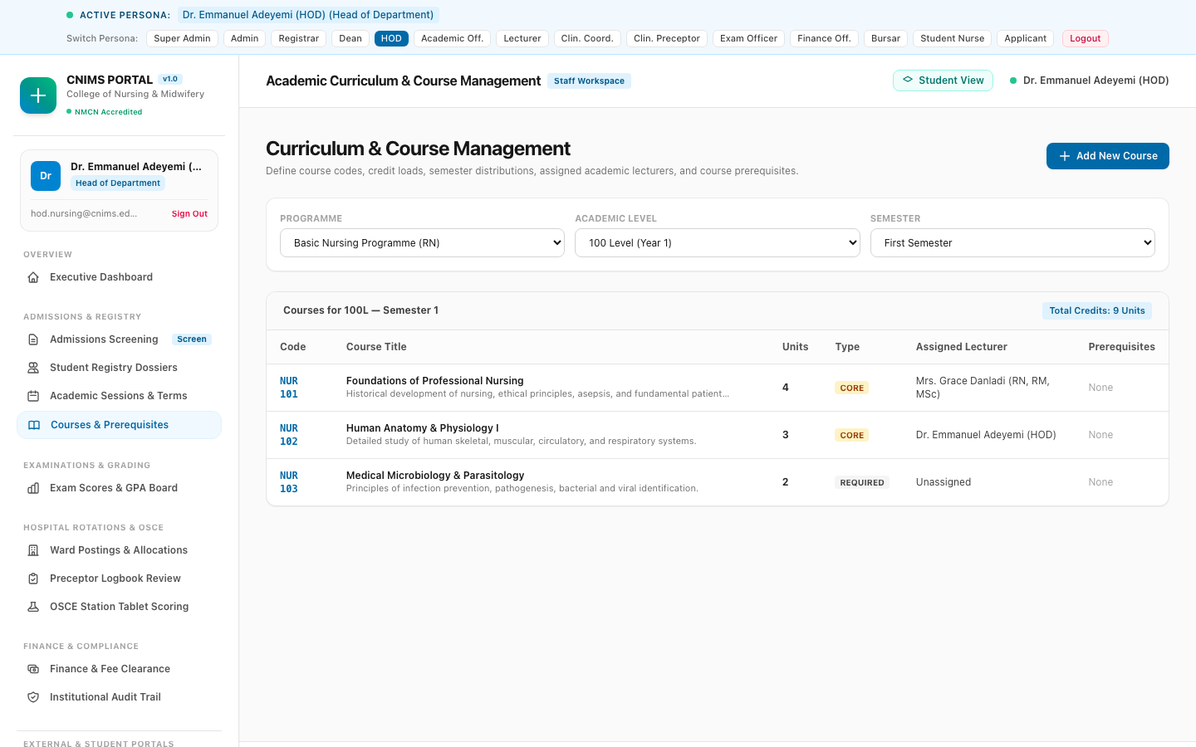
Figure 13: HOD Course Management & Curriculum Allocations (`/admin/academics`)
The course management interface displays course codes (NSC 101, NSC 102, NSC 201, NSC 202, NSC 203), titles, credit units, semester, level, assigned lecturers, and action triggers for prerequisites.

3.7 Examination Officer (Persona: Mr. Chidi Eze)
The Examination Officer is the institutional guardian of examination integrity, score sheet processing, GPA/CGPA calculations, and official result slip publication.
Persona Profile:
- Full Name: Mr. Chidi Eze
- Official Email: exam.officer@cnims.edu.ng
- Assigned Role: exam_officer
- Operational Domain: Score Processing, GPA/CGPA Engine & Senate Results Publishing
Step-by-Step Operating Workflow:
- Workflow 1: Course Score Sheet Consolidation: Examination Officer accesses the Score Entry & Grading Board (`/admin/examinations`), selecting the active session, semester, level, and course code.
- Workflow 2: Score Calculation & Grade Generation: The system compiles lecturer-entered CA scores (30%) and Exam scores (70%), calculating Total Scores, Grades (A to F), Grade Points (5.0 to 0.0), and Credit Points.
- Workflow 3: GPA/CGPA Computation Engine: Examination Officer executes the automated GPA/CGPA engine. The system calculates Quality Points, GPA, cumulative CGPA, and Academic Standing (Good Standing, Probation, Withdrawn).
- Workflow 4: Senate Ratification & Result Publishing: Examination Officer presents faculty score summaries to the Academic Board and Dean. Upon ratification, the Examination Officer clicks 'Publish Results'.
- Workflow 5: Result Slip Locking: The system publishes official results to student portals, locking score modifications and generating digitally signed result slips.
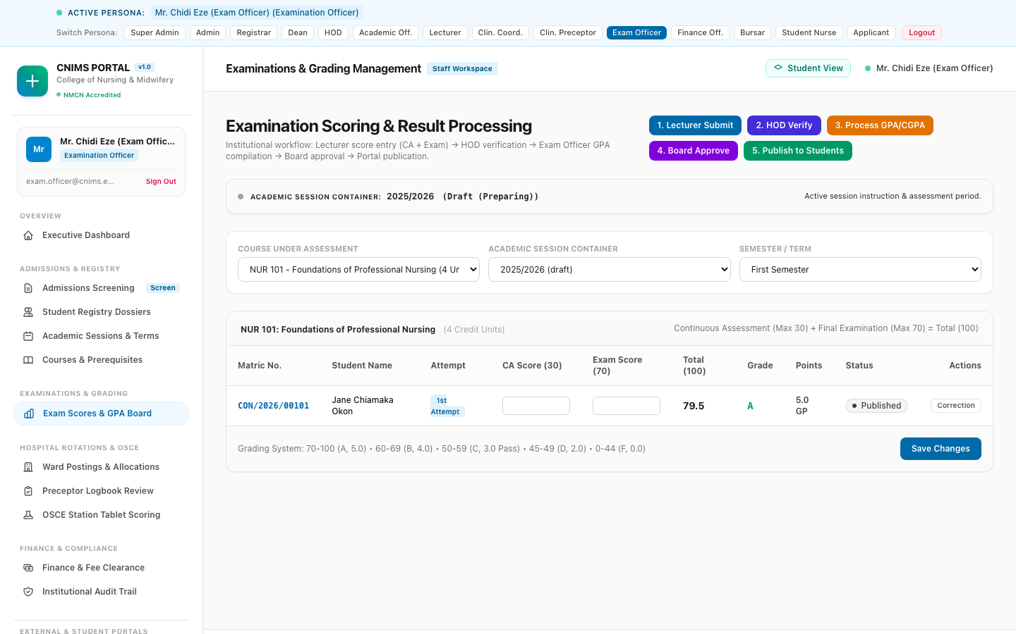
Figure 14: Examination Officer Score Entry & GPA Board (`/admin/examinations`)
The examination grading sheet displays enrolled candidates, CA scores, Examination scores, computed total marks, letter grades, grade points, publication statuses, and bulk submission tools.

3.8 Clinical Coordinator (Persona: Nurse Hauwa Sambo)
The Clinical Coordinator is responsible for off-campus teaching hospital affiliations, specialized ward rotations, preceptor assignments, and Objective Structured Clinical Examination (OSCE) planning.
Persona Profile:
- Full Name: Nurse Hauwa Sambo
- Official Email: clinical.coordinator@cnims.edu.ng
- Assigned Role: clinical_coordinator
- Operational Domain: Hospital Affiliations, Rotation Cohorts & OSCE Examination Architecture
Step-by-Step Operating Workflow:
- Workflow 1: Hospital Facility & Ward Management: Clinical Coordinator accesses the Hospital Rotations Manager (`/admin/clinical`). The system catalogs accredited teaching hospitals (e.g. Ahmadu Bello University Teaching Hospital) and specialized wards.
- Workflow 2: Rotation Cohort Creation: Coordinator configures rotation postings (e.g. '2026 Batch A - Adult Medical Nursing Rotation', Level 200, 6-week duration).
- Workflow 3: Preceptor Allocation & Capacity Management: Coordinator defines ward capacity limits (max 15 students per unit) and assigns licensed Clinical Preceptors (Nurse Ibrahim Yakubu) to supervise cohorts.
- Workflow 4: Student Placement Roster Generation: Coordinator enrolls student cohorts into rotations, generating official ward placement rosters and hospital badges.
- Workflow 5: OSCE Station Architecture: Coordinator designs the OSCE Clinical Examination (`/admin/osce`), setting up stations (Station 1: Medication Safety, Station 2: Aseptic Wound Care), allocated times (7 mins), scenarios, and scoring rubrics.
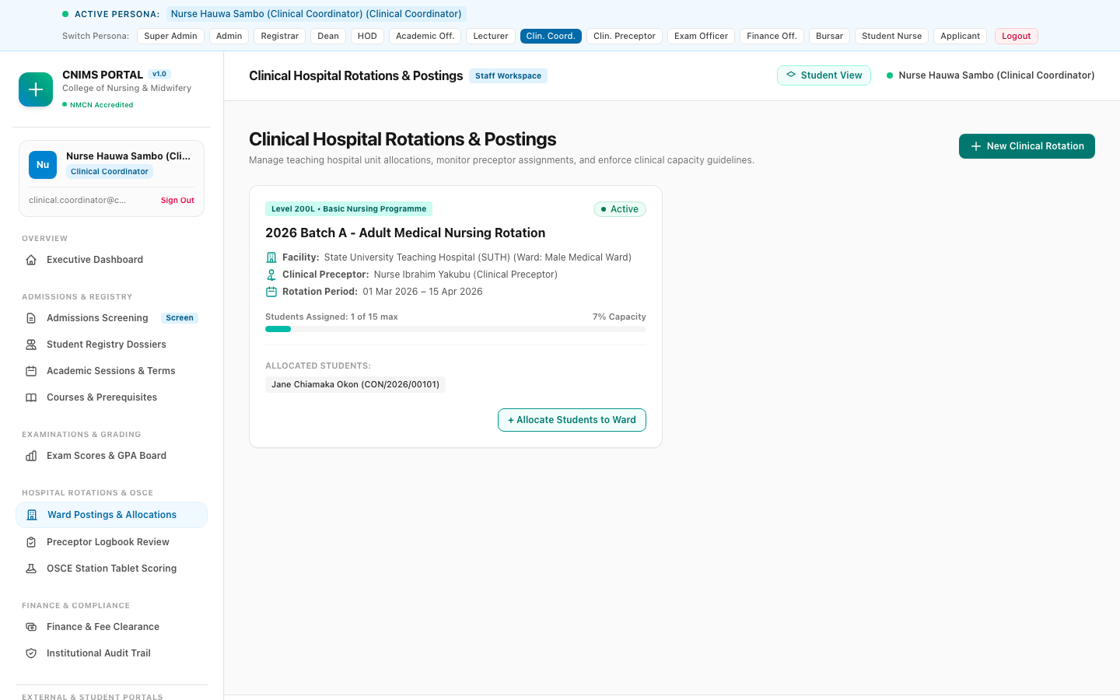
Figure 15: Clinical Coordinator Hospital Postings & Ward Management (`/admin/clinical`)
The rotation management hub displays active clinical postings, teaching hospitals, assigned wards, supervisor details, rotation dates, capacity utilization, and student cohort rosters.
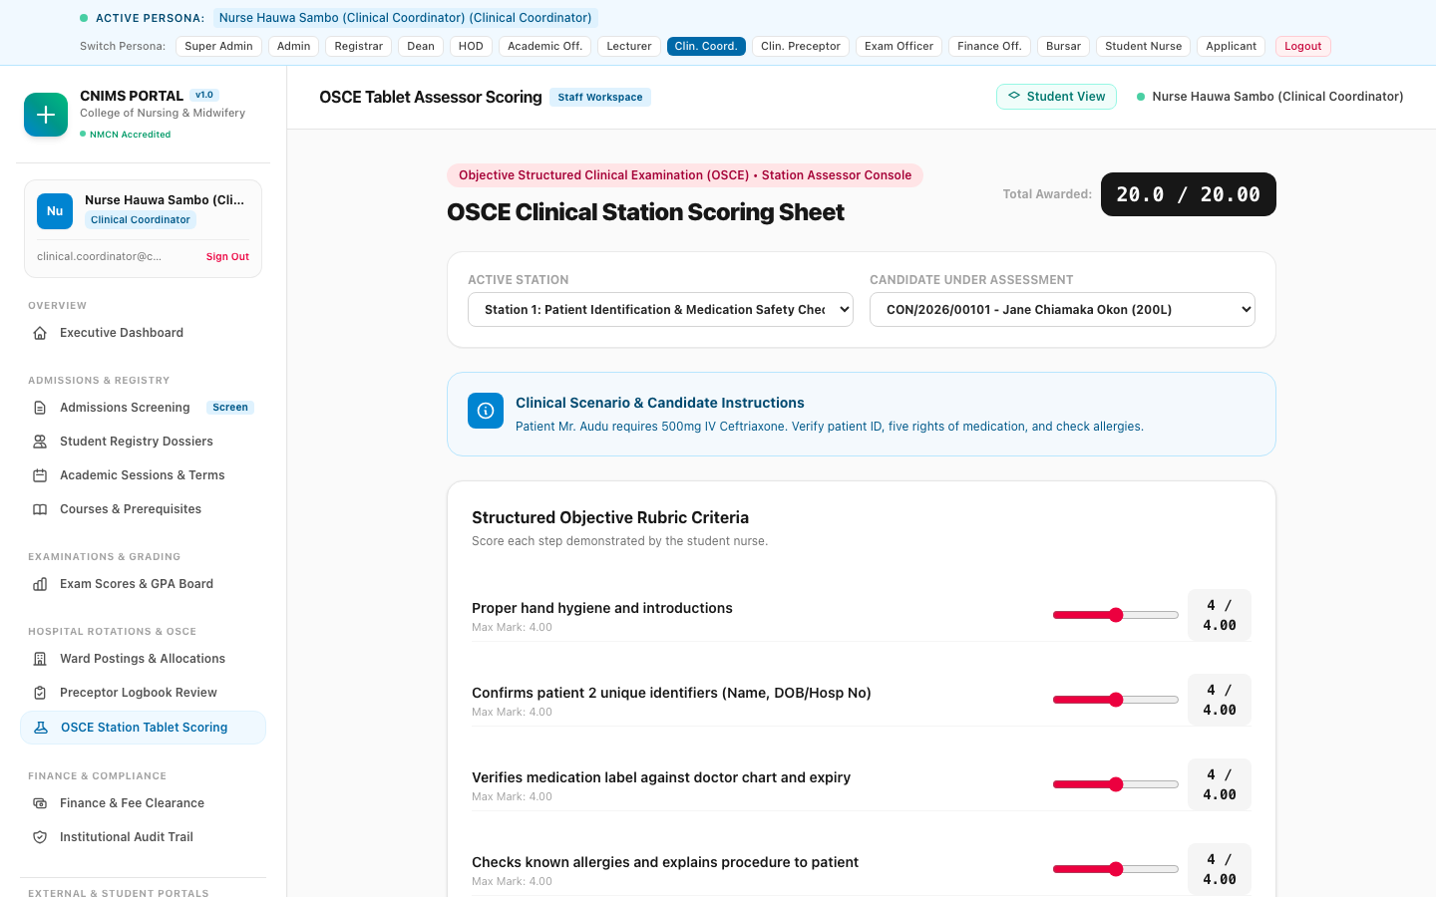
Figure 16: OSCE Station Architecture & Tablet Scoring Hub (`/admin/osce`)
The OSCE clinical assessment hub displays exam stations, clinical scenarios, allocated minutes per candidate, station rubrics, assessor assignments, and live score tallying.

3.9 Clinical Preceptor / Instructor (Persona: Nurse Ibrahim Yakubu)
The Clinical Preceptor is a registered healthcare practitioner supervising nursing students directly at the bedside in affiliated hospital wards. The Preceptor evaluates procedural performance, signs off digital logbooks, assesses clinical competencies, and scores OSCE stations.
Persona Profile:
- Full Name: Nurse Ibrahim Yakubu
- Official Email: clinical.instructor@cnims.edu.ng
- Assigned Role: clinical_instructor
- Operational Domain: Bedside Supervision, Digital Logbook Sign-Off & OSCE Examiner
Step-by-Step Operating Workflow:
- Workflow 1: Reviewing Ward Procedure Queue: Preceptor logs in and accesses the Preceptor Logbook Review Hub (`/admin/clinical/logbook`). The queue lists pending procedure logs submitted by ward students.
- Workflow 2: Inspecting Clinical Reflections: Preceptor selects a submission (e.g. Jane Okon - Complex Surgical Wound Debridement & Dressing). The Preceptor reviews the procedure date, anonymized patient reference (`PT-MED-042`), and the student's clinical reflection on aseptic technique.
- Workflow 3: Competence Verification: Preceptor evaluates the student's technique against clinical criteria: maintains sterile boundary, proper gowning and gloving, aseptic swab disposal, patient pain management.
- Workflow 4: Digital Logbook Sign-Off: Preceptor enters constructive feedback ('Good sterile boundary maintenance. Appropriate disposal of contaminated swabs.') and selects status: 'Approved'.
- Workflow 5: Competency Progress Update: The system records the Preceptor's digital signature, verification timestamp, and updates the student's NMCN competency requirement progress.
- Workflow 6: OSCE Rubric Scoring: During OSCE examinations, the Preceptor operates the tablet scoring interface (`/admin/osce`), evaluating candidate performance criterion-by-criterion against real-time rubrics.
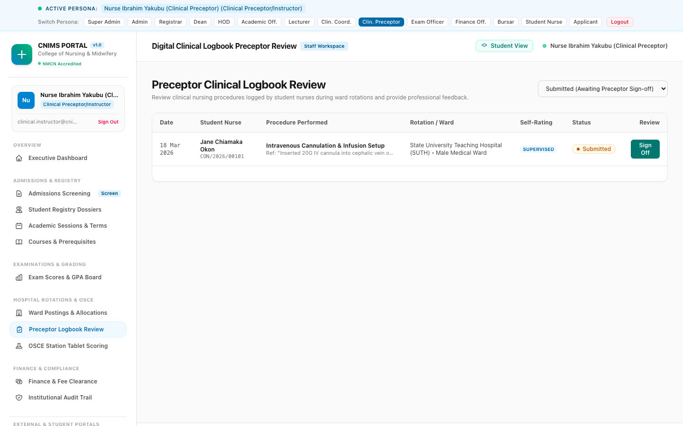
Figure 17: Clinical Preceptor Logbook Review & Approvals Hub (`/admin/clinical/logbook`)
The logbook review hub features student procedure logs, procedure categories, patient references, competency levels (Observed, Supervised, Competent, Independent), reflections, preceptor remarks, and approval toggles.
[CLINICAL LOGBOOK TIMELINE POLICY] Every logbook entry must be verified by a licensed Preceptor within 7 days of procedure completion at the hospital ward. Unverified entries do not count towards NMCN clinical licensing requirements.

3.10 Bursar & Finance Officer (Personas: Mrs. Kemi Ojo & Mr. Tunde Lawal)
The Bursary department ensures fiscal integrity, defines fee schedules, processes student payments, reconciles bank collections, and enforces mandatory financial clearance gates for course registration and examinations.
Personas Profile:
- Executive Finance: Mrs. Kemi Ojo (bursar@cnims.edu.ng) — Bursar (Chief Financial Officer)
- Operational Finance: Mr. Tunde Lawal (finance.officer@cnims.edu.ng) — Finance Officer (Operations)
- Operational Domain: Fee Schedules, Invoicing, Payment Reconciliation & Clearances
Step-by-Step Operating Workflow:
- Workflow 1: Fee Structure Configuration: Bursar accesses the Finance & Fee Clearance Hub (`/admin/finance`) and creates session fee structures (e.g., Level 200 Basic Nursing Tuition & Fees: NGN 195,000).
- Workflow 2: Itemized Fee Breakdown: Bursar defines itemized fee breakdowns: Tuition (NGN 110,000), Clinical Posting & Hospital Levy (NGN 45,000), Examination Fee (NGN 25,000), Library & ICT Fee (NGN 15,000).
- Workflow 3: Automated Invoice Generation: The system automatically generates digital invoices for all enrolled students in the corresponding program and level.
- Workflow 4: Payment Verification & Ledger Audit: Finance Officer monitors the payment ledger, auditing transaction references, bank tellers, and online payment gateways.
- Workflow 5: Financial Clearance Sign-Off: Once a student fulfills required fee thresholds (e.g. 100% or approved installment), the Finance Officer issues an official Financial Clearance (`clearance_type = course_registration`).
- Workflow 6: Clearance Gate Enforcement: The clearance instantly unlocks the student's course registration and examination result slips, preventing financial non-compliance.
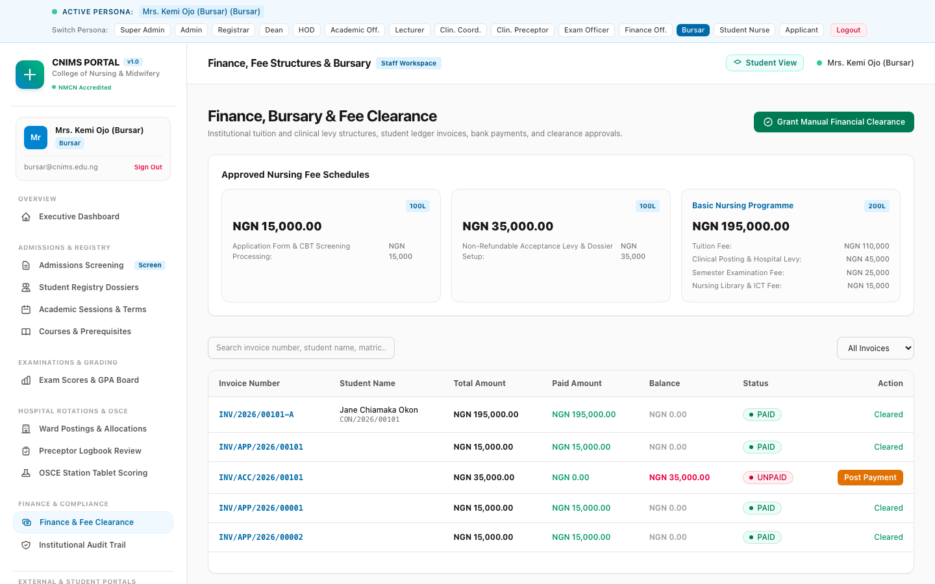
Figure 18: Bursar & Finance Officer Clearance Ledger (`/admin/finance`)
The finance management console displays fee structures, active invoice ledgers, payment transaction history, and the financial clearance registry for course registration and examination gating.

3.11 Student Nurse / Midwife (Persona: Jane Okon)
The Student Nurse is the primary beneficiary of the academic and clinical learning ecosystem. The Student Portal centralizes course registration, examination result slips, clinical rotation tracking, digital procedure logging, and fee payments.
Persona Profile:
- Full Name: Jane Chiamaka Okon
- Contact: student@cnims.edu.ng | +234 812 345 6789
- Matriculation Number: CON/2026/00101 (Basic Nursing Programme)
- Academic Level & Standing: Level 200 (Good Standing — Current CGPA: 5.00)
- Active Clinical Placement: Adult Medical Nursing Rotation (ABUTH)
Step-by-Step Operating Workflows:
Workflow 1: Student Overview & Academic Pulse
1. Jane logs into the Student Portal (`/student`). The dashboard immediately displays her academic standing ('Good Standing'), perfect CGPA (5.00), enrolled credits, outstanding fee balance (NGN 0.00 — Fully Cleared), and current hospital rotation details.
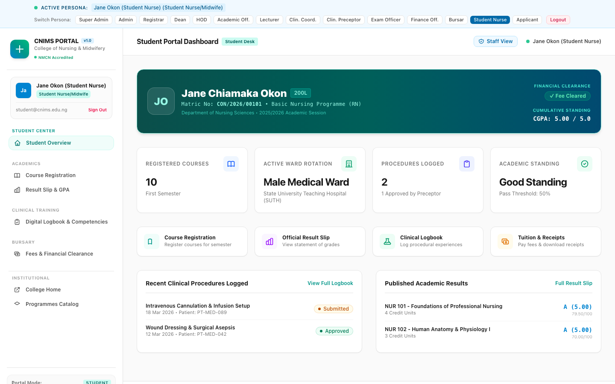
Figure 19: Student Nurse Academic & Clinical Dashboard (`/student`)
The student dashboard provides high-level academic tracking: CGPA badge (5.00), active courses, hospital rotation placement (ABUTH Adult Medical), fee clearance indicator, and quick links.
Workflow 2: Semester Course Registration
1. Once financial clearance is granted by Bursary, Jane navigates to Course Registration (`/student/courses`).
2. The portal presents available Level 200 Semester 1 courses: NSC 201 (Medical-Surgical Nursing I - 4 Credits), NSC 202 (Human Anatomy & Physiology II - 3 Credits), NSC 203 (Pharmacology for Nurses - 3 Credits).
3. Jane verifies credit unit totals (10 Units) against the allowable semester limit (min 15, max 24), and clicks 'Submit Course Registration'. The registration is routed to HOD Dr. Emmanuel Adeyemi for approval.
4. Upon HOD sign-off, Jane prints her official approved course registration slip.
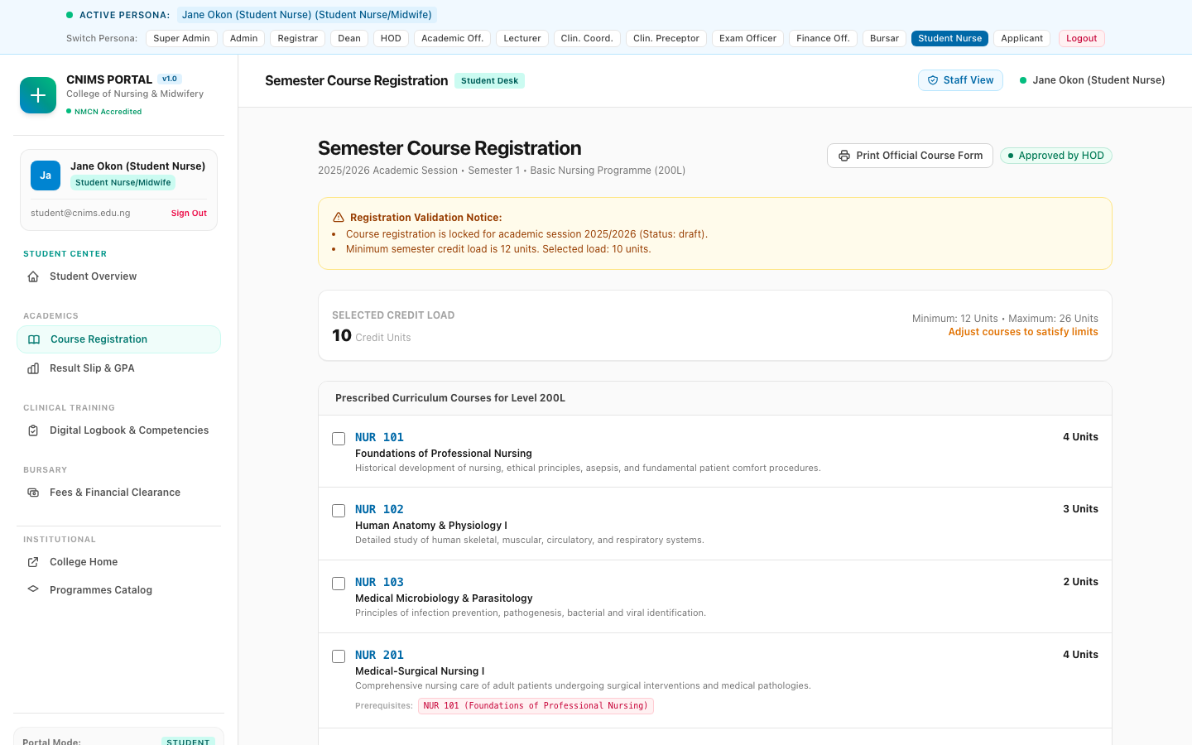
Figure 20: Student Semester Course Registration Portal (`/student/courses`)
The course registration screen shows approved course registration status, course itemization, credit unit summaries, and HOD approval timestamps.
Workflow 3: Examination Results Slip & CGPA Progression
1. Jane navigates to Examination Results (`/student/results`) to view published semester scores.
2. The results slip displays a course-by-course breakdown: NSC 101 (CA: 27.5, Exam: 52.0, Total: 79.5, Grade: A, GP: 5.0), NSC 102 (CA: 25.0, Exam: 45.0, Total: 70.0, Grade: A, GP: 5.0).
3. Total Credits Registered: 7, Credits Earned: 7, Quality Points: 35.0, GPA: 5.00, Cumulative CGPA: 5.00, Academic Standing: Good Standing.
4. Jane clicks 'Print Official Result Slip' to generate a digitally verifiable PDF result slip.
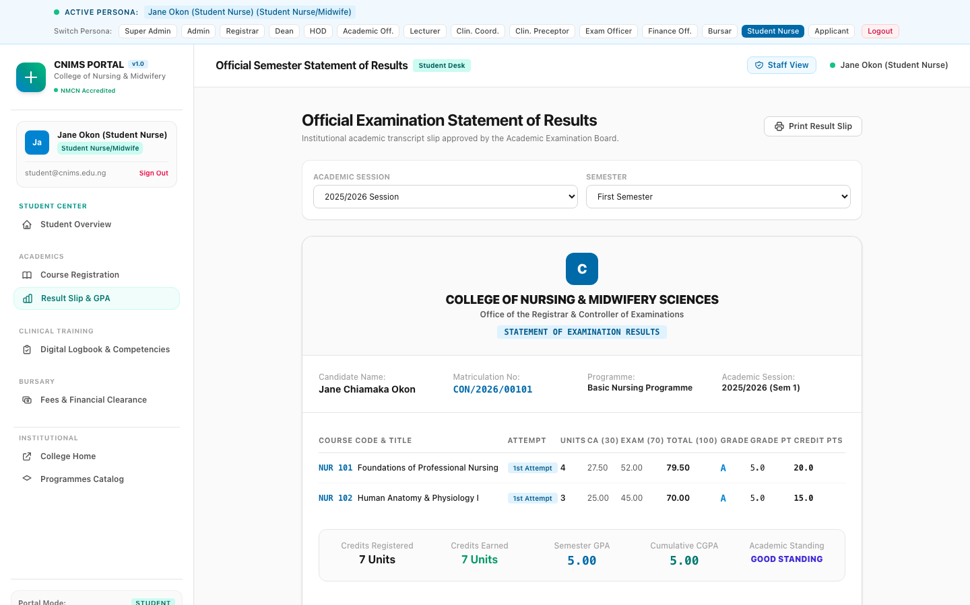
Figure 21: Student Examination Result Slip & Academic Record (`/student/results`)
The result slip interface provides itemized Continuous Assessment and Examination scores, grade points, semester GPA calculation, cumulative CGPA tracking, and print tools.
Workflow 4: Hospital Rotations & Digital Clinical Logbook
1. Jane accesses the Clinical Logbook & Rotations Portal (`/student/clinical`).
2. The rotation card details her active placement: '2026 Batch A - Adult Medical Nursing Rotation' at Ahmadu Bello University Teaching Hospital, Male Medical Ward, supervised by Preceptor Nurse Ibrahim Yakubu, with 98% attendance.
3. Jane clicks 'Log New Procedure', selects procedure type (e.g. Complex Surgical Wound Debridement & Dressing), procedure date, anonymized patient reference code (`PT-MED-042`), competency level ('Competent'), and enters her clinical reflection.
4. Jane tracks the verification status in her logbook ledger, viewing Preceptor remarks and approved timestamps.
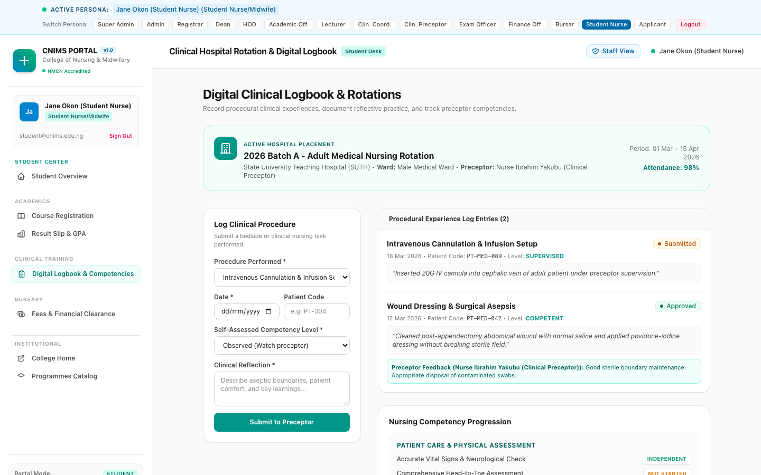
Figure 22: Student Clinical Logbook & Hospital Rotations Portal (`/student/clinical`)
The clinical portal displays active hospital rotation cards, attendance rates (98%), competency level milestones, procedure logging triggers, and verified logbook ledgers.
Workflow 5: Fees, Payments & Official Receipts
1. Jane navigates to Fees & Receipts (`/student/fees`) to view semester invoices, balances, and payment history.
2. Invoice `INV/2026/00101-A` shows total fees of NGN 195,000, paid amount NGN 195,000, balance NGN 0.00, status 'Paid'.
3. Jane clicks 'Download Receipt' to obtain her official Bursary receipt for institutional dossiers.
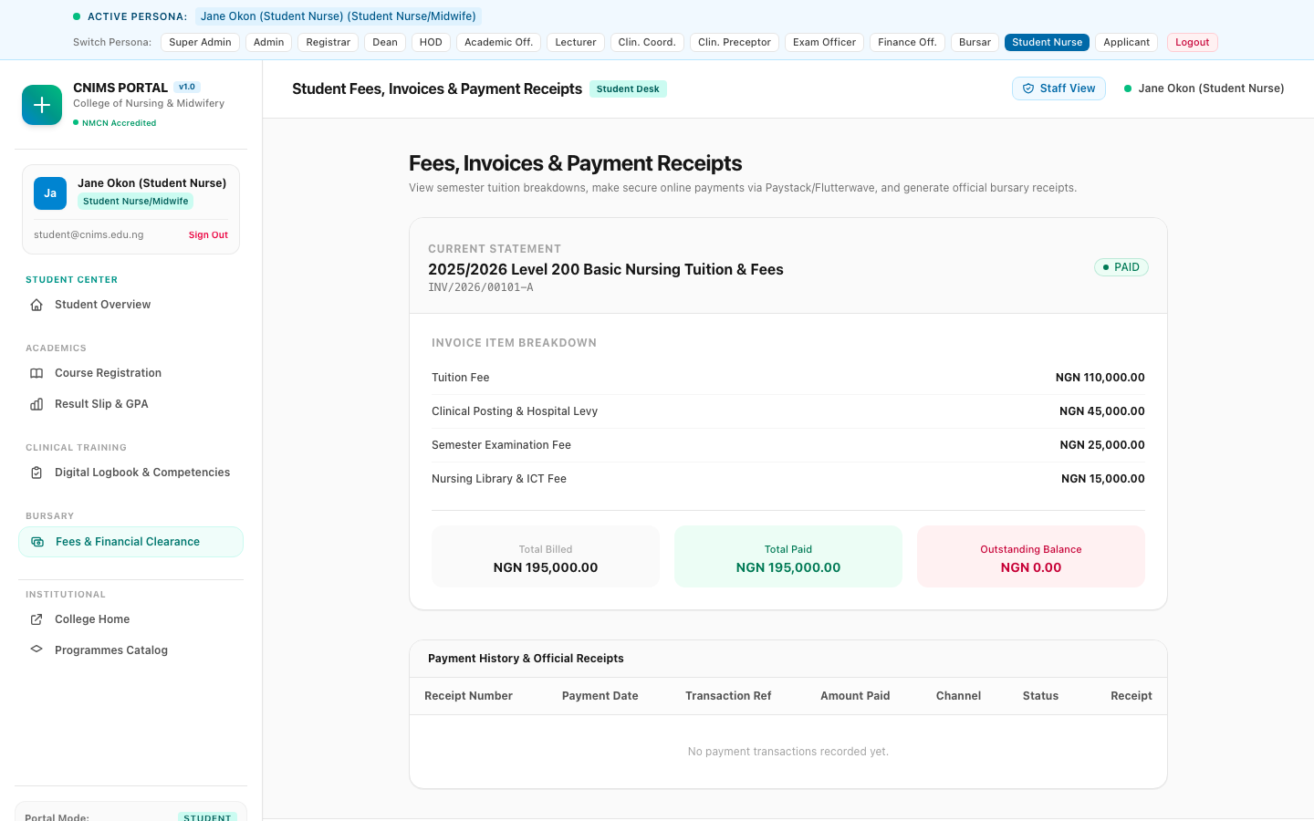
Figure 23: Student Fees, Payment History & Receipts (`/student/fees`)
The fee portal provides invoice status badges, itemized cost breakdowns, payment transaction logs, and printable official institutional receipts.

4. Institutional Governance, Regulatory Compliance & Best Practices
The operational credibility of the CNIMS ecosystem depends on strict adherence to national nursing education standards, data confidentiality, and administrative integrity. The following institutional governance rules govern all ecosystem participants:
4.1 Dual-Sitting O'Level Combination Rules
In accordance with NMCN guidelines, applicants are permitted to present results from a maximum of two examination sittings across WAEC (WASSCE) and NECO (SSCE). The combination must yield at least five distinct credit passes in English Language, Mathematics, Biology, Chemistry, and Physics. The CNIMS application wizard automatically performs cross-sitting deduplication, ensuring that higher grades in identical subjects supersede lower grades while validating that all mandatory science disciplines are satisfied.
4.2 Preceptor Supervision & Clinical Hours Integrity
All bedside clinical procedures logged into the digital system must correspond to an active, approved hospital rotation. Students are strictly prohibited from submitting logs outside rotation schedules. Preceptors are required to verify student reflections against clinical observations before granting approval. The system maintains an unalterable timestamp and digital signature for every preceptor verification, providing full auditability for Council accreditation inspections.
4.3 Examination Result Publishing & Security Protocols
The transition of examination scores from continuous assessment entry to published result slips follows a strict multi-tier approval chain: Lecturer Entry -> Departmental HOD Moderation -> Examination Officer Verification -> Academic Board / Dean Ratification -> Senate Publishing. Once a result is published, the score sheet is cryptographically locked. Any post-publication corrections require formal Senate approval, Super Administrator override, and are permanently recorded in the Institutional Audit Log.
4.4 Financial Clearance Gate Enforcement
Financial clearance gates are systematically enforced at two critical academic milestones: Course Registration and Semester Examinations. Students with outstanding tuition balances are blocked from submitting course registrations or generating examination admission cards unless an exceptional Bursary Clearance Override is granted by the Bursar.
4.5 Conclusion & Operational Readiness
The CNIMS Portal v1.0 establishes an unassailable benchmark for digital nursing and midwifery education in Nigeria. By harmonizing academic governance, admissions automation, hospital rotation oversight, digital preceptor logbooks, OSCE tablet scoring, and bursary management into a single unified platform, the College ensures academic excellence, flawless accreditation compliance, and world-class training for future healthcare professionals.

