PropNest: Property Management System

Complete Workflow & Visual Process Guide
Project Environment: Laravel 12 on PHP 8.4 (Herd)
Application URL: http://propertysystem.test (Local Dev: http://127.0.0.1:8000)
Architecture: Role-Based Access Control (Tenant & Landlord/Administrator), Tailwind CSS v4, SQLite
_________________________________________________________________________________

Executive Architecture Overview
PropNest is a full-featured Property Management Platform built around Five Key Design Components, engineered to seamlessly balance tenant self-service with landlord administration.
_________________________________________________________________________________

Component I: Tenant Authentication & Role Management
The platform implements robust user authentication and strict Role-Based Access Control (RBAC). The two primary user roles are:
- Tenant: Granted access to rent settlement, maintenance ticket creation, lease unit overview, personal receipt history, and notifications.
- Landlord / Administrator: Granted full administrative oversight to list properties, assign tenancies, create bills, approve/reject receipts, dispatch repairs, and broadcast system announcements.

Process 1: User Registration & Role Selection
- Actor: Prospective Resident or Property Owner
- Route: [/register](file:///Users/mobolaji/Herd/propertysystem/routes/web.php#L29) (GET, POST)
- Controller: [AuthController@showRegister](file:///Users/mobolaji/Herd/propertysystem/app/Http/Controllers/AuthController.php#L40)
Users create an account by providing their full name, email address, secure password, optional phone number, and explicit role assignment (tenant or landlord). The system enforces unique email constraints and password confirmation.
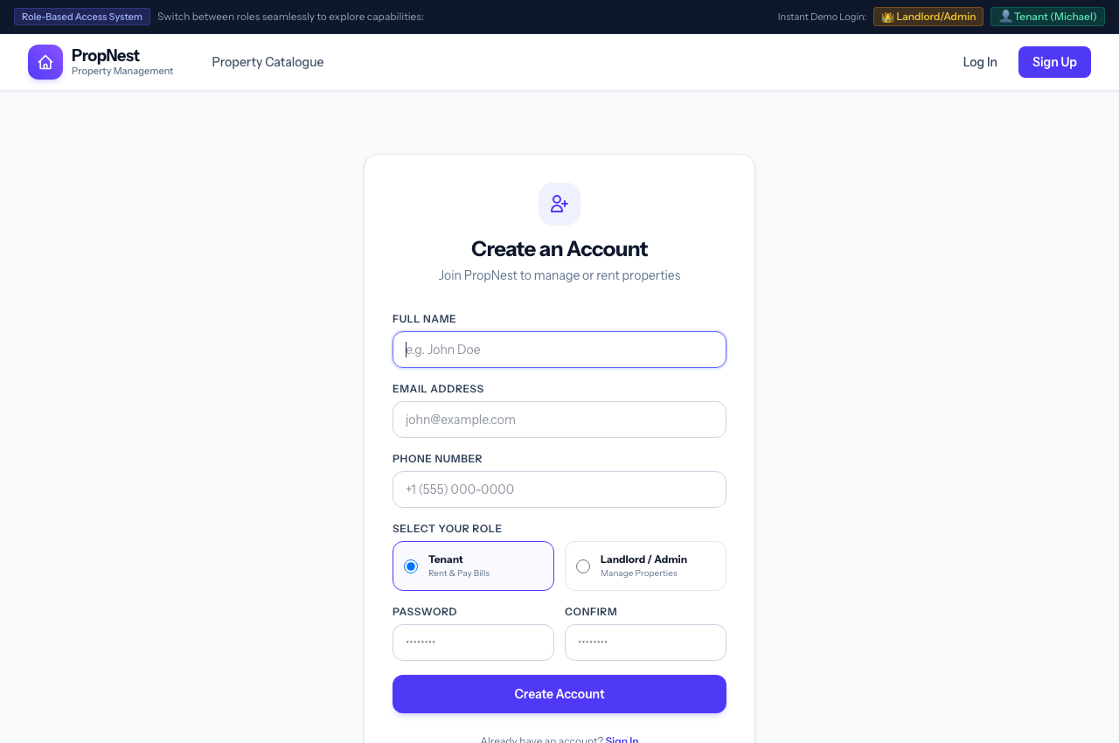
Figure: User Registration Screen
_________________________________________________________________________________

Process 2: Secure Login & Instant Role Switcher
- Actor: All Users & Auditors
- Route: [/login](file:///Users/mobolaji/Herd/propertysystem/routes/web.php#L27) (GET, POST)
- Controller: [AuthController@showLogin](file:///Users/mobolaji/Herd/propertysystem/app/Http/Controllers/AuthController.php#L14)
Standard email/password credential verification with session regeneration to defend against session fixation attacks. For testing and demonstration purposes, 1-click demo login buttons are provided on both the login screen and global navbar to effortlessly switch between Landlord (Alexander Vance) and Tenant (Michael Chen) contexts.
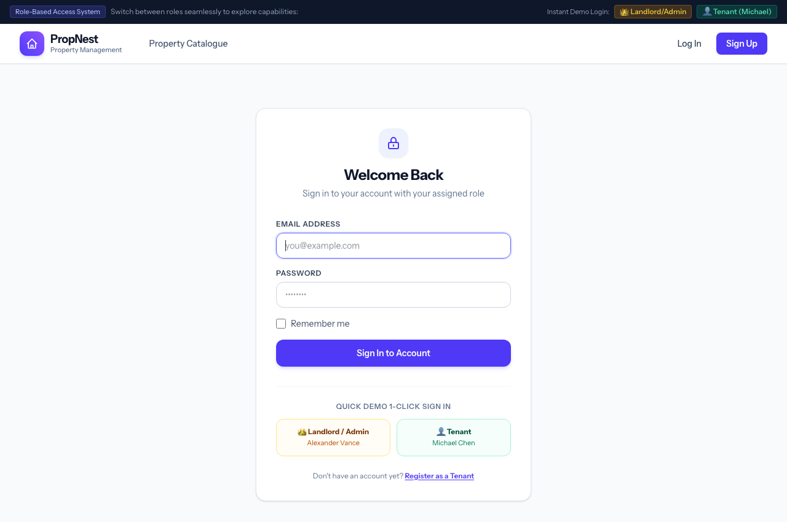
Figure: Secure Login Screen
_________________________________________________________________________________

Component II: User-Friendly and Responsive Interface
The user interface is crafted using Tailwind CSS v4 and modern typography (Instrument Sans). The interface automatically adapts between high-resolution desktop viewports, tablets, and smartphones.
Key interface highlights:
- Top Navigation Bar: Global branding, dynamic context menu tailored to the authenticated role, quick action CTA (+ Add Property for Landlord, Pay Bill / Rent for Tenant), live unread notification badge counter, and user profile avatar.
- Top Demo Switcher Bar: Persistent quick-switching banner allowing pair programmers and evaluators to swap roles without logging out manually.
- Responsive Data Cards: Metric KPIs, property cards with badge indicators, and tabular views that collapse into clean cards on mobile devices.

Process 3: Tenant Dashboard Overview
- Actor: Authenticated Tenant (Michael Chen)
- Route: [/dashboard](file:///Users/mobolaji/Herd/propertysystem/routes/web.php#L38)
- Controller: [DashboardController@index](file:///Users/mobolaji/Herd/propertysystem/app/Http/Controllers/DashboardController.php#L14)
The tenant dashboard displays:
- Active Tenancy Unit: Property hero, address, bedrooms, bathrooms, and monthly rent rate.
- Key Metric Tiles: Active Rent Status, Outstanding Bill Balance, and Open Maintenance Tickets.
- Pending Bill Tracker: Immediate settlement shortcut for rent or utility charges.
- Recent Maintenance Activity: Live status of reported issues.
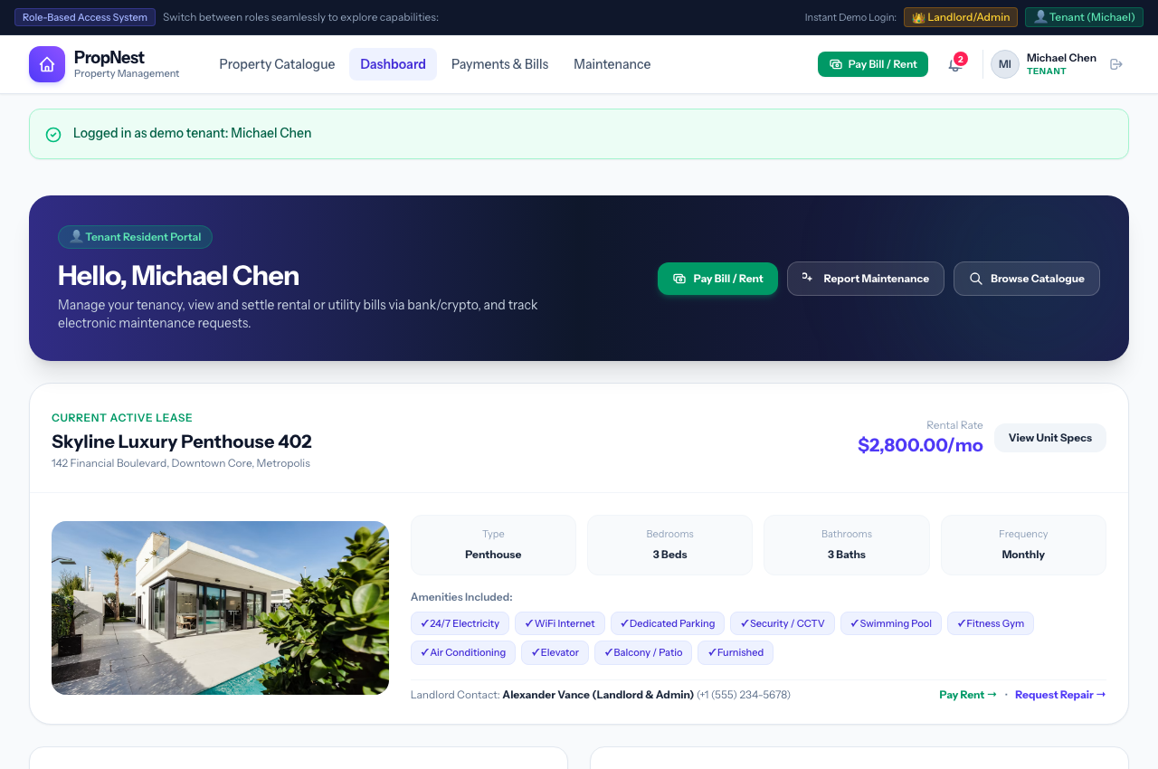
Figure: Tenant Dashboard
_________________________________________________________________________________

Process 4: Landlord Administrative Dashboard
- Actor: Authenticated Landlord / Admin (Alexander Vance)
- Route: [/dashboard](file:///Users/mobolaji/Herd/propertysystem/routes/web.php#L38)
- Controller: [DashboardController@index](file:///Users/mobolaji/Herd/propertysystem/app/Http/Controllers/DashboardController.php#L14)
The landlord administrative center provides full managerial command:
- Executive Portfolio KPIs: Total Units Managed, Active Occupancy Rate, Total Revenue Collected, and Pending Payment Verification Volume.
- Payment Auditing Alert Queue: Direct action buttons to review tenant payment slips.
- Open Work Order Triage: Maintenance requests requiring technician dispatch.
- Property Portfolio Health Table: Breakdown of rented vs available units with assigned tenant names.
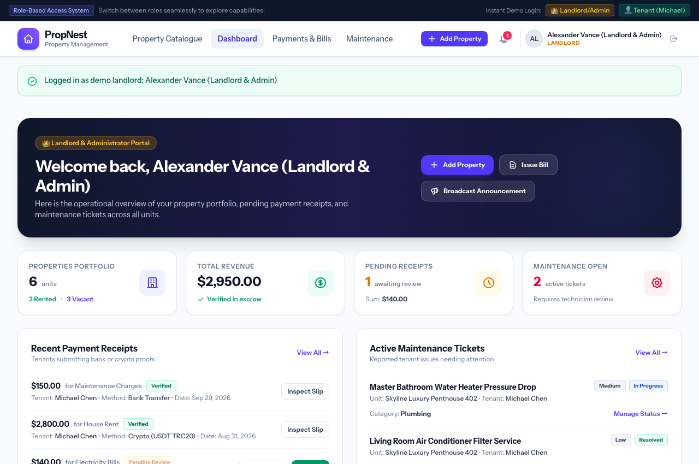
Figure: Landlord Dashboard
_________________________________________________________________________________

Component III: Property Catalogue and Management

Process 5: Multi-Criteria Property Catalogue
- Actor: Public Visitors, Prospective Tenants, and Current Residents
- Route: [/catalogue](file:///Users/mobolaji/Herd/propertysystem/routes/web.php#L23)
- Controller: [PropertyController@index](file:///Users/mobolaji/Herd/propertysystem/app/Http/Controllers/PropertyController.php#L15)
The catalogue lets users explore all listed properties in the portfolio with interactive real-time filters:
- Search Keyword: Property title, city, or street address.
- Property Type: Apartment, Penthouse, Duplex, Villa, Studio, Commercial.
- Pricing & Space: Maximum monthly budget slider, minimum bedrooms, minimum bathrooms.
- Facility Checkboxes: 24/7 Electricity, WiFi Internet, Dedicated Parking, CCTV, Swimming Pool, Gym.
- Unit Availability Badges: Available for Rent vs Occupied / Rented.
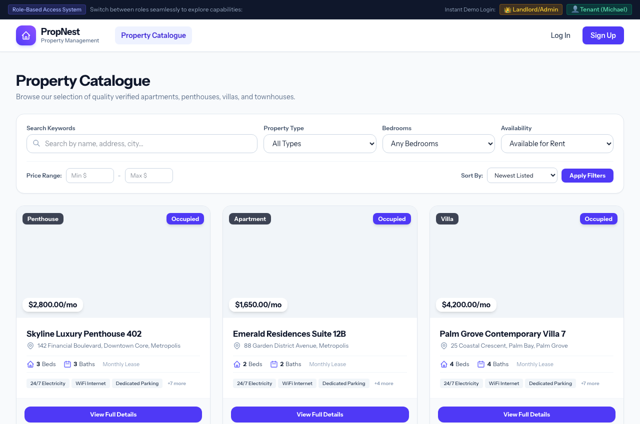
Figure: Property Catalogue
_________________________________________________________________________________

Process 6: Property Specification & Showcase
- Actor: Residents & Visitors
- Route: [/properties/{id}](file:///Users/mobolaji/Herd/propertysystem/routes/web.php#L87)
- Controller: [PropertyController@show](file:///Users/mobolaji/Herd/propertysystem/app/Http/Controllers/PropertyController.php#L90)
A comprehensive listing showcase containing:
- High-resolution visual gallery and unit overview.
- Monthly rent pricing, security deposit terms, and frequency.
- Exact bedroom and bathroom specifications.
- Curated amenities grid with icon badges.
- Integrated Landlord contact details and Tenancy Manager interface (for administrators).
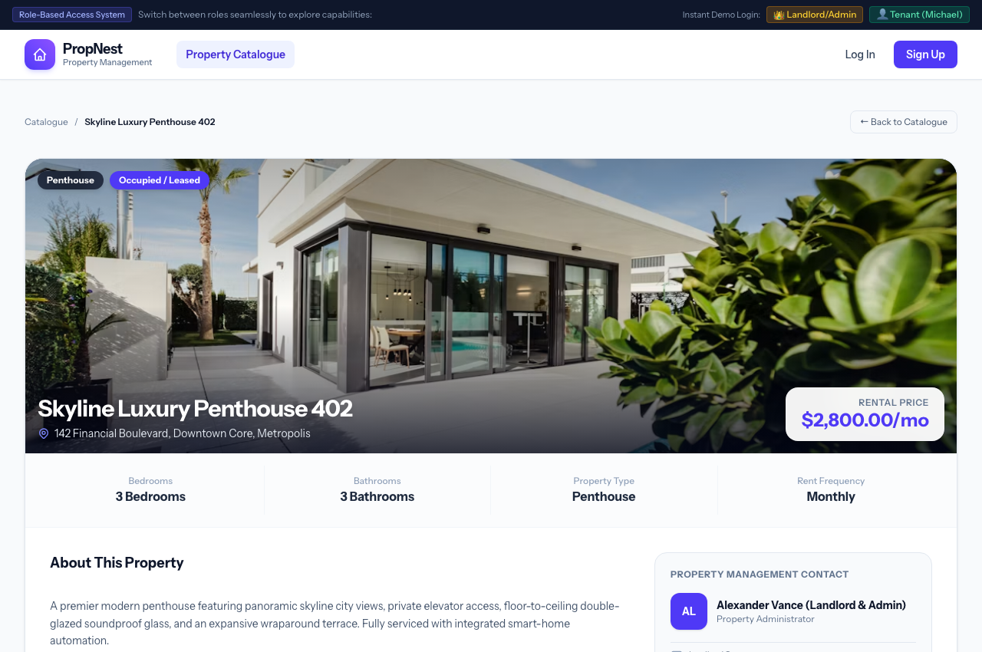
Figure: Property Details View
_________________________________________________________________________________

Process 7: Landlord Property Listing Creation
- Actor: Landlord / Administrator
- Route: [/admin/properties/create](file:///Users/mobolaji/Herd/propertysystem/routes/web.php#L65)
- Controller: [PropertyController@create](file:///Users/mobolaji/Herd/propertysystem/app/Http/Controllers/PropertyController.php#L45)
Landlords can publish new rental properties with comprehensive metadata:
- Title, street address, city, and property classification.
- Bedrooms, bathrooms, rental price ($ USD), and payment cycle (monthly/quarterly/annually).
- Featured photo URL or file upload.
- Interactive facility checkboxes (Power, WiFi, Parking, Pool, AC, Security, etc.).
- Optional initial tenant assignment from registered tenant accounts.
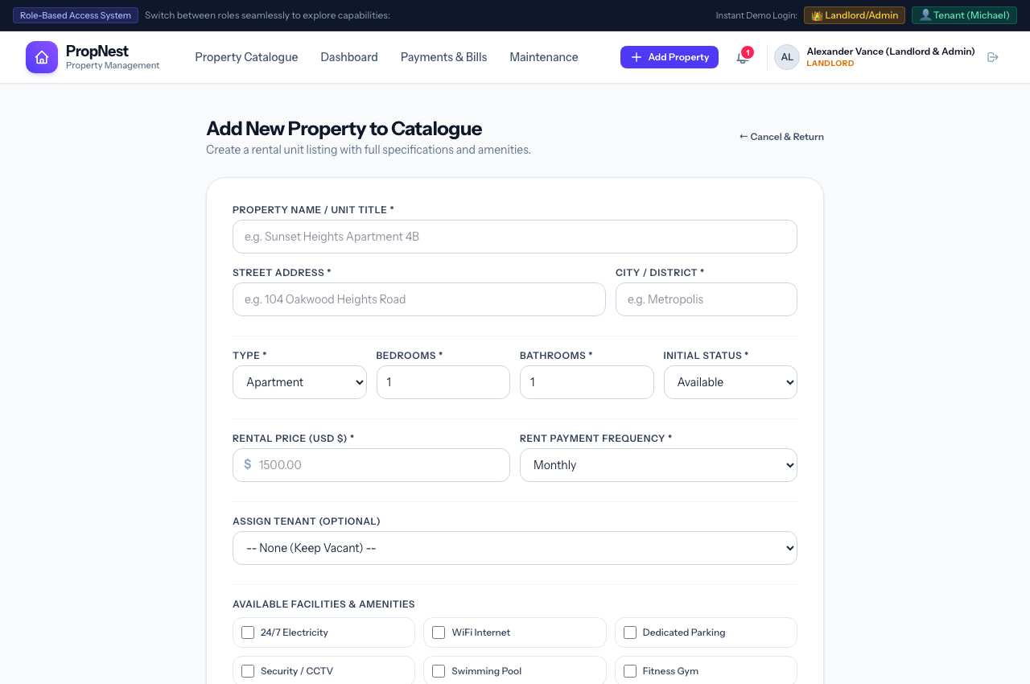
Figure: Add Property Form
_________________________________________________________________________________

Component IV: Rent and Payment Management
PropNest provides a payment management system featuring both conventional banking channels and modern cryptocurrency escrow options.

Process 8: Tenant Payment Center & Settlement Channels
- Actor: Authenticated Tenant
- Route: [/payments](file:///Users/mobolaji/Herd/propertysystem/routes/web.php#L50)
- Controller: [PaymentController@index](file:///Users/mobolaji/Herd/propertysystem/app/Http/Controllers/PaymentController.php#L17)
The Payment Center equips tenants with verified payment options:
- Bank Wire & Electronic Transfer: Beneficiary Bank, Escrow Account Title, Account Number with 1-click clipboard copy, and SWIFT/Routing info.
- Cryptocurrency Payment Facility:
- Tether (USDT TRC-20): Tron Network wallet address with copy button.
- Bitcoin (BTC): Native SegWit wallet address.
- Ethereum (ETH / USDT ERC-20): ERC-20 smart contract destination.
- Outstanding Invoices List: Itemized pending bills with Pay Now buttons.
- Historical Payment Ledger: Status tags (Pending Verification, Verified & Approved, Rejected).
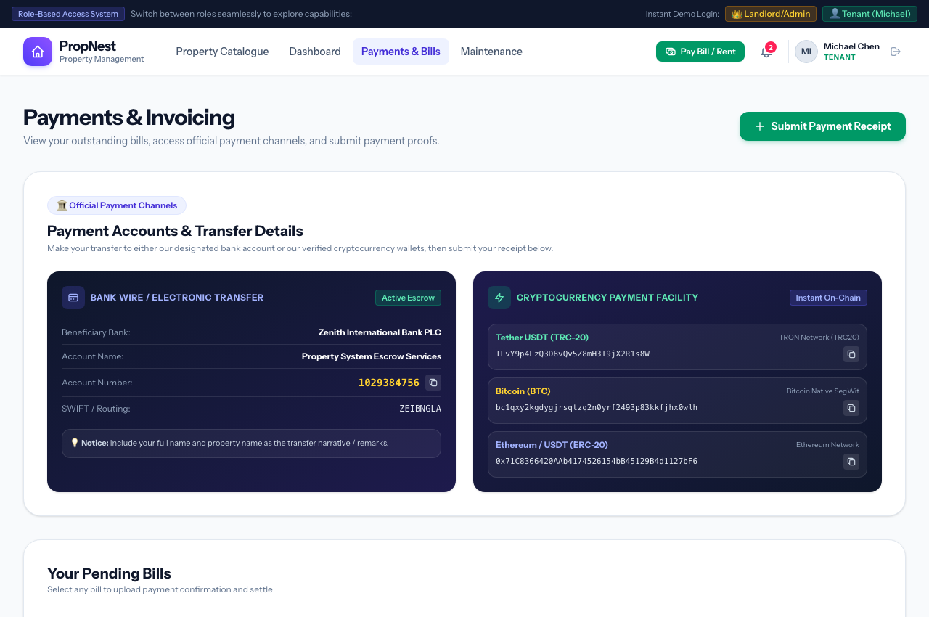
Figure: Tenant Payment Center
_________________________________________________________________________________

Process 9: Payment Receipt & Proof Submission
- Actor: Authenticated Tenant
- Route: [/payments/create](file:///Users/mobolaji/Herd/propertysystem/routes/web.php#L51)
- Controller: [PaymentController@create](file:///Users/mobolaji/Herd/propertysystem/app/Http/Controllers/PaymentController.php#L34)
When submitting proof of payment:
- Linked Bill: Tenant selects the invoice being settled (House Rent, Electricity, or Maintenance).
- Payment Method: Bank Transfer, Cryptocurrency (USDT/BTC/ETH), Debit Card, or Cash Deposit.
- Amount Paid & Transaction Reference / On-Chain TX Hash: Allows instant audit cross-referencing.
- Receipt File Upload: Upload bank slip or block explorer screenshot (PNG, JPG, PDF).
- Optional Remarks: Additional notes for the landlord audit ledger.
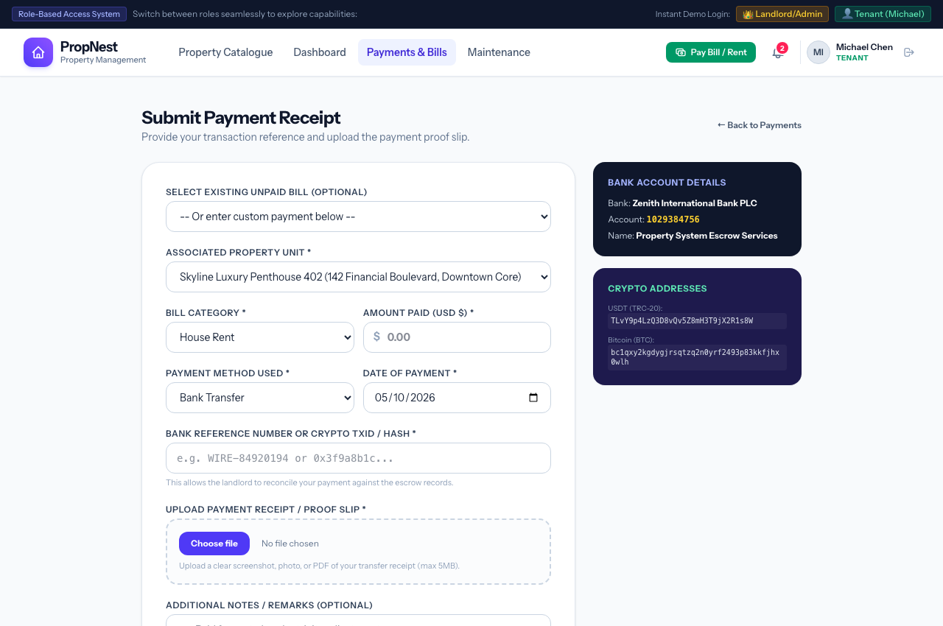
Figure: Submit Payment Receipt Form
_________________________________________________________________________________

Process 10: Official Printable Receipt Slip
- Actor: Tenant & Landlord
- Route: [/payments/{id}](file:///Users/mobolaji/Herd/propertysystem/routes/web.php#L53)
- Controller: [PaymentController@show](file:///Users/mobolaji/Herd/propertysystem/app/Http/Controllers/PaymentController.php#L72)
Upon verification, the system issues an official, verifiable digital payment receipt featuring:
- Unique Receipt Serial Number (#PN-000001).
- Verification Stamp (✓ Verified & Approved).
- Amount Settled, Payment Channel, and Settlement Timestamp.
- Resident & Unit Particulars.
- Transaction Reference / On-chain Hash and Landlord Audit Remarks.
- Browser-native Print / Save Receipt action.
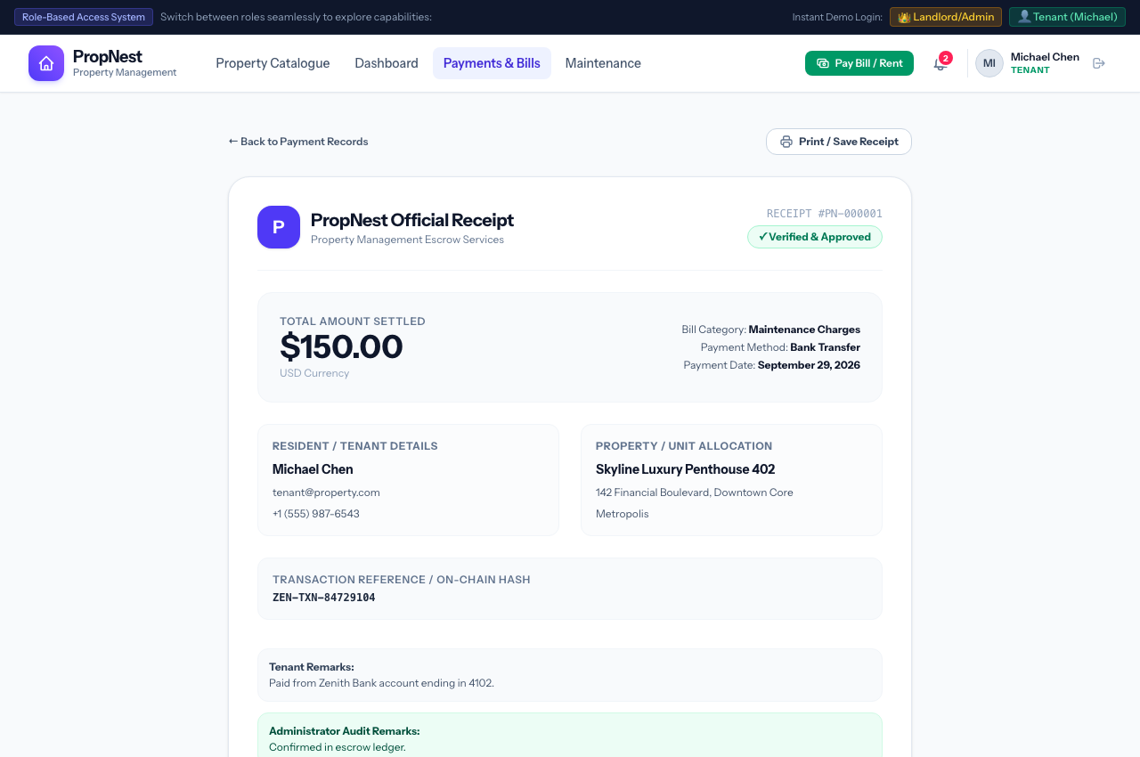
Figure: Printable Receipt Slip
_________________________________________________________________________________

Process 11: Landlord Invoicing Ledger & Audit Approval
- Actor: Landlord / Administrator
- Route: [/payments](file:///Users/mobolaji/Herd/propertysystem/routes/web.php#L50)
- Controller: [PaymentController@index](file:///Users/mobolaji/Herd/propertysystem/app/Http/Controllers/PaymentController.php#L17)
The Landlord Payment Management view features:
- Total Cash Inflow Metrics: Total Approved Funds, Pending Verification Queue, and Active Unsettled Invoices.
- Audit Action Panel: Submitted tenant slips can be reviewed with 1-click Verify & Approve or Reject actions.
- Bill Issuance CTA: Direct shortcut to create new rental or utility invoices.
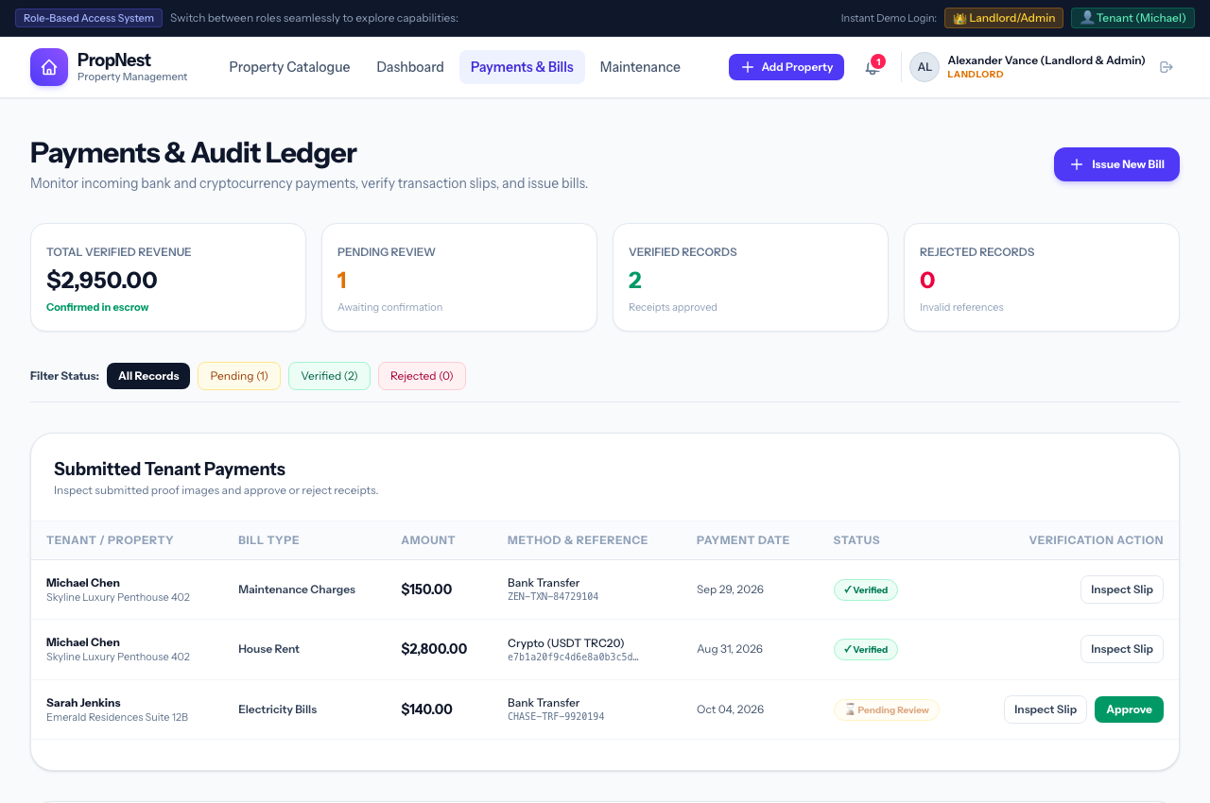
Figure: Landlord Payment Ledger
_________________________________________________________________________________

Process 12: Landlord Direct Bill Issuance
- Actor: Landlord / Administrator
- Route: [/admin/bills/create](file:///Users/mobolaji/Herd/propertysystem/routes/web.php#L73)
- Controller: [PaymentController@createBill](file:///Users/mobolaji/Herd/propertysystem/app/Http/Controllers/PaymentController.php#L130)
Landlords issue invoices to tenants by defining:
- Target property and automatically resolved tenant.
- Bill Category: House Rent, Electricity Bill, Maintenance Charges, or Water Utility.
- Invoice Amount ($ USD) and Due Date.
- Description and custom billing narrative.
- Upon submission, the tenant instantly receives a high-priority system notification.
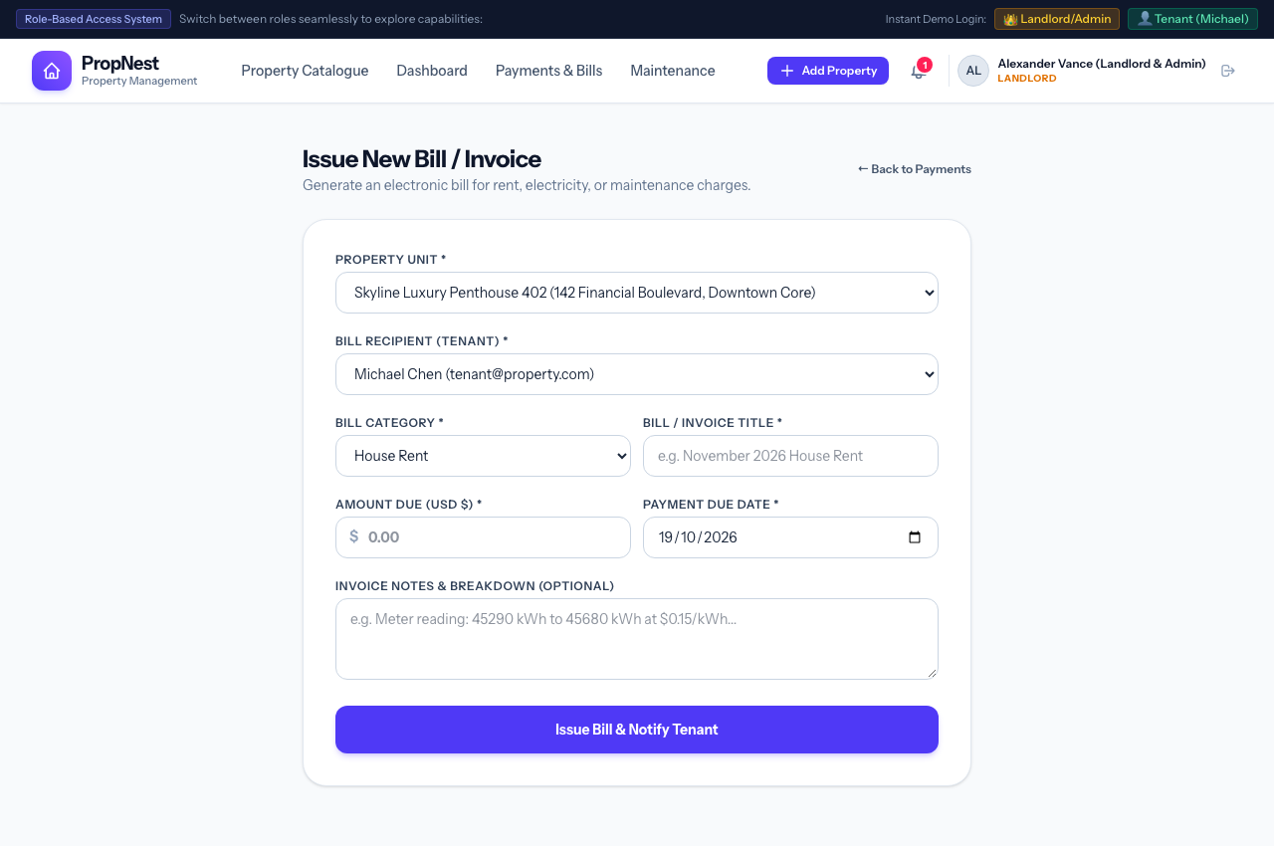
Figure: Issue New Bill Form
_________________________________________________________________________________

Component V: Maintenance and Notification Management

Process 13: Tenant Maintenance Request Submission
- Actor: Authenticated Tenant
- Route: [/maintenance/create](file:///Users/mobolaji/Herd/propertysystem/routes/web.php#L57)
- Controller: [MaintenanceController@create](file:///Users/mobolaji/Herd/propertysystem/app/Http/Controllers/MaintenanceController.php#L31)
Tenants report maintenance issues through a dedicated form:
- Category: Plumbing, Electrical, HVAC / Air Conditioning, Structural, Appliance, Pest Control, or Security.
- Urgency Level: Low, Medium, High, or Urgent Emergency.
- Issue Title & Narrative: Detailed description of the defect.
- Defect Photo Upload: Evidence photo attached directly to the work order.
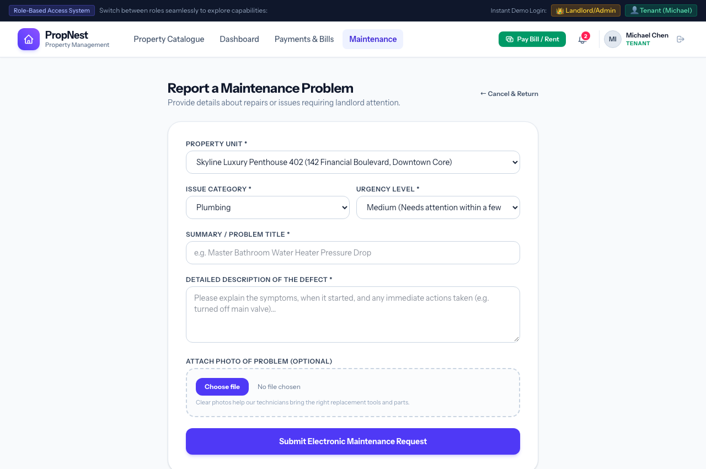
Figure: Submit Maintenance Request
_________________________________________________________________________________

Process 14: Maintenance Ticket Progress Timeline Tracker
- Actor: Tenant & Landlord
- Route: [/maintenance/{id}](file:///Users/mobolaji/Herd/propertysystem/routes/web.php#L59)
- Controller: [MaintenanceController@show](file:///Users/mobolaji/Herd/propertysystem/app/Http/Controllers/MaintenanceController.php#L68)
Both parties can monitor ticket progress with a visual step-by-step lifecycle bar:
- Submitted: Defect logged by resident with timestamp.
- Technician Dispatched / In Progress: Contractor or repair team assigned.
- Resolved: Work confirmed complete with resolution notes.
The view displays the reported description, attached defect photo, technician schedule, and landlord administrative status controls.
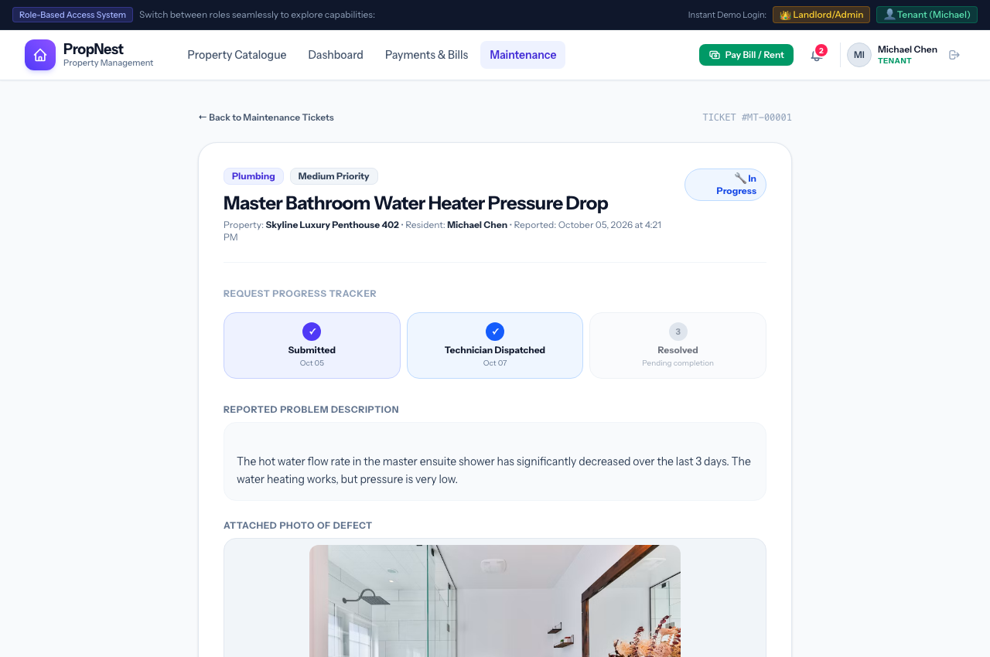
Figure: Maintenance Ticket Timeline
_________________________________________________________________________________

Process 15: Landlord Maintenance Work Order Queue
- Actor: Landlord / Administrator
- Route: [/maintenance](file:///Users/mobolaji/Herd/propertysystem/routes/web.php#L56)
- Controller: [MaintenanceController@index](file:///Users/mobolaji/Herd/propertysystem/app/Http/Controllers/MaintenanceController.php#L16)
The Landlord Maintenance console centralizes incoming requests across the entire portfolio:
- Filter tickets by status (Pending, In Progress, Resolved, Cancelled).
- View urgency badges, unit numbers, resident names, and elapsed response times.
- Update ticket state or dispatch repair contractors with a single click.
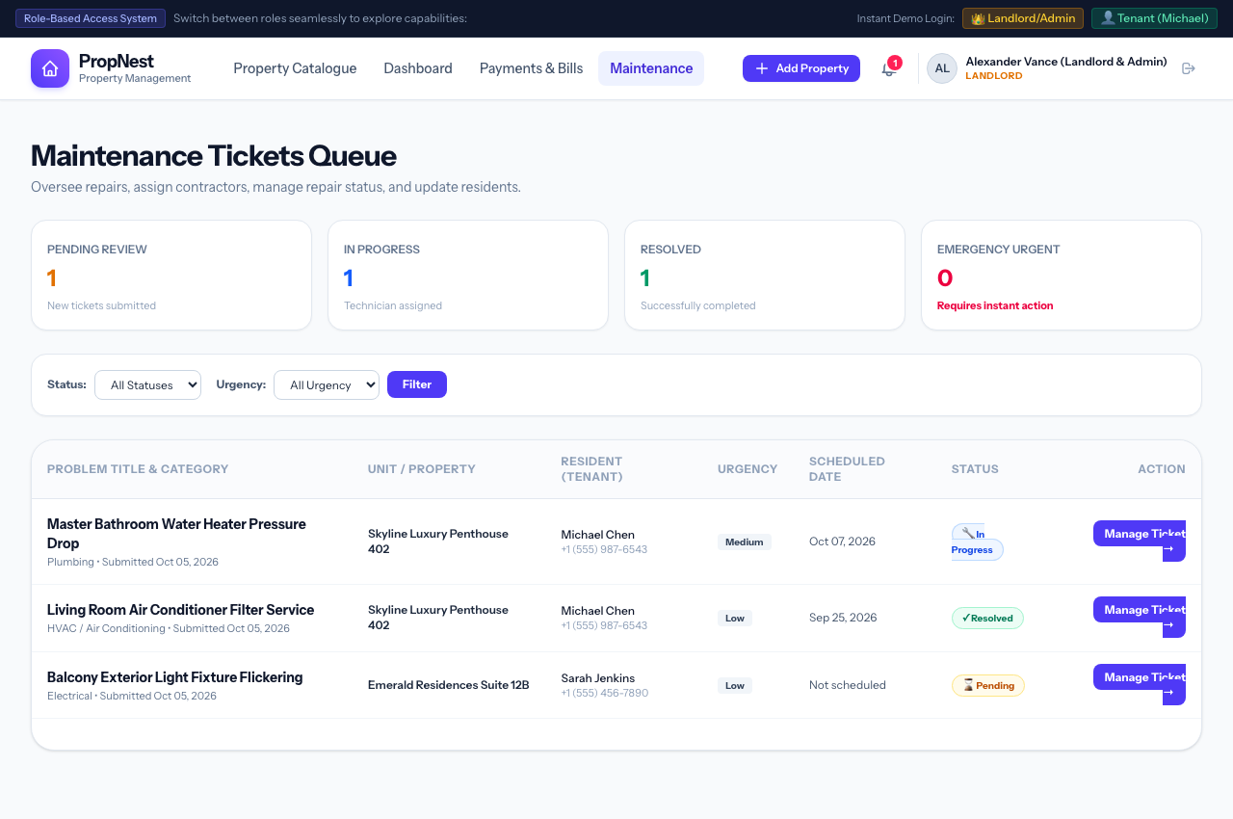
Figure: Landlord Maintenance Queue
_________________________________________________________________________________

Process 16: System Notifications & Alert Feed
- Actor: All Authenticated Users
- Route: [/notifications](file:///Users/mobolaji/Herd/propertysystem/routes/web.php#L45)
- Controller: [NotificationController@index](file:///Users/mobolaji/Herd/propertysystem/app/Http/Controllers/NotificationController.php#L14)
A centralized notifications center:
- Color-coded category tags (Payment Alert, Maintenance Update, General Announcement).
- Direct action links (e.g. View Receipt, View Work Order).
- 1-click Mark as Read and Mark All as Read buttons.
- Real-time sync with top navbar pill badge counter.
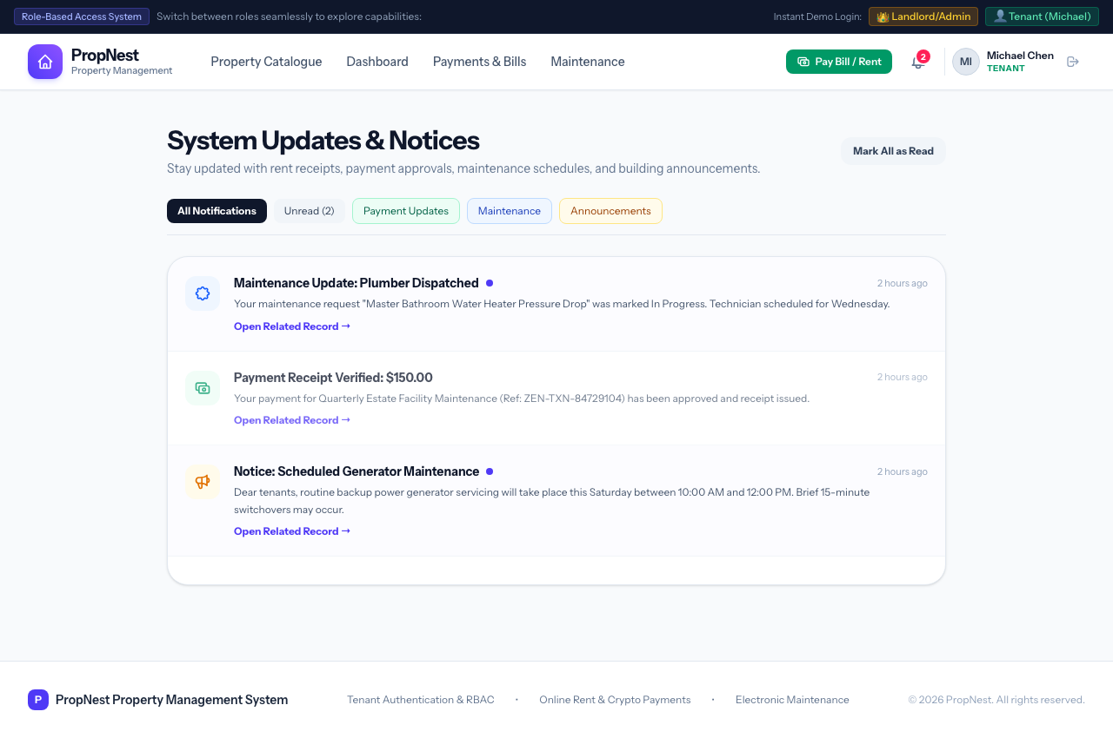
Figure: System Notifications Feed
_________________________________________________________________________________

Process 17: Landlord Portfolio Broadcast Announcement
- Actor: Landlord / Administrator
- Route: [/admin/announcements/create](file:///Users/mobolaji/Herd/propertysystem/routes/web.php#L82)
- Controller: [NotificationController@createAnnouncement](file:///Users/mobolaji/Herd/propertysystem/app/Http/Controllers/NotificationController.php#L42)
Landlords can broadcast building-wide notifications (e.g., generator maintenance, water supply schedules, seasonal notices):
- Select target: Broadcast to all tenants or residents of a specific building.
- Custom Title, Priority Level, and Announcement Message.
- On submission, the system dispatches notifications to all selected residents.
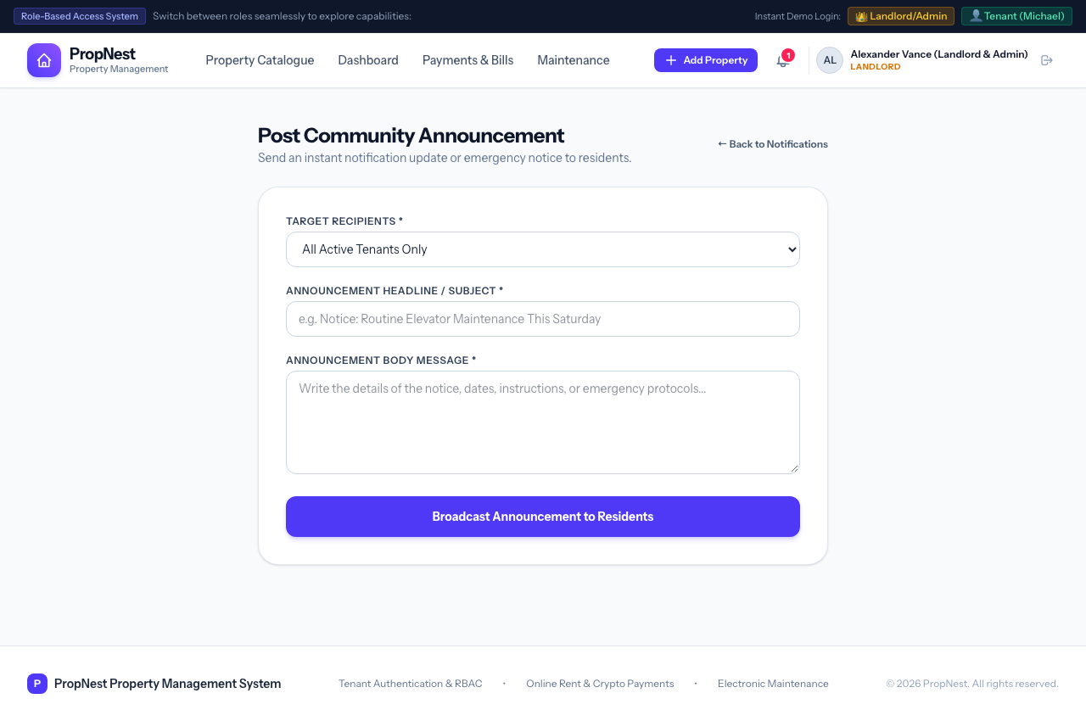
Figure: Create Portfolio Announcement
_________________________________________________________________________________

Technical Verification Summary
Suite / Test Case | File | Status
Authentication & RBAC Tests | [tests/Feature/AuthTest.php](file:///Users/mobolaji/Herd/propertysystem/tests/Feature/AuthTest.php) | PASS (7 assertions)
Property Catalogue & Management | [tests/Feature/PropertyTest.php](file:///Users/mobolaji/Herd/propertysystem/tests/Feature/PropertyTest.php) | PASS (18 assertions)
Billing & Payments Management | [tests/Feature/PaymentTest.php](file:///Users/mobolaji/Herd/propertysystem/tests/Feature/PaymentTest.php) | PASS (24 assertions)
Maintenance & Notification Dispatch | [tests/Feature/MaintenanceTest.php](file:///Users/mobolaji/Herd/propertysystem/tests/Feature/MaintenanceTest.php) | PASS (26 assertions)
Visual Capture Execution | [capture_all.js](file:///Users/mobolaji/Herd/propertysystem/capture_all.js) | 17/17 Screenshots Verified

_________________________________________________________________________________
*Report generated for PropNest Property Management System.*

