Week-6

6. Design a simple user login system using Node js.

>mkdir nodedemo

>cd nodedemo

nodedemo>npm init // click enter till you get yes option then type **yes**

Is this ok? (yes)

nodedemo>code . // we redirected to **vs code**

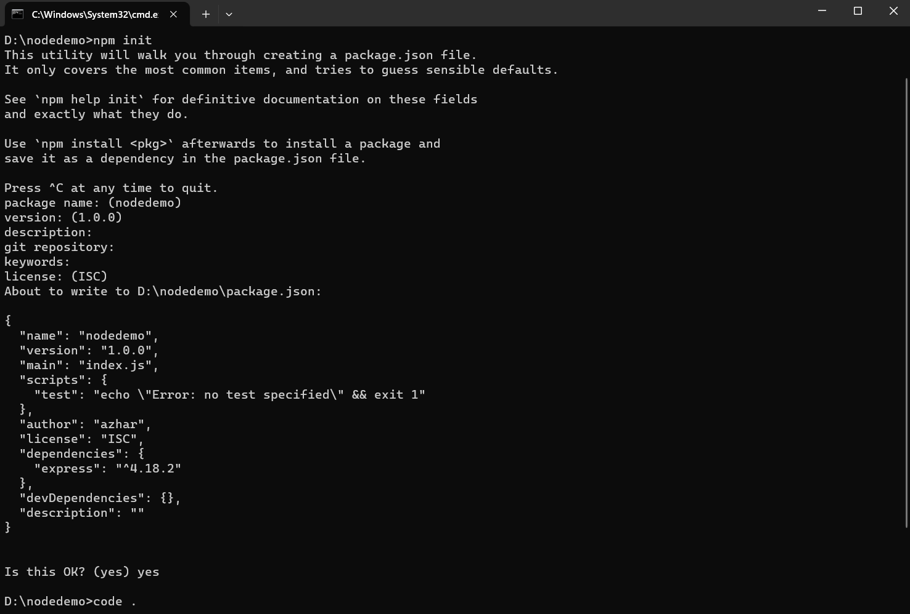

1. **Package.json**

{

"name": "nodedemo",

"version": "1.0.0",

"description": "",

"main": "index.js",

"scripts": {

"test": "echo \"Error: no test specified\" && exit 1"

},

"author": "Dhanu",

"license": "ISC",

"dependencies": {

"express": "^4.18.2"

}

}

1. **Index.js**

const express = require('express'); //Import the express dependency

const app = express(); //Instantiate an express app, the main work horse of this server

const port = 5000; //Save the port number where your server will be listening

//Idiomatic expression in express to route and respond to a client request

app.get('/', (req, res) => { //get requests to the root ("/") will route here

res.sendFile('index.html', {root: __dirname}); //server responds by sending the index.html file to the client's browser

//the .sendFile method needs the absolute path to the file, see: //https://expressjs.com/en/4x/api.html#res.sendFile

});

app.get('/pfolio.html', (req, res) => { //get requests to the root ("/") will route here

res.sendFile('pfolio.html', {root: __dirname}); //server responds by sending the index.html file to the client's browser

//the .sendFile method needs the absolute path to the file, see: https://expressjs.com/en/4x/api.html#res.sendFile

});

app.listen(port, () => { //server starts listening for any attempts from a client to connect at port: {port}

console.log(`Now listening on port ${port}`);

});

1. **Index.html**

**<!DOCTYPE html>**

**<html>**

**<head>**

**<meta name="viewport" content="width=device-width, initial-scale=1">**

**<title> Login Page </title>**

**<style>**

**Body {**

**font-family: Calibri, Helvetica, sans-serif;**

**background-color: pink;**

**}**

**button {**

**background-color: #4CAF50;**

**width: 100%;**

**color: orange;**

**padding: 15px;**

**margin: 10px 0px;**

**border: none;**

**cursor: pointer;**

**}**

**form {**

**border: 3px solid #f1f1f1;**

**}**

**input[type=text], input[type=password] {**

**width: 100%;**

**margin: 8px 0;**

**padding: 12px 20px;**

**display: inline-block;**

**border: 2px solid green;**

**box-sizing: border-box;**

**}**

**button:hover {**

**opacity: 0.7;**

**}**

**.cancelbtn {**

**width: auto;**

**padding: 10px 18px;**

**margin: 10px 5px;**

**}**

**.container {**

**padding: 25px;**

**background-color: lightblue;**

**}**

**</style>**

**</head>**

**<body>**

**<center> <h1> User Login Form </h1> </center>**

**<form action="pfolio.html" method="get">**

**<div class="container">**

**<label>Username : </label>**

**<input type="text" placeholder="Enter Username" name="username" required>**

**<label>Password : </label>**

**<input type="password" placeholder="Enter Password" name="password" required>**

**<input type="submit" />**

**<input type="checkbox" checked="checked"> Remember me**

**</div>**

**</form>**

**</body>**

**</html>**

1. **Pfolio.html**

**<html>**

**<body>**

**<h1>Welcome</h1>**

**</body>**

**</html>**

**Open the terminal in VS code //close the normal terminal**

**>npm i –s express**

**>npm install**

**>node index.js**

**Open the browser and give below url**

**ttp://localhost:5000**

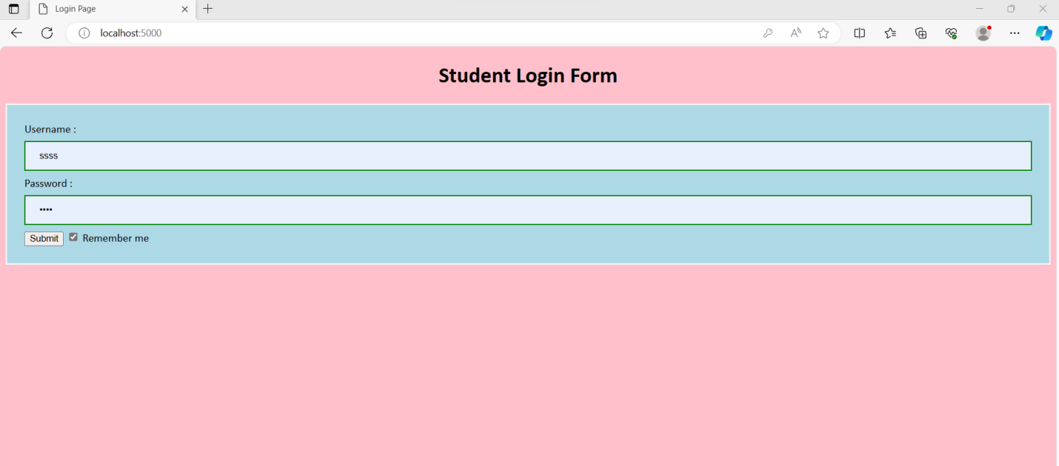

**Click on submit**

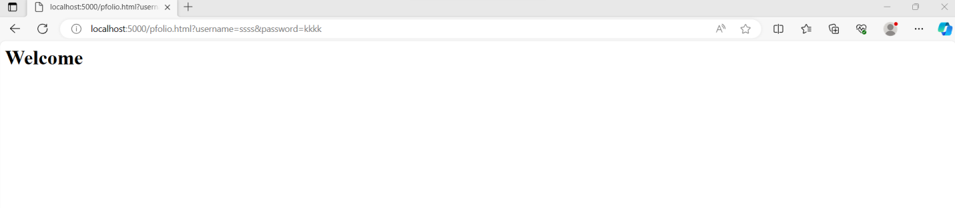

**Week-9**

9. Design a Portfolio App.

mkdir UPortfolio

>cd UPortfolio

UPortfolio >npm init // click enter till you get yes option then type **yes**

Is this ok? (yes)

nodedemo>code . // we redirected to **vs code**

1. **Package.json**

**{**

**"name": "UPortfolio",**

**"version": "1.0.0",**

**"description": "",**

**"main": "index.js",**

**"scripts": {**

**"test": "echo \"Error: no test specified\" && exit 1"**

**},**

**"author": "Dhanu",**

**"license": "ISC",**

**"dependencies": {**

**"express": "^4.18.2"**

**}**

**}**

1. **Index.js**

**const express = require('express'); //Import the express dependency**

**const app = express(); //Instantiate an express app, the main work horse of this server**

**const port = 5000; //Save the port number where your server will be listening**

**//Idiomatic expression in express to route and respond to a client request**

**app.get('/', (req, res) => { //get requests to the root ("/") will route here**

**res.sendFile('index.html', {root: __dirname}); //server responds by sending the index.html file to the client's browser**

**//the .sendFile method needs the absolute path to the file, see: https://expressjs.com/en/4x/api.html#res.sendFile**

**});**

**app.get('/pfolio.html', (req, res) => { //get requests to the root ("/") will route here**

**res.sendFile('pfolio.html', {root: __dirname}); //server responds by sending the index.html file to the client's browser**

**//the .sendFile method needs the absolute path to the file, see: https://expressjs.com/en/4x/api.html#res.sendFile**

**});**

**app.listen(port, () => { //server starts listening for any attempts from a client to connect at port: {port}**

**console.log(`Now listening on port ${port}`);**

**});**

1. **Index.html**

**<!DOCTYPE html>**

**<html>**

**<head>**

**<meta name="viewport" content="width=device-width, initial-scale=1">**

**<title> Login Page </title>**

**<style>**

**Body {**

**font-family: Calibri, Helvetica, sans-serif;**

**background-color: pink;**

**}**

**button {**

**background-color: #4CAF50;**

**width: 100%;**

**color: orange;**

**padding: 15px;**

**margin: 10px 0px;**

**border: none;**

**cursor: pointer;**

**}**

**form {**

**border: 3px solid #f1f1f1;**

**}**

**input[type=text], input[type=password] {**

**width: 100%;**

**margin: 8px 0;**

**padding: 12px 20px;**

**display: inline-block;**

**border: 2px solid green;**

**box-sizing: border-box;**

**}**

**button:hover {**

**opacity: 0.7;**

**}**

**.container {**

**padding: 25px;**

**background-color: lightblue;**

**}**

**</style>**

**</head>**

**<body>**

**<center> <h1> User Login Form </h1> </center>**

**<form action="pfolio.html" method="get">**

**<div class="container">**

**<label>Username : </label>**

**<input type="text" placeholder="Enter Username" name="username" required>**

**<label>Password : </label>**

**<input type="password" placeholder="Enter Password" name="password" required>**

**<input type="submit" />**

**<input type="checkbox" checked="checked"> Remember me**

**</div>**

**</form>**

**</body>**

**</html>**

1. **Pfolio.html**

**<html>**

**<body>**

**<h1>name:</h1><input type="text">**

**<a href="https://www.linkedin.com/in/dhanalaxmi-chinthala-a072a2268/">LinkedIN</a>**

**</body>**

**</html>**

**Open the terminal in VS code //close the normal terminal**

**>npm i –s express**

**>npm install**

**>node index.js**

**Open the browser and give below url**

**ttp://localhost:5000**

