**Week-7**

7. Design Node blog system.

>mkdir NodeBlogSystem

>cd NodeBlogSystem

NodeBlogSystem >npm init // click enter till you get yes option then type **yes**

Is this ok? (yes)

NodeBlogSystem >code . // we redirected to **vs code**

**Index.js**

**const express = require('express');**

**const app = express();**

**const port = 5000;**

**app.get('/', (req, res) => {**

**res.sendFile('/index.html', {root: __dirname});**

**});**

**app.listen(port, () => {**

**console.log(`Now listening on port ${port}`);**

**});**

**Index.html**

**<!DOCTYPE html>**

**<html lang="en">**

**<head>**

**<title>B.Tech Student Blog</title>**

**<style>**

**body {**

**font-family: Arial, sans-serif;**

**margin: 20px;**

**}**

**header {**

**text-align: center;**

**background-color: #f2f2f2;**

**padding: 10px;**

**}**

**article {**

**margin-bottom: 20px;**

**}**

**h2 {**

**color: #333;**

**}**

**p {**

**line-height: 1.6;**

**}**

**.comment-section {**

**margin-top: 20px;**

**border-top: 1px solid #ccc;**

**padding-top: 10px;**

**}**

**</style>**

**</head>**

**<body>**

**<header>**

**<h1>B.Tech Student Blog</h1>**

**</header>**

**<article>**

**<h2>Tips for Surviving Engineering Exams</h2>**

**<p>**

**Being a B.Tech student comes with its own set of challenges, especially during exams.**

**In this article, we'll explore some tips and strategies to survive engineering exams**

**and come out on top.**

**</p>**

**<div class="comment-section">**

**<h3>Comments</h3>**

**<p>No comments yet.</p>**

**</div>**

**</article>**

**<article>**

**<h2>My Internship Experience in Software Engineering</h2>**

**<p>**

**Sharing my journey and key learnings from my recent internship in software engineering.**

**From coding challenges to team collaboration, I'll discuss the insights gained during**

**this valuable experience.**

**</p>**

**<div class="comment-section">**

**<h3>Comments</h3>**

**<ul>**

**<li>Comment 1: Internships are a great way to learn!</li>**

**<li>Comment 2: How did you handle the challenges?</li>**

**</ul>**

**</div>**

**</article>**

**<!-- Add more articles for other B.Tech-related topics as needed -->**

**</body>**

**</html>**

**Open the terminal in VS code //close the normal terminal**

**>npm i –s express**

**>npm install**

**>node index.js**

**Open the browser and give below url**

**http://localhost:5000**

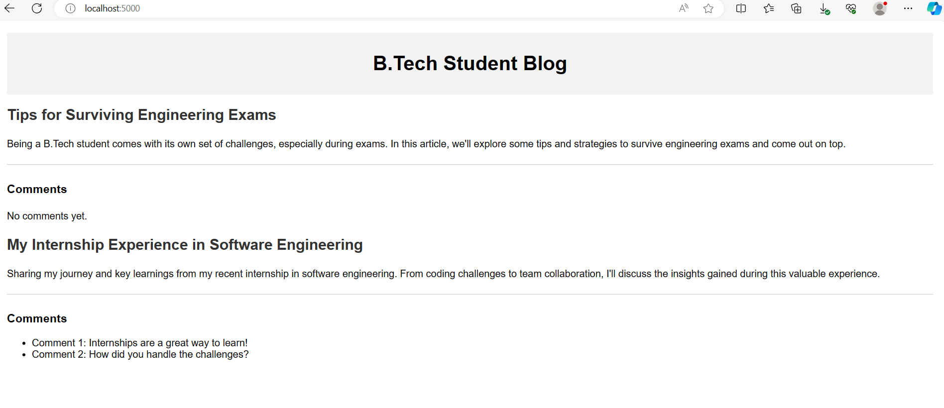

**Week-10**

10. Design Node E learning system.

mkdir NodeBlogSystem

>cd NodeBlogSystem

NodeBlogSystem >npm init // click enter till you get yes option then type **yes**

Is this ok? (yes)

NodeBlogSystem >code . // we redirected to **vs code**

**Index.js**

**const express = require('express');**

**const app = express();**

**const port = 5000;**

**app.get('/', (req, res) => {**

**res.sendFile('/index.html', {root: __dirname});**

**});**

**app.listen(port, () => {**

**console.log(`Now listening on port ${port}`);**

**});**

**Index.html**

**<!DOCTYPE html>**

**<html>**

**<head>**

**<title>Node E-Learning System</title>**

**<style>**

**body {**

**font-family: Arial, sans-serif;**

**margin: 20px;**

**}**

**header {**

**text-align: center;**

**background-color: #3498db;**

**color: #fff;**

**padding: 10px;**

**}**

**#courses {**

**display: flex;**

**flex-wrap: wrap;**

**}**

**.course {**

**border: 1px solid #ddd;**

**border-radius: 8px;**

**margin: 10px;**

**padding: 15px;**

**width: 300px;**

**}**

**.course img {**

**max-width: 100%;**

**height: auto;**

**}**

**.enroll-btn {**

**background-color: #3498db;**

**color: #fff;**

**border: none;**

**padding: 8px 16px;**

**text-align: center;**

**text-decoration: none;**

**display: inline-block;**

**font-size: 14px;**

**margin: 4px 2px;**

**cursor: pointer;**

**border-radius: 4px;**

**}**

**</style>**

**</head>**

**<body>**

**<header>**

**<h1>Node E-Learning System</h1>**

**</header>**

**<div id="courses">**

**<div class="course">**

**<img src="D:\NodeELearning\Node.jpg" alt="Course 1">**

**<h3>Introduction to Node.js</h3>**

**<p>This course covers the basics of Node.js and asynchronous JavaScript programming.</p>**

**<button class="enroll-btn" onclick="enroll('Introduction to Node.js')">Enroll Now</button>**

**</div>**

**<div class="course">**

**<img src="D:\NodeELearning\express-js.jpg" alt="Course 2">**

**<h3>Building Web Applications with Express.js</h3>**

**<p>Learn how to create web applications using the Express.js framework in Node.js.</p>**

**<button class="enroll-btn" onclick="enroll('Building Web Applications with Express.js')">Enroll Now</button>**

**</div>**

**<!-- Add more courses as needed -->**

**</div>**

**<script>**

**function enroll(courseName) {**

**alert('Enrolled in ' + courseName);**

**// In a real system, you would typically send a request to the server to handle enrollment.**

**// This example uses an alert for simplicity.**

**}**

**</script>**

**</body>**

**</html>**

**Open the terminal in VS code //close the normal terminal**

**>npm i –s express**

**>npm install**

**>node index.js**

**Open the browser and give below url**

**http://localhost:5000**

