**Structure**

**Introduction**

Start with the … the new regualtion

Current state of higher education supported with numbers – already big differences. How many unis in Bp how many anywhere else. Polarized country. Why it’s important to diversify the unis in a country.

The new regulation that will take in place in the future giving an entry requirement that effecting the already disadvantaged young population in the country.

**Research question (or hypothesis)**

Would the new mandatory foreign language exam governmental proposal more significalty effect certain areas in Hungary’s then others?

**Literature review**

To measure the young population’s foreign language capabilities, I look at the the highschool final exam data.. what is that, blablabla

Nyelvtudas minek kell hogy mernok legyel …

Diversity of though importance

Diversity of socioeconomic background

Why bad to discriminate on type of population

Midlevel, higher-level, how it differs and what can we do the make it to the same scale.

Moran’s I and Location Quotient

**Methodology - 1500**

Highschool data

Foreign Language Proficiency Score calculation

Study area: Hungary LAU 1

Flowchart

**Results (including descriptive statistics and further analysis)**

Moran’s I Global - Local

Location Quotient

**Discussion (including specific recommendations)**

Referenced literature  
Not the extensions the of the Results!   
Why it’s important  
Is there other solution by other countries to this  
Provide a solution + other examples

Bring poverty in ( 104010-BRI-PUBLIC-ADD-SERIES-Poverty-in-Europe-DOI-10-1596-K8683.pdf)

**Conclusion**

**Analysis of the impact of the foreign language exam entry requirement of Hungarian universities**

**Introduction**

This essay aim to discover the level of foreign language education on high school level across Hungary to understand the potential impact of the recently proposed governmental measure that would introduce a universal foreign language certificate precondition to enter higher education. This proposal aims to create an additional minimum entry requirement, where student applying to universities would have to obtain a certificate of a foreign language prior to applying university regardless of the course they applying to.

*Current state of higher education supported with numbers*

*Already big differences. How many unis in Bp how many anywhere else. Centralised country.*

**Research question (or hypothesis)**

Would the new mandatory foreign language certificate governmental proposal more significantly effect rural/ less developed areas in Hungary’s then others?

**Literature review**

*Foreign language learning in Hungary – bit of history*

*Diversity of Thoughts*

* <file:///C:/Users/botiv/Zotero/storage/WS9SL843/676150.html>
* Wößmann - 2008 - Efficiency and equity of European education and tr.pdf
* <https://www.sciencedirect.com/science/article/pii/S0272494405000575>

*Importance of available higher-level education*

*Need of indicator*

To observe the effect of the new regulation proposal, a foreign language proficiency level indicator is required to apply to an area. To calculate such indicator, the publicly available high school final exam data were used. In Hungary, every high school student required to take final exams from multiple subjects to finalise their studies (REFI). These subjects are the following:

1. Hungarian Language and Grammar
2. History
3. Mathematics
4. One chosen Foreign Language
5. Additional optional subject selectable from a large variety

All these exams above have two difficulty variations: a midlevel and an advanced level option. The result of these exams will be directly converted to university entry scores. Therefore, every high school student who wish to continue their studies on an advanced level required to take a foreign language test. This test gives a good measurement of the level of foreign language proficiency among young people finishing high school.

Moran’s I and Location Quotient to measure equality, disparity – GINI index??

**Methodology**

1. Highschool data

Information on every high schools and final exam data available on the website of Hungarian Education Ministry (oktatas.hu). A web scraper has been written to obtain all the necessary information of Hungarian high schools. The gathered and cleaned data includes all every foreign language exam (number) taken the spring of 2020 by (number) student in (number) educational institutions.

2. Foreign Language Proficiency Score calculation

After gathering every foreign language final exam result by high schools, to create a unified language proficiency score the mid-, and advanced level tests scores need to be converted to the same scale. The conversion made based on the official higher education entry score system’s calculations. According to that every advanced level exam above 45% awarded with 50 additional points*. For example:* *where a high school’s advanced English language average reached 30% no transformation will obtain, but if the average is 65% an additional 50 point will be added to the score, that gives 115* (<https://qips.ucas.com/qip/hungary-erettsegi-bizonyitvany>)

Therefore, the formula for creating a specific foreign language proficiency score of a spatial unit will be the following:

3. Study area: Hungary LAU 1

In analysis, the lowest level of territorial and organisational units of the public administration used, defined be the Hungarian government decree 86/2019 (IV.23) (REFI). There are 197 districts included 23 of these are the districts of the capital, Budapest. The shape file was provided by GDAM. X number of districts doesn’t have currently operating highschool. These spatial unites will be not used in the calculation as foreign language proficiently score cannot be assigned to them.

[Image]

4. Flowchart

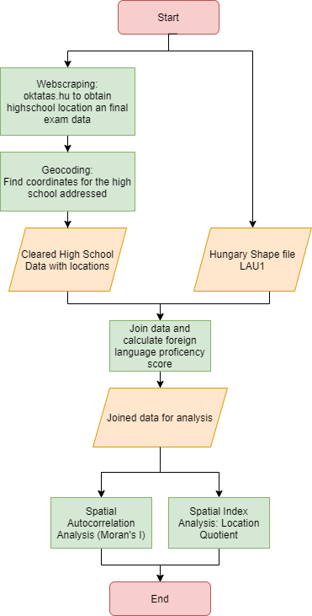

[**https://www.ksh.hu/regionalatlas_districts**](https://www.ksh.hu/regionalatlas_districts)

**Results (including descriptive statistics and further analysis)**

Following the appropriate data transformations and data merges, we can observe how the language proficiency scores distribute in the country. The range of the scores are 0 to 150, the hypothetical highest potential number meaning every student studying in the areas achieved 100% advance level foreign language final exam.

[Map of the scores and the top 3 language scores histograms]

Moran’s I Global - Local

By observing the map above, some level of clustering of high and low language scores can be noticed. To test whether spatial autocorrelation occurs, a Global Moran’s I test were conducted. According to the test below the Moran’s I Index is 0.2 and the small p-value indicates that closer, neighbouring spatial features tend to have similar language proficiency score in Hungary. (ez azt jelenti hogy egyes regiok hatranyosabban erintettek az uj intezkedessel)

[Moran’s I table – or local moran’s I map ?]

Location Quotient

The following analysis aim to measure the relative concentration of the language proficiency score of an area compared to the national average. This way we got a better understanding where the underdeveloped areas are and where the high school language education would need improvement to reach the average national level.

[LQ map]

**Discussion (including specific recommendations)**

Referenced literature  
Not the extensions the of the Results!   
Why it’s important  
Is there other solution by other countries to this  
Provide a solution + other examples

Limitations

Bring poverty in map to compare with LQ( 104010-BRI-PUBLIC-ADD-SERIES-Poverty-in-Europe-DOI-10-1596-K8683.pdf)

**Conclusion**