Intelligent Surveillance System with CNN Algorithm & Machine Learning

ABSTRACT
Over decades, with the advent of new technologies into the market, connectivity between people and resources is increasing in an unprecedented scale. Applications started collecting data and devices started exchanging data between themselves to provide us with a comfortable life. However, it also brought certain concerns along with it. Some of the prime concerns are security and data storage. The data is being generated at such an exponential scale that shortage of data storage devices may be imminent. There are various applications in real life where data storage has become a problematic issue. This application of smart surveillance system is focused on reducing data redundancy by using smart human recognition. This paper aims to elaborate the various techniques, which are used to enable this application to mitigate data storage issues by reducing data redundancy.

INTRODUCTION

Humans have come a long way in terms of development and technological advancements played a major role in it. The technologies that exist today would have been considered as ‗magic‘ a few decades ago. The technological advancements that we have been through have skyrocketed and are increasing in an unprecedented scale. We have got a smart solution for almost everything, today. Technology didn‘t only make things possible for us, it made life a lot easier and even luxurious. We have a dedicated application or a device for almost everything now. Data sharing between humans and computers and different devices has become a lot more convenient and possible these days. Living among the swarm of devices interconnected with each other, either directly or indirectly has its fair share of disadvantages of concerns. With the amount of data being collected by devices, applications and networks, privacy and security are majorly at risk. It is imperative that the technology is supposed to facilitate the lives of people, but not at the cost of their privacy and security. Because luxury at the cost of one‘s safety and security are not worth it. Security is a major concern these days at every place, and one cannot take any chances regarding it. To address this concern and ensure safety, organizations use surveillance cameras. There proved to be effective but, there are quite a number of limitations for using these devices practically, in real life. One of the major concerns is the data storage capacities. One should have higher data storage capacities to store the amount of data produced in the form of video by these devices. The data produced increases significantly if multiple surveillance cameras are installed to ensure safety. So, generally organisations only keep store of data corresponding to a few time periods of the past. They simply delete any data corresponding to the time beyond the time period. However, it is an unsafe practice to do so as this may erase the only evidence of the day after a particular amount of time. If the organisation needs the data beyond the time period for any reason, they can‘t get it, because it is no more and is deleted. By using the power of modern computing and advanced algorithms, it is possible mitigate this issue to a significant extent. Most of the recorded footage is useless for any purposes and so, instead of recording continuous video, we can enable the device to click pictures only when they are necessary. By the utilisation of modern machine learning techniques, we can enable a camera to detect humans and save a picture on detecting them. This could reduce the data storage issues to a greater extent without having to trade data for duration of recording and the purpose of the device, in the first place.

LITERATURE SURVEY

In this [1] proposed a technique, Big data applications are taking up the majority of space in industry and research. Video feeds from CCTV cameras are just as important as other kinds of big data, such as medical data and social media data. CCTV cameras are installed in all areas where security is a high priority for security reasons. Security may be characterised in a variety of ways, including theft detection, violence detection, and so on. Security plays a vital part in most highly guarded regions in a real-time setting. Using deep learning ideas, this study explores identifying and distinguishing the face traits of people. The basics of deep learning are covered in this work, which begin with object detection, action detection, and identification. Existing approaches have problems that are highlighted and summarised. Because of its wide range of applications, the available scope for increase in accuracy and process speed due to hardware innovation, and the increasing availability of vast and accessible databases, facial recognition and verification are a hot topic in research.

As a result, literature reviews are undertaken on a periodic basis in order to conceal these shifts. However, due to the wide range of facial recognition methods used, most studies focus on a single issue or group of concerns rather than examining the entire range of prevalent methods. Many recent surveys, for example, have particularly addressed a number of approaches that have attempted to achieve rotation. Face recognition algorithms have been examined from a variety of perspectives in other works. However, these surveys don't include all of the current identity verification approaches, and they don't always include the most up-to-date databases and benchmarks, such as the Mega Face Challenge benchmark.

In this [2] proposed a technique, this study examines the use of Python in a smart surveillance monitoring system. In today's world, video surveillance is crucial in terms of security. High-end cameras are required in commercial locations, schools and hospitals, warehouses, and other demanding indoor and outdoor situations. Current technologies necessitate RFIDs, which are pricey, and therefore the security domain

becomes costly, necessitating the need to work on this. This document explains how to use the Raspberry Pi, a low-cost single-board computer. This new technology is less costly, and it is employed as a standalone image processing platform in this project. It expands the use of mobile technologies to deliver critical home security and other control applications. The suggested home security system takes data and sends it to a Smart Phone using a 3G Dongle and the web application pi. Finally, we conclude that everyone wants to live in a better and safer society. This survey article has covered the majority of the algorithm, as well as the benefits and drawbacks of every paper that has been published thus far, as well as the work that has been done on this project. New designs are being introduced to give improved security and safety, as well as cost-effectiveness, and additional research is being conducted to improve it. We can make everything wireless in this project in the future, as well as improve the video quality, making it easier to run and allowing security information to be taken and watched anywhere.

In this [3] the authors proposed a technique, Globalization has caused substantial changes in several areas throughout the world, including business, security, health, and so on, during the previous few years. Security and privacy are two of their core sectors that are now of global significance. Security has been one of the most important duties since the introduction of safeguarding premises. As a result, a video surveillance system was implemented in order to ensure security. A video surveillance system monitors the behaviour, activities, or other information of individuals in a specified area in general. Video surveillance is being used in a variety of industries, not just to offer protection for a specific region. This document explains several video surveillances, automated video analysis, and insight creation methodologies. The Software System for Automated Surveillance for Academic Institution's Campus Premises was built using these approaches. They examined data collection, storage, and analysis techniques for CCTV camera surveillance in their article. We discovered that the haar cascade was beneficial for feature extraction and tuning systems that worked in tandem with deep learning models. Images could be merged, and camera location limitations were removed using the Image Mosaicing technology. Thus, among the numerous methods for gathering camera input, we found the IP-based camera technology on a distributed network to be beneficial, and the CNN model to be useful for detailed analysis.

METHODOLOGY

In this paper, detection of humans using complex machine learning processes is achieved to optimise data storage requirements and reduce the requirement for multiple data storage facilities. Humans possess some distinctive visible features that differentiate them from everything or everyone else. Some of those features are as follows: an upright body in standing position with two limbs on the sides and two limbs supporting the frame, a head on top of the body attached by neck, no tail or fur on body, forehead-to-chin distance to ear-to-ear distance ratio etc. Various such unique features are utilised by data scientists to uniquely identify humans electronically. Several such features are identified and embedded into proto text files for elastic usage. These features are utilised for use with Convolutional Neural Networks.

CONVOLUTIONAL NEURAL NETWORKS (CNN) ALGORITHMS

Neural Networks are networks formed by interconnection of several nodes with different values and weights and they play a vital role in making decisions. A single node on its own may be hardly useful. But, enough of nodes are connected with relevant weights and values, each of the nodes contribute to the making of a decision. Neural Networks are made by imitating a real human brain where these nodes are analogous to the neurons in our brain. Neural Networks play a vital role in the field of Artificial Intelligence. On a higher level, neural networks are trained with plenty of training data. Training data refers to any data with decisions related to its classification already made. Every training case or example is already labelled with the correct results and is fed to the neural network to train it. The network, then makes the necessary connections and adjusts the weights of its nodes by analysing the patterns in the training data. After sufficient training, test data is fed to the neural network to implement its learning and give a predicted output. CNN, short for Convolutional Neural Networks are fully connected feed forward

neural networks. They are known for their ability to reduce the number of parameters without losing on the quality of models. CNNs are proven to be highly efficient for image data type.

Why CNN for Image Classification?

Image classification involves the extraction of features from the image to observe some patterns in the dataset. Using an ANN for the purpose of image classification would end up being very costly in terms of computation since the trainable parameters become extremely large.
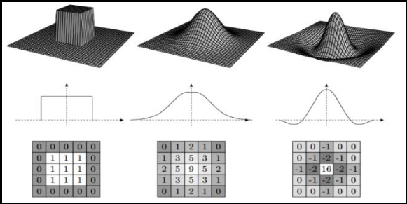

Figure 1: different filters and their effects

For example, if we have a 50 X 50 image of a cat, and we want to train our traditional ANN on that image to classify it into a dog or a cat the trainable

parameters become – (50*50) * 100 image pixels multiplied by hidden layer + 100 bias + 2 * 100 output neurons + 2 bias = 2,50,302

Image Classification Using Convolutional Neural Networks: A step by step guide:
Step 1: Choose a Dataset

Step 2: Prepare Dataset for Training

Step 3: Create Training Data

Step 4: Shuffle the Dataset

Step 5: Assigning Labels and Features

Step 6: Normalising X and converting labels to categorical data

Step 7: Split X and Y for use in CNN

Step 8: Define, compile and train the CNN Model

Step 9: Accuracy and Score of model

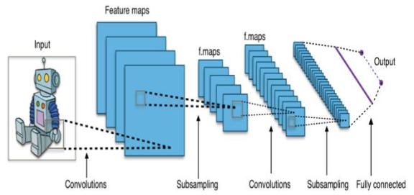

Figure 2: multiple convolutional layers extracting features from the image to output layer

TECHNOLOGIES IMPLEMENTED

A. Python

Python is an encoded high-level general-purpose programming language. Python's programming philosophy prioritises code readability, as demonstrated by the heavy use of indentation. Its object-oriented approach and language constructs were created to help programmers write quick, logical code for both small and large projects. Python is dynamically typed, and garbage collected. Structured (especially procedural) programming, object-oriented programming, and functional programming are among the programming paradigms it supports. Because of its vast standard library, Python is sometimes referred to as a "batteries included" language.

Guido van Rossum started working on Python in the late 1980s as a substitute for the ABC programming language, and Python 0.9.1 was published in 1991. Python 2.0 was released in 2000 and included additional features including list comprehensions and a garbage collection mechanism based on reference counting before being phased out in 2020 with version 2.7.18. Python 3.0 was introduced in 2008, and it was a significant rewrite of the language. It is not fully backward compatible, and most Python 2 code does not run without modification on Python 3. Python is one of the most common programming languages on the market.

MACHINE LEARNING

Machine Learning is a segment of Artificial Intelligence and Computer Science which intends on using algorithms and data modelling in such a way as to imitate a human brain and to help computer learn on its own. It focuses on learning things through making guesses and identifying the mistakes to analyse the patterns and create a learning curve.

It is an integral component of data science. Through the use of higher mathematics, probability and statistics, computers train the algorithms to make classifications and predictions that can go a long way. A properly trained ML model is quite efficient and could help uncover a lot of mysteries and predict the events. These insights are mostly utilised internally within various data-rich applications and organisations to earn maximum benefits.

Machine Learning is a very vague and wide term in use. It consists of various algorithms and training methods that are quite useful for various purposes. Out of various machine learning models, we are going to utilise Neural networks for achieving the desired purpose. Neural networks are networks of numerous nodes working in unison to mimic the thinking of a human brain, considering all the inputs provided.
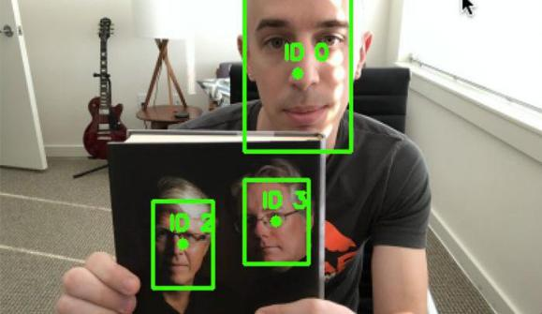

Figure 3: It will give Id‘s
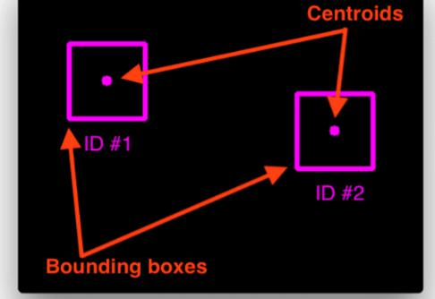

Fig 3.2: Centroids and Bounding boxes
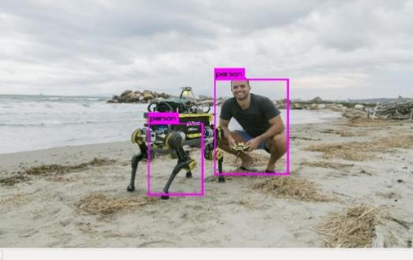

Fig3.3: Identifying the objects

RESULT AND DISCUSSION

We were able to devise a smart and advanced project/application that can potentially replace the existing excessive storage usage of CCTV cameras and could potentially revolutionise the storage and surveillance industry. Analysing a picture and detecting the presence of a human in it is the most critical step in this methodology. Because pictures are taken using different devices with varied amounts of attention to detail. This algorithm proved to be useful and efficient, regardless of the picture clarity, resolution, size or the device through which it is captured.
A picture is captured using the camera connected to the device, the application is being run in. The picture is then subjected to various mathematical multi-dimensional array operations to make it fit for the operations which are about to be performed on it. The required machine learning algorithms are performed on the picture to perform various operations to background subtraction, foreground segmentation etc. to detect if any human is present in the frame. The picture is either saved or dumped depending on the presence of human in the frame. If a human is recognised in the frame, the presence is annotated by drawing a red rectangle around the detected area and is assigned a number so as to not confuse with other subjects in the frame.

CONCLUSION

The technologies utilised in this paper, mentioned above, are easy to avail and to learn, yet, they are highly effective. The underlying concepts in this report are harder to master and implement to provide a solution for a real-life scenario, but the utilisation of python has made significantly easier. This proposed concept has greater scope for future projects and can bring revolutionary changes in terms of data storage, in the field of surveillance. This project is devised and developed with effective implementation of efficiency, in mind. It could potentially save a lot of money and resources for the people who could replace the traditional methods with this. This technology can be further developed for specific scenarios, in scope and could effectively provide a solution for one of the burning issues of today‘s era, the data storage. Because, with so many devices communicating and sharing data with each other endlessly, the infrastructure necessary to store the data is getting exhausted at a higher rate. So, a smart solution is necessary to this issue and this project proposes a smart solution that works with higher efficiency.

FUTURE WORK

This is designed in such a way that any projects in future could integrate this technology into their applications/technologies. Restricting the usage of such revolutionary tech is not good for the community and work could be done upon it, in the future, to increase its efficiency and maybe, even implement a few more features. In future we are going to implement an alarm system. This means that if your smart alarm or sensor is triggered, we will receive an alert immediately of the specific sensor that has been triggered. if any unnecessary activity happens then, we will know immediately so we can take the necessary action.

REFERENCES

[1] Image Classification Using Convolutional Neural Networks: A step by step guide, Devansh Sharma — January 11, 2021

V SUMANTH KAUSHIK, SHREYAS D G,

GURURAJA H S, SMART VIDEO SURVEILLANCE SYSTEM, ISSN:1001-1749, Volume XVI, Issue VI, JUNE/2020

Ishan Kokadwar, Anurag Kulkarni, SayaliKhare, Vaibhav Limbhore, Swati Chandurkar, Camera based Smart Surveillance System-Literature Survey, Volume: 07 Issue: 06 | June 2020.

Prasanna Rajendra, NiketWorlikar, Yash Mahajan, Siddhesh Swami, Smart Surveillance Using OpenCV, Motion Analysis And Facial Landmark, - Volume 7 Issue 1 - Jan to April 2020.

Dayana R, Suganya M, Balaji P, Mohamed Thahir A, ArunkumarP, Smart Surveillance System using Deep Learning, ISSN: 2277-3878, Volume-9, Issue-1, May 2020

Kaviyaraj R, S.Ramya, Yogapriya.D, SMART

SURVEILLANCEWITHARTIFICIAL

INTELLIGENCE: ROBBERY/THEFT MOTION DETECTION, Volume 8, Issue 7 July 2020 | ISSN: 2320-2882

Aayushi Bansal (2018) ―A factors affecting face recognition‖ IJAMTES volume 8, issue II, pp.
669-672.

A. Viji, A. Pavithra (2017), ―A real time face recognition using Raspberry Pi II‖ IJIRSET volume 3, issue 6, pp. 330-335.

Edy Winarno, WiwienHadikurniawati, Imam

Husni Al Amin, MujiSukur(2017) ,―Anti-

CheatingPresenceSystemBasedon

3WPCADualVisionFaceRecognition‖

Proceedings of IEEE conference of Electrical Engineering, Computer Science and Informatics IEEE 2017.

Neha patil, Shrikant Ambatkar and Sandeep

Kakde(2017), ―IOT Based Smart Surveillance Security System using Raspberry Pi‖, IEEE conference on signal processing April 6-8 2017, pp. 0344-0348

Jalendu Dhamija et.al (2017)―An advancement towards efficient face recognition using live video feed‖, International Conference on

Computational Intelligence and Networks ,pp. 53-56.

Nusrat Mubin Ara, Nishikanto Sarkar Simul, Md. Saiful Islam(2017), ―Convolutional Neural

Network Approach for Vision Based Student

Recognition System‖ 20th IEEE conference of

Computer and Information Technology (ICCIT), 22-24 December, 2017.

ShivprasadTavagad, Shivani Bhosale, Ajit Prakash Singh, Deepak Kumar, Survey Paper on Smart Surveillance System, Volume: 03 Issue: 02 | Feb-2016

Amol V. Nagime, Patange A.D, Smart CCTV Camera Surveillance System, ISSN (Online): 2319-7064 Index Copernicus Value (2013): 6.14 | Impact Factor (2015): 6.391

JiGwan Park, Kijin An, Daijin Kim and JongSuk

Choi (2013), ―Multiple Human Tracking using

Multiple Kinects for an Attendance Check

System of a Smart Class‖ 10th IEEE conference of Ubiquitous Robots and Ambient Intelligence (URAI), October 31-November 2, 2013.

Arun Hampapur, Lisa Brown, Jonathan Connell, SharatPankanti, Andrew Senior and Yingli Tian, Smart Surveillance: Applications, Technologies and Implications, DOI: 10.11.09/ICICS. 2003. 1292637 · Source: IEEE Xplore

Dhanshri Mali, R. T. Patil, Nagaraj Dharwadkar, Chaitanya R. Devale, Omprakash Tembhurne, Real-Time Smart Surveillance System Using Raspberry Pi,

Dr. Joy IongZong Chen, Smart Security System for Suspicious Activity Detection in Volatile Areas, Vol.02/ No. 01 Pages: 64-72.

