**A3: Black Hat / White Hat**

Name: Botond Kovács

Student number: 12323327

Creating the three plots for this assignment turned out to be an enjoyable experience. It significantly deepened my knowledge in data visualization.  
First, I developed a simple yet meaningful dashboard from the data.

Then, I modified my existing plots to make them more impactful. After that, I created the black hat dashboard, which was an interesting experience as I had never before intentionally created a misleading plot.

I have also spent a considerable amount of time familiarizing myself with the software, which proved to be incredibly useful. Now, I have a thorough understanding of things like how to create new columns in Tableau and how to create variables used for mapping.

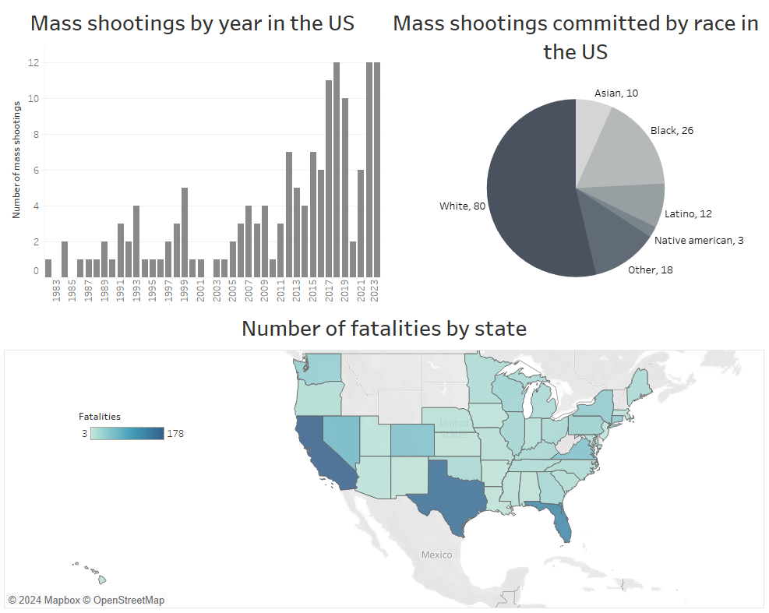**White hat visualization – neutral**

Data source: <https://www.motherjones.com/politics/2012/12/mass-shootings-mother-jones-full-data/>

On all of my dashboards, there are three plots. In the first case, the upper left plot displays the number of mass shootings for each year. It is designed without any unnecessary text, legend, or tool, ensuring a good data-to-ink ratio.

On the second part, there is a pie chart reflecting the number of shootings committed by each race. This part was challenging, as I had to clean up the "Race" column beforehand.

On the bottom, there is a map of the United States, where we can observe the fatalities for each state separately.

The plots are simple, mostly using only black color and without any chartjunk. We can understand our data from different aspects without redundancy or unnecessary appeal. The data source is shown.

**White hat visualization - affective**

Data source: <https://www.motherjones.com/politics/2012/12/mass-shootings-mother-jones-full-data/>

On this dashboard, I aimed to make my first plots more impactful while still providing accurate and comprehensive conclusions. The most notable change I made was the use of the color red. I decided to use red because of the serious topic of mass shootings; its purpose is to serve as a warning against the severity of the issue and to convey the message that "the more, the worse".

On the first plot, I added a partition of the data based on the gender of the shooter(s). This additional layer adds depth to the visualization without detracting from the main distribution.

For the second visualization, I transformed the pie chart into a treemap and added a dimension to the color: the average age of the shooters. This enhances the visualization by providing more context and insight into the data.

Lastly, I enhanced the map by displaying the fatalities as text instead of representing them solely as colors. This change allows for clearer interpretation of the data, as the color now represents the total number of victims (fatalities + injured). The data source is again shown.

**Black hat visualization**

As I have mentioned before, I found the black hat visualization to be the most enjoyable. My approach involved adding misleading elements to each plot, such as using different colors to make them less visually appealing. I have also not included the US in the first line, which makes it harder to figure out for what country the data corresponds to.

Starting with the first plot, I utilized the uncleaned version of the "gender" column, which contained various values such as "F", "M", "Female", and "Male". I then filtered out anything that was not labeled as "Female" or "Male". This practice is problematic because it distorts the true representation of the data, and the filtering is not shown anywhere. Additionally, I applied an exponential transformation to the sum of the mass shootings, which is misleading because it makes it complicated to observe small data points.

For the treemap visualization, I grouped the data on a race-type level, resulting in an excessive number of groups that are difficult to interpret. I also omitted the legend explaining the color scheme, further complicate the interpretation of the data.

On the map visualization, I again did not include a legend indicating the meaning of the colors used, leaving the interpretation of the data reliant solely on the presence of "total victims" in the title. This is problematic, especially considering the difficulty in distinguishing between the titles of the lower plots. Additionally, I zoomed in on the map, excluding Hawaii from the visualization.  
And the data source is completely missing from the dashboard