Automat secvential cu numarator74163 si multiplexor 4:1

Diagrama de tranzitii:



Tabelul de adevar numarator:

|  |  |  |
| --- | --- | --- |
| Priority signals | | Action |
| **Ld** | **PT** |
| 0 | x | load |
| 1 | 0 | maintain |
| 1 | 1 | count |
| Values for combined actions | | |
| var-m | 0 | load+maintain |
| 1 | var-c | count+maintain |
| var-c | 1 | coad+count |
| 0 | x | load+load(depends on the variable) |

Tabelul de adevar automat:

|  |  |  |  |  |  |  |  |
| --- | --- | --- | --- | --- | --- | --- | --- |
| Current state  QCQBQA | Operation | Control signals | | | | | |
| CLRN | LOADN | PT | C | B | A |
| 000 | count | 1 | 1 | 1 | x | x | x |
| 001 | count | 1 | 1 | 1 | x | x | x |
| 010 | load+keep | 1 | b | 0 | 1 | 0 | 1 |
| 011 | x | 1 | x | x | x | x | x |
| 100 | x | 1 | x | x | x | x | x |
| 101 | count+keep | 1 | 1 | a | x | x | x |
| 110 | count | 1 | 1 | 1 | x | x | x |
| 111 | load | 1 | 0 | x | 0 | 0 | 0 |

Schema electronica:



Verificarea prin simulare:

c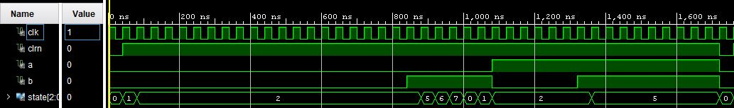

Schimbari ale ferestrei de rezultat:

* Pe o coloana



* Pe doua coloane pentru spatiu mai mic

