Automat secvential cu numarator74163 si multiplexor 4:1

Diagrama de tranzitii:

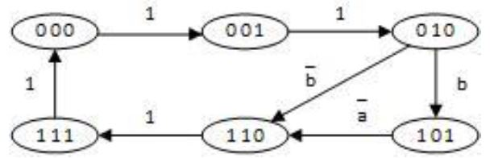

Tabelul de adevar:

Am incarcat starile care nu sunt in diagrama de tranzitie la prima stare, adica la 000.

|  |  |  |  |  |  |  |  |
| --- | --- | --- | --- | --- | --- | --- | --- |
| Current state  QCQBQA | Operation | Control signals | | | | | |
| CLRN | LOADN | PT | C | B | A |
| 000 | count | 1 | 1 | 1 | x | x | x |
| 001 | count | 1 | 1 | 1 | x | x | x |
| 010 | load+load | 1 | 0 | x | 1 | b | b |
| 011 | load initial state | 1 | 0 | x | 0 | 0 | 0 |
| 100 | load initial state | 1 | 0 | x | 0 | 0 | 0 |
| 101 | count+ keep | 1 | 1 | a | x | x | x |
| 110 | count | 1 | 1 | 1 | x | x | x |
| 111 | load | 1 | 0 | x | 0 | 0 | 0 |

