**GitHub**

1. 登陆GitHub，创建一个库

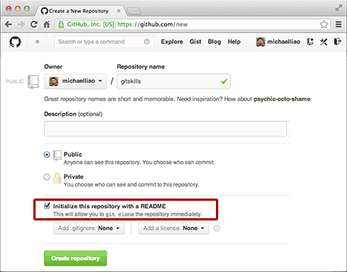

1. 用 git clone 克隆一个本地库

$ git clone git@github.com:botter2/dete.git

Cloning into 'dete'...

remote: Counting objects: 3, done.

remote: Total 3 (delta 0), reused 0 (delta 0), pack-reused 3

Receiving objects: 100% (3/3), done.

cd dete 目录查看拷贝的库。

ls

README.md