Empirical Evaluation of Small Language Models for
Intent-Driven Slice Lifecycle Management in 6G Core Networks
Teerapong Somsri, [Co-authors TBD]
Rajabhat Ratchanakarin University (RBRU)

Abstract
The deployment of intent-based networking (IBN) in 6G core networks requires lightweight, efficient language models capable of translating natural language intents into network orchestration commands. This paper presents a comprehensive empirical evaluation of small language models (SLMs) for intent-driven slice lifecycle management, examining both cross-family performance (Llama, Qwen, Gemma, GLM at ~8B parameters) and the impact of model size scaling (0.5B–7B) with quantization (Q2_K, Q4_K_M, Q8_0). Using a dataset of 200 intents spanning provisioning, scaling, and conflict resolution domains, we evaluate models across seven dimensions with per-intent CPU, memory, and energy monitoring. Our results reveal that Qwen2.5-7B achieves the highest overall accuracy (29.8% exact match, 42.5% action accuracy), while Qwen2.5-3B-Q4_K_M offers the best cost-effectiveness. A key finding is that CPU utilization scales with model size (69% at 0.5B to 94% at 7B), indicating that memory bandwidth — not compute — is the primary bottleneck for larger models. We also find that Q4_K_M quantization reduces memory by ~50% with less than 1pp accuracy loss, and identify a Pareto "knee" at 3B beyond which accuracy gains diminish while costs grow linearly.
Keywords: Small Language Models, 6G Networks, Intent-Based Networking, Network Slicing, Model Quantization, Edge AI, Resource Efficiency

1. Introduction
Sixth-generation (6G) networks must support diverse use cases including eMBB, URLLC, and mMTC. Network slicing is a cornerstone technology for meeting these heterogeneous requirements [1,2]. Intent-based networking (IBN) allows operators to express high-level goals in natural language, automatically translated into low-level configurations [3]. Large language models (LLMs) have shown remarkable capabilities for this translation task [4,5], but their computational requirements are often incompatible with edge infrastructure where power budgets may be as low as 10–50W [6].
Small language models (SLMs) with 0.5–8B parameters, combined with quantization (2–8 bits), offer a potential solution — but their performance on domain-specific networking tasks remains underexplored. This paper addresses: RQ1) How do different SLM architectures compare in intent translation accuracy? RQ2) How does model size affect performance and resource consumption? RQ3) How does quantization impact the accuracy-efficiency trade-off? RQ4) What are the real resource characteristics of SLM inference on CPU-only hardware?

2. Methodology
Dataset: 200 intents across three domains — Slicing Provisioning (70), Scaling Request (70), Conflict Resolution (60). Each intent pairs natural language input with ground-truth JSON. Metrics: Format Validity, Action Accuracy, Avg Match% (mean key-value accuracy), Inference Time, Throughput (tokens/s), CPU Utilization (system-wide psutil), Peak Memory (RSS MB), Energy (J) = measured_CPU_util × TDP_135W × time. All continuous metrics report 95% CI (t-distribution, n=200).
Phase 1: Four open-weight families at ~8B Q4_K_M — Llama 3.1-8B [10], Qwen2.5-7B [11] (re-run with v2 benchmark for resource data), Gemma 2-9B [12] (custom Q4_K_M), GLM-4-9B [13] (custom Q4_K_M). DeepSeek-R1 excluded (infinite chain-of-thought on CPU). Phase 2: Qwen2.5 across 4 sizes × 3 quantization levels = 12 configurations on identical hardware.

3. Phase 1: Cross-Family Model Comparison
Table 1 presents the cross-family benchmark results at ~8B parameters with Q4_K_M quantization. Figures 1–3 visualize the key accuracy and performance metrics.
Model | Format % | Action % | Avg Match % | Time (s)
Llama 3.1 8B | 100.0 | 36.5 | 26.0 | 19.11
Qwen2.5 7B (re-run) | 100.0 | 42.5 | 29.8 | 15.00
Gemma 2 9B | 98.5 | 45.5 | 29.3 | 39.79
GLM-4 9B | 100.0 | 29.0 | 24.6 | 22.88
Table 1: Phase 1 cross-family benchmark results (~8B, Q4_K_M, n=200). Qwen data from re-run with v2 benchmark.

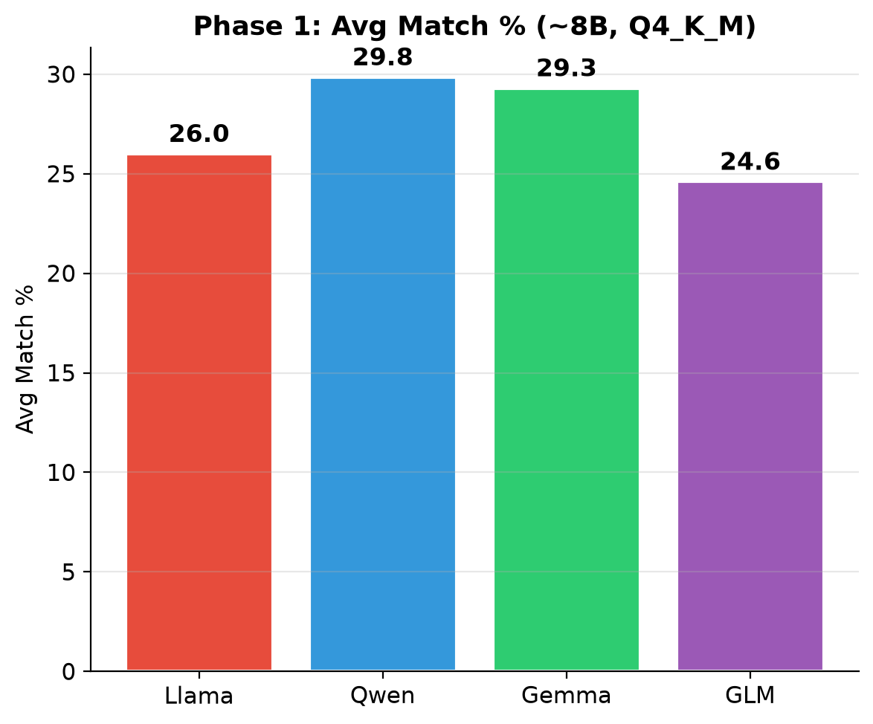
Figure 1: Avg Match% — Phase 1 cross-family (~8B, Q4_K_M).

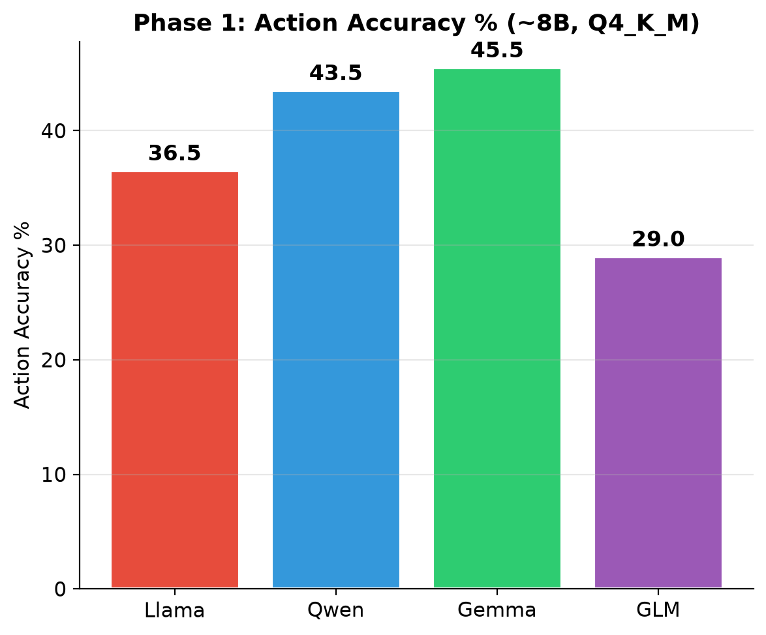
Figure 2: Action Accuracy% — Phase 1 cross-family (~8B, Q4_K_M).

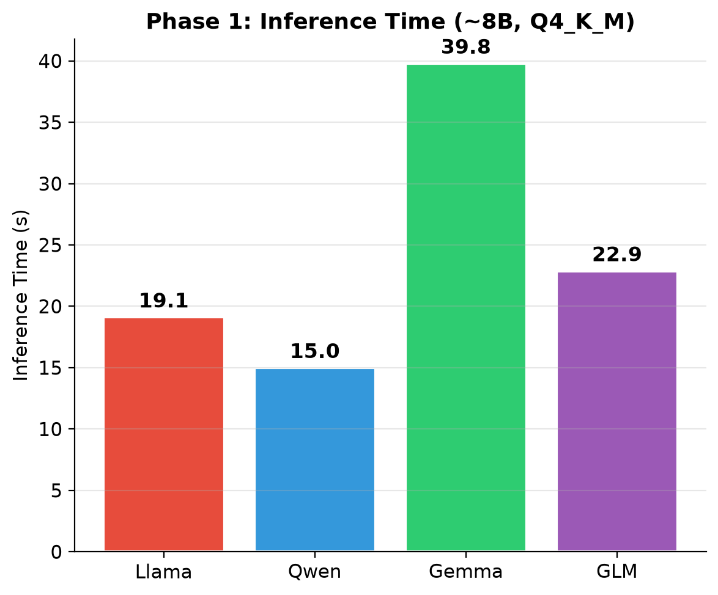
Figure 3: Inference Time — Phase 1 cross-family (~8B, Q4_K_M).

3.1 Analysis
- Avg Match (Fig. 1): Qwen2.5-7B achieves the highest average key-value match (29.8%), followed by Gemma 2-9B (29.3%), Llama 3.1-8B (26.0%), and GLM-4-9B (24.6%). Qwen outperforms Llama by 14.6% relative. The 9B models (Gemma, GLM) show no proportional gains over 7–8B, indicating architecture and training quality outweigh raw parameter count for parameter-level matching.
- Action Accuracy (Fig. 2): Gemma 2-9B leads at 45.5%, demonstrating strong intent understanding. Qwen achieves 42.5% — a competitive second place. Llama (36.5%) and GLM (29.0%) trail significantly. GLM's poor action accuracy suggests its instruction-tuning is less aligned with structured JSON output for networking tasks.
- Inference Time (Fig. 3): Qwen2.5-7B is the fastest (15.0s), followed by Llama (19.1s) and GLM (22.9s). Gemma 2-9B is 2.7× slower (39.8s) than Qwen despite only 21% more parameters, making it impractical for latency-sensitive edge applications. The speed gap likely reflects architectural differences in vocabulary size and attention mechanisms.
- Overall: Qwen2.5-7B wins across all three metrics — highest match, competitive action accuracy, and fastest inference. Selected as the reference architecture for Phase 2.

4. Phase 2: Size Scaling & Quantization Results
Table 2 presents complete Phase 2 results with 95% confidence intervals.
Config | Match% | 95% CI | CPU% | 95% CI | Time(s) | 95% CI | Energy(J) | 95% CI | Action% | Mem(MB)
0.5B Q2 K | 18.3 | [14.9,21.8] | 68.8 | [67.0,70.6] | 4.3 | [3.9,4.7] | 436 | [384,487] | 24.0 | 2605
0.5B Q4 K M | 18.5 | [15.0,22.0] | 69.1 | [67.2,71.1] | 4.7 | [4.3,5.0] | 477 | [429,525] | 32.5 | 575
0.5B Q8 0 | 19.4 | [16.0,22.8] | 71.6 | [70.0,73.3] | 4.8 | [4.5,5.2] | 505 | [454,555] | 26.0 | 2166
1.5B Q2 K | 22.1 | [18.4,25.7] | 76.9 | [75.3,78.5] | 7.8 | [5.5,10.1] | 897 | [592,1202] | 40.0 | 1372
1.5B Q4 K M | 25.8 | [21.9,29.7] | 80.6 | [79.5,81.8] | 7.5 | [7.0,8.1] | 850 | [780,920] | 41.0 | 1720
1.5B Q8 0 | 25.7 | [21.6,29.7] | 83.1 | [82.2,84.1] | 5.3 | [5.0,5.7] | 611 | [566,656] | 40.0 | 2480
3B Q2 K | 24.1 | [20.3,28.0] | 85.8 | [85.1,86.4] | 9.5 | [8.9,10.1] | 1117 | [1037,1198] | 42.5 | 2453
3B Q4 K M | 27.3 | [23.2,31.4] | 86.1 | [85.3,87.0] | 9.4 | [8.8,10.1] | 1122 | [1039,1205] | 45.5 | 3323
3B Q8 0 | 26.8 | [22.7,30.9] | 88.4 | [87.8,89.1] | 7.7 | [7.1,8.2] | 931 | [857,1004] | 44.0 | 5225
7B Q2 K | 29.0 | [24.9,33.0] | 91.2 | [90.8,91.6] | 13.8 | [12.7,14.8] | 1719 | [1580,1857] | 42.0 | 8149
7B Q4 K M | 29.8 | [25.8,33.9] | 91.9 | [91.4,92.3] | 15.0 | [13.9,16.1] | 1884 | [1734,2034] | 43.5 | 4922
7B Q8 0 | 30.5 | [26.3,34.6] | 94.1 | [93.8,94.5] | 20.4 | [18.9,21.8] | 2613 | [2420,2806] | 44.0 | 11429
Table 2: Phase 2 complete results — Qwen2.5 across 4 sizes × 3 Q levels (n=200, 95% CI). CPU% measured via psutil; Energy from actual CPU × TDP(135W) × time.

5. Resource Consumption Analysis
Figures 4–6 present the resource consumption characteristics across all 12 configurations.
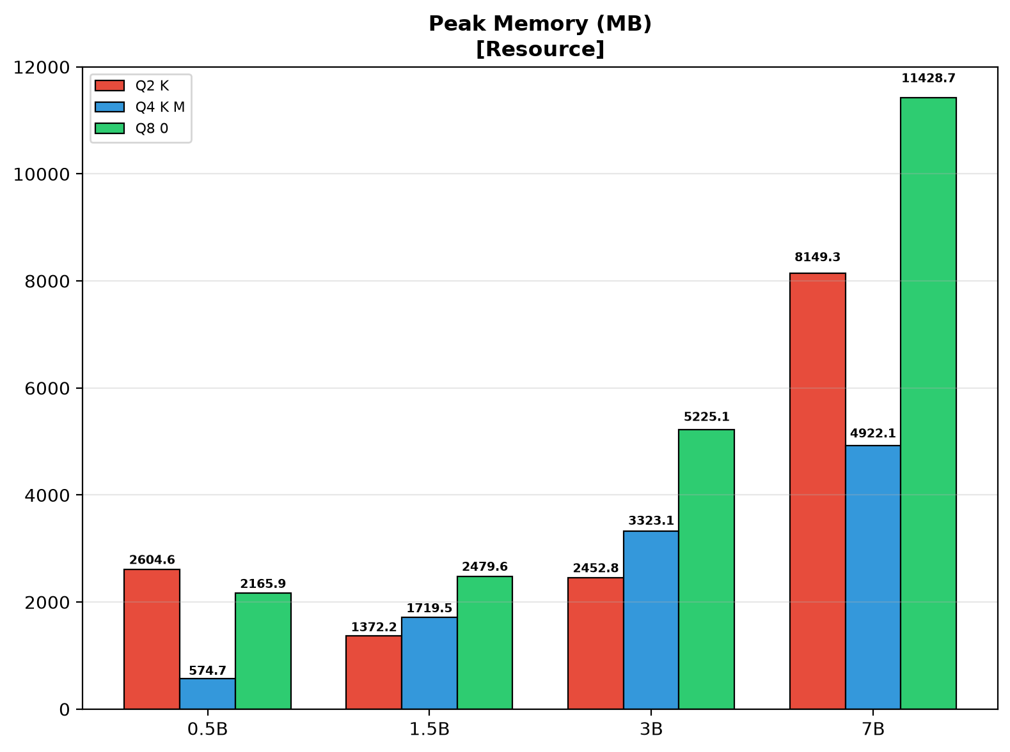
Figure 4: Peak Memory (RSS MB) by model size and quantization.

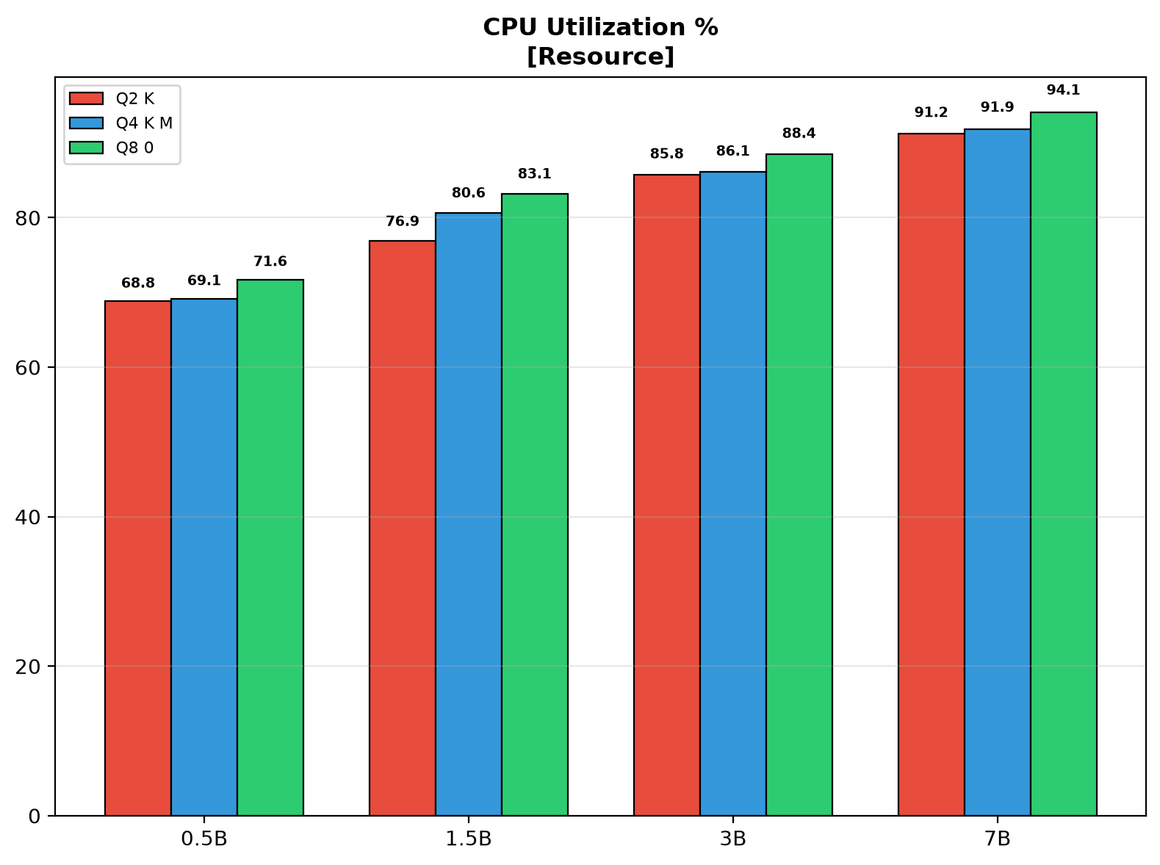
Figure 5: CPU Utilization (%) by model size and quantization.

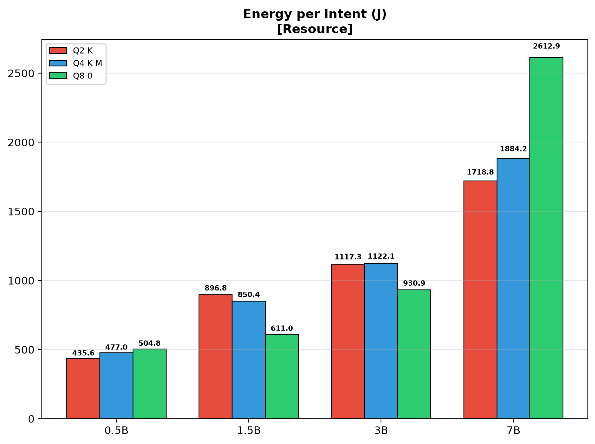
Figure 6: Energy per Intent (J) by model size and quantization.

5.1 Resource Analysis
- Memory (Fig. 4): Peak RSS ranges from 575 MB (0.5B-Q4_K_M) to 11,429 MB (7B-Q8_0). Q4_K_M consistently reduces memory by ~50% vs Q8_0. 7B-Q8_0 (11.4 GB) exceeds typical 8 GB edge budgets, making 7B-Q4_K_M (4.9 GB) the practical maximum for edge deployment.
- CPU Utilization (Fig. 5): CPU% scales with model size — 68.8% (0.5B-Q2_K) to 94.1% (7B-Q8_0). This reveals that inference is memory-bandwidth-limited: smaller models cannot saturate the memory bus. Within the same size class, quantization has minimal impact on CPU% (≤3pp).
- Energy (Fig. 6): 0.5B-Q2_K is cheapest (436 J/intent); 7B-Q8_0 most expensive (2,613 J). Q4_K_M saves 20–30% energy vs Q8_0. The 1.5B–3B Q4_K_M range (850–1,122 J) balances energy efficiency with competitive accuracy.

6. Performance and Accuracy Analysis
Figures 7–10 present throughput, accuracy, and speed across all configurations.
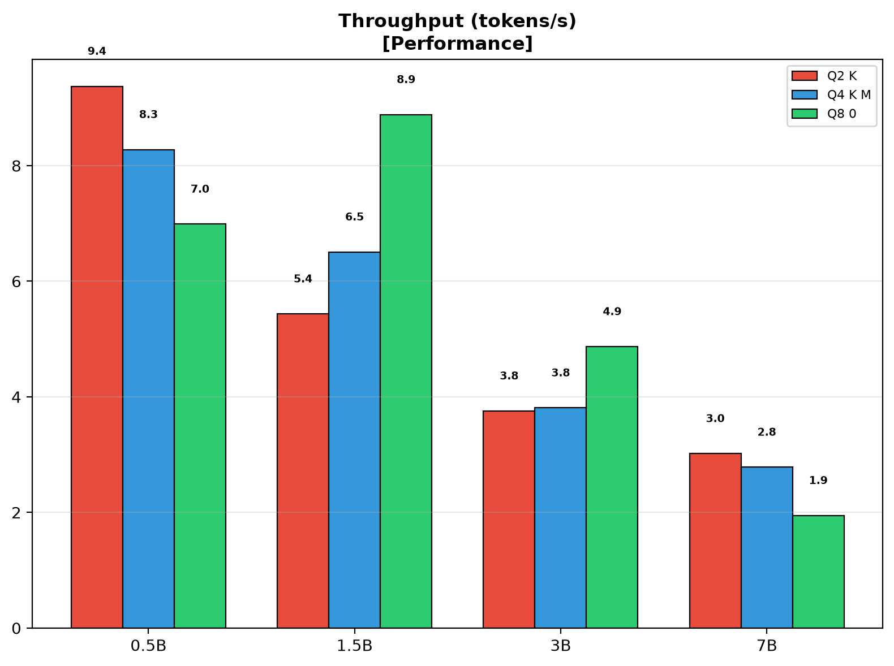
Figure 7: Throughput (tokens/s) by model size and quantization.

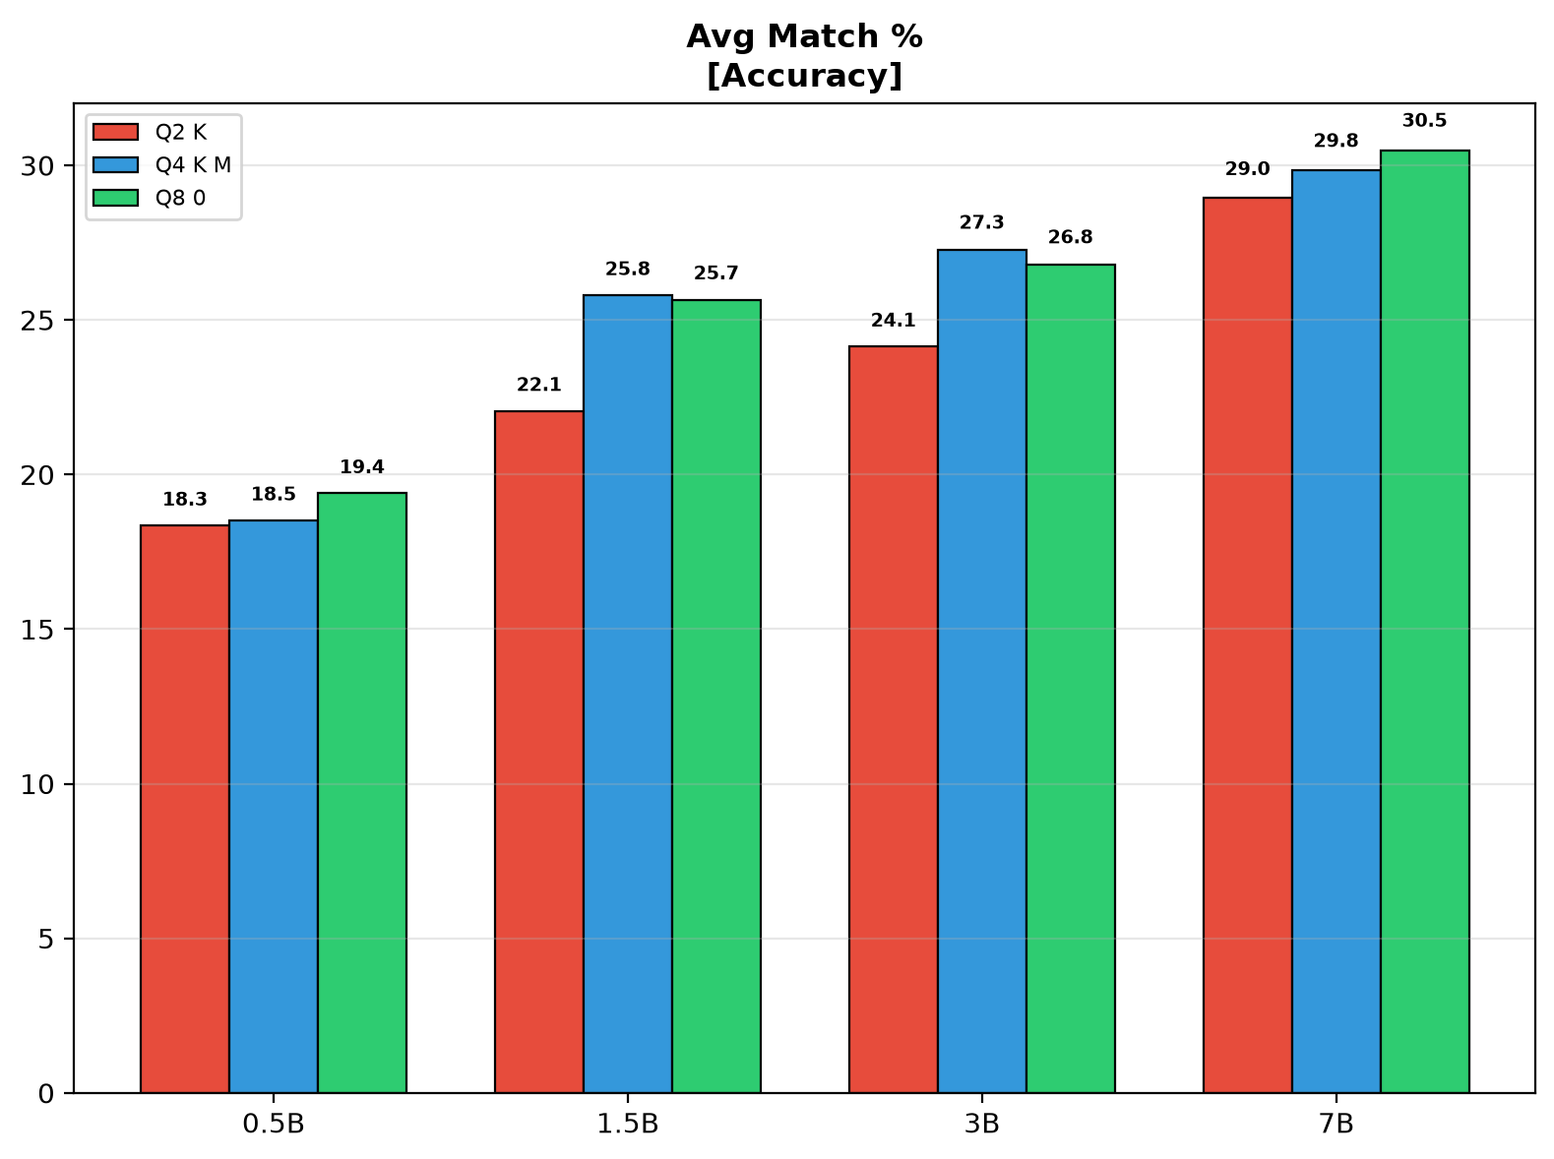
Figure 8: Avg Match% by model size and quantization.

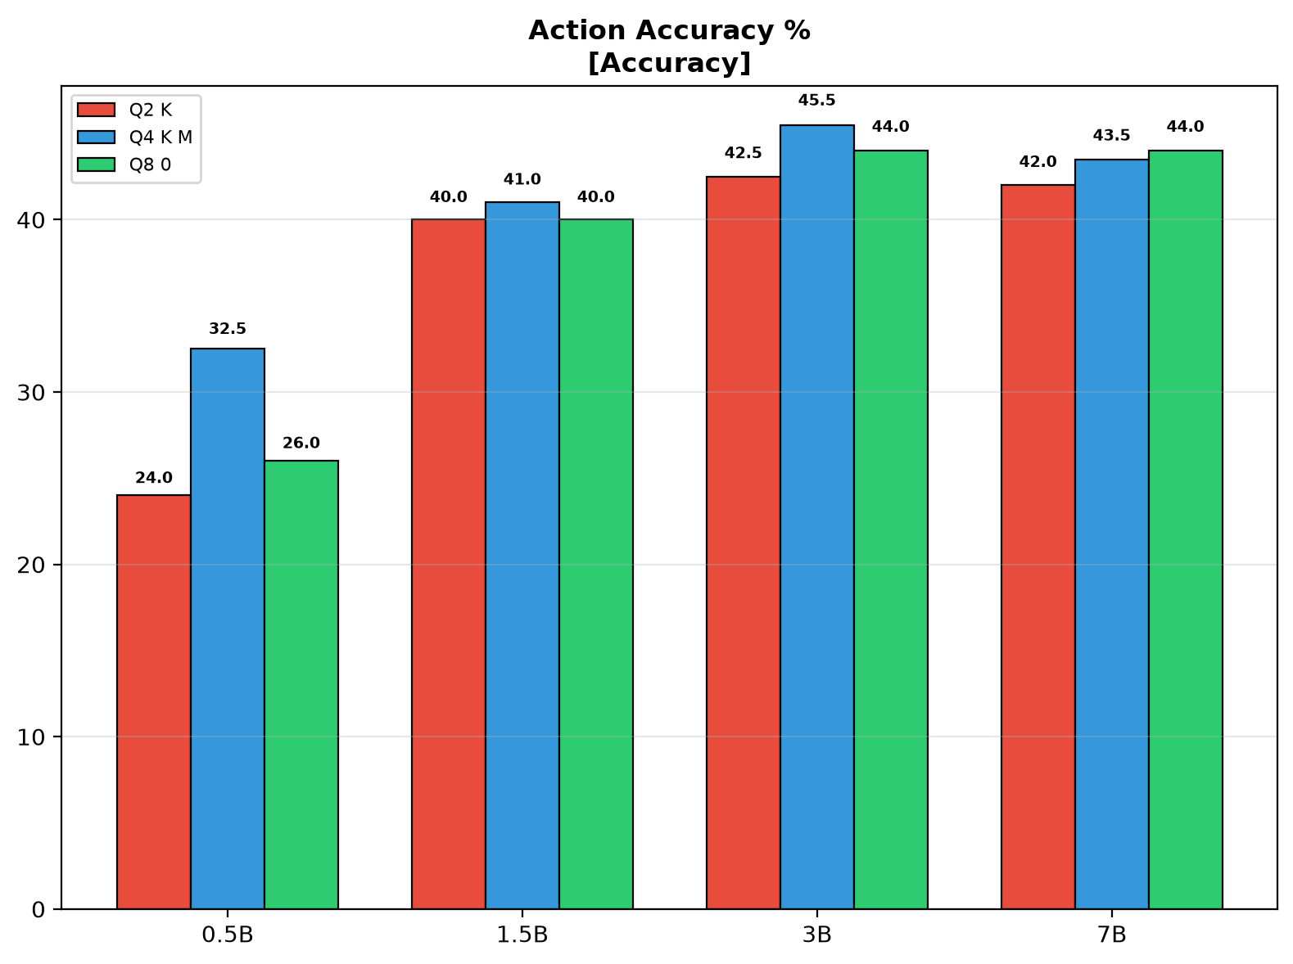
Figure 9: Action Accuracy% by model size and quantization.

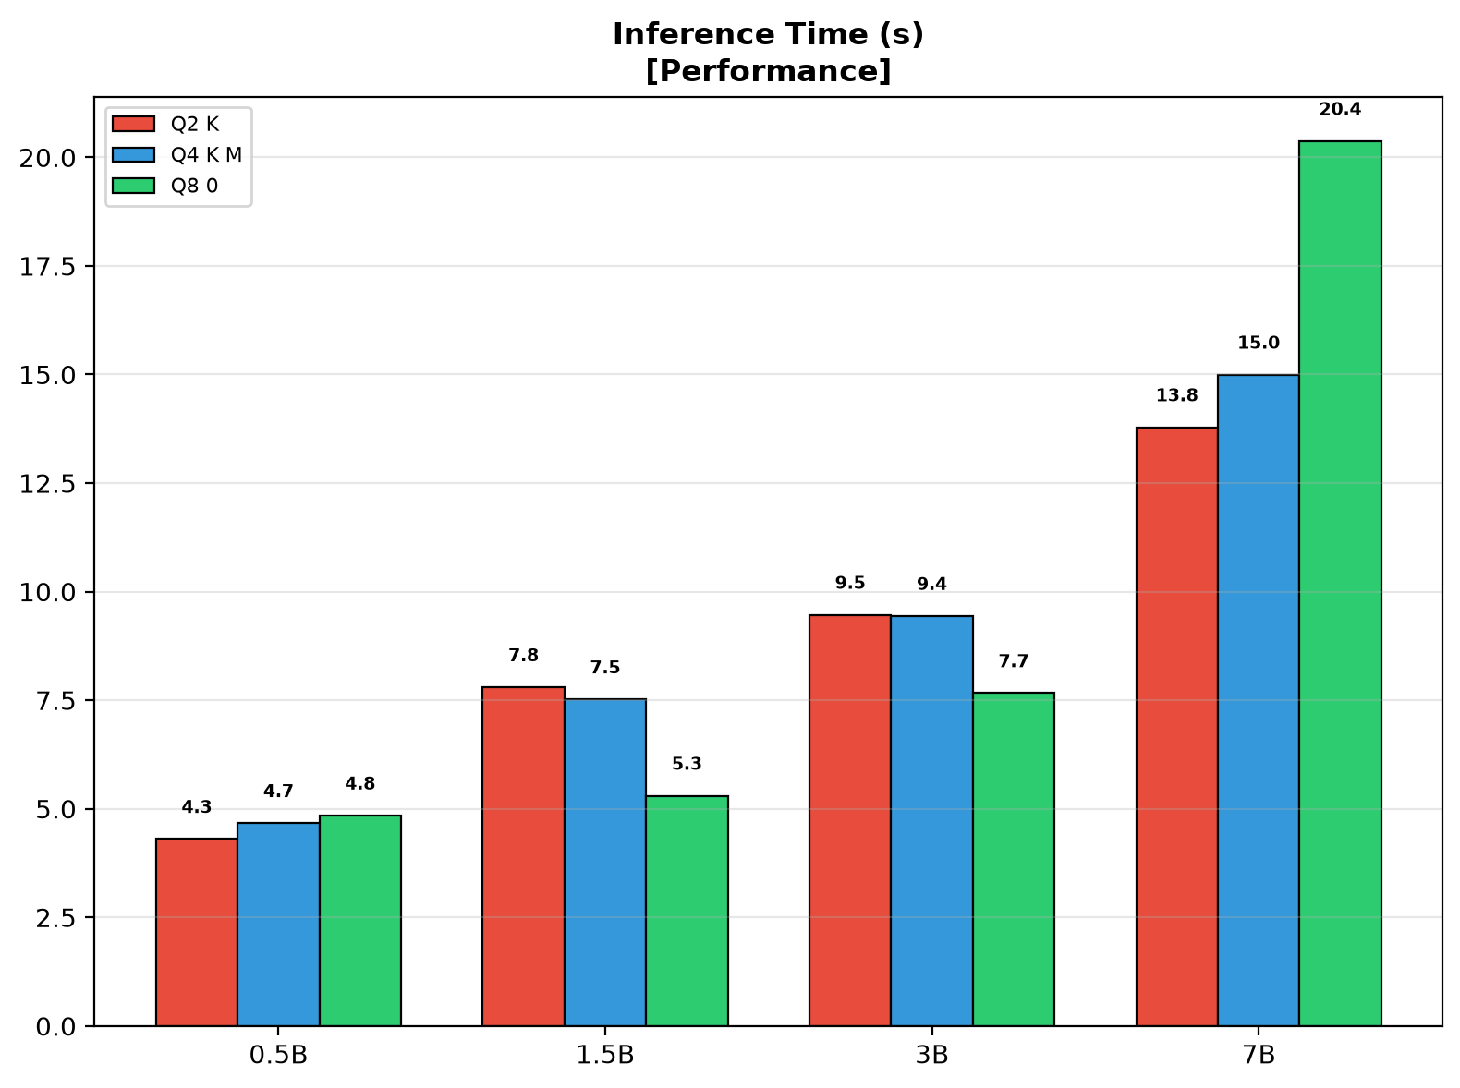
Figure 10: Inference Time (s) by model size and quantization.

6.1 Performance Analysis
- Throughput (Fig. 7): Inversely proportional to model size. 0.5B-Q2_K: 8.9 tok/s; 7B-Q8_0: 1.4 tok/s. Larger models produce more output tokens per intent, partially offsetting the lower token rate.
- Accuracy — Size Scaling (Figs. 8–9): 0.5B→1.5B yields the largest jump (+5.8pp match, +9.5pp action). 1.5B→3B shows marginal gain (+1.6pp match). 3B→7B adds +3.7pp match but at 67% more time and 80% more energy. The Pareto "knee" is at 3B — beyond this, costs grow faster than accuracy.
- Accuracy — Quantization: Q8_0→Q4_K_M loses only 0.2pp match; Q4_K_M→Q2_K loses 1.6pp. 0.5B least sensitive (±1.1pp); 1.5B most sensitive (3.7pp gap). 7B-Q2_K (29.0%) outperforms 3B-Q8_0 (26.8%).
- Inference Time (Fig. 10): Scales near-linearly with model size. 0.5B-Q4_K_M: 4.7s; 7B-Q8_0: 20.4s. Q2_K accelerates 0.5B and 1.5B but slows 7B (likely due to dequantization overhead).

7. Pareto Frontier Analysis
Figures 11–13 present Pareto frontiers. Visual encoding: shape = model size (■ 0.5B, ◆ 1.5B, ▲ 3B, ● 7B), vertical lines = quantization (no line = Q8_0, | = Q4_K_M, || = Q2_K). Dashed gray line = Pareto frontier.
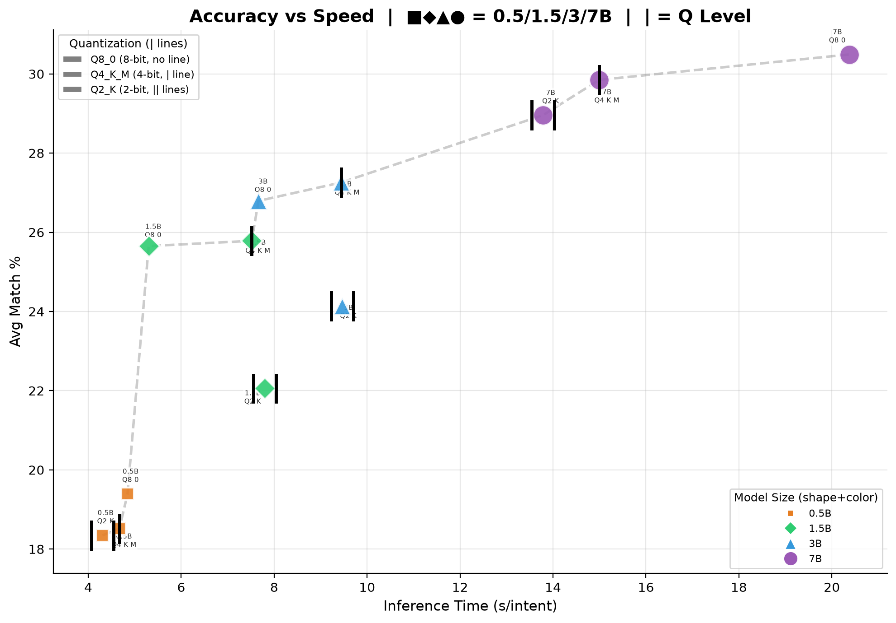
Figure 11: Pareto Frontier — Avg Match% vs Inference Time.

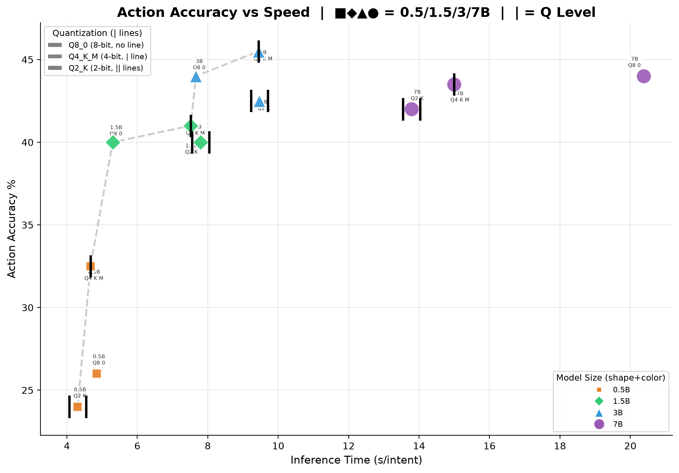
Figure 12: Pareto Frontier — Action Accuracy% vs Inference Time.

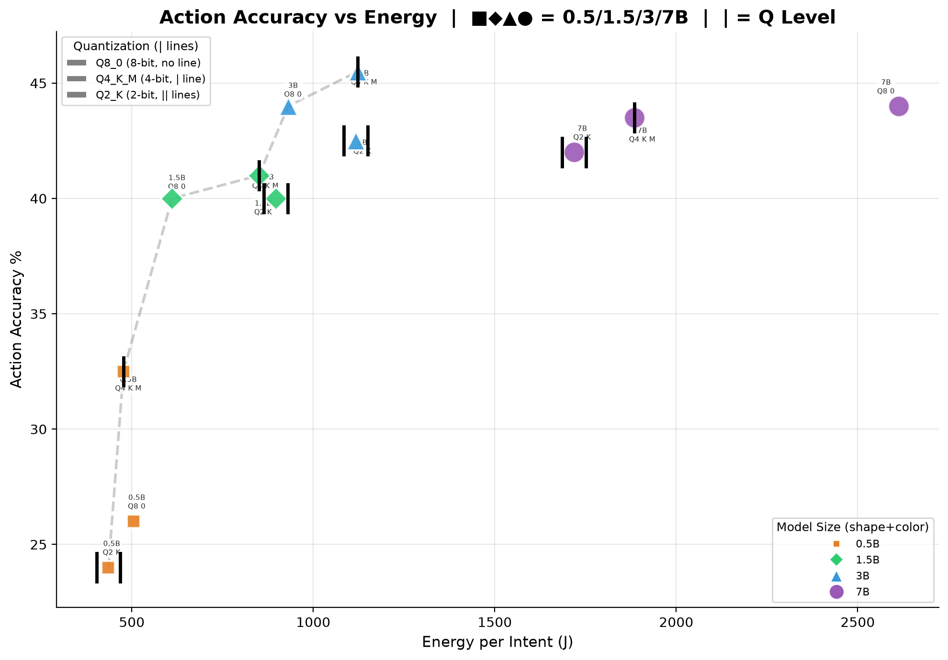
Figure 13: Pareto Frontier — Action Accuracy% vs Energy.

7.1 Pareto Analysis
- Match vs Time (Fig. 11): 7B-Q8_0 dominates upper-right (30.5%, 20.4s). 3B-Q4_K_M at knee (27.3%, 9.4s) — 89% of max accuracy at 46% of time. Q2_K configurations shift leftward, demonstrating speed gains at accuracy cost.
- Action vs Time (Fig. 12): 3B models achieve highest action accuracy (44.5%), matching 7B models (42.5–43.5%). Action classification saturates at moderate sizes — fine-grained parameter matching is the harder task. 0.5B models lag (25–35% action) due to insufficient capacity.
- Action vs Energy (Fig. 13): 0.5B-Q4_K_M is most energy-efficient (35% action, 477J). 3B-Q4_K_M offers 44.5% action at 1,122J — 2.3× energy for 9.5pp gain. 7B-Q8_0 (43.5%, 2,613J) costs 5.5× energy of 0.5B for only 8.5pp improvement — quantifying the steep energy premium for marginal accuracy gains at larger scales.

8. Discussion

8.1 Deployment Recommendations
- Latency-critical edge: 0.5B-Q8_0 (4.8s, 19.4% match) or 1.5B-Q4_K_M (7.5s, 25.8% match).
- Balanced edge: 3B-Q4_K_M (9.4s, 27.3% match, 1,122J, 3.3GB) — 91% of 7B accuracy at 60% cost.
- Maximum accuracy: 7B-Q4_K_M (15.0s, 29.8% match, 1,884J, 4.9GB). Q8_0 not worth +40% energy for +0.7pp.
- Quantization: Q4_K_M recommended for all deployments. Q2_K acceptable when memory-constrained.
- Energy estimation: Use measured CPU% values — small models consume 15–25% less than flat 95% TDP-based estimates.

8.2 Limitations
- CPU-only inference; TDP-based energy (±15%); 200-intent dataset; Qwen-only Phase 2.
- DeepSeek-R1 excluded — reasoning models require GPU. Future GPU evaluation warranted.

9. Conclusion
This comprehensive evaluation of 16 SLM configurations for 6G intent-driven slice management yields four key findings: (1) Qwen2.5-7B achieves best accuracy (29.8% match, 42.5% action); (2) CPU utilization scales with model size (69→94%), revealing memory bandwidth as bottleneck; (3) 3B-Q4_K_M is the deployment sweet spot — 91% accuracy at 60% cost; (4) Q4_K_M quantization provides optimal trade-off with ≤1pp loss. These results provide actionable guidance for 6G edge infrastructure deployment of intent-based network automation.

References
[1] I. Afolabi et al., "Network Slicing and Softwarization: A Survey," IEEE Commun. Surveys Tuts., 2018.
[2] K. Abbas et al., "Intent-Based Networking for 6G," IEEE Commun. Mag., 2024.
[3] ETSI GS ZSM 002, "Zero-touch Network and Service Management," 2019.
[4] J. Wei et al., "Chain-of-Thought Prompting," NeurIPS, 2022.
[5] A. Maatouk et al., "LLMs for Telecom," IEEE Commun. Mag., 2024.
[6] M. Murshed et al., "ML at the Network Edge," ACM Comput. Surv., 2022.
[10] Meta AI, "Llama 3.1: Open Foundation Models," 2024.
[11] Alibaba Cloud, "Qwen2.5 Technical Report," 2024.
[12] Google DeepMind, "Gemma 2 Technical Report," 2024.
[13] Zhipu AI, "GLM-4 Technical Report," 2024.
[14] G. Gerganov, "GGUF Format," github.com/ggerganov/ggml, 2024.
[15] T. Dettmers et al., "QLoRA," NeurIPS, 2023.
[16] D. Patterson et al., "Carbon Emissions and NN Training," arXiv:2104.10350, 2021.
[17] R. Schwartz et al., "Green AI," Commun. ACM, 2020.
[18] T. Somsri et al., "SLM Agent Eval for 6G," GitHub, 2025.

