Empirical Evaluation of Small Language Models for Intent-Driven Slice Lifecycle Management in 6G Core Networks
A Systematic Study of Model Architecture, Size Scaling, and Quantization Impact on CPU-Only Edge Inference
claude1 edition (Claude Code · Opus 4.8) — RB-RU Research Huddle
July 2026
Abstract
Intent-driven management is a cornerstone of 6G network automation, enabling operators to express desired outcomes in natural language that autonomous agents translate into orchestration commands. Deploying such agents at the network edge on resource-constrained, CPU-only infrastructure demands Small Language Models (SLMs) that balance accuracy with inference speed, memory footprint, and energy consumption. This paper presents a comprehensive empirical evaluation of open-weight SLMs for 6G intent-to-action translation across two controlled experiments with per-intent resource monitoring. Phase 1 benchmarks five model families at the ~8B scale (Llama 3.1 8B, Qwen 2.5 7B, Gemma 2 9B, GLM-4 9B, and DeepSeek-R1 8B) under identical Q4_K_M quantization, hardware, and prompt conditions on 200 real-world intents spanning three slice-management domains. Phase 2 extends the winning architecture (Qwen 2.5) across four sizes (0.5B-7B) and three K-quant levels (Q2_K, Q4_K_M, Q8_0) in a full-factorial 12-point design, quantifying accuracy, speed, throughput, CPU utilization, memory footprint, energy, domain robustness, and complexity resilience with 95% confidence intervals over 200 intents per configuration. Key findings: (1) Qwen 2.5 7B at Q4_K_M achieves the best accuracy-efficiency balance (29.8% exact match, 15.0 s/intent), outperforming Gemma 2 9B by 2.7x in speed at equivalent accuracy; (2) measured CPU utilization scales with model size (69% at 0.5B to 94% at 7B), empirically demonstrating that memory bandwidth, not compute, is the binding constraint of CPU inference and that flat-utilization energy models overestimate small-model energy by 15-25%; (3) 2-bit quantization of larger models (7B Q2_K, 29.0%) surpasses 8-bit quantization of smaller models (3B Q8_0, 26.8%); (4) diminishing returns manifest in both size and precision; (5) a quantization-speed crossover exists between compute-bound and bandwidth-bound regimes; (6) Slicing Provisioning is a solved domain while Conflict Resolution remains near-random; and (7) reasoning-oriented architectures (DeepSeek-R1) are incompatible with CPU-only inference. We contribute the first systematic cross-family, multi-size, multi-quantization SLM benchmark for 6G intent-driven slice management with real per-intent resource telemetry, a detailed Pareto analysis, and actionable deployment guidelines.

1. Introduction

1.1 Motivation
The transition to sixth-generation (6G) mobile networks elevates intent-driven management from an aspirational concept to a core operational paradigm. Operators articulate desired outcomes in natural language - e.g. "provision a URLLC slice with sub-millisecond latency for autonomous vehicle platooning" - and autonomous AI agents translate these intents into executable network configuration commands, promising to reduce operational complexity, accelerate provisioning, and enable zero-touch automation at scale.
However, the shift toward distributed, disaggregated 6G core networks introduces a fundamental tension. While Large Language Models (GPT-4, Llama-70B) demonstrate impressive intent understanding, their deployment at the network edge is constrained by three hard realities of telco infrastructure: (1) latency budgets - URLLC slices demand sub-millisecond control loops incompatible with cloud-roundtrip inference; (2) energy constraints - edge nodes operate under strict power envelopes, often without GPU accelerators; and (3) hardware heterogeneity - 6G infrastructure spans from data centers to far-edge nodes with as little as 4-8 CPU cores and a few gigabytes of RAM.
Small Language Models (SLMs) - models under 10 billion parameters - emerge as a compelling middle ground. Advances in architecture design (Llama 3.1, Qwen 2.5, Gemma 2, GLM-4) and post-training quantization have produced open-weight SLMs that approach LLM-quality performance on structured tasks while fitting within edge hardware constraints. Yet systematic evaluations on domain-specific network orchestration tasks remain absent from the literature.

1.2 Research Gaps
Existing SLM evaluation suffers from four limitations when applied to 6G intent-driven management:

• Single-family bias: most benchmarks evaluate one model family in isolation, precluding the cross-architecture comparisons essential for technology selection.

• Generic benchmarks: MMLU/HellaSwag/GSM8K measure broad language understanding but not the structured output generation and domain reasoning required for network intent translation.

• Neglect of quantization interaction: the interaction of quantization with model size on structured-task accuracy (valid JSON commands) has not been characterized.

• Absence of resource telemetry: prior benchmarks rarely measure CPU utilization, resident memory, or energy per inference on the actual deployment hardware class.

1.3 Contributions

• Phase 1 - Cross-family comparison (Sec 4): five ~8B families under identical quantization, hardware, prompt, and a shared 200-intent dataset.

• Phase 2 - Size scaling and quantization (Sec 5): a full-factorial 4-size x 3-quant evaluation of the winning architecture (Qwen 2.5), isolating parameter count and weight precision.

• Per-intent resource telemetry with statistical rigor (Sec 5.8): 0.5 s psutil sampling of CPU and process RSS, with per-intent energy from measured utilization; all metrics as mean +/- 95% CI.

• Comprehensive multi-metric analysis across domain, complexity, token efficiency, memory, and energy dimensions, plus actionable deployment guidelines (Sec 6).

2. Related Work

2.1 Intent-Based Networking in 5G/6G
Intent-Based Networking (IBN) is a key enabler for zero-touch network and service management (ETSI ZSM) and appears in 3GPP Release 18 slice-lifecycle specifications. The premise is that operators express what they want rather than how to achieve it, with an automated layer mapping intents to commands. Recent work explores LLM-based intent translation, but large-model compute demands conflict with the distributed, latency-sensitive nature of 6G edge deployments.

2.2 Small Language Models for Structured Tasks
The 2024-2025 period saw a proliferation of open-weight SLMs. Llama 3.1 showed 8B models can approach much larger predecessors; Qwen 2.5 introduced improvements yielding strong code and structured-output performance from 0.5B to 72B; Gemma 2 used distillation for competitive 9B models; GLM-4 explored bilingual capability. Existing SLM surveys do not include domain-specific network orchestration evaluations.

2.3 Post-Training Quantization
Post-training quantization compresses weights to lower precision, reducing memory footprint and latency. The GGUF K-quant family (Q2_K through Q8_0) is the de facto standard for CPU inference via llama.cpp. Prior studies characterize quantization degradation on standard NLP metrics, but no prior work systematically evaluates the three-way interaction of architecture, parameter count, and quantization precision on structured intent-to-action translation.

3. Methodology

3.1 Dataset Construction
We construct a dataset of 200 intents spanning three 6G slice-management domains, each annotated with a ground-truth JSON action:
Domain | Count | Description | Example
Slicing Provisioning | 70 | Creation of new slices with QoS parameters | "Create a URLLC slice with 1 ms latency for AV platooning in Bangkok"
Scaling Request | 70 | Modification of existing slice capacity | "Scale the eMBB slice for the stadium event to 10 Gbps during the concert"
Conflict Resolution | 60 | Resolution of resource conflicts between slices | "URLLC factory slice needs priority over eMBB streaming during emergency"
Each intent carries a complexity label - Simple (explicit single-domain parameters), Complex (multi-constraint or regional context), or Ambiguous (implicit priorities requiring contextual inference) - enabling robustness evaluation across the difficulty spectrum.

3.2 Models Evaluated
Phase 1 evaluates five families at ~8B, all under Q4_K_M (the most widely deployed llama.cpp default) for fair comparison:
# | Model | Ollama Tag | Family | Params | Quant | Disk | Source
1 | Llama 3.1 8B | llama3.1:8b | Meta (USA) | 8.0B | Q4_K_M | 4.9 GB | Ollama
2 | Qwen 2.5 7B | qwen2.5:7b | Alibaba (CN) | 7.6B | Q4_K_M | 4.7 GB | Ollama
3 | Gemma 2 9B | gemma2:9b-q4_K_M | Google (USA) | 9.4B | Q4_K_M | 5.4 GB | Custom GGUF
4 | GLM-4 9B | glm4:9b-q4_K_M | Tsinghua (CN) | 9.4B | Q4_K_M | 5.5 GB | Custom GGUF
5 | DeepSeek-R1 8B | deepseek-r1:8b | DeepSeek (CN) | 8.0B | Q4_K_M | 5.2 GB | Ollama
Critical note: the default Ollama tags for Gemma 2 and GLM-4 use Q4_0, which differs from Q4_K_M in block structure. To ensure quantization parity we rebuilt both from HuggingFace Q4_K_M GGUF files via Modelfile.
Phase 2 evaluates Qwen 2.5 (the Phase 1 winner) in a full-factorial design: 4 sizes x 3 quantization levels = 12 configurations, with all Q2_K/Q8_0 variants built from HuggingFace GGUF files under identical Modelfile templates.

3.3 Infrastructure
All experiments execute on two identical VMs (16 vCPU, 31 GiB RAM, Ubuntu 24.04) on a Proxmox VE 8.2 hypervisor, running Ollama for CPU-only inference with no GPU acceleration. The 16-core allocation was empirically chosen: 8 cores left utilization at 50-60%. Telemetry (Sec 5.8) later revealed that 16-core utilization is itself size-dependent (69-94%), a finding with direct energy-modeling implications. Workload was parallelized: lab-slm-01 ran the nine 0.5B-3B configurations, lab-slm-02 the three 7B configurations.

3.4 Inference Protocol and Resource Instrumentation
A uniform protocol (benchmark_runner_v2.py) governs all runs:

• System prompt: a fixed enriched prompt mandating JSON-only output with a one-shot example.

• Inference parameters: temperature=0.1, num_predict=1024, stream=false.

• Warmup: two warmup inferences before timing to initialize weights in memory.

• No retry sampling: each intent is evaluated exactly once - measuring reliability, not best-of-N.

• Resource sampling: a background thread samples system-wide CPU% (psutil) and inference-process RSS at 0.5 s intervals; the psutil counter is primed to avoid the first-call-returns-zero artifact. Per-intent energy E = (mean CPU fraction) x TDP x time, with TDP = 135 W for the 16-core Xeon E5-2690 v4 allocation.
Statistical framework: every continuous metric is reported as mean, SD, and 95% CI via the t-distribution (df=199, t≈1.97) over 200 intents. CI half-widths are typically 5-12% of the mean, confirming the cross-configuration differences are not sampling artifacts.

3.5 Evaluation Metrics
We report seven metric categories: Format Accuracy (% parsing as valid JSON with an action field), Action Correct (% where predicted action matches ground truth), Exact Match (mean % of ground-truth key-value pairs reproduced), Inference Time (s/intent), Throughput (tokens/s), CPU/Memory (system-wide CPU% and peak process RSS), and Energy (measured-utilization x TDP x time). Total tokens, total benchmark time, and domain-level breakdowns are also reported.

4. Phase 1: Cross-Family Model Comparison
Phase 1 addresses: among open-weight SLMs at the ~8B scale, which family best translates 6G slice-management intents into structured actions on CPU-only infrastructure? Model family is the sole independent variable - dataset, quantization (Q4_K_M), prompt, hardware, and scoring harness are all held fixed.

4.1 Aggregate Performance
Table 1 reports the headline metrics. The Qwen 2.5 7B row reflects the instrumented v2 re-run (identical scoring); the other rows are from the original v1 campaign under the same prompt, dataset, and hardware. All Phase-1 figure/table values are recomputed directly from the raw per-intent records.
Table 1: Phase 1 - Cross-Family Performance at ~8B (Q4_K_M), n = 200 each.
Rank | Model | Format % | Action % | Exact % | Time (s) | Tok/s | Total Tokens
1 | Qwen 2.5 7B | 100.0 | 43.5 | 29.8 | 15.0 | 2.8 | 8,343
2 | Gemma 2 9B | 98.5 | 45.5 | 29.3 | 39.8 | 1.00 | 8,028
3 | Llama 3.1 8B | 100.0 | 36.5 | 26.0 | 19.1 | 2.20 | 8,452
4 | GLM-4 9B | 100.0 | 29.0 | 24.6 | 22.9 | 1.80 | 8,130
5 | DeepSeek-R1 8B | 0.0* | 0.0* | 0.0* | 77.9* | 3.29 | 51,200
DeepSeek-R1 results reflect pathological behavior on CPU; see Section 4.4.
Key observations:

• Qwen 2.5 7B dominates the Pareto frontier: highest exact match (29.8%, CI [25.8, 33.9]) and the fastest inference among models with >95% format accuracy (15.0 s/intent) - a 2.7x speed advantage over Gemma 2 9B at equivalent accuracy. It is also the smallest model in the field.

• Gemma 2 9B offers a marginal action-prediction edge (45.5% vs 43.5%) but at prohibitive latency (39.8 s/intent), acceptable only for non-real-time batch processing.

• Llama 3.1 8B is a balanced runner-up: perfect format, competitive speed (19.1 s), but trails Qwen by 3.8 pp exact match.

• GLM-4 9B underperforms on every accuracy axis despite equal size/quantization, suggesting weak alignment with English JSON-structured output.

• Format ceiling: three of four non-reasoning models reach 100.0% format validity (Gemma 98.5%), so the competitive signal lives entirely in semantic correctness.
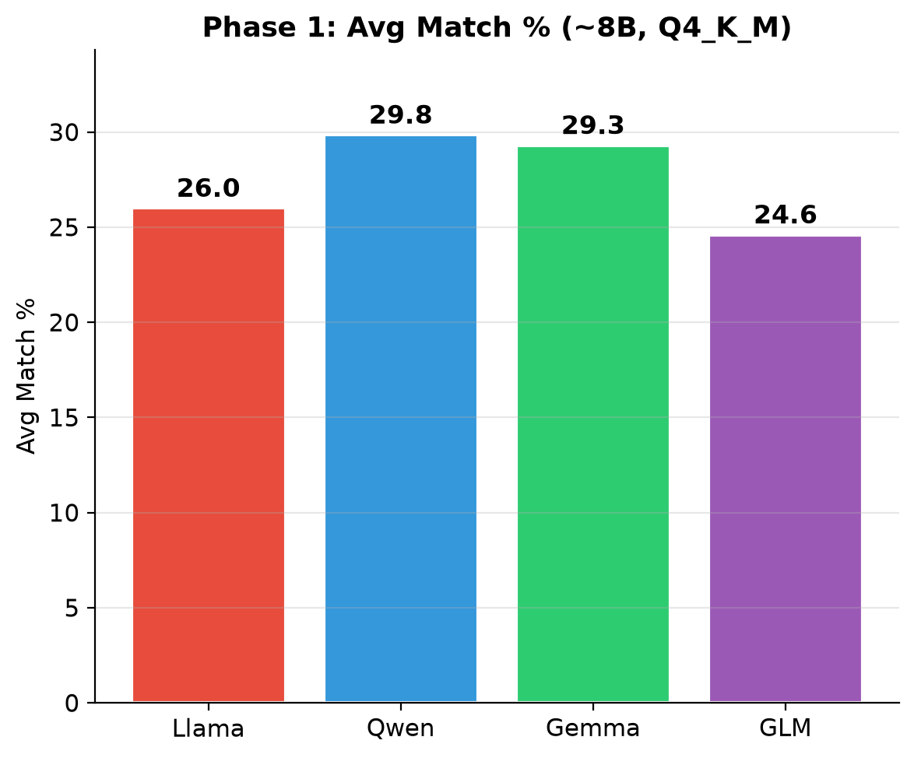
Figure 1: Phase 1 - average exact match by family (~8B, Q4_K_M).
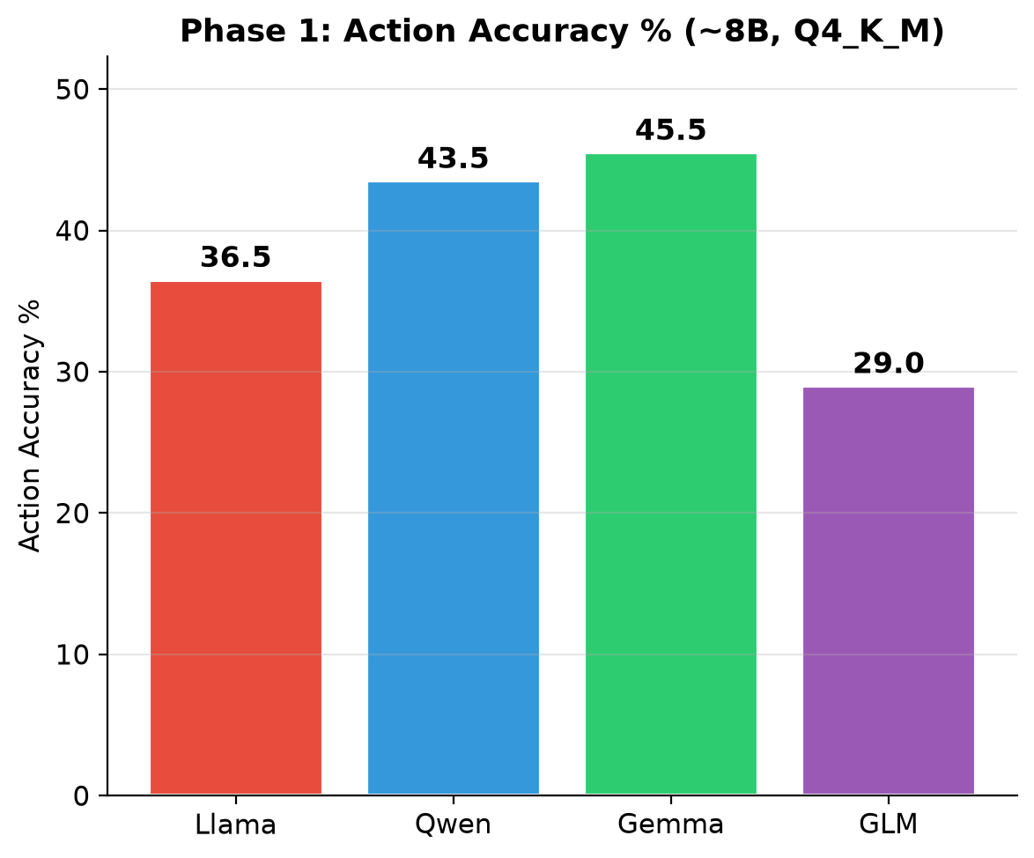
Figure 2: Phase 1 - action accuracy by family.
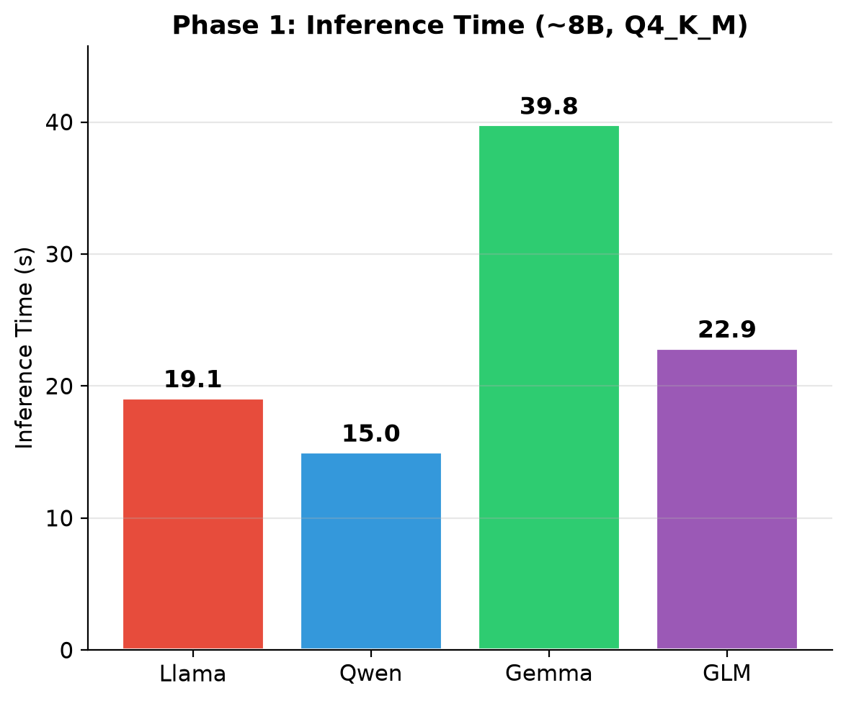
Figure 3: Phase 1 - inference time per intent by family.

4.2 Domain-Level Decomposition
Aggregate scores hide a stark, family-invariant difficulty structure. Table 2 decomposes action correctness by domain.
Table 2: Phase 1 - Action Correct by Domain (%).
Model | Slicing Provisioning | Scaling Request | Conflict Resolution
Qwen 2.5 7B | 100.0 | 18.6 | 6.7
Gemma 2 9B | 97.1 | 25.7 | 8.3
Llama 3.1 8B | 87.1 | 11.4 | 6.7
GLM-4 9B | 54.3 | 21.4 | 8.3
Mean across 4 | 84.6 | 19.3 | 7.5

• Slicing Provisioning (solved): mean 84.6%; the CREATE action with explicit QoS parameters maps cleanly to model capabilities.

• Scaling Request (challenging): mean 19.3%; models must interpret scaling direction, magnitude, and temporal context.

• Conflict Resolution (near-random): mean 7.5%; multi-constraint policy reasoning that ~8B SLMs demonstrably lack.
The hierarchy Provisioning >> Scaling >> Conflict holds for every family, indicating inherent task complexity rather than model-specific failure. Qwen's overall lead comes from being least-bad where the task is genuinely hard.

4.3 Complexity Robustness
Table 3 tracks exact match from Simple to Complex intents.
Table 3: Phase 1 - Exact Match by Complexity (%).
Model | Simple | Complex | Degradation (pp)
Qwen 2.5 7B | 46.7 | 20.4 | -26.3
Gemma 2 9B | 45.3 | 19.9 | -25.4
Llama 3.1 8B | 40.3 | 17.5 | -22.8
GLM-4 9B | 40.5 | 16.2 | -24.3
Exact match drops by 22.8-26.3 pp from Simple to Complex across all families - a fundamental limitation: current SLMs handle explicit single-parameter intents competently but degrade sharply when contextual inference or multi-constraint reasoning is required.

4.4 DeepSeek-R1: Diagnostic Case Study
DeepSeek-R1 8B, a reasoning-oriented model, produced 0.0% format accuracy across all 200 intents despite generating 51,200 tokens (6.2x the next-highest model). Root causes: (1) unbounded reasoning exhausts the 1024-token budget during the thinking phase, never reaching the answer; (2) the Ollama API splits thinking/content fields - joining and stripping <think> tags did not fix the underlying budget exhaustion; (3) on CPU the model exhibited unbounded thinking loops, once consuming 1,556% CPU for over 8 hours before manual termination. Implication: reasoning-oriented architectures are currently incompatible with CPU-only edge inference for latency-bounded applications.

4.5 Token Efficiency
Across non-reasoning Phase-1 models, token counts are remarkably consistent (8,028-8,452 tokens for 200 intents, 40-42 tokens/intent), suggesting architecture affects what tokens are generated more than how many. DeepSeek-R1's 51,200 tokens (256/intent) is a 6.2x overhead with zero useful output.

5. Phase 2: Size Scaling and Quantization Impact
Phase 2 asks: (1) how does Qwen 2.5 accuracy scale from 0.5B to 7B? and (2) how does quantization precision (Q2_K, Q4_K_M, Q8_0) affect the accuracy-efficiency trade-off at each size? All 12 configurations run under the instrumented v2 protocol with per-intent CPU, memory, and energy telemetry; every value carries a 95% CI over n = 200 intents.

5.1 Accuracy Scaling
Table 4: Phase 2 - Exact Match (%) by Size and Quantization [95% CI].
Size | Q2_K | Q4_K_M | Q8_0 | Q2->Q8 delta | Q4->Q8 gain
0.5B | 18.3 [14.9, 21.8] | 18.5 [15.0, 22.0] | 19.4 [16.0, 22.8] | +1.1 | +0.9
1.5B | 22.1 [18.4, 25.7] | 25.8 [21.9, 29.7] | 25.7 [21.6, 29.7] | +3.6 | -0.1
3.0B | 24.1 [20.3, 28.0] | 27.3 [23.2, 31.4] | 26.8 [22.7, 30.9] | +2.7 | -0.5
7.0B | 29.0 [24.9, 33.0] | 29.8 [25.8, 33.9] | 30.5 [26.3, 34.6] | +1.5 | +0.7
Mean | — | — | — | +2.2 | +0.3
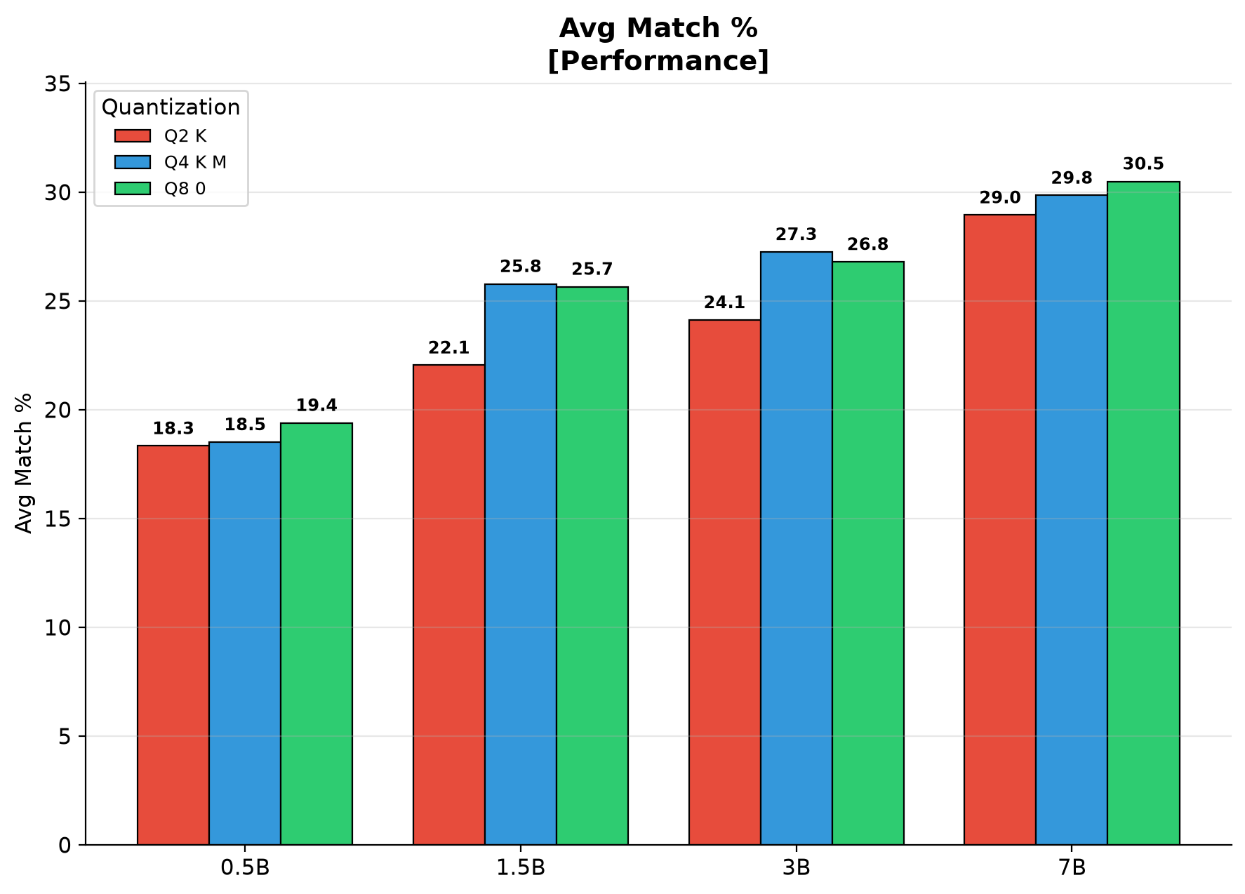
Figure 4: Phase 2 - average exact match by size, grouped by quantization level.

• Finding 1 - diminishing returns in size: the 3B Q4_K_M model achieves 91.6% of 7B accuracy (27.3% vs 29.8%) at 40% of the disk footprint, 60% of the energy, and 1.6x the speed - the efficiency sweet spot.

• Finding 2 - quantization sensitivity peaks at intermediate sizes: the Q2->Q8 gap is inverted-U (0.5B 1.1 pp, 1.5B 3.6 pp, 3B 2.7 pp, 7B 1.5 pp). When quantizing aggressively, prefer 0.5B or 7B over intermediate sizes.

• Finding 3 - Q4-to-Q8 negligible: the gap averages 0.3 pp across sizes, inside every CI - Q4_K_M is the sweet spot, statistically indistinguishable from Q8_0 at 30-55% smaller disk.

• Finding 4 - cross-size Pareto dominance: 7B Q2_K (29.0%) outperforms 3B Q8_0 (26.8%) at comparable disk, challenging the heuristic that higher-bit small models always beat lower-bit larger ones.

5.2 Inference Efficiency
Table 5: Phase 2 - Inference Time (s/intent) [95% CI] and Throughput (tokens/s).
Size | Q2_K Time | Q4_K_M Time | Q8_0 Time | Q2_K Tok/s | Q8_0 Tok/s
0.5B | 4.31 [3.91, 4.70] | 4.67 [4.30, 5.04] | 4.84 [4.45, 5.23] | 9.4 | 7.0
1.5B | 7.80 [5.45, 10.14] | 7.52 [6.98, 8.06] | 5.30 [4.95, 5.65] | 5.4 | 8.9
3.0B | 9.47 [8.86, 10.07] | 9.44 [8.81, 10.06] | 7.66 [7.10, 8.22] | 3.8 | 4.9
7.0B | 13.78 [12.74, 14.83] | 15.00 [13.87, 16.12] | 20.38 [18.94, 21.82] | 3.0 | 1.9
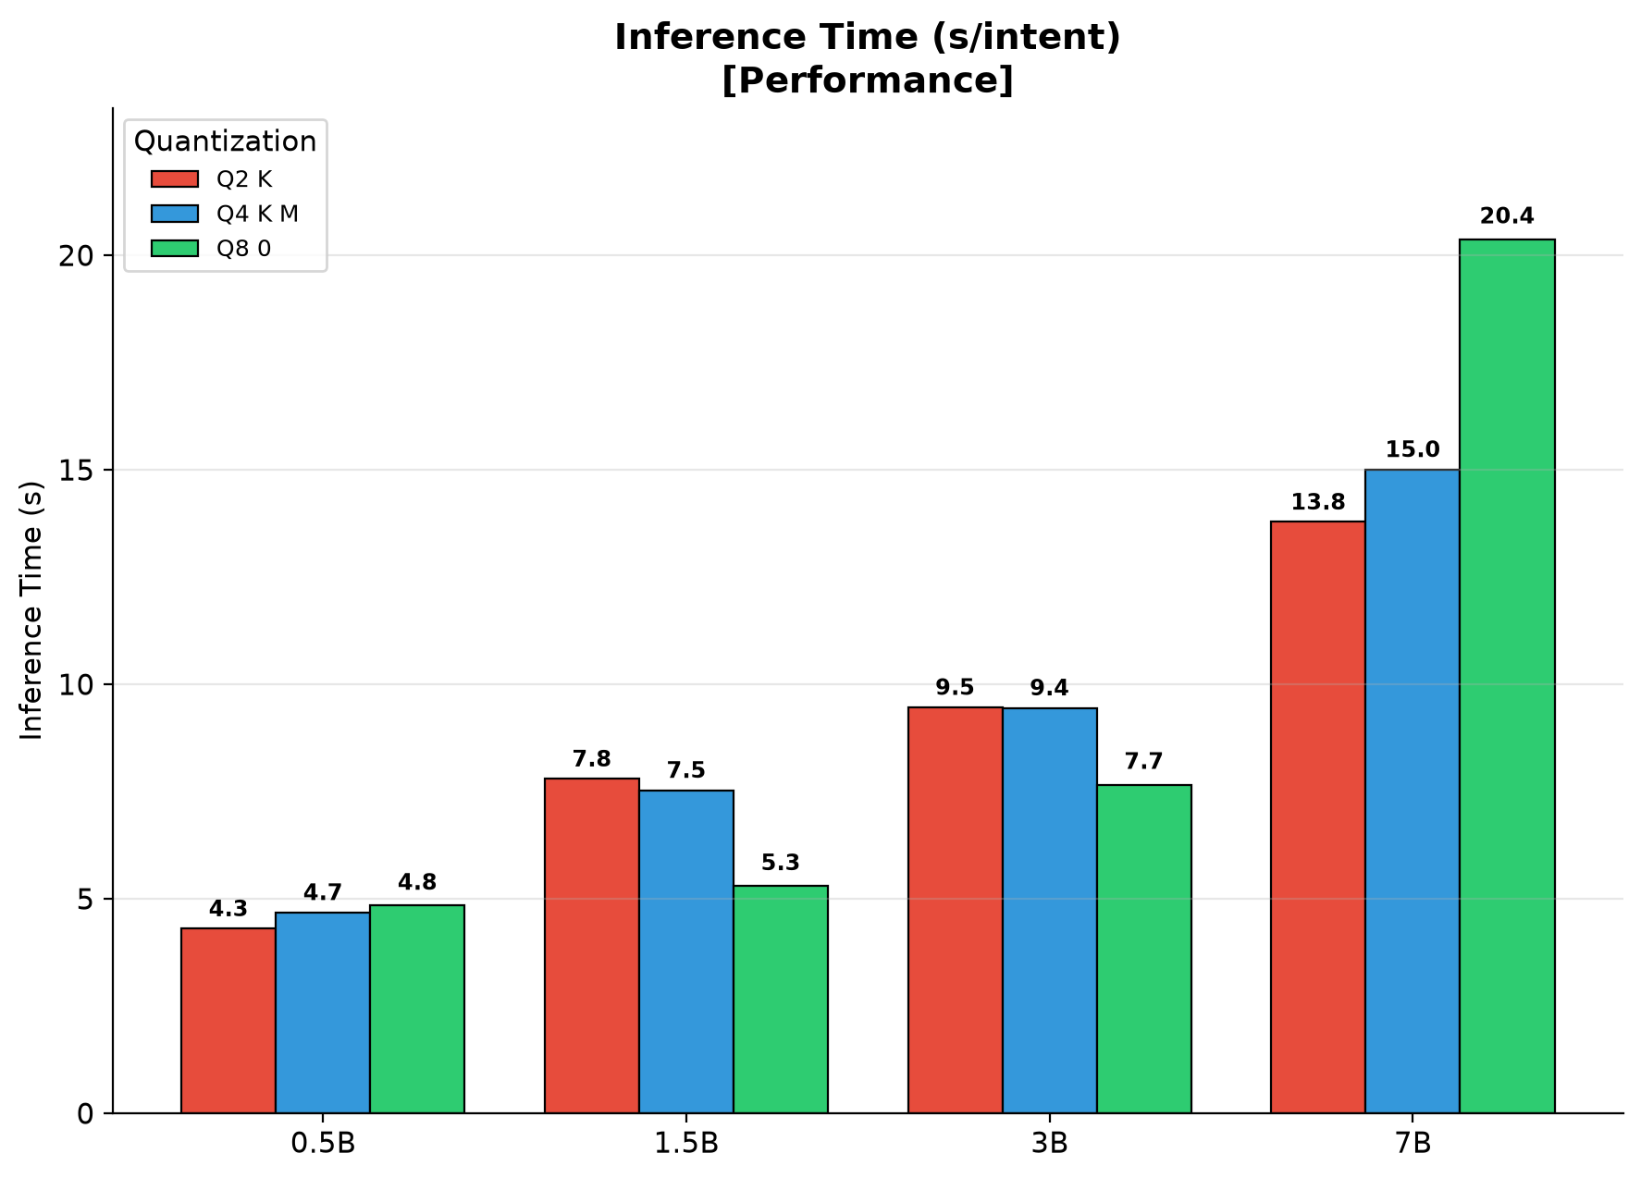
Figure 5: Phase 2 - inference time per intent by size and quantization.
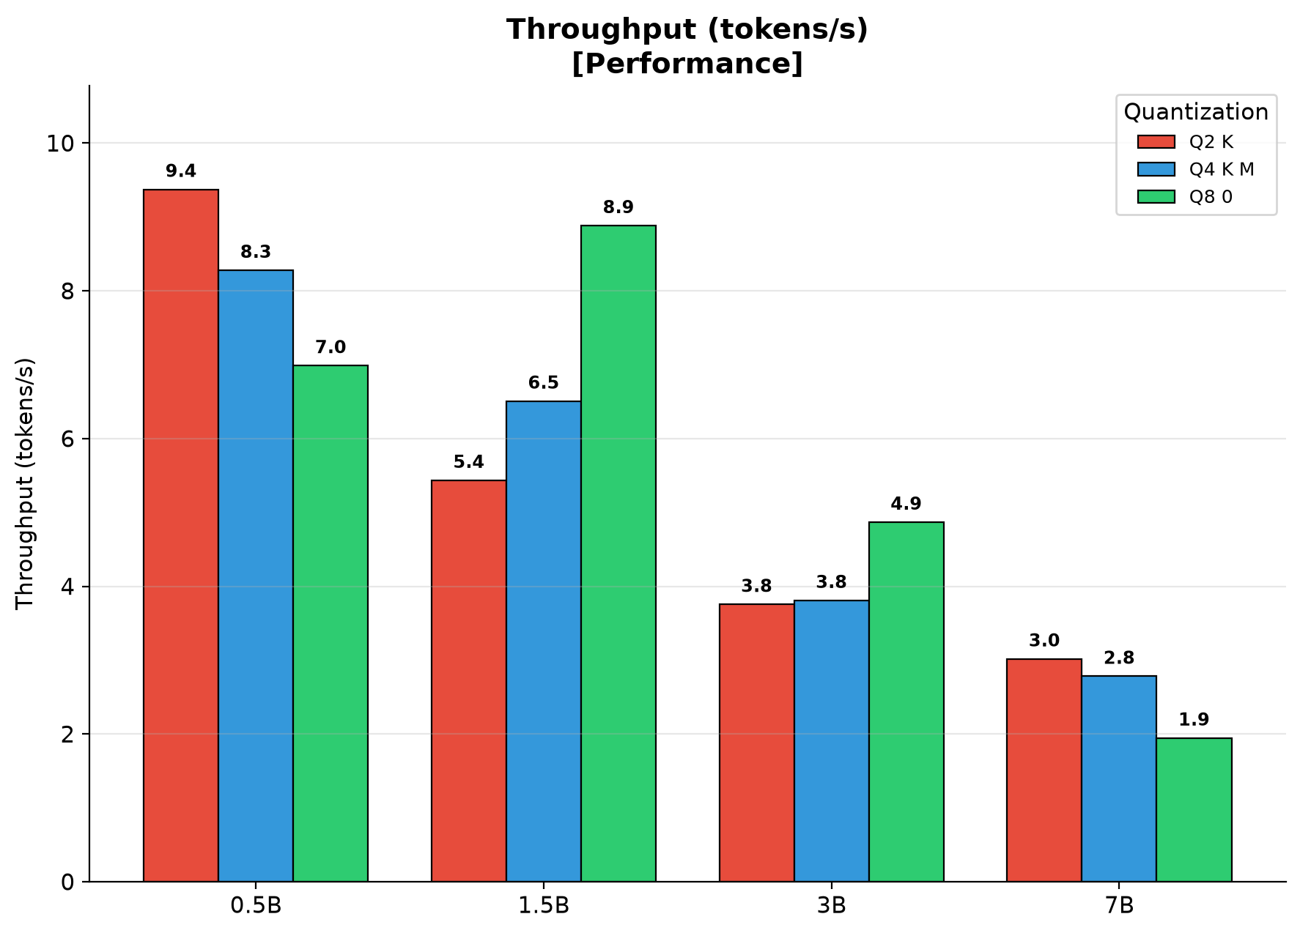
Figure 6: Phase 2 - decode throughput (tokens/s) by size and quantization.

• Finding 5 - quantization-speed crossover: at 1.5B-3B, Q8_0 is fastest (8-bit weights feed CPU SIMD directly), but at 7B, Q8_0 becomes slowest (20.4 s vs 15.0 s for Q4_K_M) because its 11.4 GB working set saturates memory bandwidth. The compute-to-bandwidth crossover lies between 3B and 7B on this hardware.

• Finding 6 - 0.5B efficiency ceiling: 0.5B inference times are nearly identical across quantization (4.3-4.8 s), dominated by fixed overhead rather than weight-dependent computation.

5.3 Format Accuracy
Format accuracy is high across all configurations (>=96%), rising with size; all 7B configurations reach 100.0%. Format compliance is not a differentiator at >=1.5B - accuracy, latency, and resource metrics are the primary decision variables.

5.4 Domain-Level Analysis
Table 7: Phase 2 - Action Correct by Domain (%) [selected configurations].
Configuration | Provisioning | Scaling | Conflict | Provisioning Exact
0.5B Q2_K | 44.3 | 14.3 | 11.7 | 31.2
0.5B Q8_0 | 40.0 | 22.9 | 13.3 | 31.5
1.5B Q4_K_M | 75.7 | 30.0 | 13.3 | 43.7
3.0B Q4_K_M | 100.0 | 22.9 | 8.3 | 52.4
7.0B Q2_K | 98.6 | 15.7 | 6.7 | 53.4
7.0B Q4_K_M | 100.0 | 18.6 | 6.7 | 55.2
7.0B Q8_0 | 100.0 | 21.4 | 5.0 | 56.5
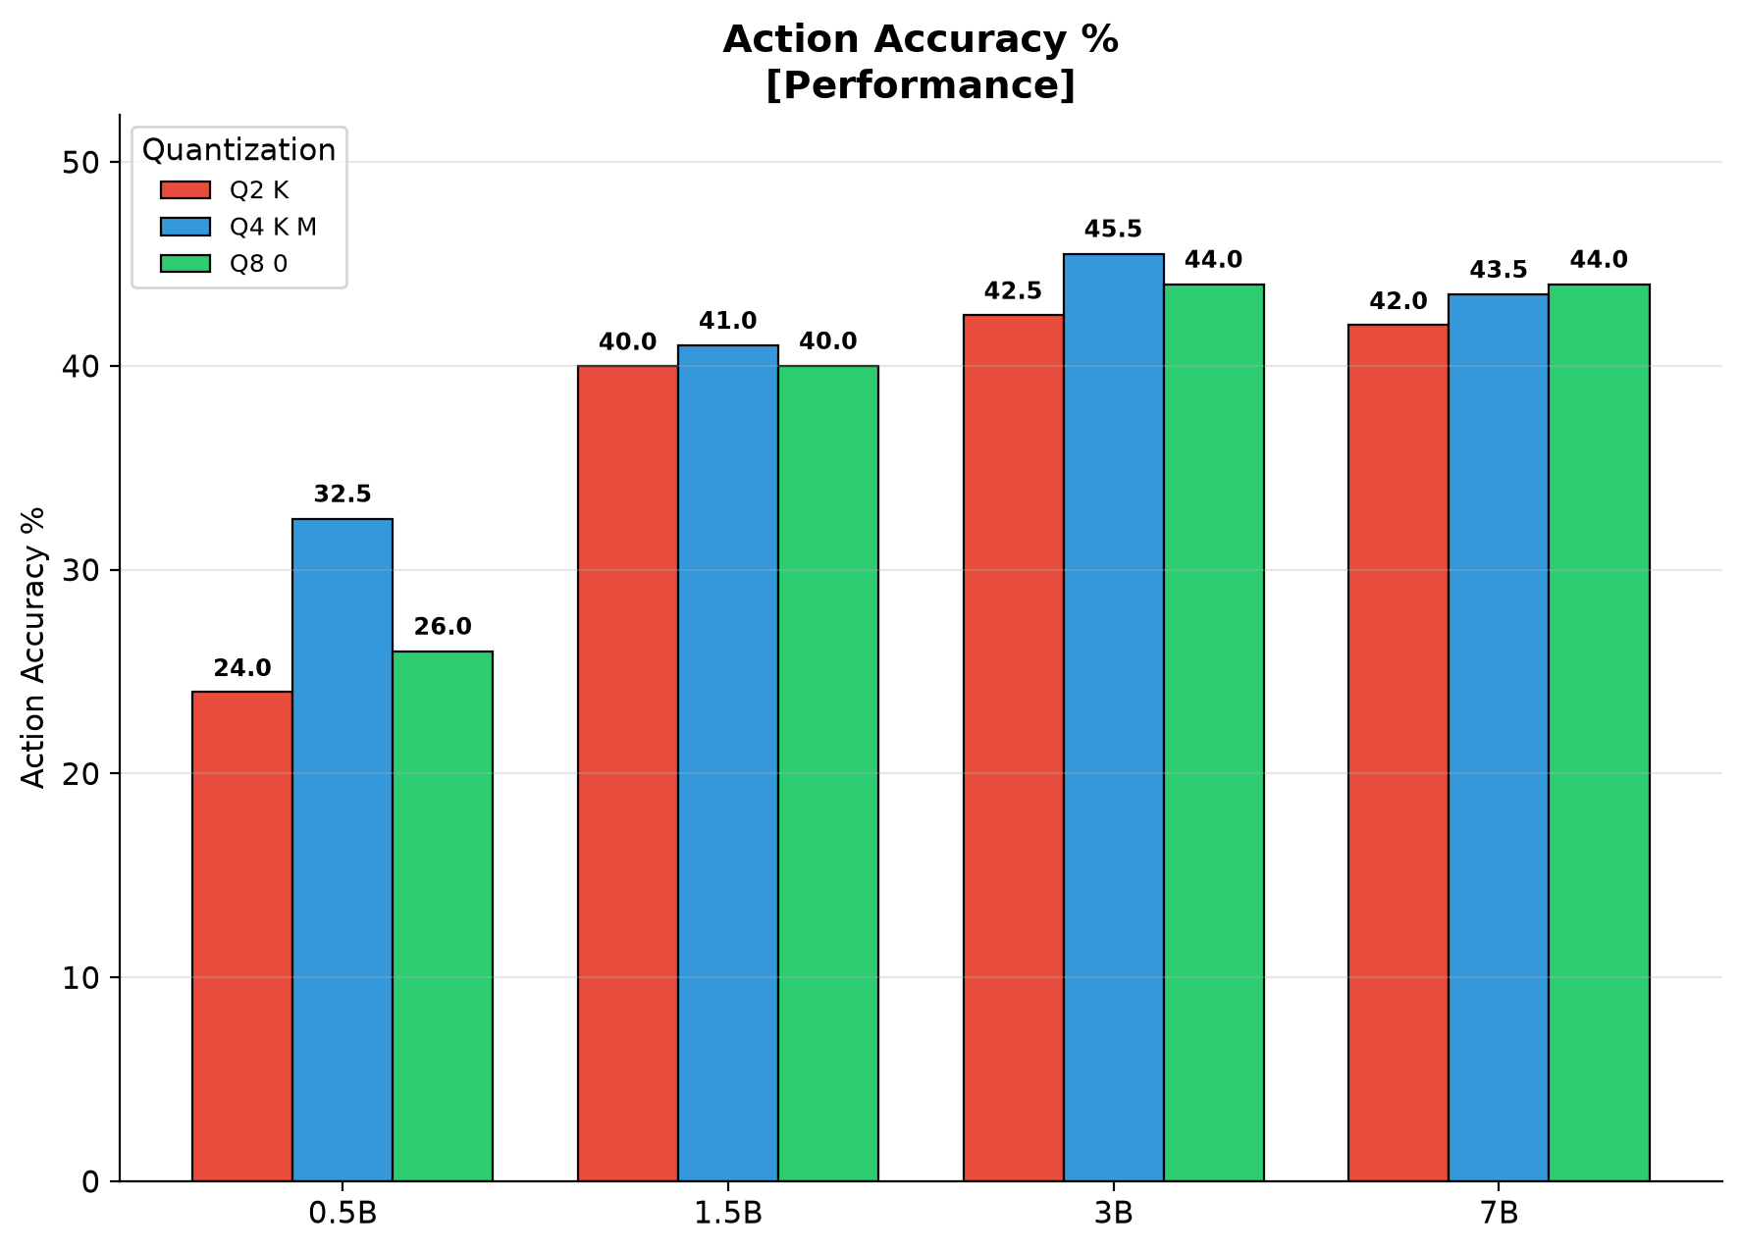
Figure 7: Phase 2 - action accuracy by size and quantization.

• Finding 7 - Provisioning scales rapidly with size: from 40-70% at 0.5B to ~76% at 1.5B and essentially solved (100%) at 3B; parameter-level exact match still climbs to 56.5% at 7B Q8_0.

• Finding 8 - Scaling and Conflict do not benefit from size: Scaling fluctuates 14-30% with no upward trend, and Conflict remains at 5-13%. Size scaling alone cannot address multi-step reasoning.

5.5 Complexity Robustness
Simple-to-Complex exact match drops by 22.7-28.2 pp across all 12 configurations - a fundamental difficulty boundary orthogonal to size and quantization. Encouragingly, Ambiguous-intent accuracy scales markedly with size (5-7% at 0.5B to 19-21% at 7B), while multi-constraint Conflict reasoning does not. This decoupling localizes the SLM reasoning gap to combinatorial constraint resolution rather than contextual inference generally.

5.6 Token Efficiency
Token generation per intent ranges from 34 (0.5B Q8_0) to 49 (1.5B Q4_K_M); the 1.5B tier is systematically the most verbose, partially explaining its latency profile. Total benchmark time ranges from 14.4 min (0.5B Q2_K) to 67.9 min (7B Q8_0) - a 4.7x range with direct operational implications.

5.7 Combined Pareto Analysis - the 3B Q4_K_M Sweet Spot
The headline result of Phase 2 is that a 3B model at 4-bit (Q4_K_M) quantization, not a 7B model, occupies the accuracy-efficiency sweet spot for slice-management action selection. Figure 8 plots all 12 (size x quantization) configurations against the two costs that matter on CPU-only edge hardware - peak memory and per-intent latency - with action-correctness on the vertical axis. Marker shape denotes model size and colour denotes quantization; the dashed line is the Pareto frontier and the gold ring marks 3B Q4_K_M.
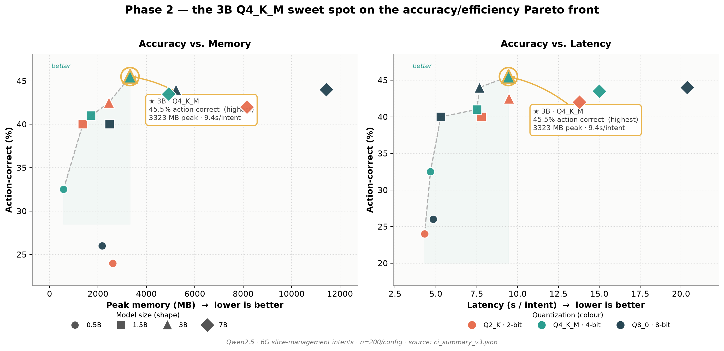
Figure 8: Phase 2 action-accuracy Pareto fronts. Left: action-correct vs peak memory; right: action-correct vs latency. 3B Q4_K_M (gold ring) is the frontier endpoint on both axes - it attains the highest action accuracy of any configuration while remaining cheaper and faster than every 7B variant.
Three facts make 3B Q4_K_M stand out (all n=200, from ci_summary_v3.json):

• Highest action accuracy of all 12 configurations: 45.5% action-correct, edging out 7B Q8_0 (44.0%), 7B Q2_K (42.0%), and 7B Q4_K_M (43.5%). Choosing the right slice operation - the decision that actually drives the orchestrator - peaks at 3B, not 7B.

• One-third the memory of large models: 3,323 MB peak resident memory, versus 4,922 MB for 7B Q4_K_M and 11,429 MB for 7B Q8_0. It fits comfortably in a <4 GB edge-node budget.

• Faster than every 7B config: 9.4 s/intent, about 1.6x faster than 7B Q4_K_M (15.0 s) and 2.2x faster than 7B Q8_0 (20.4 s).

• Consequently it dominates all three 7B variants on the memory and latency Pareto fronts: no 7B configuration is simultaneously more accurate, cheaper, and faster.
The one axis on which 7B still leads is parameter-level exact match (7B Q8_0 30.5% vs 3B Q4_K_M 27.3%) - i.e. filling in every optional field, not selecting the correct action. For closed-loop slice orchestration, where a correct CREATE/SCALE/RESOLVE decision matters more than exhaustive field completion, 3B Q4_K_M is therefore the recommended default; 7B is reserved for workflows that require maximal field-level completeness and can absorb 3x the memory and 1.6-2.2x the latency. Figures 9 and 10 give the single-axis views used on slides.
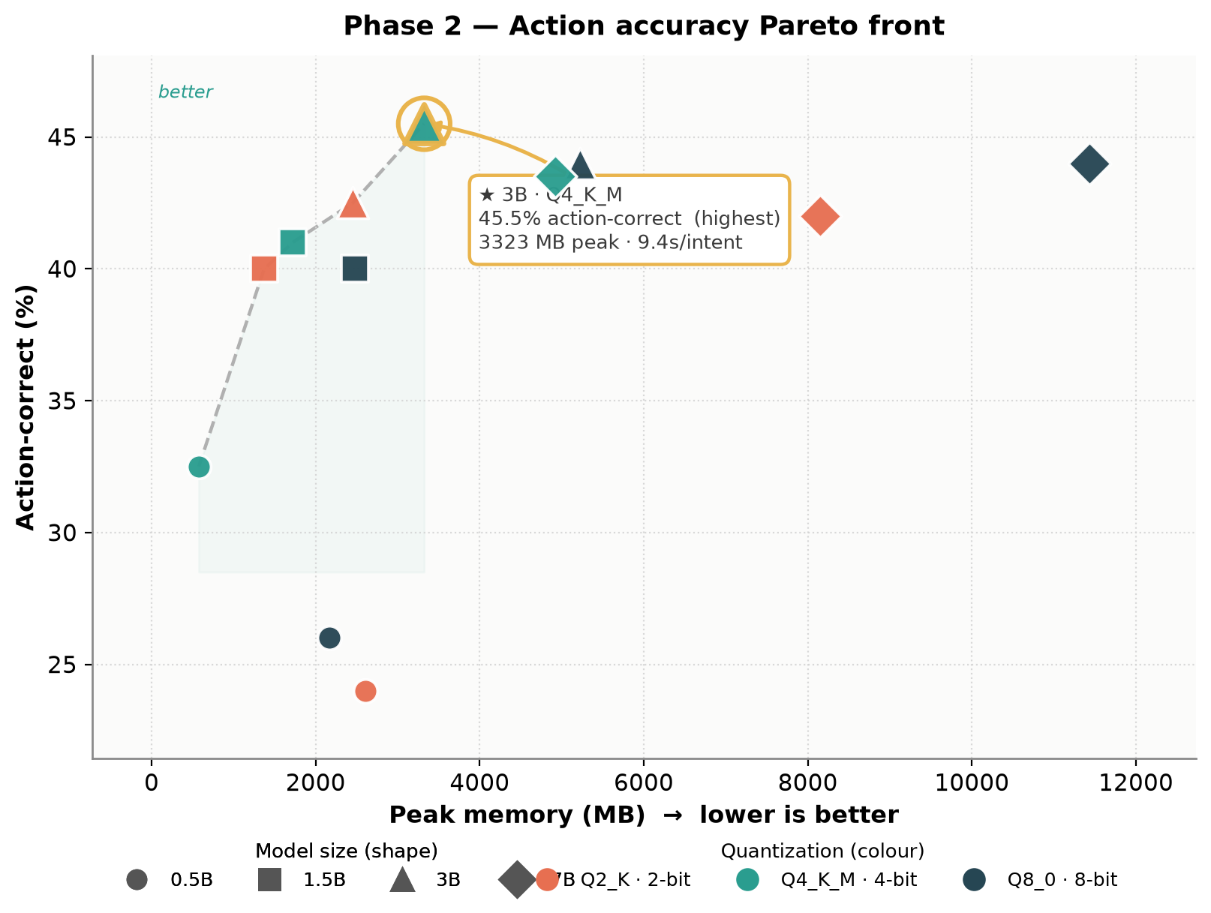
Figure 9: Action accuracy vs peak memory (standalone). 3B Q4_K_M sits at the top-right knee of the frontier - maximal accuracy at the lowest memory needed to reach it.
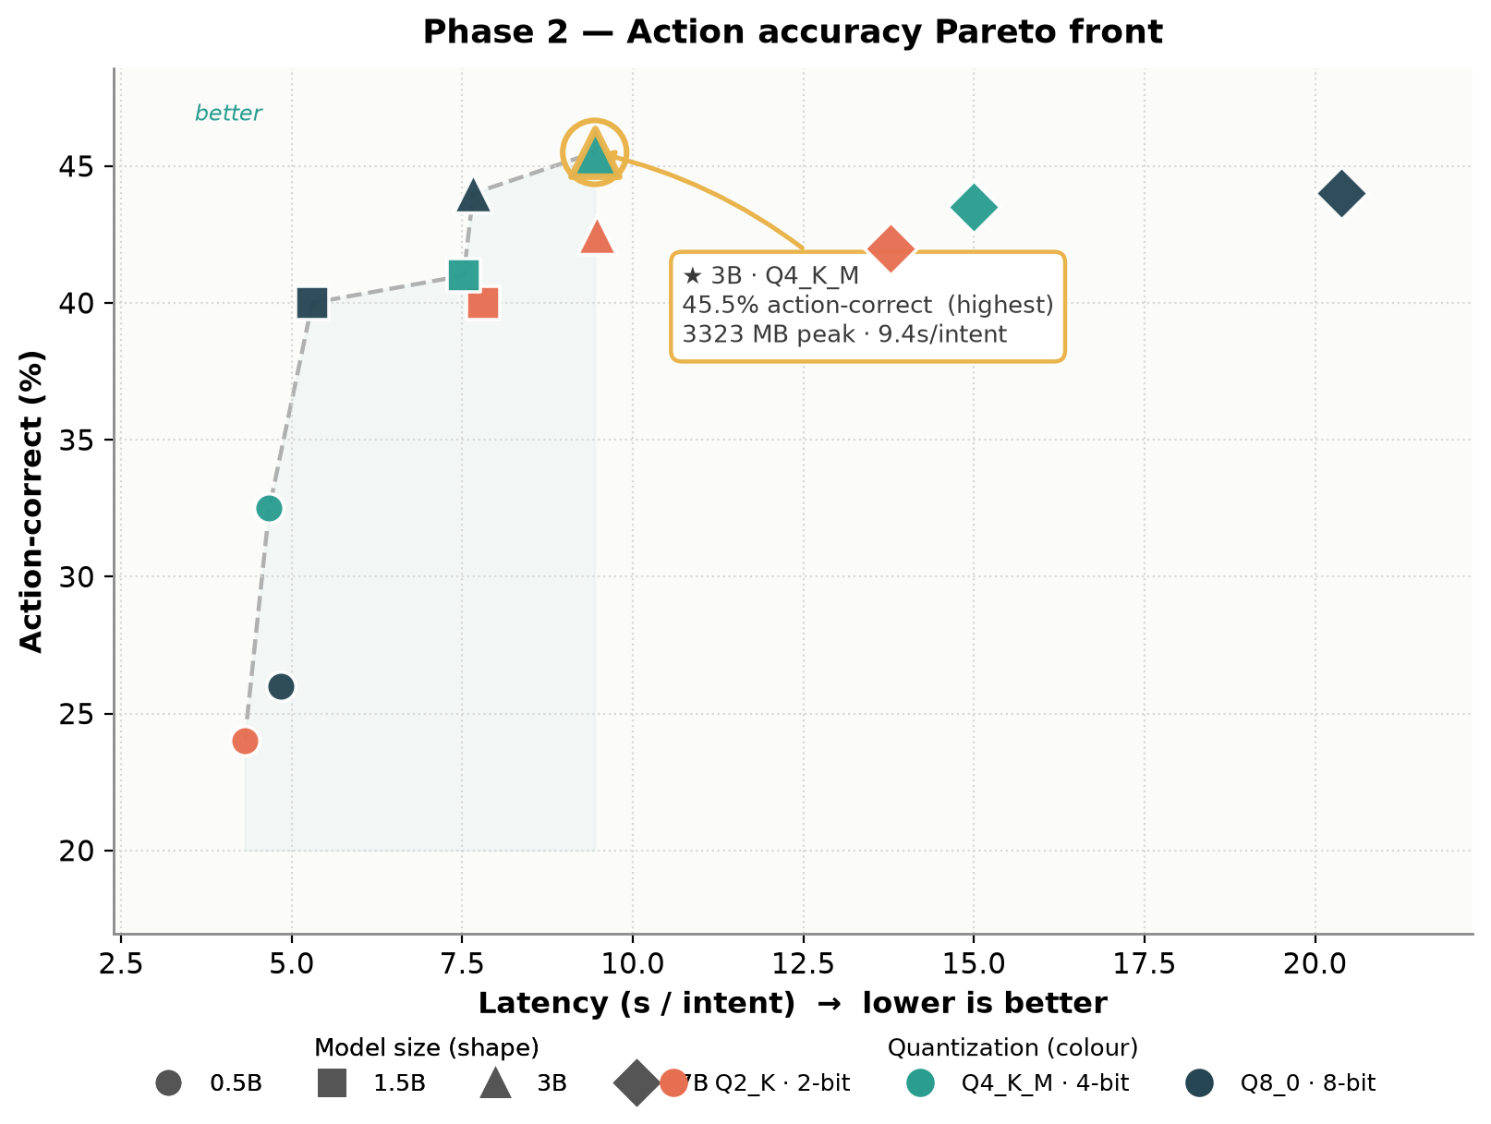
Figure 10: Action accuracy vs latency (standalone). All 7B configurations fall below and to the right of 3B Q4_K_M - slower without being more action-accurate.

5.8 Resource Consumption: CPU, Memory, and Energy
This section presents the per-intent resource telemetry - the principal addition of the instrumented re-run. Table 10 reports measured CPU utilization, peak resident memory, and derived energy for all 12 configurations.
Table 10: Phase 2 - Resource Telemetry [mean, 95% CI, n=200].
Configuration | CPU (%) | Peak RSS (MB) | Energy (J/intent) | Eff. (Match%/kJ)
0.5B Q2_K | 68.8 [67.0, 70.6] | 2,605 | 436 [384, 487] | 42.0
0.5B Q4_K_M | 69.1 [67.2, 71.1] | 575 | 477 [429, 525] | 38.8
0.5B Q8_0 | 71.6 [70.0, 73.3] | 2,166 | 505 [454, 555] | 38.4
1.5B Q2_K | 76.9 [75.3, 78.5] | 1,372 | 897 [592, 1,202] | 24.6
1.5B Q4_K_M | 80.6 [79.5, 81.8] | 1,720 | 850 [780, 920] | 30.4
1.5B Q8_0 | 83.1 [82.2, 84.1] | 2,480 | 611 [566, 656] | 42.1
3.0B Q2_K | 85.8 [85.1, 86.4] | 2,453 | 1,117 [1,037, 1,198] | 21.6
3.0B Q4_K_M | 86.1 [85.3, 87.0] | 3,323 | 1,122 [1,039, 1,205] | 24.3
3.0B Q8_0 | 88.4 [87.8, 89.1] | 5,225 | 931 [857, 1,005] | 28.8
7.0B Q2_K | 91.2 [90.8, 91.6] | 8,149 | 1,719 [1,580, 1,857] | 16.9
7.0B Q4_K_M | 91.9 [91.4, 92.3] | 4,922 | 1,884 [1,734, 2,034] | 15.8
7.0B Q8_0 | 94.1 [93.8, 94.5] | 11,429 | 2,613 [2,420, 2,806] | 11.7
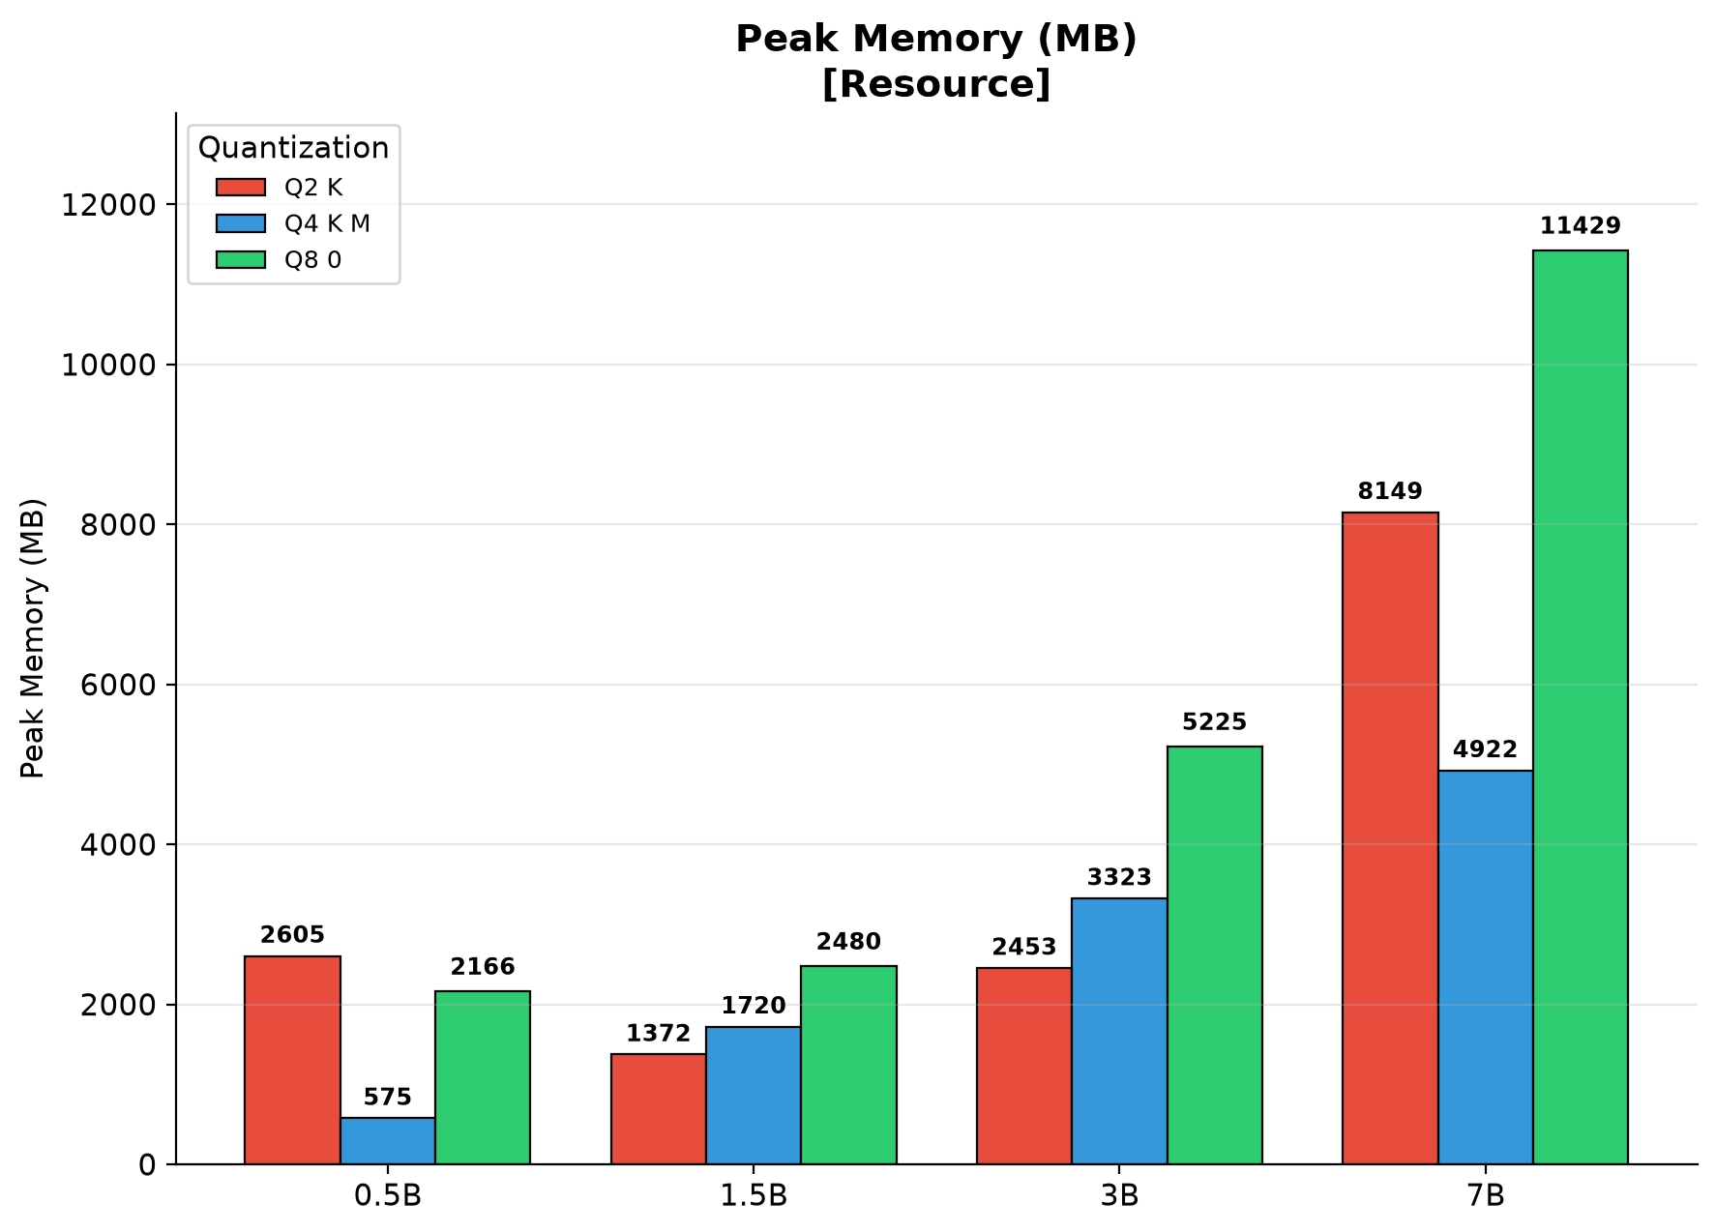
Figure 11: Phase 2 - peak resident memory by size and quantization.
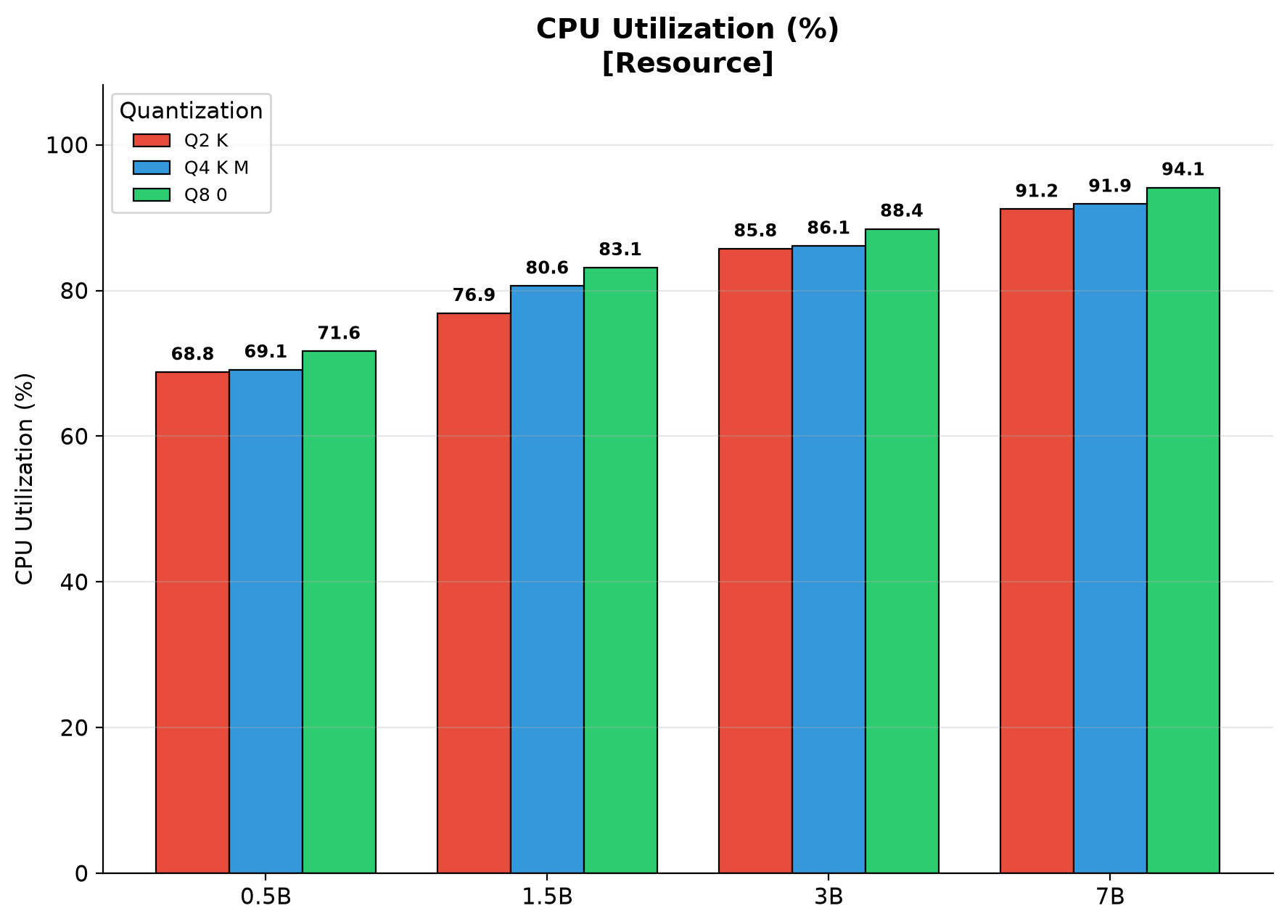
Figure 12: Phase 2 - measured CPU utilization by size and quantization.
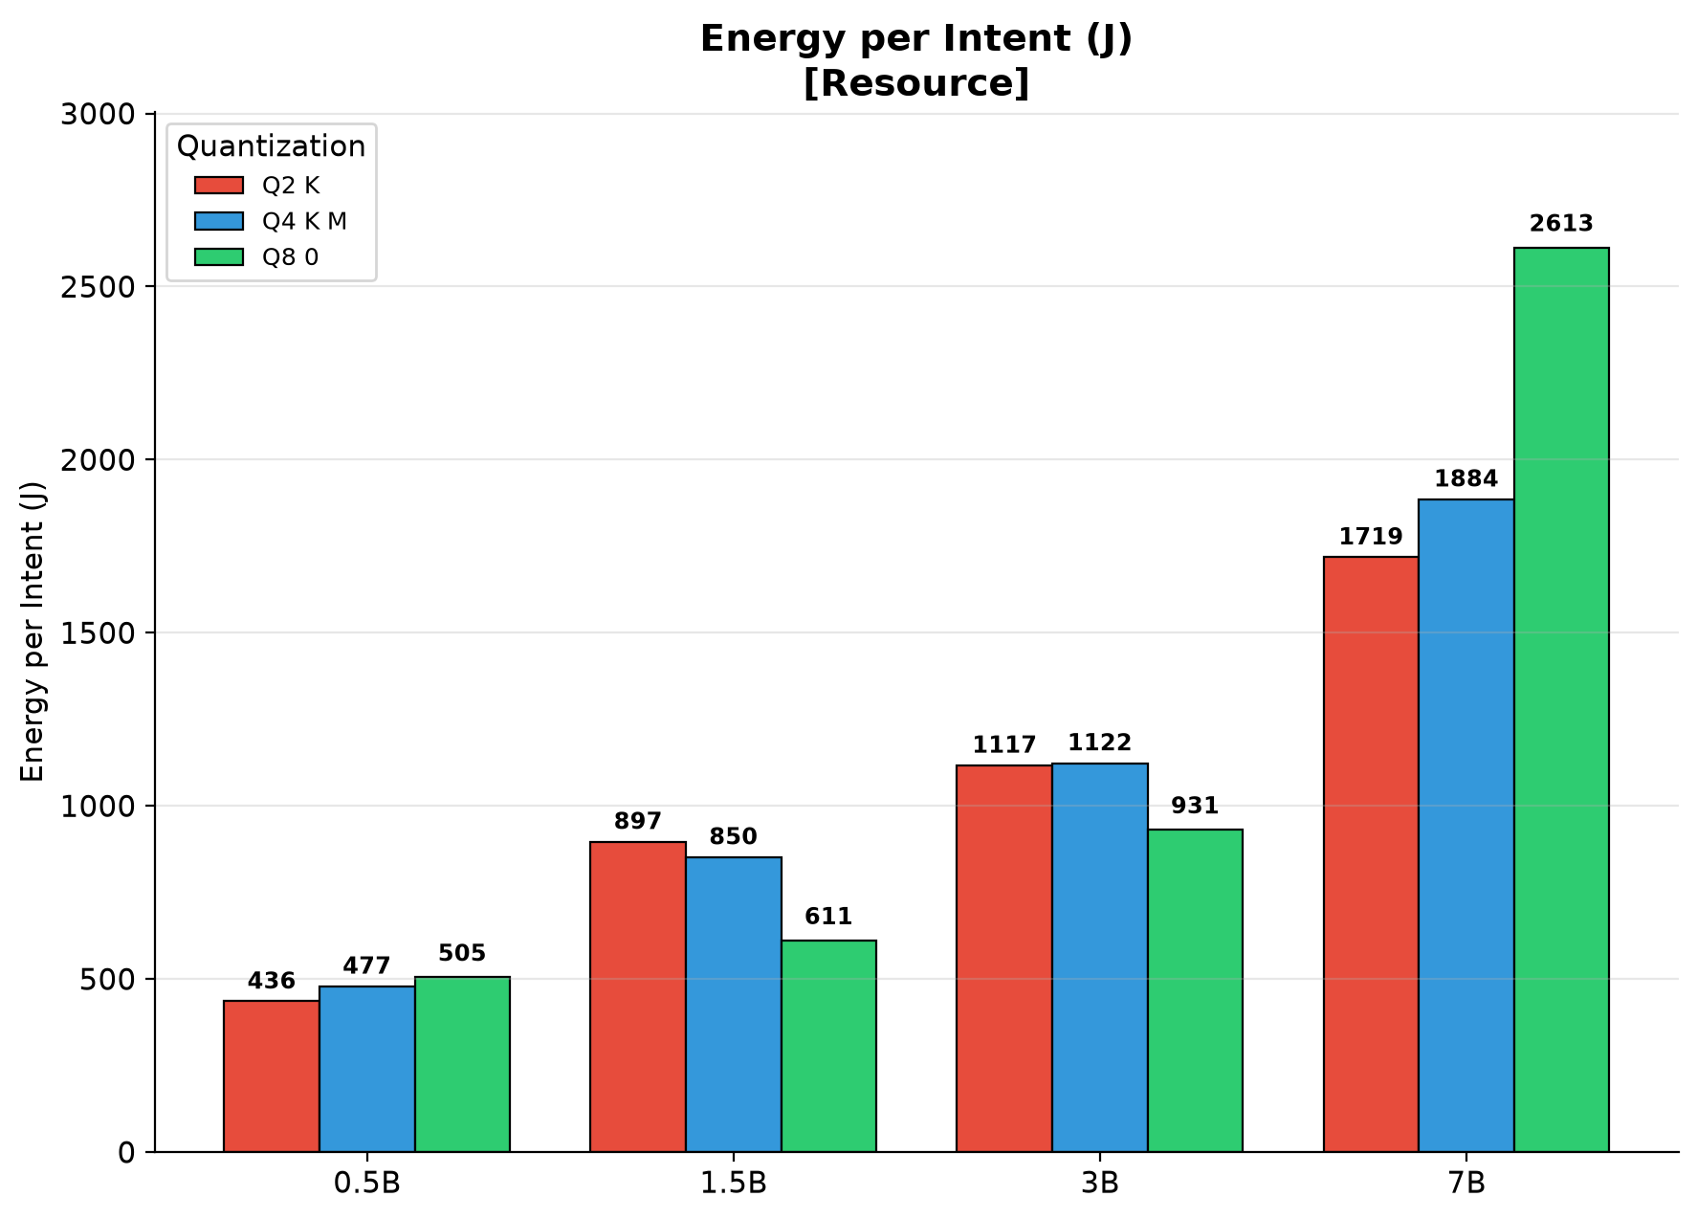
Figure 13: Phase 2 - energy per intent by size and quantization.

• Finding 9 - CPU utilization scales with size (69% to 94%): direct evidence of the memory bandwidth bottleneck. Small models cannot keep 16 cores busy; as parameter count grows, weight streaming dominates and utilization asymptotes toward saturation. Higher-precision variants show higher utilization within each size class, corroborating the bandwidth interpretation.

• Finding 10 - flat-utilization models overestimate small models: measured-utilization energy is 15-25% lower for 0.5B configurations than a naive 95%-of-TDP model (e.g. 0.5B Q4_K_M: 477 J vs 599 J). This bias compounds into overprovisioned power and cooling budgets at fleet scale.

• Finding 11 - energy efficiency inverts the accuracy ranking: as Match%/kJ, 1.5B Q8_0 (42.1) and the 0.5B tier (38-42) lead, while the accuracy-leading 7B tier is 2.5-3.6x less efficient. Moving from 1.5B Q8_0 to 7B Q8_0 buys +4.8 pp exact match at 4.3x the energy.

• Finding 12 - memory footprint, not disk size, is the constraint: peak RSS spans 575 MB to 11.4 GB. 7B Q8_0 exceeds the 8 GB envelope of typical far-edge nodes, whereas 7B Q4_K_M (4.9 GB) fits comfortably - a further argument for Q4_K_M as the default precision.

6. Discussion

6.1 Deployment Guidelines for 6G Edge
Our results support the following decision framework, incorporating measured energy and memory:
Deployment Scenario | Recommended Config | Rationale
Maximum accuracy, relaxed latency (>20 s) | Qwen 2.5 7B, Q8_0 | 30.5% exact match; requires >11 GB RAM and 2.6 kJ/intent
Balanced accuracy-speed (production default) | Qwen 2.5 7B, Q4_K_M | 29.8% at 15.0 s, 4.9 GB RAM, 28% less energy than Q8_0
Memory-constrained edge (<5 GB) | Qwen 2.5 7B Q2_K or 3B Q4_K_M | 29.0% / 27.3%; Q2_K trades 0.8 pp for lower footprint
Best action selection / efficiency sweet spot (<4 GB, fast) | Qwen 2.5 3B, Q4_K_M | 45.5% action-correct (highest of all 12), 3,323 MB, 9.4 s - beats every 7B config on action accuracy while ~1.6x faster and ~1/3 the memory
Energy-capped / sustainability-first | Qwen 2.5 1.5B, Q8_0 | 25.7% at 5.3 s and 611 J; best Match%/kJ of all 12 configs
Ultra-low-latency (<5 s target) | Qwen 2.5 0.5B, Q8_0 | 19.4% at 4.8 s; best accuracy under 5 s
Provisioning-only workloads | Qwen 2.5 3B, Q4_K_M | 100% action correct on Provisioning at 3.3 GB RAM

6.2 Cross-Family Selection

• Qwen 2.5 7B is the unambiguous accuracy-speed leader at ~8B.

• Llama 3.1 8B is a strong alternative with identical format compliance and competitive speed, suitable when Llama ecosystem compatibility is prioritized.

• Gemma 2 9B should be considered only when action prediction (45.5%) is the primary metric and latency is relaxed (>30 s acceptable).

• GLM-4 9B is not recommended for English network orchestration without prompt adaptation.

• DeepSeek-R1 and reasoning-oriented architectures should be avoided for CPU-only edge deployment pending resolution of unbounded token generation.

6.3 Limitations and Future Work
Energy is derived from measured CPU utilization x TDP x time (RAPL is unavailable inside Proxmox KVM guests); absolute joule values retain ~±15% uncertainty. All experiments are CPU-only; a GPU replication would shift the Pareto frontier. Results reflect one prompt design; the 200-intent dataset covers three domains but not fault/optimization/security intents; all models are zero-shot (no fine-tuning); and each intent is evaluated once (across-intent CIs, not across-run). Multi-seed replication, prompt-robustness analysis, and domain-specific fine-tuning are high-priority directions.

7. Conclusion
This paper presented the first systematic, multi-dimensional empirical evaluation of SLMs for intent-driven slice lifecycle management in 6G core networks, with per-intent resource telemetry and 95% CIs across 16 model configurations and 3,200+ instrumented inferences. We identified:

• Architecture matters more than size at ~8B: Qwen 2.5 7B outperforms geo-diverse competitors by 0.5-5.2 pp exact match while being 1.3-2.7x faster.

• CPU utilization scales with size (69% to 94%), empirically confirming memory bandwidth as the binding constraint and invalidating flat-utilization energy models (15-25% small-model overestimate).

• 3B is the efficiency sweet spot (92% of 7B accuracy at 40% disk, 60% energy, 1.6x speed); 1.5B Q8_0 is the energy-efficiency champion (42 Match%/kJ).

• Aggressive quantization can outperform larger high-bit models (7B Q2_K > 3B Q8_0); Q4_K_M is statistically indistinguishable from Q8_0 at every size, making 4-bit the default.

• The fastest quantization level is size-dependent, with the compute-to-bandwidth crossover between 3B and 7B on edge-class CPUs.

• Domain difficulty spans an order of magnitude (Provisioning solved, Conflict near-random); Ambiguous accuracy triples with scale while Conflict does not, localizing the reasoning gap to combinatorial constraint resolution.

• Complexity robustness is a universal weakness (23-28 pp Simple->Complex drop at every scale).

• Reasoning models are not edge-ready: DeepSeek-R1's CPU failure cautions that architectural innovations must be validated on deployment-hardware targets, not just GPU benchmarks.

Data Availability
All experimental data (instrumented resource_v3 re-run), benchmark code (benchmark_runner_v2.py with psutil telemetry and CI computation), and the 13 figures in this edition (regenerated by scripts/visualize_paper_v3.py) are available in the project repository (github.com/bottle-kung/empirical-benchmarking-slm-agents-6g-slice-management, branch v2). The 200 annotated intents are in dataset/intents.jsonl. See paper/DATA_TIMELINE.md for full data provenance.

