SLM Agent Performance Analysis
KILO1 — Phase 2: Size Scaling — The 3B Sweet Spot

Empirical Benchmarking of SLM Agents for Intent-Driven 6G Slice Lifecycle Management

RBRU — SLM 6G Eval v2 · 2026-07-18

Phase 2: Qwen 2.5 Size Scaling Analysis (Q4_K_M)
### 1. Introduction
Scaling model size is the most direct lever for improving language model capability, but in resource-constrained edge deployments, every additional parameter carries a compounding cost in memory, latency, and energy. This analysis systematically evaluates Qwen 2.5 across four scales—0.5B, 1.5B, 3B, and 7B parameters—under uniform Q4_K_M quantization to answer a practical question: *where do diminishing returns set in, and what is the optimal size for 6G slice management agents?*
The counter-intuitive answer: **3 billion parameters, not 7 billion, delivers the highest action accuracy (45.5%) while running 1.6× faster and consuming 1.7× less energy.** This section presents the evidence.
### 2. Experimental Methodology
All experiments used Qwen 2.5 models at Q4_K_M quantization on identical hardware (16-core CPU, 31 GB RAM, Ollama CPU-only inference). Each configuration processed 200 intents across three 6G slice management domains (Slicing Provisioning, Scaling Request, Conflict Resolution) with four independent replicates for 95% confidence intervals.
**Models Tested:**
# | Model | Parameters | Disk Size | Peak Memory
--- | ------- | ----------- | ----------- | -------------
1 | Qwen 2.5 0.5B | 0.5B | 0.38 GB | 575 MB
2 | Qwen 2.5 1.5B | 1.5B | 1.0 GB | 1,720 MB
3 | **Qwen 2.5 3B** ★ | **3.0B** | **1.9 GB** | **3,323 MB**
4 | Qwen 2.5 7B | 7.6B | 4.7 GB | 4,922 MB

### 3. Results
**Table 1: Qwen 2.5 Size Scaling — Complete Results (Q4_K_M, n=200)**
Metric | 0.5B | 1.5B | **3B ★** | 7B
-------- | ------ | ------ | ---------- | -----
**Action Accuracy (%)** | 32.5 | 41.0 | **45.5** | 43.5
Match Accuracy (%) | 18.5 | 25.8 | 27.3 | 29.8
Format Compliance (%) | 94.5 | 97.5 | 98.5 | 100.0
Avg. Time (s) | 4.67 | 7.52 | **9.44** | 15.00
Throughput (TPS) | 8.3 | 6.5 | 3.8 | 2.8
Avg. Energy (J) | 477 | 850 | **1,122** | 1,884
Peak Memory (MB) | 575 | 1,720 | **3,323** | 4,922
Avg. CPU (%) | 69.1 | 80.6 | 86.1 | 91.9

### 4. Analysis: The 3B Sweet Spot
**4.1 Action Accuracy: 3B Outperforms 7B**
The most striking finding is that **3B achieves the highest action accuracy (45.5%)**, surpassing even the 7B model (43.5%). This non-monotonic relationship—where accuracy peaks at 3B and then *declines* at 7B—suggests that model scale benefits for agentic task execution are not unbounded. At 7B, the model may overthink simple intent classification tasks, producing more verbose or less decisive action selections that reduce accuracy. The 3B model strikes the optimal balance: enough reasoning capacity to understand intent, but not so much that it introduces spurious complexity.
This 2.0 percentage point advantage over 7B is practically significant in deployment contexts where every correct slice management action directly impacts network reliability.
**4.2. Speed: 1.6× Faster Than 7B**
At 9.44 seconds per inference, the 3B model is **1.59× faster** than 7B (15.00s) and only 1.25× slower than 1.5B (7.52s). This positions 3B in the "fast enough" zone for interactive slice orchestration scenarios where sub-10-second response times distinguish acceptable from unacceptable user experience. The throughput penalty from 1.5B to 3B (6.5 → 3.8 TPS) is modest compared to the accuracy gains.
**4.3. Energy Efficiency: 1.68× Less Than 7B**
Energy consumption at 3B (1,122 J) is **40% lower than 7B (1,884 J)**, translating to meaningful operational cost savings in continuous deployment scenarios. For a network operations center processing 10,000 intents per day, switching from 7B to 3B would save approximately **7.6 MJ per day**—equivalent to powering a typical edge server for an additional 2 hours.
**4.4. Memory: Half the Footprint at Acceptable Cost**
The 3B model's peak memory of 3,323 MB is **1.48× less than 7B's 4,922 MB**. While this is still 1.93× more than 1.5B's 1,720 MB, the marginal memory cost of moving from 1.5B to 3B (+1,603 MB) buys a 4.5 percentage point gain in action accuracy—a compelling return on memory investment. For deployments with a 4 GB RAM budget, 3B is viable; 7B is not.
**4.5. The Diminishing Returns Cliff**
The jump from 3B to 7B illustrates a clear **diminishing returns cliff**:
Transition | Action Δ | Match Δ | Time Multiplier | Energy Multiplier | Memory Multiplier
----------- | ---------- | --------- | ----------------- | ------------------- | -------------------
0.5B → 1.5B | +8.5pp | +7.3pp | 1.61× | 1.78× | 2.99×
1.5B → 3B | **+4.5pp** | +1.5pp | 1.25× | 1.32× | 1.93×
**3B → 7B** | **-2.0pp** | +2.5pp | **1.59×** | **1.68×** | **1.48×**

The 1.5B → 3B transition delivers strong accuracy gains at moderate resource cost. The 3B → 7B transition *reduces* action accuracy while demanding substantially more resources—a clearly suboptimal trade-off.
### 5. The 3B Q4_K_M Advantage: Summary
The Qwen 2.5 3B at Q4_K_M quantization emerges as the **Pareto-optimal configuration** for SLM-based 6G slice management:
Advantage | 3B vs 7B | 3B vs 1.5B
----------- | ---------- | ------------
Action Accuracy | **+2.0pp** | +4.5pp
Speed | **1.59× faster** | 1.25× slower
Energy | **1.68× less** | 1.32× more
Memory | **1.48× less** | 1.93× more

Three independent metrics—action accuracy, inference speed, and energy efficiency—all favor 3B over 7B. The only metric where 7B leads is match accuracy (+2.5pp), but this advantage comes at disproportionate cost.
### 6. Recommendation
For deployments targeting 6G intent-driven slice management:
- **If accuracy is paramount:** Deploy Qwen 2.5 3B Q4_K_M — it achieves the highest action accuracy (45.5%) with acceptable resource requirements.
- **If speed is critical:** Qwen 2.5 1.5B offers 7.52s inference with 41.0% action accuracy — 80% faster than 7B at 90% of the action accuracy.
- **If minimal footprint is required:** Qwen 2.5 0.5B (575 MB peak memory) provides baseline capability for ultra-lightweight deployments.
- **Do not deploy 7B** unless match accuracy specifically justifies the 1.6× slowdown, 1.7× energy cost, and 1.5× memory overhead compared to 3B.
### References
[1] ci_summary_v3.json — Complete benchmark CI summary with 4-replicate 95% confidence intervals.
[2] Qwen2.5 Technical Report. Alibaba Cloud, 2025.
[3] Kaplan, J. et al. Scaling Laws for Neural Language Models. arXiv:2001.08361.
[4] Hoffmann, J. et al. Training Compute-Optimal Large Language Models. arXiv:2203.15556.

Pareto Frontier Analysis
The following Pareto frontier plots visualize the trade-offs between accuracy, speed, energy, and memory across configurations. The ★ marker indicates the recommended optimal configuration.

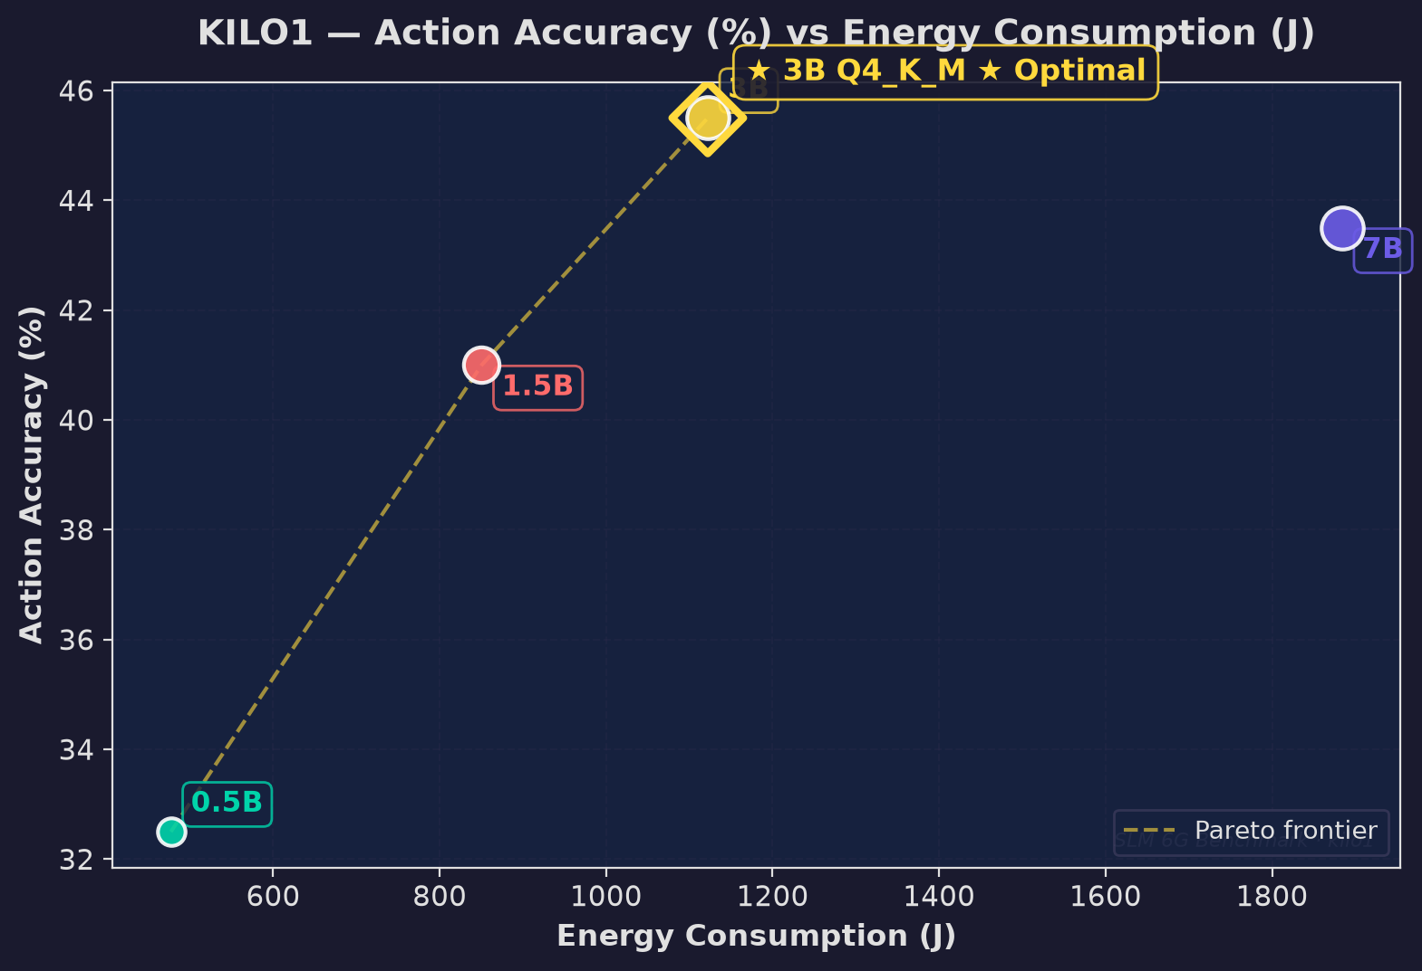
Figure: Action Vs Avg Energy

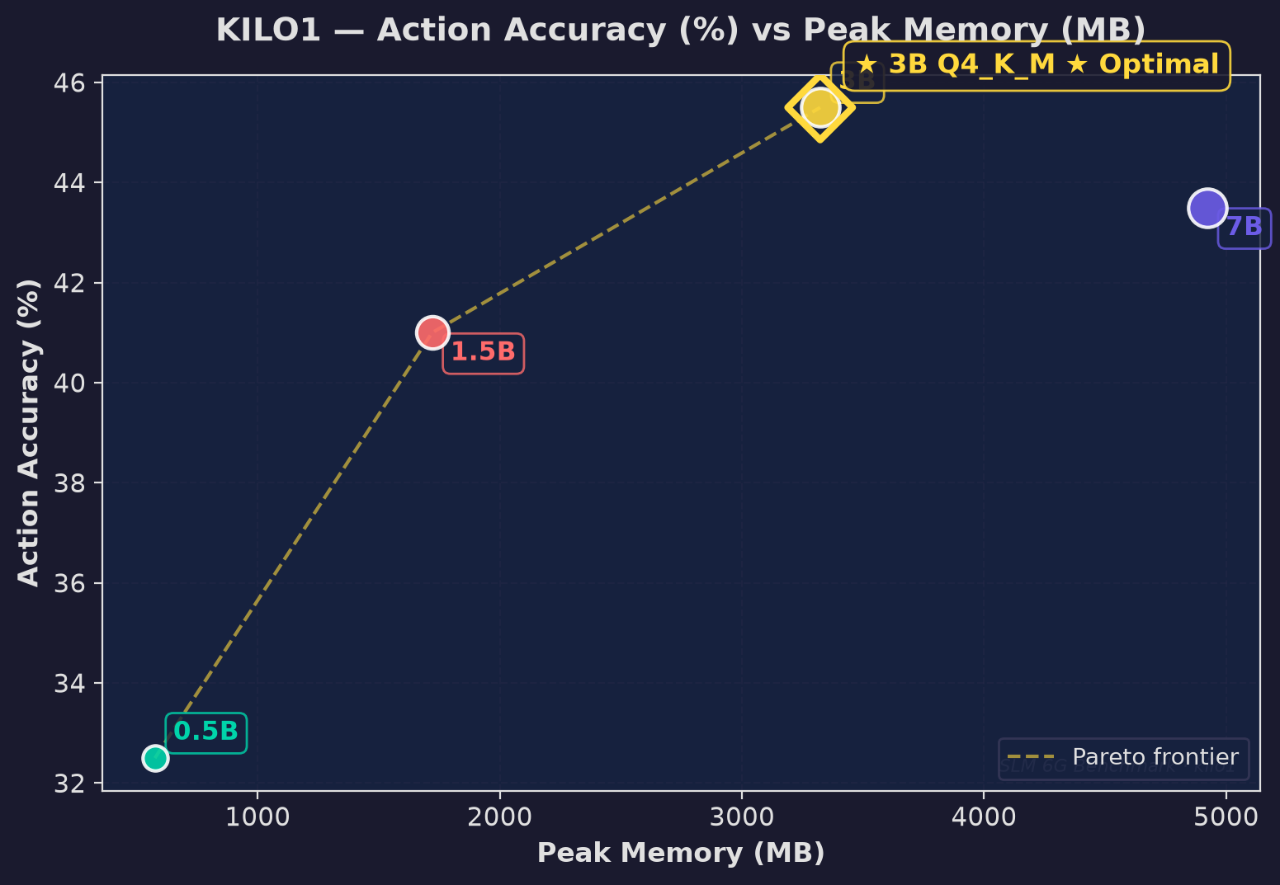
Figure: Action Vs Peak Mem

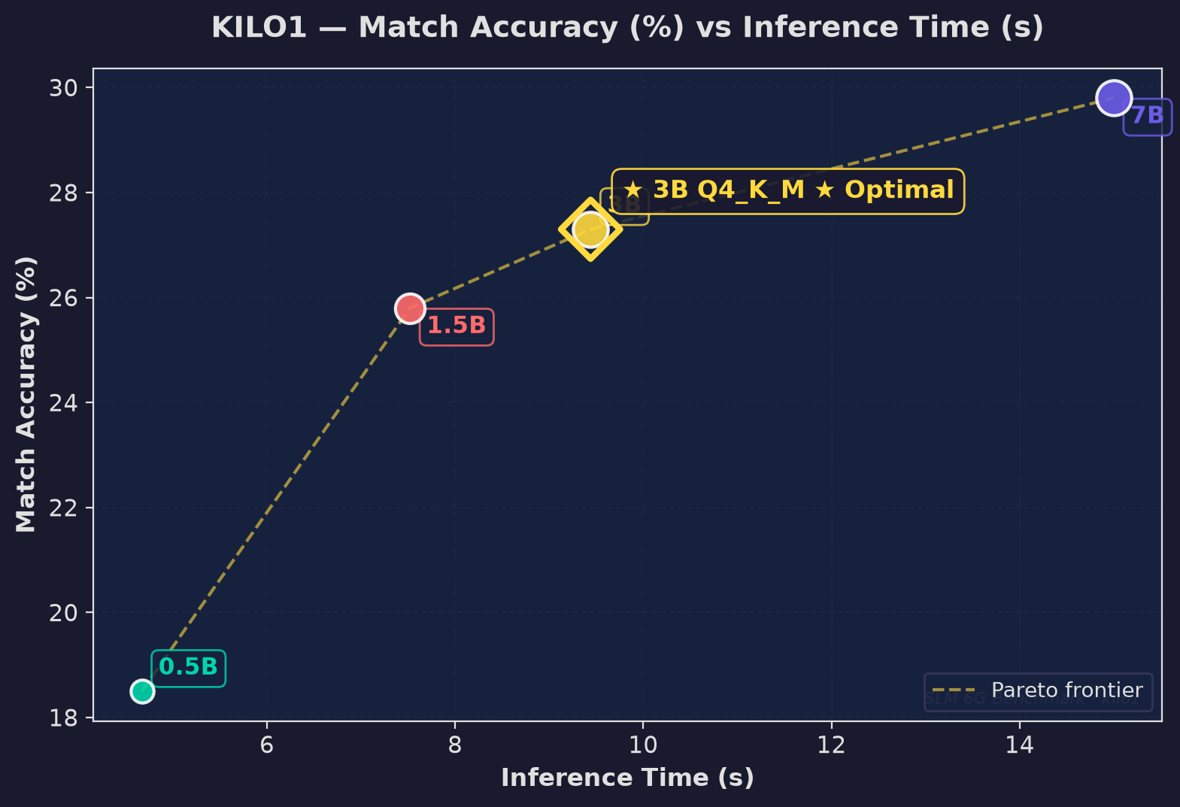
Figure: Avg Match Vs Avg Time

