Task A-B:
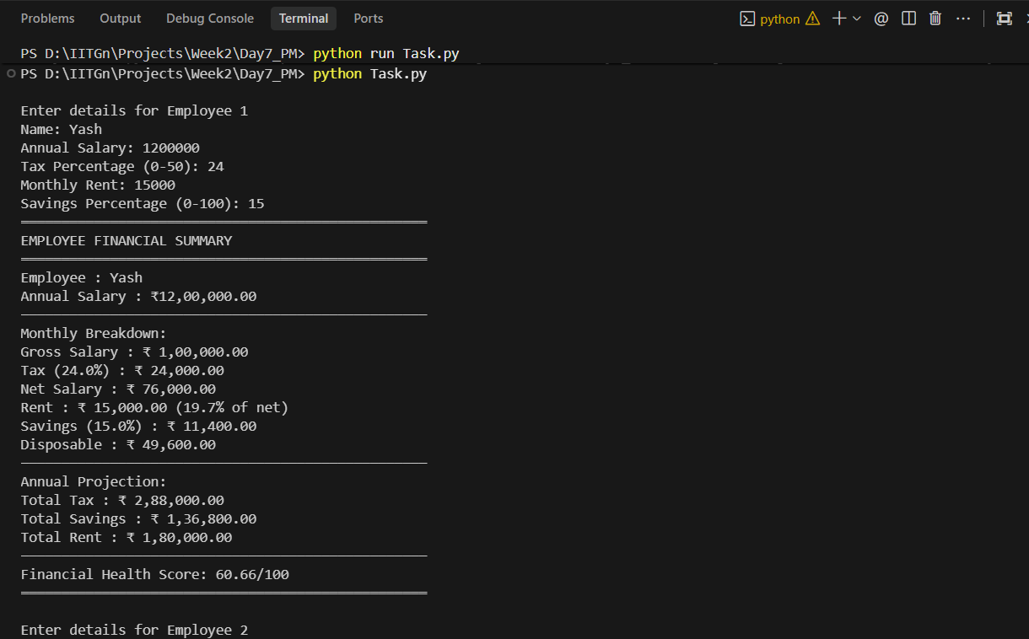
Task C:
Analyzer Functions:
def analyze_value(value):
"""
Analyze any Python value.
"""
value_type = type(value).__name__
truthy = bool(value)

try:
length = len(value)
except TypeError:
length = "N/A"

return (
f"Value: {value} | "
f"Type: {value_type} | "
f"Truthy: {truthy} | "
f"Length: {length}"
)

Corrected Version:
name = input("Name: ")
age = int(input("Age: "))

if age >= 18:
status = "Adult"
else:
status = "Minor"

print(f"{name} is {age} years old and is a {status}")
print(f"In 5 years: {age + 5}")

score = 85.5
print(f"Score: {score:.0f}")

Tasck D:
Exact Prompt Used
Here is the exact prompt I used:
"Generate a Python type conversion matrix showing what happens when converting between int, float, str, bool, list, and tuple. Include edge cases, errors, and surprising behaviors. Provide example code snippets for each conversion.”
Tested Conversion Results:
Below is a verified summary after manually testing conversions in Python:
Conversions That Work
- int(3.5) → 3
- int(True) → 1
- float(5) → 5.0
- float("3.14") → 3.14
- str(100) → "100"
- bool(0) → False
- bool("False") → True
- list("abc") → ['a', 'b', 'c']
- tuple([1, 2]) → (1, 2)
Conversions That Raise Errors
- int("3.14") → ValueError
- int("abc") → ValueError
- float("abc") → ValueError
- list(5) → TypeError
- tuple(5) → TypeError

Edge / Surprising Cases
- bool("False") → True
(Any non-empty string is truthy)
- bool([]) → False
- float("nan") → nan
(nan != nan — special IEEE behavior)
- int(False) → 0
- list((1, 2)) → [1, 2]
- str([1, 2]) → "[1, 2]" (string representation, not conversion)

Critical Evaluation:
he AI-generated conversion matrix was mostly correct for standard conversions such as int to float, float to int, and container conversions between list and tuple. However, it missed several subtle but important edge cases. For example, it did not clearly explain that bool("False") evaluates to True because Python considers any non-empty string truthy. It also failed to highlight that float("nan") produces a special IEEE floating-point value that is not equal to itself (nan != nan). Additionally, the AI overlooked that int("3.14") raises a ValueError, while int(3.14) truncates rather than rounds.
Another omission was the behavior of list(5) and tuple(5), which raise TypeError because integers are not iterable. The AI also did not emphasize floating-point precision issues such as 0.1 + 0.2 != 0.3, which are critical in financial applications.
Overall, the AI was approximately 80–85% accurate but lacked depth in edge cases and numerical precision nuances. I would improve the matrix by explicitly categorizing conversions as Safe, Truncating, Lossy, or Error-prone.

