Instruction Manual

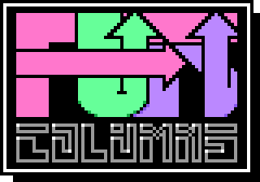

INTRODUCTION

Fun Columns SDL is a modern remake of Fun Columns for the 16-bit Apple IIGS computer from 1991 by the Free Tools Association (FTA), a French programming group. The game itself is based on an original concept by Jay Geertsen from 1989 who was working for the Hewlett Packard Company (HP) at the time.
Thank you for trying the game and I hope you like it.
COMPILING/LOADING

Fun Columns has been compiled and tested on an X86-64 Fedora based system.
It should be able to be compiled on other similar Linux or BSD boxes.

It also may well be able to be compiled on other UNIX based systems like Mac OS, but this has not been tried nor tested.

Before compiling make sure to install development libraries for SDL2, SDL_image 2.0 and libsodium for your relevant distribution.

To create an executable file for your system, use git to clone the project repository to your local system, then cd into the src directory and then type make.

If all goes well, after several seconds you should have an executable file created in the src directory. Type ./columns to execute
OBJECTIVE

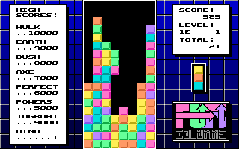
Fun Columns SDL is a match 3 style game where “columns” made of three randomly coloured tiles are presented at the top of the pane and progressively move down an invisible 8 x 18 square grid.

The aim of the game is as the column is falling, to try and rotate (using the ‘R’ key) the three tiles of the column and moving the column left/right (using the respective cursor keys) and optionally dropping the column into place prematurely (using the space bar) so that when the piece finally comes to rest, three or more adjacent tiles of the same colour in either the horizontal, vertical or diagonal positions align up (match).

The matched tiles are then eliminated (removed) from the grid, and any pieces resting above or in the vicinity of the removed pieces will then fall down into the vacated space left behind.

This match/eliminate/drop process can sometimes trigger a chain reaction so that the cycle is repeated n number of times.

As the game progresses the pane will gradually fills up with the pieces that are not eliminated and when there is no space left at the top of the grid, the game is over.

CONTROLS

Main Menu Keys

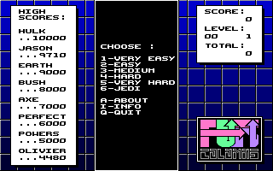
1 – 6 : Difficulty level
A : About (credits / details)
I : Info (game play key)
Q : Quit

Game play keys

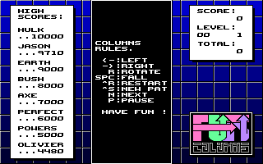
← : Move column left
→ : Move column right
Space : Fall
R : Rotate
^R : Restart (back to main menu)
^S : New tile pattern
^C : New backdrop colour
^X : Invert backdrop colour
N : Reveal next piece preview window
P : Pause game

LEVELS/DIFFICULTY

You make progress to higher levels of the games after scoring a specific amount of points. When this happens, the backdrop colour will change and the speed rate that the falling pieces drop at will increase.
SCORING

The status panel in the top right corner of the game window shows the current level and remaining levels. There you will also see how many tiles have been removed as well as your current score.

On the left side of the game window you will find the ‘Hall of Fame’ of the top eight high scores. If your score is higher than any one of the current eight, it will be replaced by your current score.

Note: The high scores are stored in a data file named .fc_dat in the same directory as the executable file.

CONTACT

PARAGON SOFTWARE

W: https://www.bou-samra.org/~paragon
W: https://github.com/bou-samra/Fun-Columns-SDL
E: paragon@bou-samra.org
© 2024 Paragon Software
© 1990/91 FTA

