Attributing AC/DC Boundary Value in Active Low-Voltage Distribution Planning
[AUTHOR NAMES AND IEEE MEMBERSHIP TO BE CONFIRMED]
[AFFILIATIONS, CITY, COUNTRY, AND CORRESPONDING AUTHOR TO BE CONFIRMED]
Abstract—Comparisons between inherited AC feeders and jointly redesigned hybrid networks confound the permission to use DC with conductor and topology changes. This paper develops a matched architecture-attribution framework in which the AC/DC boundary is endogenous while all-AC and root-converted DC remain feasible. Three public SimBench low-voltage feeders are evaluated on original and explicitly synthetic topologies across four demand/DER portfolios, five native-DC shares, three spatial allocations, four boundary efficiencies, and five nested design cells. The exact dynamic program for the declared balanced radial approximation includes line, endpoint, boundary-efficiency, standby, material, and converter-capacity terms. The factorial contains 7,200 rows and 1,440 joint-optimization cells. Under the central setting, joint planning changed modeled annual loss by -11.17% relative to matched conductor-optimized AC. Feeder-specific discrepancy screening classified 531 joint cells as robustly material and 12 as indeterminate. Converter ablations show that nominal efficiency alone is insufficient: standby and endpoint utilization alter boundaries. Nonlinear all-AC stress checks converged in every case. The results identify conditional planning mechanisms, not universal DC superiority or deployment-ready economics.
Index Terms—AC/DC distribution, active distribution networks, architecture attribution, distribution planning, low-voltage DC, power conversion.

I. INTRODUCTION
Native-DC photovoltaics, batteries, electronics, and electric-vehicle interfaces motivate renewed examination of mixed AC/DC distribution. Prior work has optimized hybrid network configuration, DC-feeder placement, converter siting, expansion, and temporal operation [1]–[6]. Consequently, assigning AC or DC states to network elements is not itself a defensible novelty claim.
A recurring identification problem remains. An inherited AC feeder is frequently compared with a hybrid design that is also allowed to reroute lines, resize conductors, or change conversion assumptions. The resulting difference combines several design freedoms. It cannot be interpreted as the marginal value of DC. This paper therefore asks a narrower question: after matching topology, conductor design, service requirements, and converter accounting, when does permission to create a DC subtree materially change a low-voltage planning solution?
The contributions are: 1) a nested estimand that separates conductor resizing, fixed-design DC permission, joint domain/conductor redesign, and topology sensitivity; 2) an exact dynamic program for the stated separable approximation, checked against independent exhaustive enumeration; 3) full-factorial transition evidence with explicit treatment of structural repetition; 4) discrepancy-based classification of modeled benefits; 5) component-level converter ablations; and 6) a reproducible evidence chain from archived public inputs to a scalar registry. The study does not claim universal DC superiority, observed field-optimal topology, protection adequacy, or deployable absolute economics.
This scope is intentionally narrower than a universal architecture ranking. The analysis estimates marginal architecture effects within a transparent screening model. Material and converter-capacity terms are normalized regularizers, while electrical loss components remain separately reported. A reader can therefore distinguish reduced line current, avoided endpoint conversion, conductor resizing, and added boundary conversion instead of interpreting their sum as a pure DC benefit.
Fig. 1 summarizes the controlled evidence chain from public feeder inputs through nested design cells, exact optimization, validation, and registry-backed reporting.
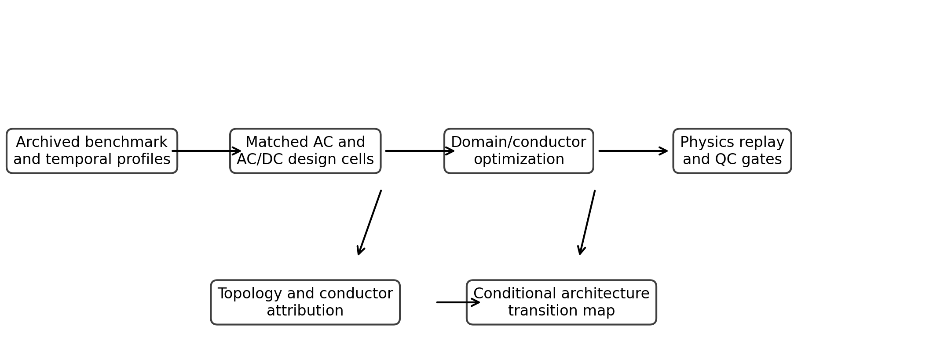
Fig. 1. Controlled architecture-attribution workflow.

II. DATA AND METHODS

A. Public Inputs and Study Cases
The electrical benchmark consists of the rural1, semiurb4, and urban6 low-voltage scenario-0 networks from SimBench v1.6.1 [7]. The exact wheel is retained in the local immutable archive and verified by SHA-256. SimBench provides topology, line parameters, geographic coordinates, loads, and 15-min annual profiles. The public charging-transaction dataset [8] is used only to check the scale of the high-EV stress portfolio; invalid or nonpositive-duration records are excluded by a predeclared rule. The benchmark topology is engineering reference data rather than observed infrastructure.
For each feeder, the original radial topology is paired with a synthetic minimum-geographic-length spanning tree constructed from the benchmark coordinates. The latter is explicitly a topology-confounding sensitivity, not a reconstruction of a utility network. Four portfolios represent base demand (K0), high PV (K1), high EV (K2), and combined PV, EV, and storage peak-shaving (K3). Their annual-energy and peak multipliers are frozen in the analysis plan.
Table I lists the frozen factorial dimensions. They are intentionally balanced scenario levels and are not weighted to represent deployment prevalence.
TABLE I. Frozen factorial dimensions. Levels are design scenarios rather than estimated population distributions.
Dimension | Levels | Interpretation
Feeder | 3 | Rural, suburban, urban
Topology | 2 | Original, synthetic MST
Portfolio | 4 | K0–K3 proxies
Native-DC share | 5 | 0%–100% annual energy
Spatial allocation | 3 | Frozen seed realizations
Boundary efficiency | 4 | 94%–99% scenarios
Design cell | 5 | Nested attribution cells
Table II defines the nested comparison cells used to attribute changes without silently granting the hybrid design additional conductor or topology freedom.
TABLE II. Nested comparison cells used for attribution.
Cell | Topology | Conductor | Domain
Inherited AC | Original | Base | AC only
AC + conductor | Matched | Optimized | AC only
Fixed hybrid | Matched | Base | Endogenous
Joint hybrid | Matched | Optimized | Endogenous
Ideal hybrid | Matched | Optimized | Lossless conversion

B. Endogenous Boundary Model
Let G=(V,E) be a radial tree rooted at the AC transformer bus r, with every edge e=(i,j) directed from parent i to child j. Each non-root bus takes domain d_i in {AC,DC}; edge (i,j) takes d_j. A boundary converter is installed exactly when d_i differs from d_j. Each edge selects conductor multiplier s_e from the common finite menu, or s_e=1 in fixed-conductor cells. Frozen downstream annual energy, peak power, and equivalent loss hours are denoted E_e, P_e, and H_e.
$$I_AC,e = 1000 f_P P_e/(√3 V_AC pf), I_DC,e = 1000 f_P P_e/V_DC$$
Here f_P is the portfolio peak multiplier, pf is power factor, V_AC=400 V line-to-line, and V_DC=750 V pole-to-pole. With base resistance per kilometre rho_e and length l_e, R_e=rho_e l_e/s_e. The coded annual line losses are 3 I_AC,e I_AC,e R_e H_e/1000 for AC and 2 I_DC,e I_DC,e R_e H_e/1000 for DC.
$$E_mis,i = f_E E_i [z_i(1-q_i)+(1-z_i)q_i], L_end,i = E_mis,i(1/η_end-1)$$
z_i is one for DC, q_i is the native-DC energy share, and f_E is the annual-energy multiplier. Thus AC-native energy served from DC and DC-native energy served from AC are treated symmetrically. For a domain transition on edge e, boundary loss is f_E E_e(1/eta_b-1)+sigma_b f_P P_e 8760 and installed boundary capacity is f_P P_e. The frozen endpoint efficiency is 96% and standby fraction is 0.2% of rated boundary power. These are dimensionless planning assumptions rather than empirical vendor curves. The model has no chronological direction reversal, part-load curve, or loss feedback.
$$J = Σ_e L_line,e + Σ_i L_end,i + Σ_e L_boundary,e + λ_M Σ_e M_e + λ_C Σ_e C_e$$
M_e=n(d_j)l_e s_e with n(AC)=4 and n(DC)=3. The material and converter-capacity weights are normalized regularizers, not monetary costs. Electrical loss components remain separately reported. The conductor-count convention is a controlled scenario index and does not establish universal grounding or return-path equivalence.
$$F_i(d)=L_end,i(d)+Σ_j min_(d',s)[F_j(d')+L_line,ij(d',s)+λ_M M_ij+B_ij(d,d')]$$
F_i(d) is the minimum score of the subtree rooted at i conditional on domain d; B_ij contains boundary electrical loss and the capacity regularizer when d differs from d'. Leaves contribute endpoint loss only, the root terminates at F_r(AC), and stored choices recover domains and conductors. The algorithm evaluates O(|E||D|^2|S|) transitions and stores O(|V||D|+|E||D|) values. It is exact only because downstream profiles are fixed and child subtrees are additive.
$$u_e = I_e/(I_max,e s_e), δ_AC,e = I_AC,e R_e/(V_AC/√3), δ_DC,e = I_DC,e R_e/(V_DC/2)$$
Ampacity utilization and single-edge voltage drop are recorded after optimization. Configured limits are screening flags, not constraints in the dynamic program. Exact optimality therefore does not extend to unbalanced voltage feasibility, meshed operation, reactive power, converter-loss feedback, protection, or reliability.

C. Attribution and Validation
For matched loss L, the conductor contrast is (L_AC,opt−L_AC,base)/L_AC,base; the fixed-design DC-permission contrast is (L_H,base−L_AC,base)/L_AC,base; and the joint incremental architecture contrast is (L_H,opt−L_AC,opt)/L_AC,opt. A synthetic-topology sensitivity compares joint loss with the corresponding original-topology result. These are attribution contrasts and marginal planning changes within the model, not causal effects or realized utility savings. The electrical-ideal converter case is reported only as an upper bound.
Analytical two-bus cases test current and loss equations and endpoint assignment. Independent exhaustive enumeration on small radial networks tests all permitted domain and conductor combinations, including all-AC, root-DC, interior-hybrid, converter-penalty, endpoint-mismatch, and conductor-driven architecture cases. Objective agreement is required within a declared numerical tolerance. Across 8 exactness cases, the largest absolute objective difference was 5.68e-14. Architecture agreement is additionally required for unique optima, while tied solutions are checked for support of the returned assignment.
For each SimBench feeder, the all-AC approximation is compared with pandapower's nonlinear balanced AC line loss using nonlinear loss as the denominator. For a joint cell with modeled loss contrast delta<0 and feeder discrepancy epsilon_f, the primary screen labels the benefit robustly material when |delta|>epsilon_f, indeterminate when 0<|delta|<=epsilon_f, and no modeled benefit when AC is retained or delta>=0. The global maximum discrepancy and 2 epsilon_f are sensitivity thresholds. These categories are screening heuristics, not confidence intervals or hypothesis tests.

D. Factorial Design and Reproducibility
The full run contains 7,200 result rows: 3 feeders, 2 topologies, 4 portfolios, 5 native-DC shares, 3 spatial allocations, 4 boundary efficiencies, and five design cells. Randomness is confined to frozen spatial seeds. Raw objects are preserved separately from processed data and verified by file size and SHA-256. Every manuscript scalar is written to a machine-readable registry before document generation.
Of 1,440 joint cells, 733 rows belong to outcome groups repeated after excluding the spatial seed, and 990 distinct outcome rows remain under that grouping. Accordingly, architecture frequencies summarize the frozen design grid; repeated structural values are not treated as independent statistical replications and no design-grid proportion is interpreted as a real-world probability.

III. RESULTS

A. Attribution Under the Central Setting
The central cell uses K3, 50% native-DC annual energy, 98% boundary efficiency, and seed 20260924. On the original topology, all three feeder optima are hybrid. Relative to inherited AC, conductor optimization changed mean modeled loss by -6.17%. Relative to matched conductor-optimized AC, joint domain/conductor planning changed mean modeled loss by -11.17%. These are modeled attribution contrasts, not claims about realized utility savings.
Table III reports the six central feeder/topology cells, and Fig. 2 visualizes the original-topology decomposition.
TABLE III. Central annual modeled loss (kWh/year). Joint contrast is relative to matched conductor-optimized AC.
Feeder/topology | AC base | AC opt. | H fixed | H joint | Joint contrast
Rural Orig. | 4361 | 4217 | 3538 | 3396 | -19.5%
Rural MST | 4595 | 4335 | 3975 | 3717 | -14.2%
Suburban Orig. | 10071 | 8993 | 9123 | 8064 | -10.3%
Suburban MST | 12336 | 10126 | 12089 | 9888 | -2.3%
Urban Orig. | 12052 | 11506 | 11623 | 11077 | -3.7%
Urban MST | 15246 | 13102 | 14989 | 12846 | -2.0%
The nested cells distinguish three mechanisms. In the rural original feeder, the conductor contrast is -3.29%, fixed-design DC permission is -18.85%, and the joint architecture contrast is -19.47%. The corresponding joint contrasts are -10.33% for suburban and -3.72% for urban. Thus conductor optimization and domain permission are neither identical nor additive in general.
Table IV reports the central boundary characteristics and the matched topology sensitivity.
TABLE IV. Central boundary characteristics on the original topology and synthetic-MST sensitivity. The topology column is a modeled sensitivity, not an observed redesign.
Feeder | Class | DC buses | Boundaries | MST joint-loss change
Rural | hybrid | 15.4% | 2 | 9.5%
Suburban | hybrid | 7.1% | 3 | 22.6%
Urban | hybrid | 14.0% | 5 | 16.0%
Synthetic minimum-length topology increased central joint loss relative to original topology by 9.45% (rural), 22.63% (suburban), and 15.97% (urban). This result illustrates why a topology change cannot be silently bundled with DC permission. The table also shows that the central original-topology solutions use small DC bus fractions and multiple interior boundaries rather than an automatic feeder-wide conversion.
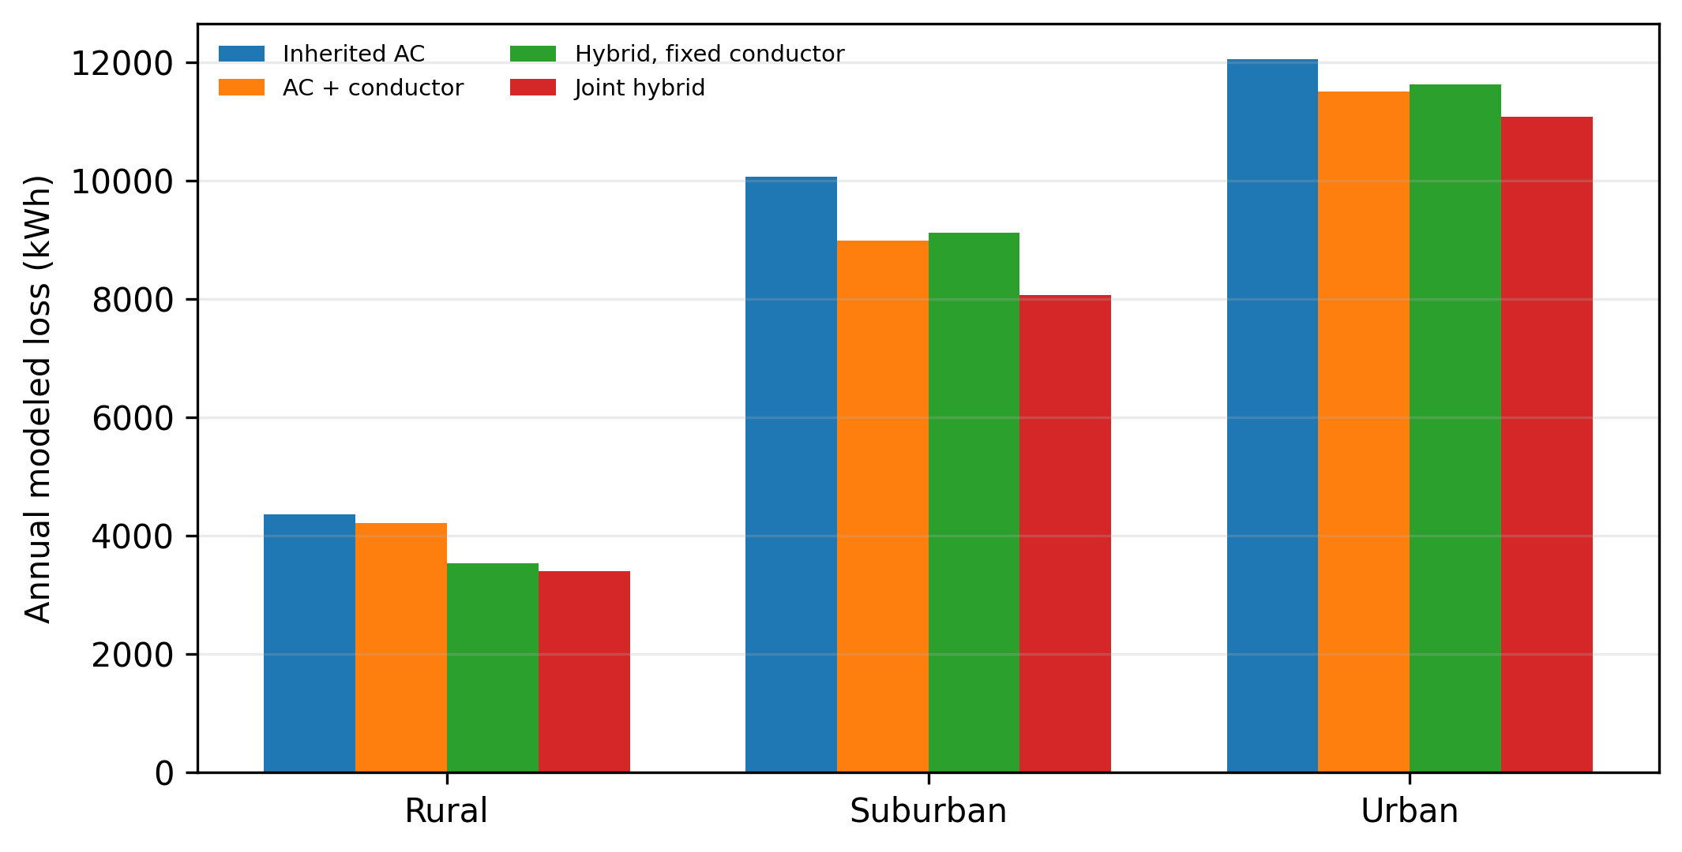
Fig. 2. Matched decomposition of annual modeled losses under the central setting.

B. Conditional Architecture Transitions
The endogenous boundary moved monotonically only in portions of the parameter space. At low native-DC share, endpoint mismatch and boundary standby losses often retained all-AC. Higher native-DC share expanded DC subtrees, but topology, feeder geometry, portfolio, and spatial clustering changed both the transition location and boundary signature. The same aggregate native-DC share can therefore yield different domain assignments.
Across all joint-optimization cells, a hybrid architecture was selected in 27.7% of cells, all-AC in 62.3%, and root-converted DC in 10.0%. These are frequencies in the sampled design grid, not probabilities for real feeders. They show that endpoint architectures remain active and that the optimizer does not mechanically force a mixed solution.
Table V separates those counts by boundary efficiency. Figs. 3 and 4 then show a representative transition surface and the aggregate DC-assignment response.
TABLE V. Joint architecture counts by boundary-efficiency scenario. Each row contains 360 frozen design cells.
Boundary efficiency | All-AC | Hybrid | Root DC
94% | 360 | 0 | 0
96% | 360 | 0 | 0
98% | 93 | 195 | 72
99% | 84 | 204 | 72
At 94% and 96% boundary efficiency, every tested joint cell retained all-AC. Hybrid and root-converted DC solutions appeared at 98% and 99%, but nominal efficiency did not uniquely determine the boundary because standby loss scales with installed capacity and endpoint mismatch depends on utilization and location. Transition locations and signatures for every feeder, topology, portfolio, share, seed, and efficiency are retained in the machine-readable factorial tables.
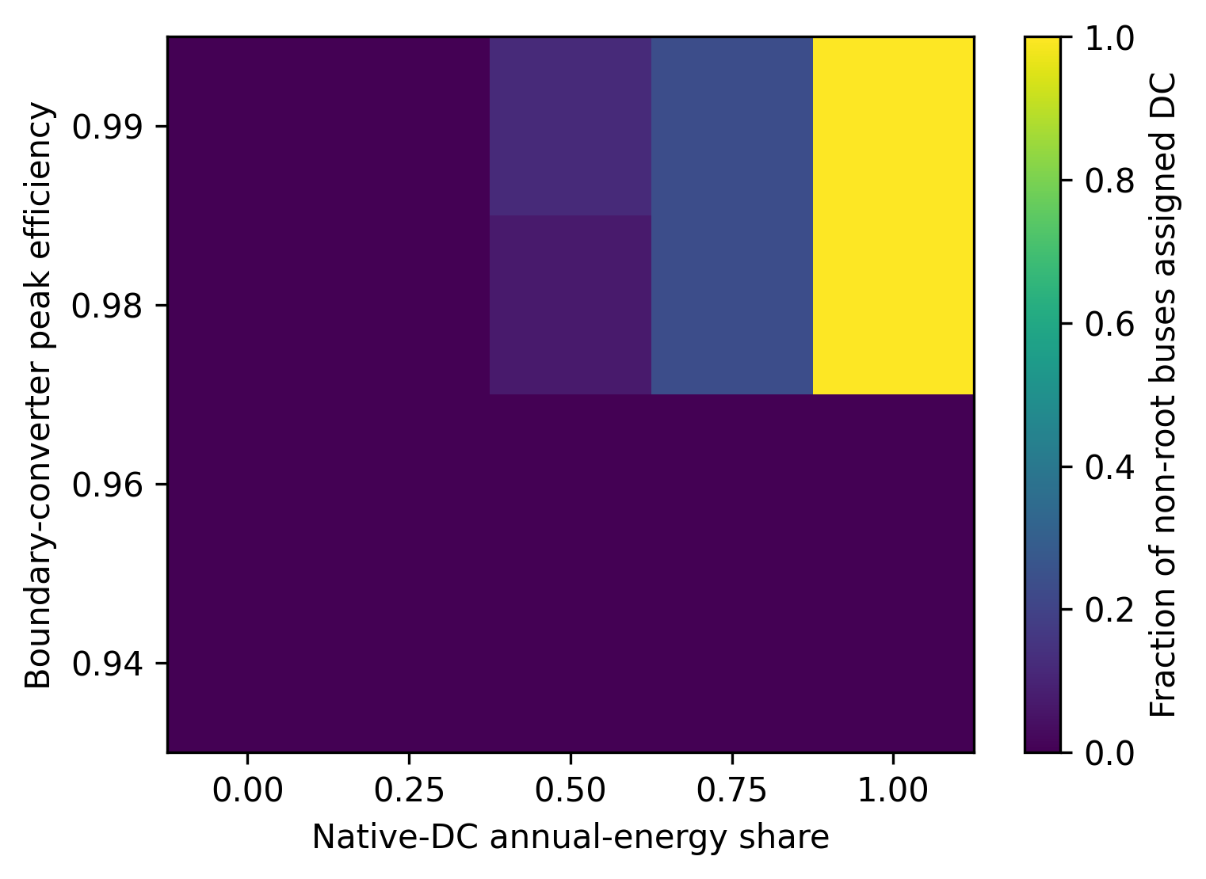
Fig. 3. Suburban architecture transition under K3; values are bus fractions assigned DC.
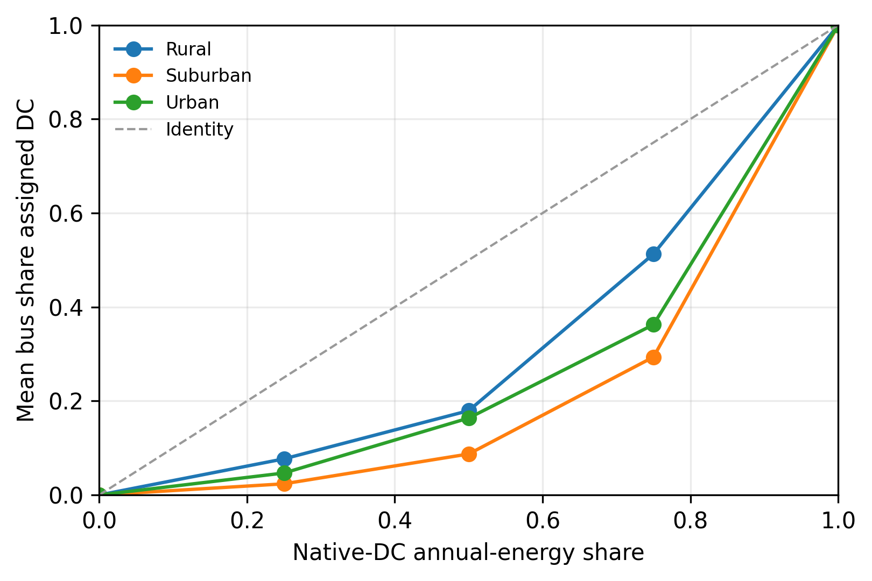
Fig. 4. Mean DC-assigned bus share versus native-DC energy share at 98% efficiency.
Table VI stratifies the joint architecture counts by native-DC annual-energy share.
TABLE VI. Joint architecture counts by native-DC annual-energy share. Counts pool feeders, topologies, portfolios, spatial seeds, and boundary efficiencies.
Native-DC energy | All-AC | Hybrid | Root DC | Cells
0% | 288 | 0 | 0 | 288
25% | 177 | 111 | 0 | 288
50% | 144 | 144 | 0 | 288
75% | 144 | 144 | 0 | 288
100% | 144 | 0 | 144 | 288
Table VI identifies three conditional regions without assigning probabilities to them. All cells remain AC when no endpoint energy is native DC. Mixed architectures appear at intermediate shares, while complete root conversion occurs only in a subset of the 100% native-DC cells. The exact balance remains converter- and network-dependent, so native-DC share is a necessary but insufficient boundary rule.

C. Exactness and Model-Discrepancy Screening
On independently enumerated toy trees, the dynamic program matched the exhaustive minimum objective in all 8 declared cases. Unique optima also matched in architecture and conductor selection. The cases cover all-AC, root-converted DC, interior hybrid, high converter penalty, high endpoint mismatch, a conductor-driven architecture change, and an explicit tied optimum. The maximum absolute objective difference was 5.68e-14; 1 case contained multiple brute-force optima.
All three pandapower cases converged. The median absolute discrepancy between the balanced resistive planning approximation and nonlinear AC line loss was 1.408%, with a maximum of 1.958%. The feeder values were 1.106% (rural), 1.958% (suburban), and 1.408% (urban), using nonlinear pandapower line loss as denominator. Fig. 5 displays the matched nonlinear and screening values.
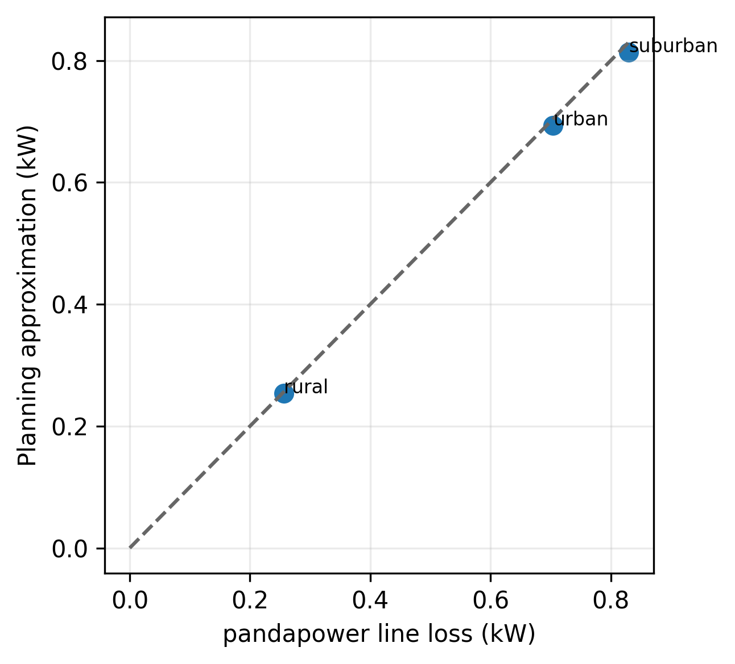
Fig. 5. All-AC approximation versus pandapower at the benchmark operating point.
Table VII compares the primary discrepancy rule with the two conservative sensitivity thresholds.
TABLE VII. Classification of 1,440 joint cells under alternative approximation-discrepancy screens.
Screening rule | No benefit/AC | Robust | Indeterminate
Feeder epsilon | 897 | 531 | 12
Global max epsilon | 897 | 525 | 18
Twice feeder epsilon | 897 | 513 | 30
Under the primary feeder-specific rule, 531 cells were robustly material, 12 were indeterminate, and 897 retained AC or had no modeled loss benefit. Doubling the feeder discrepancy moved cases from robust to indeterminate without changing the no-benefit count. The screen therefore prevents small negative contrasts from being presented as resolved architecture improvements.
The qualitative conclusion is stable to the two more conservative screening thresholds, although the robust/indeterminate boundary moves as intended.
Table VIII stratifies the primary discrepancy classification by benchmark feeder.
TABLE VIII. Feeder-stratified primary discrepancy classification; each feeder contributes 480 joint cells.
Feeder | No benefit/AC | Robust | Indeterminate
Rural | 301 | 176 | 3
Suburban | 308 | 167 | 5
Urban | 288 | 188 | 4
The feeder stratification separates approximation screening from feeder prevalence. It is useful for checking whether the aggregate count is dominated by one benchmark, but it remains a balanced scenario-grid summary rather than a statistical estimate for rural, suburban, or urban feeder populations.

D. Converter-Component Ablations
Eight matched ablations remove individual conversion terms while preserving the same factorial cells. The comparisons isolate boundary-efficiency loss, standby loss, the converter-capacity regularizer, endpoint mismatch, all boundary electrical loss, and two idealized upper bounds. The assumed ranges are dimensionless planning scenarios; they are not manufacturer curves or equipment-cost estimates.
Table IX summarizes architecture, boundary, DC-assignment, and loss changes relative to the matched baseline.
TABLE IX. Aggregate converter ablations across the matched factorial grid.
Ablation | Architecture change | Boundary change | Mean DC buses | Mean loss contrast
Baseline | 0.0% | 0.0% | 17.1% | -9.6%
No capacity reg. | 0.2% | 3.8% | 17.3% | -9.6%
No standby | 5.1% | 24.9% | 21.8% | -15.0%
No boundary eta loss | 41.2% | 64.7% | 44.6% | -42.6%
Electrical ideal | 66.6% | 75.8% | 42.2% | -29.0%
Full ideal converter | 90.0% | 90.0% | 100.0% | -48.6%
The capacity regularizer changed architecture in only 0.21% of cells, although more boundary signatures changed. Removing standby loss changed architecture in 5.07% and boundaries in 24.93%. Removing boundary-efficiency loss produced much larger changes, while eliminating endpoint mismatch selected all-AC in 100% of cells. The last result is mechanistic: without avoided endpoint conversion, the modeled reason to assign loads to DC disappears under the remaining penalties.
The electrical-ideal and full-ideal cases should not be read as feasible forecasts. The electrical-ideal case changed architecture in 66.6% of cells; the full ideal case changed it in 90.0% and selected root-converted DC in 100.0%. Their purpose is to bound conversion penalties and expose utilization dependence.
The ablation table therefore supports a component-level interpretation rather than a single undifferentiated converter-sensitivity claim.

E. Performance and Nonlinear Stress Checks
The implementation ran on Linux-6.8.0-1061-aws-x86_64-with-glibc2.35 with Python 3.10.12 and INTEL(R) XEON(R) PLATINUM 8559C; 2 logical CPUs were visible. Software versions were numpy=2.2.6;pandas=2.3.3;networkx=3.4.2;pandapower=3.4.0;simbench=1.6.1;python-docx=1.2.0;matplotlib=3.10.6. Peak process memory was 690 MiB. The 7,200-row factorial required 17.9 s, and the converter-ablation run required 36.4 s in this environment.
Table X links the analytical state counts to measured solve times for the original benchmark topologies.
TABLE X. Original-topology central solve evidence; medians use 30 repeated solves.
Feeder | Nodes/edges | Median solve | DP states | Transitions
Rural | 14/13 | 0.32 ms | 27 | 132
Suburban | 43/42 | 1.10 ms | 85 | 486
Urban | 58/57 | 1.45 ms | 115 | 642
The analytical transition count is O(|E||D|^2|S|), with two domain states and three conductor scales in the present configuration. Median repeated-solve time across all feeder/topology cells ranged from 0.32 to 1.49 ms. On chain toys, exhaustive enumeration reached 16,384 designs while the maximum DP-versus-enumeration objective difference remained 5.68e-14. Timing is implementation evidence, not an independent proof of asymptotic complexity.
All 12 balanced all-AC feeder/portfolio stress cases converged. Across the grid, minimum voltage was 0.983 p.u., maximum line loading was 49.0%, and maximum line-loss discrepancy was 2.591%. These checks support the all-AC approximation over the configured peak multipliers; they do not validate hybrid converter controls, unbalance, harmonics, grounding, protection, or reliability.

F. Distributional and Feasibility Diagnostics
Across all paired realistic cells, the median joint-hybrid change relative to conductor-optimized AC was 0.00%; the 5th–95th percentile interval was -46.63% to 0.00%. The interval spans materially different outcomes because native-DC share changes endpoint mismatch and converter utilization. Portfolio peak factors shift line losses quadratically, whereas annual energy factors shift endpoint and conversion losses approximately linearly.
The screening diagnostics flagged 0 joint-optimization cells above the configured ampacity-utilization or single-edge voltage-drop limit. The limits were 1.00 p.u. and 0.05 p.u. Flagged cells remain in the public results so that an apparent loss benefit is not presented as a feasible design. A utility-grade study would enforce phase-specific voltages, thermal ratings, and contingency requirements inside the optimization.

IV. DISCUSSION

A. What the Attribution Design Changes
The principal finding is methodological: the value assigned to DC depends on the comparison cell. Conductor redesign can move losses before any bus changes domain, while a topology sensitivity changes downstream power and line length. Reporting only the inherited-AC versus joint-hybrid difference would combine these mechanisms. The matched design prevents that total from being labeled a DC effect.
This distinction matters for both retrofit and greenfield interpretation. In a retrofit, fixed-design DC permission asks whether domain reassignment has marginal planning value without assuming simultaneous conductor replacement. In a constrained redesign, the joint contrast asks what is gained after AC receives the same conductor menu. In a synthetic greenfield sensitivity, topology is varied explicitly and its change is reported separately. None of these estimands is a causal treatment effect; each is a paired contrast under frozen model assumptions.

B. Why Converter Utilization Matters
The transition maps also reject a universal boundary rule. Native-DC penetration favors DC service by avoiding endpoint conversion, whereas converter standby loss penalizes small or lightly loaded DC subtrees. A high nominal efficiency is therefore insufficient evidence; utilization and spatial clustering matter. All-AC remains a valid optimum in parts of the tested space, and the model preserves that negative result.
The selected boundary is therefore a marginal architecture signal. A DC subtree becomes attractive when avoided endpoint mismatch and lower conductor loss exceed efficiency, standby, capacity, and material consequences at its boundary. Spatial clustering is decisive: the same aggregate DC-native share can produce different boundaries when concentrated behind one branch or dispersed among branches. This mechanism explains why one system-wide penetration threshold is not transportable across feeder geometries.
The ablations sharpen this mechanism. Removing the capacity regularizer rarely changes the architecture, while removing standby or boundary-efficiency loss changes many more boundary signatures. Consequently, quoting only a high full-load converter efficiency is inadequate. A planner also needs the power transferred through the boundary, the size implied by peak demand, the energy served behind it, and the spatial concentration of native-DC endpoints. Those variables determine whether fixed and throughput-dependent conversion penalties are diluted by useful service.

C. Interpretation of Robust and Null Regions
The discrepancy classification is intentionally asymmetric. Large modeled benefits that exceed the all-AC approximation error are labeled robustly material only under the declared screening rule; smaller benefits remain indeterminate. All-AC and nonnegative contrasts are retained as no-benefit outcomes. This prevents the factorial size from turning numerically small differences into persuasive evidence. It also preserves the scientifically relevant negative result that realistic conversion accounting can leave AC unchanged over broad portions of the design grid.
Normalized objective weights also separate engineering screening from economic valuation. Public cost evidence for low-voltage bidirectional converters, DC switchgear, protection, and maintenance is too heterogeneous for a defensible absolute net-present-value estimate. Reporting electrical components and capacity requirements separately permits later studies to apply region- and vendor-specific prices without changing the architecture-attribution design.

D. Limitations and External Validity
The model is deliberately narrower than a deployable planning tool. It uses balanced radial active-power accounting and proxy portfolios rather than unbalanced optimal power flow, phase switching, explicit inverter reactive control, chronological battery dispatch, harmonics, grounding, fault interruption, protection coordination, reliability, or regulation. The synthetic spanning tree is not observed geography. Public evidence for bidirectional LV boundary-converter cost, part-load efficiency, standby power, and lifetime remains insufficient for absolute lifecycle-cost claims. Accordingly, this paper reports conditional normalized evidence.
The nonlinear comparison validates only the all-AC loss approximation. It does not validate hybrid converter voltage control, bidirectional dispatch, fault behavior, or interactions among multiple converters. The ampacity and voltage-drop quantities are post-optimization diagnostics rather than binding constraints. Moreover, the portfolio multipliers are controlled stress proxies, not probabilistic forecasts, and the three frozen spatial allocations are sensitivity cases rather than a random sample of future adoption.
Benchmark feeders improve reproducibility but limit external validity. SimBench archetypes and the synthetic minimum-length trees do not represent the distribution of utility assets, local grounding practice, service conductor arrangements, or regulatory requirements. The conductor-count convention and the 750-V DC scenario are controlled modeling choices. The reported boundary locations should therefore be interpreted as mechanism examples within these networks, not transferable siting recommendations.
Future work should embed the attribution design in unbalanced multiperiod AC/DC optimal power flow, use measured bidirectional converter maps, and co-design protection. Chronological operation should include power direction, storage dispatch, reactive support, and part-load losses. Field utility data and equipment quotations would be required before claiming deployable boundary locations, lifecycle economics, or external validity beyond benchmark mechanism identification.

V. CONCLUSION
An endogenous AC/DC boundary is scientifically informative only when the comparison separates electrical-domain permission from conductor and topology redesign. The nested contrasts show that these freedoms produce distinct changes, while the full factorial shows conditional all-AC, hybrid, and root-converted DC regions rather than a general DC advantage. Discrepancy screening preserves indeterminate and null outcomes, and converter ablations show why nominal efficiency must be interpreted together with utilization, standby, and endpoint mismatch. The exact dynamic program and registry-backed open pipeline provide reproducible mechanism evidence for the declared balanced radial approximation. Unbalanced hybrid operation, protection, reliability, measured converter maps, and location-specific economics remain necessary before any deployment decision.

ACKNOWLEDGMENT
[FUNDING, CONFLICTS, AND NONAUTHOR CONTRIBUTIONS TO BE CONFIRMED.] During preparation of this work, the authors used Cognition Devin for substantive assistance in generating and debugging analysis code, drafting and editing all manuscript sections, and preparing figures and submission files. The authors reviewed and verified the analysis, numerical results, citations, claims, and final text and remain accountable for the article.

DATA AND CODE AVAILABILITY
The analysis code, configurations, provenance ledger, and generated outputs are available at https://github.com/bougtoir/acdc_boundary_grid. SimBench is acquired under ODbL/BSD terms; the charging data are CC BY 4.0. Exact source URLs, versions, file sizes, and SHA-256 values are recorded in the machine-readable ledger.

REFERENCES
[1] H. M. A. Ahmed, A. B. Eltantawy, and M. M. A. Salama, "A Planning Approach for the Network Configuration of AC-DC Hybrid Distribution Systems," IEEE Transactions on Smart Grid, pp. 1-1, 2016, doi: 10.1109/TSG.2016.2608508.
[2] H. Lotfi and A. Khodaei, "Hybrid AC/DC microgrid planning," Energy, vol. 118, pp. 37-46, 2017, doi: 10.1016/j.energy.2016.12.015.
[3] X. Wu, Z. Wang, T. Ding, and Z. Li, "Hybrid AC/DC Microgrid Planning with Optimal Placement of DC Feeders," Energies, vol. 12, Art. no. 1751, 2019, doi: 10.3390/en12091751.
[4] L. Zhang, B. Tong, Z. Wang, W. Tang, and C. Shen, "Optimal Configuration of Hybrid AC/DC Distribution Network Considering the Temporal Power Flow Complementarity on Lines," IEEE Transactions on Smart Grid, vol. 13, no. 5, pp. 3857-3866, 2022, doi: 10.1109/TSG.2021.3102615.
[5] H. F. de Barros, M.-C. Alvarez-Herault, B. Raison, and Q. T. Tran, "Optimal AC/DC Distribution Systems Expansion Planning From DSO's Perspective Considering Topological Constraints," IEEE Transactions on Power Delivery, vol. 38, no. 5, pp. 3417-3428, 2023, doi: 10.1109/TPWRD.2023.3277089.
[6] Z. Wang, L. Zhong, Z. Pan, T. Yu, and X. Qiu, "Optimal double Q AC-DC hybrid distribution system planning with explicit topology-variable-based reliability assessment," Applied Energy, vol. 322, Art. no. 119438, 2022, doi: 10.1016/j.apenergy.2022.119438.
[7] S. Meinecke, D. Sarajlić, S. R. Drauz, A. Klettke, L.-P. Lauven, C. Rehtanz, A. Moser, and M. Braun, "SimBench--A Benchmark Dataset of Electric Power Systems to Compare Innovative Solutions Based on Power Flow Analysis," Energies, vol. 13, Art. no. 3290, 2020, doi: 10.3390/en13123290.
[8] E. Lee, K. Baek, and J. Kim, "A dataset for multi-faceted analysis of electric vehicle charging transactions," figshare, 2023, doi: 10.6084/m9.figshare.22495141.v1.

