Institutionally divided, functionally entangled: the price of an inherited prefectural boundary in electoral districting, Kyoto–Shiga, Japan

Highlights
- A boundary's price inside representation is a measurable estimand.
- Kyoto–Shiga: the closest prefectural-government-office pair in Japan.
- Border cost: bounded at municipality scale; zero among best-found maps.
- The real border crosses less commuting flow than all 200 placebos.
- Visible administrative–functional mismatch did not imply inefficiency.

Abstract
States organize representation inside inherited territorial containers whose boundaries rarely track the geographies people actually live in. Political geography has long theorized the boundary as a durable institution that outlives the functional world it divides; what is rarely asked is what such a boundary costs inside a specific territorial system. This paper prices one. For electoral districting — a representation system with explicit legal objectives and, in Japan, a hard statutory rule that House of Representatives districts not straddle prefectural boundaries — the estimand is $C_{border}=L^{*} (Boundary ON)−L^{*} (Boundary OFF)$, the deterioration in a nonpartisan districting objective attributable solely to the inherited line. The Kyoto–Shiga border is the test bed: it separates the two closest prefectural government offices in Japan by geodesic distance (10.5 km), bisects a commuting field carrying 79,466 daily cross-prefecture trips (2020 census), and tops its prefecture's borders on a pre-specified normalized entanglement measure — although Osaka dominates raw volume, a comparison we report in full. Solving matched problems at two spatial resolutions, we find the true constraint cost is bounded but not tightly identified at municipality scale ([0, 532,293] objective units) and zero among best-found small-area maps. The real border crosses fewer trips (39,733) than all 200 matched placebo borders. A conspicuous territorial mismatch thus carried a small measured price: institutional boundaries deserve evaluation against their opportunity cost, not presumptive harmonization.
Keywords: territory; administrative boundaries; electoral geography; functional connectivity; spatial optimization; Japan

1. Introduction
Representation in democracies is organized through territory. The districts through which citizens elect legislators, the prefectures within which those districts are drawn, the service regions through which states deliver health, schooling and emergency coverage — all are inherited spatial containers, drawn at particular moments of institutional history and subsequently reproduced as administrative fact (Agnew, 1994; Elden, 2013). Political geography has long insisted that such boundaries are not neutral lines but durable institutions: they persist, are narrated into common sense, and organize political life long after the conditions that produced them have changed (Newman and Paasi, 1998; Paasi, 2009; Painter, 2010). Meanwhile, the functional geographies of daily life — commuting fields, market areas, school destinations — routinely cross those institutional lines, producing the overlapping, mismatched territorial systems in which most public life actually takes place (OECD, 2012).
Yet a second literature, quantitative electoral geography, has grown up measuring the inside of those containers: compactness, population equality, contiguity, partisan symmetry, ensemble baselines (Taylor and Johnston, 1979; Mehrotra et al., 1998; Ricca et al., 2013; Tam Cho and Liu, 2016; DeFord et al., 2021; Herschlag et al., 2020; Duchin and Tenner, 2024). The computational tools that now interrogate district maps have made the geometry of representation itself an object of measurement — and Political Geography has been a venue for exactly this convergence of computational method and territorial politics (Duchin and Tenner, 2024). What neither tradition has supplied is a measurement of the container itself: the inherited administrative boundary that statutory representation systems are required to respect is almost always treated as a fixed feature of the problem, not as a costed object of study.
This paper prices such a boundary. Requiring a representation system to respect an inherited line is a constraint on the feasible set of plans, and constraints have opportunity costs. For a public function s with feasible plan set $F_{0}$ and objective $L_{s}(D)$, the optimal unconstrained plan is $D_{s}^{*}=\backslash arg\min_{D}L_{s}(D)$; imposing the boundary requirement B restricts the feasible set to $F_{B}⊂F_{0}$ and imposes a non-negative opportunity cost $C_{s}(B)=L_{s}^{*}(B)−L_{s}^{*}(0)≥0$ on the true minima. Whether the inherited boundary is cheap or expensive for the function trapped inside it is then an empirical question — one that administrative processes almost never make answerable, because they never produce the paired plans the estimand requires.
Electoral districting supplies an unusually clean test bed, for three reasons. First, it is a spatial public-sector design problem with explicit, legally grounded objectives — population equality, contiguity, compactness, municipal coherence (Polsby and Popper, 1991; Ricca et al., 2013) — so the objective $L_{s}$ is defined by law and convention rather than invented for the exercise. Second, Japan provides a hard version of the constraint: since the 1994 introduction of single-member districts for the House of Representatives, districts have been allocated and delimited within each prefecture, so no district contains territory of two prefectures (Public Offices Election Act, 1950/2022). The prefectural boundary is therefore not a soft preference but a statutory wall inside the representation system. Third, matched ON/OFF solves can isolate the constraint's price with everything else — data, optimizer, tolerance, weights — held constant.
The Kyoto–Shiga prefectural boundary in Japan's Kinki region was deliberately selected as a case of exceptional institutional proximity and multilayer cross-border entanglement, under pre-specified criteria and reported in full in Section 4.6 (the complete comparison, including comparisons unfavourable to the pair, is retained in the analysis). The two prefectural government offices sit 10.5 km apart — the closest such pair in Japan by geodesic distance — separated by roughly 10 minutes of commuter rail; the border crosses an exceptionally proximate and functionally connected cross-border setting linked by 79,466 daily cross-prefecture commuting and schooling trips (Ministry of Internal Affairs and Communications, 2020a). The entanglement is institutionalized beyond transport: a RIETI–Kyoto University study treated the "Keiji" (Kyoto–Shiga) corridor as a single industrial cluster; professional organizations, newspaper circulation and even Kyoto's own water supply, drawn from Lake Biwa at Ōtsu through a city-owned canal since 1890, organize themselves across the line. The two prefectures are thus institutionally separate yet functionally entangled within a wider polycentric regional system.
Our contributions are fivefold. First, we formalize the administrative-boundary constraint as a paired-optimization estimand, $C_{border}=L^{*} (Boundary ON)−L^{*} (Boundary OFF)$, and compute it at two spatial resolutions, bracketing the modifiable areal unit problem (Openshaw and Taylor, 1979). Second, we couple the districting model to the commuting/schooling origin–destination network, measuring how much functional connectivity each institutional map retains. Third, we embed the real border in a distribution of 200 matched placebo borders to test whether the constraint's cost is specific to this geography. Fourth, we evaluate temporal robustness under official municipal population projections to 2050. Fifth — the conceptual contribution — we document and verify the case-selection itself: the paper shows not only how to price a boundary but how to justify, without cherry-picking, which boundary to price. All data, code, and provenance are public, and the pipeline regenerates every reported number end-to-end.
We emphasize scope. This is a measurement paper about one territorial function in one case, not a proposal to abolish prefectures or redraw any particular statutory map, and it is deliberately nonpartisan: no variable related to party, candidate, incumbent, or vote share enters the model, the data, or the evaluation. It does not estimate the benefits of alignment — administrative simplicity, coordination, shared infrastructure, public legibility — which are the other side of the decision; it supplies the opportunity-cost side, which is the side that is usually left unmeasured.

2. Territorial alignment as a constrained planning problem
Before turning to the empirical setting we make the framing explicit. Let a public function $s∈\{1,…,S\}$ be delivered through a territorial plan D chosen from a feasible set $F_{0}$, with evaluated quality $L_{s}(D)$ to be minimized (higher $L_{s}$ is worse: worse population balance, less compactness, more severed connectivity, or a declared weighted combination). The unconstrained optimum $D_{s}^{*}=\backslash arg\min_{D}L_{s}(D)$ is, in general, different for each s: health regions optimize access and capacity, emergency zones optimize response time, school catchments optimize enrollment balance and travel, electoral districts optimize representation criteria. Requiring a function's plans to respect an inherited boundary set B restricts the feasible set to $F_{B}⊂F_{0}$, and the opportunity cost of that restriction is $C_{s}(B)=L_{s}^{*}(B)−L_{s}^{*}(0)≥0$, the increase in the best achievable objective. A common-boundary requirement across functions is the special case in which every $F_{B}$ is cut by the same B.
This definition makes three distinctions that discipline everything below. The true cost $C(B)$ is defined on true minima and is usually not directly observed; what a solver reports is an incumbent, so empirical work bounds $C(B)$ rather than identifies it. Second, a negative or zero measured difference between constrained and unconstrained incumbents is a search artifact, not evidence that the constraint is free — we enforce the accounting that separates the two. Third, infeasibility of the constrained problem under a stated tolerance is a statement about the search that was run, not a proof that no feasible plan exists.
The decision problem this frames is a comparison: the benefits of respecting the inherited boundary — administrative simplicity, cross-function coordination, shared data and infrastructure, accountability, legibility to the public, reduced transaction costs — versus its opportunity cost $C(B)$. We estimate one $C(B)$ for one function. The generalization is methodological: congruence should be evaluated, not presumed. We do not claim the single application proves that public functions in general should use different boundaries.

3. Study area, data, and methods

3.1 Study area
The combined Kyoto-fu/Shiga-ken region contains 55 municipal units (36 in Kyoto including Kyoto City's 11 wards; 19 in Shiga) partitioned into 11,978 census small areas (totals may differ after merging 420 multi-part fragments of the same small area). The 2020 census population is 3,991,697 — Shiga 1,413,610, Kyoto 2,578,087 (Ministry of Internal Affairs and Communications, 2020b). Statutory representation allocates 6 single-member districts to Kyoto and 3 to Shiga (K = 9; Figure 1) (Public Offices Election Act, 1950/2022).
Figure 1. Study region: Kyoto-fu and Shiga-ken, census small areas (JGD2011).
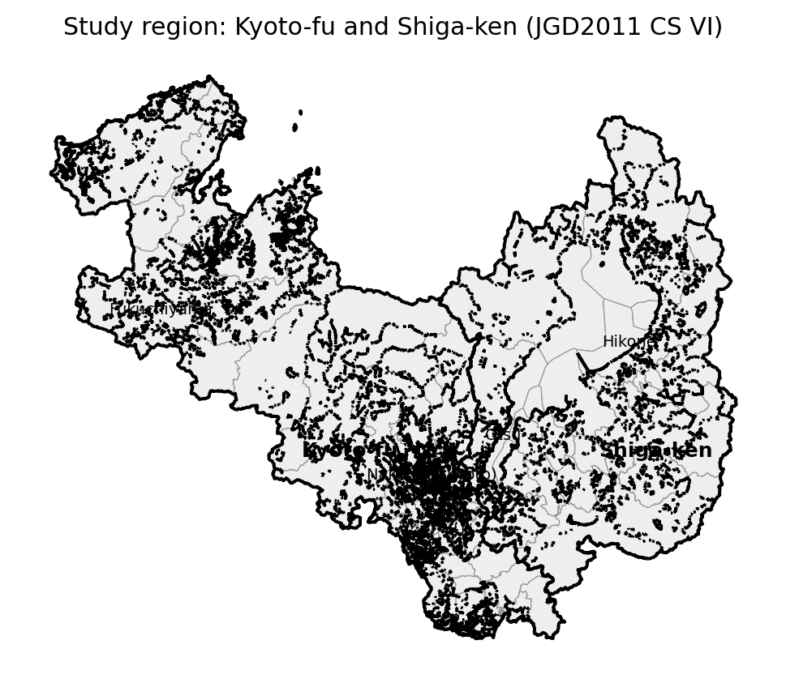

3.2 Data and provenance
All inputs are official public sources, archived locally with SHA-256 manifests (Table 1): (i) e-Stat statistical GIS small-area boundaries (r2ka, JGD2011) with 2020 census population and household counts (Ministry of Internal Affairs and Communications, 2020b); (ii) 2020 Census Table 6-1 municipality×municipality commuting/schooling origin–destination (OD) matrices, at ward resolution for Kyoto City and prefecture resolution for the comparative case-selection analysis (Ministry of Internal Affairs and Communications, 2020a); (iii) IPSS 2023 municipal population projections to 2050 (National Institute of Population and Social Security Research, 2023); (iv) the statutory district definition from the Public Offices Election Act (e-Gov law API) and the Ministry of Internal Affairs district map (Public Offices Election Act, 1950/2022). Adjacency is Queen-contiguity on small-area geometry; disconnected island/peninsula components and detached fragments of one census unit are handled by recorded bridging rules (docs/METHODS_DECISIONS.md). Because the two prefectures' r2ka boundaries do not coincide exactly, shared-boundary lengths are measured with a 30 m tolerance, and municipality-level edge weights aggregate small-area weights.
Table 1. Data sources.
dataset | source | raw path | coverage
Small-area boundaries + population | e-Stat 統計GIS r2ka (2020 census) | data/raw/r2ka_*.zip | 12,398 polygons (11,978 units)
Commuting/schooling OD | e-Stat Census Table 6-1 (2020) | data/raw/od_*.xlsx | municipality×municipality (ward-level)
Population projections | IPSS 2023 municipal projections | data/raw/ipss_kekkahyo1.xlsx | 2020–2050, 55 municipal units
Statutory districts | 公職選挙法 別表第一 (e-Gov law API) | data/raw/law_kosenkyoho.xml | Kyoto 6 + Shiga 3 = 9

3.3 Optimization models
Units are assigned to K = 9 districts. Hard constraints: population per district within $±τ$ of the district mean ($τ$ = 20%; sensitivity 10/15/30%), contiguity of every district, and — in Boundary-ON runs only — no district may contain both Kyoto (25) and Shiga (26) units. Objectives are a declared weighted sum of population deviation, boundary cut length (compactness), municipal splits (Level B only), severed OD flow, and — for M4 — projected deviation; full weights and seeds are in config/config.yaml.
- M0 evaluates the current statutory map.
- M1 minimizes population deviation + contiguity only.
- M2 (Boundary ON) is the full objective under the prefectural constraint.
- M3 (Boundary OFF) is identical without the constraint.
- M4 adds projected-population deviation (S1 proportional downscaling; S2 $±10\%$ centroid-drift sensitivity).
- M5 minimizes reassigned population from the current map subject to feasibility — the minimal-intervention benchmark.
Level A is formulated exactly as a mixed-integer program and solved by CP-SAT (OR-Tools) (Perron and Furnon, 2022) to the reported solver status and bounds on 55 municipal/ward units with rooted single-commodity-flow contiguity, 300–600 s limits, solution hints from M1, and recorded optimality gaps — we report bounds and never claim global optimality when the gap is open. Level B runs seeded simulated annealing with donor-connectivity checks and an incremental municipal-share closed form for severed flow on 11,978 small-area units, warm-started from the Level A solution. The same metrics module evaluates every assignment at both levels.
The core estimand is the Section 2 cost specialized to electoral districting, $C_{border}=L^{*} (Boundary ON)−L^{*} (Boundary OFF)$, the difference in achieved objective under otherwise identical settings, computed within level, $τ$, and seed. Where the solver proves only bounds, we report bounds; where it produces best-found incumbents, we report best-found differences and label them as such.

3.4 Placebo borders
Two hundred internal placebo borders partition the municipality-level adjacency graph via random spanning-tree cuts, matched to the real border on two-sided population share ($±10\%$), interface boundary length ($±50\%$), and two-sided contiguity. Each border is re-optimized ON and OFF at Level A (60 s limits); the distribution of placebo costs benchmarks whether the real border's cost is generic. Placebo runs that return no feasible incumbent within budget are no-incumbent-found outcomes — evidence of severe feasibility or search difficulty, not proven mathematical infeasibility.

3.5 Case-selection protocol
Choosing a border to study is itself a selection decision with cherry-picking risk, so the comparison was specified before any ranking was computed (docs/CASE_SELECTION_ANALYSIS_FREEZE.md; full audit in docs/CASE_SELECTION_AUDIT.md). The comparison set was frozen to all five of Kyoto Prefecture's borders (Osaka, Shiga, Nara, Hyogo, Fukui), Shiga's remaining borders (Mie, Gifu, Fukui) and every remaining land-border adjacency among the comparator prefectures available in the same census release, 15 unordered pairs in total. Four measures were pre-specified: raw directional flows $F_{i→j}$ and $F_{j→i}$; raw bidirectional $F_{ij}^{bi}$; a primary directional measure $R_{i→j}=\frac{F_{i→j}}{T_{i}}$ (share of origin-prefecture commuters and students); and a primary symmetric intensity $S_{ij}=\frac{F_{ij}^{bi}}{P_{i}+P_{j}}$ normalized by combined prefecture population. Exploratory measures (external-share $R_{ext}$, geometric-mean normalization $S_{2}$) were flagged as such. The protocol required every computed measure — including those unfavourable to the study pair — to be reported. Newly acquired origin-prefecture OD tables for Osaka, Hyogo, Nara, Fukui, Gifu, Mie and Wakayama (Ministry of Internal Affairs and Communications, 2020a) were added to the raw-data archive and checksum ledger under the same provenance rules as the existing inputs. The prefectural-government proximity claim was likewise verified from primary data rather than a secondary ranking: all 47 prefectural-government office locations were taken from the national public-facility register (Ministry of Land, Infrastructure, Transport and Tourism, 2006) and geodesic distances computed for all 1,081 unordered pairs on GRS80.

4. Results

4.1 Constraint cost
At Level A, CP-SAT returns FEASIBLE (not OPTIMAL) incumbents within 300 s: M2-ON objective 1,793,321 (best bound 883,334) against M3-OFF incumbent 1,870,325; the statutory baseline M0 that anchors all comparisons is shown in Figure 2 (its reconstructed metrics appear in Table 2). The raw incumbent difference (-77,004) has the wrong sign for a nested minimization problem — every ON-feasible map is OFF-feasible, so $L_{OFF}^{*}≤L_{ON}^{*}$ — which identifies it as a search artifact, not a cost. Because the validated ON assignment is itself an OFF-feasible solution of identical objective (invariant check I8), the OFF optimum is bounded above by the ON incumbent; the defensible interval for the true cost is therefore [0, 532,293] objective units — at most 0.297 of the incumbent objective scale — and its lower end is consistent with zero. A longer hinted OFF solve (900 s, warm-started from the ON incumbent) still returned no incumbent, so tighter identification is not claimed. Model-level comparisons are summarized in Table 3.
Figure 2. Current statutory House-of-Representatives districts.
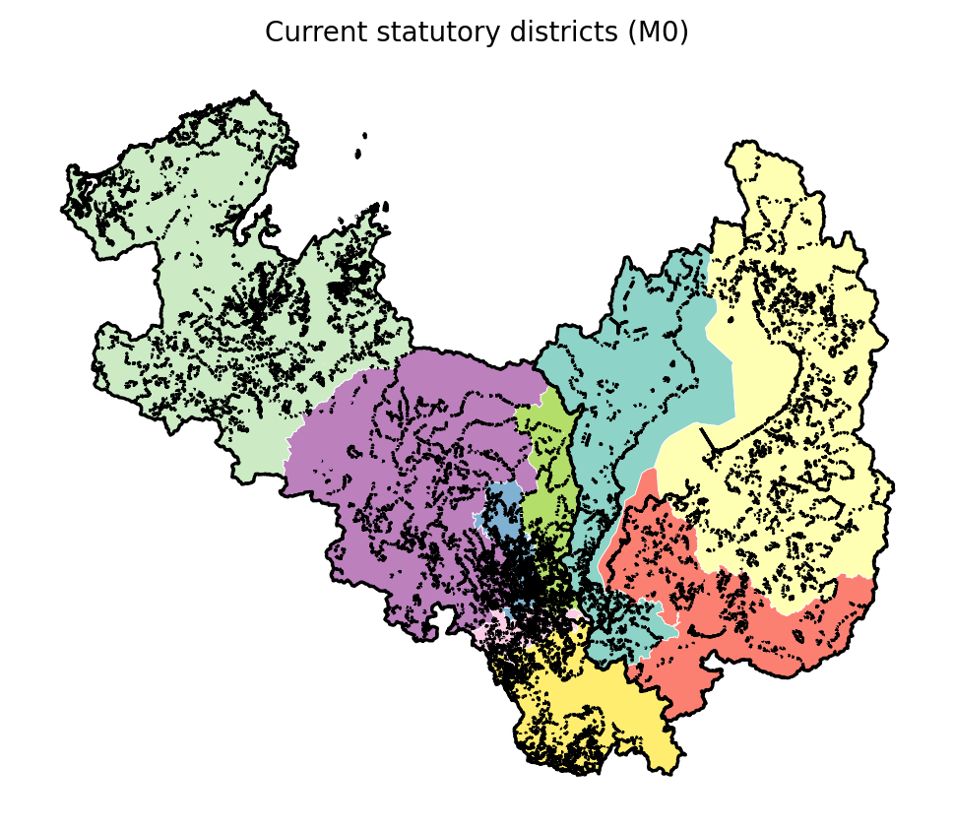
Table 2. Current-map metrics.
level | map | $max/min$ | $|dev|_{max}$ | PP | munis split | severed
A | current | 1.9744 | 0.3707 | 0.0298 | 0.0 | 233890.5
B | current | 1.9744 | 0.3707 | 0.029 | 0.0 | 233890.5
Table 3. Model comparison ON vs OFF.
level | model | $|dev|_{max}$ | $max/min$ | PP | munis split | severed | objective
A | M1 base | 0.1608508862270858 | 1.3138311735419057 | 0.033244477057695 | 0.0 | 243932.5 | 1793321.0
A | M2 ON | 0.1608508862270858 | 1.3138311735419057 | 0.033244477057695 | 0.0 | 243932.5 | 1793321.0
A | M3 OFF | 0.1574485738772256 | 1.3215579758623457 | 0.0320632788388002 | 0.0 | 249689.5 | 1870325.0
A | M4 ON | 0.1608508862270858 | 1.3138311735419057 | 0.033244477057695 | 0.0 | 243932.5 | 2168621.0
A | M4 OFF | 0.0940857985964365 | 1.19098120450228 | 0.0336414314742986 | 0.0 | 258311.5 | 2248844.0
B | M1 base | 0.1811610450392401 | 1.4055206358997756 | 0.0310174167009667 | 6.0 | 241040.9387458764 | 2.215394648817747
B | M2 ON | 0.1624584731756944 | 1.3163529563784768 | 0.0325184634140988 | 1.0 | 243922.56924311048 | 0.6245294675099053
B | M3 OFF | 0.1624584731756944 | 1.3163529563784768 | 0.0325184634140988 | 1.0 | 243922.56924311048 | 0.6245294675099053
B | M4 ON | 0.1811610450392401 | 1.4055206358997756 | 0.0310174167009667 | 6.0 | 241040.9387458764 | 2.215394648817747
B | M4 OFF | 0.1624584731756944 | 1.3163529563784768 | 0.0325184634140988 | 1.0 | 243922.56924311048 | 0.6245294675099053
At Level B the corrected accounting is sharper: recorded annealing bests referred to pre-repair intermediate solutions; evaluated on the final contiguous assignments, the ON best-found map scores 0.625 and the OFF run warm-started from that map retains exactly the same best (0.625): a best-found ON–OFF difference of 0 — removing the border constraint produces no improvement in the best-found small-area solution. The substantive explanation is visible in the maps (Figure 3) and in the flow network (Figure 4): the real border crosses only 39,733 commuting/schooling trips, below every one of the 200 matched placebo borders (median 99,420, IQR 90322 – 103038; real border at the 0th percentile). The administrative boundary broadly aligns with the Lake Biwa watershed, a geographic pattern consistent with the relatively weak functional connectivity observed across it: the observed cross-border flow indicates an unusually weak functional interface relative to the matched placebo borders. Compactness (mean PP 0.033 ON vs 0.033 OFF), municipal splits (1 vs 1), and severed intra-region flow (243,923 vs 243,923 trips) differ only marginally (Figure 5).
Figure 3. Best-found maps with the border constraint ON vs OFF.
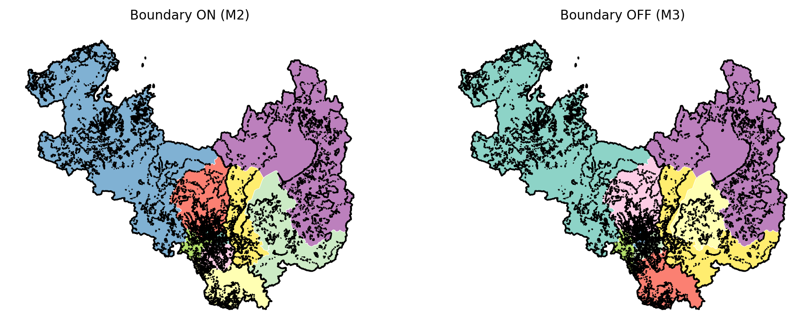
Figure 4. Cross-prefecture commuting/schooling OD network.
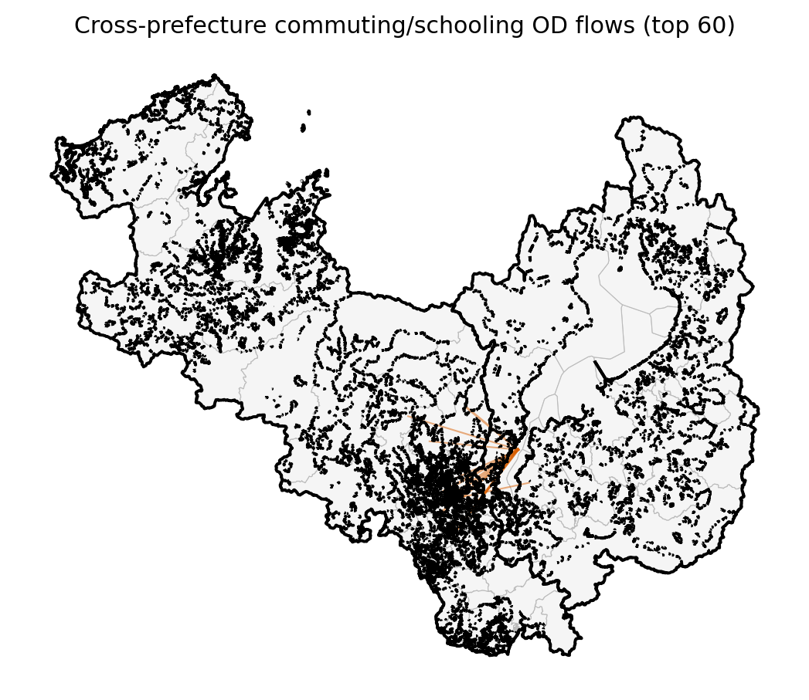
Figure 5. Objective-component comparison, ON vs OFF.
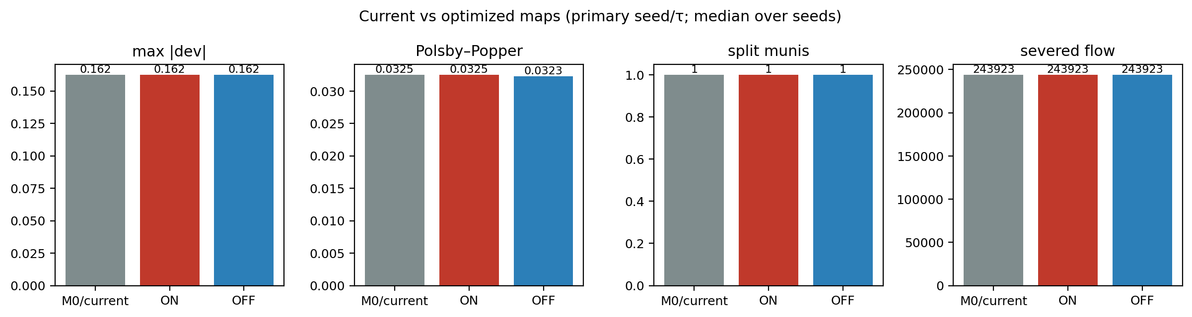

4.2 The current map
The statutory map (Figure 2) is contiguous but, reconstructed on 2020 census small-area populations, carries $|dev|_{max}$ = 0.371 and $max/min$ ratio 1.974 — Kyoto-5 (279k) is at 0.63 of the district mean (Table 2). This exceeds the experimental $±20\%$ tolerance used throughout this study (real statutory $max/min$ ≈ 2.0; ours 1.974 at Level A). Note this is a reconstruction property, not a legal judgment: the statutory map was drawn on the apportionment population basis and vintage in force at its delimitation, which differs from the 2020 census counts used here.

4.3 Sensitivity and scale
The $τ$ sweep (Table 4), seed replicates, and the Level A↔B scale comparison bound MAUP effects on the estimand; severed-flow results are robust to OD symmetrization/normalization choices (full sensitivity tables in the reproducibility bundle).
Table 4. τ sensitivity.
$τ$ | model | $|dev|_{max}$ | PP | severed | objective
0.1 | M2ON | 0.0981910701137886 | 0.0305595603875987 | 244026.3353448603 | nan
0.1 | M3OFF | 0.0992620431861436 | 0.0309976257822052 | 244023.83981967543 | nan
0.15 | M2ON | 0.1264670139041114 | 0.0311074738957966 | 245181.0 | nan
0.15 | M3OFF | 0.1475482733283613 | 0.0323402842766011 | 244093.94266502443 | nan
0.2 | M2ON | 0.1624584731756944 | 0.0325184634140988 | 243922.56924311048 | nan
0.2 | M3OFF | 0.1624584731756944 | 0.0325184634140988 | 243922.56924311048 | nan
0.3 | M2ON | 0.2576673530080064 | 0.0330996406558157 | 236271.6581644968 | nan
0.3 | M3OFF | 0.2227310840477121 | 0.0352054821331381 | 248054.54426192268 | nan

4.4 Placebo benchmark
Across 200 matched placebo borders, 61% (122 of 200) returned no feasible constrained incumbent under the shared $±20\%$ population tolerance — these are no-incumbent-found outcomes, not proven infeasibility; diagnostic reruns at up to 10× the iteration budget on a 12-border sample recovered none — persistent non-recovery under extended search, consistent with severe feasibility/search difficulty rather than a time-limit artifact, but not a proof of mathematical infeasibility (Table 5). Among the feasible borders the median constraint cost is 0.065 (IQR 0.0222 – 0.0727; the lower tail extends slightly below zero, again an incumbent-time artifact on a nested minimization, not a negative cost), and the real border — priced by the identical heuristic solver — sits at the 10th percentile (Figure 6). The real border is therefore not merely inexpensive: it is in the cheapest decile of feasible alternatives and among the minority of lines that permit any feasible map.
Figure 6. Placebo-border cost distribution vs the real border.
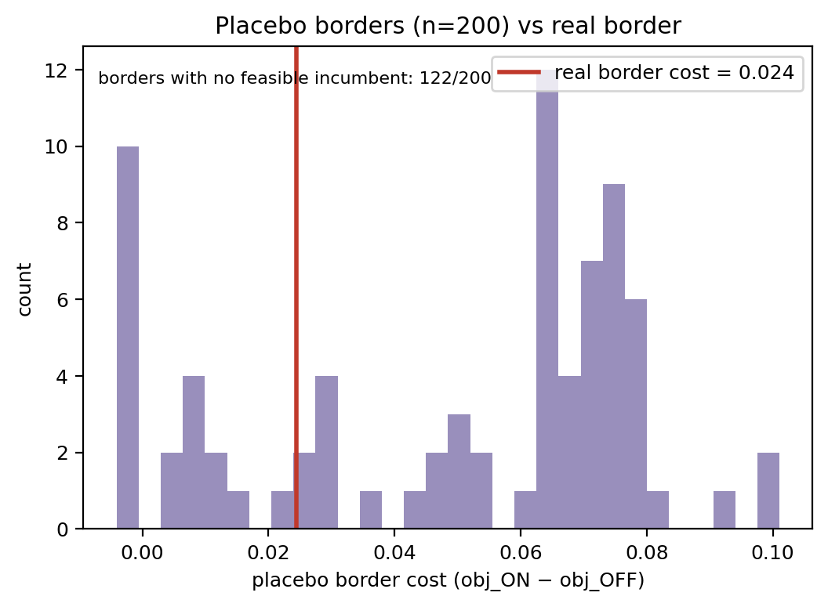
Table 5. Placebo summary.
statistic | value
n | 200
n generated | 200
n feasible ON+OFF | 78
n ON-infeasible (no incumbent found) | 122
cost median (feasible) | 0.0647
cost IQR (feasible) | 0.0222 – 0.0727
cost p5–p95 (feasible) | -0.0041 – 0.0799

4.5 Future robustness and minimal intervention
Under IPSS S1 projections the ON best-found map's max deviation reaches 0.267 by 2050 and first breaches $τ$ in 2040; the OFF map breaches in 2040. M4 explicitly robust maps and the M5 minimum-intervention repair (118,576 people, 0.030 of the region, 176 small areas) are tabulated in Table 6 (Figure 7).
Figure 7. Future robustness under IPSS projections to 2050.
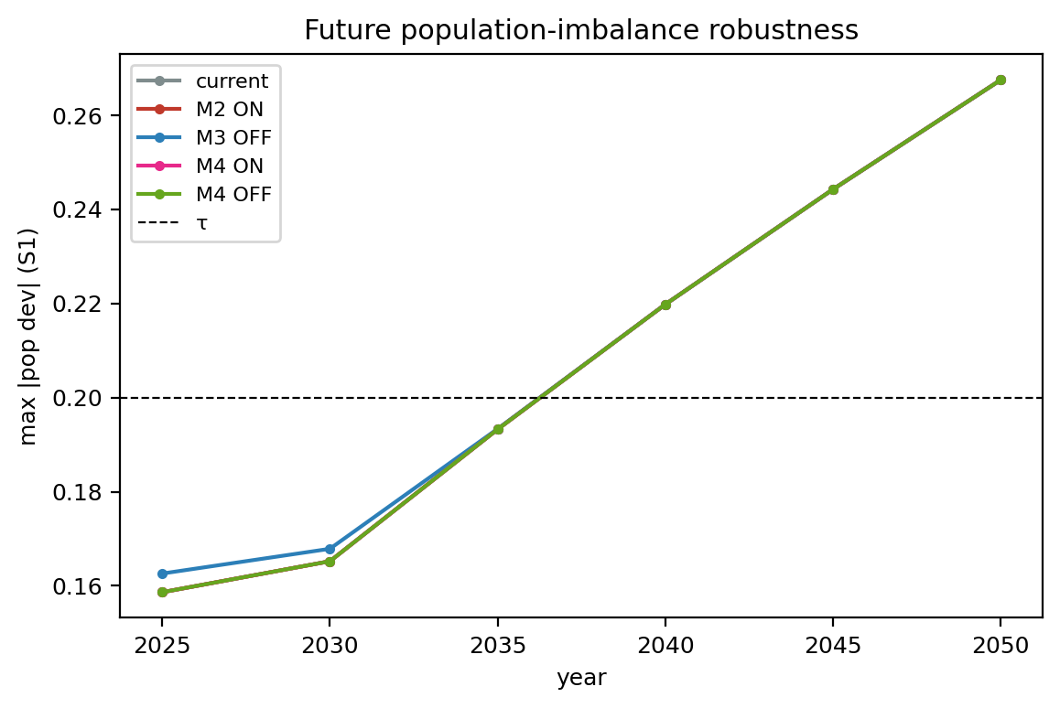
Table 6. Future robustness.
model | 2025 | 2030 | 2035 | 2040 | 2045 | 2050
M2ON | 0.159 | 0.165 | 0.193 | 0.22 | 0.244 | 0.267
M3OFF | 0.159 | 0.165 | 0.193 | 0.22 | 0.244 | 0.267
M4ON | 0.195 | 0.212 | 0.239 | 0.264 | 0.288 | 0.312
M4OFF | 0.159 | 0.165 | 0.193 | 0.22 | 0.244 | 0.267

4.6 Why this border: case-selection evidence
The pre-specified comparison (Table 7, Figure 8) yields a deliberately honest picture. On raw volume Kyoto–Shiga is not the strongest link: Kyoto–Osaka carries 176,231 bidirectional daily trips against 79,466 for Kyoto–Shiga — more than twice — and Osaka dominates Kyoto's external commuting generally. On the pre-specified normalized symmetric intensity, however, Kyoto–Shiga is the strongest of Kyoto's five borders: $S_{ij}$ = 1.99% against 1.54% for Kyoto–Osaka and 0.94% for Kyoto–Nara.
Figure 8. Case-selection comparison: Kyoto's five borders by raw bidirectional flow and normalized intensity (left); directional asymmetry of key corridors (right).
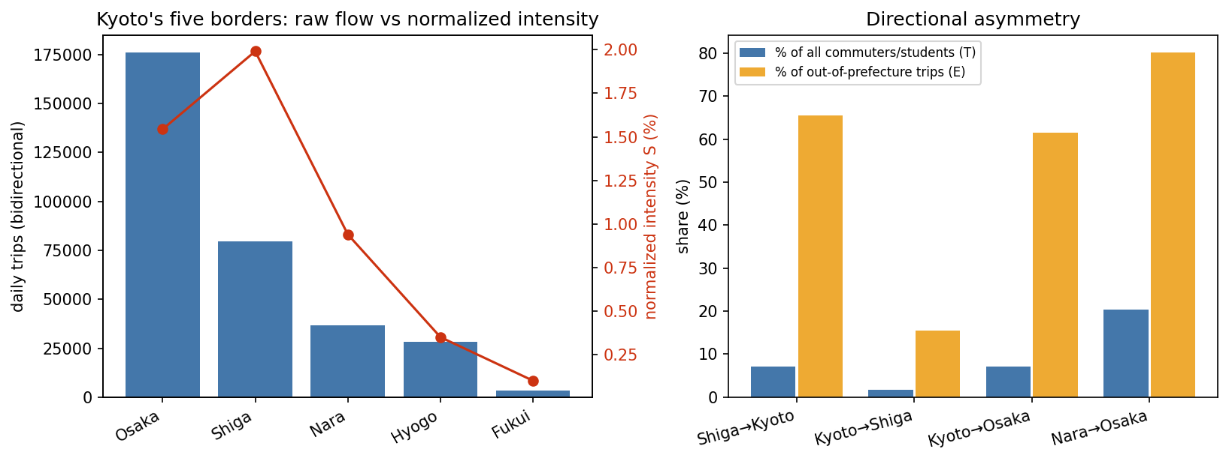
Table 7. Case-selection prefecture-pair comparison (2020 census commuting/schooling OD; frozen metrics, all pairs reported).
border pair | $F_{i→j}$ | $F_{j→i}$ | $F_{ij}^{bi}$ | $R_{i→j}$ (%) | $R_{j→i}$ (%) | $S_{ij}$ (%)
Kyoto–Shiga | 22487.0 | 56979.0 | 79466.0 | 1.78 | 7.2 | 1.991
Kyoto–Osaka | 89444.0 | 86787.0 | 176231.0 | 7.06 | 2.02 | 1.544
Kyoto–Hyogo | 9593.0 | 18709.0 | 28302.0 | 0.76 | 0.66 | 0.352
Kyoto–Nara | 16943.0 | 19774.0 | 36717.0 | 1.34 | 2.92 | 0.941
Kyoto–Fukui | 2009.0 | 1405.0 | 3414.0 | 0.16 | 0.31 | 0.102
Shiga–Mie | 1598.0 | 1617.0 | 3215.0 | 0.2 | 0.17 | 0.101
Shiga–Gifu | 1695.0 | 1476.0 | 3171.0 | 0.21 | 0.13 | 0.093
Shiga–Fukui | 973.0 | 531.0 | 1504.0 | 0.12 | 0.12 | 0.069
Osaka–Hyogo | 106051.0 | 309704.0 | 415755.0 | 2.46 | 11.0 | 2.907
Osaka–Nara | 27627.0 | 137932.0 | 165559.0 | 0.64 | 20.38 | 1.629
Osaka–Wakayama | 12974.0 | 25842.0 | 38816.0 | 0.3 | 5.55 | 0.398
Nara–Wakayama | 1670.0 | 3059.0 | 4729.0 | 0.25 | 0.66 | 0.21
Nara–Mie | 4122.0 | 2951.0 | 7073.0 | 0.61 | 0.3 | 0.229
Gifu–Mie | 3518.0 | 1479.0 | 4997.0 | 0.32 | 0.15 | 0.133
Gifu–Fukui | 261.0 | 130.0 | 391.0 | 0.02 | 0.03 | 0.014
Directional asymmetry was tested rather than assumed. Shiga is Kyoto-oriented: 7.2% of all Shiga commuters and students travel to Kyoto, comprising 65.5% of Shiga's out-of-prefecture trips. Kyoto is polycentric: 7.1% travel to Osaka but only 1.8% to Shiga — a directional rate of similar magnitude to Shiga's toward Kyoto. For full disclosure, Shiga→Kyoto is not the bloc's maximum directional share: Nara→Osaka reaches 20.4% (Table 7). Municipal concentration tells the same entanglement story from below: Kyoto is the largest external prefectural destination for 18 of Shiga's 19 municipalities (the sole exception, Maibara, sits at the prefecture's opposite end), while for Kyoto's 36 municipalities and wards Osaka tops 23 and Shiga tops only 1 — Yamashina-ku, the ward directly adjoining Ōtsu.
Proximity and shared institutions corroborate the entanglement. The Kyoto and Shiga prefectural government offices sit 10.5 km apart — the closest of all 1,081 prefectural-government-office pairs in Japan, 8.5 km closer than the runner-up pair — linked by roughly 10 minutes of commuter rail. The functional pairing has its own name in Japanese usage: "Keiji" (Kyōto–Shiga), adopted by a RIETI–Kyoto University industrial-cluster study, the national accountants' association's regional body, and corporate branch structures alike; the Kyoto Shimbun's circulation territory is exactly the two prefectures; and Kyoto City has drawn its water from Lake Biwa at Ōtsu through its own canal since 1890, an engineered cross-border dependency older than the current electoral system. Historically, Ōmi province hosted the imperial capital at Ōtsu and carried both the Tōkaidō and Nakasendō corridors — the border region has been a through-route for centuries.
The honest conclusion is therefore narrower than "the most entangled pair in Japan." Kyoto–Shiga is the strongest border on the pre-specified normalized measure within Kyoto's borders, unusually proximate, and deeply institutionalized — but it is not the table's normalized maximum (Osaka–Hyogo reaches $S_{ij}$ = 2.91%), Osaka dominates raw flow, and Nara→Osaka exceeds Shiga→Kyoto on origin-share. The pair was selected because it concentrates the study's theoretical difficulty — a hard statutory wall across a functionally entangled space — in the country's most proximate prefectural-government pairing by geodesic distance, not because it tops every measure; the divergence among measures is itself evidence about what kind of entanglement the border is.

5. Discussion
The empirical finding. The prefectural border turns out to be cheap — and that is itself the finding, with an honest precision caveat. At municipality scale the true cost is only bounded: the interval [0, 532,293] objective units is wide relative to incumbent scale because the OFF optimum resisted identification even at 900 s of hinted search, and we do not claim tighter. At census small-area scale the constrained and unconstrained best-found maps coincide exactly. The flow metrics are consistent with the low measured cost: the real border crosses only 39,733 daily trips — fewer than all 200 matched placebo borders — and the border's broad alignment with the Lake Biwa watershed is consistent with this relatively weak functional connectivity, so the functional-geography cuts a border-respecting optimizer must make are almost the same ones an unconstrained optimizer chooses anyway. The placebo benchmark sharpens this: most matched alternative borders either admit no feasible constrained incumbent or are more expensive, so the actual line is unusually well-placed, not merely unobtrusive. The Ōtsu–Kyoto corridor is the exception the rule proves: it is the one place the border bisects a commuting field, and it is small enough to be accommodated.
The territoriality reading. The result is surprising against the functionalist intuition that a boundary cutting a commuting field must bind hard — and it is precisely the kind of finding the boundary literature should expect once the question is asked correctly. Political geography treats borders as institutions that persist because they organize, not because they track function (Newman and Paasi, 1998; Painter, 2010; Elden, 2013). What this study adds is that the price of such persistence is an empirical quantity with a sign and a magnitude, not an axiom: here it is bounded at municipality scale and best-found-zero at fine scale, because the inherited line happens to run along a watershed through a weak functional interface. The boundary reproduces administrative space exactly as the institutionalist account predicts; but its measured cost inside one representation system is small. Institutional persistence and functional inefficiency are different claims, and only the second needs numbers.
The electoral-geography reading. Computational electoral geography has spent two decades measuring what happens inside statutory containers — the shape of districts, the bias of plans (Taylor and Johnston, 1979; Duchin and Tenner, 2024). This paper turns the same instruments outward onto the container itself: the prefectural wall becomes a costed design parameter rather than background. For Japan specifically, where the no-straddle rule is statutory and recent delimitations have already accepted increasing within-prefecture disparity, the estimand answers a question commissions currently cannot: what would relaxing the container buy? At fine resolution here, nothing measurable.
Mismatch is an observation; inefficiency is an estimand. The Kyoto–Shiga line is, by any visual or functional criterion, a conspicuous administrative–functional mismatch: it bisects an exceptionally proximate cross-border setting linked by 79,466 daily cross-prefecture trips. If visible mismatch implied large marginal efficiency loss, removing the constraint should yield large gains; it yielded a bounded gain at municipality scale and no gain at small-area scale. A redrawn or harmonized boundary is a reform whose benefits must be demonstrated, and the demonstrated benefit of lifting this constraint is, at the resolution where we can sharpen it, zero.
Why the case-selection discipline matters. The case is extreme on proximity and institutional entanglement but not on raw flow, and the paper says so — the alternative pair (Kyoto–Osaka) is bigger by volume, and Nara→Osaka out-ranks Shiga→Kyoto on directional share. Pre-specified measurement and full reporting are what separate a case study from a demonstration: the claim is not that this border is unique, but that a hard boundary across a deeply entangled space was priced, and priced low. The typology that falls out — institutionally divided yet functionally entangled pairs, versus divided-and-divided or entangled-and-undivided ones — is portable to other border pairs and other functions.
The general principle and its limits. Different public functions optimize different objectives; their efficient territorial partitions need not coincide, and forcing them to coincide restricts every function's feasible set (Larson and Odoni, 2007; Owen and Daskin, 1998). Territorial congruence should therefore be treated as a design decision rather than a default objective. The same paired estimand applies wherever a territorial plan must respect an inherited or shared boundary — health-service regions, emergency coverage, school catchments, transport and utility territories, multi-jurisdiction infrastructure. These are examples of the general decision problem, not findings of this study, whose empirical content is exclusively electoral; and the study does not estimate the coordination, transition, or legibility benefits that might still justify alignment.

6. Limitations
Several qualifications bound the claims. The study prices one territorial function — electoral districting — in one two-prefecture Japanese case; it does not empirically compare multiple service systems and does not estimate the coordination benefits or transition costs of multi-service alignment. The case-selection comparison is bounded by design: it covers Kinki-region prefecture pairs from a single census release, uses commuting/schooling flow as the functional layer (one dimension of connectivity, not all of it), relies on pre-specified rather than exhaustive normalizations, and draws contextual corroboration from heterogeneous sources of varying authority (the prefectural-office distance computation, though performed from official national data, rests on 2006-vintage facility coordinates). Commuting flow is one functional dimension of connectivity, not all of it. The composite objective uses declared weights; other weightings would re-price the constraint. At Level A the true optimum is not tightly identified (the OFF solve returned no incumbent even at 900 s), so the municipality-scale cost is an interval, not a point estimate; Level B is heuristic simulated annealing with no optimality bound, so its zero is a best-found difference, not a proven optimum. Placebo no-incumbent outcomes are not proven mathematical infeasibility. Municipal-share severed-flow is a closed-form approximation at Level B. Future-population robustness relies on proportional downscaling of official projections with a $±10\%$ centroid-drift sensitivity, not a behavioral model. Placebo matching is statistical, not parametric identification. Finally, all analyses are nonpartisan by design — no electoral outcome is modeled — and the $±20\%$ tolerance is an experimental design parameter, not a legal judgment about the statutory map.

7. Conclusion
Territorial alignment can be priced. By treating an inherited administrative boundary as a constraint whose opportunity cost is measurable — $C_{border}=L^{*} (Boundary ON)−L^{*} (Boundary OFF)$ — we quantified the cost of Japan's prefectural-districting rule for the Kyoto–Shiga case: bounded within [0, 532,293] objective units at municipality scale and zero among best-found small-area maps, against a functional benchmark in which the real border crosses less commuting flow than every one of 200 matched placebo borders and permits a feasible map where most placebo lines yield no feasible incumbent. The broader lesson is a decision principle, not a boundary prescription: visible administrative–functional mismatch need not imply large efficiency loss; inherited territorial constraints have a measurable price; alignment is not self-justifying; and under scarcity, heterogeneous public functions may rationally retain different footprints when the demonstrated benefits of congruence do not justify its opportunity cost. For political geography, the methodological point is that the boundary itself — not only the maps drawn inside it — can be made a measurable object.

Declarations
Ethics approval: not applicable (public aggregate statistical data only). Competing interests: the author declares none. Funding: none. Generative AI: AI-assisted tooling was used for language checking and manuscript-production assistance; all scientific content, claims, and analyses are the author's own. Data and code availability: all inputs are official public data archived with SHA-256 manifests; the full pipeline, outputs, and reproducibility bundle are public at github.com/bougtoir/admin-border-cost; every reported number regenerates end-to-end from run artifacts (docs/REPRODUCIBILITY.md).

References
Agnew, J., 1994. The territorial trap: the geographical assumptions of international relations theory. Review of International Political Economy 1(1), 53–80. https://doi.org/10.1080/09692299408434268
Balinski, M.L., Young, H.P., 1982. Fair Representation: Meeting the Ideal of One Man, One Vote. Yale University Press, New Haven.
DeFord, D., Duchin, M., Solomon, J., 2021. Recombination: a family of Markov chains for redistricting. Harvard Data Science Review 3(1). https://doi.org/10.1162/99608f92.eb30390f
Duchin, M., Tenner, B.E., 2024. Discrete geometry for electoral geography. Political Geography. https://doi.org/10.1016/j.polgeo.2023.103040
Elden, S., 2013. The Birth of Territory. University of Chicago Press, Chicago.
Herschlag, G., Kang, H.S., Luo, J., Graves, C.V., Bangia, S., Ravier, R., Mattingly, J.C., 2020. Quantifying gerrymandering in North Carolina. Statistics and Public Policy 7(1), 30–38. https://doi.org/10.1080/2330443X.2020.1796400
Larson, R.C., Odoni, A.R., 2007. Urban Operations Research, 2nd ed. Dynamic Ideas, Belmont, MA.
Mehrotra, A., Johnson, E.L., Nemhauser, G.L., 1998. An optimization-based heuristic for political districting. Management Science 44(8), 1100–1114. https://doi.org/10.1287/mnsc.44.8.1100
Ministry of Internal Affairs and Communications (Japan), 2020a. 2020 Population Census, Table 6-1: Commuting and Schooling Origin–Destination [Data set]. e-Stat.
Ministry of Internal Affairs and Communications (Japan), 2020b. Statistical GIS Boundary Data (r2ka Small Areas, JGD2011), with 2020 Census counts [Data set]. e-Stat.
Ministry of Land, Infrastructure, Transport and Tourism (Japan), 2006. National Land Numerical Information, Public Facilities (P02, prefectural-government offices) [Data set]. https://nlftp.mlit.go.jp/ksj/.
National Institute of Population and Social Security Research, 2023. Municipal Population Projections, 2020–2050 [Data set].
Newman, D., Paasi, A., 1998. Fences and neighbours in the postmodern world: boundary narratives in political geography. Progress in Human Geography 22(2), 186–207. https://doi.org/10.1191/030913298666039113
OECD, 2012. Redefining "Urban": A New Way to Measure Metropolitan Areas. OECD Publishing, Paris. https://doi.org/10.1787/9789264174108-en
Openshaw, S., Taylor, P.J., 1979. A million or so correlation coefficients: three experiments on the modifiable areal unit problem. In: Wrigley, N. (Ed.), Statistical Applications in the Spatial Sciences. Pion, London, pp. 127–144.
Owen, S.H., Daskin, M.S., 1998. Strategic facility location: a review. European Journal of Operational Research 111(3), 423–447. https://doi.org/10.1016/S0377-2217(98)00186-6
Paasi, A., 2009. Political boundaries. In: Kitchin, R., Thrift, N. (Eds.), International Encyclopedia of Human Geography. Elsevier, Oxford. https://doi.org/10.1016/B978-008044910-4.00793-8
Painter, J., 2010. Rethinking territory. Antipode 42(5), 1090–1118. https://doi.org/10.1111/j.1467-8330.2010.00795.x
Perron, L., Furnon, V., 2022. OR-Tools CP-SAT Solver [Computer software]. Google.
Polsby, D.D., Popper, R.D., 1991. The third criterion: compactness as a procedural safeguard against partisan gerrymandering. Yale Law & Policy Review 9, 301–353.
Public Offices Election Act, Law No. 100 of 1950, as amended through 2022; Annex 1 (single-member districts) (Japan). e-Gov law database.
Ricca, F., Scozzari, A., Simeone, B., 2013. Political districting: from classical models to recent approaches. Annals of Operations Research 204, 271–299. https://doi.org/10.1007/s10479-012-1267-2
Tam Cho, W.K., Liu, Y.Y., 2016. Toward a talismanic redistricting tool: a computational method for identifying extreme redistricting plans. Election Law Journal 15(4), 351–366. https://doi.org/10.1089/elj.2016.0384
Taylor, P., Johnston, R., 1979. Geography of Elections. Penguin, Harmondsworth. https://doi.org/10.4324/9781315747613

Remaining figures and tables

