Pricing territorial alignment: the opportunity cost of an inherited administrative boundary in electoral-district spatial optimization, Kyoto–Shiga, Japan

Highlights
- Territorial alignment is a constraint to be priced, not a default objective.
- Kyoto–Shiga border cost: bounded at municipality scale; best-found zero.
- The real border crosses less commuting flow than all 200 matched placebos.
- No feasible constrained incumbent was found for 122 of 200 placebo borders.
- Visible administrative–functional mismatch does not establish inefficiency.

Abstract
Public services are delivered through overlapping territorial systems whose boundaries need not coincide, yet planning often treats administrative–functional mismatch as a defect to be corrected. We reframe territorial alignment as a constrained-planning decision whose opportunity cost can be measured, and estimate it for one public function — electoral districting — where the cost is defined by the paired estimand $C_{border}=L^{*} (Boundary ON)−L^{*} (Boundary OFF)$: the deterioration in a nonpartisan districting objective attributable solely to the statutory rule that Japan's House of Representatives districts not straddle prefectural boundaries. The Kyoto–Shiga border, which bisects a commuting field of 79,466 cross-prefecture trips (2020 census), is the test bed. Solving matched problems at two spatial resolutions — an exact CP-SAT formulation at municipality scale and seeded simulated annealing on census small areas — we find the true constraint cost is bounded but not tightly identified at municipality scale ([0, 532,293] objective units, at most ~30% of incumbent scale) and zero among best-found small-area maps. The real border crosses fewer trips (39,733) than all 200 matched placebo borders (median 99,420), and no feasible constrained incumbent was found for 122 of 200 placebo borders at the same tolerance; the inherited line is unusually well placed, not generic. Visible territorial mismatch did not imply a large marginal efficiency loss: alignment should be evaluated against its opportunity cost rather than presumed beneficial.
Keywords: public-sector planning; territorial alignment; spatial optimization; administrative boundaries; electoral districting; functional connectivity

1. Introduction
Public services are delivered through space, and they are delivered through many spaces at once. A single territory is simultaneously partitioned into electoral districts, health-service regions, school catchments, emergency-response zones, transport and utility service areas — each drawn, at some point in institutional history, to optimize a different objective under different constraints [1,2]. Because these systems answer different questions, there is no general reason their efficient boundaries should coincide. Yet when an administrative boundary is visibly misaligned with a functional geography — when a statutory line bisects a commuting field, a market area, or a service region — the mismatch is commonly treated as a defect to be corrected, and harmonization of the boundary with the functional geography is treated as the presumptively correct remedy.
This paper questions the presumption. Requiring territorial alignment is itself a constraint on the feasible set of plans, and constraints have opportunity costs. For a public function s with feasible plan set $F_{0}$ and objective $L_{s}(D)$, the optimal unconstrained plan is $D_{s}^{*}=\backslash arg\min_{D}L_{s}(D)$; imposing a boundary or alignment requirement B restricts the feasible set to $F_{B}⊂F_{0}$ and imposes a non-negative opportunity cost $C_{s}(B)=L_{s}^{*}(B)−L_{s}^{*}(0)≥0$ on the true minima. Under limited resources and heterogeneous objectives, whether alignment is warranted is an empirical question: it depends on whether the coordination, administrative, legibility, or accountability benefits of a common geography exceed this cost. Observed mismatch, by itself, is therefore evidence of nothing more than different geometries — it is not evidence of inefficiency.
Measuring $C_{s}(B)$ cleanly requires a controlled comparison that administrative processes rarely provide: two plans produced by the same optimizer, the same constraints, and the same data, differing only in whether the boundary requirement is applied. Electoral districting supplies an unusually clean test bed. Districting is a spatial public-sector design problem with explicit, legally grounded objectives — population capacity and equality, contiguity, compactness, municipal coherence — a rich optimization literature [3,4,5,6,7], and, in Japan, a hard statutory version of the constraint: since the 1994 introduction of single-member districts for the House of Representatives, districts have been allocated and delimited within each prefecture, so that no district contains territory of two prefectures [8]. The redistricting literature — dominated by compactness metrics [9], optimization formulations [4,5], ensemble benchmarking [6,7], and the classic theory of territorial apportionment [10] — has rarely isolated the price of that inherited constraint itself.
The Kyoto–Shiga prefectural boundary in Japan's Kinki region is an ideal case. The two prefectures share a roughly 118 km border that is also the watershed of the Lake Biwa basin. The southern segment bisects a continuous urban fabric: Ōtsu (Shiga) adjoins Kyoto City, and the 2020 census records 79,466 commuting and schooling trips crossing the border [11]. The border is thus simultaneously a hard statutory line and an administrative boundary whose functional rationale — the watershed — is unrelated to representation.
Our contributions are fivefold. First, we formalize the administrative-boundary constraint as a paired-optimization estimand, $C_{border}=L^{*} (Boundary ON)−L^{*} (Boundary OFF)$, and compute it at two spatial resolutions, bracketing the modifiable areal unit problem (MAUP) [12]. Second, we couple the districting model to the commuting/schooling origin–destination network, measuring how much functional connectivity each institutional map retains. Third, we embed the real border in a distribution of 200 matched placebo borders to test whether the constraint's cost is specific to this geography. Fourth, we evaluate temporal robustness under official municipal population projections to 2050. Fifth — and this is the conceptual contribution — we show that the measured cost, rather than the visible mismatch, is what planning should price: territorial congruence is a design decision, not a default objective. All data, code, and provenance are public, and the pipeline regenerates every reported number end-to-end.
We emphasize scope. This is a measurement paper about one territorial public function in one case, not a proposal to abolish prefectures or redraw any particular statutory map, and it is deliberately nonpartisan: no variable related to party, candidate, incumbent, or vote share enters the model, the data, or the evaluation. It does not estimate the benefits of alignment — administrative simplicity, coordination, shared infrastructure, public legibility — which are the other side of the decision; it supplies the opportunity-cost side, which is the side that is usually left unmeasured.

2. Territorial alignment as a constrained planning problem
Before turning to the empirical setting we make the framing explicit. Let a public-sector function $s∈\{1,…,S\}$ be delivered through a territorial plan D chosen from a feasible set $F_{0}$, with evaluated quality $L_{s}(D)$ to be minimized (higher $L_{s}$ is worse: worse population balance, less compactness, more severed connectivity, or a declared weighted combination). The unconstrained optimum $D_{s}^{*}=\backslash arg\min_{D}L_{s}(D)$ is, in general, different for each s: health regions optimize access and capacity, emergency zones optimize response time, school catchments optimize enrollment balance and travel, electoral districts optimize representation criteria. Requiring a function's plans to respect an inherited boundary set B restricts the feasible set to $F_{B}⊂F_{0}$, and the opportunity cost of that restriction is $C_{s}(B)=L_{s}^{*}(B)−L_{s}^{*}(0)≥0$, the increase in the best achievable objective. A common-boundary requirement across functions is the special case in which every $F_{B}$ is cut by the same B.
This definition makes three distinctions that discipline everything below. The true cost $C(B)$ is defined on true minima and is usually not directly observed; what a solver reports is an incumbent, so empirical work bounds $C(B)$ rather than identifies it. Second, a negative or zero measured difference between constrained and unconstrained incumbents is a search artifact, not evidence that the constraint is free — we enforce the accounting that separates the two. Third, infeasibility of the constrained problem under a stated tolerance is a statement about the search that was run, not a proof that no feasible plan exists.
The decision problem this frames is a comparison: the benefits of territorial alignment — administrative simplicity, cross-function coordination, shared data and infrastructure, accountability, legibility to the public, reduced transaction costs — versus its opportunity cost $C(B)$. We estimate one $C(B)$ for one function. The generalization is methodological: congruence should be evaluated, not presumed. We do not claim the single application proves that public services in general should use different boundaries.

3. Study area, data, and methods

3.1 Study area
The combined Kyoto-fu/Shiga-ken region contains 55 municipal units (36 in Kyoto including Kyoto City's 11 wards; 19 in Shiga) partitioned into 11,978 census small areas (totals may differ after merging 420 multi-part fragments of the same small area). The 2020 census population is 3,991,697 — Shiga 1,413,610, Kyoto 2,578,087 [11]. Statutory representation allocates 6 single-member districts to Kyoto and 3 to Shiga (K = 9; Figure 1) [8].
Figure 1. Study region: Kyoto-fu and Shiga-ken, census small areas (JGD2011).
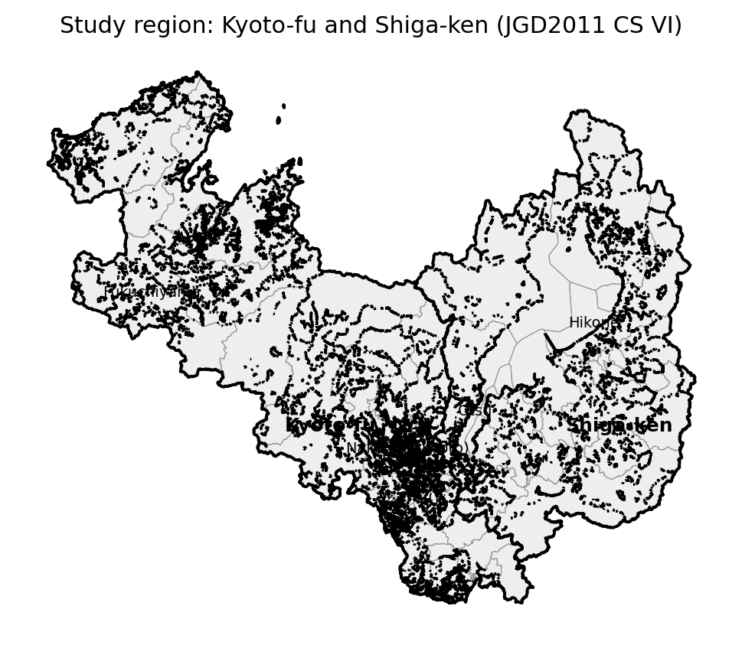

3.2 Data and provenance
All inputs are official public sources, archived locally with SHA-256 manifests (Table 1): (i) e-Stat statistical GIS small-area boundaries (r2ka, JGD2011) with 2020 census population and household counts [13]; (ii) 2020 Census Table 6-1 municipality×municipality commuting/schooling origin–destination (OD) matrices, at ward resolution for Kyoto City [11]; (iii) IPSS 2023 municipal population projections to 2050 [14]; (iv) the statutory district definition from the Public Offices Election Act (e-Gov law API) and the Ministry of Internal Affairs district map [8]. Adjacency is Queen-contiguity on small-area geometry; disconnected island/peninsula components and detached fragments of one census unit are handled by recorded bridging rules (docs/METHODS_DECISIONS.md). Because the two prefectures' r2ka boundaries do not coincide exactly, shared-boundary lengths are measured with a 30 m tolerance, and municipality-level edge weights aggregate small-area weights.
Table 1. Data sources.
dataset | source | raw path | coverage
Small-area boundaries + population | e-Stat 統計GIS r2ka (2020 census) | data/raw/r2ka_*.zip | 12,398 polygons (11,978 units)
Commuting/schooling OD | e-Stat Census Table 6-1 (2020) | data/raw/od_*.xlsx | municipality×municipality (ward-level)
Population projections | IPSS 2023 municipal projections | data/raw/ipss_kekkahyo1.xlsx | 2020–2050, 55 municipal units
Statutory districts | 公職選挙法 別表第一 (e-Gov law API) | data/raw/law_kosenkyoho.xml | Kyoto 6 + Shiga 3 = 9

3.3 Optimization models
Units are assigned to K = 9 districts. Hard constraints: population per district within $±τ$ of the district mean ($τ$ = 20%; sensitivity 10/15/30%), contiguity of every district, and — in Boundary-ON runs only — no district may contain both Kyoto (25) and Shiga (26) units. Objectives are a declared weighted sum of population deviation, boundary cut length (compactness), municipal splits (Level B only), severed OD flow, and — for M4 — projected deviation; full weights and seeds are in config/config.yaml.
- M0 evaluates the current statutory map.
- M1 minimizes population deviation + contiguity only.
- M2 (Boundary ON) is the full objective under the prefectural constraint.
- M3 (Boundary OFF) is identical without the constraint.
- M4 adds projected-population deviation (S1 proportional downscaling; S2 $±10\%$ centroid-drift sensitivity).
- M5 minimizes reassigned population from the current map subject to feasibility — the minimal-intervention benchmark.
Level A is formulated exactly as a mixed-integer program and solved by CP-SAT (OR-Tools) [15] to the reported solver status and bounds on 55 municipal/ward units with rooted single-commodity-flow contiguity, 300–600 s limits, solution hints from M1, and recorded optimality gaps — we report bounds and never claim global optimality when the gap is open. Level B runs seeded simulated annealing with donor-connectivity checks and an incremental municipal-share closed form for severed flow on 11,978 small-area units, warm-started from the Level A solution. The same metrics module evaluates every assignment at both levels.
The core estimand is the Section 2 cost specialized to electoral districting, $C_{border}=L^{*} (Boundary ON)−L^{*} (Boundary OFF)$, the difference in achieved objective under otherwise identical settings, computed within level, $τ$, and seed. Where the solver proves only bounds, we report bounds; where it produces best-found incumbents, we report best-found differences and label them as such.

3.4 Placebo borders
Two hundred internal placebo borders partition the municipality-level adjacency graph via random spanning-tree cuts, matched to the real border on two-sided population share ($±10\%$), interface boundary length ($±50\%$), and two-sided contiguity. Each border is re-optimized ON and OFF at Level A (60 s limits); the distribution of placebo costs benchmarks whether the real border's cost is generic. Placebo runs that return no feasible incumbent within budget are no-incumbent-found outcomes — evidence of severe feasibility or search difficulty, not proven mathematical infeasibility.

4. Results

4.1 Constraint cost
At Level A, CP-SAT returns FEASIBLE (not OPTIMAL) incumbents within 300 s: M2-ON objective 1,793,321 (best bound 883,334) against M3-OFF incumbent 1,870,325; the statutory baseline M0 that anchors all comparisons is shown in Figure 2 (its reconstructed metrics appear in Table 2). The raw incumbent difference (-77,004) has the wrong sign for a nested minimization problem — every ON-feasible map is OFF-feasible, so $L_{OFF}^{*}≤L_{ON}^{*}$ — which identifies it as a search artifact, not a cost. Because the validated ON assignment is itself an OFF-feasible solution of identical objective (invariant check I8), the OFF optimum is bounded above by the ON incumbent; the defensible interval for the true cost is therefore [0, 532,293] objective units — at most 0.297 of the incumbent objective scale — and its lower end is consistent with zero. A longer hinted OFF solve (900 s, warm-started from the ON incumbent) still returned no incumbent, so tighter identification is not claimed. Model-level comparisons are summarized in Table 3.
Figure 2. Current statutory House-of-Representatives districts.
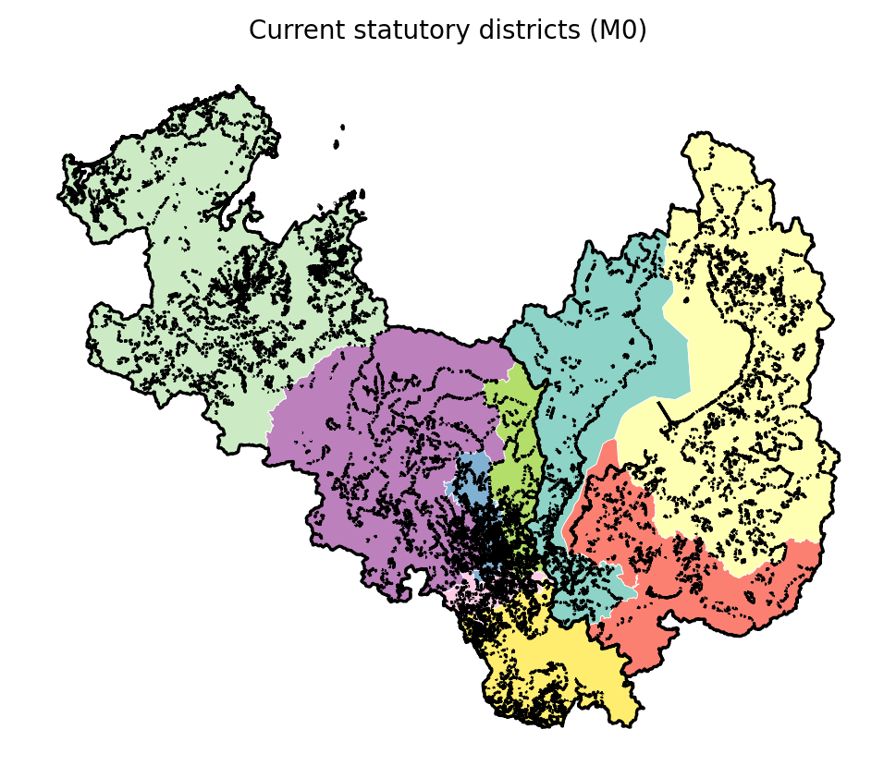
Table 2. Current-map metrics.
level | map | max/min | max|dev| | PP | splits | severed
A | current | 1.9744 | 0.3707 | 0.0298 | 0.0 | 233890.5
B | current | 1.9744 | 0.3707 | 0.029 | 0.0 | 233890.5
Table 3. Model comparison ON vs OFF.
level | model | max|dev| | max/min | PP | splits | severed | objective
A | M1 base | 0.1608508862270858 | 1.3138311735419057 | 0.033244477057695 | 0.0 | 243932.5 | 1793321.0
A | M2 ON | 0.1608508862270858 | 1.3138311735419057 | 0.033244477057695 | 0.0 | 243932.5 | 1793321.0
A | M3 OFF | 0.1574485738772256 | 1.3215579758623457 | 0.0320632788388002 | 0.0 | 249689.5 | 1870325.0
A | M4 ON | 0.1608508862270858 | 1.3138311735419057 | 0.033244477057695 | 0.0 | 243932.5 | 2168621.0
A | M4 OFF | 0.0940857985964365 | 1.19098120450228 | 0.0336414314742986 | 0.0 | 258311.5 | 2248844.0
B | M1 base | 0.1811610450392401 | 1.4055206358997756 | 0.0310174167009667 | 6.0 | 241040.9387458764 | 2.215394648817747
B | M2 ON | 0.1624584731756944 | 1.3163529563784768 | 0.0325184634140988 | 1.0 | 243922.56924311048 | 0.6245294675099053
B | M3 OFF | 0.1624584731756944 | 1.3163529563784768 | 0.0325184634140988 | 1.0 | 243922.56924311048 | 0.6245294675099053
B | M4 ON | 0.1811610450392401 | 1.4055206358997756 | 0.0310174167009667 | 6.0 | 241040.9387458764 | 2.215394648817747
B | M4 OFF | 0.1624584731756944 | 1.3163529563784768 | 0.0325184634140988 | 1.0 | 243922.56924311048 | 0.6245294675099053
At Level B the corrected accounting is sharper: recorded annealing bests referred to pre-repair intermediate solutions; evaluated on the final contiguous assignments, the ON best-found map scores 0.625 and the OFF run warm-started from that map retains exactly the same best (0.625): a best-found ON–OFF difference of 0 — removing the border constraint produces no improvement in the best-found small-area solution. The substantive explanation is visible in the maps (Figure 3) and in the flow network (Figure 4): the real border crosses only 39,733 commuting/schooling trips, below every one of the 200 matched placebo borders (median 99,420, IQR 90322 – 103038; real border at the 0th percentile). The administrative boundary broadly aligns with the Lake Biwa watershed, a geographic pattern consistent with the relatively weak functional connectivity observed across it: the observed cross-border flow indicates an unusually weak functional interface relative to the matched placebo borders. Compactness (mean PP 0.033 ON vs 0.033 OFF), municipal splits (1 vs 1), and severed intra-region flow (243,923 vs 243,923 trips) differ only marginally (Figure 5).
Figure 3. Best-found maps with the border constraint ON vs OFF.
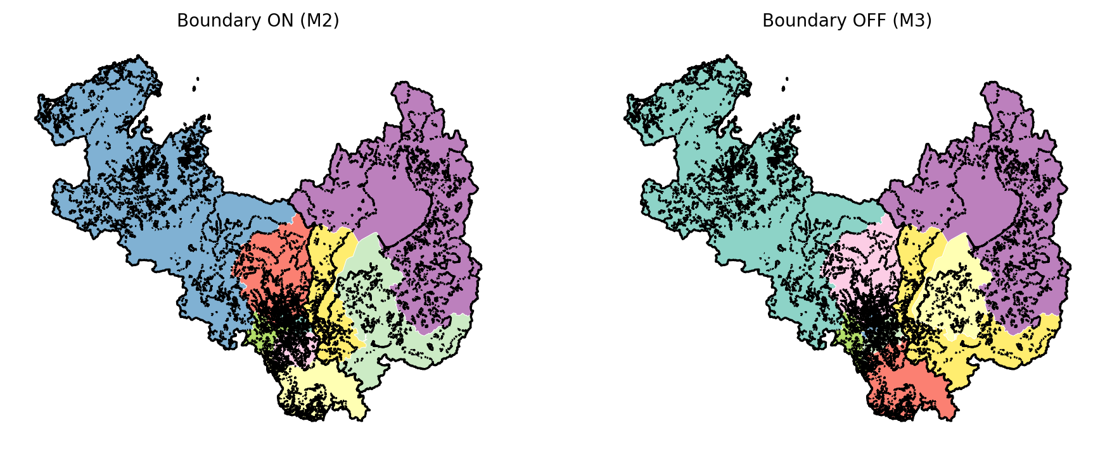
Figure 4. Cross-prefecture commuting/schooling OD network.
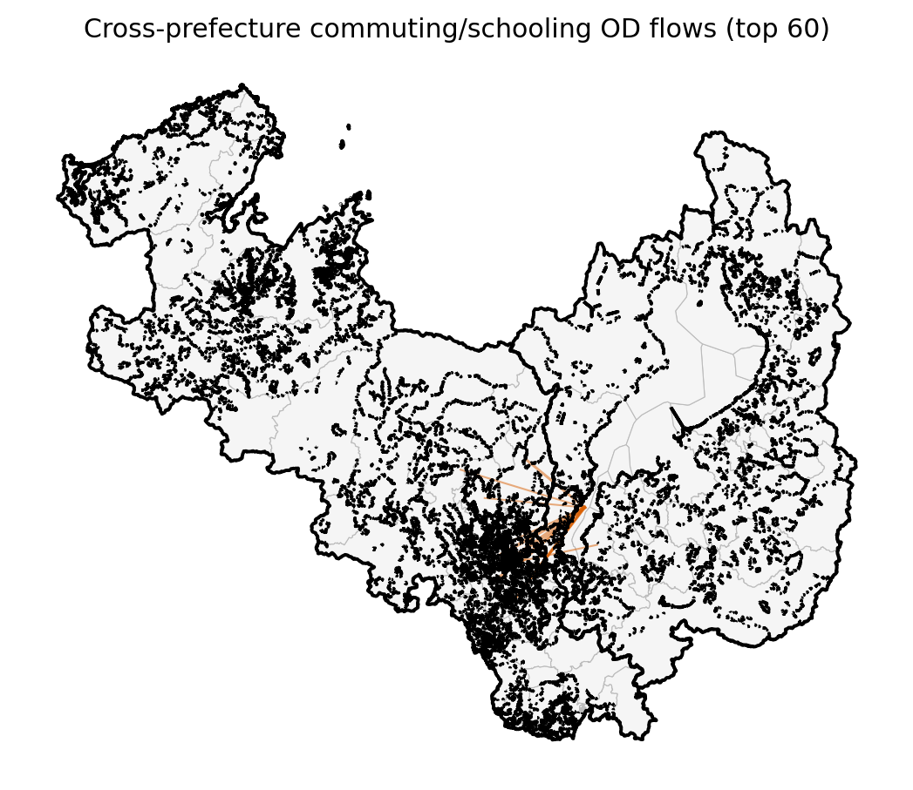
Figure 5. Objective-component comparison, ON vs OFF.
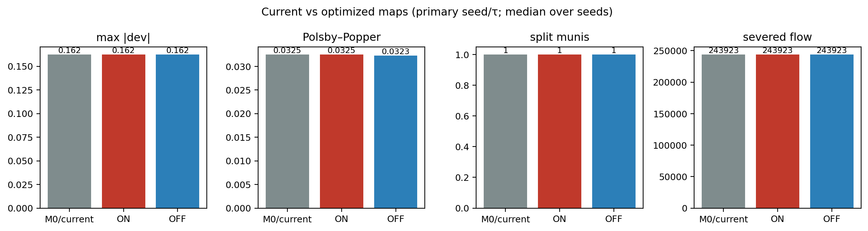

4.2 The current map
The statutory map (Figure 2) is contiguous but, reconstructed on 2020 census small-area populations, carries $max|dev|$ = 0.371 and $max/min$ ratio 1.974 — Kyoto-5 (279k) is at 0.63 of the district mean (Table 2). This exceeds the experimental $±20\%$ tolerance used throughout this study (real statutory $max/min$ ≈ 2.0; ours 1.974 at Level A). Note this is a reconstruction property, not a legal judgment: the statutory map was drawn on the apportionment population basis and vintage in force at its delimitation, which differs from the 2020 census counts used here.

4.3 Sensitivity and scale
The $τ$ sweep (Table 4), seed replicates, and the Level A↔B scale comparison bound MAUP effects on the estimand; severed-flow results are robust to OD symmetrization/normalization choices (full sensitivity tables in the reproducibility bundle).
Table 4. tau sensitivity.
tau | model | max|dev| | PP | severed | objective
0.1 | M2ON | 0.0981910701137886 | 0.0305595603875987 | 244026.3353448603 | nan
0.1 | M3OFF | 0.0992620431861436 | 0.0309976257822052 | 244023.83981967543 | nan
0.15 | M2ON | 0.1264670139041114 | 0.0311074738957966 | 245181.0 | nan
0.15 | M3OFF | 0.1475482733283613 | 0.0323402842766011 | 244093.94266502443 | nan
0.2 | M2ON | 0.1624584731756944 | 0.0325184634140988 | 243922.56924311048 | nan
0.2 | M3OFF | 0.1624584731756944 | 0.0325184634140988 | 243922.56924311048 | nan
0.3 | M2ON | 0.2576673530080064 | 0.0330996406558157 | 236271.6581644968 | nan
0.3 | M3OFF | 0.2227310840477121 | 0.0352054821331381 | 248054.54426192268 | nan

4.4 Placebo benchmark
Across 200 matched placebo borders, 61% (122 of 200) returned no feasible constrained incumbent under the shared $±20\%$ population tolerance — these are no-incumbent-found outcomes, not proven infeasibility; diagnostic reruns at up to 10× the iteration budget on a 12-border sample recovered none — persistent non-recovery under extended search, consistent with severe feasibility/search difficulty rather than a time-limit artifact, but not a proof of mathematical infeasibility (Table 5). Among the feasible borders the median constraint cost is 0.065 (IQR 0.0222 – 0.0727; the lower tail extends slightly below zero, again an incumbent-time artifact on a nested minimization, not a negative cost), and the real border — priced by the identical heuristic solver — sits at the 10th percentile (Figure 6). The real border is therefore not merely inexpensive: it is in the cheapest decile of feasible alternatives and among the minority of lines that permit any feasible map.
Figure 6. Placebo-border cost distribution vs the real border.
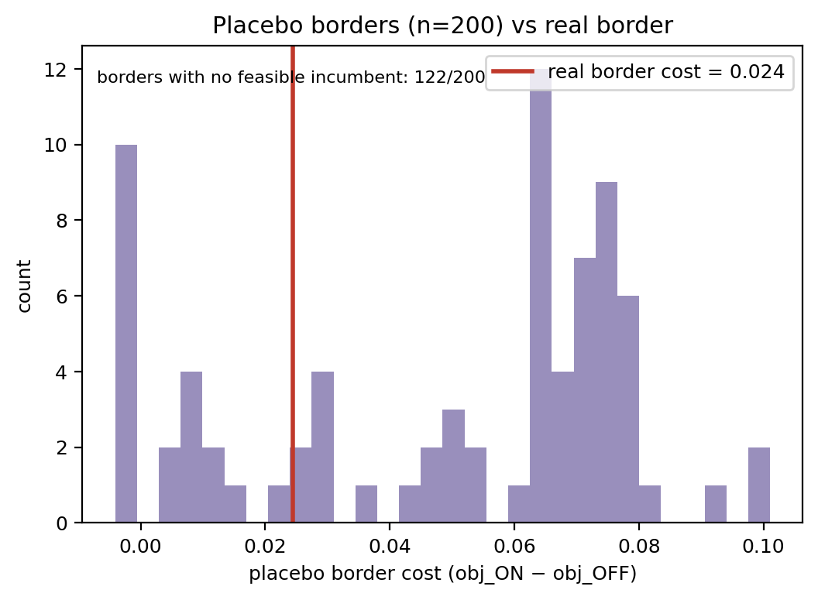
Table 5. Placebo summary.
statistic | value
n | 200
n generated | 200
n feasible ON+OFF | 78
n ON-infeasible (no incumbent found) | 122
cost median (feasible) | 0.0647
cost IQR (feasible) | 0.0222 – 0.0727
cost p5–p95 (feasible) | -0.0041 – 0.0799

4.5 Future robustness and minimal intervention
Under IPSS S1 projections the ON best-found map's max deviation reaches 0.267 by 2050 and first breaches $τ$ in 2040; the OFF map breaches in 2040. M4 explicitly robust maps and the M5 minimum-intervention repair (118,576 people, 0.030 of the region, 176 small areas) are tabulated in Table 6 (Figure 7).
Figure 7. Future robustness under IPSS projections to 2050.
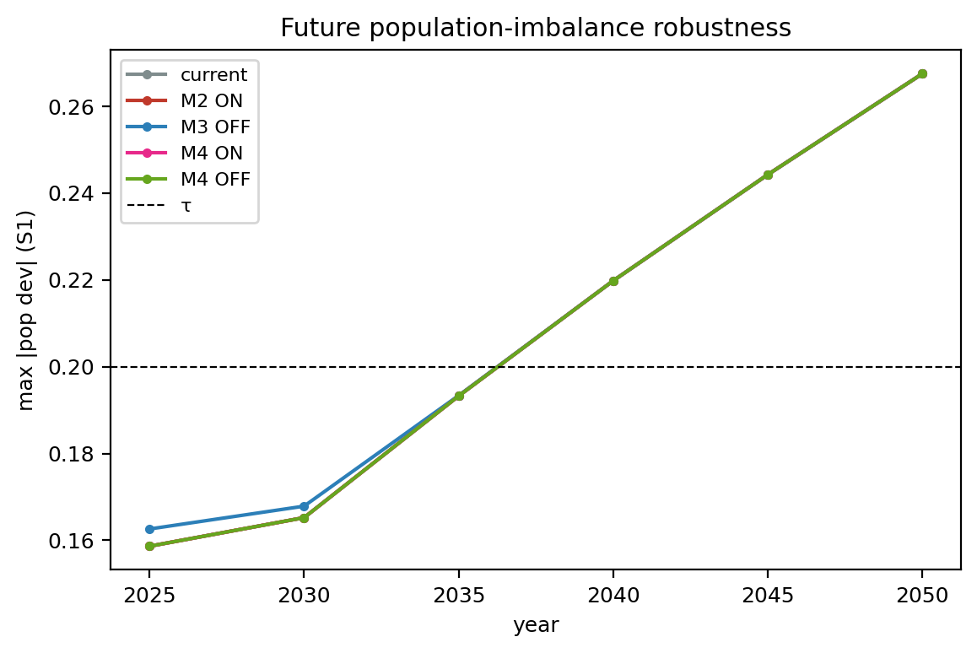
Table 6. Future robustness.
model | 2025 | 2030 | 2035 | 2040 | 2045 | 2050
M2ON | 0.159 | 0.165 | 0.193 | 0.22 | 0.244 | 0.267
M3OFF | 0.159 | 0.165 | 0.193 | 0.22 | 0.244 | 0.267
M4ON | 0.195 | 0.212 | 0.239 | 0.264 | 0.288 | 0.312
M4OFF | 0.159 | 0.165 | 0.193 | 0.22 | 0.244 | 0.267

5. Discussion
The empirical finding. The prefectural border turns out to be cheap — and that is itself the finding, with an honest precision caveat. At municipality scale the true cost is only bounded: the interval [0, 532,293] objective units is wide relative to incumbent scale because the OFF optimum resisted identification even at 900 s of hinted search, and we do not claim tighter. At census small-area scale the constrained and unconstrained best-found maps coincide exactly. The flow metrics are consistent with the low measured cost: the real border crosses only 39,733 daily trips — fewer than all 200 matched placebo borders — and the border's broad alignment with the Lake Biwa watershed is consistent with this relatively weak functional connectivity, so the functional-geography cuts a border-respecting optimizer must make are almost the same ones an unconstrained optimizer chooses anyway. The placebo benchmark sharpens this: most matched alternative borders either admit no feasible constrained incumbent or are more expensive, so the actual line is unusually well-placed, not merely unobtrusive. The Ōtsu–Kyoto corridor is the exception the rule proves: it is the one place the border bisects a commuting field, and it is small enough to be accommodated.
The implication for mismatch-driven reform. The result is informative precisely because it is counterintuitive. The Kyoto–Shiga line is, by any visual or functional criterion, a conspicuous administrative–functional mismatch: it bisects a continuous urban fabric carrying 79,466 daily cross-prefecture trips. If visible mismatch implied large marginal efficiency loss, removing the constraint should yield large gains; it yielded a bounded gain at municipality scale and no gain at small-area scale. Mismatch is an observation; inefficiency is an estimand. A redrawn or harmonized boundary is a reform whose benefits must be demonstrated, and the demonstrated benefit of lifting this constraint is, at the resolution where we can sharpen it, zero.
The general planning principle. Different public functions optimize different objectives under different demand, capacity, accessibility, equity, and network constraints; their efficient territorial partitions need not coincide, and forcing them to coincide restricts every function's feasible set. Territorial congruence should therefore be treated as a design decision rather than a default objective. When administrative and fiscal resources are limited, preserving non-congruent service territories may be rational when the estimated gains from harmonization are smaller than the coordination, transition, or opportunity costs required to achieve it. We are explicit that this study does not estimate those broader coordination or transition costs — it supplies one side of the calculus by pricing a spatial constraint. Nor do we claim that territorial mismatch is efficient, that fragmentation improves efficiency, or that alignment wastes resources; the claim is narrower and methodological: overlapping public geographies should not be harmonized merely because they differ, and the case for alignment depends on whether its benefits exceed the measurable opportunity cost of the constraint it imposes.
Transferability. The same paired estimand applies wherever a public-sector territorial plan is required to respect an inherited or shared boundary: health-service regions, emergency-response coverage, school catchments, transport and utility service territories, and multi-jurisdiction infrastructure planning. These are examples of the general decision problem — future applications of the measurement framework — not findings of this study, whose empirical content is exclusively electoral.

6. Limitations
Several qualifications bound the claims. The study prices one territorial public function — electoral districting — in one two-prefecture Japanese case; it does not empirically compare multiple service systems and does not estimate the coordination benefits or transition costs of multi-service alignment. Commuting/schooling flow is one functional dimension of connectivity, not all of it. The composite objective uses declared weights; other weightings would re-price the constraint. At Level A the true optimum is not tightly identified (the OFF solve returned no incumbent even at 900 s), so the municipality-scale cost is an interval, not a point estimate; Level B is heuristic simulated annealing with no optimality bound, so its zero is a best-found difference, not a proven optimum. Placebo no-incumbent outcomes are not proven mathematical infeasibility. Municipal-share severed-flow is a closed-form approximation at Level B. Future-population robustness relies on proportional downscaling of official projections with a $±10\%$ centroid-drift sensitivity, not a behavioral model. Placebo matching is statistical, not parametric identification. Finally, all analyses are nonpartisan by design — no electoral outcome is modeled — and the $±20\%$ tolerance is an experimental design parameter, not a legal judgment about the statutory map.

7. Conclusion
Territorial alignment can be priced. By treating an inherited administrative boundary as a constraint whose opportunity cost is measurable — $C_{border}=L^{*} (Boundary ON)−L^{*} (Boundary OFF)$ — we quantified the cost of Japan's prefectural-districting rule for the Kyoto–Shiga case: bounded within [0, 532,293] objective units at municipality scale and zero among best-found small-area maps, against a functional benchmark in which the real border crosses less commuting flow than every one of 200 matched placebo borders and permits a feasible map where most placebo lines yield no feasible incumbent. The broader lesson is a decision principle, not a boundary prescription: visible administrative–functional mismatch need not imply large efficiency loss; inherited territorial constraints have a measurable price; alignment is not self-justifying; and under scarcity, heterogeneous public functions may rationally retain different footprints when the demonstrated benefits of congruence do not justify its opportunity cost. Alignment should be pursued where its benefits can be shown to exceed that cost — and this framework supplies the side of that comparison that planning practice usually leaves unmeasured.

Declarations
Ethics approval: not applicable (public aggregate statistical data only). Competing interests: the authors declare none. Funding: none. Generative AI: not used in the writing process beyond grammar-checking tools. Data and code availability: all inputs are official public data archived with SHA-256 manifests; the full pipeline, outputs, and reproducibility bundle are public at github.com/bougtoir/admin-border-cost; every reported number regenerates end-to-end from run artifacts (docs/REPRODUCIBILITY.md).

References
[1] R. C. Larson, A. R. Odoni. Urban Operations Research, 2nd ed. Dynamic Ideas, Belmont, MA, 2007.
[2] S. H. Owen, M. S. Daskin. Strategic facility location: a review. European Journal of Operational Research 1998;111(3):423–447. https://doi.org/10.1016/S0377-2217(98)00186-6.
[3] W. K. Tam Cho, Y. Y. Liu. Toward a talismanic redistricting tool: A computational method for identifying extreme redistricting plans. Election Law Journal 2016;15(4):351–366. https://doi.org/10.1089/elj.2016.0384.
[4] A. Mehrotra, E. L. Johnson, G. L. Nemhauser. An optimization-based heuristic for political districting. Management Science 1998;44(8):1100–1114. https://doi.org/10.1287/mnsc.44.8.1100.
[5] F. Ricca, A. Scozzari, B. Simeone. Political districting: From classical models to recent approaches. Annals of Operations Research 2013;204:271–299. https://doi.org/10.1007/s10479-012-1267-2.
[6] D. DeFord, M. Duchin, J. Solomon. Recombination: A family of Markov chains for redistricting. Harvard Data Science Review 2021;3(1). https://doi.org/10.1162/99608f92.eb30390f.
[7] G. Herschlag, H. S. Kang, J. Luo, C. V. Graves, S. Bangia, R. Ravier, J. C. Mattingly. Quantifying gerrymandering in North Carolina. Statistics and Public Policy 2020;7(1):30–38. https://doi.org/10.1080/2330443X.2020.1796400.
[8] Public Offices Election Act, Law No. 100 of 1950, as amended through 2022; Annex 1 (single-member districts) (Japan). e-Gov law database.
[9] D. D. Polsby, R. D. Popper. The third criterion: Compactness as a procedural safeguard against partisan gerrymandering. Yale Law & Policy Review 1991;9:301–353.
[10] M. L. Balinski, H. P. Young. Fair Representation: Meeting the Ideal of One Man, One Vote. Yale University Press, 1982.
[11] Ministry of Internal Affairs and Communications (Japan). 2020 Population Census, Table 6-1: Commuting and Schooling Origin–Destination by Municipality [Data set]. e-Stat, 2020.
[12] S. Openshaw, P. J. Taylor. A million or so correlation coefficients: Three experiments on the modifiable areal unit problem. In: N. Wrigley (Ed.), Statistical Applications in the Spatial Sciences. Pion, London, 1979, pp. 127–144.
[13] Ministry of Internal Affairs and Communications (Japan). Statistical GIS Boundary Data (r2ka Small Areas, JGD2011) [Data set]. e-Stat, 2020.
[14] National Institute of Population and Social Security Research. Municipal Population Projections, 2020–2050 [Data set]. 2023.
[15] L. Perron, V. Furnon. OR-Tools CP-SAT Solver [Computer software]. Google, 2022.

Remaining figures and tables

