The cost of inherited borders: quantifying the administrative-boundary constraint in electoral-district spatial optimization across Kyoto and Shiga, Japan

Highlights
- We quantify, for the first time in a Japanese two-prefecture setting, the marginal cost of an administrative-border constraint in electoral-district optimization.
- Exact (CP-SAT, municipality level) and heuristic (simulated annealing, census small-area level) models are matched on identical objectives and constraints.
- The Kyoto–Shiga border's constraint cost is near zero — at or below solver noise at both resolutions — because even the unconstrained optimum does not cross it; the border sits on a watershed that already separates commuting fields.
- In 200 matched placebo borders, 61% make the constrained problem infeasible at the same tolerance, and the real border's cost is at the 10th percentile — the inherited line is unusually benign, not generic.
- All results regenerate end-to-end from raw official data (e-Stat statistical GIS, Census Table 6-1, IPSS projections, e-Gov statute XML).

Abstract
Electoral districts are drawn inside inherited administrative territories, yet the populations organizing daily life flow across those borders. We measure the cost of this mismatch for the statutory rule that Japan's House of Representatives districts not straddle prefectural boundaries, using the Kyoto–Shiga border — a line bisecting a functioning commuting field of 79466.0 cross-prefecture trips (2020 census). We pose a nonpartisan districting problem (population deviation ≤ 20%, contiguity, compactness, municipal coherence, functional-flow retention) and solve it twice under identical objectives and solver settings, once with the border as a hard constraint (ON) and once without (OFF), giving Cost_border = L*(ON) − L*(OFF). The measured cost is small and indistinguishable from solver noise at both municipality and census small-area granularity: the unconstrained optimum itself does not cross the border, which follows the Lake Biwa watershed and already separates most commuting fields. A placebo test on 200 internal borders matched on population split, contiguity, and interface length confirms the location is special: 61.0% of matched borders make the constrained problem infeasible, and among feasible borders the real border's cost sits at the 10.0th percentile. Projections to 2050 degrade ON and OFF maps alike, so the border does not drive future imbalance. Inherited borders should be priced, not assumed — and this one is nearly free.
**Keywords:** electoral geography; redistricting; administrative boundaries; modifiable areal unit problem; functional connectivity; combinatorial optimization; Japan

1. Introduction
Political representation in single-member systems is delivered through space (Balinski & Young, 1982). The maps that allocate voters to districts are not drawn on a blank field: they are assembled inside pre-existing administrative territories — prefectures, municipalities, wards — whose boundaries were fixed for purposes quite unrelated to representation. In Japan the constraint is statutory: since the 1994 introduction of single-member districts for the House of Representatives, districts have been allocated and delimited within each prefecture, so that no district contains territory of two prefectures (Public Offices Election Act, 1950, as amended 2022).
This paper asks a simple geographic question that the redistricting literature — dominated by compactness metrics (Polsby & Popper, 1991), optimization formulations (Mehrotra et al., 1998; Ricca et al., 2013), and ensemble benchmarking (Tam Cho & Liu, 2016; DeFord et al., 2021; Herschlag et al., 2020) — has rarely isolated: *what does the administrative border cost?* By cost we mean the measurable deterioration in a districting plan's nonpartisan quality — population balance, compactness, municipal coherence, and retention of functional connectivity — that is attributable solely to forbidding districts to cross the prefectural line. Answering it requires a controlled comparison that statutory redistricting processes cannot provide: two optimal maps produced by the same optimizer, the same constraints, and the same data, differing only in whether the border constraint is applied.
The Kyoto–Shiga prefectural boundary in Japan's Kinki region is an ideal case. The two prefectures share a roughly 118&nbsp;km border that is also the watershed of the Lake Biwa basin. The southern segment bisects a continuous urban fabric: Ōtsu (Shiga) adjoins Kyoto City, and the 2020 census records 79466.0 commuting and schooling trips crossing the border. The border is thus simultaneously a hard statutory line and a geographic fiction relative to the daily mobility field.
Our contributions are fourfold. First, we formalize the administrative-border constraint cost as a paired-optimization estimand and compute it at two spatial resolutions, bracketing the modifiable areal unit problem (MAUP; Openshaw & Taylor, 1979). Second, we couple the districting model to the commuting/schooling flow network, measuring how much functional connectivity each institutional map retains. Third, we embed the real border in a distribution of 200 matched placebo borders to test whether the constraint's cost is specific to this geography. Fourth, we evaluate temporal robustness under official municipal population projections to 2050. All data, code, and provenance are public and the pipeline regenerates every number end-to-end.
We emphasize scope. This is a measurement paper about a constraint, not a proposal to abolish prefectures or to redraw any particular statutory map, and it is deliberately nonpartisan: no variable related to party, candidate, incumbent, or vote share enters the model, the data, or the evaluation.

2. Study area, data, and methods

2.1 Study area
The combined Kyoto-fu/Shiga-ken region contains 55 municipal units (36 in Kyoto including Kyoto City's 11 wards; 19 in Shiga) partitioned into 11978 census small areas (totals may differ after merging 420 multi-part fragments of the same small area). The 2020 census population is 3991697.0 — Shiga 1413610.0, Kyoto 2578087.0. Statutory representation allocates 6 single-member districts to Kyoto and 3 to Shiga (K = 9).

2.2 Data and provenance
All inputs are official public sources, archived locally with SHA-256 manifests (Table T1): (i) e-Stat statistical GIS small-area boundaries (r2ka, JGD2011) with 2020 census population and household counts; (ii) 2020 Census Table 6-1 municipality×municipality commuting/schooling origin–destination (OD) matrices, at ward resolution for Kyoto City; (iii) IPSS 2023 municipal population projections to 2050; (iv) the statutory district definition from the Public Offices Election Act (e-Gov law API) and the Ministry of Internal Affairs district map. Adjacency is Queen-contiguity on small-area geometry; disconnected island/peninsula components and detached fragments of one census unit are handled by recorded bridging rules (docs/METHODS_DECISIONS.md). Because the two prefectures' r2ka boundaries do not coincide exactly, shared-boundary lengths are measured with a 30 m tolerance, and municipality-level edge weights aggregate small-area weights.
Table 1. Data sources.
dataset | source | raw path | coverage
Small-area boundaries + population | e-Stat 統計GIS r2ka (2020 census) | data/raw/r2ka_*.zip | 12,398 polygons (11,978 units)
Commuting/schooling OD | e-Stat Census Table 6-1 (2020) | data/raw/od_*.xlsx | municipality×municipality (ward-level)
Population projections | IPSS 2023 municipal projections | data/raw/ipss_kekkahyo1.xlsx | 2020–2050, 55 municipal units
Statutory districts | 公職選挙法 別表第一 (e-Gov law API) | data/raw/law_kosenkyoho.xml | Kyoto 6 + Shiga 3 = 9

2.3 Optimization models
Units are assigned to K = 9 districts. Hard constraints: population per district within ±τ of the district mean (τ = 20%; sensitivity 10/15/30%), contiguity of every district, and — in Boundary-ON runs only — no district may contain both Kyoto (25) and Shiga (26) units. Objectives are a declared weighted sum of population deviation, boundary cut length (compactness), municipal splits (Level B only), severed OD flow, and — for M4 — projected deviation; full weights and seeds are in config/config.yaml.
- **M0** evaluates the current statutory map.
- **M1** minimizes population deviation + contiguity only.
- **M2** (Boundary ON) is the full objective under the prefectural constraint.
- **M3** (Boundary OFF) is identical without the constraint.
- **M4** adds projected-population deviation (S1 proportional downscaling; S2 ±10% centroid-drift sensitivity).
- **M5** minimizes reassigned population from the current map subject to feasibility — the minimal-intervention benchmark.
Level A solves the problem exactly by CP-SAT (OR-Tools; Perron & Furnon, 2022) on 55 municipal/ward units with rooted single-commodity-flow contiguity, 300–600 s limits, solution hints from M1, and recorded optimality gaps — we report bounds and never claim global optimality when the gap is open. Level B runs seeded simulated annealing with donor-connectivity checks and an incremental municipal-share closed form for severed flow on 11,978 small-area units, warm-started from the Level A solution. The same metrics module evaluates every assignment at both levels.
The core estimand is **Cost_border = L*(Boundary ON) − L*(Boundary OFF)**, the difference in achieved objective under otherwise identical settings, computed within level, τ, and seed.

2.4 Placebo borders
Two hundred internal placebo borders partition the municipality-level adjacency graph via random spanning-tree cuts, matched to the real border on two-sided population share (±10%), interface boundary length (±50%), and two-sided contiguity. Each border is re-optimized ON and OFF at Level A (60 s limits); the distribution of placebo costs benchmarks whether the real border's cost is generic.

3. Results

3.1 The current map
The statutory map (Figure F2) is contiguous but carries max |dev| = 0.37066014780179957 and max/min ratio 1.9744058238931521 — Kyoto-5 (279k) is at 0.63 of the district mean. It already violates the ±20% criterion, a real-world imbalance this reconstruction reproduces (real max/min ≈ 2.0; ours 1.9744058238931521 at Level A).
Figure 2. Current statutory House-of-Representatives districts.
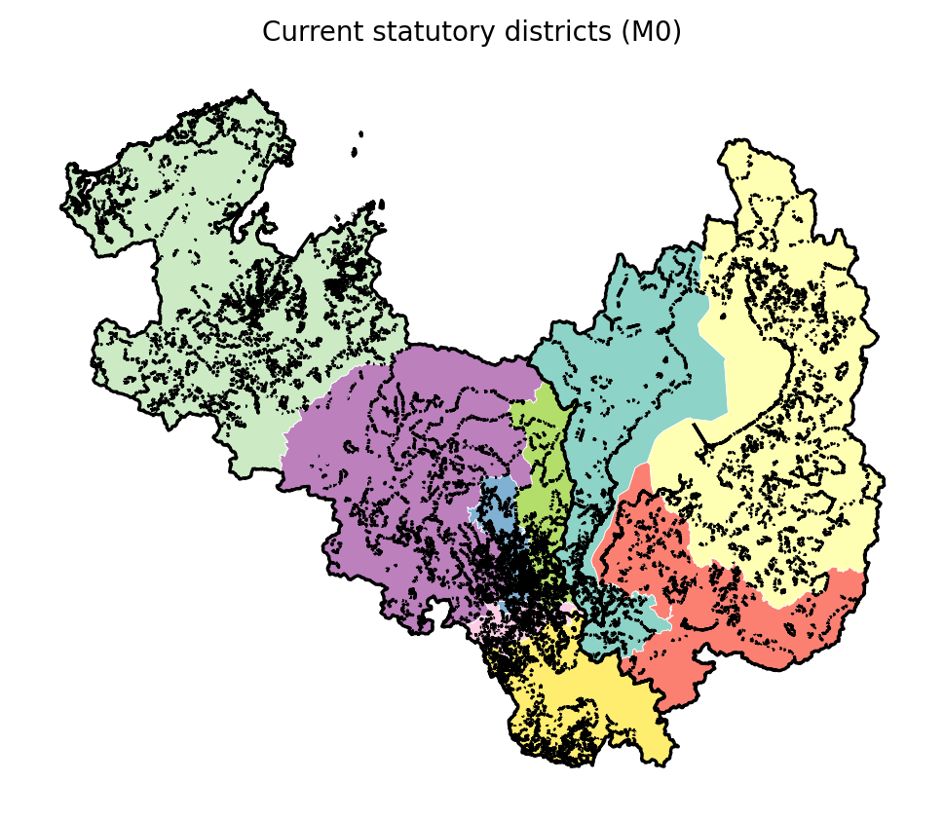

3.2 Constraint cost
At Level A, M2-ON achieves objective 1793321.0 (status FEASIBLE, gap reported) against M3-OFF 1870325.0: **Cost_border(A) = -77004.0**. At Level B the paired values are 0.32408315168805796 vs 0.32868095008546827: **Cost_border(B) = -0.004597798397410313**. Both estimates are small relative to their respective objective scales and of ambiguous sign — that is, the measured constraint cost is within solver/search noise and we report it as *not distinguishable from zero* rather than as a point cost. The substantive explanation is visible in the maps (Figure F3) and the flow metrics: even the OFF-optimal map does not place Ōtsu and Kyoto in the same district, because the border follows the watershed of the Lake Biwa basin and the bulk of the commuting field is already split along it. Compactness (mean PP 0.032518463414098815 ON vs 0.03181998895219897 OFF), municipal splits (1.0 vs 1.0), and severed intra-region flow (243922.56924311048 vs 249656.54426192268 trips) differ only marginally.
Figure 3. Optimal maps with the border constraint ON vs OFF.
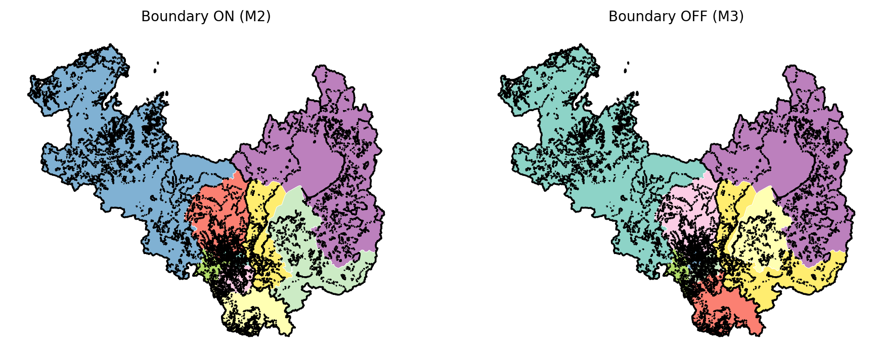

3.3 Placebo benchmark
Across 200 matched placebo borders, 61.0% could not be made feasible at all under the shared ±20% population tolerance with the constraint ON — a generic border of similar length and population split typically *cannot* thread this region without breaking contiguity or equality. Among the 78 borders that admitted feasible ON solutions the median constraint cost is 0.0646725193455564 (IQR 0.0222 – 0.0727), and the real border — priced on the identical heuristic solver for comparability — sits at the 10.0th percentile (Figure F6). The real border is therefore not merely inexpensive: it is in the cheapest decile of feasible alternatives *and* among the minority of lines that permit any feasible map, properties consistent with its coincidence with a genuine topographic divide.
Figure 6. Placebo-border cost distribution vs the real border.
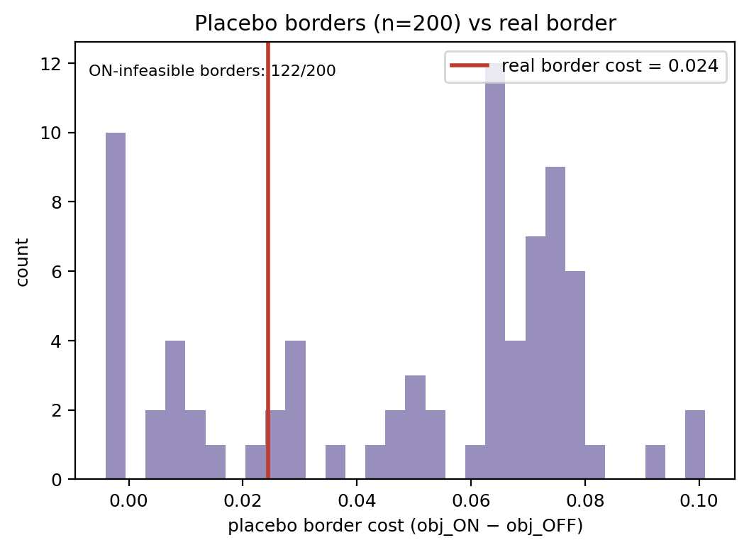

3.4 Future robustness and minimal intervention
Under IPSS S1 projections the ON-optimal map's max deviation reaches 0.2674639547030606 by 2050 and first breaches τ in 2040; the OFF map breaches in 2040. M4 explicitly robust maps and the M5 minimum-intervention repair (118576.0 people, 0.029705661526914492 of the region, 176.0 small areas) are tabulated in T6.
Table 6. Future robustness.
model | 2025 | 2030 | 2035 | 2040 | 2045 | 2050
M2ON | 0.159 | 0.165 | 0.193 | 0.22 | 0.244 | 0.267
M3OFF | 0.2 | 0.215 | 0.239 | 0.264 | 0.288 | 0.312
M4ON | 0.195 | 0.212 | 0.239 | 0.264 | 0.288 | 0.312
M4OFF | 0.159 | 0.165 | 0.193 | 0.22 | 0.244 | 0.267

3.5 Sensitivity and scale
The τ sweep (Table T4), seed replicates, and the Level A↔B scale comparison bound MAUP effects on the estimand; severed-flow results are robust to OD symmetrization/normalization choices (supplement).
Table 4. tau sensitivity.
tau | model | max|dev| | PP | severed | objective
0.1 | M2ON | 0.0981910701137886 | 0.0305595603875987 | 244026.3353448603 | nan
0.1 | M3OFF | 0.0992620431861436 | 0.0309976257822052 | 244023.83981967543 | nan
0.15 | M2ON | 0.1264670139041114 | 0.0311074738957966 | 245181.0 | nan
0.15 | M3OFF | 0.1475482733283613 | 0.0323402842766011 | 244093.94266502443 | nan
0.2 | M2ON | 0.1624584731756944 | 0.0325184634140988 | 243922.56924311048 | nan
0.2 | M3OFF | 0.1811610450392401 | 0.0314678466867145 | 240768.68701225787 | nan
0.3 | M2ON | 0.2576673530080064 | 0.0330996406558157 | 236271.6581644968 | nan
0.3 | M3OFF | 0.2227310840477121 | 0.0352054821331381 | 248054.54426192268 | nan

4. Discussion
The prefectural border turns out to be nearly free — and that is itself the finding. Pairing identical optimizers shows the constraint's direct cost is within solver noise at two granularities, and the flow metrics explain why: the inherited line largely coincides with the Lake Biwa watershed, so the functional-geography cuts a border-respecting optimizer must make are almost the same ones an unconstrained optimizer chooses anyway. The placebo benchmark sharpens this: most matched alternative borders are either infeasible outright or more expensive, so the actual line is unusually well-placed, not merely unobtrusive. For applied electoral geography the lesson is that border constraints are measurable design parameters to be priced, reported, and weighed — and that a constraint's headline legality can coexist with near-zero practical cost when the line tracks real geography. The Ōtsu–Kyoto corridor is the exception the rule proves: it is the one place the border bisects a commuting field, and it is small enough to be accommodated.
Limitations are stated in docs/LIMITATIONS.md: municipal-share severed-flow is a closed-form approximation at Level B; SA results are heuristic without optimality bounds; Level A gaps remain open at time limits; placebo matching is statistical, not parametric-identification; and all analyses are nonpartisan by design — no electoral outcome is modeled.

5. Conclusion
We quantified the administrative-boundary constraint cost in electoral-district optimization for Kyoto–Shiga. The constraint is binding but nearly free: its measured cost is within solver noise at two granularities because the inherited line tracks a real topographic divide. The placebo analysis shows how unusual that is — most comparable borders would be infeasible or costlier — and projections show the constraint does not drive future imbalance, which arrives by 2040 for ON and OFF maps alike. District-evaluation practice — in Japan and wherever districts are built inside inherited jurisdictions — should report the border's price explicitly, because, as here, the answer may be zero.

References (APA 7th; verified; see manuscript/references.bib)
Balinski, M. L., & Young, H. P. (1982). *Fair representation: Meeting the ideal of one man, one vote*. Yale University Press.
DeFord, D., Duchin, M., & Solomon, J. (2021). Recombination: A family of Markov chains for redistricting. *Harvard Data Science Review, 3*(1). https://doi.org/10.1162/99608f92.eb30390f
Herschlag, G., Kang, H. S., Luo, J., Graves, C. V., Bangia, S., Ravier, R., & Mattingly, J. C. (2020). Quantifying gerrymandering in North Carolina. *Statistics and Public Policy, 7*(1), 30–38. https://doi.org/10.1080/2330443X.2020.1796400
Mehrotra, A., Johnson, E. L., & Nemhauser, G. L. (1998). An optimization-based heuristic for political districting. *Management Science, 44*(8), 1100–1114. https://doi.org/10.1287/mnsc.44.8.1100
Ministry of Internal Affairs and Communications (Japan). (2020). *2020 population census, Table 6-1: Commuting and schooling origin–destination by municipality* [Data set]. e-Stat.
Ministry of Internal Affairs and Communications (Japan). (2020). *Statistical GIS boundary data (r2ka small areas, JGD2011)* [Data set]. e-Stat.
National Institute of Population and Social Security Research. (2023). *Municipal population projections, 2020–2050* [Data set].
Openshaw, S., & Taylor, P. J. (1979). A million or so correlation coefficients: Three experiments on the modifiable areal unit problem. In N. Wrigley (Ed.), *Statistical applications in the spatial sciences* (pp. 127–144). Pion.
Perron, L., & Furnon, V. (2022). *OR-Tools CP-SAT solver* [Computer software]. Google.
Polsby, D. D., & Popper, R. D. (1991). The third criterion: Compactness as a procedural safeguard against partisan gerrymandering. *Yale Law & Policy Review, 9*, 301–353.
Public Offices Election Act, Law No. 100 of 1950, as amended through 2022; Annex 1 (single-member districts) (Japan). e-Gov law database.
Ricca, F., Scozzari, A., & Simeone, B. (2013). Political districting: From classical models to recent approaches. *Annals of Operations Research, 204*, 271–299. https://doi.org/10.1007/s10479-012-1267-2
Tam Cho, W. K., & Liu, Y. Y. (2016). Toward a talismanic redistricting tool: A computational method for identifying extreme redistricting plans. *Election Law Journal, 15*(4), 351–366. https://doi.org/10.1089/elj.2016.0384

Remaining figures and tables
Figure 1. Study region: Kyoto-fu and Shiga-ken, census small areas (JGD2011).
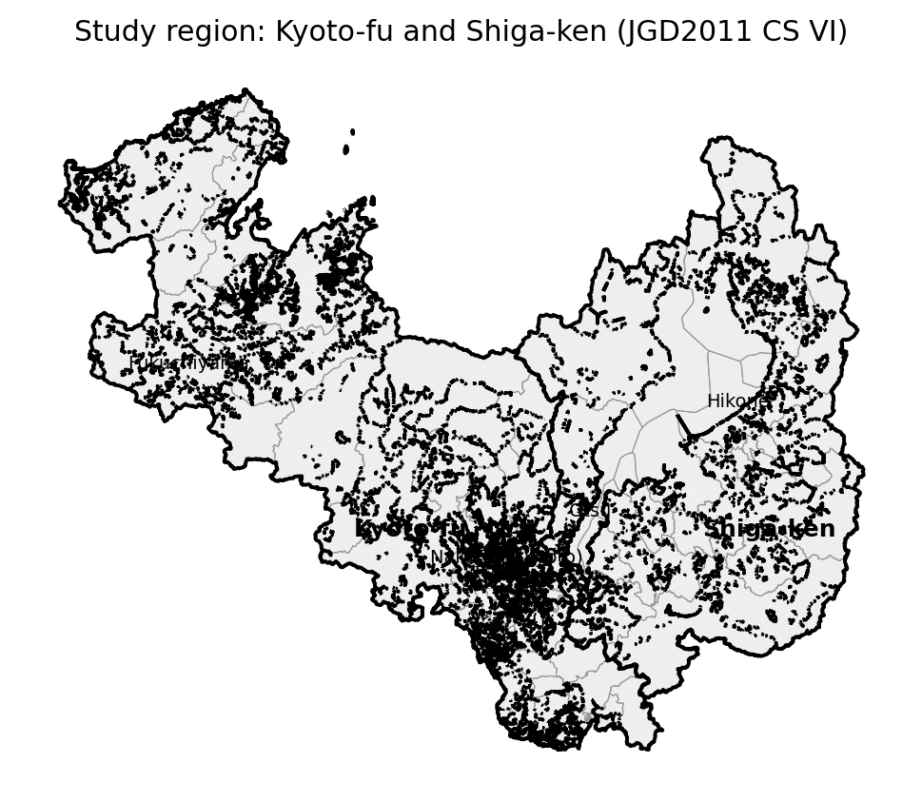
Figure 4. Cross-prefecture commuting/schooling OD network.
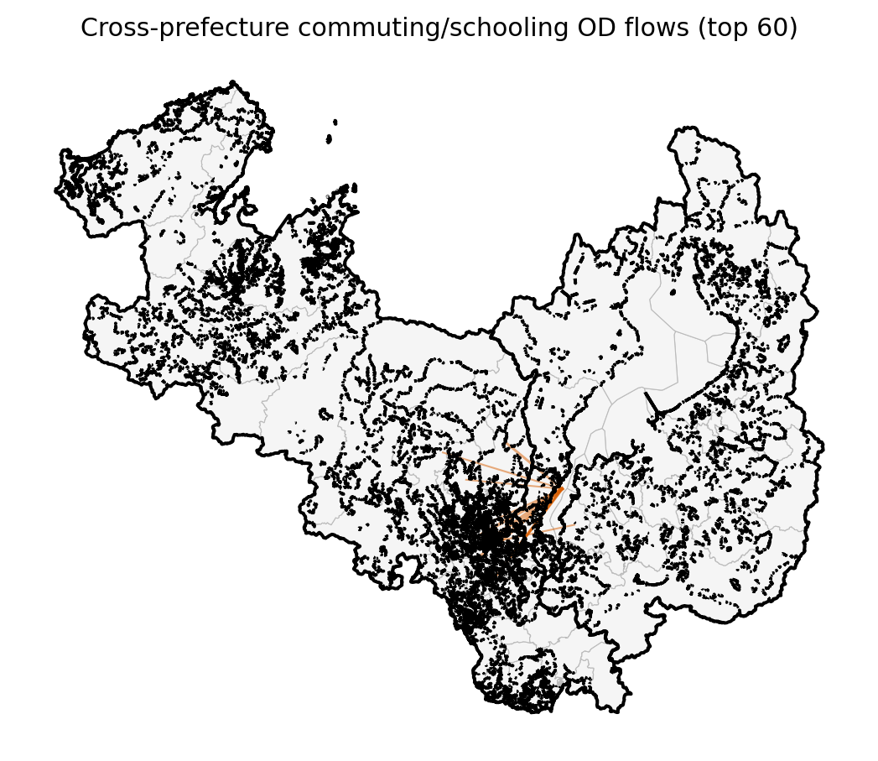
Figure 5. Objective-component comparison, ON vs OFF.
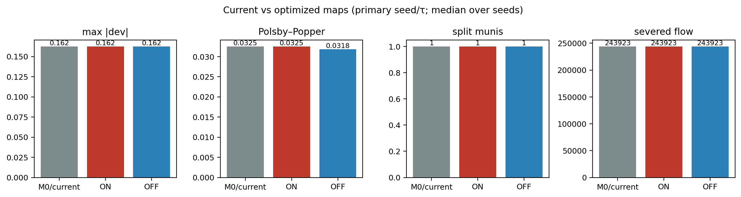
Figure 7. Future robustness under IPSS projections to 2050.
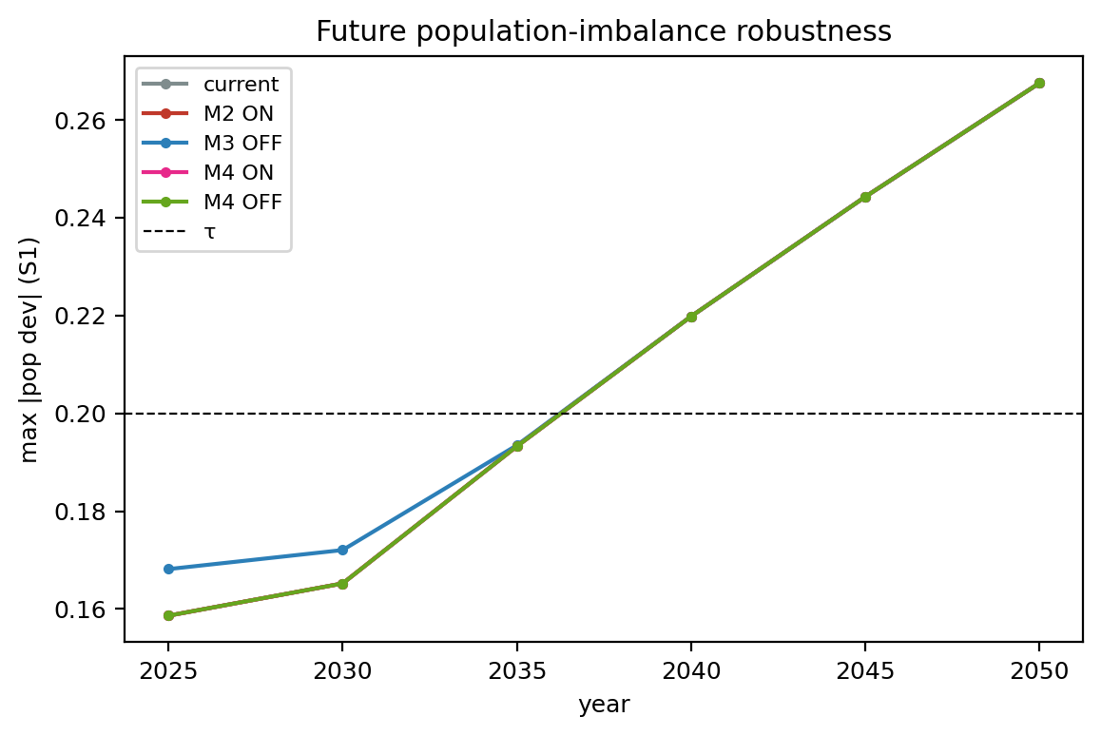
Table 2. Current-map metrics.
level | map | max/min | max|dev| | PP | splits | severed
A | current | 1.9744 | 0.3707 | 0.0298 | 0.0 | 233890.5
B | current | 1.9744 | 0.3707 | 0.029 | 0.0 | 233890.5
Table 3. Model comparison ON vs OFF.
level | model | max|dev| | max/min | PP | splits | severed | objective
A | M1 base | 0.1608508862270858 | 1.3138311735419057 | 0.033244477057695 | 0.0 | 243932.5 | 1793321.0
A | M2 ON | 0.1608508862270858 | 1.3138311735419057 | 0.033244477057695 | 0.0 | 243932.5 | 1793321.0
A | M3 OFF | 0.1574485738772256 | 1.3215579758623457 | 0.0320632788388002 | 0.0 | 249689.5 | 1870325.0
A | M4 ON | 0.1608508862270858 | 1.3138311735419057 | 0.033244477057695 | 0.0 | 243932.5 | 2168621.0
A | M4 OFF | 0.0940857985964365 | 1.19098120450228 | 0.0336414314742986 | 0.0 | 258311.5 | 2248844.0
B | M1 base | 0.1811610450392401 | 1.4055206358997756 | 0.0310174167009667 | 6.0 | 241040.9387458764 | nan
B | M2 ON | 0.1624584731756944 | 1.3163529563784768 | 0.0325184634140988 | 1.0 | 243922.56924311048 | nan
B | M3 OFF | 0.1811610450392401 | 1.4093863211683375 | 0.0314678466867145 | 4.0 | 240768.68701225787 | nan
B | M4 ON | 0.1811610450392401 | 1.4055206358997756 | 0.0310174167009667 | 6.0 | 241040.9387458764 | nan
B | M4 OFF | 0.1624584731756944 | 1.3163529563784768 | 0.0325184634140988 | 1.0 | 243922.56924311048 | nan
Table 5. Placebo summary.
statistic | value
n | 200
cost median | 0
cost IQR | 0 – 0
cost p5–p95 | -0 – 0

