When does a dynamic conservation network pay? An individual-based simulation of habitat, managed-care, and discovery policies across a wild-captive system
  - Original research paper
Author: Tatsuki Onishi (corresponding author).
Affiliation: Independent researcher.
Corresponding author contact: see cover letter.

Highlights
- A fully specified individual-based model couples wild habitat, managed facilities, and a non-living biobank.
- Fixed, interpretable decision rules are compared, not optimized policies; no POMDP or MCMC machinery is used.
- Habitat-first and circulation policies reverse across two-factor environmental sweeps with no universal winner.
- Species lost before becoming visible to managers ('extinction before discovery') persist under most policies.
- Perfect current-state information does not improve outcomes, because the binding constraint is action capacity, not observation.

Abstract
Conservation planning increasingly coordinates wild habitat protection, zoos, breeding centres, pre-release stations, rehabilitation, and biobanking into a single managed network, yet the conditions under which active circulation between wild and managed nodes outperforms simpler strategies are poorly understood. We built an individual-based Monte Carlo simulation of eight synthetic species across nine node types over 100 annual time steps, with noisy and delayed observation, discovery of initially latent species, environmental change, disease, inbreeding, welfare costs, and budget feedback from public engagement. Eight fixed, fully specified decision rules (S0–S8) were compared under 192 paired-seed replicates, Latin-hypercube sensitivity analysis, five two-factor environmental sweeps, feature ablations, and a perfect-current-state-information comparator. A habitat-first policy (S6) achieved mean year-100 species survival of 0.529 [0.000, 0.875] versus 0.473 [0.125, 0.750] for the balanced circulation policy (S7); robust sweep cells favoured S7 in 35 cells and S6 in 26 cells, with 64 indeterminate. Six of eight policies were non-dominated across six objectives, so no weighting collapses the trade-off to a single best policy. The paired perfect-information effect on the prespecified utility index was -0.003 [-0.112, 0.131], indistinguishable from zero. The main transferable result is mechanistic rather than prescriptive: circulation between wild and managed nodes pays when habitat deteriorates faster than movement and welfare costs accumulate, and it fails otherwise; the threshold is located inside the model's own parameter space, not assumed. A reduced two-channel criterion derived from the same equations predicts the direction of strong reversals in held-out configurations but cannot detect marginal, statistically indeterminate ones. Extinction before discovery remains the dominant failure mode across all feasible policies.
Keywords: individual-based model; ex situ conservation; reintroduction; decision analysis; stochastic simulation; latent biodiversity; Monte Carlo

1. Introduction
Conservation of threatened species has shifted from protecting habitat in place toward managing integrated networks that link wild reserves, zoos, breeding centres, pre-release stations, rehabilitation facilities, and biobanks (Conde et al. 2011; Conde et al. 2013; Watson et al. 2014; Hoban et al. 2020; Howell et al. 2021; Williams & Brown 2022). Reintroduction biology documents both successes and recurring failures (Snyder et al. 1996; Jule et al. 2008; Seddon et al. 2014), and decision-analytic work has framed allocation problems in conservation as constrained resource-management problems (McCarthy & Possingham 2007; Chadès et al. 2008; Joseph et al. 2009). What remains unclear is not whether circulation between wild and managed nodes can help — well-documented programmes show it can (Kaczensky et al. 2007; Mee et al. 2007; D’Elia et al. 2015) — but under which environmental and budgetary conditions it outperforms simply protecting and restoring habitat.
Answering that question with a model is difficult for three reasons. First, the decision problem is combinatorial: resources must be split across habitat, surveys, rescue, breeding, genetics, banking, and public engagement, and each channel interacts with the others. Second, the state is partially observed: managers act on noisy, delayed counts and quality estimates, and some species may go extinct before they are ever recognized. Third, objectives do not collapse into one number: persistence, animal welfare, genetic integrity, cost, and future options all matter and routinely conflict (Harrington et al. 2013; Beausoleil et al. 2018; Mellor et al. 2020).
We therefore built a transparent, fully specified individual-based model (IBM) of a nine-node conservation network and compared eight fixed, interpretable decision rules under identical stochastic environments. The model is a discrete-time Monte Carlo IBM — not a solved POMDP and not an MCMC inference problem: policies are explicit rules, and outcomes are distributions over replicate stochastic futures. All mechanisms, equations, update order, parameter values, and the pseudocode of both the annual step and the action-selection rule are given here in the main text, so the model can be re-implemented without consulting source code.
The study asks four questions: (i) does a balanced dynamic circulation policy (S7) outperform a habitat-first policy (S6) in species persistence; (ii) where in the joint parameter space of habitat deterioration and movement cost does the ranking reverse; (iii) how often do latent species go extinct before becoming visible to decision-makers; and (iv) how much would perfect current-state information improve decisions — a question we answer by rerunning the same decision rule with true instead of noisy observations.
The setting spans several literatures the model draws on jointly: protected-area and climate-driven conservation (Hoegh-Guldberg et al. 2008; Thomas 2011; Redford et al. 2012), genetic and small-population management (Frankham 2008; Pritchard et al. 2012; Boehm & Cronk 2021), capture, veterinary, and welfare practice (Dickens et al. 2010; Kock et al. 2010), undescribed and undiscovered biodiversity (Mora et al. 2011; Tedesco et al. 2014; Liu et al. 2022), and structured decision-making under uncertainty (Kennedy et al. 2008; Williams & Hoffman 2009; Moss et al. 2015).

2. Materials and methods

2.1 Method identity and scope
The model is a discrete-time, individual-based Monte Carlo simulation. Each replicate runs 100 annual steps; randomness enters through pseudo-random draws keyed by (replicate seed, process, year). Policies are fixed decision rules — heuristics that read current observations — not solutions to a belief-state optimization. We make no POMDP claim, no EVPI claim, and no inference claim: all outcomes are simulation distributions in model units. Throughout, 'comparator' means the perfect-current-state-information comparator described in Section 2.6; the word 'oracle' is not used.

2.2 Entities, state variables, and initialization
Eight synthetic species differ in growth, mortality, niche breadth, habitat specificity, climate and anthropogenic sensitivity, dispersal, detectability, fertility, social dependence, migration need, and captivity tolerance (Table 1). Five are initially known to managers (knowledge stage 5); three are latent (stage 0) and become visible only through the discovery submodel (Section 2.5). Individuals carry species, sex, age, origin node, current node, founder identity, inbreeding coefficient, health in [0.35, 1], infection state (susceptible/infected/recovered), wildness, habituation, stress tolerance, foraging skill, release readiness, and an alive flag; 364 individuals exist at initialization with demographic ratios from the species configuration.
Nine nodes represent origin wild habitat (index 0), alternative wild habitat (1), a protected reserve (2), a conventional zoo (3), a conservation zoo (4), a breeding centre (5), a semi-wild pre-release station (6), a rehabilitation facility (7), and a non-living biobank (8). The biobank stores genetic material only: no individual ever occupies it, and all demography, disease, and movement loops exclude node 8. Node attributes include base quality, capacity, disease and anthropogenic pressure, predation, welfare standard, cost, connectivity, research intensity, visitor exposure, and restoration potential (Fig. 1).
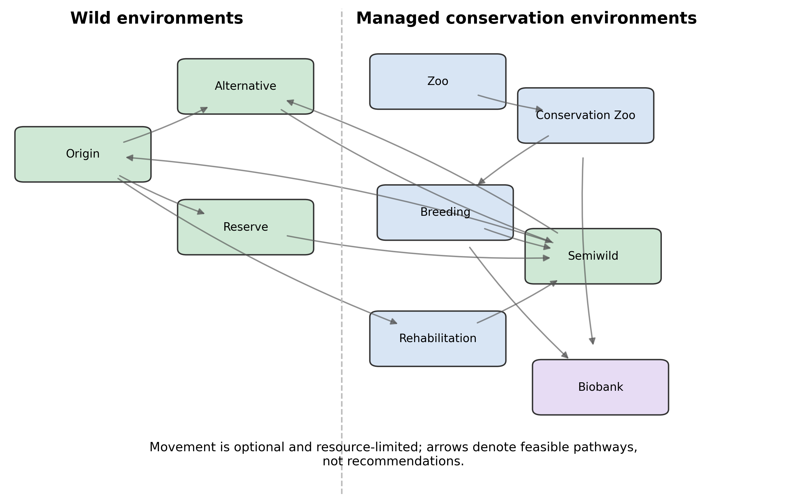
Figure 1. Conservation network represented in the simulation. Arrows denote potential movement among wild, managed, transitional, rehabilitation, and biobank nodes; feasible policies act on observed rather than true state.
Table 1. Base simulation parameters.
parameter | base value
years | 100
initial_budget | 100.0
max_individuals | 1200
observation_noise | 0.18
quality_observation_noise | 0.1
observation_delay | 1
background_detection_probability | 0.005
climate_velocity | 0.012
habitat_deterioration | 0.006
relocation_mortality | 0.025
relocation_stress | 0.1
movement_disease_risk | 0.03
quarantine_effectiveness | 0.65
quarantine_cost_per_move | 0.25
infection_fertility_penalty | 0.3
s3_refuge_trigger | 0.48
s3_return_threshold | 0.62
s3_return_delay | 5
captivity_welfare_penalty | 0.12
wild_predation_welfare_weight | 0.1
food_insecurity_welfare_weight | 0.18
managed_crowding_welfare_weight | 0.12
managed_restriction_welfare_weight | 0.12
infection_welfare_weight | 0.16
habituation_welfare_weight | 0.1
relocation_welfare_weight | 0.12
ex_situ_breeding_benefit | 0.22
inbreeding_fertility_penalty | 0.35
inbreeding_mortality_penalty | 0.08
release_survival_penalty | 0.08
survey_cost | 10.0
engagement_coefficient | 0.08
engagement_habitat_feedback | 0.02
habitat_protection_efficiency | 0.025
biobank_future_value | 0.05
biobank_annual_decay | 0.01
catastrophe_probability | 0.035
funding_collapse_probability | 0.015
origin_fidelity | 0.2
mortality_multiplier | 1.0
anthropogenic_pressure_multiplier | 1.0
predation_multiplier | 1.0
scenario | directional_change

2.3 Annual process and core equations
Each year executes the fourteen steps of Algorithm 1 in the fixed order shown. The species–node suitability that drives both ecology and decisions is
suit(s,j) = clip( q_j·(0.72 + 0.28·breadth_s) − spec_s·(1 − q_j)·0.32 + M_j(1 − W_j)·(tol_s − 0.5)·0.25 − M_j(1 − W_j)·mig_s·0.24 ; 0.02, 0.99 ) (Eq. 1)
where q_j is node quality, spec_s habitat specificity, tol_s captivity tolerance, mig_s migration need, and M_j, W_j the managed and wild indicators. Survival of individual i is
p_surv(i) = clip( 1 − mort_s·μ − (1 − suit)·0.24 − press_i·0.08 − 1{infected}·0.14 + M_j·research_j·0.035 − W_j·pred_j·μ_pred·0.035 − (1 − health_i)·0.08 − inbreeding_i·0.08 ; 0.05, 0.995 ) (Eq. 2)
and the per-species-node reproduction rate is
rate = (mort_s + growth_s)·(0.5 + fert_s)·suit(s,j)·max(0.05, 1 − dens_j)·5.0·(1 + 0.22·spend_exsitu/B_t if managed)·max(0.05, 1 − local_infection·0.30)·max(0.05, 1 − mean_inbreeding·0.35) (Eq. 3)
with births ~ Poisson(n_females·rate), dens_j = n(s,j)/capacity_j, and a hard population cap of 1200 living individuals. Habitat quality follows scenario deterioration (0.006/yr under directional change), a directional climate displacement of 0.012·t/100 between nodes 0 and 1, habitat-investment recovery proportional to spend, a scheduled abrupt collapse at year 33 in the collapse scenario, and random catastrophes (probability 0.035/yr, losing a uniform 0.16–0.38 of quality). Funding collapses arrive with probability 0.015/yr (budget ×0.72).

Algorithm 1 — one annual step (implemented order)
1. Funding draw: with p = 0.015, B ← 0.72·B (skipped for S0).
2. Budget split: spend_c ← B·a(π,c)/Σa(π) over the seven allocation channels.
3. Environment: apply scenario trend, directional climate displacement, habitatinvestment, scheduled collapse, and catastrophe; clip quality to [0.05, 0.98].
4. Observation: compute true suitability; produce noisy observed counts(LogNormal σ = 0.18, stage ≥ 2 only) and delayed observed quality(1 year lag + N(0, 0.10)); compute decision suitability fromobserved quality.
5. Discovery: each latent species may advance one stage (Section 2.5).
6. Action: move eligible individuals under the policy rule (Algorithm 2);apply relocation stress, movement mortality (p = 0.025), releasemortality (p = 0.08 for managed→wild), and transit infection withquarantine coverage.
7. Within-node disease: infect susceptibles at clip(disease_j·prevalence_j, 0,0.65); recover infecteds at p = 0.32.
8. Survival: each individual survives independently with Eq. 2; deaths applied.
9. Age and health: age + 1; health random walk clipped to [0.35, 1].
10. Reproduction: Poisson births per species–node with diversity-aware paternity ifgenetics spend > 0; total population capped at 1200.
11. Biobank and EBD bookkeeping: biobank stock decays 1%/yr and grows withinvestment for extant visible species; record extinction beforediscovery for latent species lost at stage < 2.
12. Welfare: accumulate individual welfare and the seven-component burden decomposition.
13. Human feedback: update engagement; reset next year's budget to B0·(0.82 +0.24·engagement) for nonzero policies.
14. Snapshot and log: record year-50 snapshot and the annual trajectory row.

2.4 Observation, delay, and discovery
Decision rules never see the true state. Observed counts are true counts times LogNormal noise (σ = 0.18) and exist only for species at knowledge stage ≥ 2; observed quality is last year's true quality plus Gaussian noise (σ = 0.10). Latent species advance at most one knowledge stage per year with stage-specific probabilities that increase in survey spend and detectability, on top of a background discovery probability of 0.005/yr. A species that goes extinct while still at stage < 2 is recorded as an extinction before discovery (EBD) — an endpoint defined on the model's own visibility rule, not on formal taxonomic description.

2.5 Policies and action selection
Eight policies (Table 2) share one budget and differ only in (a) fixed allocation shares across the seven channels, (b) movement eligibility, and (c) target scoring. Algorithm 2 gives the action-selection rule in full.

Algorithm 2 — action selection per annual step
1. If policy ∈ {S0, S6} or rescue spend = 0: no movement (S6's 3% rescue share isspent but never converted to moves).
2. Move capacity C = ⌊rescue spend / 2.5⌋.
3. Rank visible species by risk r(s) = 1/(1 + n_obs(s)) + (1 − decision suitabilityat origin).
4. Eligibility: S1 = individuals in managed nodes; S2/S4/S5/S7 =suitability < 0.58; S3 = refuge mode if origin suitability < 0.48,return mode if year ≥ 5 and suitability ≥ 0.62 andrelease_ready ≥ 0.40, else no move.
5. Target: S1 = best wild node by decision suitability; S2 =conventional zoo always; S3 = best of {conservation zoo, breeding}or origin; S4/S5/S7 = argmax over nodes of [suitability −0.04·cost + 0.03·research + policy bonuses + 0.20·1{origin}];biobank score = −1.
6. Take = min(candidates, C − moved, max(1, ⌊candidates/5⌋), remaining target capacity).
7. Move `take` individuals: apply relocation stress to health, habituation(±0.08/0.05), wildness (±0.06/0.07), release readiness (+0.05 semi-wild/−0.01).
8. Apply movement mortality (0.025), release mortality (0.08), transit infection0.03·(1 − coverage·0.65) with coverage = min(1, rescue spend/(0.25·moved)).

Table 2. Policy definitions and budget shares.
policy | name | engine | habitat | survey | rescue | ex situ | genetics | biobank | engagement
S0 | No intervention | none | 0 | 0 | 0 | 0 | 0 | 0 | 0
S1 | Ex-situ phase-down | rule | 0.550 | 0.160 | 0.080 | 0 | 0.050 | 0.050 | 0.110
S2 | Lifetime captivity | rule | 0.080 | 0.050 | 0.220 | 0.420 | 0.100 | 0.050 | 0.080
S3 | Return to origin | rule | 0.280 | 0.100 | 0.200 | 0.180 | 0.080 | 0.050 | 0.110
S4 | State-dependent circulation | state-dependent rule | 0.220 | 0.120 | 0.200 | 0.180 | 0.100 | 0.070 | 0.110
S5 | Dynamic global allocation | greedy expected utility | 0.200 | 0.140 | 0.220 | 0.160 | 0.090 | 0.080 | 0.110
S6 | Habitat-first | rule | 0.680 | 0.140 | 0.030 | 0 | 0.030 | 0.020 | 0.100
S7 | Hybrid portfolio | forward-rollout proxy | 0.350 | 0.160 | 0.140 | 0.100 | 0.080 | 0.080 | 0.090

2.6 Experimental design
The production design uses 192 paired-seed replicates per policy (seeds shared across policies so environmental draws coincide; policy-dependent draws are not exactly common streams). Monte Carlo convergence was audited through nested prefixes to n = 384. Sensitivity analysis covers 12 parameters by Latin hypercube (128 designs × 4 replicates), summarized by Spearman rank correlations and descriptive partial-rank interactions. Five two-factor sweeps (5×5 cells × 8 paired replicates) compare S4, S6, and S7 across joint ranges of captivity benefit, climate velocity, deterioration, relocation cost, engagement feedback, and survey capacity; a cell's direction is called robust only if sign-stable from n = 4 to n = 8 and the mean exceeds 1.96 Monte Carlo standard errors. Nine feature ablations and six adverse-condition designs isolate mechanism effects.
The perfect-current-state-information comparator reruns S7 with true counts and true current quality substituted for noisy delayed observations, on the same paired seeds and the same decision rule. The paired difference is an information effect only — the comparator still uses the S7 heuristic and selects no hindsight-optimal actions, so it is not EVPI.
Policy comparison is multi-objective: six prespecified objectives (survival ↑, mean individual welfare ↑, effective founders ↑, EBD fraction ↓, cost ↓, future-option value ↑) with exact-dominance Pareto flags. We report the frontier and do not select a weighted winner.

2.7 Parameters, empirical anchors, and limitations
All parameters are synthetic (class C): they encode plausible relative magnitudes, not taxon-specific effect sizes, and all model units are arbitrary. GBIF occurrence aggregates for three managed-species exemplars (Przewalski's horse, scimitar-horned oryx, California condor) were downloaded and persisted with a provenance ledger (Tables 3, 4); they document that detection-rich, management-linked species exist and are used as motivation only — they do not calibrate or validate any model parameter. Published reintroduction and captive-management studies (Snyder et al. 1996; Araki et al. 2007; Kaczensky et al. 2007; Mee et al. 2007; Jule et al. 2008; D’Elia et al. 2015; Gilbert et al. 2017; Hoban et al. 2020) supply qualitative anchors for mechanism choices (relocation stress, release mortality, quarantine, diversity-aware breeding), again without numerical calibration. This synthetic framing is deliberate and is a limitation: quantitative claims are transferable only as mechanistic directions and thresholds in relative terms.

Table 3. Bibliographic metadata and evidence-support levels for human appraisal.
species | rank | title | doi | year | journal | publisher | crossref citations | verification status | selection note | full text access | support level | required action
California condor | 1 | Junk ingestion and nestling mortality in a reintroduced population of California Condors Gymnogyps californianus | 10.1017/s095927090700069x | 2007 | Bird Conservation International | Cambridge University Press (CUP) | 54 | Crossref metadata and complete article text verified | Four primary sources were retained after complete-text appraisal for bounded claims about reintroduction monitoring, spatial planning, post-release hazards, and ecological decision making under partial observability. Selection is not a systematic review. | FULL_TEXT_LOCAL | DIRECT | Keep the claim population- and period-specific.
California condor | 2 | Activity-specific ecological niche models for planning reintroductions of California condors ( Gymnogyps californianus ) | 10.1016/j.biocon.2015.01.002 | 2015 | Biological Conservation | Elsevier BV | 51 | Crossref metadata and complete article text verified | Four primary sources were retained after complete-text appraisal for bounded claims about reintroduction monitoring, spatial planning, post-release hazards, and ecological decision making under partial observability. Selection is not a systematic review. | FULL_TEXT_LOCAL | DIRECT | Do not treat modeled suitability as site validation.
Przewalski's horse | 1 | Przewalski’s Horse (Equus ferus przewalskii) Re-introduction in the Great Gobi B Strictly Protected Area: from Species to Ecosystem Conservation | 10.22353/mjbs.2007.05.03 | 2007 | Mongolian Journal of Biological Sciences | National University of Mongolia | 4 | Crossref metadata and complete article text verified | Four primary sources were retained after complete-text appraisal for bounded claims about reintroduction monitoring, spatial planning, post-release hazards, and ecological decision making under partial observability. Selection is not a systematic review. | FULL_TEXT_LOCAL | DIRECT | Keep the claim bounded to this documented project.
cross-cutting decision theory | 1 | Partial observability and management of ecological systems | 10.1002/ece3.9197 | 2022 | Ecology and Evolution | Wiley | 12 | Crossref metadata and complete article text verified | Four primary sources were retained after complete-text appraisal for bounded claims about reintroduction monitoring, spatial planning, post-release hazards, and ecological decision making under partial observability. Selection is not a systematic review. | FULL_TEXT_LOCAL | DIRECT | Do not imply that the present heuristic simulation solves a POMDP.

Table 4. GBIF observation-coverage aggregates from persisted API responses.
species | scientific name | gbif taxon key | gbif query total | records 2000 2025 | records 2015 2025 | years with records | first record year | last record year
Przewalski's horse | Equus ferus przewalskii | 5787170 | 785 | 700 | 663 | 23 | 2002 | 2026
Scimitar-horned oryx | Oryx dammah | 5220165 | 227 | 133 | 125 | 25 | 1899 | 2026
California condor | Gymnogyps californianus | 2481920 | 33646 | 31951 | 25910 | 116 | 1805 | 2026

2.8 Reduced reversal criterion and independent validation
The sweeps of Section 3.3 map where the S6–S7 ranking reverses but do not by themselves predict it. To test whether the reversal is mechanistically derivable rather than merely mapped, we reduced the full IBM to a per-species deterministic rollout that preserves the model's own update equations: suitability follows Eq. 1, survival follows Eq. 2 with stochastic terms replaced by expectations, births require co-located mature females and males with a minimum breeding population, each latent species' undiscovered cohort joins the movable pool at its expected discovery year, and the annual rescue capacity (a total across species under the IBM) is shared as an equal quota among at-risk species. The reduced model is not a closed-form theorem — it is a semi-analytical approximation in which four constants (typical health, inbreeding load, female fraction, minimum breeding population) were calibrated once on the 125 development sweep cells and then frozen; every other quantity is derived from the configuration and scenario before any policy comparison is run.
For each configuration we compute the reduced persistence index M under three arms — the S7 allocation with its relocation rule, the S7 allocation with movement disabled, and the S6 allocation (which never moves) — and define
$$Ψ = ln[(M_S7,rule + ε)/(M_S6 + ε)] = H + C, H = ln[(M_S7,no-move + ε)/(M_S6 + ε)], C = ln[(M_S7,rule + ε)/(M_S7,no-move + ε)]$$
where ε = 0.02 is a persistence floor bounding the log-ratios. H is the habitat channel (the cost of the S7 package's reduced habitat share, ≤ 0 by construction) and C is the circulation channel (what relocation adds under the S7 budget). The decomposition matters because the S6–S7 contrast bundles two changes: the budget reallocation and the relocation rule. A factorial check on the full IBM (S6 budget + S7 rule; S7 budget + movement disabled) shows the two channels act non-additively — circulation under the S6 budget is nearly neutral in median because that budget funds too few moves — so Ψ is evaluated as the joint index, not as two independent effects.
Independent validation used 56 held-out configurations never used in calibration: in-domain sweep midpoints, single-parameter shifts, joint perturbations, out-of-distribution settings (short/long horizon, low budget, high mortality, altered node qualities), and deliberately hostile cells (stable origins, high movement harm, easy restoration, all-latent and high-cost survey regimes). Each cell ran 12 paired seeds per policy with seeds disjoint from the development set. A cell is determinate when its mean S7 − S6 difference exceeds two Monte Carlo standard errors, indeterminate otherwise; sign(Ψ) is the predicted direction. Baselines are B0 (always S6), B1 (best single-parameter threshold fitted on development cells; selected parameter climate_velocity at 0.0219), and B2 (L2-penalized logistic regression on the parameter vector, fitted on development cells). Decision regret is the mean year-100 survival forgone by following the predicted sign instead of the observed better policy.

3. Results

3.1 Policy outcomes under the base scenario
Under directional environmental change, habitat-first S6 achieved the highest mean year-100 survival (0.529 [0.000, 0.875]), followed by S7 (0.473 [0.125, 0.750]) and S4 (0.378 [0.125, 0.625]); the captivity-centric policy S2 retained essentially no wild population (0.000 [0.000, 0.000] individuals) and lost 0.684 [0.333, 1.000] of latent species to EBD. S3's refuge-and-return rule produced 25.432 [0.000, 56.225] successful returns at the cost of large movement totals (Table 5; Fig. 2).

Table 5. Policy outcome estimates and replicate-distribution intervals.
policy | cost | founder effective | fraction ebd | future option value | mean individual welfare | species retained 100 | survival 100
S0 | 0.000 [0.000, 0.000] | 0.000 [0.000, 0.000] | 0.993 [1.000, 1.000] | 0.015 [0.005, 0.025] | 0.352 [0.188, 0.449] | 0.000 [0.000, 0.000] | 0.000 [0.000, 0.000]
S1 | 11179.239 [11068.854, 11247.349] | 2.478 [0.000, 5.419] | 0.168 [0.000, 0.667] | 0.255 [0.067, 0.440] | 0.682 [0.287, 0.759] | 2.453 [0.000, 5.000] | 0.307 [0.000, 0.625]
S2 | 11296.244 [11182.195, 11428.453] | 2.345 [0.000, 3.954] | 0.684 [0.333, 1.000] | 0.117 [0.026, 0.181] | 0.477 [0.369, 0.514] | 1.099 [0.000, 2.000] | 0.137 [0.000, 0.250]
S3 | 11189.871 [11076.015, 11317.220] | 3.650 [2.487, 4.893] | 0.396 [0.000, 1.000] | 0.246 [0.153, 0.290] | 0.591 [0.519, 0.629] | 2.625 [1.000, 3.000] | 0.328 [0.125, 0.375]
S4 | 11176.496 [11071.974, 11272.194] | 3.330 [2.211, 4.731] | 0.354 [0.000, 1.000] | 0.264 [0.136, 0.378] | 0.609 [0.560, 0.658] | 3.026 [1.000, 5.000] | 0.378 [0.125, 0.625]
S5 | 11184.786 [11076.556, 11262.858] | 3.268 [1.955, 4.992] | 0.311 [0.000, 1.000] | 0.253 [0.128, 0.343] | 0.614 [0.562, 0.662] | 2.828 [1.000, 4.000] | 0.354 [0.125, 0.500]
S6 | 11192.089 [11086.434, 11257.357] | 3.902 [0.000, 6.314] | 0.174 [0.000, 0.667] | 0.371 [0.070, 0.552] | 0.732 [0.335, 0.780] | 4.229 [0.000, 7.000] | 0.529 [0.000, 0.875]
S7 | 11162.327 [11048.148, 11247.362] | 3.297 [1.610, 4.637] | 0.227 [0.000, 0.667] | 0.331 [0.130, 0.473] | 0.617 [0.441, 0.742] | 3.786 [1.000, 6.000] | 0.473 [0.125, 0.750]

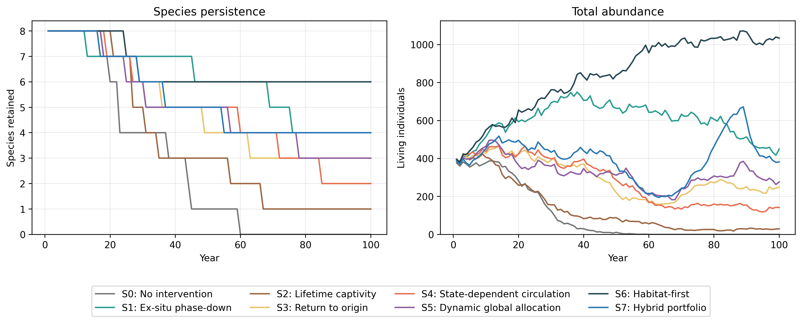
Figure 2. Mean 100-year trajectories under the eight conservation policies. Trajectories are synthetic model outcomes, not forecasts for real taxa.

3.2 Trade-offs do not collapse to a winner
Six of the eight policies were Pareto non-dominated across the six objectives (S0, S1, S3, S4, S6, S7); only S2 and S5 were dominated. S6 maximized survival, habitat integrity (0.857 [0.640, 0.962]), and welfare (0.732 [0.335, 0.780]) at essentially zero monetary cost, while S7 dominated on wild abundance (633.094 [0.000, 1200.000]) and future-option value (0.331 [0.130, 0.473]). The balanced policy's extra survival and option value therefore cost habitat quality, welfare, and money — a genuine multi-objective trade-off, not a dominated compromise (Figs. 3, 4).
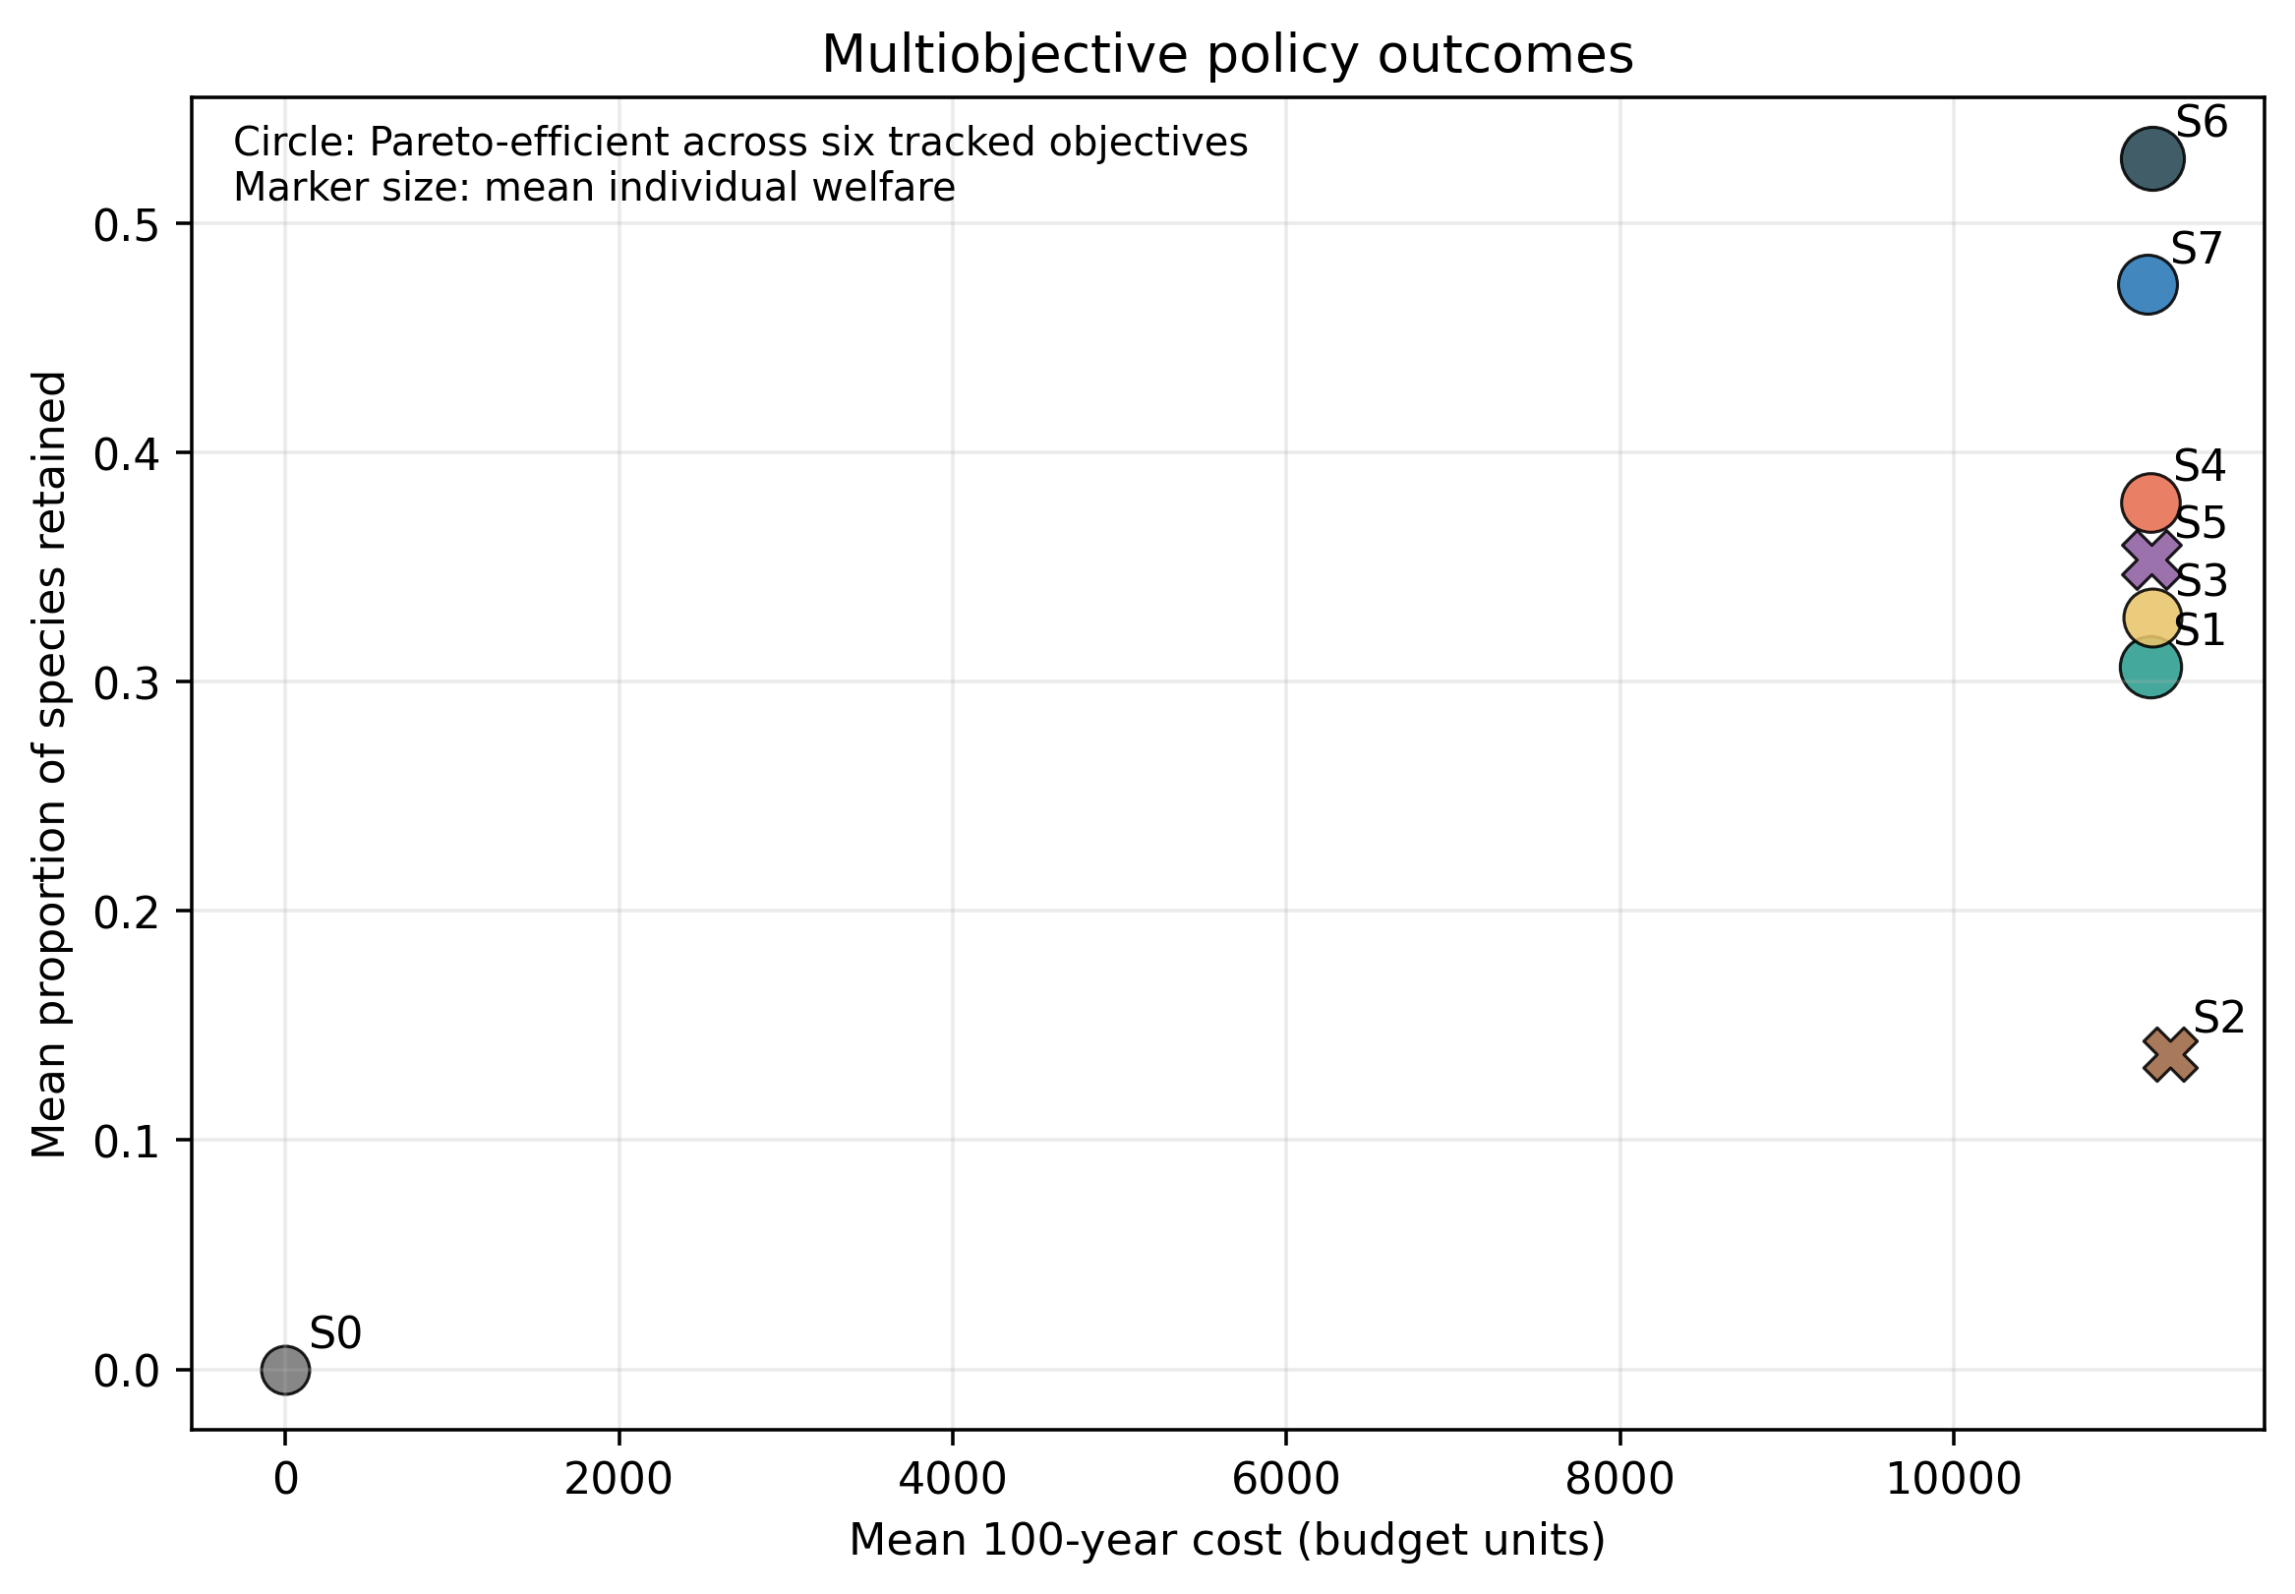
Figure 3. Multiobjective policy comparison and Pareto status under the declared aggregate objectives.
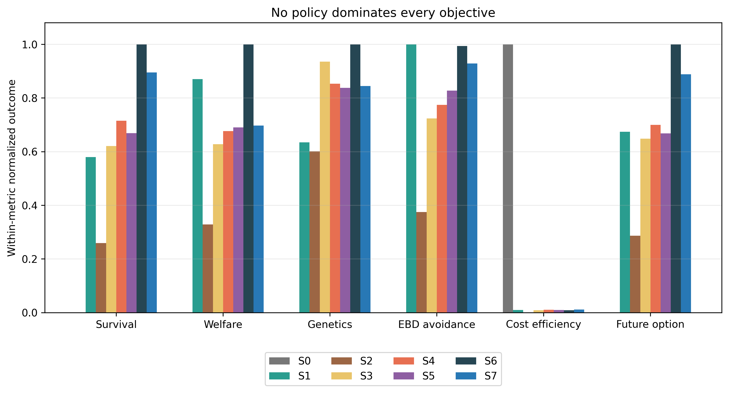
Figure 4. Normalized cross-objective outcomes. Normalization is descriptive and does not define cardinal utility.

3.3 Where the ranking reverses
Across the five sweeps, 35 cells robustly favoured S7, 26 robustly favoured S6, and 64 remained indeterminate at paired n = 8. S7's advantage concentrated in high-deterioration, high-climate-velocity cells and where movement is cheap and survivable; S6's advantage concentrated where captivity benefit is low, habitat investment is effective, or survey capacity is limiting (Fig. 5). The reversal band is wide: roughly half of all cells could not be signed at our replicate budget.
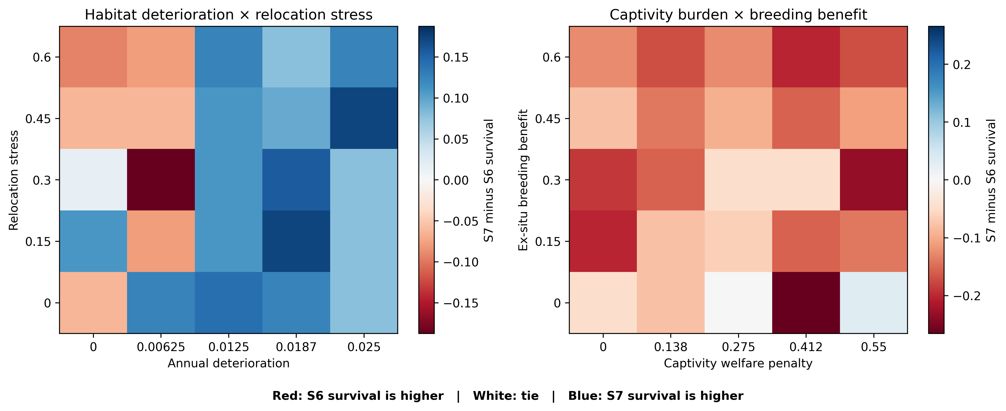
Figure 5. Policy-reversal surfaces for selected two-factor sweeps. Color represents the difference in 100-year survival between the hybrid portfolio (S7) and habitat-first policy (S6).

3.4 Extinction before discovery
EBD affected 0.174 [0.000, 0.667] of latent species even under the best feasible policy, versus 0.993 [1.000, 1.000] under the no-intervention control. Survey investment reduces but never eliminates EBD, because detection probability saturates and movement eligibility is visibility-gated: a species invisible at stage < 2 cannot be rescued (Fig. 6).
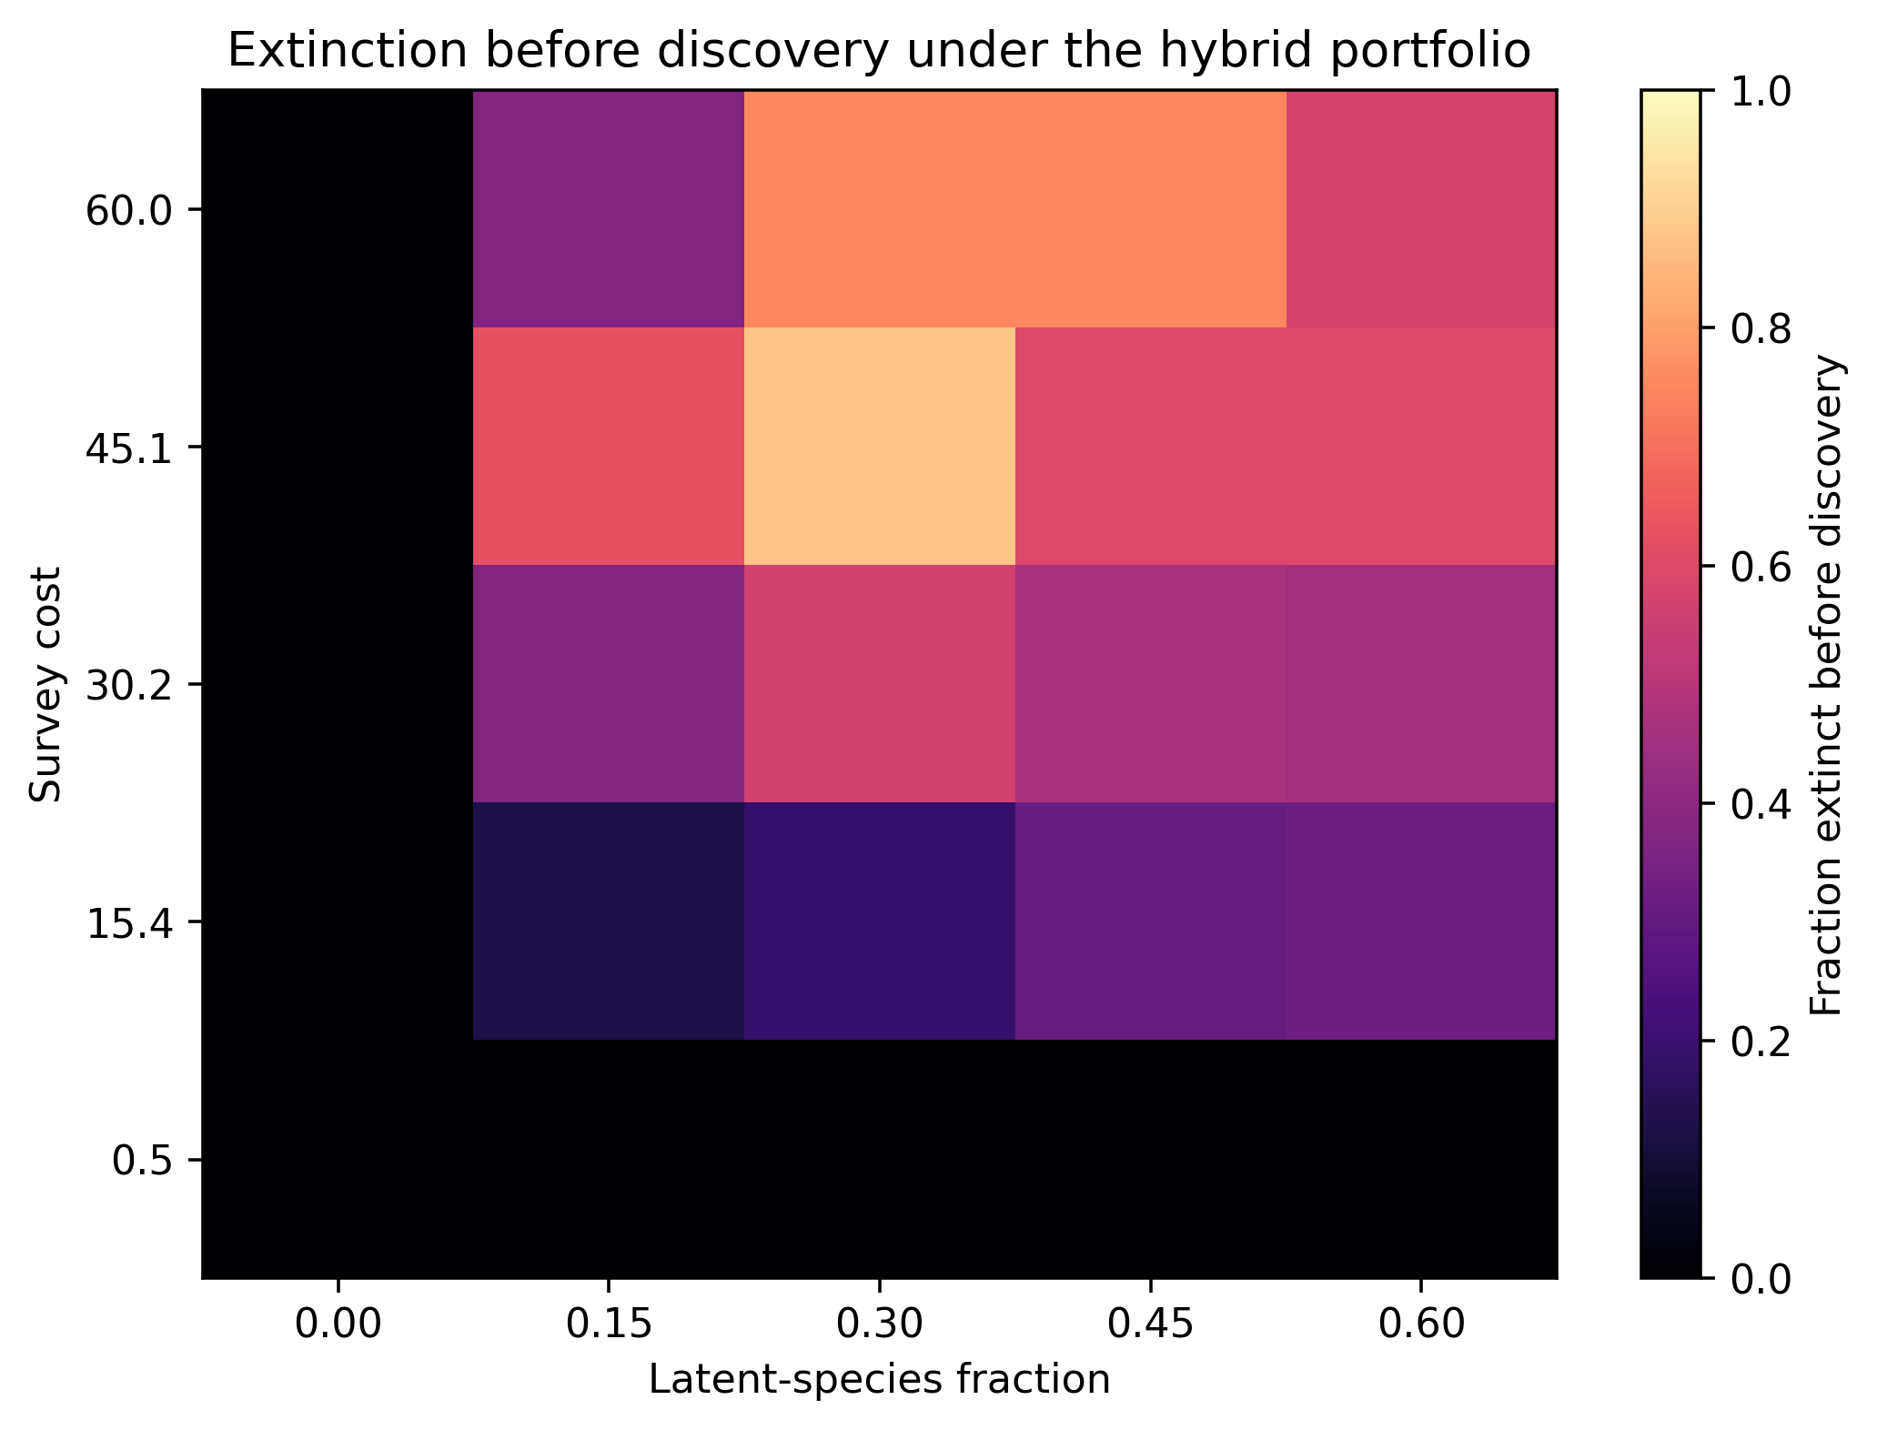
Figure 6. Extinction-before-discovery outcomes across latent-species fraction and survey-cost conditions.

3.5 Information is not the bottleneck
The paired perfect-current-state-information effect on the prespecified utility index was -0.003 [-0.112, 0.131], and weighting-scheme sensitivity kept the interval straddling zero (Table 6; Figs. 7–9). Perfect current observation does not rescue the feasible policy, because the binding constraints are movement capacity, welfare and mortality costs, and the visibility gate — not observational noise.

Table 6. Current-state-information effect under alternative normative weights.
scenario | survival 100 | future option value | habitat integrity | ebd avoidance | mean individual welfare | estimate | lower | upper | mc half width | n
registered | 0.350 | 0.200 | 0.150 | 0.150 | 0.150 | -0.003 | -0.112 | 0.131 | 0.009 | 192
equal_components | 0.200 | 0.200 | 0.200 | 0.200 | 0.200 | -0.002 | -0.110 | 0.125 | 0.008 | 192
persistence_priority | 0.600 | 0.100 | 0.100 | 0.100 | 0.100 | -0.006 | -0.162 | 0.169 | 0.013 | 192
welfare_priority | 0.100 | 0.100 | 0.100 | 0.100 | 0.600 | -0.000 | -0.063 | 0.076 | 0.006 | 192
future_option_priority | 0.100 | 0.600 | 0.100 | 0.100 | 0.100 | -0.001 | -0.095 | 0.117 | 0.008 | 192
ebd_priority | 0.100 | 0.100 | 0.100 | 0.600 | 0.100 | 0.001 | -0.221 | 0.223 | 0.016 | 192

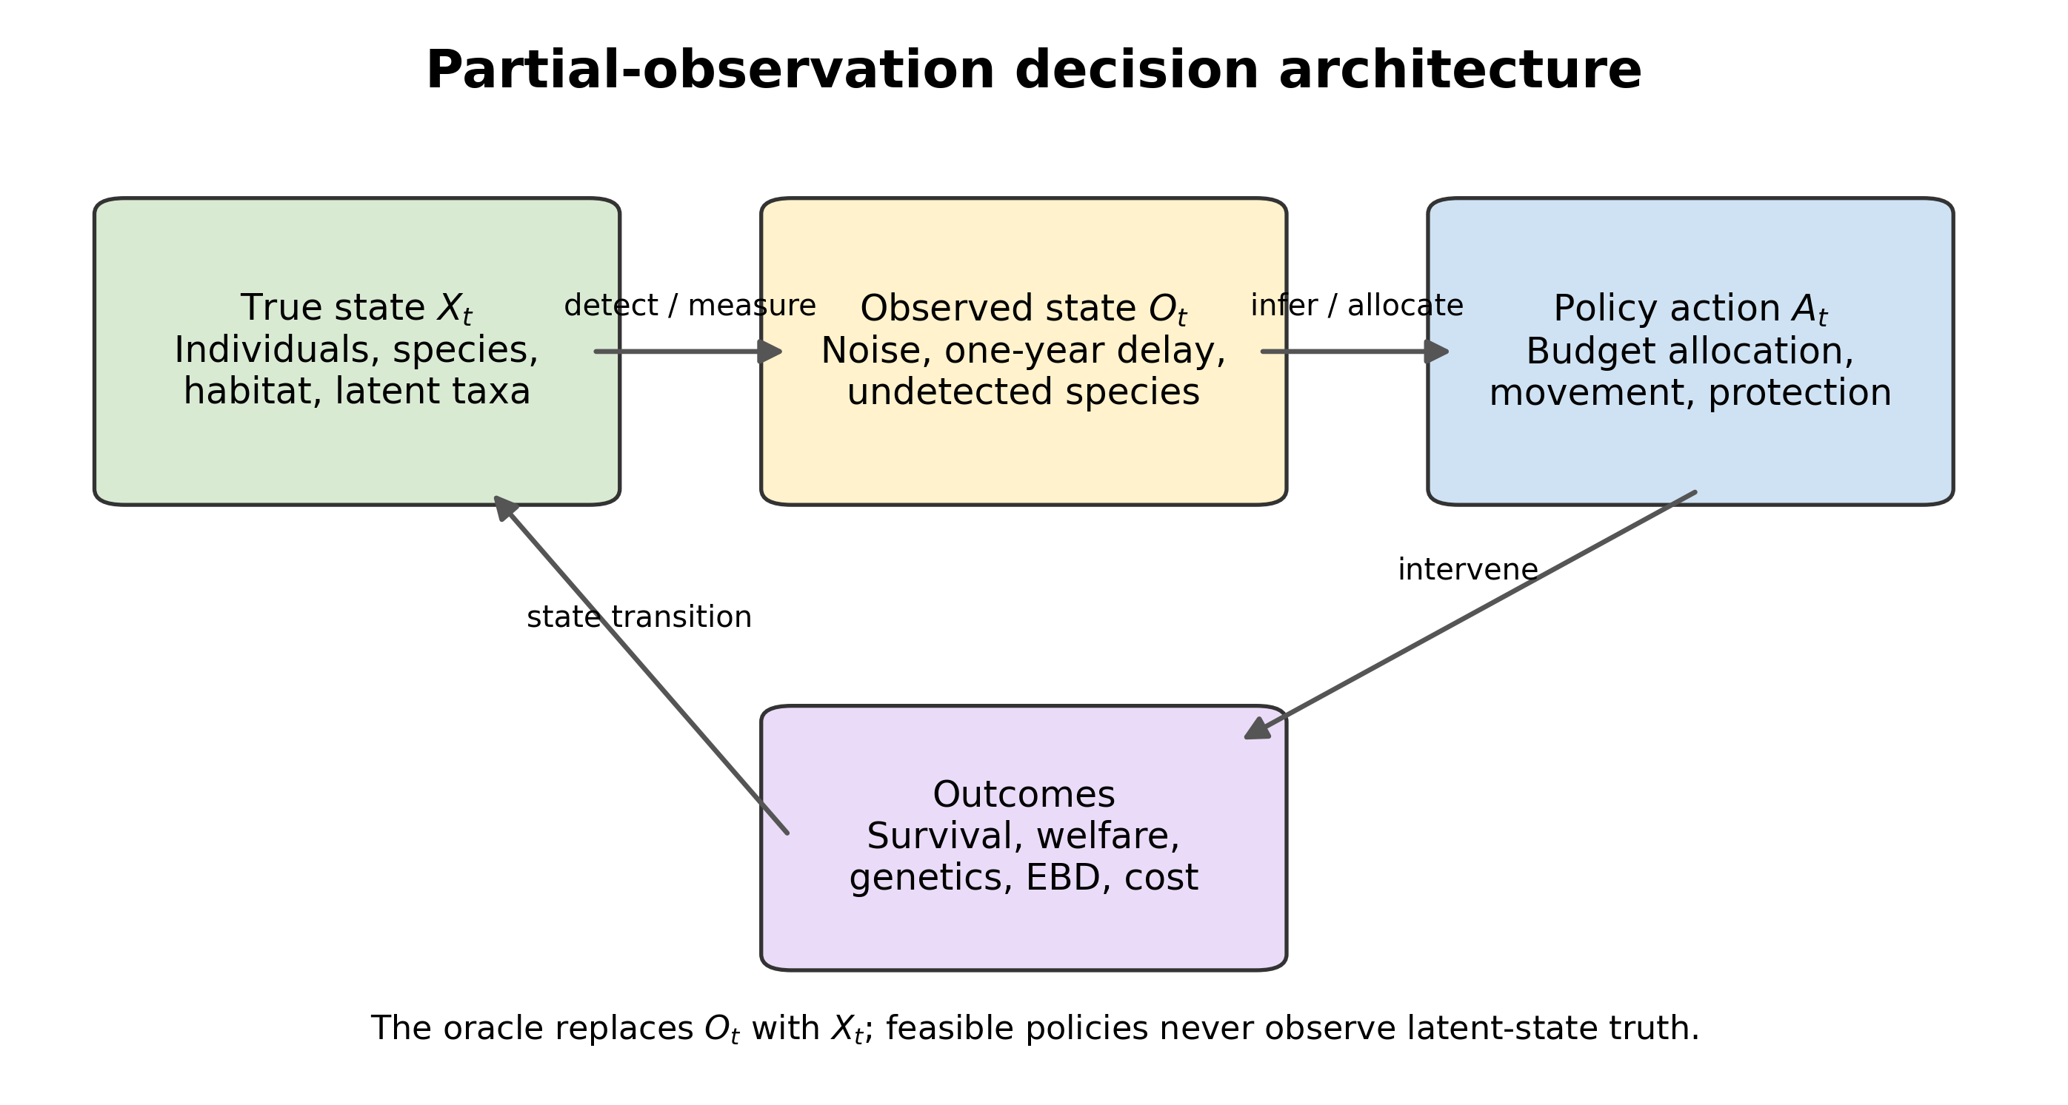
Figure 7. Partial-observation architecture separating true ecological state, observations, policy actions, and realized outcomes.
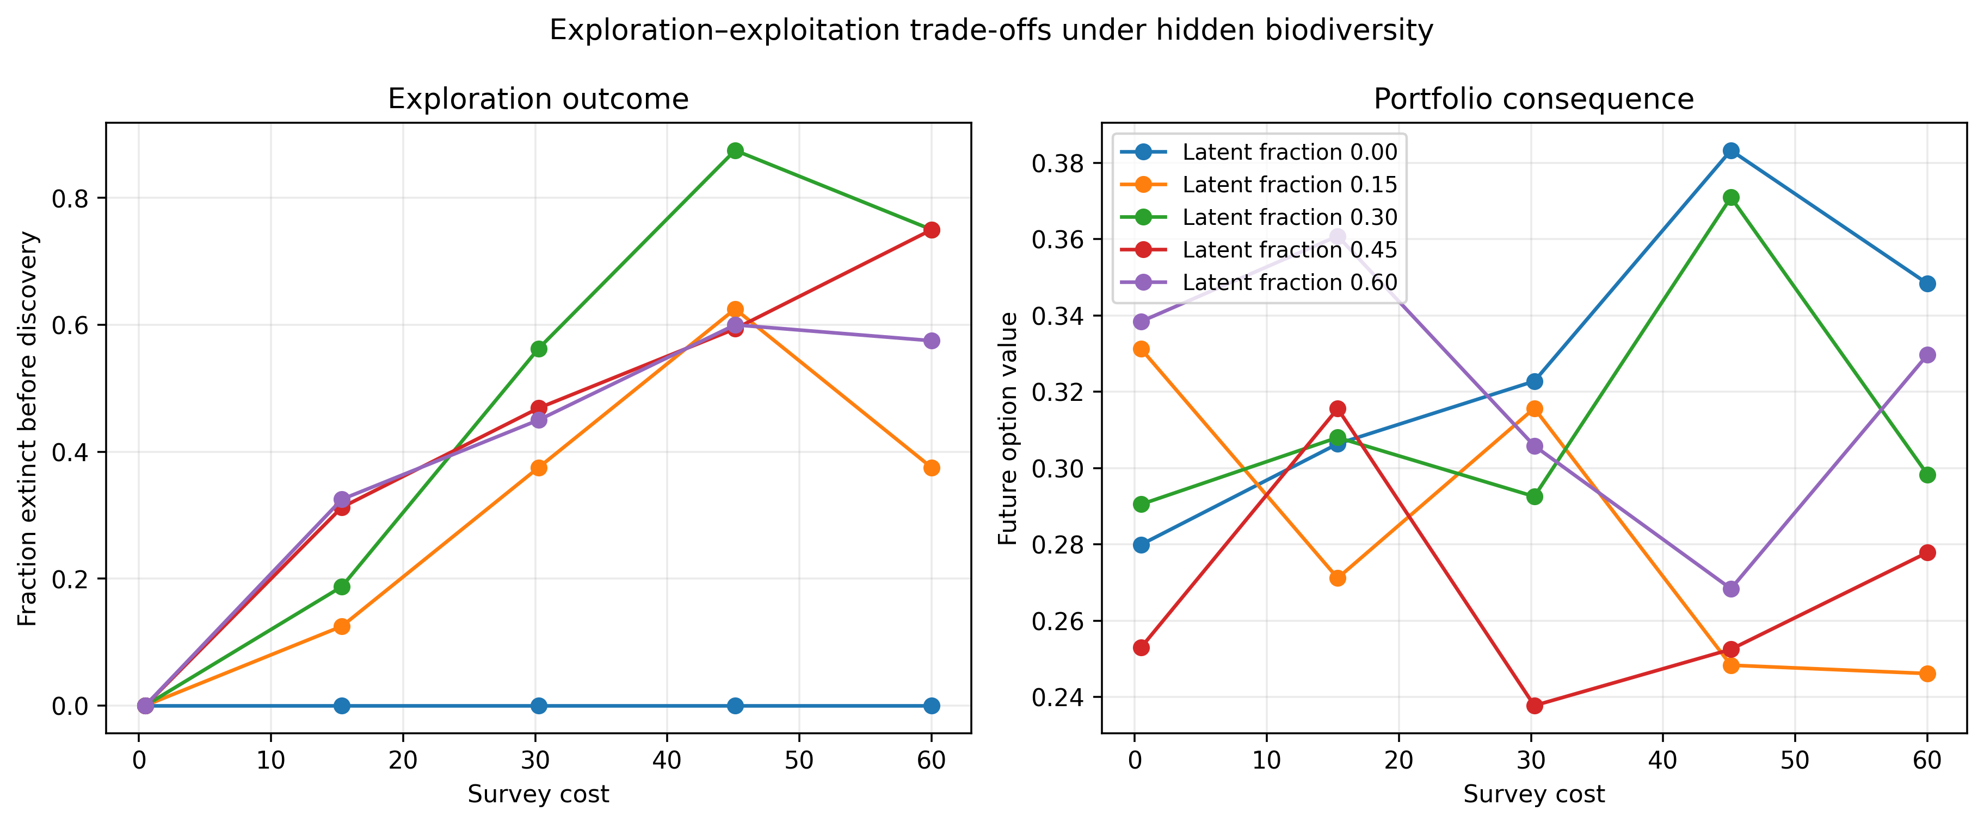
Figure 8. Exploration–exploitation patterns across survey-cost conditions.
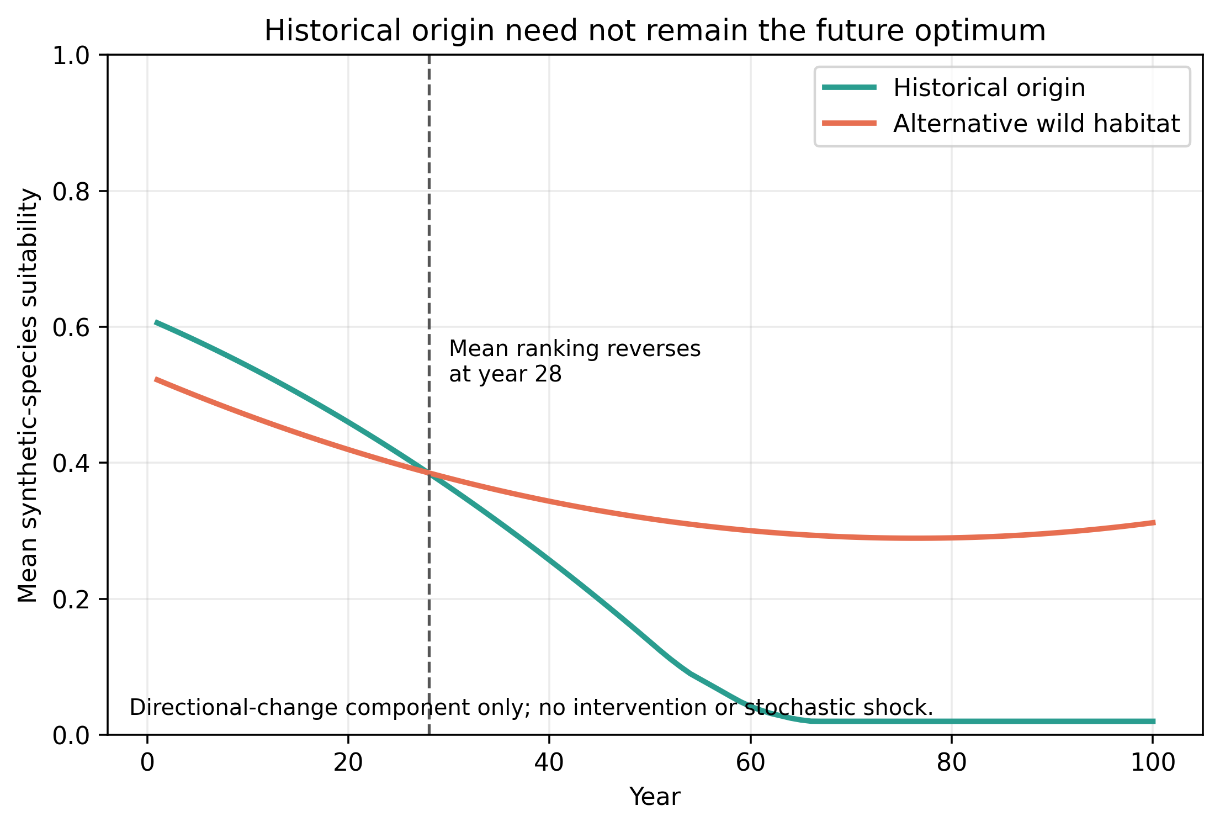
Figure 9. Origin-to-future habitat-quality shift under the deterministic component of directional environmental change.

3.6 Sensitivity and ablations
Latin-hypercube Spearman profiles and ablations (Tables 7–9) confirm the mechanism reading: outcomes move with deterioration rate, relocation mortality, captivity breeding benefit, and survey capacity in the directions the equations predict, and removing the visibility gate or movement costs removes S7's advantage.
Table 7. Design-level Latin-hypercube sensitivity correlations.
policy | metric | parameter | spearman rho | n designs | replicates per design
S4 | survival_100 | habitat_deterioration | -0.676 | 128 | 4
S4 | survival_100 | climate_velocity | -0.134 | 128 | 4
S4 | survival_100 | relocation_mortality | -0.091 | 128 | 4
S4 | survival_100 | relocation_stress | -0.106 | 128 | 4
S4 | survival_100 | ex_situ_breeding_benefit | 0.155 | 128 | 4
S4 | survival_100 | release_survival_penalty | -0.034 | 128 | 4
S4 | survival_100 | movement_disease_risk | -0.046 | 128 | 4
S4 | survival_100 | captivity_welfare_penalty | -0.050 | 128 | 4
S4 | survival_100 | survey_cost | -0.094 | 128 | 4
S4 | survival_100 | engagement_coefficient | 0.157 | 128 | 4
S4 | survival_100 | initial_budget | 0.262 | 128 | 4
S4 | survival_100 | habitat_protection_efficiency | 0.414 | 128 | 4
S4 | fraction_ebd | habitat_deterioration | 0.310 | 128 | 4
S4 | fraction_ebd | climate_velocity | 0.173 | 128 | 4
S4 | fraction_ebd | relocation_mortality | -0.216 | 128 | 4
S4 | fraction_ebd | relocation_stress | 0.054 | 128 | 4
S4 | fraction_ebd | ex_situ_breeding_benefit | -0.000 | 128 | 4
S4 | fraction_ebd | release_survival_penalty | -0.050 | 128 | 4
S4 | fraction_ebd | movement_disease_risk | 0.096 | 128 | 4
S4 | fraction_ebd | captivity_welfare_penalty | -0.053 | 128 | 4
S4 | fraction_ebd | survey_cost | 0.609 | 128 | 4
S4 | fraction_ebd | engagement_coefficient | -0.024 | 128 | 4
S4 | fraction_ebd | initial_budget | -0.296 | 128 | 4
S4 | fraction_ebd | habitat_protection_efficiency | -0.145 | 128 | 4
S4 | mean_individual_welfare | habitat_deterioration | -0.551 | 128 | 4
S4 | mean_individual_welfare | climate_velocity | -0.078 | 128 | 4
S4 | mean_individual_welfare | relocation_mortality | -0.016 | 128 | 4
S4 | mean_individual_welfare | relocation_stress | 0.039 | 128 | 4
S4 | mean_individual_welfare | ex_situ_breeding_benefit | 0.038 | 128 | 4
S4 | mean_individual_welfare | release_survival_penalty | -0.092 | 128 | 4
S4 | mean_individual_welfare | movement_disease_risk | -0.058 | 128 | 4
S4 | mean_individual_welfare | captivity_welfare_penalty | -0.449 | 128 | 4
S4 | mean_individual_welfare | survey_cost | 0.036 | 128 | 4
S4 | mean_individual_welfare | engagement_coefficient | 0.120 | 128 | 4
S4 | mean_individual_welfare | initial_budget | 0.015 | 128 | 4
S4 | mean_individual_welfare | habitat_protection_efficiency | 0.244 | 128 | 4
S4 | future_option_value | habitat_deterioration | -0.721 | 128 | 4
S4 | future_option_value | climate_velocity | -0.084 | 128 | 4
S4 | future_option_value | relocation_mortality | -0.070 | 128 | 4
S4 | future_option_value | relocation_stress | -0.086 | 128 | 4
S4 | future_option_value | ex_situ_breeding_benefit | 0.168 | 128 | 4
S4 | future_option_value | release_survival_penalty | -0.025 | 128 | 4
S4 | future_option_value | movement_disease_risk | -0.048 | 128 | 4
S4 | future_option_value | captivity_welfare_penalty | -0.045 | 128 | 4
S4 | future_option_value | survey_cost | -0.083 | 128 | 4
S4 | future_option_value | engagement_coefficient | 0.175 | 128 | 4
S4 | future_option_value | initial_budget | 0.241 | 128 | 4
S4 | future_option_value | habitat_protection_efficiency | 0.426 | 128 | 4
S6 | survival_100 | habitat_deterioration | -0.486 | 128 | 4
S6 | survival_100 | climate_velocity | -0.372 | 128 | 4
S6 | survival_100 | relocation_mortality | 0.053 | 128 | 4
S6 | survival_100 | relocation_stress | -0.028 | 128 | 4
S6 | survival_100 | ex_situ_breeding_benefit | 0.028 | 128 | 4
S6 | survival_100 | release_survival_penalty | 0.020 | 128 | 4
S6 | survival_100 | movement_disease_risk | -0.073 | 128 | 4
S6 | survival_100 | captivity_welfare_penalty | -0.083 | 128 | 4
S6 | survival_100 | survey_cost | -0.099 | 128 | 4
S6 | survival_100 | engagement_coefficient | 0.047 | 128 | 4
S6 | survival_100 | initial_budget | -0.124 | 128 | 4
S6 | survival_100 | habitat_protection_efficiency | 0.712 | 128 | 4
S6 | fraction_ebd | habitat_deterioration | 0.357 | 128 | 4
S6 | fraction_ebd | climate_velocity | 0.110 | 128 | 4
S6 | fraction_ebd | relocation_mortality | -0.174 | 128 | 4
S6 | fraction_ebd | relocation_stress | 0.088 | 128 | 4
S6 | fraction_ebd | ex_situ_breeding_benefit | 0.016 | 128 | 4
S6 | fraction_ebd | release_survival_penalty | 0.005 | 128 | 4
S6 | fraction_ebd | movement_disease_risk | 0.138 | 128 | 4
S6 | fraction_ebd | captivity_welfare_penalty | 0.029 | 128 | 4
S6 | fraction_ebd | survey_cost | 0.550 | 128 | 4
S6 | fraction_ebd | engagement_coefficient | -0.035 | 128 | 4
S6 | fraction_ebd | initial_budget | -0.115 | 128 | 4
S6 | fraction_ebd | habitat_protection_efficiency | -0.569 | 128 | 4
S6 | mean_individual_welfare | habitat_deterioration | -0.535 | 128 | 4
S6 | mean_individual_welfare | climate_velocity | -0.369 | 128 | 4
S6 | mean_individual_welfare | relocation_mortality | 0.005 | 128 | 4
S6 | mean_individual_welfare | relocation_stress | -0.047 | 128 | 4
S6 | mean_individual_welfare | ex_situ_breeding_benefit | 0.061 | 128 | 4
S6 | mean_individual_welfare | release_survival_penalty | 0.028 | 128 | 4
S6 | mean_individual_welfare | movement_disease_risk | -0.060 | 128 | 4
S6 | mean_individual_welfare | captivity_welfare_penalty | -0.037 | 128 | 4
S6 | mean_individual_welfare | survey_cost | -0.051 | 128 | 4
S6 | mean_individual_welfare | engagement_coefficient | 0.068 | 128 | 4
S6 | mean_individual_welfare | initial_budget | -0.115 | 128 | 4
S6 | mean_individual_welfare | habitat_protection_efficiency | 0.753 | 128 | 4
S6 | future_option_value | habitat_deterioration | -0.536 | 128 | 4
S6 | future_option_value | climate_velocity | -0.316 | 128 | 4
S6 | future_option_value | relocation_mortality | 0.016 | 128 | 4
S6 | future_option_value | relocation_stress | -0.021 | 128 | 4
S6 | future_option_value | ex_situ_breeding_benefit | 0.072 | 128 | 4
S6 | future_option_value | release_survival_penalty | 0.011 | 128 | 4
S6 | future_option_value | movement_disease_risk | -0.080 | 128 | 4
S6 | future_option_value | captivity_welfare_penalty | -0.054 | 128 | 4
S6 | future_option_value | survey_cost | -0.072 | 128 | 4
S6 | future_option_value | engagement_coefficient | 0.045 | 128 | 4
S6 | future_option_value | initial_budget | -0.115 | 128 | 4
S6 | future_option_value | habitat_protection_efficiency | 0.756 | 128 | 4
S7 | survival_100 | habitat_deterioration | -0.672 | 128 | 4
S7 | survival_100 | climate_velocity | -0.095 | 128 | 4
S7 | survival_100 | relocation_mortality | -0.036 | 128 | 4
S7 | survival_100 | relocation_stress | -0.127 | 128 | 4
S7 | survival_100 | ex_situ_breeding_benefit | 0.122 | 128 | 4
S7 | survival_100 | release_survival_penalty | 0.027 | 128 | 4
S7 | survival_100 | movement_disease_risk | -0.097 | 128 | 4
S7 | survival_100 | captivity_welfare_penalty | -0.034 | 128 | 4
S7 | survival_100 | survey_cost | -0.149 | 128 | 4
S7 | survival_100 | engagement_coefficient | 0.156 | 128 | 4
S7 | survival_100 | initial_budget | 0.158 | 128 | 4
S7 | survival_100 | habitat_protection_efficiency | 0.594 | 128 | 4
S7 | fraction_ebd | habitat_deterioration | 0.384 | 128 | 4
S7 | fraction_ebd | climate_velocity | 0.138 | 128 | 4
S7 | fraction_ebd | relocation_mortality | -0.167 | 128 | 4
S7 | fraction_ebd | relocation_stress | 0.051 | 128 | 4
S7 | fraction_ebd | ex_situ_breeding_benefit | -0.038 | 128 | 4
S7 | fraction_ebd | release_survival_penalty | -0.010 | 128 | 4
S7 | fraction_ebd | movement_disease_risk | 0.170 | 128 | 4
S7 | fraction_ebd | captivity_welfare_penalty | -0.031 | 128 | 4
S7 | fraction_ebd | survey_cost | 0.645 | 128 | 4
S7 | fraction_ebd | engagement_coefficient | -0.015 | 128 | 4
S7 | fraction_ebd | initial_budget | -0.242 | 128 | 4
S7 | fraction_ebd | habitat_protection_efficiency | -0.226 | 128 | 4
S7 | mean_individual_welfare | habitat_deterioration | -0.658 | 128 | 4
S7 | mean_individual_welfare | climate_velocity | -0.263 | 128 | 4
S7 | mean_individual_welfare | relocation_mortality | -0.036 | 128 | 4
S7 | mean_individual_welfare | relocation_stress | 0.047 | 128 | 4
S7 | mean_individual_welfare | ex_situ_breeding_benefit | 0.061 | 128 | 4
S7 | mean_individual_welfare | release_survival_penalty | -0.000 | 128 | 4
S7 | mean_individual_welfare | movement_disease_risk | 0.003 | 128 | 4
S7 | mean_individual_welfare | captivity_welfare_penalty | -0.202 | 128 | 4
S7 | mean_individual_welfare | survey_cost | -0.057 | 128 | 4
S7 | mean_individual_welfare | engagement_coefficient | 0.115 | 128 | 4
S7 | mean_individual_welfare | initial_budget | -0.012 | 128 | 4
S7 | mean_individual_welfare | habitat_protection_efficiency | 0.425 | 128 | 4
S7 | future_option_value | habitat_deterioration | -0.702 | 128 | 4
S7 | future_option_value | climate_velocity | -0.090 | 128 | 4
S7 | future_option_value | relocation_mortality | -0.024 | 128 | 4
S7 | future_option_value | relocation_stress | -0.105 | 128 | 4
S7 | future_option_value | ex_situ_breeding_benefit | 0.122 | 128 | 4
S7 | future_option_value | release_survival_penalty | 0.025 | 128 | 4
S7 | future_option_value | movement_disease_risk | -0.097 | 128 | 4
S7 | future_option_value | captivity_welfare_penalty | -0.031 | 128 | 4
S7 | future_option_value | survey_cost | -0.127 | 128 | 4
S7 | future_option_value | engagement_coefficient | 0.181 | 128 | 4
S7 | future_option_value | initial_budget | 0.147 | 128 | 4
S7 | future_option_value | habitat_protection_efficiency | 0.592 | 128 | 4

Table 8. Strongest pairwise partial-rank interaction screens.
policy | metric | parameter 1 | parameter 2 | partial rank interaction | n designs
S4 | fraction_ebd | habitat_deterioration | survey_cost | 0.228 | 128
S4 | fraction_ebd | climate_velocity | initial_budget | 0.209 | 128
S4 | fraction_ebd | relocation_mortality | engagement_coefficient | -0.203 | 128
S4 | future_option_value | habitat_deterioration | habitat_protection_efficiency | -0.227 | 128
S4 | future_option_value | relocation_mortality | engagement_coefficient | 0.206 | 128
S4 | future_option_value | release_survival_penalty | habitat_protection_efficiency | 0.204 | 128
S4 | mean_individual_welfare | ex_situ_breeding_benefit | habitat_protection_efficiency | -0.309 | 128
S4 | mean_individual_welfare | release_survival_penalty | engagement_coefficient | -0.277 | 128
S4 | mean_individual_welfare | engagement_coefficient | initial_budget | -0.226 | 128
S4 | survival_100 | relocation_mortality | engagement_coefficient | 0.242 | 128
S4 | survival_100 | habitat_deterioration | habitat_protection_efficiency | -0.226 | 128
S4 | survival_100 | release_survival_penalty | habitat_protection_efficiency | 0.188 | 128
S6 | fraction_ebd | climate_velocity | initial_budget | 0.250 | 128
S6 | fraction_ebd | relocation_mortality | captivity_welfare_penalty | -0.235 | 128
S6 | fraction_ebd | relocation_mortality | engagement_coefficient | -0.205 | 128
S6 | future_option_value | relocation_mortality | relocation_stress | 0.187 | 128
S6 | future_option_value | survey_cost | habitat_protection_efficiency | -0.182 | 128
S6 | future_option_value | relocation_mortality | captivity_welfare_penalty | 0.169 | 128
S6 | mean_individual_welfare | relocation_mortality | relocation_stress | 0.203 | 128
S6 | mean_individual_welfare | climate_velocity | relocation_stress | -0.169 | 128
S6 | mean_individual_welfare | relocation_mortality | initial_budget | 0.167 | 128
S6 | survival_100 | relocation_mortality | engagement_coefficient | 0.196 | 128
S6 | survival_100 | release_survival_penalty | engagement_coefficient | -0.183 | 128
S6 | survival_100 | survey_cost | habitat_protection_efficiency | -0.181 | 128
S7 | fraction_ebd | climate_velocity | initial_budget | 0.259 | 128
S7 | fraction_ebd | habitat_deterioration | survey_cost | 0.241 | 128
S7 | fraction_ebd | relocation_mortality | engagement_coefficient | -0.183 | 128
S7 | future_option_value | survey_cost | habitat_protection_efficiency | -0.243 | 128
S7 | future_option_value | relocation_mortality | engagement_coefficient | 0.211 | 128
S7 | future_option_value | release_survival_penalty | engagement_coefficient | -0.182 | 128
S7 | mean_individual_welfare | release_survival_penalty | engagement_coefficient | -0.270 | 128
S7 | mean_individual_welfare | habitat_deterioration | initial_budget | 0.254 | 128
S7 | mean_individual_welfare | ex_situ_breeding_benefit | habitat_protection_efficiency | -0.210 | 128
S7 | survival_100 | survey_cost | habitat_protection_efficiency | -0.254 | 128
S7 | survival_100 | relocation_mortality | engagement_coefficient | 0.232 | 128
S7 | survival_100 | release_survival_penalty | engagement_coefficient | -0.181 | 128

Table 9. Ablation and adverse-condition outcomes.
analysis | design | policy | survival 100 | fraction ebd | mean individual welfare
ablations | biobank | S4 | 0.302 | 0.444 | 0.597
ablations | biobank | S6 | 0.448 | 0.250 | 0.679
ablations | biobank | S7 | 0.406 | 0.278 | 0.589
ablations | climate | S4 | 0.396 | 0.417 | 0.636
ablations | climate | S6 | 0.615 | 0.306 | 0.762
ablations | climate | S7 | 0.542 | 0.278 | 0.660
ablations | disease | S4 | 0.417 | 0.361 | 0.599
ablations | disease | S6 | 0.333 | 0.194 | 0.698
ablations | disease | S7 | 0.521 | 0.250 | 0.539
ablations | genetics | S4 | 0.323 | 0.389 | 0.632
ablations | genetics | S6 | 0.490 | 0.194 | 0.754
ablations | genetics | S7 | 0.490 | 0.250 | 0.601
ablations | human_feedback | S4 | 0.260 | 0.528 | 0.586
ablations | human_feedback | S6 | 0.188 | 0.250 | 0.604
ablations | human_feedback | S7 | 0.344 | 0.306 | 0.613
ablations | latent_species | S4 | 0.354 | 0 | 0.612
ablations | latent_species | S6 | 0.573 | 0 | 0.727
ablations | latent_species | S7 | 0.427 | 0 | 0.636
ablations | origin_fidelity | S4 | 0.417 | 0.278 | 0.602
ablations | origin_fidelity | S6 | 0.521 | 0.139 | 0.722
ablations | origin_fidelity | S7 | 0.635 | 0.194 | 0.586
ablations | partial_observability | S4 | 0.417 | 0.333 | 0.570
ablations | partial_observability | S6 | 0.427 | 0.139 | 0.703
ablations | partial_observability | S7 | 0.469 | 0.222 | 0.593
ablations | welfare | S4 | 0.396 | 0.250 | 1
ablations | welfare | S6 | 0.479 | 0.167 | 0.954
ablations | welfare | S7 | 0.490 | 0.167 | 1
adverse_conditions | efficient_restoration | S4 | 0.781 | 0.194 | 0.731
adverse_conditions | efficient_restoration | S6 | 0.938 | 0.056 | 0.787
adverse_conditions | efficient_restoration | S7 | 0.823 | 0.056 | 0.769
adverse_conditions | excellent_origin | S4 | 0.740 | 0.222 | 0.684
adverse_conditions | excellent_origin | S6 | 0.896 | 0.028 | 0.785
adverse_conditions | excellent_origin | S7 | 0.760 | 0.194 | 0.760
adverse_conditions | high_captivity_penalty | S4 | 0.312 | 0.444 | 0.467
adverse_conditions | high_captivity_penalty | S6 | 0.490 | 0.111 | 0.710
adverse_conditions | high_captivity_penalty | S7 | 0.479 | 0.278 | 0.532
adverse_conditions | high_relocation_harm | S4 | 0.312 | 0.306 | 0.612
adverse_conditions | high_relocation_harm | S6 | 0.583 | 0.056 | 0.740
adverse_conditions | high_relocation_harm | S7 | 0.323 | 0.111 | 0.607
adverse_conditions | negative_engagement | S4 | 0.312 | 0.389 | 0.631
adverse_conditions | negative_engagement | S6 | 0.521 | 0.222 | 0.758
adverse_conditions | negative_engagement | S7 | 0.469 | 0.222 | 0.633
adverse_conditions | zero_breeding_advantage | S4 | 0.323 | 0.417 | 0.623
adverse_conditions | zero_breeding_advantage | S6 | 0.531 | 0.083 | 0.712
adverse_conditions | zero_breeding_advantage | S7 | 0.438 | 0.250 | 0.628

3.7 Reversal criterion: predictive scope and failure regions
On the development cells the frozen criterion signed 0.888 of all 125 cells correctly and 0.910 of the 122 determinate ones. On the untouched held-out set the pattern holds for strong reversals and fails for marginal ones: 26 of 56 cells were determinate (17 favouring S7, 9 favouring S6), and Ψ signed 0.846 of them correctly — sensitivity 1.00 for S7-favoured cells, specificity 0.56 for S6-favoured cells (Table 10, Fig. 10). Because Ψ cannot abstain, its accuracy over all held-out cells, including the 30 indeterminate ones, is only 0.393; it still exceeds every baseline (B0 0.161, B1 0.286, B2 0.196), and following its sign costs a mean decision regret of 0.045 versus 0.084 for always-S6.
The failure region is well-defined: among the 23 cells with |Ψ| < 0.2 the sign is correct in only 0.174 of cases — at chance. Restricting attention to |Ψ| ≥ 0.1 (post-hoc characterization, not part of the frozen formula) leaves 36 covered cells with 0.947 determinate accuracy. The remaining failures concentrate in captivity-centric and all-latent hostile regimes, where the deterministic rollout overstates ex-situ salvage that the IBM's shared rescue capacity and mate limitation cannot realize. The factorial attribution confirms the mechanism reading: S7-favoured cells are driven by the circulation channel (median +0.16 main effect, +0.30 interaction under the S7 budget), whereas S6-favoured cells are driven by the bundled reallocation penalty (median −0.54); the S7–S6 difference is therefore not the isolated causal effect of circulation. A mechanism ladder shows the latent undiscovered cohort is the largest load-bearing component — removing it cuts mean Ψ by ~83% — and that mate limitation shifts, rather than eliminates, the boundary.
Table 10. Held-out performance of the reduced reversal criterion Psi against baseline predictors B0-B2 on the 56 held-out cells. All-cell accuracy includes the 30 indeterminate cells, which no sign predictor can label correctly without abstention; determinate accuracy conditions on the 26 cells whose mean difference exceeds two Monte Carlo standard errors; regret is the mean survival forgone by following the predicted sign instead of the observed better policy.
predictor | all cell accuracy | determinate accuracy | balanced accuracy 3class | regret
Psi (minimal-model criterion) | 0.393 | 0.846 | 0.519 | 0.045
B0 always-S6 | 0.161 | 0 | 0.333 | 0.084
B1 single-parameter threshold (dev-fitted) | 0.286 | — | 0.471 | —
B2 logistic surrogate (dev-fitted) | 0.196 | — | 0.338 | —

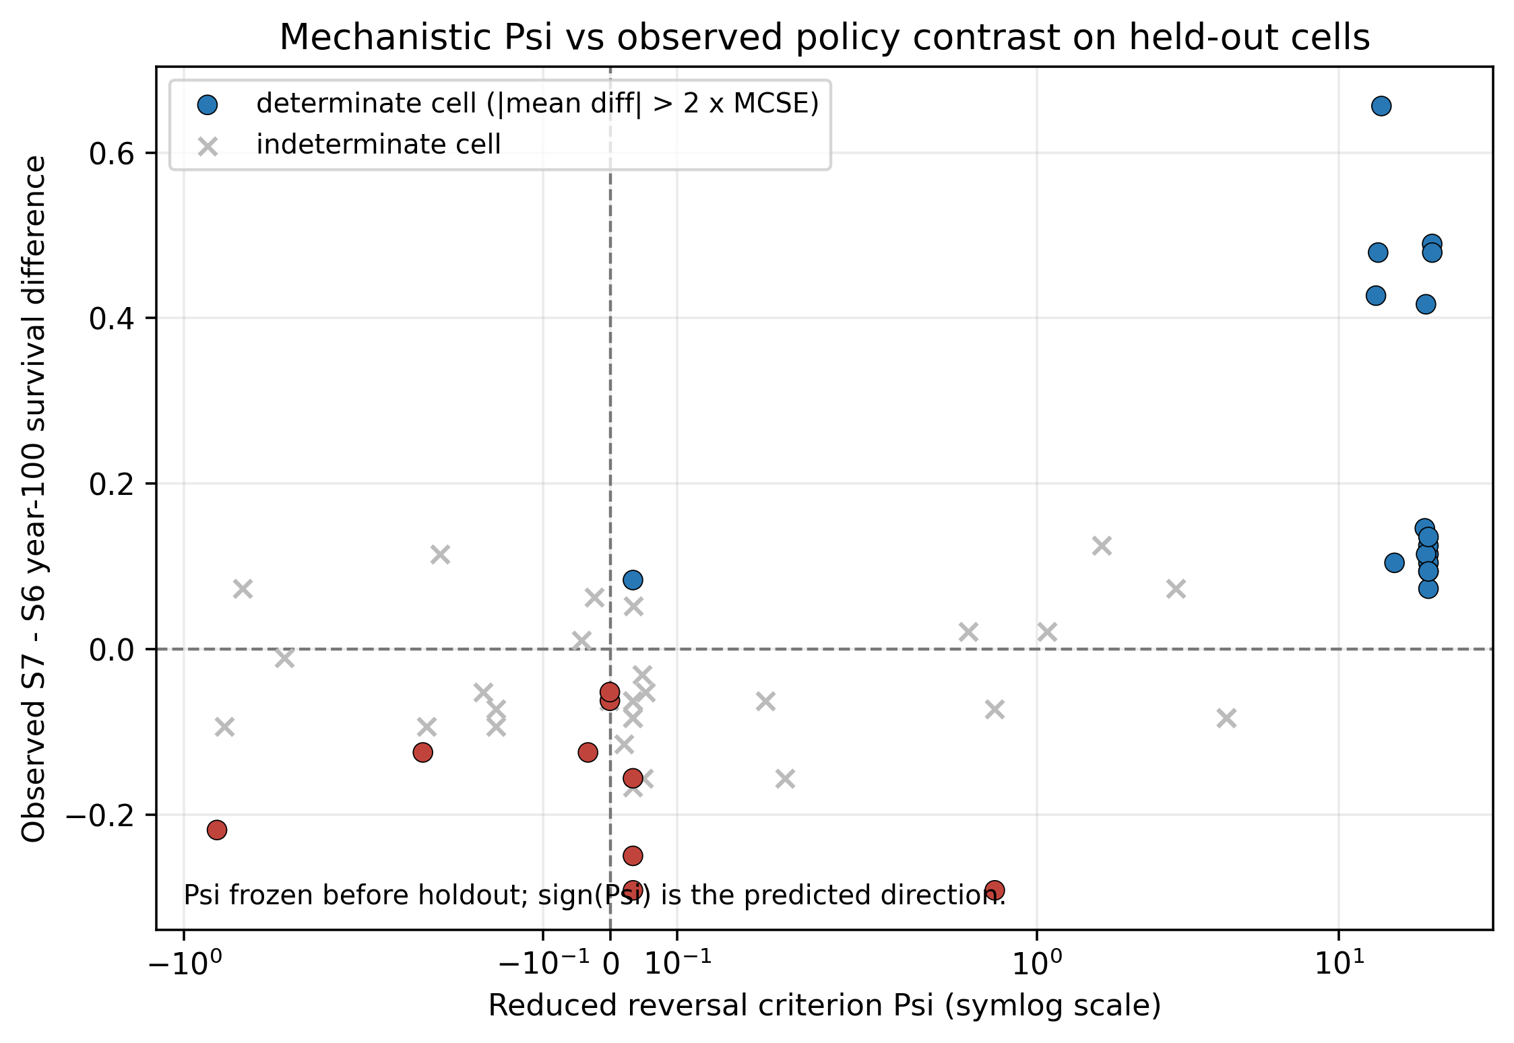
Figure 10. Reduced reversal criterion Psi versus the observed S7 minus S6 year-100 survival difference on the 56 held-out cells. Filled circles are determinate cells (|mean difference| > 2 Monte Carlo standard errors) coloured by observed direction; grey crosses are indeterminate cells. Psi was frozen before the hold-out runs; sign(Psi) is the predicted direction.

4. Discussion
The transferable scientific message is mechanistic: whether a dynamic conservation network pays is decided by the relative magnitudes of habitat-deterioration pressure, movement and welfare costs, and discovery capacity — not by whether managers possess better real-time information. In the model's own parameter space the circulation policy wins in a wide but bounded region; outside it, habitat-first spending wins at lower cost and higher welfare. That the reversal is located inside, and swept across, the parameter space — rather than assumed at a point estimate — is the study's main result.
The reduced criterion makes this claim sharper and marks its boundary. Under the tested model conditions, sign(Ψ) predicts the direction of strong reversals with high accuracy and near-zero decision regret relative to trivial baselines, so the reversal is not merely an emergent map but a derivable consequence of the same equations run at lower fidelity. The bound is equally clear: Ψ cannot recognize indeterminate cells, its sign is uninformative near zero, and its deterministic skeleton cannot represent the bimodal seed-level outcomes of the full IBM. The criterion is therefore a model-specific, bounded condition — not a general ecological law — and its prediction inherits the confounding noted above: the S7–S6 contrast bundles a budget reallocation with the relocation rule, so a positive Ψ certifies the package, not circulation in isolation.
The zero information effect is a second result with practical weight: it predicts that monitoring investments aimed at fixing noisy counts will not pay until action capacity, movement harm, and the visibility gate are addressed first. This is consistent with the management literature showing action constraints dominate information constraints in resource-limited conservation (Canessa et al. 2015; Chadès et al. 2021; Bolton et al. 2022). EBD is the third result: any system in which intervention requires recognition loses a share of its unseen biota regardless of budget — an argument for cheaper baseline discovery rather than better rescue.
Honest limitations bound all of this. Parameters are synthetic and uncalibrated; GBIF aggregates and case literature anchor plausibility, not magnitudes. Policies are fixed rules, so no result about optimized or belief-updating management is claimed. The welfare index and utility weights are normative devices used only to structure the trade-off — the paper deliberately avoids declaring any single policy 'best'. Model units are arbitrary; thresholds are transferable only in relative terms (e.g., 'when deterioration outpaces the capacity of habitat investment to recover it').
Within those bounds, the model offers a falsifiable map: measure deterioration versus movement cost in a real network, locate the system on the sweep plane, and read off which policy archetype the model predicts to be non-dominated — the figure's axes are in model units but the structure of the prediction is directly testable (McLachlan et al. 2007; Richardson et al. 2009; Costello et al. 2013).

5. Conclusions
A fully specified IBM of a nine-node conservation network shows that dynamic wild–managed circulation is neither universally superior nor useless: its advantage is a located region of parameter space. Six of eight policy archetypes are Pareto non-dominated, extinction before discovery is a persistent structural failure, and perfect information without action capacity buys nothing. The complete specification (Algorithms 1–2, Eqs. 1–3, parameter table) is provided so the model can be re-implemented, challenged, and extended.

Acknowledgments
Conflict of interest: none declared.
Funding: none.
Data availability: all code, configuration, generated outputs, and the values registry are available at https://github.com/bougtoir/agentic-conservation; results reproduce from the registry and seed manifest shipped with the repository. An earlier version of this work was submitted elsewhere and declined; this submission is a substantially rewritten modelling study.
AI assistance: an AI coding assistant (Devin, Cognition AI) executed the computational pipeline and drafted document scaffolding under author direction; all scientific claims, interpretation, and this text are the author's responsibility.

References
Araki H, Cooper B, Blouin MS. 2007. Genetic Effects of Captive Breeding Cause a Rapid, Cumulative Fitness Decline in the Wild. Science 318:100-103. DOI: 10.1126/science.1145621.
Beausoleil NJ, Mellor DJ, Baker L, Baker SE, Bellio M, Clarke AS, Dale A, Garlick S, Jones B, Harvey A, Pitcher BJ, Sherwen S, Stockin KA, Zito S. 2018. “Feelings and Fitness” Not “Feelings or Fitness”–The Raison d'être of Conservation Welfare, Which Aligns Conservation and Animal Welfare Objectives. Frontiers in Veterinary Science 5:296. DOI: 10.3389/fvets.2018.00296.
Boehm MMA, Cronk QCB. 2021. Dark extinction: the problem of unknown historical extinctions. Biology Letters 17:20210007. DOI: 10.1098/rsbl.2021.0007.
Bolton RL, Mooney A, Pettit MT, Bolton AE, Morgan L, Drake GJ, Appeltant R, Walker SL, Gillis JD, Hvilsom C. 2022. Resurrecting biodiversity: advanced assisted reproductive technologies and biobanking. Reproduction and Fertility 3:R121-R146. DOI: 10.1530/RAF-22-0005.
Canessa S, Guillera-Arroita G, Lahoz-Monfort JJ, Southwell DM, Armstrong DP, Chadès I, Lacy RC, Converse SJ. 2015. When do we need more data? A primer on calculating the value of information for applied ecologists. Methods in Ecology and Evolution 6:1219-1228. DOI: 10.1111/2041-210X.12423.
Chadès I, McDonald-Madden E, McCarthy MA, Wintle B, Linkie M, Possingham HP. 2008. When to stop managing or surveying cryptic threatened species. Proceedings of the National Academy of Sciences 105:13936-13940. DOI: 10.1073/pnas.0805265105.
Chadès I, Pascal LV, Nicol S, Fletcher CS, Ferrer-Mestres J. 2021. A primer on partially observable Markov decision processes (POMDPs). Methods in Ecology and Evolution 12:2058-2072. DOI: 10.1111/2041-210X.13692.
Conde DA, Colchero F, Gusset M, Pearce-Kelly P, Byers O, Flesness N, Browne RK, Jones OR. 2013. Zoos through the Lens of the IUCN Red List: A Global Metapopulation Approach to Support Conservation Breeding Programs. PLoS ONE 8:e80311. DOI: 10.1371/journal.pone.0080311.
Conde DA, Flesness N, Colchero F, Jones OR, Scheuerlein A. 2011. An Emerging Role of Zoos to Conserve Biodiversity. Science 331:1390-1391. DOI: 10.1126/science.1200674.
Costello MJ, May RM, Stork NE. 2013. Can We Name Earth's Species Before They Go Extinct?. Science 339:413-416. DOI: 10.1126/science.1230318.
Dickens MJ, Delehanty DJ, Romero LM. 2010. Stress: An inevitable component of animal translocation. Biological Conservation 143:1329-1341. DOI: 10.1016/j.biocon.2010.02.032.
D’Elia J, Haig SM, Johnson M, Marcot BG, Young R. 2015. Activity-specific ecological niche models for planning reintroductions of California condors ( Gymnogyps californianus ). Biological Conservation 184:90-99. DOI: 10.1016/j.biocon.2015.01.002.
Frankham R. 2008. Genetic adaptation to captivity in species conservation programs. Molecular Ecology 17:325-333. DOI: 10.1111/j.1365-294X.2007.03399.x.
Gilbert T, Gardner R, Kraaijeveld AR, Riordan P. 2017. Contributions of zoos and aquariums to reintroductions: historical reintroduction efforts in the context of changing conservation perspectives. International Zoo Yearbook 51:15-31. DOI: 10.1111/izy.12159.
Harrington LA, Moehrenschlager A, Gelling M, Atkinson RPD, Hughes J, Macdonald DW. 2013. Conflicting and Complementary Ethics of Animal Welfare Considerations in Reintroductions. Conservation Biology 27:486-500. DOI: 10.1111/cobi.12021.
Hoban S, Bruford M, D'Urban Jackson J, Lopes-Fernandes M, Heuertz M, Hohenlohe PA, Paz-Vinas I, Sjögren-Gulve P, Segelbacher G, Vernesi C, Aitken S, Bertola LD, Bloomer P, Breed M, Rodríguez-Correa H, Funk WC, Grueber CE, Hunter ME, Jaffe R, Liggins L, Mergeay J, Moharrek F, O'Brien D, Ogden R, Palma-Silva C, Pierson J, Ramakrishnan U, Simo-Droissart M, Tani N, Waits L, Laikre L. 2020. Genetic diversity targets and indicators in the CBD post-2020 Global Biodiversity Framework must be improved. Biological Conservation 248:108654. DOI: 10.1016/j.biocon.2020.108654.
Hoegh-Guldberg O, Hughes L, McIntyre S, Lindenmayer DB, Parmesan C, Possingham HP, Thomas CD. 2008. Assisted Colonization and Rapid Climate Change. Science 321:345-346. DOI: 10.1126/science.1157897.
Howell LG, Frankham R, Rodger JC, Witt RR, Clulow S, Upton RMO, Clulow J. 2021. Integrating biobanking minimises inbreeding and produces significant cost benefits for a threatened frog captive breeding programme. Conservation Letters 14:e12776. DOI: 10.1111/conl.12776.
Joseph LN, Maloney RF, Possingham HP. 2009. Optimal Allocation of Resources among Threatened Species: a Project Prioritization Protocol. Conservation Biology 23:328-338. DOI: 10.1111/j.1523-1739.2008.01124.x.
Jule KR, Leaver LA, Lea SEG. 2008. The effects of captive experience on reintroduction survival in carnivores: A review and analysis. Biological Conservation 141:355-363. DOI: 10.1016/j.biocon.2007.11.007.
Kaczensky P, Ganbaatar O, von Wehrden H, Enksaikhan N, Lkhagvasuren D, Walzer C. 2007. Przewalski’s Horse (Equus ferus przewalskii) Re-introduction in the Great Gobi B Strictly Protected Area: from Species to Ecosystem Conservation. Mongolian Journal of Biological Sciences 5:13-18. DOI: 10.22353/mjbs.2007.05.03.
Kennedy MC, Ford ED, Singleton P, Finney M, Agee JK. 2008. Informed multi-objective decision-making in environmental management using Pareto optimality. Journal of Applied Ecology 45:181-192. DOI: 10.1111/j.1365-2664.2007.01367.x.
Kock RA, Woodford MH, Rossiter PB. 2010. Disease risks associated with the translocation of wildlife. Revue Scientifique et Technique de l'OIE 29:329-350. DOI: 10.20506/rst.29.2.1980.
Liu J, Slik F, Zheng S, Lindenmayer DB. 2022. Undescribed species have higher extinction risk than known species. Conservation Letters 15:e12876. DOI: 10.1111/conl.12876.
McCarthy MA, Possingham HP. 2007. Active Adaptive Management for Conservation. Conservation Biology 21:956-963. DOI: 10.1111/j.1523-1739.2007.00677.x.
McLachlan JS, Hellmann JJ, Schwartz MW. 2007. A Framework for Debate of Assisted Migration in an Era of Climate Change. Conservation Biology 21:297-302. DOI: 10.1111/j.1523-1739.2007.00676.x.
Mee A, Rideout BA, Hamber JA, Todd JN, Austin G, Clark M, Wallace MP. 2007. Junk ingestion and nestling mortality in a reintroduced population of California Condors Gymnogyps californianus. Bird Conservation International 17:119-130. DOI: 10.1017/s095927090700069x.
Mellor DJ, Beausoleil NJ, Littlewood KE, McLean AN, McGreevy PD, Jones B, Wilkins C. 2020. The 2020 Five Domains Model: Including Human–Animal Interactions in Assessments of Animal Welfare. Animals 10:1870. DOI: 10.3390/ani10101870.
Mora C, Tittensor DP, Adl S, Simpson AGB, Worm B. 2011. How Many Species Are There on Earth and in the Ocean?. PLoS Biology 9:e1001127. DOI: 10.1371/journal.pbio.1001127.
Moss A, Jensen E, Gusset M. 2015. Evaluating the contribution of zoos and aquariums to Aichi Biodiversity Target 1. Conservation Biology 29:537-544. DOI: 10.1111/cobi.12383.
Pritchard DJ, Fa JE, Oldfield S, Harrop SR. 2012. Bring the captive closer to the wild: redefining the role of ex situ conservation. Oryx 46:18-23. DOI: 10.1017/S0030605310001766.
Redford KH, Jensen DB, Breheny JJ. 2012. Integrating the Captive and the Wild. Science 338:1157-1158. DOI: 10.1126/science.1228899.
Richardson DM, Hellmann JJ, McLachlan JS, Sax DF, Schwartz MW, Gonzalez P, Brennan EJ, Camacho A, Root TL, Sala OE, Schneider SH, Ashe DM, Clark JR, Early R, Etterson JR, Fielder ED, Gill JL, Minteer BA, Polasky S, Safford HD, Thompson AR, Vellend M. 2009. Multidimensional evaluation of managed relocation. Proceedings of the National Academy of Sciences 106:9721-9724. DOI: 10.1073/pnas.0902327106.
Seddon PJ, Griffiths CJ, Soorae PS, Armstrong DP. 2014. Reversing defaunation: Restoring species in a changing world. Science 345:406-412. DOI: 10.1126/science.1251818.
Snyder NFR, Derrickson SR, Beissinger SR, Wiley JW, Smith TB, Toone WD, Miller B. 1996. Limitations of Captive Breeding in Endangered Species Recovery. Conservation Biology 10:338-348. DOI: 10.1046/j.1523-1739.1996.10020338.x.
Tedesco PA, Bigorne R, Bogan AE, Giam X, Jézéquel C, Hugueny B. 2014. Estimating How Many Undescribed Species Have Gone Extinct. Conservation Biology 28:1360-1370. DOI: 10.1111/cobi.12285.
Thomas CD. 2011. Translocation of species, climate change, and the end of trying to recreate past ecological communities. Trends in Ecology & Evolution 26:216-221. DOI: 10.1016/j.tree.2011.02.006.
Watson JEM, Dudley N, Segan DB, Hockings M. 2014. The performance and potential of protected areas. Nature 515:67-73. DOI: 10.1038/nature13947.
Williams BK, Brown ED. 2022. Partial observability and management of ecological systems. Ecology and Evolution 12:e9197. DOI: 10.1002/ece3.9197.
Williams SE, Hoffman EA. 2009. Minimizing genetic adaptation in captive breeding programs: A review. Biological Conservation 142:2388-2400. DOI: 10.1016/j.biocon.2009.05.034.

