Dynamic conservation networks under environmental change and hidden biodiversity
  - Conservation Biology Contributed Paper — anonymous draft
ANONYMOUS HUMAN-REVIEW DRAFT — NOT READY FOR SCIENTIFIC SUBMISSION
All numerical results are generated from the current repository outputs. Complete text was appraised for the four case and decision-theory sources; other cited sources support only statements in their retained author abstracts or titles. Accountable human authors must verify all claims and assumptions, revise the prose in their own scientific voice, and approve the final submission.

Abstract
Conservation decisions increasingly link habitat protection, managed care, movement, breeding, survey, and biobanking, yet the conditions under which dynamic networks outperform fixed strategies remain unclear. We developed an individual-based, annual simulation of eight synthetic species across nine wild and managed node types for 100 years. Five species were initially known and three were latent to feasible decision makers. Eight policies were compared under finite budgets, environmental change, noisy delayed observations, welfare costs, genetics, disease, human engagement, and origin fidelity. The production design used 192 paired-seed replications per policy, Latin-hypercube sensitivity analysis, five two-factor sweeps, feature ablations, adverse conditions, and a current-state-information comparator. Habitat-first policy S6 had mean year-100 survival 0.529 [0.000, 0.875], whereas the hybrid policy S7 had 0.473 [0.125, 0.750]. Robust sweep-cell contrasts favored S7 in 35 cells and S6 in 26; 64 cells were directionally indeterminate. S7 produced mean individual welfare 0.617 [0.441, 0.742]; lifetime captivity S2 produced 0.477 [0.369, 0.514]. The paired current-state-information effect on the prespecified utility scale was -0.003 [-0.112, 0.131]. Dynamic conservation therefore had no universal advantage: benefits depended on habitat change, survey cost, movement harm, managed-care benefit, and the objectives being valued. The framework identifies assumption-dependent reversal boundaries rather than prescribing one institutional form.
Keywords: biodiversity discovery; conservation decision analysis; ex situ conservation; partial observability; policy reversal; reintroduction; value of information
Article impact statement: Hidden biodiversity and shifting habitat can reverse which mix of protection, managed care, and movement performs best.

Introduction
Conservation portfolios operate across environments rather than within a single protected place. About one in seven threatened terrestrial vertebrate species is held in captivity (Conde et al. 2011), and proposals to integrate captive and wild management have argued for a larger ex situ role alongside dominant in situ approaches (Pritchard et al. 2012; Redford et al. 2012). Threatened species are unevenly represented in zoo collections, and managing viable zoo metapopulations requires coordination among many institutions (Conde et al. 2013). Zoos and aquariums can supply source animals for reintroduction (Gilbert et al. 2017) within a spectrum of conservation translocations that extends from reinforcement and reintroduction to introductions outside the indigenous range (Seddon et al. 2014). Habitat protection, zoological and breeding facilities, rehabilitation, assisted movement, prerelease environments, survey, and biobanking can therefore alter different components of persistence.
Each component also carries documented costs. Captive breeding has faced poor reintroduction success, high costs, domestication, disease outbreaks, and preemption of other recovery techniques (Snyder et al. 1996). Genetic adaptation to captivity is generally deleterious when populations are returned to the wild (Frankham 2008); in steelhead trout, captive rearing reduced subsequent reproductive success in the wild by approximately 40% per captive-reared generation (Araki et al. 2007). Potential welfare problems were recorded in 67% of 199 reviewed reintroduction projects, whereas welfare was explicitly addressed in 6% (Harrington et al. 2013), and harms to individual welfare can also hamper conservation goals (Beausoleil et al. 2018). Under climate change, moving species outside historic ranges has been proposed to reduce biodiversity loss (Hoegh-Guldberg et al. 2008), but assisted migration has required an explicit framework for debate (McLachlan et al. 2007).
These effects occur under incomplete knowledge: managers may observe abundance or habitat with error and delay, while some taxa remain undetected, undescribed, or unrecognized as threatened. One estimate suggests that about 86% of existing species await description (Mora et al. 2011), although richness estimates and the risk of extinction before naming are contested (Costello et al. 2013). Undescribed species may account for 15–59% of recent extinctions, depending on taxon and region (Tedesco et al. 2014); such losses have been termed dark extinction (Boehm & Cronk 2021), and the proportion threatened among newly described vertebrates has increased over time (Liu et al. 2022). A strategy that protects known populations efficiently can therefore differ from one that preserves options for unknown biodiversity.
Complete-text case evidence illustrates complementary requirements rather than a universal recipe. A Przewalski's horse project progressed from captive-born release toward standardized monitoring and broader ecosystem work. Activity-specific niche models evaluated with withheld data identified candidate California condor reintroduction areas, while the authors retained the need for ground reconnaissance and assessment of unmodeled threats. In a reintroduced southern California condor population, anthropogenic-material ingestion contributed to nestling mortality and low nest success (Kaczensky et al. 2007; Mee et al. 2007; D’Elia et al. 2015). Ecological decision theory under partial observability separates hidden states from observations and tracks belief states, but adds substantial computational and interpretive complexity (Williams & Brown 2022). Such formulations have shown that managing for a cryptic threatened species can be optimal even when its presence is uncertain (Chadès et al. 2008) and formalize trade-offs between management and surveillance under imperfect observation (Chadès et al. 2021).
Existing debates can be distorted by treating survival, wild restoration, experienced welfare, genetic representation, disease, cost, and future option value as interchangeable. A dynamic network may improve one outcome while worsening another, and movement may be beneficial when future habitat shifts but harmful when origin habitat remains excellent or transfer risk is high. The relevant scientific problem is consequently conditional: when do dynamic networks change outcomes relative to fixed strategies, and when do those differences disappear or reverse?
We addressed this question with a transparent synthetic decision experiment. The contribution is not a calibrated population forecast or a universal recommendation. It is an integrated test bed in which latent biodiversity, individual heterogeneity, partial observability, wild and managed nodes, finite resources, and multiple outcomes can be varied together. We expected policy rankings to reverse across environmental and institutional conditions and treated those reversals, rather than a base-case winner, as the principal result.

Methods

Simulation scope and state
The model followed eight synthetic species for 100 annual steps. Five species were initially represented in the observation state; three existed in the true ecological state but were latent to feasible decision makers. Latent species progressed through existence, detection, description, monitoring, threat recognition, and protection. A latent population could become extinct before description, producing the extinction-before-discovery endpoint. Table 1 lists the base parameters used in the production run. State definitions, observation rules, budget constraints, environmental transitions, disease, welfare, genetic proxies, biobanking, and policy engines are specified in the reproducibility repository.
Table 1. Base simulation parameters.
parameter | base value
years | 100
initial_budget | 100.0
max_individuals | 1200
observation_noise | 0.18
quality_observation_noise | 0.1
observation_delay | 1
background_detection_probability | 0.005
climate_velocity | 0.012
habitat_deterioration | 0.006
relocation_mortality | 0.025
relocation_stress | 0.1
movement_disease_risk | 0.03
quarantine_effectiveness | 0.65
quarantine_cost_per_move | 0.25
infection_fertility_penalty | 0.3
s3_refuge_trigger | 0.48
s3_return_threshold | 0.62
s3_return_delay | 5
captivity_welfare_penalty | 0.12
wild_predation_welfare_weight | 0.1
food_insecurity_welfare_weight | 0.18
managed_crowding_welfare_weight | 0.12
managed_restriction_welfare_weight | 0.12
infection_welfare_weight | 0.16
habituation_welfare_weight | 0.1
relocation_welfare_weight | 0.12
ex_situ_breeding_benefit | 0.22
inbreeding_fertility_penalty | 0.35
inbreeding_mortality_penalty | 0.08
release_survival_penalty | 0.08
survey_cost | 10.0
engagement_coefficient | 0.08
engagement_habitat_feedback | 0.02
habitat_protection_efficiency | 0.025
biobank_future_value | 0.05
biobank_annual_decay | 0.01
catastrophe_probability | 0.035
funding_collapse_probability | 0.015
origin_fidelity | 0.2
mortality_multiplier | 1.0
anthropogenic_pressure_multiplier | 1.0
predation_multiplier | 1.0
scenario | directional_change

Individuals carried sex, age or life stage, origin, current node, founder or lineage, inbreeding proxy, health, infection, wildness, habituation, stress tolerance, foraging ability, release readiness, and alive status. Species traits governed growth, mortality, niche breadth, habitat specificity, climate and anthropogenic sensitivity, dispersal, detectability, fertility, social dependence, migration need, and captivity tolerance. Population transitions combined survival, reproduction, movement, infection, welfare, and environmental change while enforcing a maximum living population.
These processes were represented qualitatively with synthetic values. Relocation stress reflects the view that stress is an inevitable component of animal translocation (Dickens et al. 2010); release readiness reflects analyses of captive experience and reintroduction survival (Jule et al. 2008); and transfer-associated infection reflects the disease risks of wildlife translocation (Kock et al. 2010). Founder and inbreeding proxies were retained because genetic-diversity targets and indicators were undeveloped in earlier global biodiversity strategies (Hoban et al. 2020) and because minimizing genetic adaptation is a recognized aim of captive breeding (Williams & Hoffman 2009). The welfare index is synthetic and is not an implementation of multidomain assessment such as the Five Domains Model (Mellor et al. 2020). Biobank value is stylized; cryobanking combined with assisted reproduction can reinstate lost genetic diversity (Bolton et al. 2022). The engagement feedback is also synthetic: increased biodiversity understanding over zoo and aquarium visits (Moss et al. 2015) does not establish the habitat-protection effect assumed in the model.
Nine node types represented original wild habitat, alternative wild habitat, protected reserve, conventional zoo, conservation zoo, breeding center, semi-wild or prerelease facility, rehabilitation facility, and biobank. Figure 1 shows the modeled network and potential movement paths.
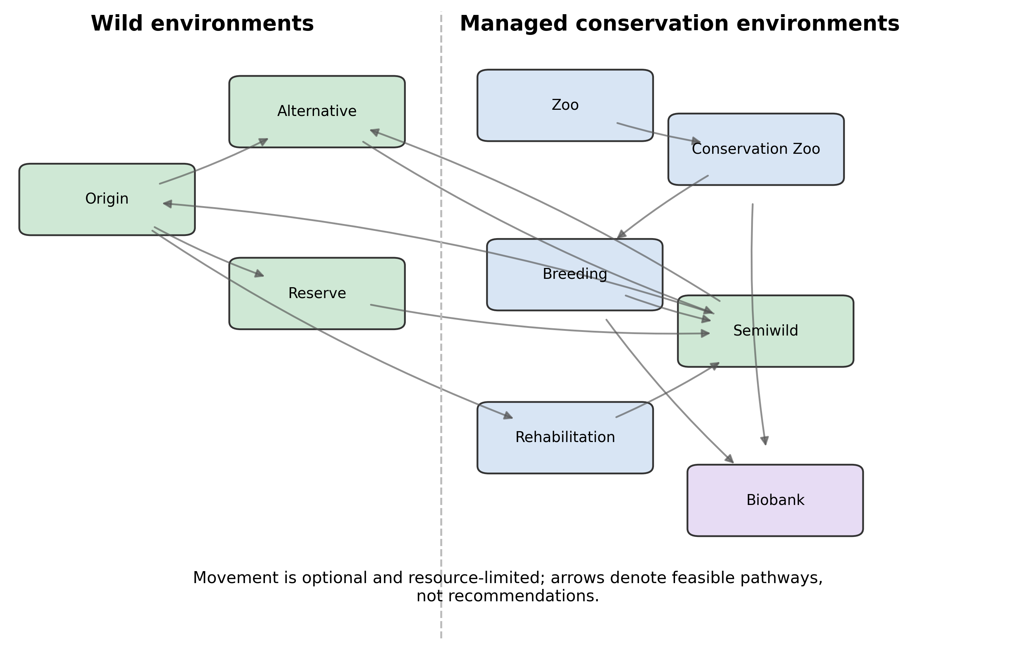
Figure 1. Conservation network represented in the simulation. Arrows denote potential movement among wild, managed, transitional, rehabilitation, and biobank nodes; feasible policies act on observed rather than true state.

Observation and policy decisions
Feasible policies received noisy, delayed observations rather than true habitat quality or latent-species state. The model distinguished the true number of species into observed and latent components. Survey spending altered discovery progression; protection could begin only after sufficient recognition. An oracle analysis exposed true current abundance and habitat quality to the same S7 action class. It did not expose future environmental draws, solve a partially observable Markov decision process (POMDP), or select actions using realized future utility. The contrast was motivated by value-of-information reasoning, which asks whether reducing uncertainty would change a management decision (Canessa et al. 2015), but it is not a value-of-information calculation.
Eight policies ranged from no intervention through fixed rules to dynamic allocation (Table 2). S0 applied no intervention. S1 phased down ex situ management, S2 emphasized lifetime captivity, S3 returned individuals to origin when feasible, S4 used state-dependent circulation, S5 used greedy expected utility without automatic origin privilege, S6 emphasized habitat, and S7 combined habitat, survey, selective circulation, breeding, genetics, biobanking, and engagement with a forward-quality proxy. Annual spending could not exceed available resources, reflecting the importance of management cost and probability of success in allocation among threatened species (Joseph et al. 2009).

Table 2. Policy definitions and budget shares.
policy | name | engine | habitat | survey | rescue | ex situ | genetics | biobank | engagement
S0 | No intervention | none | 0 | 0 | 0 | 0 | 0 | 0 | 0
S1 | Ex-situ phase-down | rule | 0.550 | 0.160 | 0.080 | 0 | 0.050 | 0.050 | 0.110
S2 | Lifetime captivity | rule | 0.080 | 0.050 | 0.220 | 0.420 | 0.100 | 0.050 | 0.080
S3 | Return to origin | rule | 0.280 | 0.100 | 0.200 | 0.180 | 0.080 | 0.050 | 0.110
S4 | State-dependent circulation | state-dependent rule | 0.220 | 0.120 | 0.200 | 0.180 | 0.100 | 0.070 | 0.110
S5 | Dynamic global allocation | greedy expected utility | 0.200 | 0.140 | 0.220 | 0.160 | 0.090 | 0.080 | 0.110
S6 | Habitat-first | rule | 0.680 | 0.140 | 0.030 | 0 | 0.030 | 0.020 | 0.100
S7 | Hybrid portfolio | forward-rollout proxy | 0.350 | 0.160 | 0.140 | 0.100 | 0.080 | 0.080 | 0.090

Outcomes and analysis
Outcomes were retained separately: survival and species retention, wild abundance, extinction before discovery, cumulative welfare-person-years, mean individual welfare, effective-founder and inbreeding proxies, disease, successful reintroduction, relocation burden, habitat integrity, future option value, engagement, expenditure, and cost per species retained. The prespecified information-value utility weighted year-100 survival (0.35), future option value (0.20), habitat integrity (0.15), avoidance of extinction before discovery (0.15), and mean individual welfare (0.15). This utility was used only for the oracle contrast and not to declare an overall policy winner. Policies were instead compared by Pareto nondominance, which displays trade-offs among conflicting objectives without weighting them into a single value (Kennedy et al. 2008).
The production analysis used 192 replications per policy with shared seed labels. Because policy actions change later random draws, these are paired seeds rather than mathematically exact common random streams. Intervals are percentiles of the simulation replicate distribution, not empirical confidence intervals. Sensitivity analysis used a Latin-hypercube design over 12 parameters. Five two-factor sweeps varied habitat deterioration by relocation stress, latent fraction by survey cost, climate velocity by assisted-colonization risk, captivity burden by breeding benefit, and engagement effect by habitat-protection efficiency. Nine feature ablations and six adverse-condition designs evaluated whether differences disappeared or reversed. The common replication count was fixed after a nested convergence audit through 384 paired replications, and seeds were recorded with each policy outcome. Stochastic replicates were averaged within each Latin-hypercube design before Spearman association (Table 3) and partial-rank interaction screening (Table 4). Cell-level two-factor sign stability was evaluated with nested replicate prefixes.
Table 3. Design-level Latin-hypercube sensitivity correlations.
policy | metric | parameter | spearman rho | n designs | replicates per design
S4 | survival_100 | habitat_deterioration | -0.676 | 128 | 4
S4 | survival_100 | climate_velocity | -0.134 | 128 | 4
S4 | survival_100 | relocation_mortality | -0.091 | 128 | 4
S4 | survival_100 | relocation_stress | -0.106 | 128 | 4
S4 | survival_100 | ex_situ_breeding_benefit | 0.155 | 128 | 4
S4 | survival_100 | release_survival_penalty | -0.034 | 128 | 4
S4 | survival_100 | movement_disease_risk | -0.046 | 128 | 4
S4 | survival_100 | captivity_welfare_penalty | -0.050 | 128 | 4
S4 | survival_100 | survey_cost | -0.094 | 128 | 4
S4 | survival_100 | engagement_coefficient | 0.157 | 128 | 4
S4 | survival_100 | initial_budget | 0.262 | 128 | 4
S4 | survival_100 | habitat_protection_efficiency | 0.414 | 128 | 4
S4 | fraction_ebd | habitat_deterioration | 0.310 | 128 | 4
S4 | fraction_ebd | climate_velocity | 0.173 | 128 | 4
S4 | fraction_ebd | relocation_mortality | -0.216 | 128 | 4
S4 | fraction_ebd | relocation_stress | 0.054 | 128 | 4
S4 | fraction_ebd | ex_situ_breeding_benefit | -0.000 | 128 | 4
S4 | fraction_ebd | release_survival_penalty | -0.050 | 128 | 4
S4 | fraction_ebd | movement_disease_risk | 0.096 | 128 | 4
S4 | fraction_ebd | captivity_welfare_penalty | -0.053 | 128 | 4
S4 | fraction_ebd | survey_cost | 0.609 | 128 | 4
S4 | fraction_ebd | engagement_coefficient | -0.024 | 128 | 4
S4 | fraction_ebd | initial_budget | -0.296 | 128 | 4
S4 | fraction_ebd | habitat_protection_efficiency | -0.145 | 128 | 4
S4 | mean_individual_welfare | habitat_deterioration | -0.551 | 128 | 4
S4 | mean_individual_welfare | climate_velocity | -0.078 | 128 | 4
S4 | mean_individual_welfare | relocation_mortality | -0.016 | 128 | 4
S4 | mean_individual_welfare | relocation_stress | 0.039 | 128 | 4
S4 | mean_individual_welfare | ex_situ_breeding_benefit | 0.038 | 128 | 4
S4 | mean_individual_welfare | release_survival_penalty | -0.092 | 128 | 4
S4 | mean_individual_welfare | movement_disease_risk | -0.058 | 128 | 4
S4 | mean_individual_welfare | captivity_welfare_penalty | -0.449 | 128 | 4
S4 | mean_individual_welfare | survey_cost | 0.036 | 128 | 4
S4 | mean_individual_welfare | engagement_coefficient | 0.120 | 128 | 4
S4 | mean_individual_welfare | initial_budget | 0.015 | 128 | 4
S4 | mean_individual_welfare | habitat_protection_efficiency | 0.244 | 128 | 4
S4 | future_option_value | habitat_deterioration | -0.721 | 128 | 4
S4 | future_option_value | climate_velocity | -0.084 | 128 | 4
S4 | future_option_value | relocation_mortality | -0.070 | 128 | 4
S4 | future_option_value | relocation_stress | -0.086 | 128 | 4
S4 | future_option_value | ex_situ_breeding_benefit | 0.168 | 128 | 4
S4 | future_option_value | release_survival_penalty | -0.025 | 128 | 4
S4 | future_option_value | movement_disease_risk | -0.048 | 128 | 4
S4 | future_option_value | captivity_welfare_penalty | -0.045 | 128 | 4
S4 | future_option_value | survey_cost | -0.083 | 128 | 4
S4 | future_option_value | engagement_coefficient | 0.175 | 128 | 4
S4 | future_option_value | initial_budget | 0.241 | 128 | 4
S4 | future_option_value | habitat_protection_efficiency | 0.426 | 128 | 4
S6 | survival_100 | habitat_deterioration | -0.486 | 128 | 4
S6 | survival_100 | climate_velocity | -0.372 | 128 | 4
S6 | survival_100 | relocation_mortality | 0.053 | 128 | 4
S6 | survival_100 | relocation_stress | -0.028 | 128 | 4
S6 | survival_100 | ex_situ_breeding_benefit | 0.028 | 128 | 4
S6 | survival_100 | release_survival_penalty | 0.020 | 128 | 4
S6 | survival_100 | movement_disease_risk | -0.073 | 128 | 4
S6 | survival_100 | captivity_welfare_penalty | -0.083 | 128 | 4
S6 | survival_100 | survey_cost | -0.099 | 128 | 4
S6 | survival_100 | engagement_coefficient | 0.047 | 128 | 4
S6 | survival_100 | initial_budget | -0.124 | 128 | 4
S6 | survival_100 | habitat_protection_efficiency | 0.712 | 128 | 4
S6 | fraction_ebd | habitat_deterioration | 0.357 | 128 | 4
S6 | fraction_ebd | climate_velocity | 0.110 | 128 | 4
S6 | fraction_ebd | relocation_mortality | -0.174 | 128 | 4
S6 | fraction_ebd | relocation_stress | 0.088 | 128 | 4
S6 | fraction_ebd | ex_situ_breeding_benefit | 0.016 | 128 | 4
S6 | fraction_ebd | release_survival_penalty | 0.005 | 128 | 4
S6 | fraction_ebd | movement_disease_risk | 0.138 | 128 | 4
S6 | fraction_ebd | captivity_welfare_penalty | 0.029 | 128 | 4
S6 | fraction_ebd | survey_cost | 0.550 | 128 | 4
S6 | fraction_ebd | engagement_coefficient | -0.035 | 128 | 4
S6 | fraction_ebd | initial_budget | -0.115 | 128 | 4
S6 | fraction_ebd | habitat_protection_efficiency | -0.569 | 128 | 4
S6 | mean_individual_welfare | habitat_deterioration | -0.535 | 128 | 4
S6 | mean_individual_welfare | climate_velocity | -0.369 | 128 | 4
S6 | mean_individual_welfare | relocation_mortality | 0.005 | 128 | 4
S6 | mean_individual_welfare | relocation_stress | -0.047 | 128 | 4
S6 | mean_individual_welfare | ex_situ_breeding_benefit | 0.061 | 128 | 4
S6 | mean_individual_welfare | release_survival_penalty | 0.028 | 128 | 4
S6 | mean_individual_welfare | movement_disease_risk | -0.060 | 128 | 4
S6 | mean_individual_welfare | captivity_welfare_penalty | -0.037 | 128 | 4
S6 | mean_individual_welfare | survey_cost | -0.051 | 128 | 4
S6 | mean_individual_welfare | engagement_coefficient | 0.068 | 128 | 4
S6 | mean_individual_welfare | initial_budget | -0.115 | 128 | 4
S6 | mean_individual_welfare | habitat_protection_efficiency | 0.753 | 128 | 4
S6 | future_option_value | habitat_deterioration | -0.536 | 128 | 4
S6 | future_option_value | climate_velocity | -0.316 | 128 | 4
S6 | future_option_value | relocation_mortality | 0.016 | 128 | 4
S6 | future_option_value | relocation_stress | -0.021 | 128 | 4
S6 | future_option_value | ex_situ_breeding_benefit | 0.072 | 128 | 4
S6 | future_option_value | release_survival_penalty | 0.011 | 128 | 4
S6 | future_option_value | movement_disease_risk | -0.080 | 128 | 4
S6 | future_option_value | captivity_welfare_penalty | -0.054 | 128 | 4
S6 | future_option_value | survey_cost | -0.072 | 128 | 4
S6 | future_option_value | engagement_coefficient | 0.045 | 128 | 4
S6 | future_option_value | initial_budget | -0.115 | 128 | 4
S6 | future_option_value | habitat_protection_efficiency | 0.756 | 128 | 4
S7 | survival_100 | habitat_deterioration | -0.672 | 128 | 4
S7 | survival_100 | climate_velocity | -0.095 | 128 | 4
S7 | survival_100 | relocation_mortality | -0.036 | 128 | 4
S7 | survival_100 | relocation_stress | -0.127 | 128 | 4
S7 | survival_100 | ex_situ_breeding_benefit | 0.122 | 128 | 4
S7 | survival_100 | release_survival_penalty | 0.027 | 128 | 4
S7 | survival_100 | movement_disease_risk | -0.097 | 128 | 4
S7 | survival_100 | captivity_welfare_penalty | -0.034 | 128 | 4
S7 | survival_100 | survey_cost | -0.149 | 128 | 4
S7 | survival_100 | engagement_coefficient | 0.156 | 128 | 4
S7 | survival_100 | initial_budget | 0.158 | 128 | 4
S7 | survival_100 | habitat_protection_efficiency | 0.594 | 128 | 4
S7 | fraction_ebd | habitat_deterioration | 0.384 | 128 | 4
S7 | fraction_ebd | climate_velocity | 0.138 | 128 | 4
S7 | fraction_ebd | relocation_mortality | -0.167 | 128 | 4
S7 | fraction_ebd | relocation_stress | 0.051 | 128 | 4
S7 | fraction_ebd | ex_situ_breeding_benefit | -0.038 | 128 | 4
S7 | fraction_ebd | release_survival_penalty | -0.010 | 128 | 4
S7 | fraction_ebd | movement_disease_risk | 0.170 | 128 | 4
S7 | fraction_ebd | captivity_welfare_penalty | -0.031 | 128 | 4
S7 | fraction_ebd | survey_cost | 0.645 | 128 | 4
S7 | fraction_ebd | engagement_coefficient | -0.015 | 128 | 4
S7 | fraction_ebd | initial_budget | -0.242 | 128 | 4
S7 | fraction_ebd | habitat_protection_efficiency | -0.226 | 128 | 4
S7 | mean_individual_welfare | habitat_deterioration | -0.658 | 128 | 4
S7 | mean_individual_welfare | climate_velocity | -0.263 | 128 | 4
S7 | mean_individual_welfare | relocation_mortality | -0.036 | 128 | 4
S7 | mean_individual_welfare | relocation_stress | 0.047 | 128 | 4
S7 | mean_individual_welfare | ex_situ_breeding_benefit | 0.061 | 128 | 4
S7 | mean_individual_welfare | release_survival_penalty | -0.000 | 128 | 4
S7 | mean_individual_welfare | movement_disease_risk | 0.003 | 128 | 4
S7 | mean_individual_welfare | captivity_welfare_penalty | -0.202 | 128 | 4
S7 | mean_individual_welfare | survey_cost | -0.057 | 128 | 4
S7 | mean_individual_welfare | engagement_coefficient | 0.115 | 128 | 4
S7 | mean_individual_welfare | initial_budget | -0.012 | 128 | 4
S7 | mean_individual_welfare | habitat_protection_efficiency | 0.425 | 128 | 4
S7 | future_option_value | habitat_deterioration | -0.702 | 128 | 4
S7 | future_option_value | climate_velocity | -0.090 | 128 | 4
S7 | future_option_value | relocation_mortality | -0.024 | 128 | 4
S7 | future_option_value | relocation_stress | -0.105 | 128 | 4
S7 | future_option_value | ex_situ_breeding_benefit | 0.122 | 128 | 4
S7 | future_option_value | release_survival_penalty | 0.025 | 128 | 4
S7 | future_option_value | movement_disease_risk | -0.097 | 128 | 4
S7 | future_option_value | captivity_welfare_penalty | -0.031 | 128 | 4
S7 | future_option_value | survey_cost | -0.127 | 128 | 4
S7 | future_option_value | engagement_coefficient | 0.181 | 128 | 4
S7 | future_option_value | initial_budget | 0.147 | 128 | 4
S7 | future_option_value | habitat_protection_efficiency | 0.592 | 128 | 4

Table 4. Strongest pairwise partial-rank interaction screens.
policy | metric | parameter 1 | parameter 2 | partial rank interaction | n designs
S4 | fraction_ebd | habitat_deterioration | survey_cost | 0.228 | 128
S4 | fraction_ebd | climate_velocity | initial_budget | 0.209 | 128
S4 | fraction_ebd | relocation_mortality | engagement_coefficient | -0.203 | 128
S4 | future_option_value | habitat_deterioration | habitat_protection_efficiency | -0.227 | 128
S4 | future_option_value | relocation_mortality | engagement_coefficient | 0.206 | 128
S4 | future_option_value | release_survival_penalty | habitat_protection_efficiency | 0.204 | 128
S4 | mean_individual_welfare | ex_situ_breeding_benefit | habitat_protection_efficiency | -0.309 | 128
S4 | mean_individual_welfare | release_survival_penalty | engagement_coefficient | -0.277 | 128
S4 | mean_individual_welfare | engagement_coefficient | initial_budget | -0.226 | 128
S4 | survival_100 | relocation_mortality | engagement_coefficient | 0.242 | 128
S4 | survival_100 | habitat_deterioration | habitat_protection_efficiency | -0.226 | 128
S4 | survival_100 | release_survival_penalty | habitat_protection_efficiency | 0.188 | 128
S6 | fraction_ebd | climate_velocity | initial_budget | 0.250 | 128
S6 | fraction_ebd | relocation_mortality | captivity_welfare_penalty | -0.235 | 128
S6 | fraction_ebd | relocation_mortality | engagement_coefficient | -0.205 | 128
S6 | future_option_value | relocation_mortality | relocation_stress | 0.187 | 128
S6 | future_option_value | survey_cost | habitat_protection_efficiency | -0.182 | 128
S6 | future_option_value | relocation_mortality | captivity_welfare_penalty | 0.169 | 128
S6 | mean_individual_welfare | relocation_mortality | relocation_stress | 0.203 | 128
S6 | mean_individual_welfare | climate_velocity | relocation_stress | -0.169 | 128
S6 | mean_individual_welfare | relocation_mortality | initial_budget | 0.167 | 128
S6 | survival_100 | relocation_mortality | engagement_coefficient | 0.196 | 128
S6 | survival_100 | release_survival_penalty | engagement_coefficient | -0.183 | 128
S6 | survival_100 | survey_cost | habitat_protection_efficiency | -0.181 | 128
S7 | fraction_ebd | climate_velocity | initial_budget | 0.259 | 128
S7 | fraction_ebd | habitat_deterioration | survey_cost | 0.241 | 128
S7 | fraction_ebd | relocation_mortality | engagement_coefficient | -0.183 | 128
S7 | future_option_value | survey_cost | habitat_protection_efficiency | -0.243 | 128
S7 | future_option_value | relocation_mortality | engagement_coefficient | 0.211 | 128
S7 | future_option_value | release_survival_penalty | engagement_coefficient | -0.182 | 128
S7 | mean_individual_welfare | release_survival_penalty | engagement_coefficient | -0.270 | 128
S7 | mean_individual_welfare | habitat_deterioration | initial_budget | 0.254 | 128
S7 | mean_individual_welfare | ex_situ_breeding_benefit | habitat_protection_efficiency | -0.210 | 128
S7 | survival_100 | survey_cost | habitat_protection_efficiency | -0.254 | 128
S7 | survival_100 | relocation_mortality | engagement_coefficient | 0.232 | 128
S7 | survival_100 | release_survival_penalty | engagement_coefficient | -0.181 | 128

The empirical component was deliberately separate from the synthetic model. Persisted Global Biodiversity Information Facility (GBIF) API responses supplied taxonomy matches and occurrence-year coverage aggregates for three conservation taxa (Table 5); they did not calibrate abundance, occupancy, demographic rates, or intervention effects. Persisted Bibliographic, repository, and publisher snapshots supported an evidence-level audit (Table 6). Complete text was inspected for the four case and decision-theory articles. Other background citations were verified against exact-DOI Crossref metadata, and statements attributed to them were restricted to their retained author abstracts or article titles. Five formerly selected sources without verified text were excluded from the citation set. The literature did not calibrate the model.

Table 5. GBIF observation-coverage aggregates from persisted API responses.
species | scientific name | gbif taxon key | gbif query total | records 2000 2025 | records 2015 2025 | years with records | first record year | last record year
Przewalski's horse | Equus ferus przewalskii Poliakov, 1881 | 5787170 | 785 | 700 | 663 | 23 | 2002 | 2026
Scimitar-horned oryx | Oryx dammah (Cretzschmar, 1827) | 5220165 | 227 | 133 | 125 | 25 | 1899 | 2026
California condor | Gymnogyps californianus (Shaw, 1797) | 2481920 | 33646 | 31951 | 25910 | 116 | 1805 | 2026

Table 6. Bibliographic metadata and evidence-support levels for human appraisal.
species | rank | title | doi | year | journal | publisher | crossref citations | verification status | selection note | full text access | support level | required action
California condor | 1 | Junk ingestion and nestling mortality in a reintroduced population of California Condors Gymnogyps californianus | 10.1017/s095927090700069x | 2007 | Bird Conservation International | Cambridge University Press (CUP) | 54 | Crossref metadata and complete article text verified | Four primary sources were retained after complete-text appraisal for bounded claims about reintroduction monitoring, spatial planning, post-release hazards, and ecological decision making under partial observability. Selection is not a systematic review. | FULL_TEXT_LOCAL | DIRECT | Keep the claim population- and period-specific.
California condor | 2 | Activity-specific ecological niche models for planning reintroductions of California condors ( Gymnogyps californianus ) | 10.1016/j.biocon.2015.01.002 | 2015 | Biological Conservation | Elsevier BV | 51 | Crossref metadata and complete article text verified | Four primary sources were retained after complete-text appraisal for bounded claims about reintroduction monitoring, spatial planning, post-release hazards, and ecological decision making under partial observability. Selection is not a systematic review. | FULL_TEXT_LOCAL | DIRECT | Do not treat modeled suitability as site validation.
Przewalski's horse | 1 | Przewalski’s Horse (Equus ferus przewalskii) Re-introduction in the Great Gobi B Strictly Protected Area: from Species to Ecosystem Conservation | 10.22353/mjbs.2007.05.03 | 2007 | Mongolian Journal of Biological Sciences | National University of Mongolia | 4 | Crossref metadata and complete article text verified | Four primary sources were retained after complete-text appraisal for bounded claims about reintroduction monitoring, spatial planning, post-release hazards, and ecological decision making under partial observability. Selection is not a systematic review. | FULL_TEXT_LOCAL | DIRECT | Keep the claim bounded to this documented project.
cross-cutting decision theory | 1 | Partial observability and management of ecological systems | 10.1002/ece3.9197 | 2022 | Ecology and Evolution | Wiley | 12 | Crossref metadata and complete article text verified | Four primary sources were retained after complete-text appraisal for bounded claims about reintroduction monitoring, spatial planning, post-release hazards, and ecological decision making under partial observability. Selection is not a systematic review. | FULL_TEXT_LOCAL | DIRECT | Do not imply that the present heuristic simulation solves a POMDP.

Results

Base-case policy outcomes
No single policy dominated every outcome (Table 7). S6 had the largest mean year-100 survival, 0.529 [0.000, 0.875], and retained 4.229 [0.000, 7.000] species. S7 had survival 0.473 [0.125, 0.750] and retained 3.786 [1.000, 6.000] species. S4 had survival 0.378 [0.125, 0.625]. S0 reached zero mean year-100 survival in the directional-change base scenario, but that outcome is a property of the configured experiment rather than an empirical estimate. Multiobjective Pareto status is shown in Figure 2.

Table 7. Policy outcome estimates and replicate-distribution intervals.
policy | cost | founder effective | fraction ebd | future option value | mean individual welfare | species retained 100 | survival 100
S0 | 0.000 [0.000, 0.000] | 0.000 [0.000, 0.000] | 0.993 [1.000, 1.000] | 0.015 [0.005, 0.025] | 0.352 [0.188, 0.449] | 0.000 [0.000, 0.000] | 0.000 [0.000, 0.000]
S1 | 11179.239 [11068.854, 11247.349] | 2.478 [0.000, 5.419] | 0.168 [0.000, 0.667] | 0.255 [0.067, 0.440] | 0.682 [0.287, 0.759] | 2.453 [0.000, 5.000] | 0.307 [0.000, 0.625]
S2 | 11296.244 [11182.195, 11428.453] | 2.345 [0.000, 3.954] | 0.684 [0.333, 1.000] | 0.117 [0.026, 0.181] | 0.477 [0.369, 0.514] | 1.099 [0.000, 2.000] | 0.137 [0.000, 0.250]
S3 | 11189.871 [11076.015, 11317.220] | 3.650 [2.487, 4.893] | 0.396 [0.000, 1.000] | 0.246 [0.153, 0.290] | 0.591 [0.519, 0.629] | 2.625 [1.000, 3.000] | 0.328 [0.125, 0.375]
S4 | 11176.496 [11071.974, 11272.194] | 3.330 [2.211, 4.731] | 0.354 [0.000, 1.000] | 0.264 [0.136, 0.378] | 0.609 [0.560, 0.658] | 3.026 [1.000, 5.000] | 0.378 [0.125, 0.625]
S5 | 11184.786 [11076.556, 11262.858] | 3.268 [1.955, 4.992] | 0.311 [0.000, 1.000] | 0.253 [0.128, 0.343] | 0.614 [0.562, 0.662] | 2.828 [1.000, 4.000] | 0.354 [0.125, 0.500]
S6 | 11192.089 [11086.434, 11257.357] | 3.902 [0.000, 6.314] | 0.174 [0.000, 0.667] | 0.371 [0.070, 0.552] | 0.732 [0.335, 0.780] | 4.229 [0.000, 7.000] | 0.529 [0.000, 0.875]
S7 | 11162.327 [11048.148, 11247.362] | 3.297 [1.610, 4.637] | 0.227 [0.000, 0.667] | 0.331 [0.130, 0.473] | 0.617 [0.441, 0.742] | 3.786 [1.000, 6.000] | 0.473 [0.125, 0.750]

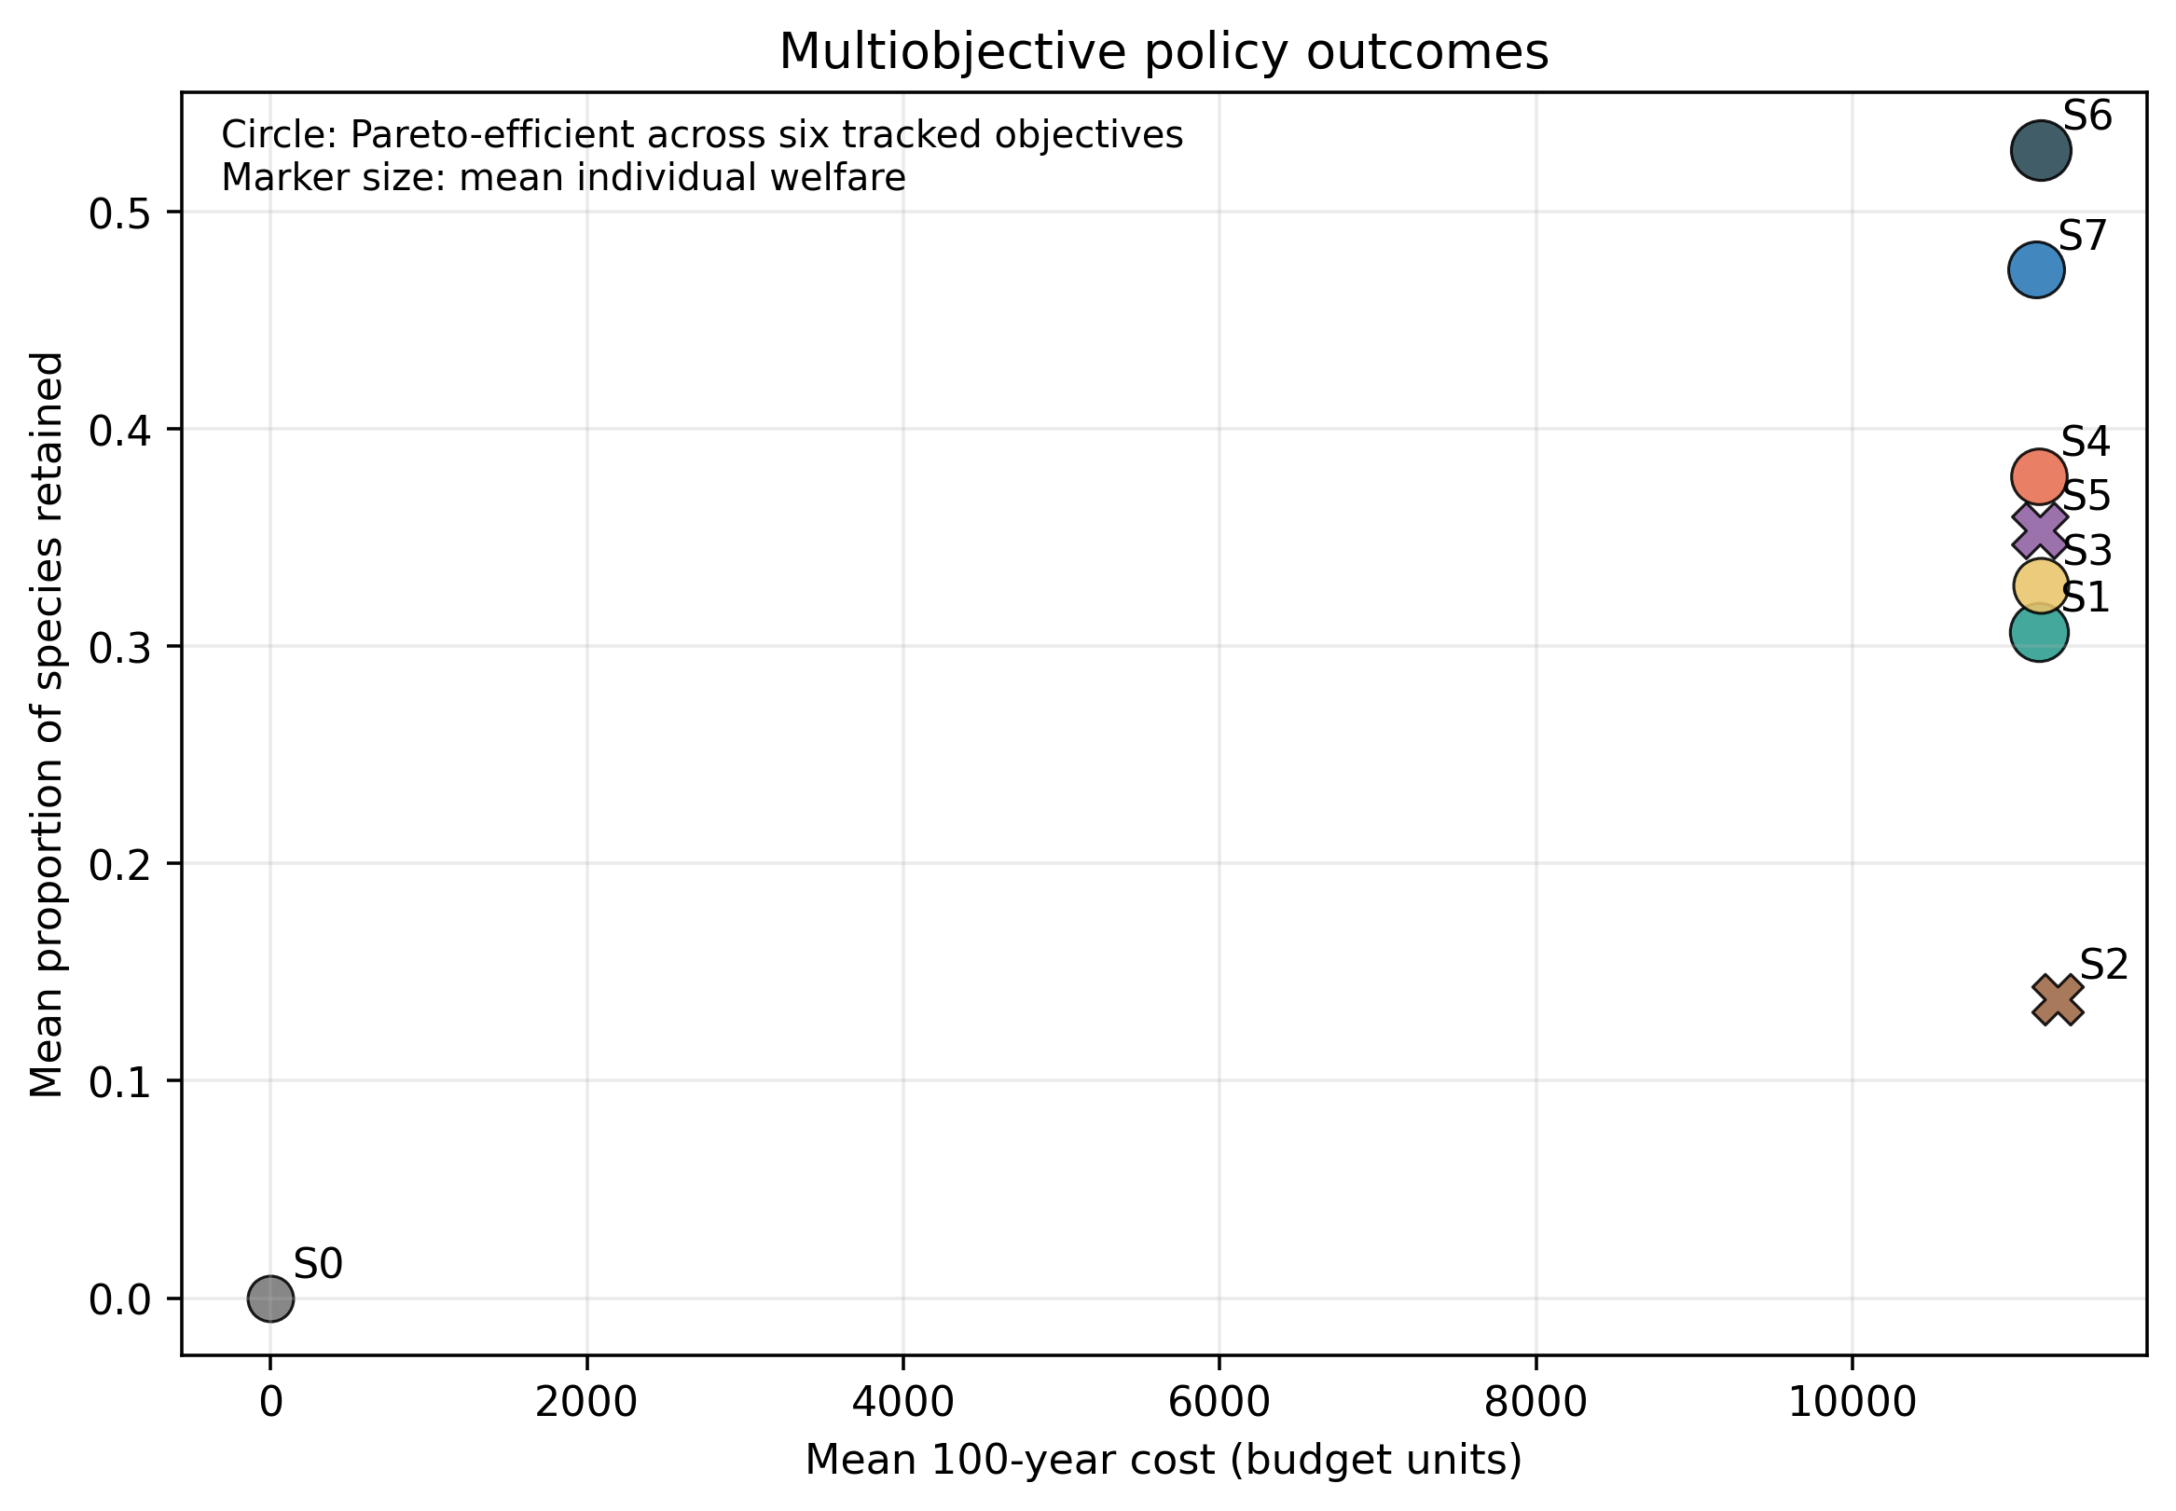
Figure 2. Multiobjective policy comparison and Pareto status under the declared aggregate objectives.
Temporal trajectories showed divergence among policies as directional environmental change accumulated (Figure 3). Policies with habitat investment maintained higher average survival than no intervention in the base scenario, whereas fixed return to origin did not preserve species through year 100. Managed-care and dynamic policies differed in how persistence was distributed between wild and managed nodes.
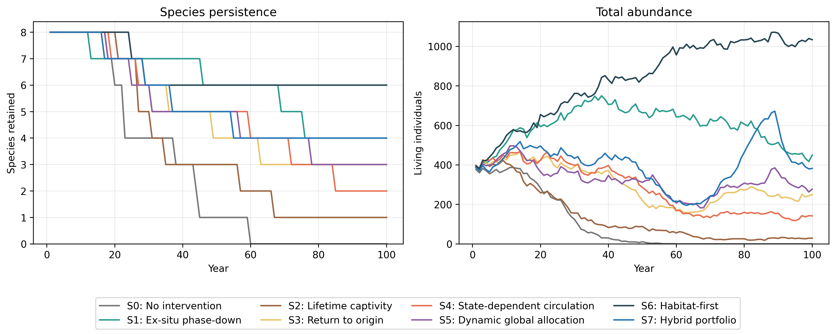
Figure 3. Mean 100-year trajectories under the eight conservation policies. Trajectories are synthetic model outcomes, not forecasts for real taxa.

Welfare, hidden biodiversity, and information
S7 mean individual welfare was 0.617 [0.441, 0.742]; the corresponding estimate for lifetime captivity S2 was 0.477 [0.369, 0.514]. S7's extinction-before-discovery fraction was 0.227 [0.000, 0.667], compared with 0.311 [0.000, 1.000] for S5 and 0.174 [0.000, 0.667] for S6; extinction before discovery across latent-fraction and survey-cost conditions is shown in Figure 4. These outcomes remained distinct because high persistence in managed care did not necessarily imply restoration of free-living populations, high individual welfare, or low extinction before discovery (Figure 5). Normalized cross-objective values are descriptive and do not imply cardinal comparability among objectives.
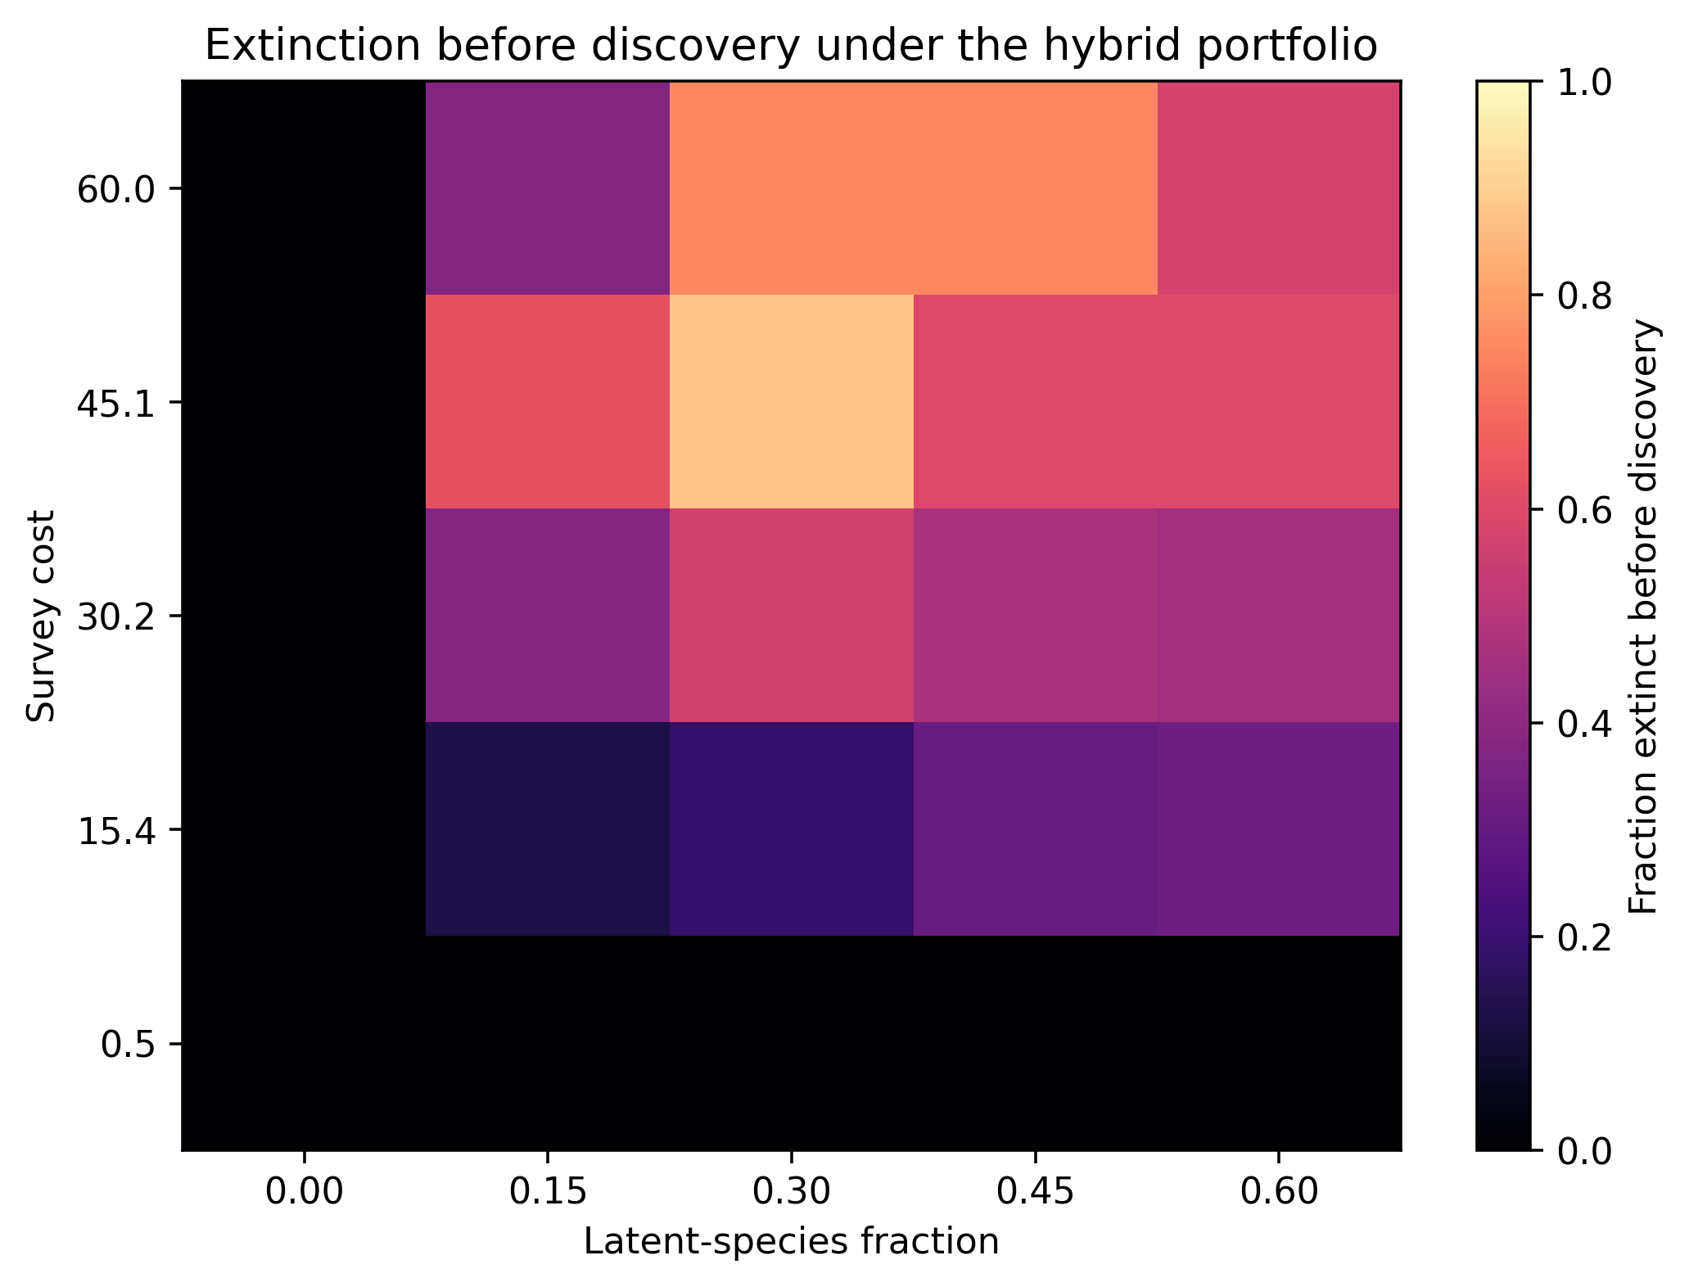
Figure 4. Extinction-before-discovery outcomes across latent-species fraction and survey-cost conditions.
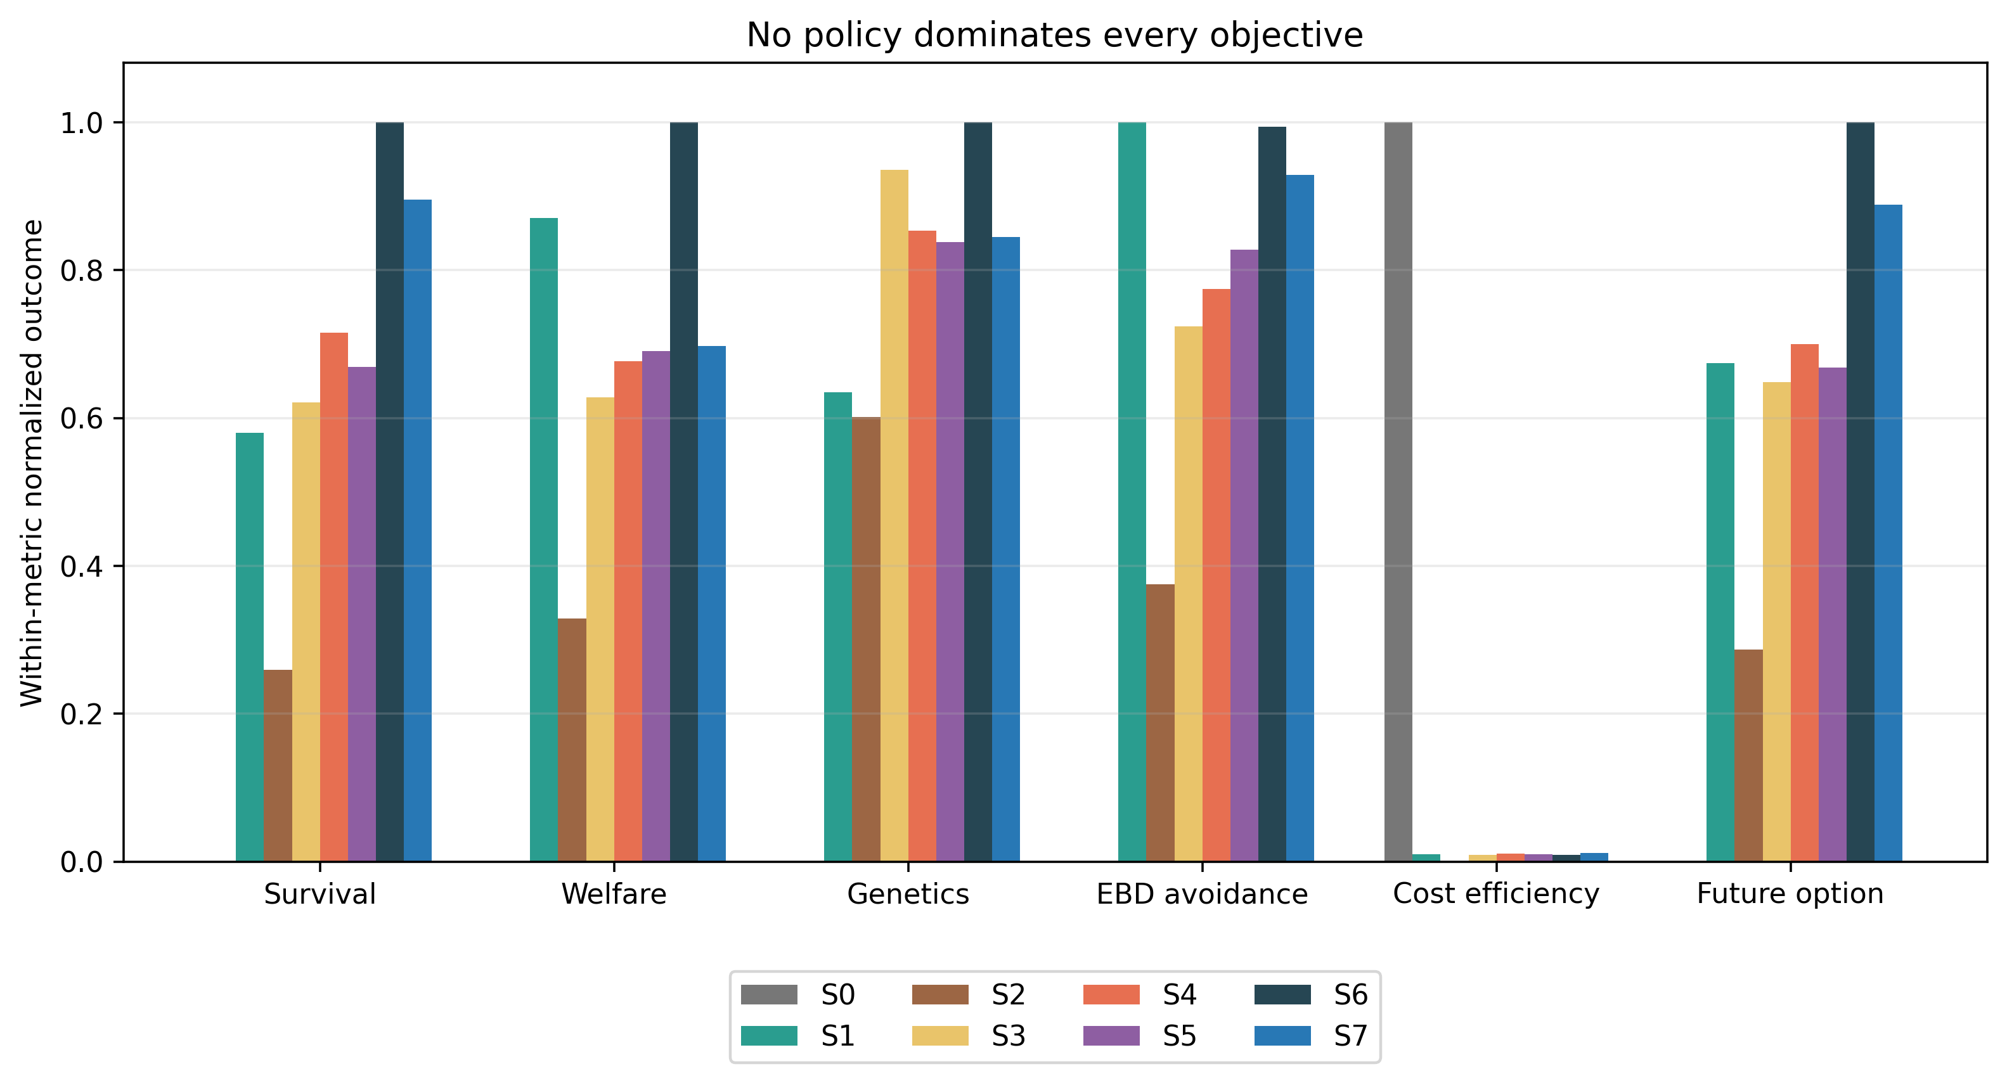
Figure 5. Normalized cross-objective outcomes. Normalization is descriptive and does not define cardinal utility.
Supplying true current state to the same S7 action class changed the prespecified decision utility by -0.003 [-0.112, 0.131] on average. The paired effect could be positive or negative because the decision rule was not reoptimized and no hindsight action selection was applied. This estimate is conditional on the policy class and normative utility weights; it is not theoretical EVPI or an intrinsic monetary or ecological value of biodiversity information. The separation of true state, observations, actions, and outcomes is shown in Figure 6.
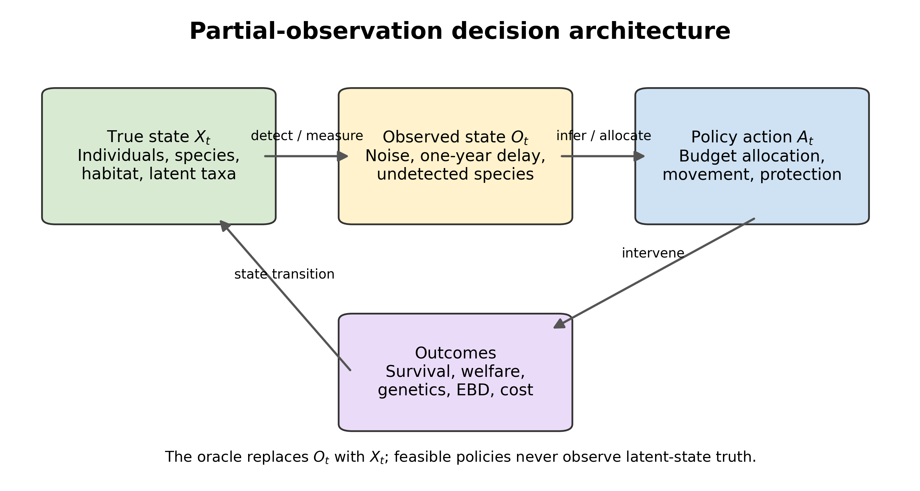
Figure 6. Partial-observation architecture separating true ecological state, observations, policy actions, and realized outcomes.

Reversal and robustness conditions
Across the prespecified two-factor cells, robust survival contrasts favored S7 in 35 cells and S6 in 26; 64 cells were indeterminate under the registered sign-stability and Monte Carlo error criterion. Selected reversal surfaces are shown in Figure 7. Habitat deterioration, relocation stress, survey cost, assisted-colonization risk, captivity burden, breeding benefit, engagement, and protection efficiency jointly changed the direction or magnitude of policy contrasts. Survey-cost exploration–exploitation patterns are shown in Figure 8.
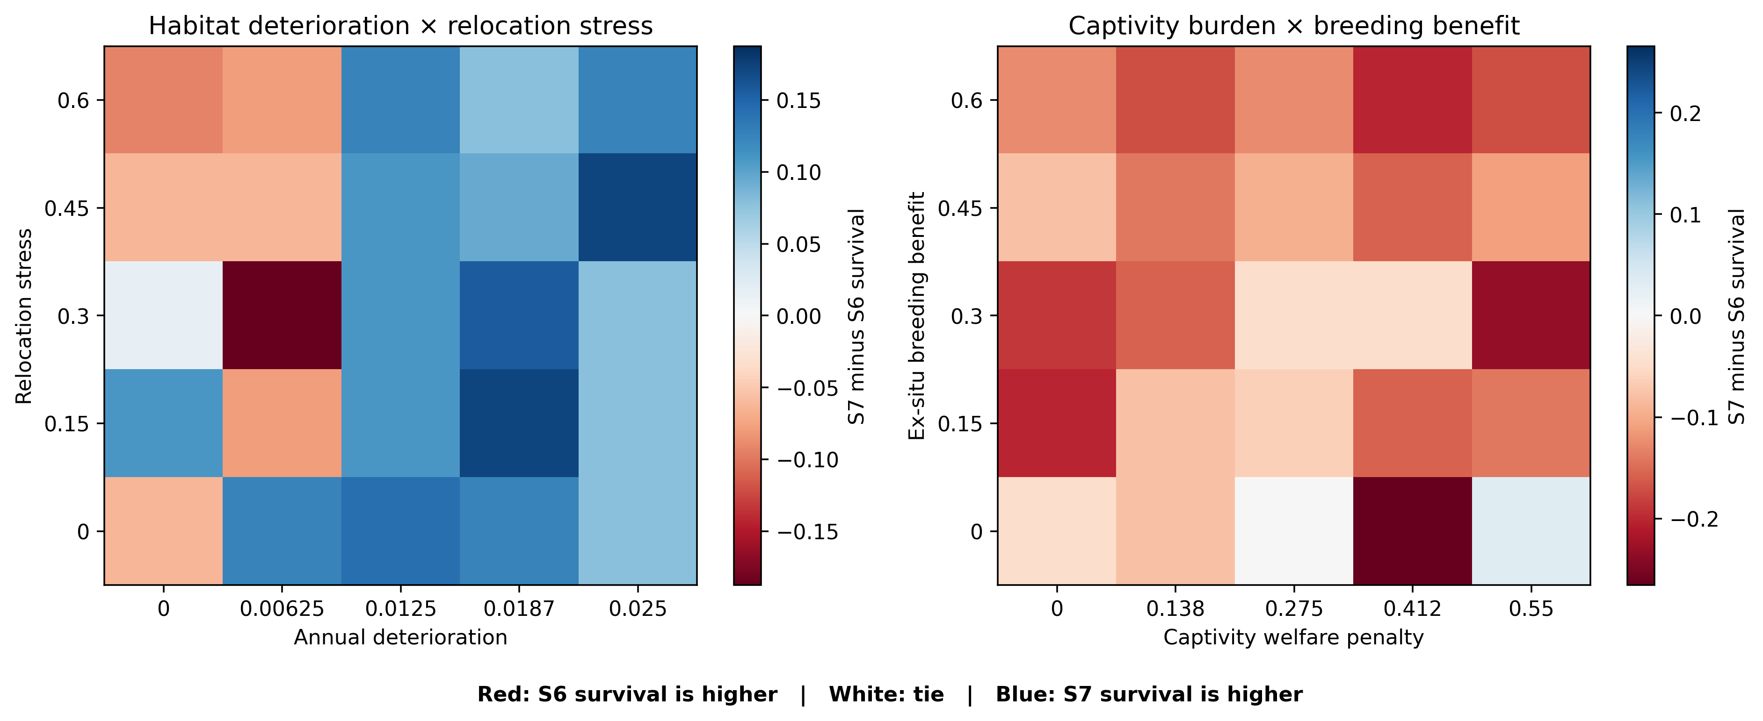
Figure 7. Policy-reversal surfaces for selected two-factor sweeps. Color represents the difference in 100-year survival between the hybrid portfolio (S7) and habitat-first policy (S6).
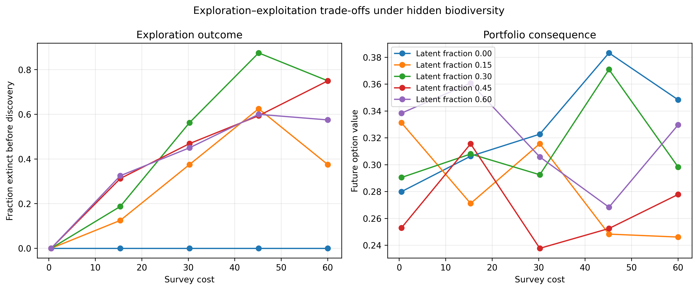
Figure 8. Exploration–exploitation patterns across survey-cost conditions.
Adverse-condition designs clarified mechanisms. Stable excellent origin habitat and high relocation harm weakened unnecessary movement; severe captivity burden reduced welfare under managed care; zero breeding advantage removed a major pathway through which ex situ investment could aid persistence; and efficient restoration strengthened habitat-centered strategies. Removing latent species eliminated extinction-before-discovery by construction. Removing origin fidelity changed dynamic allocation without making any one dynamic policy uniformly preferable. Feature ablations removed human feedback, latent species, genetics, climate, biobanking, disease, welfare, partial observability, and origin fidelity (Table 8).
Table 8. Ablation and adverse-condition outcomes.
analysis | design | policy | survival 100 | fraction ebd | mean individual welfare
ablations | biobank | S4 | 0.302 | 0.444 | 0.597
ablations | biobank | S6 | 0.448 | 0.250 | 0.679
ablations | biobank | S7 | 0.406 | 0.278 | 0.589
ablations | climate | S4 | 0.396 | 0.417 | 0.636
ablations | climate | S6 | 0.615 | 0.306 | 0.762
ablations | climate | S7 | 0.542 | 0.278 | 0.660
ablations | disease | S4 | 0.417 | 0.361 | 0.599
ablations | disease | S6 | 0.333 | 0.194 | 0.698
ablations | disease | S7 | 0.521 | 0.250 | 0.539
ablations | genetics | S4 | 0.323 | 0.389 | 0.632
ablations | genetics | S6 | 0.490 | 0.194 | 0.754
ablations | genetics | S7 | 0.490 | 0.250 | 0.601
ablations | human_feedback | S4 | 0.260 | 0.528 | 0.586
ablations | human_feedback | S6 | 0.188 | 0.250 | 0.604
ablations | human_feedback | S7 | 0.344 | 0.306 | 0.613
ablations | latent_species | S4 | 0.354 | 0 | 0.612
ablations | latent_species | S6 | 0.573 | 0 | 0.727
ablations | latent_species | S7 | 0.427 | 0 | 0.636
ablations | origin_fidelity | S4 | 0.417 | 0.278 | 0.602
ablations | origin_fidelity | S6 | 0.521 | 0.139 | 0.722
ablations | origin_fidelity | S7 | 0.635 | 0.194 | 0.586
ablations | partial_observability | S4 | 0.417 | 0.333 | 0.570
ablations | partial_observability | S6 | 0.427 | 0.139 | 0.703
ablations | partial_observability | S7 | 0.469 | 0.222 | 0.593
ablations | welfare | S4 | 0.396 | 0.250 | 1
ablations | welfare | S6 | 0.479 | 0.167 | 0.954
ablations | welfare | S7 | 0.490 | 0.167 | 1
adverse_conditions | efficient_restoration | S4 | 0.781 | 0.194 | 0.731
adverse_conditions | efficient_restoration | S6 | 0.938 | 0.056 | 0.787
adverse_conditions | efficient_restoration | S7 | 0.823 | 0.056 | 0.769
adverse_conditions | excellent_origin | S4 | 0.740 | 0.222 | 0.684
adverse_conditions | excellent_origin | S6 | 0.896 | 0.028 | 0.785
adverse_conditions | excellent_origin | S7 | 0.760 | 0.194 | 0.760
adverse_conditions | high_captivity_penalty | S4 | 0.312 | 0.444 | 0.467
adverse_conditions | high_captivity_penalty | S6 | 0.490 | 0.111 | 0.710
adverse_conditions | high_captivity_penalty | S7 | 0.479 | 0.278 | 0.532
adverse_conditions | high_relocation_harm | S4 | 0.312 | 0.306 | 0.612
adverse_conditions | high_relocation_harm | S6 | 0.583 | 0.056 | 0.740
adverse_conditions | high_relocation_harm | S7 | 0.323 | 0.111 | 0.607
adverse_conditions | negative_engagement | S4 | 0.312 | 0.389 | 0.631
adverse_conditions | negative_engagement | S6 | 0.521 | 0.222 | 0.758
adverse_conditions | negative_engagement | S7 | 0.469 | 0.222 | 0.633
adverse_conditions | zero_breeding_advantage | S4 | 0.323 | 0.417 | 0.623
adverse_conditions | zero_breeding_advantage | S6 | 0.531 | 0.083 | 0.712
adverse_conditions | zero_breeding_advantage | S7 | 0.438 | 0.250 | 0.628

Empirical source audit
The persisted GBIF aggregate queries returned Przewalski's horse, 785 coordinate-bearing present records (663 dated 2015–2025); Scimitar-horned oryx, 227 coordinate-bearing present records (125 dated 2015–2025); California condor, 33,646 coordinate-bearing present records (25,910 dated 2015–2025). Differences can reflect observation effort, accessibility, digitization, taxonomy, and data publishing. They cannot be interpreted as relative abundance, occupancy, population trend, or conservation effectiveness. The four case and decision-theory publications were verified by DOI, title, year, journal, and authorship, and their complete methods, results, and discussion text was appraised for the bounded claims in the Introduction.

Discussion
The central result was conditionality rather than dominance. Habitat-first S6 had the highest mean survival in the base configuration, while S7 had higher mean welfare and future option value, but their survival ordering reversed repeatedly across prespecified conditions. Dynamic conservation networks therefore cannot be evaluated by movement or institutional connectivity alone. Their effect depends on whether changing habitat creates a real future-location benefit large enough to exceed relocation mortality, stress, pathogen transmission, maladaptation, captivity burden, survey cost, and the opportunity cost of diverting resources from habitat. This conditionality is consistent with arguments that managed relocation involves interacting, value-laden considerations and decisions under imperfect information (Richardson et al. 2009) and that climate-driven translocation challenges the aim of recreating past ecological communities (Thomas 2011), which bears directly on origin fidelity. The deterministic origin-to-future habitat-quality shift under zero intervention and zero stochastic shock is shown in Figure 9.
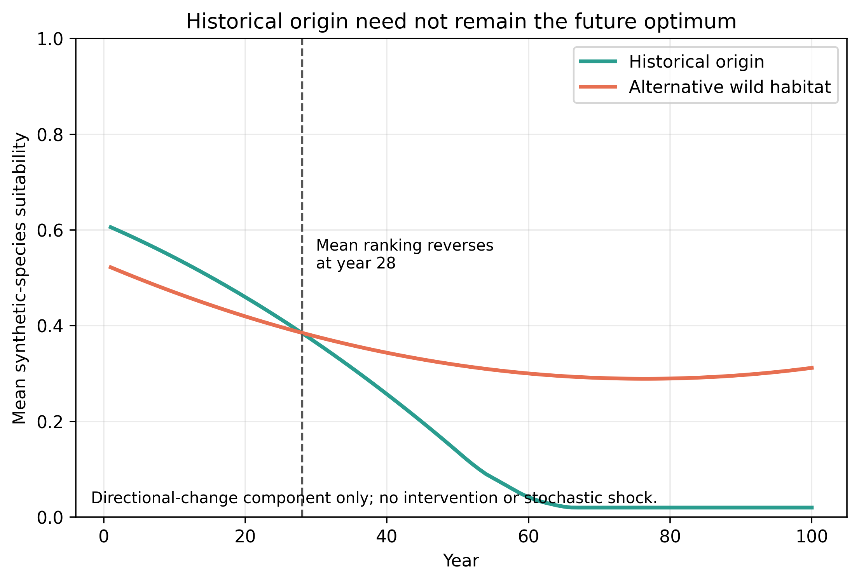
Figure 9. Origin-to-future habitat-quality shift under the deterministic component of directional environmental change.
The framework's scientific contribution is to place wild habitat, managed care, transitional facilities, rehabilitation, survey, and biobanking in one partially observed allocation problem while keeping welfare, genetics, disease, information, and cost as explicit outcomes. Latent taxa are modeled as real populations hidden from decisions rather than as missing labels, so discovery delay can interact with extinction. The survey–protection balance is a form of the trade-off between management performance and learning addressed by active adaptive management (McCarthy & Possingham 2007). The current-state-information comparator further shows that information effects arise only through a decision rule and objective function; its sign and magnitude under alternative utility weights (equal-component, persistence-, welfare-, future-option-, and extinction-before-discovery-priority weights) are reported in Table 9. These diagnostics change only the declared aggregation weights, not simulated actions or outcomes.

Table 9. Current-state-information effect under alternative normative weights.
scenario | survival 100 | future option value | habitat integrity | ebd avoidance | mean individual welfare | estimate | lower | upper | mc half width | n
registered | 0.350 | 0.200 | 0.150 | 0.150 | 0.150 | -0.003 | -0.112 | 0.131 | 0.009 | 192
equal_components | 0.200 | 0.200 | 0.200 | 0.200 | 0.200 | -0.002 | -0.110 | 0.125 | 0.008 | 192
persistence_priority | 0.600 | 0.100 | 0.100 | 0.100 | 0.100 | -0.006 | -0.162 | 0.169 | 0.013 | 192
welfare_priority | 0.100 | 0.100 | 0.100 | 0.100 | 0.600 | -0.000 | -0.063 | 0.076 | 0.006 | 192
future_option_priority | 0.100 | 0.600 | 0.100 | 0.100 | 0.100 | -0.001 | -0.095 | 0.117 | 0.008 | 192
ebd_priority | 0.100 | 0.100 | 0.100 | 0.600 | 0.100 | 0.001 | -0.221 | 0.223 | 0.016 | 192

This structure separates persistence from restoration. A captive population can preserve living individuals or founder representation without restoring a free-living population, whereas rapid release can increase wild abundance while imposing movement mortality or disease. Likewise, cumulative welfare-person-years rewards both survival duration and experienced conditions, while mean individual welfare isolates average conditions among living individuals. Reporting these outcomes separately prevents a single weighted score from concealing normative trade-offs.
The results do not establish that any real zoo, reserve, translocation program, breeding center, or biobank should expand or contract. Species are synthetic, demographic and genetic processes are simplified, policy shares are fixed, and the S7 forward-quality proxy is not a solved partially observable Markov decision process. Disease, catastrophes, social behavior, and biobank viability are stylized, although modeled integration of biobanked sperm into amphibian captive breeding reduced programme cost and made genetic-retention targets feasible (Howell et al. 2021). Replicate intervals characterize model variation, not sampling uncertainty in a real population. Paired seed labels also do not ensure identical random streams after policies change system state.
Applied use would require preregistered taxon-specific calibration, pedigree or genomic dynamics, epidemiological transmission models, facility and landscape constraints, stakeholder-derived multiattribute utilities, and full-text evidence synthesis. Observation systems should also be evaluated for bias: the GBIF audit demonstrates only data availability, and high record counts may primarily reflect survey and publishing effort.
Within those limits, the model supports a practical research principle. Conservation network design should be tested against explicit reversal conditions before base-case rankings are generalized. Movement is most defensible when future habitat gains and managed-care benefits exceed welfare, disease, and opportunity costs; habitat-centered strategies become more attractive when origin quality is stable, restoration is efficient, or movement is harmful, so evidence on the performance and potential of protected areas (Watson et al. 2014) bears directly on the habitat-first comparator. Survey and information investment matter most when they can alter a feasible action before hidden populations disappear.

Acknowledgments
[HUMAN AUTHORS: add only verified acknowledgments after obtaining any required permission. Keep identifying information out of the anonymous file.]

Data and code availability
Synthetic inputs, code, seed assignments, result tables, and figure scripts are organized in the reproducibility repository. Public-source API responses are retained as immutable timestamped snapshots with URLs, retrieval conditions, sizes, SHA-256 checksums, license notes, and completeness statements. Before submission, human authors must add a durable repository citation, version or DOI, license, and anonymous review link. The repository contains GBIF aggregate year-facet responses and bibliographic metadata, not individual occurrence records. Publisher full text retained for appraisal is not redistributed in the public or anonymous packages.

Artificial-intelligence use disclosure
Devin, an artificial-intelligence software engineering system developed by Cognition AI, was used to implement and test code, organize public-source metadata, execute analyses, generate code-derived displays, and prepare this human-review draft. The AI did not create or alter empirical source data and is not an author. Human authors must independently inspect and revise all prose, citations, analyses, assumptions, figures, and tables; determine the scientific interpretation; and accept responsibility for the submitted work. [HUMAN AUTHORS: verify the exact product/model description and final journal placement before submission.]

Literature cited
Complete article text was appraised for the four case and decision-theory entries; the remaining entries were verified against exact-DOI Crossref metadata and are cited only for statements supported by their author abstracts or titles. Final claim wording and citation approval remain the responsibility of the human authors.
Araki H, Cooper B, Blouin MS. 2007. Genetic Effects of Captive Breeding Cause a Rapid, Cumulative Fitness Decline in the Wild. Science 318:100-103. DOI: 10.1126/science.1145621.
Beausoleil NJ, Mellor DJ, Baker L, Baker SE, Bellio M, Clarke AS, Dale A, Garlick S, Jones B, Harvey A, Pitcher BJ, Sherwen S, Stockin KA, Zito S. 2018. “Feelings and Fitness” Not “Feelings or Fitness”–The Raison d'être of Conservation Welfare, Which Aligns Conservation and Animal Welfare Objectives. Frontiers in Veterinary Science 5:296. DOI: 10.3389/fvets.2018.00296.
Boehm MMA, Cronk QCB. 2021. Dark extinction: the problem of unknown historical extinctions. Biology Letters 17:20210007. DOI: 10.1098/rsbl.2021.0007.
Bolton RL, Mooney A, Pettit MT, Bolton AE, Morgan L, Drake GJ, Appeltant R, Walker SL, Gillis JD, Hvilsom C. 2022. Resurrecting biodiversity: advanced assisted reproductive technologies and biobanking. Reproduction and Fertility 3:R121-R146. DOI: 10.1530/RAF-22-0005.
Canessa S, Guillera-Arroita G, Lahoz-Monfort JJ, Southwell DM, Armstrong DP, Chadès I, Lacy RC, Converse SJ. 2015. When do we need more data? A primer on calculating the value of information for applied ecologists. Methods in Ecology and Evolution 6:1219-1228. DOI: 10.1111/2041-210X.12423.
Chadès I, McDonald-Madden E, McCarthy MA, Wintle B, Linkie M, Possingham HP. 2008. When to stop managing or surveying cryptic threatened species. Proceedings of the National Academy of Sciences 105:13936-13940. DOI: 10.1073/pnas.0805265105.
Chadès I, Pascal LV, Nicol S, Fletcher CS, Ferrer-Mestres J. 2021. A primer on partially observable Markov decision processes (POMDPs). Methods in Ecology and Evolution 12:2058-2072. DOI: 10.1111/2041-210X.13692.
Conde DA, Colchero F, Gusset M, Pearce-Kelly P, Byers O, Flesness N, Browne RK, Jones OR. 2013. Zoos through the Lens of the IUCN Red List: A Global Metapopulation Approach to Support Conservation Breeding Programs. PLoS ONE 8:e80311. DOI: 10.1371/journal.pone.0080311.
Conde DA, Flesness N, Colchero F, Jones OR, Scheuerlein A. 2011. An Emerging Role of Zoos to Conserve Biodiversity. Science 331:1390-1391. DOI: 10.1126/science.1200674.
Costello MJ, May RM, Stork NE. 2013. Can We Name Earth's Species Before They Go Extinct?. Science 339:413-416. DOI: 10.1126/science.1230318.
Dickens MJ, Delehanty DJ, Romero LM. 2010. Stress: An inevitable component of animal translocation. Biological Conservation 143:1329-1341. DOI: 10.1016/j.biocon.2010.02.032.
D’Elia J, Haig SM, Johnson M, Marcot BG, Young R. 2015. Activity-specific ecological niche models for planning reintroductions of California condors ( Gymnogyps californianus ). Biological Conservation 184:90-99. DOI: 10.1016/j.biocon.2015.01.002.
Frankham R. 2008. Genetic adaptation to captivity in species conservation programs. Molecular Ecology 17:325-333. DOI: 10.1111/j.1365-294X.2007.03399.x.
Gilbert T, Gardner R, Kraaijeveld AR, Riordan P. 2017. Contributions of zoos and aquariums to reintroductions: historical reintroduction efforts in the context of changing conservation perspectives. International Zoo Yearbook 51:15-31. DOI: 10.1111/izy.12159.
Harrington LA, Moehrenschlager A, Gelling M, Atkinson RPD, Hughes J, Macdonald DW. 2013. Conflicting and Complementary Ethics of Animal Welfare Considerations in Reintroductions. Conservation Biology 27:486-500. DOI: 10.1111/cobi.12021.
Hoban S, Bruford M, D'Urban Jackson J, Lopes-Fernandes M, Heuertz M, Hohenlohe PA, Paz-Vinas I, Sjögren-Gulve P, Segelbacher G, Vernesi C, Aitken S, Bertola LD, Bloomer P, Breed M, Rodríguez-Correa H, Funk WC, Grueber CE, Hunter ME, Jaffe R, Liggins L, Mergeay J, Moharrek F, O'Brien D, Ogden R, Palma-Silva C, Pierson J, Ramakrishnan U, Simo-Droissart M, Tani N, Waits L, Laikre L. 2020. Genetic diversity targets and indicators in the CBD post-2020 Global Biodiversity Framework must be improved. Biological Conservation 248:108654. DOI: 10.1016/j.biocon.2020.108654.
Hoegh-Guldberg O, Hughes L, McIntyre S, Lindenmayer DB, Parmesan C, Possingham HP, Thomas CD. 2008. Assisted Colonization and Rapid Climate Change. Science 321:345-346. DOI: 10.1126/science.1157897.
Howell LG, Frankham R, Rodger JC, Witt RR, Clulow S, Upton RMO, Clulow J. 2021. Integrating biobanking minimises inbreeding and produces significant cost benefits for a threatened frog captive breeding programme. Conservation Letters 14:e12776. DOI: 10.1111/conl.12776.
Joseph LN, Maloney RF, Possingham HP. 2009. Optimal Allocation of Resources among Threatened Species: a Project Prioritization Protocol. Conservation Biology 23:328-338. DOI: 10.1111/j.1523-1739.2008.01124.x.
Jule KR, Leaver LA, Lea SEG. 2008. The effects of captive experience on reintroduction survival in carnivores: A review and analysis. Biological Conservation 141:355-363. DOI: 10.1016/j.biocon.2007.11.007.
Kaczensky P, Ganbaatar O, von Wehrden H, Enksaikhan N, Lkhagvasuren D, Walzer C. 2007. Przewalski’s Horse (Equus ferus przewalskii) Re-introduction in the Great Gobi B Strictly Protected Area: from Species to Ecosystem Conservation. Mongolian Journal of Biological Sciences 5:13-18. DOI: 10.22353/mjbs.2007.05.03.
Kennedy MC, Ford ED, Singleton P, Finney M, Agee JK. 2008. Informed multi-objective decision-making in environmental management using Pareto optimality. Journal of Applied Ecology 45:181-192. DOI: 10.1111/j.1365-2664.2007.01367.x.
Kock RA, Woodford MH, Rossiter PB. 2010. Disease risks associated with the translocation of wildlife. Revue Scientifique et Technique de l'OIE 29:329-350. DOI: 10.20506/rst.29.2.1980.
Liu J, Slik F, Zheng S, Lindenmayer DB. 2022. Undescribed species have higher extinction risk than known species. Conservation Letters 15:e12876. DOI: 10.1111/conl.12876.
McCarthy MA, Possingham HP. 2007. Active Adaptive Management for Conservation. Conservation Biology 21:956-963. DOI: 10.1111/j.1523-1739.2007.00677.x.
McLachlan JS, Hellmann JJ, Schwartz MW. 2007. A Framework for Debate of Assisted Migration in an Era of Climate Change. Conservation Biology 21:297-302. DOI: 10.1111/j.1523-1739.2007.00676.x.
Mee A, Rideout BA, Hamber JA, Todd JN, Austin G, Clark M, Wallace MP. 2007. Junk ingestion and nestling mortality in a reintroduced population of California Condors Gymnogyps californianus. Bird Conservation International 17:119-130. DOI: 10.1017/s095927090700069x.
Mellor DJ, Beausoleil NJ, Littlewood KE, McLean AN, McGreevy PD, Jones B, Wilkins C. 2020. The 2020 Five Domains Model: Including Human–Animal Interactions in Assessments of Animal Welfare. Animals 10:1870. DOI: 10.3390/ani10101870.
Mora C, Tittensor DP, Adl S, Simpson AGB, Worm B. 2011. How Many Species Are There on Earth and in the Ocean?. PLoS Biology 9:e1001127. DOI: 10.1371/journal.pbio.1001127.
Moss A, Jensen E, Gusset M. 2015. Evaluating the contribution of zoos and aquariums to Aichi Biodiversity Target 1. Conservation Biology 29:537-544. DOI: 10.1111/cobi.12383.
Pritchard DJ, Fa JE, Oldfield S, Harrop SR. 2012. Bring the captive closer to the wild: redefining the role of ex situ conservation. Oryx 46:18-23. DOI: 10.1017/S0030605310001766.
Redford KH, Jensen DB, Breheny JJ. 2012. Integrating the Captive and the Wild. Science 338:1157-1158. DOI: 10.1126/science.1228899.
Richardson DM, Hellmann JJ, McLachlan JS, Sax DF, Schwartz MW, Gonzalez P, Brennan EJ, Camacho A, Root TL, Sala OE, Schneider SH, Ashe DM, Clark JR, Early R, Etterson JR, Fielder ED, Gill JL, Minteer BA, Polasky S, Safford HD, Thompson AR, Vellend M. 2009. Multidimensional evaluation of managed relocation. Proceedings of the National Academy of Sciences 106:9721-9724. DOI: 10.1073/pnas.0902327106.
Seddon PJ, Griffiths CJ, Soorae PS, Armstrong DP. 2014. Reversing defaunation: Restoring species in a changing world. Science 345:406-412. DOI: 10.1126/science.1251818.
Snyder NFR, Derrickson SR, Beissinger SR, Wiley JW, Smith TB, Toone WD, Miller B. 1996. Limitations of Captive Breeding in Endangered Species Recovery. Conservation Biology 10:338-348. DOI: 10.1046/j.1523-1739.1996.10020338.x.
Tedesco PA, Bigorne R, Bogan AE, Giam X, Jézéquel C, Hugueny B. 2014. Estimating How Many Undescribed Species Have Gone Extinct. Conservation Biology 28:1360-1370. DOI: 10.1111/cobi.12285.
Thomas CD. 2011. Translocation of species, climate change, and the end of trying to recreate past ecological communities. Trends in Ecology & Evolution 26:216-221. DOI: 10.1016/j.tree.2011.02.006.
Watson JEM, Dudley N, Segan DB, Hockings M. 2014. The performance and potential of protected areas. Nature 515:67-73. DOI: 10.1038/nature13947.
Williams BK, Brown ED. 2022. Partial observability and management of ecological systems. Ecology and Evolution 12:e9197. DOI: 10.1002/ece3.9197.
Williams SE, Hoffman EA. 2009. Minimizing genetic adaptation in captive breeding programs: A review. Biological Conservation 142:2388-2400. DOI: 10.1016/j.biocon.2009.05.034.

