Beyond Aid Volume: Donor Heterogeneity, Aid Architecture, and Medium-Run Development Outcomes

Abstract
Aid-effectiveness research has focused largely on how much aid countries receive, yet recipients experience aid through a structured delivery architecture — its composition by aid type, delivery channel, financial instrument, and tying status. This paper constructs a harmonized, disbursement-weighted aid-architecture panel from the full OECD Creditor Reporting System (145,790 donor–recipient–year observations, 1995–2024), merged with UN World Population Prospects demography and World Development Indicators outcomes (141 countries, 4,169 recipient-years), and asks how architecture varies across donors and how exposure to different architectures is associated with medium-run outcomes at comparable total aid. Adding donor fixed effects to a recipient-and-year baseline raises explained variance by roughly 13–28 percentage points across major architecture shares, although for some dimensions recipient characteristics contribute comparably. Illustratively, at fixed ODA per capita, reallocating the aid-type portfolio toward technical cooperation is associated with lower subsequent GDP per capita and manufacturing share (a 10-point reallocation ≈ -0.020 log points); estimates are imprecise and selection remains plausible. Evaluating assistance by volume alone conceals systematic differences in how aid is delivered.
Keywords: foreign aid; aid architecture; donor heterogeneity; technical cooperation; aid effectiveness; development assistance

1. Introduction
Aid effectiveness has traditionally been evaluated in terms of amounts: how much aid a country receives, and whether that volume raises growth or development outcomes ^{1,2,3}. The resulting debate — over policy interactions, timing, and fragility of the aid–growth correlation ^{4,5,6,7,8,9} — has largely treated aid as a single quantity. Meta-analytic assessments reach similarly fragile conclusions: pooled across decades of specifications, the average aid–growth association is small and highly sensitive to model choice ^{10,8}, and even quasi-experimental designs exploiting concessional-lending thresholds find effects concentrated in particular subsamples rather than a general volume effect ¹¹.
Nominal volume, however, aggregates a heterogeneous delivery structure. Two recipients receiving identical aid totals in a given year may experience that aid through entirely different portfolios: one may receive mostly grants delivered through its own ministries, another mostly concessional loans implemented by donor executing agencies; one may procure goods and services domestically, another under tied procurement from the donor's suppliers; one may host a large technical-cooperation program while another relies on direct budget support. The bilateral total is silent on every one of these margins — on aid type, on delivery channel, on financial instrument, on tying status, and on the implementation arrangements that follow from them.
The problem is not hypothetical. Aggregate aid totals are the headline statistic of development cooperation — the number reported in donor communiqués, monitored against international targets, and fed into cross-country regressions — yet two identical totals can describe transfers with almost nothing in common operationally. A recipient whose aid arrives mostly as tied project contracts implemented by foreign firms experiences a different inflow than one receiving the same dollars as untied budget support credited to its treasury: the first may leave little fiscal trace beyond the projects themselves, while the second is a budgeted public resource. Comparing their outcomes per dollar of "aid" treats these as the same exposure.
These margins are not merely administrative detail; each is a plausible channel through which the same nominal transfer could be experienced differently. The literature has proposed several such pathways, which we flag as hypotheses rather than mechanisms this paper tests: aid delivered through recipient-government systems may build public-sector implementation capacity, while aid implemented by donors or contractors may substitute for it; budget support integrates with the recipient's fiscal planning and may improve predictability, whereas project aid arrives earmarked to specific activities; procurement structure determines how much of the nominal transfer is actually spent inside the recipient economy; the modality mix shapes the administrative burden placed on scarce civil-service capacity; and the timing at which benefits accrue differs across modalities. Whether and when any of these pathways operates is an empirical question this paper does not resolve — but each implies that the content of a constant-USD dollar of aid depends on the architecture through which it is delivered.
The analytical stakes are therefore twofold. If architecture matters, then the average association between volume and outcomes masks composition effects that could differ in sign and magnitude across margins — a plausible contributor to the fragility of the aggregate literature. If architecture does not matter, then documenting that fact cleanly still requires measuring it: the null question cannot be asked of data that aggregate the margins away. Either way, an empirical description of aid architecture — how much it varies, whose identity predicts it, how it covaries with later outcomes — is a precondition for evaluating aid on anything other than a volume basis.
Several literatures study these margins separately. The aggregate aid-effectiveness literature supplies the motivation but treats aid almost exclusively as a volume. Donor-allocation research shows that bilateral aid responds to donor motives — strategic, commercial, and historical — as much as to recipient need ^{12,13,14,15}, that transparency and governance shape allocations ¹⁶, and that donor heterogeneity extends beyond the traditional DAC membership ^{17,18}; this work establishes that donors are not interchangeable, though it explains where money goes more than how it is delivered. Fungibility studies show that the use to which aid is put depends on its form and on the recipient's budgetary response ^{19,20,21,22}, and sector-level analyses reach similar conclusions for earmarked flows ²³. Evaluations of tying and delivery practice document large, persistent cross-donor differences in procurement conditionality and channel use ^{24,25,26,27}. Macroeconomic side-condition literatures show that the instrument mix matters for tradable-sector outcomes through real-exchange-rate and absorption channels ^{28,29}. Aid volatility complicates planning on the recipient side ³⁰. Institutional and capacity-building analyses link aid structure to governance quality and state capacity ^{31,32,33,34}, and the conditionality literature examines how the terms attached to aid shape its political economy ³⁵. Bourguignon and Sundberg called for opening the "black box" between disbursement and outcome ³⁶.
What remains fragmented is integration. The gap is not a shortage of studies of aid heterogeneity — each margin above has its own literature — but the absence of an empirical framework that (a) measures the major architecture dimensions together on a common, comprehensive data foundation; (b) quantifies how much of the architecture a recipient faces is attributable to donor identity rather than recipient characteristics; (c) relates architecture to medium-run outcomes at comparable total aid volume; (d) preserves the compositional interpretation that share-based measures require; and (e) produces outputs that subsequent causal or scenario work can build on directly.
Positioning matters as much as novelty. This is primarily a measurement and decomposition paper with an associational panel analysis attached — not a causal evaluation of any modality, not a donor ranking, and not another generic aid–growth regression. The most policy-sensitive number we report, a technical-cooperation-share association, is deliberately framed as illustrative: its purpose is to demonstrate what the architecture variables can and cannot support inferentially, not to adjudicate whether technical cooperation helps or harms.
This paper's contribution is a harmonized measurement and decomposition exercise that supplies that framework, in four parts: (i) a disbursement-weighted aid-architecture stack built on the full OECD Creditor Reporting System (CRS) activity file — 145,790 donor–recipient–year observations over 1995–2024, the population of reported ODA activities rather than a sample; (ii) a donor-versus-recipient decomposition that quantifies, margin by margin, how much of the architecture a recipient faces is predictable from which donor supplies it versus which recipient absorbs it; (iii) a frozen set of lagged-outcome regressions linking composition to medium-run outcomes at comparable total aid, accompanied by a pre-registered falsification suite; and (iv) dashboard-ready scenario exports that let readers explore fixed-total-aid portfolio reallocations under the model's coefficients. Each element maps onto one of the gaps (a)–(e) above: the stack supplies the common data foundation, the decomposition the attribution, the frozen regressions the outcome link at fixed volume, the compositional definitions the interpretability, and the exports the reusability. All outcome associations are reported as adjusted associations, not causal effects. Section 2 describes the data, Section 3 the measurement approach, Section 4 the empirical design, Section 5 the results, and Section 6 their interpretation and limits.

2. Data
The analysis combines four public sources (full provenance, checksums and machine-readable manifests are maintained in the project repository):
- OECD Creditor Reporting System, full activity file (about 6.2 million
activity rows, 1973–2024); ODA rows, 1995–2024 used here. CRS amounts are reported in millions of constant USD (DAC deflator base).
- OECD DAC aggregate tables and official code lists.
- World Bank World Development Indicators (21 indicators).
- UN World Population Prospects 2024.
- World Bank procurement notices (partial, recent-biased; exploratory
linkage only) and the AidData 3.1 core release (robustness cross-check; coverage ends 2013).

2.1 Creditor Reporting System
The primary exposure source is the OECD Creditor Reporting System (CRS), the donor community's activity-level reporting standard. Each CRS record describes one aid activity — a commitment or disbursement by a reporting donor to a recipient, in a sector, through a channel, under a financial instrument and an aid-type modality, with tying status where reported — rather than an annual aggregate. We retain official development assistance (category 10) records for 1995–2024 and use gross disbursements converted to constant US dollars with the DAC deflator. Disbursements rather than commitments are used because they measure resources actually transferred; commitments are retained as a secondary field. Records are then aggregated to the donor–recipient–year level, yielding 145,790 dyad-years in the architecture panel. The activity-level design matters for the measurement concept: composition shares are computed from the same activity population for every dyad-year, so differences in shares reflect differences in the underlying portfolio of transfers rather than differences in reporting conventions at the aggregate level. Sector, channel, finance-type, aid-type, and tying codes are taken from the official OECD code lists; where a parent channel is reported it is used in preference to the sub-channel, and CRS records carry dedicated fields for the technical-cooperation value component of project aid and for tied, partially tied, and untied amounts. The 1995 start restricts the panel to the period of fuller CRS reporting coverage and more consistent code use; earlier records (the file begins in 1973) remain in the raw archive but are not used.

2.2 Outcomes and demographic covariates
Outcomes come from the World Bank World Development Indicators. The primary outcomes — log real GDP per capita, gross fixed capital formation relative to GDP, and manufacturing value added relative to GDP — are chosen to capture complementary development dimensions: the income level, investment effort, and structural change respectively. Two secondary outcomes, tax revenue relative to GDP and electricity access, capture fiscal capacity and basic-service reach. Macroeconomic covariates used in the widest adjustment set (foreign direct investment and exports relative to GDP) come from the same source.
Demographic adjustment uses the UN World Population Prospects 2024. Population totals supply denominators, but the adjustment set also exploits the WPP's internal structure: population growth, urbanization, the shares aged 0–14 and 65 and above, median age, and total fertility enter because demographic composition — not population size alone — is a plausible joint correlate of aid allocation and medium-run outcomes. Two countries with identical population growth can face very different dependency burdens, and the WPP separates these dimensions rather than reducing demography to a single trend.

2.3 Secondary sources with limited roles
AidData 3.1 extends coverage to non-DAC reporters, including major non-traditional donors, but ends in 2013 ³⁷; it is used only as a coverage cross-check on the CRS-based panel. World Bank procurement notices name the winning supplier's country for a partial, recent-biased subset of contracts; they support an exploratory linkage to local participation only. A supplier's country is not domestic value added, subcontracting is unobserved, and coverage is partial, so this layer is never used to claim local-retention effects.

2.4 Harmonization
Country identifiers are reconciled through the OECD recipient and donor code lists: CRS recipient codes map to ISO3 codes together with region, income-group, landlocked, SIDS, and fragile-state flags, and donor codes map to ISO3 where a country donor exists, with multilateral and institutional reporters retained as separate donor entities. Architecture shares are computed only where a dyad-year's disbursed total is positive, so missing amounts are distinguished from true zeros: a dyad-year absent from the CRS means no reported ODA flow, which is different from a flow whose composition fields are blank. Tying shares are defined only where tying amounts are reported; dyad-years with unreported tying are flagged rather than coded as untied — a distinction that matters because unreported tying is itself unevenly distributed across donors and years. Recipient-year aggregates pool all donor flows received in a year and therefore describe the architecture of the total portfolio the recipient faced, not the portfolio of any single donor.

3. Measuring aid architecture
Architecture is measured as disbursement-weighted shares of constant-USD ODA along four margins, each built from the corresponding CRS code list. Aid type (the CRS aid-type modality) separates technical cooperation, budget support, project-type interventions, pooled and earmarked contributions, NGO core support, scholarships and student costs, debt relief, and administrative plus in-donor refugee and awareness costs. Delivery channel separates recipient government, donor government, third-country government, NGOs, multilateral bodies, public-private partnerships and networks, private-sector entities, and universities; where a parent channel is reported it takes precedence over the executing sub-channel, so shares describe the channel structure the donor selected rather than the last implementing agent in the chain. Financial instrument separates grants, concessional loans, equity, debt relief, guarantees, and residual instruments. Tying status separates untied, partially tied, and tied amounts where donors report them. Variables follow a frozen level ontology — raw disbursement amount, architecture shares, downstream outcomes — so no derived quantity ever feeds back into a lower level, and supplier country is never treated as domestic value added.
A fifth margin, purpose sector, is tracked in the stack for completeness — education, health, water and sanitation, governance and other social, infrastructure, energy, finance and business, productive, environment, multisector, program support, debt, humanitarian, and administrative/refugee/other groups — but is not carried into the frozen outcome regressions, whose estimands use aid type, channel, finance, and tying. Sector shares enter the dashboard and stack exports but are not analyzed further here, to keep the inferential layer focused.
Shares, not activity counts or levels, are the unit of measurement because the object of interest is the composition of the portfolio a recipient faces. A dyad-year in which 60% of disbursed aid runs through recipient-government systems is architecturally different from one at 20%, independently of whether the totals differ. Weighting by disbursement ensures shares reflect resource composition rather than the number of activities — a single large loan counts by its value, not as one line item equal to a small grant.
We deliberately do not collapse the four margins into a composite "architecture quality" index. Any scalar index would require weights that are not identifiable from the data — nothing determines whether a point of government-channel share should count more or less than a point of untied share — would destroy the interpretability of the component dimensions, whose coefficients carry direct compositional meanings, and would manufacture an ordinal ranking of donors or recipients that the measurement does not support. The temptation is understandable — a single number is easier to report and to rank on — but the cost is deciding in advance, without evidence, that margins trade off at fixed rates. Retaining separate dimensions preserves exactly what can be defended: each share is measured identically for every dyad-year, and each coefficient reads as a reallocation contrast within its own margin.
One definitional caveat matters for interpretation. The CRS aid-type variable distinguishes technical cooperation (type D) as a modality; a substantial share of technical-cooperation activity is delivered inside project-type interventions. The TC share used here (disbursement-weighted mean 1.8%) is therefore a narrow modality measure — the standalone TC modality — not total technical-cooperation intensity; the TC value component embedded in projects is measured separately through the CRS TC-amount field and shows no consistent association pattern. A reader comparing our headline TC share with the higher TC intensities sometimes quoted in the literature should keep this distinction in view: the modality share understates total TC activity wherever TC is delivered inside projects, and the two measures answer different questions — one about delivery modality, the other about resource content.
All share variables are compositional: within each margin they sum to one, so increasing one share mechanically implies decreasing another. Coefficients are therefore contrasts against the omitted share (aid type: debt relief plus residual "other"; channel: "other"; finance: residual category), and the omitted composition matters for interpretation. Concretely, a coefficient β on the technical-cooperation share means that moving 10 percentage points of the aid-type portfolio into technical cooperation — and therefore 10 points out of the omitted composition — is associated with a β/10 change in the outcome-window mean at fixed total aid per capita. It is not a statement about raising the TC share while holding every other share fixed, which the summation constraint makes impossible.
Tying merits separate caution. Tied and untied amounts are self-reported, and coverage is incomplete and uneven across donors and over time; early CRS years in particular carry sparse tying fields. We therefore compute tying shares only on the reported subset, flag unreported dyad-years rather than coding them as untied, and treat all tying-related quantities as descriptive context rather than inferential inputs.

4. Empirical design

4.1 Specification and fixed effects
The primary specification regresses the mean of outcome Y over lag window w (1–2, 3–5, 6–10, or 11–15 years after exposure year t) on the year-t architecture shares, log ODA per capita at t, a pre-registered adjustment set, and country and year fixed effects, with country-clustered standard errors.
Country fixed effects absorb all time-invariant recipient characteristics — geography, institutional history, persistent level of development — so coefficients are identified from within-country changes in architecture exposure rather than from cross-sectional comparisons between chronically different recipients. Year fixed effects absorb global shocks and common trends in aid practice and outcomes — the post-2001 scaling-up of aid, the 2008–09 financial crisis, the COVID-19 period — that would otherwise load onto any architecture–outcome association. Standard errors are clustered by recipient because both exposures and outcomes are serially correlated within countries: donors maintain multi-year engagement strategies, so a recipient's portfolio in year t strongly predicts its portfolio in year t+1, and unclustered errors would overstate precision.
The outcome regressions run at the recipient-year level — the level at which development outcomes are defined — using the architecture of the total aid portfolio the recipient faced that year, pooled across donors. The dyadic donor–recipient–year panel is reserved for the decomposition exercise (Section 4.4), where donor identity is the object of interest. Keeping the two units separate avoids attributing a single donor's architecture to an outcome that responds, if anything, to the combined portfolio.

4.2 Window means and multiple windows
Outcomes are averaged across each window rather than taken at a single lag for two reasons: annual outcomes are noisy, so averaging reduces the sensitivity of each coefficient to which particular post-exposure year is examined; and the conceptual question concerns medium-run consequences of exposure, not event-study dynamics. Multiple windows are retained because candidate pathways operate on different clocks: a delivery-structure margin could plausibly appear within one to two years if it works through implementation mechanics, a capacity or procurement channel would operate over the medium run, and structural outcomes such as manufacturing share adjust on still slower horizons. Reporting all four windows descriptively avoids selecting the lag that produces a preferred sign, and we impose and claim no monotonic temporal mechanism.

4.3 Demographic and macroeconomic adjustment
The frozen adjustment sets are deliberately modest. The primary set (adjustment B) adds to log ODA per capita and the fixed effects the WPP controls population growth and urbanization plus the age-structure variables — shares aged 0–14 and 65 and above, median age, and total fertility. Demographic structure is a plausible joint correlate of aid allocation — donors target need — and of medium-run outcomes — dependency burdens shape savings, labor supply, and fiscal capacity — so conditioning on it removes one obvious compositional channel. A narrower set A drops the age-structure variables; a wider set C adds FDI and export shares relative to GDP. Adjustment improves comparability across recipient-years; it does not create causal identification, and nothing in the design can exclude time-varying confounders we do not observe.

4.4 Donor-versus-recipient decomposition
The decomposition asks how much of the variation in each architecture share is accounted for by donor identity versus recipient identity. Each disbursement-weighted share is regressed on donor, recipient, and year indicators by weighted least squares, with dyad disbursements as weights, and R² is compared across specifications. The incremental donor R² — the increase in explained variance when donor indicators are added to a recipient-and-year baseline — measures how much donors contribute to the architecture recipients face over and above what recipient identity and year already explain; the incremental recipient R² is defined symmetrically. These are decomposition statistics, not causal attributions: they quantify how predictable architecture is from each identity margin, not which side chooses it.

4.5 Falsification suite
Three pre-registered falsification exercises bound what the main associations could reflect. A lead placebo replaces exposure-year architecture with architecture measured three years after the outcome window begins; a nonzero association there would flag reverse timing or persistent unobserved heterogeneity. A pseudo-outcome substitutes urban-population share — a variable aid architecture should not plausibly shift on these horizons — for the development outcomes. A within-year permutation shuffles aid-type share vectors across recipients within each year (200 draws, fixed seed) and locates the observed TC coefficient in the resulting distribution; this tests whether the estimation machinery produces the sign and magnitude mechanically, but it cannot rule out confounding by indication — donors may select real, systematically different recipients into TC-heavy portfolios, which permutation preserves by construction. The suite is deliberately asymmetric: each test can only reject a specific mechanical account — reverse timing, a generic regressor artifact, a parameterization quirk — and no combination of them delivers causal identification, so a failure to reject is the informative outcome and we report it as such.

4.6 Identification limits
The design's limits are as important as its mechanics. Country and year fixed effects remove time-invariant heterogeneity and common shocks, and the adjustment sets remove observed compositional correlates, but no element of the design addresses time-varying, unobserved selection: if donors shift portfolios toward technical cooperation in response to a recipient's deteriorating capacity — a change invisible to our covariates — the resulting association is a selection correlation, not an effect of architecture. The falsification suite narrows the space of mechanical explanations without identifying a causal one. We therefore treat the outcome layer as a disciplined description of conditional covariation, useful for bounding what architecture correlates with and for targeting future designs, rather than as an evaluation of what architecture does.
Estimands, windows, and adjustment sets were frozen before inference; the claim ceiling is adjusted association throughout. Primary outcomes: log real GDP per capita, gross fixed capital formation per GDP, and manufacturing value added per GDP; secondary outcomes: tax revenue per GDP and electricity access.

5. Results

5.1 Sample and architecture exposure
Table 1 summarizes the sample: 4,169 recipient-years across 141 countries (1995–2024). Mean ODA disbursements equal 6.8% of recipient GDP (median 2.6%); median ODA is about $53 per capita. The mean–median gap in the GDP-share distribution reflects a well-known skew: a minority of recipients — small economies and post-crisis states — receive aid flows that are very large relative to GDP, while the median recipient receives a few percent. Beneath these recipient-year statistics sit 145,790 donor–recipient–year rows: the typical recipient deals with many donors simultaneously, so the architecture of a recipient-year is a weighted blend of several distinct donor delivery models rather than a single bilateral style.
Figure 1 shows the evolution of disbursement-weighted aid-type and channel shares across the panel. Project-type interventions dominate the aid-type composition throughout the period (disbursement-weighted mean 41%), with pooled and earmarked contributions a substantial second category (22%); budget support (7%) and standalone technical cooperation (2%) each remain single-digit shares of disbursements by value. On the channel margin, multilateral implementation carries the largest average share (28%), ahead of recipient-government systems (19%), but the split between government, NGO, multilateral, and other implementation differs widely across dyads and years — precisely the variation the decomposition and the outcome regressions exploit. The ODA/GDP histogram is shown in Figure A1 (Appendix).

5.2 Donor heterogeneity and the decomposition of architecture
Figure 2 — the paper's central exhibit — shows architecture profiles of the top-20 donors by ODA volume. The differences are stark and systematic: some donors route the bulk of their portfolio through recipient-government systems while others work predominantly through multilateral or non-government channels; standalone technical-cooperation shares range from near zero to a substantial fraction of the portfolio; and reported untied shares differ sharply (descriptive variation only; no quality ranking is implied). These are not noise around a common architecture — they are persistent, donor-characteristic delivery models.
Table 2 decomposes the variance of each architecture share to quantify this pattern. Adding donor fixed effects to a recipient-and-year baseline raises R² from 0.401 to 0.624 for the recipient-government channel share (incremental R² = 0.223); donor increments are 0.249 for technical cooperation and 0.268 for budget support. Donor identity thus contributes substantially to explained architecture variation: knowing which donor is on the other side of the dyad predicts a large fraction of the channel and modality mix a recipient sees.
The decomposition is not one-sided, however. For the project-type share the recipient dimension contributes comparably (incremental recipient R² = 0.225 vs donor 0.131): which recipient a donor serves independently predicts the modality mix, consistent with recipients differing in implementation capacity, in the projects they can host, and in the terms they negotiate. The full donor- and recipient-side decomposition for every margin is reported in full (Table A1, Appendix). Architecture is therefore jointly produced — supplied in systematically different forms by different donors, and filtered by recipient context — rather than dictated by either side.
One null result inside the decomposition deserves note: the TC value component embedded within project aid (share_tc_usd_irtc) is barely predictable from either identity margin (full R² = 0.004). Whether that reflects genuinely idiosyncratic allocation or simply thin, uneven reporting of the field, it cautions against reading structure into the embedded-TC layer that the modality-level TC share does exhibit.

5.3 Architecture and medium-run outcomes
Table 3 reports the technical-cooperation-share coefficients across lag windows for the primary outcomes; the full 320-coefficient grid over all architecture margins, outcomes, windows, and adjustment sets is reported in Table A2 (Appendix). We focus on the TC share because it is the sharpest architectural contrast the data offer: a modality whose stated purpose is capacity transfer, measured separately from the capacity-relevant question of who implements the underlying projects.
At the 3–5-year window, β = -0.203 (SE 0.177) for log GDP per capita and β = -4.345 pp (SE 2.840) for manufacturing share. Compositionally, a 10-percentage-point reallocation toward technical cooperation (from the omitted composition, at fixed total aid) corresponds to about 0.020 log points lower mean GDP per capita and 0.43 pp lower manufacturing share over the window. These estimates are imprecise: conventional intervals include zero at most windows, so the coefficients are best read as negative point associations of uncertain magnitude rather than as established negative relationships. The compositional reading also matters: the coefficient contrasts TC-heavy portfolios against the omitted aid-type composition, not against project aid specifically.
The other margins carry their own patterns. At the same 3–5-year window, the recipient-government channel share is positively associated with subsequent GDP per capita (β = 0.253, SE 0.071) — the grid's only positive association reaching conventional significance at this window — while the administrative/refugee/awareness aid-type share is strongly negative (β = -2.585, SE 0.557), a category that bundles in-donor administrative and refugee costs and plausibly marks diverted-to-domestic rather than transferred resources. The embedded-TC value share shows no consistent association (β = -0.103, SE 0.160 at this window), consistent with the decomposition's near-unpredictable pattern for that field. These coefficients share the compositional interpretation and the same selection caveats; we flag the channel association as the most informative single-margin contrast in the grid and return to it in the Discussion.

5.4 Lag structure and sensitivity
Figure 3 shows TC-share coefficients by window in chronological order for the primary outcomes (secondary outcomes — tax/GDP and electricity access — are shown in Figure A2 (Appendix). Two descriptive features stand out. First, the negative point estimates for GDP per capita do not attenuate monotonically with horizon: the 6–10-year point estimate is the most negative, and we do not read a clean temporal mechanism into the pattern — imprecision is too large to distinguish attenuation from amplification. Second, the sample thins at longer windows — fewer exposure years have 11–15 years of observable outcomes — so intervals widen correspondingly and the far-horizon estimates are the least precise.
Across adjustment sets A–C the TC coefficient on GDP per capita moves from -0.134 to -0.369 — directionally stable and larger in magnitude under the aggressive macroeconomic controls — while the manufacturing coefficient stays in a narrow negative range (-5.379 to -3.861). We describe this as directional stability, not robustness: the intervals remain broad in every adjustment set, and stability of the point-estimate sign is consistent both with a weak underlying association and with a stable selection pattern. The full adjustment-set sensitivity grid is in the sensitivity grid is reported in Table A3 (Appendix).

5.5 Falsification
Table 4 summarizes the pre-registered suite. A lead placebo (architecture measured three years after the outcome window) yields β = -0.230 (p = 0.166), compatible with zero — future architecture does not "explain" past outcomes, so the primary specification is not simply detecting persistent country heterogeneity through reverse timing. A pseudo-outcome (urban-population share) likewise shows no significant aid-type term, consistent with the estimates reflecting development-related covariation rather than a mechanical feature of the share regressors. A within-year permutation of aid-type share vectors (200 draws, fixed seed) places the observed TC coefficient (-0.203) beyond |β| of all but 2% of randomized allocations (permutation mean -0.0026, sd 0.083). This last statistic is an extremeness share, not a conventional p-value: it shows the observed coefficient is unusually negative relative to what the same machinery produces on randomly reassigned — but real — architecture portfolios. Crucially it does not rule out confounding by indication, because the permutation preserves the mapping from architecture to whatever recipient characteristics originally attracted it. The complete falsification results are reported in Table A4 (Appendix).

5.6 Procurement linkage (exploratory)
In the partial, recent-biased World Bank contract-award sample — only 32 recipient-years are mergeable to the architecture panel — the share of contract value awarded to in-country bidders correlates weakly and negatively with the recipient-government channel share (r ≈ -0.161), and weakly positively with the TC share. Neither pattern supports a simple local-participation reading, and the caveats are first-order: supplier country is not domestic value added, subcontracting is unobserved, and coverage is partial and skewed to recent years. This layer is presented strictly as a measurement extension motivating better local-participation reporting, not as evidence on local retention.

6. Discussion

6.1 Aid architecture as a hidden dimension of aid exposure
At equal nominal ODA per capita, recipients face materially different portfolios — different aid types, channels, instruments, and tying arrangements. Volume-only evaluation aggregates this structure away and implicitly assumes that a dollar of aid is a dollar of aid: that the treatment delivered by a tied, contractor-implemented loan equals the treatment delivered by untied budget support through government systems. The architecture stack shows the assumption is not merely a simplification but a loss of measurable information — the differences are large, persistent over time, and partly systematic to the donor. If any of the delivery margins matter for what aid accomplishes, then evaluating assistance by volume alone discards exactly the variation that would reveal it. In that sense architecture is a hidden dimension of aid exposure: present in the data, consequential in principle, and invisible to any analysis that conditions only on amounts.
The practical consequence is a change in what "more aid" and "better aid" can mean. For a fixed total, donors and recipients effectively choose a point in a multidimensional architecture space, and the evidence here is that they choose very different points. Two evaluation errors follow if that space is ignored: attributing to volume differences what in fact differs in composition, and treating recipients' outcomes as responses to a treatment that was never homogeneous in the first place.

6.2 Donor heterogeneity versus recipient context
Donor fixed effects contribute meaningfully to explained architecture variance, consistent with allocation research showing donor motives shape where aid goes ^{12,13,38}; the present result adds that they also shape how it is delivered. Several institutional sources could generate such systematic differences — statutory mandates that constrain modality choice, national procurement rules and untying commitments, historical specialization in particular sectors or regions, and organizational delivery models built around implementing agencies versus direct budget operations — but the decomposition measures predictability, not provenance, and we label these as possible explanations rather than demonstrated mechanisms.
Equally, the decomposition is not one-sided: for project-type shares the recipient dimension contributes comparably, meaning architecture also reflects recipient demand, absorptive choices, and project pipelines. A recipient that can prepare, appraise, and co-finance discrete investments presents a different portfolio opportunity than one that cannot; recipients negotiate, and some negotiating positions produce more government-channel or budget-support aid than others. The finding that both margins matter is itself informative: architecture is jointly produced, so efforts to change it by reforming donor behavior alone will meet the constraint of recipient capacity and preference — and vice versa.

6.3 Why TC-heavy portfolios may correlate with weaker outcomes
The leading rival explanation for the negative TC-share association is confounding by indication: donors deploy technical cooperation where institutions and implementation capacity are weakest, and where results are hardest to produce on any margin. Under that reading TC intensity is a marker of a difficult context — fragile institutions, post-crisis settings, administrations unable to absorb project aid directly — not a harmful modality. This selection story is consistent with every feature of the results: the negative sign, the directional stability under stronger controls (conditioning on observable difficulty does not remove unobservable difficulty), and the failure of the permutation test to shrink the estimate (reassigning real portfolios preserves the indication mapping). We therefore do not interpret the TC coefficient as evidence that technical cooperation reduces growth.
Alternative hypotheses, explicitly labeled as such, remain open: TC may substitute for — rather than build — local capacity when external experts perform functions that would otherwise have to be staffed domestically; TC-heavy portfolios may reflect implementation difficulty that project aid would have handled no better; and the modality-D measure itself is a narrow slice of total technical-cooperation intensity. The lead-placebo and pseudo-outcome tests bound mechanical explanations but cannot eliminate selection. The honest summary is that the association is detectable, directionally stable, unusually extreme relative to randomized within-year compositions — and imprecise, non-causal, and vulnerable to residual selection that no test here can close.
The other margins read the same way — informative, but selection-exposed. The positive recipient-government-channel association is consistent with the capacity/fiscal-integration hypothesis that channeling aid through domestic systems accompanies better medium-run outcomes — and equally consistent with reverse selection, in which donors entrust government systems only where capacity already exists. The strongly negative administrative/refugee/awareness share is near-mechanical: that category substantially records in-donor costs, so a larger share literally means a smaller fraction of the nominal total ever reaches the recipient economy. Both results sharpen the measurement point — architecture shares correlate with outcomes in interpretable directions — without crossing into causal reading.

6.4 What the measurement implies for the aid literature
Three measurement implications follow. First, aid-volume studies implicitly mask architecture: the same regressor — ODA per capita — averages across portfolios whose composition varies systematically, so heterogeneous associations are compressed into a single fragile coefficient; this may be one source of the well-documented fragility of the aggregate aid–growth literature. Second, donor comparisons based only on amounts are incomplete: donors differ in what they deliver, not just how much, and amount-based scorecards cannot capture that margin. Third, the gaps in the data themselves are findings: tying fields are incompletely reported, supplier-country procurement data cannot measure local economic participation, and TC value embedded in projects is only partially observed. Future CRS and procurement reporting that closes these gaps would improve every downstream analysis of this kind — and the architecture stack makes the value of such closing concrete: each unmeasured margin is a dimension on which two identical aid totals may still differ.

6.5 Procurement and local participation remain a partial layer
The exploratory procurement linkage illustrates both the promise and the current limits of extending architecture measurement toward the recipient economy. Supplier-country data cannot measure domestic value added; subcontracting and reporting gaps are material; and the mergeable sample is small. The linkage is therefore a proof of concept — the architecture stack can be joined to local-participation outcomes once reporting harmonizes — not evidence about how much aid value is retained locally.

6.6 Implications for aid evaluation
Within these limits the policy implications are restrained but real. Amount alone is an insufficient statistic for aid exposure, so evaluation and comparison frameworks — including donor scorecards and recipient-level aid monitoring — should track composition and delivery structure explicitly alongside volumes. Reporting standards deserve as much attention as totals: tying coverage, TC-within-project measurement, and procurement/local-participation fields are exactly the dimensions where better data would most change what can be learned. And because architecture is jointly produced by donor supply and recipient context, coherence agendas that push only donors or only recipients to change will predictably under-deliver. For evaluation practice specifically, the modest steps are the valuable ones: report composition shares alongside totals in donor and recipient monitoring; treat modality and channel as descriptors of the exposure, not footnotes to it; and build portfolio comparisons — "same total, different architecture" — into assessments that today compare only amounts. We deliberately do not prescribe any specific reallocation — toward or away from technical cooperation, budget support, or any channel — on the basis of this associational evidence.

6.7 A research agenda for causal identification
The measurement stack is built to support a concrete causal agenda. Candidate identification strategies exploit changes in the rules of delivery rather than changes in volume: donor-specific procurement or untying reforms that shift the tied share at roughly fixed totals; modality rule changes — the introduction or reform of budget-support instruments, or reclassifications of TC activities — that move aid-type shares discontinuously; staggered adoption of Paris/Busan-era commitments across donors, which supplies difference-in-differences variation in channel and modality shares; and donor policy shocks (agency reorganizations, mandate changes) that alter delivery models exogenously to recipient conditions. A complementary route runs through recipients: decentralization, public-finance, or civil-service reforms that change a recipient's ability to host particular modalities would shift the recipient side of the decomposition and could instrument the jointly produced margin from the other direction.
Each of these designs has the same shape: find a shock that moves the composition at approximately fixed volume, verify the first stage on the architecture shares themselves, and only then interpret the outcome equation. What these designs require — and what this paper supplies — is a consistent, comprehensive measurement of the architecture margin at the donor–recipient–year level, so that a reform's first-stage effect on composition can be estimated before any outcome equation is run. The decomposition also tells researchers where to look: margins with large donor increments are the margins donor-side reforms can actually move.

6.8 Limitations
The limitations are first-order and worth restating compactly. The outcome associations are conditional correlations exposed to time-varying unobserved selection; the TC measure is a narrow modality, not total technical-cooperation intensity; tying fields are incompletely reported; the procurement layer covers only a small, recent-biased sample; the architecture margins are correlated with each other, so single-margin coefficients share interpretation risk; and CRS covers reported ODA only, so the architecture of non-DAC and non-reporting flows — a growing share of the landscape — is outside the frame. None of these undermines the measurement contribution, which stands independently of the outcome layer; all of them discipline how far the outcome layer can be read.

6.9 Interpretation tools, not policy calculators
The dashboard-ready scenario exports deserve explicit framing. They let a user compare fixed-total-aid portfolio reallocations — holding total aid constant and moving share points between architecture categories — under the model's associational coefficients. They are interpretation tools for the compositional logic of the estimates: they make concrete what a reallocation contrast means and where its uncertainty lies. They are not policy calculators, do not rank donors, and inherit every caveat of the underlying adjusted associations — including support limits (scenarios outside the observed support are flagged) and imprecision.

7. Conclusion
This paper set out to measure something the aid literature has long treated as background noise: the architecture through which assistance is delivered. Using the full OECD Creditor Reporting System, we constructed a disbursement-weighted donor–recipient–year panel of aid architecture — aid type, delivery channel, financial instrument, and tying status — merged with demographic and outcome data for 141 recipient countries over 1995–2024.
Three findings stand out. First, architecture is measurable and it varies systematically: the differences across donors in channel, modality, and tying composition are large and persistent, and donor identity adds 13–28 percentage points of explained variance over a recipient-and-year baseline on the major margins. Second, architecture is jointly produced: for project-type shares the recipient dimension contributes comparably to the donor dimension, so the portfolio a recipient faces reflects both who supplies the aid and what the recipient can absorb and negotiate. Third, at comparable total aid, composition-weighted associations with medium-run outcomes are detectable — most visibly the negative technical-cooperation-share association — but they are imprecise, compositional, and non-causal, with confounding by indication the leading untested explanation.
The paper does not establish that any modality, channel, or tying practice causes better or worse development outcomes, and it does not rank donors or prescribe reallocations. The falsification suite narrows mechanical explanations without closing selection, and the narrowness of some measurement fields — tying coverage, TC embedded in projects — marks where the data, not the design, bind hardest.
What it changes for aid research is the unit of description: evaluation should distinguish the amount transferred from the structure through which that amount is delivered. The measurement framework, the decomposition, and the falsification discipline demonstrated here make that distinction operational on the largest available evidence base. Until the field adopts it, the architecture that recipients actually experience will remain inside the residual of every aid–volume regression.

Data availability statement
All data are public: OECD Creditor Reporting System and DAC tables (OECD), World Development Indicators (World Bank), World Population Prospects 2024 (United Nations), AidData 3.1, and World Bank procurement notices. Raw-source acquisition scripts, provenance manifests, panel-construction and analysis code, and dashboard-ready exports are available in the project repository (link on title page). Source terms of use apply; proprietary or access-restricted microdata are not redistributed.

References
1. Burnside & Dollar. Aid, Policies, and Growth. American Economic Review. 2000. doi:10.1257/aer.90.4.847
2. Burnside & Dollar. Aid, Policies, and Growth: Revisiting the Evidence. World Bank Policy Research Working Paper 3251. 2004. doi:10.1596/1813-9450-3251
3. Rajan & Subramanian. Aid and Growth: What Does the Cross-Country Evidence Really Show?. Review of Economics and Statistics. 2008. doi:10.1162/rest.90.4.643
4. Easterly. Can Foreign Aid Buy Growth?. Journal of Economic Perspectives. 2003. doi:10.1257/089533003769204344
5. Clemens et al.. Counting Chickens when they Hatch: Timing and the Effects of Aid on Growth. The Economic Journal. 2012. doi:10.1111/j.1468-0297.2011.02482.x
6. Arndt, Jones & Tarp. Assessing Foreign Aid’s Long-Run Contribution to Growth and Development. World Development. 2015. doi:10.1016/j.worlddev.2013.12.016
7. Minoiu & Reddy. Development Aid and Economic Growth: A Positive Long-Run Relation. Quarterly Review of Economics and Finance. 2010. doi:10.1016/j.qref.2009.10.004
8. Doucouliagos & Paldam. The ineffectiveness of development aid on growth: An update. European Journal of Political Economy. 2011. doi:10.1016/j.ejpoleco.2010.11.004
9. Mekasha & Tarp. Aid and Growth: What Meta-Analysis Reveals. The Journal of Development Studies. 2013. doi:10.1080/00220388.2012.709621
10. Doucouliagos & Paldam. The Aid Effectiveness Literature - The Sad Result of 40 Years of Research. Journal of Economic Surveys. 2009. doi:10.2139/ssrn.1147611
11. Galiani et al.. The Effect of Aid on Growth: Evidence from a Quasi-Experiment. Journal of Economic Growth. 2017. doi:10.1007/s10887-016-9137-4
12. Alesina & Dollar. Who Gives Foreign Aid to Whom and Why?. Journal of Economic Growth. 2000. doi:10.1023/a:1009874203400
13. Kilby & Dreher. The Impact of Aid on Growth Revisited: Do Donor Motives Matter?. Economics Letters. 2010. doi:10.1016/j.econlet.2010.02.015
14. Feeny & McGillivray. What Determines Bilateral Aid Allocations? Evidence From Time Series Data. Review of Development Economics. 2008. doi:10.1111/j.1467-9361.2008.00443.x
15. Berthelemy & Tichit. Bilateral donors' aid allocation decisions—a three-dimensional panel analysis. International Review of Economics &amp; Finance. 2004. doi:10.1016/j.iref.2003.11.004
16. Greenhill, Priolo & Ward. Donor Transparency and Aid Allocation. Political Studies. 2013. doi:10.2139/ssrn.1644704
17. Dreher & Fuchs. Rogue Aid? The Determinants of China's Aid Allocation. Canadian Journal of Economics. 2015. doi:10.2139/ssrn.1932086
18. Fuchs & Vadlamannati. The Needy Donor: An Empirical Analysis of India’s Aid Motives. World Development. 2013. doi:10.2139/ssrn.2140949
19. Boone. Politics and the Effectiveness of Foreign Aid. European Economic Review. 1996. doi:10.1016/0014-2921(95)00127-1
20. Feyzioglu, Swaroop & Zhu. A Panel Data Analysis of the Fungibility of Foreign Aid. World Bank Economic Review. 1998. doi:10.1093/wber/12.1.29
21. Devarajan & Swaroop. The Implications of Foreign Aid Fungibility for Development Assistance. World Bank Policy Research Working Paper 2022. 1998. doi:10.1596/1813-9450-2022
22. Pettersson. Foreign sectoral aid fungibility, growth and poverty reduction. Journal of International Development. 2007. doi:10.1002/jid.1378
23. Dreher, Nunnenkamp & Thiele. Does Aid for Education Educate Children? Evidence from Panel Data. World Bank Economic Review. 2008. doi:10.1596/4481
24. Easterly & Pfutze. Where Does the Money Go? Best and Worst Practices in Foreign Aid. Journal of Economic Perspectives. 2008. doi:10.1257/jep.22.2.29
25. Clay, Geddes & Natali. Untying Aid: Is it Working? An Evaluation of the Implementation of the Paris Declaration and of the 2001 DAC Recommendation on Untying ODA to the LDCs. Danish Institute for International Studies (DIIS) report. 2009.
26. Jepma. Aid Tying: Trade and Resource Allocation Effects. The Economics of Aid (Jepma, ed., Routledge). 1991.
27. Morrissey & White. EVALUATING THE CONCESSIONALITY OF TIED AID*. The Manchester School. 1996. doi:10.1111/j.1467-9957.1996.tb00481.x
28. Wagner. Aid and the Dutch disease: Macroeconomic management when everybody loves you. World Development. 2014. doi:10.1016/0305-750x(92)90016-o
29. Rajan & Subramanian. Aid, Dutch disease, and manufacturing growth. Journal of Development Economics. 2011. doi:10.1016/j.jdeveco.2009.12.004
30. Bulir & Hamann. Volatility of Development Aid: From the Frying Pan into the Fire?. World Development. 2008. doi:10.1016/j.worlddev.2007.02.019
31. Knack. Aid Dependence and the Quality of Governance: Cross-Country Empirical Tests. Southern Economic Journal. 2001. doi:10.2307/1061596
32. Brautigam & Knack. Foreign Aid, Institutions, and Governance in Sub‐Saharan Africa. Economic Development and Cultural Change. 2004. doi:10.1086/380592
33. Fukuda-Parr, Lopes & Malik. Capacity for Development: New Solutions to Old Problems. Earthscan/UNDP (eds. Fukuda-Parr, Lopes, Malik). 2002.
34. Kenny. What Is Effective Aid? How Would Donors Allocate It?. European Journal of Development Research. 2008. doi:10.1080/09578810802078704
35. Temple. Aid and Conditionality. Handbook of Development Economics. 2010. doi:10.1016/b978-0-444-52944-2.00005-7
36. Bourguignon & Sundberg. Aid Effectiveness—Opening the Black Box. American Economic Review. 2007. doi:10.1257/aer.97.2.316
37. Gehring et al.. China's Global Finance Footprint 2005–2014: Comparing AidData and CGIT. Australian Economic Review. 2017.
38. Nowak-Lehmann et al.. Does Aid Promote Donor Exports? Commercial Interest versus Instrumental Philanthropy. Kyklos. 2014. doi:10.1111/kykl.12068

Tables
Table 1. Sample and architecture summary (disbursement-weighted shares, pooled). Table 2. Variance decomposition of architecture shares (incremental R² of donor and recipient fixed effects). Table 3. Technical-cooperation-share coefficients by lag window (β; country-clustered SE in parentheses; compositional contrast vs omitted aid-type composition). Table 4. Falsification suite summary.

Figures
Figure 1. Disbursement-weighted aid-type and channel shares over time. Figure 2. Aid-architecture shares of the top-20 donors by ODA volume (descriptive; no quality ranking implied). Figure 3. Technical-cooperation-share coefficients by outcome window after exposure year (compositional contrast vs omitted aid-type composition; whiskers are 95% CI).

Tables
Table 1. Sample and architecture summary.
Measure | Value | Note
Donor–recipient–year observations | 145,790 | disbursement-weighted unless noted
Recipient countries | 141 | disbursement-weighted unless noted
Recipient-years | 4,169 | disbursement-weighted unless noted
Years | 1995–2024 | disbursement-weighted unless noted
Mean ODA disbursed / recipient GDP | 6.8% | disbursement-weighted unless noted
Median ODA disbursed / recipient GDP | 2.6% | disbursement-weighted unless noted
Median ODA per capita (constant US$) | $53 | disbursement-weighted unless noted
Disb.-weighted TC share (modality D) | 1.8% | disbursement-weighted unless noted
Disb.-weighted budget-support share | 11.5% | disbursement-weighted unless noted
Disb.-weighted project-type share | 54.5% | disbursement-weighted unless noted
Disb.-weighted pooled/earmarked share | 5.7% | disbursement-weighted unless noted
Disb.-weighted debt-relief share | 3.6% | disbursement-weighted unless noted
Table 2. Variance decomposition of architecture shares.
Architecture share | R² recipient+year FE | R² +donor FE | Incremental R² donor | Incremental R² recipient | n
Technical cooperation (aid-type share) | 0.101 | 0.35 | 0.249 | 0.051 | 145790
Project-type interventions (aid-type share) | 0.541 | 0.671 | 0.131 | 0.225 | 145790
Budget support (aid-type share) | 0.231 | 0.499 | 0.268 | 0.114 | 145790
Recipient-government channel share | 0.401 | 0.624 | 0.223 | 0.106 | 145790
NGO channel share | 0.177 | 0.452 | 0.276 | 0.191 | 145790
TC component of project aid (value share) | 0.003 | 0.004 | 0.001 | 0.002 | 145790
Table 3. TC-share coefficients by lag window (β; SE).
Outcome | 1–2 y | 3–5 y | 6–10 y | 11–15 y
log real GDP per capita | -0.224 (0.172) | -0.203 (0.177) | -0.527 (0.275) | -0.393 (0.251)
Manufacturing VA / GDP | -4.877 (2.716) | -4.345 (2.840) | -1.575 (2.409) | 1.127 (2.100)
GFCF / GDP | 3.866 (8.156) | -0.638 (7.614) | -2.608 (6.816) | -0.005 (8.472)
Tax revenue / GDP | 6.800 (9.020) | -17.552 (13.915) | -18.404 (12.915) | -23.498 (14.789)
Electricity access | 7.127 (11.855) | 6.805 (15.381) | 1.326 (15.990) | -12.466 (9.718)
Table 4. Falsification suite.
Test | Target estimand | Observed result | Null/reference | Interpretation
lead_placebo | β of aid-type shares measured t+3 vs outcome window mean (w3_5) | β=-0.230, p=0.166, n=3542 | future architecture should not predict current-period outcomes | Compatible with zero; no reverse-timing artifact detected.
pseudo_outcome_urban | β of aid-type shares on urban-population share (outcome architecture cannot affect) | all aid-type terms insignificant (min p=0.158, n=3,608) | null association expected | Passed; no mechanical share-construction artifact.
shuffle_placebo | β_TC (log GDP pc, w3_5) vs 200 within-year permuted allocations | real β=-0.203; share of permutations with |β|≥|β_obs| = 0.02 | exchangeable benchmark: permutation mean -0.0026, sd 0.083 | Only ~2% of permuted compositions are as extreme; rules out parameterization artifacts, not selection.

Appendix
Table A1. Donor/recipient decomposition (full).
var | r2_full | r2_donoronly | r2_recipient_year | r2_year_only | incr_r2_donor | incr_r2_recipient | incr_r2_donor_vs_year | r2_null | n
share_aidtype_technical_cooperation | 0.3496 | 0.2983 | 0.101 | 0.041 | 0.2486 | 0.0513 | 0.2573 | 0.0 | 145790
share_aidtype_project | 0.6712 | 0.4465 | 0.5406 | 0.1502 | 0.1307 | 0.2248 | 0.2963 | 0.0 | 145790
share_aidtype_budget_support | 0.4991 | 0.385 | 0.2312 | 0.0263 | 0.2679 | 0.1141 | 0.3587 | 0.0 | 145790
share_channel_public_recipient | 0.6241 | 0.5182 | 0.4008 | 0.0845 | 0.2233 | 0.1059 | 0.4337 | 0.0 | 145790
share_channel_ngo | 0.4523 | 0.2615 | 0.1766 | 0.0426 | 0.2757 | 0.1908 | 0.2188 | 0.0 | 145790
share_tc_usd_irtc | 0.004 | 0.0018 | 0.0029 | 0.0008 | 0.0011 | 0.0022 | 0.001 | 0.0 | 145790
Table A2. Full coefficient grid (all terms, outcomes, windows, adjustment sets; first 60 rows).
window | outcome | xset | term | beta | se | p | n | r2_within
w1_2 | log_gdppc | aidtype | share_aidtype_technical_cooperation | -0.2242 | 0.1724 | 0.1934 | 3804 | 0.1761
w1_2 | log_gdppc | aidtype | share_aidtype_budget_support | -0.0699 | 0.0548 | 0.202 | 3804 | 0.1761
w1_2 | log_gdppc | aidtype | share_aidtype_project | 0.0212 | 0.0474 | 0.655 | 3804 | 0.1761
w1_2 | log_gdppc | aidtype | share_aidtype_pooled_earmarked | -0.3564 | 0.2132 | 0.0947 | 3804 | 0.1761
w1_2 | log_gdppc | aidtype | share_aidtype_ngo_core | -0.9944 | 0.5828 | 0.088 | 3804 | 0.1761
w1_2 | log_gdppc | aidtype | share_aidtype_scholarships_students | -0.0843 | 0.2668 | 0.7519 | 3804 | 0.1761
w1_2 | log_gdppc | aidtype | share_aidtype_admin_refugee_awareness | -1.7053 | 0.5198 | 0.001 | 3804 | 0.1761
w1_2 | log_gdppc | channel | share_channel_public_recipient | 0.1974 | 0.0673 | 0.0034 | 3804 | 0.3042
w1_2 | log_gdppc | channel | share_channel_public_donor | -0.1713 | 0.1325 | 0.1964 | 3804 | 0.3042
w1_2 | log_gdppc | channel | share_channel_ngo | -0.1329 | 0.2905 | 0.6474 | 3804 | 0.3042
w1_2 | log_gdppc | channel | share_channel_multilateral | -0.1959 | 0.088 | 0.0261 | 3804 | 0.3042
w1_2 | log_gdppc | channel | share_channel_private_recipient | -0.3169 | 0.2535 | 0.2114 | 3804 | 0.3042
w1_2 | log_gdppc | finance | share_finance_grant | 0.0272 | 0.0404 | 0.5003 | 3804 | 0.2639
w1_2 | log_gdppc | finance | share_finance_loan | 0.1299 | 0.0664 | 0.0504 | 3804 | 0.2639
w1_2 | log_gdppc | extra | share_tc_usd_irtc | 0.0783 | 0.0816 | 0.3372 | 3804 | 0.2709
w1_2 | log_gdppc | extra | share_untied | -0.0464 | 0.0316 | 0.1422 | 3804 | 0.2709
w1_2 | gfcf_gdp | aidtype | share_aidtype_technical_cooperation | 3.8664 | 8.1561 | 0.6355 | 3091 | 0.0054
w1_2 | gfcf_gdp | aidtype | share_aidtype_budget_support | -1.4589 | 1.8758 | 0.4368 | 3091 | 0.0054
w1_2 | gfcf_gdp | aidtype | share_aidtype_project | 0.8074 | 1.3483 | 0.5493 | 3091 | 0.0054
w1_2 | gfcf_gdp | aidtype | share_aidtype_pooled_earmarked | -7.9048 | 6.0677 | 0.1928 | 3091 | 0.0054
w1_2 | gfcf_gdp | aidtype | share_aidtype_ngo_core | 2.5379 | 17.1709 | 0.8825 | 3091 | 0.0054
w1_2 | gfcf_gdp | aidtype | share_aidtype_scholarships_students | 5.6084 | 6.5548 | 0.3923 | 3091 | 0.0054
w1_2 | gfcf_gdp | aidtype | share_aidtype_admin_refugee_awareness | -20.3539 | 24.1084 | 0.3986 | 3091 | 0.0054
w1_2 | gfcf_gdp | channel | share_channel_public_recipient | 3.3076 | 2.0363 | 0.1044 | 3091 | 0.0189
w1_2 | gfcf_gdp | channel | share_channel_public_donor | -1.9577 | 4.1085 | 0.6337 | 3091 | 0.0189
w1_2 | gfcf_gdp | channel | share_channel_ngo | 3.6279 | 5.0497 | 0.4725 | 3091 | 0.0189
w1_2 | gfcf_gdp | channel | share_channel_multilateral | -6.9107 | 2.7738 | 0.0128 | 3091 | 0.0189
w1_2 | gfcf_gdp | channel | share_channel_private_recipient | 6.291 | 4.5973 | 0.1713 | 3091 | 0.0189
w1_2 | gfcf_gdp | finance | share_finance_grant | 0.0746 | 1.5664 | 0.962 | 3091 | -0.0291
w1_2 | gfcf_gdp | finance | share_finance_loan | 1.6184 | 1.8077 | 0.3707 | 3091 | -0.0291
w1_2 | gfcf_gdp | extra | share_tc_usd_irtc | -0.4825 | 2.1241 | 0.8203 | 3091 | -0.0171
w1_2 | gfcf_gdp | extra | share_untied | 0.2253 | 0.8837 | 0.7988 | 3091 | -0.0171
w1_2 | manf_gdp | aidtype | share_aidtype_technical_cooperation | -4.8766 | 2.7161 | 0.0727 | 3406 | 0.051
w1_2 | manf_gdp | aidtype | share_aidtype_budget_support | -0.1989 | 0.7278 | 0.7847 | 3406 | 0.051
w1_2 | manf_gdp | aidtype | share_aidtype_project | -0.3144 | 0.5794 | 0.5874 | 3406 | 0.051
w1_2 | manf_gdp | aidtype | share_aidtype_pooled_earmarked | -0.6102 | 3.0561 | 0.8418 | 3406 | 0.051
w1_2 | manf_gdp | aidtype | share_aidtype_ngo_core | 4.9518 | 7.2455 | 0.4944 | 3406 | 0.051
w1_2 | manf_gdp | aidtype | share_aidtype_scholarships_students | -3.2244 | 4.815 | 0.5031 | 3406 | 0.051
w1_2 | manf_gdp | aidtype | share_aidtype_admin_refugee_awareness | 2.4163 | 9.4739 | 0.7987 | 3406 | 0.051
w1_2 | manf_gdp | channel | share_channel_public_recipient | 0.9858 | 0.9985 | 0.3236 | 3406 | -0.0852
w1_2 | manf_gdp | channel | share_channel_public_donor | 0.4026 | 1.6321 | 0.8052 | 3406 | -0.0852
w1_2 | manf_gdp | channel | share_channel_ngo | -0.0809 | 2.4749 | 0.9739 | 3406 | -0.0852
w1_2 | manf_gdp | channel | share_channel_multilateral | 1.4753 | 0.9513 | 0.121 | 3406 | -0.0852
w1_2 | manf_gdp | channel | share_channel_private_recipient | -0.5462 | 3.0646 | 0.8586 | 3406 | -0.0852
w1_2 | manf_gdp | finance | share_finance_grant | -0.9881 | 0.7334 | 0.178 | 3406 | 0.0108
w1_2 | manf_gdp | finance | share_finance_loan | 0.1971 | 0.7767 | 0.7997 | 3406 | 0.0108
w1_2 | manf_gdp | extra | share_tc_usd_irtc | -0.4673 | 1.5626 | 0.7649 | 3406 | 0.0058
w1_2 | manf_gdp | extra | share_untied | -0.6611 | 0.3959 | 0.095 | 3406 | 0.0058
w1_2 | tax_gdp | aidtype | share_aidtype_technical_cooperation | 6.8 | 9.0204 | 0.451 | 2077 | 0.0421
w1_2 | tax_gdp | aidtype | share_aidtype_budget_support | 5.5441 | 7.3804 | 0.4526 | 2077 | 0.0421
w1_2 | tax_gdp | aidtype | share_aidtype_project | 2.333 | 3.4004 | 0.4927 | 2077 | 0.0421
w1_2 | tax_gdp | aidtype | share_aidtype_pooled_earmarked | -59.1824 | 65.182 | 0.364 | 2077 | 0.0421
w1_2 | tax_gdp | aidtype | share_aidtype_ngo_core | 2.8556 | 22.5879 | 0.8994 | 2077 | 0.0421
w1_2 | tax_gdp | aidtype | share_aidtype_scholarships_students | -14.1813 | 12.0759 | 0.2404 | 2077 | 0.0421
w1_2 | tax_gdp | aidtype | share_aidtype_admin_refugee_awareness | -42.9337 | 34.4182 | 0.2124 | 2077 | 0.0421
w1_2 | tax_gdp | channel | share_channel_public_recipient | -1.0522 | 3.9516 | 0.7901 | 2077 | 0.06
w1_2 | tax_gdp | channel | share_channel_public_donor | 0.5749 | 3.4555 | 0.8679 | 2077 | 0.06
w1_2 | tax_gdp | channel | share_channel_ngo | -13.884 | 17.9353 | 0.439 | 2077 | 0.06
w1_2 | tax_gdp | channel | share_channel_multilateral | -49.7349 | 53.5777 | 0.3534 | 2077 | 0.06
w1_2 | tax_gdp | channel | share_channel_private_recipient | -14.3558 | 18.7289 | 0.4435 | 2077 | 0.06
Table A3. Adjustment-set sensitivity.
outcome | set | n | beta_tc | se_tc | beta_bs | beta_govt
log_gdppc | A | 3538 | -0.1342 | 0.1981 | -0.0796 | nan
log_gdppc | B | 3538 | -0.2031 | 0.1773 | -0.0673 | nan
log_gdppc | C | 2865 | -0.3688 | 0.1964 | -0.0204 | nan
gfcf_gdp | A | 2913 | -0.2488 | 7.6499 | -2.3996 | nan
gfcf_gdp | B | 2913 | -0.6381 | 7.614 | -2.5456 | nan
gfcf_gdp | C | 2758 | -0.0768 | 7.5349 | -3.6983 | nan
manf_gdp | A | 3215 | -5.3789 | 2.8949 | -0.4857 | nan
manf_gdp | B | 3215 | -4.3445 | 2.8398 | -0.4661 | nan
manf_gdp | C | 2678 | -3.8614 | 2.8915 | -1.2087 | nan
Table A4. Falsification results (full).
test | term | beta | p | n | real_beta | placebo_mean | placebo_sd | pct_gt_real
lead_placebo | share_aidtype_technical_cooperation_lead | -0.2296 | 0.1661 | 3542 | nan | nan | nan | nan
pseudo_outcome_urban | share_aidtype_technical_cooperation | -2.2315 | 0.1578 | 3608 | nan | nan | nan | nan
pseudo_outcome_urban | share_aidtype_budget_support | -0.4037 | 0.3114 | 3608 | nan | nan | nan | nan
pseudo_outcome_urban | share_aidtype_project | -0.2566 | 0.5331 | 3608 | nan | nan | nan | nan
pseudo_outcome_urban | share_aidtype_pooled_earmarked | 0.2216 | 0.8646 | 3608 | nan | nan | nan | nan
pseudo_outcome_urban | share_aidtype_ngo_core | -0.5538 | 0.9115 | 3608 | nan | nan | nan | nan
pseudo_outcome_urban | share_aidtype_scholarships_students | 0.6895 | 0.6765 | 3608 | nan | nan | nan | nan
pseudo_outcome_urban | share_aidtype_admin_refugee_awareness | -1.0702 | 0.5837 | 3608 | nan | nan | nan | nan
shuffle_placebo | share_aidtype_technical_cooperation | nan | nan | 200 | -0.2031 | -0.0026 | 0.0828 | 0.02

Figures
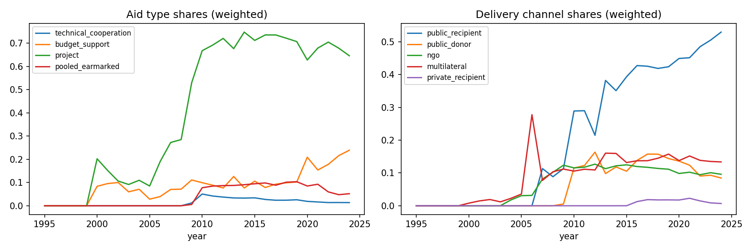
Figure 1. Disbursement-weighted aid-type and channel shares over time.
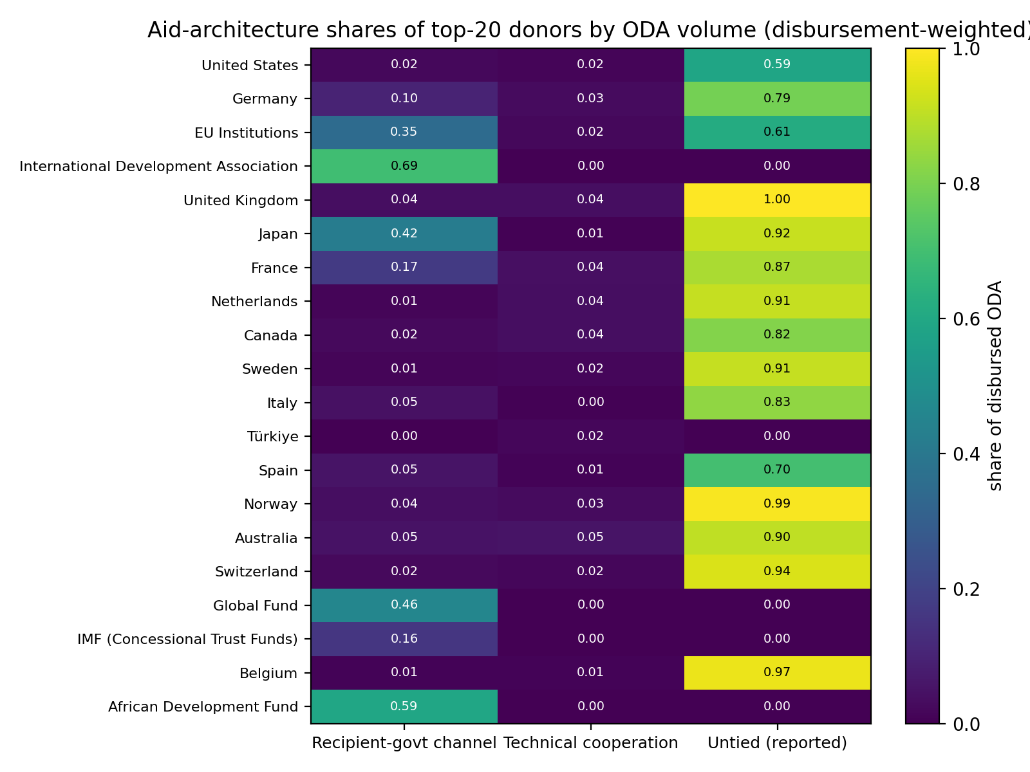
Figure 2. Aid-architecture shares of the top-20 donors by ODA volume (descriptive; no quality ranking implied).
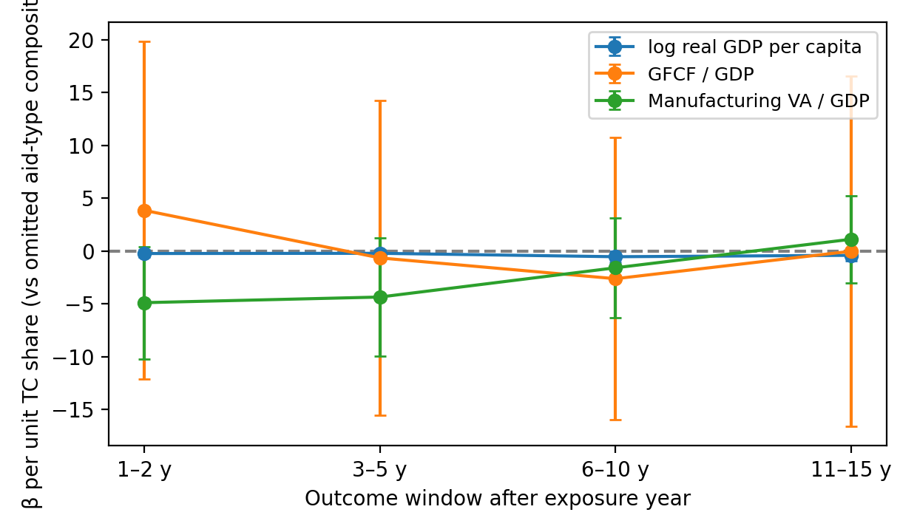
Figure 3. Technical-cooperation-share coefficients on primary outcomes by outcome window (compositional contrast vs the omitted aid-type composition; 95% CI). Secondary outcomes in Figure A2.
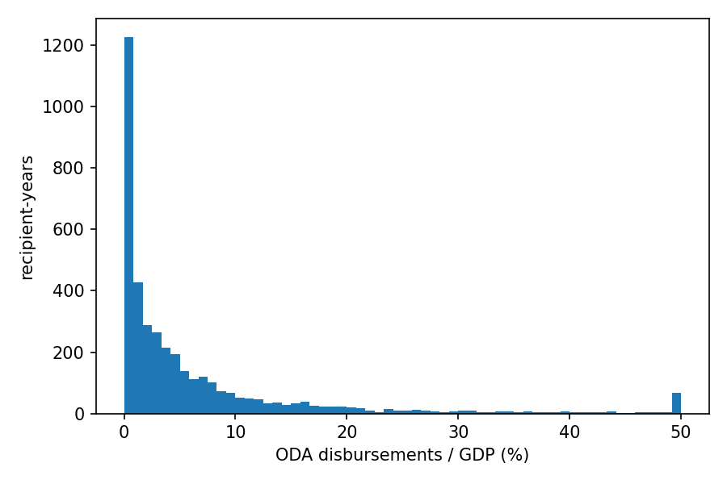
Figure A1. Distribution of ODA disbursements as a share of recipient GDP (%).
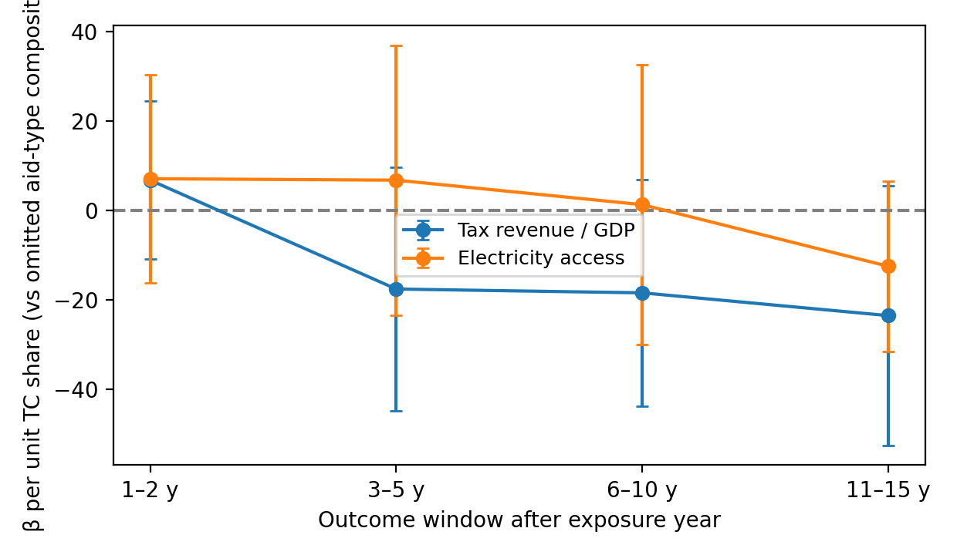
Figure A2. TC-share coefficients on secondary outcomes (tax/GDP, electricity access), by outcome window; 95% CI.

