Supplementary Materials — Beyond Aid Volume: Donor Heterogeneity, Aid Architecture, and Medium-Run Development Outcomes
S1. Full coefficient grid (all terms, outcomes, windows, adjustment sets):
window | outcome | xset | term | beta | se | p | n | r2_within
w1_2 | log_gdppc | aidtype | share_aidtype_technical_cooperation | -0.2242 | 0.1724 | 0.1934 | 3804 | 0.1761
w1_2 | log_gdppc | aidtype | share_aidtype_budget_support | -0.0699 | 0.0548 | 0.202 | 3804 | 0.1761
w1_2 | log_gdppc | aidtype | share_aidtype_project | 0.0212 | 0.0474 | 0.655 | 3804 | 0.1761
w1_2 | log_gdppc | aidtype | share_aidtype_pooled_earmarked | -0.3564 | 0.2132 | 0.0947 | 3804 | 0.1761
w1_2 | log_gdppc | aidtype | share_aidtype_ngo_core | -0.9944 | 0.5828 | 0.088 | 3804 | 0.1761
w1_2 | log_gdppc | aidtype | share_aidtype_scholarships_students | -0.0843 | 0.2668 | 0.7519 | 3804 | 0.1761
w1_2 | log_gdppc | aidtype | share_aidtype_admin_refugee_awareness | -1.7053 | 0.5198 | 0.001 | 3804 | 0.1761
w1_2 | log_gdppc | channel | share_channel_public_recipient | 0.1974 | 0.0673 | 0.0034 | 3804 | 0.3042
w1_2 | log_gdppc | channel | share_channel_public_donor | -0.1713 | 0.1325 | 0.1964 | 3804 | 0.3042
w1_2 | log_gdppc | channel | share_channel_ngo | -0.1329 | 0.2905 | 0.6474 | 3804 | 0.3042
w1_2 | log_gdppc | channel | share_channel_multilateral | -0.1959 | 0.088 | 0.0261 | 3804 | 0.3042
w1_2 | log_gdppc | channel | share_channel_private_recipient | -0.3169 | 0.2535 | 0.2114 | 3804 | 0.3042
w1_2 | log_gdppc | finance | share_finance_grant | 0.0272 | 0.0404 | 0.5003 | 3804 | 0.2639
w1_2 | log_gdppc | finance | share_finance_loan | 0.1299 | 0.0664 | 0.0504 | 3804 | 0.2639
w1_2 | log_gdppc | extra | share_tc_usd_irtc | 0.0783 | 0.0816 | 0.3372 | 3804 | 0.2709
w1_2 | log_gdppc | extra | share_untied | -0.0464 | 0.0316 | 0.1422 | 3804 | 0.2709
w1_2 | gfcf_gdp | aidtype | share_aidtype_technical_cooperation | 3.8664 | 8.1561 | 0.6355 | 3091 | 0.0054
w1_2 | gfcf_gdp | aidtype | share_aidtype_budget_support | -1.4589 | 1.8758 | 0.4368 | 3091 | 0.0054
w1_2 | gfcf_gdp | aidtype | share_aidtype_project | 0.8074 | 1.3483 | 0.5493 | 3091 | 0.0054
w1_2 | gfcf_gdp | aidtype | share_aidtype_pooled_earmarked | -7.9048 | 6.0677 | 0.1928 | 3091 | 0.0054
w1_2 | gfcf_gdp | aidtype | share_aidtype_ngo_core | 2.5379 | 17.1709 | 0.8825 | 3091 | 0.0054
w1_2 | gfcf_gdp | aidtype | share_aidtype_scholarships_students | 5.6084 | 6.5548 | 0.3923 | 3091 | 0.0054
w1_2 | gfcf_gdp | aidtype | share_aidtype_admin_refugee_awareness | -20.3539 | 24.1084 | 0.3986 | 3091 | 0.0054
w1_2 | gfcf_gdp | channel | share_channel_public_recipient | 3.3076 | 2.0363 | 0.1044 | 3091 | 0.0189
w1_2 | gfcf_gdp | channel | share_channel_public_donor | -1.9577 | 4.1085 | 0.6337 | 3091 | 0.0189
w1_2 | gfcf_gdp | channel | share_channel_ngo | 3.6279 | 5.0497 | 0.4725 | 3091 | 0.0189
w1_2 | gfcf_gdp | channel | share_channel_multilateral | -6.9107 | 2.7738 | 0.0128 | 3091 | 0.0189
w1_2 | gfcf_gdp | channel | share_channel_private_recipient | 6.291 | 4.5973 | 0.1713 | 3091 | 0.0189
w1_2 | gfcf_gdp | finance | share_finance_grant | 0.0746 | 1.5664 | 0.962 | 3091 | -0.0291
w1_2 | gfcf_gdp | finance | share_finance_loan | 1.6184 | 1.8077 | 0.3707 | 3091 | -0.0291
w1_2 | gfcf_gdp | extra | share_tc_usd_irtc | -0.4825 | 2.1241 | 0.8203 | 3091 | -0.0171
w1_2 | gfcf_gdp | extra | share_untied | 0.2253 | 0.8837 | 0.7988 | 3091 | -0.0171
w1_2 | manf_gdp | aidtype | share_aidtype_technical_cooperation | -4.8766 | 2.7161 | 0.0727 | 3406 | 0.051
w1_2 | manf_gdp | aidtype | share_aidtype_budget_support | -0.1989 | 0.7278 | 0.7847 | 3406 | 0.051
w1_2 | manf_gdp | aidtype | share_aidtype_project | -0.3144 | 0.5794 | 0.5874 | 3406 | 0.051
w1_2 | manf_gdp | aidtype | share_aidtype_pooled_earmarked | -0.6102 | 3.0561 | 0.8418 | 3406 | 0.051
w1_2 | manf_gdp | aidtype | share_aidtype_ngo_core | 4.9518 | 7.2455 | 0.4944 | 3406 | 0.051
w1_2 | manf_gdp | aidtype | share_aidtype_scholarships_students | -3.2244 | 4.815 | 0.5031 | 3406 | 0.051
w1_2 | manf_gdp | aidtype | share_aidtype_admin_refugee_awareness | 2.4163 | 9.4739 | 0.7987 | 3406 | 0.051
w1_2 | manf_gdp | channel | share_channel_public_recipient | 0.9858 | 0.9985 | 0.3236 | 3406 | -0.0852
w1_2 | manf_gdp | channel | share_channel_public_donor | 0.4026 | 1.6321 | 0.8052 | 3406 | -0.0852
w1_2 | manf_gdp | channel | share_channel_ngo | -0.0809 | 2.4749 | 0.9739 | 3406 | -0.0852
w1_2 | manf_gdp | channel | share_channel_multilateral | 1.4753 | 0.9513 | 0.121 | 3406 | -0.0852
w1_2 | manf_gdp | channel | share_channel_private_recipient | -0.5462 | 3.0646 | 0.8586 | 3406 | -0.0852
w1_2 | manf_gdp | finance | share_finance_grant | -0.9881 | 0.7334 | 0.178 | 3406 | 0.0108
w1_2 | manf_gdp | finance | share_finance_loan | 0.1971 | 0.7767 | 0.7997 | 3406 | 0.0108
w1_2 | manf_gdp | extra | share_tc_usd_irtc | -0.4673 | 1.5626 | 0.7649 | 3406 | 0.0058
w1_2 | manf_gdp | extra | share_untied | -0.6611 | 0.3959 | 0.095 | 3406 | 0.0058
w1_2 | tax_gdp | aidtype | share_aidtype_technical_cooperation | 6.8 | 9.0204 | 0.451 | 2077 | 0.0421
w1_2 | tax_gdp | aidtype | share_aidtype_budget_support | 5.5441 | 7.3804 | 0.4526 | 2077 | 0.0421
w1_2 | tax_gdp | aidtype | share_aidtype_project | 2.333 | 3.4004 | 0.4927 | 2077 | 0.0421
w1_2 | tax_gdp | aidtype | share_aidtype_pooled_earmarked | -59.1824 | 65.182 | 0.364 | 2077 | 0.0421
w1_2 | tax_gdp | aidtype | share_aidtype_ngo_core | 2.8556 | 22.5879 | 0.8994 | 2077 | 0.0421
w1_2 | tax_gdp | aidtype | share_aidtype_scholarships_students | -14.1813 | 12.0759 | 0.2404 | 2077 | 0.0421
w1_2 | tax_gdp | aidtype | share_aidtype_admin_refugee_awareness | -42.9337 | 34.4182 | 0.2124 | 2077 | 0.0421
w1_2 | tax_gdp | channel | share_channel_public_recipient | -1.0522 | 3.9516 | 0.7901 | 2077 | 0.06
w1_2 | tax_gdp | channel | share_channel_public_donor | 0.5749 | 3.4555 | 0.8679 | 2077 | 0.06
w1_2 | tax_gdp | channel | share_channel_ngo | -13.884 | 17.9353 | 0.439 | 2077 | 0.06
w1_2 | tax_gdp | channel | share_channel_multilateral | -49.7349 | 53.5777 | 0.3534 | 2077 | 0.06
w1_2 | tax_gdp | channel | share_channel_private_recipient | -14.3558 | 18.7289 | 0.4435 | 2077 | 0.06
S2. Donor/recipient decomposition (full):
var | r2_full | r2_donoronly | r2_recipient_year | r2_year_only | incr_r2_donor | incr_r2_recipient | incr_r2_donor_vs_year | r2_null | n
share_aidtype_technical_cooperation | 0.3496 | 0.2983 | 0.101 | 0.041 | 0.2486 | 0.0513 | 0.2573 | 0.0 | 145790
share_aidtype_project | 0.6712 | 0.4465 | 0.5406 | 0.1502 | 0.1307 | 0.2248 | 0.2963 | 0.0 | 145790
share_aidtype_budget_support | 0.4991 | 0.385 | 0.2312 | 0.0263 | 0.2679 | 0.1141 | 0.3587 | 0.0 | 145790
share_channel_public_recipient | 0.6241 | 0.5182 | 0.4008 | 0.0845 | 0.2233 | 0.1059 | 0.4337 | 0.0 | 145790
share_channel_ngo | 0.4523 | 0.2615 | 0.1766 | 0.0426 | 0.2757 | 0.1908 | 0.2188 | 0.0 | 145790
share_tc_usd_irtc | 0.004 | 0.0018 | 0.0029 | 0.0008 | 0.0011 | 0.0022 | 0.001 | 0.0 | 145790
S3. Adjustment-set sensitivity:
outcome | set | n | beta_tc | se_tc | beta_bs | beta_govt
log_gdppc | A | 3538 | -0.1342 | 0.1981 | -0.0796 | nan
log_gdppc | B | 3538 | -0.2031 | 0.1773 | -0.0673 | nan
log_gdppc | C | 2865 | -0.3688 | 0.1964 | -0.0204 | nan
gfcf_gdp | A | 2913 | -0.2488 | 7.6499 | -2.3996 | nan
gfcf_gdp | B | 2913 | -0.6381 | 7.614 | -2.5456 | nan
gfcf_gdp | C | 2758 | -0.0768 | 7.5349 | -3.6983 | nan
manf_gdp | A | 3215 | -5.3789 | 2.8949 | -0.4857 | nan
manf_gdp | B | 3215 | -4.3445 | 2.8398 | -0.4661 | nan
manf_gdp | C | 2678 | -3.8614 | 2.8915 | -1.2087 | nan
S4. Falsification results (full):
test | term | beta | p | n | real_beta | placebo_mean | placebo_sd | pct_gt_real
lead_placebo | share_aidtype_technical_cooperation_lead | -0.2296 | 0.1661 | 3542 | nan | nan | nan | nan
pseudo_outcome_urban | share_aidtype_technical_cooperation | -2.2315 | 0.1578 | 3608 | nan | nan | nan | nan
pseudo_outcome_urban | share_aidtype_budget_support | -0.4037 | 0.3114 | 3608 | nan | nan | nan | nan
pseudo_outcome_urban | share_aidtype_project | -0.2566 | 0.5331 | 3608 | nan | nan | nan | nan
pseudo_outcome_urban | share_aidtype_pooled_earmarked | 0.2216 | 0.8646 | 3608 | nan | nan | nan | nan
pseudo_outcome_urban | share_aidtype_ngo_core | -0.5538 | 0.9115 | 3608 | nan | nan | nan | nan
pseudo_outcome_urban | share_aidtype_scholarships_students | 0.6895 | 0.6765 | 3608 | nan | nan | nan | nan
pseudo_outcome_urban | share_aidtype_admin_refugee_awareness | -1.0702 | 0.5837 | 3608 | nan | nan | nan | nan
shuffle_placebo | share_aidtype_technical_cooperation | nan | nan | 200 | -0.2031 | -0.0026 | 0.0828 | 0.02
Figure S1. Distribution of ODA disbursements as a share of recipient GDP (%).
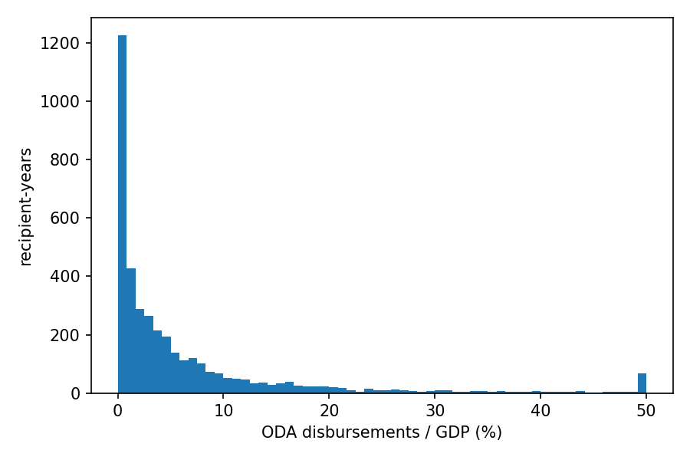
Figure S2. TC-share coefficients on secondary outcomes (tax/GDP, electricity access), by outcome window; 95% CI.
