Photobiomodulation-induced vasodilation of glabrous skin arteriovenous anastomoses as a wearable, non-pharmacological strategy for blood pressure reduction: A hypothesis
Tatsuki Onishi
[Affiliation to be inserted]
Keywords: Arteriovenous anastomoses; Photobiomodulation; Blood pressure; Low-level laser therapy; Peripheral vascular resistance; Wearable device

Abstract
Hypertension remains the leading modifiable risk factor for cardiovascular disease, yet medication non-adherence and adverse effects of antihypertensive drugs, particularly diuretics, limit treatment efficacy. Arteriovenous anastomoses (AVAs) are direct vascular connections between arterioles and venules concentrated in glabrous skin of the palms, soles, and digits. When dilated, AVAs create low-resistance parallel pathways that reduce total peripheral resistance (TPR) and consequently lower arterial blood pressure. We hypothesize that targeted photobiomodulation (PBM) at 630–850 nm, delivered via a wearable LED array to palmar and plantar surfaces, can selectively dilate AVAs through nitric oxide (NO) release from endothelial stores, thereby producing clinically significant blood pressure reduction without pharmacological intervention. This hypothesis is supported by three convergent lines of evidence: (1) surgically created arteriovenous fistulae reduce systolic blood pressure by 27 mmHg in randomized trials; (2) PBM at 660 nm produces NO-dependent vasodilation and hypotensive effects in experimental models; and (3) AVA blood flow fluctuations correlate inversely with mean arterial pressure (r = −0.8). A wearable PBM device targeting AVA-rich glabrous skin could offer a drug-free, side-effect-free alternative to third-line antihypertensives, with the added benefit of peripheral warming in cold environments.

1. Introduction
Hypertension affects over 1.3 billion adults globally and remains the single largest contributor to cardiovascular mortality.¹ Despite the availability of multiple drug classes, approximately 50% of treated patients fail to achieve target blood pressure, and medication non-adherence rates reach 50–80% within one year of initiation.² Third-line agents, particularly thiazide diuretics, carry clinically significant adverse effects including hypokalemia, hyperuricemia, glucose intolerance, and dehydration, which further compromise adherence.³
The fundamental hemodynamic equation, mean arterial pressure (MAP) = cardiac output (CO) × total peripheral resistance (TPR), dictates that any sustained reduction in TPR, without compensatory increases in CO, will lower blood pressure.⁴ Arteriovenous anastomoses (AVAs) are direct vascular connections between arterioles and venules, concentrated predominantly in glabrous (non-hairy) skin of the palms, soles, lips, and ears.⁵ With luminal diameters of 20–150 µm (5–10 times larger than capillaries), AVAs present dramatically lower resistance to flow when dilated.⁶ Their primary physiological role is thermoregulation: sympathetic withdrawal dilates AVAs, increasing skin blood flow up to 1 L/min and facilitating radiative heat loss.⁷
Crucially, AVA dilation adds low-resistance parallel pathways to the systemic circulation, mechanically reducing TPR. This relationship is not merely theoretical: Walløe demonstrated that spontaneous AVA blood flow oscillations correlate inversely with MAP fluctuations (r = −0.3 to −0.8), with peak-to-trough MAP variations of 15 mmHg coinciding with AVA opening and closing cycles.⁵ Furthermore, surgically created central arteriovenous fistulae (the ROX Coupler) reduce office systolic blood pressure by 26.9 mmHg (p < 0.0001) in patients with resistant hypertension, providing definitive proof that adding parallel low-resistance vascular pathways lowers blood pressure.⁸
Photobiomodulation (PBM), formerly termed low-level laser therapy (LLLT), employs non-ionizing light at 600–1000 nm to modulate cellular function.⁹ A well-characterized mechanism of PBM is the release of nitric oxide (NO) from intracellular stores including cytochrome c oxidase (Complex IV) and S-nitrosothiols.¹⁰ NO is a potent vasodilator that activates soluble guanylate cyclase, elevates cyclic GMP, and relaxes vascular smooth muscle.¹¹ Recent studies demonstrate that PBM at 660 nm produces NO-dependent hypotensive effects in hypertensive animal models, with the effect abolished by NOS inhibition and restored by NO donors.¹²
We propose that these two established phenomena—AVA-mediated TPR reduction and PBM-induced NO release—can be integrated into a single wearable device that non-invasively lowers blood pressure by photobiomodulating AVA-rich glabrous skin.
2. The Hypothesis
We hypothesize that targeted photobiomodulation (630–850 nm) delivered to palmar and/or plantar glabrous skin via a wearable LED array will produce clinically significant reductions in arterial blood pressure (≥5 mmHg systolic) through selective vasodilation of arteriovenous anastomoses mediated by photochemical release of nitric oxide from endothelial stores.
The proposed mechanism operates through the following causal chain (Fig. 1): PBM irradiation (20–100 mW/cm²) penetrates the dermis to a depth of 14–26 mm,¹³ reaching AVAs located at 1–3 mm depth in glabrous skin.⁵ Photon absorption by cytochrome c oxidase and hemoglobin-bound nitrosyl groups releases NO into the vascular smooth muscle layer surrounding AVAs.^{10,12} NO activates the sGC/cGMP/PKG pathway, causing smooth muscle relaxation and AVA dilation.¹¹ The resulting increase in AVA conductance adds parallel low-resistance pathways to the systemic circulation, reducing TPR.⁵ With MAP = CO × TPR, a 5–10% reduction in TPR yields a 4.5–9 mmHg reduction in MAP (assuming baseline MAP of 90 mmHg), which exceeds the threshold for clinical significance.¹⁴
This mechanism is fundamentally distinct from the thermal vasodilation employed by existing devices (e.g., AVACEN, which uses conductive heating plus negative pressure,¹⁵ and the selective thermal stimulation system of Diller et al., which targets spinal thermoregulatory centers during sleep).²⁹ PBM offers a photochemical pathway to vasodilation that does not require tissue heating, operates at milliwatt-level power consumption suitable for battery-powered wearables, and avoids the engineering complexity of vacuum-sealed chambers.
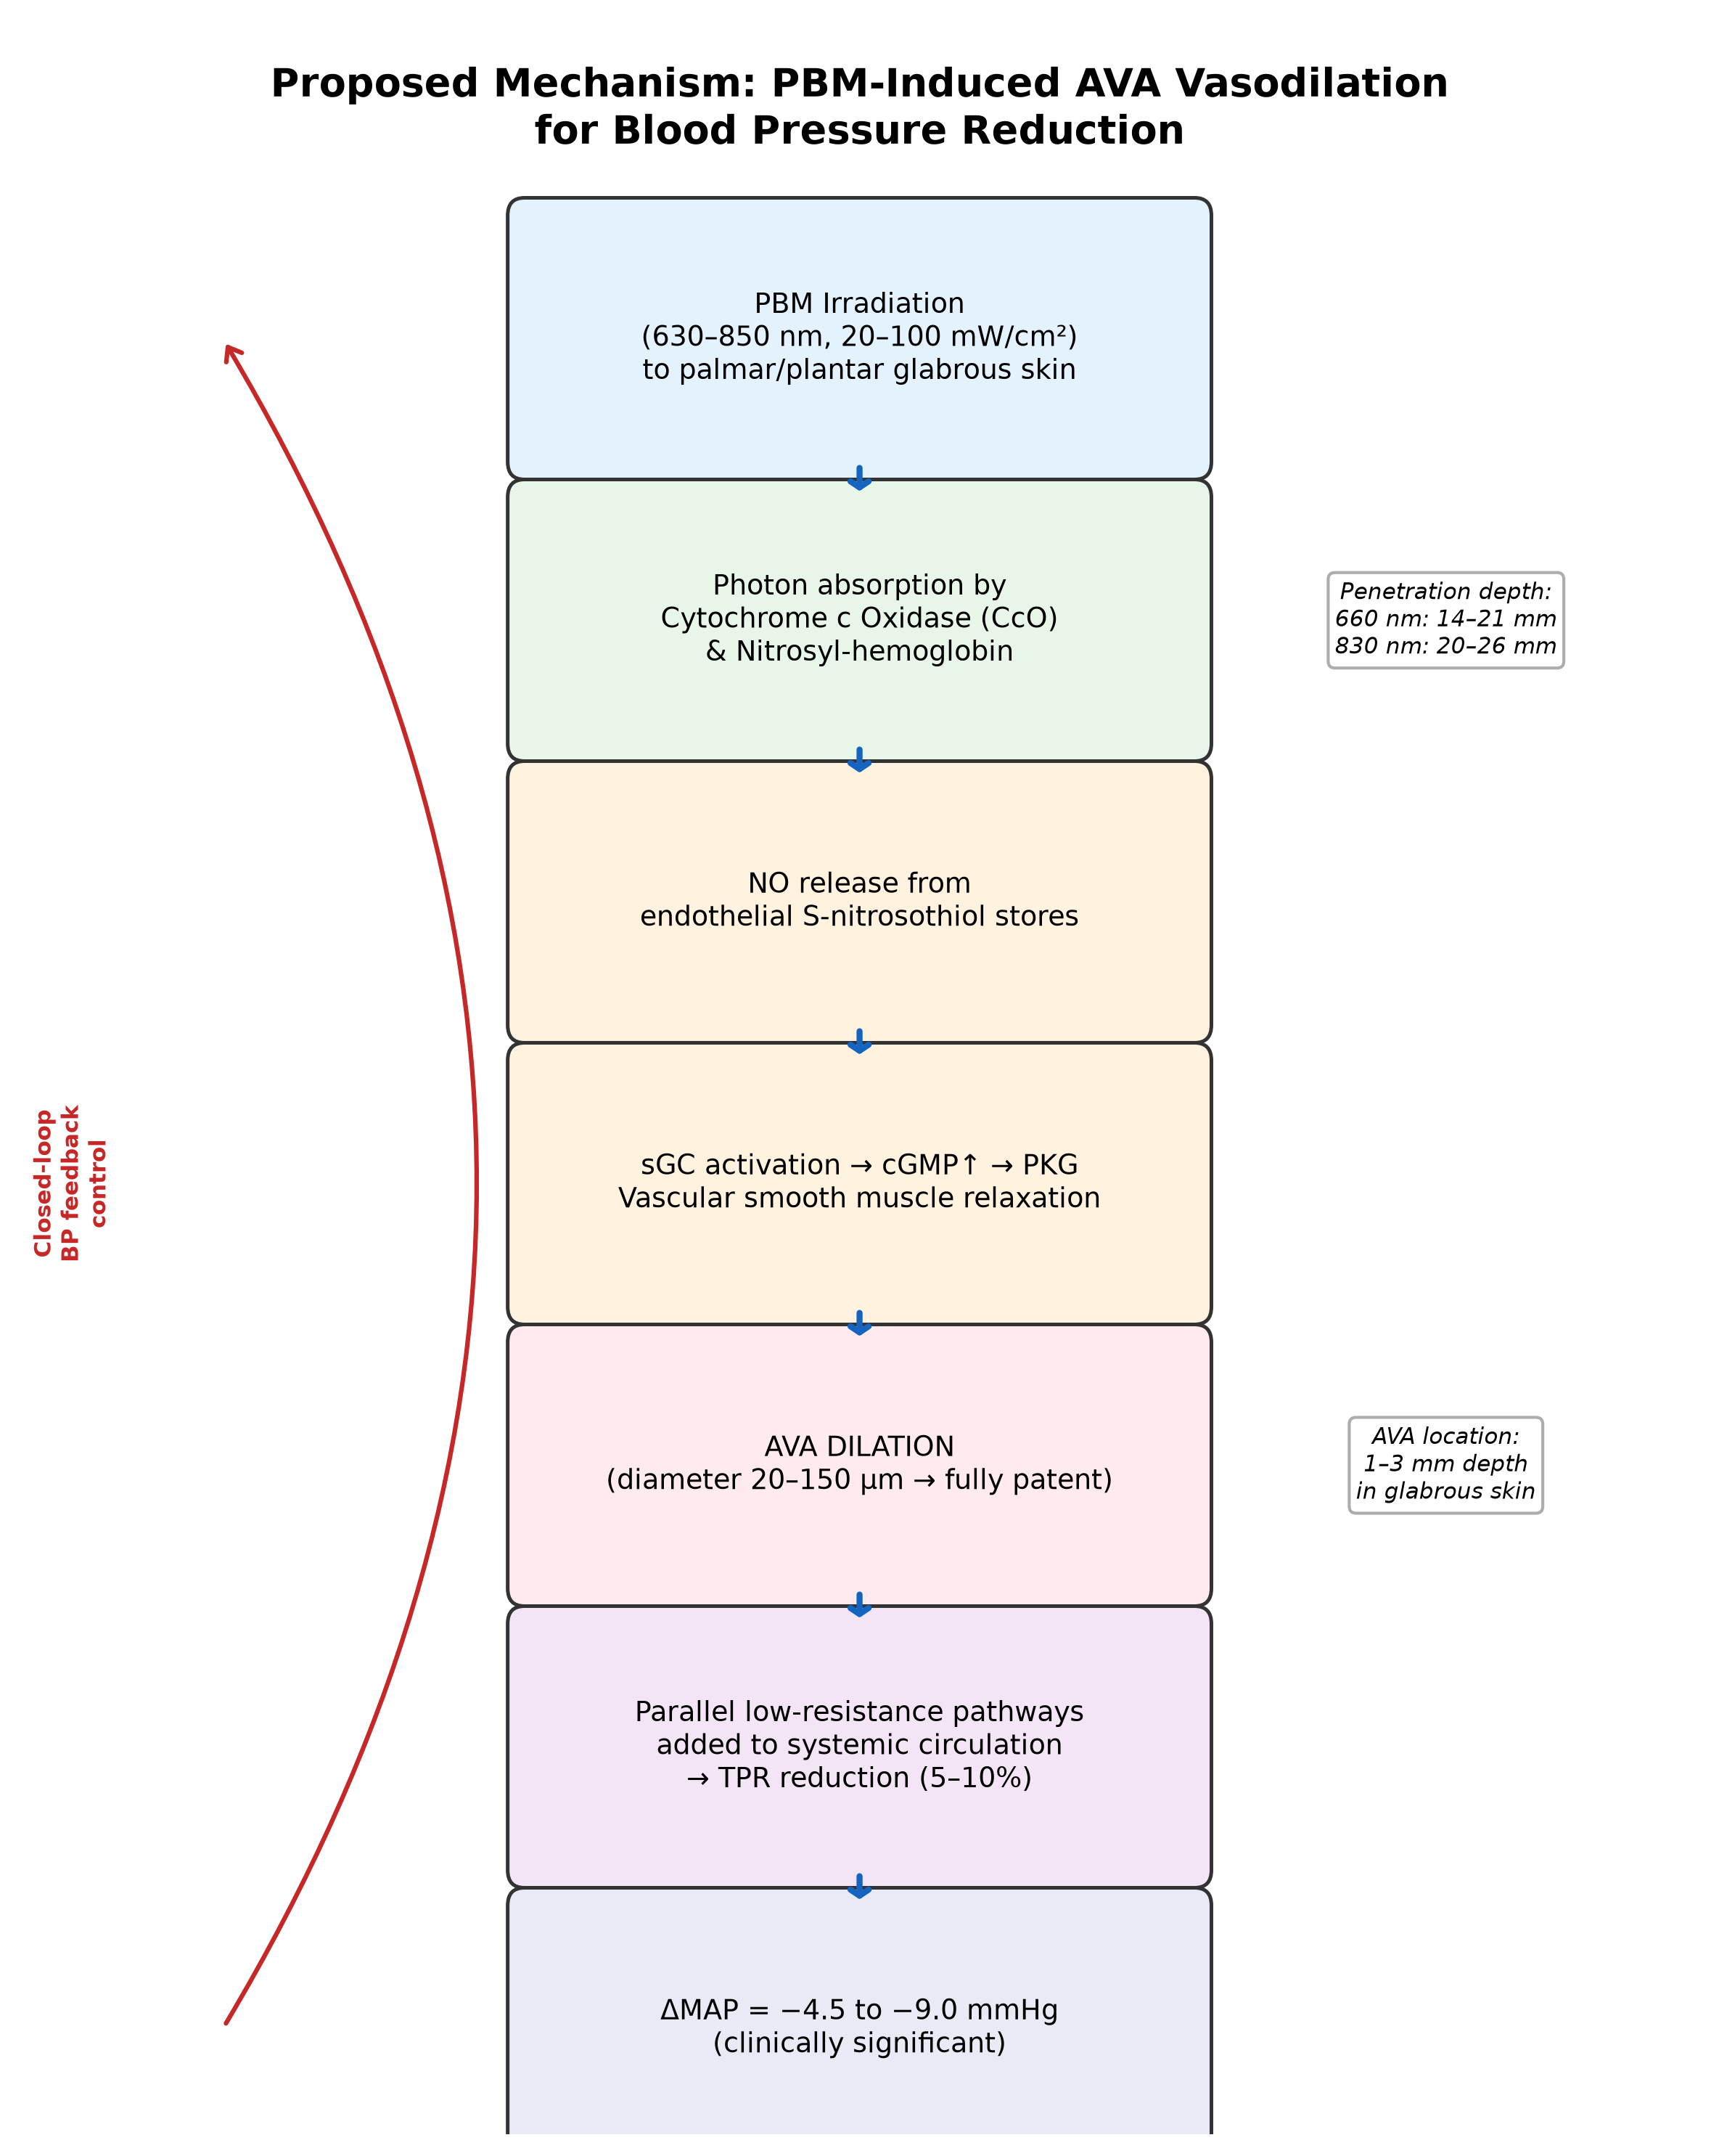
Fig. 1. Schematic of proposed causal chain: PBM irradiation (630–850 nm) → photon absorption by CcO/nitrosyl-hemoglobin → NO release → sGC/cGMP activation → AVA smooth muscle relaxation → AVA dilation → TPR reduction → MAP decrease.
3. Evaluation of the Hypothesis
Three independent lines of evidence support the plausibility of this hypothesis:
First, the principle that adding arteriovenous shunt flow reduces systemic blood pressure is established at the highest level of clinical evidence. The ROX CONTROL HTN randomized controlled trial (n = 83) demonstrated that a surgically placed iliac arteriovenous coupler reduced office systolic blood pressure by 26.9 mmHg versus 3.7 mmHg in controls (p < 0.0001), with 24-hour ambulatory reductions of 13.5 mmHg sustained at 12 months.^{8,16} Similarly, Faul et al. showed that iliac arteriovenous shunts in hypertensive COPD patients reduced systolic blood pressure by 13 mmHg at 12 months (p < 0.0001).¹⁷ These trials confirm that TPR reduction via parallel low-resistance pathways is an effective antihypertensive strategy.
Second, PBM-induced vasodilation and blood pressure reduction have been demonstrated experimentally. Ribeiro et al. showed that 660 nm laser irradiation reduced MAP in hypertensive rats, and that this effect was abolished by the NOS inhibitor L-NAME, confirming NO-dependence.¹² A 2025 systematic review and meta-analysis confirmed that PBM reduces systolic blood pressure, diastolic blood pressure, and MAP while increasing NO levels, though with very low certainty of evidence requiring further high-quality trials.¹⁸ Importantly, PBM at clinically relevant power densities (50–100 mW/cm²) increases dermal blood flow by 25–30% as measured by laser Doppler flowmetry.¹⁹
Third, the physiological link between AVA blood flow and blood pressure is well-established. Walløe's comprehensive review documented inverse correlations between AVA blood flow and MAP (r = −0.3 to −0.8) during thermoneutral-zone oscillations, with MAP fluctuations of approximately 15 mmHg.⁵ Kräuchi et al. demonstrated in 51 subjects that the distal-to-proximal skin temperature gradient (a surrogate for AVA blood flow) predicts blood pressure dipping status (r = −0.436, p = 0.0014), with 78.6% concordance between wrist skin temperature rhythms and blood pressure dipping patterns.^{20,21} Furthermore, Gani et al. showed that local passive heat application (40–42°C), which activates AVA vasodilation, reduced systolic blood pressure by 19 mmHg acutely and 28 mmHg overnight in patients with autonomic failure (p < 0.001 versus sham).²²
A potential counterargument is baroreflex compensation: acute TPR reduction may trigger sympathetic activation that increases heart rate and cardiac output, partially offsetting the blood pressure decrease.⁴ However, several observations mitigate this concern. The Vanderbilt heat study demonstrated sustained overnight blood pressure reductions of 28 mmHg, suggesting that baroreflex compensation is incomplete during prolonged stimulation.²² Additionally, PBM has been reported to enhance parasympathetic tone,²³ which may blunt the sympathetic reflex. Gradual-onset stimulation (ramping PBM intensity over minutes rather than seconds) could further minimize baroreflex triggering. Finally, elderly patients with resistant hypertension—the primary target population—typically exhibit reduced baroreflex sensitivity, making sustained TPR-mediated blood pressure reduction more achievable.²⁴
Table 1. Comparison of arteriovenous shunt-based blood pressure reduction strategies
Approach | Mechanism | BP reduction  (SBP, mmHg) | Invasiveness | Evidence level
ROX Coupler  (iliac AV fistula) | Surgically created  fixed AV shunt | −26.9 | Invasive  (catheter) | RCT (n=83)⁸
AVACEN 100  (palm heating +  neg. pressure) | Conductive heat +  vacuum → AVA dilation | Under  investigation | Non-invasive  (stationary) | Pilot studies¹⁵
Selective thermal  stimulation  (Diller, 2022) | Spinal heating →  hypothalamic reflex  → AVA dilation | Not yet  reported | Non-invasive  (bed-integrated) | POC (n=10)²⁸
PBM-AVA device  (proposed) | PBM → NO release  → AVA dilation  → TPR↓ | Predicted:  −5 to −10 | Non-invasive  (wearable) | Hypothesis
4. Hypothesis Testing
The hypothesis can be tested through the following approaches:
A proof-of-concept study in healthy volunteers (n = 20–30) would apply PBM (660–830 nm LED array, 50–100 mW/cm², 20–30 minutes) to palmar skin while continuously monitoring blood pressure via finger photoplethysmography (e.g., Finapres) and skin blood flow via laser Doppler flowmetry. The primary endpoint would be change in MAP from baseline. A sham-controlled crossover design with an identical but non-emitting device would control for placebo effects. Simultaneous measurement of distal skin temperature would confirm AVA engagement, while plasma nitrite/nitrate levels would verify the NO-dependent mechanism.
If the proof-of-concept yields positive results, a Phase II randomized controlled trial in patients with Stage 1–2 hypertension (n = 60–80) would compare active PBM (worn for 4–8 hours daily for 8 weeks) versus sham, with 24-hour ambulatory blood pressure as the primary endpoint. Subgroup analyses by season (winter vs. summer) would test the additional hypothesis that cold-weather AVA closure contributes to seasonal blood pressure elevation and that PBM can prevent this increase.
Dose-response relationships should be characterized across wavelengths (630, 660, 810, 850 nm), power densities (20–200 mW/cm²), and irradiation durations to identify optimal parameters for sustained AVA dilation without tachyphylaxis.
5. Consequences of the Hypothesis and Discussion
If confirmed, this hypothesis has several important implications. First, a wearable PBM device targeting AVA-rich skin would represent a fundamentally new class of non-pharmacological antihypertensive intervention—one that operates through physical vascular mechanics rather than neurohormonal modulation. Unlike renal denervation or baroreflex activation therapy, this approach is entirely non-invasive and reversible.
Second, the device concept uniquely addresses the problem of cold-induced hypertension.²⁵ In temperate climates, blood pressure rises by 5–10 mmHg in winter due to sympathetically mediated AVA closure and resultant TPR elevation.²⁶ A wearable PBM device that maintains AVA patency could simultaneously prevent seasonal blood pressure elevation and provide peripheral warming—transforming an antihypertensive device into one that patients actively desire to use, potentially resolving the longstanding challenge of treatment adherence.
Third, this approach may complement or substitute for third-line diuretic therapy. For patients intolerant of thiazides due to metabolic adverse effects (hypokalemia, hyperuricemia, impaired glucose tolerance), a PBM-AVA device could provide equivalent blood pressure reduction (5–10 mmHg) without systemic metabolic perturbation.³
Fourth, the same device platform could address Raynaud's phenomenon, a condition characterized by episodic AVA closure in digits, with clear endpoints (attack frequency, duration) and smaller required sample sizes—offering a pragmatic initial regulatory pathway.²⁷
Limitations of the proposed approach include inter-individual variability in PBM response (responders vs. non-responders),¹⁹ potential NO store depletion during prolonged use, and the possibility that baroreflex compensation may attenuate chronic blood pressure reduction in some patient populations. These concerns can be addressed through closed-loop feedback control (adjusting PBM parameters in response to continuous blood pressure monitoring) and pulsed irradiation protocols that allow NO store replenishment between active periods.
In conclusion, the convergence of evidence from invasive arteriovenous shunt trials, PBM-induced vasodilation studies, and AVA physiology research supports the hypothesis that wearable photobiomodulation targeting glabrous skin can produce clinically meaningful blood pressure reduction. This approach merits experimental validation as a potential drug-free alternative for hypertension management.

References
1. GBD 2019 Risk Factors Collaborators. Global burden of 87 risk factors in 204 countries and territories, 1990-2019. Lancet. 2020;396(10258):1223-1249.
2. Burnier M, Egan BM. Adherence in hypertension. Circ Res. 2019;124(7):1124-1140.
3. Roush GC, Ernst ME, Kostis JB, et al. Head-to-head comparisons of hydrochlorothiazide with indapamide and chlorthalidone: antihypertensive and metabolic effects. Hypertension. 2015;65(5):1041-1046.
4. Hall JE. Guyton and Hall Textbook of Medical Physiology. 14th ed. Philadelphia: Elsevier; 2021.
5. Walløe L. Arterio-venous anastomoses in the human skin and their role in temperature control. Temperature (Austin). 2016;3(1):92-103.
6. Midttun M, Sejrsen P, Paaske WP. Blood flow rate in arteriovenous anastomoses from the finger in control subjects and in patients with Raynaud's phenomenon. Clin Physiol. 1996;16(3):275-284.
7. Johnson JM, Minson CT, Kellogg DL Jr. Cutaneous vasodilator and vasoconstrictor mechanisms in temperature regulation. Compr Physiol. 2014;4(1):33-89.
8. Lobo MD, Sobotka PA, Stanton A, et al. Central arteriovenous anastomosis for the treatment of patients with uncontrolled hypertension (the ROX CONTROL HTN study): a randomised controlled trial. Lancet. 2015;385(9978):1634-1641.
9. Anders JJ, Lanzafame RJ, Arany PR. Low-level light/laser therapy versus photobiomodulation therapy. Photomed Laser Surg. 2015;33(4):183-184.
10. Karu TI, Pyatibrat LV, Afanasyeva NI. Cellular effects of low power laser therapy can be mediated by nitric oxide. Lasers Surg Med. 2005;36(4):307-314.
11. Moncada S, Higgs EA. The discovery of nitric oxide and its role in vascular biology. Br J Pharmacol. 2006;147(S1):S193-S201.
12. Ribeiro BG, Alves AN, Dos Santos LA, et al. Nitric oxide storage levels modulate vasodilation and the hypotensive effect induced by photobiomodulation using an AlGaAs diode laser (660 nm). Lasers Med Sci. 2022;37(6):2551-2559.
13. De Freitas Rodrigues A, Sordillo LA, Sordillo PP, et al. In vivo attenuation profile of 660 nm and 830 nm wavelengths on human skin. Lasers Med Sci. 2024;39(1):28.
14. Lewington S, Clarke R, Qizilbash N, et al. Age-specific relevance of usual blood pressure to vascular mortality. Lancet. 2002;360(9349):1903-1913.
15. AVACEN Medical. AVACEN 100 Treatment System. US Patent 8,679,170 B2. 2014.
16. Lobo MD, Ott C, Gane EJ, et al. Central iliac arteriovenous anastomosis for uncontrolled hypertension: one-year results from the ROX CONTROL HTN trial. Hypertension. 2017;70(6):1099-1105.
17. Faul JL, Galindo J, Engelsgjerd JS, et al. Creation of an iliac arteriovenous shunt lowers blood pressure in chronic obstructive pulmonary disease patients with hypertension. J Vasc Surg. 2014;59(4):1078-1083.
18. Damasceno GM, Pfaff AMCS, Gomes RSA, et al. Photobiomodulation therapy in hypertension management—Evidence from a systematic review and meta-analysis. J Clin Med. 2025;14(19):6716.
19. Rogatkin DA, Dunaev AV. Stimulation of blood microcirculation at low level laser irradiation. Proc SPIE. 2014;9129:912922.
20. Kräuchi K, Gompper B, Hauenstein D, et al. Diurnal blood pressure variations are associated with changes in distal-proximal skin temperature gradient. Chronobiol Int. 2012;29(9):1189-1197.
21. Martinez-Nicolas A, Ortiz-Tudela E, Rol MA, et al. Wrist skin temperature, motor activity, and body position as determinants of the circadian pattern of blood pressure. Chronobiol Int. 2013;30(5):668-678.
22. Gani F, Guzman RC, Ahmed SS, et al. Local passive heat for the treatment of hypertension in autonomic failure. J Am Heart Assoc. 2021;10(13):e018979.
23. Ferraresi C, Huang YY, Hamblin MR. Photobiomodulation in human muscle tissue: an advantage in sports performance? J Biophotonics. 2016;9(11-12):1273-1299.
24. Grassi G, Ram VS. Evidence for a critical role of the sympathetic nervous system in hypertension. J Am Soc Hypertens. 2016;10(5):457-466.
25. Modesti PA. Season, temperature and blood pressure: a complex interaction. Eur J Intern Med. 2013;24(7):604-607.
26. Barnett AG, Sans S, Salomaa V, et al. The effect of temperature on systolic blood pressure. Blood Press Monit. 2007;12(3):195-203.
27. Flavahan NA. A vascular mechanistic approach to understanding Raynaud phenomenon. Nat Rev Rheumatol. 2015;11(3):146-158.
28. Haghayegh S, Khoshnevis S, Smolensky MH, et al. Novel temperature-controlled sleep system to improve sleep: a proof-of-concept study. J Sleep Res. 2022;31(5):e13662.
29. Diller KR, Khoshnevis S, Hemmen L. Thermoregulatory manipulation of systemic blood pressure. US Patent 11,229,548 B2. 2022.

