The Accountants of One Another's Lives
Eighty years after Hiroshima we still argue about whether the bomb was necessary. That is the wrong argument.
The destruction of Hiroshima and Nagasaki is still defended, eight decades on, in a familiar idiom. The bombs, for all their horror, were necessary: they ended the war quickly and thereby spared the far larger number of lives—American and Japanese, soldier and civilian—that an invasion of the home islands would have consumed. Generations of historians have contested the factual premises of this story, asking whether surrender was already near, whether the casualty projections were inflated after the fact, and whether the true audience for the blast was Moscow rather than Tokyo.¹ That empirical quarrel matters. But it is not the argument I want to have.
Look instead at the shape of the justification, quite apart from whether its numbers are right. It is a piece of arithmetic. It concedes that lives were taken and answers that more lives were saved; it sets the dead of two cities on one pan of a scale and the hypothetical dead of an invasion on the other, and reads off the balance. Grant the defender everything he wants—that the bombs did shorten the war, that they did avert a bloodier landing. A question remains that the arithmetic cannot put to itself, because it has already assumed the answer: are human beings the kind of agents who may set themselves up as the accountants of one another's lives, deciding who shall live and who shall die in another's stead?
Call this a shift in the layer of the question (Figure 1). The “was it necessary?” debate operates inside the calculus; it audits a weighing whose legitimacy it never examines. The question I want to press sits outside the calculus and asks whether we are entitled to perform it at all. The two layers are independent: one can win every point on the inner layer—concede that the sums add up—and still have said nothing to the outer one. Much of what passes for moral debate about the bomb, and about war in general, is an argument on the inner layer mistaken for an argument on the outer. And which layer a society instinctively reaches for tells us what it already takes for granted about the standing of persons. The same doubling holds for war in any of its forms, including the quieter ones: economic coercion and cultural domination are also ways of securing one's own flourishing by drawing down another's, and they too invite both questions.
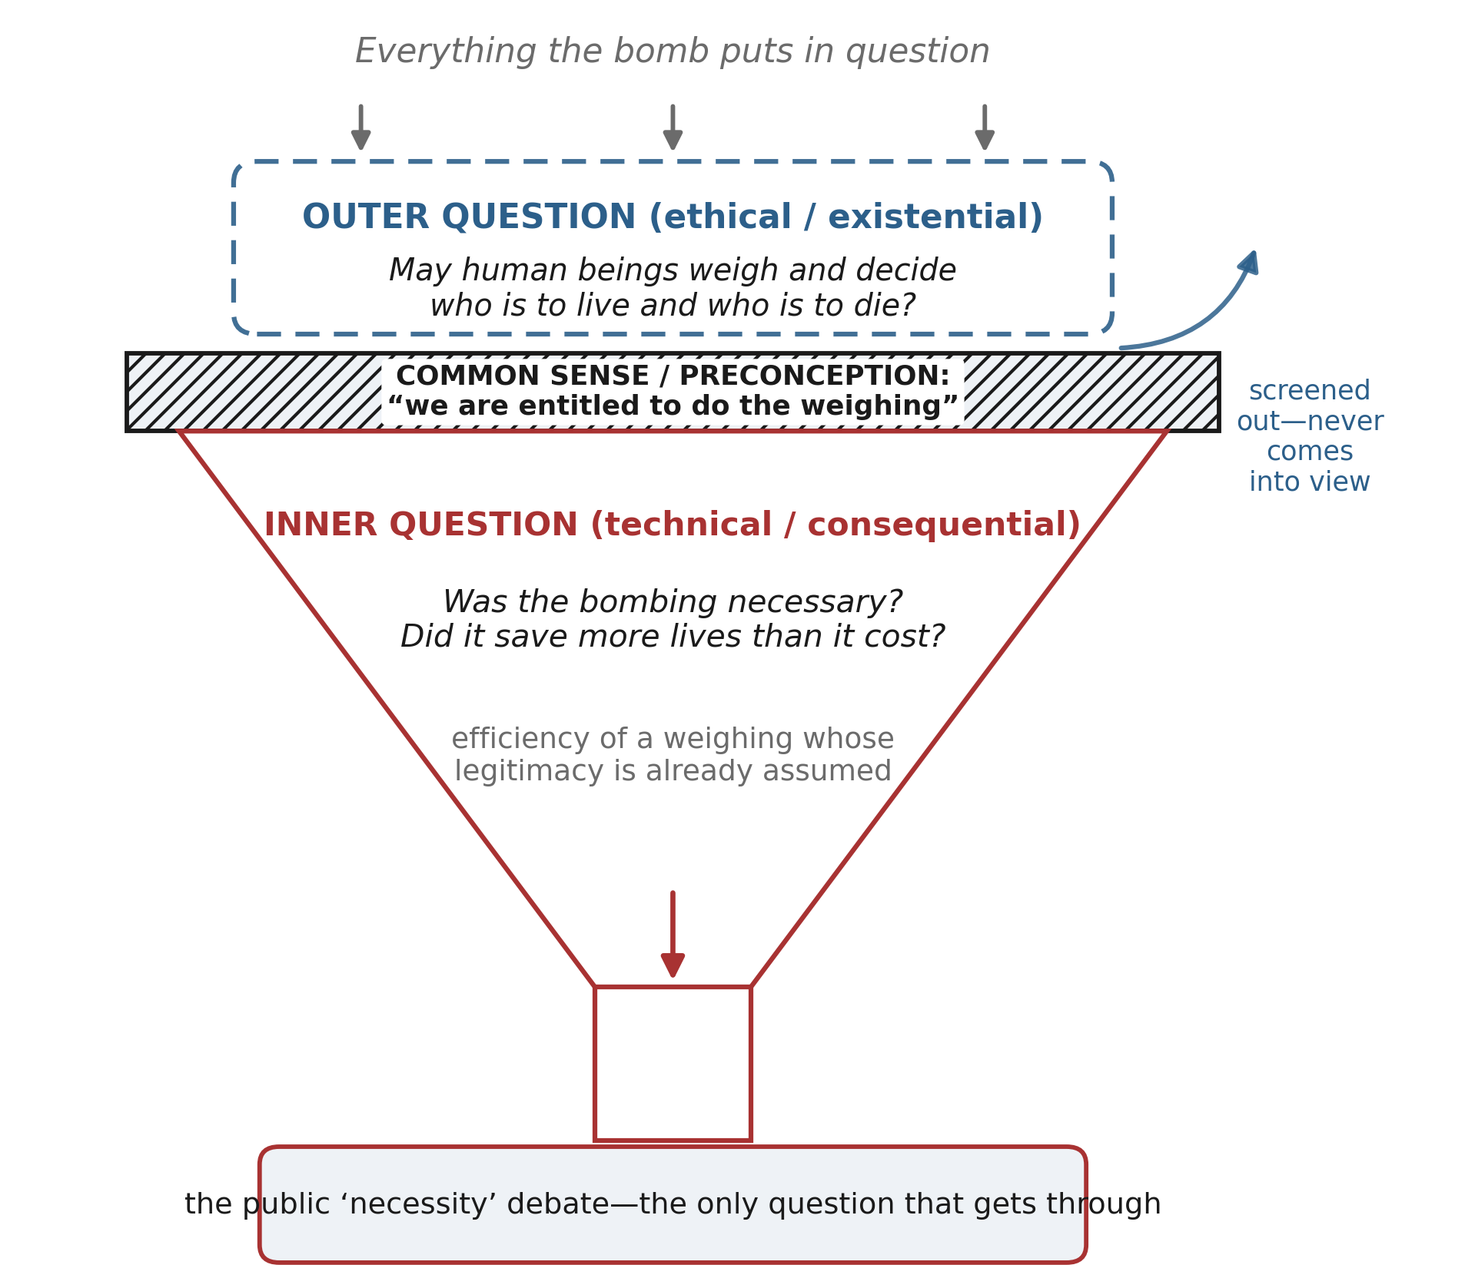
Figure 1. The funnel of attention. Every question the bombing raises pours in at the top, but a layer of common sense and preconception—that we are entitled to do the weighing—acts as a sieve: only the inner, technical question (“was it necessary?”) passes through into public debate, while the outer question—whether such weighing is ours to perform at all—is screened out and never comes into view.
Why the sums do not add up
The justification borrows its structure from utilitarianism, which holds that the right act produces the greatest balance of good over bad, summed across everyone affected. The summing is the crucial move, and it is more questionable than its long familiarity suggests. As John Rawls insisted, to add one person's loss into another's gain and call the net a justification is to fail to take seriously the distinction between persons—to treat a collection of separate lives as though it were a single great life with a single ledger.² There is no super-person who enjoys the sum; there are only the many, one of whom is being spent for the others. The invasion's phantom dead do not exist to be saved, and the citizens of Hiroshima were not compensated by the survival of strangers.
There is a deeper trouble still. Aggregation assumes that the goods and losses of different lives can be measured on one scale and converted into a common currency. But the measures are as many as the persons, and perhaps more: what a life is worth, what it is for, what its loss subtracts from the world, is answered differently from within each life, in terms that do not reduce to a shared unit. Value pluralists have long argued that goods are genuinely incommensurable—that there is no master scale on which a mother, a scholar, a child, and a soldier can be expressed as quantities and traded off.³ If that is right, the utilitarian ledger is not merely hard to compute; it is trying to add quantities that were never in the same units. The balance it reads off is an artifact of a scale it had to invent. The impossibility is not practical but principled.
Moral philosophers have built a whole laboratory around the smaller case: the runaway trolley that will kill five unless it is diverted onto one, and the surgeon who could save five patients by harvesting the organs of one healthy visitor. Most people flinch at the surgeon while accepting the switch, and the literature has spent half a century refining the distinctions—doing versus allowing, intending a death versus merely foreseeing it—that might explain the difference. Those distinctions are real and they matter. But notice that they, too, are conducted inside the calculus: they ask which weighings come out permissible. The outer question is prior. It does not ask whether the surgeon has correctly computed five against one; it asks what has already happened to a person when he becomes, in someone else’s reasoning, the one—a quantity to be spent so that a larger quantity may be kept. The atomic bomb is the surgeon’s case written at the scale of cities, and the unease most people feel at the surgeon is the outer question trying to make itself heard.
Choosing under finitude
And yet we cannot simply refuse to choose. Resources are finite; the harvest feeds some and not others; the lifeboat has a number. One might dream of escaping the predicament by making supply infinite or need vanishingly small, but neither is available to us: even the universe is finite, and nothing comes from nothing. So the tragic structure of choice under scarcity does not disappear, and any honest ethics has to say something about how to act inside it rather than pretending to abolish it.
Here is the pivot. If some weighing is unavoidable, the morally decisive line cannot fall on whether one weighs, but on how. I distinguish two attitudes that can wear the same numerical face. In the taking calculus, the other is an eliminable variable, a quantity to be zeroed out when the total improves; his death is a cost that the ledger, once balanced, treats as discharged. In the giving calculus, the other is an end, never merely a means; one weighs because one must, but one bears the weighing as loss, keeps faith with the one who could not be saved, and refuses to record him as a rounding error. The distinction is Kant's, between a price—the value of something for which an equivalent can be substituted—and a dignity, which admits of no equivalent and forbids the substitution.⁴ A person has a dignity, not a price; to reason about persons as though they had prices is the original move of the taking calculus.
The giving calculus is not innocent; it still weighs, and so is not free of tragedy. But the difference in attitude is not a psychological gloss on an otherwise identical act. It changes what the act is. It shows itself in a moral remainder—grief, and the sense of a wrong done even in doing what one had to—and in a direction: the giving agent absorbs cost onto himself before displacing it onto others. What was monstrous in the reasoning that reached for the bomb, on this view, is not that officials did arithmetic—statesmen under duress must reckon with numbers—but that they reasoned in the taking mode about people who were never theirs to price, and did so, moreover, having never once paused at the outer question. A society that can no longer hear the difference between taking and giving, so long as the totals match, has lost the thing that separates provision from predation.
Whom one may place on the scale
Even granting that some weighing is unavoidable, a further question is whom the weighing may range over at all. The just war tradition answers with the principle of noncombatant immunity: those who have not made themselves into agents of harm may not be made the direct objects of attack. Michael Walzer grounds the immunity in the idea that one becomes a legitimate target only by posing a threat, which is why even the munitions worker is liable at the factory yet regains his immunity at home.⁵ I would reground the line on consent and vocation rather than on function. The soldier who dies at his post dies within a calling he has assumed; there is a dignity available to him in the form of professional honor—the acceptance of mortal risk as part of a role freely shouldered. The civilian has consented to no such thing. He is a pure victim, and to place him on the scale is not to demand a sacrifice of him but to make him bear a cost he never undertook to bear.
This is also why the hardest case in the just war tradition—the munitions worker—turns on the same idea from the other side. If the worker is a legitimate target while building weapons, it is not simply because he is useful to the war, but because, in taking up that work, he has stepped partway into the zone of danger and shoulders something of a combatant’s risk. A society that finds the worker’s liability obvious but the civilian’s inviolability negotiable has, I suspect, a weak feeling for vocation and sacrifice—for the idea, captured in the old language of noblesse oblige, that those who accept danger do so precisely so that others need not. Where that feeling is strong, the line protecting the pure victim is not a technicality to be argued around; it is the visible edge of a whole ethic of who owes danger to whom.
This is why the atomic bombing is, on the outer view, beyond argument. It did not aim at soldiers, or even at workers while at their machines; it aimed at cities—at civilian populations as such, whose deaths were the instrument by which a government elsewhere was to be moved. Elizabeth Anscombe saw this clearly when she opposed the honoring of the man who ordered it: the deliberate killing of the innocent as a means to one's ends is murder, and no accumulation of good consequences converts murder into something else.⁶ That a society finds this debatable is itself the symptom worth noticing. It suggests a thin sense of the very ideas—vocation, sacrifice, the honor of those who accept danger so that others need not—that mark the civilian off as inviolable in the first place.
The sovereign who weighs
Who, then, appointed anyone the accountant? Modern political thought has a name for the power that decides which lives may be placed outside the circle of those it is a crime to kill. Giorgio Agamben calls it sovereign power, exercised over what he calls bare life; Michel Foucault describes a biopolitics that administers populations in the aggregate, deciding whom to make live and whom to let die.⁷ Strategic bombing, the language of acceptable losses, the actuarial cast of nuclear deterrence—these are that power in its late form, the taking calculus raised to the scale of peoples and dressed as necessity. The outer question is, at bottom, a refusal to grant that power its self-appointment. And it is not a museum piece. In a world that is rearming, and in which the threat to hold whole populations hostage is once more spoken aloud, the temptation to reason about the many as summable quantities is not receding but returning.
Two civilizations, and a mismatch
Step back to the largest scale. Civilizations meet scarcity in two broadly different ways. One increases supply—it expands, conquers, converts, opens new frontiers and draws them into itself. The other reduces demand—it contracts, defends, disciplines its own wanting, and seeks sufficiency rather than growth. The two strategies have loose affinities with religious forms: a tradition of one exclusive truth tends to treat the world as a frontier still to be brought in, while immanentist and pluralist traditions, finding the sacred already here, feel less pull toward expansion. The affinities are only tendencies—ascetic Protestantism reduced demand and yet, as Weber saw, midwifed a vast engine of supply—but the two axes, supply-versus-demand and expansion-versus-contraction, are worth holding apart, because a great deal of history lives on their off-diagonals.
It is tempting to think that an expansionist civilization needs only an open frontier to stay at peace, so that a new frontier—outer space, say—might drain its pressure and quiet its wars. I think this is half true, and the half that is false is instructive. The frontier such traditions crave is really two frontiers of different kinds. The material frontier is extensive: empty land and unused energy, a matter of volume that more space can enlarge. The spiritual frontier is intensive: it is aimed at particular souls and at the neighbor who believes otherwise, a matter of density, not volume. The two cannot be exchanged: an intensive demand cannot be discharged into an extensive supply. The pattern is suggestive rather than probative, but it is at least striking that the Age of Discovery flung open a vast material frontier and yet coincided with Europe's most terrible wars of religion. Space enlarges only the extensive frontier; it leaves the mismatch untouched and may even amplify the intensive drive to carry one's own truth to the stars. If the heavens pacify anything, it will not be as an outlet but as a mirror—the view of the whole earth, undivided, that shrinks the tribal claim itself. And shrinking the claim is a reduction of demand, not an increase of supply.
Deterring the third war
This is the practical payoff. If the analysis holds, a third world war will not be averted by refining the calculus of deterrence—by making our threats more credible or our targeting more precise. That project stays on the inner layer and leaves untouched the disposition to treat lives as summable at all. What is needed is movement along both hands at once. Technology can raise supply, but it meets a ceiling in the finitude of the world, and worse, efficiency tends to enlarge appetite rather than sate it, so that supply-side progress underwrites the very growth in demand it was meant to relieve. Hence the second hand: a discipline of demand, the deliberate lowering of what we take ourselves to need. This is the sane core of what E. F. Schumacher called Buddhist economics—an economics organized around sufficiency rather than maximal consumption.⁸ At the level of the person it is the resolve to reduce one's own taking before displacing cost onto others; at the level of the civilization it is the choice of contraction and defense over expansion and conquest.
There is a name for what this makes possible: a second-order kind of prevention. First-order deterrence tries to make the next war too costly to start, and so keeps refining the very calculus of hostage populations that is the problem. Second-order prevention works upstream, on the appetite that generates the confrontation in the first place, and so aims to make the calculus less necessary rather than more exact. A civilization that has learned to want less has fewer occasions to place its neighbors on the scale, and a smaller stake in the frontiers over which the great wars are fought. Restraint of demand is not only an ethic; it is also a security posture, and for the small and exposed nations that have the most to lose in a war of expansion, it may be the one that reaches deepest toward the root.
The deepest prevention, then, is not a better weighing but a disciplined retreat from the posture of the one who weighs. We cannot reach the vanishing point at which no one need ever be placed on a scale; finitude forbids it. But we can decide which direction we face. Eighty years after Hiroshima, the question worth asking is not whether the bomb added up. It is whether we still wish to be the kind of beings who keep the books—or whether we might, at last, prefer to give in order to keep others alive rather than to take in order to live. That preference will not abolish tragedy. But it is the ground on which a third world war might become, not merely deterred, but unthinkable.
Notes
1. The classic public statement of the necessity thesis is Henry L. Stimson, “The Decision to Use the Atomic Bomb,” Harper’s Magazine, February 1947. For the historiographical challenge, see Gar Alperovitz, The Decision to Use the Atomic Bomb (New York: Knopf, 1995); and J. Samuel Walker, Prompt and Utter Destruction, 3rd ed. (Chapel Hill: University of North Carolina Press, 2016).
2. John Rawls, A Theory of Justice, rev. ed. (Cambridge, MA: Harvard University Press, 1999), 23–24; and Rawls, “Fifty Years after Hiroshima” (1995), in Collected Papers, ed. Samuel Freeman (Cambridge, MA: Harvard University Press, 1999), 565–572.
3. See Isaiah Berlin, “The Pursuit of the Ideal,” in The Crooked Timber of Humanity (London: John Murray, 1990); and Joseph Raz, The Morality of Freedom (Oxford: Clarendon Press, 1986), chap. 13.
4. Immanuel Kant, Groundwork of the Metaphysics of Morals, ed. and trans. Mary Gregor (Cambridge: Cambridge University Press, 1998), 4:434–435.
5. Michael Walzer, Just and Unjust Wars, 5th ed. (New York: Basic Books, 2015), 138–159.
6. G. E. M. Anscombe, “Mr Truman’s Degree” (1957), reprinted in her Ethics, Religion and Politics: Collected Philosophical Papers, vol. 3 (Oxford: Blackwell, 1981), 62–71.
7. Giorgio Agamben, Homo Sacer: Sovereign Power and Bare Life, trans. Daniel Heller-Roazen (Stanford: Stanford University Press, 1998); Michel Foucault, The History of Sexuality, vol. 1, trans. Robert Hurley (New York: Pantheon, 1978), 135–145.
8. E. F. Schumacher, Small Is Beautiful: Economics as if People Mattered (London: Blond & Briggs, 1973), chap. 4 (“Buddhist Economics”).

