Beyond the Calculus of Lives: Commensurability, the Ethics of Giving, and the Civilizational Roots of Total War
Abstract
Debates over whether the atomic bombing of Japan was necessary are conducted inside a calculus: they ask whether a weighing of lives came out right. This article shifts the layer of the question and asks whether human beings are the kind of agents entitled to weigh and decide who is to live and who is to die. I argue, first, that the utilitarian justification presupposes a commensurability of lives that value pluralism gives us reason to deny; second, that because finitude makes some choosing unavoidable, the morally decisive line falls not on the outcome of a weighing but on its attitude—whether the other is treated as an eliminable variable or as an end whose loss is borne as loss. I then read the sovereign power to weigh lives through Agamben and Foucault, and locate total war in a civilizational choice between increasing supply and reducing demand. Preventing a third world war, I conclude, requires not a better calculus but a disciplined retreat from it.
Keywords: nuclear ethics; commensurability; value pluralism; just war; noncombatant immunity; biopolitics; Buddhist economics; the ethics of finitude
1. Shifting the Layer of the Question
Eight decades after the Pacific War, the destruction of Hiroshima and Nagasaki is still defended in a familiar idiom. On this account the bombs, for all their horror, were necessary: they ended the war quickly and so spared the far larger number of lives—American and Japanese, combatant and civilian—that an invasion of the home islands would have consumed.¹ Historians have contested the factual premises of this story for decades, questioning whether surrender was imminent, whether the casualty projections were inflated after the fact, and whether the demonstration of power to the Soviet Union was the operative motive.² That empirical quarrel is important, but it is not my subject. I want to notice something about the shape of the justification itself, quite apart from whether its numbers are right.
The justification is a piece of arithmetic. It concedes that lives were taken and answers that more lives were saved; it sets the dead of two cities on one pan of a scale and the hypothetical dead of an invasion on the other, and reads off the balance. Grant, for the sake of argument, every factual claim the defender wants—that the bombs did shorten the war, that they did avert a bloodier invasion. A question remains that the arithmetic cannot pose to itself, because it presupposes the answer: are human beings the kind of agents who may set themselves up as the accountants of one another's lives, deciding who shall live and who shall die in another's stead?
I call this a shift in the layer of the question (Figure 1). The “was it necessary?” debate operates inside the calculus; it audits a weighing whose legitimacy it never examines. The question I press sits outside the calculus and asks whether we are entitled to perform it at all. The two layers are logically independent: one can win every point on the inner layer—concede that the sums add up—and still have said nothing to the outer one. Much of what passes for moral debate about the bomb, and about war more generally, is an argument on the inner layer mistaken for an argument on the outer. The distinction is not merely analytic housekeeping. Which layer a society instinctively argues on reveals what it already takes for granted about the standing of persons.
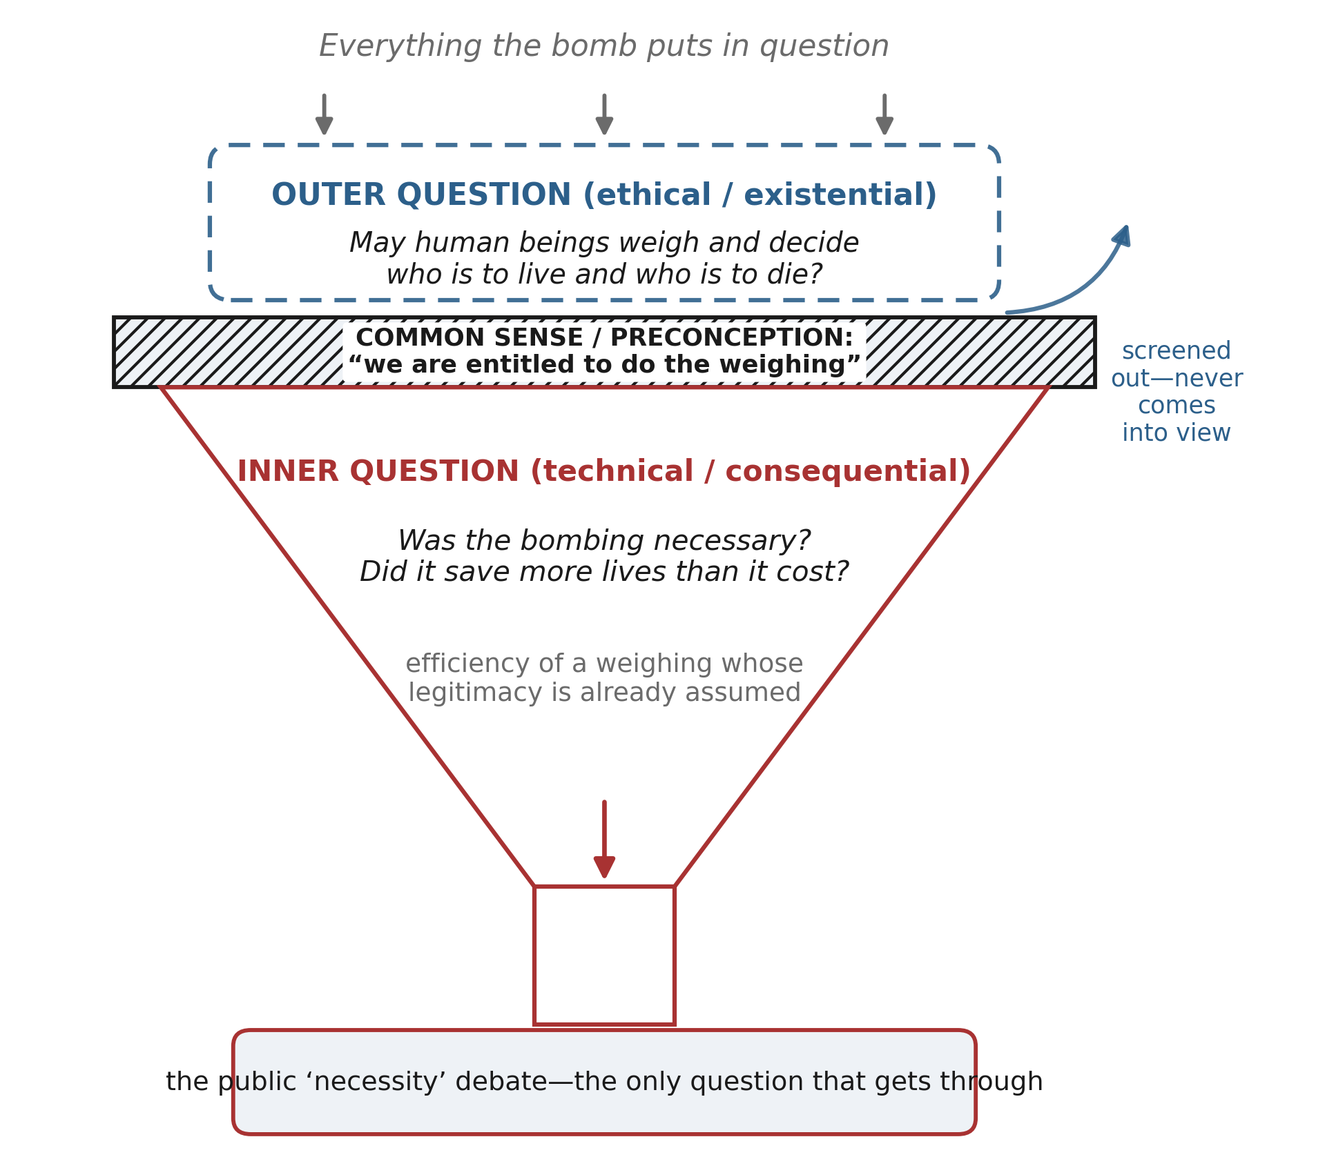
Figure 1. The funnel of attention. Every question the bombing raises enters at the top, but a layer of common sense and preconception—that we are entitled to do the weighing—acts as a sieve: only the inner, technical (“was it necessary?”) question passes through into public debate, while the outer question—whether such weighing is ours to perform at all—is screened out and never comes into view.
The same doubling of layers holds for war in general, and in any of its forms. Economic coercion and cultural domination are also ways of securing one's own flourishing by drawing down another's; they, too, invite the inner-layer question of whether they “work” and the outer-layer question of whether one may play the role they cast one in. My aim in this article is to give the outer question a rigorous statement, to show that it has deep roots in the ethical tradition, and to connect it to a larger diagnosis of why civilizations go to total war—and thus to the practical problem, acute again in a fluid and rearming world, of preventing a third one.
A word on method and scope. This is a work of normative argument, not of historical revision; I take no stand on the disputed facts of 1945 beyond granting the defender his most favorable version, precisely so that the outer-layer question can be isolated from the empirical quarrel that usually swallows it. Nor do I claim that the argument settles what any particular government should do in a given crisis; its ambition is prior to that—to recover a question that policy has learned not to ask, and to show that the recovery has consequences all the way down, from the metaethics of value to the design of security institutions. The choice of Hiroshima as the case is deliberate. It is the moment at which the arithmetic of lives was performed most explicitly, at the largest scale, and with the clearest public conscience; if the outer-layer question has force anywhere, it has force here, and what is learned here transfers to the quieter weighings—of sanctions, of deterrence, of the acceptable civilian toll—that fill the ordinary conduct of states. The bomb is not the disease but its purest symptom, and I use it as a lens rather than a target.
2. The Impossibility of the Calculus: Commensurability and Its Denial
Begin with the framework the justification tacitly assumes. Consequentialism in its classical utilitarian form holds that the right act is the one that produces the greatest balance of good over bad, summed impartially across all those affected.³ Aggregation is essential to it: goods and harms accruing to distinct persons are entered into a single ledger and totalled, so that a large enough benefit spread across many can always, in principle, outweigh a grave harm concentrated on a few.⁴ The atomic justification is this structure applied to lives. It treats being killed as a quantity of disvalue, holds that such quantities can be added across persons, and concludes that the smaller sum is to be preferred.
The first and most famous objection is Rawls's. Utilitarianism, he wrote, “does not take seriously the distinction between persons”: it extends to society as a whole the principle of rational choice for one person, as though the many individuals were so many desires within a single super-person whose satisfactions could be traded off against one another.⁵ But persons are not fused in this way. The loss suffered by the one who is sacrificed is not compensated by the gains of those who are spared, because there is no experiential subject who both loses and gains. Bernard Williams pressed a companion point: the impartial sum requires the agent to treat his own deepest commitments—and, I would add, the irreplaceable particularity of the person before him—as just one more input to be overridden whenever the total demands it, alienating him from the very integrity that makes him a self.⁶ Thomas Nagel, writing specifically of massacre in war, concluded that there are things one may not do to a person whatever the numbers, because the victim can rightly ask the agent, of what is being done to him in particular, “why?” and receive no answer that is about him rather than about the sum.⁷
These are objections to aggregation. I want to add a deeper one, directed at the presupposition that makes aggregation intelligible in the first place: commensurability. To add two things on one scale, they must share a common measure, a single dimension of value in terms of which each can be expressed as so many units. The utilitarian ledger assumes that the worth of a life, and of everything a life contains, can be rendered on such a scale. Value pluralism denies this. Isaiah Berlin argued that the goods of human life are genuinely many, not reducible to one master value, and that they can conflict without there being any common currency in which their conflict is settled.⁸ Joseph Raz refined the point into a formal thesis of incommensurability: two options are incommensurable when it is false both that one is better than the other and that they are of equal value—when, that is, the very relation “greater than, equal to, or less than” fails to hold between them.⁹
Now consider what a human life is as an object of valuation. Each life is the bearer of its own ends, its own attachments, its own irreplaceable vantage on the world; the scales by which worth might be reckoned are as many as there are persons, and arguably more, since a single life contains plural and competing goods within itself. Even granting that within one life some rough ranking of options is possible, between lives there is no shared unit into which each can be converted for summing. The utilitarian must assume that “one death” on the Hiroshima pan and “one death” on the invasion pan denote fungible quantities of the same stuff. But a death is the extinction of a world, and worlds are not fungible.¹⁰ This is a more radical charge than Rawls's. Rawls grants that the losses and gains are commensurable and objects that they may not be summed across the boundaries between persons; the incommensurability objection says that the entries were never expressible in a common unit to begin with, so that the summing is not a forbidden operation but a meaningless one.¹¹
If this is right, the atomic justification does not merely reach a repugnant conclusion; it commits a category mistake. It presents as the output of a calculation something that no calculation could deliver, because the magnitudes it purports to compare were never on a common scale. The rhetoric of “lives saved” borrows the authority of arithmetic without the entitlement to it. This does not yet tell us what to do. It tells us that whatever we do, we cannot honestly represent it as the sum the defender claims to have computed.
It will be objected that we compare lives constantly and unavoidably: the battlefield medic triages, the health system prices a year of life, the regulator fixes a value on statistical mortality. If incommensurability were true, the objection runs, all such practice would be impossible, and since it is not impossible, incommensurability must be false. The reply turns on a distinction the objection blurs. To choose under incommensurability is not the same as to choose by computing a common sum. The medic who saves the salvageable is not asserting that the salvageable life contains more units of a homogeneous good than the life he lets go; he is acting well under a tragic constraint without claiming that arithmetic vindicates him. What incommensurability denies is not that we can choose, nor even that some choices are better than others, but that the choice is licensed by, and answerable to, a cardinal quantity of aggregated value.¹⁰ At most there is rough comparability—enough to act, never enough to certify a killing as the balance struck by a ledger.⁹ The atomic justification does not merely choose under tragedy; it claims the authority of a sum. That claim, and not the possibility of hard choice, is what the argument refuses.
3. Choosing Under Finitude: The Taking Calculus and the Giving Calculus
One might read the argument so far as a counsel of paralysis: if lives cannot be weighed, then any choice among them is illegitimate, and we are left mute before every tragic dilemma. That conclusion does not follow, and it is worth seeing exactly why, because the reason marks the turn from critique to construction.
We could escape the need to choose among lives only under one of two conditions: if supply were infinite, so that no one's provision came at another's expense; or if demand were infinitesimal, so that embodied beings asked nothing of a finite world. Neither is available to us. The universe itself is finite, and nothing comes from nothing; there is no arrangement of matter and energy under which the last scarcity is abolished. Choice under scarcity is therefore not a contingent predicament we might one day engineer away but a standing feature of embodied existence. To choose is, in some measure, always to weigh. The critic of the calculus who imagines he has clean hands has merely declined to notice the weighings his own life already performs.
So the honest position is not that we may never let considerations of number bear on action, but that the difference between a defensible and an indefensible weighing lies elsewhere than in its result. My proposal is that it lies in the attitude the agent takes toward those he must weigh. Consider two calculi that might issue in numerically identical choices. In the first—call it the taking calculus—the other person figures as an eliminable variable, a term in someone else's survival function that may be set to zero when the total improves. In the second—the giving calculus—the other figures as an end, someone to whom the agent stands in a relation of responsibility, so that even a choice that cannot be avoided is registered and borne as a wound rather than discharged as a computation.
The distinction is Kantian at its root. Kant separated things that have a price, for which an equivalent can be substituted, from what has dignity, which is “raised above all price and therefore admits of no equivalent.” To have dignity is precisely to be incommensurable, to resist the substitution that pricing presupposes; and persons, as ends in themselves, have dignity rather than price.¹² The taking calculus prices the person—fixes an equivalent for him and pays it out for a larger return. The giving calculus refuses the equivalence even as it acts, and so keeps faith with the dignity it cannot honor perfectly. Emmanuel Levinas gives the same structure a phenomenological form: the face of the other addresses me with a claim that precedes and exceeds any totality into which I might sum him, an infinity that says, before all calculation, ‘you shall not kill.’¹³ To weigh in the giving mode is to weigh while remaining answerable to that address.
What, concretely, distinguishes the two? Not, by hypothesis, the tallies. The marks are three. First, remainder: the giving calculus leaves a moral remainder—grief, responsibility, the sense of a wrong done even in doing what one had to—where the taking calculus, having balanced its books, feels itself owed nothing and mourns nothing. Second, direction of the tie-breaker: forced to choose, the giving agent absorbs cost onto himself and his own projects before displacing it onto others, whereas the taking agent optimizes without any such asymmetry. Third, the standing of the unchosen: the giving calculus continues to regard the one it could not save as a claimant with a grievance, not as a rounding error. What was monstrous in the reasoning that reached for the bomb, on this view, is not that officials did arithmetic—statesmen under duress must reckon with numbers—but that they reasoned in the taking mode about people who were never theirs to price, and did so, moreover, having never paused at the outer-layer question at all.
A hard-nosed reader will protest that this makes morality turn on a feeling. If two acts have the same outcome, what can it matter whether the agent mourned? The objection assumes that the remainder is a mere sentiment decorating an act whose moral character is already fixed by its consequences. But the remainder is not decoration; it is evidence, and sometimes constitutive. Bernard Williams called the residue that a decent agent feels after a forced wrong agent-regret, and argued that its absence marks not toughness but a failure to register a moral reality: that a genuine claim was overridden, not annulled.¹⁴ Martha Nussbaum, reading Greek tragedy, showed that the mature response to an irresolvable conflict of obligations is not to declare the defeated obligation cancelled by the victorious one but to remain answerable to both, and so to owe something to the party one had to fail.¹⁵ The remainder tracks this fact. And because it does, it is not inert: the agent who feels it acts differently next time—builds the institutions, the rules of engagement, the habits of restraint that a society without the remainder never troubles to build. Attitude, in this sense, is not private sentiment but a disposition with public and cumulative effects. It is the difference between a polity that treats each recourse to lethal force as a wound to be minimized and one that treats it as a cost to be optimized.
I concede without embarrassment that the giving calculus still weighs, and so is not innocent of the tragic structure of finite life. To choose whom to feed with a finite harvest is still to prefer some to others. But the difference in attitude is not a psychological gloss on an otherwise identical act; it changes what the act is. A society that has lost the distinction—that hears no difference between taking and giving so long as the totals match—has lost the thing that separates provision from predation.
4. Whom One May Place on the Scale: Combatants, Civilians, and the Ethics of the Professional
Even granting that some weighing is unavoidable and that its mode is what matters morally, a further question arises about its scope: over whom may the weighing range at all? Here the just war tradition has an answer that the outer-layer view can endorse and deepen. The principle of noncombatant immunity holds that those who have not made themselves into agents of harm may not be made the direct objects of attack; the combatant, who has taken up the business of force, has forfeited the immunity the civilian retains.¹⁶ Michael Walzer grounds the immunity in the idea that one becomes a legitimate target only by posing a threat, by entering the zone of danger as a participant—which is why, on his account, even the munitions worker is liable while at the factory and making weapons, yet regains his immunity at home, where he is a person and not a threat.¹⁷
I want to reground this line where Walzer draws it, shifting its basis from function to consent and vocation. The soldier who dies at his post dies within a calling he has assumed; there is a dignity available to him in the form of professional honor, the acceptance of mortal risk as constitutive of a role freely shouldered—the ethic captured in the older language of noblesse oblige, obligation that rank and capacity impose. The civilian has assumed no such calling. He is a pure patient of the violence, a victim in the strict sense of one who has consented to nothing. If a weighing must fall somewhere, it should fall toward those who have taken the risk into their vocation and away from those who have not—not because the soldier's life is worth less on some scale (the argument of Section 2 forbids that comparison) but because he, unlike the civilian, has a relationship to the danger that makes his dying intelligible as something other than sheer wrong done to him. Here the professional's readiness to stand in harm's way is not a devaluing of his life but the highest expression of its dignity.
The consent basis invites an immediate objection: most soldiers through history have been conscripts, pressed into service by states they did not choose, and some—child soldiers above all—cannot consent in any meaningful sense. If liability depended on literal autobiographical consent, the account would exempt most combatants and collapse. So I do not rest it there. Consent is the clearest case of a more general relation: standing within the role of a bearer of arms, and thereby presenting oneself as a threat and entering the zone of danger. The role is normative, not merely biographical; the conscript, however he arrived at it, occupies it and poses the threat that grounds his liability, whereas the civilian occupies no such role and poses no such threat. What the vocation account adds to the bare fact of threat is an explanation of why the soldier's death can be more than sheer wrong done to him—why there is honor available in it—and that explanation is fullest where the role is freely embraced and thinnest where it is coerced. This is why our moral unease rightly returns, rather than disappears, in the case of the child soldier: we sense that someone has been placed in the zone of danger who never could have shouldered its meaning, and the wrong belongs to those who put him there. The account thus tracks our judgments across the range of cases better than the crude function test, which would make liability a simple matter of causal contribution to the war effort.
This yields a verdict on the bomb that requires no delicate balancing. The atomic attacks did not target the soldier at his post or even the worker at his factory; they took the city itself—the civilian as such, the pure patient—as the direct object, indeed as the intended instrument, the terror of whose death was the very mechanism by which surrender was to be produced. Under the doctrine of double effect, which permits foreseen but unintended civilian deaths incident to a legitimate military aim but forbids their use as a means, this is not a hard case.¹⁸ The killing of the innocent was not a side effect of striking something else; it was the instrument. Elizabeth Anscombe saw this with unmatched clarity when she opposed the award of an honorary degree to Truman, naming him a murderer on the ground that the deliberate killing of the innocent as a means to victory is murder whatever its consequences—and refusing the consequentialist frame that would make the question turn on a tally.¹⁹ Rawls, half a century later, reached the same judgment.²⁰
I add only this. That such a case is treated as genuinely debatable—that reasonable people are expected to argue about whether the incineration of noncombatant cities might be licensed by its results—is itself a symptom. It indicates a public culture in which the ideas of vocation and professional sacrifice have thinned to the point where the distinction between the one who has accepted danger and the one who has not no longer registers, and every death is flattened into an interchangeable unit of disvalue awaiting its place in a sum. The debatability of the bomb is a measure of how far the taking calculus has colonized the moral imagination.
The most serious challenge to this verdict is Walzer's own doctrine of supreme emergency. Faced with an imminent and unprecedented threat—Nazism triumphant, say—Walzer allows that a political community may deliberately violate noncombatant immunity, as Britain arguably did in the early area bombing of German cities, because the very existence of a moral world is at stake.²¹ If the prohibition can be overridden in extremis, the objection runs, then it is after all a weight in a balance, and we are back inside the calculus. I resist this at both levels. On the outer view, the prohibition on using the innocent as a mere means is not a heavy weight but a constraint of a different type—not something that great enough stakes outweigh, but something that stakes do not reach; supreme emergency is precisely the taking calculus readmitted under the duress that makes it most tempting and least examined. But even those unwilling to go so far should notice the second point: the atomic case does not satisfy Walzer's own conditions. The United States in 1945 faced neither imminent defeat nor an existential threat to its moral community; it faced the prospect of a costlier victory it was already assured of winning. Whatever one thinks of supreme emergency in the abstract, the bombing was not an instance of it. The exception, even granted, does not cover the case.
5. The Sovereign Who Weighs: Biopolitics and a Civilizational Diagnosis
The outer-layer question—may we weigh lives at all?—has a political history, and it is largely a history of the question's suppression. To decide who lives and who dies is the oldest signature of sovereign power, and modern thought has traced how that power installs itself precisely by never letting the outer question be asked. Giorgio Agamben argues that sovereignty consists in the capacity to produce “bare life,” life that may be killed without the killing counting as a crime—to draw the line between the life that is politically qualified and the life that is exposed.²² Michel Foucault describes the modern transformation of this power into biopolitics: a power that takes the life of populations as its object and administers it at the aggregate—fostering some lives, disallowing others to the point of death—through the apparatus of statistics, public health, and, at the limit, the calculated sacrifices of war.²³ The strategic bombing of cities is biopolitics in its most naked form: whole populations entered as quantities into an equation of national survival.
What these analyses share with my argument is the recognition that the gravest violence begins not with a wrong answer to the question of who may weigh, but with the question's disappearance—with the emergence of a standpoint from which weighing lives appears as an administrative task rather than a usurpation. To recover the outer-layer question is thus a political act: it reintroduces, against the sovereign's silence, the doubt about whether anyone is entitled to occupy the accountant's chair.
Nuclear deterrence is this biopolitics raised to a principle and made permanent. Under mutual assured destruction, entire civilian populations are held, continuously and by design, as hostages to the conduct of their governments; the credibility of the threat depends on a standing readiness to incinerate them. Thomas Schelling described this with cold precision as the diplomacy of violence, in which the capacity to inflict pain on the innocent is not an unfortunate by-product of war but its very instrument of persuasion.²⁴ Here the taking calculus is not merely committed in a moment of decision but institutionalized as a posture maintained around the clock, for decades, as the ordinary condition of international order. The outer-layer question, asked of deterrence, is radical precisely because deterrence has normalized what it interrogates: it treats the reduction of populations to hostages—to summable quantities of potential disvalue—as the settled grammar of security. That this arrangement is widely regarded as prudent, even stabilizing, is the clearest measure of how completely the sovereign's chair has been occupied without the question of entitlement being raised.
Why do polities drift toward this standpoint, and toward the total wars it licenses? Here I offer a wider diagnosis. Confronted with the finitude that makes provision a problem, a civilization can lean in one of two directions: it can seek to increase supply—to expand the stock of what there is, if necessary by taking it from others—or it can seek to reduce demand, to want less and so to need less of the world. The two leanings carry characteristic postures toward the outside: the supply strategy tends toward expansion and conquest, the demand strategy toward contraction and defense.
These leanings have religious signatures, and it is tempting to line them up neatly—expansionist monotheism against contractive polytheism and pantheism. There is something to the alignment. A tradition organized around a single universal truth is structurally disposed to treat the outside as unredeemed territory awaiting incorporation, so that mission and conquest travel together; Lynn White Jr. argued that the Western desacralization of nature, licensing its unlimited exploitation, has specifically monotheistic roots.²⁵ A tradition that finds the divine distributed through an already-full world—pantheist, animist, immanent—has, by contrast, no external frontier to conquer and inclines toward harmony and restraint; early Buddhism makes the reduction of demand into an explicit soteriology, treating craving itself as the thing to be extinguished.
But the neat alignment must be resisted, for the axes come apart under scrutiny (Figure 2). Monotheism contains powerful demand-reducing currents—the desert ascetics, the monastic vow of poverty, the Franciscan embrace of want—and Max Weber famously showed how one such ascetic impulse, Protestant this-worldly self-denial, issued by an unintended dialectic in the limitless accumulation of capital, demand-reduction feeding supply-expansion.²⁶ Conversely, polytheisms have been engines of conquest: Rome absorbed the gods of the peoples it subdued, and some agrarian cults sustained their fertility by extracting sacrificial victims from without. The lesson is that “supply-increasing versus demand-reducing” and “expansion versus contraction” are two independent axes, not one, and the religions distribute themselves across all four quadrants. What the map preserves from the naive typology is only this: the theology of an infinite external frontier and the ethic of unlimited supply are natural allies, and both stand at the maximal distance from the outer-layer question. Where the world is a frontier to be taken, the peoples on it are variables to be optimized. This is the metaphysical home of the taking calculus.
I should be explicit about the status of these claims, since a typology that sorts religions risks caricature. I am not ranking traditions by moral worth, nor predicting the behavior of their adherents, who overwhelmingly live at peace with their neighbors. The claim is about the structural tendencies of doctrines under pressure—about the directions in which a metaphysic inclines a civilization when scarcity forces the question of provision—not about the character of believers. And the two-axis map is built precisely to defeat the caricature it might seem to invite: because supply-orientation and expansion are independent of each other, the framework predicts and accommodates the counterexamples rather than being embarrassed by them. Ascetic Protestantism sits in the demand-reducing column and yet, by Weber's dialectic, drove supply-expansion; imperial Rome sits among the polytheisms and yet conquered without limit. These are not anomalies to be explained away but data the model is designed to hold. What survives the qualifications is modest and, I think, secure: a metaphysic of the infinite external frontier lowers the threshold at which a civilization will reach for the taking calculus, and nothing in the typology licenses the inference from a people's creed to its guilt.
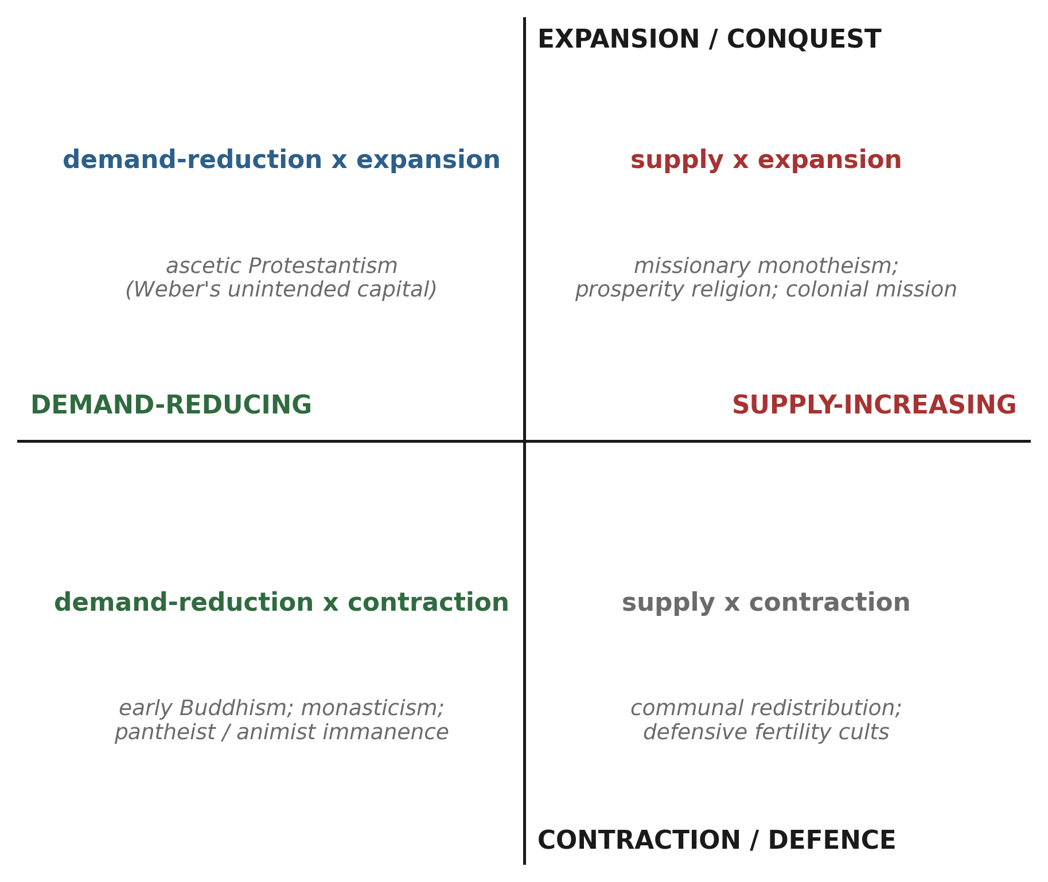
Figure 2. Two independent axes—supply-increasing vs. demand-reducing, and expansion vs. contraction—with illustrative religious and economic types. The naive alignment of monotheism with expansion and pantheism with restraint holds only as a tendency; ascetic Protestantism and expansionist polytheism occupy the off-diagonal cells.
5.1 The Frontier Mismatch: Intensive and Extensive Frontiers, and a Third Incommensurability
A single mechanism can be extracted from this diagnosis, and it bears directly on the contemporary fear of civilizational war. A tradition of the infinite external frontier depends, for its peace, on the frontier remaining open: Frederick Jackson Turner argued that the vitality and cohesion of an expansionist society are sustained by the availability of unclaimed land, so that the closing of the frontier throws the expansionist energy back upon the society itself.²⁷ One might infer that once the known and unclaimed regions are exhausted, collision becomes inevitable, and that a new frontier—outer space, say—might therefore drain the pressure and pacify the wars of the expansionist creeds. I think this inference is half right, and that seeing why sharpens the whole account.
The frontier that such traditions crave is not one thing but two, and the two have different topologies. The material frontier is extensive: empty land, unused energy, a matter of volume that more space can always enlarge. The spiritual frontier is intensive: it is directed at particular souls, at the neighbor who believes otherwise, at territory that is not empty but wrongly occupied—a matter of density, not of volume. The two cannot be exchanged for each other. An intensive demand cannot be discharged into an extensive supply, because the object the intensive drive seeks (this heretic, converted or erased) is not the object the extensive frontier offers (that empty expanse, settled). This is a third incommensurability, and it is the same blade that has cut twice already, now recurring at the civilizational scale: as lives are not convertible into a common unit (Section 2) and dignity is not convertible into price (Section 3), so the spiritual and material frontiers are not convertible into each other. Conflict springs less from the exhaustion of frontier than from the mismatch between the two frontiers—from the attempt, and the failure, to vent an intensive pressure through an extensive outlet.
The historical record fits the mismatch better than the exhaustion story. The Age of Discovery flung open a vast extensive frontier, yet Europe’s most terrible religious war, the Thirty Years’ War, raged in the same epoch: the new material space did nothing to relieve the intensive pressure of confessional truth-claims turned against the neighbor. Conversely, where the intensive demand is low—where a plurality of truths has been inwardly accepted—religious war is rare even under material scarcity. What varies is not the quantity of available frontier but the phase-match between the two kinds. The implication for the space age is sobering. Space enlarges only the extensive frontier; it leaves the phase gap untouched, and the very triumph of expansion may amplify the intensive drive to carry one’s own truth to the stars—a Jevons rebound of the spirit. The one pacifying path space might open is not the frontier as outlet but the frontier as mirror: the ‘overview effect,’ the relativizing of tribal and confessional boundaries reported by those who have seen the earth whole and undivided from outside.²⁸ But that works by lowering the intensive demand itself—by shrinking the claim rather than enlarging the supply—and so belongs, once again, to the demand-reducing hand to which I now turn.
6. Deterring Total War: The Two-Handed Task of Technology and Thought
If the analysis is right, the prevention of a third world war cannot be secured by refining the calculus of deterrence—by making our weighings of populations more accurate or our threats more credible. That project remains on the inner layer and leaves untouched the disposition to treat lives as summable at all. What is required is movement along both axes at once, technological and ideational, toward the asymptotes at which the pressure to weigh lives relaxes (Figure 3).
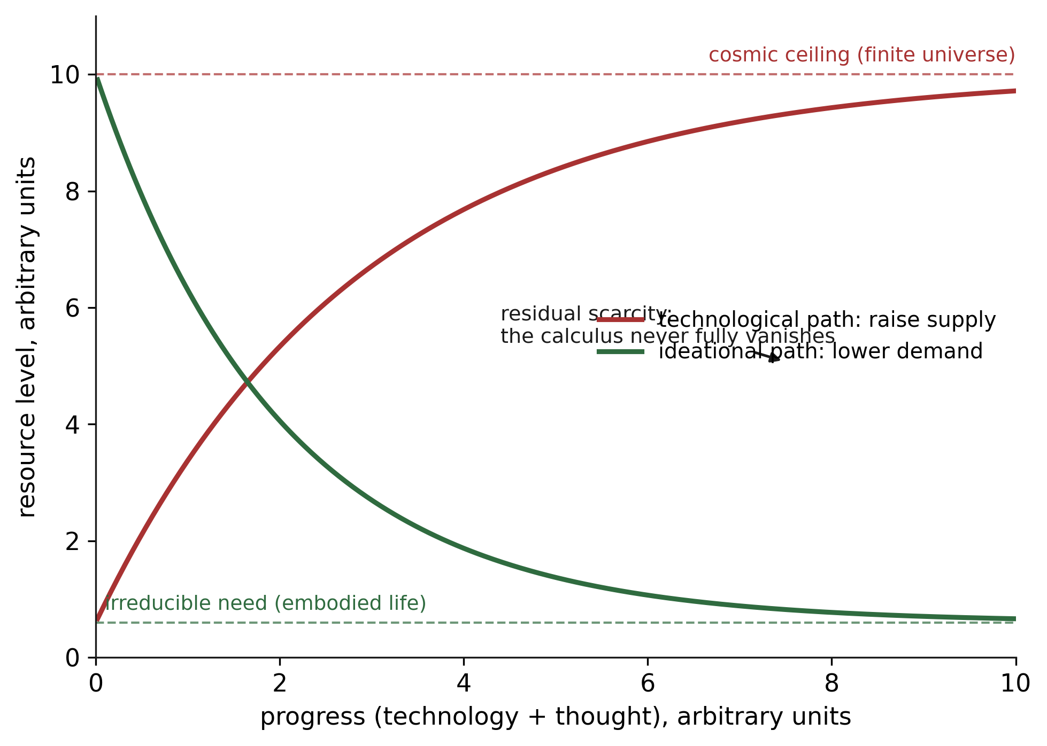
Figure 3. Asymptotic model of relief from the calculus. Raising supply approaches a cosmic ceiling; reducing demand approaches an irreducible floor set by embodied need. Neither reaches zero scarcity, so a residue of tragic weighing always remains; the claim is directional, not utopian.
The technological hand works on supply: more energy, more food, more of the material substrate of life, so that fewer provisions come at a rival's expense. Its promise is real but bounded, and bounded in two ways. It meets a final ceiling in the finitude of the universe; and, long before that, it is undercut by a perverse dynamic first noticed by William Stanley Jevons, who observed that improvements in the efficiency of coal use increased rather than decreased total consumption, because efficiency cheapens use and so multiplies it.²⁹ The rebound generalizes: supply-side progress, pursued alone, tends to inflate the very demand it was meant to satisfy, so that the frontier recedes as fast as one advances on it. Technology unaccompanied by any discipline of wanting does not close the gap between demand and supply; it runs in place, and licenses the endless expansion that keeps the taking calculus in business.
Hence the indispensability of the second, ideational hand, which works on demand: the deliberate cultivation of wanting less. E. F. Schumacher's “Buddhist economics” made this its first principle, defining the rational aim of economic life as the maximum of well-being with the minimum of consumption, rather than the maximum of consumption as such.³⁰ What I propose adds to Schumacher's economics the ethical and political content of the preceding sections: demand-reduction matters not only because it eases the material scramble but because it is the practical form of stepping down from the sovereign's chair. To reduce one's own demand is to withdraw, by just that much, from the position of the taker—to make oneself the first bearer of cost rather than the optimizer who displaces cost onto others. The discipline of wanting less is thus continuous with the giving calculus at the level of the person: the individual who lowers his own claims on a finite world is doing, in small, what a peaceable civilization must do in large. It is here that private asceticism and the avoidance of world war turn out to be the same movement viewed at different scales, and here too that the tradition of ahimsa, which refuses to license impure means by pure ends, meets the argument of Section 4.³¹
This is not a program for the abolition of scarcity or of choice; the asymptote is approached, never reached, and a residue of tragic weighing will always remain (Figure 3). Nor is it a counsel of passivity in the face of aggression: a civilization organized around contraction and defense must still defend, and Section 4's ethic of the professional who accepts danger on others' behalf is precisely the honorable form that defense takes. The claim is directional. A world that pours its ingenuity into raising supply while cultivating limitless demand is a world whose frontier is forever receding and whose politics is therefore permanently expansionary—the structural precondition of total war. A world that couples technological supply with an ethic of reduced demand is one in which the pressure to resolve scarcity by taking, and so to weigh the lives of others, steadily diminishes. Hans Jonas argued that the scale of modern technological power demands a new ethics answerable to the future and to the finite conditions of life on earth;³² the two-handed task is what such an ethics looks like when it is turned specifically against the recurrence of total war.
The realist will answer that this is a luxury of the secure. A civilization that unilaterally reduces its wants, he says, merely clears the field for the unrestrained, who will expand into the room it vacates; demand-reduction is a recipe for conquest by the greedy. The objection would be decisive against a doctrine of disarmament, but that is not the doctrine. What is to be reduced is demand—the appetite that drives a polity to resolve scarcity by taking from others—not the capacity to defend what one has. The two-handed task keeps the defensive hand; Section 4's ethic of the professional who accepts danger on others' behalf is exactly the honorable form that a contractive, defensive civilization's security takes. Indeed the argument cuts the other way for the exposed. A small state on a dangerous border cannot make itself safe by out-expanding a larger neighbor; its security, if it has any, lies in becoming hard to digest and cheap to leave alone—in defensive resilience joined to a politics that gives its neighbors no frontier to covet. For such a state, restraint of demand is not utopian sentiment but the most realistic security posture available. Joseph Nye argued that a defensible nuclear ethics must weave together consequences, rights, and intentions rather than collapsing into any one of them;³³ the account offered here specifies which thread is non-negotiable—the refusal to make the innocent a mere instrument—and which civilizational disposition makes honoring it sustainable.
7. Objections and Replies
Three further objections deserve a direct answer. The first is that the position is quietist: that in the face of atrocities demanding action, an ethic of wanting less and holding the scale reluctantly does nothing for the victims. But the argument is not a private spirituality of withdrawal. Its institutional content is considerable: it underwrites the laws of armed conflict and their prohibition on targeting civilians, the protection of the noncombatant as a right rather than a courtesy, and a security policy that measures itself by the wounds it refuses to inflict. To reduce demand at the civilizational scale is a program of political economy, not a counsel of retreat. Quietism would be the refusal to hold the scale at all; what is proposed is to hold it differently, and to build the institutions that a giving posture requires.
The second objection is that incommensurability, if taken seriously, paralyzes policy: governments must compare and aggregate, and a doctrine that forbids it forbids governing. The reply completes the one begun in Section 2. Incommensurability does not forbid choice; it forbids a particular self-description of choice—the claim that a killing has been vindicated by a computed surplus of value. Sound institutions already reflect this. The lexical priority of certain rights over aggregate welfare, the side-constraints that no cost-benefit total may breach, the categorical prohibitions of the laws of war: these are the giving calculus written into public structure, mechanisms by which a polity binds itself in advance not to treat certain persons as summable. Far from paralyzing policy, the view recommends a familiar and workable architecture, and explains why its constraints are not mere prudence but principle.
The third objection is that the distinction between taking and giving is unverifiable, a matter of inner attitude to which we have no access, and so useless for judgment. But the distinction is not locked inside the agent's breast. Its three marks are public. Whether a polity leaves a moral remainder shows in how it memorializes its dead and its enemy's, in whether it holds inquiries or averts its eyes; whether it directs the tie-breaker against itself shows in whether it accepts risk to its own forces to spare noncombatants, as the law of proportionality demands; whether it regards the unchosen as claimants shows in reparation, apology, and the revision of doctrine. Attitude leaves tracks. We read it in individuals every day, and we can read it in institutions by the same signs, writ large.
8. Conclusion
The question of whether the atomic bombings were necessary is the wrong question, or rather a question on the wrong layer. Answered on its own terms, in the affirmative or the negative, it leaves the graver matter untouched: whether human beings are entitled to weigh and trade the lives of others at all. I have argued that the weighing the justification claims to perform is not merely impermissible but, given the incommensurability of lives, unintelligible as arithmetic; that because finitude nonetheless forces us to choose, what distinguishes provision from predation is not the outcome of a weighing but its attitude—the taking calculus that prices the person against the giving calculus that keeps faith with a dignity it cannot perfectly honor; that the scope of any defensible weighing is constrained by the difference between those who have taken danger into a vocation and those who remain pure patients of it; and that the drift of whole civilizations toward the sovereign's chair, from which lives appear as summable quantities, is bound up with a choice between increasing supply and reducing demand.
These threads are one argument. The incommensurability that unmasks the calculus, the attitude that survives its collapse, the vocation that bounds its reach, the frontier that mismatches and so ignites, the two hands that might yet prevent—each is a face of a single refusal: the refusal to occupy the accountant's chair as though it were ours by right. The unity matters, because the danger is unified. A civilization does not arrive at the incineration of cities by a single wicked decision but by a long habituation, in which the person becomes a quantity, the quantity becomes summable, and the summing becomes governance. To interrupt that habituation at any one of its stages is to weaken it at all of them. That is why an argument pitched at the level of metaphysics and attitude is not a retreat from politics but its most durable form: institutions decay, treaties lapse, deterrents are outbuilt, but a people that has learned to flinch at the sovereign's chair carries the prohibition in a place no adversary can disarm.
The upshot for the prevention of a third world war is not a sharper calculus but a disciplined retreat from it. We are, by our nature as finite and embodied beings, condemned to some weighing; the whole moral question is in what spirit, over whom, and with how much reluctance we do it. To live for oneself by taking from another is the oldest of our motions. To give so that another may live—accepting that this, too, holds a scale, but holding it as one who would rather bear the cost than impose it—is the harder motion, and the one a survivable century will have to learn. Resources are finite, and so the scale will not be laid down in our time. But whose hand is on it, and whether that hand trembles, is ours to decide.
Notes
1. Henry L. Stimson, “The Decision to Use the Atomic Bomb,” Harper’s Magazine 194 (February 1947): 97–107.
2. Gar Alperovitz, The Decision to Use the Atomic Bomb and the Architecture of an American Myth (New York: Alfred A. Knopf, 1995); Tsuyoshi Hasegawa, Racing the Enemy: Stalin, Truman, and the Surrender of Japan (Cambridge, MA: Harvard University Press, 2005).
3. Jeremy Bentham, An Introduction to the Principles of Morals and Legislation (1789; Oxford: Clarendon Press, 1996); John Stuart Mill, Utilitarianism (1863), ed. Roger Crisp (Oxford: Oxford University Press, 1998).
4. Henry Sidgwick, The Methods of Ethics, 7th ed. (London: Macmillan, 1907), esp. bk. IV. On aggregation as the defining commitment, see Samuel Scheffler, The Rejection of Consequentialism, rev. ed. (Oxford: Clarendon Press, 1994).
5. John Rawls, A Theory of Justice, rev. ed. (Cambridge, MA: Harvard University Press, 1999), 24–25.
6. Bernard Williams, “A Critique of Utilitarianism,” in J. J. C. Smart and Bernard Williams, Utilitarianism: For and Against (Cambridge: Cambridge University Press, 1973), 108–118.
7. Thomas Nagel, “War and Massacre,” Philosophy & Public Affairs 1, no. 2 (1972): 123–144.
8. Isaiah Berlin, The Crooked Timber of Humanity: Chapters in the History of Ideas, ed. Henry Hardy (London: John Murray, 1990), 1–19.
9. Joseph Raz, The Morality of Freedom (Oxford: Clarendon Press, 1986), 321–366.
10. For the collection that frames the debate, see Ruth Chang, ed., Incommensurability, Incomparability, and Practical Reason (Cambridge, MA: Harvard University Press, 1997), editor’s introduction.
11. The contrast is developed in John Gray, Isaiah Berlin (Princeton: Princeton University Press, 1996), chap. 3, on the political stakes of pluralism.
12. Immanuel Kant, Groundwork of the Metaphysics of Morals (1785), trans. and ed. Mary Gregor (Cambridge: Cambridge University Press, 1998), 4:434–435.
13. Emmanuel Levinas, Totality and Infinity: An Essay on Exteriority, trans. Alphonso Lingis (Pittsburgh: Duquesne University Press, 1969), 194–201, 262–263.
14. Bernard Williams, “Moral Luck,” in Moral Luck: Philosophical Papers 1973–1980 (Cambridge: Cambridge University Press, 1981), 20–39, on agent-regret.
15. Martha C. Nussbaum, The Fragility of Goodness: Luck and Ethics in Greek Tragedy and Philosophy, rev. ed. (Cambridge: Cambridge University Press, 2001), esp. chaps. 2–3.
16. The principle of distinction is codified in Protocol I Additional to the Geneva Conventions (1977), arts. 48, 51. For its moral foundations, see Michael Walzer, Just and Unjust Wars: A Moral Argument with Historical Illustrations, 5th ed. (New York: Basic Books, 2015), chap. 9.
17. Walzer, Just and Unjust Wars, 145–146 (on the munitions worker).
18. The doctrine descends from Thomas Aquinas, Summa Theologiae II-II, q. 64, a. 7; for its modern statement see Philippa Foot, “The Problem of Abortion and the Doctrine of the Double Effect,” Oxford Review 5 (1967): 5–15.
19. G. E. M. Anscombe, “Mr Truman’s Degree” (1957), reprinted in her Ethics, Religion and Politics: Collected Philosophical Papers, vol. 3 (Oxford: Blackwell, 1981), 62–71.
20. John Rawls, “Fifty Years after Hiroshima” (1995), in Collected Papers, ed. Samuel Freeman (Cambridge, MA: Harvard University Press, 1999), 565–572.
21. Michael Walzer, Just and Unjust Wars, 5th ed. (New York: Basic Books, 2015), chap. 16 (“Supreme Emergency”); for criticism, see Brian Orend, The Morality of War, 2nd ed. (Peterborough: Broadview, 2013), chap. 5.
22. Giorgio Agamben, Homo Sacer: Sovereign Power and Bare Life, trans. Daniel Heller-Roazen (Stanford: Stanford University Press, 1998), 71–86.
23. Michel Foucault, “Society Must Be Defended”: Lectures at the Collège de France, 1975–76, trans. David Macey (New York: Picador, 2003), 239–264; and The History of Sexuality, vol. 1, trans. Robert Hurley (New York: Pantheon, 1978), 135–145.
24. Thomas C. Schelling, Arms and Influence (New Haven: Yale University Press, 1966), chap. 1 (“The Diplomacy of Violence”).
25. Lynn White Jr., “The Historical Roots of Our Ecologic Crisis,” Science 155, no. 3767 (1967): 1203–1207.
26. Max Weber, The Protestant Ethic and the Spirit of Capitalism (1905), trans. Talcott Parsons (London: Routledge, 1992), esp. chap. 5.
27. Frederick Jackson Turner, “The Significance of the Frontier in American History” (1893), in The Frontier in American History (New York: Henry Holt, 1920), 1–38.
28. On the ‘overview effect,’ see Frank White, The Overview Effect: Space Exploration and Human Evolution, 3rd ed. (Reston, VA: AIAA, 2014); and Carl Sagan, Pale Blue Dot: A Vision of the Human Future in Space (New York: Random House, 1994), 3–9.
29. William Stanley Jevons, The Coal Question, 2nd ed. (London: Macmillan, 1866), chap. 7. For the contemporary literature, see Blake Alcott, “Jevons’ Paradox,” Ecological Economics 54, no. 1 (2005): 9–21.
30. E. F. Schumacher, “Buddhist Economics,” in Small Is Beautiful: Economics as if People Mattered (London: Blond & Briggs, 1973), 50–58.
31. M. K. Gandhi, Non-Violent Resistance (Satyagraha) (New York: Schocken, 1961); on craving (taṇhā) as the root to be extinguished, Walpola Rahula, What the Buddha Taught, 2nd ed. (New York: Grove Press, 1974), 29–44.
32. Hans Jonas, The Imperative of Responsibility: In Search of an Ethics for the Technological Age, trans. Hans Jonas with David Herr (Chicago: University of Chicago Press, 1984).
33. Joseph S. Nye Jr., Nuclear Ethics (New York: Free Press, 1986), esp. chaps. 1 and 5.

