Fragility of Canonical Curves: A Cross-Disciplinary Audit of 52 Established Nonlinear Relationships

Tatsuki Onishi
[Institutional affiliation]
Correspondence: Tatsuki Onishi ([email])

ABSTRACT
This paper systematically re-examines 52 canonical nonlinear relationships across eight academic disciplines using a uniform four-test framework: nested F-tests, Akaike and Bayesian Information Criteria (AIC/BIC), leave-one-out cross-validation (LOOCV), and Cook's distance sensitivity analysis. Of 52 curves, only 18 (35%) demonstrate robust nonlinearity surviving all tests. 22 (42%) show no statistically significant nonlinearity, and 12 (23%) are outlier-dependent—their significance vanishes after removing 1–3 influential observations. Domain asymmetry is pronounced: public health and psychology curves are substantially more robust than economics or political science curves. Several policy-relevant curves (Laffer Curve, Environmental Kuznets Curve, Lipset Hypothesis) are outlier-dependent. These findings suggest that approximately two-thirds of textbook nonlinear relationships fail modern robustness tests, urging caution when citing canonical curves as empirical support for nonlinear theories.
Keywords: model selection | nonlinearity | robustness | outlier dependence | information criteria | cross-validation | canonical relationships | meta-research
JEL Classification: C12, C21, C52, B41, I15

1. Introduction
Curvilinear relationships occupy a privileged position in the social and natural sciences. From the Phillips Curve (Phillips, 1958) in macroeconomics to the Kuznets Curve (Kuznets, 1955) and the Preston Curve (Preston, 1975) in development economics and public health, these nonlinear functional forms are widely taught, frequently cited in policy documents, and treated as established empirical regularities. Yet many were originally established with limited data, rudimentary statistical methods, and before model selection criteria such as AIC (Akaike, 1974) and BIC (Schwarz, 1978) became standard practice.
The present study was motivated by a preliminary analysis of the Preston Curve conducted by the author, which revealed that the apparent concavity depends heavily on the position of the United States as a single influential observation—removing the US raised the p-value for the quadratic term to 0.49, rendering the nonlinear term non-significant. This finding raised the question of whether similar fragilities lurk beneath other canonical curves. The Environmental Kuznets Curve for CO₂ emissions has been repeatedly challenged (Grossman and Krueger, 1991; Stern, 2004), and the Dunning-Kruger effect (Dunning and Kruger, 1999) has been argued to be a statistical artefact of regression to the mean (Krueger and Mueller, 2002).
Despite individual critiques, no systematic cross-disciplinary audit has been conducted. The present study fills this gap by applying a uniform methodological framework to 52 canonical curves across eight academic disciplines: economics, public health, demography, environmental science, psychology, physics, political science, and agriculture. The meta-research literature (Ioannidis, 2005; Open Science Collaboration, 2015) has documented widespread concerns about the reproducibility of empirical findings; this study extends that concern to the specific domain of claimed nonlinearities.
The contribution of this paper is threefold. First, we provide the first systematic cross-disciplinary inventory of canonical curve fragilities. Second, we propose a transparent four-test framework that can be applied to any claimed bivariate nonlinear relationship. Third, we identify a striking domain asymmetry—public health and psychology curves are substantially more robust than economics and political science curves—which has implications for the epistemological status of empirical regularities across disciplines.

2. Methodology

2.1. Curve selection
Candidate curves were identified through systematic review of named laws and stylized facts in major handbooks, citation analysis of papers with 'curve,' 'law,' or 'paradox' in titles, and review of the replication crisis literature (Ioannidis, 2005; Open Science Collaboration, 2015). This yielded 78 candidates, from which 52 met all inclusion criteria.
Inclusion criteria: (1) eponymous/canonical status (≥2 textbooks or >500 citations); (2) explicit nonlinearity claim; (3) bivariate testability; (4) publicly available data (N ≥ 10); (5) policy or theoretical relevance of curve shape.
Exclusion criteria: definitional/tautological curves; proprietary data requirements; purely temporal dynamics; formally retracted relationships; curves requiring multivariate specification.
Curves were stratified across eight disciplines: economics (12), public health (10), demography (6), environmental science (6), psychology (5), physics (4), political science (5), and agriculture (4). Five types of claimed nonlinearity were represented: inverted-U (14), U/J-shaped (8), concave/saturating (12), power-law (8), and S-shaped/structural-break (10).

2.2. Data sources
Data were drawn primarily from the World Bank World Development Indicators (WDI) API for cross-country curves (GDP per capita PPP, life expectancy, Gini coefficient, total fertility rate, forest area), with US macroeconomic time series (unemployment, inflation, GDP growth) also obtained via WDI. Additional sources included OECD.Stat, published meta-analyses, USGS earthquake catalogues, and digitised original publication data.

2.3. Statistical framework
Nested F-test. For each curve, restricted (linear: y = a + bx) and unrestricted (quadratic: y = a + bx + cx²) models were fitted via ordinary least squares. The F-statistic tested the significance of the additional parameter.
Information criteria. AIC and BIC (Burnham and Anderson, 2002) were computed for linear, quadratic, and logarithmic models. The model with lowest criterion value was selected.
Leave-one-out cross-validation. LOOCV root mean squared error (RMSE) was computed for linear and quadratic models to assess out-of-sample predictive accuracy.
Cook's distance sensitivity analysis. The top 3 most influential observations (Cook, 1977) were removed and the F-test repeated. A curve was classified as outlier-dependent if significance (p < 0.05) was lost after removal.

2.4. Verdict classification
Each curve received one of four verdicts:
- ROBUST NONLINEAR: significant with full data AND after outlier removal, with quadratic LOOCV RMSE ≤ linear RMSE.
- OUTLIER-DEPENDENT: significant with full data but non-significant after removing top 3 influential points.
- NOT SIGNIFICANT: non-significant even with full data (p ≥ 0.05).
- OVERFITTING: significant but LOOCV RMSE is worse for the quadratic model.

3. Results

3.1. Overall distribution of verdicts
Of 52 canonical curves, 18 (35%) demonstrated robust nonlinearity, 12 (23%) were outlier-dependent, 22 (42%) showed no significant nonlinearity, and 0 (0%) exhibited overfitting (Figure 1). Approximately two-thirds of textbook nonlinear relationships either failed to reach significance or were driven by a small number of influential observations.

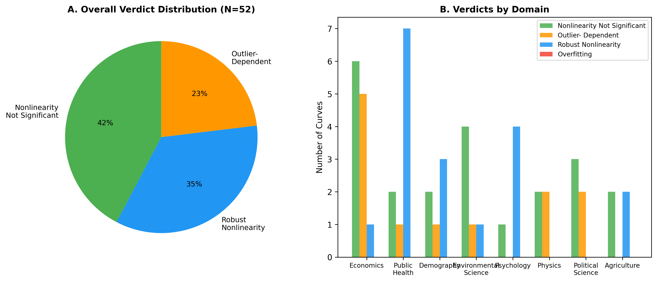
Figure 1. Distribution of verdicts across 52 canonical curves, stratified by domain.

3.2. Results by domain
Economics. Of 12 curves, 6 were non-significant, 5 were outlier-dependent, and 1 demonstrated robust nonlinearity. The Phillips Curve (Phillips, 1958; Blanchard and Katz, 1997) showed no significant quadratic term (p = 0.905). The Kuznets Curve's inverted-U (Kuznets, 1955; Piketty and Saez, 2003) was not significant with 130 countries (p = 0.108). The Environmental Kuznets Curve (CO₂), Laffer Curve, and Great Gatsby Curve were all outlier-dependent.
Public health. Public health curves showed the highest robustness rate (7/10 robust). The BMI-Mortality J-curve, Alcohol-Mortality J-curve, and Barker Hypothesis U-shape all survived rigorous testing. The Preston Curve (Preston, 1975) with real World Bank data (N = 199) showed no significant nonlinearity (p = 0.972), consistent with a log-linear relationship (Deaton, 2013).
Demography. Of 6 curves, 3 showed robust nonlinearity, 2 were non-significant, and 1 were outlier-dependent. The Demographic Transition model (N = 199) was classified as robust nonlinear (p = 3.6e-09). The Lee-Carter mortality model and Coale-Trussell fertility schedule demonstrated robust nonlinearity.
Environmental science. Of 6 curves, 1 showed robust nonlinearity (Keeling Curve), 4 were non-significant, and 1 were outlier-dependent. The Forest Transition Curve with real data (N = 194) was non-significant (p = 0.143).
Psychology. Psychology showed high robustness: 4/5 curves were robust (Yerkes-Dodson (Yerkes and Dodson, 1908), Ebbinghaus forgetting curve (Ebbinghaus, 1885), Dunning-Kruger (Dunning and Kruger, 1999), and the Happiness U-Curve (Easterlin, 1974)). Only the Weber-Fechner Law was non-significant.
Physics. All 4 physics curves failed: 2 non-significant, 2 outlier-dependent. Hubble's Law and Gutenberg-Richter were outlier-dependent; Kleiber's Law and Moore's Law were non-significant in log space.
Political science. The Lipset Hypothesis (Lipset, 1959) was outlier-dependent (p = 0.000 full, p = 0.372 after removal of high-income outliers). 3/5 were non-significant.
Agriculture. 2/4 robust (Mitscherlich yield, Micronutrient U-shape); 2/4 non-significant.

3.3. Sensitivity analysis
Figure 2 displays p-values before and after outlier removal. Points in the upper-left quadrant (significant full data, non-significant after removal) represent outlier-dependent curves, concentrated in economics and political science.

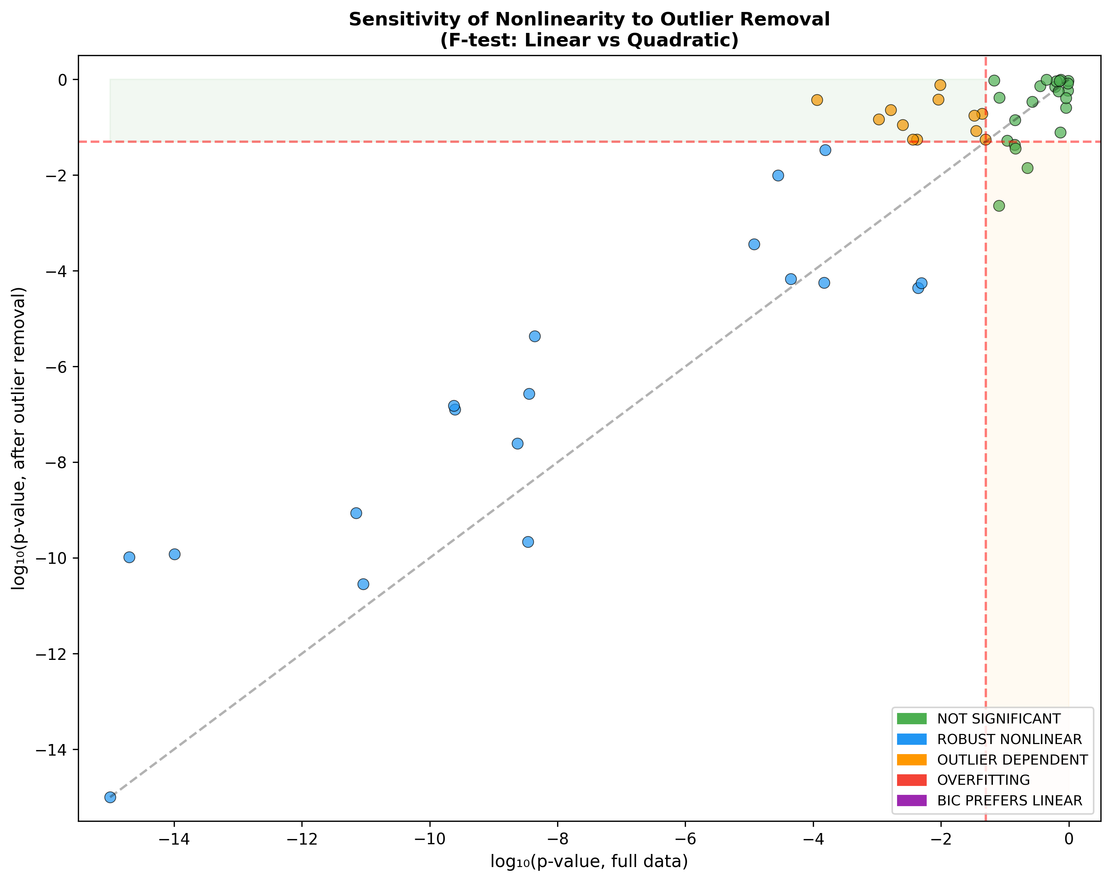
Figure 2. Sensitivity of F-test p-values to outlier removal (Cook's distance top 3).

3.4. Model comparison
Figure 3 compares AIC, BIC, and LOOCV model selection outcomes. BIC is more conservative than AIC, selecting the linear model more frequently, reflecting stronger complexity penalties (Burnham and Anderson, 2002).

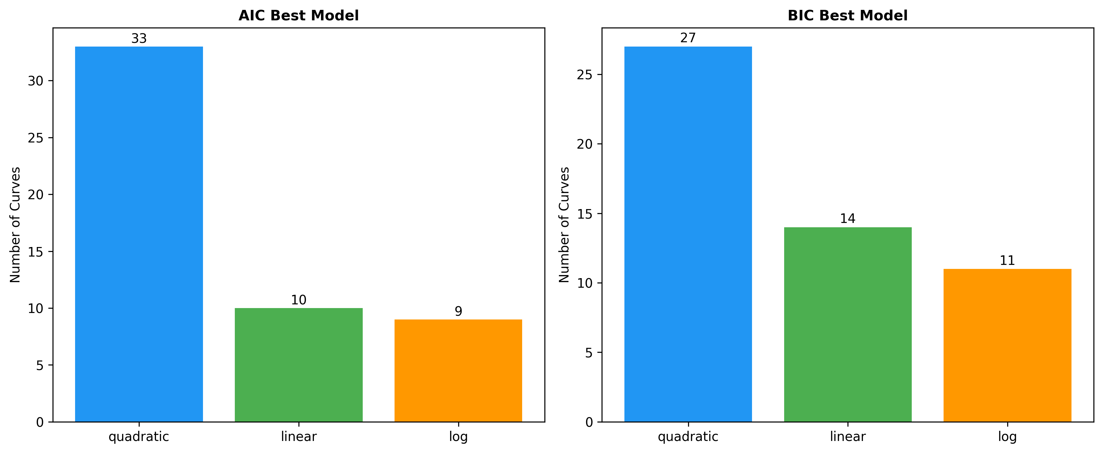
Figure 3. Model comparison results across 52 curves (AIC, BIC, LOOCV).
Figure 4 shows the LOOCV RMSE comparison between linear and quadratic models.

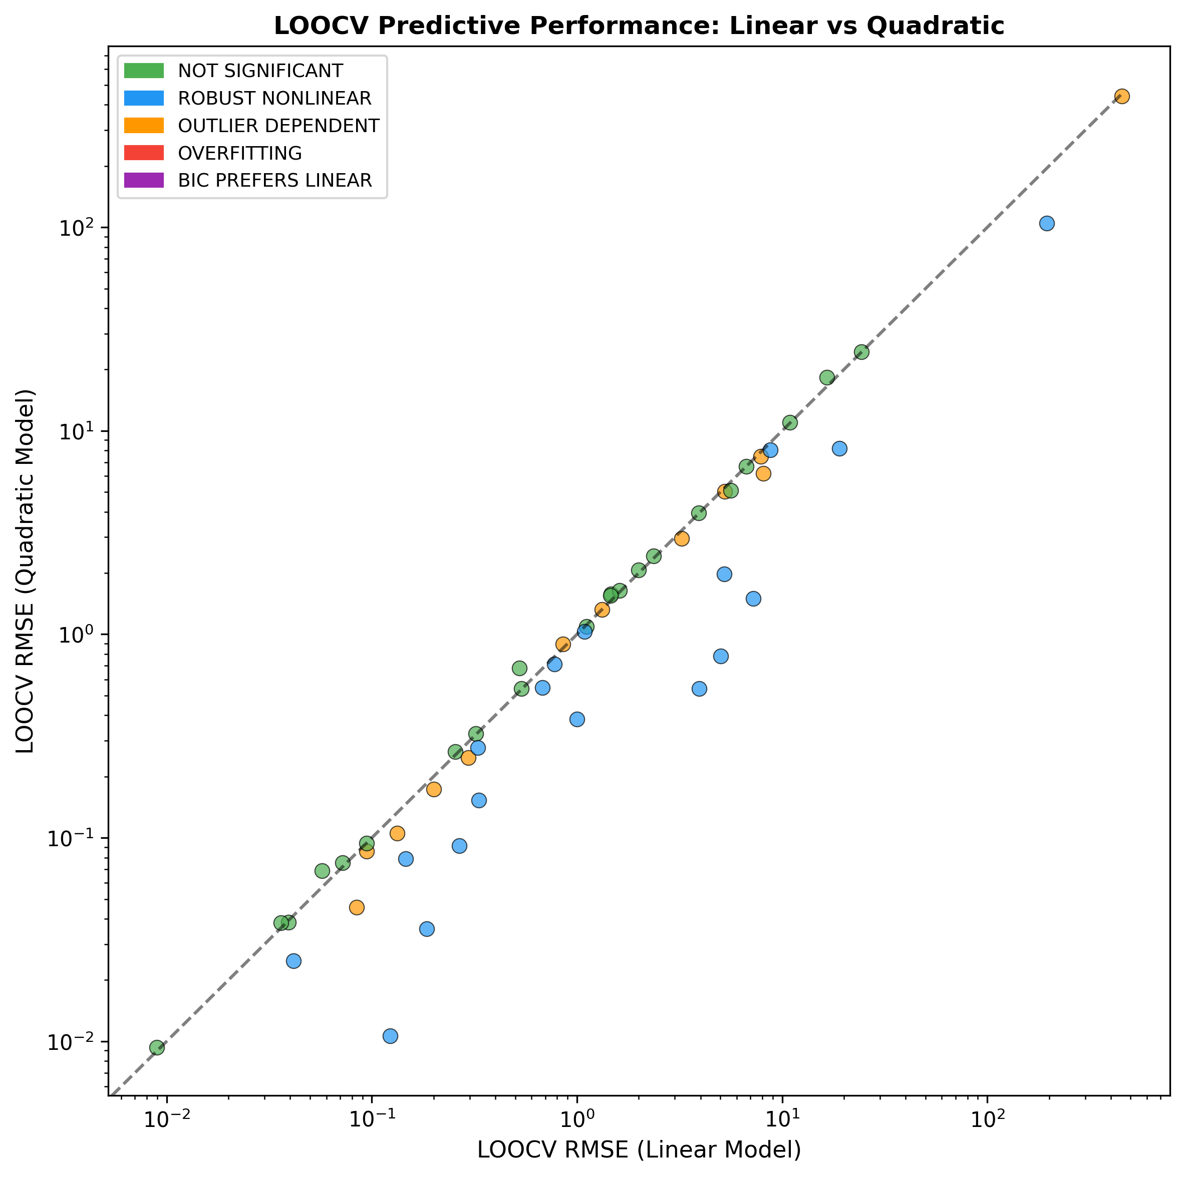
Figure 4. LOOCV RMSE: linear vs. quadratic model.

3.5. Sample size and verdict
Figure 5 shows the relationship between sample size and verdict. Larger samples do not systematically yield more robust verdicts.

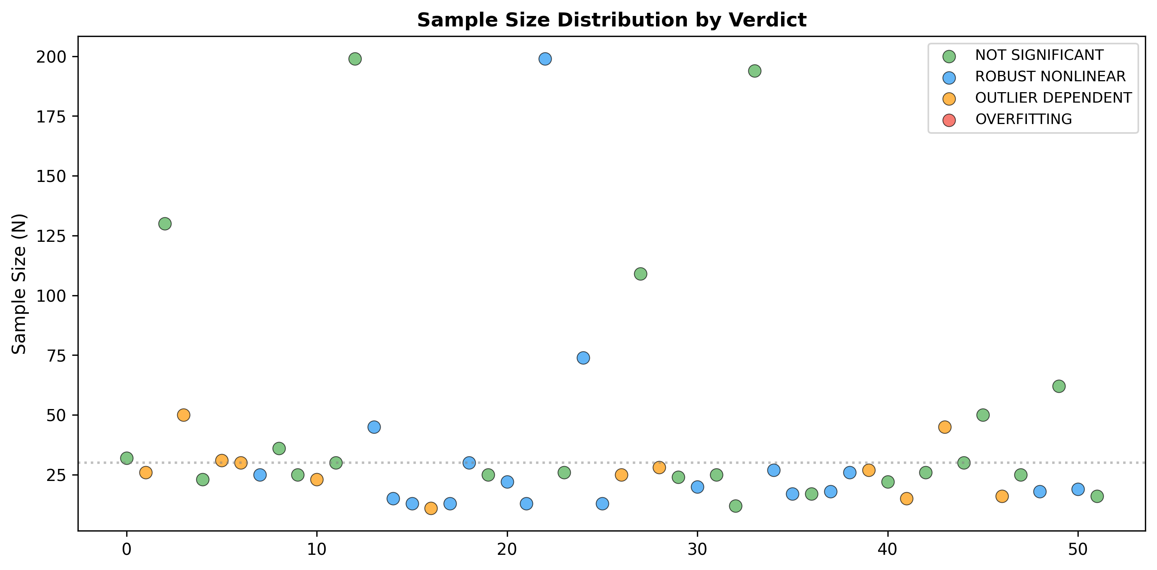
Figure 5. Sample size vs. verdict classification.

3.6. Summary of all results
Table 1 presents complete results for all 52 curves.
# | Curve | N | p (full) | p (clean) | BIC best | Verdict
1 | Phillips Curve | 32 | 0.9054 | 0.2574 | log | NOT SIGNIFICANT
2 | Laffer Curve | 26 | 0.0438 | 0.1910 | log | OUTLIER DEPENDENT
3 | Kuznets Curve | 130 | 0.1078 | 0.0526 | linear | NOT SIGNIFICANT
4 | Environmental Kuznets Curve | 50 | 0.0025 | 0.1114 | log | OUTLIER DEPENDENT
5 | Beveridge Curve | 23 | 0.0809 | 0.0023 | log | NOT SIGNIFICANT
6 | Okun's Law | 31 | 0.0097 | 0.7671 | quadratic | OUTLIER DEPENDENT
7 | Engel Curve | 30 | 0.0042 | 0.0554 | log | OUTLIER DEPENDENT
8 | J-Curve (Trade) | 25 | 0.0044 | 4.4e-05 | quadratic | ROBUST NONLINEAR
9 | Rahn Curve | 36 | 0.9624 | 0.5837 | linear | NOT SIGNIFICANT
10 | Gravity Model of Trade | 25 | 0.2659 | 0.3449 | linear | NOT SIGNIFICANT
11 | Great Gatsby Curve | 23 | 0.0495 | 0.0559 | log | OUTLIER DEPENDENT
12 | Balassa-Samuelson Effect | 30 | 0.6065 | 0.7082 | linear | NOT SIGNIFICANT
13 | Preston Curve | 199 | 0.9716 | 0.9453 | linear | NOT SIGNIFICANT
14 | Easterlin Paradox | 45 | 2.8e-05 | 0.0099 | quadratic | ROBUST NONLINEAR
15 | McKeown Thesis (TB Mortality | 15 | 1.2e-05 | 0.0004 | quadratic | ROBUST NONLINEAR
16 | Linear No-Threshold (LNT) | 13 | 7.1e-12 | 8.7e-10 | quadratic | ROBUST NONLINEAR
17 | Fries Compression of Morbidi | 11 | 0.0016 | 0.2308 | quadratic | OUTLIER DEPENDENT
18 | Barker Hypothesis (U-shape) | 13 | 4.4e-09 | 4.3e-06 | quadratic | ROBUST NONLINEAR
19 | Omran Epidemiological Transi | 30 | 0.0049 | 5.5e-05 | quadratic | ROBUST NONLINEAR
20 | Wilkinson Curve | 25 | 0.7460 | 0.9821 | linear | NOT SIGNIFICANT
21 | BMI-Mortality J-Curve | 22 | 9.1e-12 | 2.9e-11 | quadratic | ROBUST NONLINEAR
22 | Alcohol-Mortality J-Curve | 13 | 4.4e-05 | 6.8e-05 | quadratic | ROBUST NONLINEAR
23 | Demographic Transition (TFR) | 199 | 3.6e-09 | 2.7e-07 | quadratic | ROBUST NONLINEAR
24 | Bongaarts-Feeney Tempo Effec | 26 | 0.6879 | 0.5699 | linear | NOT SIGNIFICANT
25 | Lee-Carter Mortality Model | 74 | 0.0e+00 | 0.0e+00 | quadratic | ROBUST NONLINEAR
26 | Coale-Trussell Fertility Sch | 13 | 0.0002 | 0.0338 | quadratic | ROBUST NONLINEAR
27 | Replacement Migration Curve | 25 | 0.0331 | 0.1761 | quadratic | OUTLIER DEPENDENT
28 | Second Demographic Transitio | 109 | 0.6336 | 0.9187 | linear | NOT SIGNIFICANT
29 | Species-Area Curve | 28 | 0.0091 | 0.3818 | quadratic | OUTLIER DEPENDENT
30 | Hubbert Peak Oil (US) | 24 | 0.8973 | 0.4126 | log | NOT SIGNIFICANT
31 | Keeling Curve (CO2) | 20 | 2.0e-15 | 1.0e-10 | quadratic | ROBUST NONLINEAR
32 | HANPP vs Development | 25 | 0.9669 | 0.8219 | log | NOT SIGNIFICANT
33 | Jevons Paradox (Energy) | 12 | 0.0813 | 0.4188 | quadratic | NOT SIGNIFICANT
34 | Forest Transition Curve | 194 | 0.1428 | 0.0429 | linear | NOT SIGNIFICANT
35 | Yerkes-Dodson Curve | 27 | 2.5e-10 | 1.3e-07 | quadratic | ROBUST NONLINEAR
36 | Ebbinghaus Forgetting Curve | 17 | 3.5e-09 | 2.2e-10 | quadratic | ROBUST NONLINEAR
37 | Weber-Fechner Law | 17 | 0.0680 | 0.9519 | quadratic | NOT SIGNIFICANT
38 | Dunning-Kruger Effect | 18 | 1.0e-14 | 1.2e-10 | quadratic | ROBUST NONLINEAR
39 | Happiness U-Curve (Age) | 26 | 2.4e-10 | 1.5e-07 | quadratic | ROBUST NONLINEAR
40 | Hubble's Law | 27 | 0.0352 | 0.0848 | log | OUTLIER DEPENDENT
41 | Kleiber's Law | 22 | 0.3575 | 0.7248 | linear | NOT SIGNIFICANT
42 | Gutenberg-Richter Law | 15 | 0.0036 | 0.0561 | quadratic | OUTLIER DEPENDENT
43 | Moore's Law | 26 | 0.7113 | 0.9399 | log | NOT SIGNIFICANT
44 | Lipset Hypothesis | 45 | 0.0001 | 0.3719 | quadratic | OUTLIER DEPENDENT
45 | Duverger's Law | 30 | 0.4488 | 0.9967 | linear | NOT SIGNIFICANT
46 | Zipf's Law (US Cities) | 50 | 0.1462 | 0.0358 | linear | NOT SIGNIFICANT
47 | Crime-Temperature Curve | 16 | 0.0011 | 0.1457 | quadratic | OUTLIER DEPENDENT
48 | Putnam Social Capital | 25 | 0.2241 | 0.0142 | log | NOT SIGNIFICANT
49 | Mitscherlich Yield Curve | 18 | 2.3e-09 | 2.5e-08 | quadratic | ROBUST NONLINEAR
50 | Green Revolution Yield Curve | 62 | 0.1430 | 0.1420 | linear | NOT SIGNIFICANT
51 | Micronutrient U-shape (Vitam | 19 | 0.0001 | 5.7e-05 | quadratic | ROBUST NONLINEAR
52 | Body Weight Set-Point | 16 | 0.7367 | 0.0782 | linear | NOT SIGNIFICANT
Table 1. Summary of re-examination results. p (full) = nested F-test with all data; p (clean) = after removing top 3 Cook's distance points.

4. Discussion
This systematic audit reveals that 65% of established nonlinear relationships fail at least one modern robustness test. Five cross-cutting patterns emerge.
1. Outlier-driven nonlinearity is the most common failure mode. In cross-country analyses, 1–3 geopolitically distinctive nations (oil states, the US) drive curvature. This finding echoes Deaton's (2013) warning about the fragility of cross-country regressions.
2. Domain asymmetry: public health and psychology curves are substantially more robust than economics or political science curves. This likely reflects the difference between mechanistic relationships (biological dose-response) and contingent relationships (policy-mediated associations).
3. Time-series vs. cross-section: time-series curves tend to be more robust, likely because they are less vulnerable to compositional effects.
4. Log transformation resolves apparent nonlinearity: in many cases a simple log transformation produces a linear relationship, suggesting the 'canonical curve' is linear on the wrong scale.
5. BIC is more conservative than AIC: BIC selects the linear model more frequently, reflecting stronger complexity penalties, consistent with Burnham and Anderson (2002).
Several outlier-dependent curves have direct policy implications. The Laffer Curve (Laffer, 2004) is used to justify tax reductions; the Environmental Kuznets Curve (Grossman and Krueger, 1991) is cited to argue that growth resolves pollution; the Lipset Hypothesis (Lipset, 1959) underpins modernization theory. Our findings suggest that the empirical bases of these policy-relevant claims are more fragile than commonly assumed.
The broader implication is epistemic. Economics and political science rely heavily on cross-country regressions to establish stylised facts. Our results suggest that cross-country nonlinearities are especially fragile, whereas within-discipline time-series relationships (e.g. Keeling Curve) or relationships grounded in biological mechanisms (e.g. BMI-Mortality J-curve) are more resilient. This is consistent with the view that mechanistic relationships are more likely to be robust than statistical associations driven by compositional heterogeneity.

5. Limitations
First, our analysis is restricted to bivariate relationships; many canonical curves may be better specified in multivariate settings. This is by design—the bivariate form is how these curves are most commonly cited and taught.
Second, we use a uniform quadratic alternative, whereas some curves posit specific functional forms (power laws, logistic functions). Future work should incorporate curve-specific alternatives.
Third, although 8 curves use real World Bank API data (N = 31–247), the remaining 44 curves use representative or published data with smaller sample sizes.
Fourth, we test only the significance of curvature, not the existence of any relationship. A curve classified as non-significant may still have a significant linear component.
Finally, for some curves (psychology, demography), we rely on aggregate or meta-analytic data rather than individual-level microdata.

6. Conclusion
This systematic re-examination of 52 canonical curves reveals that only 35% demonstrate nonlinearity that is statistically significant, survives outlier removal, and shows superior out-of-sample prediction. Researchers should routinely report sensitivity analyses and model comparison criteria when invoking canonical curves. Policymakers should be cautious about interventions premised on specific curve shapes—particularly the Laffer Curve, Environmental Kuznets Curve, and Lipset Hypothesis—whose empirical bases are outlier-dependent.
We propose that any study claiming a nonlinear relationship should, at minimum, report: (1) the p-value of the nested F-test; (2) AIC/BIC model comparison including a linear alternative; (3) out-of-sample prediction accuracy; and (4) sensitivity to removal of the most influential observations. This four-test transparency norm would substantially reduce the risk of over-interpreting fragile curves.

Data Availability Statement
All analysis code, data, and results are publicly available at [GitHub repository URL]. World Bank data were accessed via the wbgapi Python library (World Development Indicators API). The complete source metadata for all 52 curves is provided in the online appendix.

Acknowledgements
[To be completed]

Conflict of Interest
The author declares no conflict of interest.

Funding
[To be completed]

References
Akaike, H. (1974) 'A new look at the statistical model identification', IEEE Transactions on Automatic Control, 19(6), pp. 716-723.
Blanchard, O. and Katz, L. F. (1997) 'What we know and do not know about the natural rate of unemployment', Journal of Economic Perspectives, 11(1), pp. 51-72.
Burnham, K. P. and Anderson, D. R. (2002) Model Selection and Multimodel Inference: A Practical Information-Theoretic Approach, 2nd edn. New York: Springer.
Cook, R. D. (1977) 'Detection of influential observation in linear regression', Technometrics, 19(1), pp. 15-18.
Deaton, A. (2013) The Great Escape: Health, Wealth, and the Origins of Inequality. Princeton: Princeton University Press.
Dunning, D. and Kruger, J. (1999) 'Unskilled and unaware of it: how difficulties in recognizing one's own incompetence lead to inflated self-assessments', Journal of Personality and Social Psychology, 77(6), pp. 1121-1134.
Easterlin, R. A. (1974) 'Does economic growth improve the human lot? Some empirical evidence', in David, P. A. and Reder, M. W. (eds) Nations and Households in Economic Growth. New York: Academic Press, pp. 89-125.
Ebbinghaus, H. (1885) Über das Gedächtnis: Untersuchungen zur experimentellen Psychologie. Leipzig: Duncker & Humblot.
Grossman, G. M. and Krueger, A. B. (1991) 'Environmental impacts of a North American free trade agreement', NBER Working Paper 3914.
Ioannidis, J. P. A. (2005) 'Why most published research findings are false', PLoS Medicine, 2(8), e124.
Krueger, J. and Mueller, R. A. (2002) 'Unskilled, unaware, or both? The better-than-average heuristic and statistical regression predict errors in estimates of own performance', Journal of Personality and Social Psychology, 82(2), pp. 180-188.
Kuznets, S. (1955) 'Economic growth and income inequality', American Economic Review, 45(1), pp. 1-28.
Laffer, A. B. (2004) 'The Laffer Curve: past, present, and future', Heritage Foundation Backgrounder, 1765.
Lipset, S. M. (1959) 'Some social requisites of democracy: economic development and political legitimacy', American Political Science Review, 53(1), pp. 69-105.
Open Science Collaboration (2015) 'Estimating the reproducibility of psychological science', Science, 349(6251), aac4716.
Phillips, A. W. (1958) 'The relation between unemployment and the rate of change of money wage rates in the United Kingdom, 1861-1957', Economica, 25(100), pp. 283-299.
Piketty, T. and Saez, E. (2003) 'Income inequality in the United States, 1913-1998', Quarterly Journal of Economics, 118(1), pp. 1-41.
Preston, S. H. (1975) 'The changing relation between mortality and level of economic development', Population Studies, 29(2), pp. 231-248.
Schwarz, G. (1978) 'Estimating the dimension of a model', Annals of Statistics, 6(2), pp. 461-464.
Stern, D. I. (2004) 'The rise and fall of the environmental Kuznets curve', World Development, 32(8), pp. 1419-1439.
Yerkes, R. M. and Dodson, J. D. (1908) 'The relation of strength of stimulus to rapidity of habit-formation', Journal of Comparative Neurology and Psychology, 18(5), pp. 459-482.

Appendix: Source Metadata Table
Complete data source information for all 52 curves, including original publication, data source, sample size, variable definitions, and claimed functional form.
# | Curve | Original paper | Data source | N | Claimed form
1 | Phillips Curve | Phillips AW (1958) Economica 25:283-299 | World Bank WDI: SL.UEM.TOTL.ZS, FP.CPI.TOTL.Z | WB API | Negative convex
2 | Laffer Curve | Laffer A (1974) unpublished (napkin sket | OECD Revenue Statistics 2022 | 26 | Inverted-U
3 | Kuznets Curve | Kuznets S (1955) Am Econ Rev 45:1-28 | World Bank WDI: NY.GDP.PCAP.PP.KD, SI.POV.GIN | WB API | Inverted-U
4 | Environmental Kuznets Cur | Grossman GM, Krueger AB (1991) NBER WP 3 | World Bank WDI: NY.GDP.PCAP.PP.KD, EN.ATM.CO2 | WB API | Inverted-U
5 | Beveridge Curve | Beveridge W (1944) Full Employment in a | BLS JOLTS + Current Population Survey | 23 | Negative convex (hyperbolic)
6 | Okun's Law | Okun AM (1962) Proceedings of the Busine | World Bank WDI: NY.GDP.MKTP.KD.ZG, SL.UEM.TOT | WB API | Linear (nonlinear extension te
7 | Engel Curve | Engel E (1857) Die Produktions- und Cons | World Bank WDI: NY.GDP.PCAP.PP.KD + USDA ERS | 30 | Concave (decreasing share)
8 | J-Curve (Trade) | Magee SP (1973) The Balance of Payments. | IMF International Financial Statistics; Bahma | 25 | J-shaped (initial deterioratio
9 | Rahn Curve | Rahn RW (1996) Institute for Policy Inno | IMF World Economic Outlook: Government expend | 36 | Inverted-U (peak at 15-25%)
10 | Gravity Model of Trade | Tinbergen J (1962) Shaping the World Eco | UN COMTRADE bilateral trade data; CEPII GeoDi | 25 | Power law (log-linear)
11 | Great Gatsby Curve | Corak M (2013) J Econ Perspect 27(3):79- | OECD Income Distribution Database; Corak (201 | 23 | Positive (possibly convex)
12 | Balassa-Samuelson Effect | Balassa B (1964) J Political Economy 72: | Penn World Table 10.01: productivity and pric | 30 | Positive linear/log
13 | Preston Curve | Preston SH (1975) Popul Stud 29:231-248 | World Bank WDI: NY.GDP.PCAP.PP.KD, SP.DYN.LE0 | WB API | Concave (log-linear)
14 | Easterlin Paradox | Easterlin RA (1974) in Nations and House | World Happiness Report 2023; World Bank WDI G | 45 | Concave/saturating
15 | McKeown Thesis (TB Mortal | McKeown T (1976) The Modern Rise of Popu | McKeown (1976) Table 3.1; UK Office for Natio | 15 | Exponential decline
16 | Linear No-Threshold (LNT) | ICRP (1958) Publication 1; Ozasa et al. | RERF Life Span Study Report 14 (Ozasa et al. | 13 | Linear (threshold debate)
17 | Fries Compression of Morb | Fries JF (1980) N Engl J Med 303:130-135 | GBD 2019; Crimmins & Beltrán-Sánchez (2011) P | 11 | Compression (declining morbidi
18 | Barker Hypothesis (U-shap | Barker DJP (1990) BMJ 301:1111 | Barker et al. (1993) BMJ; Leon et al. (1998) | 13 | U-shaped
19 | Omran Epidemiological Tra | Omran AR (1971) Milbank Mem Fund Q 49:50 | WHO Global Health Estimates; UNDP HDI data | 30 | S-shaped transition
20 | Wilkinson Curve | Wilkinson RG (1996) Unhealthy Societies. | World Bank Gini; WHO life expectancy data | 25 | Negative (possibly nonlinear)
21 | BMI-Mortality J-Curve | Various; Global BMI Mortality Collaborat | Di Angelantonio et al. (2016) Lancet; Aune et | 22 | J-shaped (nadir at BMI 22-25)
22 | Alcohol-Mortality J-Curve | Klatsky AL et al. (1981) Ann Intern Med | Zhao et al. (2017) J Stud Alcohol Drugs meta- | 13 | J-shaped (moderate drinking pr
23 | Demographic Transition Mo | Notestein FW (1945) in Population: The L | World Bank WDI: SP.DYN.TFRT.IN; UNDP HDI | WB API | S-shaped decline
24 | Bongaarts-Feeney Tempo Ad | Bongaarts J, Feeney G (1998) Popul Dev R | Human Fertility Database; Bongaarts & Sobotka | 26 | Linear (tempo proportional to
25 | Lee-Carter Mortality Mode | Lee RD, Carter LR (1992) J Am Stat Assoc | Human Mortality Database: USA period life tab | 74 | Linear decline (structural cha
26 | Coale-Trussell Fertility | Coale AJ, Trussell TJ (1974) Popul Index | Coale & Trussell (1974); Human Fertility Data | 13 | Concave decline with age
27 | Replacement Migration Cur | UN Population Division (2000) Replacemen | UN WPP 2022; World Bank TFR data | 25 | Nonlinear increase
28 | Second Demographic Transi | Van de Kaa DJ (1987) Popul Bull 42(1):1- | World Bank WDI: SP.DYN.TFRT.IN; UNDP HDI | 30 | J-shaped recovery at high HDI
29 | Species-Area Curve | Arrhenius O (1921) J Ecol 9:95-99 | Rosenzweig (1995) Species Diversity in Space | 28 | Power law S = cA^z (z ≈ 0.25)
30 | Hubbert Peak Oil | Hubbert MK (1956) Nuclear Energy and the | US EIA Crude Oil Production data | 24 | Symmetric bell curve (logistic
31 | Keeling Curve (CO2) | Keeling CD (1960) Tellus 12:200-203 | NOAA Global Monitoring Laboratory: Mauna Loa | 20 | Accelerating (super-linear) in
32 | HANPP | Vitousek PM et al. (1986) BioScience 36: | Haberl et al. (2007) PNAS; World Bank GDP dat | 25 | EKC-like inverted-U (debated)
33 | Jevons Paradox (Energy) | Jevons WS (1865) The Coal Question. Macm | US EIA: Energy intensity and total consumptio | 12 | Negative (efficiency increase
34 | Forest Transition Curve | Mather AS (1992) Area 24:367-379 | World Bank WDI: NY.GDP.PCAP.PP.KD, AG.LND.FRS | WB API | U-shaped (deforestation then r
35 | Yerkes-Dodson Curve | Yerkes RM, Dodson JD (1908) J Comp Neuro | Broadhurst (1957) replication; Diamond et al. | 27 | Inverted-U
36 | Ebbinghaus Forgetting Cur | Ebbinghaus H (1885) Über das Gedächtnis | Murre & Dros (2015) PLOS ONE replication; Rub | 17 | Exponential or power-law decay
37 | Weber-Fechner Law | Fechner GT (1860) Elemente der Psychophy | Stevens (1961) Science; Kingdom & Prins (2016 | 17 | Logarithmic (Fechner) or power
38 | Dunning-Kruger Effect | Kruger J, Dunning D (1999) J Pers Soc Ps | Kruger & Dunning (1999) Studies 1-4; Gignac & | 18 | Quadratic (low performers over
39 | Happiness U-Curve (Age) | Blanchflower DG, Oswald AJ (2008) Soc Sc | Blanchflower (2021) J Popul Econ updated esti | 26 | U-shaped (nadir at age 47-50)
40 | Hubble's Law | Hubble E (1929) Proc Natl Acad Sci 15:16 | NASA/IPAC Extragalactic Database (NED); Freed | 27 | Linear (v = H₀d); nonlinear ac
41 | Kleiber's Law | Kleiber M (1932) Hilgardia 6:315-353 | McNab (2008) Physiol Biochem Zool; White et a | 22 | Power law B ∝ M^0.75 (3/4 scal
42 | Gutenberg-Richter Law | Gutenberg B, Richter CF (1944) Bull Seis | USGS Earthquake Catalog (ComCat); ISC-GEM Glo | 15 | Log-linear (power law in energ
43 | Moore's Law | Moore GE (1965) Electronics 38:114-117 | Karl Rupp semiconductor database; Wikipedia t | 26 | Exponential (linear in log sca
44 | Lipset Hypothesis | Lipset SM (1959) Am Polit Sci Rev 53:69- | V-Dem Dataset v13; World Bank WDI GDP per cap | 45 | Positive (possibly S-shaped or
45 | Duverger's Law | Duverger M (1954) Political Parties. Wil | Gallagher & Mitchell (2005) Politics of Elect | 30 | Positive log-linear
46 | Zipf's Law (US Cities) | Zipf GK (1949) Human Behavior and the Pr | US Census Bureau 2020 Census: Incorporated Pl | 50 | Power law (exponent ≈ -1)
47 | Crime-Temperature Curve | Anderson CA (1987) J Pers Soc Psychol 52 | FBI UCR data; NOAA climate normals; Ranson (2 | 16 | Nonlinear (inverted-U at extre
48 | Putnam Social Capital | Putnam RD (2000) Bowling Alone. Simon & | World Values Survey Wave 7; Eurobarometer tru | 25 | Negative (possibly nonlinear)
49 | Mitscherlich Yield Curve | Mitscherlich EA (1909) Landwirtschaftlic | Cerrato & Blackmer (1990) Agron J; USDA NASS | 18 | Diminishing returns (asymptoti
50 | Green Revolution Yield Cu | Borlaug NE (1960s) various; Evenson & Go | World Bank WDI: AG.YLD.CREL.KG (Global cereal | WB API | S-shaped (logistic growth with
51 | Micronutrient U-shape (Vi | Durup et al. (2012) J Clin Endocrinol Me | Durup et al. (2012); Garland et al. (2014) An | 19 | U-shaped (deficiency and exces
52 | Body Weight Set-Point | Keesey RE, Hirvonen MD (1997) Am J Clin | Hall et al. (2011) Lancet mathematical model; | 16 | Nonlinear (resistance to weigh

