Regional variation in anaesthesia practice in Japan: a cross-sectional ecological study of secondary medical areas
Running header: Anaesthesia variation in Japan

[This is the anonymised manuscript file for triple-anonymised peer review. Author names, affiliations and contact details are provided in the separate title-page file.]

Article type: Original research article
Word count (main text, excluding abstract, references, tables and figures): approximately 3000 words
Tables: 3 Figures: 2 References: 21
Reporting guideline: STROBE checklist for cross-sectional studies (uploaded as supplementary material)
Target journal: BMJ Quality & Safety

Regional variation in anaesthesia practice in Japan: a cross-sectional ecological study of secondary medical areas

ABSTRACT
Objectives To quantify regional variation in anaesthesia practice across Japanese secondary medical areas and to test whether the variation is primarily explained by structural access to university hospitals or by prefecture-specific claims auditing.
Design Cross-sectional ecological study using publicly available age- and sex-standardised claim ratios.
Setting 335 secondary medical areas nested within 47 prefectures of Japan, fiscal year 2022.
Participants Secondary medical areas (the ecological unit of analysis); individual patient data were not used.
Main outcome measures Standardised claim ratios for general anaesthesia (L008), spinal anaesthesia (L004), epidural anaesthesia (L002) and continuous epidural infusion (L003).
Results Coefficients of variation ranged from 53.7% (general anaesthesia) to 87.2% (epidural). Only 0.058 of general anaesthesia variance lay between prefectures; university hospital presence explained 0.358 of total variance (β = 64.1, 95% CI 54.8 to 73.4, P <0.001) and was positive in every prefecture. Sensitivity analyses showed that the maximum audit-related ratio shift was less than 0.53% of the interquartile range for general anaesthesia. Covariate adjustment for population density and anaesthesiologist supply attenuated but did not eliminate the university hospital effect.
Conclusions Regional variation in anaesthesia practice is predominantly structural. It signals a quality and equity gap in access to neuraxial techniques under universal coverage and should not be interpreted as evidence of differential auditing.

Keywords:
anaesthesia; small-area variation; multilevel analysis; quality of care; patient safety; health equity; universal health coverage; Japan

KEY MESSAGES
What is already known on this topic
Regional variation in medical practice is well documented in high-income countries, but it is often difficult to distinguish genuine clinical variation from artefacts of coding, auditing or payment policy. Japan's uniform national fee schedule combined with prefecture-specific claims auditing offers a natural experiment for testing these explanations.
What this study adds
In a nationwide cross-sectional ecological analysis of age- and sex-standardised anaesthesia claim ratios across 335 secondary medical areas, university hospital presence was the dominant structural determinant of general, epidural and continuous epidural anaesthesia use, while differential prefectural auditing could explain only a small fraction of the observed variation.
How this study might affect research, practice or policy
Quality and safety improvement efforts should treat geographic variation in neuraxial and combined general-epidural anaesthesia as a modifiable equity problem under universal coverage, directing workforce and monitoring resources toward structural access rather than coding audits.

INTRODUCTION
Japan's universal health insurance system covers the entire population under a nationally uniform fee schedule that specifies reimbursement for every procedure.¹ Because the fee schedule and the insured benefit are identical across the country, geographic variation in procedure use is usually interpreted as a signal of differences in clinical supply, practice style or unmet need. The same data, however, are also used for prefecture-level insurance auditing (shinsa), and audit intensity varies across prefectures.² This creates two competing explanations for any observed regional variation: it may reflect genuine differences in the quality and availability of care, or it may be an artefact of differential claims scrutiny. Distinguishing these explanations is central to patient safety, health equity and the efficient governance of universal coverage systems.
Anaesthesia practice is a particularly useful quality-of-care signal. The choice between general anaesthesia alone and a combined general-regional technique is clinically consequential: epidural and continuous epidural techniques may improve pain control and recovery, and emerging evidence links regional anaesthesia to oncological and functional outcomes in selected surgeries.³⁻⁴ If access to these techniques varies systematically by geography, then patients' probability of receiving potentially beneficial care depends on where they live, which is a quality and equity problem under universal coverage. Japan's 2026 fee schedule revision clarified the general-anaesthesia billing code, reducing one source of audit ambiguity.⁵
We used publicly available standardised claim ratios to address: (i) How large is regional variation in anaesthesia practice? (ii) Is this variation explained by differential prefectural auditing? (iii) What proportion of variance lies between and within prefectures? (iv) Which structural factors, including university hospital proximity, are associated with the observed variation?
METHODS
Study design and ethical considerations
This was a cross-sectional ecological study using publicly available aggregate data only. No individual-level data were accessed. Patients and the public were not involved in the design, conduct or reporting of this study because it uses aggregate, publicly released data. Ethics committee approval was not required under the Ethical Guidelines for Medical and Biological Research Involving Human Subjects (Japan, 2021 revision). The study was reported in accordance with the Strengthening the Reporting of Observational Studies in Epidemiology (STROBE) checklist for cross-sectional studies,⁶ which is provided as supplementary material.
Geographic units
Japan's healthcare delivery system is organised into a hierarchical structure of medical areas defined under Article 30-4 of the Medical Care Act.⁷ The 47 prefectures serve as tertiary medical areas; within each prefecture, secondary medical areas (n = 335 nationally) are designated as the basic units for inpatient care planning. Crucially, secondary medical areas are completely nested within prefectures and do not cross prefectural boundaries. This nesting differs from the Hospital Service Areas and Hospital Referral Regions used in the United States, which can cross state boundaries,⁸ and makes within-prefecture comparisons unconfounded by spillover under a common audit policy.
Data sources and standardised claim ratios
We used three data sources. First, standardised claim ratios for fiscal year 2022 published by the Cabinet Office under the 'Regional Variation Visualisation' initiative.⁹ Standardised claim ratios are computed by indirect standardisation: expected claim frequencies are calculated by applying national age- and sex-specific claim rates to the local population structure, and the ratio is defined as 100 × (observed claims / expected claims). Ratios are calculated on a residence basis, so claims are attributed to the beneficiary's registered address rather than to the providing facility. Patient travel for treatment therefore does not inflate the ratio of the receiving area. Areas with very few claims are masked by the data provider to protect privacy and appear as missing values. Second, we obtained physician statistics from the 2022 Survey of Physicians, Dentists and Pharmacists.¹⁰ Third, secondary medical area boundaries, land area and population density were obtained from the National Land Numerical Information medical-area dataset (A38-20).¹¹
Anaesthesia procedure codes and university hospital mapping
Six procedure codes from the Japanese fee schedule were analysed (Table 1): L008 (closed-circuit general anaesthesia); L002 (epidural anaesthesia as main technique); L003 (continuous epidural infusion, largely billed as adjunct to general anaesthesia); L004 (spinal anaesthesia); L009 (anaesthesia management fee I, a proxy for specialist staffing); and L100 (inpatient nerve block). We mapped university hospitals to their respective secondary medical areas based on municipal address. 64 secondary medical areas (19.1%) contained at least one university hospital, distributed across all 47 prefectures, which enables within-prefecture comparisons between university and non-university areas under a common audit policy.
RESULTS
Study population and variation in anaesthesia practice
The 335 secondary medical areas were distributed across 47 prefectures (median 7 areas per prefecture, range 3 to 21); 64 areas (19.1%) contained at least one university hospital. Standardised claim ratios for general anaesthesia were available for 334 of 335 areas; ratios for epidural anaesthesia were available for 307 areas, with 28 areas masked owing to low volume. Substantial variation was observed across all codes (Table 2). General anaesthesia ratios ranged from 2.3 to 435.7 (coefficient of variation 53.7%), a 189.4-fold difference. Epidural anaesthesia showed the greatest relative variation (coefficient of variation 87.2%); continuous epidural infusion 65.0% and spinal anaesthesia 56.8%. The geographic distribution of ratios is shown in Figure 1.
Table 2. Distribution of standardised claim ratios across 335 secondary medical areas (national average = 100), fiscal year 2022.
Code | n | Mean (SD) | Median (IQR) | Min | Max | CV (%)
L008 | 334 | 79.7 (42.8) | 73.5 (50.0-103.0) | 2.3 | 435.7 | 53.7
L002 | 307 | 95.6 (83.4) | 76.6 (31.2-133.4) | 0.9 | 519.1 | 87.2
L003 | 331 | 83.5 (54.3) | 73.4 (45.0-117.0) | 0.4 | 443.0 | 65.0
L004 | 334 | 93.8 (53.3) | 84.6 (55.8-127.4) | 1.0 | 346.5 | 56.8
L009 | 314 | 87.3 (49.9) | 78.9 (51.4-116.5) | 0.1 | 392.2 | 57.2
L100 | 335 | 99.8 (77.1) | 77.8 (43.7-125.9) | 3.0 | 433.3 | 77.3
SD, standard deviation; IQR, interquartile range; CV, coefficient of variation. Areas with low claim volume are masked by the data provider and appear as missing values; the n column reflects the number of secondary medical areas with non-missing values for each code.
Figure 1. Geographic distribution of anaesthesia standardised claim ratios across 335 secondary medical areas of Japan, fiscal year 2022. (A) General anaesthesia (L008). (B) Spinal anaesthesia (L004). (C) Epidural anaesthesia as main anaesthetic (L002). (D) Continuous epidural infusion (L003). Choropleth maps shaded by quintile of the standardised claim ratio (national average = 100). Red circles mark secondary medical areas containing at least one university hospital. Areas masked by the data provider owing to low volume are shown in grey.
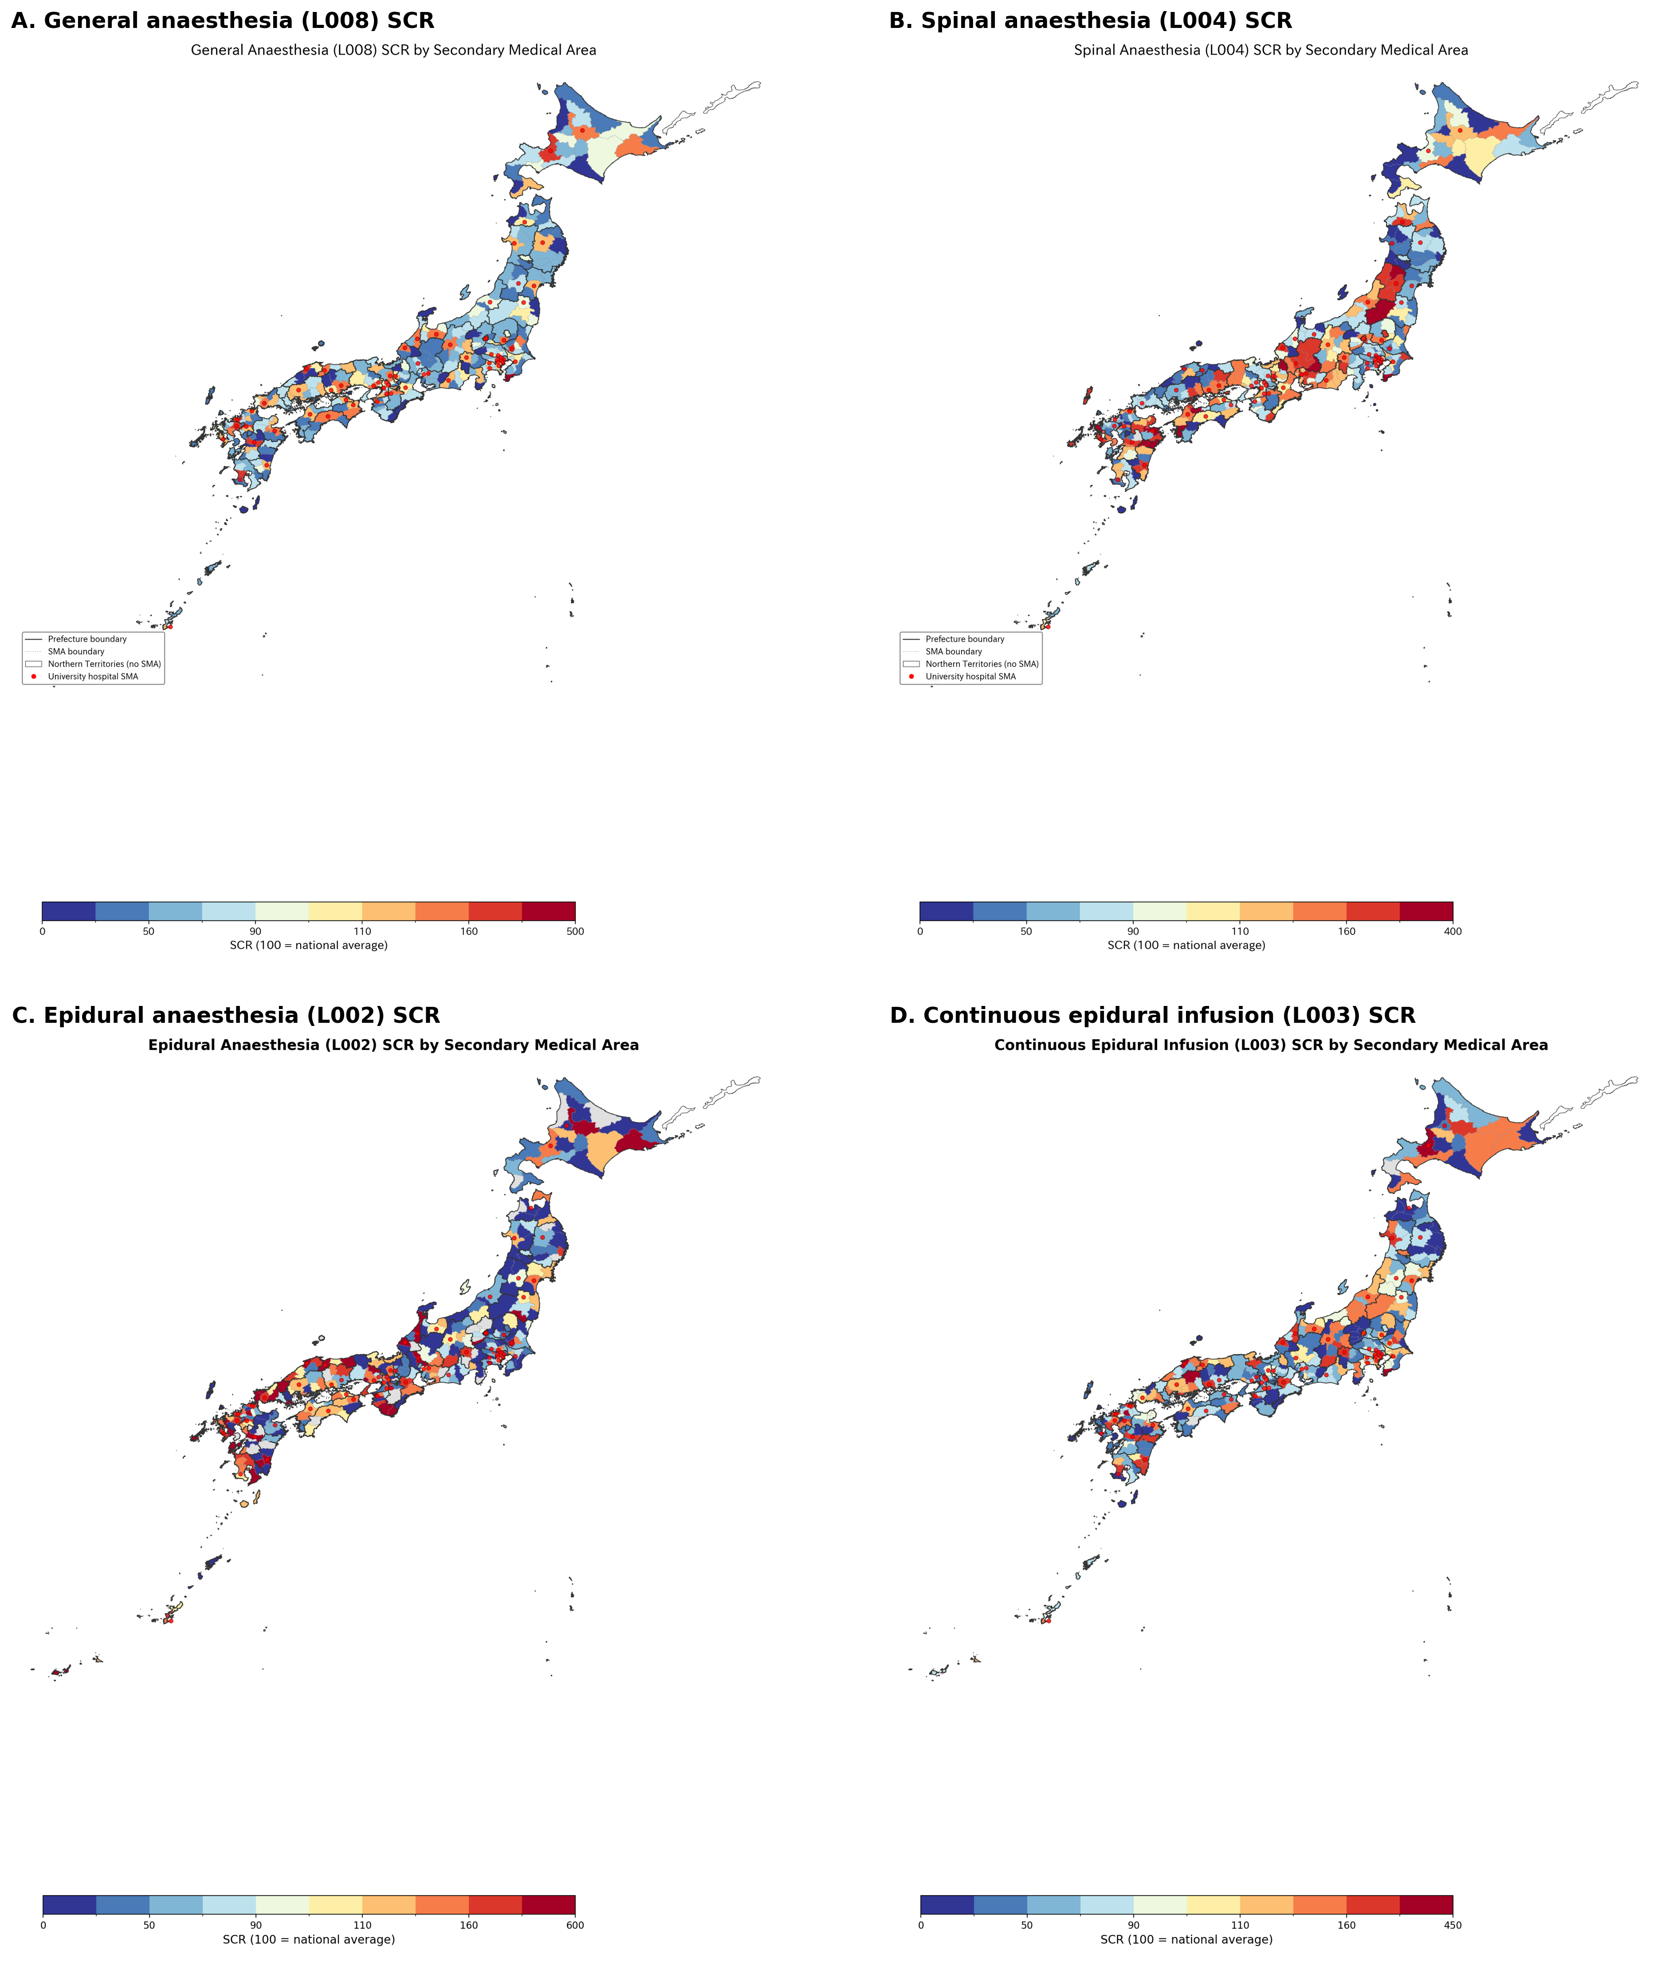

Multilevel model and university hospital effect
The null multilevel model showed that only 0.058 of general anaesthesia variance was attributable to the prefecture level (intraclass correlation coefficient 0.058), indicating that 85.5% occurred within prefectures where audit policy is uniform. Spinal anaesthesia showed stronger prefecture-level clustering (intraclass correlation coefficient 0.343), consistent with a greater role of prefectural factors for that code. Adding university hospital presence as a fixed effect produced the largest improvement for general anaesthesia (marginal R² 0.358; β = 64.1, 95% confidence interval 54.8 to 73.4) and was statistically significant for every code (all P <0.001) (Table 3). University hospital areas had higher general anaesthesia ratios than non-university areas in 47 of 47 prefectures, with a mean within-prefecture difference of +63.3 points (paired t = 13.28, P <0.001) (Figure 2A). Cohen's d for the university hospital effect on general anaesthesia was 1.88; on continuous epidural infusion 1.12; on epidural anaesthesia 0.59; and on spinal anaesthesia 0.40. A combined measure capturing the general-anaesthesia plus continuous-epidural workflow (mean of L008 and L003 SCR; 331 areas with data for both codes) showed a coefficient of variation of 55.5% and preserved a large university hospital effect (Cohen's d 1.55; university mean 130.3 versus non-university 70.2) (Figure 2B).
Table 3. Multilevel linear mixed model results: standardised claim ratio as outcome, prefecture as random intercept.
Code | Null model ICC | β university (95% CI) | P value | Marginal R²
L008 | 0.058 | +64.1 (54.8 to 73.4) | <0.001 | 0.358
L002 | 0.191 | +49.0 (27.2 to 70.8) | <0.001 | 0.125
L003 | 0.106 | +55.8 (43.0 to 68.7) | <0.001 | 0.162
L004 | 0.343 | +23.0 (11.0 to 35.1) | <0.001 | 0.020
β university, fixed effect coefficient for university hospital presence (binary 0/1); CI, confidence interval; ICC, intraclass correlation coefficient (proportion of variance attributable to prefecture level in the null random-intercept model); Marginal R², proportional reduction in total (prefecture + residual) variance from the null model after adding the university hospital fixed effect. Models were estimated by restricted maximum likelihood.
A covariate-adjusted sensitivity model added the natural logarithm of population density and the anaesthesiologist share of all physicians (both standardised). The university hospital coefficient was attenuated but remained positive and statistically significant for general anaesthesia (β = +41.8, 95% CI 32.4 to 51.2, P <0.001), epidural anaesthesia (β = +39.1, 95% CI 14.5 to 63.7, P 0.002) and continuous epidural infusion (β = +33.9, 95% CI 20.0 to 47.7, P <0.001). For spinal anaesthesia the point estimate was positive but no longer statistically significant (β = +9.7, 95% CI -4.0 to 23.3, P 0.165). Population density was positively associated with general anaesthesia ratios (β = 8.3, P <0.001) but not with the other three codes. The anaesthesiologist share was positively associated with general, epidural, continuous epidural and spinal anaesthesia (P <0.001, 0.039, <0.001 and 0.005, respectively).
Figure 2. University hospital presence and the combined general-anaesthesia plus continuous-epidural measure. (A) Distribution of secondary medical areas containing at least one university hospital (n = 64 of 335; red). (B) Choropleth map of the combined general-anaesthesia plus continuous-epidural standardised claim ratio (mean of L008 and L003 SCR; 331 areas with data for both codes), shaded by quintile. Red circles mark secondary medical areas containing at least one university hospital. Areas masked by the data provider for either code are shown in grey.
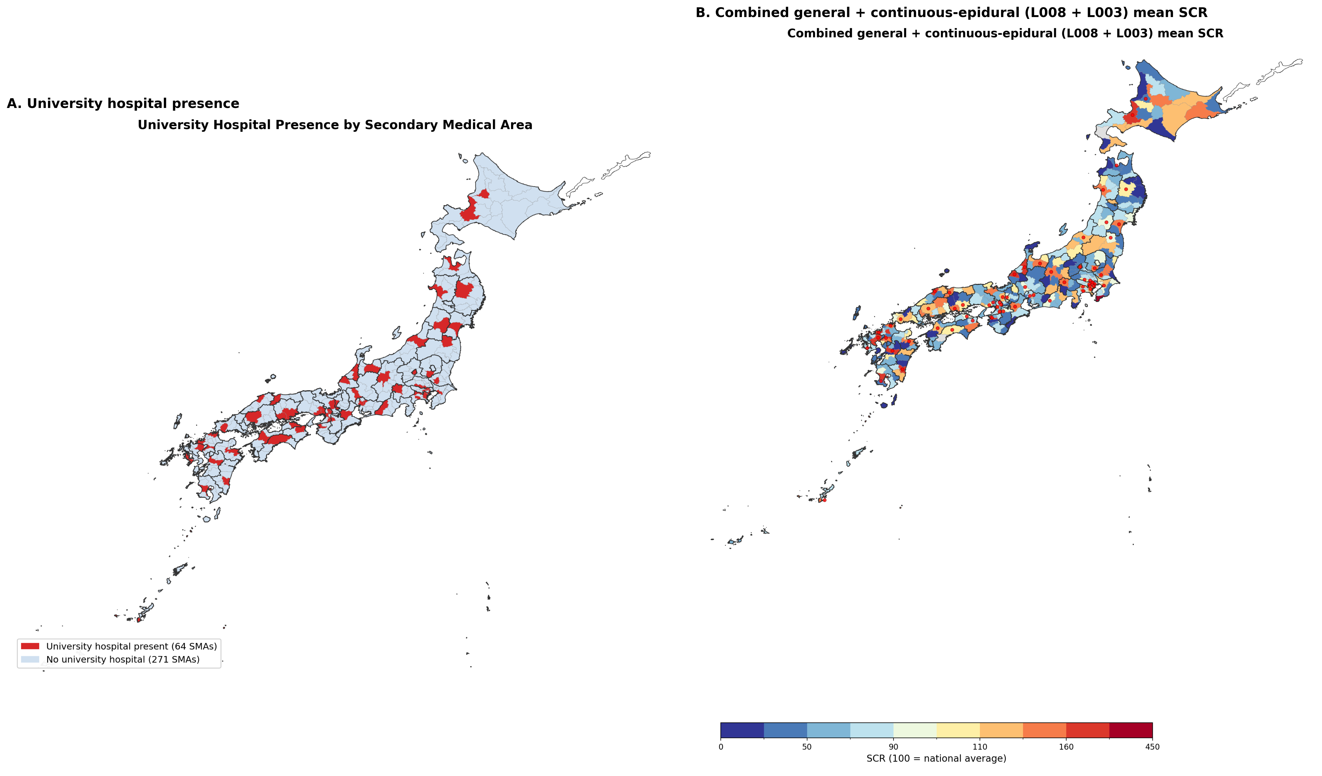

Sensitivity analyses against the audit hypothesis
All three pre-specified sensitivity analyses converged in rejecting the audit hypothesis. First, within-prefecture variance decomposition attributed 14.5% of general anaesthesia variance to between-prefecture differences, 40.5% to the university hospital effect within prefecture, and 45.0% to residual within-group variation; the university hospital effect alone explained 47.4% of all within-prefecture variance. Second, general and spinal anaesthesia were positively, not negatively, correlated (r = 0.235, P <0.001), as were general and epidural anaesthesia (r = 0.319, P <0.001), inconsistent with audit-driven reclassification and consistent with a common supply factor. Third, the maximum prefectural audit-rate difference of 0.28 percentage points could produce a ratio shift of approximately 0.28 points, equivalent to approximately 0.53% of the observed interquartile range for general anaesthesia and 0.27% for epidural anaesthesia. Combining general (L008) and spinal (L004) ratios produced an alternative audit-insensitive measure with a coefficient of variation of 43.4% and a university hospital effect that remained large (Cohen's d 1.26), confirming that the structural effect is not artefactually erased by combining reclassifiable codes.
Robustness: empirical Bayes shrinkage and outliers
Empirical Bayes shrinkage toward prefecture means was implemented as a stress test of the area-level ratios. Under this model, shrinkage substantially compressed the area-level ratios toward their prefecture means. For general anaesthesia, Cohen's d for the university-hospital effect fell from 1.88 (raw) to 0.63 (shrunken), an attenuation of 66.5%; for epidural anaesthesia (L002) from 0.59 to 0.23 (60.6%); and for spinal anaesthesia (L004) from 0.40 to 0.04 (89.9%). The general anaesthesia effect therefore remained of moderate magnitude despite heavy shrinkage, whereas the L002 and L004 effects were materially attenuated, indicating that those smaller raw effects are more vulnerable to sampling instability. These shrinkage estimates are complementary to, and consistent in direction with, the mixed-effects model coefficients reported in Table 3, which themselves incorporate prefecture-level shrinkage. Two areas were identified as outliers (more than three standard deviations from the mean general anaesthesia ratio): Awa (Chiba) in Chiba (ratio 216.7) and central Tokyo (Tokyo) in Tokyo (ratio 435.7). Excluding outliers did not alter the direction or statistical significance of any finding.
DISCUSSION
Statement of principal findings
Regional variation in anaesthesia practice across Japan's 335 secondary medical areas is large and predominantly structural. University hospital presence explained the largest share of variance for general anaesthesia and was positive in every prefecture, while the amount of variance attributable to prefecture-level factors -- where audit intensity differs -- was small. Three independent sensitivity analyses converged in rejecting differential auditing as the main explanation. The implication for quality and safety is that the observed variation is a marker of unequal access to potentially beneficial anaesthesia techniques, not a signal of coding quality or fraud; it should be addressed through workforce and monitoring policies rather than additional coding audits.
Strengths and limitations
Strengths include the use of age- and sex-standardised ratios covering the entire national population; analysis at a fine geographic scale of 335 areas; multilevel modelling that properly accounts for the nested data structure; empirical Bayes shrinkage to address low-volume instability; multiple pre-specified sensitivity analyses; within-prefecture comparisons that hold audit policy constant; and the residence-based ratio definition that mitigates patient travel effects. Limitations include the ecological fallacy inherent in area-level analysis;¹² the cross-sectional design, which precludes causal inference; the post-audit nature of the data, which reflects reimbursed rather than intended practice; the partial overlap between university hospital presence and urban concentration; the absence of code-specific audit-rate data; and the inability to quantify defensive undercoding from claims alone. A specific constraint of the publicly available dataset is that the combined anaesthesia add-on billed under L008 (the explicit code for general-plus-epidural technique) is aggregated with other anaesthesia add-ons in the regional variation data release and cannot be extracted separately at the secondary-medical-area level; patient-level National Database records would be required to measure the true rate of combined general-epidural anaesthesia. We therefore used L002 (epidural as main technique) and L003 (continuous epidural infusion) as the publicly reported proxies for regional technique use. A covariate-adjusted sensitivity model added population density and anaesthesiologist supply; the university hospital coefficient remained positive and statistically significant for general, epidural and continuous epidural anaesthesia, but not for spinal anaesthesia. The positive point estimate for spinal anaesthesia is, however, compatible with the same structural gradient operating in an underpowered model, and may partly reflect a countervailing tendency for neuraxial anaesthesia to be used in settings where anaesthesiologists are less available. The aggregate data cannot separate these opposing mechanisms, so the adjusted spinal-anaesthesia coefficient is best interpreted as an imprecise net effect.
Interpretation within the context of the wider literature
Our findings are consistent with the broader medical practice variation literature. The Dartmouth Atlas project documented extensive regional variation in surgical rates in the United States, driven primarily by physician supply and practice style.¹³ Comparable patterns have been described for the National Health Service¹⁴ and in Germany¹⁵ and Australia.¹⁶ Our study extends this evidence by exploiting Japan's uniquely uniform fee schedule combined with prefecture-specific auditing to disentangle administrative and clinical sources of variation, and by providing, to our knowledge, the first multilevel small-area analysis of anaesthesia technique under universal coverage in East Asia. The university hospital effect we report (Cohen's d = 1.88) is substantial, plausibly reflecting the influence of the ikyoku (university medical office) system on clinical practice in affiliated hospitals.¹⁷ The intraclass correlation coefficient of 0.058 for general anaesthesia indicates that most variation occurs within prefectures, consistent with institutional factors dominating over prefectural-level factors for this code.
Our findings extend beyond Japan in three respects. First, the within-prefecture variance decomposition we describe is directly transportable to other universal-coverage systems that combine a centrally uniform fee schedule with regionally devolved claims auditing, including Taiwan's National Health Insurance,¹⁸ South Korea's National Health Insurance Service, and the tariff-based systems of Germany, France and the English National Health Service.^{14,15} Second, the dominance of tertiary-teaching-hospital concentration as a structural determinant of technique choice echoes analogous patterns for teaching-hospital anaesthesia mix reported in the US and United Kingdom,^{13,14} and for other tertiary-intensive specialties across OECD countries;¹⁹ the consistency of the university effect across 47 of 47 prefectures in our data suggests that it is a robust feature of high-income health systems rather than a Japanese idiosyncrasy. Third, the variation we identify in epidural anaesthesia (L002, coefficient of variation 87.2%) and continuous epidural infusion (L003, 65.0%) speaks to an international quality and equity agenda: where emerging evidence links regional anaesthesia to oncological and functional outcomes,³⁻⁴ monitoring the distribution of anaesthesia techniques could serve as a system-level quality indicator across any universal coverage setting committed to equitable access to technology-rich care.^{20,21} Extrapolation to low- and middle-income countries is more cautious because fee schedules and audit arrangements are typically heterogeneous and claims data often incomplete.
Implications for quality improvement, practice and policy
The findings have three implications for improving quality and safety. First, variation in neuraxial and combined general-epidural anaesthesia should be monitored as a system-level quality and equity indicator. In high-income countries with universal coverage, patients' access to techniques that may improve recovery should not depend on the local presence of a university hospital. Second, regulators should not interpret low regional ratios as evidence of poor coding or underclaiming; our audit-impact estimates suggest that even the largest plausible audit effect would shift ratios by only a small fraction of the observed range. Third, the within-prefecture variance-decomposition framework provides a transferable quality-surveillance tool for distinguishing administrative from structural sources of small-area variation in other procedures and settings.
CONCLUSIONS
Regional variation in anaesthesia practice in Japan is large and predominantly structural, driven by access to university hospitals rather than by insurance auditing. The variation in epidural and continuous epidural use represents a quality and equity gap under universal coverage. Quality improvement and patient-safety policy should address supply and organisational determinants of anaesthesia practice, monitor technique distribution as a system-level quality indicator, and extend the same administrative-versus-structural variance decomposition to other perioperative quality indicators, rather than treat the observed variation as an artefact of claims processing or auditing.
REFERENCES
1. Ikegami N, Yoo BK, Hashimoto H, et al. Japanese universal health coverage: evolution, achievements, and challenges. Lancet 2011;378:1106-15.
2. Social Insurance Medical Fee Payment Fund. 審査状況（令和4年度）— 都道府県別医科歯科計審査状況（点数）. Tokyo: Social Insurance Medical Fee Payment Fund, 2023. https://www.ssk.or.jp/smph/tokeijoho/shinsatokei/shinsajokyo_r04.html (accessed 24 Jul 2026).
3. Sessler DI, Pei L, Huang Y, et al. Recurrence of breast cancer after regional or general anaesthesia: a randomised controlled trial. Lancet 2019;394:1807-15.
4. Weng M, Chen W, Hou W, et al. The effect of neuraxial anaesthesia on cancer recurrence and survival after cancer surgery: an updated meta-analysis. Oncotarget 2016;7:15262-73.
5. Ministry of Health, Labour and Welfare. 2026 revision of the medical fee schedule: changes to the medical fee schedule master (R08). Tokyo: MHLW, 2026. https://shinryohoshu.mhlw.go.jp/shinryohoshu/file/info/smente260522.pdf (accessed 24 Jul 2026).
6. von Elm E, Altman DG, Egger M, et al. The Strengthening the Reporting of Observational Studies in Epidemiology (STROBE) statement: guidelines for reporting observational studies. Lancet 2007;370:1453-7.
7. Matsuda S. Health policy in Japan: current situation and future challenges. JMA J 2019;2:1-10.
8. Wennberg JE, Cooper MM, eds. The Dartmouth Atlas of Health Care. Chicago: American Hospital Publishing, 1999.
9. Cabinet Office. Regional variation visualisation (chiikisa no mieruka). https://www5.cao.go.jp/keizai-shimon/kaigi/special/reform/mieruka/chiikisa/index.html (accessed 10 Mar 2026).
10. Ministry of Health, Labour and Welfare. Survey of Physicians, Dentists and Pharmacists 2022 (e-Stat). https://www.e-stat.go.jp (accessed 12 Mar 2026).
11. Ministry of Land, Infrastructure, Transport and Tourism. National Land Numerical Information download service. https://nlftp.mlit.go.jp (accessed 10 Mar 2026).
12. Greenland S. Ecologic versus individual-level sources of bias in ecologic estimates of contextual health effects. Int J Epidemiol 2001;30:1343-50.
13. Wennberg JE, Fisher ES, Skinner JS. Geography and the debate over Medicare reform. Health Aff (Millwood) 2002;Suppl Web Exclusives:W96-114.
14. NHS RightCare. The NHS Atlas of Variation in Healthcare. London: Public Health England, 2015.
15. Schäfer T, Pritzkuleit R, Jeszenszky C, et al. Trends and geographical variation of primary hip and knee joint replacement in Germany. Osteoarthritis Cartilage 2013;21:279-88.
16. Australian Commission on Safety and Quality in Health Care. Australian Atlas of Healthcare Variation. Sydney: ACSQHC, 2015.
17. Otsuka T. The ikyoku system of university orthopaedic surgery departments: an in-hospital organisational system unique to Japan. J Orthop Sci 2012;17:513-14.
18. Cheng T-M. Taiwan's new national health insurance program: genesis and experience so far. Health Aff (Millwood) 2003;22:61-76.
19. OECD. Geographic Variations in Health Care: What Do We Know and What Can Be Done to Improve Health System Performance? Paris: OECD Publishing, 2014.
20. Donabedian A. The quality of care: how can it be assessed? JAMA 1988;260:1743-8.
21. Merry AF, Cooper JB, Soyannwo O, et al. International standards for a safe practice of anesthesia 2010. Can J Anesth 2010;57:1027-34.

