Regional variation in anaesthesia practice in Japan under universal health coverage: structural determinants and claims-audit sensitivity
Running header: Anaesthesia variation in Japan

[Author names, affiliations and contact details are provided in the separate title-page file.]

Article type: Original research article
Word count (main text, excluding abstract, references, tables and figures): approximately 3432 words
Tables: 2 Figures: 2 References: 21
Highlights: 3-5 bullet points summarising novel findings (uploaded as a separate file)
Reporting guideline: STROBE checklist for cross-sectional studies (uploaded as supplementary material)
Target journal: Health Policy

Regional variation in anaesthesia practice in Japan under universal health coverage: structural determinants and claims-audit sensitivity

ABSTRACT
Background: Geographic variation in anaesthesia technique is well documented, but separating true differences in care from coding, reimbursement and audit artefacts is rarely possible. Japan's uniform fee schedule and prefecture-specific claims auditing create a natural experiment for this separation.
Objective: To quantify the respective contributions of structural access (university hospital proximity) and prefectural claims auditing to regional variation in anaesthesia practice under universal health coverage.
Methods: Cross-sectional ecological study of age- and sex-standardised claim ratios for general, spinal, epidural and continuous epidural anaesthesia across 335 secondary medical areas nested within 47 prefectures, fiscal year 2022. We fitted multilevel linear models with prefecture random intercepts and a university-hospital fixed effect, and tested robustness to population density and anaesthesiologist supply, log-transformed ratios, and an upper-bound audit-rate impact.
Results: Coefficients of variation ranged from 53.7% to 87.2%. For general anaesthesia, only 5.8% of variance lay between prefectures; university hospital presence explained 35.8% of total variance (P < 0.001). The association persisted after log transformation and covariate adjustment; audit-related ratio shifts were small relative to observed variation, supporting structural access over differential auditing.
Conclusion: Regional variation in anaesthesia practice is predominantly structural, driven by access to university hospitals rather than by prefectural auditing. In universal-coverage systems this pattern indicates inequitable access to neuraxial techniques; policy efforts may need to address workforce and organisational barriers, not additional coding audits.

Keywords:
anaesthesia; small-area variation; multilevel analysis; health equity; universal health coverage; health policy; Japan

1. INTRODUCTION
National administrative claims data are a cornerstone of health-services and epidemiologic surveillance in countries with universal health coverage[1]. Because claims record reimbursed procedures, they capture documented care rather than bedside intention; in systems with uniform fee schedules, however, geographic variation in claims is commonly interpreted as a signal of differences in service delivery, practice style and unmet need[1,2]. The same records are also used for prefecture-level insurance auditing (shinsa), and audit intensity varies across prefectures[3]. Where audits differ, between-area variation in claims could reflect differential scrutiny rather than differential care. Distinguishing between them is important for population health research and policy: if variation is real, it signals inequitable access; if it is an artefact, quality-improvement and payment reforms may be misdirected.
Japan offers a natural experiment for this question. The fee schedule and insured benefits are nationally uniform, so price variation is eliminated, while prefectures independently operate claims audits. Anaesthesia is a useful tracer: the choice between general anaesthesia alone and neuraxial or combined techniques is clinically consequential and plausibly linked to outcomes, yet the technical and workforce requirements for neuraxial techniques tend to concentrate in teaching hospitals[4-6]. If access to these techniques varies by geography, patients' probability of receiving potentially beneficial care depends on place of residence, which is an equity problem under universal coverage. Because the FY2022 data predate the 2026 clarification of the general-anaesthesia billing code, any coding ambiguity that existed during the study period is retained in the analysis[7].
We used publicly available, age- and sex-standardised claim ratios to ask: (i) How large is regional variation in anaesthesia practice across Japan's secondary medical areas? (ii) Is the variation consistent with differential prefectural auditing? (iii) What proportion of variance lies between versus within prefectures? (iv) Is the distribution associated with proximity to university hospitals after adjusting for population density and anaesthesiologist supply? By exploiting the nesting of secondary medical areas within prefectures, we provide a transferable framework for distinguishing administrative from structural sources of small-area variation in other universal-coverage systems.
2. MATERIALS AND METHODS
2.1 Study design and ethical considerations
This was a cross-sectional ecological study using publicly available aggregate data only. No individual-level data were accessed. Patients and the public were not involved in the design, conduct or reporting of this study because it uses aggregate, publicly released data. Ethics committee approval was not required under the Ethical Guidelines for Medical and Biological Research Involving Human Subjects (Japan, 2021 revision). The study was reported in accordance with the Strengthening the Reporting of Observational Studies in Epidemiology (STROBE) checklist for cross-sectional studies[8], which is provided as supplementary material.
2.2 Geographic units
Japan's healthcare delivery system is organised into a hierarchical structure of medical areas defined under Article 30-4 of the Medical Care Act[9]. The 47 prefectures serve as tertiary medical areas; within each prefecture, secondary medical areas (n = 335 nationally) are designated as the basic units for inpatient care planning. Crucially, secondary medical areas are completely nested within prefectures and do not cross prefectural boundaries. This nesting differs from the Hospital Service Areas and Hospital Referral Regions used in the United States, which can cross state boundaries[10], and makes within-prefecture comparisons unconfounded by spillover under a common audit policy.
2.3 Data sources and standardised claim ratios
We used three data sources. First, standardised claim ratios for fiscal year 2022 published by the Cabinet Office under the 'Regional Variation Visualisation' initiative[11]. Standardised claim ratios are computed by indirect standardisation: expected claim frequencies are calculated by applying national age- and sex-specific claim rates to the local population structure, and the ratio is defined as , where O and E are the observed and expected claim counts. Ratios are calculated on a residence basis, so claims are attributed to the beneficiary's registered address rather than to the providing facility. Patient travel for treatment therefore does not inflate the ratio of the receiving area. Areas with very few claims are masked by the data provider to protect privacy and appear as missing values. Second, we obtained physician statistics from the 2022 Survey of Physicians, Dentists and Pharmacists[12]. Third, secondary medical area boundaries, land area and population density were obtained from the National Land Numerical Information medical-area dataset (A38-20)[13].
2.4 Anaesthesia procedure codes and university hospital mapping
Four primary anaesthesia procedure codes from the Japanese fee schedule were used for multilevel analysis: L008 (closed-circuit general anaesthesia); L002 (epidural anaesthesia as main technique); L003 (continuous epidural infusion, largely billed as an adjunct to general anaesthesia); and L004 (spinal anaesthesia). Two additional codes, L009 (anaesthesia management fee I) and L100 (inpatient nerve block), were retained for descriptive context only, as proxies for specialist anaesthesiologist staffing and inpatient pain-clinic activity; they were not entered into the multilevel models because the hypothesised structural and audit mechanisms refer to the choice of anaesthetic technique. We mapped university hospitals to their respective secondary medical areas based on municipal address. 64 secondary medical areas (19.1%) contained at least one university hospital, distributed across all 47 prefectures, which enables within-prefecture comparisons between university and non-university areas under a common audit policy.
2.5 Statistical analysis
We computed descriptive statistics for each standardised claim ratio (mean, standard deviation, median, interquartile range, minimum, maximum and coefficient of variation). To account for the nesting of secondary medical areas within prefectures, we fitted multilevel linear models with prefecture random intercepts and a binary fixed effect for university hospital presence, using restricted maximum likelihood. The null model intraclass correlation coefficient quantified the proportion of variance between prefectures, and the proportional reduction in total variance (sometimes labelled marginal R²) measured the decrease in total (prefecture-level plus residual) variance after adding the university-hospital fixed effect. We conducted the following sensitivity and robustness analyses: within-prefecture paired comparisons of university and non-university areas; a covariate-adjusted model adding the natural logarithm of population density and the anaesthesiologist share of all physicians; an empirical Bayes shrinkage stress-test of area-level ratios toward prefecture means; and a log-transformed multilevel model to address right-skewed SCR distributions and influential outliers. To examine the audit hypothesis specifically, we used the multilevel variance decomposition, pairwise correlations between codes, an upper-bound estimate of the maximum prefectural audit-rate impact, and a combined general/spinal anaesthesia measure. No formal multiple-comparison adjustment was applied; reported p-values are nominal and should be interpreted as exploratory. All analyses were performed in Python 3.10 using NumPy, Pandas, SciPy and Statsmodels.
3. RESULTS
3.1 Study population and variation in anaesthesia practice
The 335 secondary medical areas were distributed across 47 prefectures (median 7 areas per prefecture, range 3 to 21); 64 areas (19.1%) contained at least one university hospital. Standardised claim ratios for general anaesthesia were available for 334 of 335 areas; ratios for epidural anaesthesia were available for 307 areas, with 28 areas masked owing to low volume. Substantial variation was observed across the primary anaesthesia codes (Table 1). General anaesthesia ratios ranged from 2.3 to 435.7 (coefficient of variation 53.7%), a 189.4-fold difference. Epidural anaesthesia showed the greatest relative variation (coefficient of variation 87.2%); continuous epidural infusion 65.0% and spinal anaesthesia 56.8%. The geographic distribution of ratios is shown in Figure 1.
Table 1. Distribution of standardised claim ratios across 335 secondary medical areas (national average = 100), fiscal year 2022.
Code | n | Mean (SD) | Median (IQR) | Min | Max | CV (%)
L008 | 334 | 79.7 (42.8) | 73.5 (50.0-103.0) | 2.3 | 435.7 | 53.7
L002 | 307 | 95.6 (83.4) | 76.6 (31.2-133.4) | 0.9 | 519.1 | 87.2
L003 | 331 | 83.5 (54.3) | 73.4 (45.0-117.0) | 0.4 | 443.0 | 65.0
L004 | 334 | 93.8 (53.3) | 84.6 (55.8-127.4) | 1.0 | 346.5 | 56.8
SD, standard deviation; IQR, interquartile range; CV, coefficient of variation. L008 = closed-circuit general anaesthesia; L002 = epidural anaesthesia as main technique; L003 = continuous epidural infusion, largely billed as an adjunct to general anaesthesia; L004 = spinal anaesthesia. Areas with low claim volume are masked by the data provider and appear as missing values; the n column reflects the number of secondary medical areas with non-missing values for each code.
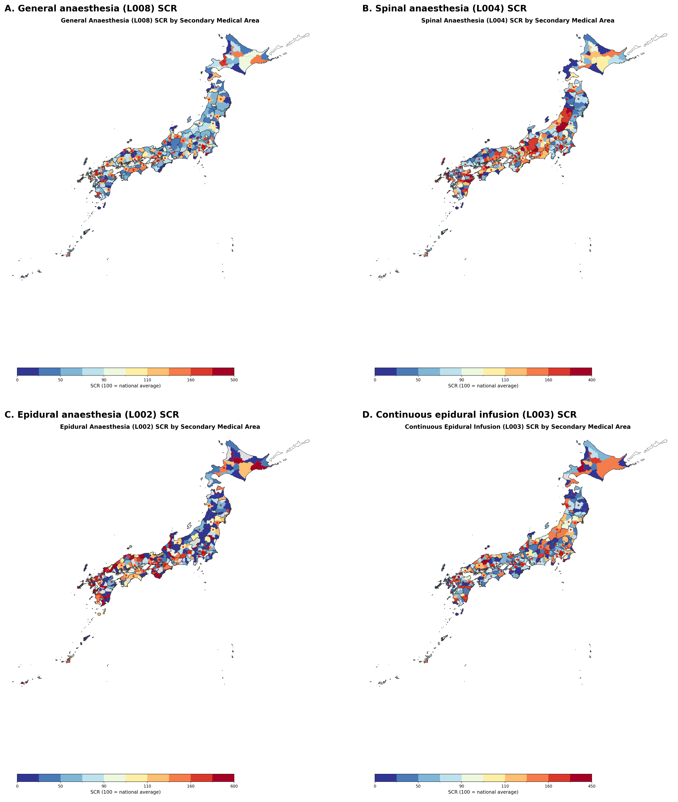
Figure 1. Geographic distribution of anaesthesia standardised claim ratios across 335 secondary medical areas of Japan, fiscal year 2022. (A) General anaesthesia (L008). (B) Spinal anaesthesia (L004). (C) Epidural anaesthesia as main anaesthetic (L002). (D) Continuous epidural infusion (L003). Choropleth maps shaded by quintile of the standardised claim ratio (national average = 100). Red circles mark secondary medical areas containing at least one university hospital. Areas masked by the data provider owing to low volume are shown in grey.

3.2 Multilevel model and university hospital effect
The null multilevel model showed that only 5.8% of general anaesthesia variance was attributable to the prefecture level (intraclass correlation coefficient 0.058), indicating that 94.2% occurred within prefectures where audit policy is uniform. Spinal anaesthesia showed stronger prefecture-level clustering (intraclass correlation coefficient 0.343), consistent with a greater role of prefectural factors for that code. Adding university hospital presence as a fixed effect produced the largest proportional reduction in total variance for general anaesthesia (35.8%; β = +64.1, 95% confidence interval 54.8 to 73.4) and was statistically significant for every code (all P < 0.001) (Table 2). A log-transformed sensitivity model yielded the same direction of association for general anaesthesia (β = 0.75, 95% CI 0.61 to 0.89, P < 0.001), supporting the robustness of the linear model findings to right-skewed ratios and extreme outliers. University hospital areas had higher general anaesthesia ratios than non-university areas in all 47 prefectures, with a mean within-prefecture difference of +63.3 points (t = 13.28, P < 0.001) (Figure 2A). Cohen's d for the university hospital effect on general anaesthesia was 1.88; on continuous epidural infusion 1.12; on epidural anaesthesia 0.59; and on spinal anaesthesia 0.40. As a robustness check we averaged the L008 and L003 standardised claim ratios (an unweighted mean, not a clinical co-administration rate; 331 areas with data for both codes); this combined measure showed a coefficient of variation of 55.5% and preserved a large university hospital effect (Cohen's d 1.55; university mean 130.3 versus non-university 70.2) (Figure 2B).
Table 2. Multilevel linear mixed model results: standardised claim ratio as outcome, prefecture as random intercept.
Code | Null model ICC | β university (95% CI) | P value | Proportional reduction in total variance
L008 | 0.058 | +64.1 (54.8 to 73.4) | <0.001 | 0.358
L002 | 0.191 | +49.0 (27.2 to 70.8) | <0.001 | 0.125
L003 | 0.106 | +55.8 (43.0 to 68.7) | <0.001 | 0.162
L004 | 0.343 | +23.0 (11.0 to 35.1) | <0.001 | 0.020
β university, fixed effect coefficient for university hospital presence (binary 0/1); CI, confidence interval; ICC, intraclass correlation coefficient (proportion of variance attributable to prefecture level in the null random-intercept model); proportional reduction in total variance, decrease in total (prefecture + residual) variance after adding the university hospital fixed effect to the null random-intercept model. Models were estimated by restricted maximum likelihood.
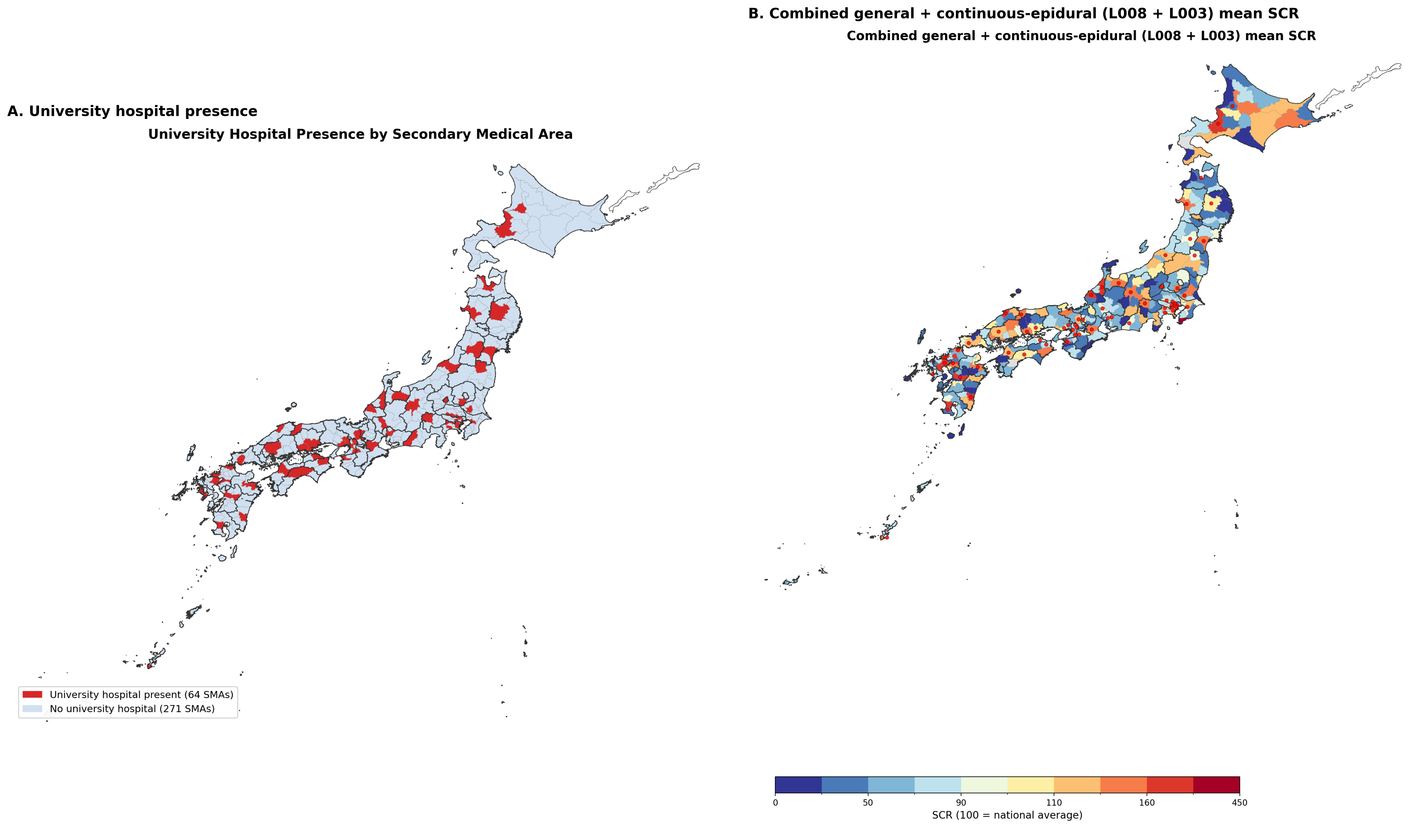
Figure 2. University hospital presence and the combined general-anaesthesia plus continuous-epidural measure. (A) Geographic distribution of secondary medical areas containing at least one university hospital (n = 64 of 335; red). (B) Choropleth map of the combined general-anaesthesia plus continuous-epidural standardised claim ratio (unweighted mean of L008 and L003 SCRs, not a clinical co-administration rate; 331 areas with data for both codes), shaded by quintile. Red circles mark secondary medical areas containing at least one university hospital. Areas masked by the data provider for either code are shown in grey.

A covariate-adjusted sensitivity model added the natural logarithm of population density and the anaesthesiologist share of all physicians (both standardised). The university hospital coefficient was attenuated but remained positive and statistically significant for general anaesthesia (β = +41.8, 95% CI 32.4 to 51.2, P < 0.001), epidural anaesthesia (β = +39.1, 95% CI 14.5 to 63.7, P = 0.002) and continuous epidural infusion (β = +33.9, 95% CI 20.0 to 47.7, P < 0.001). For spinal anaesthesia the point estimate was positive but no longer statistically significant (β = +9.7, 95% CI -4.0 to 23.3, P = 0.165). Population density was positively associated with general anaesthesia ratios (β = 8.3, P < 0.001) but not with the other three codes. The anaesthesiologist share was positively associated with general, epidural, continuous epidural and spinal anaesthesia (general P < 0.001, epidural P = 0.039, continuous epidural P < 0.001 and spinal P = 0.005). The covariate-adjusted mixed models produced optimizer-convergence warnings in Statsmodels[14]; we therefore refitted them with the lbfgs and cg optimisers, and the point estimates remained stable across optimisers and sensitivity analyses.
3.3 Checks against the audit hypothesis
Several lines of evidence pointed away from differential auditing as the main explanation. First, the multilevel model estimates that only 5.8% of general anaesthesia variance lies between prefectures, where audit policy differs, so differential auditing can account for at most a small share of observed variation. University hospital presence explained 35.8% of total variance in the same model, a structural component far larger than the between-prefecture share. Second, general and spinal anaesthesia were positively correlated (r = 0.235, P < 0.001), as were general and epidural anaesthesia (r = 0.319, P < 0.001). Positive correlations are more consistent with a common supply-side factor than with audit-driven reclassification, although a uniform audit effect across all codes cannot be ruled out. Third, the maximum prefectural audit-rate difference of 0.28 percentage points could produce a ratio shift of approximately 0.28 points under the conservative, linear one-to-one mapping, equivalent to approximately 0.53% of the observed interquartile range for general anaesthesia and 0.27% for epidural anaesthesia. Fourth, combining general (L008) and spinal (L004) ratios produced an alternative measure that should be insensitive to miscoding between reclassifiable codes; it showed a coefficient of variation of 43.4% and a university hospital effect that remained large (Cohen's d 1.26), confirming that the structural effect is not erased as an artefact by combining codes.
3.4 Robustness: empirical Bayes shrinkage and outliers
Empirical Bayes shrinkage toward prefecture means was implemented as a stress test of the area-level ratios. Under this model, shrinkage substantially compressed the area-level ratios toward their prefecture means. For general anaesthesia, Cohen's d for the university-hospital effect fell from 1.88 (raw) to 0.63 (shrunken), an attenuation of 66.5%; for epidural anaesthesia (L002) from 0.59 to 0.23 (60.6%); and for spinal anaesthesia (L004) from 0.40 to 0.04 (89.9%). The general anaesthesia effect therefore remained moderate despite heavy shrinkage, whereas the L002 and L004 effects were materially attenuated, indicating that those smaller raw effects are more vulnerable to sampling instability. These shrinkage estimates are complementary to, and consistent in direction with, the mixed-effects model coefficients reported in Table 2, which themselves incorporate prefecture-level shrinkage. Two areas were identified as outliers (more than three standard deviations from the mean general anaesthesia ratio): Awa (Chiba) in Chiba (ratio 216.7) and central Tokyo (Tokyo) in Tokyo (ratio 435.7). Excluding outliers did not alter the direction or statistical significance of any finding.
4. DISCUSSION
4.1 Statement of principal findings
Regional variation in anaesthesia practice across Japan's 335 secondary medical areas is substantial and appears to reflect structural access factors more than prefectural auditing. University hospital presence was associated with the largest proportional reduction in total variance for general anaesthesia and a positive association in every prefecture, while the proportion of variance attributable to prefecture-level factors -- where audit intensity differs -- was small. The audit-sensitivity checks and robustness analyses pointed away from differential auditing as the main explanation. Because the outcome is a reimbursed claim ratio, the observed gradient reflects billed service delivery rather than bedside intention; however, the within-prefecture structure of the data and the audit-sensitivity analyses make it unlikely that differential scrutiny is the full explanation. The remaining variation is therefore best interpreted as a geographic pattern in the provision of potentially beneficial anaesthesia services.
4.2 Strengths and limitations
Strengths include the use of age- and sex-standardised ratios covering the entire national population; analysis at a fine geographic scale of 335 areas nested within 47 prefectures; multilevel modelling that accounts for the nested data structure; empirical Bayes shrinkage to address low-volume instability; multiple pre-specified sensitivity analyses; and the residence-based ratio definition that mitigates patient travel effects. Limitations are those common to ecological, cross-sectional claims studies: the ecological fallacy[15]; the inability to infer individual-level treatment from area-level aggregates; the cross-sectional design, which precludes causal inference; the post-audit nature of the data, which reflects reimbursed rather than intended practice; and the partial overlap between university hospital presence and urban concentration. A further limitation is that the standardised claim ratios are residence-based, whereas university hospital presence is a provider-location variable. If patients cross secondary medical area boundaries for surgery, the estimated university-hospital effect is an ecological association between local supply and residents' reimbursement rather than a causal effect of living in the same area. We could not access code-specific audit rates, so the audit-sensitivity bound relies on the aggregate prefectural audit differential and the simplifying assumption of a one-to-one percentage-point mapping. A specific data constraint is that the combined anaesthesia add-on billed under L008 is aggregated with other add-ons in the publicly released regional variation dataset and cannot be extracted separately; patient-level National Database records would be needed to measure the true rate of combined general-epidural anaesthesia. We therefore used L002 (epidural as main technique) and L003 (continuous epidural infusion) as the best available public proxies. A covariate-adjusted sensitivity model added population density and anaesthesiologist share of physicians; the university hospital coefficient remained positive and statistically significant for general, epidural and continuous epidural anaesthesia, but not for spinal anaesthesia. The positive point estimate for spinal anaesthesia is compatible with the same structural gradient in an underpowered model, and may partly reflect a countervailing tendency for neuraxial anaesthesia to be provided in settings where anaesthesiologists are less available. The aggregate data cannot separate these opposing mechanisms, so the adjusted spinal-anaesthesia coefficient is best interpreted as an imprecise net effect.
4.3 International generalizability and clinical relevance
These findings are consistent with the broader literature on geographic variation in medical practice. The Dartmouth Atlas project documented extensive regional variation in surgical rates in the United States, driven primarily by physician supply and practice style[16]. Comparable patterns have been described for the National Health Service in England[17], Germany[18] and Australia[19]. Our study extends this evidence by exploiting Japan's uniform fee schedule combined with prefecture-specific auditing to disentangle administrative and structural sources of variation, and, to our knowledge, is one of the first multilevel small-area analyses of anaesthesia technique under universal coverage in East Asia using publicly available, nationwide standardised claim ratios. The university hospital effect we report (Cohen's d = 1.88) is substantial, plausibly reflecting the influence of the ikyoku (university medical office) system on practice in affiliated hospitals[20].
The natural experiment used here depends on two institutional features: a uniform national fee schedule that eliminates price variation, and regionally devolved claims auditing that makes within-region audit policy homogeneous while allowing it to differ between regions. Both features are present in several high-income universal-coverage systems, including Taiwan's National Health Insurance[21], South Korea's National Health Insurance Service, and the tariff-based systems of Germany, France and the English National Health Service[17,18]. In these settings the within-region variance decomposition and audit-sensitivity bound are directly transportable. In countries without universal health coverage, or where reimbursement varies by insurer, state or facility, price and insurance-status differences confound any comparison of regional claims rates, so the audit hypothesis cannot be isolated. The broader framework of decomposing small-area variation into structural versus institutional-artefact components can still be applied if comparable data exist, but the audit-specific interpretation must be calibrated to local reimbursement and auditing arrangements.
For clinical anaesthesia practice, the finding that university-hospital areas use more neuraxial and combined techniques has direct perioperative implications. Neuraxial anaesthesia and epidural analgesia are associated with reduced postoperative opioid consumption, lower postoperative nausea and vomiting, and faster recovery in selected populations[4-6]. Geographic variation in these techniques therefore translates into variation in potentially modifiable patient outcomes, not merely variation in billing. Because the observed gradient is not explained by differential auditing, interventions may warrant targeting workforce distribution, training and organisational capacity rather than coding compliance.
4.4 Implications for perioperative practice and policy
Three potential policy implications follow. First, administrative claims data can be used as a surveillance tool to monitor small-area variation in perioperative care under universal coverage, but should be interpreted alongside sensitivity analyses for coding and audit effects. Second, the observed variation in epidural and continuous epidural use suggests a potential equity gap: patients' access to techniques that may improve recovery appears to depend on whether they live near a university hospital. Third, regulators may be better served by addressing workforce and organisational determinants of anaesthesia service delivery rather than treating low regional ratios primarily as coding or fraud issues. The variance-decomposition framework is transferable to other procedures and to systems with a national fee schedule and regional audit variation, but the audit-specific interpretation is limited in settings where fee and insurance structures are heterogeneous.
5. CONCLUSIONS
Regional variation in anaesthesia practice under universal coverage in Japan is substantial and appears to reflect structural access factors -- notably proximity to university hospitals -- more than prefectural claims auditing. The pattern is best interpreted as a documented service-delivery gradient that reflects potentially inequitable access to neuraxial techniques. In countries without universal coverage or with heterogeneous reimbursement, the audit hypothesis cannot be isolated, although the structural-access framework can be adapted if comparable data exist. Perioperative surveillance of small-area variation would benefit from separating administrative from structural sources before interpreting claims data as care variation or a coding issue.
6. RESEARCH IN CONTEXT
- What is already known: Geographic variation in anaesthesia technique is well documented, but few studies have separated structural access to care from administrative coding and auditing effects in universal-coverage systems.
- What this study adds: Across Japan's 335 secondary medical areas, university-hospital proximity was associated with large differences in standardised claim ratios, whereas prefectural claims-audit differences explained only a small share of variance.
- What are the implications of these findings: Administrative claims can be used as a surveillance signal for perioperative variation in universal coverage settings, but low regional ratios should prompt review of workforce and organisational access before being treated as coding or fraud issues.
REFERENCES
1. Ikegami N, Yoo BK, Hashimoto H, et al. Japanese universal health coverage: evolution, achievements, and challenges. Lancet 2011;378:1106-15.
2. Hashimoto H, Ikegami N, Shibuya K, et al. Cost containment and quality of care in Japan: is there a trade-off? Lancet 2011;378:1174-82.
3. Social Insurance Medical Fee Payment Fund. 審査状況（令和4年度）— 都道府県別医科歯科計審査状況（点数）. Tokyo: Social Insurance Medical Fee Payment Fund, 2023. https://www.ssk.or.jp/smph/tokeijoho/shinsatokei/shinsajokyo_r04.html (accessed 24 Jul 2026).
4. Sessler DI, Pei L, Huang Y, et al. Recurrence of breast cancer after regional or general anaesthesia: a randomised controlled trial. Lancet 2019;394:1807-15.
5. Chen WK, Miao CH. The effect of anesthetic technique on survival in human cancers: a meta-analysis of retrospective and prospective studies. PLoS One 2013;8:e56540.
6. Weng M, Chen W, Hou W, et al. The effect of neuraxial anaesthesia on cancer recurrence and survival after cancer surgery: an updated meta-analysis. Oncotarget 2016;7:15262-73.
7. Ministry of Health, Labour and Welfare. 2026 revision of the medical fee schedule: changes to the medical fee schedule master (R08). Tokyo: MHLW, 2026. https://shinryohoshu.mhlw.go.jp/shinryohoshu/file/info/smente260522.pdf (accessed 24 Jul 2026).
8. von Elm E, Altman DG, Egger M, et al. The Strengthening the Reporting of Observational Studies in Epidemiology (STROBE) statement: guidelines for reporting observational studies. Lancet 2007;370:1453-7.
9. Matsuda S. Health policy in Japan: current situation and future challenges. JMA J 2019;2:1-10.
10. Wennberg JE, Cooper MM, eds. The Dartmouth Atlas of Health Care. Chicago: American Hospital Publishing, 1999.
11. Cabinet Office. Regional variation visualisation (chiikisa no mieruka). https://www5.cao.go.jp/keizai-shimon/kaigi/special/reform/mieruka/chiikisa/index.html (accessed 10 Mar 2026).
12. Ministry of Health, Labour and Welfare. Survey of Physicians, Dentists and Pharmacists 2022 (e-Stat). https://www.e-stat.go.jp (accessed 12 Mar 2026).
13. Ministry of Land, Infrastructure, Transport and Tourism. National Land Numerical Information download service. https://nlftp.mlit.go.jp (accessed 10 Mar 2026).
14. Seabold S, Perktold J. Statsmodels: econometric and statistical modeling with Python. In: Proceedings of the 9th Python in Science Conference. 2010:92-6.
15. Greenland S. Ecologic versus individual-level sources of bias in ecologic estimates of contextual health effects. Int J Epidemiol 2001;30:1343-50.
16. Wennberg JE, Fisher ES, Skinner JS. Geography and the debate over Medicare reform. Health Aff (Millwood) 2002;Suppl Web Exclusives:W96-114.
17. NHS RightCare. The NHS Atlas of Variation in Healthcare. London: Public Health England, 2015.
18. Schäfer T, Pritzkuleit R, Jeszenszky C, et al. Trends and geographical variation of primary hip and knee joint replacement in Germany. Osteoarthritis Cartilage 2013;21:279-88.
19. Australian Commission on Safety and Quality in Health Care. Australian Atlas of Healthcare Variation. Sydney: ACSQHC, 2015.
20. Otsuka T. The ikyoku system of university orthopaedic surgery departments: an in-hospital organisational system unique to Japan. J Orthop Sci 2012;17:513-14.
21. Cheng T-M. Taiwan's new national health insurance program: genesis and experience so far. Health Aff (Millwood) 2003;22:61-76.

