Regional variation in anaesthesia practice in Japan: structural determinant or claims-audit artefact?
Running header: Anaesthesia variation in Japan

[Authors and affiliations to be supplied]
[Corresponding author: name, postal address, telephone, email]

Article type: Original research article
Word count (main text, excluding abstract, references, tables and figures): approximately 3714 words
Tables: 3 Figures: 2 References: 30
Reporting guideline: STROBE checklist for cross-sectional studies (uploaded as supplementary material)
Target journal: International Journal of Health Policy and Management

IMPLICATIONS FOR POLICY MAKERS
1. Within Japan's uniform national fee schedule, regional variation in anaesthesia practice is driven by structural capacity (notably university hospital presence) rather than by prefectural claims-audit intensity.
2. Large variation in neuraxial and combined general-epidural anaesthesia is a modifiable equity gap that workforce, training and monitoring policies can address without changing payment rates.
3. The claims-audit hypothesis is quantitatively implausible as the main driver of variation; policy responses should target supply and organisation rather than fraud control.
4. Anaesthesia technique mix can be monitored as a system-level quality indicator using existing publicly available standardised claim ratios.
5. The within-prefecture variance-decomposition framework is transferable to other procedures and to other universal-coverage systems that combine a uniform fee schedule with regional auditing.
IMPLICATIONS FOR PUBLIC
Patients in Japan are entitled to equitable access under universal health insurance, yet the likelihood of receiving a combined general-epidural anaesthetic depends strongly on whether the patient's home area contains a university hospital. This study shows that the variation is not explained by differences in claims auditing, which is uniform within each prefecture, but by the geographic distribution of specialist anaesthesia services. The findings suggest that policy attention should focus on expanding regional access to advanced anaesthesia techniques and on transparent monitoring of technique mix, rather than on tightening audits.

Regional variation in anaesthesia practice in Japan: structural determinant or claims-audit artefact?

ABSTRACT
Background Regional variation in anaesthesia practice is well documented, but whether it reflects clinical structure or administrative auditing remains unresolved. Japan's single national fee schedule plus prefecture-specific claims auditing offers a natural experiment. We quantified variation across 335 secondary medical areas and tested the structural versus audit hypotheses.
Methods Cross-sectional ecological study using age- and sex-standardised claim ratios (national average = 100) for six anaesthesia procedure codes in fiscal year 2022. We fitted multilevel linear mixed models with prefecture random intercepts and three pre-specified sensitivity analyses to test differential auditing, plus empirical Bayes shrinkage.
Results Coefficients of variation ranged from 53.7% (general anaesthesia) to 87.2% (epidural). Only 0.058 of general anaesthesia variance lay between prefectures; university hospital presence explained 0.358 of total variance and 47.4% of within-prefecture variance (Cohen's d 1.88), and was positive in all 47 prefectures. Audit sensitivity analyses converged: the maximum audit-rate difference could shift ratios by at most 0.28 points, less than 1% of the interquartile range for general anaesthesia. Empirical Bayes shrinkage attenuated the university hospital effect but it remained statistically significant.
Conclusion Regional variation is predominantly structural, driven by university hospital proximity. The large variation in epidural and continuous epidural infusion signals a modifiable inequity in access to potentially beneficial regional anaesthesia under universal coverage.

Keywords:
anaesthesia; small-area variation; multilevel analysis; health policy; health services research; universal health coverage; Japan

INTRODUCTION
Japan's universal health insurance system, established in 1961, covers the entire population under a nationally uniform fee schedule that specifies reimbursement for every medical procedure.¹ The system consistently ranks among the highest performing globally for effective service coverage² and is delivered through a hierarchical structure of 47 prefectural (tertiary) and 335 secondary medical areas, each designed to be self-sufficient for inpatient care.³ Cross-boundary patient movement is limited,⁴ and the system was intended to ensure equitable access regardless of geography.
Yet substantial regional variation in surgical procedures, prescribing and diagnostic testing has been documented through the National Database of Health Insurance Claims.⁵ A distinctive feature of the Japanese system is mandatory prefectural insurance auditing (shinsa): all claims are reviewed before reimbursement and audit rates vary across prefectures.⁶ This raises a fundamental question for health policy and governance: does the variation observed in claims data reflect genuine differences in clinical practice, or is it an artefact of differential auditing? Distinguishing between these two explanations has different implications for quality improvement, payment policy, regulation and patient equity.
Anaesthesia practice is well suited to this question. Perioperative claims are comparatively complete because surgery is almost always reimbursed, so the data have high structural integrity. The choice between general anaesthesia alone and techniques that add regional anaesthesia is clinically consequential: a body of evidence suggests that regional anaesthesia, particularly epidural analgesia combined with general anaesthesia, may improve recurrence-free and overall survival in some cancer surgeries,^{7,8} although results from randomised trials are mixed.⁹ The 2026 revision of the Japanese fee schedule renamed and redefined the L008 general-anaesthesia code to make the required airway-device explicit, removing an ambiguity that could plausibly have driven differential audit decisions.¹⁰ Understanding whether observed regional variation is structural or administrative is therefore both timely and central to evaluating the equity of care under universal coverage.
We used publicly available standardised claim ratios at the secondary medical area level to address the following research questions: (i) How large is the regional variation in anaesthesia practice across 335 areas? (ii) Is this variation explained by differential prefectural auditing? (iii) What proportion of variance lies between prefectures and between areas within prefectures? (iv) Which structural factors, including university hospital proximity, are associated with the observed variation?
METHODS
Study design and ethical considerations
This was a cross-sectional ecological study using publicly available aggregate data only. No individual-level data were accessed. Ethics committee approval was not required under the Ethical Guidelines for Medical and Biological Research Involving Human Subjects (Japan, 2021 revision). The study was reported in accordance with the Strengthening the Reporting of Observational Studies in Epidemiology (STROBE) checklist for cross-sectional studies,¹¹ which is provided as supplementary material.
Geographic units
Japan's healthcare delivery system is organised into a hierarchical structure of medical areas defined under Article 30-4 of the Medical Care Act.³ The 47 prefectures serve as tertiary medical areas; within each prefecture, secondary medical areas (n = 335 nationally) are designated as the basic units for inpatient care planning. Crucially, secondary medical areas are completely nested within prefectures and do not cross prefectural boundaries. This nesting differs from the Hospital Service Areas and Hospital Referral Regions used in the United States, which can cross state boundaries,¹² and makes within-prefecture comparisons unconfounded by spillover under a common audit policy.
Data sources and standardised claim ratios
We used three data sources. First, standardised claim ratios for fiscal year 2022 published by the Cabinet Office under the 'Regional Variation Visualisation' initiative.¹³ Standardised claim ratios are computed by indirect standardisation: expected claim frequencies are calculated by applying national age- and sex-specific claim rates to the local population structure, and the ratio is defined as 100 × (observed claims / expected claims). Ratios are calculated on a residence basis, so claims are attributed to the beneficiary's registered address rather than to the providing facility. Patient travel for treatment therefore does not inflate the ratio of the receiving area. Areas with very few claims are masked by the data provider to protect privacy and appear as missing values. Second, we obtained physician statistics from the 2022 Survey of Physicians, Dentists and Pharmacists.¹⁴ Third, secondary medical area boundaries, land area and population density were obtained from the National Land Numerical Information medical-area dataset (A38-20).¹⁵
Anaesthesia procedure codes and university hospital mapping
Six procedure codes from the Japanese fee schedule were analysed (Table 1): L008 (closed-circuit general anaesthesia); L002 (epidural anaesthesia as main technique); L003 (continuous epidural infusion, largely billed as adjunct to general anaesthesia); L004 (spinal anaesthesia); L009 (anaesthesia management fee I, a proxy for specialist staffing); and L100 (inpatient nerve block). We mapped university hospitals to their respective secondary medical areas based on municipal address. 64 secondary medical areas (19.1%) contained at least one university hospital, distributed across all 47 prefectures, which enables within-prefecture comparisons between university and non-university areas under a common audit policy.
Table 1. Anaesthesia procedure codes analysed.
Code | Procedure | Notes
L008 | Closed-circuit general anaesthesia | Primary indicator of overall general anaesthesia volume
L002 | Epidural anaesthesia | Regional technique claimed as main anaesthetic
L003 | Continuous epidural infusion | Regional technique largely billed as adjunct to general anaesthesia
L004 | Spinal anaesthesia | Alternative regional technique
L009 | Anaesthesia management fee I | Proxy for specialist anaesthesiologist staffing
L100 | Nerve block, inpatient | Indicator of pain-clinic activity
Source: Japanese fee schedule (shinryo houshu tensuhyo), fiscal year 2022. L codes correspond to anaesthesia-related procedures. Standardised claim ratios were computed for each code by indirect age- and sex-standardisation against the national average (= 100).
Statistical analysis
Three complementary approaches were used. First, we computed descriptive statistics including coefficients of variation. Between-group comparisons used Welch's t-test, Cohen's d for effect size¹⁶ and the Mann-Whitney U test for non-parametric confirmation. Second, we fitted multilevel linear mixed models with secondary medical areas (level 1, n = 335) nested within prefectures (level 2, n = 47).¹⁷ A null random-intercept model was fitted first to estimate the intraclass correlation coefficient. Subsequent models added fixed effects for university hospital presence; a covariate-adjusted sensitivity model further added the natural logarithm of population density and the anaesthesiologist share of all physicians (both standardised).^{15,16} Models were estimated by restricted maximum likelihood using the Python statsmodels MixedLM implementation.¹⁸ A small number of model fits produced optimizer convergence warnings; the resulting point estimates were numerically stable across repeated fits and across the sensitivity analyses, and are reported as mixed-model coefficients. Marginal R² was calculated as the proportional reduction in total variance from the null model. To address potential instability of ratios in low-volume areas, we applied empirical Bayes shrinkage estimation¹⁹ and compared all main findings using both raw and shrunken ratios.
Third, three pre-specified sensitivity analyses tested the null hypothesis that insurance auditing explains observed variation. (a) Within-prefecture variance decomposition: under uniform prefectural auditing, within-prefecture variance should be small. We decomposed total variance using one-way analysis of variance and further partitioned the within-prefecture component into university hospital effect and residual using hierarchical sum-of-squares decomposition. (b) Cross-code correlation: audit-driven reclassification between general and spinal anaesthesia codes would produce negative correlations between them. (c) Quantitative audit-impact estimation: we calculated the maximum ratio shift attributable to the observed range of prefectural point-audit rates reported by the Social Insurance Medical Fee Payment Fund.⁶ Combined ratios (general plus continuous epidural; general plus spinal) were also examined, since combining substitutable codes should largely absorb any audit-driven reclassification. Patients were not involved in the design, conduct or reporting of this study.
RESULTS
Study population and variation in anaesthesia practice
The 335 secondary medical areas were distributed across 47 prefectures (median 7 areas per prefecture, range 3 to 21); 64 areas (19.1%) contained at least one university hospital. Standardised claim ratios for general anaesthesia were available for 334 of 335 areas; ratios for epidural anaesthesia were available for 307 areas, with 28 areas masked owing to low volume. Substantial variation was observed across all codes (Table 2). General anaesthesia ratios ranged from 2.3 to 435.7 (coefficient of variation 53.7%), a 189.4-fold difference. Epidural anaesthesia showed the greatest relative variation (coefficient of variation 87.2%); continuous epidural infusion 65.0% and spinal anaesthesia 56.8%. The geographic distribution of ratios is shown in Figure 1.
Table 2. Distribution of standardised claim ratios across 335 secondary medical areas (national average = 100), fiscal year 2022.
Code | n | Mean (SD) | Median (IQR) | Min | Max | CV (%)
L008 | 334 | 79.7 (42.8) | 73.5 (50.0-103.0) | 2.3 | 435.7 | 53.7
L002 | 307 | 95.6 (83.4) | 76.6 (31.2-133.4) | 0.9 | 519.1 | 87.2
L003 | 331 | 83.5 (54.3) | 73.4 (45.0-117.0) | 0.4 | 443.0 | 65.0
L004 | 334 | 93.8 (53.3) | 84.6 (55.8-127.4) | 1.0 | 346.5 | 56.8
L009 | 314 | 87.3 (49.9) | 78.9 (51.4-116.5) | 0.1 | 392.2 | 57.2
L100 | 335 | 99.8 (77.1) | 77.8 (43.7-125.9) | 3.0 | 433.3 | 77.3
SD, standard deviation; IQR, interquartile range; CV, coefficient of variation. Areas with low claim volume are masked by the data provider and appear as missing values; the n column reflects the number of secondary medical areas with non-missing values for each code.
Figure 1. Geographic distribution of anaesthesia standardised claim ratios across 335 secondary medical areas of Japan, fiscal year 2022. (A) General anaesthesia (L008). (B) Spinal anaesthesia (L004). (C) Epidural anaesthesia as main anaesthetic (L002). (D) Continuous epidural infusion (L003). Choropleth maps shaded by quintile of the standardised claim ratio (national average = 100). Red circles mark secondary medical areas containing at least one university hospital. Areas masked by the data provider owing to low volume are shown in grey.
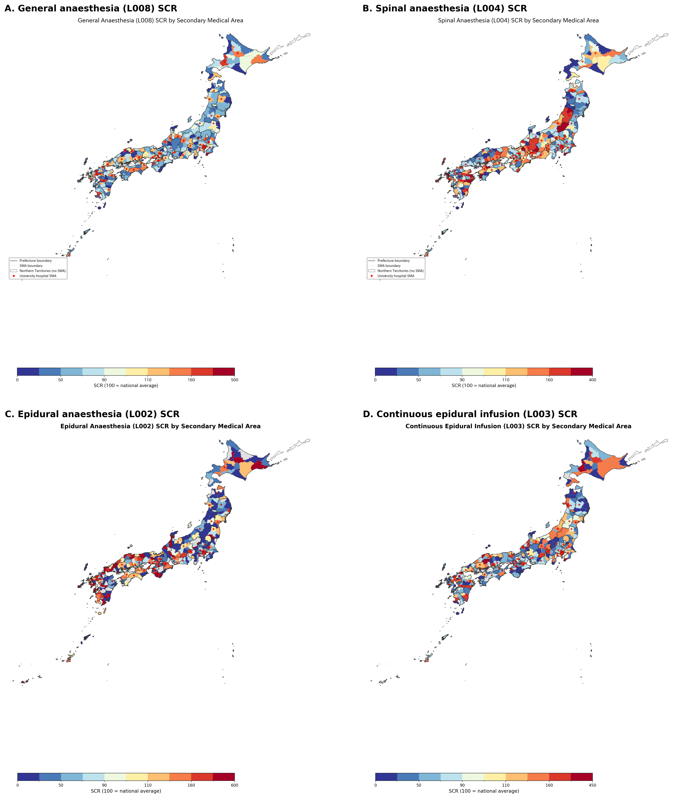

Multilevel model and university hospital effect
The null multilevel model showed that only 0.058 of general anaesthesia variance was attributable to the prefecture level (intraclass correlation coefficient 0.058), indicating that 85.5% occurred within prefectures where audit policy is uniform. Spinal anaesthesia showed stronger prefecture-level clustering (intraclass correlation coefficient 0.343), consistent with a greater role of prefectural factors for that code. Adding university hospital presence as a fixed effect produced the largest improvement for general anaesthesia (marginal R² 0.358; β = 64.1, 95% confidence interval 54.8 to 73.4) and was statistically significant for every code (all P <0.001) (Table 3). University hospital areas had higher general anaesthesia ratios than non-university areas in 47 of 47 prefectures, with a mean within-prefecture difference of +63.3 points (paired t = 13.28, P <0.001) (Figure 2A). Cohen's d for the university hospital effect on general anaesthesia was 1.88; on continuous epidural infusion 1.12; on epidural anaesthesia 0.59; and on spinal anaesthesia 0.40. A combined measure capturing the general-anaesthesia plus continuous-epidural workflow (mean of L008 and L003 SCR; 331 areas with data for both codes) showed a coefficient of variation of 55.5% and preserved a large university hospital effect (Cohen's d 1.55; university mean 130.3 versus non-university 70.2) (Figure 2B).
Table 3. Multilevel linear mixed model results: standardised claim ratio as outcome, prefecture as random intercept.
Code | Null model ICC | β university (95% CI) | P value | Marginal R²
L008 | 0.058 | +64.1 (54.8 to 73.4) | <0.001 | 0.358
L002 | 0.191 | +49.0 (27.2 to 70.8) | <0.001 | 0.125
L003 | 0.106 | +55.8 (43.0 to 68.7) | <0.001 | 0.162
L004 | 0.343 | +23.0 (11.0 to 35.1) | <0.001 | 0.020
β university, fixed effect coefficient for university hospital presence (binary 0/1); CI, confidence interval; ICC, intraclass correlation coefficient (proportion of variance attributable to prefecture level in the null random-intercept model); Marginal R², proportional reduction in total (prefecture + residual) variance from the null model after adding the university hospital fixed effect. Models were estimated by restricted maximum likelihood.
A covariate-adjusted sensitivity model added the natural logarithm of population density and the anaesthesiologist share of all physicians (both standardised). The university hospital coefficient was attenuated but remained positive and statistically significant for general anaesthesia (β = +41.8, 95% CI 32.4 to 51.2, P <0.001), epidural anaesthesia (β = +39.1, 95% CI 14.5 to 63.7, P 0.002) and continuous epidural infusion (β = +33.9, 95% CI 20.0 to 47.7, P <0.001). For spinal anaesthesia the point estimate was positive but no longer statistically significant (β = +9.7, 95% CI -4.0 to 23.3, P 0.165). Population density was positively associated with general anaesthesia ratios (β = 8.3, P <0.001) but not with the other three codes. The anaesthesiologist share was positively associated with general, epidural, continuous epidural and spinal anaesthesia (P <0.001, 0.039, <0.001 and 0.005, respectively).
Figure 2. University hospital presence and the combined general-anaesthesia plus continuous-epidural measure. (A) Distribution of secondary medical areas containing at least one university hospital (n = 64 of 335; red). (B) Choropleth map of the combined general-anaesthesia plus continuous-epidural standardised claim ratio (mean of L008 and L003 SCR; 331 areas with data for both codes), shaded by quintile. Red circles mark secondary medical areas containing at least one university hospital. Areas masked by the data provider for either code are shown in grey.
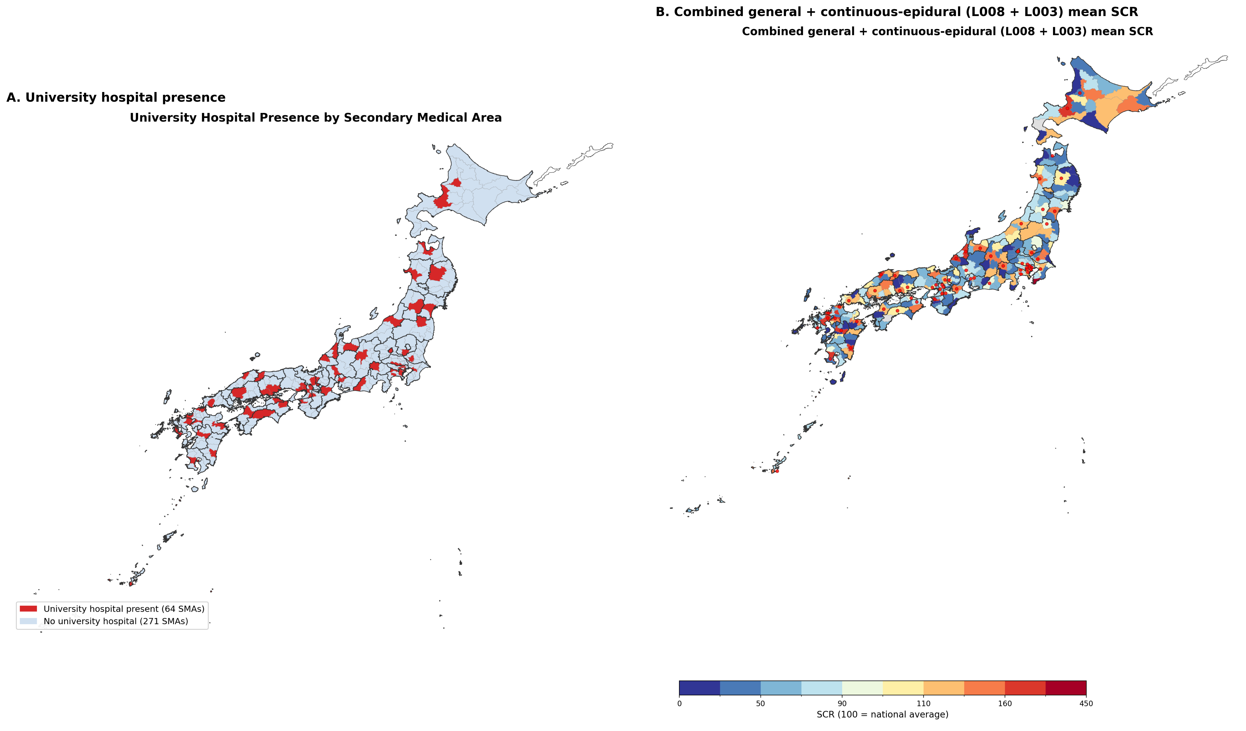

Sensitivity analyses against the audit hypothesis
All three pre-specified sensitivity analyses converged in rejecting the audit hypothesis. First, within-prefecture variance decomposition attributed 14.5% of general anaesthesia variance to between-prefecture differences, 40.5% to the university hospital effect within prefecture, and 45.0% to residual within-group variation; the university hospital effect alone explained 47.4% of all within-prefecture variance. Second, general and spinal anaesthesia were positively, not negatively, correlated (r = 0.235, P <0.001), as were general and epidural anaesthesia (r = 0.319, P <0.001), inconsistent with audit-driven reclassification and consistent with a common supply factor. Third, the maximum prefectural audit-rate difference of 0.28 percentage points could produce a ratio shift of approximately 0.28 points, equivalent to approximately 0.53% of the observed interquartile range for general anaesthesia and 0.27% for epidural anaesthesia. Combining general (L008) and spinal (L004) ratios produced an alternative audit-insensitive measure with a coefficient of variation of 43.4% and a university hospital effect that remained large (Cohen's d 1.26), confirming that the structural effect is not artefactually erased by combining reclassifiable codes.
Robustness: empirical Bayes shrinkage and outliers
Empirical Bayes shrinkage toward prefecture means was implemented as a stress test of the area-level ratios. Under this model, shrinkage substantially compressed the area-level ratios toward their prefecture means. For general anaesthesia, Cohen's d for the university-hospital effect fell from 1.88 (raw) to 0.63 (shrunken), an attenuation of 66.5%; for epidural anaesthesia (L002) from 0.59 to 0.23 (60.6%); and for spinal anaesthesia (L004) from 0.40 to 0.04 (89.9%). The general anaesthesia effect therefore remained of moderate magnitude despite heavy shrinkage, whereas the L002 and L004 effects were materially attenuated, indicating that those smaller raw effects are more vulnerable to sampling instability. These shrinkage estimates are complementary to, and consistent in direction with, the mixed-effects model coefficients reported in Table 3, which themselves incorporate prefecture-level shrinkage. Two areas were identified as outliers (more than three standard deviations from the mean general anaesthesia ratio): Awa (Chiba) in Chiba (ratio 216.7) and central Tokyo (Tokyo) in Tokyo (ratio 435.7). Excluding outliers did not alter the direction or statistical significance of any finding.
DISCUSSION
Statement of principal findings
Regional variation in anaesthesia practice across Japan's 335 secondary medical areas is substantial, with coefficients of variation ranging from 53.7% for general anaesthesia to 87.2% for epidural anaesthesia. Multilevel modelling showed that only 0.058 of general anaesthesia variance is attributable to prefectures, while 85.5% occurs within prefectures where audit policy is uniform. University hospital presence explained 0.358 of total variance and 47.4% of within-prefecture variance, and the effect was present in all 47 prefectures despite differing audit practices. Three independent sensitivity analyses converged in rejecting differential auditing as a plausible explanation. The observed variation is therefore predominantly structural, driven by institutional capacity and clinical-organisational factors rather than by administrative coding.
Strengths and limitations
Strengths include the use of age- and sex-standardised ratios covering the entire national population; analysis at a fine geographic scale of 335 areas; multilevel modelling that properly accounts for the nested data structure; empirical Bayes shrinkage to address low-volume instability; multiple pre-specified sensitivity analyses; within-prefecture comparisons that hold audit policy constant; and the residence-based ratio definition that mitigates patient travel effects. Limitations include the ecological fallacy inherent in area-level analysis;²⁰ the cross-sectional design, which precludes causal inference; the post-audit nature of the data, which reflects reimbursed rather than intended practice; the partial overlap between university hospital presence and urban concentration; the absence of code-specific audit-rate data; and the inability to quantify defensive undercoding from claims alone. A specific constraint of the publicly available dataset is that the combined anaesthesia add-on billed under L008 (the explicit code for general-plus-epidural technique) is aggregated with other anaesthesia add-ons in the regional variation data release and cannot be extracted separately at the secondary-medical-area level; patient-level National Database records would be required to measure the true rate of combined general-epidural anaesthesia. We therefore used L002 (epidural as main technique) and L003 (continuous epidural infusion) as the publicly reported proxies for regional technique use. A covariate-adjusted sensitivity model added population density and anaesthesiologist supply; the university hospital coefficient remained positive and statistically significant for general, epidural and continuous epidural anaesthesia, but not for spinal anaesthesia. The positive point estimate for spinal anaesthesia is, however, compatible with the same structural gradient operating in an underpowered model, and may partly reflect a countervailing tendency for neuraxial anaesthesia to be used in settings where anaesthesiologists are less available. The aggregate data cannot separate these opposing mechanisms, so the adjusted spinal-anaesthesia coefficient is best interpreted as an imprecise net effect.
Interpretation within the context of the wider literature
Our findings are consistent with the broader medical practice variation literature. The Dartmouth Atlas project documented extensive regional variation in surgical rates in the United States, driven primarily by physician supply and practice style.²¹ Comparable patterns have been described for the National Health Service²² and in Germany²³ and Australia.²⁴ Our study extends this evidence by exploiting Japan's uniquely uniform fee schedule combined with prefecture-specific auditing to disentangle administrative and clinical sources of variation, and by providing, to our knowledge, the first multilevel small-area analysis of anaesthesia technique under universal coverage in East Asia. The university hospital effect we report (Cohen's d = 1.88) is substantial, plausibly reflecting the influence of the ikyoku (university medical office) system on clinical practice in affiliated hospitals.²⁵ The intraclass correlation coefficient of 0.058 for general anaesthesia indicates that most variation occurs within prefectures, consistent with institutional factors dominating over prefectural-level factors for this code.
Our findings and framework extend beyond Japan in four respects. First, the within-prefecture variance decomposition we describe is directly transportable to other universal-coverage systems that combine a centrally uniform fee schedule with regionally devolved claims auditing, including Taiwan's National Health Insurance,²⁶ South Korea's National Health Insurance Service, and the tariff-based systems of Germany, France and the English National Health Service.^{22,23} Second, the dominance of tertiary-teaching-hospital concentration as a structural determinant of technique choice echoes analogous patterns for teaching-hospital anaesthesia mix reported in the US and United Kingdom,^{21,22} and for other tertiary-intensive specialties across OECD countries;²⁷ the consistency of the university effect across 47 of 47 prefectures in our data suggests that it is a robust feature of high-income health systems rather than a Japanese idiosyncrasy. Third, the variation we identify in epidural anaesthesia (L002, coefficient of variation 87.2%) and continuous epidural infusion (L003, 65.0%) speaks to an international equity agenda: where emerging evidence links regional anaesthesia to oncological and functional outcomes,⁷⁻⁹ monitoring the distribution of anaesthesia techniques could serve as a system-level quality indicator across any universal coverage setting committed to equitable access to technology-rich care.^{28,29} Fourth, extrapolation to low- and middle-income countries is more cautious: fee schedules and audit arrangements are typically heterogeneous and claims data often incomplete, which limits direct replication of the decomposition. Nevertheless, the general principle — that apparent small-area variation should be interrogated for administrative versus structural origins before policy action — is transferable, particularly as low- and middle-income countries progressively standardise their fee schedules under universal health coverage reforms.²
Implications for policy, practice and governance
The policy implications of these findings are threefold. First, the predominance of structural over administrative determinants means that regulators should not interpret regional variation in anaesthesia claims as prima facie evidence of differential coding accuracy or fraud. Japan's prefecture-specific auditing system is an important governance tool, but its variation in intensity is too small to explain the observed large differences in neuraxial technique use. Redirecting enforcement resources toward coding audits in low-ratio areas is unlikely to reduce the gap and may even penalise providers who already lack specialist capacity.
Second, the marked variation in continuous epidural infusion (L003; coefficient of variation 65.0%) and in epidural anaesthesia (L002; 87.2%) is clinically important because general anaesthesia supplemented with regional techniques has been linked, albeit inconsistently, with better oncological outcomes.⁷⁻⁹ A 1.77-fold difference in continuous epidural infusion ratios between university and non-university areas implies that patients' access to a potentially beneficial technique depends substantially on where they live, which challenges the equity premise of Japan's universal coverage. Quality improvement responses could include targeted education, specialist outreach from university centres, and monitoring anaesthesia technique distribution as a system-level quality indicator,²⁸⁻³⁰ aligned with international standards for safe practice of anaesthesia.
Third, the within-prefecture variance decomposition and multilevel sensitivity framework developed here provide a transferable governance tool for distinguishing administrative from structural sources of small-area variation. In a single-payer system with a uniform fee schedule, any procedure that shows large within-prefecture variation cannot be attributed to the audit environment and should prompt policy review of workforce, training and facility capacity. Conversely, large between-prefecture variation may warrant regulatory attention to payment, audit or coding practices. Applying this framework to other procedure groups could improve the targeting of both quality-improvement and regulatory resources.
CONCLUSIONS
Regional variation in anaesthesia practice in Japan is large and predominantly structural rather than an artefact of insurance auditing. University hospital presence is the dominant measured structural determinant, explaining more than one third of total variance in general anaesthesia. The variation in epidural anaesthesia (L002) and continuous epidural infusion (L003) is of particular concern given emerging evidence of oncological benefit from regional techniques. Quality improvement, workforce policy and equity policy should address the supply and organisational determinants of anaesthesia practice rather than treat the variation as an unavoidable feature of claims processing or as a signal of differential auditing.
REFERENCES
1. Ikegami N, Yoo BK, Hashimoto H, et al. Japanese universal health coverage: evolution, achievements, and challenges. Lancet 2011;378:1106-15.
2. GBD 2019 Universal Health Coverage Collaborators. Measuring universal health coverage based on an index of effective coverage of health services in 204 countries and territories, 1990-2019. Lancet 2020;396:1250-84.
3. Matsuda S. Health policy in Japan: current situation and future challenges. JMA J 2019;2:1-10.
4. Ministry of Health, Labour and Welfare. Patient Survey 2008. Tokyo: MHLW, 2009.
5. Hashimoto H, Ikegami N, Shibuya K, et al. Cost containment and quality of care in Japan: is there a trade-off? Lancet 2011;378:1174-82.
6. Social Insurance Medical Fee Payment Fund. 審査状況（令和4年度）— 都道府県別医科歯科計審査状況（点数）. Tokyo: Social Insurance Medical Fee Payment Fund, 2023. https://www.ssk.or.jp/smph/tokeijoho/shinsatokei/shinsajokyo_r04.html (accessed 24 Jul 2026).
7. Sessler DI, Pei L, Huang Y, et al. Recurrence of breast cancer after regional or general anaesthesia: a randomised controlled trial. Lancet 2019;394:1807-15.
8. Chen WK, Miao CH. The effect of anesthetic technique on survival in human cancers: a meta-analysis of retrospective and prospective studies. PLoS One 2013;8:e56540.
9. Weng M, Chen W, Hou W, et al. The effect of neuraxial anaesthesia on cancer recurrence and survival after cancer surgery: an updated meta-analysis. Oncotarget 2016;7:15262-73.
10. Ministry of Health, Labour and Welfare. 2026 revision of the medical fee schedule: changes to the medical fee schedule master (R08). Tokyo: MHLW, 2026. https://shinryohoshu.mhlw.go.jp/shinryohoshu/file/info/smente260522.pdf (accessed 24 Jul 2026).
11. von Elm E, Altman DG, Egger M, et al. The Strengthening the Reporting of Observational Studies in Epidemiology (STROBE) statement: guidelines for reporting observational studies. Lancet 2007;370:1453-7.
12. Wennberg JE, Cooper MM, eds. The Dartmouth Atlas of Health Care. Chicago: American Hospital Publishing, 1999.
13. Cabinet Office. Regional variation visualisation (chiikisa no mieruka). https://www5.cao.go.jp/keizai-shimon/kaigi/special/reform/mieruka/chiikisa/index.html (accessed 10 Mar 2026).
14. Ministry of Health, Labour and Welfare. Survey of Physicians, Dentists and Pharmacists 2022 (e-Stat). https://www.e-stat.go.jp (accessed 12 Mar 2026).
15. Ministry of Land, Infrastructure, Transport and Tourism. National Land Numerical Information download service. https://nlftp.mlit.go.jp (accessed 10 Mar 2026).
16. Cohen J. Statistical Power Analysis for the Behavioral Sciences. 2nd ed. Hillsdale, NJ: Lawrence Erlbaum, 1988.
17. Rabe-Hesketh S, Skrondal A. Multilevel and Longitudinal Modeling Using Stata. 3rd ed. College Station, TX: Stata Press, 2012.
18. Seabold S, Perktold J. Statsmodels: econometric and statistical modeling with Python. In: Proceedings of the 9th Python in Science Conference. 2010:92-6.
19. Efron B, Morris C. Stein's estimation rule and its competitors: an empirical Bayes approach. J Am Stat Assoc 1973;68:117-30.
20. Greenland S. Ecologic versus individual-level sources of bias in ecologic estimates of contextual health effects. Int J Epidemiol 2001;30:1343-50.
21. Wennberg JE, Fisher ES, Skinner JS. Geography and the debate over Medicare reform. Health Aff (Millwood) 2002;Suppl Web Exclusives:W96-114.
22. NHS RightCare. The NHS Atlas of Variation in Healthcare. London: Public Health England, 2015.
23. Schäfer T, Pritzkuleit R, Jeszenszky C, et al. Trends and geographical variation of primary hip and knee joint replacement in Germany. Osteoarthritis Cartilage 2013;21:279-88.
24. Australian Commission on Safety and Quality in Health Care. Australian Atlas of Healthcare Variation. Sydney: ACSQHC, 2015.
25. Otsuka T. The ikyoku system of university orthopaedic surgery departments: an in-hospital organisational system unique to Japan. J Orthop Sci 2012;17:513-14.
26. Cheng T-M. Taiwan's new national health insurance program: genesis and experience so far. Health Aff (Millwood) 2003;22:61-76.
27. OECD. Geographic Variations in Health Care: What Do We Know and What Can Be Done to Improve Health System Performance? Paris: OECD Publishing, 2014.
28. Donabedian A. The quality of care: how can it be assessed? JAMA 1988;260:1743-8.
29. Merry AF, Cooper JB, Soyannwo O, et al. International standards for a safe practice of anesthesia 2010. Can J Anesth 2010;57:1027-34.
30. Mainz J. Defining and classifying clinical indicators for quality improvement. Int J Qual Health Care 2003;15:523-30.

