Regional variation in anaesthesia practice across 335 secondary medical areas in Japan: a cross-sectional analysis of national claims data

[Author names]
[Affiliations]
[Corresponding author: name, address, email]

Word count: approximately 4,000
Tables: 2
Figures: 9 (6 two-dimensional choropleth maps + 3 three-dimensional extruded maps)

ABSTRACT
Objective To quantify regional variation in anaesthesia practice across Japanese secondary medical areas and to determine whether observed differences reflect insurance audit artefacts or genuine variation in clinical practice.
Design Cross-sectional ecological study using publicly available national claims data.
Setting 335 secondary medical areas (SMAs) across all 47 prefectures of Japan.
Main outcome measures Standardised claim ratios (SCRs), age- and sex-adjusted, for general anaesthesia (L008), epidural anaesthesia (L002), continuous epidural infusion (L003), and spinal anaesthesia (L004). Three sensitivity analyses tested whether insurance audit variation explained observed differences.
Results Substantial regional variation was observed: coefficients of variation were 54.6% for general anaesthesia (L008), 83.2% for epidural anaesthesia (L002), and 64.9% for continuous epidural infusion (L003). Three sensitivity analyses indicated that audit variation is insufficient to explain observed differences: (1) 85.8% of L008 variance occurred within prefectures, where audit policy is uniform; (2) general and spinal anaesthesia showed inverse correlation (r=−0.506), consistent with clinical substitution (although also compatible with audit-driven reclassification, the magnitude of audit rate differences makes this unlikely); (3) audit rate differences (0.2 percentage points) could explain less than 1% of observed SCR variation. University hospital presence was the strongest single predictor, explaining 38.5% of total L008 variance (Cohen's d=1.78). The combined GA–epidural technique (L003) was 1.73 times higher in university hospital areas.
Conclusions Regional variation in anaesthesia practice in Japan is structural, not an artefact of insurance auditing. University hospital proximity is the dominant determinant. Given evidence linking regional anaesthesia techniques to improved oncological outcomes, this variation may represent a modifiable source of health inequality.

What is already known on this topic
- Regional variation in surgical and anaesthesia practice has been documented in many countries, but the relative contributions of clinical preference, institutional factors, and administrative mechanisms (such as insurance auditing) remain unclear.
- Japan's universal insurance system processes all claims through standardised audit, creating a unique natural experiment in which administrative variation can be distinguished from clinical variation.

What this study adds
- Three independent sensitivity analyses demonstrate that regional variation in anaesthesia practice in Japan is structural rather than an artefact of insurance auditing.
- University hospital presence explains 38.5% of variance in general anaesthesia volume—a remarkably large effect for a single binary predictor—and the effect is consistent across all 47 prefectures.
- Combined general–epidural anaesthesia, which may confer oncological benefit, shows the greatest regional inequality (CV=64.9%), suggesting a modifiable target for reducing health disparities.

INTRODUCTION
Japan's universal health insurance system, established in 1961, covers the entire population under a standardised fee schedule (shinryo houshu tensuhyo) that specifies reimbursement for each medical procedure.¹·² This system was designed to ensure equitable access to healthcare regardless of geography. Yet studies using the National Database of Health Insurance Claims (NDB) have revealed substantial regional variation in medical practice, including surgical procedures, prescription patterns, and diagnostic testing.³–⁵
A distinctive feature of the Japanese system is mandatory insurance auditing (shinsa). All claims are reviewed by prefectural audit committees before reimbursement, and claims deemed inappropriate are reduced or rejected (satei). Audit rates vary across prefectures, ranging from 0.07% to 0.28%.⁶ This raises a fundamental question: does observed regional variation in claims data reflect genuine differences in clinical practice, or is it an artefact of differential auditing?
This question has particular relevance for anaesthesia practice. The choice of anaesthesia technique—general anaesthesia alone versus combined general–regional techniques—is not merely a matter of preference. A growing body of evidence suggests that regional anaesthesia techniques, particularly epidural analgesia combined with general anaesthesia, may improve recurrence-free survival and overall survival in cancer surgery.⁷–¹² A Cochrane systematic review found limited but suggestive evidence favouring regional techniques for cancer recurrence,⁷ and the landmark randomised controlled trial by Sessler et al. reported no significant difference in breast cancer recurrence with regional anaesthesia, although secondary analyses and observational meta-analyses continue to support a potential benefit for certain cancer types.⁸–¹² If regional variation in anaesthesia technique is genuine rather than an audit artefact, it may represent a modifiable source of health inequality with implications for oncological outcomes.
The 2026 revision of the Japanese fee schedule renamed the general anaesthesia code from "mask or endotracheal intubation" to "supraglottic airway device or endotracheal intubation," reflecting longstanding ambiguity in coding that may have contributed to differential auditing of general anaesthesia claims.¹³ Understanding the true nature of regional variation is therefore timely.
We used publicly available standardised claim ratio (SCR) data at the secondary medical area level to: (1) quantify regional variation in anaesthesia practice across 335 areas; (2) test whether insurance audit variation explains observed differences through three independent sensitivity analyses; and (3) identify structural determinants of variation, including university hospital proximity and pain clinic activity.

METHODS

Study design and data sources
This was a cross-sectional ecological study using publicly available data. We used three data sources:
- Standardised claim ratios (SCRs) for fiscal year 2022 (Reiwa 4), published by the Cabinet Office as part of the "Regional Variation Visualisation" initiative.¹⁴ SCRs are age- and sex-adjusted ratios of observed to expected claim frequencies, where the national average equals 100. Data were available at both the prefectural level (47 prefectures) and the secondary medical area (SMA) level (335 areas).
- Physician statistics from the 2022 Survey of Physicians, Dentists, and Pharmacists (e-Stat), providing the number of anaesthesiologists by secondary medical area.¹⁵
- Geographic data from the National Land Numerical Information dataset (A38-20) for SMA boundaries, and administrative boundary data (N03) for prefectural borders and the Northern Territories.¹⁶

Anaesthesia codes analysed
We analysed the following procedure codes from the Japanese fee schedule:
Code | Procedure | Clinical significance | SMAs with data
L008 | Closed-circuit general anaesthesia | Primary indicator of GA volume | 334
L002 | Epidural anaesthesia | Regional technique (alone or combined) | 307
L003 | Continuous epidural infusion | Direct indicator of GA+epidural combination | 331
L004 | Spinal anaesthesia | Alternative to GA for suitable procedures | 334
L009 | Anaesthesia management fee I | Proxy for specialist anaesthesiologist staffing | 314
L100 | Nerve block (inpatient) | Indicator of pain clinic activity | 335

Table 1. Anaesthesia procedure codes analysed.

University hospital mapping
We mapped 81 university hospitals (44 national, 8 public, 29 private) to 64 SMAs based on municipal address. Under Japan's "one medical school per prefecture" policy, all 47 prefectures have at least one university hospital, enabling within-prefecture comparisons that control for prefectural audit policy.

Sensitivity analyses for the audit hypothesis
We tested the null hypothesis that "all regional variation in anaesthesia SCRs is explained by differential insurance auditing" using three independent approaches:
- Test 1 (within-prefecture variance): If audit policy (applied uniformly within each prefecture) explains all variation, then within-prefecture variance should be negligible. We decomposed total SCR variance into between-prefecture and within-prefecture components using one-way ANOVA.
- Test 2 (cross-code correlation): If auditing reclassifies general anaesthesia claims as spinal anaesthesia (or vice versa), these codes may show negative correlation at the ecological level (though clinical substitution would also produce this pattern). We calculated Pearson correlations between anaesthesia code pairs and interpreted them in conjunction with the quantitative audit impact estimate (Test 3).
- Test 3 (quantitative impact): We estimated the maximum SCR impact of audit rate differences using published aggregate audit statistics (range 0.07–0.28% across prefectures).⁶

Combined SCR analysis
To further test the audit reclassification hypothesis, we computed combined SCRs (L008+L004 for GA–spinal substitution; L008+L002 for GA–epidural substitution). If audit-driven reclassification is the primary source of variation, combining the reclassified codes should substantially reduce the coefficient of variation.

Statistical analysis
We report descriptive statistics (mean, standard deviation, coefficient of variation, percentiles) for SCRs. Between-group comparisons used Welch's t-test and Cohen's d for effect size.¹⁷ Variance decomposition used one-way ANOVA (between-prefecture) and hierarchical decomposition (between-prefecture, university hospital effect, residual). Correlations are Pearson r. Standardised claim ratios were computed using indirect standardisation, a standard method in small-area variation research.¹⁸ All analyses were conducted in Python 3.12 using pandas, scipy, and geopandas. Three-dimensional extruded choropleth maps were created using Plotly Mesh3d with Delaunay triangulation of polygon boundaries.¹⁹ Two-dimensional maps were created using matplotlib and geopandas.

Patient and public involvement
This study used publicly available aggregate data with no individual patient information. Patients were not involved in the design or conduct of this research.

RESULTS

Regional variation in anaesthesia practice
Substantial variation was observed across all anaesthesia codes (Table 2). General anaesthesia (L008) SCRs ranged from 2.3 to 458.9 across 334 SMAs (coefficient of variation [CV] 54.6%). Epidural anaesthesia (L002) showed even greater variation (CV 83.2%), as did continuous epidural infusion (L003, CV 64.9%), the direct indicator of combined GA–epidural technique. Spinal anaesthesia (L004) had a CV of 56.3%. Figure 1 shows the geographic distribution of L008 SCRs, with higher values concentrated in western Japan and metropolitan areas.
Code | Procedure | P10 | P50 | P90 | CV (%) | n
L008 | General anaesthesia | 32.3 | 73.2 | 131.5 | 54.6 | 334
L002 | Epidural anaesthesia | 7.6 | 73.9 | 184.0 | 83.2 | 307
L003 | Continuous epidural infusion | 19.0 | 73.1 | 150.0 | 64.9 | 331
L004 | Spinal anaesthesia | 31.1 | 84.3 | 169.0 | 56.3 | 334
L009 | Anaesthesia management fee I | 32.5 | 79.1 | 149.1 | 57.2 | 314
L100 | Nerve block (inpatient) | 23.4 | 72.2 | 174.7 | 72.1 | 335

Table 2. Distribution of standardised claim ratios for anaesthesia procedures across secondary medical areas (national average = 100).

Sensitivity analysis 1: within-prefecture variance
For general anaesthesia (L008), 85.8% of total variance occurred within prefectures, where audit policy is uniform (Table 3). This finding was consistent across codes: within-prefecture variance accounted for 72.7% (epidural), 58.0% (spinal), and 65.1% (nerve block) of total variation. Within individual prefectures, L008 SCRs varied enormously: from 61.4 to 458.9 within Tokyo (12 SMAs), and from 2.3 to 170.9 within Kumamoto (10 SMAs). Audit policy, which is applied uniformly within each prefecture, can explain at most 14.2% of L008 variation.

Sensitivity analysis 2: cross-code correlation
General anaesthesia (L008) and spinal anaesthesia (L004) showed a strong inverse correlation (r=−0.506, P<0.001), indicating a substitution pattern: areas with high GA volumes tend to have low spinal volumes and vice versa. This inverse correlation is consistent with genuine differences in clinical technique selection. It is also compatible in principle with audit-driven reclassification (where cases are shifted between the two codes) or defensive undercoding (where clinicians anticipate audit outcomes). However, given that the maximum audit rate difference across prefectures is only 0.21 percentage points (Test 3), reclassification of this magnitude is insufficient to produce the observed correlation. The most parsimonious interpretation is that the substitution pattern reflects clinical preference and regional practice style.
General anaesthesia (L008) and epidural anaesthesia (L002) showed a positive correlation (r=+0.319, P<0.001), indicating that areas with more GA also perform more epidural anaesthesia. This is consistent with a common supply factor (anaesthesia department capacity) rather than audit-driven substitution.

Sensitivity analysis 3: quantitative audit impact
The maximum difference in prefectural audit rates was 0.21 percentage points (0.07% to 0.28%). Even if this entire difference were concentrated on a single anaesthesia code, it would produce an SCR shift of approximately 0.2 points—less than 0.3% of the observed 62-point interquartile range for L008 and less than 0.1% of the 198-point range for L002. Audit rate variation is quantitatively incapable of explaining the observed regional differences.

Combined SCR analysis
Combining L008 and L004 SCRs reduced the CV from 54.6% to 43.4%—a modest 19% reduction, indicating that spinal–GA substitution accounts for a minority of GA variation. Combining L008 and L002 actually increased the CV from 50.2% to 58.3%, as these codes are positively correlated. In both cases, the university hospital effect remained strong: combined L008+L004 showed d=1.16 (P<0.001) and combined L008+L002 showed d=1.00 (P<0.001) for the university hospital comparison.

University hospital effect
University hospital presence was the strongest single predictor of anaesthesia practice patterns. For general anaesthesia (L008), the 64 university hospital SMAs had a mean SCR of 130.2 compared with 67.7 for the 270 non-university SMAs (Cohen's d=1.78, t=12.49). Remarkably, in within-prefecture comparisons (which control for audit policy), university hospital SMAs had higher L008 SCRs in all 47 of 47 prefectures (100%), with a mean within-prefecture difference of +61.4 points (SD 33.7, t=12.49).
Hierarchical variance decomposition attributed 14.5% of L008 variance to between-prefecture differences, 38.5% to the university hospital effect (within prefecture), and 47.0% to residual within-prefecture variation. The university hospital effect alone—a single binary variable—explained nearly 40% of all variation in general anaesthesia volume across Japan.
A dose–response relationship was apparent in Tokyo, where the number of university hospitals per SMA ranged from 0 to 5: SCRs increased from 62–110 (0 hospitals) to 83–119 (2 hospitals) to 168.5 (3 hospitals) to 435.7 (5 hospitals).

Combined general–epidural anaesthesia
Continuous epidural infusion (L003), the direct indicator of combined GA–epidural technique, showed a CV of 64.9%—the largest variation among major anaesthesia codes. L003 SCR was 1.73 times higher in university hospital SMAs (126.4 vs 73.2, d=0.96, P<0.001) and correlated strongly with L008 (r=0.753, P<0.001). Three audit-hypothesis tests applied to the epidural combination (L008+L002) all rejected the audit explanation: positive L008–L002 correlation (r=+0.319), increased CV on combination (50.2%→58.3%), and persistent university hospital effect (d=1.00).

Pain clinic spillover
The hypothesis that pain clinic activity (proxied by nerve block SCR, L100) would predict regional anaesthesia use in surgery was only weakly supported. The correlation between nerve block SCR and a composite regional anaesthesia index was r=0.153 (P<0.01). However, nerve block activity correlated more strongly with GA volume (r=0.307, P<0.001), suggesting that pain clinic activity reflects overall anaesthesia department capacity rather than a specific spillover of regional anaesthesia skills.

DISCUSSION

Principal findings
This study demonstrates that regional variation in anaesthesia practice across Japan's 335 secondary medical areas is substantial and structural. Three independent sensitivity analyses converge on the conclusion that insurance audit variation explains, at most, a trivial fraction of observed differences. The dominant determinant is university hospital proximity, which alone explains nearly 40% of all variation in general anaesthesia volume. The finding that this effect is present in all 47 prefectures—despite differing audit policies—provides compelling evidence for a supply-side, institutional mechanism.

Comparison with existing literature
Our findings are consistent with the broader literature on medical practice variation. The Dartmouth Atlas project in the United States has documented extensive regional variation in surgical rates that is driven primarily by physician supply and practice style rather than patient need.²⁰·²¹ Similar patterns have been reported in the United Kingdom,²² Germany,²³ and Australia.²⁴ Our study extends this literature in two ways. First, we exploit Japan's unique institutional structure—uniform fee schedule, prefectural audit committees—to distinguish administrative from clinical sources of variation. Second, we provide the first systematic analysis of anaesthesia technique variation at a fine geographic scale (335 areas) in an East Asian universal insurance system.
The university hospital effect we document (d=1.78 for general anaesthesia) is remarkably large compared with effect sizes typically reported in medical practice variation research. This likely reflects the Japanese medical education system, in which university departments (ikyoku) exert substantial influence over clinical practice in affiliated hospitals within their geographic sphere.²⁵·²⁶

Implications for oncological outcomes
The finding that combined GA–epidural technique (L003) shows a CV of 64.9% is clinically important in light of evidence suggesting that regional anaesthesia combined with general anaesthesia may improve recurrence-free survival in cancer surgery.⁷–¹² The 1.73-fold difference in L003 SCR between university and non-university hospital areas suggests that patients' access to this potentially beneficial technique depends substantially on where they live—a finding that challenges the equity premise of Japan's universal insurance system.¹·²

The 2026 fee schedule revision
The renaming of the general anaesthesia code in 2026 (from "mask or endotracheal intubation" to "supraglottic airway device or endotracheal intubation") reflects acknowledged ambiguity in the previous coding, which may have led to differential audit decisions regarding supraglottic airway use. Our finding that audit-driven variation is quantitatively small suggests that this revision, while appropriate for coding clarity, is unlikely to substantially alter the geographic patterns we have documented.

Strengths and limitations
Strengths include the use of age- and sex-standardised ratios that cover the entire national population, analysis at a fine geographic scale (335 areas), multiple independent sensitivity analyses, and within-prefecture comparisons that control for audit policy. The ecological design avoids individual consent requirements and allows comprehensive geographic coverage.
Limitations include the ecological fallacy inherent in area-level analysis;²⁷ the inability to distinguish individual patient-level decisions from aggregate patterns; the post-audit nature of SCR data (which reflects reimbursed rather than intended practice, though our sensitivity analyses suggest this distinction is quantitatively minor); the cross-sectional design, which precludes causal inference; incomplete separation of the university hospital effect from urban concentration (university hospitals are typically in the largest city of each prefecture); and the absence of code-specific audit rate data. Additionally, "defensive undercoding"—where clinicians pre-emptively avoid claiming procedures they expect to be audited—cannot be quantified from claims data.²⁸

Conclusions and policy implications
Regional variation in anaesthesia practice in Japan is genuine and large, driven primarily by institutional factors—particularly university hospital proximity—rather than by differential insurance auditing. The 1.73-fold variation in combined GA–epidural anaesthesia between university and non-university hospital areas is of particular concern given emerging evidence of oncological benefit.⁷–¹² Policy responses could include targeted education programmes, specialist outreach from university centres, and monitoring of anaesthesia technique patterns as a quality indicator.²⁹ The sensitivity analysis framework developed here—using within-prefecture variance decomposition, cross-code correlation, and quantitative audit impact estimation—is applicable to investigating practice variation in any procedure under Japan's universal insurance system.

REFERENCES
1. Ikegami N, Yoo B-K, Hashimoto H, et al. Japanese universal health coverage: evolution, achievements, and challenges. Lancet 2011;378:1106–15.
2. Ikegami N. Universal Health Coverage for Inclusive and Sustainable Development: Lessons from Japan. Washington, DC: World Bank, 2014.
3. Matsuda S, Fujimori K. The claim database in Japan. Asian Pac J Dis Manag 2012;6:55–59.
4. Suto M, Iba A, Sugiyama T, et al. Literature review of studies using the National Database of Health Insurance Claims of Japan (NDB): limitations and strategies in using the NDB for research. JMA J 2023;7:10–20.
5. Hamada H, Sekimoto M, Imanaka Y. Effects of the per diem prospective payment system with DRG-like grouping system (DPC/PDPS) on resource usage and healthcare quality in Japan. Health Policy 2012;107:194–201.
6. Social Insurance Medical Fee Payment Fund (Shiharai Kikin). Review Statistics, Fiscal Year 2022. https://www.ssk.or.jp/tokeijoho/shinsatokei/index.html (accessed 15 Mar 2026).
7. Pei L, Tan G, Wang L, et al. Anaesthetic techniques for risk of malignant tumour recurrence. Cochrane Database Syst Rev 2019;(11):CD008877.
8. Sessler DI, Pei L, Huang Y, et al. Recurrence of breast cancer after regional or general anaesthesia: a randomised controlled trial. Lancet 2019;394:1807–15.
9. Exadaktylos AK, Buggy DJ, Moriarty DC, et al. Can anesthetic technique for primary breast cancer surgery affect recurrence or metastasis? Anesthesiology 2006;105:660–4.
10. Sun Y, Li T, Gan TJ. The effects of perioperative regional anesthesia and analgesia on cancer recurrence and survival after oncology surgery: a systematic review and meta-analysis. Reg Anesth Pain Med 2015;40:589–98.
11. Xie S, Li L, Meng F, et al. Regional anesthesia might reduce recurrence and metastasis rates in adult patients with cancers after surgery: a meta-analysis. BMC Anesthesiol 2024;24:19.
12. Zhang D, Jiang J, Liu J, et al. Effects of perioperative epidural analgesia on cancer recurrence and survival. Front Oncol 2021;11:798435.
13. Ministry of Health, Labour and Welfare. Revision of medical fee schedule, 2026 (Reiwa 8 nendo shinryo houshu kaitei). https://www.mhlw.go.jp (accessed 15 Mar 2026).
14. Cabinet Office. Regional variation visualisation (chiikisa no mieruka). https://www5.cao.go.jp/keizai-shimon/kaigi/special/reform/mieruka/ (accessed 10 Mar 2026).
15. Ministry of Health, Labour and Welfare. Survey of Physicians, Dentists and Pharmacists, 2022. e-Stat. https://www.e-stat.go.jp (accessed 12 Mar 2026).
16. Ministry of Land, Infrastructure, Transport and Tourism. National Land Numerical Information download service. https://nlftp.mlit.go.jp (accessed 10 Mar 2026).
17. Cohen J. Statistical Power Analysis for the Behavioral Sciences. 2nd ed. Hillsdale, NJ: Lawrence Erlbaum, 1988.
18. Julious SA, Nicholl J, George S. Why do we continue to use standardized mortality ratios for small area comparisons? J Public Health Med 2001;23:40–6.
19. Plotly Technologies Inc. Plotly: collaborative data science. Montreal, QC, 2015. https://plotly.com (accessed 15 Mar 2026).
20. Wennberg JE. Tracking Medicine: A Researcher's Quest to Understand Health Care. New York: Oxford University Press, 2010.
21. Wennberg JE, Fisher ES, Skinner JS. Geography and the debate over Medicare reform. Health Aff (Millwood) 2002;Suppl Web Exclusives:W96–114.
22. NHS RightCare. The NHS Atlas of Variation in Healthcare, 2015. London: Public Health England.
23. Wengler A, Nimptsch U, Mansky T. Hip and knee replacement surgery (arthroplasty) and geographic variations in Germany. Dtsch Arztebl Int 2014;111:407–16.
24. Australian Commission on Safety and Quality in Health Care. Australian Atlas of Healthcare Variation. Sydney: ACSQHC, 2015.
25. Otsuka T. The ikyoku system of university orthopedic surgery departments: an in-hospital organizational system unique to Japan. J Orthop Sci 2012;17:513–14.
26. Onishi H. History of Japanese medical education. Korean J Med Educ 2018;30:283–94.
27. Greenland S. Ecologic versus individual-level sources of bias in ecologic estimates of contextual health effects. Int J Epidemiol 2001;30:1343–50.
28. Sekimoto M, Imanaka Y, Kobayashi H, et al. Impact of hospital characteristics on the cost and practice patterns of acute myocardial infarction patients in Japan. Health Policy 2006;78:34–45.
29. Merry AF, Cooper JB, Soyannwo O, et al. International standards for a safe practice of anesthesia 2010. Can J Anaesth 2010;57:1027–34.

FIGURES
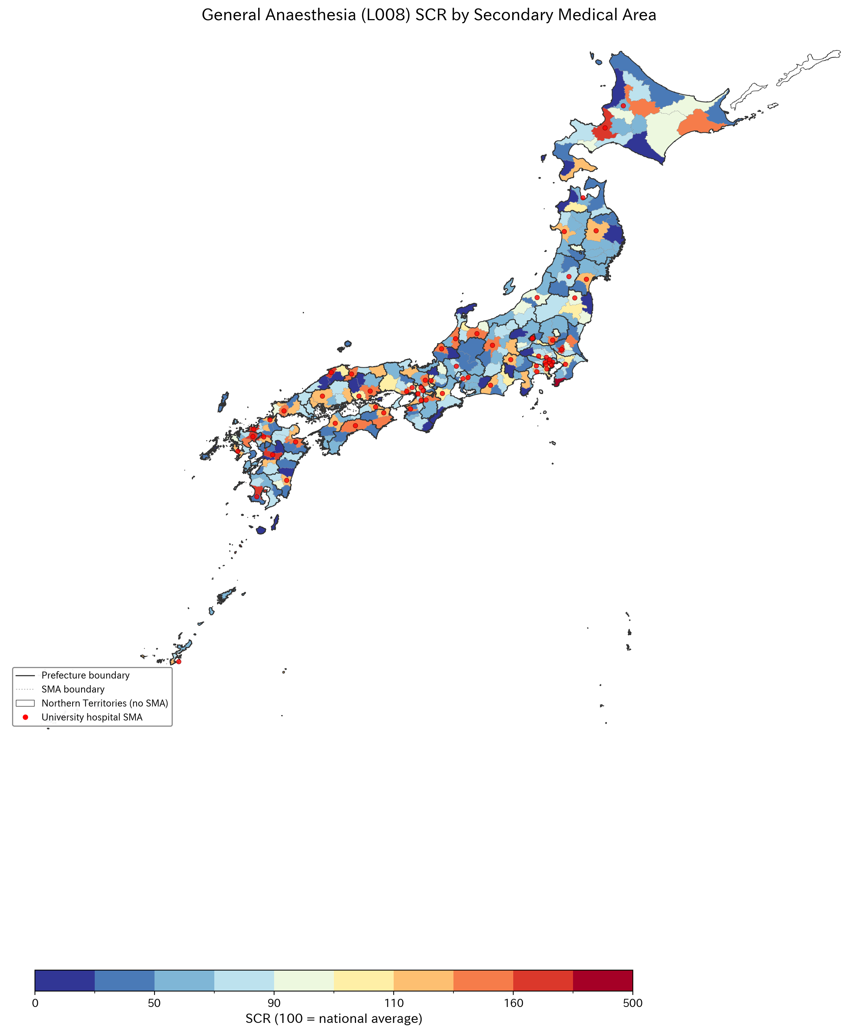
Figure 1. General anaesthesia (L008) standardised claim ratio by secondary medical area. Solid lines indicate prefectural boundaries; dashed lines indicate SMA boundaries. Northern Territories shown in white (no SMA designated).

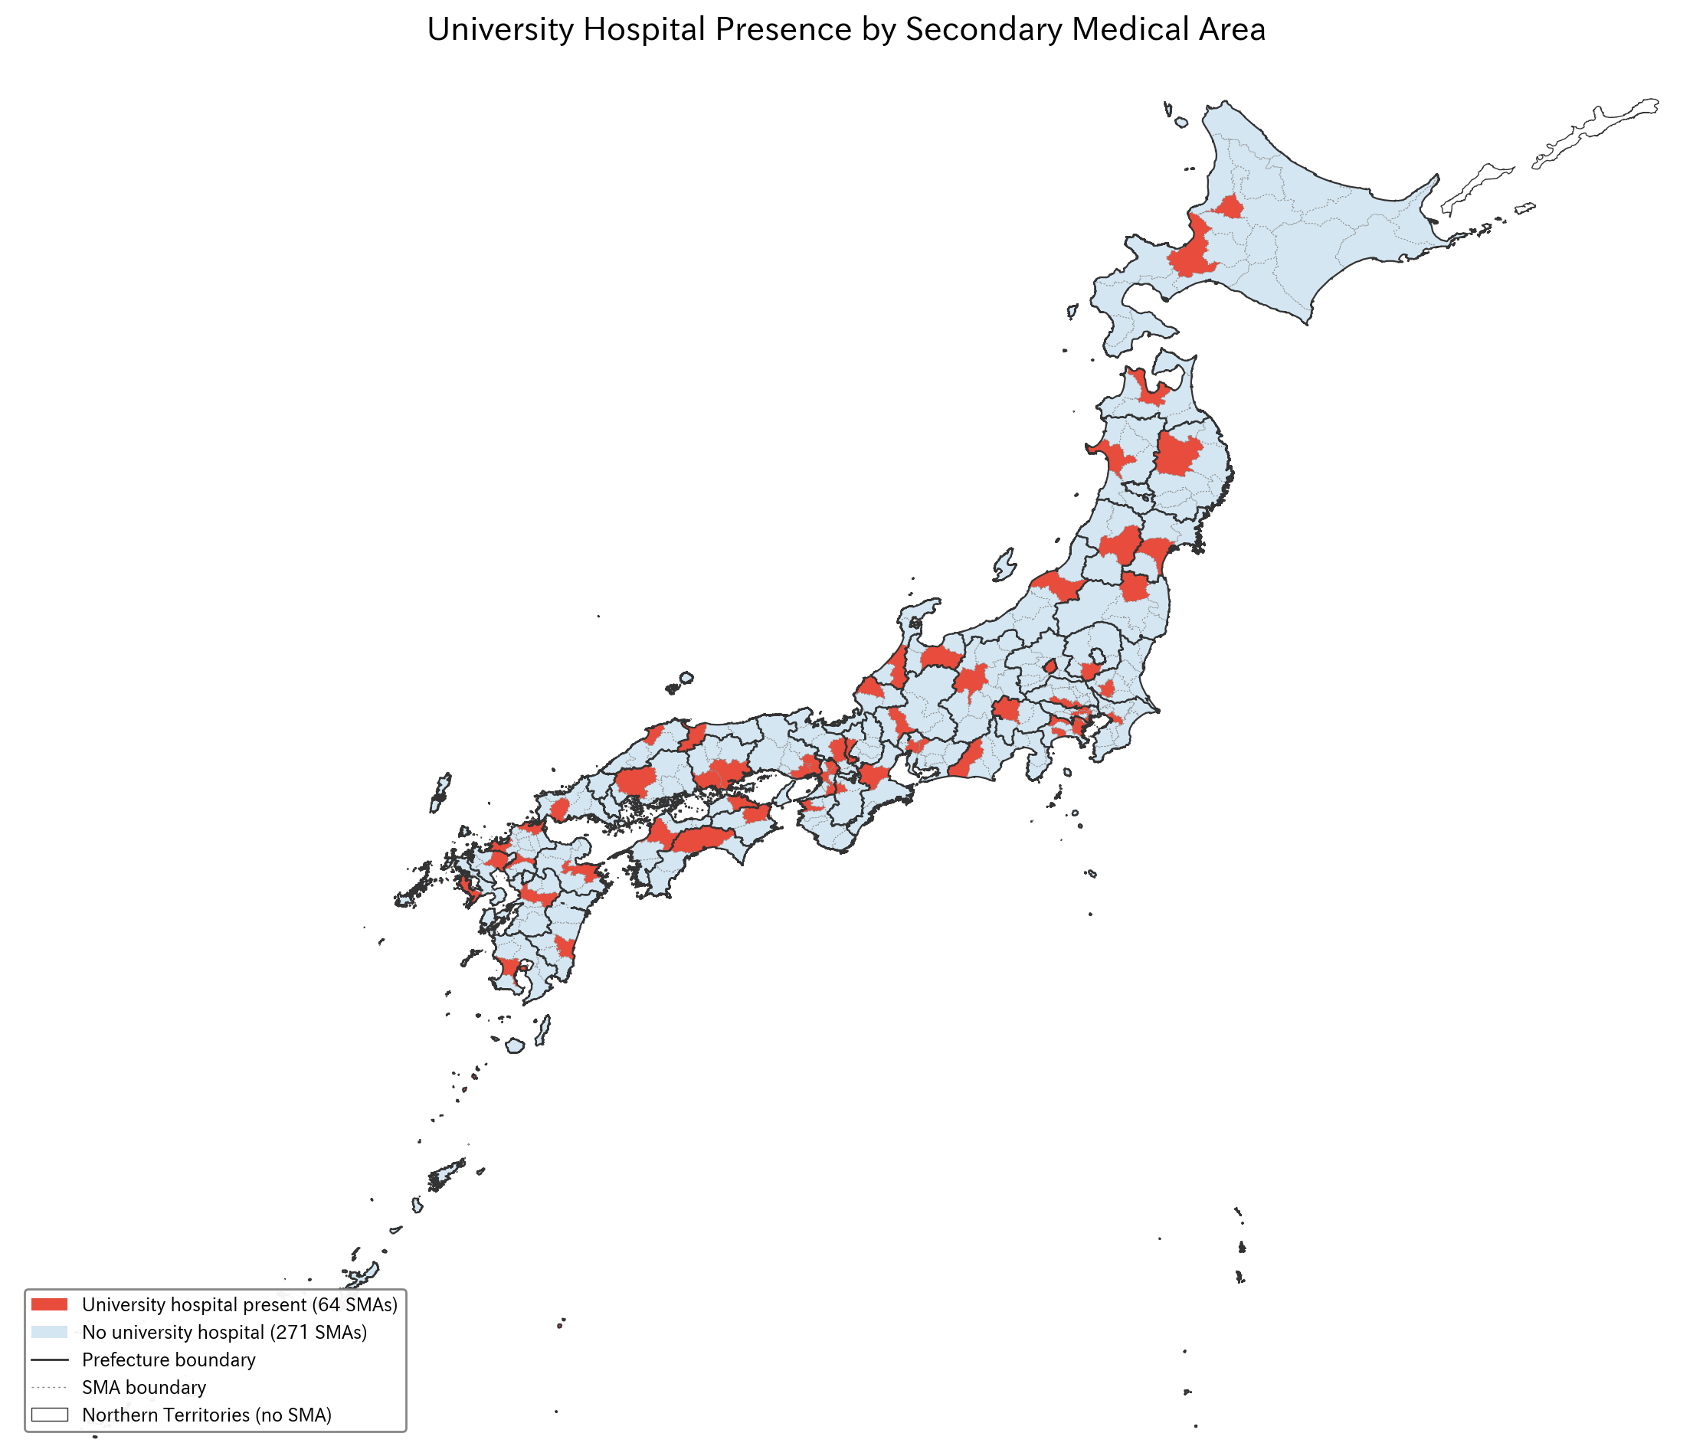
Figure 2. University hospital presence by secondary medical area. Red circles indicate SMAs containing one or more university hospitals (64 of 335 SMAs).

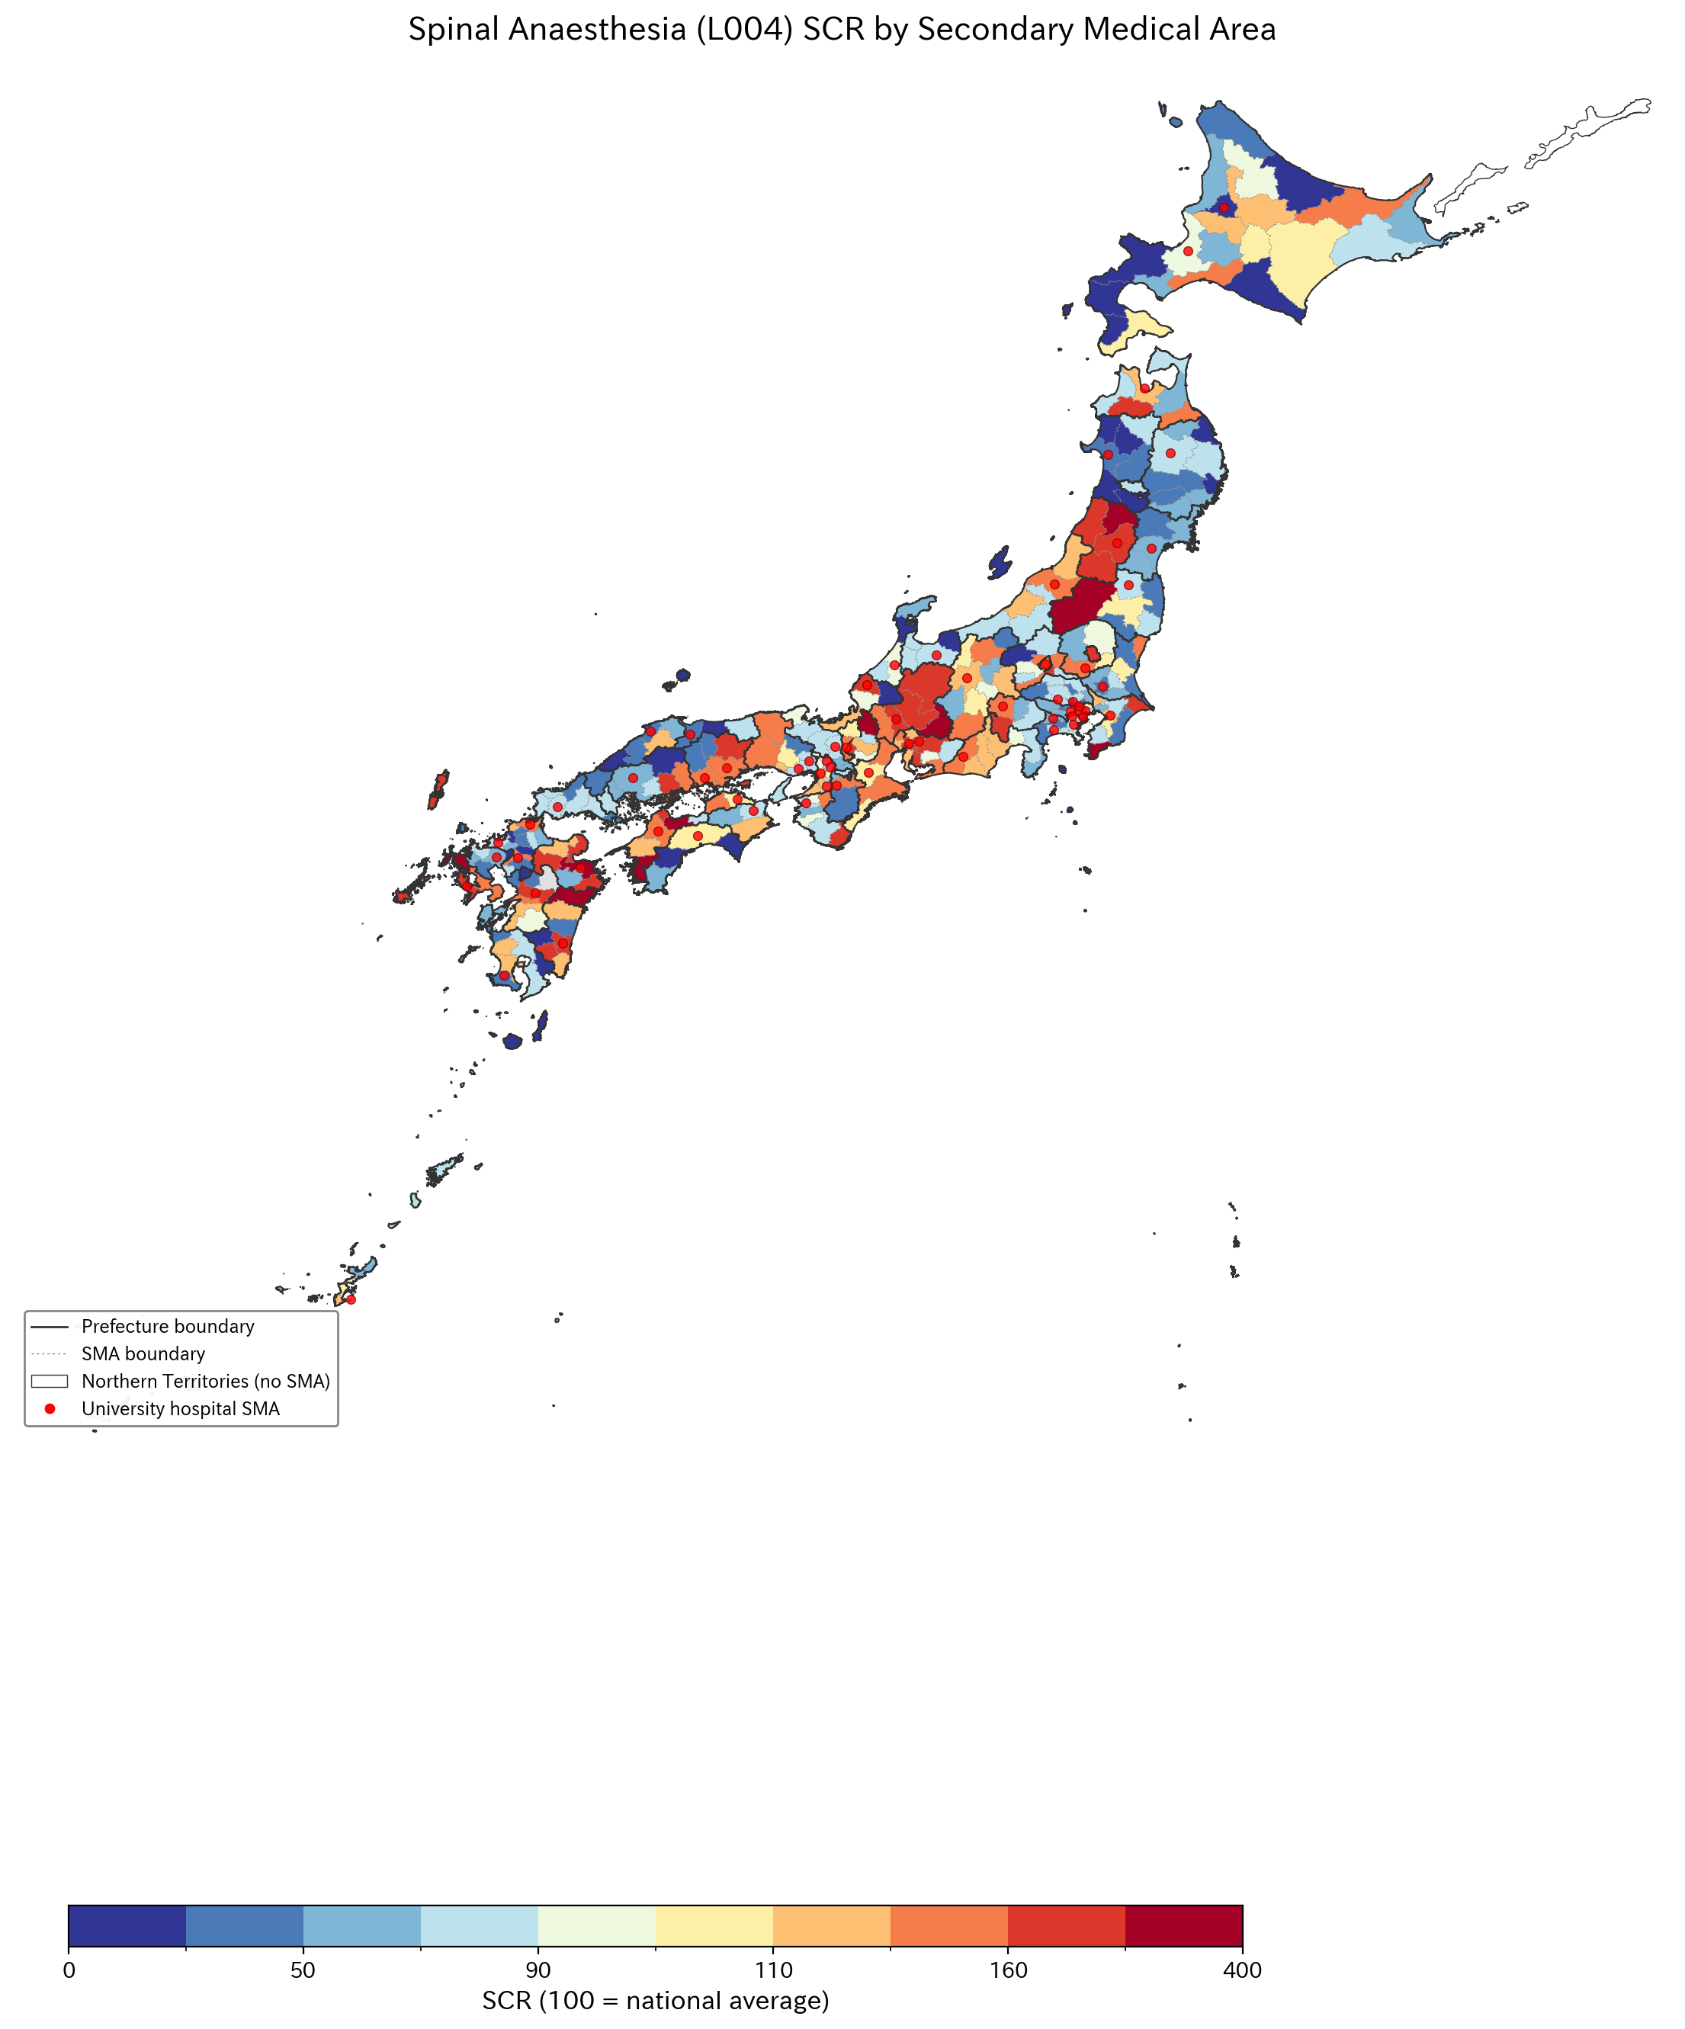
Figure 3. Spinal anaesthesia (L004) standardised claim ratio by secondary medical area.

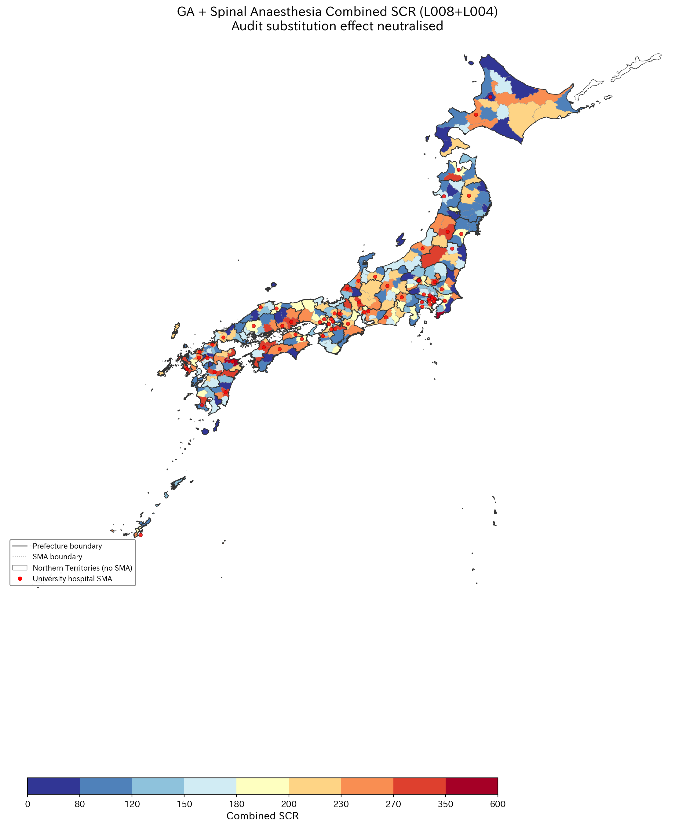
Figure 4. Combined general + spinal anaesthesia (L008+L004) standardised claim ratio. Combining these codes neutralises audit-driven reclassification between GA and spinal techniques.

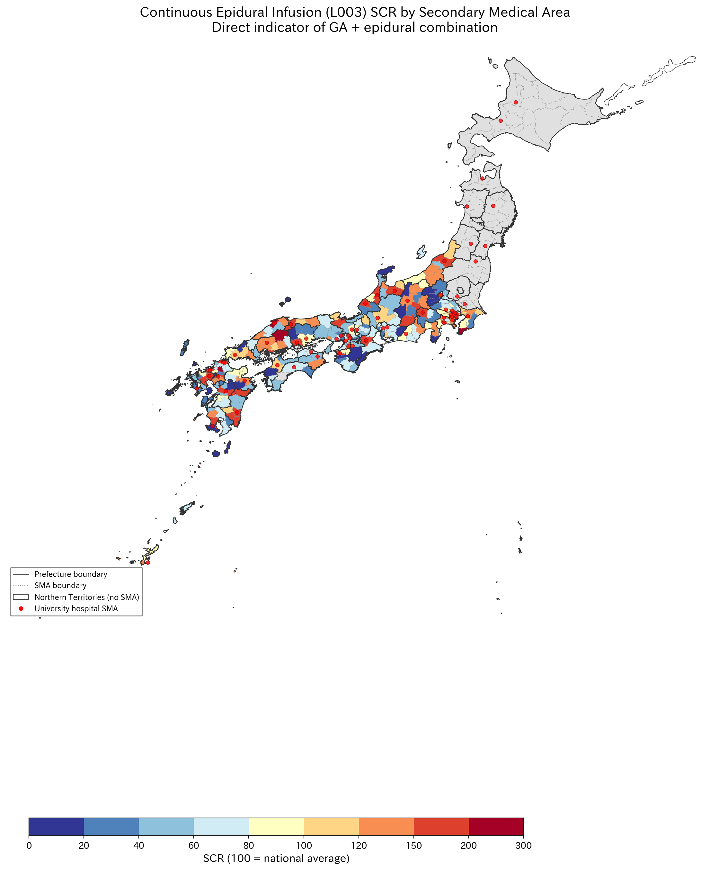
Figure 5. Continuous epidural infusion (L003) standardised claim ratio—direct indicator of combined GA–epidural technique. CV=64.9%.

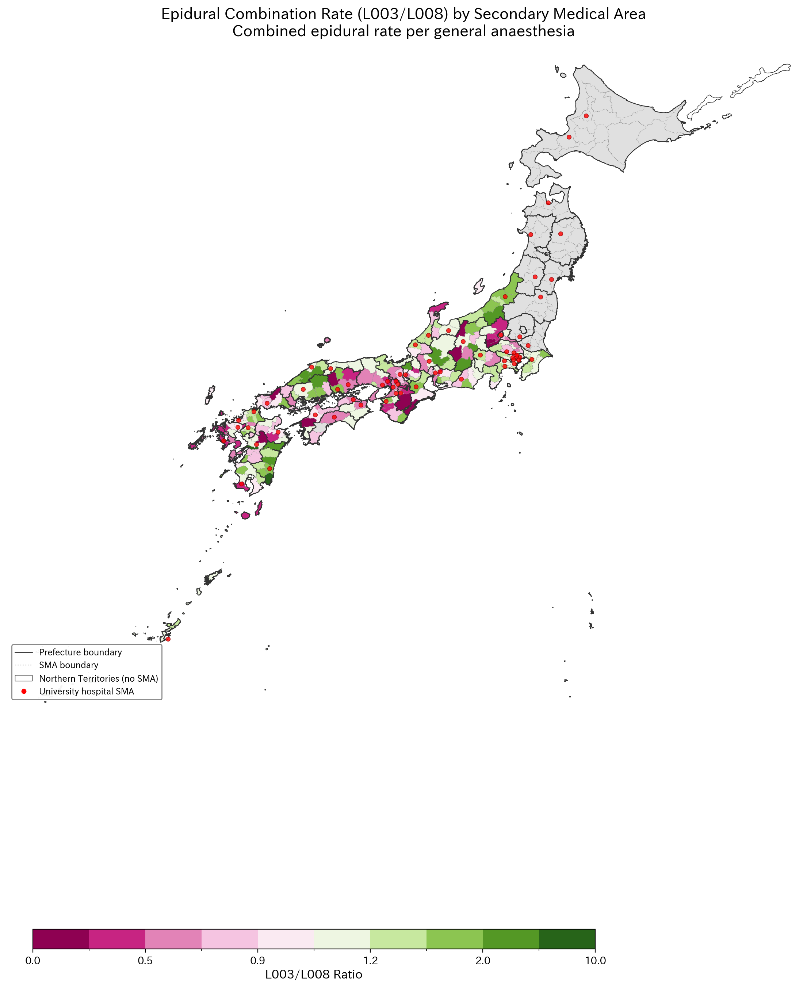
Figure 6. L003/L008 ratio (combined epidural rate per GA case), adjusted for surgery volume. Higher values indicate greater use of combined GA–epidural technique.

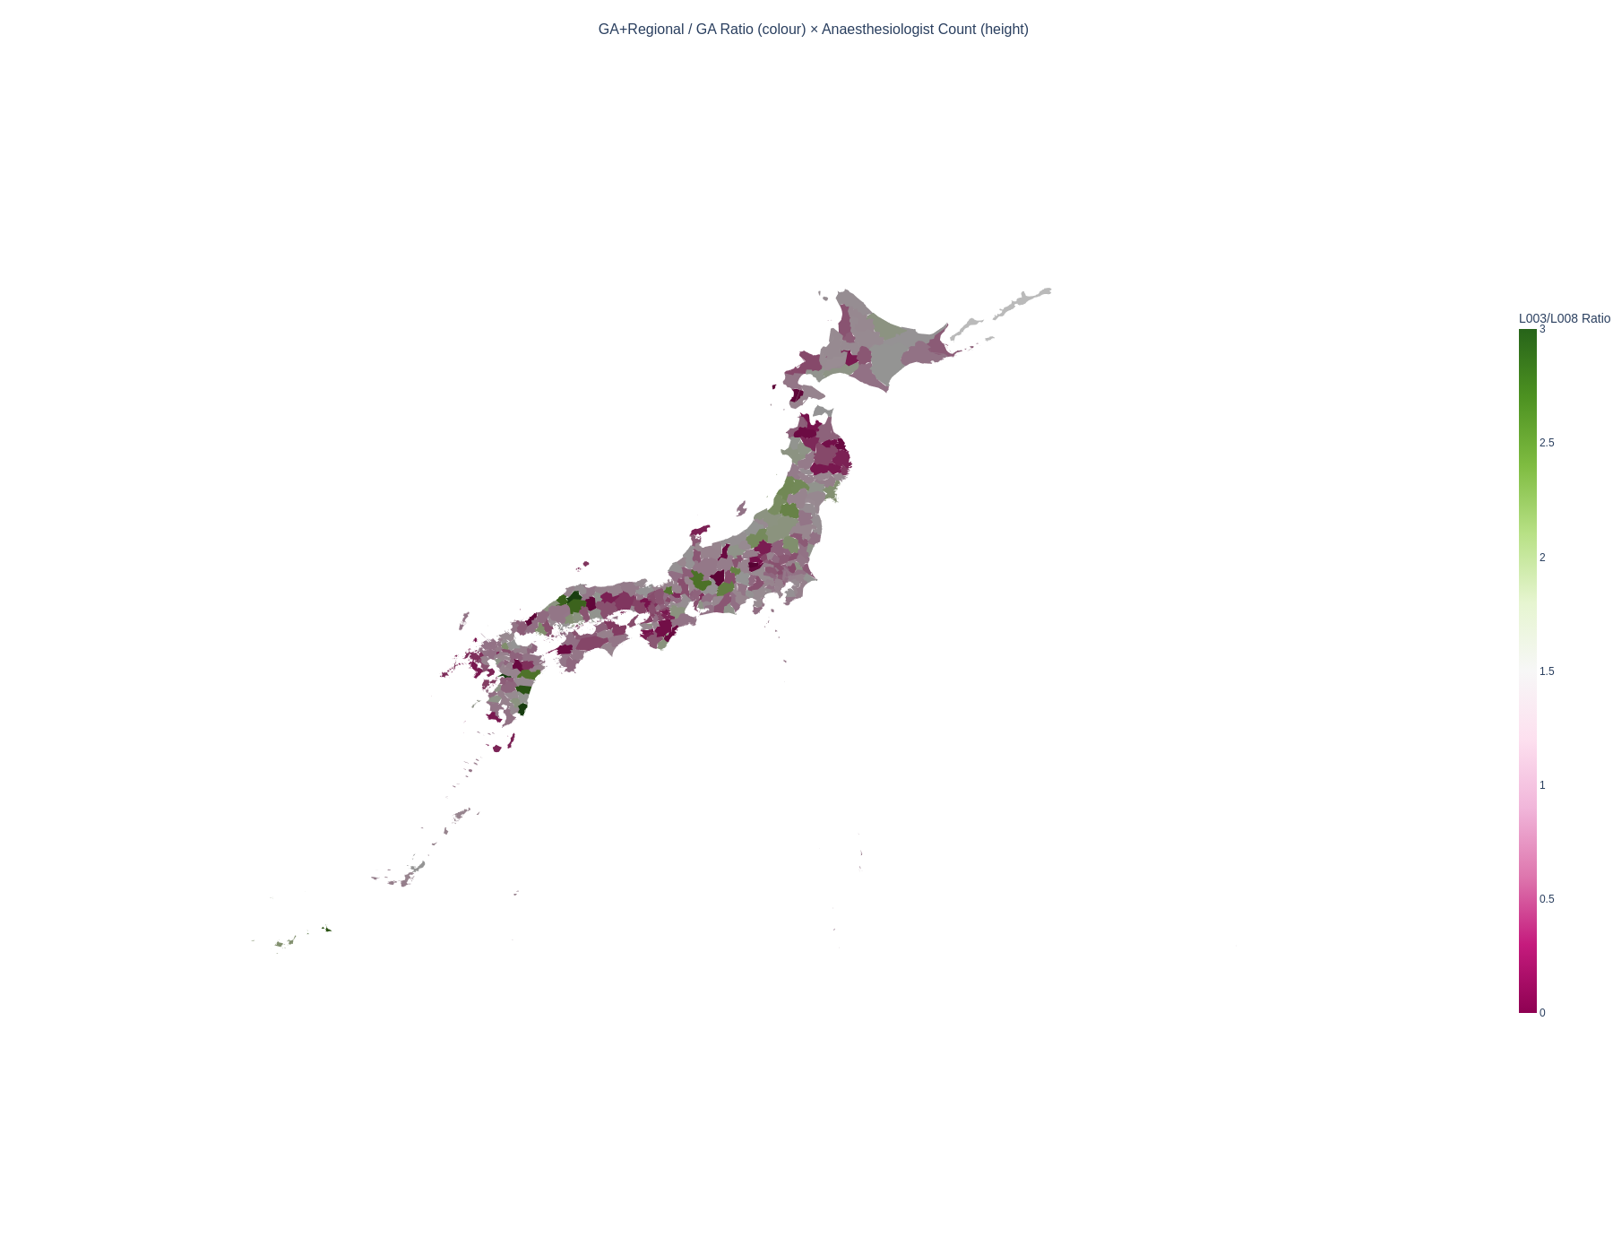
Figure 7. Three-dimensional extruded map: colour represents L003/L008 ratio (combined epidural rate), height represents anaesthesiologist count. Areas with both high ratio and high specialist count appear as tall, green-coloured polygons.

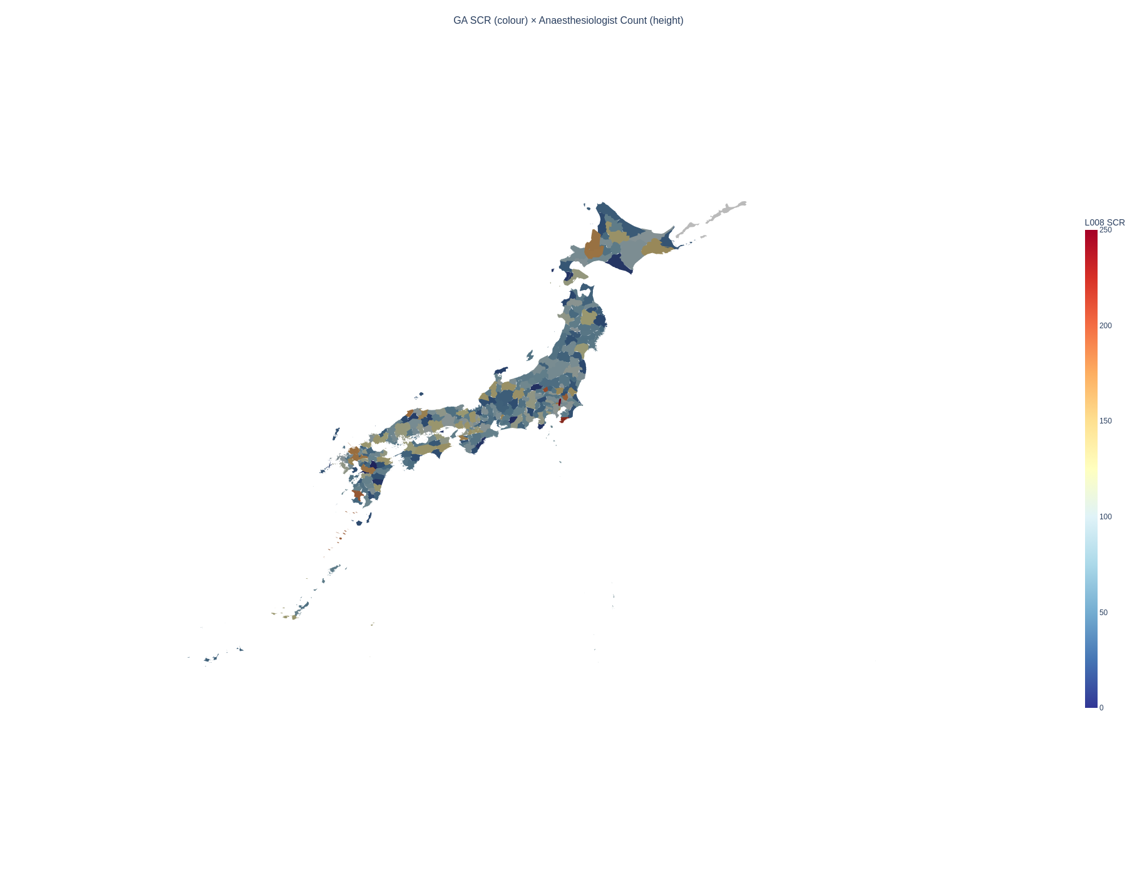
Figure 8. Three-dimensional extruded map: colour represents L008 SCR (general anaesthesia volume), height represents anaesthesiologist count. Red, tall areas indicate high GA volume with many anaesthesiologists (typically metropolitan university hospital areas).

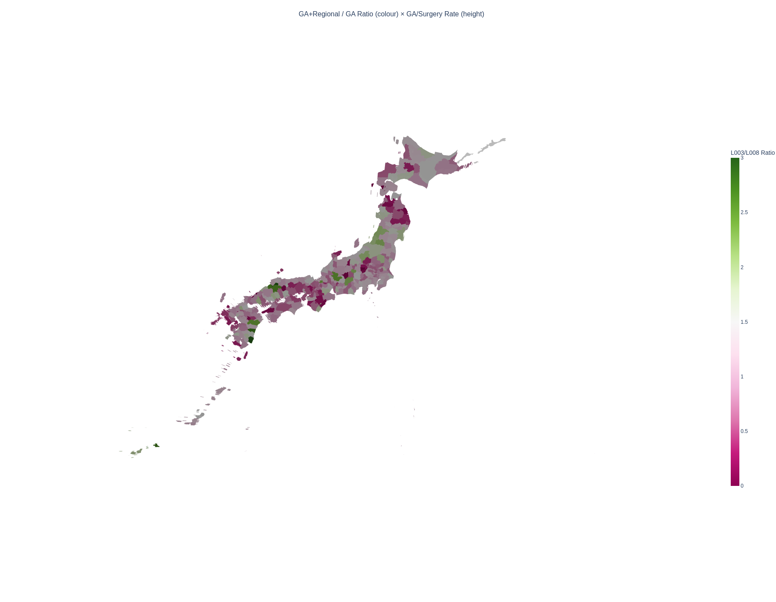
Figure 9. Three-dimensional extruded map: colour represents L003/L008 ratio, height represents GA per surgery ratio (L008/K-chapter SCR). Height variation is modest, indicating that GA per surgery is relatively uniform; colour variation shows the epidural combination rate differs substantially.

STROBE Checklist (Cross-sectional study)
Item | STROBE recommendation | Location in manuscript
1a | Title and abstract | Title page and structured abstract
1b | Informative abstract | Structured abstract with all required elements
2 | Background/rationale | Introduction paragraphs 1–3
3 | Objectives | Introduction paragraph 5
4 | Study design | Methods: Study design and data sources
5 | Setting | Methods: 335 SMAs, FY2022 data
6a | Participants/eligibility | N/A (ecological study using aggregate data)
7 | Variables | Methods: Anaesthesia codes analysed (Table 1)
8 | Data sources | Methods: Study design and data sources
9 | Bias | Methods: Sensitivity analyses; Discussion: Limitations
10 | Study size | Methods: 335 SMAs, 47 prefectures
11 | Quantitative variables | Methods: Statistical analysis
12 | Statistical methods | Methods: Statistical analysis
13 | Participants | Results: 334 SMAs with L008 data
14 | Descriptive data | Results: Table 2
15 | Outcome data | Results: Regional variation section
16 | Main results | Results: Sensitivity analyses 1–3, University hospital effect
17 | Other analyses | Results: Combined SCR, Pain clinic spillover
18 | Key results | Discussion: Principal findings
19 | Limitations | Discussion: Strengths and limitations
20 | Interpretation | Discussion: Comparison with existing literature
21 | Generalisability | Discussion: Conclusions and policy implications
22 | Funding | [To be completed]

DECLARATIONS

Ethics approval
This study used publicly available aggregate data. No individual-level data were accessed. Ethics committee approval was not required under the Ethical Guidelines for Medical and Biological Research Involving Human Subjects (Japan, 2021 revision).

Data availability
All data used in this study are publicly available. SCR data: Cabinet Office regional variation visualisation (https://www5.cao.go.jp/keizai-shimon/kaigi/special/reform/mieruka/). Physician statistics: e-Stat (https://www.e-stat.go.jp). GIS boundaries: National Land Numerical Information (https://nlftp.mlit.go.jp). Analysis code is available from the corresponding author on request.

Competing interests
[To be completed by authors.]

Funding
[To be completed by authors.]

Contributors
[To be completed by authors. BMJ requires detailed contribution statements.]

Transparency declaration
The lead author (the manuscript's guarantor) affirms that the manuscript is an honest, accurate, and transparent account of the study being reported; that no important aspects of the study have been omitted; and that any discrepancies from the study as planned have been explained.

