Regional variation in anesthesia practice across 335 secondary medical areas in Japan: a cross-sectional analysis of national claims data

[Author names]
[Affiliations]
[Corresponding author: name, address, email]

Word count: approximately 3,800
Tables: 2
Figures: 4 (3 multi-panel choropleth maps + 1 three-dimensional extruded map)
Supplementary figures: 5 (2 additional 3D maps + 3 individual 2D maps)

ABSTRACT
Background Regional variation in anesthesia practice has been documented internationally, but the relative contributions of clinical preference, institutional factors, and administrative mechanisms remain unclear. Japan’s universal insurance system, with its mandatory prefectural claims auditing, provides a unique setting to distinguish administrative from clinical sources of variation.
Methods Cross-sectional ecological study using publicly available standardized claim ratios (SCRs) for fiscal year 2022 across 335 secondary medical areas (SMAs). We analyzed six anesthesia procedure codes: general anesthesia (L008), epidural anesthesia (L002), continuous epidural infusion (L003), spinal anesthesia (L004), anesthesia management fee (L009), and nerve block (L100). Three sensitivity analyses tested whether insurance audit variation explained observed differences: within-prefecture variance decomposition, cross-code correlation analysis, and quantitative audit impact estimation.
Results Substantial regional variation was observed: coefficients of variation (CV) were 54.6% for general anesthesia (L008), 83.2% for epidural anesthesia (L002), and 64.9% for continuous epidural infusion (L003). Three sensitivity analyses indicated that audit variation is insufficient to explain observed differences: 85.8% of L008 variance occurred within prefectures (where audit policy is uniform); general and spinal anesthesia showed inverse correlation (r=−0.506); and audit rate differences could explain less than 1% of observed SCR variation. University hospital presence was the strongest single predictor, explaining 38.5% of total L008 variance (Cohen’s d=1.78). Combined GA–epidural technique (L003) was 1.73 times higher in university hospital areas.
Conclusion Regional variation in anesthesia practice in Japan is structural, not an artifact of insurance auditing. University hospital proximity is the dominant determinant. Given evidence linking regional anesthesia techniques to improved oncologic outcomes, this variation may represent a modifiable source of health inequality.

WHAT IS ALREADY KNOWN ON THIS TOPIC
- Regional variation in surgical and anesthesia practice has been documented in many countries, but the relative contributions of clinical preference, institutional factors, and administrative mechanisms (such as insurance auditing) remain unclear.
- Japan’s universal insurance system processes all claims through standardized prefectural audit, creating a unique natural experiment in which administrative variation can be distinguished from clinical variation.

WHAT THIS STUDY ADDS
- Three independent sensitivity analyses demonstrate that regional variation in anesthesia practice in Japan is structural rather than an artifact of insurance auditing.
- University hospital presence explains 38.5% of variance in general anesthesia volume—a remarkably large effect for a single binary predictor—and the effect is consistent across all 47 prefectures.

HOW THIS STUDY MIGHT AFFECT RESEARCH, PRACTICE OR POLICY
- Combined general–epidural anesthesia, which may confer oncologic benefit, shows the greatest regional inequality (CV=64.9%), suggesting a modifiable target for reducing health disparities.
- The sensitivity analysis framework developed here—within-prefecture variance decomposition, cross-code correlation, and quantitative audit impact estimation—is applicable to investigating practice variation in any procedure under Japan’s universal insurance system.

INTRODUCTION
Japan’s universal health insurance system, established in 1961, covers the entire population under a standardized fee schedule (shinryo houshu tensuhyo) that specifies reimbursement for each medical procedure.¹·² This system was designed to ensure equitable access to healthcare regardless of geography. Yet studies using the National Database of Health Insurance Claims (NDB) have revealed substantial regional variation in medical practice, including surgical procedures, prescription patterns, and diagnostic testing.³–⁵
A distinctive feature of the Japanese system is mandatory insurance auditing (shinsa). All claims are reviewed by prefectural audit committees before reimbursement, and claims deemed inappropriate are reduced or rejected (satei). Audit rates vary across prefectures, ranging from 0.07% to 0.28%.⁶ This raises a fundamental question: does observed regional variation in claims data reflect genuine differences in clinical practice, or is it an artifact of differential auditing?
This question has particular relevance for anesthesia practice. The choice of anesthesia technique—general anesthesia alone versus combined general–regional techniques—is not merely a matter of preference. A growing body of evidence suggests that regional anesthesia techniques, particularly epidural analgesia combined with general anesthesia, may improve recurrence-free survival and overall survival in cancer surgery.⁷–¹² A Cochrane systematic review found limited but suggestive evidence favoring regional techniques for cancer recurrence,⁷ and the landmark randomized controlled trial by Sessler et al. reported no significant difference in breast cancer recurrence with regional anesthesia, although secondary analyses and observational meta-analyses continue to support a potential benefit for certain cancer types.⁸–¹² If regional variation in anesthesia technique is genuine rather than an audit artifact, it may represent a modifiable source of health inequality with implications for oncologic outcomes.
The 2026 revision of the Japanese fee schedule renamed the general anesthesia code from "mask or endotracheal intubation" to "supraglottic airway device or endotracheal intubation," reflecting longstanding ambiguity in coding that may have contributed to differential auditing of general anesthesia claims.¹³ Understanding the true nature of regional variation is therefore timely.
We used publicly available standardized claim ratio (SCR) data at the secondary medical area level to: (1) quantify regional variation in anesthesia practice across 335 areas; (2) test whether insurance audit variation explains observed differences through three independent sensitivity analyses; and (3) identify structural determinants of variation, including university hospital proximity and pain clinic activity.

METHODS

Study design and data sources
This was a cross-sectional ecological study using publicly available data. We used three data sources:
- Standardized claim ratios (SCRs) for fiscal year 2022 (Reiwa 4), published by the Cabinet Office as part of the "Regional Variation Visualization" initiative.¹⁴ SCRs are age- and sex-adjusted ratios of observed to expected claim frequencies, where the national average equals 100. Data were available at both the prefectural level (47 prefectures) and the secondary medical area (SMA) level (335 areas).
- Physician statistics from the 2022 Survey of Physicians, Dentists, and Pharmacists (e-Stat), providing the number of anesthesiologists by secondary medical area.¹⁵
- Geographic data from the National Land Numerical Information dataset (A38-20) for SMA boundaries, and administrative boundary data (N03) for prefectural borders and the Northern Territories.¹⁶

Anesthesia codes analyzed
We analyzed the following procedure codes from the Japanese fee schedule (Table 1):
Code | Procedure | Clinical significance | SMAs with data
L008 | Closed-circuit general anesthesia | Primary indicator of GA volume | 334
L002 | Epidural anesthesia | Regional technique (alone or combined) | 307
L003 | Continuous epidural infusion | Direct indicator of GA+epidural combination | 331
L004 | Spinal anesthesia | Alternative to GA for suitable procedures | 334
L009 | Anesthesia management fee I | Proxy for specialist anesthesiologist staffing | 314
L100 | Nerve block (inpatient) | Indicator of pain clinic activity | 335

Table 1. Anesthesia procedure codes analyzed.

University hospital mapping
We mapped 81 university hospitals (44 national, 8 public, 29 private) to 64 SMAs based on municipal address. Under Japan’s "one medical school per prefecture" policy, all 47 prefectures have at least one university hospital, enabling within-prefecture comparisons that control for prefectural audit policy.

Sensitivity analyses for the audit hypothesis
We tested the null hypothesis that "all regional variation in anesthesia SCRs is explained by differential insurance auditing" using three independent approaches:
- Test 1 (within-prefecture variance): If audit policy (applied uniformly within each prefecture) explains all variation, then within-prefecture variance should be negligible. We decomposed total SCR variance into between-prefecture and within-prefecture components using one-way ANOVA.
- Test 2 (cross-code correlation): If auditing reclassifies general anesthesia claims as spinal anesthesia (or vice versa), these codes may show negative correlation at the ecological level (though clinical substitution would also produce this pattern). We calculated Pearson correlations between anesthesia code pairs and interpreted them in conjunction with the quantitative audit impact estimate (Test 3).
- Test 3 (quantitative impact): We estimated the maximum SCR impact of audit rate differences using published aggregate audit statistics (range 0.07–0.28% across prefectures).⁶

Combined SCR analysis
To further test the audit reclassification hypothesis, we computed combined SCRs (L008+L004 for GA–spinal substitution; L008+L002 for GA–epidural substitution). If audit-driven reclassification is the primary source of variation, combining the reclassified codes should substantially reduce the coefficient of variation.

Statistical analysis
We report descriptive statistics (mean, standard deviation, coefficient of variation, percentiles) for SCRs. Between-group comparisons used Welch’s t-test and Cohen’s d for effect size.¹⁷ Variance decomposition used one-way ANOVA (between-prefecture) and hierarchical decomposition (between-prefecture, university hospital effect, residual). Correlations are Pearson r. Standardized claim ratios were computed using indirect standardization, a standard method in small-area variation research.¹⁸ All analyses were conducted in Python 3.12 using pandas, scipy, and geopandas. Three-dimensional extruded choropleth maps were created using Plotly Mesh3d with Delaunay triangulation of polygon boundaries.¹⁹ Two-dimensional maps were created using matplotlib and geopandas.

Patient and public involvement
This study used publicly available aggregate data with no individual patient information. Patients were not involved in the design or conduct of this research.

RESULTS

Regional variation in anesthesia practice
Substantial variation was observed across all anesthesia codes (Table 2). General anesthesia (L008) SCRs ranged from 2.3 to 458.9 across 334 SMAs (coefficient of variation [CV] 54.6%). Epidural anesthesia (L002) showed even greater variation (CV 83.2%), as did continuous epidural infusion (L003, CV 64.9%), the direct indicator of combined GA–epidural technique. Spinal anesthesia (L004) had a CV of 56.3%. Figure 1 shows the geographic distribution of general anesthesia and spinal anesthesia SCRs, revealing an inverse spatial pattern.
Code | Procedure | P10 | P50 | P90 | CV (%) | n
L008 | General anesthesia | 32.3 | 73.2 | 131.5 | 54.6 | 334
L002 | Epidural anesthesia | 7.6 | 73.9 | 184.0 | 83.2 | 307
L003 | Continuous epidural infusion | 19.0 | 73.1 | 150.0 | 64.9 | 331
L004 | Spinal anesthesia | 31.1 | 84.3 | 169.0 | 56.3 | 334
L009 | Anesthesia management fee I | 32.5 | 79.1 | 149.1 | 57.2 | 314
L100 | Nerve block (inpatient) | 23.4 | 72.2 | 174.7 | 72.1 | 335

Table 2. Distribution of standardized claim ratios for anesthesia procedures across secondary medical areas (national average = 100).

Sensitivity analysis 1: within-prefecture variance
For general anesthesia (L008), 85.8% of total variance occurred within prefectures, where audit policy is uniform. This finding was consistent across codes: within-prefecture variance accounted for 72.7% (epidural), 58.0% (spinal), and 65.1% (nerve block) of total variation. Within individual prefectures, L008 SCRs varied enormously: from 61.4 to 458.9 within Tokyo (12 SMAs), and from 2.3 to 170.9 within Kumamoto (10 SMAs). Audit policy, which is applied uniformly within each prefecture, can explain at most 14.2% of L008 variation.

Sensitivity analysis 2: cross-code correlation
General anesthesia (L008) and spinal anesthesia (L004) showed a strong inverse correlation (r=−0.506, P<0.001), indicating a substitution pattern: areas with high GA volumes tend to have low spinal volumes and vice versa. This inverse correlation is consistent with genuine differences in clinical technique selection. It is also compatible in principle with audit-driven reclassification (where cases are shifted between the two codes) or defensive undercoding (where clinicians anticipate audit outcomes). However, given that the maximum audit rate difference across prefectures is only 0.21 percentage points (Test 3), reclassification of this magnitude is insufficient to produce the observed correlation. The most parsimonious interpretation is that the substitution pattern reflects clinical preference and regional practice style.
General anesthesia (L008) and epidural anesthesia (L002) showed a positive correlation (r=+0.319, P<0.001), indicating that areas with more GA also perform more epidural anesthesia. This is consistent with a common supply factor (anesthesia department capacity) rather than audit-driven substitution.

Sensitivity analysis 3: quantitative audit impact
The maximum difference in prefectural audit rates was 0.21 percentage points (0.07% to 0.28%). Even if this entire difference were concentrated on a single anesthesia code, it would produce an SCR shift of approximately 0.2 points—less than 0.3% of the observed 62-point interquartile range for L008 and less than 0.1% of the 198-point range for L002. Audit rate variation is quantitatively incapable of explaining the observed regional differences.

Combined SCR analysis
Combining L008 and L004 SCRs reduced the CV from 54.6% to 43.4%—a modest 19% reduction, indicating that spinal–GA substitution accounts for a minority of GA variation (Figure 2B). Combining L008 and L002 actually increased the CV from 50.2% to 58.3%, as these codes are positively correlated. In both cases, the university hospital effect remained strong: combined L008+L004 showed d=1.16 (P<0.001) and combined L008+L002 showed d=1.00 (P<0.001) for the university hospital comparison.

University hospital effect
University hospital presence was the strongest single predictor of anesthesia practice patterns (Figure 2A). For general anesthesia (L008), the 64 university hospital SMAs had a mean SCR of 130.2 compared with 67.7 for the 270 non-university SMAs (Cohen’s d=1.78, t=12.49). Remarkably, in within-prefecture comparisons (which control for audit policy), university hospital SMAs had higher L008 SCRs in all 47 of 47 prefectures (100%), with a mean within-prefecture difference of +61.4 points (SD 33.7, t=12.49).
Hierarchical variance decomposition attributed 14.5% of L008 variance to between-prefecture differences, 38.5% to the university hospital effect (within prefecture), and 47.0% to residual within-prefecture variation. The university hospital effect alone—a single binary variable—explained nearly 40% of all variation in general anesthesia volume across Japan.
A dose–response relationship was apparent in Tokyo, where the number of university hospitals per SMA ranged from 0 to 5: SCRs increased from 62–110 (0 hospitals) to 83–119 (2 hospitals) to 168.5 (3 hospitals) to 435.7 (5 hospitals).

Combined general–epidural anesthesia
Continuous epidural infusion (L003), the direct indicator of combined GA–epidural technique, showed a CV of 64.9%—the largest variation among major anesthesia codes (Figure 3). L003 SCR was 1.73 times higher in university hospital SMAs (126.4 vs 73.2, d=0.96, P<0.001) and correlated strongly with L008 (r=0.753, P<0.001). Three audit-hypothesis tests applied to the epidural combination (L008+L002) all rejected the audit explanation: positive L008–L002 correlation (r=+0.319), increased CV on combination (50.2%→58.3%), and persistent university hospital effect (d=1.00).

Pain clinic spillover
The hypothesis that pain clinic activity (proxied by nerve block SCR, L100) would predict regional anesthesia use in surgery was only weakly supported. The correlation between nerve block SCR and a composite regional anesthesia index was r=0.153 (P<0.01). However, nerve block activity correlated more strongly with GA volume (r=0.307, P<0.001), suggesting that pain clinic activity reflects overall anesthesia department capacity rather than a specific spillover of regional anesthesia skills.

DISCUSSION

Principal findings
This study demonstrates that regional variation in anesthesia practice across Japan’s 335 secondary medical areas is substantial and structural. Three independent sensitivity analyses converge on the conclusion that insurance audit variation explains, at most, a trivial fraction of observed differences. The dominant determinant is university hospital proximity, which alone explains nearly 40% of all variation in general anesthesia volume. The finding that this effect is present in all 47 prefectures—despite differing audit policies—provides compelling evidence for a supply-side, institutional mechanism.

Comparison with existing literature
Our findings are consistent with the broader literature on medical practice variation. The Dartmouth Atlas project in the United States has documented extensive regional variation in surgical rates that is driven primarily by physician supply and practice style rather than patient need.²⁰·²¹ Similar patterns have been reported in the United Kingdom,²² Germany,²³ and Australia.²⁴ Our study extends this literature in two ways. First, we exploit Japan’s unique institutional structure—uniform fee schedule, prefectural audit committees—to distinguish administrative from clinical sources of variation. Second, we provide the first systematic analysis of anesthesia technique variation at a fine geographic scale (335 areas) in an East Asian universal insurance system.
The university hospital effect we document (d=1.78 for general anesthesia) is remarkably large compared with effect sizes typically reported in medical practice variation research. This likely reflects the Japanese medical education system, in which university departments (ikyoku) exert substantial influence over clinical practice in affiliated hospitals within their geographic sphere.²⁵·²⁶
Our findings are directly relevant to the ongoing debate about anesthesia technique and cancer outcomes. Settled and unsettled questions about local anesthetic dosing variation in regional anesthesia have been highlighted in this journal,²⁷ and our study extends the variation framework to the macro level of technique selection across an entire national health system.

Implications for oncologic outcomes
The finding that combined GA–epidural technique (L003) shows a CV of 64.9% is clinically important in light of evidence suggesting that regional anesthesia combined with general anesthesia may improve recurrence-free survival in cancer surgery.⁷–¹² The 1.73-fold difference in L003 SCR between university and non-university hospital areas suggests that patients’ access to this potentially beneficial technique depends substantially on where they live—a finding that challenges the equity premise of Japan’s universal insurance system.¹·²

The 2026 fee schedule revision
The renaming of the general anesthesia code in 2026 (from "mask or endotracheal intubation" to "supraglottic airway device or endotracheal intubation") reflects acknowledged ambiguity in the previous coding, which may have led to differential audit decisions regarding supraglottic airway use. Our finding that audit-driven variation is quantitatively small suggests that this revision, while appropriate for coding clarity, is unlikely to substantially alter the geographic patterns we have documented.

Strengths and limitations
Strengths include the use of age- and sex-standardized ratios that cover the entire national population, analysis at a fine geographic scale (335 areas), multiple independent sensitivity analyses, and within-prefecture comparisons that control for audit policy. The ecological design avoids individual consent requirements and allows comprehensive geographic coverage.
Limitations include the ecological fallacy inherent in area-level analysis;²⁸ the inability to distinguish individual patient-level decisions from aggregate patterns; the post-audit nature of SCR data (which reflects reimbursed rather than intended practice, though our sensitivity analyses suggest this distinction is quantitatively minor); the cross-sectional design, which precludes causal inference; incomplete separation of the university hospital effect from urban concentration (university hospitals are typically in the largest city of each prefecture); and the absence of code-specific audit rate data. Additionally, "defensive undercoding"—where clinicians preemptively avoid claiming procedures they expect to be audited—cannot be quantified from claims data.²⁹

Conclusions and policy implications
Regional variation in anesthesia practice in Japan is genuine and large, driven primarily by institutional factors—particularly university hospital proximity—rather than by differential insurance auditing. The 1.73-fold variation in combined GA–epidural anesthesia between university and non-university hospital areas is of particular concern given emerging evidence of oncologic benefit.⁷–¹² Policy responses could include targeted education programs, specialist outreach from university centers, and monitoring of anesthesia technique patterns as a quality indicator.³⁰ The sensitivity analysis framework developed here—using within-prefecture variance decomposition, cross-code correlation, and quantitative audit impact estimation—is applicable to investigating practice variation in any procedure under Japan’s universal insurance system.

REFERENCES
1. Ikegami N, Yoo B-K, Hashimoto H, et al. Japanese universal health coverage: evolution, achievements, and challenges. Lancet 2011;378:1106–15.
2. Ikegami N. Universal Health Coverage for Inclusive and Sustainable Development: Lessons from Japan. Washington, DC: World Bank, 2014.
3. Matsuda S, Fujimori K. The claim database in Japan. Asian Pac J Dis Manag 2012;6:55–59.
4. Suto M, Iba A, Sugiyama T, et al. Literature review of studies using the National Database of Health Insurance Claims of Japan (NDB): limitations and strategies in using the NDB for research. JMA J 2023;7:10–20.
5. Hamada H, Sekimoto M, Imanaka Y. Effects of the per diem prospective payment system with DRG-like grouping system (DPC/PDPS) on resource usage and healthcare quality in Japan. Health Policy 2012;107:194–201.
6. Social Insurance Medical Fee Payment Fund (Shiharai Kikin). Review Statistics, Fiscal Year 2022. https://www.ssk.or.jp/tokeijoho/shinsatokei/index.html (accessed 15 Mar 2026).
7. Pei L, Tan G, Wang L, et al. Anesthetic techniques for risk of malignant tumor recurrence. Cochrane Database Syst Rev 2019;(11):CD008877.
8. Sessler DI, Pei L, Huang Y, et al. Recurrence of breast cancer after regional or general anesthesia: a randomized controlled trial. Lancet 2019;394:1807–15.
9. Exadaktylos AK, Buggy DJ, Moriarty DC, et al. Can anesthetic technique for primary breast cancer surgery affect recurrence or metastasis? Anesthesiology 2006;105:660–4.
10. Sun Y, Li T, Gan TJ. The effects of perioperative regional anesthesia and analgesia on cancer recurrence and survival after oncology surgery: a systematic review and meta-analysis. Reg Anesth Pain Med 2015;40:589–98.
11. Xie S, Li L, Meng F, et al. Regional anesthesia might reduce recurrence and metastasis rates in adult patients with cancers after surgery: a meta-analysis. BMC Anesthesiol 2024;24:19.
12. Zhang D, Jiang J, Liu J, et al. Effects of perioperative epidural analgesia on cancer recurrence and survival. Front Oncol 2021;11:798435.
13. Ministry of Health, Labour and Welfare. Revision of medical fee schedule, 2026 (Reiwa 8 nendo shinryo houshu kaitei). https://www.mhlw.go.jp (accessed 15 Mar 2026).
14. Cabinet Office. Regional variation visualization (chiikisa no mieruka). https://www5.cao.go.jp/keizai-shimon/kaigi/special/reform/mieruka/ (accessed 10 Mar 2026).
15. Ministry of Health, Labour and Welfare. Survey of Physicians, Dentists and Pharmacists, 2022. e-Stat. https://www.e-stat.go.jp (accessed 12 Mar 2026).
16. Ministry of Land, Infrastructure, Transport and Tourism. National Land Numerical Information download service. https://nlftp.mlit.go.jp (accessed 10 Mar 2026).
17. Cohen J. Statistical Power Analysis for the Behavioral Sciences. 2nd ed. Hillsdale, NJ: Lawrence Erlbaum, 1988.
18. Julious SA, Nicholl J, George S. Why do we continue to use standardized mortality ratios for small area comparisons? J Public Health Med 2001;23:40–6.
19. Plotly Technologies Inc. Plotly: collaborative data science. Montreal, QC, 2015. https://plotly.com (accessed 15 Mar 2026).
20. Wennberg JE. Tracking Medicine: A Researcher’s Quest to Understand Health Care. New York: Oxford University Press, 2010.
21. Wennberg JE, Fisher ES, Skinner JS. Geography and the debate over Medicare reform. Health Aff (Millwood) 2002;Suppl Web Exclusives:W96–114.
22. NHS RightCare. The NHS Atlas of Variation in Healthcare, 2015. London: Public Health England.
23. Wengler A, Nimptsch U, Mansky T. Hip and knee replacement surgery (arthroplasty) and geographic variations in Germany. Dtsch Arztebl Int 2014;111:407–16.
24. Australian Commission on Safety and Quality in Health Care. Australian Atlas of Healthcare Variation. Sydney: ACSQHC, 2015.
25. Otsuka T. The ikyoku system of university orthopedic surgery departments: an in-hospital organizational system unique to Japan. J Orthop Sci 2012;17:513–14.
26. Onishi H. History of Japanese medical education. Korean J Med Educ 2018;30:283–94.
27. Koscielniak-Nielsen ZJ, Helbo-Hansen HS. Settled science or unwarranted variation in local anesthetic dosing? Reg Anesth Pain Med 2019;44:998–1000.
28. Greenland S. Ecologic versus individual-level sources of bias in ecologic estimates of contextual health effects. Int J Epidemiol 2001;30:1343–50.
29. Sekimoto M, Imanaka Y, Kobayashi H, et al. Impact of hospital characteristics on the cost and practice patterns of acute myocardial infarction patients in Japan. Health Policy 2006;78:34–45.
30. Merry AF, Cooper JB, Soyannwo O, et al. International standards for a safe practice of anesthesia 2010. Can J Anesth 2010;57:1027–34.

FIGURES
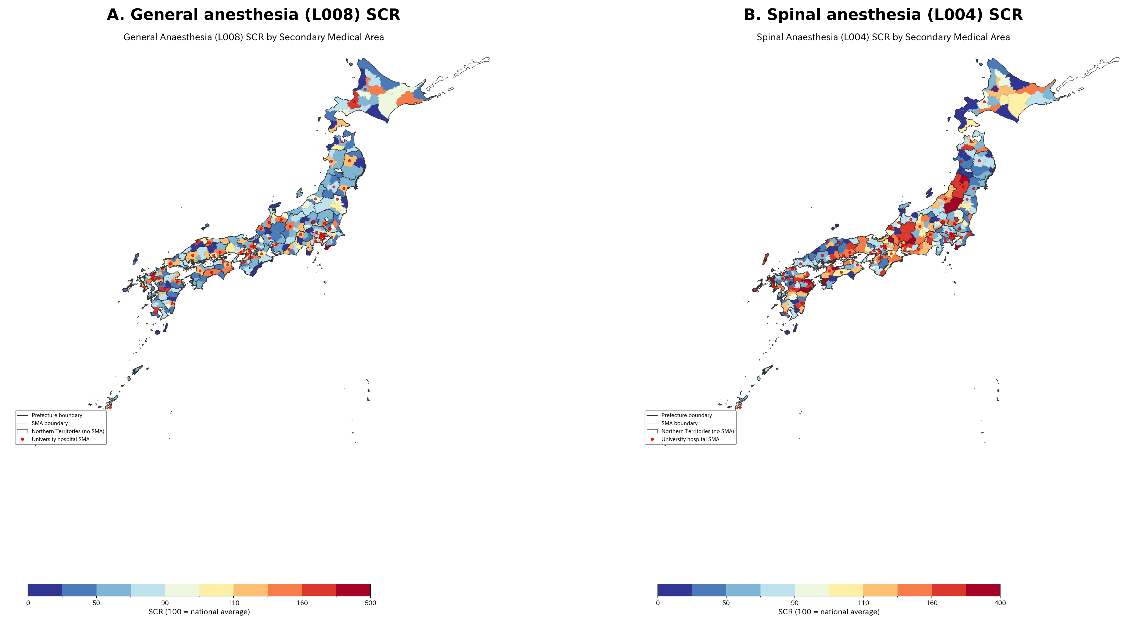
Figure 1. Geographic distribution of anesthesia standardized claim ratios by secondary medical area. (A) General anesthesia (L008) SCR. (B) Spinal anesthesia (L004) SCR. Note the inverse spatial pattern: areas with high GA tend to have low spinal anesthesia volumes and vice versa (r=−0.506). Solid lines indicate prefectural boundaries; dashed lines indicate SMA boundaries. Northern Territories shown in white (no SMA designated).

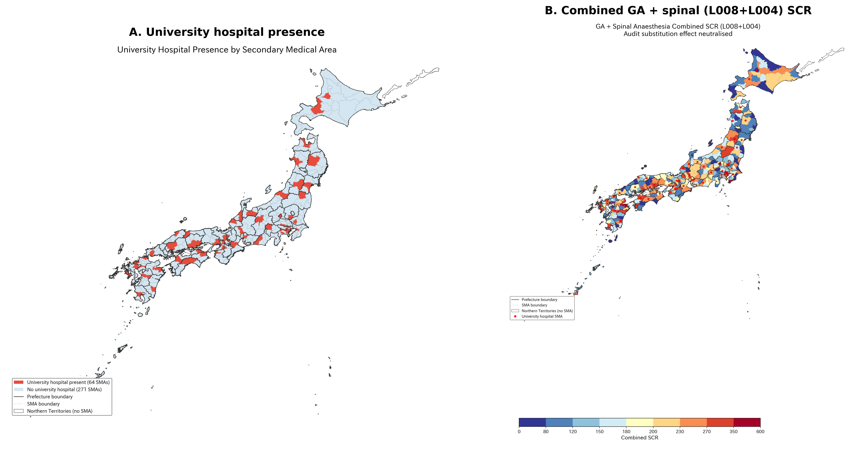
Figure 2. University hospital effect and combined SCR analysis. (A) University hospital presence by SMA: red circles indicate SMAs containing one or more university hospitals (64 of 335 SMAs). (B) Combined GA + spinal anesthesia (L008+L004) SCR: combining these codes neutralizes potential audit-driven reclassification, yet substantial regional variation persists (CV=43.4%).

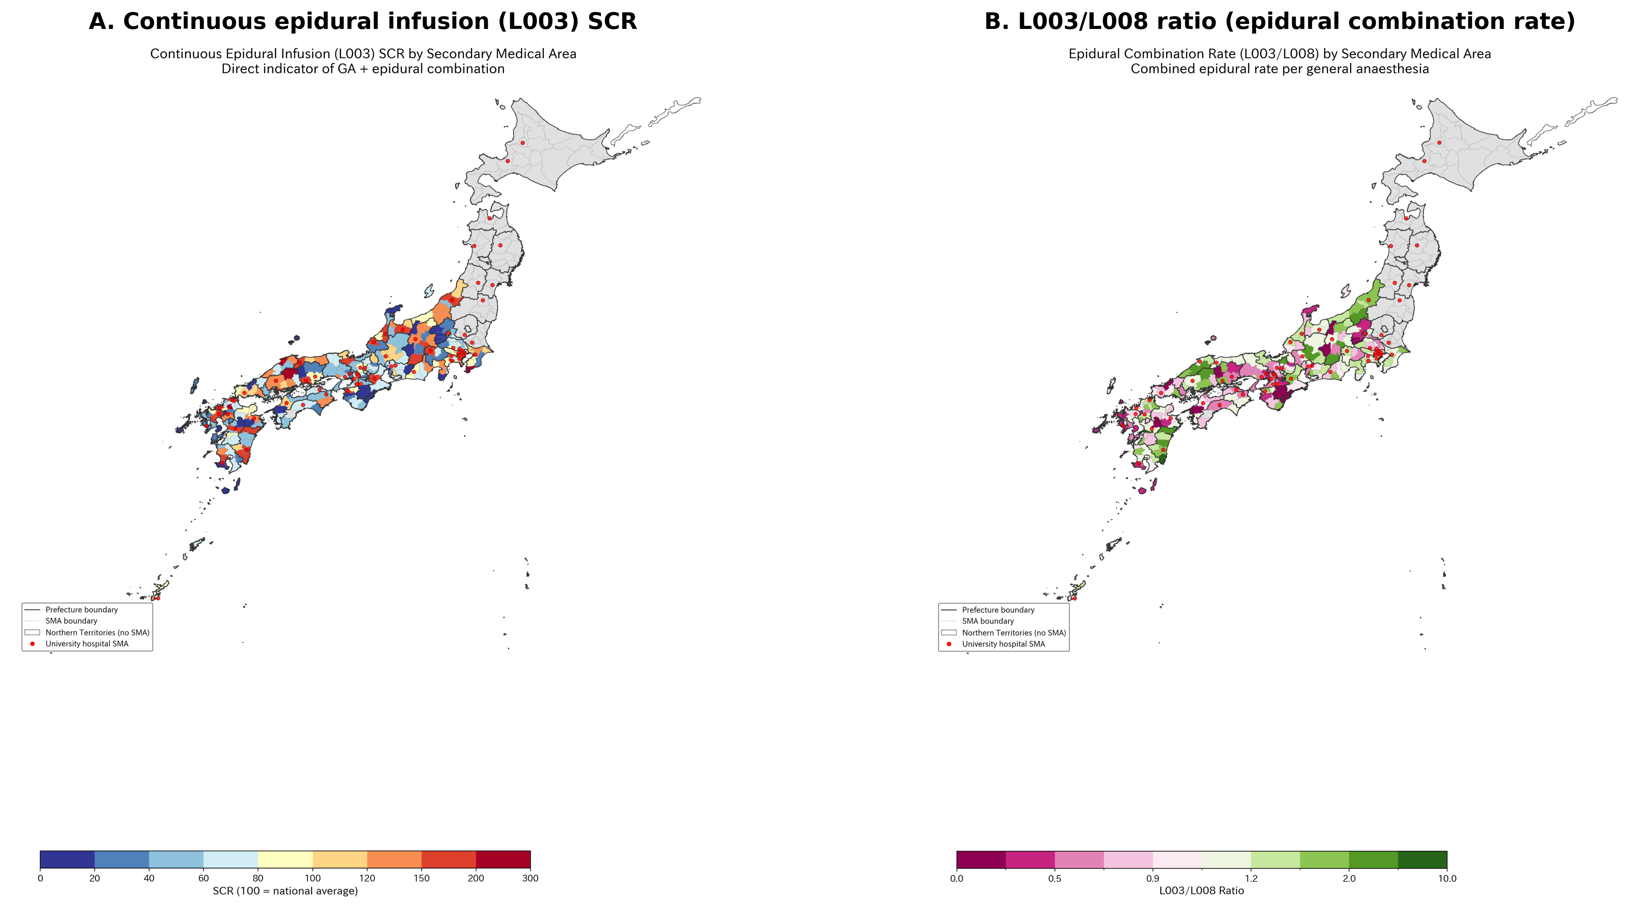
Figure 3. Combined GA–epidural anesthesia variation. (A) Continuous epidural infusion (L003) SCR—direct indicator of combined GA–epidural technique (CV=64.9%). (B) L003/L008 ratio (epidural combination rate per GA case), adjusted for surgery volume. Higher values indicate greater use of combined GA–epidural technique.

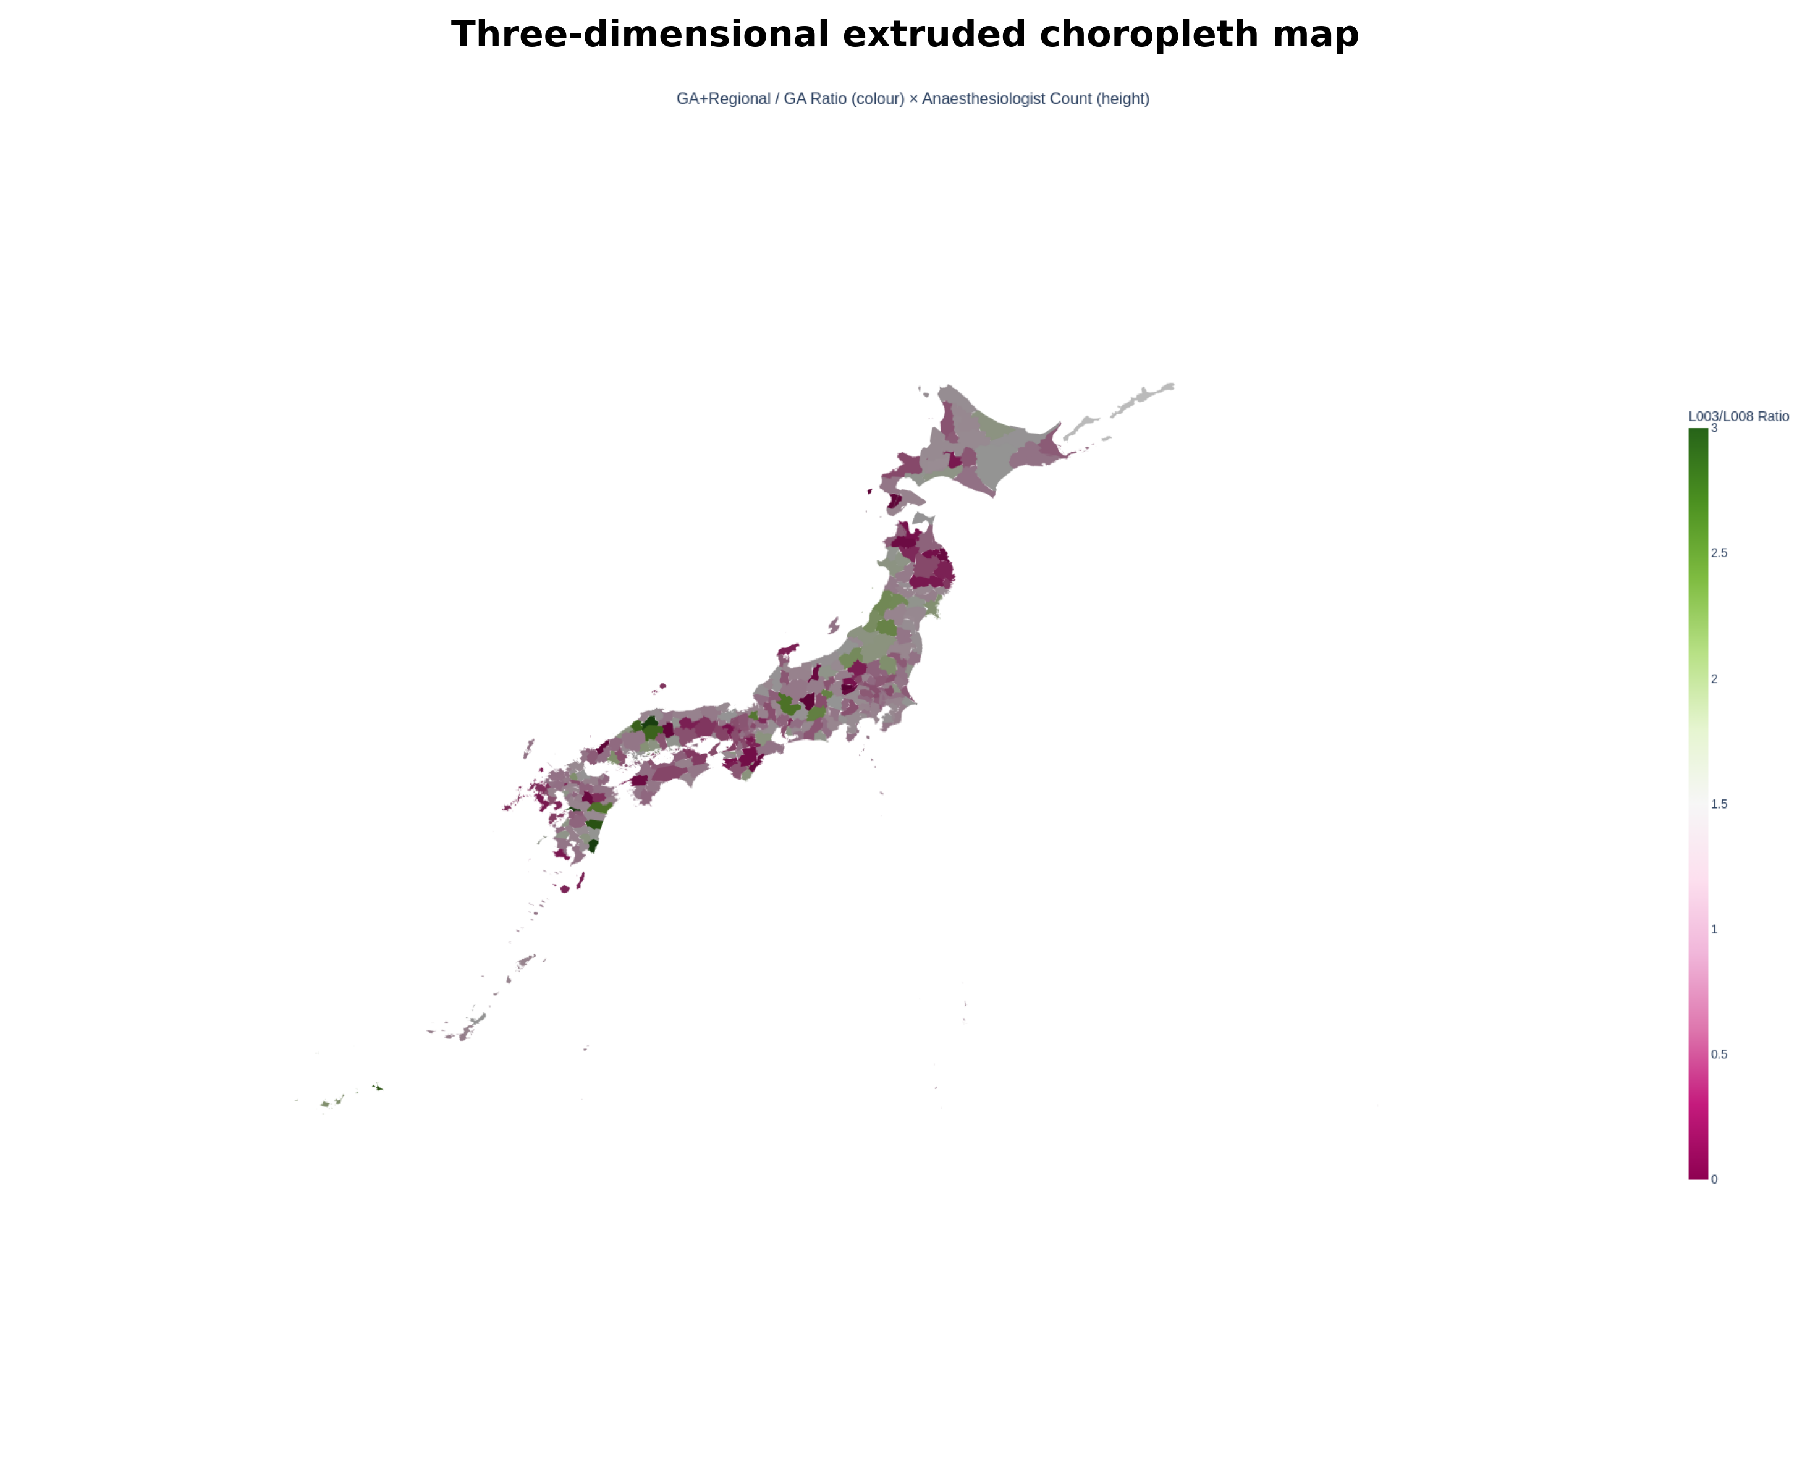
Figure 4. Three-dimensional extruded choropleth map. Color represents L003/L008 ratio (combined epidural rate); height represents anesthesiologist count per SMA. Areas with both high epidural combination rate and high specialist count appear as tall, green-colored polygons, typically corresponding to university hospital areas in metropolitan regions.

STROBE Checklist (Cross-sectional study)
Item | STROBE recommendation | Location in manuscript
1a | Title and abstract | Title page and structured abstract
1b | Informative abstract | Structured abstract with all required elements
2 | Background/rationale | Introduction paragraphs 1–3
3 | Objectives | Introduction paragraph 5
4 | Study design | Methods: Study design and data sources
5 | Setting | Methods: 335 SMAs, FY2022 data
6a | Participants/eligibility | N/A (ecological study using aggregate data)
7 | Variables | Methods: Anesthesia codes analyzed (Table 1)
8 | Data sources | Methods: Study design and data sources
9 | Bias | Methods: Sensitivity analyses; Discussion: Limitations
10 | Study size | Methods: 335 SMAs, 47 prefectures
11 | Quantitative variables | Methods: Statistical analysis
12 | Statistical methods | Methods: Statistical analysis
13 | Participants | Results: 334 SMAs with L008 data
14 | Descriptive data | Results: Table 2
15 | Outcome data | Results: Regional variation section
16 | Main results | Results: Sensitivity analyses 1–3, University hospital effect
17 | Other analyses | Results: Combined SCR, Pain clinic spillover
18 | Key results | Discussion: Principal findings
19 | Limitations | Discussion: Strengths and limitations
20 | Interpretation | Discussion: Comparison with existing literature
21 | Generalizability | Discussion: Conclusions and policy implications
22 | Funding | [To be completed]

DECLARATIONS

Ethics approval
This study used publicly available aggregate data. No individual-level data were accessed. Ethics committee approval was not required under the Ethical Guidelines for Medical and Biological Research Involving Human Subjects (Japan, 2021 revision).

Data availability
All data used in this study are publicly available. SCR data: Cabinet Office regional variation visualization (https://www5.cao.go.jp/keizai-shimon/kaigi/special/reform/mieruka/). Physician statistics: e-Stat (https://www.e-stat.go.jp). GIS boundaries: National Land Numerical Information (https://nlftp.mlit.go.jp). Analysis code is available from the corresponding author on request.

Competing interests
[To be completed by authors.]

Funding
[To be completed by authors.]

Contributors
[To be completed by authors.]

AI statement
[To be completed. Per RAPM/BMJ policy, authors must provide details of any AI technology used in the preparation of this manuscript, including what AI technology was used, the reason for its use, and what task it performed.]

Transparency declaration
The lead author (the manuscript’s guarantor) affirms that the manuscript is an honest, accurate, and transparent account of the study being reported; that no important aspects of the study have been omitted; and that any discrepancies from the study as planned have been explained.

