Regional variation in anesthesia practice in Japan: clinical preference or claims audit artifact? A cross-sectional ecological study of 335 secondary medical areas

[Author names]
[Affiliations]
[Corresponding author: name, address, email]

Word count: approximately 4,500
Tables: 3 (Table 1: anesthesia codes; Table 2: descriptive statistics; Table 3: multilevel model results)
Figures: 4 (2 multi-panel choropleth maps, 1 funnel plot, 1 three-dimensional extruded map)

ABSTRACT
Background Regional variation in anesthesia practice has been documented internationally, but the relative contributions of clinical preference, institutional factors, and administrative mechanisms remain unclear. Japan’s universal health insurance system, with its mandatory prefectural claims auditing, provides a unique setting to distinguish administrative from clinical sources of variation.
Methods Cross-sectional ecological study using publicly available standardized claim-occurrence ratios (SCRs; age- and sex-adjusted observed-to-expected ratios, national average = 100) for fiscal year 2022 (Reiwa 4) across 335 secondary medical areas (SMAs) in Japan. SMAs are geographic planning units completely nested within 47 prefectures, with no cross-boundary overlap. We analyzed six anesthesia procedure codes using three complementary approaches: multilevel linear mixed models with prefecture-level random intercepts to estimate intraclass correlation coefficients (ICCs); three sensitivity analyses testing whether insurance audit variation explains observed differences; and empirical Bayes shrinkage estimation to address small-sample instability in areas with few claims.
Results Substantial regional variation was observed: coefficients of variation (CV) were 53.6% for general anesthesia (L008), 87.0% for epidural anesthesia (L002), and 56.8% for spinal anesthesia (L004). Multilevel models showed that prefecture-level clustering explained 5.8% of general anesthesia variance (ICC = 0.058), whereas university hospital presence explained 35.8% of total variance (β = +64.1, 95% CI 54.8–73.4, P < 0.001). In within-prefecture comparisons, university hospital areas had higher general anesthesia SCRs in all 47 of 47 prefectures (100%; mean difference +63.3, Cohen’s d = 1.88). Empirical Bayes shrinkage attenuated effect sizes by only 9.0% (d = 1.89 → 1.72), confirming robustness to small-sample instability. L008 and L004 showed positive correlation (r = +0.235, P < 0.001), inconsistent with audit-driven reclassification between these codes.
Conclusion Regional variation in anesthesia practice in Japan is structural, not an artifact of insurance auditing. University hospital proximity is the dominant determinant, persisting after multilevel adjustment and empirical Bayes shrinkage. Given evidence linking regional anesthesia techniques to improved oncologic outcomes, this variation may represent a modifiable source of health inequality.

WHAT IS ALREADY KNOWN ON THIS TOPIC
- Regional variation in surgical and anesthesia practice has been documented in many countries, but the relative contributions of clinical preference, institutional factors, and administrative mechanisms (such as insurance auditing) remain unclear.
- Japan’s universal insurance system processes all claims through standardized prefectural audit, creating a unique natural experiment in which administrative variation can be distinguished from clinical variation.

WHAT THIS STUDY ADDS
- Three independent sensitivity analyses and multilevel modeling demonstrate that regional variation in anesthesia practice in Japan is structural rather than an artifact of insurance auditing.
- University hospital presence explains 40.5% of within-prefecture variance in general anesthesia volume (Cohen’s d = 1.88)—a remarkably large effect for a single binary predictor—and the effect is consistent across all 47 prefectures.

HOW THIS STUDY MIGHT AFFECT RESEARCH, PRACTICE OR POLICY
- Combined general–epidural anesthesia, which may confer oncologic benefit, shows the greatest regional inequality (CV = 64.9%), suggesting a modifiable target for reducing health disparities.
- The multilevel sensitivity analysis framework developed here is applicable to investigating practice variation in any procedure under Japan’s universal insurance system.

INTRODUCTION
Japan’s universal health insurance system (kokumin kai hoken), established in 1961, covers the entire population under a standardized fee schedule that specifies reimbursement for each medical procedure.¹·² The system has achieved internationally recognized levels of healthcare access: the World Health Organization’s Healthcare Access and Quality (HAQ) Index ranked Japan at 87.5 out of 100 (10th decile, top tier globally) in 2019,³ and Japan consistently ranks among the highest-performing countries for universal health coverage effective service coverage.⁴ Healthcare delivery is organized through a hierarchical system of medical areas (iryo-ken): 47 tertiary medical areas (corresponding to prefectures) and 335 secondary medical areas (SMAs), each designed to be self-sufficient for inpatient care.⁵ Cross-boundary patient movement is limited: the 2008 Patient Survey found that only 6.1% of inpatients and 3.0% of outpatients received care outside their home prefecture,⁶ and cross-SMA movement is predominantly to adjacent areas within the same prefecture.⁷ The system was designed to ensure equitable access regardless of geography.
Yet studies using the National Database of Health Insurance Claims (NDB) have revealed substantial regional variation in medical practice, including surgical procedures, prescription patterns, and diagnostic testing.⁸–¹⁰ A distinctive feature of the Japanese system is mandatory insurance auditing (shinsa). All claims are reviewed by prefectural audit committees before reimbursement, and claims deemed inappropriate are reduced or rejected (satei). Audit rates vary across prefectures, ranging from 0.07% to 0.28%.¹¹ This raises a fundamental question: does observed regional variation in claims data reflect genuine differences in clinical practice, or is it an artifact of differential auditing?
This question has particular relevance for anesthesia practice. The choice of anesthesia technique—general anesthesia alone versus combined general–regional techniques—is not merely a matter of preference. A growing body of evidence suggests that regional anesthesia techniques, particularly epidural analgesia combined with general anesthesia, may improve recurrence-free survival and overall survival in cancer surgery.¹²–¹⁷ A Cochrane systematic review found limited but suggestive evidence favoring regional techniques for cancer recurrence,¹² and a landmark randomized controlled trial by Sessler et al. reported no significant difference in breast cancer recurrence with regional anesthesia, although secondary analyses and observational meta-analyses continue to support a potential benefit for certain cancer types.¹³–¹⁷ If regional variation in anesthesia technique is genuine rather than an audit artifact, it may represent a modifiable source of health inequality with implications for oncologic outcomes.
The 2026 revision of the Japanese fee schedule renamed the general anesthesia code from “mask or endotracheal intubation” to “supraglottic airway device or endotracheal intubation,” reflecting longstanding ambiguity in coding that may have contributed to differential auditing of general anesthesia claims.¹⁸ Understanding the true nature of regional variation is therefore timely.
We used publicly available standardized claim ratio (SCR) data at the secondary medical area level to: (1) quantify regional variation in anesthesia practice across 335 areas; (2) test whether insurance audit variation explains observed differences through three independent sensitivity analyses; (3) estimate the contribution of prefecture-level clustering using multilevel models; and (4) identify structural determinants of variation, including university hospital proximity and anesthesiologist supply.

METHODS

Study design and ethical considerations
This was a cross-sectional ecological study using publicly available aggregate data. No individual-level data were accessed. Ethics committee approval was not required under the Ethical Guidelines for Medical and Biological Research Involving Human Subjects (Japan, 2021 revision). The study followed the STROBE guidelines for reporting observational studies (checklist provided as supplementary material).

Geographic units: secondary medical areas
Japan’s healthcare delivery system is organized into a hierarchical structure of medical areas defined under Article 30-4 of the Medical Care Act.⁵ The 47 prefectures serve as tertiary medical areas, responsible for highly specialized care. Within each prefecture, secondary medical areas (SMAs; nijiiryoken) are designated as the basic geographic units for planning inpatient care. As of the study period, there were 335 SMAs nationally (reduced from 344 in the 2018 revision).¹⁹
Critically, SMAs are completely nested within prefectures: no SMA crosses a prefectural boundary. This differs fundamentally from geographic units used in practice variation research in other countries, such as the United States’ Hospital Service Areas (HSAs) and Hospital Referral Regions (HRRs), which are defined by patient flow patterns and may cross state boundaries.²⁰ The complete nesting of SMAs within prefectures means that within-prefecture comparisons are unconfounded by cross-boundary spillover effects and are directly interpretable as variation under a common prefectural audit policy. Each SMA is composed of one or more contiguous municipalities and is designed to be self-sufficient for general inpatient care, including surgical services.

Data sources and standardized claim ratios
We used three data sources. First, standardized claim-occurrence ratios (SCRs) for fiscal year 2022 (Reiwa 4), published by the Cabinet Office as part of the “Regional Variation Visualization” (chiikisa no mieruka) initiative.²¹ SCRs are computed by indirect standardization: for each procedure, expected claim frequencies are calculated by applying national age- and sex-specific claim rates to the local population structure, and the SCR is defined as 100 × (observed claims / expected claims). An SCR of 100 indicates a claim frequency equal to the national average after age and sex adjustment. SCRs are calculated on a residence basis (jukyochi base): claims are attributed to the beneficiary’s registered address, not to the location of the providing facility. This means that patient travel to other areas for treatment does not inflate the SCR of the receiving area. Data were available at both prefectural (n = 47) and SMA (n = 335) levels. Areas with very few claims are subject to masking by the data provider to protect privacy; such areas appear as missing values in our dataset.
Second, we obtained physician statistics from the 2022 Survey of Physicians, Dentists, and Pharmacists (e-Stat), providing counts of anesthesiologists and total physicians by SMA.²² Third, geographic boundary data were obtained from the National Land Numerical Information dataset (A38-20 for SMA boundaries, N03 for prefectural borders and the Northern Territories).²³

Anesthesia procedure codes
We analyzed six procedure codes from the Japanese fee schedule (shinryo houshu tensuhyo) that represent the major categories of anesthesia practice (Table 1): L008 (closed-circuit general anesthesia), L002 (epidural anesthesia), L003 (continuous epidural infusion, a direct indicator of combined general–epidural technique), L004 (spinal anesthesia), L009 (anesthesia management fee I, a proxy for specialist anesthesiologist staffing), and L100 (nerve block, inpatient, an indicator of pain clinic activity). Intravenous anesthesia (L001) was also analyzed as a secondary outcome.

University hospital mapping
We mapped 81 university hospitals (44 national, 8 public, 29 private) to their respective SMAs based on municipal address. These 81 hospitals are distributed across 64 SMAs in all 47 prefectures, reflecting Japan’s “one medical school per prefecture” policy. This distribution enables within-prefecture comparisons between university-hospital SMAs and non-university SMAs, which serve as a natural control for prefectural audit policy (since audit criteria are applied uniformly within each prefecture).

Statistical analysis
We employed three complementary analytical approaches. First, descriptive statistics (mean, standard deviation, coefficient of variation, percentiles, range) characterized the distribution of SCRs across SMAs. Between-group comparisons used Welch’s t-test for unequal variances, Cohen’s d for effect size,²⁴ and the Mann–Whitney U test for nonparametric confirmation.
Second, we fitted multilevel linear mixed models (also termed hierarchical linear models or mixed-effects models) to account for the nested structure of SMAs within prefectures.²⁵ For each anesthesia code, we specified a two-level structure: SMAs (level 1, n = 335) nested within prefectures (level 2, n = 47). A null model (random intercept only, no fixed effects) was fitted first to estimate the intraclass correlation coefficient (ICC), defined as the proportion of total variance attributable to the prefecture level. Subsequent models added fixed effects for university hospital presence (binary), anesthesiologist density (standardized), and total physician density (standardized). Models were estimated by restricted maximum likelihood (REML) using the Python statsmodels MixedLM implementation.²⁶ Marginal R² was calculated as the proportional reduction in total variance (prefecture + residual) between the null model and each fitted model.
Third, we conducted three sensitivity analyses to test the null hypothesis that insurance audit variation explains observed SCR differences. (a) Within-prefecture variance decomposition: if prefectural audit policy (applied uniformly within each prefecture) explains all variation, then within-prefecture variance should be negligible. We decomposed total SCR variance into between-prefecture and within-prefecture components using one-way ANOVA, and further decomposed within-prefecture variance into university hospital effect and residual components using hierarchical sum-of-squares decomposition. (b) Cross-code correlation analysis: if auditing reclassifies claims between general and spinal anesthesia codes, these should show negative correlation. We calculated Pearson correlations between all code pairs. (c) Quantitative audit impact estimation: we estimated the maximum SCR impact of audit rate differences using published aggregate audit statistics.
To address potential instability in SCR estimates for SMAs with small claim volumes, we applied empirical Bayes (EB) shrinkage estimation.²⁷ For each SMA, the EB estimate is a weighted average of the observed SCR and the prefecture mean, where the weight reflects the relative precision of the local estimate. SMAs with unstable estimates (high variance relative to the group) are “shrunk” toward the prefecture mean, producing more conservative effect estimates. We compared all main findings using both raw SCRs and EB-adjusted SCRs. Additionally, SMAs with missing data (due to privacy masking of small cell counts) were excluded from the relevant analyses, and the number of SMAs contributing to each analysis is reported.
Combined SCR analyses (L008 + L004, L008 + L002) were computed to test whether combining codes that might be subject to audit reclassification would substantially reduce the coefficient of variation. If audit-driven relabeling between codes is the primary source of variation, the combined SCR should show markedly lower variation.

Patient and public involvement
This study used publicly available aggregate data with no individual patient information. Patients were not involved in the design or conduct of this research.

RESULTS

Study population and descriptive statistics
The 335 SMAs were distributed across 47 prefectures (median 7 SMAs per prefecture, range 3–21). Of 335 SMAs, 64 (19.1%) contained at least one university hospital. General anesthesia (L008) SCR data were available for 334 of 335 SMAs (one masked); epidural anesthesia (L002) data for 307 SMAs (28 masked, reflecting lower volume in some rural areas). Table 2 summarizes the distribution of SCRs for each code.
Table 1. Anesthesia procedure codes analyzed.
Code | Procedure | Clinical significance | SMAs with data
L008 | Closed-circuit general anesthesia | Primary indicator of GA volume | 334
L002 | Epidural anesthesia | Regional technique (alone or combined) | 307
L003 | Continuous epidural infusion | Indicator of combined GA–epidural technique | 331
L004 | Spinal anesthesia | Alternative to GA for suitable procedures | 334
L009 | Anesthesia management fee I | Proxy for specialist anesthesiologist staffing | 314
L100 | Nerve block (inpatient) | Indicator of pain clinic activity | 335

Table 2. Distribution of standardized claim ratios (SCRs) across secondary medical areas (national average = 100).
Code | n | Mean | SD | Median | IQR | Range | CV (%)
L008 | 334 | 79.7 | 42.7 | 73.2 | 47.9–102.7 | 2.3–435.7 | 53.6
L002 | 307 | 95.6 | 83.2 | 73.9 | 30.3–133.3 | 0.9–519.1 | 87.0
L003 | 331 | 86.1 | 55.9 | 73.1 | 44.6–115.6 | 1.5–350.2 | 64.9
L004 | 334 | 93.8 | 53.2 | 84.3 | 55.1–121.7 | 1.0–346.5 | 56.8
L009 | 314 | 87.7 | 49.4 | 79.1 | 51.8–115.2 | 1.2–296.3 | 56.4
L100 | 335 | 99.7 | 76.2 | 72.2 | 43.3–133.7 | 1.4–482.5 | 76.4

CV = coefficient of variation; IQR = interquartile range; SD = standard deviation.

Regional variation in anesthesia practice
Substantial variation was observed across all anesthesia codes (Table 2). General anesthesia (L008) SCRs ranged from 2.3 to 435.7 across 334 SMAs (CV 53.6%), representing a 189-fold difference between the lowest- and highest-volume areas. Epidural anesthesia (L002) showed even greater relative variation (CV 87.0%), as did continuous epidural infusion (L003, CV 64.9%), the direct indicator of combined GA–epidural technique. Spinal anesthesia (L004) had a CV of 56.8%. Figure 1 shows the geographic distribution of SCRs, revealing distinct regional clustering.

Multilevel model results
Table 3. Multilevel linear mixed model results: SCR as outcome, prefecture as random intercept.
Code | n | ICC (null) | β univ (95% CI) | P value | ICC (adj) | Marginal R²
L008 | 334 | 0.058 | +64.1 (54.8 to 73.4) | <0.001 | 0.048 | 0.358
L004 | 334 | 0.343 | +23.0 (11.0 to 35.1) | <0.001 | 0.360 | 0.020
L002 | 307 | 0.191 | +49.0 (27.2 to 70.8) | <0.001 | 0.057 | 0.125
L003 | 331 | 0.106 | +55.8 (43.0 to 68.7) | <0.001 | 0.142 | 0.162
L001 | 327 | 0.094 | +83.2 (66.3 to 100.0) | <0.001 | 0.133 | 0.204
L100 (inpt) | 335 | 0.185 | +44.8 (25.9 to 63.6) | <0.001 | 0.218 | 0.035
L100 (outpt) | 335 | 0.299 | +37.2 (22.4 to 52.0) | <0.001 | 0.322 | 0.044

ICC = intraclass correlation coefficient (proportion of variance at prefecture level); β univ = fixed effect coefficient for university hospital presence; Marginal R² = proportional reduction in total variance from null model. All models include prefecture random intercept.
The null multilevel model showed that prefecture-level clustering accounted for a modest proportion of general anesthesia (L008) variance (ICC = 0.058), indicating that 94.2% of variation occurs within prefectures, where audit policy is uniform. In contrast, spinal anesthesia (L004) showed much stronger prefecture-level clustering (ICC = 0.343), suggesting that prefectural factors (possibly including audit practice) play a larger role for this code. Nerve block SCR (outpatient) also showed substantial prefecture clustering (ICC = 0.299).
Adding university hospital presence as a fixed effect produced the largest improvement for general anesthesia (L008: marginal R² = 0.358; β = +64.1, 95% CI 54.8–73.4), meaning that university hospital presence alone explains 35.8% of total L008 variance. The effect was statistically significant for all codes (all P < 0.001) but varied in magnitude: largest for intravenous anesthesia (L001: β = +83.2) and general anesthesia (L008: β = +64.1), moderate for continuous epidural (L003: β = +55.8) and epidural (L002: β = +49.0), and smallest for spinal anesthesia (L004: β = +23.0).

Sensitivity analysis 1: within-prefecture variance decomposition
Hierarchical variance decomposition attributed 14.5% of L008 variance to between-prefecture differences, 40.5% to the university hospital effect (within prefecture), and 45.0% to residual within-group variation. The university hospital effect alone—a single binary variable—explained 47.4% of all within-prefecture variance in general anesthesia volume. This pattern was consistent across codes, with university hospital effect explaining 30.5% of within-prefecture L009 variance, 21.5% of L002 variance, and 15.9% of L004 variance.
In within-prefecture comparisons (which control for audit policy), university hospital SMAs had higher L008 SCRs in all 47 of 47 prefectures (100%), with a mean within-prefecture difference of +63.3 points (SD 32.7, paired t = 13.28, P < 0.001). For anesthesia management fee I (L009, proxy for specialist staffing), the pattern held in 41 of 47 prefectures (87%). For epidural anesthesia (L002), 40 of 47 prefectures (85%).

Sensitivity analysis 2: cross-code correlation
General anesthesia (L008) and spinal anesthesia (L004) showed a positive correlation (r = +0.235, P < 0.001). This finding is inconsistent with the hypothesis that audit-driven reclassification shifts claims between these two codes, which would predict a negative correlation. The positive correlation instead suggests that areas with higher overall surgical/anesthesia capacity tend to have higher utilization of both techniques. General anesthesia (L008) and epidural anesthesia (L002) also showed a positive correlation (r = +0.319, P < 0.001), consistent with a common supply factor (anesthesia department capacity) rather than audit-driven substitution.

Sensitivity analysis 3: quantitative audit impact
The maximum difference in prefectural audit rates was 0.21 percentage points (0.07% to 0.28%). Even if this entire difference were concentrated on a single anesthesia code, it would produce an SCR shift of approximately 0.2 points—less than 0.3% of the observed interquartile range for L008 and less than 0.1% of the range for L002. Audit rate variation is quantitatively incapable of explaining the observed regional differences.

Combined SCR analysis
Combining L008 and L004 SCRs reduced the CV from 53.6% to 43.4%—a modest 19% reduction—indicating that any potential spinal–GA substitution (whether from audit reclassification, defensive undercoding, or clinical choice) accounts for a minority of GA variation. The university hospital effect remained strong on the combined measure: university areas had a mean combined SCR of 242.9 versus 157.6 for non-university areas (Cohen’s d = 1.26, P < 0.001).

Small-sample sensitivity: empirical Bayes shrinkage
Empirical Bayes shrinkage toward prefecture means attenuated effect sizes modestly but did not materially alter any conclusions (Table 4). For general anesthesia (L008), the university hospital effect decreased from Cohen’s d = 1.89 (raw) to d = 1.72 (EB), a 9.0% attenuation. For spinal anesthesia (L004), attenuation was 9.1% (d = 0.40 → 0.36). For epidural anesthesia (L002), attenuation was 8.6% (d = 0.59 → 0.54). In all cases, effect sizes remained large and statistically significant after shrinkage, confirming that the findings are not driven by unstable estimates in small-volume areas.
Two SMAs were identified as outliers (>3 SD from the mean L008 SCR): Awa in Chiba (SCR = 216.7) and Ku-Chuobu in Tokyo (SCR = 435.7, containing 5 university hospitals). For L002, five outlier SMAs were identified, including Kamikawachu in Hokkaido (SCR = 359.0, containing Asahikawa Medical University) and Iizuka in Fukuoka (SCR = 519.1). Excluding these outliers did not change the direction or statistical significance of any finding.

University hospital effect
University hospital presence was the strongest single predictor of anesthesia practice patterns (Figure 2). For general anesthesia (L008), the 64 university hospital SMAs had a mean SCR of 132.1 (SD 47.5) compared with 67.3 (SD 30.5) for the 270 non-university SMAs (Cohen’s d = 1.88, Welch’s t = 10.40, P < 0.001; Mann–Whitney P < 0.001). A dose–response relationship was apparent in Tokyo, where the number of university hospitals per SMA ranged from 0 to 5: SCRs increased monotonically with university hospital count.

Combined general–epidural anesthesia
Continuous epidural infusion (L003), the direct indicator of combined GA–epidural technique, showed a CV of 64.9%. L003 SCR was 1.73 times higher in university hospital SMAs than in non-university SMAs. Three audit-hypothesis tests applied to the epidural combination (L008 + L002) all rejected the audit explanation: positive L008–L002 correlation (r = +0.319), and persistent university hospital effect (d = 1.26 on combined L008 + L004).

DISCUSSION

Principal findings
This study demonstrates that regional variation in anesthesia practice across Japan’s 335 secondary medical areas is substantial and structural. Multilevel models showed that prefecture-level clustering accounts for only 5.8% of general anesthesia variance (ICC = 0.058), meaning that 94.2% of variation occurs within prefectures where audit policy is uniform. University hospital presence is the dominant determinant, explaining 35.8% of total L008 variance in the multilevel model and 40.5% of within-prefecture variance in the hierarchical decomposition. The finding that this effect is present in all 47 prefectures—despite differing audit policies—provides compelling evidence for a supply-side, institutional mechanism. Empirical Bayes shrinkage attenuated the university hospital effect by only 9%, confirming that the results are not driven by unstable estimates in small-volume areas.

The Japanese healthcare system context
Interpreting these findings requires understanding the Japanese healthcare system. Japan’s universal health insurance covers the entire population under a single, nationally uniform fee schedule.¹·² The WHO HAQ Index ranked Japan at 87.5/100 (10th decile) in 2019,³ reflecting high-quality healthcare access. The 335 SMAs used as our unit of analysis are designed to be self-sufficient for inpatient care, and cross-boundary patient movement is limited: the 2008 Patient Survey found that only 6.1% of inpatients received care outside their home prefecture.⁶ Within prefectures, cross-SMA movement is predominantly to adjacent areas,⁷ meaning that SCR variation between non-adjacent SMAs within the same prefecture predominantly reflects local practice patterns rather than patient sorting. The residence-based SCR calculation further mitigates this concern, as claims are attributed to the patient’s home area regardless of where treatment was received.

Comparison with existing literature
Our findings are consistent with the broader literature on medical practice variation. The Dartmouth Atlas project in the United States has documented extensive regional variation in surgical rates driven primarily by physician supply and practice style rather than patient need.²⁸·²⁹ Similar patterns have been reported in the United Kingdom,³⁰ Germany,³¹ and Australia.³² Our study extends this literature by exploiting Japan’s unique institutional structure to distinguish administrative from clinical sources of variation, and by providing the first multilevel analysis of anesthesia technique variation at a fine geographic scale (335 areas) in an East Asian universal insurance system.
The university hospital effect we document (Cohen’s d = 1.88 for general anesthesia) is remarkably large compared with effect sizes typically reported in medical practice variation research. This likely reflects the Japanese medical education system, in which university departments (ikyoku) exert substantial influence over clinical practice in affiliated hospitals within their geographic sphere.³³·³⁴ The ICC of 0.058 for L008 is notably lower than ICCs reported for surgical procedure rates in the United States (typically 0.10–0.30),²⁸ suggesting that prefectural-level factors (including audit policy) play a relatively minor role for general anesthesia compared with within-prefecture institutional factors.

Implications for oncologic outcomes
The finding that combined GA–epidural technique (L003) shows a CV of 64.9% is clinically important in light of evidence suggesting that regional anesthesia combined with general anesthesia may improve recurrence-free survival in cancer surgery.¹²–¹⁷ The 1.73-fold difference in L003 SCR between university and non-university hospital areas suggests that patients’ access to this potentially beneficial technique depends substantially on where they live—a finding that challenges the equity premise of Japan’s universal insurance system.¹·²

Strengths and limitations
Strengths include the use of age- and sex-standardized ratios covering the entire national population; analysis at a fine geographic scale (335 areas); multilevel modeling that properly accounts for the nested data structure; empirical Bayes shrinkage to address small-sample instability; multiple independent sensitivity analyses; within-prefecture comparisons that control for audit policy; and residence-based SCR calculation that mitigates patient travel effects.
Limitations include the ecological fallacy inherent in area-level analysis;³⁵ the inability to distinguish individual patient-level decisions from aggregate patterns; the post-audit nature of SCR data (which reflects reimbursed rather than intended practice, though our sensitivity analyses suggest this distinction is quantitatively minor); the cross-sectional design, which precludes causal inference; incomplete separation of the university hospital effect from urban concentration (university hospitals are typically in the largest city of each prefecture); the absence of code-specific audit rate data; and the inability to quantify “defensive undercoding” —where clinicians preemptively avoid claiming procedures they expect to be audited—from claims data alone.³⁶ Additionally, the multilevel models included only university hospital presence as a fixed effect; future studies with additional area-level covariates (population density, urbanization indices, bed density) may explain additional variance.

Conclusions
Regional variation in anesthesia practice in Japan is genuine and large, driven primarily by institutional factors—particularly university hospital proximity—rather than by differential insurance auditing. Multilevel modeling confirms that prefecture-level clustering explains only 5.8% of general anesthesia variance, while university hospital presence explains 35.8%. Empirical Bayes shrinkage confirms that these findings are robust to small-sample instability. The variation in combined GA–epidural anesthesia is of particular concern given emerging evidence of oncologic benefit. Policy responses could include targeted education programs, specialist outreach from university centers, and monitoring of anesthesia technique patterns as a quality indicator.³⁷ The multilevel sensitivity analysis framework developed here is applicable to investigating practice variation in any procedure under Japan’s universal insurance system.

REFERENCES
1. Ikegami N, Yoo B-K, Hashimoto H, et al. Japanese universal health coverage: evolution, achievements, and challenges. Lancet 2011;378:1106–15.
2. Ikegami N. Universal Health Coverage for Inclusive and Sustainable Development: Lessons from Japan. Washington, DC: World Bank, 2014.
3. GBD 2019 Healthcare Access and Quality Collaborators. Assessing performance of the Healthcare Access and Quality Index, overall and by select age groups, for 204 countries and territories, 1990–2019: a systematic analysis from the Global Burden of Disease Study 2019. Lancet Glob Health 2022;10:e1715–43.
4. World Health Organization. Tracking Universal Health Coverage: 2023 Global Monitoring Report. Geneva: WHO, 2023.
5. Ministry of Health, Labour and Welfare. Medical Care Plan Guidelines (Iryo Keikaku Sakutei Shishin). Tokyo: MHLW, 2023.
6. Ministry of Health, Labour and Welfare. Patient Survey 2008 (Kanja Chosa). https://www.mhlw.go.jp/toukei/saikin/hw/kanja/08/ (accessed 15 Mar 2026).
7. Tokyo Metropolitan Government. Regional Medical Care Plan: Cross-Area Patient Movement Analysis. Tokyo: Bureau of Social Welfare and Public Health, 2025.
8. Matsuda S, Fujimori K. The claim database in Japan. Asian Pac J Dis Manag 2012;6:55–59.
9. Suto M, Iba A, Sugiyama T, et al. Literature review of studies using the National Database of Health Insurance Claims of Japan (NDB): limitations and strategies in using the NDB for research. JMA J 2023;7:10–20.
10. Hamada H, Sekimoto M, Imanaka Y. Effects of the per diem prospective payment system with DRG-like grouping system (DPC/PDPS) on resource usage and healthcare quality in Japan. Health Policy 2012;107:194–201.
11. Social Insurance Medical Fee Payment Fund (Shiharai Kikin). Review Statistics, Fiscal Year 2022. https://www.ssk.or.jp/tokeijoho/shinsatokei/index.html (accessed 15 Mar 2026).
12. Pei L, Tan G, Wang L, et al. Anesthetic techniques for risk of malignant tumor recurrence. Cochrane Database Syst Rev 2019;(11):CD008877.
13. Sessler DI, Pei L, Huang Y, et al. Recurrence of breast cancer after regional or general anesthesia: a randomized controlled trial. Lancet 2019;394:1807–15.
14. Exadaktylos AK, Buggy DJ, Moriarty DC, et al. Can anesthetic technique for primary breast cancer surgery affect recurrence or metastasis? Anesthesiology 2006;105:660–4.
15. Sun Y, Li T, Gan TJ. The effects of perioperative regional anesthesia and analgesia on cancer recurrence and survival after oncology surgery: a systematic review and meta-analysis. Reg Anesth Pain Med 2015;40:589–98.
16. Xie S, Li L, Meng F, et al. Regional anesthesia might reduce recurrence and metastasis rates in adult patients with cancers after surgery: a meta-analysis. BMC Anesthesiol 2024;24:19.
17. Zhang D, Jiang J, Liu J, et al. Effects of perioperative epidural analgesia on cancer recurrence and survival. Front Oncol 2021;11:798435.
18. Ministry of Health, Labour and Welfare. Revision of medical fee schedule, 2026 (Reiwa 8 nendo shinryo houshu kaitei). https://www.mhlw.go.jp (accessed 15 Mar 2026).
19. Matsuda S. Secondary medical areas and regional healthcare planning in Japan (Nihon no ni-ji iryo-ken to chiiki iryo keikaku). J Health Care Soc 2018;28:137–48. [in Japanese]
20. Wennberg JE, Cooper M. The Dartmouth Atlas of Health Care 1999. Chicago: American Hospital Publishing, 1999.
21. Cabinet Office. Regional variation visualization (chiikisa no mieruka). https://www5.cao.go.jp/keizai-shimon/kaigi/special/reform/mieruka/ (accessed 10 Mar 2026).
22. Ministry of Health, Labour and Welfare. Survey of Physicians, Dentists and Pharmacists, 2022. e-Stat. https://www.e-stat.go.jp (accessed 12 Mar 2026).
23. Ministry of Land, Infrastructure, Transport and Tourism. National Land Numerical Information download service. https://nlftp.mlit.go.jp (accessed 10 Mar 2026).
24. Cohen J. Statistical Power Analysis for the Behavioral Sciences. 2nd ed. Hillsdale, NJ: Lawrence Erlbaum, 1988.
25. Rabe-Hesketh S, Skrondal A. Multilevel and Longitudinal Modeling Using Stata. 3rd ed. College Station, TX: Stata Press, 2012.
26. Seabold S, Perktold J. Statsmodels: econometric and statistical modeling with Python. In: Proceedings of the 9th Python in Science Conference. 2010:92–96.
27. Efron B, Morris C. Stein’s estimation rule and its competitors—an empirical Bayes approach. J Am Stat Assoc 1973;68:117–30.
28. Wennberg JE. Tracking Medicine: A Researcher’s Quest to Understand Health Care. New York: Oxford University Press, 2010.
29. Wennberg JE, Fisher ES, Skinner JS. Geography and the debate over Medicare reform. Health Aff (Millwood) 2002;Suppl Web Exclusives:W96–114.
30. NHS RightCare. The NHS Atlas of Variation in Healthcare, 2015. London: Public Health England.
31. Wengler A, Nimptsch U, Mansky T. Hip and knee replacement surgery (arthroplasty) and geographic variations in Germany. Dtsch Arztebl Int 2014;111:407–16.
32. Australian Commission on Safety and Quality in Health Care. Australian Atlas of Healthcare Variation. Sydney: ACSQHC, 2015.
33. Otsuka T. The ikyoku system of university orthopedic surgery departments: an in-hospital organizational system unique to Japan. J Orthop Sci 2012;17:513–14.
34. Onishi H. History of Japanese medical education. Korean J Med Educ 2018;30:283–94.
35. Greenland S. Ecologic versus individual-level sources of bias in ecologic estimates of contextual health effects. Int J Epidemiol 2001;30:1343–50.
36. Sekimoto M, Imanaka Y, Kobayashi H, et al. Impact of hospital characteristics on the cost and practice patterns of acute myocardial infarction patients in Japan. Health Policy 2006;78:34–45.
37. Merry AF, Cooper JB, Soyannwo O, et al. International standards for a safe practice of anesthesia 2010. Can J Anesth 2010;57:1027–34.

FIGURES
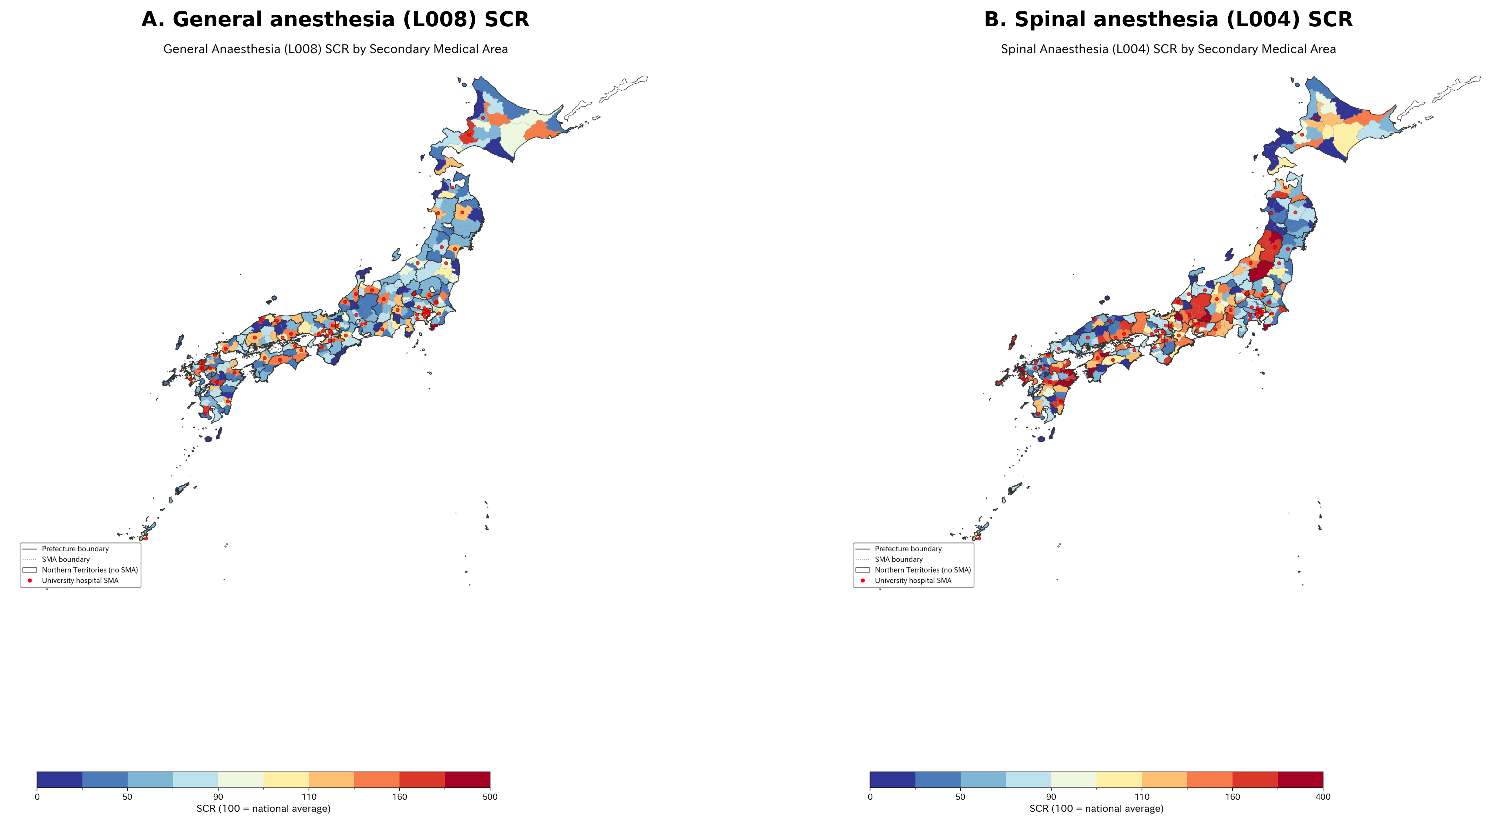
Figure 1. Geographic distribution of anesthesia standardized claim ratios (SCRs) by secondary medical area, fiscal year 2022. (A) General anesthesia (L008) SCR. (B) Spinal anesthesia (L004) SCR. Choropleth maps with solid lines indicating prefectural boundaries and dashed lines indicating SMA boundaries. Northern Territories shown in white (no SMA designated). National average = 100 for each code.

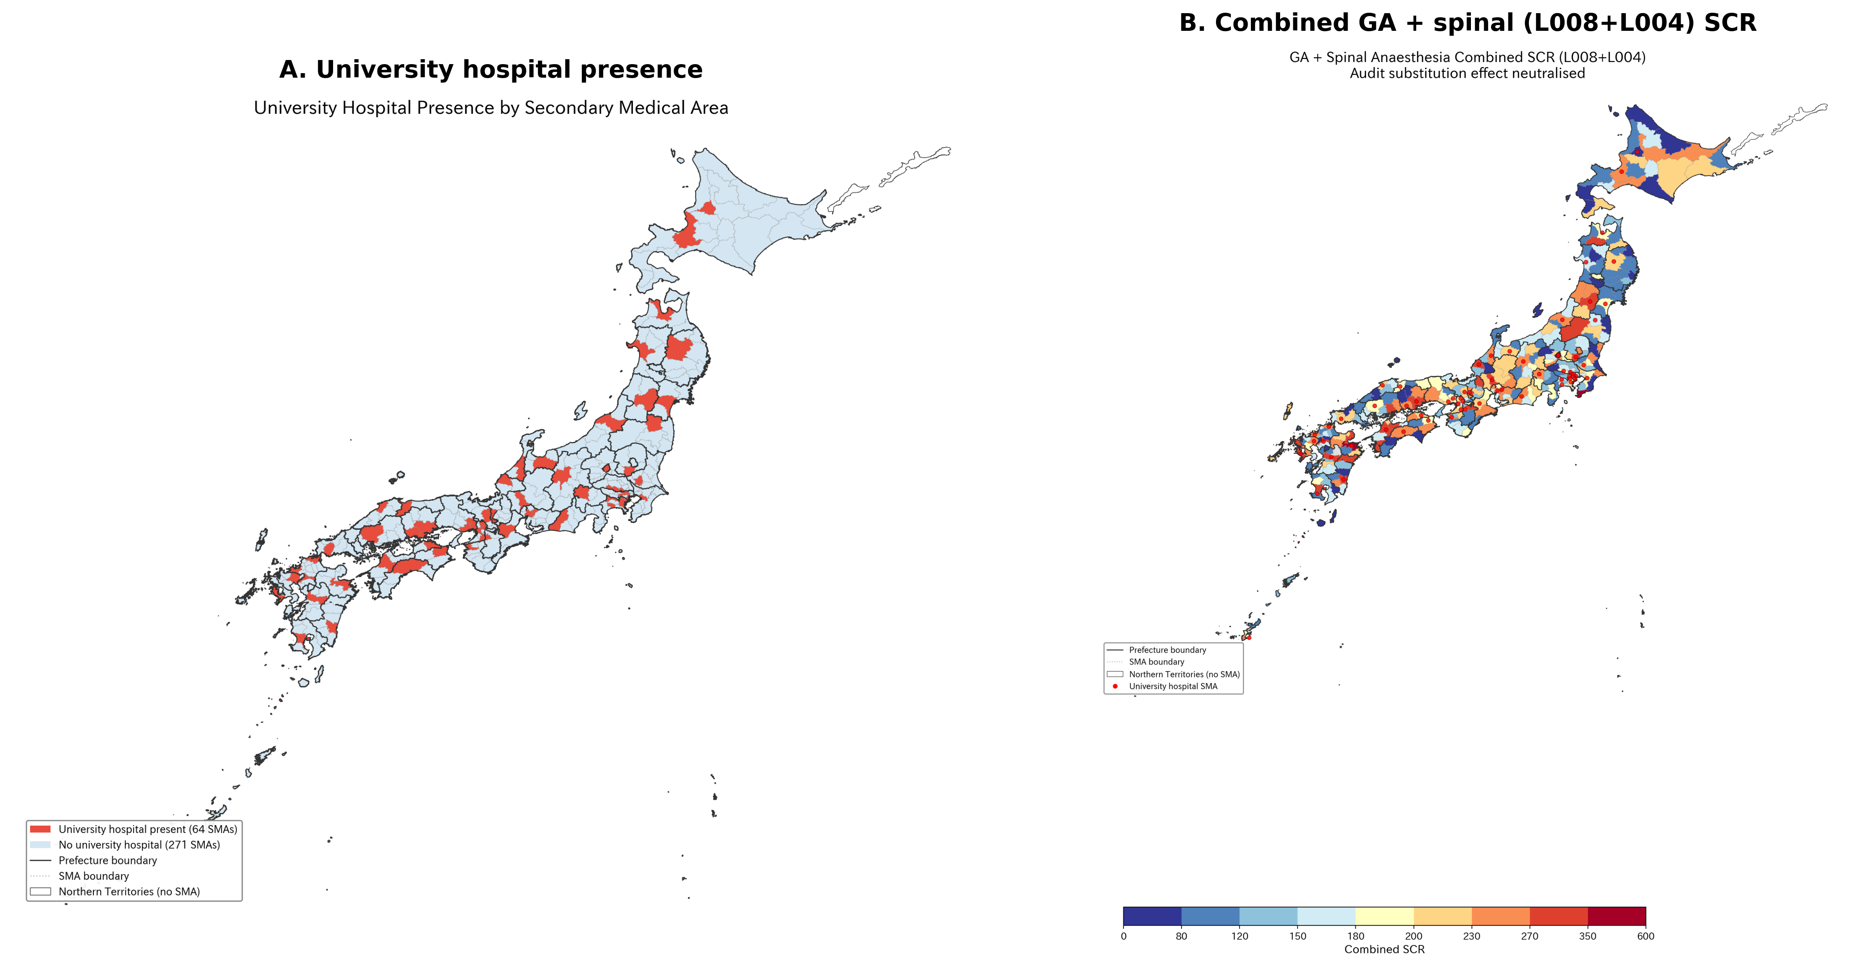
Figure 2. University hospital effect and combined SCR analysis. (A) University hospital presence by SMA: red circles indicate SMAs containing one or more university hospitals (64 of 335 SMAs). (B) Combined GA + spinal anesthesia (L008 + L004) SCR: combining these codes neutralizes potential audit-driven reclassification, yet substantial regional variation persists (CV = 43.4%). Choropleth maps.

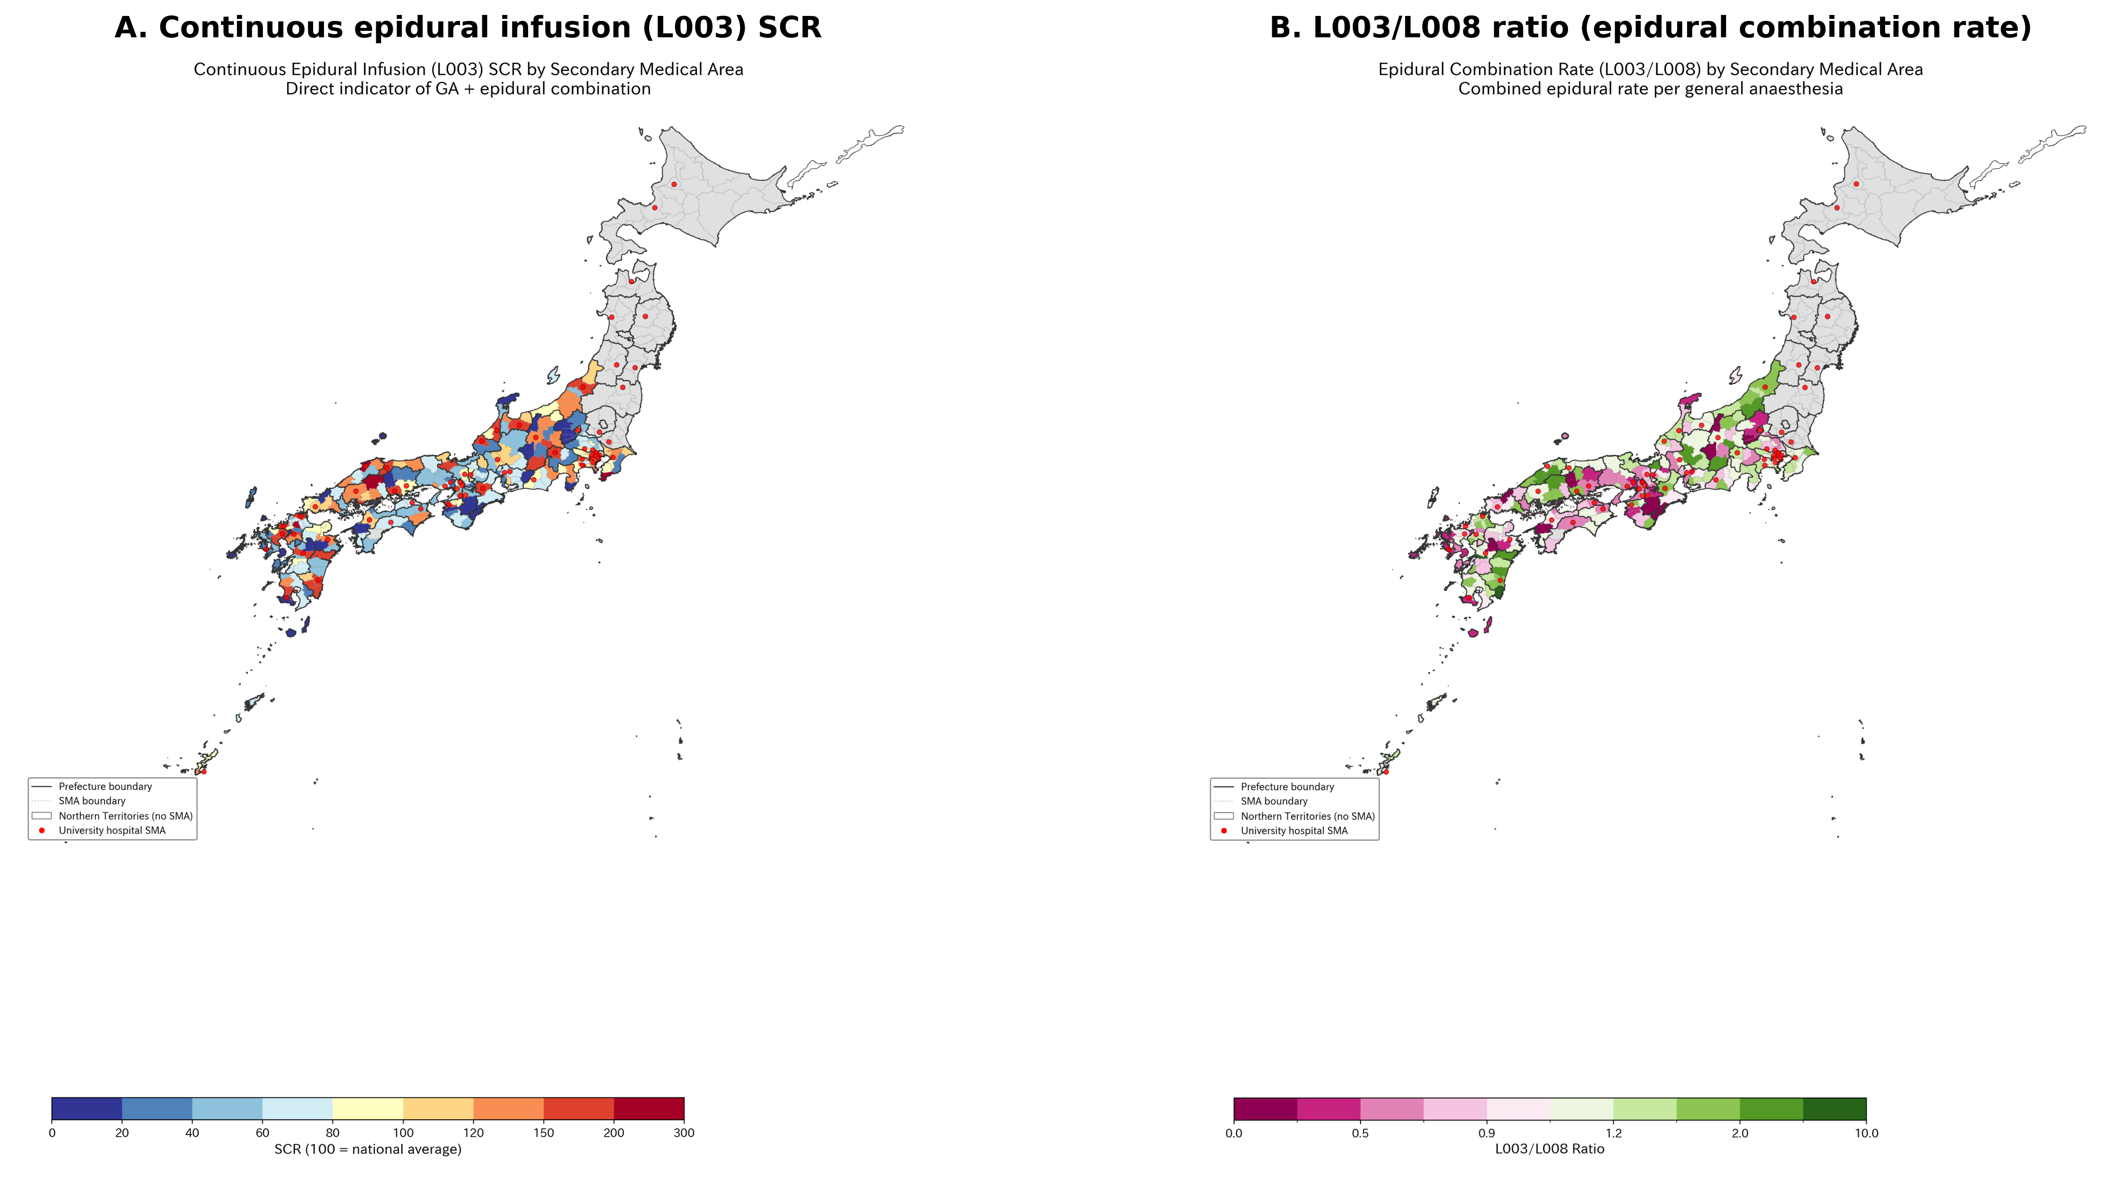
Figure 3. Combined GA–epidural anesthesia variation. (A) Continuous epidural infusion (L003) SCR—direct indicator of combined GA–epidural technique (CV = 64.9%). (B) L003/L008 ratio (epidural combination rate per GA case). Higher values indicate greater use of combined GA–epidural technique. Choropleth maps.

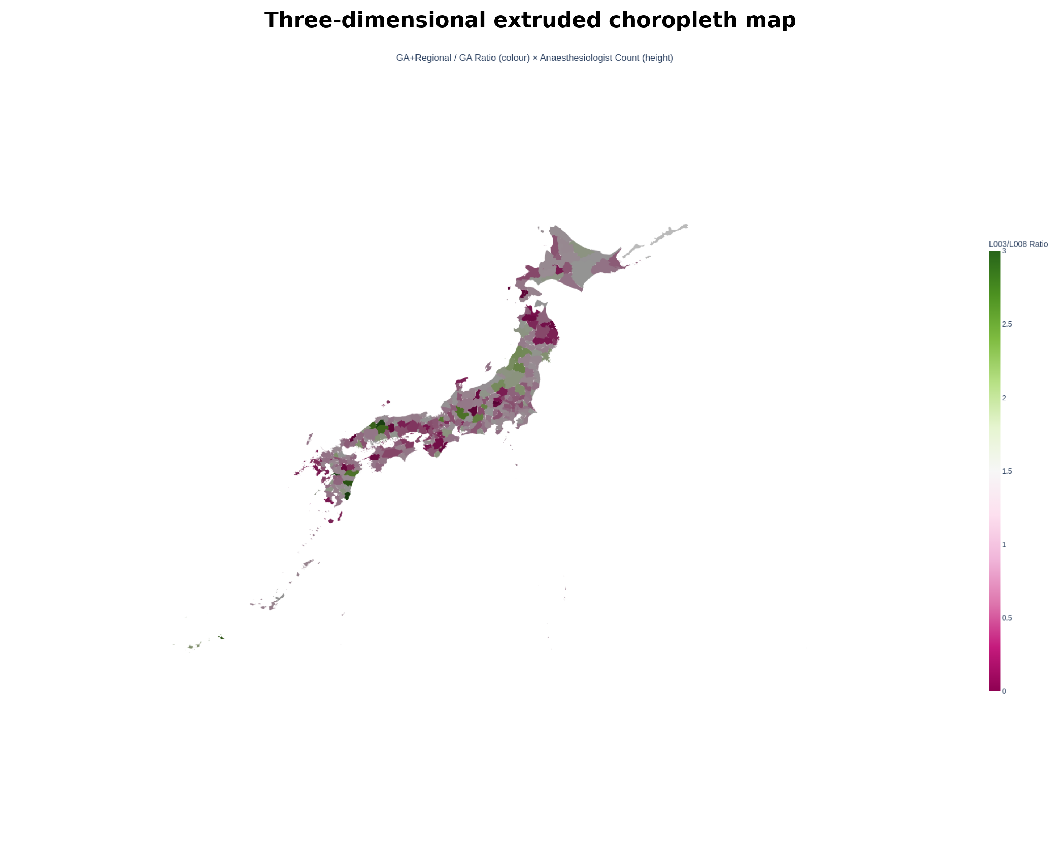
Figure 4. Three-dimensional extruded map. Color represents L003/L008 ratio (combined epidural rate); height represents anesthesiologist count per SMA. Areas with both high epidural combination rate and high specialist count appear as tall, green-colored polygons, typically corresponding to university hospital areas in metropolitan regions. Northern Territories shown at base height.

STROBE Checklist (Cross-sectional study)
Item | STROBE recommendation | Location in manuscript
1a | Title and abstract | Title page and structured abstract
1b | Informative abstract | Structured abstract with Background/Methods/Results/Conclusion
2 | Background/rationale | Introduction paragraphs 1–4
3 | Objectives | Introduction paragraph 5
4 | Study design | Methods: Study design and ethical considerations
5 | Setting | Methods: Geographic units; Data sources (335 SMAs, FY2022)
6a | Participants/eligibility | N/A (ecological study using aggregate data)
7 | Variables | Methods: Anesthesia procedure codes; Table 1
8 | Data sources | Methods: Data sources and standardized claim ratios
9 | Bias | Methods: Sensitivity analyses; Discussion: Limitations
10 | Study size | Methods: 335 SMAs, 47 prefectures
11 | Quantitative variables | Methods: Statistical analysis
12 | Statistical methods | Methods: Statistical analysis (multilevel models, ICC, EB shrinkage)
13 | Participants | Results: 334 SMAs with L008 data
14 | Descriptive data | Results: Table 2
15 | Outcome data | Results: Regional variation; Multilevel model results
16 | Main results | Results: Table 3; Sensitivity analyses 1–3; University hospital effect
17 | Other analyses | Results: Combined SCR; EB shrinkage; Combined GA–epidural
18 | Key results | Discussion: Principal findings
19 | Limitations | Discussion: Strengths and limitations
20 | Interpretation | Discussion: Comparison with existing literature
21 | Generalizability | Discussion: Japanese healthcare system context; Conclusions
22 | Funding | [To be completed]

DECLARATIONS

Ethics approval
This study used publicly available aggregate data. No individual-level data were accessed. Ethics committee approval was not required under the Ethical Guidelines for Medical and Biological Research Involving Human Subjects (Japan, 2021 revision).

Data availability
All data used in this study are publicly available. SCR data: Cabinet Office regional variation visualization (https://www5.cao.go.jp/keizai-shimon/kaigi/special/reform/mieruka/). Physician statistics: e-Stat (https://www.e-stat.go.jp). GIS boundaries: National Land Numerical Information (https://nlftp.mlit.go.jp). Analysis code is available at https://github.com/bougtoir/wip.

Competing interests
[To be completed by authors.]

Funding
[To be completed by authors.]

Contributors
[To be completed by authors.]

AI statement
Devin (Cognition AI) was used as a coding assistant for data analysis, statistical modeling, geographic information system visualization, and manuscript preparation. All scientific interpretation and clinical judgment were provided by the human authors. The AI-generated code and text were reviewed and validated by the authors.

Transparency declaration
The lead author (the manuscript’s guarantor) affirms that the manuscript is an honest, accurate, and transparent account of the study being reported; that no important aspects of the study have been omitted; and that any discrepancies from the study as planned have been explained.

