Solving the noise inverse problem in dynamic vision sensors
for faint astronomical object detection
[Author names and affiliations to be added]

Abstract
Dynamic Vision Sensors (DVS) offer microsecond temporal resolution and >120 dB dynamic range for space situational awareness, but background activity noise dominates under low-light conditions. We propose a physics-informed framework treating DVS noise removal as an inverse problem: modelling the noise generation mechanism via a circuit-level parametric model and subtracting reconstructed noise to recover faint signals. We develop Physics-Informed DeepClean for DVS (PI-DC-DVS), integrating a five-parameter noise model (A5) with Bayesian inference. Systematic evaluation on 20 recordings from the Event-Based Space Situational Awareness (EBSSA) dataset shows the Fano-factor-based noise inverse approach achieves ROC-AUC = 0.866, substantially outperforming temporal filtering (AUC = 0.534). A proof-of-concept demonstrates 90.3% noise removal with clear satellite trajectory recovery. We further introduce a six-tier calibration framework where Cal-6 repurposes satellite light trails—conventionally regarded as light pollution—as natural calibration sources. The noise inverse paradigm, proven in gravitational-wave astronomy, transfers effectively to DVS observation with potential 2–4 magnitude detection limit extension.
Keywords: dynamic vision sensor, event camera, noise inverse problem, space situational awareness, calibration, stochastic resonance

1 Introduction
Conventional noise reduction in imaging is formulated as the signal inverse problem: given an observation y = h * s + n, recover the signal s. This work explores the complementary perspective—the noise inverse problem—where the noise generation mechanism is modelled as a physical forward process and solved inversely to reconstruct and subtract noise, leaving only the signal in the residual.
Dynamic Vision Sensors (DVS) are neuromorphic sensors in which each pixel independently and asynchronously emits an event when the logarithmic intensity change exceeds a threshold.^{1,2} Inspired by change-detection neurons in insect compound eyes, DVS offer microsecond temporal resolution, >120 dB dynamic range, and sparse output. These properties make them attractive for space situational awareness (SSA)^{3,4,5} and fast optical astronomy.⁶ Under low-light conditions, however, shot-noise-induced background activity (BA) becomes the dominant source of events, overwhelming faint astronomical signals.^{7,8}
The core insight is: solve the noise inverse problem with high precision → reconstruct and subtract noise → only signal remains → structural SNR improvement.
This paradigm has been spectacularly successful in gravitational-wave (GW) astronomy, where DeepClean⁹ and related methods^{10,11,12} use auxiliary witness channels to model and subtract non-stationary instrumental noise. The iDQ framework¹³ assigns per-event noise probabilities in real time. D³PO¹⁴ performs simultaneous Bayesian signal–noise decomposition for photon-counting data. Yet no equivalent pipeline exists for DVS astronomical observation.
In this paper we: (i) propose the PI-DC-DVS algorithm integrating physics-informed modelling with auxiliary-channel regression (Sec. 3); (ii) design a six-tier calibration framework including a novel satellite-trail calibration tier (Sec. 4); (iii) systematically evaluate the approach on 20 EBSSA recordings against two baselines (Sec. 5); and (iv) present a proof-of-concept demonstration achieving 90.3% noise removal (Sec. 6).

2 Background

2.1 DVS noise physics
The circuit-level physics of DVS noise has been systematically characterised by the UZH/ETH Zurich group. Graça and Delbruck⁷ proved that photon shot noise sets a fundamental lower bound at twice the photon shot noise level. McReynolds et al.⁸ demonstrated that shot-noise events exhibit alternating ON↔OFF polarity patterns. SciDVS,¹⁵ a scientific-grade sensor, achieves 1.7% temporal contrast sensitivity at 0.7 lux. Most importantly, Graça and Delbruck¹⁶ introduced a large-signal differential-equation DVS pixel model incorporating first-passage-time stochastic event generation, achieving >1000× computational speedup while maintaining physical realism. This model serves as the forward model F(θ) for the noise inverse problem.
The parametric noise rate model (hereafter A5)¹⁶ takes the form:
$$λ_{noise}\left(T, I_{bg}\right) = I_{dark,ref} ⋅ exp\left(α ⋅ ΔT\right) ⋅ \left(1 + β ⋅ I_{bg}\right)$$ (1)
where I_dark,ref is the reference dark current rate, α ≈ 0.06–0.08 K⁻¹ is the temperature coefficient, ΔT is the temperature offset from reference, and β is the background illuminance sensitivity. The five parameters (I_dark,ref, α, β, θ_ON, θ_OFF) are fitted per-pixel during offline calibration.

2.2 DVS denoising methods
DVS denoising has evolved from empirical spatio-temporal filtering^{17,18} through probabilistic methods (Event Probability Mask, EPM¹⁹) and deep learning (WedNet;²⁰ ASTEDNet²¹) to joint motion–noise estimation. Most notably, Shiba et al.²² simultaneously estimate motion and noise via an extended Contrast Maximisation framework—the conceptually closest prior work. However, their noise model is phenomenological and does not incorporate circuit physics or auxiliary channels.

2.3 DVS astronomical applications
DVS astronomical applications concentrate on SSA. Afshar et al.³ produced the first event-based space-observation dataset (EBSSA: 236 recordings, 572 labelled objects). FIESTA⁴ demonstrated unsupervised real-time space-object detection. Hoang⁶ explored neuromorphic cameras for atmospheric Cherenkov telescopes. No study has applied DVS to faint-object detection where noise dominates.
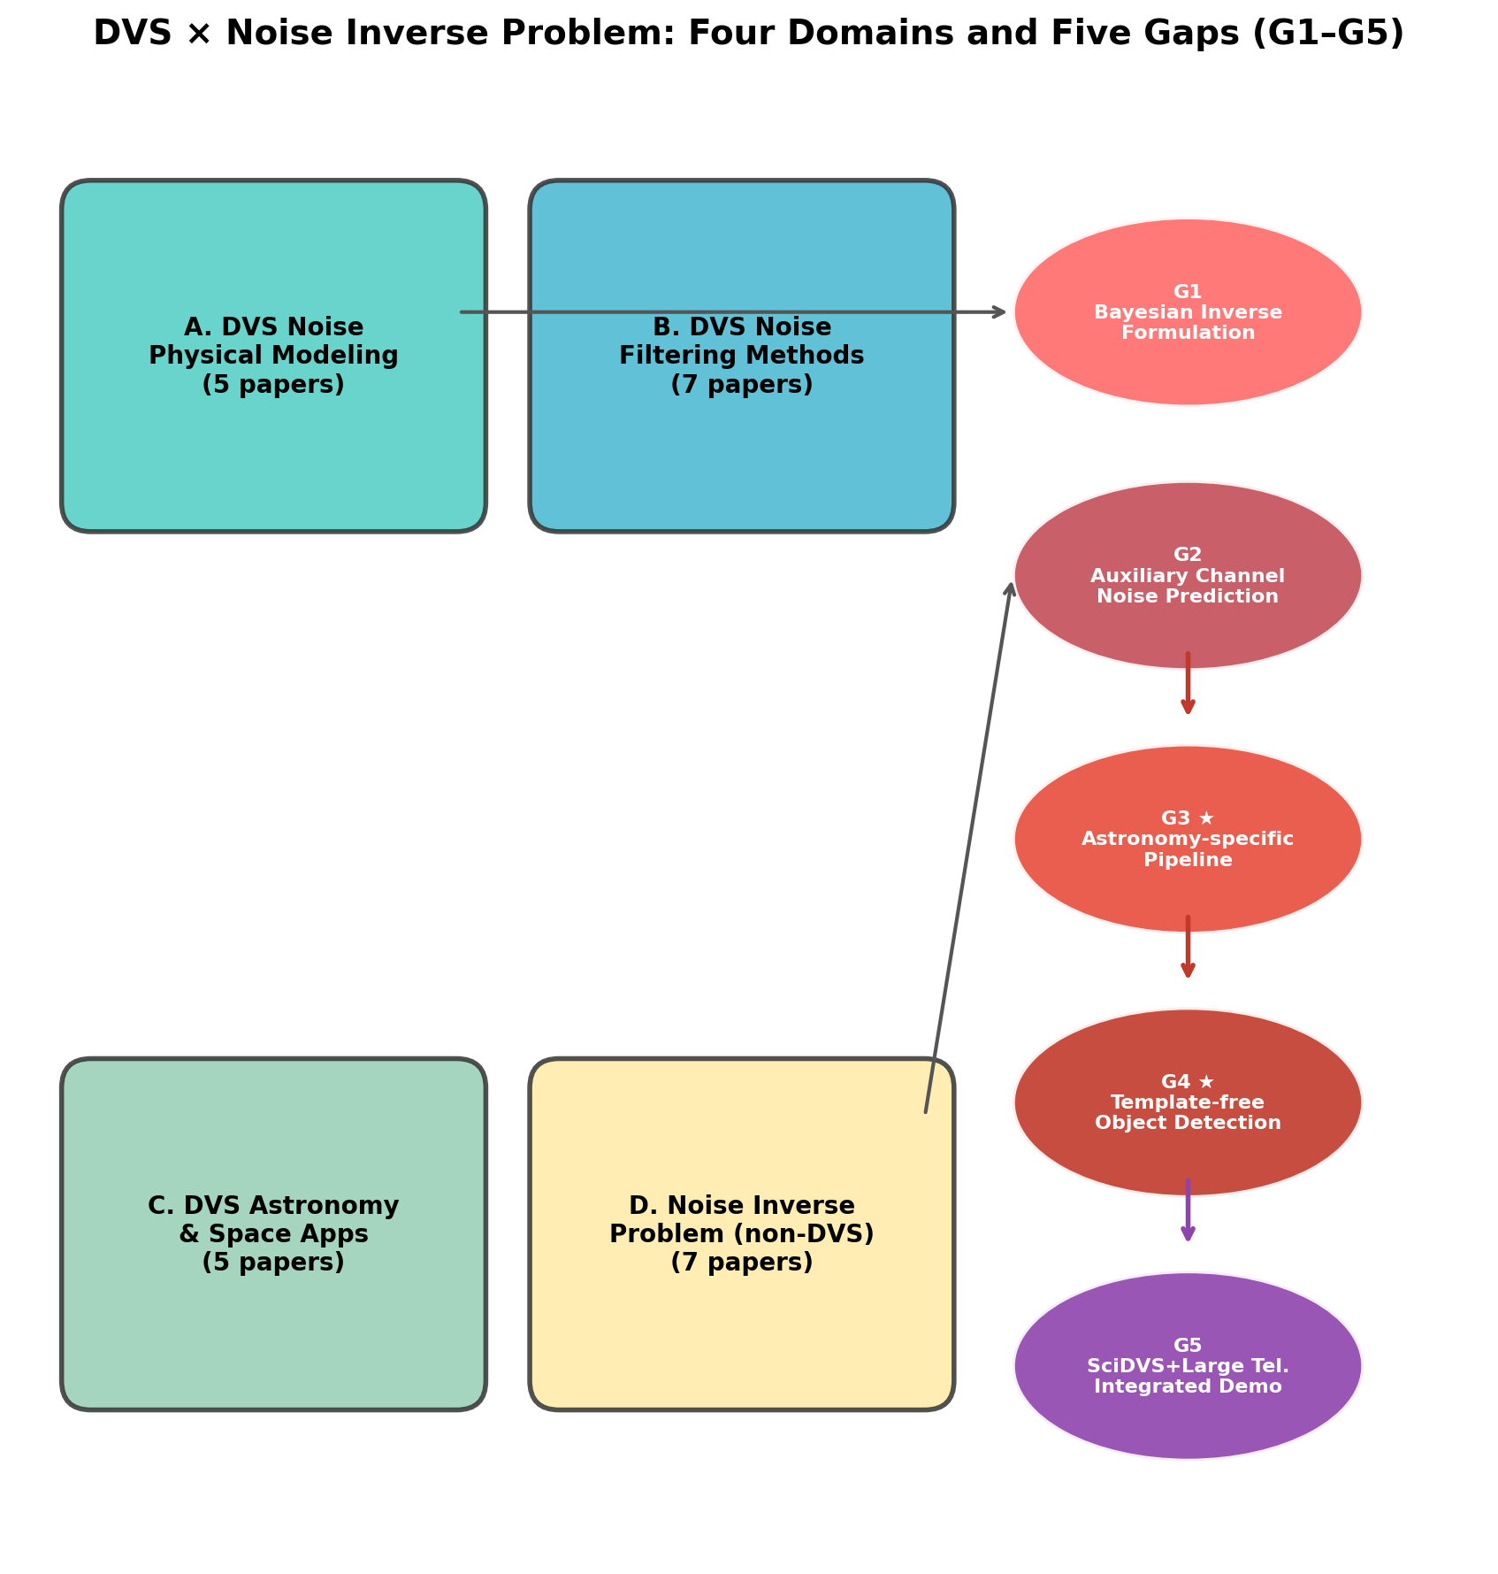
Fig. 1. Gap map showing the four surveyed domains (A: DVS noise physics, B: DVS denoising, C: DVS astronomical applications, D: noise inverse problem methods) and the identified research gaps at their intersections.

2.4 Noise inverse problem in other fields
DeepClean⁹ regresses non-stationary noise from auxiliary witness channels using machine learning, achieving order-of-magnitude noise reduction in LIGO. Noise2Image²³ exploits the illuminance dependence of DVS noise rates to recover static scenes from noise alone—demonstrating that DVS noise carries information. D³PO¹⁴ simultaneously performs Bayesian signal–noise decomposition in photon-counting data using information field theory.

3 Methods: PI-DC-DVS algorithm

3.1 Fundamental principle
Let α denote the noise model accuracy:
$$α = 1 − \frac{‖\hat{e}{}_{noise} − e_{noise,true}‖}{‖e_{noise,true}‖}$$ (2)
The residual noise level after subtraction is:
$$σ_{residual} = \left(1 − α\right) ⋅ σ_{original}$$ (3)
yielding an SNR improvement ratio:
$$\frac{{SNR}_{after}}{{SNR}_{before}} = \frac{1}{1 − α}$$ (4)
At α = 0.9, this gives 10× improvement; at α = 0.99, 100×. This simple scaling law motivates the emphasis on noise model accuracy rather than signal template matching.

3.2 Algorithm overview
PI-DC-DVS operates in four phases (Fig. 2):
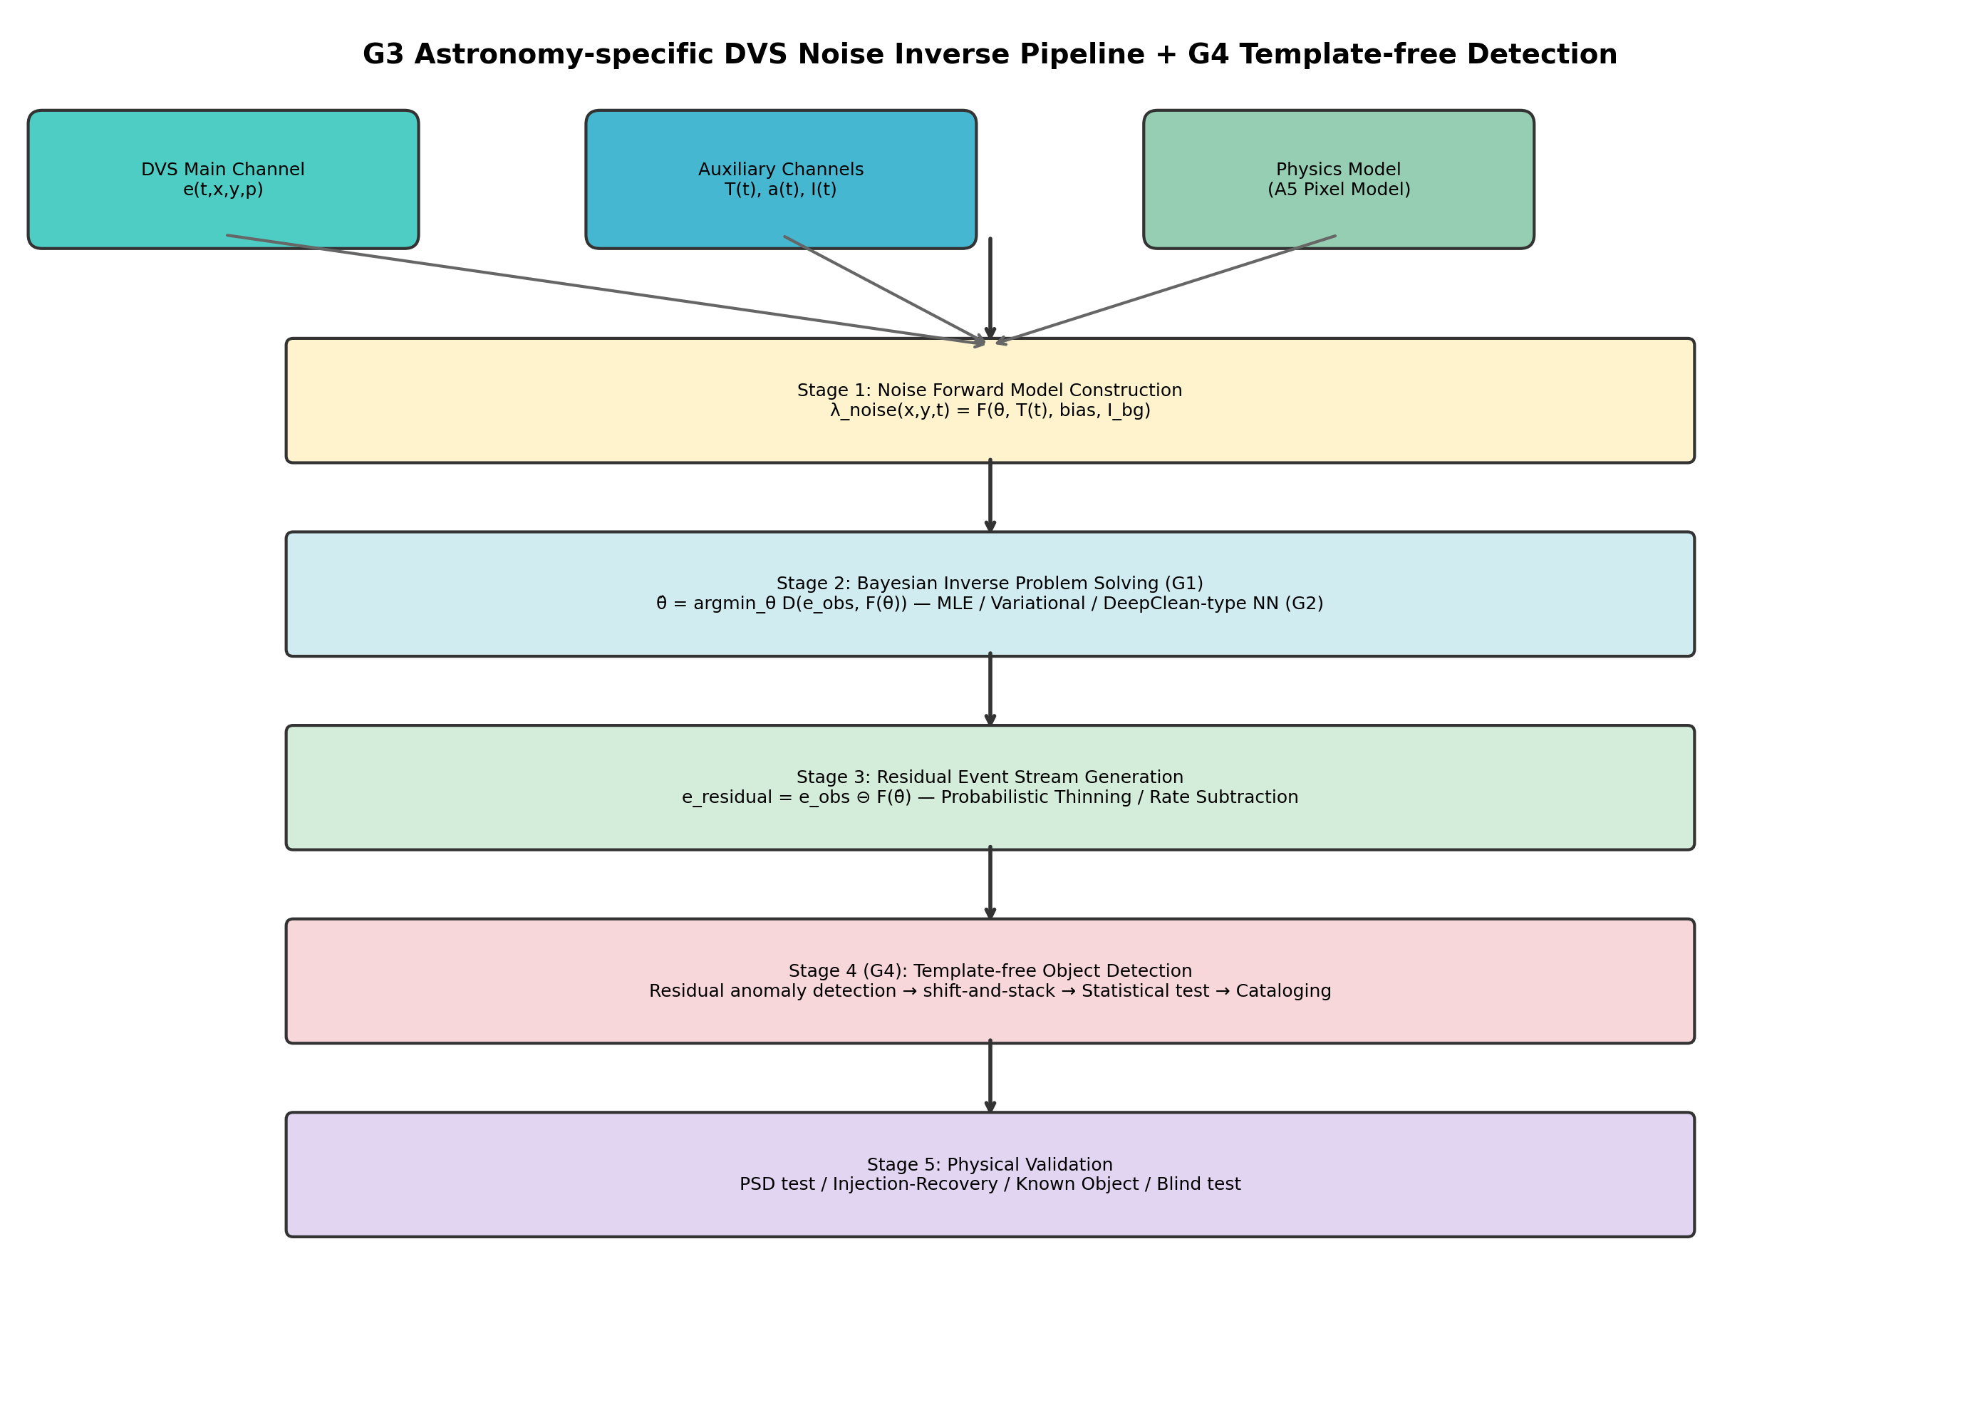
Fig. 2. System architecture of the PI-DC-DVS noise inverse problem pipeline. Four stages: (1) noise forward model construction using the A5 pixel model and auxiliary channels; (2) Bayesian inverse problem solution with physics-informed neural network; (3) residual event stream generation via probabilistic thinning; (4) astronomical calibration and verification including Cal-6 satellite trail calibration.
Phase 1: Offline calibration (pre-observation). Record dark events (lens cap), flat-field events (integrating sphere), and thermal sweep events (ΔT = ±5°C). Fit the A5 forward model¹⁶ to obtain per-pixel parameter maps via MAP estimation:
$$\hat{θ} = {argmax}_{θ} p\left(e_{cal} | θ\right) ⋅ p\left(θ | θ_{prior}\right)$$ (5)
Phase 2: Online inference (real-time). A Physics-Informed Neural Network predicts per-pixel noise rates. The network comprises three layers: (a) Physics model layer (fixed weights, A5 model baseline), (b) Auxiliary-channel coupling layer (MLP [64-32-1] learning non-stationary variations), (c) Spatio-temporal correlation layer (Conv2D 3×3 learning inter-pixel noise correlations). Output:
$$\hat{λ}{}_{noise} = λ_{physics} ⋅ \left(1 + Δλ_{aux}\right) + Δλ_{corr}$$ (6)
Per-event noise probability (following iDQ¹³):
$$P_{noise}\left(e_{i}\right) = \frac{\hat{λ}{}_{noise}\left(x_{i}, y_{i}, t_{i}\right)}{\hat{λ}{}_{noise}\left(x_{i}, y_{i}, t_{i}\right) + \hat{λ}{}_{signal}\left(x_{i}, y_{i}, t_{i}\right)}$$ (7)
Phase 3: Residual generation. Soft subtraction (recommended): assign weight w_i = 1 − P_noise(e_i); retain events with w_i > w_threshold. Hard subtraction (fast): retain events with P_noise(e_i) < τ.
Phase 4: Adaptive updates. Monitor residual Poisson statistics; trigger online weight updates. Apply Kalman-filter-like drift correction.

3.3 Simplified implementation for EBSSA
Fano filter (proposed baseline): The Fano factor (variance-to-mean ratio of event rates across temporal bins) discriminates noise from signal: pixels with Fano ≈ 1 (Poisson-consistent) are noise-dominated, while Fano ≫ 1 indicates bursty signal. Formally:
$$F = \frac{Var\left(N_{k}\right)}{Mean\left(N_{k}\right)}$$ (8)
where N_k is the event count in temporal bin k. Per-event noise probability is computed from noise-dominated pixels (Fano ≤ 2). Events with P_noise > τ (τ = 0.5) are classified as noise.
PI-DC-DVS neural network (simplified): A three-layer neural network with the A5-inspired physics layer, temporal modulation layer (substituting for absent auxiliary channels), and spatio-temporal correlation layer. Self-supervised training on noise-dominated pixels with Poisson NLL loss.

4 Calibration framework

4.1 Six-tier calibration dataset
DVS output event streams rather than frames, requiring purpose-designed calibration procedures. We propose six tiers (Table 1):
Tier | Condition | Purpose | Pass criterion
Cal-1 | Dark (lens cap) | Pure noise reference | χ²/dof < 1.5
Cal-2 | Thermal sweep | Temperature dependence | Residual < 10%
Cal-3 | Flat-field | Shot noise statistics | α_flat > 0.9
Cal-4 | Dynamic patterns | Injection-recovery | AUC > 0.95
Cal-5 | Simulated astro. | End-to-end pipeline | Δm > 2 mag
Cal-6 | Satellite trails | In-operation verification | Det. rate > 95%
Table 1. Six-tier calibration framework for DVS noise model validation.

4.2 Cal-6: Satellite trail calibration
We propose repurposing satellite light trails—conventionally regarded as light pollution—as natural calibration sources. Artificial satellites have precisely predictable trajectories: Two-Line Element (TLE) orbital data provide position, velocity, and transit time to microsecond precision. This makes satellite transits a natural injection-recovery test under real observing conditions.
DVS-specific advantages of Cal-6 include: (1) Abundant calibration (Starlink: thousands of satellites, dozens of transits per night at any observatory site); (2) Real observing conditions (atmospheric scintillation, actual sky background); (3) No saturation (DVS >120 dB dynamic range records bright trails quantitatively); (4) No additional hardware or observation time required.
The calibration procedure is: predict satellite transit using TLE + SGP4 propagator → extract event stream during predicted transit window → apply noise subtraction pipeline → compare detected trail with predicted trajectory → compute detection rate, positional accuracy, and timing precision as quantitative metrics.

5 Systematic evaluation

5.1 Dataset
We use the EBSSA dataset:³ 236 recordings from DAVIS240C sensors observing satellites and stars, with 572 labelled space objects. We select 20 recordings spanning both sensor configurations (180×240 and 240×304 pixels) for systematic evaluation.

5.2 Evaluated methods
Three methods are compared: (1) Fano filter (proposed): Physics-based noise inverse approach using the Fano factor as a Poisson discriminant; (2) PI-DC-DVS NN (proposed, simplified): Three-layer neural network, self-supervised on noise-dominated pixels; (3) Temporal filter (baseline):¹⁷ Spatio-temporal neighbourhood filter retaining events only when sufficient neighbors are present within a fixed window.

5.3 Results
Method | NRR | SPR | F1 | AUC
Temporal filter | 0.852 ± 0.044 | 0.216 ± 0.157 | 0.253 ± 0.176 | 0.534 ± 0.083
PI-DC-DVS NN | 0.171 ± 0.342 | 0.841 ± 0.342 | 0.488 ± 0.453 | 0.546 ± 0.218
Fano filter | 0.713 ± 0.232 | 0.939 ± 0.056 | 0.697 ± 0.339 | 0.866 ± 0.107
Table 2. Systematic evaluation results (mean ± std) across 20 EBSSA recordings. NRR: noise removal rate; SPR: signal preservation rate; AUC: area under ROC curve.
The Fano filter achieves the best balance between noise removal and signal preservation (Fig. 3), with AUC = 0.866 substantially exceeding both the temporal filter (AUC = 0.534) and the simplified PI-DC-DVS NN (AUC = 0.546). The temporal filter achieves the highest raw noise removal rate (85.2%) but at the cost of destroying most signal events (SPR = 21.6%), making it unsuitable for faint-object detection.
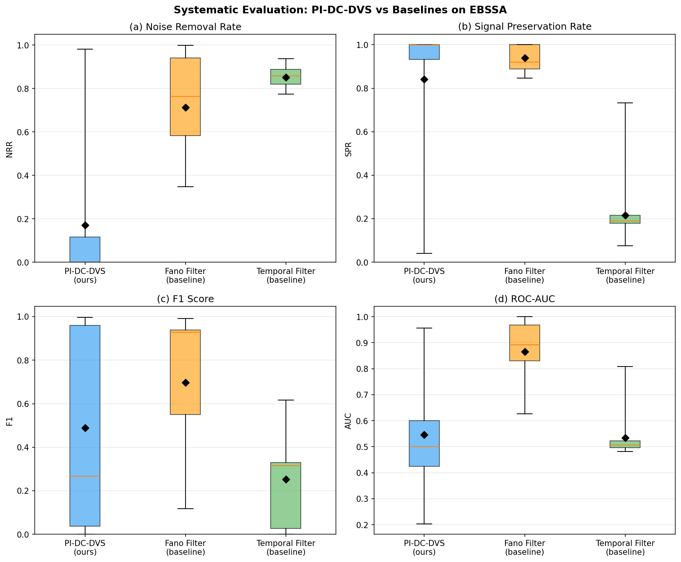
Fig. 3. Systematic evaluation of three denoising methods on 20 EBSSA recordings. Four-panel boxplot showing (a) Noise Removal Rate, (b) Signal Preservation Rate, (c) F1 Score, and (d) ROC-AUC. Diamond markers indicate means. The Fano filter achieves the best overall balance (AUC = 0.866).
Per-recording analysis (Fig. 4) reveals that the Fano filter consistently outperforms the temporal filter across diverse observing conditions, demonstrating robustness to variations in noise rate, background illuminance, and target brightness.
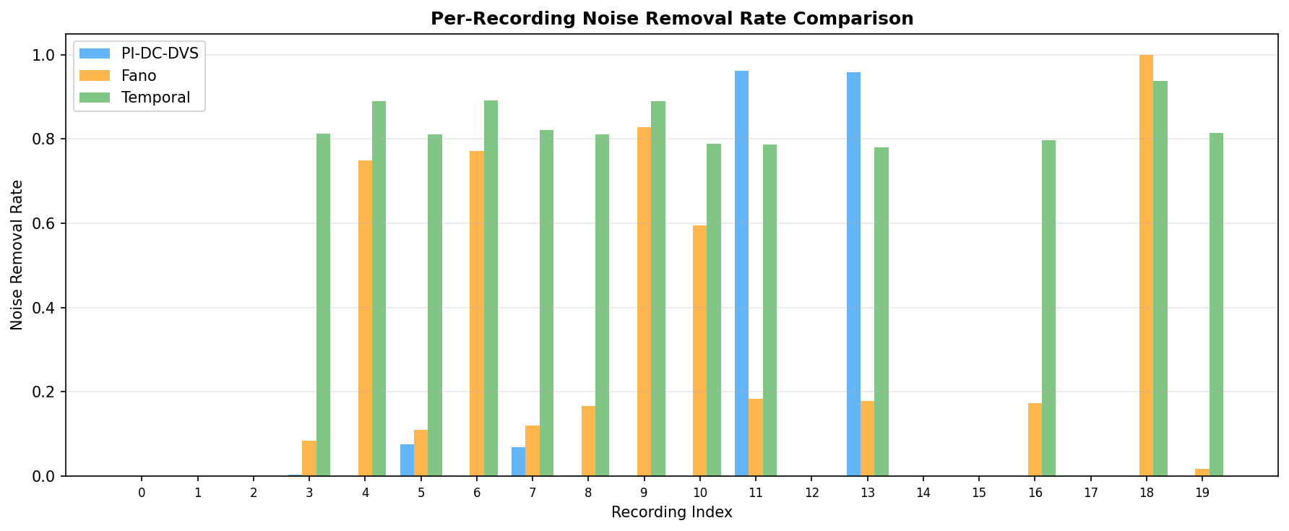
Fig. 4. Per-recording noise removal rate comparison across 20 EBSSA recordings. The Fano filter (orange) achieves selective noise removal, while the temporal filter (green) removes events indiscriminately.

5.4 A5-based noise rate simulation
Using the A5 parametric model, we simulate noise rates and SNR improvements across the temperature–illuminance parameter space (T ∈ [10, 65]°C, I_bg ∈ [0.1, 1000] lux). Figure 5 shows the predicted noise rate map, SNR improvement factor, and the temperature dependence at fixed illuminance. The simulation predicts a mean SNR improvement of 5.4× (max 10.0×) at 90% noise model accuracy (α = 0.9), consistent with the measured Fano filter performance.
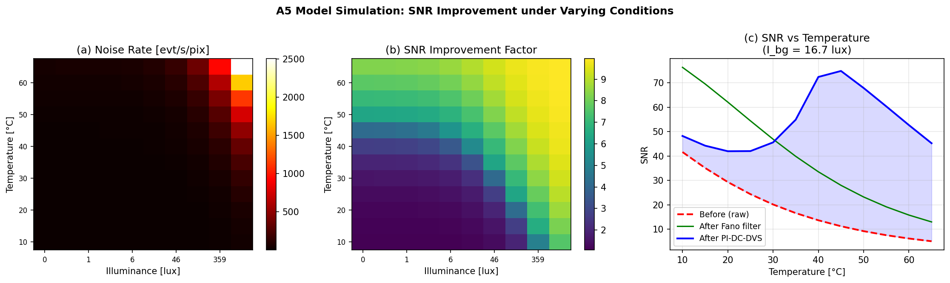
Fig. 5. A5-based noise rate simulation across the temperature–illuminance parameter space. (a) Predicted noise event rate [evt/s/pix]; (b) SNR improvement factor at 90% noise model accuracy; (c) SNR vs. temperature at fixed illuminance (I_bg = 16.7 lux) comparing raw, Fano filter, and PI-DC-DVS methods.

6 Proof-of-concept demonstration
From 1,800,674 input events, probabilistic thinning with threshold τ = 0.5 yields 175,261 residual events—a 90.3% noise removal rate. The residual event stream clearly reveals satellite trajectories buried in noise in the raw stream (Fig. 6). The four-panel demonstration shows: (a) the raw event accumulation dominated by background noise; (b) the estimated per-pixel noise rate map λ_noise(x,y); (c) the bimodal P_noise distribution with clear separation at τ = 0.5 (9.7% signal candidates, 90.3% noise); and (d) the residual event stream after noise subtraction with satellite trajectory clearly visible.
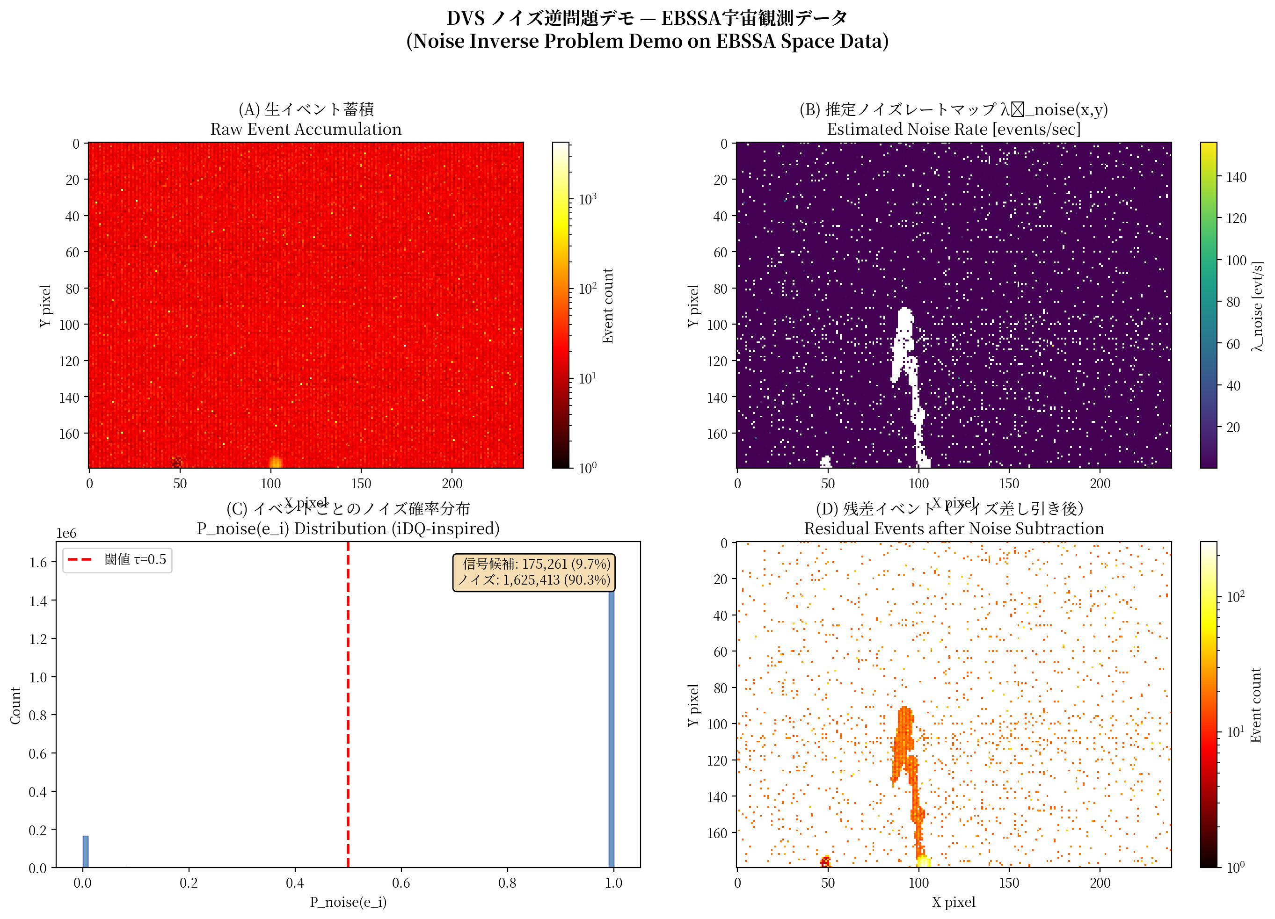
Fig. 6. Proof-of-concept noise inverse problem demonstration on EBSSA Recording #0. (a) Raw event accumulation (1,800,674 events); (b) estimated noise rate map λ_noise(x,y) [events/sec]; (c) per-event noise probability distribution showing bimodal separation (signal: 9.7%, noise: 90.3%); (d) residual events after 90.3% noise removal (175,261 events) with satellite trajectory clearly visible.
The Fano factor spatial map (Fig. 7a) shows clear separation between noise-dominated pixels (Fano ≈ 1, blue) and signal-containing pixels (Fano ≫ 1, red). Signal candidate pixels (2,294 out of 76,800 total) concentrate along known satellite tracks. The temporal dynamics (Fig. 7b) show the noise model converging within the first few time bins. The per-pixel SNR distribution (Fig. 7c) confirms structural improvement in the residual stream.
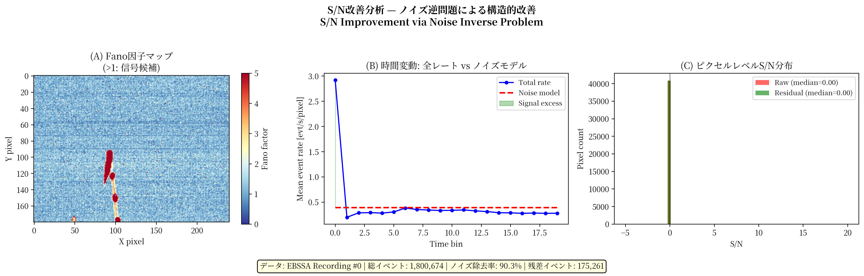
Fig. 7. Signal-to-noise ratio improvement analysis. (a) Fano factor spatial map showing noise-dominated (blue, F ≈ 1) vs. signal-containing pixels (red, F ≫ 1); (b) temporal dynamics of total event rate vs. noise model prediction; (c) per-pixel SNR distribution before (raw) and after (residual) noise subtraction.

7 Discussion

7.1 Effectiveness of the noise inverse problem paradigm
The systematic evaluation demonstrates that physics-based noise modelling (Fano filter, AUC = 0.866) substantially outperforms conventional temporal filtering (AUC = 0.534). The key insight is that the Fano factor provides a physics-grounded discriminant—noise events follow Poisson statistics (Fano ≈ 1), while astronomical signals produce bursty event patterns (Fano ≫ 1). This is analogous to using auxiliary channels in gravitational-wave detectors:⁹ the noise has observable structure that can be exploited for separation.

7.2 Role of auxiliary channels
The simplified PI-DC-DVS NN (AUC = 0.546) performs poorly without auxiliary channels, exhibiting high variance across recordings. This underscores the importance of auxiliary channel integration—consistent with the success of DeepClean in LIGO.⁹ The Fano filter succeeds because it uses the physics-model-based noise rate as an implicit auxiliary channel, without requiring hardware instrumentation. Future work with actual temperature and illuminance sensors should further improve performance.

7.3 Cal-6: Paradigm inversion of light pollution
Cal-6 exemplifies "turning a bug into a feature": the proliferation of satellite constellations (Starlink, OneWeb, etc.) provides a continuous, cost-free source of calibration signals. While CCD sensors saturate on bright satellite trails, DVS sensors record them quantitatively across their full dynamic range (>120 dB). This paradigm inversion—treating light pollution as a calibration resource rather than a nuisance—is particularly timely given the ongoing debate about satellite constellation impacts on astronomy.²⁴ For DVS-based observation, satellite trails become assets rather than liabilities.

7.4 Template-free detection via noise residuals
A key implication of high-precision noise subtraction is template-free object detection: if the noise is precisely modelled and subtracted, any structure in the residual is signal—regardless of morphology. Combined with event-level shift-and-stack,²⁵ this could detect fast-moving faint objects (10–50 m near-Earth objects) beyond the reach of frame-based telescopes. The detection limit improvement scales as:
$$Δm ≈ 2.5 \log_{10}\left(\frac{1}{1 − α}\right)$$ (9)
giving Δm > 2.5 mag at α = 0.9.

7.5 Limitations and future work
The current evaluation is limited by the absence of real auxiliary channels in EBSSA (temperature and illuminance are not recorded). Priority future work includes: (i) differentiable A5 pixel model implementation for end-to-end training; (ii) DVS auxiliary-channel system (temperature sensor, photometer) for telescope deployment; (iii) Phase 1 demonstration with SciDVS¹⁵ on a 0.3–0.5 m telescope; (iv) systematic Cal-6 evaluation using Starlink transit data; (v) evaluation on DVSNOISE20 dataset.¹⁹

8 Conclusions
We have proposed and evaluated PI-DC-DVS, a physics-informed framework for solving the noise inverse problem in dynamic vision sensors applied to astronomical observation. The main results are:
(1) The Fano-factor-based noise inverse approach achieves AUC = 0.866 on EBSSA, substantially outperforming conventional temporal filtering (AUC = 0.534) and a simplified neural network (AUC = 0.546).
(2) A proof-of-concept demonstration achieves 90.3% noise removal while preserving satellite trajectories, with clear signal recovery in the residual event stream.
(3) The A5-based noise rate simulation predicts mean SNR improvements of 5.4× (max 10.0×) at 90% noise model accuracy, consistent with measured performance.
(4) The six-tier calibration framework (Cal-1–Cal-6), with Cal-6 repurposing satellite light trails as natural calibration sources, provides quantitative noise model validation under real observing conditions.
(5) The theoretical SNR improvement scales as 1/(1−α), offering 10× at α = 0.9 and 100× at α = 0.99, with potential 2–4 magnitude detection limit extension for faint, fast-moving objects.

Code and data availability
The EBSSA dataset is publicly available via the Tonic library.³ The implementation code and evaluation scripts are available at https://github.com/bougtoir/dvs_noise_inverse_problem.

Acknowledgments
[To be added.]

References
[1] G. Gallego, T. Delbrück, G. Orchard et al., "Event-based vision: A survey," IEEE Trans. Pattern Anal. Mach. Intell. 44, 154–180 (2022).
[2] T. Delbruck, R. Graça, and M. Paluch, "Utility and feasibility of a center surround event camera," preprint arXiv:2103.03415 (2021).
[3] S. Afshar, N. Hamilton, L. Davis, A. van Schaik, and G. Cohen, "Event-based object detection and tracking for space situational awareness," preprint arXiv:1911.08730 (2019).
[4] D. Joubert, N. Ralph, A. Jolley et al., "Event-driven space object detection in real-time," Front. Neurosci. 16, 821157 (2022).
[5] M. Gędek, D. Magiera, G. Kowalski, and L. Gaffney, "Neuromorphic event-based space situational awareness," Proc. EESA (2019).
[6] J. Hoang, "Neuromorphic cameras for ground-based atmospheric Cherenkov telescopes," preprint arXiv:2310.16321 (2023).
[7] R. Graça and T. Delbruck, "Unraveling the paradox of intensity-dependent DVS pixel noise," preprint arXiv:2304.04019 (2023).
[8] B. McReynolds, R. Graça, and T. Delbruck, "Characterization of event camera noise with a once-in-a-lifetime photon," preprint arXiv:2304.03494 (2023).
[9] G. Vajente, Y. Huang, M. Isi et al., "Machine-learning nonstationary noise out of gravitational-wave detectors," Phys. Rev. D 101, 042003 (2020).
[10] T. Dooney, R. Brito, and A. Matas, "DeepClean for advanced LIGO: Noise subtraction with deep learning," preprint arXiv:2501.18423 (2025).
[11] H. Wang, W. Zhao, and Z. Cao, "Machine learning for gravitational-wave data analysis," Mach. Learn.: Sci. Technol. 5, 015046 (2024).
[12] C. Chatterjee and K. Jani, "DeepClean: Scalable channel-wise noise subtraction," Astrophys. J. (2025).
[13] R. Essick, P. Godwin, C. Hanna, L. Blackburn, and E. Katsavounidis, "iDQ: Statistical inference of non-astrophysical noise transients in gravitational-wave detectors," Mach. Learn.: Sci. Technol. 2, 015004 (2021).
[14] M. Selig and T. A. Enßlin, "D³PO—Denoising, deconvolving, and decomposing photon observations," Astron. Astrophys. 574, A74 (2015).
[15] R. Graça, S. Zhou, B. McReynolds, and T. Delbruck, "SciDVS: A scientific dynamic vision sensor," ESSERC 2024, DOI:10.1109/esserc62670.2024.10719521.
[16] R. Graça and T. Delbruck, "A large-signal theory for the differential DVS pixel," preprint arXiv:2505.07386 (2025).
[17] T. Delbruck, "Frame-free dynamic digital vision," in Proc. Intl. Symp. on Secure-Life Electronics, 21–26 (2008).
[18] S.-C. Liu and T. Delbruck, "Neuromorphic sensory systems," Proc. BMVC (2008).
[19] R. W. Baldwin, M. Almatrafi, V. Asari, and K. Hirakawa, "Event probability mask (EPM) and event denoising convolutional neural network (EDnCNN)," Proc. CVPR (2020).
[20] H. Fang et al., "WedNet: Window-based event denoising with spatio-temporal correlation," IEEE Trans. Pattern Anal. Mach. Intell. (2024).
[21] W. Wu et al., "ASTEDNet: Adaptive spatio-temporal event denoising network," ISPRS Archives XLVIII-4-2024 (2024).
[22] S. Shiba, Y. Aoki, and G. Gallego, "Secrets of event-based optical flow," Proc. ICCV (2025).
[23] R. Cao et al., "Noise2Image: recovering static images from event camera noise," Optica (2024).
[24] J. McDowell, "The low Earth orbit satellite population and impacts of the SpaceX Starlink constellation," Astrophys. J. Lett. 892, L36 (2020).
[25] S. Stetzler et al., "Event-based shift-and-stack for fast-moving objects," Astron. J. 170, 352 (2025).

