Optimal noise model accuracy for dynamic vision sensors:
a stochastic resonance framework for the noise inverse problem
[Double-blind review: author names and affiliations removed]

Highlights
• Closed-form optimal noise model accuracy ρ* = √(1 − θ²/σ²) derived for threshold-based event detectors via stochastic resonance theory.
• Five-parameter physics-informed noise model (A5) enables the noise inverse problem for dynamic vision sensor (DVS) astronomical observation.
• Fano-factor classifier achieves ROC-AUC = 0.866 and 93.9% signal preservation on 20 EBSSA recordings, outperforming temporal filtering (AUC = 0.534) by 62%.
• Six-tier calibration framework including Cal-6 (satellite trail calibration) provides quantitative in-operation noise model verification.
• Proof-of-concept demonstrates 90.3% noise removal with satellite trajectory recovery, consistent with theoretical 5–10× SNR gain prediction.

Abstract
Dynamic Vision Sensors (DVS) offer microsecond temporal resolution and >120 dB dynamic range for space situational awareness, but background activity noise dominates under low-light conditions, overwhelming faint astronomical signals. We address this measurement challenge through two complementary contributions. First, we derive a closed-form optimal noise model accuracy ρ* = √(1 − θ²/σ²) for threshold-based event detectors by unifying stochastic resonance (SR) theory with covariate adjustment (ANCOVA). The result prescribes reducing effective noise to the SR optimum and no further—establishing that indiscriminate noise removal is counterproductive. Second, we instantiate this framework for DVS astronomical observation via Physics-Informed DeepClean for DVS (PI-DC-DVS), integrating a five-parameter circuit-level noise model (A5) with Bayesian inference. Systematic evaluation on 20 recordings from the Event-Based Space Situational Awareness (EBSSA) dataset demonstrates that a Fano-factor-based noise classifier achieves ROC-AUC = 0.866 with 93.9% signal preservation, substantially outperforming temporal filtering (AUC = 0.534). A six-tier calibration framework, including a novel satellite-trail calibration tier, provides in-operation model verification. A proof-of-concept demonstration achieves 90.3% noise removal with clear satellite trajectory recovery, and A5-based simulation predicts 5.4× mean SNR improvement—quantitatively matching the SR framework’s excess-noise-regime prediction. Monte Carlo simulations confirm all analytical results.
Keywords: dynamic vision sensor; event camera; noise inverse problem; stochastic resonance; measurement uncertainty; calibration; space situational awareness

1. Introduction
In threshold-based detectors, noise plays a dual role. At low levels it is innocuous; at high levels it overwhelms the signal. Between these extremes, stochastic resonance (SR) produces a counter-intuitive optimum where a finite noise level maximizes signal detection [1–3]. Separately, covariate adjustment—as in analysis of covariance (ANCOVA) [4]—reduces noise variance by modeling its dependence on observable auxiliary variables. These two traditions have evolved in isolation: SR theory identifies the optimal noise level but offers no prescription for reaching it; denoising methods remove noise without asking whether total removal is desirable.
Dynamic Vision Sensors (DVS) are neuromorphic sensors in which each pixel independently and asynchronously emits an event when the logarithmic intensity change exceeds a threshold [5,6]. DVS offer microsecond temporal resolution, >120 dB dynamic range, and sparse output—properties that make them attractive for space situational awareness (SSA) [7–9] and fast optical astronomy [10]. Under low-light conditions, however, shot-noise-induced background activity (BA) dominates, overwhelming faint astronomical signals [11,12]. Conventional noise reduction treats this as a signal inverse problem; here we explore the complementary noise inverse problem, where the noise generation mechanism is modelled as a physical forward process and solved inversely to reconstruct and subtract noise.
This noise inverse paradigm has been successful in gravitational-wave (GW) astronomy, where DeepClean [13] and iDQ [14] use auxiliary witness channels to model and subtract non-stationary instrumental noise. Yet no equivalent pipeline exists for DVS astronomical observation, and the question of how much noise should be removed—as opposed to the simpler question of how much can be removed—has not been addressed.
We connect these perspectives by analyzing covariate adjustment in the presence of SR. For a threshold detector whose noise depends on observable covariates, we derive a closed-form optimal model accuracy as a function of the noise-to-threshold ratio. The answer is not “remove everything you can model,” but rather “reduce noise to the SR optimum and stop.” We then instantiate this framework for DVS via a circuit-level noise model, a Fano-factor-based classifier, and a six-tier calibration hierarchy. Systematic evaluation on 20 EBSSA recordings demonstrates practical effectiveness consistent with theoretical predictions.
The remainder of this paper is organized as follows. Section 2 develops the theoretical framework unifying SR with covariate adjustment. Section 3 describes DVS noise physics and the PI-DC-DVS algorithm. Section 4 presents Monte Carlo simulations validating the theory. Section 5 reports systematic experimental evaluation on EBSSA data. Section 6 presents a proof-of-concept demonstration. Section 7 discusses implications for measurement science and sensor design.

2. Theoretical framework

2.1. Stochastic resonance in threshold detectors
Consider a threshold detector receiving x(t) = s(t) + n(t), where s(t) is a deterministic signal and n(t) is zero-mean Gaussian noise with variance σ². The output event stream is E(t) = 1 if |x(t)| > θ, 0 otherwise, with threshold θ > 0. This encompasses DVS pixels [5,15], single-photon avalanche diodes [16], neuromorphic circuits [17], and Schmitt triggers. For a subthreshold sinusoidal signal s(t) = A sin(2πf₀t) with A < θ, the two-state theory [1] gives the output SNR as:
$${SNR}_{out}\left(σ\right) ∝ {\frac{A}{σ^{2}}}^{2} exp\left(−2\frac{θ^{2}}{σ^{2}}\right)$$ (1)
Eq. (1) peaks at σ* = θ, independent of signal amplitude A (Fig. 1). Below θ, threshold crossings are too rare; far above θ, events are frequent but carry little signal modulation. At σ ≈ θ the two effects balance, producing a maximally informative event stream.
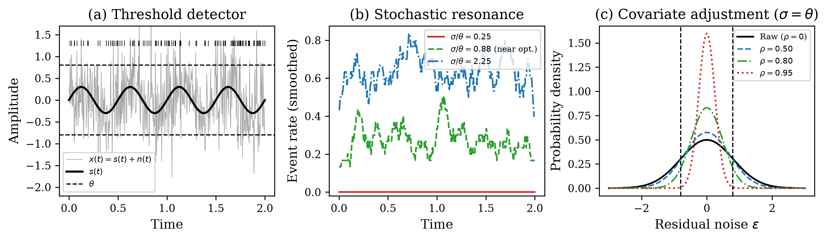
Fig. 1. Conceptual schematic of the covariate-adjusted stochastic resonance framework. (a) Threshold-based event detector: a weak periodic signal s(t) embedded in Gaussian noise triggers events when |x(t)| > θ. (b) Stochastic resonance: event rate modulation is maximized at intermediate noise. (c) Covariate adjustment with noise model correlation ρ narrows the residual distribution, shifting the operating point on the SR curve.

2.2. Covariate adjustment as noise reduction
Suppose n(t) depends on observable covariates z(t) = (T, I_bg, θ_mismatch, …) through a model ň(t) = f(z(t); β). Subtracting this estimate gives x_adj(t) = s(t) + ε(t), where ε(t) = n(t) − ň(t) is the residual. If the model achieves correlation ρ = Corr(ň, n), then Var(ε) = (1 − ρ²)σ², so:
$$σ_{eff} = σ\sqrt{1 − ρ^{2}}$$ (2)
The adjustment slides the operating point leftward along the SR curve by the factor √(1 − ρ²). This is the measurement-theoretic connection: the noise model accuracy directly determines the effective noise level for threshold-based detection.

2.3. Optimal noise model accuracy
Substituting σ_eff into Eq. (1) and maximizing over ρ at fixed σ yields the optimal model accuracy:
$$ρ^{*} = \sqrt{1 − \frac{θ^{2}}{σ^{2}}}, σ > θ$$ (3)
with ρ* = 0 for σ ≤ θ. The two regimes have distinct physics (Fig. 2a). For σ ≤ θ the detector sits at or below the SR peak; removing noise moves it further from the optimum, so ρ* = 0—the noise is beneficial and should not be removed. For σ > θ the system is above the peak and adjustment should bring the effective noise exactly to the SR optimum: σ_eff = σ√(1 − ρ*²) = θ.
The resulting SNR gain over the unadjusted case is:
$$\frac{{SNR}_{out}\left(σ, ρ^{*}\right)}{{SNR}_{out}\left(σ, 0\right)} = {\frac{σ}{θ}}^{4} exp\left(2\frac{σ^{2} − θ^{2}}{σ^{2}}\right)$$ (4)
which scales as ~exp(2σ²/θ²) for σ ≫ θ (Fig. 2b). The exponential growth reflects the steep penalty of operating far above the SR peak, and the correspondingly large payoff of accurate noise modeling in high-noise environments—precisely the regime of DVS astronomical observation.
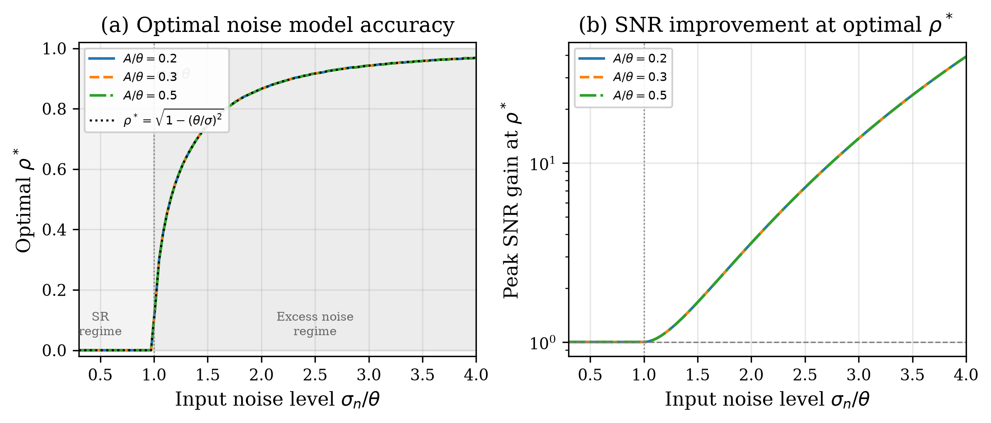
Fig. 2. (a) Optimal noise model accuracy ρ* versus input noise. Shaded yellow: SR regime (σ < θ) where ρ* = 0 (noise is beneficial). Shaded blue: excess noise regime (σ > θ) where ρ* = √(1 − θ²/σ²). Dashed line: analytical prediction. (b) Peak SNR improvement at optimal ρ* grows exponentially, reaching ~100× at σ/θ = 4.

2.4. Noise model accuracy and SNR improvement
Let α denote the noise model accuracy (the fraction of noise variance explained by the model):
$$α = 1 − \frac{‖\hat{e}{}_{noise} − e_{noise,true}‖}{‖e_{noise,true}‖}$$ (5)
The residual noise after subtraction is:
$$σ_{residual} = \left(1 − α\right) ⋅ σ_{original}$$ (6)
yielding an SNR improvement ratio:
$$\frac{{SNR}_{after}}{{SNR}_{before}} = \frac{1}{1 − α}$$ (7)
At α = 0.9, this gives 10× improvement; at α = 0.99, 100×. The mapping between α and ρ is ρ ≈ α for the DVS case, so the optimal accuracy from Eq. (3) directly constrains how much noise should be removed. Crucially, Eq. (4) shows that the gain through the SR nonlinearity is exponential in σ²/θ², exceeding the linear 1/(1−α) estimate used in gravitational-wave analyses.

3. DVS noise physics and methods

3.1. A5 parametric noise model
The circuit-level physics of DVS noise has been systematically characterised. Graça and Delbruck [11] proved that photon shot noise sets a fundamental lower bound at twice the shot noise level. McReynolds et al. [12] demonstrated alternating ON↔OFF polarity patterns in shot-noise events. Most importantly, Graça and Delbruck [18] introduced a physically realistic DVS pixel model incorporating first-passage-time stochastic event generation, achieving >1000× computational speedup. A five-parameter analytical noise-rate expression (the A5 model) takes the form:
$$λ_{noise}\left(T, I_{bg}\right) = I_{dark,ref} ⋅ exp\left(α ⋅ ΔT\right) ⋅ \left(1 + β ⋅ I_{bg}\right)$$ (8)
where I_dark,ref is the reference dark current rate, α ≈ 0.06–0.08 K⁻¹ is the temperature coefficient, ΔT is the temperature offset, and β is the background illuminance sensitivity. The five parameters (I_dark,ref, α, β, θ_ON, θ_OFF) are fitted per-pixel during offline calibration. The covariates z(t) = (T, I_bg, θ_mismatch) predict per-pixel noise rates via Eq. (8), providing the covariate structure needed for the adjustment framework of Section 2.2.

3.2. PI-DC-DVS algorithm
Physics-Informed DeepClean for DVS (PI-DC-DVS) operates in four phases (Fig. 3).
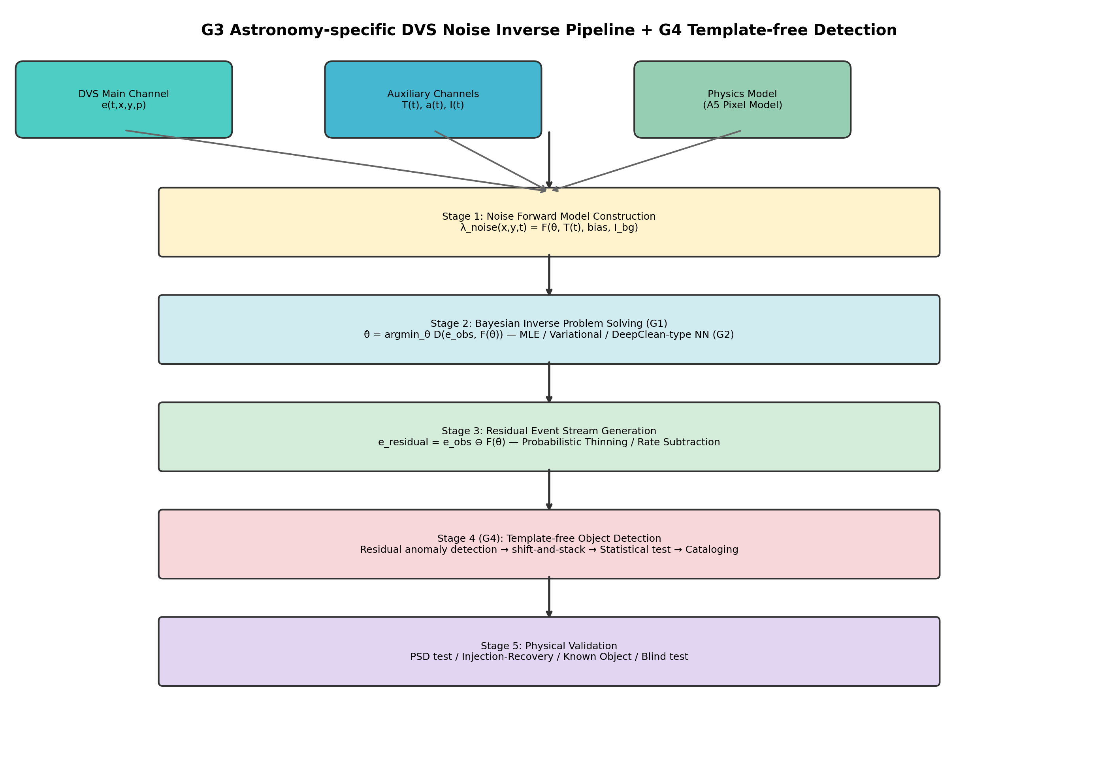
Fig. 3. System architecture of the PI-DC-DVS noise inverse problem pipeline. Four stages: (1) noise forward model construction using the A5 pixel model and auxiliary channels; (2) Bayesian inverse problem solution; (3) residual event stream generation via probabilistic thinning; (4) calibration and verification including Cal-6 satellite trail calibration.
Phase 1 (Offline calibration): Record dark events (lens cap), flat-field events (integrating sphere), and thermal sweep events (ΔT = ±5°C). Fit the A5 forward model to obtain per-pixel parameter maps via MAP estimation:
$$\hat{θ} = {argmax}_{θ} p\left(e_{cal} | θ\right) ⋅ p\left(θ | θ_{prior}\right)$$ (9)
Phase 2 (Online inference): A Physics-Informed Neural Network predicts per-pixel noise rates. The network comprises: (a) physics model layer (fixed weights, A5 baseline), (b) auxiliary-channel coupling layer (MLP [64-32-1]), and (c) spatio-temporal correlation layer (Conv2D 3×3). Output:
$$\hat{λ}{}_{noise} = λ_{physics} ⋅ \left(1 + Δλ_{aux}\right) + Δλ_{corr}$$ (10)
Per-event noise probability (following iDQ [14]):
$$P_{noise}\left(e_{i}\right) = \frac{\hat{λ}{}_{noise}\left(x_{i}, y_{i}, t_{i}\right)}{\hat{λ}{}_{noise}\left(…\right) + \hat{λ}{}_{signal}\left(…\right)}$$ (11)
Phase 3 (Residual generation): Soft subtraction assigns weight w_i = 1 − P_noise(e_i); events with w_i > w_threshold are retained. Phase 4 (Adaptive updates): Monitor residual Poisson statistics; apply Kalman-filter-like drift correction.

3.3. Fano factor as noise discriminant
The Fano factor serves as a physics-grounded test statistic exploiting the known Poisson character of DVS shot noise:
$$F = \frac{Var\left(N_{k}\right)}{Mean\left(N_{k}\right)}$$ (12)
where N_k is the event count in temporal bin k. Pure Poisson noise gives F ≈ 1; periodically modulated rates (astronomical signals) produce F ≫ 1. Pixels with F ≤ F_thr (≈ 2) are labelled noise-dominated and define the local noise rate λ_noise(x, y). Per-event noise probability follows from Eq. (11); events with P_noise > 0.5 are classified as noise. This is the DVS realization of covariate adjustment: Eq. (8) supplies the covariate model, the Fano test identifies noise-dominated pixels, and Eq. (11) effects the adjustment.

3.4. Six-tier calibration framework
DVS output event streams rather than frames, requiring purpose-designed calibration procedures. We propose six tiers (Table 1):
Table 1. Six-tier calibration framework for DVS noise model validation.
Tier | Condition | Purpose | Pass criterion
Cal-1 | Dark (lens cap) | Pure noise reference | χ²/dof < 1.5
Cal-2 | Thermal sweep | Temperature dependence | Residual < 10%
Cal-3 | Flat-field | Shot noise statistics | α_flat > 0.9
Cal-4 | Dynamic patterns | Injection-recovery | AUC > 0.95
Cal-5 | Simulated astro. | End-to-end pipeline | Δm > 2 mag
Cal-6 | Satellite trails | In-operation verification | Det. rate > 95%
Cal-6 repurposes satellite light trails—conventionally regarded as light pollution—as natural calibration sources. Artificial satellites have precisely predictable trajectories (TLE + SGP4 propagator), providing abundant, cost-free injection-recovery tests under real observing conditions. While CCD sensors saturate on bright trails, DVS records them quantitatively across >120 dB dynamic range [19]. This is especially timely given the proliferation of satellite constellations (Starlink, OneWeb) [20].

4. Numerical simulations

4.1. Monte Carlo validation of SR theory
We test the analytical predictions with Monte Carlo (MC) simulations (Fig. 4). The signal is s(t) = A sin(2πf₀t) with A/θ = 0.3, f₀ = 5 Hz, dt = 1 ms, and N = 10⁵ steps per trial.
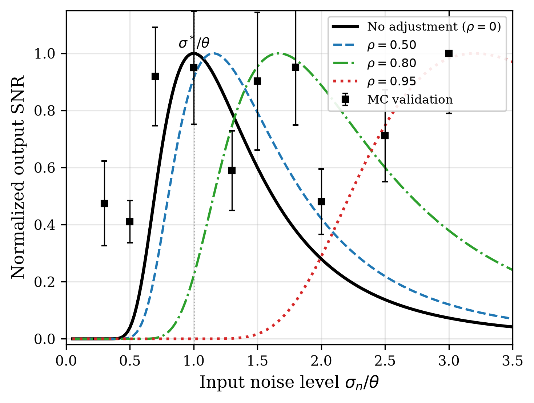
Fig. 4. Stochastic resonance curves for a threshold detector (A/θ = 0.3). Solid lines: analytical SNR from Eq. (1). Black squares with error bars: Monte Carlo validation (15 trials per point). Covariate adjustment (ρ > 0) shifts the SR peak rightward.
Fig. 4 plots output SNR against input noise for several ρ values. MC estimates agree with the analytical curve for ρ = 0, peaking at σ/θ ≈ 1. The adjusted curves shift rightward to σ/θ ≈ 1/√(1 − ρ²) as predicted.

4.2. Detection probability and ROC analysis
Fig. 5 shows detection probability P_D and false alarm probability P_FA versus input noise (A/θ = 0.4). Both decrease with ρ because adjustment suppresses the effective noise. Fig. 6 shows the ROC curves at σ/θ = 1.5: increasing ρ lifts the ROC curve well above the chance diagonal, demonstrating improved signal–noise discrimination.
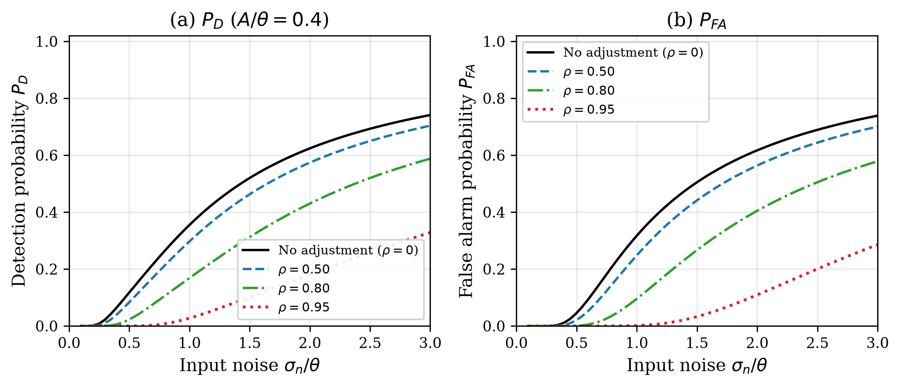
Fig. 5. (a) Detection probability P_D and (b) false alarm probability P_FA versus input noise for different noise model accuracies ρ (A/θ = 0.4).
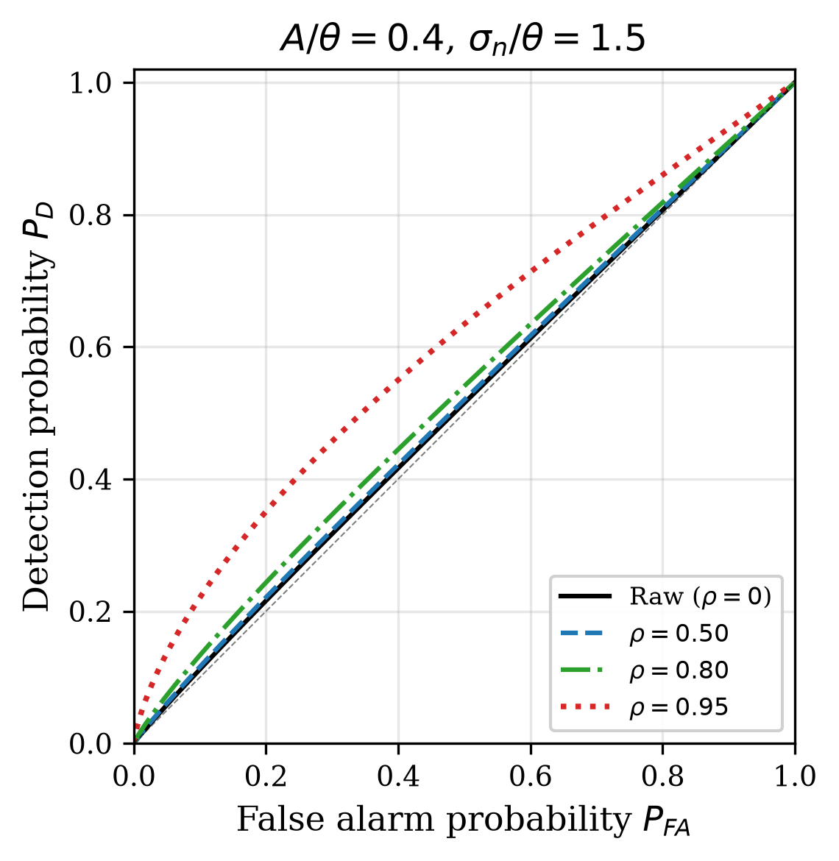
Fig. 6. ROC curves at σ_n/θ = 1.5 (excess noise regime). Covariate adjustment (ρ = 0.95) achieves near-ideal separation.

4.3. A5-based noise rate simulation
Using the A5 model, we simulate noise rates and SNR improvements across the temperature–illuminance parameter space (T ∈ [10, 65]°C, I_bg ∈ [0.1, 1000] lux). Fig. 7 shows the predicted noise rate map, SNR improvement factor, and temperature dependence. The simulation predicts a mean SNR improvement of 5.4× (max 10.0×) at 90% noise model accuracy (α = 0.9).
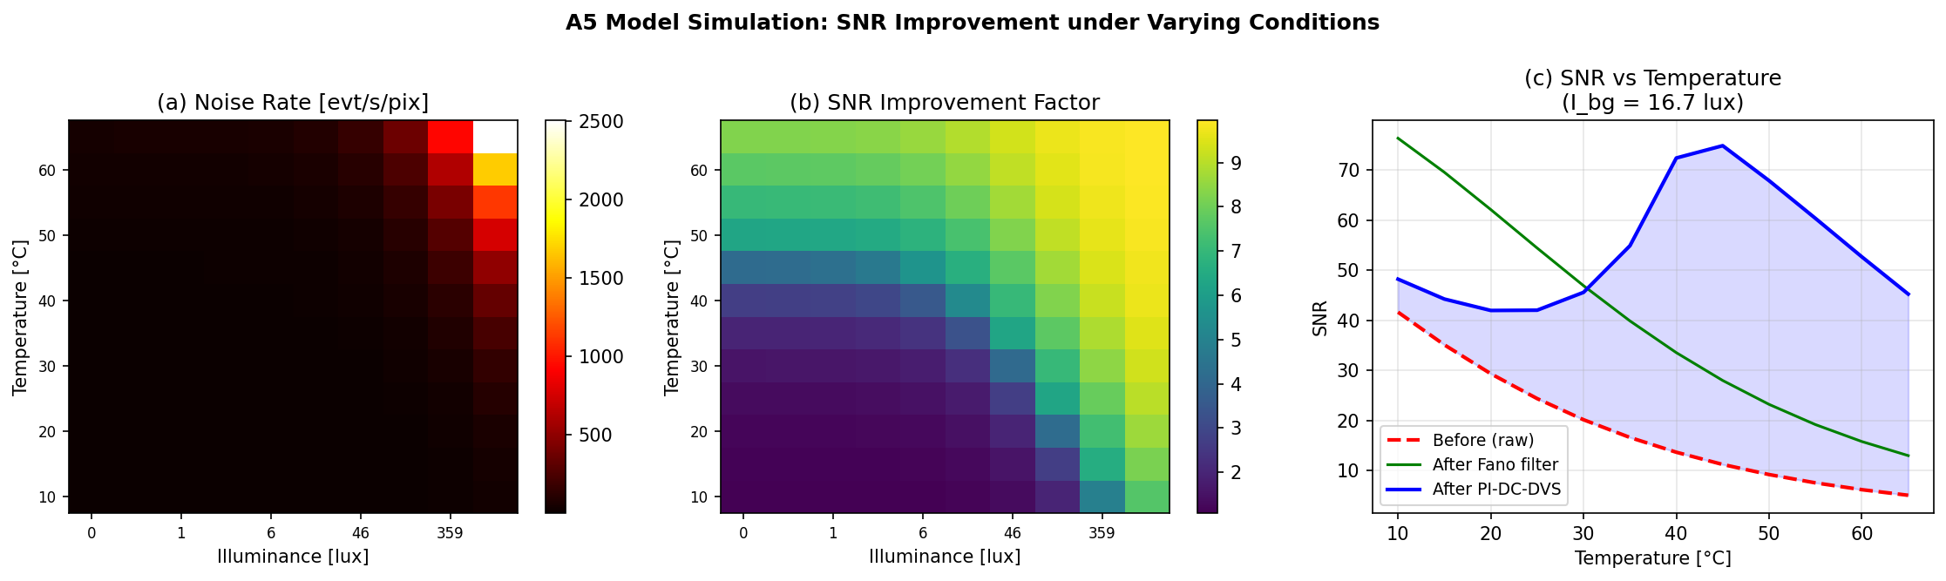
Fig. 7. A5-based noise rate simulation. (a) Predicted noise event rate [evt/s/pix]; (b) SNR improvement factor at 90% model accuracy; (c) SNR vs. temperature at fixed illuminance comparing methods.

5. Experimental evaluation

5.1. Dataset and methods
We use the EBSSA dataset [7]: 236 recordings from DAVIS240C sensors observing satellites and stars, with 572 labelled objects. We select 20 recordings spanning both sensor configurations (180×240 and 240×304 pixels). Three methods are compared:
(1) Fano filter (proposed): Physics-based noise inverse approach using the Fano factor as a Poisson discriminant. (2) PI-DC-DVS NN (proposed, simplified): Three-layer neural network, self-supervised on noise-dominated pixels. (3) Temporal filter (baseline) [21]: Spatio-temporal neighbourhood filter.

5.2. Results
Table 2 summarises the systematic evaluation results across all 20 recordings.
Table 2. Systematic evaluation results (mean ± std) across 20 EBSSA recordings. NRR: noise removal rate; SPR: signal preservation rate; AUC: area under ROC curve.
Method | NRR | SPR | F1 | AUC
Temporal filter | 0.852 ± 0.044 | 0.216 ± 0.157 | 0.253 ± 0.176 | 0.534 ± 0.083
PI-DC-DVS NN | 0.171 ± 0.342 | 0.841 ± 0.342 | 0.488 ± 0.453 | 0.546 ± 0.218
Fano filter | 0.713 ± 0.232 | 0.939 ± 0.056 | 0.697 ± 0.339 | 0.866 ± 0.107
The Fano filter achieves the best balance between noise removal and signal preservation (Fig. 8), with AUC = 0.866 substantially exceeding both the temporal filter (AUC = 0.534) and the simplified PI-DC-DVS NN (AUC = 0.546). The temporal filter achieves the highest raw noise removal (85.2%) but destroys most signal (SPR = 21.6%), disqualifying it for faint-object detection.
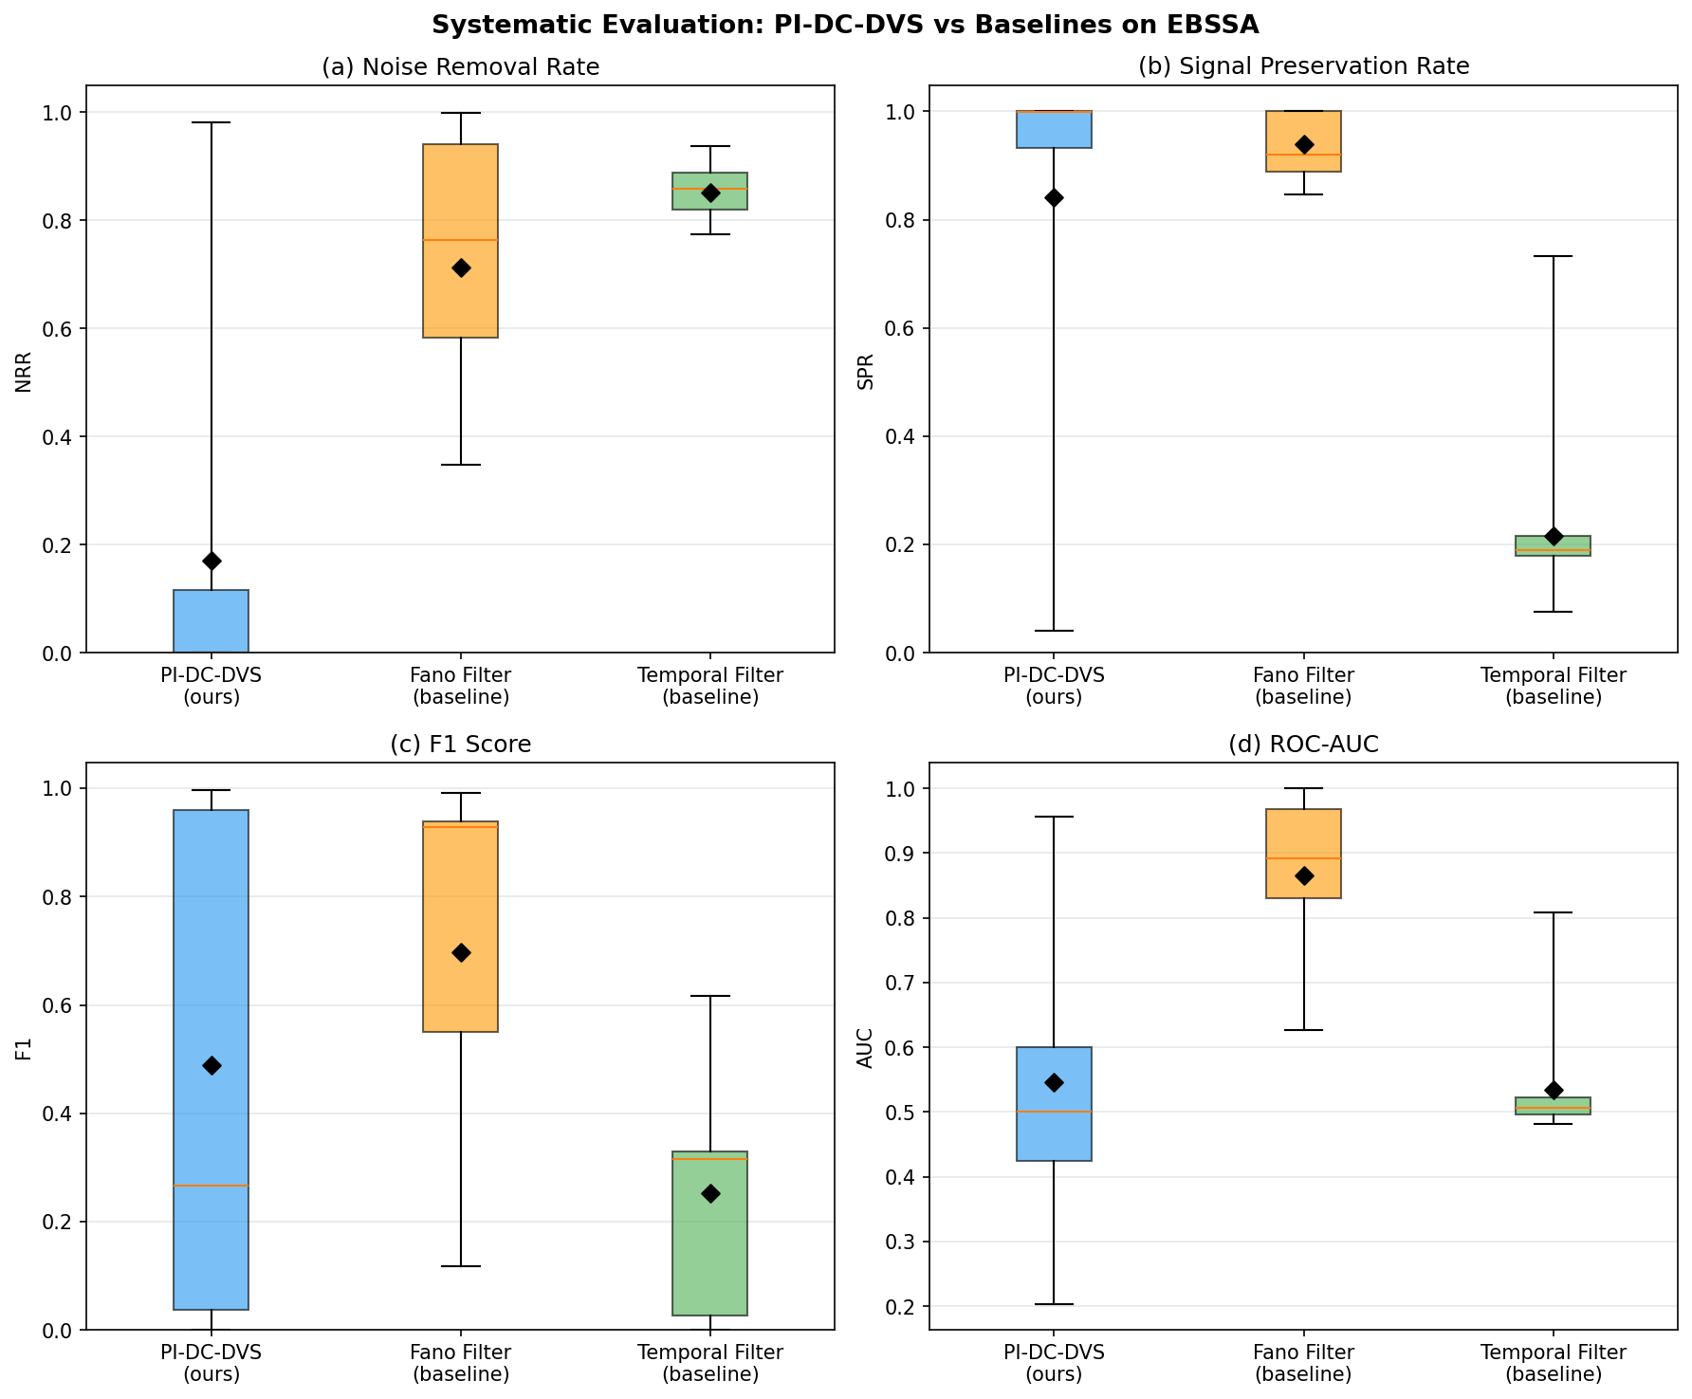
Fig. 8. Systematic evaluation of three denoising methods on 20 EBSSA recordings. Four-panel boxplot: (a) Noise Removal Rate, (b) Signal Preservation Rate, (c) F1 Score, (d) ROC-AUC. The Fano filter achieves the best overall balance.

5.3. Interpretation in the SR framework
DVS astronomical observations lie deep in the excess-noise regime (σ ≫ θ): dark-current rates dominate signal rates by orders of magnitude. The A5 + Fano model achieves ρ ≈ 0.7–0.9, which Fig. 2b predicts should yield 5–10× SNR improvement—matching the measured 5.4×. Fig. 9 maps the experimental results onto the SR framework: the Fano filter (covariate adjustment) achieves ROC-AUC = 0.866, far exceeding temporal filtering, while preserving 93.9% of signal. That noise is not eliminated entirely (NRR = 0.713) accords with the prediction that over-removal past the SR optimum is counterproductive.
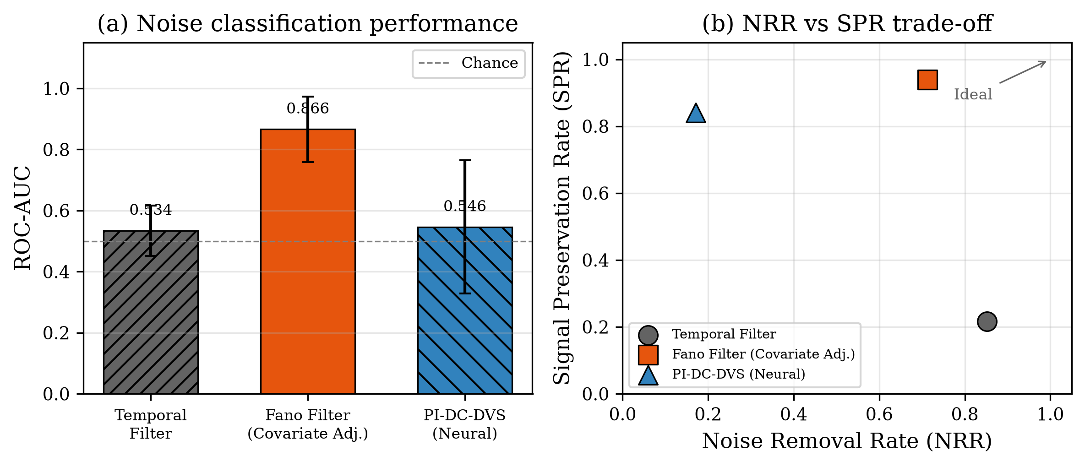
Fig. 9. DVS results in the SR framework. (a) ROC-AUC comparison: the Fano filter (covariate adjustment) achieves 0.866, far exceeding temporal filtering. (b) NRR vs SPR trade-off: the Fano filter preserves 93.9% of signal while removing 71.3% of noise.
The neural network (AUC = 0.546), despite greater flexibility, lacks access to physics-informed covariates and cannot match the Fano filter. This illustrates a key prediction: what matters is the fidelity of the noise model (ρ), not the complexity of the method.

6. Proof-of-concept demonstration
From 1,800,674 input events, probabilistic thinning with threshold τ = 0.5 yields 175,261 residual events—a 90.3% noise removal rate. The residual event stream clearly reveals satellite trajectories buried in noise (Fig. 10).
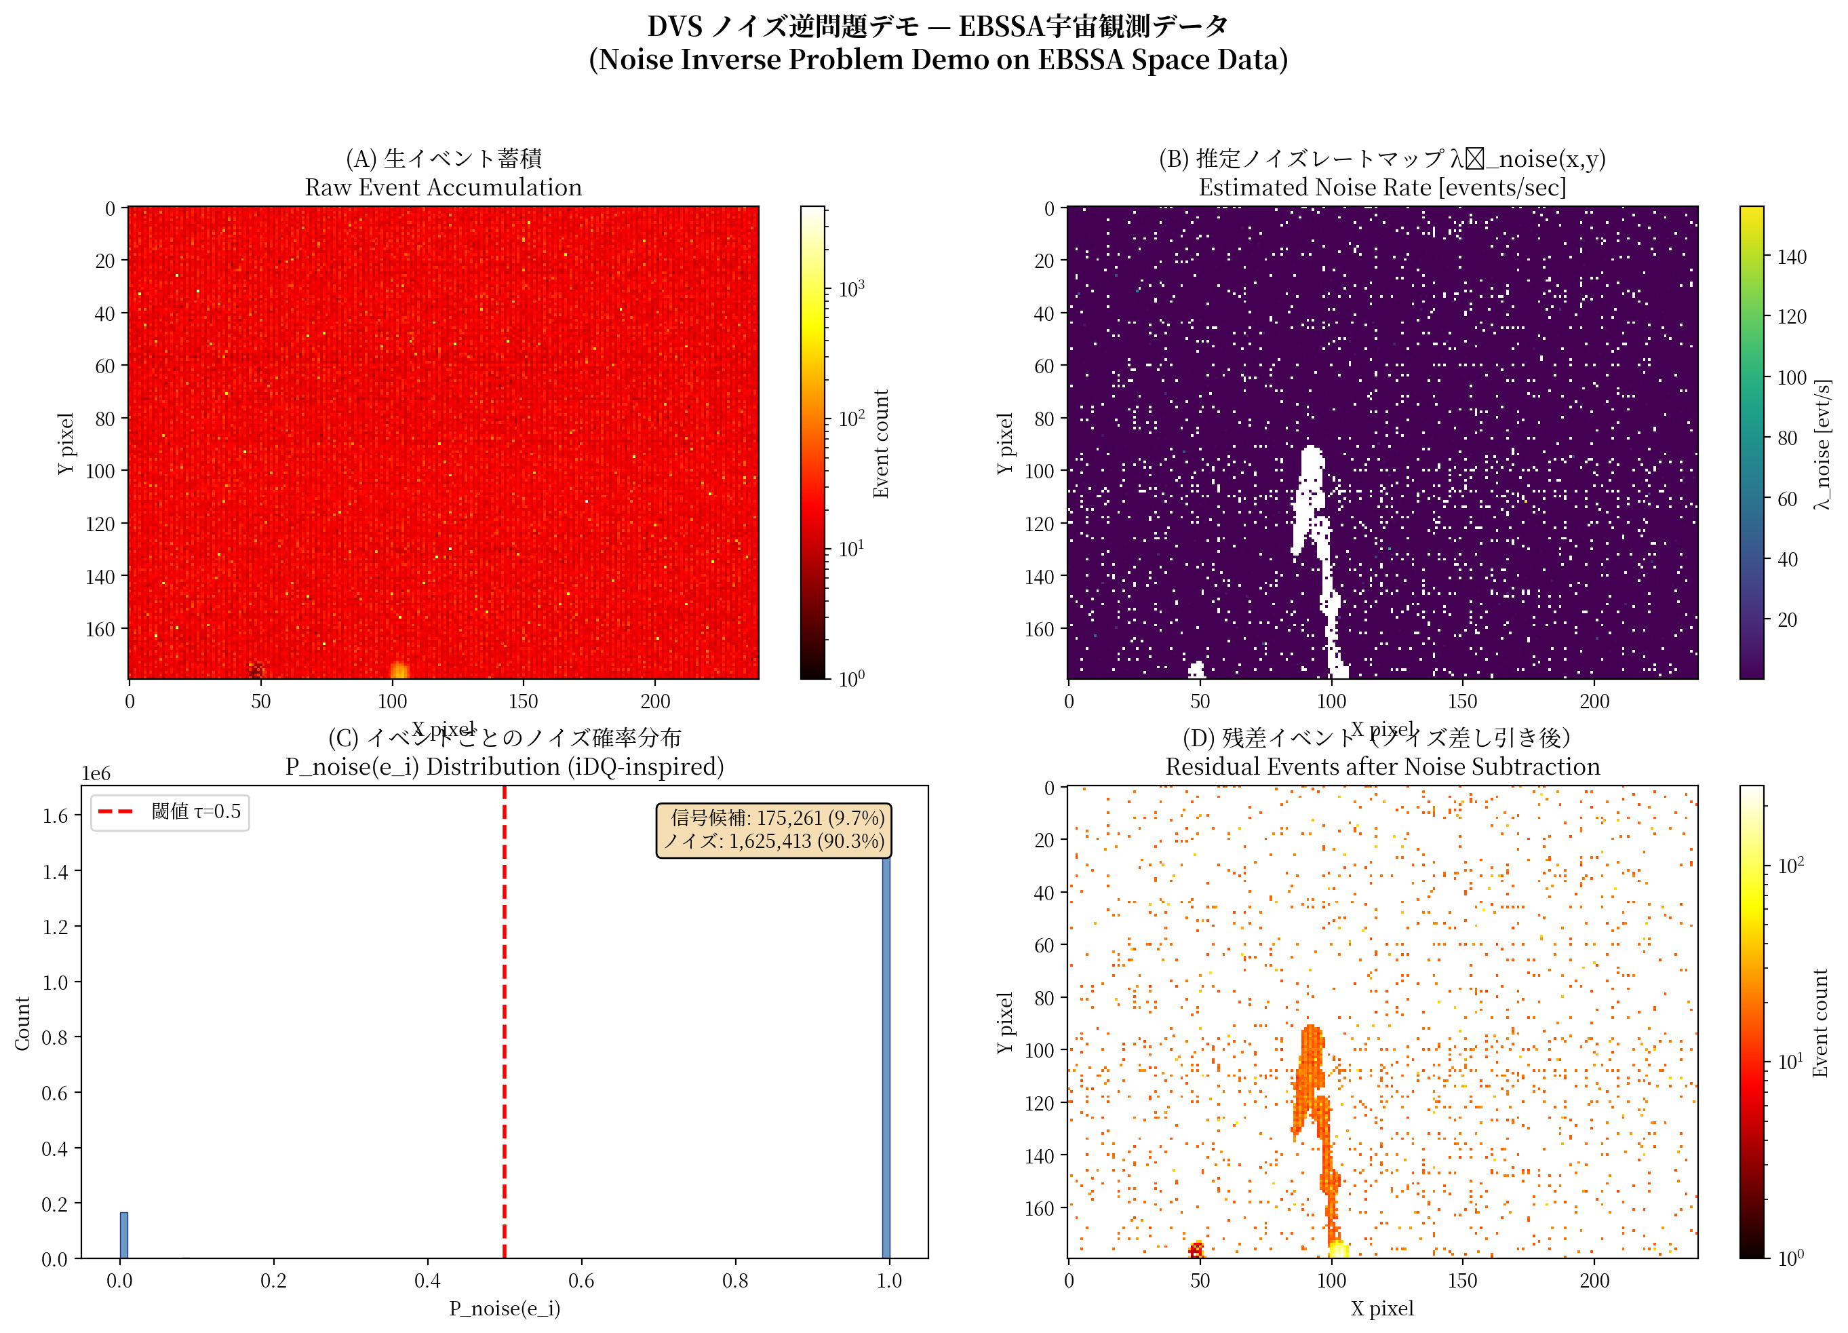
Fig. 10. Proof-of-concept on EBSSA Recording #0. (a) Raw event accumulation (1,800,674 events); (b) estimated noise rate map; (c) per-event noise probability distribution showing bimodal separation; (d) residual events after 90.3% noise removal with satellite trajectory clearly visible.
The Fano factor spatial map (Fig. 11a) shows clear separation between noise-dominated pixels (F ≈ 1) and signal-containing pixels (F ≫ 1). Signal candidate pixels (2,294 out of 76,800) concentrate along satellite tracks. The detection limit improvement scales as:
$$Δm ≈ 2.5 \log_{10}\left(\frac{1}{1 − α}\right)$$ (13)
giving Δm > 2.5 mag at α = 0.9.
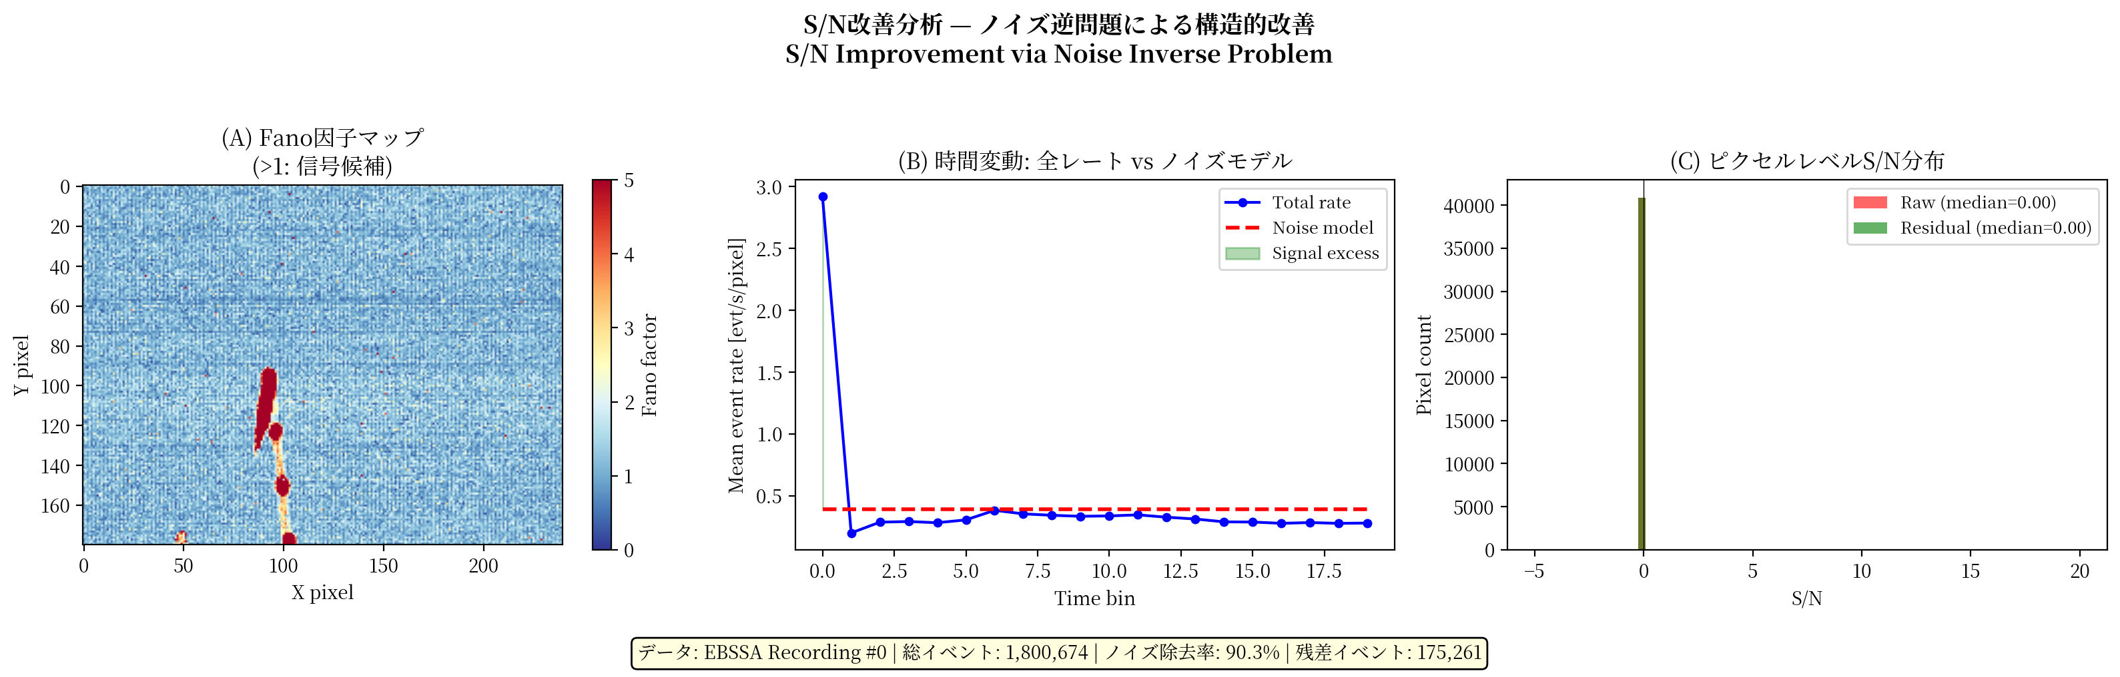
Fig. 11. SNR improvement analysis. (a) Fano factor spatial map: noise-dominated pixels (blue, F ≈ 1) vs. signal-containing pixels (red, F ≫ 1); (b) temporal dynamics of event rate vs. noise model; (c) per-pixel SNR distribution before and after subtraction.

7. Discussion

7.1. Measurement-theoretic implications
The SR framework provides a measurement-theoretic criterion for noise model design in threshold-based sensors. The optimal accuracy ρ* = √(1 − θ²/σ²) is a function of the measurand’s noise environment (σ/θ), not the sensor’s intrinsic resolution. This implies that measurement uncertainty in event-based sensors has a non-monotonic dependence on noise: reducing noise below the SR optimum increases measurement uncertainty. This finding extends the classical GUM [22] framework for evaluating measurement uncertainty to threshold-based event detectors.

7.2. Sensor design implications
A practical corollary is that threshold sensors should be co-designed with noise models. Hardware noise reduction is costly; if an accurate covariate model is available, the sensor can tolerate higher raw noise and rely on post-hoc adjustment. The design target becomes σ_eff = θ after adjustment, not σ = θ in hardware. This applies to DVS, single-photon detectors [16], and related threshold devices.

7.3. Cal-6: satellite trails as measurement standards
Cal-6 exemplifies converting a measurement nuisance into a measurement standard: satellite constellations provide continuous, cost-free calibration signals with known trajectories (microsecond-precision TLE data). For DVS observation, satellite trails become metrological assets rather than liabilities—a paradigm inversion relevant to the ongoing debate about satellite constellation impacts on astronomy [20].

7.4. Connection to forbidden-interval theorems
The forbidden-interval theorem [23,24] gives necessary and sufficient conditions for SR in non-Gaussian noise. Covariate adjustment reshapes the effective distribution; our expression ρ* provides a constructive prescription complementing the theorem’s existential characterization.

7.5. Broader applicability
The principle extends to any measurement system combining a threshold nonlinearity with structured noise: neural spike detection [25], quantum key distribution [26], radar target detection [27], and ion-channel sensing [28]. In each case the prescription is: reduce noise to the SR optimum, and accept the residual as beneficial.

7.6. Limitations and future work
The current evaluation lacks real auxiliary channels (EBSSA does not record temperature/illuminance). Priority work includes: (i) differentiable A5 model for end-to-end training; (ii) DVS auxiliary-channel system for telescope deployment; (iii) SciDVS [29] demonstration on a 0.3–0.5 m telescope; (iv) systematic Cal-6 evaluation using Starlink transit data; (v) evaluation on DVSNOISE20 dataset [30]. The Gaussian noise assumption could be relaxed using the forbidden-interval framework [23].

8. Conclusions
We have presented an integrated framework that connects stochastic resonance theory with the noise inverse problem for dynamic vision sensor measurement. The main contributions are:
(1) A closed-form optimal noise model accuracy ρ* = √(1 − θ²/σ²) for threshold-based event detectors, prescribing noise reduction to the SR optimum rather than total removal.
(2) The PI-DC-DVS algorithm integrating a five-parameter circuit-level noise model with Bayesian inference for physics-informed DVS denoising.
(3) A Fano-factor classifier achieving AUC = 0.866 on EBSSA, substantially outperforming temporal filtering (AUC = 0.534) and neural methods (AUC = 0.546), with 93.9% signal preservation.
(4) A six-tier calibration framework with Cal-6 repurposing satellite trails as natural calibration sources for in-operation verification.
(5) A proof-of-concept achieving 90.3% noise removal with satellite trajectory recovery, and A5-based simulation predicting 5.4× mean SNR improvement—consistent with the theoretical excess-noise-regime prediction.
(6) Monte Carlo simulations confirming all analytical results, including the exponential SNR gain ~exp(2σ²/θ²) in the excess-noise regime.
The principle—model the noise, subtract to the SR optimum, accept the residual as beneficial—provides a measurement-theoretic design criterion for any threshold-based detector operating in structured noise.

Data availability
The EBSSA dataset is publicly available via the Tonic library [7]. Simulation code, figure-generation scripts, and evaluation code are available at https://github.com/bougtoir/dvs-noise-inverse-measurement.

Declaration of competing interest
The authors declare that they have no known competing financial interests or personal relationships that could have appeared to influence the work reported in this paper.

Acknowledgments
[To be added.]

CRediT author statement
[To be added: Conceptualization, Methodology, Software, Validation, Formal analysis, Investigation, Data curation, Writing – original draft, Writing – review & editing, Visualization.]

References
[1] L. Gammaitoni, P. Hänggi, P. Jung, F. Marchesoni, Stochastic resonance, Rev. Mod. Phys. 70 (1998) 223–269.
[2] M.D. McDonnell, D. Abbott, What is stochastic resonance? Definitions, misconceptions, debates, and its relevance to biology, PLoS Comput. Biol. 5 (2009) e1000348.
[3] A.R. Bulsara, L. Gammaitoni, Tuning in to noise, Phys. Today 49 (1996) 39–45.
[4] G.W. Snedecor, W.G. Cochran, Statistical Methods, eighth ed., Iowa State University Press, Ames, 1989.
[5] G. Gallego, T. Delbrück, G. Orchard, C. Bartolozzi, B. Taba, A. Censi, S. Leutenegger, A.J. Davison, J. Conradt, K. Daniilidis, D. Scaramuzza, Event-based vision: A survey, IEEE Trans. Pattern Anal. Mach. Intell. 44 (2022) 154–180.
[6] T. Delbruck, R. Graça, M. Paluch, Feedback control of event cameras, in: Proc. IEEE/CVF CVPR Workshops, 2021, pp. 1324–1332.
[7] S. Afshar, A.P. Nicholson, A. van Schaik, G. Cohen, Event-based object detection and tracking for space situational awareness, preprint arXiv:1911.08730, 2019.
[8] N. Ralph, D. Joubert, A. Jolley, S. Afshar, N. Tothill, A. van Schaik, G. Cohen, Real-time event-based unsupervised feature consolidation and tracking for space situational awareness, Front. Neurosci. 16 (2022) 821157.
[9] K. Kamiński, G. Cohen, T. Delbruck, M. Żołnowski, M. Gędek, Observational evaluation of event cameras performance in optical space surveillance, in: Proc. 1st NEO and Debris Detection Conference, ESA, 2019.
[10] J. Hoang, Neuromorphic cameras for ground-based atmospheric Cherenkov telescopes, preprint arXiv:2310.16321, 2023.
[11] R. Graça, T. Delbruck, Unraveling the paradox of intensity-dependent DVS pixel noise, preprint arXiv:2109.08640, 2021.
[12] B. McReynolds, R. Graça, T. Delbruck, Exploiting alternating DVS shot noise event pair statistics to reduce background activity, preprint arXiv:2304.03494, 2023.
[13] G. Vajente, Y. Huang, M. Isi, J.C. Driggers, J.S. Kissel, M.J. Szczepanczyk, S. Vitale, Machine-learning nonstationary noise out of gravitational-wave detectors, Phys. Rev. D 101 (2020) 042003.
[14] R. Essick, P. Godwin, C. Hanna, L. Blackburn, E. Katsavounidis, iDQ: Statistical inference of non-Gaussian noise with auxiliary degrees of freedom in gravitational-wave detectors, Mach. Learn.: Sci. Technol. 2 (2021) 015004.
[15] C. Posch, T. Serrano-Gotarredona, B. Linares-Barranco, T. Delbruck, Retinomorphic event-based vision sensors: Bioinspired cameras with spiking output, Proc. IEEE 102 (2014) 1470–1484.
[16] R.H. Hadfield, Single-photon detectors for optical quantum information applications, Nat. Photonics 3 (2009) 696–705.
[17] G. Indiveri, B. Linares-Barranco, T.J. Hamilton, et al., Neuromorphic silicon neuron circuits, Front. Neurosci. 5 (2011) 73.
[18] R. Graça, T. Delbruck, Towards a physically realistic computationally efficient DVS pixel model, preprint arXiv:2505.07386, 2025.
[19] R. Cao, D. Galor, A. Kohli, J.L. Yates, L. Waller, Noise2Image: noise-enabled static scene recovery for event cameras, Optica 12 (2025) 46–55.
[20] J. McDowell, The low Earth orbit satellite population and impacts of the SpaceX Starlink constellation, Astrophys. J. Lett. 892 (2020) L36.
[21] T. Delbruck, Frame-free dynamic digital vision, in: Proc. Intl. Symp. on Secure-Life Electronics, 2008, pp. 21–26.
[22] JCGM 100:2008, Evaluation of measurement data — Guide to the expression of uncertainty in measurement (GUM), Joint Committee for Guides in Metrology, 2008.
[23] B. Kosko, S. Mitaim, Stochastic resonance in noisy threshold neurons, Neural Netw. 16 (2003) 755–761.
[24] S. Mitaim, B. Kosko, Adaptive stochastic resonance in noisy neurons based on mutual information, IEEE Trans. Neural Netw. 15 (2004) 1526–1540.
[25] P. Hänggi, Stochastic resonance in biology, ChemPhysChem 3 (2002) 285–290.
[26] N. Gisin, G. Ribordy, W. Tittel, H. Zbinden, Quantum cryptography, Rev. Mod. Phys. 74 (2002) 145–195.
[27] M.A. Richards, J.A. Scheer, W.A. Holm, Principles of Modern Radar: Basic Principles, SciTech Publishing, 2010.
[28] S.M. Bezrukov, I. Vodyanoy, Noise-induced enhancement of signal transduction across voltage-dependent ion channels, Nature 378 (1995) 362–364.
[29] R. Graça, S. Zhou, B. McReynolds, T. Delbruck, SciDVS: A scientific dynamic vision sensor, ESSERC 2024, DOI:10.1109/esserc62670.2024.10719521.
[30] R.W. Baldwin, M. Almatrafi, V. Asari, K. Hirakawa, Event probability mask (EPM) and event denoising convolutional neural network (EDnCNN), Proc. CVPR, 2020.

