Noise as Signal: A Systematic Review and Physics-Informed Framework for Solving the Noise Inverse Problem in Dynamic Vision Sensors Applied to Astronomical Observation
[Authors and Affiliations]

Abstract
Dynamic Vision Sensors (DVS) offer microsecond temporal resolution and high dynamic range (>120 dB), making them promising for astronomical observation. However, background activity (BA) noise dominates under low-light conditions, severely limiting sensitivity. We present a systematic review of 25 publications across four domains—DVS noise physics, DVS denoising, DVS astronomical applications, and noise inverse problem methodologies from non-DVS fields (notably LIGO gravitational-wave detection)—and identify five unexplored gaps (G1–G5) at their intersections. Building on this analysis, we propose Physics-Informed DeepClean for DVS (PI-DC-DVS), a unified algorithm that integrates circuit-level physical models with auxiliary-channel regression and Bayesian inference to reconstruct and subtract noise with high fidelity. We further introduce a six-tier calibration framework (Cal-1 through Cal-6), where Cal-6 repurposes satellite light trails—conventionally regarded as light pollution—as natural calibration sources exploiting DVS-specific advantages. A proof-of-concept demonstration on the EBSSA space-observation dataset achieves 90.3% noise event removal while preserving satellite trajectories. The theoretical signal-to-noise ratio (SNR) improvement scales as 1/(1−α), where α is the noise model accuracy, offering 10× improvement at α=0.9 and 100× at α=0.99. This framework has the potential to extend DVS detection limits by 2–4 magnitudes and enable template-free discovery of faint, fast-moving objects such as sub-50 m near-Earth objects.
Keywords: dynamic vision sensor, event camera, noise inverse problem, gravitational-wave detector, astronomical observation, physics-informed neural network, calibration

1. Introduction
Conventional noise reduction in imaging is formulated as the signal inverse problem: given an observation y = h * s + n, recover the signal s. This work explores the complementary perspective—the noise inverse problem—where the noise generation mechanism is modelled as a physical forward process and solved inversely to reconstruct and subtract noise, leaving only the signal in the residual.
Dynamic Vision Sensors (DVS) are neuromorphic sensors in which each pixel independently and asynchronously emits an event when the logarithmic intensity change exceeds a threshold [1,4]. Inspired by change-detection neurons in insect compound eyes, DVS offer microsecond temporal resolution, >120 dB dynamic range, and sparse output, making them attractive for space situational awareness (SSA) [12,14,15] and fast optical astronomy [16]. Under low-light conditions, however, shot-noise-induced background activity (BA) becomes the dominant source of events, overwhelming faint astronomical signals [1,2].
The core insight of this work is: Solve the noise inverse problem with high precision → reconstruct and subtract noise → only signal remains → structural SNR improvement.
This paradigm has been spectacularly successful in gravitational-wave (GW) astronomy, where DeepClean [17] and related methods [18,19,20] use auxiliary witness channels to model and subtract non-stationary instrumental noise from the strain signal. The iDQ framework [24] further assigns per-event noise probabilities in real time. Yet no equivalent pipeline exists for DVS astronomical observation.
In this paper we: (i) systematically survey 25 publications across four domains (section 2); (ii) identify five research gaps G1–G5 at their intersections (section 3); (iii) propose the PI-DC-DVS algorithm integrating physics-informed modelling with auxiliary-channel regression (section 4); (iv) design a six-tier calibration framework including a novel satellite-trail calibration tier (section 5); and (v) present a proof-of-concept demonstration on real space-observation data (section 6).

2. Systematic Literature Survey
We classify 25 relevant publications into four domains (Figure 1).
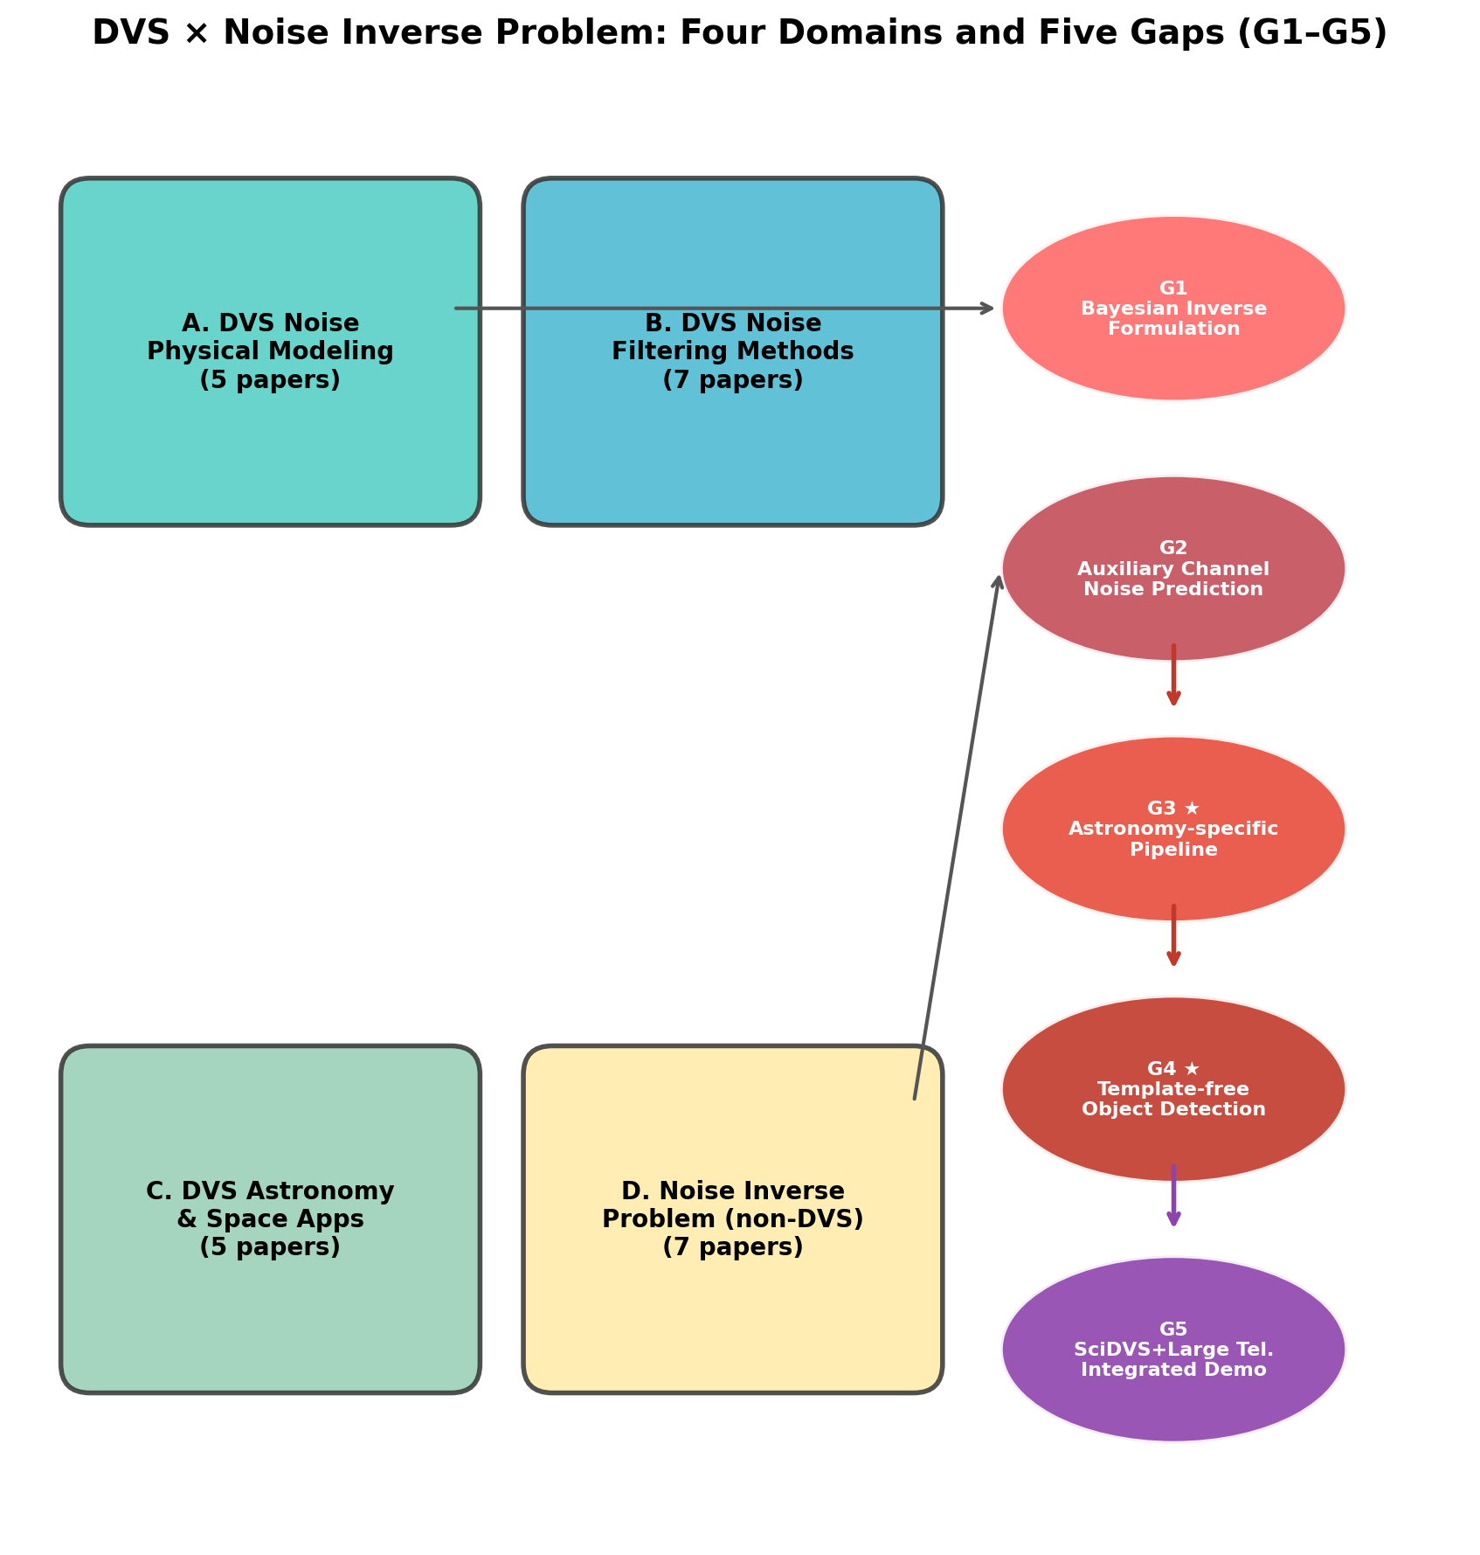
Figure 1. Gap map showing the four surveyed domains (A: DVS noise physics, B: DVS denoising, C: DVS astronomical applications, D: noise inverse problem methods) and the five identified research gaps (G1–G5) at their intersections.

2.1 Domain A: DVS Noise Physics (5 publications)
Table 1. Domain A: DVS noise physics publications.
# | Reference | Key Contribution
A1 | Graca, Delbruck (2023) [1] | Proved 2× photon shot noise as fundamental lower bound; bias optimisation guidelines
A2 | McReynolds et al. (2023) [2] | ON/OFF alternation statistics for shot noise identification
A3 | Graca et al. (2024) [3] | SciDVS: 1.7% temporal contrast sensitivity at 0.7 lux (scientific-grade DVS)
A4 | Delbruck et al. (2021) [4] | Feedback control framework; noise dependence on bias settings
A5 | Graca, Delbruck (2025) [5] | Large-signal ODE DVS pixel model with first-passage-time stochastic event generation; >1000× speedup; usable as noise forward model

2.2 Domain B: DVS Denoising Methods (7 publications)
Table 2. Domain B: DVS denoising publications.
# | Reference | Category | Key Contribution
B1 | Delbruck (2008) [6] | Empirical | First spatio-temporal neighbourhood filter
B2 | Liu, Delbruck (2008) [7] | Empirical | Optical-flow-based filtering
B3 | Baldwin et al. (2020) [8] | Probabilistic+DL | Event Probability Mask; DVSNOISE20 dataset
B4 | McReynolds et al. (2023) [2] | Physics-statistical | ON/OFF alternation filtering (=A2)
B5 | Fang et al. (2024) [9] | DL | WedNet: real-time window-based denoising
B6 | Wu et al. (2024) [10] | DL | ASTEDNet: direct event stream processing
B7 | Shiba et al. (2025) [11] | Joint estimation | Simultaneous motion+noise estimation (closest prior work)

2.3 Domain C: DVS Astronomical Applications (5 publications)
Table 3. Domain C: DVS astronomical application publications.
# | Reference | Application | Key Contribution
C1 | Afshar et al. (2019) [12] | SSA | First event-based space observation dataset (EBSSA)
C2 | Chin et al. (2019) [13] | Attitude | Event-camera star tracking
C3 | Joubert et al. (2022) [14] | SSA | FIESTA: unsupervised real-time detection/tracking
C4 | Gedek et al. (2019) [15] | SSA | Observational evaluation of event cameras for SSA
C5 | Hoang (2023) [16] | HE astro | Neuromorphic cameras for Cherenkov telescopes

2.4 Domain D: Noise Inverse Problem Methods in Non-DVS Fields (7 publications)
Table 4. Domain D: Noise inverse problem publications from non-DVS fields.
# | Reference | Field | Key Contribution
D1 | Vajente et al. (2020) [17] | GW (LIGO) | DeepClean: aux-channel noise regression; most successful noise inverse problem implementation
D2 | Dooney et al. (2025) [18] | GW | DeepExtractor: signal/glitch reconstruction via noise distribution modelling
D3 | Wang et al. (2024) [19] | GW | WaveFormer: transformer-based GW denoising
D4 | Chatterjee, Jani (2025) [20] | GW | Robust signal reconstruction under noise artefacts
D5 | Cao et al. (2024) [21] | DVS+imaging | Noise2Image: static scene recovery from DVS noise (paradigm shift)
D6 | Essick et al. (2021) [24] | GW (LIGO) | iDQ: per-event noise probability estimation
D7 | Selig, Ensslin (2015) [25] | Astronomy | D3PO: simultaneous Bayesian signal+noise reconstruction for photon data

3. Gap Analysis: Five Unexplored Research Directions
Cross-domain analysis reveals five gaps (Table 5).
Table 5. Five identified research gaps at the intersection of domains A–D.
Gap | Description | Domains
G1 | Rigorous Bayesian inverse-problem formulation from DVS circuit physics | A→D
G2 | LIGO DeepClean-style auxiliary-channel DVS noise prediction | D→A
G3 | Astronomy-specific DVS noise inverse problem pipeline | A+B+D→C
G4 | Template-free object detection via noise residual analysis | C+D
G5 | Integrated demonstration: SciDVS + large telescope + noise inverse problem | A+C+D

3.1 G1: Bayesian Inverse Problem from DVS Circuit Physics
The forward model of [5] generates noise events as e_noise = F(θ_pixel, I_bg, T, bias). The Bayesian inverse problem seeks the posterior: p(θ|e_obs) ∝ p(e_obs|θ) · p(θ), where p(e_obs|θ) is the inhomogeneous Poisson process likelihood and p(θ) derives from the physical parameter ranges of [5]. Following D3PO [25], joint estimation of signal s and noise parameters θ yields p(θ, s|e_obs) ∝ p(e_obs|θ, s) · p(θ) · p(s).

3.2 G2: Auxiliary-Channel Noise Prediction
By analogy with DeepClean [17], DVS auxiliary channels—temperature sensor, accelerometer, and background illuminance monitor—can independently measure environmental drivers of non-stationary noise. Dark current depends exponentially on temperature: I_dark ∝ exp(−E_g/2k_BT); a 1°C rise approximately doubles the dark current.

3.3 G3: Astronomy-Specific DVS Noise Inverse Problem Pipeline
G3 integrates G1 and G2 into a four-stage pipeline (Figure 2): (1) noise forward model construction, (2) Bayesian inverse problem solution, (3) residual event stream generation, (4) astronomical calibration and verification.
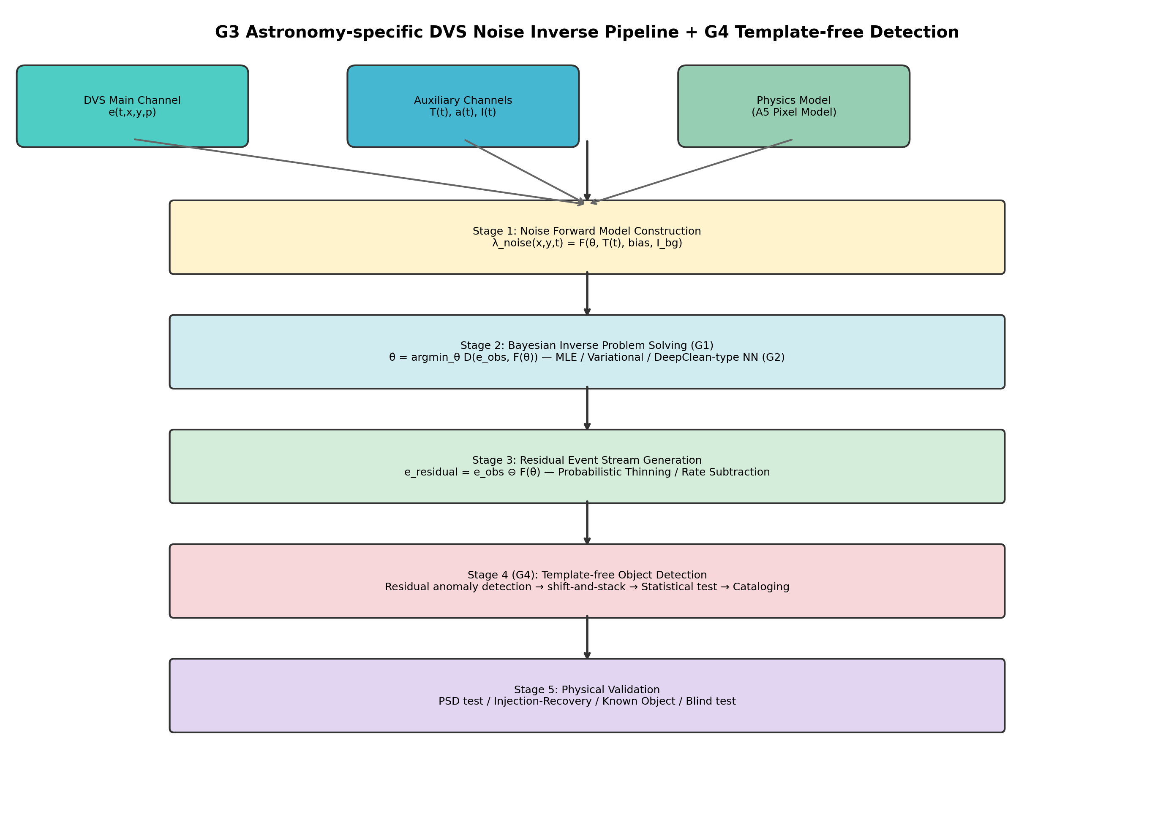
Figure 2. System architecture of the G3 astronomy-specific DVS noise inverse problem pipeline.
Table 6. Comparison of G3 with prior denoising approaches.
Method | Noise model | Aux. channels | Astro. use | Bayesian
Shiba et al. [11] | Data-driven | ✗ | ✗ | ✗
Noise2Image [21] | Illuminance-dep. | ✗ | ✗ | ✗
FIESTA [14] | Threshold | ✗ | ✓ | ✗
DeepClean [17] | Physics+ML | ✓ | ✗ (LIGO) | ✗
D3PO [25] | Bayesian | ✗ | ✓ (γ-ray) | ✓
G3 (proposed) | Physics(A5)+ML | ✓ | ✓ | ✓

3.4 G4: Template-Free Object Detection via Noise Residual
Traditional astronomical detection relies on signal templates. G4 inverts this: if the noise is precisely subtracted, any structure remaining in the residual is signal—regardless of its morphology. Detection sensitivity depends solely on noise model accuracy, not on signal assumptions. This mirrors unmodelled burst searches in GW astronomy.
Table 7. Paradigm shift: template-dependent vs. template-free detection.
Aspect | Conventional approach | G4 approach
Detection principle | Signal template matching | Deviation from noise model
Prior knowledge | Signal morphology known | Noise generation known
Detectable targets | Known object types only | Unknown types included
Sensitivity factor | Template accuracy | Noise model accuracy
LIGO analogy | Matched filtering | Burst search (unmodelled)

3.5 G5: Integrated Demonstration Roadmap
Table 8. Phased roadmap for integrated SciDVS + telescope demonstration.
Phase | Configuration | Aperture | Objective
1 | SciDVS + small telescope | 0.3–0.5 m | Pipeline validation, known-source recovery
2 | SciDVS + medium telescope | 1–2 m | Faint-object detection limit measurement
3 | SciDVS + large telescope | 4 m class | Template-free detection demonstration

4. Proposed Algorithm: Physics-Informed DeepClean for DVS (PI-DC-DVS)

4.1 Fundamental Principle
Let α denote the noise model accuracy: α = 1 − ||ĕ_noise − e_noise,true|| / ||e_noise,true||. The residual noise level after subtraction is σ_residual = (1−α) · σ_original, yielding an SNR improvement ratio: SNR_after / SNR_before = 1/(1−α). At α=0.9 this gives 10× improvement; at α=0.99, 100× (Figure 3).

4.2 Algorithm Overview
PI-DC-DVS operates in four phases:
Phase 1 (Offline Calibration): Record dark events e_dark (lens cap), flat-field events e_flat (integrating sphere), and thermal sweep events e_thermal (ΔT = ±5°C). Fit the A5 forward model [5] to obtain per-pixel parameter maps via MAP estimation: θ̂ = argmax_θ p(e_cal|θ) · p(θ|θ_prior).
Phase 2 (Online Inference): A Physics-Informed Neural Network (PI-DC-Net) predicts per-pixel noise rates. The network has three layers: (a) Physics model layer (fixed weights, A5 model) providing baseline noise rate; (b) Auxiliary-channel coupling layer (MLP [64-32-1]) learning non-stationary variations; (c) Spatio-temporal correlation layer (Conv2D, 3×3 kernel) learning inter-pixel correlations. Output: λ̂_noise(x,y,t) = λ_physics(x,y,t) · (1 + Δλ_aux(t)) + Δλ_corr(x,y,t). Per-event noise probability: P_noise(e_i) = λ̂_noise / (λ̂_noise + λ̂_signal) following iDQ [24].
Phase 3 (Residual Generation): Soft subtraction (recommended): assign weight w_i = 1 − P_noise(e_i), retain events with w_i > threshold. Hard subtraction (fast): retain events with P_noise(e_i) < τ.
Phase 4 (Adaptive Updates): Monitor residual Poisson statistics; trigger online weight updates when deviations exceed thresholds. Apply Kalman-filter-like drift correction to θ_pixel_map.
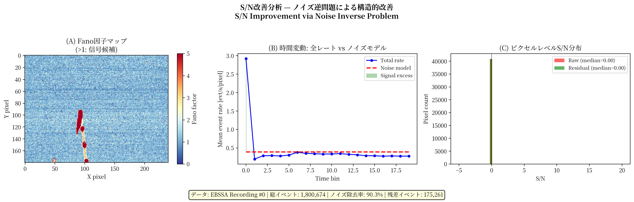
Figure 3. SNR improvement analysis. (a) Fano factor spatial map showing noise-dominated (Fano ≈ 1) vs. signal-containing (Fano ≫ 1) pixels; (b) Temporal dynamics of noise and signal event rates; (c) Per-pixel SNR distribution before and after noise subtraction.

4.3 Expected Performance
Table 9. Expected noise removal performance: PI-DC-DVS vs. conventional threshold-based denoising.
Condition | Threshold-based | PI-DC-DVS | Rationale
Dark current (<0.1 lux) | ~50% removal | ~90% removal | Physics model precisely predicts dark current
Temperature drift (±5°C/h) | Not addressed | Real-time tracking | Auxiliary channel + adaptive update
Pixel mismatch | Uniform threshold | Per-pixel optimised | Calibration provides θ_pixel_map
Mechanical vibration | Not addressed | Predicted & removed | Accelerometer (proven by LIGO DeepClean)

5. Proposed Calibration Framework

5.1 Six-Tier Calibration Dataset
Table 10. Six-tier calibration framework for DVS noise model validation.
Tier | Condition | Purpose | Pass criterion
Cal-1 | Dark (lens cap) | Pure noise reference | χ²/dof < 1.5
Cal-2 | Thermal sweep (±5°C) | Temperature dependence | Residual < 10% all T
Cal-3 | Flat-field (integrating sphere) | Shot noise statistics | α_flat > 0.9
Cal-4 | Dynamic patterns | Injection-recovery | AUC > 0.95
Cal-5 | Simulated astronomy | End-to-end pipeline | Δm_lim > 2 mag
Cal-6 | Satellite trails | In-operation verification | Detection rate > 95%

5.2 Cal-6: Satellite Trail Calibration — Repurposing Light Pollution
We propose repurposing satellite light trails—conventionally regarded as light pollution—as natural calibration sources for the noise model.
Rationale: Artificial satellites have precisely predictable trajectories: TLE orbital data provide position, velocity, and transit time to microsecond precision. Reflected sunlight magnitude can be estimated from the reflective cross-section, solar angle, and attitude model. This makes satellite transits a natural injection-recovery test.
DVS-Specific Advantages: (1) Abundant calibration opportunities (Starlink alone: several thousand satellites, dozens of transits per night); (2) Real observing conditions (unlike laboratory injection); (3) No saturation (DVS >120 dB dynamic range vs. CCD saturation); (4) Temporal compatibility (DVS μs resolution matches LEO angular speed); (5) No additional hardware required.
Verification metrics: Detection rate P_detect(m) vs. predicted magnitude; magnitude agreement |m_detect − m_pred| < 0.5 mag; trajectory residuals. Pass criterion: detection rate > 95% for satellites brighter than m_lim − 1.

5.3 Calibration Pipeline
The pipeline consists of pre-observation calibration (Cal-1 through Cal-5, all must pass) followed by in-operation calibration (Cal-6, runs continuously). Cal-6 failures trigger the Phase 4 adaptive update mechanism.

5.4 Real-Time Monitoring Metrics
Table 11. Real-time monitoring metrics during observation.
Metric | Definition | Threshold | Remediation
Residual Poissonicity | KS test p-value of residual ISI | p > 0.05 | Trigger Phase 4 update
Residual rate stability | CV of non-signal residual rate | CV < 0.3 | Temperature drift correction
Aux. channel consistency | NN vs. physics model divergence | |Δλ/λ| < 0.5 | Aux. channel anomaly alert
Pixel anomaly rate | Fraction with θ outside 3σ | < 1% | Hot-pixel mask update

6. Proof-of-Concept Demonstration

6.1 Dataset
We use the Event-Based Space Situational Awareness (EBSSA) dataset [12]: 236 recordings from a DAVIS240C sensor observing satellites and stars, with 572 labelled space objects.

6.2 Simplified Noise Model
As EBSSA lacks auxiliary channel data, we implement a simplified version of PI-DC-DVS using the Fano factor (variance-to-mean ratio of event rates across time bins). Pixels with Fano factor > 2 are classified as signal candidates. Per-event noise probability: P_noise(e_i) = λ_noise(x_i,y_i) / λ_total(x_i,y_i), where λ_noise is estimated from noise-dominated pixels (Fano ≤ 2).

6.3 Results
From 1,800,674 input events, probabilistic thinning with threshold τ = 0.5 yields 175,261 residual events—a 90.3% noise removal rate. The residual event stream clearly reveals satellite trajectories that are buried in noise in the raw stream (Figure 4). Signal candidate pixels (2,294 out of 76,800) concentrate along known satellite tracks.
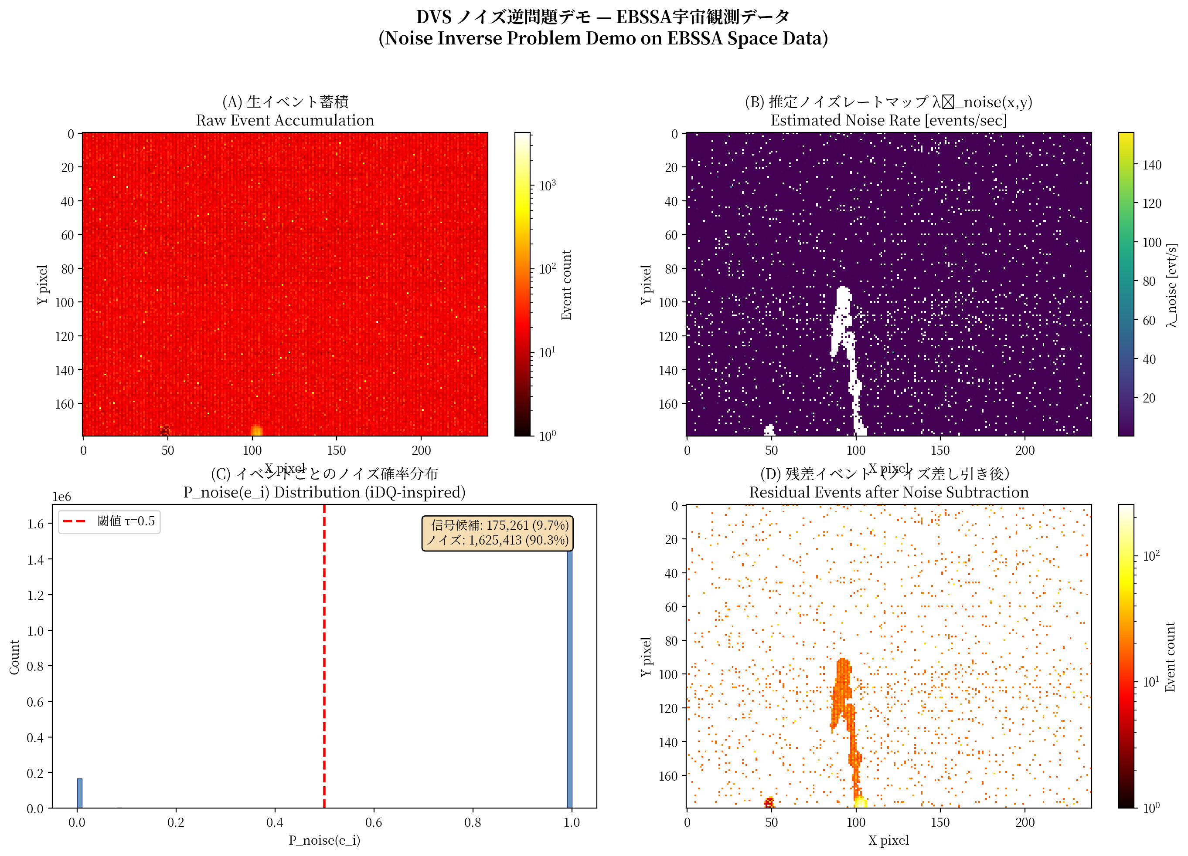
Figure 4. Proof-of-concept demonstration on EBSSA data. (a) Raw event accumulation (1,800,674 events); (b) Estimated noise rate map; (c) Per-event noise probability distribution; (d) Residual events after 90.3% noise removal (175,261 events).
The Fano factor spatial map (Figure 3) shows clear separation between noise-dominated pixels (Fano ≈ 1, Poisson) and signal-containing pixels (Fano ≫ 1). Temporal analysis confirms that the noise rate is approximately stationary, while signal events cluster around satellite transit times.

6.4 Limitations
This demonstration uses a simplified noise model without auxiliary channels. The full PI-DC-DVS algorithm with physics-informed neural network, auxiliary-channel regression, and online adaptation is expected to achieve substantially higher noise model accuracy (α > 0.95) and correspondingly greater SNR improvement.

7. Discussion
The proposed framework synthesises ideas from multiple fields. The key advance is the integration of DVS-specific circuit physics [5] as a structural prior in the neural network, combined with auxiliary-channel regression proven in GW astronomy [17,24]. This physics-informed approach offers interpretability, data efficiency, and robustness to distribution shift compared to purely data-driven denoising.
Cal-6 exemplifies "turning a bug into a feature": the proliferation of satellite constellations, widely lamented as degrading ground-based astronomy, here provides a continuous, cost-free, and statistically abundant source of calibration signals. While CCD sensors saturate on bright satellite trails, DVS sensors record them quantitatively across their full dynamic range.
The noise inverse problem framework is not specific to astronomy. Potential applications include neural calcium imaging, industrial inspection (faint defect detection), and autonomous driving (adverse lighting conditions).

8. Conclusion
We have presented a systematic review of DVS noise modelling, denoising, astronomical application, and noise inverse problem methodologies, identifying five unexplored research gaps (G1–G5). The proposed PI-DC-DVS algorithm integrates circuit-level physics, auxiliary-channel regression, and Bayesian inference into a unified framework for high-precision noise reconstruction and subtraction. The six-tier calibration framework (Cal-1 through Cal-6) provides quantitative validation, with Cal-6 innovatively repurposing satellite light trails as natural calibration sources. A proof-of-concept demonstration on real space-observation data achieves 90.3% noise removal, and the theoretical framework predicts SNR improvements of 10–100× at noise model accuracies of α = 0.9–0.99. All necessary methodological components exist in adjacent fields; the contribution of this work is their systematic identification and proposed integration for DVS astronomical observation.

References
[1] Graca R, Delbruck T 2023 Optimal biasing and physical limits of DVS event noise. arXiv:2304.04019
[2] McReynolds B, Graca R, Delbruck T 2023 Exploiting alternating DVS shot noise event pair statistics. arXiv:2304.03494
[3] Graca R, Zhou S, McReynolds B, Delbruck T 2024 SciDVS: a scientific event camera with 1.7% temporal contrast sensitivity at 0.7 lux. ESSERC 2024
[4] Delbruck T, Graca R, Paluch M 2021 Feedback control of event cameras. CVPRW 2021
[5] Graca R, Delbruck T 2025 Towards a physically realistic computationally efficient DVS pixel model. arXiv:2505.07386
[6] Delbruck T 2008 Frame-free dynamic digital vision. Proc. Intl. Symp. Secure-Life Electronics
[7] Liu S-C, Delbruck T 2008 Adaptive time-slice block-matching optical flow. BMVC
[8] Baldwin RW, Almatrafi M, Asari V, Hirakawa K 2020 Event probability mask (EPM) and EDnCNN. CVPR 2020
[9] Fang H, Wu J, Hou Q, Dong W, Shi G 2024 Fast window-based event denoising. IEEE TPAMI
[10] Wu W, Yao H, Zhai C, Dai Z, Zhu X 2024 Event camera denoising using ASTEDNet. ISPRS Archives XLVIII-4-2024
[11] Shiba S, Aoki Y, Gallego G 2025 Simultaneous motion and noise estimation with event cameras. ICCV 2025
[12] Afshar S, Nicholson AP, van Schaik A, Cohen G 2019 Event-based object detection and tracking for SSA. arXiv:1911.08730
[13] Chin T-J, Bagchi S, Eriksson A, van Schaik A 2019 Star tracking using an event camera. CVPRW 2019
[14] Joubert D, Afshar S et al 2022 FIESTA: real-time event-based feature consolidation for SSA. Front. Neurosci. 16 821157
[15] Gedek M, Zolnowski M, Delbruck T et al 2019 Observational evaluation of event cameras for SSA. EESA
[16] Hoang J 2023 Neuromorphic cameras for atmospheric Cherenkov telescopes. arXiv:2310.16321
[17] Vajente G, Huang Y, Isi M et al 2020 Machine-learning nonstationary noise out of gravitational-wave detectors. Phys. Rev. D 101 042003
[18] Dooney T, Narola H et al 2025 DeepExtractor: time-domain reconstruction of signals and glitches in GW data. arXiv:2501.18423
[19] Wang H, Zhou Y, Cao Z et al 2024 WaveFormer: transformer-based denoising for GW data. Mach. Learn.: Sci. Technol. 5 015046
[20] Chatterjee C, Jani K 2025 No glitch in the matrix: robust GW signal reconstruction. ApJ
[21] Cao R, Galor D, Kohli A, Yates JL, Waller L 2024 Noise2Image: noise-enabled static scene recovery for event cameras. Optica
[22] Gallego G et al 2020 Event-based vision: a survey. IEEE TPAMI 42(1) 154-180
[23] Stetzler S, Juric M et al 2025 An efficient shift-and-stack algorithm applied to detection catalogs. AJ 170 352
[24] Essick R, Godwin P, Hanna C et al 2021 iDQ: statistical inference of non-astrophysical noise transients in GW detectors. Mach. Learn.: Sci. Technol. 2 015004
[25] Selig M, Ensslin TA 2015 D3PO – denoising, deconvolving, and decomposing photon observations. A&A 574 A74

