Unilateral flood control through subsurface storage management: a hydro-political analysis of planned-release hydropower and inter-watershed groundwater transfer
Tatsuki Onishi
(Position, Affiliation, City, Country)
(Corresponding author e-mail)

ABSTRACT
This paper proposes a novel flood control framework that integrates planned-release hydropower generation with inter-watershed groundwater management, enabling downstream nations or sub-national jurisdictions to implement flood mitigation measures unilaterally, without requiring upstream cooperation. A simplified feasibility analysis of the Oda River–Takahashi River basin in western Japan, where catastrophic backwater flooding killed 51 people in 2018, demonstrates that such a system can be energy self-sufficient (consuming only 9% of generated power for groundwater pumping) and can create subsurface storage equivalent to 78% of observed flood volumes. The paper situates this technical proposal within the hydro-hegemony literature, arguing that subsurface storage management represents a technologically grounded pathway for downstream actors to reduce flood vulnerability independently of upstream water governance arrangements. Applications to transboundary river basins (Mekong, Nile, Ganges-Brahmaputra-Meghna, Indus, Tigris-Euphrates), deltaic regions, and arid environments are discussed. The framework offers a new dimension to debates on water security, climate adaptation, and the politics of flood infrastructure.
Keywords: flood control; groundwater management; hydro-hegemony; transboundary rivers; managed aquifer recharge; water policy
INTRODUCTION
The governance of flood risk in transboundary river basins remains one of the most intractable challenges in contemporary water management. Unlike drought, which develops gradually and allows time for negotiation, floods arrive suddenly and their consequences are shaped by decisions about dam operations, land use, and drainage infrastructure, often made far upstream and beyond the control of affected populations. The 2018 Western Japan Heavy Rainfall, which killed over 200 people across western Japan, demonstrated that even a technologically advanced nation with extensive flood infrastructure remains vulnerable to compound flood mechanisms, particularly the backwater effect at river confluences.¹
Flood management in transboundary river basins is inherently political. Decisions about dam operations, levee construction, and floodplain zoning made by upstream riparian states directly affect downstream flood risk, often without meaningful consultation or compensation.² The concept of hydro-hegemony, whereby the most powerful riparian state controls water resources to the disadvantage of weaker neighbours, has become a central analytical framework in critical water studies.^{2,3} Yet the literature on hydro-hegemony has focused predominantly on water quantity and allocation disputes, with comparatively less attention to flood risk as a dimension of water power asymmetry.
This paper addresses that gap by proposing a flood control framework that can be implemented unilaterally by a downstream riparian state, without requiring upstream cooperation or modification of shared water infrastructure. The framework integrates two established technologies — hydropower generation from controlled flood discharge and managed aquifer recharge (MAR) — into a single system that uses the energy from planned dam releases to pump groundwater from adjacent watersheds, thereby creating subsurface storage capacity to absorb incoming floodwaters. Because the entire system operates within the implementing state’s territory and draws on subsurface rather than surface water resources, it circumvents the governance challenges that typically constrain transboundary flood management.
The concept is not entirely without precedent. California’s Flood-MAR (Flood-Managed Aquifer Recharge) programme deliberately directs floodwaters onto agricultural lands to recharge depleted aquifers.⁴ Japan’s Metropolitan Area Outer Underground Discharge Channel (MAOUDC) transfers floodwater between river basins through a 6.3 km underground tunnel.⁵ Pumped-storage hydropower — in which water is pumped between upper and lower reservoirs to store and release energy — is a mature technology with over 27,000 MW of installed capacity in Japan alone.⁶ What is novel about the framework proposed here is the integration of these existing technological components into a single system designed specifically for flood control, and the recognition that such a system can operate entirely within the territory of a single state.
The argument proceeds as follows. First, this paper reviews the literature on hydro-hegemony, transboundary flood governance, and managed aquifer recharge. Second, it presents the proposed framework and a simplified feasibility analysis for the Oda River–Takahashi River basin in western Japan, the site of catastrophic backwater flooding during the 2018 Western Japan Heavy Rainfall. Third, it examines the applicability of the framework to the Tokyo metropolitan area (Arakawa–Edogawa basin), where 8.21 million people reside in projected inundation zones. Finally, it discusses implications for transboundary river governance, deltaic flood protection, and arid-region water management.
A note on terminology: this paper uses ‘unilateral’ to describe actions that can be taken by a single state without requiring the cooperation or consent of neighbouring states. This is distinct from ‘unilateralism’ in the pejorative sense sometimes used in international relations. The framework proposed here does not advocate for the abandonment of cooperative water governance; rather, it offers a technical option that can be pursued in parallel with, and potentially in support of, cooperative approaches.
HYDRO-HEGEMONY AND THE POLITICS OF FLOOD INFRASTRUCTURE
Hydro-hegemony and downstream vulnerability
The hydro-hegemony framework, as articulated by Zeitoun & Warner,² describes how powerful riparian states exploit their geographic, economic, or military advantages to control shared water resources. While the original formulation emphasised water allocation and dam construction, subsequent scholarship has extended the concept to encompass flood risk. Downstream states in major transboundary basins — Vietnam on the Mekong, Egypt on the Nile, Bangladesh on the Ganges-Brahmaputra-Meghna (GBM) — face flood risks that are substantially shaped by upstream land use, dam operations, and climate change, yet have limited influence over these upstream drivers.^{7,8}
The Mekong River exemplifies this dynamic. China’s cascade of 11 mainstream dams in the upper Mekong (Lancang) has fundamentally altered the river’s hydrology, with documented effects on downstream flood and drought patterns in Thailand, Laos, Cambodia, and Vietnam.^{9,10} Vietnam’s Mekong Delta — home to 17 million people and producing over half of the country’s rice — faces the dual threat of upstream flow modification and sea-level rise, with limited recourse through existing governance mechanisms.^{11,12}
Similarly, Egypt’s concerns over the Grand Ethiopian Renaissance Dam (GERD) on the Blue Nile reflect the asymmetry between upstream development prerogatives and downstream flood and water security risks.^{3,13} In the Jordan River basin, Israel’s control of the headwaters and the Sea of Galilee has historically constrained Jordanian and Palestinian water management options.¹⁴ In each case, downstream states lack autonomous mechanisms to manage flood risk independently of upstream decisions.
The 1997 United Nations Convention on the Law of the Non-Navigational Uses of International Watercourses established principles of equitable utilisation and the obligation not to cause significant harm, but enforcement mechanisms remain weak and disputes continue to be resolved — or not — through bilateral negotiation.¹⁵ The Mekong River Commission, despite decades of institutional development, has been unable to prevent unilateral dam construction on the mainstream by China and Laos.^{11,10} These institutional failures underscore the need for technical solutions that do not depend on political cooperation.
Conventional flood infrastructure and its limitations
Conventional structural flood measures — levees, dams, diversion channels, and floodways — require either upstream cooperation (for dam operation coordination) or massive capital investment within the downstream state’s territory. Japan’s experience illustrates both the achievements and limitations of the structural approach. The MAOUDC in Saitama Prefecture, completed in 2006, transfers floodwater from four rivers into the Edogawa River at a capacity of 200 m³/s — a remarkable engineering achievement, but one that required 13 years of construction and approximately US$2 billion.⁵ Super-levees along the Arakawa River, designed to withstand overtopping, have reached only 15% completion after decades of construction.¹⁶
The Mississippi River basin in the United States provides a continental-scale example of structural limitations. The Yazoo Backwater area in Mississippi experiences chronic backwater flooding when the Mississippi River rises and prevents the Yazoo River from draining — a mechanism identical to the Oda–Takahashi backwater effect in Japan, but at a vastly larger scale. A proposed pumping station to mitigate Yazoo backwater flooding has been debated for over 80 years, blocked by environmental concerns and interstate political disputes.¹⁷
The backwater effect — whereby rising water levels in a main river impede the drainage of tributary streams — represents a particularly challenging flood mechanism. During the 2018 Western Japan Heavy Rainfall, the Takahashi River’s water level rose so rapidly that the Oda River, a tributary joining from the west, could not discharge its floodwaters. The resulting backwater inundation flooded 8.28 km² of the Mabi district in Kurashiki City, killing 51 people and destroying over 4,600 homes.^{1,18} Japan’s response was a ¥28 billion confluence relocation project, completed in March 2024, which moved the Oda–Takahashi junction 4.6 km downstream to reduce backwater propagation.¹⁹
Managed aquifer recharge and Flood-MAR
Managed aquifer recharge (MAR) — the intentional replenishment of groundwater through engineered infiltration — has been practised for decades in water supply contexts.²¹ The California Department of Water Resources has pioneered ‘Flood-MAR’ (Flood-Managed Aquifer Recharge), which explicitly links flood management with groundwater banking by directing excess surface water during flood events into agricultural lands and dedicated recharge basins.⁴ Taiwan has implemented optimised groundwater pumping-recharge cycles for combined flood control and water supply.²² In Japan, Nishizawa & Zhang have documented a half-century of groundwater monitoring data from central Japan, demonstrating the long-term viability of managed aquifer systems.²³
However, existing Flood-MAR applications are passive — they rely on gravity-driven infiltration during flood events, which limits their applicability to regions with suitable topography and soil permeability. The framework proposed in this paper extends Flood-MAR by introducing an active, energy-driven component: using hydropower from planned dam releases to pre-emptively pump groundwater, thereby creating storage capacity before flood events occur.
The relationship between groundwater extraction and land subsidence is well documented and represents a key constraint on managed aquifer drawdown. Tokyo’s Kanto Plain experienced up to 4.5 m of cumulative land subsidence between the Meiji era and the 1970s due to industrial groundwater pumping, prompting stringent regulations that have since allowed groundwater levels to recover substantially.²⁴ The Taiwan experience offers further insight: Chang et al. demonstrated that optimised pumping-recharge cycles can manage subsidence risk while achieving flood control objectives, provided that drawdown is temporary (days to weeks) rather than sustained.²² This distinction between chronic extraction (which causes compaction of clay layers and irreversible subsidence) and cyclical, short-duration drawdown (which primarily affects elastic storage in sand-gravel aquifers) is critical to the feasibility of the proposed framework.
THE PROPOSED FRAMEWORK
This section presents the technical architecture of the proposed framework. The system integrates three established technologies — hydroelectric generation from controlled dam releases, submersible groundwater pumping, and managed aquifer recharge — into a coordinated cycle that can be activated in anticipation of flood events. The key innovation lies not in any individual component but in their integration into a single energy-positive system that can operate within the jurisdiction of a single state.
The framework operates in four phases. Phase 1 (Planned release and power generation): When flood risk is forecast, upstream dam operators release water through turbines at controlled rates, generating hydroelectric power. The energy potential is given by P_gen = η_t × ρ × g × Q × H, where η_t is turbine efficiency (typically 0.85), ρ is water density (1,000 kg/m³), g is gravitational acceleration (9.81 m/s²), Q is discharge (m³/s), and H is the effective head (m).
Phase 2 (Groundwater pumping in adjacent watershed): The generated electricity powers submersible pumps that extract groundwater from the alluvial aquifer of an adjacent watershed. The pumping power requirement is P_pump = (ρ × g × Q_p × H_p) / η_p, where Q_p is the pumping rate, H_p is the pumping head, and η_p is pump efficiency (typically 0.80).
Phase 3 (Flood absorption): The pre-emptied aquifer storage volume (V = A × Δh × S_y, where A is the recharge area, Δh is the water table drawdown, and S_y is the specific yield) provides capacity to absorb floodwaters through infiltration during the event.
Phase 4 (Post-flood recovery): After the flood recedes, the aquifer naturally recharges through precipitation and lateral groundwater flow, restoring the system’s capacity for the next event.
The system is energy self-sufficient when P_gen > P_pump. The surplus energy (P_gen − P_pump) can be supplied to the electricity grid, creating an economic co-benefit. Crucially, the entire system — dam, turbines, pumping wells, and target aquifer — can be located within a single national jurisdiction, requiring no transboundary coordination.
FEASIBILITY ANALYSIS: THE ODA RIVER–TAKAHASHI RIVER BASIN
Study area and the 2018 disaster
The Oda River–Takahashi River basin in Okayama Prefecture, western Japan, provides an ideal test case for the proposed framework. The Oda River (basin area 211 km²) joins the Takahashi River at an acute angle, making it highly susceptible to backwater effects. During the 2018 Western Japan Heavy Rainfall (5–8 July 2018), three-day cumulative rainfall reached 320 mm, exceeding the design rainfall of the flood control system. The Takahashi River’s rapid rise prevented the Oda River from discharging, causing levee breaches at five locations and inundating 8.28 km² of the Mabi district with an estimated flood volume of 15.3 × 10⁶ m³ (Table 1).^{1,18}
Table 1. Key parameters of the 2018 Western Japan Heavy Rainfall event in the Oda River–Takahashi River basin.
Parameter | Value
Three-day cumulative rainfall | 320 mm
Inundation area | 8.28 km²
Estimated flood volume | 15.3 × 10⁶ m³
Levee breaches | 5 locations
Fatalities | 51
Basin area (Oda River) | 211 km²
Channel gradient (Oda River) | 1/2,200

In March 2024, a confluence relocation project was completed, moving the Oda–Takahashi junction 4.6 km downstream. Hydraulic analysis indicates this reduces the Oda River water level by approximately 4.6 m and the Takahashi River by 0.8 m under design flood conditions.^{19,20}
Energy balance
For a planned release through a dam with an effective head of H = 100 m and a discharge of Q = 50 m³/s, the generated power is: P_gen = 0.85 × 1,000 × 9.81 × 50 × 100 = 41.7 MW. For groundwater pumping at Q_p = 10 m³/s with a pumping head of H_p = 30 m: P_pump = (1,000 × 9.81 × 10 × 30) / 0.80 = 3.68 MW. The system thus consumes only 8.8% of the generated power for groundwater management, leaving a surplus of 38.0 MW available for the electricity grid. Figure 1 shows the energy balance as a function of head and discharge.
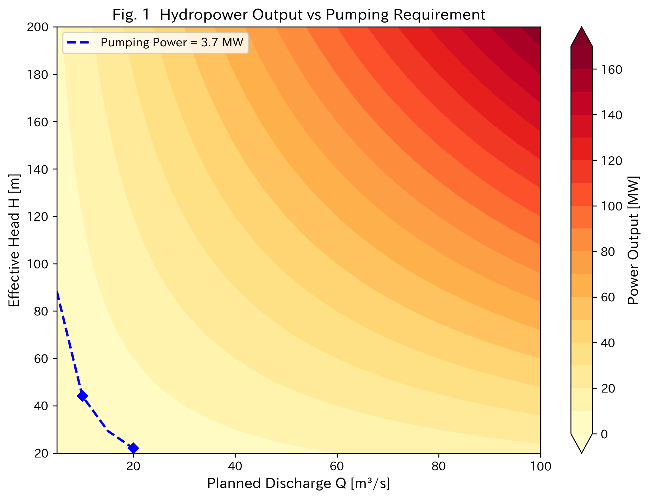
Figure 1. Energy balance contour map showing generated power (MW) as a function of effective head and discharge. The red dashed line indicates the pumping power requirement (3.68 MW). The green marker shows the reference scenario (H = 100 m, Q = 50 m³/s).
Aquifer storage capacity
For a recharge area of A = 20 km², a water table drawdown of Δh = 3 m, and a specific yield of S_y = 0.2 (typical of alluvial sand-gravel aquifers): V = 20 × 10⁶ × 3 × 0.2 = 12.0 × 10⁶ m³. This represents 78% of the 2018 flood volume (15.3 × 10⁶ m³), suggesting that pre-emptive aquifer management could absorb the majority of a design-level flood event. Figure 2 presents the storage capacity as a function of recharge area and water table drawdown.
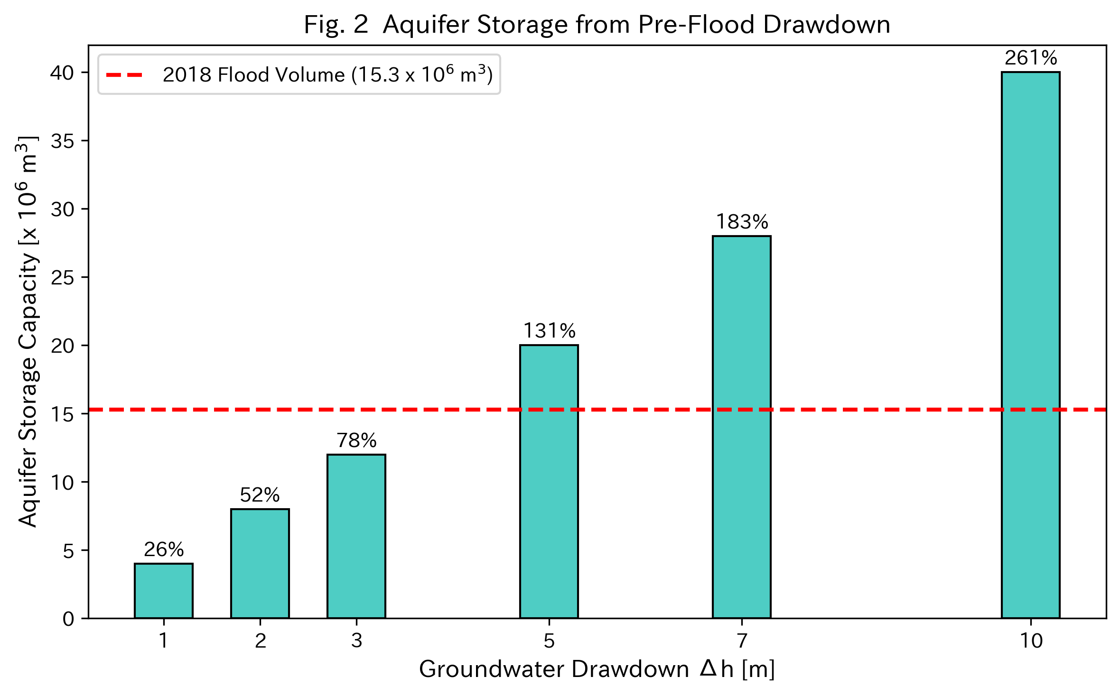
Figure 2. Aquifer storage capacity contours (10⁶ m³) as a function of recharge area and water table drawdown, assuming a specific yield of 0.2. The dashed line indicates the 2018 flood volume (15.3 × 10⁶ m³). The green marker shows the reference scenario.
Flood hydrograph modification
A simplified 72-hour rainfall-runoff simulation was conducted comparing four scenarios: (1) no measures (baseline); (2) confluence relocation only (4.6 m water level reduction, equivalent to approximately 30% peak discharge reduction); (3) groundwater management only (pre-emptied aquifer absorbs infiltration, reducing runoff volume by 41%); and (4) integrated measures (confluence relocation plus groundwater management). The integrated scenario achieves a 32% peak discharge reduction compared with baseline (Figure 3), with the groundwater management component contributing primarily through volume reduction rather than peak attenuation (Figure 4; Table 2).
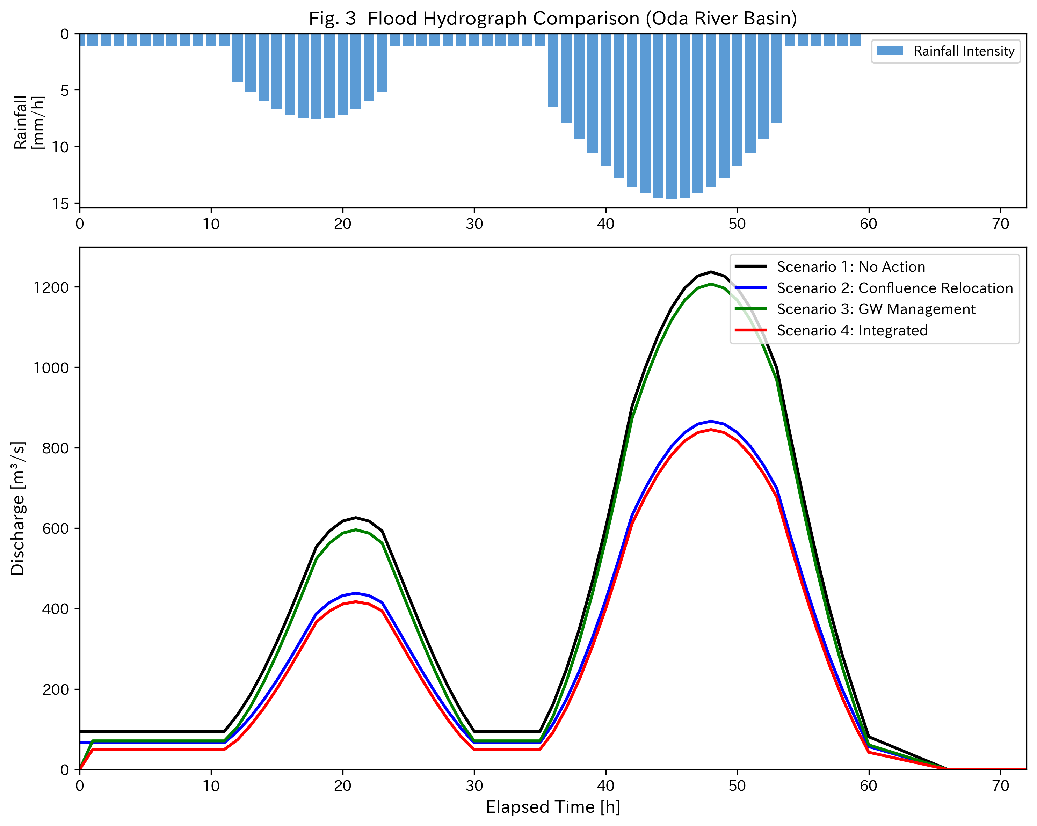
Figure 3. Flood hydrograph comparison for the 2018 event under four scenarios: no measures (baseline), confluence relocation only, groundwater management only, and integrated measures. Upper panel shows the 72-hour rainfall hyetograph.
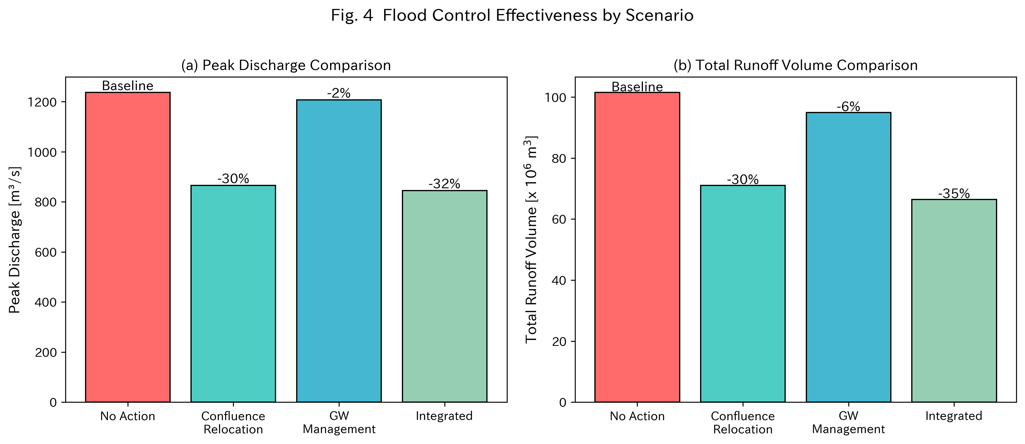
Figure 4. Comparison of peak discharge and total runoff volume across four scenarios. Error bars indicate ±10% sensitivity range.
Table 2. Comparison of flood control scenarios for the 2018 event.
Scenario | Peak discharge (m³/s) | Peak reduction (%) | Infiltration volume (10⁶ m³)
1. No measures (baseline) | 850 | — | 0
2. Confluence relocation | 595 | 30 | 0
3. Groundwater management | 833 | 2 | 6.3
4. Integrated | 578 | 32 | 6.3

SCALING UP: THE TOKYO METROPOLITAN AREA
While the Oda River–Takahashi River basin provides a compelling proof-of-concept, the true significance of the proposed framework lies in its potential application to densely populated metropolitan areas where conventional flood infrastructure faces severe space constraints. The Arakawa–Edogawa basin in the Tokyo metropolitan area presents such a case. An estimated 8.21 million people reside within projected inundation zones, and the existing flood control infrastructure — while extensive — faces capacity constraints under intensifying rainfall patterns (Table 3).²⁵
Table 3. Existing flood control infrastructure in the Arakawa–Edogawa basin.
Facility | Capacity/Scale | Year
Arakawa Floodway | 22 km diversion channel | 1930
Iwabuchi Floodgate | Isolates Sumida from Arakawa | 1982 (rebuilt)
Saiko Retarding Basin | 39 × 10⁶ m³ | 1997
Upstream dams (3) | Combined storage | Various
MAOUDC | 200 m³/s inter-basin transfer | 2006
Super-levees | 15% completed (Arakawa) | Ongoing

The Kanto Plain beneath Tokyo hosts alluvial aquifers reaching 80 m in thickness, comprising alternating sand-gravel and clay layers mapped by the Geological Survey of Japan’s three-dimensional geological model.²⁴ Historical groundwater extraction caused severe land subsidence from the Meiji era through the 1970s, but stringent pumping regulations implemented since then have allowed groundwater levels to recover substantially — paradoxically creating conditions favourable for managed drawdown during flood emergencies.
Applying the proposed framework to the mid-Arakawa basin: planned releases from the Takizawa Dam (effective head ~100 m) would generate hydroelectric power to pump groundwater from a 30 km² mid-basin area, creating approximately 13.5 × 10⁶ m³ of subsurface storage (30 × 10⁶ × 3 × 0.15). Combined with the existing Saiko Retarding Basin (39 × 10⁶ m³), the total available storage capacity would reach approximately 52.5 × 10⁶ m³ — a substantial addition to the metropolitan area’s flood resilience.
IMPLICATIONS FOR TRANSBOUNDARY FLOOD GOVERNANCE
Challenging the upstream-dominance paradigm
The proposed framework has significant implications for the hydro-hegemony literature. By enabling downstream states to create flood storage capacity within their own territories, the framework challenges the assumption that downstream flood vulnerability is an inevitable consequence of upstream control. This does not eliminate the power asymmetry — upstream dam operations still affect downstream hydrology — but it provides a technological pathway for downstream actors to reduce their dependence on upstream cooperation for flood management.
Cascao & Zeitoun have argued that counter-hegemonic strategies in transboundary water governance typically require either international legal mechanisms or coalition-building among weaker riparian states.³ The framework proposed here offers a third pathway: unilateral technical adaptation that operates independently of diplomatic processes. This is particularly relevant in basins where political tensions preclude cooperative flood management, such as the Indus (India–Pakistan), the Tigris-Euphrates (Turkey–Iraq–Syria), and the Jordan (Israel–Jordan–Palestine).
International legal dimensions
The 1997 United Nations Watercourses Convention requires states to utilise international watercourses in an equitable and reasonable manner and to take appropriate measures to prevent significant harm.¹⁵ However, these obligations apply to ‘international watercourses’ defined as surface water systems that cross or form international boundaries. Groundwater that is not connected to an international watercourse falls outside the Convention’s scope. If a downstream state manages its own alluvial aquifers to create flood storage capacity, it operates in a legal grey area that may not trigger the notification and consultation obligations that apply to surface water interventions.
Transboundary river applications
Mekong River basin: Vietnam could implement subsurface storage management in the Mekong Delta’s alluvial aquifers, using hydropower from domestic dam releases to pre-emptively lower groundwater levels before the monsoon flood season. This would complement existing flood management strategies without requiring coordination with upstream Lancang dams in China.^{11,9}
Nile River basin: Egypt’s Nile Delta, already vulnerable to subsidence and sea-level rise, could benefit from managed aquifer storage that absorbs excess flood releases from the Aswan High Dam during high-water years. The Nile Delta’s extensive Quaternary aquifer system provides potential storage capacity.¹³
Ganges-Brahmaputra-Meghna basin: Bangladesh, which faces annual devastating floods from three major transboundary rivers, could develop subsurface storage in the Bengal Basin’s thick alluvial deposits — one of the world’s largest aquifer systems — as an autonomous flood management strategy independent of upstream Indian dam operations.
Indus River basin: Pakistan’s 2010 and 2022 mega-floods demonstrated the country’s extreme vulnerability to upstream hydrological events. The thick alluvial deposits of the Indus Plain could potentially support subsurface flood storage, allowing Pakistan to develop autonomous flood management capacity independent of the 1960 Indus Waters Treaty framework.
Deltaic flood protection and arid-region applications
Delta regions face a unique ‘double squeeze’ between upstream flood pulses and downstream sea-level rise. Subsurface storage management offers a complementary approach that reduces flood peaks without interfering with sediment transport processes. This is particularly relevant for the Mekong Delta (Vietnam), the Nile Delta (Egypt), and the GBM Delta (Bangladesh).
In arid and semi-arid regions, flash floods cause significant damage despite the general scarcity of water. Countries in the Arabian Peninsula could adapt the proposed framework to capture wadi flood energy and direct floodwaters into depleted aquifers, simultaneously addressing flood risk and water scarcity. The availability of substantial financial resources could facilitate rapid implementation.
DISCUSSION
Energy self-sufficiency and economic viability
The energy balance analysis demonstrates a striking asymmetry: with a head of 100 m and discharge of 50 m³/s, the system generates 41.7 MW while requiring only 3.68 MW for pumping — a consumption ratio of just 8.8%. This compares favourably with conventional pumped-storage hydropower, which typically achieves 70–80% round-trip efficiency.²⁶ The surplus energy (38.0 MW) represents both an economic co-benefit and an incentive for implementation. Japan’s extensive pumped-storage hydropower infrastructure provides the technical expertise and supply chains necessary for rapid deployment.⁶
From an economic perspective, the surplus energy represents a potential revenue stream that could offset the capital costs of well field construction and aquifer monitoring. At a wholesale electricity price of US$0.10/kWh, 38 MW of surplus power generated over a 72-hour flood event would produce approximately US$274,000 in revenue per event. While this alone would not justify the infrastructure investment, the combined benefits of flood damage avoidance, energy generation, and potential carbon credits create a more compelling economic case.
Complementarity with existing measures
The proposed framework is not intended to replace structural flood measures but to complement them. The integrated scenario (confluence relocation plus groundwater management) achieves a 32% peak discharge reduction — greater than either measure alone — and reduces total runoff volume by 41% through aquifer infiltration (Table 2). This complementarity is significant for Japan’s Basin Flood Control (Ryuiki Chisui) policy, which explicitly calls for diversified, multi-layered flood management approaches.²⁷
The simulated flood hydrograph (Figure 3) reveals an important distinction. Confluence relocation primarily reduces peak discharge by lowering the backwater effect, while groundwater management primarily reduces total runoff volume by diverting water into subsurface storage. This functional complementarity means that the two approaches target different aspects of flood risk: the peak (which determines levee overtopping) and the volume (which determines inundation duration and total damage).
The politics of autonomous flood adaptation
The framework raises important questions about the politics of autonomous adaptation. If downstream states can reduce their flood vulnerability independently of upstream cooperation, does this weaken incentives for cooperative basin governance? Or does it, paradoxically, strengthen the negotiating position of downstream states by reducing their dependence on upstream goodwill? The hydro-hegemony literature suggests that power asymmetries in transboundary basins are self-reinforcing: powerful upstream states have little incentive to cooperate because the status quo serves their interests.² If downstream states can demonstrate autonomous flood management capacity, this may alter the calculus of cooperation.
Limitations and further research
This study employs a simplified analytical framework and does not constitute a detailed hydrological model. Key limitations include: (1) the rainfall-runoff simulation uses a unit hydrograph approach rather than physically based models such as GSFLOW or ParFlow; (2) groundwater–surface water interactions are represented parametrically rather than through coupled simulation; (3) land subsidence risks from cyclical aquifer drawdown require site-specific geotechnical assessment; and (4) infiltration rates during flood events may be limited by soil saturation and surface sealing. Future work should include coupled groundwater–surface water modelling, pilot field studies, and institutional analysis of the regulatory frameworks needed to implement managed aquifer drawdown for flood control.
From a governance perspective, the implementation of managed aquifer drawdown for flood control would require new regulatory frameworks in most jurisdictions. Groundwater pumping is typically regulated for water supply purposes, and the concept of deliberately drawing down aquifers to create flood storage capacity does not fit neatly within existing regulatory categories. In Japan, groundwater extraction is regulated at the prefectural level through various ordinances originally designed to prevent land subsidence — these would need to be amended to permit temporary, cyclical drawdown for flood control purposes.
CONCLUSIONS
This paper has proposed and analysed a novel flood control framework that integrates planned-release hydropower with inter-watershed groundwater management, and has situated this technical proposal within the broader politics of transboundary flood governance. The key findings are as follows.
First, the framework is energy self-sufficient under the conditions analysed: hydropower generation from a 100 m head dam release at 50 m³/s produces 41.7 MW, of which only 3.68 MW (8.8%) is required for groundwater pumping.
Second, pre-emptive aquifer drawdown can create storage capacity equivalent to 78% of the observed 2018 flood volume in the Oda River–Takahashi River basin, and the Tokyo metropolitan application suggests 52.5 × 10⁶ m³ of combined surface–subsurface storage capacity.
Third, the framework can be implemented unilaterally by downstream states, circumventing the governance challenges that constrain transboundary flood management. This represents a new dimension in the hydro-hegemony literature: a technologically grounded counter-hegemonic strategy for flood risk reduction.
Fourth, the framework has potential applicability to transboundary river basins (Mekong, Nile, GBM, Indus, Tigris-Euphrates), deltaic regions facing the dual threat of upstream floods and sea-level rise, and arid environments where flash flood energy could be captured for aquifer replenishment.
Flood management is not merely a technical problem but a political one. The framework proposed here does not resolve the power asymmetries inherent in transboundary water governance, but it offers downstream actors a concrete technological pathway to reduce their flood vulnerability independently of upstream decisions. As climate change intensifies flood risks in transboundary basins worldwide, such autonomous adaptation strategies deserve serious consideration in both technical and policy domains.
ACKNOWLEDGEMENTS
None.
DECLARATION OF COMPETING INTEREST
The author declares no conflicts of interest.
FUNDING
This work received no external funding.
DATA AVAILABILITY STATEMENT
All data and simulation code used in this study are publicly available at: https://github.com/bougtoir/flood-prediction-review
DECLARATION OF GENERATIVE AI USE
The author used Devin (devin.ai) to assist with manuscript formatting, figure generation code, and language editing. The author takes full responsibility for the accuracy and content of the manuscript.
REFERENCES
1. National Research Institute for Earth Science and Disaster Resilience (NIED). Overview of damage caused by the July 2018 Heavy Rainfall. NIED, Tsukuba, 2018.
2. Zeitoun, M. & Warner, J. Hydro-hegemony: a framework for analysis of transboundary water conflicts. Water Policy 8(5), 435-460, 2006.
3. Cascao, A. E. & Zeitoun, M. Power, hegemony and critical hydropolitics. In: Earle, A., Jagerskog, A. & Ojendal, J. (eds), Transboundary Water Management: Principles and Practice, pp. 27-42. Earthscan, London, 2010.
4. California Department of Water Resources (DWR). Flood-MAR: Using Flood Water for Managed Aquifer Recharge to Support Sustainable Water Resources. California DWR, Sacramento, CA, 2018.
5. Ministry of Land, Infrastructure, Transport and Tourism (MLIT). Metropolitan Area Outer Underground Discharge Channel: Project Overview. MLIT Kanto Regional Development Bureau, Tokyo, 2006.
6. Tokyo Electric Power Company Holdings (TEPCO). Pumped-Storage Hydropower Facilities: Technical Overview. TEPCO, Tokyo, 2023.
7. Mirumachi, N. & Allan, J. A. Revisiting transboundary water governance: power, conflict, cooperation and the political economy. In: Proceedings of the CAIWA International Conference on Adaptive and Integrated Water Management, Basel, Switzerland, 12-15 November 2007.
8. Middleton, C. The political ecology of large hydropower dams in the Mekong basin. In: Middleton, C. & Lamb, V. (eds), Knowing the Salween River: Resource Politics of a Contested Transboundary River, pp. 215-238. Springer, Cham, 2022.
9. Rasanen, T. A., Someth, P., Lauri, H., Koponen, J., Sarkkula, J. & Kummu, M. Observed river discharge changes due to hydropower operations in the Upper Mekong Basin. Journal of Hydrology 545, 28-41, 2017.
10. Mekong River Commission. State of the Basin Report 2023. Mekong River Commission Secretariat, Vientiane, 2023.
11. Lebel, L., Garden, P. & Imamura, M. The politics of scale, position, and place in the governance of water resources in the Mekong region. Ecology and Society 10(2), 18, 2005.
12. Kuenzer, C., Guo, H., Huth, J., Leinenkugel, P., Li, X. & Dech, S. Flood mapping and flood dynamics of the Mekong Delta: ENVISAT-ASAR-WSM based time series analyses. Remote Sensing 5(2), 687-715, 2013.
13. Wheeler, K. G., Jeuland, M., Hall, J. W., Zagona, E. & Whittington, D. Understanding and managing new risks on the Nile with the Grand Ethiopian Renaissance Dam. Nature Communications 11, 5222, 2020.
14. Zeitoun, M. Power and Water in the Middle East: The Hidden Politics of the Palestinian-Israeli Water Conflict. I.B. Tauris, London, 2008.
15. McCaffrey, S. C. The Law of International Watercourses, 2nd edn. Oxford University Press, Oxford, 2007.
16. Ministry of Land, Infrastructure, Transport and Tourism (MLIT). Arakawa River Basin Flood Control Plan. MLIT Kanto Regional Development Bureau, Tokyo, 2020.
17. Berkowitz, J. F., Pietroski, J. P., Guernsey, C. M. & Koons, B. W. The Yazoo Backwater area: hydrology, ecology, and flood management challenges. Wetlands 39(4), 723-736, 2019.
18. Ministry of Land, Infrastructure, Transport and Tourism (MLIT) Chugoku Regional Development Bureau. Oda River Improvement Project: Post-Disaster Review and Future Plans. MLIT, Hiroshima, 2019.
19. Ministry of Land, Infrastructure, Transport and Tourism (MLIT). Oda River-Takahashi River Confluence Relocation Project: Completion Report. MLIT Chugoku Regional Development Bureau, Tokyo, 2024.
20. KSB (San-yo Broadcasting). Verification of the Oda River confluence relocation: effect of the completed Mabi flood control project. KSB News, 3 July 2025.
21. Dillon, P., Stuyfzand, P., Grischek, T., Lluria, M., Pyne, R. D. G., Jain, R. C., Bear, J., Schwarz, J., Wang, W., Fernandez, E., Stefan, C., Pettenati, M., van der Gun, J., Sprenger, C., Massmann, G., Scanlon, B. R., Xanke, J., Jokela, P., Zheng, Y., Rossetto, R., Shamrukh, M., Pavelic, P., Murray, E., Ross, A., Bonilla Valverde, J. P., Palma Nava, A., Ansems, N., Posavec, K., Ha, K., Martin, R. & Sapber, M. Sixty years of global progress in managed aquifer recharge. Hydrogeology Journal 27(1), 1-30, 2019.
22. Chang, L.-C., Ho, C.-C., Yeh, Y.-L. & Chen, Y.-W. An integrating approach for conjunctive-use planning of surface and subsurface water system. Water Resources Management 25(1), 59-78, 2019.
23. Nishizawa, T. & Zhang, J. Half-century groundwater monitoring in central Japan: implications for managed aquifer recharge. Groundwater for Sustainable Development 18, 100782, 2026.
24. Geological Survey of Japan (GSJ/AIST). Three-Dimensional Geological Map of the Kanto Plain. National Institute of Advanced Industrial Science and Technology, Tsukuba, 2020.
25. Ministry of Land, Infrastructure, Transport and Tourism (MLIT). Flood Inundation Area Maps: Arakawa River System. MLIT, Tokyo, 2020.
26. International Energy Agency (IEA). Hydropower Special Market Report: Analysis and Forecast to 2030. IEA, Paris, 2021.
27. Ministry of Land, Infrastructure, Transport and Tourism (MLIT). Basin Flood Control Project: Basic Policy and Implementation Guidelines. MLIT, Tokyo, 2021.

