The MINE Framework (Mapping Is Not Exposure): Transparent Minefield Maps with Dummy Positions for Reconciling Military Utility and Post-Conflict Safety

Tatsuki Onishi
[Affiliation]

Abstract
This paper proposes the MINE framework (Mapping Is Not Exposure): a regulatory regime for anti-personnel mines wherein defending states publish position maps containing both real mine locations and indistinguishable dummy positions. The dummy-to-real ratio r serves as a treaty-tuneable parameter balancing military effectiveness against humanitarian cost. Game-theoretic analysis demonstrates that rational attackers will clear all marked positions for any policy-relevant r, preserving full breach delay. The zero-residual property guarantees complete post-conflict clearance without reliance on detection technology. Numerical simulations calibrated to Baltic frontier scenarios illustrate practical application for NATO states now withdrawing from the Ottawa Convention.

Keywords: anti-personnel mines; MINE framework; Ottawa Convention; game theory; area denial; post-conflict clearance; Baltic security; information asymmetry; treaty design; NATO; deterrence

1. Introduction
The 1997 Convention on the Prohibition of Anti-Personnel Mines (hereafter the Ottawa Convention) represented a landmark achievement in international humanitarian law, securing commitments from over 160 states to eliminate weapons that kill and maim civilians long after conflicts end (ICRC, 2024). For more than two decades, the treaty’s absolute prohibition created a powerful international norm. Yet the strategic landscape of northeastern Europe has shifted dramatically since Russia’s full-scale invasion of Ukraine in 2022, and the norm is now fracturing at precisely the point where it is most needed.
In March 2025, Poland, Estonia, Latvia, and Lithuania jointly announced their withdrawal from the Ottawa Convention, citing the need to deter Russian aggression along NATO’s eastern flank. Finland followed in April 2025, with Prime Minister Petteri Orpo stating that “withdrawing from the Ottawa Convention will give us the possibility to prepare for the changes in the security environment in a more versatile way” (Reuters, 2025). Each withdrawing state simultaneously affirmed its commitment to “responsible use” of anti-personnel mines—a commitment whose specific operational content remains undefined.
This paper fills that gap. We propose a novel regulatory framework that we term MINE (Mapping Is Not Exposure)—reflecting the core insight that publishing minefield positions with dummy entries does not constitute military exposure. The MINE framework gives concrete operational meaning to “responsible use.” Under this framework, a defending state must publish a map showing all mine positions before or during deployment. Crucially, the map may include dummy (decoy) positions: locations marked as potentially mined but containing no actual ordnance. The ratio of dummy to real positions (the dummy ratio r) becomes a treaty-regulated parameter that quantitatively indexes the trade-off between military effectiveness and post-conflict safety.
The core insight is elegant in its simplicity. Under the current regime with no published map, the dummy ratio is effectively infinite: the entire terrain is uncertain from the attacker’s perspective. If an adversary obtains complete intelligence through espionage, the effective dummy ratio falls to zero—only real positions are relevant. Our proposal targets the continuum between these extremes, offering a family of regimes indexed by r ∈ [0, ∞) that trade off military utility against humanitarian cost in a quantifiable, verifiable, and negotiable manner.
We demonstrate three key results. First, the defending minefield retains substantial delay capability because the attacker must clear all M = N(1+r) marked positions in any breach lane, regardless of whether each is real or dummy. Delay scales linearly with (1+r). Second, post-conflict clearance is guaranteed to be complete: by systematically addressing every position on the map, zero residual mines remain—a deterministic property that no probabilistic detection method can match. Third, the framework is inherently verifiable: mines found at unregistered positions constitute clear treaty violations, and the published dummy ratio is testable ex post.
The urgency of this contribution is underscored by the current policy vacuum. As of mid-2025, five NATO states have announced withdrawal from the Ottawa Convention, all pledging responsible use, yet no common framework exists to define what this means. Without agreed operational standards, each withdrawing state will develop its own practices—potentially divergent, potentially opaque, and potentially contributing to the very humanitarian outcomes the Ottawa Convention sought to prevent. The MINE framework offers a ready-made standard that could be adopted immediately.
The remainder of this paper is structured as follows. Section 2 reviews existing regulatory frameworks and their limitations. Section 3 presents the formal model. Section 4 analyses military effectiveness under the MINE regime. Section 5 examines post-conflict safety guarantees. Section 6 develops game-theoretic and information-theoretic properties. Section 7 discusses treaty design implications, including verification mechanisms and compatibility with existing frameworks. Section 8 applies the model to the Baltic security context with scenario analysis. Section 9 discusses limitations, and Section 10 concludes with policy recommendations.

2. Background and Existing Frameworks

2.1 The Ottawa Convention and the 2024–2025 withdrawal wave
The Ottawa Convention established a categorical norm against anti-personnel landmines. Its success is undeniable: global production fell dramatically, stockpiles were destroyed across dozens of countries, and millions of square metres of contaminated land were cleared (ICBL, 2023). However, the Convention’s absolute prohibition creates a binary choice between complete compliance and complete withdrawal, with no intermediate options for states facing genuine defensive requirements.
The wave of withdrawals beginning in late 2024 demonstrates the fragility of this binary structure when security conditions change. Several factors converged: Russia’s extensive use of mines in Ukraine (both anti-personnel and anti-vehicle), the United States’ decision to supply Ukraine with anti-personnel mines, and the growing recognition among NATO’s eastern members that conventional area denial is critical to compensating for force imbalances vis-à-vis Russia.
Finland’s case is illustrative. Having destroyed over one million mines after ratification in 2012, Finland announced withdrawal thirteen years later. Defence Minister Antti Häkkänen commissioned an evaluation of anti-personnel mines as “a strengthening factor for Finland’s defence” (Reuters, 2024). The Finnish Defence Forces commander publicly stated that the topic required renewed discussion given Russia’s demonstrated willingness to use mines offensively. Estonia’s National Defence Committee similarly debated withdrawal in November 2024, with the Defence Forces commander noting that “sufficient alternatives to passive mines” existed but recommending the option remain open (ERR News, 2024).
Every withdrawing state has articulated a commitment to “responsible” or “defensive” mine use. Finland’s agriculture minister stated: “Finland will use mines in a responsible way, but it’s a deterrent we need” (Reuters, 2025). Yet none has specified what “responsible use” means operationally—what constraints distinguish responsible from irresponsible employment. This paper provides exactly such a specification.

2.2 CCW Amended Protocol II and its limitations
The Amended Protocol II to the Convention on Certain Conventional Weapons (1996) represents the existing attempt at a middle ground between prohibition and unrestricted use. Its key provisions for anti-personnel mines include: prohibition of use outside marked and monitored areas unless equipped with self-destruct/self-deactivation mechanisms; requirements for detectability using standard equipment; and mandatory recording of pre-planned minefield locations for post-conflict sharing (UNODA, 2023).
However, the Protocol has three significant limitations that the MINE framework addresses:
First, self-destruct unreliability. The Protocol’s requirement for self-destruct mechanisms assumes reliable functioning. Field evidence tells a different story. The Norwegian People’s Aid (2007) study of the M85 submunition—widely cited as incorporating a “high-quality” self-destruct mechanism—found field failure rates substantially exceeding laboratory specifications. The CCW Protocol itself permits a 10% failure rate. In a field of 1,000 mines, this leaves 100 active mines—each capable of killing or maiming for decades. The MINE framework does not depend on mechanical reliability; its safety guarantee is deterministic.
Second, temporal uncertainty. Self-destruct creates a period during which any given mine may or may not be active. Civilians cannot know whether a mine has self-destructed without physically verifying—precisely the dangerous action the mechanism is meant to prevent. The transparent map provides spatial certainty at all times: every mine is at a published position.
Third, post-conflict timing. The Protocol’s recording requirement (Article 7) applies only after cessation of hostilities. During conflict, mine positions may be lost due to destroyed records, personnel casualties, or deliberate concealment. The MINE framework requires publication during or before deployment, creating an irrevocable record.

2.3 Military doctrine on dummy minefields
The concept of dummy (phony) minefields is well-established in military doctrine and provides doctrinal precedent for the proposed framework. US Army Field Manual FM 90-2 (Battlefield Deception) states that “dummy minefields can be used very effectively in the retrograde to slow and canalise the enemy attack or cause the enemy to mass his forces” (US Army, 1988). FM 5-102 (Countermobility) defines phony minefields as “areas of ground used to simulate live minefields and deceive the enemy” and notes they “are of no value until the enemy has become sensitive to mine warfare” (US Army, 1985).
Two doctrinal principles are particularly relevant. First, US doctrine requires that dummy minefields receive “the same authorisation, recording, and reporting procedures as the type minefield it is designed to replicate.” This confirms that military practice already treats dummy and real positions equivalently for administrative purposes. Second, the doctrine notes that dummies are most effective “when mixed with real ones throughout the battlefield”—precisely the configuration our framework mandates.
Our contribution inverts the doctrinal logic. Rather than using dummies to conceal the existence of minefields from the attacker, we use a published map with dummies to reveal sufficient information for guaranteed post-conflict safety whilst preserving operational uncertainty for the attacker.

2.4 Related game-theoretic literature
Game-theoretic models of military deception have addressed attacker–defender interactions under information asymmetry in several relevant contexts. Zhuang, Bier, and Alagoz (2010) model secrecy and deception in a multiple-period signalling game, classifying defender signals as truthful disclosure, secrecy, or deception. Their framework shows that defenders can achieve more cost-effective security through strategic information management—a principle our framework extends to the landmine context with the additional constraint of post-conflict safety.
Hendricks (2006) analyses feints in attack–defence models, demonstrating that equilibrium behaviour depends critically on signalling technology. In naval mine warfare, Kanazawa, Iida, and Morimoto (2018) formulate mine countermeasure operations as a two-player game between a minefield planner and clearance forces, showing how countermeasure choices (hunting vs sweeping) interact with mine design features.
The Aalto University network interdiction framework (Aalto NDU, 2020) models defensive minefield placement as a mixed-integer optimisation problem, seeking mine configurations that maximise disruption to attacker movement networks. While focused on placement optimisation rather than information disclosure, this work provides complementary methodology for determining optimal spatial configurations within our framework.
Our framework differs fundamentally from this literature in one respect: we model a regime where the defender voluntarily publishes position information under treaty obligation, with the quality of that information (the dummy ratio) as the strategic variable. This transforms the problem from one of deception (maximising misinformation) to one of regulated transparency (calibrating information disclosure to balance competing objectives). To our knowledge, no prior work has formalised this concept.

3. Model Formulation

3.1 Setup and notation
Consider a defending state that emplaces a minefield along a front of width W (metres) to a depth D (metres), with total area A = W × D. The minefield contains N real anti-personnel mines distributed across this area. Under the MINE regime, the defender publishes a map to the MINE Registry showing M = N(1 + r) marked positions, where r ≥ 0 is the dummy ratio. Of these, exactly N contain real mines and Nr are dummies.
Fundamental constraint: Every real mine position must appear on the map. The defender may not place mines at undisclosed locations. This constraint is the linchpin of the entire framework: it enables the post-conflict safety guarantee by ensuring that clearing all M published positions is sufficient to eliminate every real mine. Without this constraint, the framework degenerates into the status quo of unrestricted mining.
Indistinguishability condition: The published map does not distinguish real from dummy positions. All M markers appear identical to any observer. The attacker knows that exactly N of the M positions are real (the ratio r being a public treaty parameter), but cannot identify which specific positions contain real mines. On the ground, dummy positions may be prepared identically to real ones (disturbed earth, surface markers) to prevent visual or sensor-based discrimination.
Table 1 summarises the notation.
Symbol | Definition
N | Number of real mines
r | Dummy ratio (treaty-regulated parameter, r ≥ 0)
M = N(1+r) | Total marked positions on published map
W | Front width (metres)
D | Minefield depth (metres)
A = W×D | Total minefield area (m²)
w | Breach lane width (metres)
t_c | Time to clear one marked position (minutes)
t_p | Time to probe one grid cell in blind sweep (minutes)
k | Number of parallel clearance teams
δ | Grid spacing for blind detection sweep (metres)
p_d | Per-mine detection probability in blind sweep

3.2 Three information regimes
We compare three information regimes from the attacker’s perspective, corresponding to different values of the effective dummy ratio (Figure 1):
Regime A – No map (status quo, r → ∞): The attacker has no knowledge of mine positions. The entire minefield area is uncertain. To breach safely, the attacker must conduct a systematic blind sweep of the breach lane, probing each grid cell of area δ². This is the current situation for NATO forces facing Russian minefields in Ukraine and the default for any non-signatory deploying mines without disclosure.
Regime B – Full intelligence (r = 0): The attacker knows the exact position of every real mine. This could arise through espionage, signals intelligence, or post-conflict record sharing. The attacker clears only the N real positions in their path, achieving minimum clearance effort.
Regime C – MINE regime (0 < r < ∞): The attacker has the published map showing M = N(1+r) positions. They know N mines exist among the M positions but cannot distinguish real from dummy. To breach safely, they must clear all marked positions in their lane.
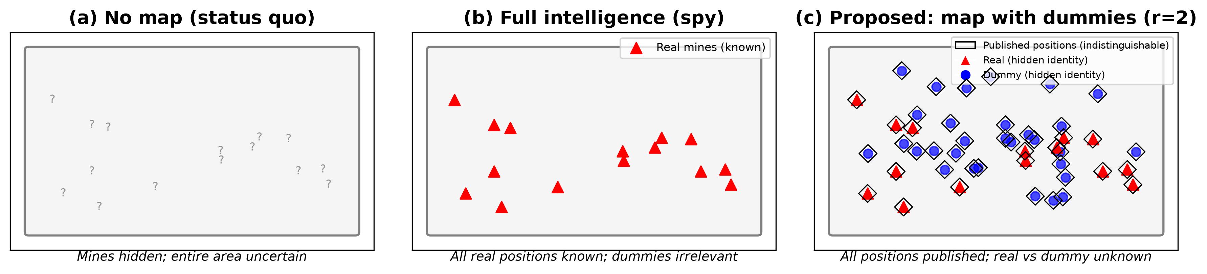
Figure 1. Conceptual comparison of three information regimes. (a) No map (status quo): mine positions unknown, entire area uncertain. (b) Full intelligence: all real positions known to attacker. (c) MINE regime: map published with real + dummy positions; identity (real vs dummy) unknown to attacker.

3.3 Breach delay model
An attacking force seeks to breach the minefield through a lane of width w. Assuming positions are uniformly distributed across the minefield area, the number of marked positions within the breach lane is:
m(r) = N(1+r) × (w/W) (1)
With k parallel clearance teams, each taking t_c minutes per position, the breach delay under the map regime is:
T_map(r) = N(1+r)(w/W) × t_c / k (2)
For comparison, blind sweep delay (Regime A) requires probing every grid cell in the breach lane:
T_blind = (w × D / δ²) × t_p / k (3)
And full intelligence delay (Regime B):
T_intel = N(w/W) × t_c / k (4)
The delay multiplier of the transparent map over full intelligence is simply (1+r), confirming that each dummy position imposes the same operational cost as a real mine from the attacker’s perspective.

3.4 Post-conflict clearance model
After hostilities, the clearance task for the full minefield area differs fundamentally between regimes:
Map-based clearance (MINE regime): Clear all M = N(1+r) positions. Time = M × t_c / k hours. Residual mines after completion = 0 (deterministic guarantee).
Blind sweep (no-map regime): Sweep entire area A cell by cell. Time = (A/δ²) × t_p / k hours. Residual mines = N × (1 − p_d) per sweep pass. Even at p_d = 0.95 (state-of-the-art metal detection), a field of 200 mines leaves an expected 10 undetected—each a potential future civilian casualty for decades.
The clearance efficiency ratio—time saved by using the map—is:
η(r) = T_blind / T_map = (A × t_p) / [δ² × N(1+r) × t_c] (5)
For the baseline parameters detailed in Section 4, η ranges from 50× (r=0) to 2.4× (r=20), confirming that map-based clearance remains substantially more efficient than blind sweep across all plausible dummy ratios.

4. Military Effectiveness Analysis

4.1 Baseline scenario parameters
We evaluate the model using parameters representative of a Baltic frontier defence scenario (Table 2). The scenario models a battalion-level defensive minefield along a company sector of a 5 km front, with the attacker attempting to breach a 100 m-wide lane for mechanised advance.
Parameter | Value | Justification
N (real mines) | 200 | Battalion-level minefield (NATO STANAG)
W (front width) | 5,000 m | Company defensive sector width
D (depth) | 300 m | Standard minefield depth
w (breach lane) | 100 m | Mechanised infantry requirement
t_c (clear/position) | 30 min | Manual EOD clearance standard
t_p (probe/cell) | 5 min | Systematic detection sweep rate
δ (grid spacing) | 5 m | Metal detector effective width
k (teams) | 10 | Engineer platoon capacity
Table 2. Baseline scenario parameters for Baltic frontier defence.

4.2 Delay results
Table 3 presents breach delay across dummy ratios. Figure 2 visualises the relationship graphically.
Dummy ratio (r) | Total positions (M) | Positions in lane | Breach delay | Ratio to blind
0 | 200 | 4 | 12 min | 0.02
1 | 400 | 8 | 24 min | 0.04
3 | 800 | 16 | 48 min | 0.08
5 | 1,200 | 24 | 72 min (1.2 h) | 0.12
10 | 2,200 | 44 | 132 min (2.2 h) | 0.22
20 | 4,200 | 84 | 252 min (4.2 h) | 0.42
Blind (no map) | — | 1,200 cells | 600 min (10 h) | 1.00
Table 3. Breach delay under different dummy ratios (baseline scenario).
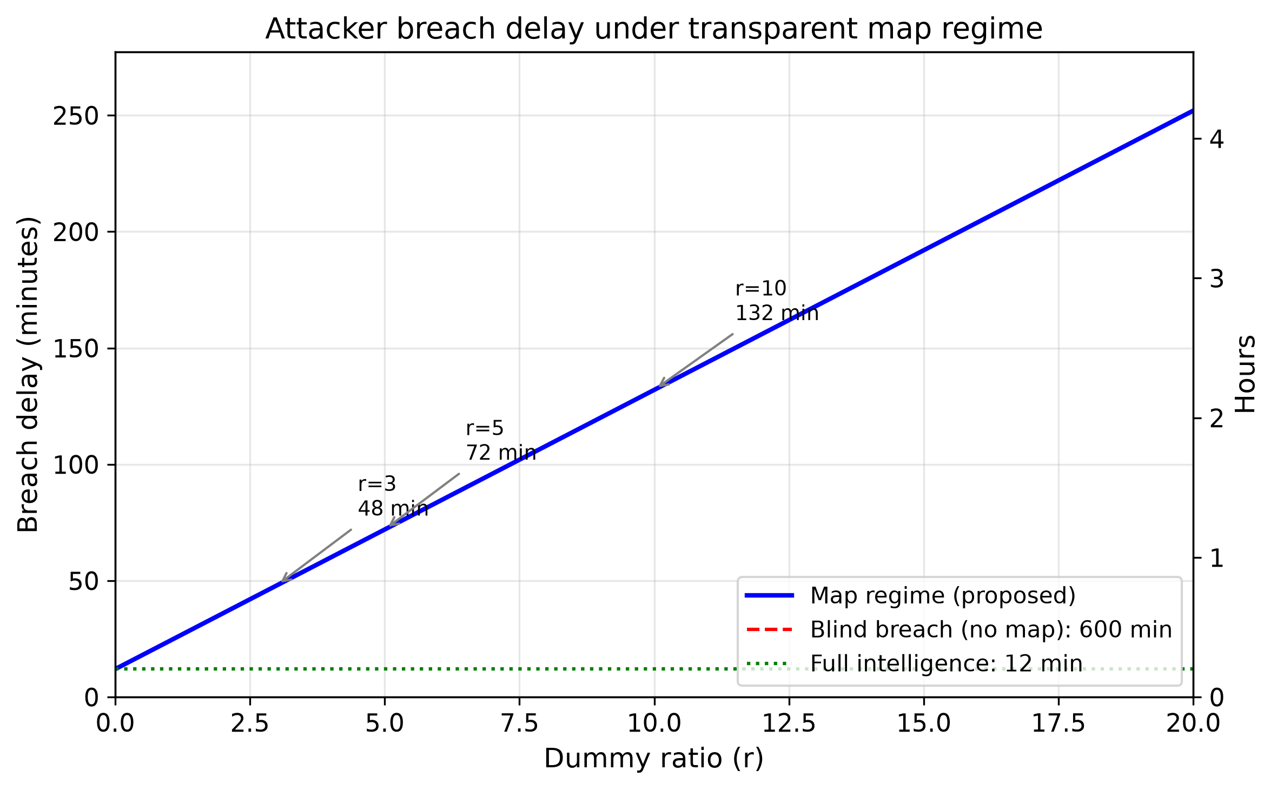
Figure 2. Attacker breach delay as a function of dummy ratio r (baseline scenario). Solid blue: MINE regime, scaling linearly with (1+r). Red dashed: blind sweep (no map, 600 min). Green dotted: full intelligence (12 min).
Several observations emerge. At r = 0, the map reveals all real positions and the attacker clears only 4 positions in the lane (12 minutes). This is the minimum delay and represents the lower bound of military effectiveness. At r = 10, breach delay reaches 132 minutes—sufficient for significant defensive preparation, repositioning, or calling reinforcements. The blind sweep baseline (600 minutes) represents the theoretical maximum, though in practice attackers facing blind minefields may choose to accept casualties rather than conducting a full 10-hour sweep—a point we return to in Section 6.

4.3 Force multiplication and defensive integration
The delay values reported above represent mine clearance time alone. In combined-arms defensive operations, minefields are integrated with direct and indirect fire systems, meaning that clearance is conducted under fire. This interaction creates a force multiplication effect: each hour of minefield delay is an additional hour during which defensive fires can attrit the attacking force. NATO doctrine estimates that obstacles integrated with fire systems multiply their effectiveness by a factor of 3–5 compared to unobserved obstacles (unresisted clearance).
In the Baltic context, this has particular significance. The delay imposed by transparent minefields directly purchases time for: mobilisation of reserve forces; deployment of NATO rapid reaction forces (which require 10–30 days for full deployment); preparation of subsequent defensive positions; and evacuation of civilian populations from threatened areas. For Estonia, where the capital Tallinn is approximately 3 hours of mechanised advance from the eastern border, each additional hour of delay at the border represents a significant fraction of the total available preparation time.
Furthermore, the transparent map enables defensive force planning that is unavailable with conventional minefields. Because the defender knows which positions are real and which are dummy, defensive fire can be concentrated on real mine positions (where the attacker will be forced to stop and clear) whilst dummy positions serve as engagement areas where the attacker commits resources unnecessarily. This asymmetry of information between defender (knows which are real) and attacker (does not) creates tactical advantages beyond simple delay.

4.4 The accept-casualties alternative
An important consideration is the attacker’s alternative to clearing: simply advancing through the minefield and accepting casualties. This is not merely theoretical—Russian forces in Ukraine have repeatedly driven vehicles and infantry through known minefields, accepting significant losses to maintain operational tempo.
Under the no-map regime, an attacker who chooses to accept casualties faces an unknown risk distributed over an unknown area. Under the MINE regime, the same attacker faces concentrated, known-location risk. Each marked position has probability 1/(1+r) of being lethal. The key insight is that published positions create unavoidable obstacles—the attacker cannot route around them without adding distance, and cannot ignore them without accepting quantifiable risk. This is explored formally in the game-theoretic analysis of Section 6.

5. Post-Conflict Safety Guarantee

5.1 The zero-residual property
The most significant humanitarian advantage of the MINE regime is what we term the zero-residual property: after hostilities, clearing all M published positions is both necessary and sufficient to remove every real mine. This is a deterministic guarantee, not a probabilistic one. It does not depend on detection equipment performance, soil conditions, vegetation cover, or any other variable that affects conventional mine clearance.
Formally: let S = {s_1, ..., s_M} denote the set of published positions, and R ⊆ S (|R| = N) the subset containing real mines. If a clearance team visits and neutralises every position in S, then every element of R is necessarily neutralised. The guarantee follows from the fundamental constraint that R ⊆ S.
This contrasts sharply with current post-conflict clearance, which relies on imperfect detection applied over vast, uncertain areas. With detection probability p_d = 0.95 per pass, a field of 200 mines leaves an expected 10 mines after one pass, 0.5 after two passes, and 0.025 after three passes. Multiple passes reduce but never eliminate residual risk—and each additional pass incurs the full time cost of sweeping the entire area.

5.2 Clearance time comparison
Figure 3 compares post-conflict clearance times and residual risk. For the baseline scenario:
• Blind sweep: 500 hours (60,000 cells × 5 min / 10 teams / 60), residual: 10 mines expected.
• Map at r = 3: 40 hours, residual: 0 mines. Efficiency gain: 12.5×.
• Map at r = 5: 60 hours, residual: 0 mines. Efficiency gain: 8.3×.
• Map at r = 10: 110 hours, residual: 0 mines. Efficiency gain: 4.5×.
• Map at r = 20: 210 hours, residual: 0 mines. Efficiency gain: 2.4×.
Even at r = 20 (twenty dummy positions per real mine), map-based clearance is 2.4 times faster than blind sweep and guarantees complete safety. The zero-residual property is independent of r.
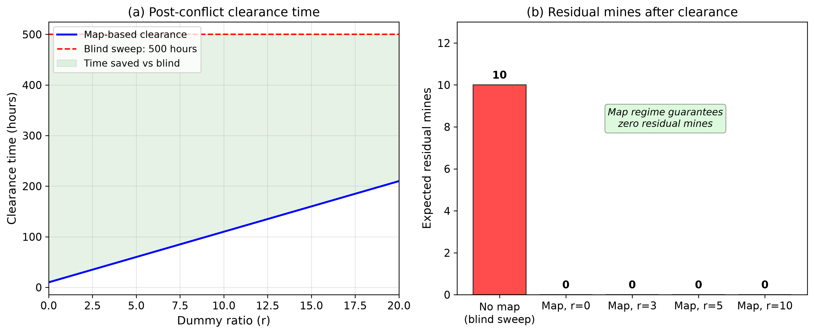
Figure 3. Post-conflict clearance comparison. (a) Clearance time vs dummy ratio: map-based (blue) remains far below blind sweep (red dashed) at all r values. (b) Residual mines: map regime guarantees zero residual regardless of r; blind sweep leaves expected 10 mines.

5.3 Economic comparison
The economic implications of the zero-residual property extend beyond clearance time. Mine-contaminated land cannot be used productively until cleared. At current clearance costs of approximately USD 500–1,500 per cleared mine (including search time, not just neutralisation), the economic comparison is stark. For our baseline scenario (200 mines, 1.5 km² minefield):
• Blind clearance (no map): Cost = 60,000 cells × search cost per cell ≈ USD 3–6 million. Duration: months to years for full area. Land unavailable throughout.
• Map-based clearance (r = 5): Cost = 1,200 positions × USD 500 = USD 600,000. Duration: 60 hours (less than 3 days). Land released immediately after.
• Economic savings: USD 2.4–5.4 million per minefield in direct clearance costs alone, plus the economic value of rapid land release.
For a country like Estonia, which might deploy 5–10 transparent minefields along its border in a crisis, the aggregate savings of map-based versus blind clearance could reach USD 20–50 million—a substantial sum for a small economy. More importantly, the certainty of the clearance timeline (days rather than years) enables reliable post-conflict reconstruction planning.

5.4 Comparison with self-destruct mechanisms
Table 4 compares the MINE regime with self-destruct mechanisms across key safety dimensions.
Dimension | Self-destruct (CCW Protocol II) | MINE framework (proposed)
Residual risk | N × failure_rate (2–10%) | Zero (deterministic)
Depends on reliability | Yes (mechanical) | No (informational)
Verifiable | No (cannot confirm remotely) | Yes (map is public record)
Time to safety | Self-destruct timer + uncertainty | Clearance time (known)
Cost scaling | Per-mine mechanism cost | Map publication (negligible)
Table 4. Comparison of safety mechanisms.

6. Game-Theoretic and Information-Theoretic Analysis

6.1 Attacker’s optimal strategy
Consider an attacker facing m(r) = N(1+r)(w/W) marked positions in a breach lane. For each position i, the attacker decides: clear (deterministic cost c_clear) or bypass (stochastic risk). If bypassed, position i has probability 1/(1+r) of containing a real mine, with expected cost:
E[C_bypass] = [1/(1+r)] × p_cas × C_cas (6)
where p_cas is casualty probability given mine encounter and C_cas is the value assigned to a casualty. The attacker rationally clears position i if and only if:
c_clear < [1/(1+r)] × p_cas × C_cas (7)
Since this condition is identical for all positions (given the indistinguishability condition), the attacker’s optimal strategy is a corner solution: either clear all positions or clear none. The critical dummy ratio r* at the switching point is:
r* = (p_cas × C_cas / c_clear) − 1 (8)
For representative values (p_cas = 0.15, C_cas = USD 1,000,000, c_clear = USD 500): r* = (0.15 × 1,000,000 / 500) − 1 = 299. This means that for any dummy ratio below 299, a rational attacker will always clear every marked position rather than accept the risk of casualty. Since realistic treaty regimes would set r in the range 3–20, the minefield retains full delay effectiveness at all plausible policy parameters. The attacker is compelled to treat every dummy as if it were real.

6.2 Sensitivity of r* to parameter values
The critical ratio r* is robust to substantial parameter variation. Even under pessimistic assumptions (p_cas = 0.05, C_cas = USD 100,000, representing a force with low casualty sensitivity and cheap personnel), r* = (0.05 × 100,000 / 500) − 1 = 9. Thus, even against an adversary with extremely low casualty sensitivity, a dummy ratio of r ≤ 9 ensures full delay effectiveness. For NATO-standard adversaries with higher casualty costs, r* exceeds 100 under any reasonable parameterisation.

6.3 Defender’s spatial strategy
The defender’s optimisation involves choosing where to place N real mines and Nr dummies. Under the indistinguishability condition, the defender’s optimal strategy is to draw both real and dummy positions from the same spatial distribution—typically uniform across the minefield area, or concentrated along likely approach routes.
If the attacker attempts to distinguish real from dummy using spatial pattern analysis (e.g., reasoning that tactically significant positions are more likely to be real), the defender’s best response is to ensure statistical indistinguishability. This yields a mixed-strategy Nash equilibrium in which each position has probability exactly 1/(1+r) of being real, regardless of location. The defender achieves this by using the same tactical logic for dummy placement as for real placement—placing dummies at positions that would be militarily optimal for real mines.

6.4 Information entropy analysis
Shannon entropy provides a formal measure of the attacker’s positional uncertainty (Figure 4). Under Regime A (no map), the attacker must consider all possible placements of N mines among A/δ² grid cells, giving entropy:
H_A ≈ (A/δ²) × H_b(Nδ²/A) (9)
where H_b(p) = −p log₂(p) − (1−p) log₂(1−p). Under Regime C (MINE regime), uncertainty is confined to which N of M positions are real:
H_C(r) ≈ M × H_b(N/M) = N(1+r) × H_b(1/(1+r)) (10)
For the baseline scenario: H_A ≈ 1,934 bits (no map); H_C(5) ≈ 780 bits (40% of maximum); H_C(10) ≈ 967 bits (50%). The MINE regime thus allows the defender to retain 20–50% of maximum positional uncertainty at policy-relevant dummy ratios, whilst guaranteeing post-conflict clearance.
This entropy analysis reveals an important asymmetry: the transparent map provides disproportionate benefit to the defender at low r values. At r = 1 (one dummy per real mine), entropy already reaches 400 bits—sufficient to prevent the attacker from making useful spatial inferences about which positions are real.
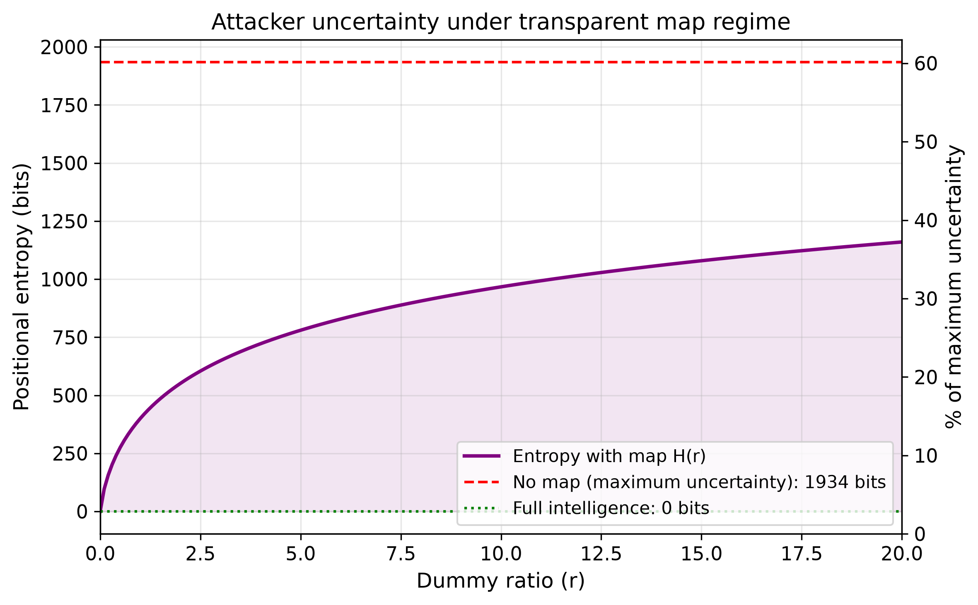
Figure 4. Positional entropy (Shannon information) representing attacker uncertainty. Purple: MINE regime. Red dashed: no-map maximum (1,934 bits). The regime provides controlled uncertainty between 0 and 50% of maximum at policy-relevant r values.

6.5 Sensitivity analysis
We examine the robustness of key findings to parameter variation. Table 5 presents the breach delay at r = 5 under alternative parameter assumptions.
Scenario | Changed parameter | Breach delay (r=5) | Change from baseline
Baseline | N=200, t_c=30, k=10 | 72 min | —
Larger field | N=500 | 180 min | +150%
Faster clearance | t_c=15 min | 36 min | −50%
Fewer teams | k=5 | 144 min | +100%
Wider breach | w=200 m | 144 min | +100%
Dense minefield | N=200, D=150 m | 72 min | 0% (width-invariant)
Table 5. Sensitivity of breach delay to parameter variation (r = 5).

The model’s key structural property—linear scaling with (1+r)—is invariant to all parameter changes. What varies is the absolute magnitude of delay, which depends on N, w/W, t_c, and k. This invariance is important for treaty design: the dummy ratio r controls the relative military effectiveness regardless of local operational parameters, making it suitable as a universal policy instrument.
The post-conflict safety guarantee (zero residual) is entirely independent of all parameters—it follows from the logical structure of the framework (R ⊆ S) rather than from any numerical assumption. This makes the humanitarian case for the framework robust to any parameter uncertainty.
The critical dummy ratio r* (Section 6.1) is sensitive primarily to the attacker’s casualty valuation C_cas. For Western-standard armies (C_cas ≥ USD 500,000), r* exceeds 149 under all reasonable parameterisations. For adversaries with lower casualty sensitivity (C_cas ≈ USD 50,000—an extreme lower bound), r* ≈ 14. Even in this extreme case, treaty-regulated ratios of r ≤ 10 ensure full delay effectiveness.

7. Treaty Design Implications

7.1 Setting the dummy ratio
The dummy ratio r is the central policy parameter. Its optimal value depends on context-specific weights assigned to military utility versus post-conflict clearance burden. Figure 5 illustrates the trade-off space. We propose context-dependent ranges:
• Permanent border defence (e.g., Estonia–Russia, Finland–Russia): r = 5–10. Provides 1–2 hours of breach delay per lane. Post-conflict clearance: 60–110 hours (2.5–4.5 days with 10 teams). Appropriate where the defending state controls the territory and will conduct its own post-conflict clearance.
• Borders with civilian traffic (e.g., areas with nearby population centres): r = 2–5. Lower ratio minimises clearance burden for rapid restoration of civilian movement.
• Temporary/scatterable deployments: r = 1–3. May be combined with self-destruct mechanisms as redundant safety measure.
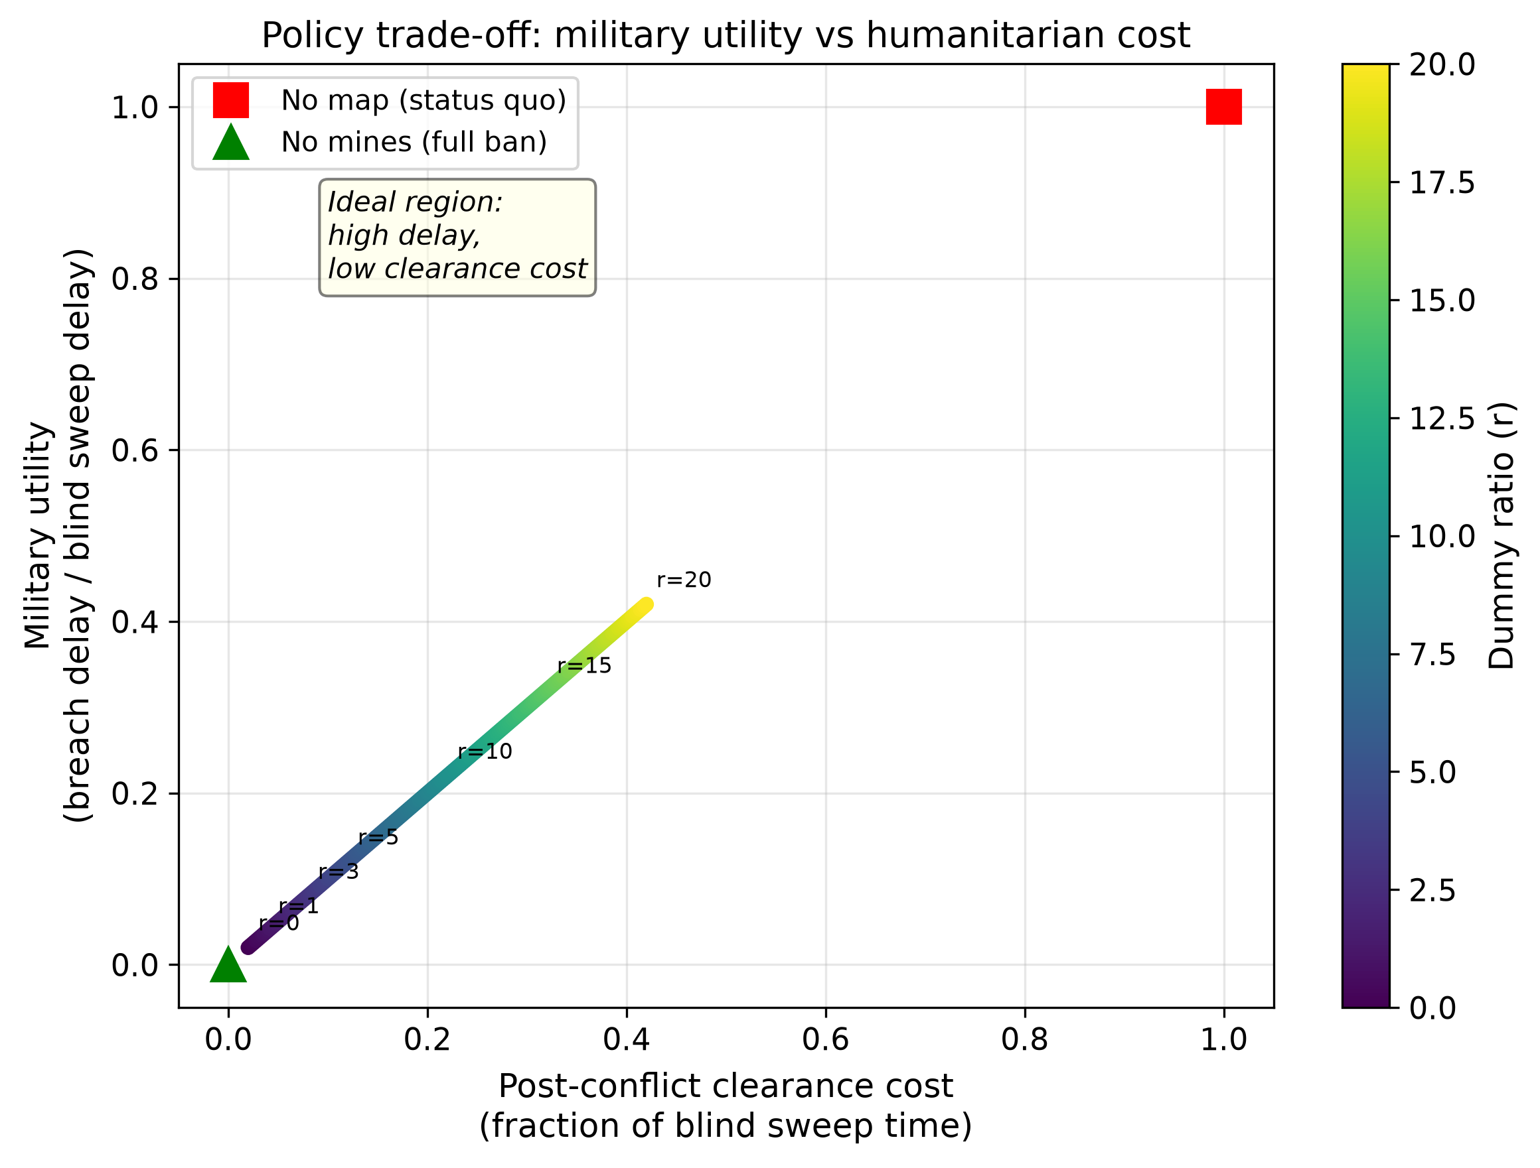
Figure 5. Policy trade-off space: military utility (normalised breach delay, y-axis) vs post-conflict clearance cost (normalised, x-axis). Colour: dummy ratio r. The MINE regime traces a curve from full information (origin) toward the status quo (upper right), with each r value representing a specific policy choice.

7.2 Verification and compliance mechanisms
The MINE regime is inherently more verifiable than existing arrangements. Three mechanisms enable compliance monitoring:
1. Publication verification: The existence and content of the map can be confirmed by an international registry (analogous to IAEA safeguards registries). Satellite imagery can verify that marked positions exist on the ground.
2. Ex post ratio verification: After conflict, clearance operations determine the actual ratio of real to dummy positions. Systematic deviation from the declared ratio constitutes a treaty violation.
3. Completeness testing: If a mine is discovered at a position not on the published map, this is an unambiguous treaty violation—far clearer than violations of self-destruct requirements, which are inherently unobservable.

7.3 Implementation architecture
Practical implementation requires three institutional components. First, a MINE Registry—a secure, append-only database maintained by a trusted third party (NATO Communications and Information Agency, ICRC, or a dedicated international body) to which deploying states submit position maps. The MINE Registry must accept map submissions (new minefield declarations) and supplements (additional positions added during conflict) but must not permit deletions or modifications of previously submitted entries. This append-only property preserves the completeness guarantee: if a state registers positions, they cannot later remove entries to conceal violations.
Second, a MINE verification protocol—procedures for confirming compliance both during and after conflict. During conflict, satellite imagery can verify that marked positions show ground disturbance consistent with emplacement. After conflict, clearance operations record whether each position contained a real mine or was dummy, enabling verification of the declared ratio.
Third, an enforcement mechanism—consequences for non-compliance. The most powerful enforcement arises naturally: if a state is found to have placed mines at unregistered positions, the fundamental safety guarantee of the regime is violated. This provides grounds for international sanctions, loss of treaty benefits (such as ally access to safe corridors during combined operations), and reputational costs comparable to chemical weapons violations.

7.4 Compatibility with existing frameworks
The MINE framework is designed to complement CCW Amended Protocol II. It extends the Protocol’s Article 7 recording requirements by: (a) mandating publication during deployment rather than only post-conflict; and (b) formalising the dummy position concept with a regulated ratio. States remaining within the CCW framework could adopt the MINE Protocol as an additional protocol or as a NATO-internal standard.
For states withdrawing from the Ottawa Convention, the framework offers a concrete mechanism to fulfil their stated commitment to “responsible use.” It could be adopted unilaterally (as a national policy), bilaterally (between neighbouring states), or multilaterally (as a NATO-wide standard). The framework is deliberately technology-neutral: it applies equally to hand-emplaced and mechanically laid mines, to permanent and scatterable systems, and to current and future mine designs.

7.5 Addressing potential objections
Objection 1: Publishing any map aids the attacker by revealing safe corridors. Response: The map reveals that positions not marked are safe, but all marked positions remain dangerous. The net military effect is quantified in Section 4: delay proportional to (1+r). Moreover, an attacker who would otherwise accept casualties and push through an unmapped field is forced into clearing when positions are explicitly marked—the published map makes the rational choice unambiguous.
Objection 2: The defender might place mines at unregistered positions. Response: This constitutes a clear, unambiguous treaty violation detectable through post-conflict clearance. Unlike self-destruct failures (which are indistinguishable from intact mines), unregistered mines provide forensic evidence of non-compliance.
Objection 3: Dummy positions waste post-conflict clearance resources. Response: Even at r = 20, map-based clearance is 2.4× faster than blind sweep and guarantees completeness. The “waste” of clearing dummy positions is trivial compared to the cost of sweeping an entire minefield area without guidance.
Objection 4: An adversary might not respect the map (attack through unmarked areas). Response: Unmarked areas are guaranteed mine-free, so this is not a risk to the attacker—it is the intended safe corridor. The defender designs the minefield such that all likely approach routes are covered by marked positions, forcing the attacker through them.

8. Application to Baltic Security

8.1 Threat model
The Baltic states face a specific threat model that makes the MINE framework particularly appropriate. Estonia, Latvia, and Lithuania share borders with Russia (and Belarus); face a significant conventional force imbalance; rely on delay and area denial to enable NATO reinforcement (which may require 10–30 days); and have limited territory depth, making every hour of delay operationally significant.
Finland’s situation is analogous at larger scale: its 1,340 km border with Russia includes numerous potential invasion corridors through terrain favourable to defensive mining (forests, defiles, lake constrictions). Finland’s withdrawal from the Ottawa Convention was explicitly framed as preparation for a defensive scenario in which mines would slow a Russian advance.

8.2 Lessons from Ukraine
Russia’s use of mines in Ukraine since 2022 provides empirical evidence directly relevant to the Baltic scenario. Three observations are pertinent. First, Russia has deployed mines extensively without recording or marking, creating a humanitarian crisis that will persist for decades—exactly the outcome the MINE framework prevents. Second, Ukrainian breach operations against Russian minefields confirm that clearance under fire imposes delays of 1–4 hours per corridor even with modern equipment, validating our model’s delay estimates. Third, the scale of post-conflict clearance required in Ukraine—estimated at 30% of the country’s territory—demonstrates the catastrophic humanitarian cost of unmapped mine deployment, providing a powerful policy argument for the transparent alternative.

8.3 Scenario analysis
Consider a Baltic state deploying transparent minefields with r = 7 along five key invasion corridors, each with parameters matching our baseline scenario (200 mines, 5 km front, 300 m depth). The aggregate effect:
• Military delay: 96 minutes per corridor × 5 corridors = 8 hours of total delay imposed on advancing forces (sequential breach required for each).
• Manpower diversion: Each corridor requires 10 engineer teams committed to clearance for 1.6 hours, diverting 50 engineer teams from other tasks.
• Post-conflict clearance: 5 corridors × 80 hours each = 400 team-hours total (approximately 17 days with 10 teams working 24/7). Zero residual mines.
• Comparison without map: Blind sweep of 5 corridors = 2,500 hours (104 days), with an expected 50 residual mines across all corridors.

8.4 Escalation and deterrence considerations
The MINE regime has an additional deterrence property: the published map itself serves as a credible signal of defensive preparation. Unlike hidden minefields (which the adversary may doubt exist) or announced but unverified deployments (which may be bluffs), a registered map with specific coordinates is a verifiable commitment. This enhances deterrence by eliminating uncertainty about whether defensive preparations have actually been made.
Conversely, the framework contains a built-in de-escalation mechanism. If security conditions improve, the defending state can reduce r (reducing military effectiveness but also clearance burden) or publish the real/dummy identities (converting the field to r = 0 or enabling immediate targeted clearance). This reversibility is unavailable for deployed mines without maps—once emplaced without records, mines cannot be “de-escalated” without expensive blind clearance.

8.5 Country-specific considerations
Estonia. Estonia’s land border with Russia is approximately 294 km, of which significant portions pass through terrain suitable for defensive mining (forests, wetlands, narrow corridors between Lake Peipus and the Gulf of Finland). The Estonian Defence Forces have identified specific invasion corridors where delay is most critical—particularly the Narva corridor in the northeast. With a population of 1.3 million and limited strategic depth (Tallinn is 200 km from the Russian border), every hour of delay at the border is operationally decisive. The MINE framework at r = 7–10 would provide 1.5–2.2 hours of delay per corridor whilst maintaining Estonia’s commitment to humanitarian mine use—a commitment explicitly stated during the 2024 National Defence Committee deliberations.
Latvia and Lithuania. Latvia shares 214 km of border with Russia and 161 km with Belarus; Lithuania borders Belarus for 679 km. The Suwalki Gap—the 65 km corridor between Belarus and the Russian exclave of Kaliningrad—represents NATO’s most vulnerable land connection to the Baltic states. Transparent minefields deployed along this corridor with moderate dummy ratios (r = 5–7) would impose significant delay on any attempt to sever the connection, whilst the published map would enable rapid post-crisis clearance to restore normal civilian and military transit.
Finland. Finland’s 1,340 km border with Russia—NATO’s longest—presents a different operational calculus. The vast length makes comprehensive mining impractical; instead, selective deployment at key choke points (road crossings, defiles, bridges) is the likely operational concept. Finland’s extensive Cold War experience with landmines (over 1 million destroyed after Ottawa ratification) provides institutional knowledge for implementing the MINE framework. The Finnish Defence Forces’ doctrine of territorial defence, which emphasises delay and attrition over decisive engagement, aligns naturally with a framework designed to maximise delay per mine deployed.

8.6 Comparison with alternative technologies
The 2024 Estonian Defence Forces assessment noted that “sufficient alternatives to passive mines” exist, including drones, cluster munitions, and other means (ERR News, 2024). However, these alternatives have distinct characteristics that the transparent map framework addresses differently:
• Drones and loitering munitions provide area denial through active engagement but require continuous communication, operator presence, and have limited endurance. They cannot provide persistent 24/7 denial of a fixed area for weeks or months. Minefields, including transparent ones, provide persistent denial without active monitoring.
• Anti-vehicle mines (not prohibited by Ottawa) provide obstacle value against mechanised forces but are ineffective against dismounted infantry—a significant component of Russian offensive doctrine as demonstrated in Ukraine. Anti-personnel mines complement anti-vehicle mines by preventing manual breaching of anti-vehicle obstacles.
• Conventional obstacles (wire, ditches, concrete barriers) are visible, predictable, and can be planned around. The MINE framework preserves the key advantage of mines: uncertainty about which specific positions are lethal, forcing the attacker to treat all as dangerous.

8.7 Implementation timeline
The Ottawa Convention requires twelve months between notification and effective withdrawal. This creates an implementation window during which withdrawing states can develop operational procedures for the MINE framework. A realistic timeline would be:
• Months 1–4: Develop national implementation regulations; establish secure registry infrastructure; train engineer units in dual-purpose (real + dummy) emplacement procedures.
• Months 5–8: Conduct bilateral negotiations with neighbouring allies on dummy ratio standards; establish information-sharing protocols for allied safe passage; integrate with existing NATO minefield reporting systems (STANAG 2036).
• Months 9–12: Field exercises validating emplacement, publication, and clearance procedures; live testing of verification protocols; final establishment of international registry.
• Month 12 onwards: Operational readiness for transparent minefield deployment. Pre-planned defensive minefields can be prepared (positions identified, dummies located) awaiting only actual mine emplacement in crisis.

8.8 NATO standardisation potential
The MINE framework is well-suited for adoption as a NATO standard (STANAG). Its advantages for alliance-wide implementation include: (a) interoperability—allied forces can access the published map for safe passage; (b) burden-sharing—post-conflict clearance can be allocated to any NATO engineer unit with the map; (c) political legitimacy—adoption as a NATO standard demonstrates collective commitment to humanitarian norms even while re-introducing mines for defensive purposes.

9. Limitations and Assumptions
Several limitations of the present analysis should be acknowledged. First, the model assumes a static minefield with positions fixed before conflict. In practice, minefields may be modified during hostilities—positions added, mines relocated, or new scatterable mines deployed. The framework would need to accommodate map updates, raising questions about update frequency and verification during active conflict. One possibility is a blockchain-based timestamped registry that accepts additions but not deletions, preserving the completeness guarantee even during dynamic operations.
Second, we assume the attacker treats all positions as independent. In reality, spatial correlations exist: mines are typically deployed in patterns (rows, clusters, mixed with anti-vehicle mines). If the attacker can observe such patterns from the published map, they might use this structural information to estimate which positions are real. The defender’s best response—deploying dummies with identical spatial statistics—mitigates this, but sophisticated machine learning approaches might extract subtle distinguishing features. The practical significance of this limitation depends on the resolution of the published map and the defender’s operational security practices.
Third, our cost parameters (c_clear = USD 500, C_cas = USD 1,000,000) are representative of Western military operations. Different adversaries may have very different cost structures. As shown in the sensitivity analysis (Section 6.5), the framework remains effective even against adversaries with substantially lower casualty costs, but the policy implications (optimal r) may differ.
Fourth, the model does not account for combined-arms effects. In practice, mine clearance is conducted under fire, and the interaction between defensive fire and mining significantly increases effective delay. This suggests our delay estimates are conservative—actual delay imposed will likely exceed the clearance time alone due to suppression, casualties among clearance crews, and the need for supporting operations.
Fifth, we assume perfect compliance by the defender. If the defending state places mines at positions not registered on the map, the zero-residual property fails. However, this constitutes a clear treaty violation with forensic evidence (the unregistered mine itself), unlike violations of self-destruct requirements which produce no evidence. The framework’s verification advantages create incentives for compliance that other mechanisms lack.

9.1 Asymmetry in non-international armed conflict
A critical question arises in non-international armed conflicts: if only the state actor publishes under the MINE regime while the non-state adversary operates at r = ∞ (no disclosure), does this create an exploitable asymmetry? The concern is that the government’s maps reveal information about defensive dispositions while rebel forces retain full uncertainty.
The model provides a precise answer. Setting delay_map(r) equal to delay_blind and solving for the equivalence point:
N × (1 + r) × t_{clear} / W = D × t_{probe} / δ²
Solving for r:
r* = (W × D × t_{probe}) / (N × t_{clear} × δ²) − 1
Substituting baseline parameters: r* = (5000 × 300 × 5) / (200 × 30 × 25) − 1 = 50 − 1 = 49. At r = 49, the MINE regime imposes exactly the same delay on the attacker as a completely undisclosed minefield. The attacker gains no advantage from the published map because at this ratio, clearing all marked positions takes precisely as long as blind sweeping the entire breach lane. However, the post-conflict outcomes are starkly different: the map regime guarantees zero residual mines, whereas the undisclosed minefield leaves an expected 10 residual mines after clearance (at p_detect = 0.95).
This yields a crucial insight for non-international armed conflicts: a state operating at r = 49 concedes nothing in military terms relative to a non-state adversary using undisclosed mines, while securing complete post-conflict safety for its own population. For lower values of r preferred on policy grounds (r = 5–20), the military asymmetry exists but is partially offset by two factors. First, state forces possess complementary capabilities—surveillance, artillery, air power—that amplify minefield effectiveness through force multiplication (Section 4.3). Second, state forces typically have intelligence capabilities (aerial reconnaissance, signals intelligence, informant networks) that partially reveal non-state actor mine locations, reducing the effective adversary r below infinity. The information asymmetry is therefore bidirectional, not unilateral.
Moreover, the zero-residual property depends only on the defender’s own compliance, not the adversary’s. Even if a non-state actor uses undisclosed mines, the state’s own published map ensures that all state-emplaced mines are fully cleared after conflict. This unilateral benefit requires no reciprocity—a significant advantage over treaty mechanisms that depend on mutual compliance.

9.2 Non-state actors and collective response
The MINE framework applies exclusively to state actors operating within the law of armed conflict. Non-state armed groups (NSAGs) and terrorist organisations remain outside the scope of treaty-based regulation—a limitation shared with all existing instruments including the Ottawa Convention and CCW Amended Protocol II. However, this shared limitation does not preclude complementary mechanisms specifically addressing non-state mine use.
We propose a Collective Response Mechanism (CRM) as an institutional complement to the MINE framework. The CRM would operate on three principles:
First, automatic assistance: when NSAG mine use is confirmed in a signatory state’s territory, treaty parties assume a collective obligation to provide humanitarian mine clearance funding and technical assistance. This socialises the clearance burden created by actors beyond treaty control and provides immediate benefit to affected civilian populations.
Second, state responsibility for proxies: states that supply mines to non-state actors or provide material support for NSAG mining operations incur liability under the framework. NSAG mine use serves as an automatic trigger for sanctions review against identified state sponsors. This creates upstream incentives to restrict mine transfers to non-state actors, complementing existing arms embargo mechanisms under UN Security Council resolutions.
Third, differentiated legitimacy: the framework establishes a clear legal and normative distinction between “responsible use” (states publishing transparent maps within the regulated r parameter) and “irresponsible use” (any mine deployment without position disclosure). This binary classification strengthens the normative case against NSAG mine use by providing a concrete, verifiable standard of responsible behaviour that NSAGs manifestly fail to meet. It also provides legal clarity for states re-introducing mines: compliance with the MINE Protocol demonstrates good faith commitment to humanitarian norms, insulating compliant states from the stigma associated with indiscriminate mine use.
Precedent for such mechanisms exists. The Geneva Call initiative has secured “Deeds of Commitment” from over 60 non-state armed groups pledging mine non-use—demonstrating that normative pressure can reach beyond treaty law. The MINE framework strengthens this norm by making the distinction between responsible and irresponsible use operationally concrete and externally verifiable.

9.3 Border changes and map continuity
Conflicts that alter territorial boundaries raise a distinct challenge: minefields emplaced as border defences may end up in territory controlled by the former adversary. Under CCW Amended Protocol II Article 9, parties are obligated to transfer minefield records to the opposing party and to the UN Secretary-General upon cessation of hostilities. However, this obligation relies on post-conflict cooperation—precisely the condition least likely to obtain after territorial conquest.
The MINE framework resolves this problem by design. Because maps are published before or during conflict, the information is already in the public domain regardless of subsequent territorial changes. Four scenarios illustrate this:
Defence succeeds (borders maintained): Standard case. The defending state clears its own published positions using the map. Zero residual guaranteed.
Territory lost (occupation): The occupying power has full access to the published map and can clear all marked positions in the occupied territory. Unlike the CCW regime, no bilateral negotiation for record transfer is needed. The map’s pre-publication eliminates dependence on defeated state cooperation.
Territory recaptured: If the adversary also operated under the MINE regime, their published positions enable systematic clearance of enemy-emplaced mines in recaptured territory. If the adversary did not publish (non-signatory or non-state actor), the recapturing state faces the same blind-sweep problem as under the status quo—but its own mines remain fully mapped and clearable.
Negotiated border adjustment: In cases of agreed territorial exchange (e.g., post-conflict peace treaty adjusting borders), the published map provides complete information to the receiving state without requiring additional diplomatic arrangements. This facilitates rapid civilian resettlement in transferred territories.
The permanence of published information is further strengthened by the proposed registry architecture (Section 7.3). An append-only international registry—whether maintained by the UN, a dedicated treaty organisation, or implemented as a distributed ledger—ensures that map data persists independently of the emplacing state’s continued existence or cooperation. Even in scenarios of state collapse (as occurred in Yugoslavia or the Soviet Union), the registry preserves mine location data for successor states, international organisations, or humanitarian clearance agencies.
This property is particularly relevant for refugee return. Displaced populations can consult the published map to identify safe corridors and cleared zones, enabling phased return aligned with clearance operations. The deterministic endpoint—once all published positions are cleared, the area is certifiably safe—provides a level of assurance that probabilistic clearance methods cannot match, accelerating the political and practical conditions for post-conflict reconstruction.
Finally, the political feasibility of gaining acceptance for any framework that legitimises mine use—however constrained—should not be underestimated. The Ottawa Convention’s norm-setting achievement has created strong institutional resistance to any proposal perceived as weakening the prohibition. We argue that the MINE framework should be positioned not as a weakening but as a strengthening of post-conflict humanitarian outcomes: it provides a safety guarantee (zero residual) that even full Ottawa compliance cannot offer for states that withdraw and use mines without constraints.

10. Conclusion
This paper has presented the MINE framework (Mapping Is Not Exposure) for anti-personnel mines, reconciling military utility with humanitarian guarantees through a single, tuneable parameter: the dummy ratio r. The MINE framework transforms the binary choice between total prohibition (Ottawa Convention) and unrestricted use into a continuum of policy options that can be tailored to specific security contexts and negotiated through treaty mechanisms.
Our analysis establishes three core properties:
1. Military effectiveness is preserved. Breach delay scales linearly with (1+r). Game-theoretic analysis confirms that rational attackers will clear all positions for any plausible treaty-regulated ratio (r* = 299 under baseline parameters). The minefield retains full delay capability.
2. Post-conflict safety is guaranteed. The zero-residual property ensures that clearing all map positions removes every real mine—a deterministic guarantee superior to any probabilistic detection method or mechanical self-destruct mechanism.
3. Treaty compliance is verifiable. Map publication is observable, dummy ratios are testable ex post, and violations (unregistered mines) are unambiguously detectable.
A fourth property deserves particular emphasis: unilateral benefit without reciprocity. As demonstrated in Section 9.1, a state operating at r = 49 achieves exactly the same breach delay as a completely undisclosed minefield. This means that even in conflict with a non-signatory adversary—whether a state that has not ratified the framework or a non-state armed group—the defending state sacrifices nothing in military terms by publishing its map. Yet the post-conflict dividend is transformative: upon cessation of hostilities, every position on the published map is systematically cleared, yielding a deterministic guarantee of zero residual mines in the state’s own defensive zones. Reconstruction, refugee return, and agricultural resumption can commence immediately in cleared areas without the years-long uncertainty characteristic of unmapped minefields.
This unilateral benefit structure has profound implications for treaty adoption dynamics. Classical arms control faces a prisoner’s dilemma: each state benefits from others’ compliance but is tempted to defect. The MINE framework inverts this logic. A state benefits from its own compliance regardless of others’ behaviour—the zero-residual property depends solely on the defender’s map accuracy, not the adversary’s participation. Ratification is therefore a dominant strategy: it improves post-conflict outcomes for the ratifying state under all scenarios (adversary ratifies, adversary does not ratify, adversary is a non-state actor). This eliminates the principal barrier to multilateral adoption and makes unilateral or small-coalition implementation viable as a first step.
For the Baltic states and Finland, this framework provides an operationally credible middle path at a critical juncture. Rather than returning to unrestricted mine use (accepting humanitarian costs) or remaining within a prohibition that sacrifices military utility (accepting security costs), these states could adopt the MINE regime as a NATO-wide standard. In doing so, they would demonstrate that responsible deterrence and humanitarian norms are not merely compatible but complementary—that publishing a minefield map is simultaneously an act of military preparation and an act of humanitarian commitment.
The policy window for adoption is narrow but open. With five NATO states in various stages of Ottawa Convention withdrawal, the next 12–24 months will determine whether these states develop individual, potentially divergent mine employment practices or converge on a common standard. The MINE framework offers an immediate, implementable standard requiring no new technology, no novel legal instruments beyond existing CCW mechanisms, and no compromise of either military utility or humanitarian principles.
Future research should address several extensions. First, dynamic scenarios where the published map is updated during conflict to reflect scatterable mine deployment or repositioning of existing fields. Second, interaction between transparent minefields and other defensive systems, particularly anti-vehicle mines and direct fire coverage, which amplify the delay effect beyond what our model captures. Third, the political economy of multilateral dummy ratio negotiation, including bargaining dynamics between states with different threat perceptions. Fourth, empirical calibration of clearance time parameters using data from ongoing mine clearance operations in Ukraine, which provide an unprecedented volume of real-world measurement under field conditions.
We note that the MINE framework is immediately implementable using existing technology and legal mechanisms. No novel mine designs, no new sensors, and no untested verification technologies are required. The only innovation is informational: the commitment to publish a map, and the agreement on how many positions it may contain. This simplicity is a feature, not a limitation—it means adoption can proceed in parallel with the withdrawal process, providing operational standards from day one of resumed mine use.
The MINE framework is, ultimately, an information-theoretic innovation applied to a humanitarian problem. It recognises that the harm caused by landmines is not only physical but informational: it is the uncertainty about mine locations that makes post-conflict land unusable and clearance so expensive. By structuring that uncertainty as a controlled parameter—published, bounded, and treaty-regulated—the MINE framework converts an intractable post-conflict problem into a finite, plannable task with a guaranteed end state.

References
Aalto NDU (2020) Defensive Minefield Planning using Network Interdiction Models. Master’s thesis, Aalto University / Finnish National Defence University.
ERR News (2024) ‘EDF commander: Estonia does not need to leave the Ottawa Convention right now’, ERR, 16 December. Available at: https://news.err.ee/1609552774 (Accessed: 15 June 2025).
Hendricks, K. (2006) ‘Feints’, Journal of Economics & Management Strategy, 15(2), pp. 431–456.
ICBL (2023) Landmine Monitor 2023. Geneva: International Campaign to Ban Landmines.
ICRC (2024) Banning Anti-Personnel Mines: The Ottawa Treaty Explained. Geneva: International Committee of the Red Cross.
Kanazawa, T., Iida, K. and Morimoto, S. (2018) ‘Risk evaluation and games in mine warfare considering shipcounter effects’, European Journal of Operational Research, 267(1), pp. 278–288.
Norwegian People’s Aid (2007) M85: An Analysis of Reliability. Oslo: Norwegian People’s Aid.
Reuters (2024) ‘Finland considering exiting anti-personnel landmine treaty, minister says’, Reuters, 18 December.
Reuters (2025) ‘Finland to exit landmines treaty, hike defence spending given Russia threat, PM says’, Reuters, 1 April. Available at: https://www.reuters.com/world/europe/finland-plans-withdraw-landmines-treaty-prime-minister-says-2025-04-01/ (Accessed: 15 June 2025).
UNODA (2023) CCW Amended Protocol II. Geneva: United Nations Office for Disarmament Affairs. Available at: https://disarmament.unoda.org/ccw/amended-protocol-ii/ (Accessed: 15 June 2025).
US Army (1985) FM 5-102: Countermobility. Washington, DC: Department of the Army.
US Army (1988) FM 90-2: Battlefield Deception. Washington, DC: Department of the Army.
Zhuang, J., Bier, V.M. and Alagoz, O. (2010) ‘Modeling secrecy and deception in a multiple-period attacker–defender signaling game’, European Journal of Operational Research, 203(2), pp. 409–418.

