Supplementary material
Supplementary Figure 1. Closed malpractice claims per 1,000 physicians by specialty, 2008-2024 (rates, not counts).
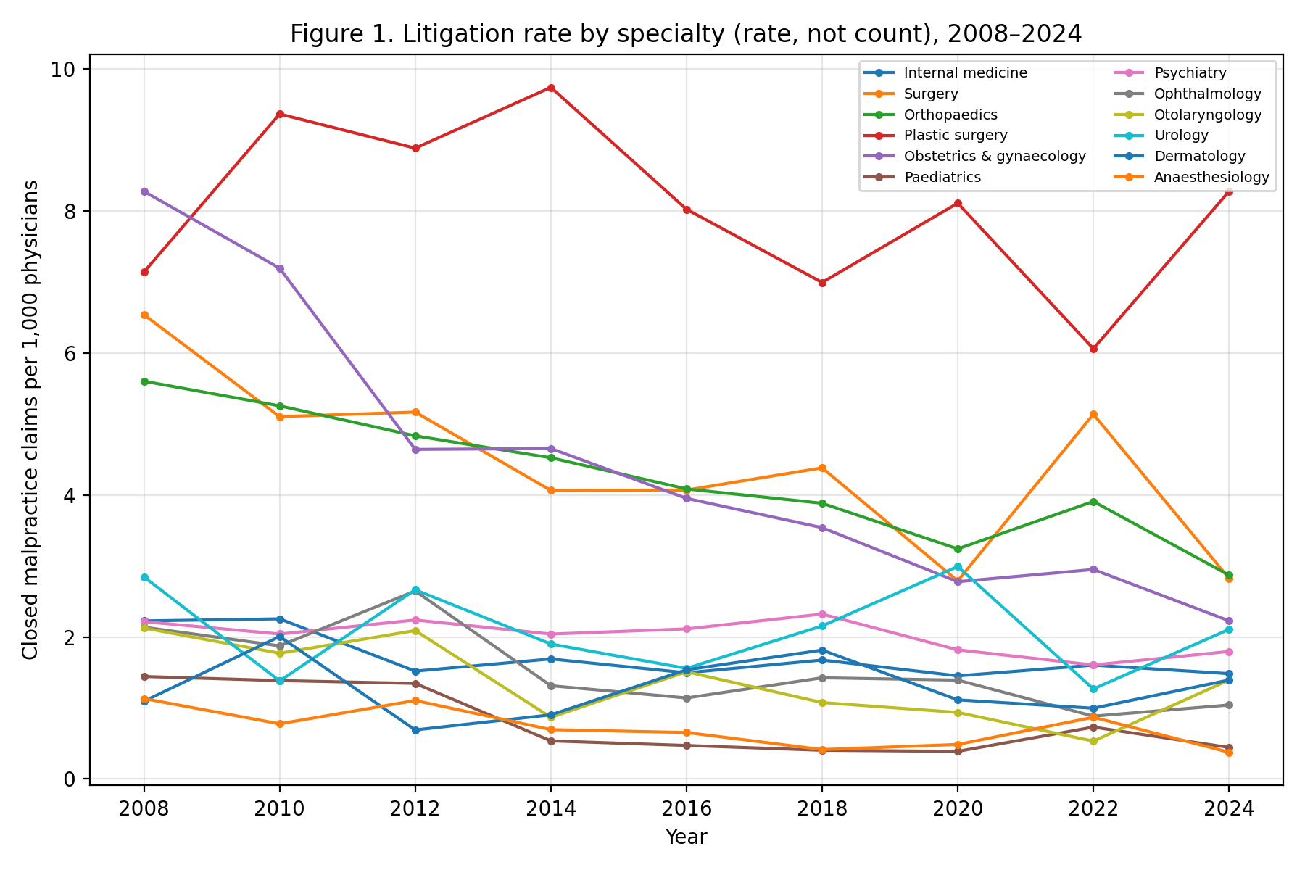

Supplementary Figure 2. Physician workforce by specialty, indexed to 2008 (=100).
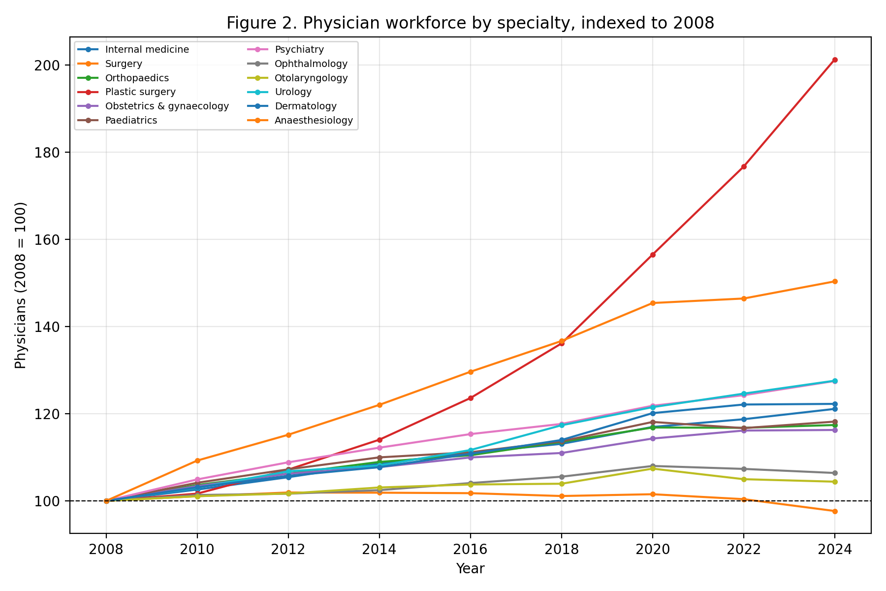

Supplementary Table 1. Primary data sources and their resolution.
Series | Source | Resolution | Years | Role
Physicians by specialty | MHLW Statistics of Physicians | Biennial | 2004-2024 | Denominator & outcome
Closed malpractice claims | Supreme Court, by specialty | Annual | 2008-2024 | Exposure (numerator)
Hospitals by specialty | MHLW Survey of Medical Institutions | Annual | 2008-2024 | Outcome
Clinics by specialty | MHLW Survey (static) | Every 3 years | 2008-2023 | Descriptive only
JMSR report counts | JMSR / MAIS | Annual | 2015-2024 | Sensitivity (2016-2024)
Newspaper article counts | Nikkei Telecom 21 | Annual | 2008-2018 | Sensitivity (2009-2018)

Supplementary Table 2. Equivalence (TOST) results (effect per +1 SD litigation rate).
Outcome | Coef per SD | 90% CI | Margin | TOST p | Equivalent
Physician growth | -0.21% | -0.84%, +0.42% | ±1% | 0.023 | Yes
Physician growth | -0.21% | -0.84%, +0.42% | ±2% | 0.000 | Yes
Hospital growth | +0.07% | -0.91%, +1.06% | ±1% | 0.059 | No
Hospital growth | +0.07% | -0.91%, +1.06% | ±2% | 0.002 | Yes

Supplementary Table 3. JMSR-adjusted annual hospital growth model (2016-2024) with both exposures entered simultaneously.
Exposure | Coefficient | p | n
Lagged litigation rate | +0.0021 | 0.26 | 108
Lagged JMSR report rate | -0.0009 | 0.66 | 108

Supplementary Table 4. Media-adjusted annual hospital growth model (2009-2018) with a linear time trend; full year fixed effects are omitted because the national article-count series is collinear with them.
Exposure | Coefficient | p | n
Lagged litigation rate | -0.0003 | 0.71 | 120
Lagged media count (per 1,000 articles) | -0.0014 | 0.18 | 120

