Population-level replacement of interferon-based standard therapy for hepatitis C after interferon-free direct-acting antivirals: a new-treatment-anticipation / practical-drug-lag analysis of Japan's NDB Open Data

Abstract
Background: If population-level anticipation of a newly reported/reimbursed treatment is real, use of the prior standard therapy should fall sharply once the awaited option arrives; if not, either the anticipation/practical lag is absent or decision-makers are not reacting to the news. Methods: Using Japan's NDB Open Data (2014-2023), we tracked national dispensed quantity of interferon (IFN)-based standard therapy (peginterferon, ribavirin) and of interferon-free direct-acting antivirals (DAAs) for hepatitis C, against official approval/reimbursement milestones. Results: Peginterferon dispensing fell 99.2% from FY2014 to FY2023; ribavirin reached near-zero by FY2018. Total DAA dispensing peaked in FY2015 (19.4 million units, +188% vs FY2014) and then fell 92% by FY2023. Conclusion: The IFN-based standard therapy was replaced at the population level within about two years, and the DAA surge-then-decay is consistent with a finite pool of long-waiting patients being treated in a burst (pent-up demand) rather than steady substitution.

Introduction
When a new therapy is announced through the media or scheduled for reimbursement, advocates of the new treatment expect a population-wide shift away from the current standard of care. Chronic hepatitis C offers an unusually clean natural experiment: interferon-based therapy was the standard until interferon-free DAAs arrived in Japan in 2014-2015, when daclatasvir plus asunaprevir became the world's first all-oral, interferon- and ribavirin-free regimen¹. We use nationwide dispensing counts from NDB Open Data² to test whether the standard therapy was displaced at the population level around these announcement/reimbursement events.

Methods
We used NDB Open Data editions 1-10 (fiscal years 2014-2023)², extracting the national total dispensed quantity (総計/処方数量) for each drug from the sex- and age-stratified prescription-drug tables (oral, topical, injectable). Drugs were classified by their actual product names into IFN-based standard therapy (peginterferon, ribavirin) and 9 interferon-free DAA products. Three first-generation NS3/4A protease inhibitors (simeprevir, telaprevir, vaniprevir), which were used together with peginterferon and ribavirin rather than as interferon-free regimens, were tabulated separately and excluded from the DAA group. Conventional interferon is reported separately because it is not hepatitis-C-specific. The metric is dispensed quantity (tablets/capsules for oral drugs, syringes/vials for injections), not a patient count, and is compared within a product over time. Official approval and NHI drug-price listing milestones^{1,3} were used as intervention markers at fiscal-year resolution (Table 1).
Table 1. Official approval / NHI drug-price listing milestones used as intervention markers.
FY | Date | Drug | Milestone | Source
2014 | 2014-07-04 | daclatasvir + asunaprevir | approval | 承認年月日 2014-07-04 (スンベプラカプセル/ダクルインザ錠 添付文書); Bristol-Myers Squibb K.K. press release 2014-07-04
2014 | 2014-09-02 | daclatasvir + asunaprevir | NHI listing | 薬価基準収載日 2014-09-02 (添付文書); 発売 2014-09-03 (BMS press release 2014-09-03)
2015 | 2015-03-26 | sofosbuvir | approval | ソバルディ錠 承認年月日 2015-03-26 (添付文書 / インタビューフォーム)
2015 | 2015-05-20 | sofosbuvir | NHI listing | 薬価収載 2015-05-20 (中医協 2015-05-13 総会決定; 厚労省保険局医療課通知 保医発0519第1号)
2015 | 2015-07-03 | ledipasvir/sofosbuvir | approval | MHLW 製造販売承認 2015-07-03 (朝日新聞 2015-07-04 報道; 添付文書)
2015 | 2015-08-31 | ledipasvir/sofosbuvir | NHI listing | ハーボニー配合錠 薬価収載日 2015-08-31 (添付文書)
2017 | 2017-09-27 | glecaprevir/pibrentasvir | approval | 製造販売承認 2017-09-27 (PMDA/MHLW; AbbVie GK)
2017 | 2017-11-22 | glecaprevir/pibrentasvir | NHI listing | マヴィレット配合錠 薬価収載日 2017-11-22 (中医協 2017-11-15 総会決定; 添付文書); 発売 2017-11-27
Statistical analysis. Because NDB begins in FY2014, coincident with IFN-free DAA availability, there is no pre-intervention baseline and a conventional pre/post interrupted time series is not identifiable; with 10 annual national observations we therefore fitted descriptive trend models. Total DAA dispensing was modelled by continuous segmented (broken-stick) log-linear regression with a knot at the observed peak fiscal year, estimating pre- and post-peak annual multiplicative rates of change; each IFN-based drug was modelled by exponential (log-linear) decay over fiscal years with positive dispensing. Uncertainty was expressed as heteroskedasticity- and autocorrelation-consistent (Newey-West, maxlags=1) 95% intervals⁴, cross-checked by a residual bootstrap (10,000 resamples)⁵. These quantify how fast dispensing changed and its uncertainty; they are not causal estimates. Analyses used Python (statsmodels); the full pipeline (download -> build -> analyze -> figures) is openly reproducible.

Results
The interferon-based standard therapy collapsed after IFN-free DAAs became available (Fig. 1). Peginterferon dispensing fell 99.2% from FY2014 to FY2023, and ribavirin reached near-zero by FY2018. In the trend models this corresponded to peginterferon declining 36% per year (95% CI 24-47%), ribavirin 76% per year (95% CI 60-85%; FY2014-FY2019), and conventional interferon 25% per year (95% CI 24-26%).
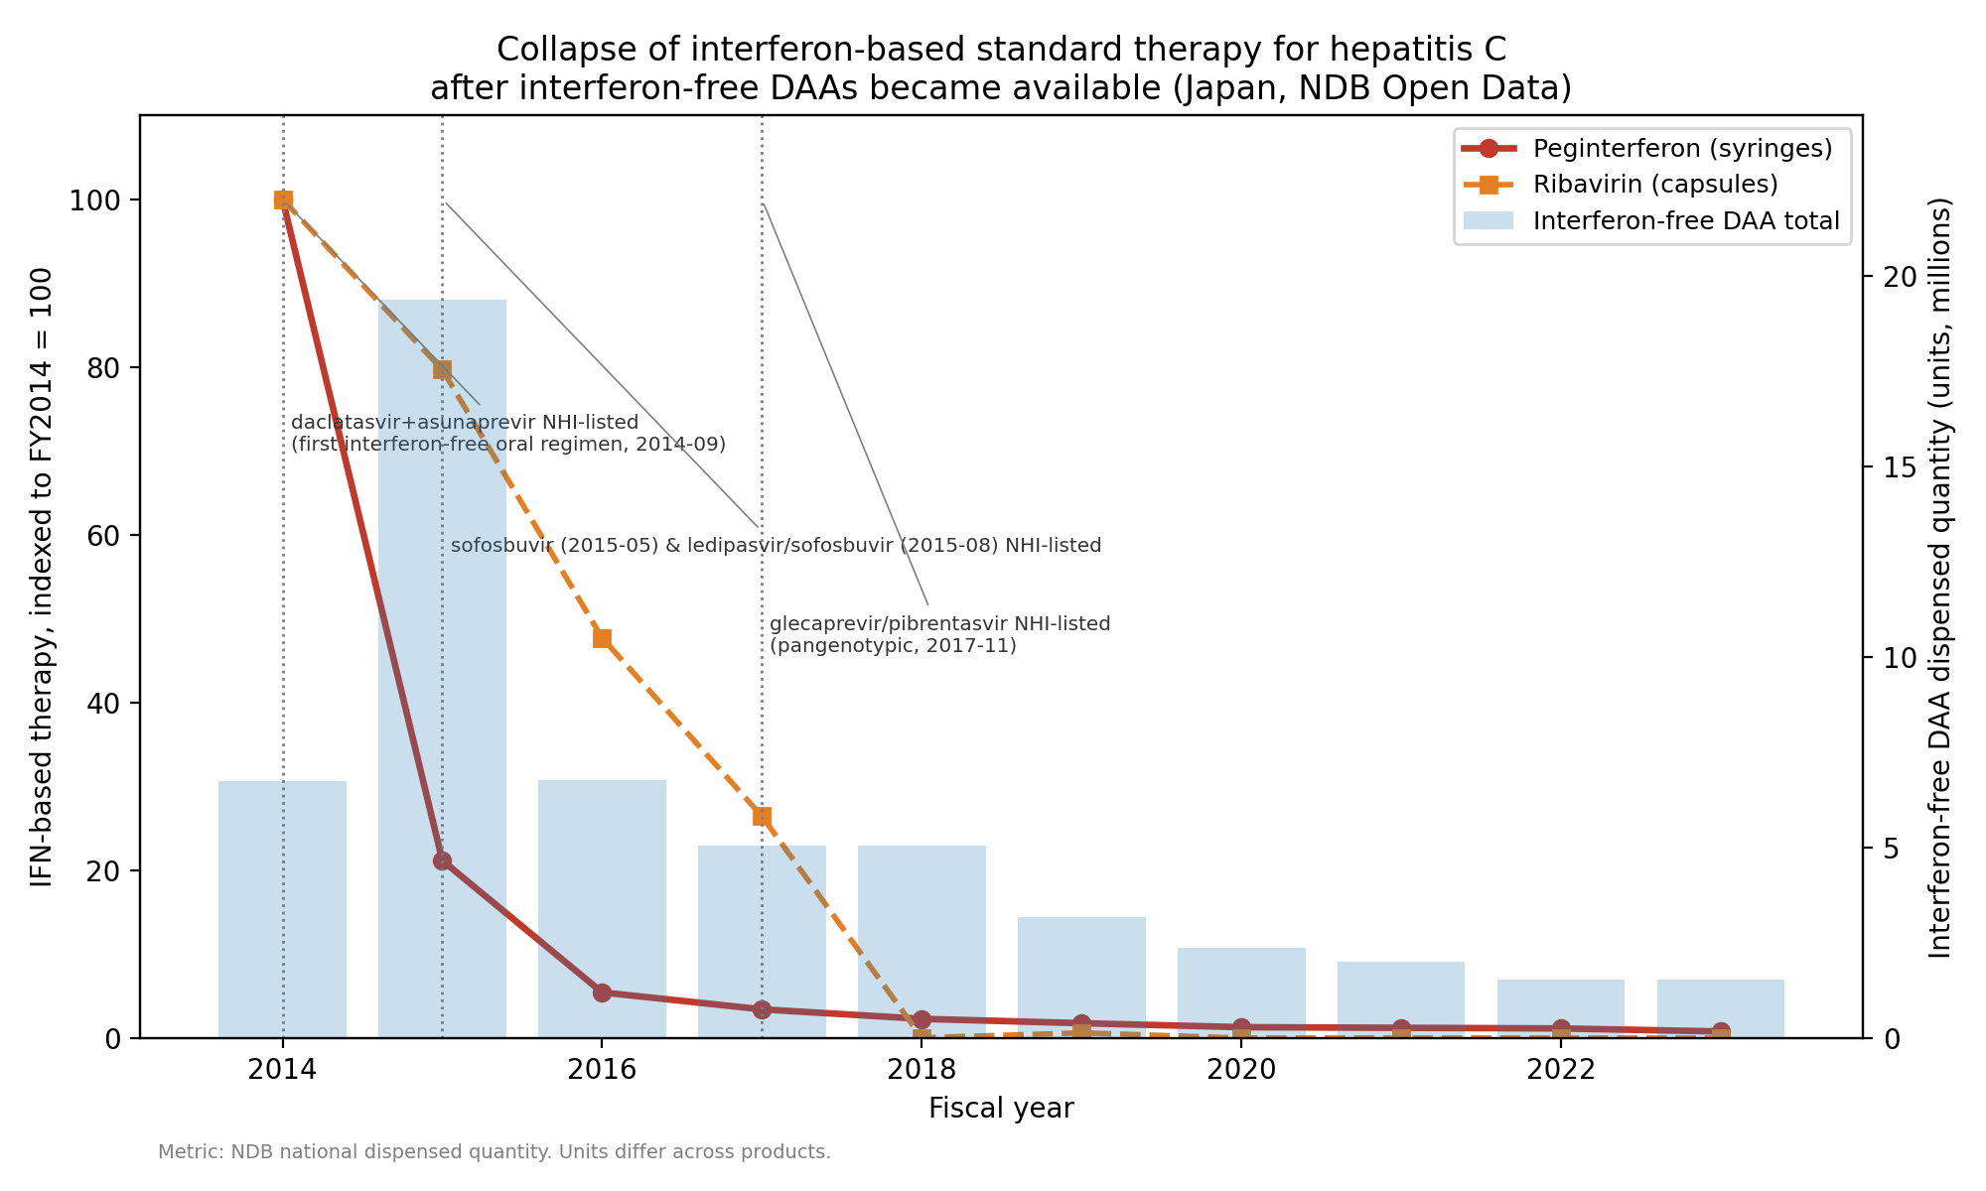
Fig. 1. Collapse of interferon-based standard therapy (indexed to FY2014 = 100) with total DAA dispensed quantity and dated announcement markers.
DAA use itself showed a surge-then-decay pattern (Fig. 2): total DAA dispensing peaked in FY2015 at 19.4 million units (+188% vs FY2014) and then declined 92% to 1.5 million units by FY2023, with successive products replacing earlier ones. In the segmented model, DAA dispensing declined 25% per year after the FY2015 peak (95% CI 20-29%), and the post-peak slope differed significantly from the pre-peak slope (P=0.000).
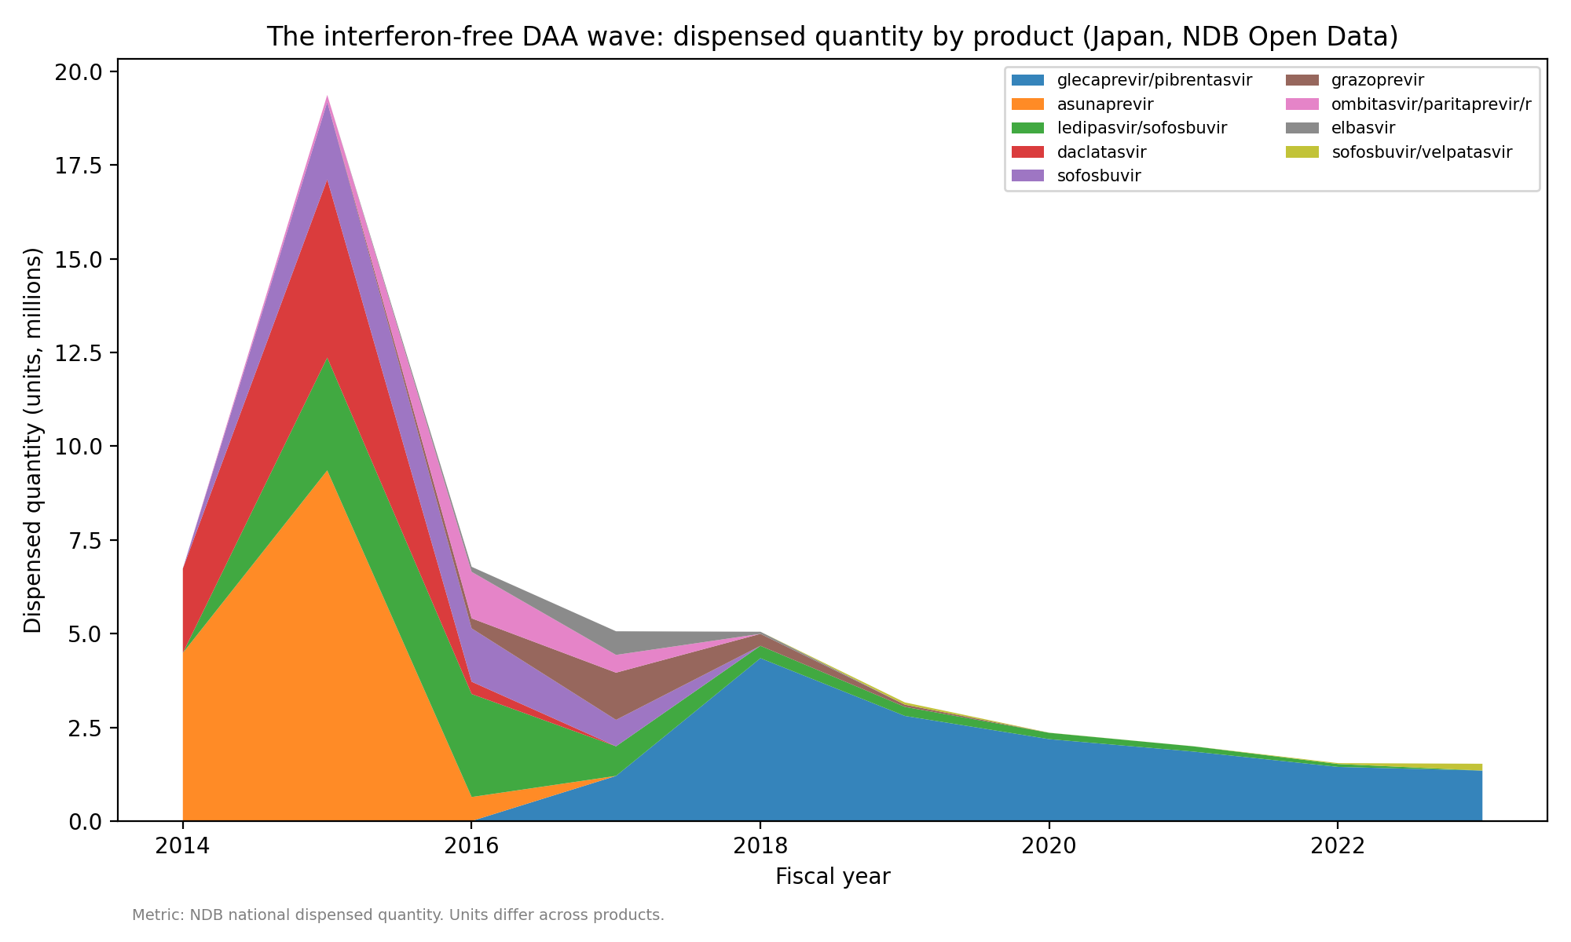
Fig. 2. The DAA wave: dispensed quantity by product.
To give a rough sense of the practical patient scale (dispensed quantity is not a patient count), we converted the dispensed quantity of each interferon-free DAA to approximate full treatment courses using documented per-course unit counts (daily dose x standard duration), counting one anchor component per two-drug regimen to avoid double-counting. This yields an estimated peak of about 89,858 courses in FY2015 and an estimated 265,914-297,637 courses over FY2014-FY2023 (duration-sensitivity range). These figures are explicit estimates dependent on the regimen assumptions and are not observed patient counts.

Discussion
For hepatitis C DAAs there was no population-level practical lag: the standard therapy was displaced within about two years of the announcements/listings, indicating that decision-makers reacted rapidly. The DAA surge-then-decay is consistent with a finite stock of long-waiting patients being cured in a burst (pent-up demand) rather than a steady replacement flow. This is descriptive evidence supporting the anticipation hypothesis; it does not by itself establish that media coverage caused individual treatment choices. External pre-2014 utilization data (e.g. national hepatitis programmes or society statistics) would be needed to quantify the full pre-DAA interferon baseline and are outside NDB; our claim is therefore limited to the speed of within-NDB displacement.

Limitations
NDB Open Data begins in FY2014, the same period IFN-free DAAs launched, so there is no pre-DAA interferon baseline within NDB; the FY2014 value already reflects decline from the pre-2014 peak. The metric is dispensed quantity, not patient counts, and units differ across products, so the summed DAA quantity is not a patient count. Data are annual, precluding within-year interrupted time-series or formal causal estimation; the reported trend rates carry wide uncertainty intervals given the small number of annual observations (n=10), and no control condition or placebo event is included. Secular changes from FY2020 onward, including the COVID-19 pandemic's effect on outpatient visits and prescribing, may also have influenced later dispensing and cannot be separated from the ongoing DAA decline.

Conclusion
In hepatitis C, the interferon-based standard therapy was replaced at the population level within about two years of interferon-free DAAs, and the surge-then-decay of DAA use is consistent with realized pent-up demand. This supports the existence of population-level new-treatment anticipation for this case, while cautioning that the same pattern need not generalize to therapies with weaker anticipation or greater practical constraints.

Data and code availability
Raw NDB Open Data workbooks are publicly available from MHLW and are re-downloadable via scripts/download_ndb.py; derived datasets, analysis code and figure/manuscript generators are in the project repository.

References
1. Bristol-Myers Squibb K.K. Press release: approval in Japan of the world's first all-oral, interferon- and ribavirin-free treatment for chronic hepatitis C (daclatasvir + asunaprevir). 4 July 2014.
2. Ministry of Health, Labour and Welfare (Japan). NDB Open Data (1st-10th editions). https://www.mhlw.go.jp/ndb/opendatasite/ (accessed for fiscal years 2014-2023).
3. Ministry of Health, Labour and Welfare / Central Social Insurance Medical Council (Chuikyo). NHI drug-price listings of direct-acting antivirals for hepatitis C (2014-2017).
4. Newey WK, West KD. A simple, positive semi-definite, heteroskedasticity and autocorrelation consistent covariance matrix. Econometrica. 1987;55(3):703-708.
5. Efron B, Tibshirani RJ. An Introduction to the Bootstrap. New York: Chapman & Hall; 1993.

