SITS9: A Stitch-in-Time Language Unifying Music, Textile, and Cuisine through Operational Homology

[Author name(s) and affiliation(s) to be inserted]

Submitted to: Leonardo, MIT Press — General Article

Abstract
We propose SITS9 (A Stitch in Time Saves Nine), a minimal domain-specific language consisting of five primitive instructions -- FWD, RET, CROSS, TENSION, and ANCHOR -- that can simultaneously describe musical chord progressions, sewing/embroidery patterns, and cooking procedures. By defining domain-specific renderers (a 'loom renderer' for textile SVG, a 'tone renderer' for MIDI music, and a 'kitchen renderer' for text-based recipes), a single SITS9 program (called a Deck) produces valid, aesthetically coherent output in all three domains. We demonstrate the system using Pachelbel's Canon (I-V-vi-iii-IV-I-IV-V) as a test case and argue that the operational homology reflects both historical fact -- the Jacquard loom and music-box punch-card convergence, and the Inca quipu as a precursor of cross-domain encoding -- and a deeper cognitive universality in how humans structure temporal processes. We further discuss applications to cryptographic steganography (textile ciphers), palette constraints and cultural identity, physical-object steganography via femtosecond laser inscription, and the design of cross-modal workshops in which a single Deck generates cuisine, handicraft, and music as parallel experiences.
Keywords: SITS9; domain-specific language; operational homology; Jacquard loom; quipu; steganography; cross-modal workshop; chord progression; sashiko; computational craft

1. Introduction: 'Moving Forward by Going Back'
The Japanese back stitch (kaeshi-nui) is defined by a single kinetic principle: advance the needle, then retreat it partway through the previous stitch hole before advancing again. This forward-return-forward cycle creates overlapping stitches that are stronger and more continuous than a simple running stitch. The operation can be summarised as FWD-RET-FWD, where the retreat through previously covered ground is what gives the stitch its structural integrity.¹
Harmonic chord progressions in tonal music obey the same principle. A canonical ii-V-I progression (e.g. Dm7-G7-Cmaj7 in C major) moves away from the tonic (forward into tension) and then returns to it (resolution). Simply ascending a scale does not constitute 'progression'; it is the inclusion of return -- the controlled retreat to a previously established point -- that produces harmonic motion and emotional persuasiveness.²
Cooking exhibits the same pattern. The foundation of classical sauce-making is a cycle of heating (forward), cooling and tasting (return), and reheating (forward again). Reducing a stock into a demi-glace is, operationally, a literal back stitch: energy is added, withdrawn, evaluated, and added again in an iterative loop that progressively concentrates flavour.³
That these three domains share an operational core is not, in itself, surprising: all three are acts of applying temporal operations to a material substrate to produce emergent structure (thread becomes fabric, vibrations become melody, ingredients become cuisine). What is surprising is that the shared core can be captured by exactly five instructions, and that the resulting cross-domain translations are not merely formally valid but aesthetically coherent -- the textile 'sounds like' the music, and the recipe 'looks like' the stitch pattern, in ways that human participants in pilot workshops have found intuitively meaningful.
This paper formalises the shared operational structure underlying these three domains as SITS9 -- named after the proverb 'A stitch in time saves nine', reflecting the principle that a single well-placed instruction eliminates redundancy across domains. We define a minimal instruction set, implement three domain-specific renderers, demonstrate the system with Pachelbel's Canon as a test case, and discuss historical precedents, cryptographic implications, and workshop applications.

2. Historical Parallel Evolution: Three Domains, One Code
When the developmental histories of music, textile craft, and cuisine are placed side by side, a striking parallelism emerges: all three domains followed the same trajectory of instruction-set complexification (Table 1).
Table 1. Parallel evolution of instruction-set complexity across three temporal-process domains.
Era | Textile | Music | Cuisine | Shared instruction pattern
Primitive | Running stitch (equal-interval repetition) | Monophonic chant (Gregorian) | Open-flame roasting (single process) | loop ^{FWD}
Ancient | Weaving (warp-weft crossing) | Organum (two voices) | Boiling (water + fire combined) | Invention of CROSS
Medieval | Sashiko (geometric repetition) | Counterpoint (polyphony) | Sauce systems (base + variation) | Multi-layer parallel processing
Renaissance | Tapestry (pictorial expression) | Fugue (structural counterpoint) | Court cuisine (course structure) | Systematisation of RET
Industrial Rev. | Jacquard loom (punch card) | Barrel organ / music box (punch card) | Canning (process preservation) | Encoding and reproduction of process
20th century | Bauhaus textiles | Minimal music (Reich, Riley) | Nouvelle cuisine | Parameter minimisation + precision
Present | CNC knitting / digital embroidery | DAW / MIDI | Molecular gastronomy / sous-vide | Binary instruction sequences

2.1 The Jacquard Loom: Literal Unification
In 1804 Joseph Marie Jacquard patented a loom driven by punched cards that encoded weaving patterns. At the same period, barrel organs and music boxes used an identical medium -- punched cards or punched rolls -- to encode melodies. Textile and music were thus literally driven by the same programming language before the computer existed.¹ Charles Babbage acknowledged Jacquard's cards as the direct inspiration for the Analytical Engine (1837), and Ada Lovelace famously noted that the Engine 'weaves algebraical patterns just as the Jacquard-loom weaves flowers and leaves.'

2.2 The Quipu: Pre-Columbian Multi-Domain Encoding
The Inca quipu (khipu) is an even earlier precedent for cross-domain encoding. A quipu encodes information through the combination of knot types, positions, counts, and cord colours. The same physical object simultaneously served as an accounting system (numerical records), a narrative device (oral-history mnemonic), and a textile artefact (fibre structure). The quipu is an accounting ledger, an epic poem, and a textile -- a single physical object encoding multiple domains at once.⁴ Recent research suggests that some quipus carried intentionally encrypted military communications, which the Spanish conquerors could not decode.
The historical lineage can thus be traced as: quipu (Inca) -> Jacquard loom punch card (1804) -> barrel organ / player piano (same medium) -> Babbage Analytical Engine (1837) -> computer -> MIDI + digital embroidery -> SITS9 (return to unification).
It is significant that each 'branching point' in this lineage was a moment when a single encoding medium was applied to a new domain. The Jacquard card was originally textile-only; its adoption for barrel organs was a deliberate cross-domain transfer. Babbage's recognition that the same cards could drive computation was another such transfer. In each case, the medium did not change -- only the renderer. SITS9 recapitulates this pattern at the software level: the 'card deck' (JSON-serialised instruction sequence) remains constant while the renderer determines the output domain.
A further historical note: the McLuhan dictum 'the medium is the message' is literally embodied in both quipu and SITS9.⁵ In a quipu, the medium (knotted cord) and the message (the information encoded in the knots) are physically inseparable. In SITS9, the stitch pattern IS the music IS the recipe -- they are not three messages carried in one medium, but one message read in three ways.

3. SITS9 Formal Specification

3.1 Primitive Instructions
SITS9 defines exactly five primitive instructions (Table 2). The design goal was the smallest instruction set that can express the forward-return-cross-tension-anchor patterns observed in all three domains.
Table 2. The five SITS9 primitive instructions and their domain-specific interpretations.
Instruction | Parameter | Loom reading | Tone reading | Kitchen reading
FWD(n) | n: distance | Advance n stitch units | n-degree interval / n-beat duration | Heat for n time-units
RET(n) | n: return distance | Retreat n stitch units (back stitch) | n-degree descent / rest | Rest / cool for n time-units
CROSS | angle, depth, wrap | Toggle surface/back (needle pierces fabric) | Toggle melody/bass voice | Switch cooking method (grill/simmer/steam)
TENSION(v) | v: 0.0-1.0 | Thread tension | Dynamic level (velocity) | Heat level (low-high)
ANCHOR | (none) | Knot (fix thread to fabric) | Tonic resolution | Taste and season (fix flavour)

3.2 Card and Deck
A sequence of primitive instructions is grouped into a Card (analogous to one Jacquard punch card). A Deck is an ordered sequence of Cards, analogous to the Jacquard card deck. Each Card may carry optional domain-specific metadata (chord name, stitch pattern name, etc.), but rendering is based solely on the primitive instructions. A Deck also carries global parameters: BPM (for the tone renderer), key root (MIDI note number), and stitch-unit scale (mm per unit).
In the reference implementation, instructions are defined as frozen (immutable) dataclasses in Python, ensuring that a Deck is a deterministic specification: the same Deck always produces the same output from any renderer. Decks are serialised to and from JSON, which serves as the 'punch card format' -- a platform-independent, human-readable, and version-controllable representation. A Card may also carry a repeat count, allowing loops without duplicating instruction data (analogous to a Jacquard card being run through the loom multiple times).
Deck
+-- Card 0: 'D (I)' [ANCHOR, TENSION(0.2)]
+-- Card 1: 'A (V)' [TENSION(0.8), FWD(5), CROSS]
+-- Card 2: 'Bm (vi)' [TENSION(0.5), FWD(2), CROSS]
+-- Card 3: 'F#m (iii)' [TENSION(0.4), RET(5), CROSS]
+-- Card 4: 'G (IV)' [TENSION(0.3), FWD(1), CROSS]
+-- Card 5: 'D (I)' [TENSION(0.2), RET(5), CROSS]
+-- Card 6: 'G (IV)' [TENSION(0.3), FWD(3), CROSS]
+-- Card 7: 'A (V)' [TENSION(0.8), FWD(2), CROSS]

3.3 Renderer Architecture
Each renderer takes a Deck as input and produces domain-specific output (see Figure 1 for the SVG renderer output). The architecture is extensible: adding a new renderer (e.g. for dance choreography, garden layout, or cipher decryption) requires no change to the Deck structure. This separation of instruction and rendering mirrors the Model-View pattern in software architecture, but applied to physical-world domains: the Deck is the model, and each renderer is a view that interprets the same abstract instructions in a domain-specific context.
+-> LoomRenderer (SVG) -> sashiko pattern
SITS9 Deck --+-> ToneRenderer (MIDI) -> music
+-> KitchenRenderer (text) -> recipe

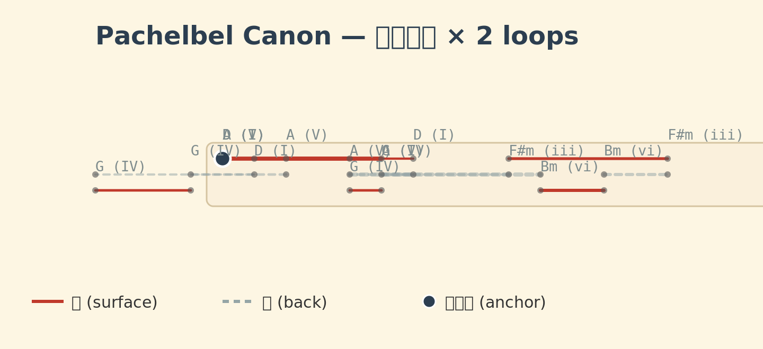
Figure 1. SITS9 Loom Renderer output for Pachelbel's Canon (I-V-vi-iii-IV-I-IV-V, 2 loops). Red solid lines = surface stitches; grey dashed lines = back stitches; filled black circles = anchor points (knots).

4. Structural Homology: Back Stitch and Chord Progression
Neither back stitching nor chord progression moves forward in a straight line. The controlled retreat is what gives each its characteristic strength: physical tensile strength in the case of stitching, and emotional persuasiveness in the case of harmony. A running stitch (pure FWD) is the textile equivalent of simply ascending a scale: functional, but not 'progressive'. It is the inclusion of RET -- return through previously covered ground -- that constitutes progression in both domains.
This claim is not merely metaphorical. Consider the physical mechanics: in back stitching, the thread passes through the same hole twice -- first going forward past it, then returning through it. This overlap creates a denser, stronger seam than a running stitch. In a ii-V-I cadence, the harmony passes through dominant tension (the 'overshoot') before returning to the tonic. The resolution through previously heard harmonic territory creates a denser, more satisfying closure than simply arriving at the tonic from an adjacent chord. In both cases, the retreat through previously covered ground is the mechanism that converts a sequence into a structure.
Table 3 maps stitch types to their SITS9 instruction patterns, corresponding harmonic idioms, and culinary analogues.
Table 3. Mapping of stitch types to SITS9 patterns, harmonic idioms, and culinary processes.
Stitch type | SITS9 pattern | Harmonic analogue | Culinary analogue
Running stitch | loop ^{FWD(n), CROSS} | Pedal point (sustained chord) | Constant-temperature heating
Back stitch | loop FWD, CROSS, FWD, TENSION+, CROSS, RET, TENSION-, ANCHOR | ii-V-I functional progression | Heat-cool-reheat (sauce reduction)
Half-back stitch | loop ^{FWD(n), CROSS, RET(n/2), CROSS} | Deceptive cadence (V-vi) | Partial cooling (carry-over cooking)
Herringbone (chidori-gake) | loop FWD(1), CROSS(+30), FWD(1), CROSS(-30) | Stepwise bass line | Alternating ingredients
Blind hem (matsuri-nui) | loop ^{FWD(n), CROSS(depth=minimal)} | Pedal tone (sustained bass) | Long low-heat simmer
Blanket stitch (kagari-nui) | loop ^{CROSS(wrap=true), FWD(1)} | Ostinato (repeating pattern) | Continuous stirring (risotto)

5. Demonstration: Pachelbel's Canon
To validate the system, we encoded the harmonic progression of Pachelbel's Canon in D (I-V-vi-iii-IV-I-IV-V) as an eight-Card SITS9 Deck. Each Card's TENSION value reflects the harmonic tension of the chord degree (I = 0.2, V = 0.8, vi = 0.5, iii = 0.4, IV = 0.3). The FWD/RET directions and distances were chosen to produce a back-stitch-like forward-and-return pattern in the SVG renderer, while CROSS instructions with alternating angles (+/-30 degrees) create a visible zigzag in the stitch pattern.
Figure 2 shows the harmonic tension profile of the Deck: each chord is represented as a coloured bar (blue = ANCHOR, red = FWD, green = RET) whose height encodes its TENSION value. The dashed connecting line reveals the 'tension arc' of the progression -- rising sharply to the dominant (V), descending through the return sequence (vi -> iii -> IV -> I), and re-ascending for the loop.

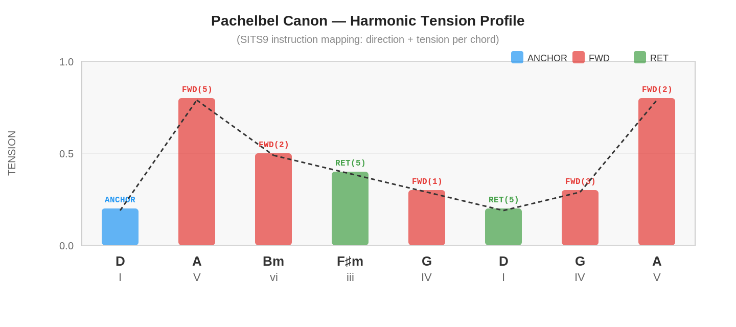
Figure 2. Harmonic tension profile of Pachelbel's Canon encoded as SITS9 instructions. Bar colour indicates instruction type: blue = ANCHOR, red = FWD, green = RET. Bar height = TENSION value. Dashed line traces the tension arc.
The same Deck was passed to all three renderers:
(a) The LoomRenderer produced an SVG sashiko pattern (Figure 1) in which surface stitches (red solid lines) and back stitches (grey dashed lines) form a zigzag that visually encodes the harmonic tension profile. Anchor points (filled circles) mark the tonic. Figure 3 shows the textile schema: the needle path alternates between the surface (orange band) and back (blue band) of the fabric, with each CROSS instruction representing a penetration of the needle through the cloth.

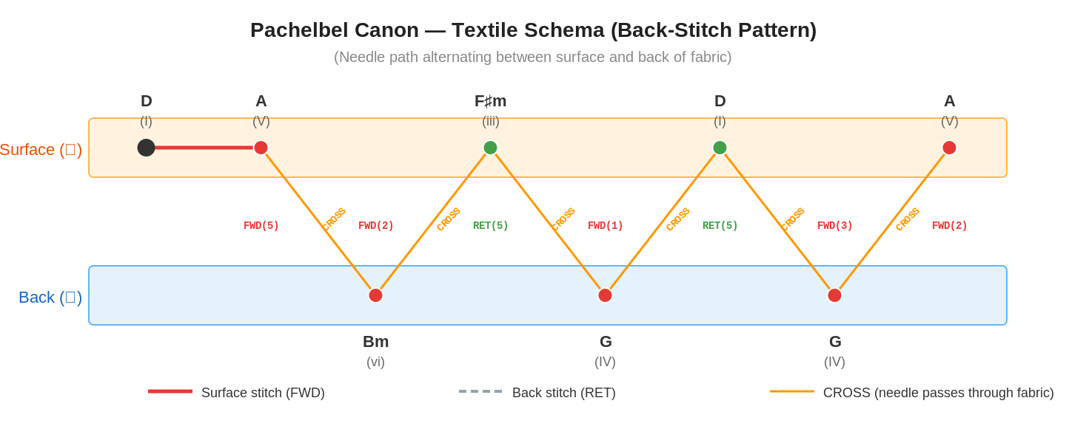
Figure 3. Textile schema (back-stitch pattern) for Pachelbel's Canon. The needle path alternates between surface (orange) and back (blue) of the fabric. Red lines = FWD stitches on surface; orange diagonal lines = CROSS (needle penetration); black dot = ANCHOR (knot).
(b) The ToneRenderer produced a MIDI file with two tracks (piano melody on channel 0, strings bass on channel 1). Each FWD generates note-on events proportional to n, each RET produces a rest, CROSS toggles between channels, TENSION sets velocity, and ANCHOR resolves to a tonic major triad.
(c) The KitchenRenderer produced a text recipe in which FWD maps to heating time, RET to resting/cooling, CROSS to switching cooking method (grill -> simmer -> steam), TENSION to heat level, and ANCHOR to tasting and seasoning. Figure 4 shows the cooking schema: the heat level (TENSION) traces the same arc as the harmonic tension, while background colour zones indicate cooking method transitions triggered by CROSS.

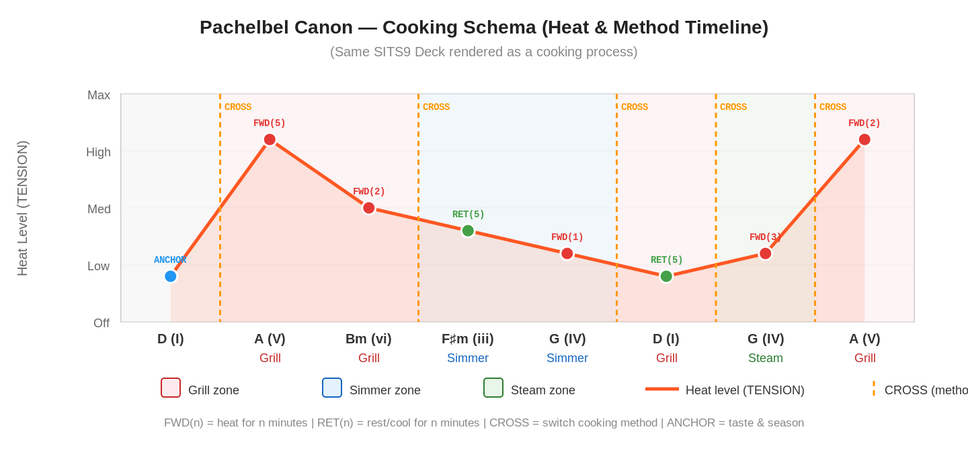
Figure 4. Cooking schema for Pachelbel's Canon. The heat curve (TENSION) follows the same profile as the harmonic tension in Figure 2. Background zones indicate cooking method: red = grill, blue = simmer, green = steam. Dashed vertical lines = CROSS (method switch).
All three outputs are generated from the identical JSON-serialised Deck, confirming that a single 'program' produces coherent output across three sensory domains. The visual similarity between the tension arc in Figure 2, the zigzag trajectory in Figure 3, and the heat curve in Figure 4 is not a coincidence but a direct consequence of the shared instruction sequence. The source code and all generated artefacts are available in the supplementary repository.
It is worth noting why Pachelbel's Canon is a particularly revealing test case. The progression I-V-vi-iii-IV-I-IV-V is the prototypical 'back-stitch' pattern in harmonic space: the first half (I to iii) moves away from the tonic by stepwise descent through the diatonic circle, while the second half (IV to V) returns toward the tonic, overlapping with the starting territory before re-advancing. This is structurally identical to the kinetics of kaeshi-nui: the needle advances past the previous stitch, retreats through it, and advances again. The SITS9 encoding makes this identity not metaphorical but literal -- the same FWD-RET-CROSS instruction sequence generates both the stitch trajectory and the harmonic motion.

5.1 National Anthem Demonstrations
To test whether the system generalises beyond a single well-known progression, we encoded four national anthems with contrasting musical characters: Kimigayo (Japan), La Marseillaise (France), The Star-Spangled Banner (US), and Hino Nacional Brasileiro (Brazil). Each anthem was converted into a SITS9 Deck by mapping its melodic contour, dynamic profile, and rhythmic character to the five primitives, following the same methodology as the Pachelbel encoding.
The results confirmed the predictions based on each anthem's musical characteristics (see Section 9.1 for the full comparison table). Kimigayo, with its pentatonic scale, slow tempo (BPM 54), and narrow melodic range, produced a SITS9 Deck with small FWD values (2-3), low TENSION (0.15-0.45), and gentle CROSS angles (15 degrees). The resulting SVG shows a restrained, meditative stitch pattern with short, evenly spaced stitches -- visually reminiscent of traditional sashiko. The generated recipe calls for low heat, long simmering times, and minimal method-switching, consistent with washoku aesthetics.
By contrast, La Marseillaise (BPM 120, march tempo) produced a Deck with large FWD/RET amplitudes (5-7), high TENSION values (up to 0.95), and steep CROSS angles (45 degrees). The SVG renders as a bold, aggressive zigzag with sharp directional changes. The recipe alternates between high-heat searing and rapid cooling -- a rhythm that resembles classical French sauce technique. The Star-Spangled Banner, with its famously wide vocal range (1.5 octaves), produced the largest FWD values (up to 8), creating an SVG with dramatic leaps and a recipe with extreme temperature variations. The Brazilian anthem's syncopation manifested as irregular FWD intervals and a flowing, rhythmically asymmetric stitch pattern.
These demonstrations illustrate a key design principle of SITS9: the language does not merely permit cross-domain translation -- it preserves the 'cultural accent' of the source material across all renderings. A pentatonic source produces pentatonic-feeling outputs in every domain.

6. Palette Constraints and Cultural Identity
In certain musical traditions, the available pitch set is deliberately restricted -- for example, the Japanese pentatonic scale (yo-na-nuki: omitting the 4th and 7th degrees). This restriction of the discrete palette is not a limitation but a culturally constitutive choice, and it has direct parallels in textile and cuisine (Table 4).
Table 4. Palette constraints across domains.
Domain | Constrained palette (pentatonic-like) | Full palette (chromatic-like)
Music | Pentatonic: omit 4th & 7th scale degrees | Twelve-tone: use all pitches equally
Textile | Sashiko: white thread on indigo (1 colour) | Jacquard full-colour: unlimited palette
Cuisine | Japanese: dashi, soy, miso, salt, sugar (5 bases) | Molecular gastronomy: synthesise any flavour

In SITS9, palette constraint is expressed as the discrete set of values that FWD(n) can take:
Pentatonic: n in {1, 2, 3, 5, 6} (skip 4 and 7)
Diatonic: n in {1, 2, 3, 4, 5, 6, 7}
Chromatic: n in {1, 2, ..., 12} (no constraint)
A key observation is that stronger palette constraints produce clearer cultural signatures. Pentatonic melodies are immediately identified as 'Japanese', 'Chinese', or 'Celtic'; indigo sashiko is immediately identified as Japanese; dashi-and-soy flavour profiles are immediately identified as washoku. By reducing information entropy, palette constraints amplify cultural signal.⁶
This relationship can be expressed informally as: cultural distinctiveness is inversely proportional to palette size. A twelve-tone composition, a full-colour digital textile, and a molecular-gastronomy dish can each be virtuosic, but none carries a strong cultural fingerprint. Conversely, a pentatonic melody played on a shakuhachi, a white-on-indigo sashiko cloth, and a bowl of miso soup each carry unmistakable cultural identity precisely because their palettes are constrained to a handful of values.
In SITS9 terms, palette constraint operates as a filter on the parameter space of FWD(n), TENSION(v), and CROSS(angle). A 'Japanese-style' SITS9 Deck might restrict FWD to n in ^{1, 2, 3}, TENSION to v in ^{0.1, 0.3, 0.5}, and CROSS angle to ^{-15, 0, 15}. A 'French-style' Deck might allow the full range. The cultural character of the output is thus encoded not in the instructions themselves but in the constraints imposed on their parameters -- a meta-level of cultural encoding that sits above the instruction set itself.

7. Textile Ciphers: SITS9 as Steganography
The use of textile as a covert information channel has multiple historical precedents (Table 5).
Table 5. Historical examples of textile-based cryptographic and steganographic communication.
Period | Case | Mechanism
WWI | Belgian knitting spies | Knit=0, purl=1: binary encoding of railway movements. MI5 banned knitting near the front lines.⁷
French Revolution | Tricoteuses (knitting women) | Dickens' Madame Defarge encodes execution lists in knitting patterns (fictional, but the concept existed).
Inca Empire | Quipu military cipher | Administrative records + encrypted military messages in the same knotted-cord medium.⁴
Antebellum US | Underground Railroad quilt code (disputed) | Quilt patterns as route-guiding ciphers. (Contested: no confirmed primary sources.)⁸

What unites these examples is that the information channel was the craft process itself, not a hidden compartment within a craft object. A knitted scarf is not a container with a message hidden inside; the scarf IS the message, read in a different encoding. This is precisely the architecture of SITS9: a Deck is not a container with three payloads -- it is a single sequence of instructions that is simultaneously readable as three different artefacts.
In the SITS9 framework, a single Deck appears as 'a beautiful sashiko pattern', 'a pleasant piece of music', and 'a cooking recipe' -- but a fourth renderer (a cipher decryptor) could extract a plaintext message that none of the other three renderers reveal. The steganographic strength of such a system is that the 'cover objects' (textile, music, recipe) are not merely wrappers -- they are genuine, aesthetically functional artefacts in their own right. The strongest steganographic medium is one that nobody recognises as a medium at all. A contemporary art-practice example is Alyce Santoro's Sonic Fabric, a textile woven from recycled audio cassette tape that can be 'played back' by running a modified tape head across the cloth -- a literal textile-as-music artefact.⁹:
Censorship susceptibility ~ Recognition as a medium
Cipher strength ~ 1 / Censorship susceptibility

8. Future Prospect: Physical-Object Steganography
The textile-cipher discussion (Section 7) can be extended beyond fabric and thread. If information can be inscribed in a material whose 'media recognition' is zero, ultimate steganography is achieved.

8.1 Lens Inscription: Cipher as Halation
Femtosecond lasers can inscribe refractive-index changes inside transparent substrates at micrometre scale. Applied to an eyeglass lens, the resulting micro-patterns are visually indistinguishable from ordinary halation (light scatter and reflection artefacts). An SITS9 Deck encoded as a 3D point cloud and inscribed inside a lens via femtosecond laser becomes a fourth renderer output -- an ImplantRenderer -- that is physically portable and appears to the naked eye as nothing more than a minor lens imperfection.
+-> LoomRenderer -> sashiko pattern
SITS9 Deck --+-> ToneRenderer -> music
+-> KitchenRenderer -> recipe
+-> ImplantRenderer -> 3D point cloud (laser inscription)

8.2 Intraocular and Orthopaedic Implants
The same principle applies to medical implants. An intraocular lens (IOL) is a transparent acrylic or silicone substrate ideally suited for 3D laser inscription, and resides inside the body where physical access requires surgery (Table 6).
Table 6. Candidate substrates for physical-object steganography.
Medium | Material | Secrecy | Notes
Eyeglass lens | Glass / polycarbonate | High (disguised as halation) | Non-invasive, easily replaced, carried daily
Intraocular lens (IOL) | Acrylic / PMMA | Very high (inside body + transparent) | Widely used in cataract surgery
Joint / bone-fixation screw | Titanium / ceramic | Very high (deep inside body) | Large capacity; multiple units = distributed storage
Dental implant | Titanium | High | Visible on X-ray but pattern not decodable

In terms of information density, if each refractive-index change at 1 um^3 encodes 1 bit, a single eyeglass lens (several cm^3) can theoretically store terabits of data (noise constraints reduce practical capacity by orders of magnitude, but several books' worth of data remains feasible). Compared to the CIA's Cold War technique of hiding microfilm in dental fillings, 3D laser inscription emits no active signal (unlike RFID) and is therefore substantially more resistant to scanning and detection.
The connection to SITS9 is direct: an ImplantRenderer would map FWD(n) to a displacement of n micrometres along the inscription axis, RET(n) to a return displacement, CROSS to a change of inscription plane (z-axis shift), TENSION to the refractive-index change magnitude (higher tension = stronger inscription = more visible under microscopy), and ANCHOR to a reference marker. The same Deck that produces a sashiko pattern and a MIDI file would also produce a three-dimensional point cloud suitable for femtosecond laser inscription. The resulting inscribed lens could be read back into a Deck and re-rendered as music, textile, or recipe -- a physical artefact that is simultaneously a wearable object, an information store, and a cross-modal creative work.

9. Application: Cross-Modal Workshop Design
As a practical application, we propose workshops in which participants experience all three SITS9 renderings of a single Deck. Each participant leaves with: (a) a hand-stitched sashiko coaster, (b) a MIDI playback of the music generated from their stitch pattern, and (c) a dish prepared from the recipe generated from the same Deck. Because each participant's stitching style differs slightly, the resulting music also differs -- revealing that 'stitching style = performance style = cooking style' is consistent across domains.

9.1 National Anthems as Source Material
A particularly effective input for such workshops is the national anthem. Anthems are nearly free of copyright restrictions, and each participant can select 'their own country's song' as a personally meaningful starting point. Because the musical characteristics of an anthem directly reflect its culture's palette, the SITS9 renderings preserve the cultural signature across domains (Table 7).
Table 7. National anthems as SITS9 input: predicted cross-domain renderings.
Anthem | Musical features | SITS9 profile | Predicted textile / cuisine
Kimigayo (Japan) | Pentatonic, slow tempo, narrow range | Small FWD values, low TENSION, few CROSS | Restrained sashiko pattern / gentle simmered washoku
La Marseillaise (France) | March, abrupt modulation, wide dynamics | Large FWD/RET amplitude, sudden TENSION changes, frequent CROSS | High-contrast embroidery / rapid heat-cool cycles (sauce reduction)
Star-Spangled Banner (US) | Wide range (1.5 octaves), leaping intervals | Large FWD(n), large CROSS angles | Bold zigzag pattern / dynamic heat variation
Hino Nacional (Brazil) | Syncopation, long melodic lines | Irregular FWD intervals, long Cards | Rhythmic uneven-spaced stitches / staggered cooking steps

9.2 Workshop Procedure
Phase 1 (Introduction, 15 min): Participants select the anthem of their cultural heritage. The facilitator demonstrates the SITS9 conversion and shows that three outputs emerge from a single Deck.
Phase 2 (Cuisine, 30 min): Each participant follows the recipe generated from their anthem Deck to prepare a simple dish. The connection to music is not revealed at this stage.
Phase 3 (Textile, 30 min): Using the same Deck rendered as stitching instructions, participants stitch on bleached cloth. Completed patterns are photographed.
Phase 4 (Music, 15 min): Photographed stitch patterns are loaded into the music renderer. The revelation -- 'your national anthem was hidden in your cooking and stitching' -- is made.
Phase 5 (Comparison, 15 min): All participants' textiles, dishes, and music are displayed side by side. Exchanging sashiko and tasting each other's anthem-derived dishes becomes an embodied exercise in cross-cultural understanding.
The educational significance of this workshop lies in the embodied realisation that 'culture' is not confined to a single domain but operates as a consistent operational palette across music, craft, and food.

10. Discussion: Why Did All Three Domains Follow the Same Evolution?
Why did music, textile, and cuisine follow the same trajectory of instruction-set complexification? Our hypothesis is that all three are fundamentally acts of 'applying temporal operations to a material to create structure': thread x temporal operation -> fabric; sound x temporal operation -> music; ingredient x temporal operation -> cuisine. The complexification pattern is shared because the human cognitive architecture -- the order in which we can understand and memorise sequences of 'repetition -> crossing -> return' -- is universal. SITS9's ability to unify three domains is not a coincidence but a reflection of the universal structure of human procedural cognition.⁵
A supporting observation comes from the parallel evolution summarised in Table 1. The fact that all three domains independently passed through the same stages -- from single-operation repetition (running stitch / monophonic chant / open-flame roasting) to multi-layer crossing (weaving / polyphony / sauce systems) to encoded reproduction (Jacquard / player piano / canning) -- suggests that the trajectory is not culturally contingent but cognitively constrained. Each stage introduces one additional degree of freedom to the instruction set: CROSS introduces a second axis, RET introduces temporal non-monotonicity, TENSION introduces continuous modulation. The order in which humans can learn and teach these degrees of freedom appears to be invariant across cultures and across domains. Steve Reich's concept of 'music as a gradual process' -- in which perceptible, slowly unfolding transformations constitute the musical material -- is itself an instance of this universal trajectory: minimal music strips the instruction set back to loop-FWD and makes the process audible.¹⁰
The naming of SITS9 -- from the proverb 'a stitch in time saves nine' -- captures a deeper principle: the language's economy of means. Five instructions suffice to span three domains not because the domains are simple, but because the underlying operational algebra is small. Just as a Turing machine needs only a few symbols to be computationally universal, SITS9 achieves cross-domain universality with five primitives because the human procedural repertoire is itself built from a small set of temporal operations.
A limitation of the current work is that the mappings between SITS9 instructions and domain-specific actions are manually designed rather than empirically derived. The TENSION-to-heat mapping in the KitchenRenderer, for example, is linear, but human perception of 'cooking intensity' may follow a logarithmic or sigmoidal curve. Similarly, the CROSS angle-to-interval mapping in the ToneRenderer is a simplification of what is, in musical practice, a highly context-dependent relationship. Future work could involve perceptual experiments to determine whether listeners, stitchers, and cooks independently converge on similar tension curves when presented with the same abstract instruction sequence. The national-anthem workshop proposed in Section 9 provides a natural experimental framework for such studies.
Another avenue for future investigation is the formal relationship between SITS9 and existing computational models. The Card/Deck structure bears a clear resemblance to subroutines and programs in imperative languages, while the immutable, frozen-dataclass implementation of instructions suggests a functional-programming interpretation. Exploring whether SITS9 Decks form a monoid under concatenation, or whether the renderer architecture can be formalised as a functor from an 'instruction category' to domain-specific categories, could place the system on firmer mathematical foundations and enable automatic reasoning about cross-domain equivalences.

11. Conclusion
SITS9 (A Stitch in Time Saves Nine) is a minimal formal language consisting of five primitive instructions -- FWD, RET, CROSS, TENSION, ANCHOR -- from which music, textile pattern, and cooking recipe can be simultaneously generated via domain-specific renderers. We have demonstrated this with a working implementation using Pachelbel's Canon and four national anthems as test cases, confirming that the system preserves both structural coherence and cultural character across all three output domains.
That such unification is possible is a modern re-discovery of the historical fact that the Jacquard loom and the music box were driven by the same punch card, and that the Inca quipu encoded accounting, narrative, and textile structure in a single knotted-cord medium. SITS9 moves beyond surface analogy ('A resembles B') to structural equivalence ('A and B are different renderings of the same instruction set C'), with applications ranging from cryptographic steganography and physical-object inscription to cross-modal workshop design and cultural-palette analysis.
The name SITS9 encapsulates the core insight: a single well-placed stitch -- a single well-designed instruction set -- saves nine domain-specific representations. As the historical record from quipu to Jacquard to MIDI attests, the convergence of textile, music, and process encoding is not a modern invention but a recurring pattern in the history of human technology. SITS9 simply makes the convergence explicit, executable, and extensible.

Acknowledgements
[To be inserted.]

References
^{1.} Essinger, J. (2004) Jacquard's Web: How a Hand-Loom Led to the Birth of the Information Age. Oxford University Press.
^{2.} Aldwell, E., Schachter, C. and Cadwallader, A. (2019) Harmony and Voice Leading, 5th edn. Cengage Learning.
^{3.} McGee, H. (2004) On Food and Cooking: The Science and Lore of the Kitchen. New York: Scribner.
^{4.} Urton, G. (2003) Signs of the Inka Khipu: Binary Coding in the Andean Knotted-String Records. Austin: University of Texas Press.
^{5.} McLuhan, M. (1964) Understanding Media: The Extensions of Man. New York: McGraw-Hill.
^{6.} Lerdahl, F. and Jackendoff, R. (1983) A Generative Theory of Tonal Music. Cambridge, MA: MIT Press.
^{7.} Stallings, W. (2017) Cryptography and Network Security: Principles and Practice, 7th edn. Hoboken, NJ: Pearson.
^{8.} Tobin, J. and Dobard, R. (1999) Hidden in Plain View: A Secret Story of Quilts and the Underground Railroad. New York: Anchor Books. [Contested thesis]
^{9.} Santoro, A. (2007) Sonic Fabric. Available at: https://sonicfabric.com/ (Accessed: 22 June 2026).
^{10.} Reich, S. (2002) Writings on Music, 1965-2000. Oxford University Press.

