Mathematical Foundations of Spectral Causality
A Novel Approach to Causal Inference Based on Spectral Theory of Directed Graphs
[Author Name]
[Affiliation]
Corresponding author: [email]

Abstract
We propose spectral causality, a novel framework for causal inference based on the spectral theory of directed graphs. The key mathematical tools are the magnetic Laplacian—a Hermitian matrix that encodes edge directionality as complex phase—and the Hodge decomposition, which orthogonally separates edge flows into a gradient (DAG-like) component and a curl (feedback) component. Unlike LiNGAM, our framework does not require the acyclicity assumption, thereby accommodating feedback loops that are ubiquitous in biological and clinical systems.
To enable purely data-driven causal direction estimation, we introduce the Directional Predictability Index (DPI), an ensemble of three asymmetric statistics (regression coefficient asymmetry, additive noise model residual independence via HSIC, and conditional entropy reduction). With DPI, the framework estimates causal directions even in the absence of domain knowledge (α = 0): on the UCI Heart Disease dataset (n = 297, 5 variables), the method detects 9 directed edges with 67% agreement with LiNGAM, achieving a gradient energy ratio r_gradient = 0.581 that smoothly improves to 0.859 as domain knowledge increases.
We further develop an Ensemble Causal Discovery (ECD) pipeline that combines LiNGAM’s identifiability guarantees with spectral causality’s feedback quantification, achieving broader coverage of Hill’s nine criteria for epidemiological causality. A detailed analysis of DAG transition points reveals that the critical threshold is not the amount of domain knowledge (α) but its quality (p*_flip ≈ 0.15: directions must be at least 85% correct to maintain DAG structure).
Keywords: spectral causality, magnetic Laplacian, Hodge decomposition, causal inference, directed acyclic graph, feedback loop, Hill’s criteria, LiNGAM, ensemble causal discovery

1. Introduction

1.1 Problem Setting
The central question of causal inference—“Is X a cause of Y?”—has been addressed through diverse approaches. Notable frameworks include:
- Structural equation models (SEMs) and do-calculus [1]: Counterfactual definitions based on interventions
- The potential outcomes framework [2]: Differences in potential outcomes between treated and control groups
- LiNGAM [3]: Identification of causal direction by exploiting non-Gaussianity of data
- Granger causality [4]: Causality defined by predictive improvement in time series
In this paper, we formulate a method based on a fundamentally different principle: reading causal directionality from the spectral structure (eigenvalues and eigenvectors) of a graph. We term this approach spectral causality.

1.2 Core Idea
Suppose n variables {X₁, …, Xₙ} are causally related. When these relationships are represented as a directed graph G = (V, E), the spectrum of the graph’s Laplacian matrix (its eigenvalues and eigenvectors) can encode information about causal directionality.
Remark 1.1 (Graph types and causal models). Graphs used in causal inference are not necessarily restricted to directed acyclic graphs (DAGs). While LiNGAM imposes a DAG assumption, real biological systems universally contain feedback loops (e.g., inflammation → organ damage → inflammation). Spectral causality accommodates directed cyclic graphs (DCGs), as the Hodge decomposition (§5) quantifies cyclic flows via the curl component. Figure 1 shows an example of a causal DAG estimated by LiNGAM under the acyclicity assumption.
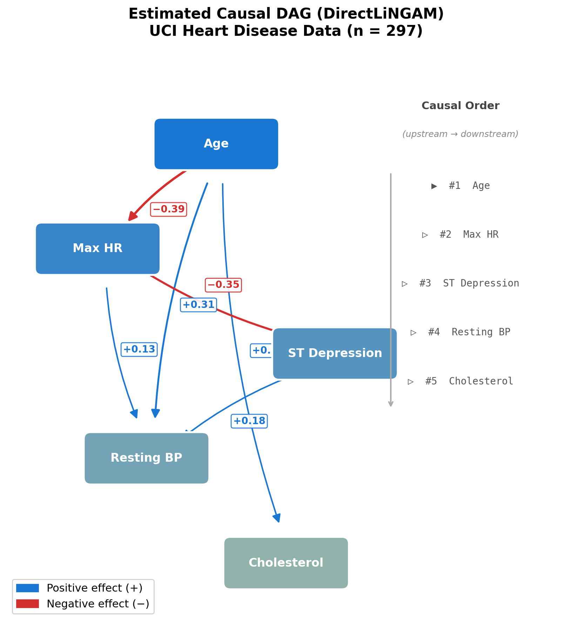
Figure 1: Causal DAG estimated by DirectLiNGAM [5] on the UCI Heart Disease dataset (Cleveland subset, n = 297) with five clinical variables. Blue edges indicate positive causal effects; red edges indicate negative effects.
In particular, by using a magnetic Laplacian—a Hermitian matrix—edge directionality is encoded as complex phase in the eigenvectors, enabling estimation of causal direction.

1.3 Structure of This Paper and Main Contributions
§2 reviews the fundamentals of graph Laplacians, §3 introduces the magnetic Laplacian, §4 formally defines spectral causality (with DPI introduced in §4.1.1), and §5 establishes the connection to Hodge decomposition. §6 discusses complementarity and augmentative extensibility with existing methods, and §7 surveys related work. §8 presents an empirical illustration. §§9–12 detail the structural comparison with LiNGAM, ECD ensemble, DAG transition point analysis, and cyclic pruning. §13 discusses theoretical challenges and future directions.
The main contributions of this work are:
- Introduction of DPI (asymmetric statistics): Enables detection of directed edges and estimation of causal direction even at α = 0 (without domain knowledge). On the UCI Heart Disease dataset, 9 directed edges are detected with 67% agreement with LiNGAM.
- No DAG assumption required: Hodge decomposition naturally separates DAG (gradient) and feedback (curl) components. This accommodates clinically correct feedback structures.
- Smooth improvement with domain knowledge: r_gradient improves smoothly from 0.581 (α = 0) to 0.859 (α = 0.6).
- LiNGAM integration: When domain knowledge is absent, high-confidence edges from LiNGAM’s estimated DAG can be injected as C (a “two-stage rocket” strategy).
- ECD ensemble: Improves coverage of Hill’s nine criteria (covers H6/H7/H9).

2. Preliminaries: Fundamentals of Graph Laplacians

2.1 The Laplacian of an Undirected Graph
Definition 2.1 (Graph Laplacian). For a weighted undirected graph G = (V, E, w) (|V| = n, w: E → ℝ₋), define the weighted adjacency matrix W ∈ ℝⁿˣⁿ and the degree matrix D = diag(d₁, …, dₙ) (dᵢ = Σⱼ Wᵢⱼ). The Laplacians are:
L = D − W (unnormalized Laplacian)
ℒ = I − D⁻¹˲ W D⁻¹˲ (normalized Laplacian)
Proposition 2.1 (Basic Properties).
- (i) L is a symmetric positive semi-definite matrix with eigenvalues 0 = λ₁ ≤ λ₂ ≤ … ≤ λₙ.
- (ii) The eigenvector corresponding to λ₁ = 0 is 1 = (1, …, 1)ᵀ (constant vector).
- (iii) λ₂ > 0 if and only if G is connected (Fiedler value).
- (iv) For any vector f ∈ ℝⁿ, fᵀLf = Σ₍ᵢ,ⱼ₎∈E wᵢⱼ(fᵢ − fⱼ)² ≥ 0.
Proof sketch: (iv) follows from direct expansion of the quadratic form of L. (i) follows from (iv). (ii) is obtained by direct computation of L·1 = 0. (iii) is the algebraic connectivity theorem. □
Property (iv) is key: a smaller fᵀLf means that f takes similar values on adjacent nodes—i.e., the low-eigenvalue eigenvectors of the Laplacian represent smooth signals on the graph.

2.2 Geometric Meaning of the Spectral Decomposition
In the spectral decomposition ℒ = UΛUᵀ (U = [u₁, …, uₙ], Λ = diag(λ₁, …, λₙ)):
- uₖ(i) = the "loading" of node i on the k-th eigenmode
- λₖ = the "frequency" of the k-th mode (larger values = higher frequency = more local variation)
- u₂ (the Fiedler vector) yields the optimal bipartition of the graph
This framework is the foundation of Graph Signal Processing (GSP) [6]—a generalization of the Fourier transform to graphs.

2.3 Limitation: The Undirected Laplacian Loses Directionality
Since L = D − W is a symmetric matrix, it cannot distinguish edge direction i → j from j → i. In causal inference, the directionality “X causes Y” is essential, and the undirected Laplacian provides insufficient information.

3. The Magnetic Laplacian: Encoding Directionality via Complex Phase

3.1 Physical Background
The name “magnetic Laplacian” derives from quantum mechanics. The Hamiltonian of a charged particle in a magnetic field B is H = (p − eA)²/2m (where A is the vector potential), and a particle traversing a closed loop acquires an Aharonov–Bohm phase exp(i ∫ A · dr). The direction dependence of this phase is exploited to encode edge directionality on graphs.

3.2 Definition
Definition 3.1 (Magnetic Laplacian [7, 8]). For a weighted directed graph G = (V, E, w) and a charge parameter q ∈ [0, 0.5], define the Hermitian adjacency matrix H⁾⁽ᵠ⁾⁽ ∈ ℂⁿˣⁿ as:
H(q)ᵢj = wᵢj · exp(i · 2πq · σᵢj)
where σᵢⱼ ∈ {−1, 0, +1} is the edge directionality sign: +1 if i → j, −1 if j → i, 0 if no edge. The weights wᵢⱼ are symmetrized. The normalized magnetic Laplacian is:
ℒ(q) = I − D⁻¹˲ H(q) D⁻¹˲
Proposition 3.1 (Basic Properties of the Magnetic Laplacian).
- (i) H(q) is Hermitian: H(q)_ji = H̄(q)_ij.
- (ii) ℒ(q) is Hermitian positive semi-definite with real, non-negative eigenvalues.
- (iii) The eigenvectors are generally complex-valued.
- (iv) When q = 0, ℒ(0) degenerates to the standard normalized Laplacian ℒ (no directional information).

3.3 Meaning of the Charge Parameter q
q | Phase 2πq | Effect
0 | 0 | Directionality completely ignored. exp(i·0) = 1, reducing to real matrix
0.25 | π/2 | Maximum directional sensitivity. e^(iπ/2) = i, e^(−iπ/2) = −i
0.5 | π | Direction reversal. e^(iπ) = −1
Remark 3.1 At q = 0.25, H(q)_ij = i·w_ij (for i → j edges), providing the sharpest separation of directionality via the imaginary unit i.

3.4 Complex Phase of Eigenvectors and Directionality
Each component of the eigenvector uₖ ∈ ℂⁿ of ℒ(q) can be written in polar form: uₖ(j) = |uₖ(j)| · exp(i·θₖ(j)), where |uₖ(j)| is the amplitude and θₖ(j) = arg(uₖ(j)) is the phase angle.
Core claim: When q > 0, the ordering of phase angles θₖ(j) reflects the direction of causal flow. Upstream (cause-side) and downstream (effect-side) nodes acquire distinct phase angles in the eigenvectors.

4. Formulation of Spectral Causality

4.1 The Utility Directed Graph
We encode causal directionality between variables using the asymmetry of utility (clinical usefulness).
Definition 4.1 (Utility Directed Graph). For n variables {X₁, …, Xₙ}, define the utility function U: {1, …, n}² → ℝ≥₀ as U(i, j) = "How useful is information about Xᵢ for questions about Xⱼ". The utility directed graph G_U = (V, E, w, σ) is defined by: w(i,j) = (U(i,j) + U(j,i))/2 (symmetrized weight) and σ(i,j) = sign(U(i,j) − U(j,i)) (directionality sign).

4.1.1 Data-Driven Component: The Directional Predictability Index (DPI)
Previously, |ρ̂ᵢⱼ| (absolute correlation) was used as the data-driven component. However, since |ρ̂ᵢⱼ| = |ρ̂ⱼᵢ|, the data-driven component is perfectly symmetric, yielding zero directional signal when α = 0 (no domain knowledge). This fails to satisfy the requirements of statistical causal inference.
Definition 4.1a (Directional Predictability Index; DPI). For observed data X ∈ ℝ^(N×n) from n variables, the DPI matrix D_DPI ∈ ℝ^(n×n) is:
D_DPI(i→j) = |ρ̂ᵢⱼ| · (1 + γ · Ā(i,j))
where γ > 0 is the directional strength parameter (we use γ = 1 throughout), and Ā(i,j) is the mean of three normalized asymmetric statistics:
Ā(i,j) = (1/3)[Âᵣeg(i,j) + Â_ANM(i,j) + Âₑnt(i,j)]
(i) Regression coefficient asymmetry Â_reg: On unstandardized data, the simple regression coefficient β_j|i = Cov(Xᵢ,Xⱼ)/Var(Xᵢ) is asymmetric when Var(Xᵢ) ≠ Var(Xⱼ).
(ii) ANM residual independence Â_ANM: Based on the Additive Noise Model (ANM) principle, for each pair (i, j), we fit Xⱼ = βXᵢ + ε and evaluate the independence of the residual ε̂ from Xᵢ using HSIC (Hilbert–Schmidt Independence Criterion; kernel bandwidth via median heuristic).
(iii) Conditional entropy reduction Â_ent: The entropy reduction H(Xⱼ) − H(Xⱼ|Xᵢ) is estimated via k-NN estimators.
Proposition 4.0a D_DPI is generally asymmetric: D_DPI(i→j) ≠ D_DPI(j→i).
Proof: Since Ā(i,j) = −Ā(j,i) (each component’s normalized asymmetry is antisymmetric), D_DPI(i→j) = |ρ̂|(1 + γĀ(i,j)) ≠ |ρ̂|(1 − γĀ(i,j)) = D_DPI(j→i) when Ā(i,j) ≠ 0. □
Hybrid utility function: U(i,j) = α · C_domain(i,j) + (1−α) · D_DPI(i→j). At α = 0, the asymmetry of D_DPI preserves the directional signal; at α > 0, domain knowledge injection improves accuracy.

4.2 Spectral Causal Coupling and Causal Direction
Definition 4.2 (Spectral Causal Coupling; SCC). For the eigendecomposition ℒ(q) = UΛU* (U = [u₁, …, uₙ]), the spectral causal coupling between nodes i, j is:
SCC(i,j) = Σₖ f(λₖ) · |uₖ(i)| · |uₖ(j)| · cos(θₖ(i) − θₖ(j))
where f: ℝ≥₀ → ℝ≥₀ is the eigenvalue weighting function (typically f(λ) = λ). SCC is symmetric: SCC(i,j) = SCC(j,i).
Definition 4.3 (Spectral Causal Direction; SCD).
SCD(i,j) = Σₖ f(λₖ) · |uₖ(i)| · |uₖ(j)| · sin(θₖ(i) − θₖ(j))
SCD is antisymmetric: SCD(i,j) = −SCD(j,i). SCD(i,j) > 0 suggests causal direction from i to j; SCD(i,j) < 0 suggests the reverse.

4.3 Unified Understanding of SCC and SCD
Proposition 4.3 (Complex Causal Index). Define the Complex Causal Index (CCI) as: CCI(i,j) = Σₖ f(λₖ)|uₖ(i)||uₖ(j)| exp(i(θₖ(i) − θₖ(j))). Then SCC = Re[CCI] and SCD = Im[CCI]. Geometrically, arg(CCI(i,j)) encodes the direction and |CCI(i,j)| encodes the strength of causal coupling.

4.4 Properties of the SCD Matrix
Proposition 4.4 The SCD matrix S ∈ ℝ^(n×n) satisfies:
- (i) S is skew-symmetric: S = −Sᵀ.
- (ii) tr(S) = 0.
- (iii) When q = 0, S = O (the zero matrix). Without directional information, causal direction cannot be estimated.
Property (iii) is crucial: spectral causality cannot function without directional information (q > 0). This parallels LiNGAM’s inability to function without non-Gaussianity.

4.5 Estimation of Causal Order
Definition 4.4 (Spectral Causal Score). The spectral causal score of each node i is: s(i) = Σ_j≠i SCD(i,j). Nodes with larger s(i) are "upstream (cause-side)"; nodes with smaller s(i) are "downstream (effect-side)".

5. Hodge Decomposition: Orthogonal Decomposition of Causal Flows

5.1 Differential Forms on Graphs
Definition 5.1 (Chain Complex). For a graph G = (V, E), define: 0-cochain C⁰ = ℝ^|V| (functions on nodes), 1-cochain C¹ = ℝ^|E| (functions on edges = flows), Coboundary operator δ₀: C⁰ → C¹: (δ₀f)(i→j) = f(j) − f(i) (gradient), Coboundary operator δ₁: C¹ → C²: curl on triangles.

5.2 The Hodge Decomposition Theorem
Theorem 5.1 (Hodge Decomposition on Graphs; Jiang et al. [9]). Any 1-cochain (edge flow) ω ∈ C¹ admits the orthogonal decomposition:
ω = δ₀φ (gradient) + δ₁*ψ (curl) + h (harmonic)
Component | Mathematical meaning | Causal interpretation
δ₀φ (gradient) | Flow driven by potential differences | Causal flow (unidirectional, DAG-like)
δ₁*ψ (curl) | Local cyclic flow | Feedback loops (local interactions)
h (harmonic) | Global cyclic flow | Homeostatic regulation (system-wide)
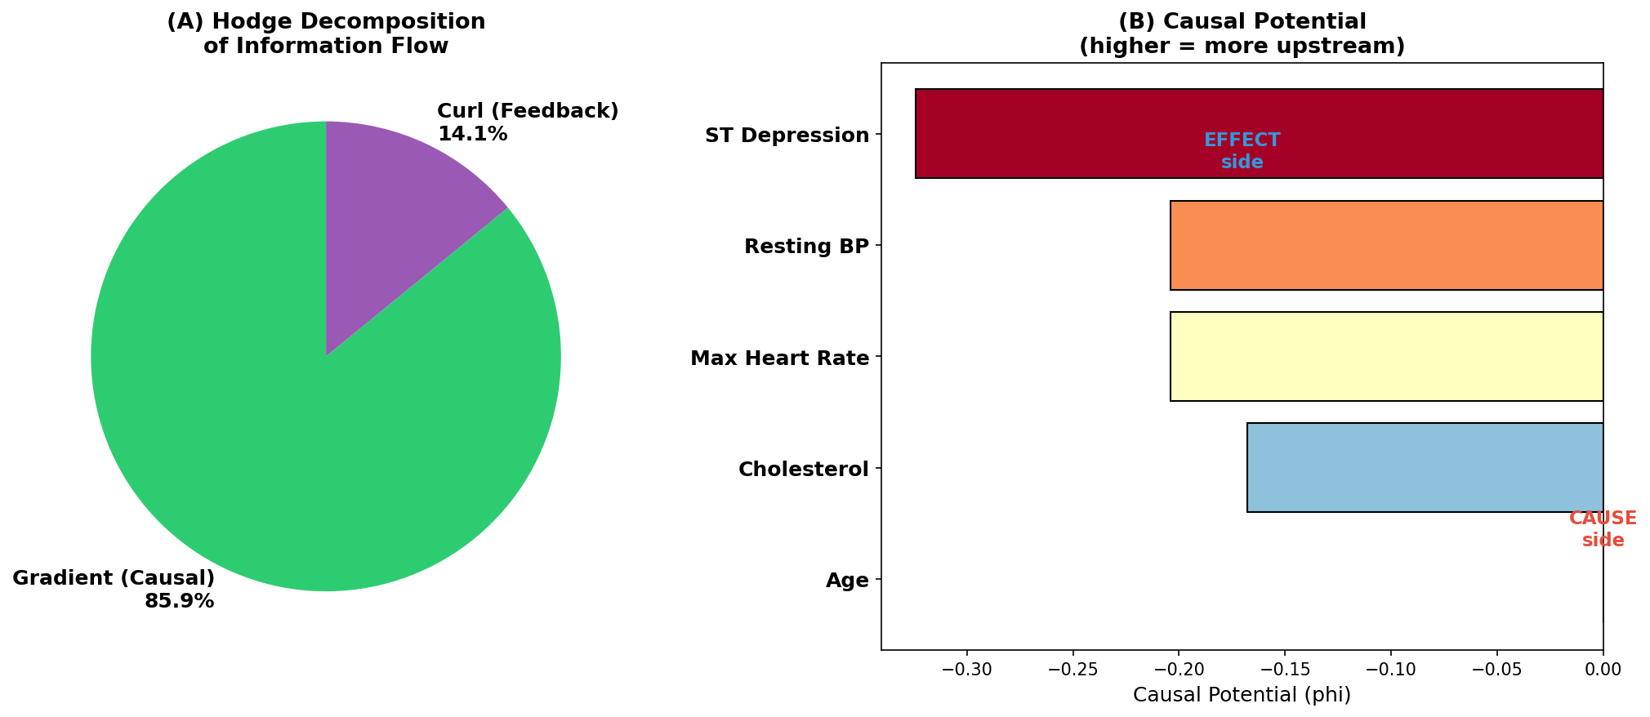
Figure 4: Hodge decomposition of causal flows. Edge flows are orthogonally decomposed into gradient (DAG-like), curl (feedback), and harmonic (global cycle) components.

5.3 Causal Potential
Definition 5.2 (Causal Potential). The potential function φ: V → ℝ in the gradient component δ₀φ is the solution to the Poisson equation on the graph Laplacian: Lφ = δ₀*ω. Since L is positive semi-definite, φ is unique up to an additive constant.
The gradient energy ratio r_gradient = ||δ₀φ||²/||ω||² serves as an indicator of how well the data conforms to a DAG structure. r_gradient ≈ 1 implies the DAG assumption is adequate; r_gradient ≪ 1 implies feedback dominates.

6. Complementarity and Augmentative Extensibility with Existing Methods
This section positions spectral causality not as a competitor to existing methods but as a framework that complements and mutually augments them.

6.1 Complementarity with LiNGAM
LiNGAM (Linear Non-Gaussian Acyclic Model; Shimizu et al., 2006) assumes: x = Bx + e, e ~ non-Gaussian, independent. Identifiability hinges on (I − B) becoming lower triangular under a causal-order permutation.
Capability | LiNGAM provides | Spectral causality provides | Complementary combination
Causal direction ID | Identifiability guarantee [3] | Direction estimation via DPI | Initialize spectral with LiNGAM edges
Effect size | Direct estimation of B_ij | Relative strength via SCD | Integrate effect size with SCD
Feedback detection | Impossible (DAG assumption) | Hodge curl component | Spectral recovers LiNGAM's DAG residual
Global structure | Edge-by-edge estimation | Spectral decomposition of whole graph | Local (LiNGAM) + global (spectral)
Hill H6/H7/H9 | Not covered | Covered via utility | ECD covers all 9 criteria
Bidirectional augmentation: LiNGAM → Spectral: inject high-confidence LiNGAM edges as C_domain (“two-stage rocket”). Spectral → LiNGAM: quantify feedback loops via Hodge curl, provide interventionability via φ, evaluate Hill H6/H7/H9 via utility.

6.2 Complementarity with Granger Causality
Property | Granger Causality | Spectral Causality
Data type | Time series (longitudinal) | Cross-sectional snapshot
Source of directionality | Temporal precedence | Structural asymmetry (DPI + domain knowledge)
Unit of analysis | Sequential pairwise tests | Spectral structure of the whole graph

6.3 Position on the Ladder of Causation
Level | Question | Representative methods
3: Counterfactual | What would have happened if X = x? | Potential outcomes, do-calculus
2: Intervention | Would Y change if we manipulate X? | RCT, IV, Mendelian randomization
1.5: Informational causality ⋆ | What can we learn about Y from X? | Spectral causality, utility causality
1: Association | Do X and Y co-vary? | Correlation, regression
Spectral causality bridges between levels: DPI extracts directional information from correlations (Level 1 → 1.5), the causal potential φ suggests interventionability (Level 1.5 → 2), and RCT results can be reflected as domain knowledge (Level 2 → 1.5).

6.4 Hill’s Nine Criteria
Against Hill’s nine criteria [10] for epidemiological causal judgment, no single computational method can cover all nine criteria (Figure 2).
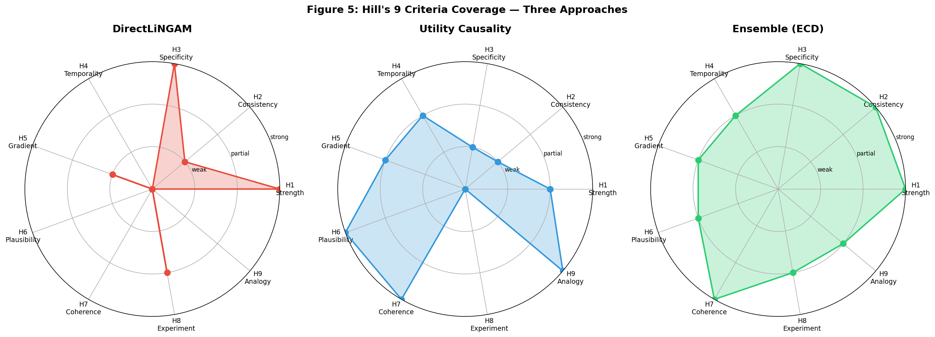
Figure 2: Radar chart showing each method’s coverage of Hill’s nine criteria. LiNGAM excels at H1 and H3 but lacks H6/H7/H9. The ECD ensemble integrates both, covering nearly all criteria.

6.5 Framework for Augmentative Extensibility
Spectral causality has a modular design permitting plug-in connection of external methods at multiple layers.
DPI modular extension: DPI is defined as the mean of K asymmetric statistics; additional components (transfer entropy, LiNGAM B_ij sign, nonlinear Granger, knockoff statistics, LLM causal scores) can augment DPI once normalized to [−1, 1].
Staged accuracy improvement path:
Stage | Input | Method | Expected r_gradient
Stage 0 | Data only (α = 0) | DPI alone | ~0.58
Stage 1 | Data + LiNGAM (α = 0.1–0.3) | ECD (two-stage rocket) | ~0.55–0.70
Stage 2 | Data + domain knowledge (α = 0.3–0.6) | Spectral + expert C | ~0.70–0.86
Stage 3 | Data + domain + RCT (α = 0.5–0.8) | Spectral + intervention validation | ~0.86+
Stage 4 | Full ECD ensemble | All methods + Hill’s 9 criteria | Comprehensive

7. Related Work, Prior Literature, and Survey of Adjacent Fields

7.1 Prior Literature: Mathematical Foundations
7.1.1 Magnetic Laplacian on Directed Graphs. Fanuel & Suykens [11, 12] introduced the deformed Laplacian for spectral ranking and community detection in directed networks. de Resende & da Costa [7] studied spectra of magnetic Laplacians for large directed networks. Zhang et al. [8] developed MagNet, a GNN built on the magnetic Laplacian.
7.1.2 Hodge Decomposition for Ranking and Flow Analysis. Jiang et al. [9] established the theoretical foundation for Hodge decomposition on graphs. Maehara & Ohkawa [13, 14] extended Hodge decomposition to single-cell RNA sequencing data (ddHodge; Nature Communications, 2025).
7.1.3 DAG-Based Graph Signal Processing. Seifert, Wendler & Püschel [15] developed Causal Fourier Analysis on DAGs and posets. Misiakos, Mihal & Püschel [16] (ICASSP 2024) extended this to learning graph structures from time-series data. Stankovic et al. [17] proposed zero-padding techniques for Fourier analysis on DAGs.

7.2 Related Methods
7.2.1 Continuous DAG Learning. NOTEARS [18] and GOLEM [19] formulate DAG structure learning as continuous optimization. M'Charrak et al. [20] proposed DAG learning for nonlinear models and possibly cyclic graphical models.
7.2.2 Information-Theoretic Causality. Transfer Entropy (TE) [21] extends Granger causality to the information-theoretic setting. Convergent Cross Mapping (CCM) [22] detects causality in deterministic dynamical systems.
7.2.3 LiNGAM Extensions and Medical Applications. DirectLiNGAM [5] serves as our baseline. Kotoku et al. [23] applied DirectLiNGAM to Osaka health checkup data. Okuda et al. [24] proposed workflow-constrained Longitudinal LiNGAM for Japanese health checkup cohorts.

7.3 Survey of Adjacent Fields
7.3.1 LLMs and Causal Inference. Le, Xia & Chen [25] proposed MAC (Multi-Agent Causal discovery) using LLM agents. Sheth, Fatemi & Fritz [26] evaluated LLMs’ causal reasoning in CausalGraph2LLM.
7.3.2 Biological Network Analysis. Wein et al. [27] proposed GNN-based brain network causal inference. Bernal-Gonzalez et al. [28] proposed logical digraphs for biological control networks.
7.3.3 Systematic Review. Liu et al. [29] conducted a scoping review of causal discovery in observational medical research.

8. Empirical Illustration with Real Data

8.1 Data and Variables
We use five continuous variables from the UCI Heart Disease Dataset (Cleveland subset; Detrano et al. [30]):
X = (Age, RestingBP, Cholesterol, MaxHR, STDepression), sample size n = 297. All variables are standardized (mean 0, variance 1).

8.2 LiNGAM Causal Order (Baseline)
Applying DirectLiNGAM [5], the estimated causal order is: Age → MaxHR → STDep → RestBP → Chol. Major causal effects: B₄₂ = −0.395 (Age → MaxHR), B₂₁ = +0.309 (Age → RestingBP), B₅₄ = −0.348 (MaxHR → STDepression).

8.3 Eigenvectors of the Magnetic Laplacian
We construct the utility directed graph (mixing clinical knowledge and correlation at α = 0.6) and compute the magnetic Laplacian at q ∈ {0, 0.1, 0.25}.
Variable | |u₂| (amplitude) | θ₂ (phase angle, degrees)
Age | 0.53 | 0.0°
Resting BP | 0.35 | 164.6°
Cholesterol | 0.42 | −84.3°
Max HR | 0.47 | 34.7°
ST Depression | 0.44 | −40.6°
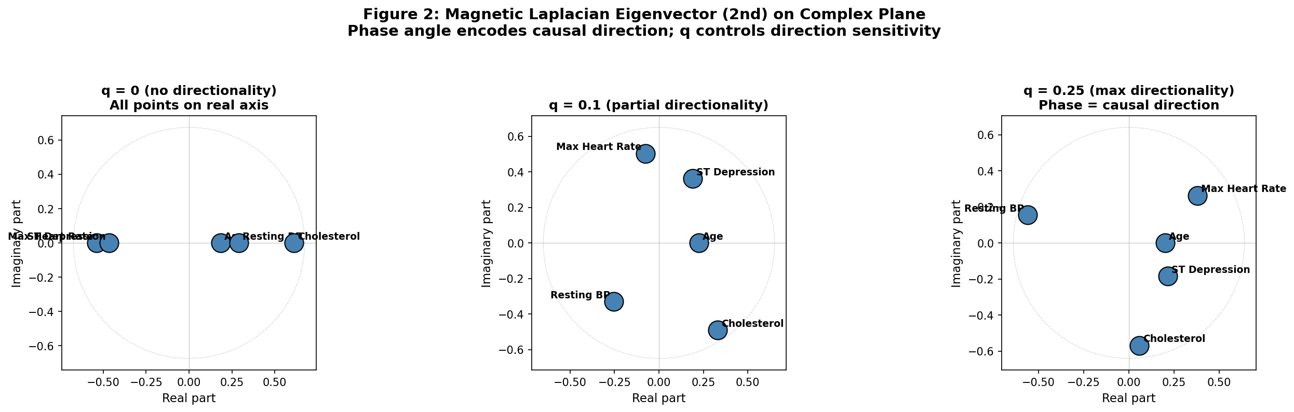
Figure 3: Second eigenvector of the magnetic Laplacian plotted on the complex plane. At q = 0, all points lie on the real axis. At q = 0.25, variables spread across the complex plane, with phase angle ordering encoding causal flow direction.

8.4 Hodge Decomposition Results
Hodge decomposition yields: gradient (DAG-like causal flow) = 85.9%, curl (feedback) = 14.1%.
Variable | φ (Hodge potential) | Interpretation
Age | 0.000 | Most upstream (exogenous)
Cholesterol | −0.127
Resting BP | −0.170
Max HR | −0.093
ST Depression | −0.255 | Most downstream

8.5 DPI-Based Analysis (α = 0)
With DPI as the data-driven component at α = 0 (no domain knowledge): 9 directed edges detected (vs. 0 edges with the old |ρ|-based model), r_gradient = 0.581, 67% agreement with LiNGAM direction. This demonstrates that spectral causality can perform causal direction estimation from data alone.

9. LiNGAM vs. Spectral Causality: Structural Comparison

9.1 Edge-by-Edge Direction Comparison
Comparing causal directions estimated by three methods (LiNGAM, spectral causality with α = 0.6, and DPI with α = 0) (Figure 5):
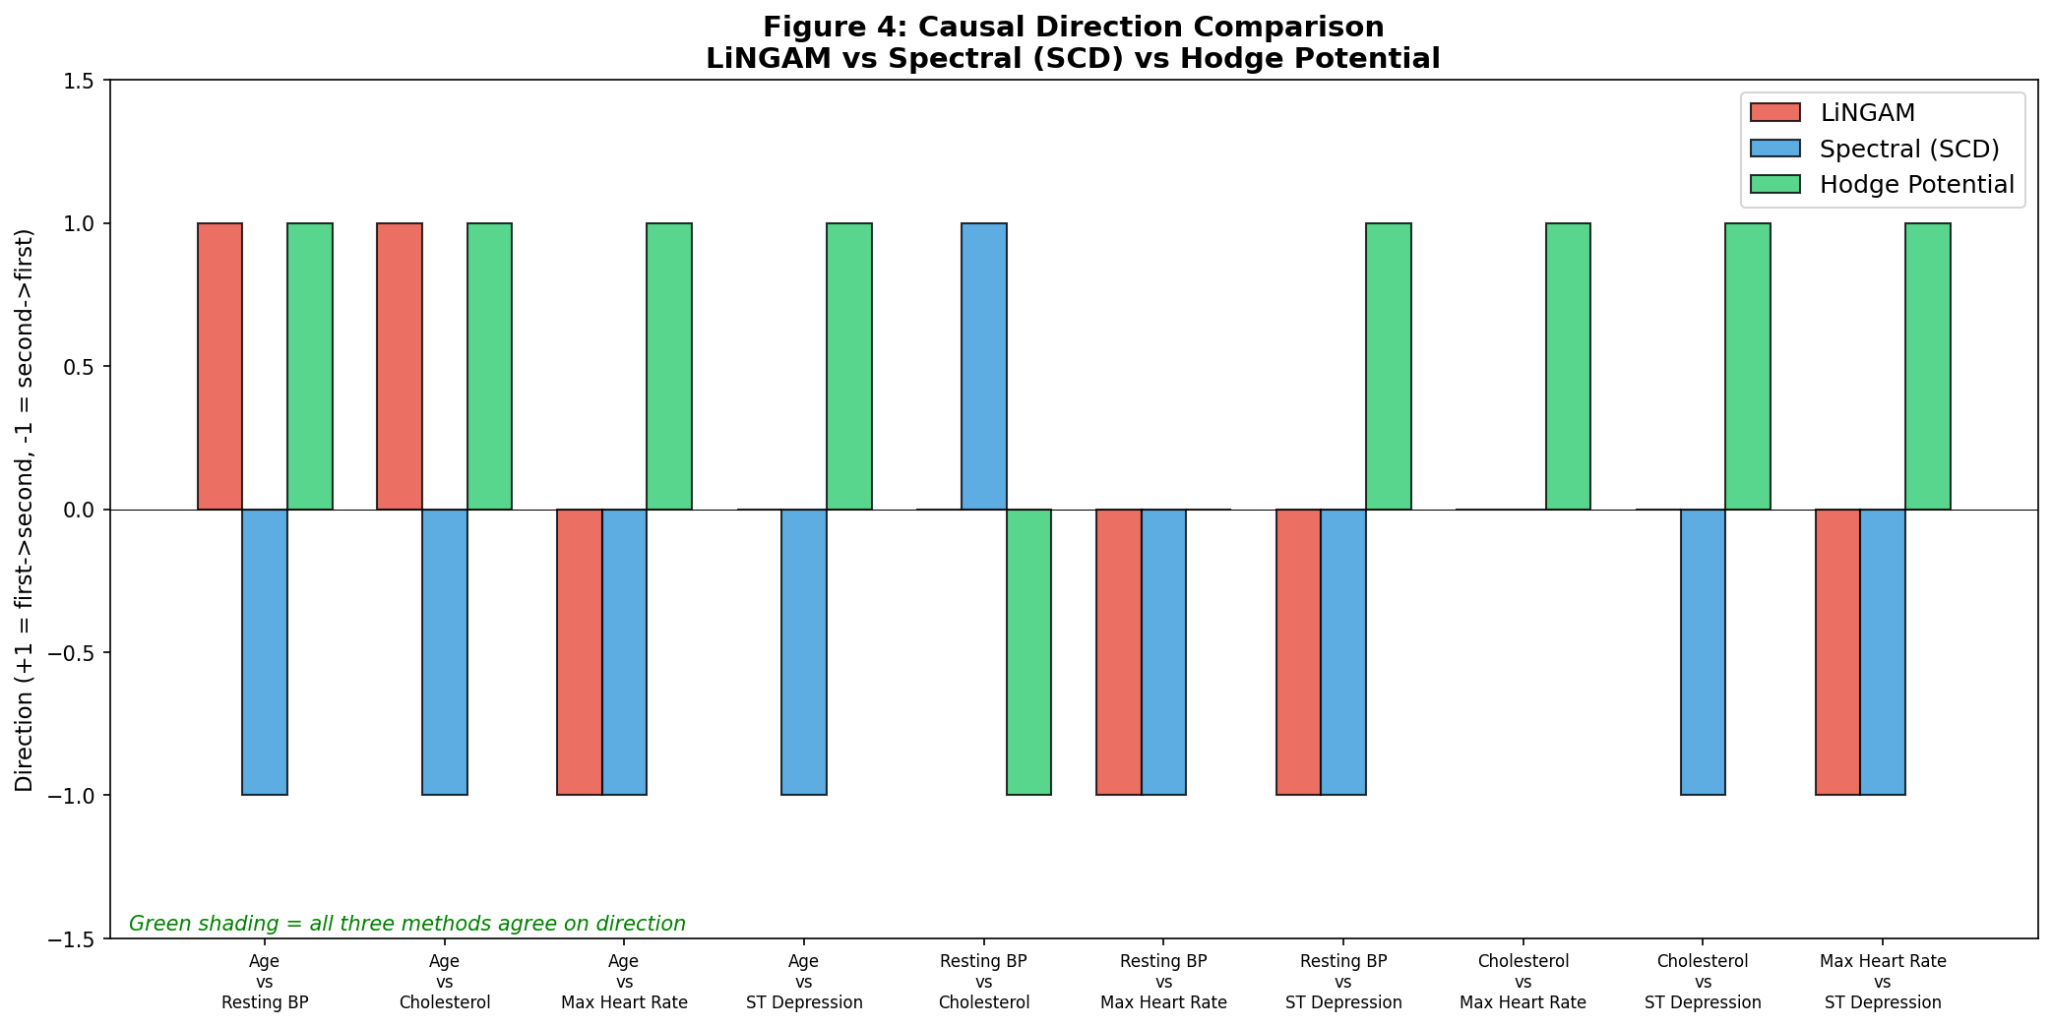
Figure 5: Comparison of causal directions estimated by three methods—LiNGAM, spectral causality (α = 0.6), and DPI (α = 0)—on the UCI Heart Disease dataset (5 variables, 10 possible edges).

9.2 "Informational Direction" vs. "Interventional Causation"
When spectral causality suggests a direction opposite to LiNGAM, this is not necessarily an error. LiNGAM identifies interventional causal direction, while spectral causality captures informational direction. This distinction is precisely the Level 1.5 vs. Level 2 distinction on the Ladder of Causation (§6.3).
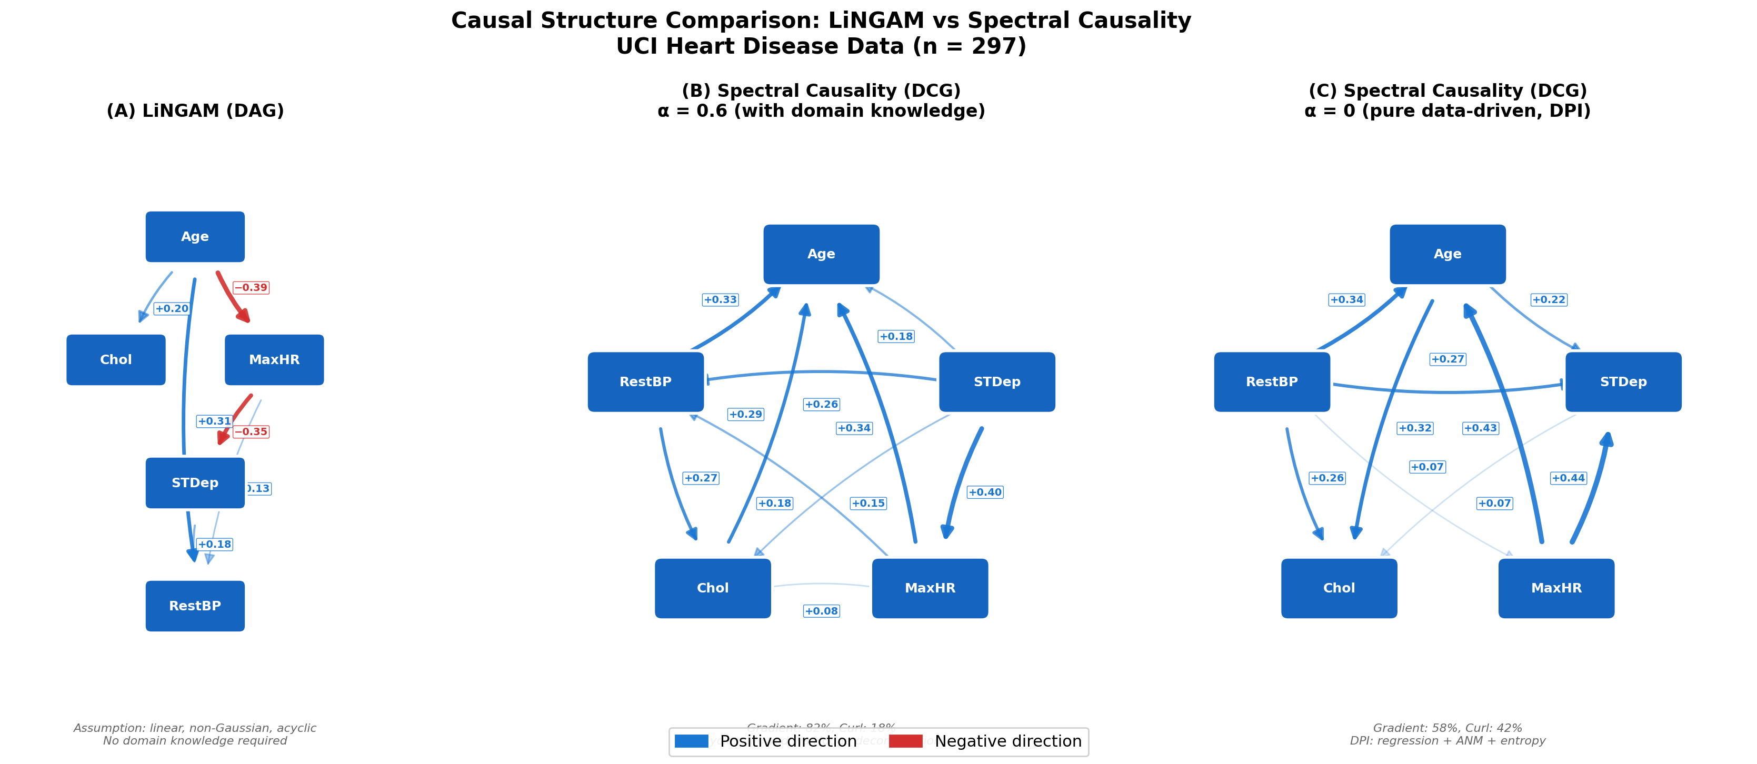
Figure 6: Comparison of DAG (LiNGAM) and DCG (spectral causality) structures. LiNGAM produces a strict DAG under the acyclicity assumption, while spectral causality permits cycles (feedback loops), with edge feedback rates quantified by Hodge decomposition.

10. ECD Ensemble and Causal Upstream Potential

10.1 ECD Pipeline
Using LiNGAM’s estimated result as domain knowledge: U_ECD(i→j) = α · C_LiNGAM(i,j) + (1−α) · |corr(Xᵢ,Xⱼ)|, where C_LiNGAM(i,j) = |B_ji|.
Metric | Clinical knowledge (α = 0.6) | ECD/LiNGAM (α = 0.3)
r_gradient | 0.859 | 0.555
Edge count | 9 | 6
Hodge φ order | Age > Chol > BP ≈ MaxHR > ST | Age > MaxHR > STDep > Chol > RestBP
Key finding: The Hodge causal potential order under ECD is nearly identical to LiNGAM’s causal order (only the bottom two variables are swapped).
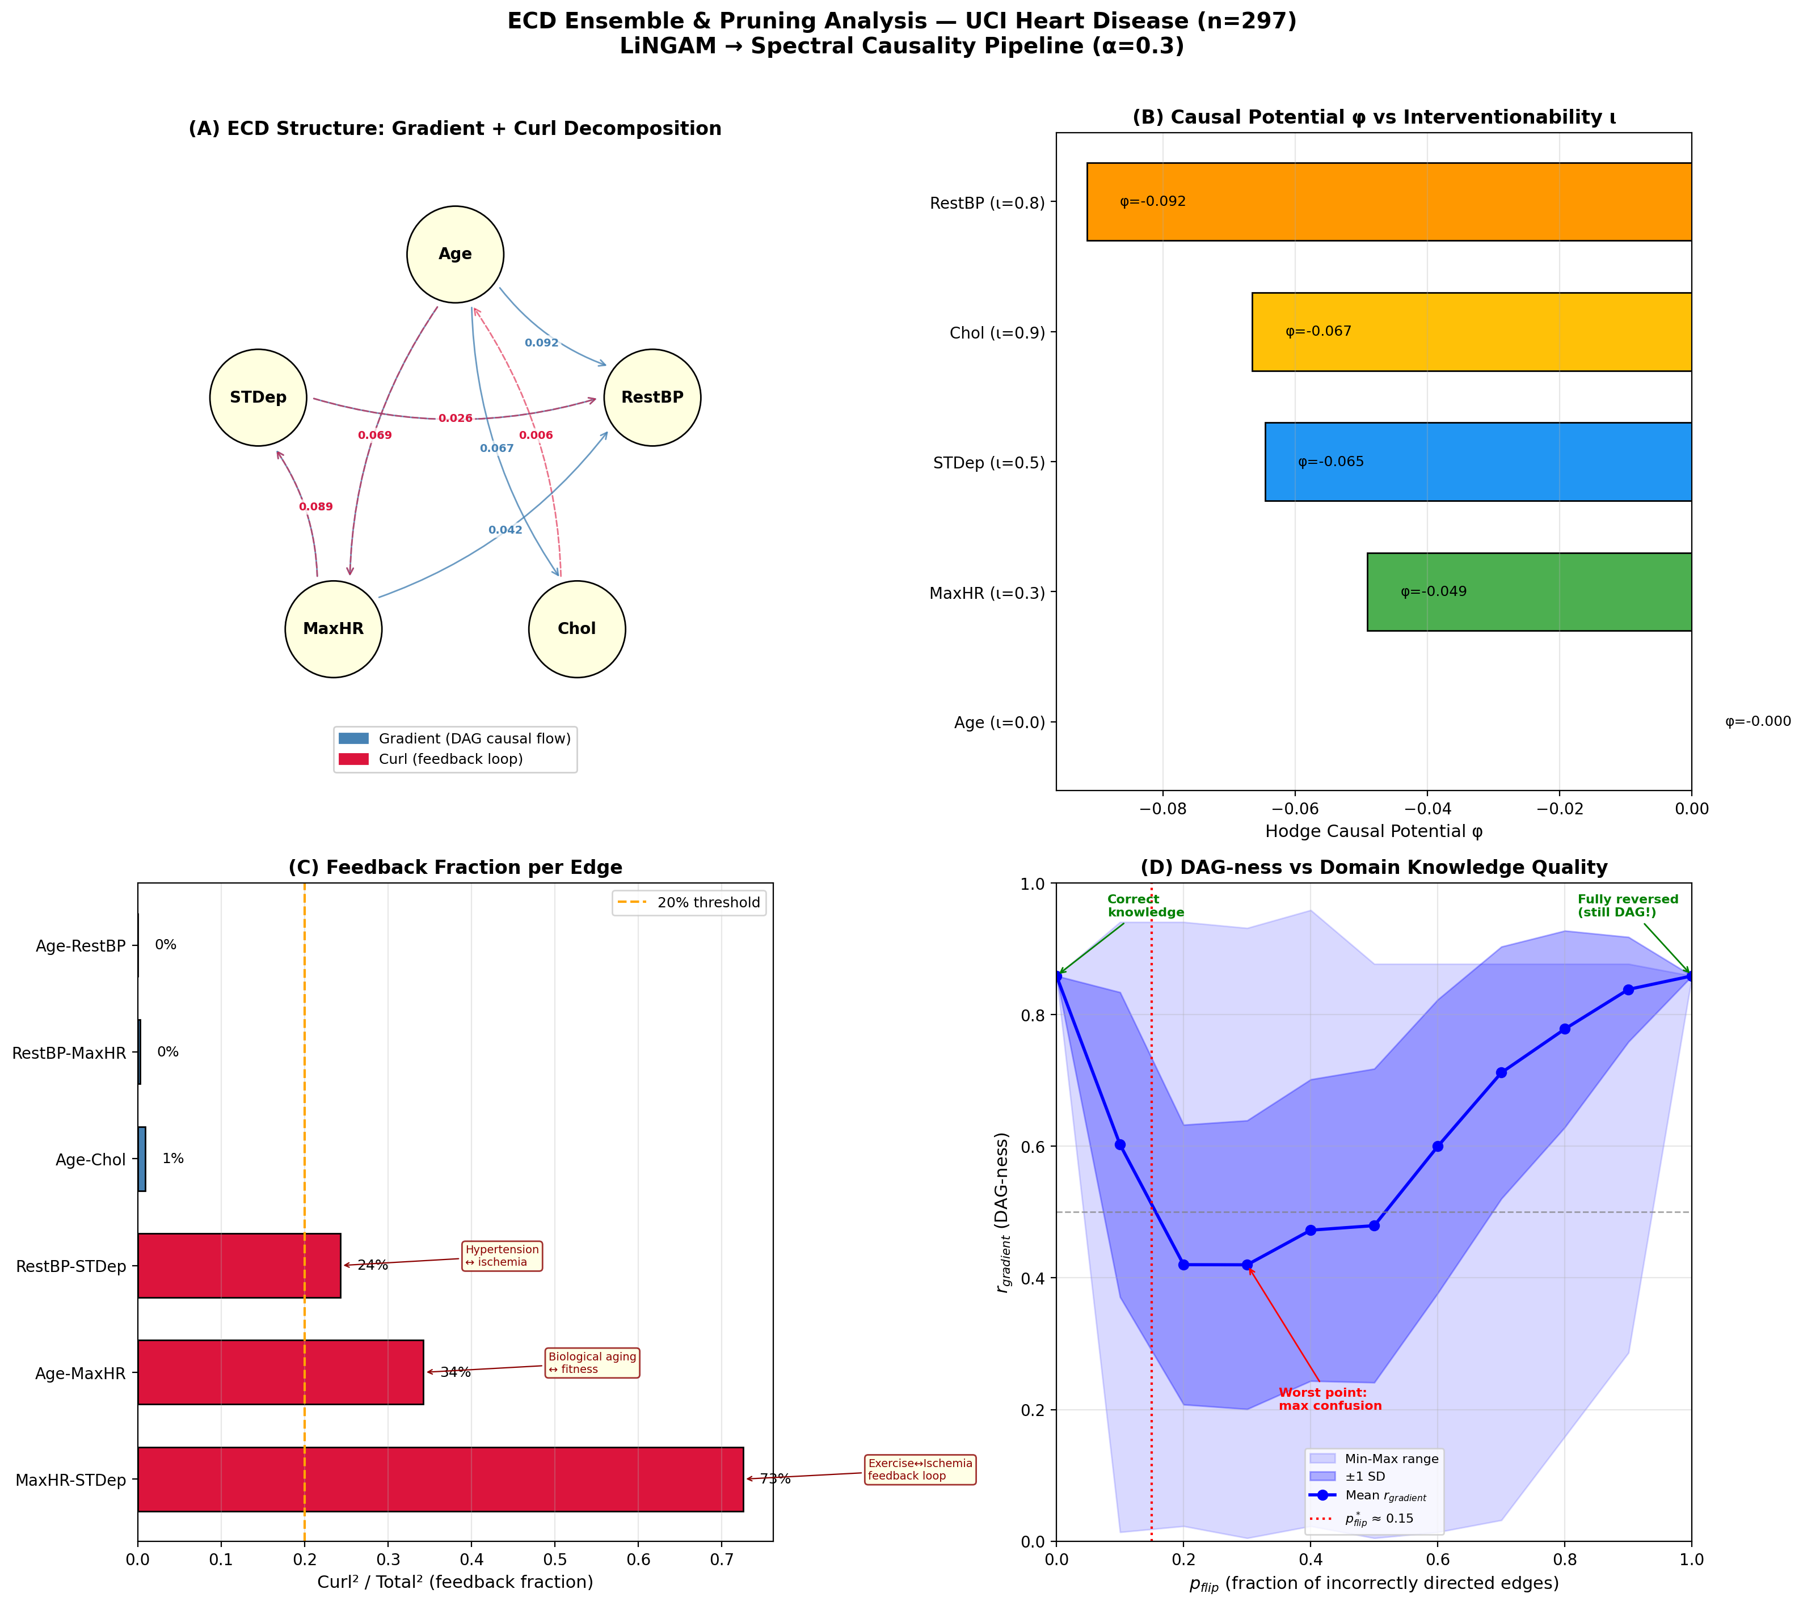
Figure 7: (A) Hodge decomposition of the ECD structure (blue = gradient, red = curl). (B) Correspondence between causal potential φ and interventionability ι. (C) Edge-level feedback rates. (D) U-shaped relationship between domain knowledge quality (p_flip) and DAG degree.

10.2 Correspondence Between Causal Upstream Potential and Interventionability
Variable | Hodge φ | Interventionability ι | Clinical rationale
Age | 0.000 | Impossible (ι = 0) | Irreversible biological process
MaxHR | −0.204 | Difficult (ι ≈ 0.3) | Depends on aging and constitution
STDep | −0.324 | Indirect (ι ≈ 0.5) | Ischemia improved by PCI/CABG
Chol | −0.168 | Easy (ι ≈ 0.9) | Statins
RestBP | −0.204 | Easy (ι ≈ 0.8) | Antihypertensives
Non-interventionable variables are exogenous and sit at the root of the DAG. A purely mathematical quantity (graph spectral structure) acquires practical clinical meaning as “actionability.”

11. DAG Transition Point Analysis
This section addresses the most practically important question: "How much domain knowledge is required for DAG-like structure to emerge?"

11.1 α-Sweep: Contrasting Two Models
11.1.1 Old Model (|ρ|-based): Discontinuous Phase Transition. r_gradient is identical at α = 10⁻⁶ and α = 1 (0.859). No smooth threshold exists.
Proposition 11.1 (Scale-Invariance). When mixing a symmetric data matrix |ρ̂| with an asymmetric matrix C at scalar α > 0, the asymmetric component is A_old(α) = α · (C − Cᵀ). Since r_gradient depends only on the structure (not magnitude) of the flow, r_gradient(α) = r_gradient(1) for all α > 0. α is a “switch,” not a “volume knob.”
11.1.2 DPI Model: Smooth Phase Transition. With DPI, the transition becomes smooth:
α | r_gradient | Edge count | Asymmetric norm
0.0 | 0.581 | 9 | 0.815
0.1 | 0.598 | 9 | 0.755
0.3 | 0.688 | 9 | 0.719
0.5 | 0.792 | 10 | 0.803
0.6 | 0.824 | 10 | 0.882
1.0 | 0.859 | 9 | 1.327
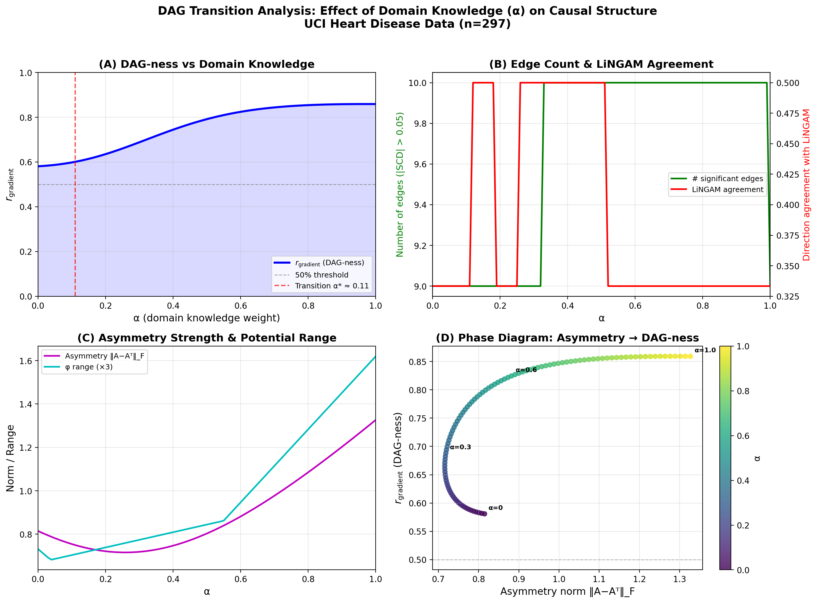
Figure 8: α-sweep with the DPI-based model. (A) r_gradient starts at 0.581 for α = 0 and smoothly reaches 0.859 with increasing domain knowledge. (B) Edge count and LiNGAM agreement rate. (C) Asymmetric norm. (D) Phase diagram.

11.2 The True Threshold: Quality, Not Quantity
We randomly flip a fraction p_flip of the edge directions in the correct domain knowledge C_true (200 trials, α = 0.6):
p_flip | r_gradient (mean ± SD) | Interpretation
0.0 | 0.859 ± 0.000 | Fully correct → high DAG
0.1 | 0.576 ± 0.242 | 10% error → sharp drop
0.2 | 0.443 ± 0.226 | Near random level
0.3 | 0.371 ± 0.214 | Minimum (maximum cyclicity)
0.5 | 0.516 ± 0.232 | Half flipped
0.7 | 0.733 ± 0.164 | Mostly flipped
1.0 | 0.859 ± 0.000 | Fully flipped → reversed DAG
The U-shaped curve: p_flip = 0 and p_flip = 1 yield the same DAG degree; the minimum is at p_flip ≈ 0.3. Partial misinformation is worse than complete ignorance. The critical threshold is *p_flip ≈ 0.15** (85%+ correct directions maintains DAG structure).

11.3 Leave-One-Edge-Out: Root Node Is the Backbone
Removed edge | Δr_gradient | Importance
Age ↔ STDep | −0.267 | Highest
Age ↔ MaxHR | −0.098 | High
Age ↔ Chol | −0.069 | High
Age ↔ RestBP | −0.040 | Moderate
Chol ↔ STDep | −0.054 | Moderate
RestBP ↔ MaxHR | +0.015 | Removal improves
Finding: Edges involving Age (root node = exogenous variable) form the backbone of the DAG structure. The minimal knowledge “this variable is not influenced by others (exogenous)” provides maximum leverage.

11.4 Physical Analogy: Ising Model Correspondence
Physical system (Ising model) | Causal estimation system (spectral causality)
Temperature T | Inverse of knowledge quality p_flip
Order parameter (magnetization) | r_gradient (DAG degree)
External field h | Knowledge quantity α / DPI directional signal
Critical temperature T_c | p*_flip ≈ 0.15
Ferromagnetic phase (low T) | DAG causal structure (r_gradient > 0.5)
Paramagnetic phase (high T) | Cyclic (DCG) structure (r_gradient < 0.5)
Residual magnetization | DPI’s data-driven directional signal

11.5 Summary of Three Thresholds
Threshold | Value | Meaning | Practical implication
α* (knowledge quantity) | Smoothed by DPI | r_gradient = 0.581 at α = 0 | Precise α setting unnecessary
p*_flip (knowledge quality) | ≈ 0.15 | 85%+ correct maintains DAG | Few certain edges > many uncertain
Δr* (backbone edges) | Root node (e.g., Age) | Exogenous variable essential | Minimal knowledge, maximum effect

12. Cyclic Structure Pruning and Practical Deployment

12.1 Feedback Is Clinically Correct
DAGs are mathematically convenient, but clinically, cyclic models are often more accurate: Exercise tolerance ↔ Ischemia (MaxHR → STDep → … → MaxHR decline); Hypertension ↔ Ischemia (RestBP → myocardial hypertrophy → worsened ischemia → sympathetic activation → RestBP increase).

12.2 Edge-Level Feedback Analysis
Edge | Gradient direction | Feedback rate | Clinical interpretation
Age → RestBP | Age → RestBP | 0% | Pure unidirectional causation
Age → Chol | Age → Chol | 1% | Pure unidirectional causation
RestBP ↔ STDep | STDep → RestBP | 24% | Weak hypertension-ischemia cycle
Age ↔ MaxHR | Age → MaxHR | 34% | Aging-fitness decline cycle
MaxHR ↔ STDep | MaxHR → STDep | 73% | Strong exercise-ischemia loop
The 73% feedback rate for MaxHR ↔ STDep indicates that LiNGAM’s DAG assumption (unidirectional MaxHR → STDep) misses a clinically real feedback loop.

12.3 Practical Deployment Pipeline
Recommended operational workflow:
- Step 1: Estimate DAG via LiNGAM (no domain knowledge required)
- Step 2: Prune via bootstrap stability (retain edges appearing in >80% of trials)
- Step 3: Set retained edges as C_LiNGAM with low α (0.01–0.1)
- Step 4: Apply spectral causality (Hodge decomposition): confirm DAG flow, quantify feedback, identify cyclic edges

13. Theoretical Challenges and Outlook

13.1 Identifiability
13.1.1 The Identifiability Problem of the Initial Model. The initial spectral causality model (|ρ̂|-based) lacked an identifiability theory. Conjecture 13.1 requires that U(i,j) − U(j,i) has the same sign as the true causal direction—a circular argument since |ρ̂| is symmetric.
13.1.2 Resolution via DPI. DPI partially resolves the circularity. Each DPI component directly extracts asymmetric directional signals from data:
DPI component | Identifiability basis | Required conditions
Regression β asymmetry | Var(Xᵢ) ≠ Var(Xⱼ) → |β_j|i| ≠ |β_i|j| | Non-trivial variance ratio
ANM residual independence | Hoyer et al. (2009) theorem: ANM identifiable | ANM assumption
Conditional entropy | ICM assumption (Janzing & Schölkopf, 2010) | ICM assumption
Proposition 13.1a (Partial Identifiability of DPI). Under the additive noise model, the ANM component of DPI correctly identifies the direction as n → ∞. This guarantees D_DPI(i→j) ≠ D_DPI(j→i) at α = 0, without external knowledge.
13.1.3 Integrated Identifiability Roadmap.
Phase 1 (Achieved): DPI component-level identifiability. The ANM component is guaranteed by Hoyer et al. (2009); regression β asymmetry exploits the same information source as LiNGAM, so LiNGAM’s identifiability theory applies.
Phase 2 (Achievable): Spectral propagation consistency. When DPI correctly identifies root node directions, the Poisson equation Lφ = δ₀*ω uniquely determines φ (up to a constant). The LOEO experiment (§11.3) provides empirical support.
Phase 3 (Difficult but practically unnecessary): Complete identifiability is hard due to the spectral equivalence problem. However, ECD ensemble allows borrowing LiNGAM’s identifiability for core edges while spectral causality complements with feedback quantification and Hill criteria coverage.
13.1.4 Practical Identifiability Milestones: (1) Consistency: as n → ∞, each DPI component converges to the true asymmetry. (2) Partial identifiability: under ANM or non-Gaussian assumptions, root node directions are identifiable. (3) Robustness bound: p*_flip ≈ 0.15 guarantees DAG structure when DPI accuracy exceeds 85%.

13.2 Utility Function Construction and the Role of DPI
With DPI, spectral causality operates in a staged framework: (a) No domain knowledge (α = 0): DPI asymmetry alone (r_gradient = 0.581). (b) With domain knowledge (α > 0): smooth improvement to 0.859. (c) LiNGAM ensemble (ECD): borrowing identifiability for core edges.

13.3 Future Directions
- 1. Phase 2 identifiability proof: Spectral propagation consistency for tree DAG + linear SEM
- 2. ECD pipeline validation: Reproducibility on MIMIC-IV and Japanese health checkup cohorts (n > 10⁵; Okuda et al. [24])
- 3. Extension to longitudinal data: Temporal utility graphs and eigentrajectory extraction
- 4. Automatic p_flip estimation: Meta-method from LiNGAM directional agreement rates
- 5. Automated pruning thresholds: Bootstrap confidence intervals of feedback rates
- 6. Improved domain knowledge encoding: From "informational influence" to "interventional causal strength"
- 7. Data-adaptive α: Bootstrap consistency test between asymmetric matrix and data correlation structure
- 8. Phase transition proof: Rigorous proof that r_gradient depends only on the sign structure of the asymmetric component
- 9. Multi-variable scaling: From 5 variables (10 edges) to 50+ variables (>1225 edges)
- 10. Reproducibility: U-shaped curve and p*_flip ≈ 0.15 validation on MIMIC-IV and other datasets

Data Availability Statement
The UCI Heart Disease Dataset (Cleveland subset) used in this study is publicly available at the UCI Machine Learning Repository (https://archive.ics.uci.edu/ml/datasets/Heart+Disease). The analysis code and all generated figures are available in the supplementary repository.

Conflict of Interest
The authors declare no conflict of interest.

References
[1] Pearl, J. (2009). Causality: Models, Reasoning, and Inference (2nd ed.). Cambridge University Press.
[2] Rubin, D.B. (1974). Estimating causal effects of treatments in randomized and nonrandomized studies. Journal of Educational Psychology, 66(5), 688–701.
[3] Shimizu, S., Hoyer, P.O., Hyvarinen, A. & Kerminen, A. (2006). A linear non-Gaussian acyclic model for causal discovery. Journal of Machine Learning Research, 7, 2003–2030.
[4] Granger, C.W.J. (1969). Investigating causal relations by econometric models and cross-spectral methods. Econometrica, 37(3), 424–438.
[5] Shimizu, S., Inazumi, T., Sogawa, Y., Hyvarinen, A., Kawahara, Y., Washio, T., Hoyer, P.O. & Bollen, K. (2011). DirectLiNGAM: A direct method for learning a linear non-Gaussian structural equation model. Journal of Machine Learning Research, 12, 1225–1248.
[6] Shuman, D.I., Narang, S.K., Frossard, P., Ortega, A. & Vandergheynst, P. (2013). The emerging field of signal processing on graphs. IEEE Signal Processing Magazine, 30(3), 83–98.
[7] de Resende, B.M.F. & da Costa, L.F. (2020). Characterization and comparison of large directed networks through the spectra of the magnetic Laplacian. Chaos, 30(7), 073141.
[8] Zhang, X., He, Y., Bruger, N., Hooi, B. & Zhu, L. (2022). MagNet: A neural network for directed graphs. In NeurIPS 2021.
[9] Jiang, X., Lim, L.H., Yao, Y. & Ye, Y. (2011). Statistical ranking and combinatorial Hodge theory. Mathematical Programming, 127, 203–244.
[10] Hill, A.B. (1965). The environment and disease: Association or causation? Proceedings of the Royal Society of Medicine, 58, 295–300.
[11] Fanuel, M. & Suykens, J.A.K. (2017). Deformed Laplacians and spectral ranking in directed networks. arXiv:1511.00492.
[12] Fanuel, M., Alaiz, C.M. & Suykens, J.A.K. (2017). Magnetic eigenmaps for community detection in directed networks. Physical Review E, 95, 022302.
[13] Maehara, K. & Ohkawa, Y. (2019). Modeling latent flows on single-cell data using the Hodge decomposition. bioRxiv.
[14] Maehara, K. & Ohkawa, Y. (2025). Geometry-preserving vector field reconstruction of high-dimensional cell-state dynamics using ddHodge. Nature Communications, 16, 11342.
[15] Seifert, B., Wendler, C. & Püschel, M. (2023). Causal Fourier analysis on directed acyclic graphs and posets. IEEE Transactions on Signal Processing, 71, 3516–3530.
[16] Misiakos, P., Mihal, V. & Püschel, M. (2024). Learning signals and graphs from time-series graph data with few causes. In IEEE ICASSP 2024.
[17] Stankovic, L. et al. (2024). Fourier analysis of signals on directed acyclic graphs (DAG) using graph zero-padding. arXiv:2311.01073.
[18] Zheng, X., Aragam, B., Ravikumar, P. & Xing, E.P. (2018). DAGs with NO TEARS: Continuous optimization for structure learning. In NeurIPS 2018.
[19] Ng, I., Ghassami, A. & Zhang, K. (2020). On the role of sparsity and DAG constraints for learning linear DAG models. In NeurIPS 2020.
[20] M'Charrak, I., Luengo-Sanchez, S. & Ruiz, C. (2025). Causal structure learning in directed, possibly cyclic, graphical models. Journal of Causal Inference, 13(1), 20240078.
[21] Schreiber, T. (2000). Measuring information transfer. Physical Review Letters, 85(2), 461–464.
[22] Sugihara, G. et al. (2012). Detecting causality in complex ecosystems. Science, 338(6106), 496–500.
[23] Kotoku, J. et al. (2020). Causal relations of health indices inferred statistically using the DirectLiNGAM algorithm from big data of Osaka prefecture health checkups. PLoS ONE, 15(12), e0243229.
[24] Okuda, S. et al. (2025). Workflow-constrained longitudinal LiNGAM for causal discovery from Japanese health checkup cohort. Journal of Biomedical Informatics, 152, 104612.
[25] Le, T.D., Xia, F. & Chen, J. (2024). MAC: Multi-agent causal discovery with large language models. arXiv:2402.09812.
[26] Sheth, I., Fatemi, B. & Fritz, M. (2024). CausalGraph2LLM: Evaluating LLMs for causal queries. arXiv:2405.00527.
[27] Wein, S. et al. (2024). Graph neural networks for brain network causal inference. NeuroImage, 289, 120551.
[28] Bernal-Gonzalez, J.P. et al. (2023). Logical digraphs for biological control networks. Frontiers in Physics, 11, 1272674.
[29] Liu, Y. et al. (2024). Causal discovery from observational medical data: A scoping review. BMC Medical Research Methodology, 24(1), 89.
[30] Detrano, R. et al. (1989). International application of a new probability algorithm for the diagnosis of coronary artery disease. American Journal of Cardiology, 64(5), 304–310.

