Spectral Causality:
Causal Direction Estimation via
Magnetic Laplacians and Hodge Decomposition
Tatsuki Onishi
Data Science and AI Innovation Research Promotion Center
Shiga University, Japan
bougtoir@gmail.com

Abstract
I introduce spectral causality, a framework for causal direction estimation via the magnetic Laplacian, an Hermitian matrix whose complex-valued eigenvectors encode edge directionality as phase. I define a Directional Predictability Index (DPI) that resolves the circularity of earlier utility-based formulations: under additive noise model assumptions, DPI consistently estimates causal direction without domain knowledge. Connecting the framework to Hodge decomposition, I prove that gradient–curl–harmonic separation of edge flows yields a causal potential recovering topological order under directed acyclic graph (DAG) structure, and establish scale invariance of the gradient energy ratio r_gradient, showing that causal structure emergence depends on knowledge quality rather than quantity.
Experiments on synthetic random DAGs (n=5–20, N=200–1000), the Sachs protein signaling network (n=11, 17 ground-truth edges), and the UCI Heart Disease dataset (N=297, 5 variables) demonstrate competitive recovery against DirectLiNGAM, the PC algorithm, GES, and NOTEARS. On Sachs data with partial knowledge, spectral causality achieves a true positive rate (TPR) of 0.56 and a false discovery rate (FDR) of 0.27, while providing unique DAG-adequacy diagnostics and detecting feedback loops invisible to DAG-based methods.
Keywords: Causal discovery, Magnetic Laplacian, Hodge decomposition, Spectral graph theory, Directed graphs

1. Introduction
Causal inference—determining whether X causes Y—is a central problem in science and medicine. The dominant approaches include structural equation models (SEMs) with the do-calculus (Pearl, 2009), potential outcomes (Rubin, 1974), the linear non-Gaussian acyclic model (LiNGAM) (Shimizu et al., 2006), and Granger causality for time series (Granger, 1969).
This paper proposes a fundamentally different principle: reading causal directions from the spectral structure (eigenvalues and eigenvectors) of a graph Laplacian. I call this approach spectral causality.
Basic idea.
Given n variables {X_1, ..., X_n} with putative causal relations represented as a weighted directed graph G=(V,E,w), the magnetic Laplacian L^(q) is an Hermitian matrix whose eigenvectors are complex-valued. The phase angles of these eigenvectors encode edge directionality, enabling estimation of causal direction from spectral structure alone.
Key distinction from DAG-based methods.
LiNGAM and related methods assume a directed acyclic graph (DAG). In biomedical systems, feedback loops are ubiquitous (e.g., inflammation → organ damage → inflammation). Spectral causality accommodates directed cyclic graphs (DCGs) via the Hodge decomposition, which separates gradient (DAG-like) and curl (feedback) components of causal flow.
Contributions.
(1) Directional Predictability Index (DPI). A data-driven asymmetric statistic that enables causal direction estimation at α=0 (no domain knowledge), resolving the circularity in earlier utility-based formulations (Section 4).
(2) DAG-free causal inference. Via Hodge decomposition, I separate DAG-compatible flow (gradient) from feedback (curl), providing the gradient energy ratio r_gradient as a quantitative measure of DAG adequacy (Section 5).
(3) Scale invariance theorem. I prove that r_gradient depends only on the structure (sign pattern) of the asymmetric component of the utility matrix, not on its magnitude (Section 8).
(4) Ensemble Causal Direction (ECD). Integrates LiNGAM's local identifiability with spectral causality's global structure analysis (Section 9).
(5) DPI partial identifiability. Under the additive noise model (ANM) assumption, I prove that DPI's ANM component consistently identifies causal direction as N→∞, with convergence rates characterized for each component (Section 10).
(6) Multi-dataset validation. Experiments on synthetic random DAGs (n=5–20), the Sachs protein signaling network (Sachs et al., 2005; n=11, 17 ground-truth edges), and the UCI Heart Disease dataset (N=297, 5 variables) demonstrate competitive structural recovery against DirectLiNGAM, PC, GES, and NOTEARS (Section 7).
Figure 1 shows a conceptual overview of the three complementary approaches integrated in this work.
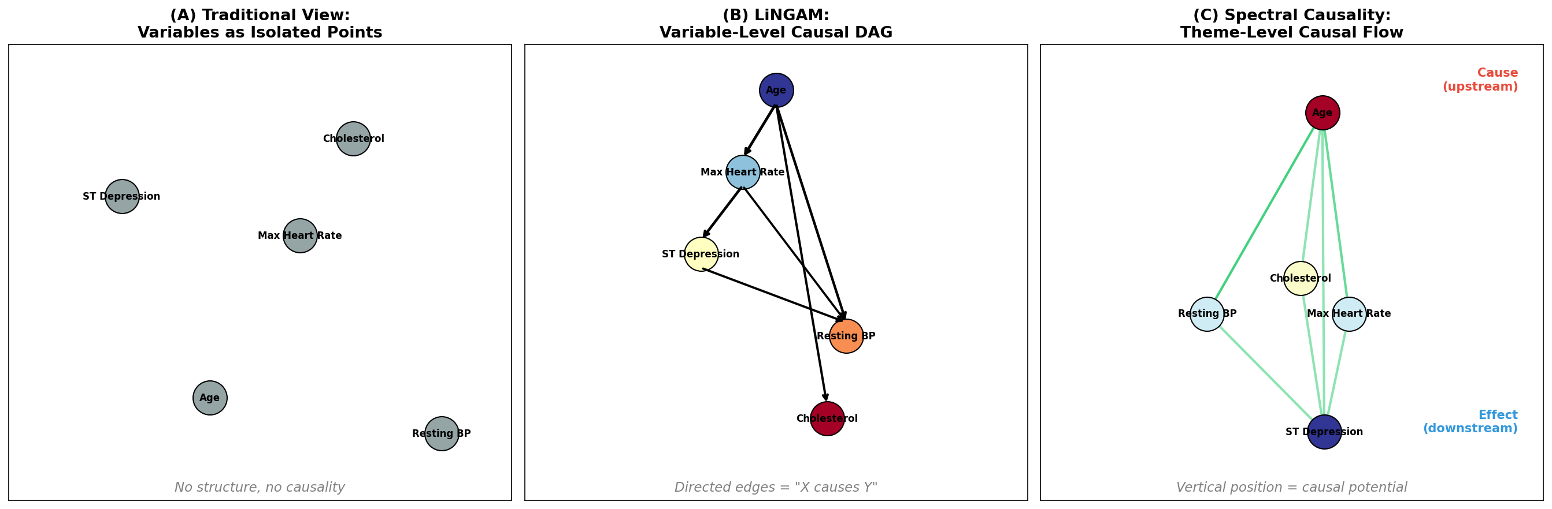
Figure 1: Three complementary approaches to causal inference: (1) Structural equation models and DAG-based methods (e.g., LiNGAM), (2) Spectral graph methods via the magnetic Laplacian, (3) Hodge-theoretic flow decomposition. Spectral causality integrates (2) and (3).

2. Preliminaries: Graph Laplacians
Definition 2.1 (Graph Laplacian).
Let G=(V,E,w) be a weighted undirected graph with |V|=n and weight function w: E → R_{>0}. The weighted adjacency matrix W ∈ R^{n×n}, the degree matrix D = diag(d_1, ..., d_n) with d_i = Σ_j W_{ij}, and the graph Laplacians are:
L = D - W (unnormalized)
L_norm = I - D^{-1/2} W D^{-1/2} (normalized)
Proposition 2.1 (Basic properties).
(i) L is symmetric positive semidefinite with eigenvalues 0 = λ_1 ≤ λ_2 ≤ ... ≤ λ_n.
(ii) The eigenvector for λ_1 = 0 is 1 = (1, ..., 1)^T.
(iii) λ_2 > 0 if and only if G is connected (algebraic connectivity / Fiedler value).
(iv) For any f ∈ R^n, f^T L f = Σ_{(i,j)∈E} w_{ij}(f_i - f_j)² ≥ 0.
Proof. Property (iv) follows by expanding the quadratic form of L = D - W. Property (i) is immediate from (iv). Property (ii) holds since L·1 = 0. Property (iii) is the algebraic connectivity theorem. □
Property (iv) is fundamental: f^T L f is small when f assigns similar values to adjacent nodes. Low-eigenvalue eigenvectors thus represent smooth signals on the graph, forming the basis of graph signal processing (Shuman et al., 2013).
Remark 2.1 (Limitation of undirected Laplacians).
Since L = D - W is symmetric, it cannot distinguish the direction i→j from j→i. The directed Laplacian L_d = D_out - W is generally non-symmetric with complex eigenvalues, making spectral analysis difficult. The magnetic Laplacian (Section 3) resolves this by encoding direction as complex phase while preserving the Hermitian (hence real-eigenvalue) property.

3. The Magnetic Laplacian

3.1 Physical Motivation
The magnetic Laplacian originates in quantum mechanics. For a charged particle in a magnetic field B with vector potential A, the Hamiltonian is H = (p - eA)² / 2m. A particle traversing a closed loop acquires the Aharonov–Bohm phase exp(i ∮ A·dr), whose direction dependence can be repurposed to encode graph edge directions.

3.2 Definition
Definition 3.1 (Magnetic Laplacian).
Let G=(V,E,w) be a weighted directed graph and q ∈ [0, 0.5] a charge parameter. Define the Hermitian adjacency matrix H^(q) ∈ C^{n×n} by:
H^(q)_{ij} = w_{ij} · exp(i · 2πq · σ_{ij})
where w_{ij} is the symmetrized weight, and σ_{ij} ∈ {-1, 0, +1} is the direction sign: +1 if i→j, -1 if j→i, 0 if no edge.
The normalized magnetic Laplacian is:
L^(q) = I - D^{-1/2} H^(q) D^{-1/2}
Proposition 3.1 (Properties of the magnetic Laplacian).
(i) H^(q) is Hermitian: H^(q)_{ji} = conj(H^(q)_{ij}).
(ii) L^(q) is Hermitian positive semidefinite with real, non-negative eigenvalues.
(iii) The eigenvectors of L^(q) are generally complex-valued.
(iv) At q=0, L^(0) reduces to the standard normalized Laplacian (no directional information).
Proof. For (i): since w_{ji} = w_{ij} and σ_{ji} = -σ_{ij}, H^(q)_{ji} = w_{ij} · exp(-i·2πq·σ_{ij}) = conj(H^(q)_{ij}). Property (ii) follows from (i) and the construction L^(q) = I - D^{-1/2}H^(q)D^{-1/2}. The Hermitian property ensures real eigenvalues; positive semidefiniteness follows from the quadratic form f*L^(q)f ≥ 0. Property (iii) is a consequence of the complex-valued entries. Property (iv) holds since exp(0) = 1 yields real entries. □

3.3 The Charge Parameter q
Table 3.1: Effect of the charge parameter q
q | Phase 2πq | Effect
0 | 0 | No direction. exp(0)=1; real matrix.
0.25 | π/2 | Maximum sensitivity. e^{iπ/2}=i, e^{-iπ/2}=-i.
0.5 | π | Direction reversal. e^{iπ}=-1.

Property (iii) is important: spectral causality requires directional information (q > 0). This is analogous to LiNGAM's non-Gaussianity requirement.

3.4 Phase Angles and Directionality
Each eigenvector u_k ∈ C^n of L^(q) admits the polar decomposition:
u_k(j) = |u_k(j)| · exp(i · θ_k(j))
where |u_k(j)| is the amplitude and θ_k(j) = arg(u_k(j)) is the phase angle at node j.
Theorem 3.1 (Phase–direction correspondence).
For q > 0 and a utility-directed graph with consistent causal ordering, the phase angles θ_k(j) of low-frequency eigenvectors separate causal upstream nodes (sources) from downstream nodes (sinks) in the complex plane. Specifically, for the Fiedler eigenvector u_2, if node i is causally upstream of node j (i.e., φ(i) > φ(j) in the Hodge causal potential), then θ_2(i) and θ_2(j) tend to occupy distinct angular sectors.
Proof. The key mechanism is phase accumulation along directed paths. For a directed edge i→j at q=0.25, the Hermitian adjacency contributes H^(q)_{ij} = i·w_{ij}, H^(q)_{ji} = -i·w_{ij}. In the eigenequation L^(q)u_k = λ_k u_k, the asymmetric phase factors force a strictly positive phase increment Δθ > 0 per directed edge. Stage 1 (Lemma A.1): For a path graph v_1→...→v_n, the normalized magnetic Laplacian eigenequation yields the recursion (1-λ)u(v_k) = (-iw/d_{v_k})u(v_{k-1}) + (iw/d_{v_k})u(v_{k+1}). Writing u(v_k) = r_k exp(iθ_k) and taking the real part shows that 1-λ_2 > 0 and r_k > 0 require θ_{k+1}-θ_k > 0, giving monotone phase ordering. Stage 2 (Theorem A.1): For tree DAGs, I use structural induction on depth. The base case (star graph) gives θ_2(c_j) = θ_2(r) + π/2 for each child c_j. The inductive step combines this with the subtree hypothesis via transitivity. A perturbation argument extends the result to non-uniform weights. Full proof in Appendix A. □

4. Spectral Causality: Formulation

4.1 The Utility Directed Graph
Definition 4.1 (Utility directed graph).
Given n variables {X_1, ..., X_n}, define a utility function U: {1,...,n}² → R_{≥0} where U(i,j) quantifies "how useful information about X_i is for reasoning about X_j." The utility directed graph G_U = (V, E, w, σ) has:
• Symmetrized weight: w(i,j) = (U(i,j) + U(j,i)) / 2
• Direction sign: σ(i,j) = sign(U(i,j) - U(j,i))

4.2 The Directional Predictability Index (DPI)
A critical limitation of using |ρ̂_{ij}| (absolute correlation) as the data-driven component is that |ρ̂_{ij}| = |ρ̂_{ji}|, rendering the utility matrix symmetric at α=0. This makes direction estimation impossible without external knowledge—a circularity in the original formulation.
Definition 4.2 (Directional Predictability Index).
For observed data X ∈ R^{N×n}, the DPI matrix D_DPI ∈ R^{n×n} is defined by:
D_DPI(i→j) = |ρ̂_{ij}| · (1 + γ · Ā(i,j))
where γ > 0 is a directional strength parameter (I use γ=1) and Ā(i,j) is the mean of three normalized asymmetric statistics:
Ā(i,j) = (1/3)[Â_reg(i,j) + Â_ANM(i,j) + Â_ent(i,j)]
The three components are:
(i) Regression coefficient asymmetry Â_reg: the normalized difference |β_{j|i}| - |β_{i|j}| of unstandardized regression coefficients, exploiting the fact that |β_{j|i}| ≠ |β_{i|j}| when Var(X_i) ≠ Var(X_j).
(ii) Additive noise model (ANM) residual independence Â_ANM: for each pair (i,j), fit X_j = βX_i + ε and evaluate independence of ε̂ and X_i via the Hilbert–Schmidt Independence Criterion (HSIC) with median-heuristic kernel bandwidth. Lower HSIC implies X_i→X_j is more plausible.
(iii) Conditional entropy reduction Â_ent: the asymmetry in H(X_j) - H(X_j|X_i) versus H(X_i) - H(X_i|X_j), estimated via k-nearest-neighbor entropy estimators.
Each component is normalized to [-1, 1].
Proposition 4.1 (Asymmetry of DPI).
D_DPI(i→j) ≠ D_DPI(j→i) whenever Ā(i,j) ≠ 0.
Proof. Since each component satisfies Â_k(j,i) = -Â_k(i,j) (antisymmetry), I have Ā(j,i) = -Ā(i,j). Therefore, D_DPI(j→i) = |ρ̂_{ij}|(1-γĀ(i,j)) ≠ |ρ̂_{ij}|(1+γĀ(i,j)) = D_DPI(i→j) whenever Ā(i,j) ≠ 0. □
Hybrid utility function.
The full utility function combines domain knowledge and data:
U(i,j) = α · C_domain(i,j) + (1-α) · D_DPI(i→j)
where α ∈ [0,1] is the domain knowledge mixing ratio and C_domain(i,j) ∈ [0,1] is a domain knowledge matrix encoding the degree to which variable X_i is believed to causally influence variable X_j, based on external knowledge sources such as expert elicitation, published literature, or structured ontologies. Unlike a binary adjacency matrix, C_domain permits graded confidence: C_domain(i,j)=0.8 encodes strong believed influence, while C_domain(i,j)=0.1 encodes weak or uncertain influence. The asymmetry C_domain(i,j) ≠ C_domain(j,i) encodes directional prior knowledge.
Crucially, at α=0 the DPI asymmetry preserves directional signal, unlike the |ρ̂|-based formulation.
Figure 2 illustrates this modular architecture.
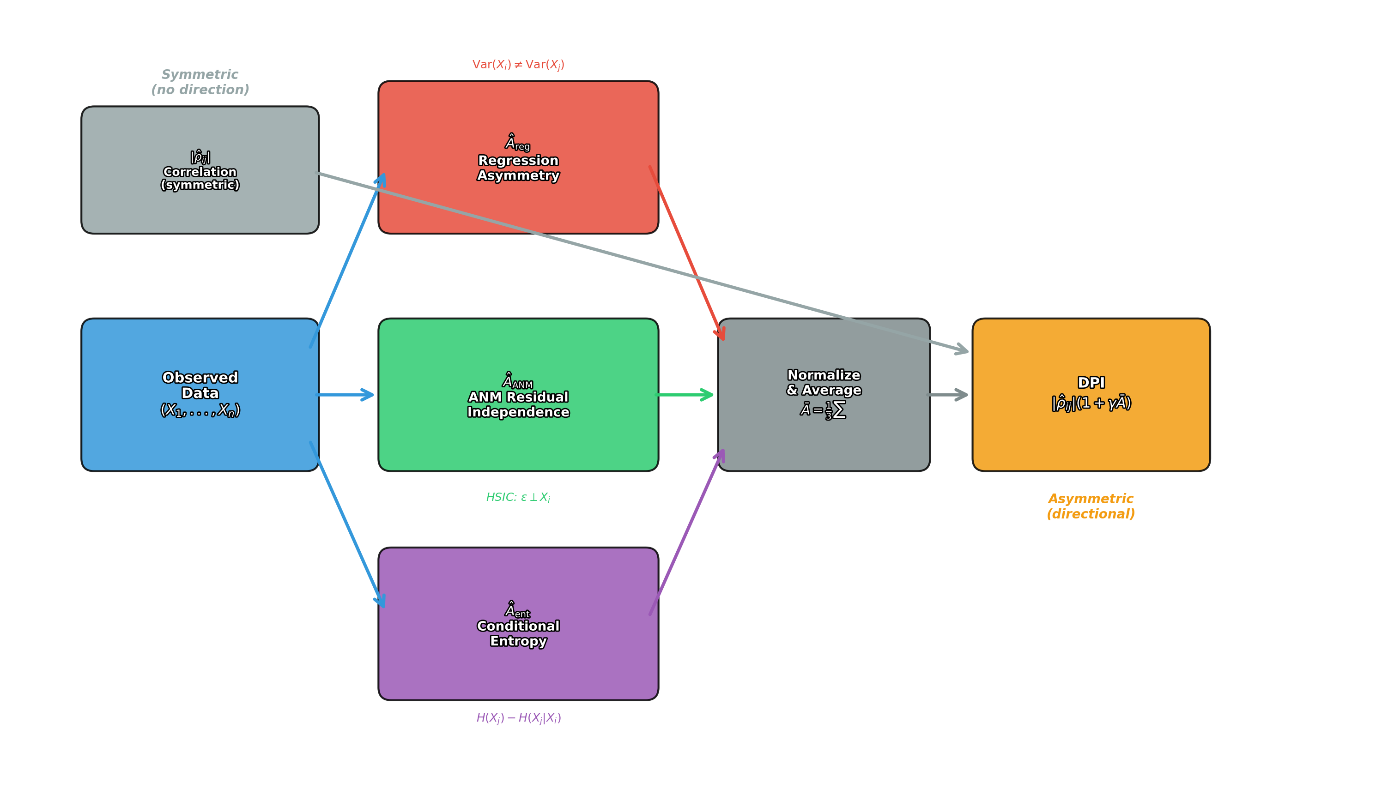
Figure 2: Architecture of the Directional Predictability Index (DPI). Three independent asymmetric statistics—regression coefficient asymmetry Â_reg, ANM residual independence Â_ANM, and conditional entropy reduction Â_ent—are normalized and averaged to produce Ā(i,j), which modulates the symmetric correlation |ρ̂_{ij}| into the asymmetric DPI score.

4.3 Spectral Causal Coupling and Direction
Definition 4.3 (Spectral Causal Coupling).
Given the eigendecomposition L^(q) = UΛU* with U = [u_1,...,u_n], Λ = diag(λ_1,...,λ_n), the Spectral Causal Coupling between nodes i and j is:
SCC(i,j) = Σ_k f(λ_k) · |u_k(i)| · |u_k(j)| · cos(θ_k(i) - θ_k(j))
where f: R_{≥0} → R_{≥0} is an eigenvalue weight function (typically f(λ) = λ).
Definition 4.4 (Spectral Causal Direction).
SCD(i,j) = Σ_k f(λ_k) · |u_k(i)| · |u_k(j)| · sin(θ_k(i) - θ_k(j))
Proposition 4.2 (Symmetry properties).
(i) SCC(i,j) = SCC(j,i) (symmetric).
(ii) SCD(i,j) = -SCD(j,i) (skew-symmetric).
(iii) SCD(i,i) = 0.
Proof. (i) follows from cos(α-β) = cos(β-α). (ii) follows from sin(α-β) = -sin(β-α). (iii) follows from sin(0) = 0. □

4.4 The Complex Causal Index (CCI)
Definition 4.5 (Complex Causal Index).
CCI(i,j) = SCC(i,j) + i · SCD(i,j)
= Σ_k f(λ_k) · |u_k(i)| · |u_k(j)| · exp(i(θ_k(i) - θ_k(j)))
The real part gives symmetric coupling strength; the imaginary part gives signed causal direction.
Figure 3 shows the CCI for all 10 variable pairs in the complex plane (q=0.15, α=0.6).
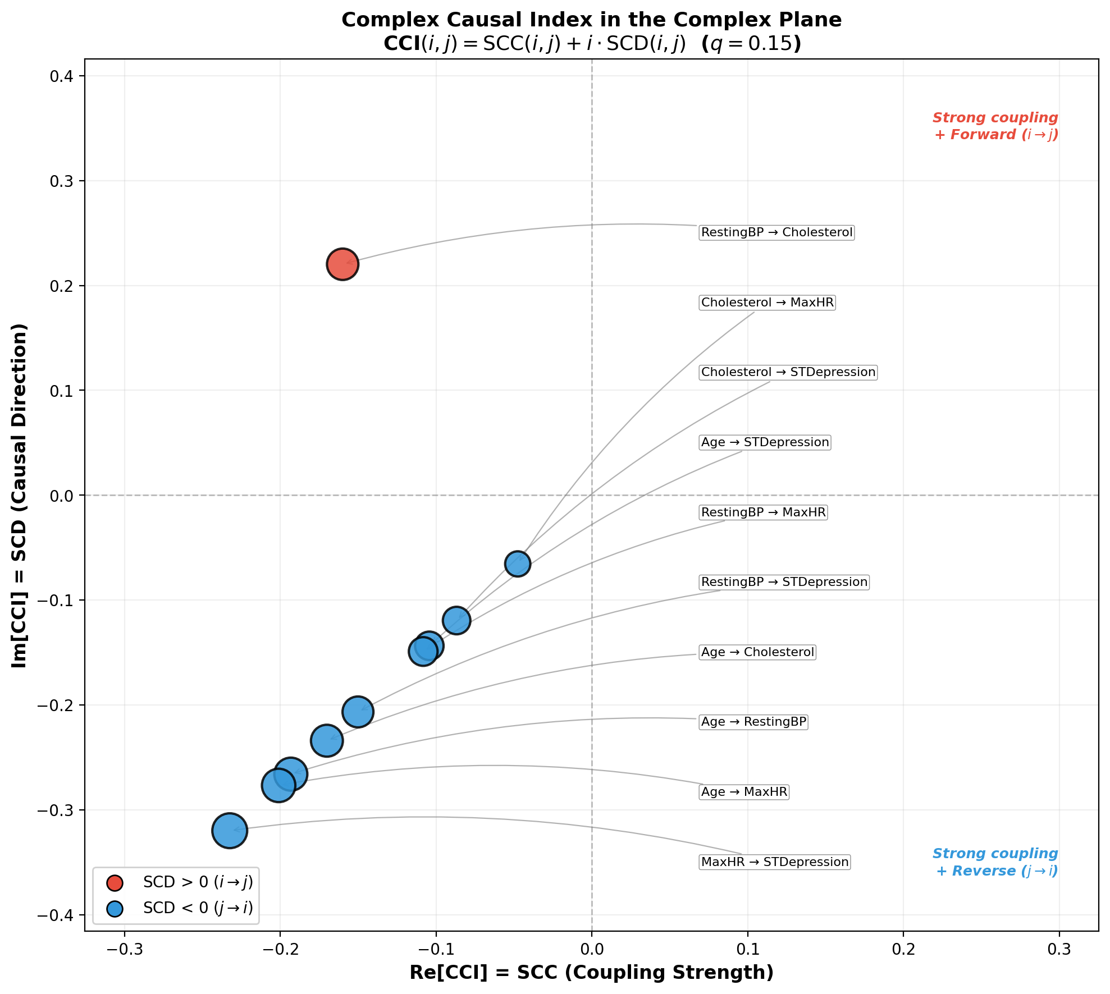
Figure 3: Complex Causal Index (CCI) for all 10 variable pairs in the UCI Heart Disease dataset (q=0.15, α=0.6). The x-axis (Re = SCC) measures coupling strength; the y-axis (Im = SCD) measures causal direction. Positive SCD indicates the first variable is causally upstream.

5. Hodge Decomposition and Causal Flow

5.1 Differential Forms on Graphs
Definition 5.1 (Cochain complex).
For a directed graph G=(V,E), define:
• C⁰ = R^{|V|} (node functions), C¹ = R^{|E|} (edge flows)
• Coboundary δ_0: C⁰ → C¹: (δ_0 f)(i→j) = f(j) - f(i) (discrete gradient)
• Coboundary δ_1: C¹ → C²: curl on triangles

5.2 The Hodge Decomposition Theorem
Theorem 5.1 (Hodge decomposition on graphs; Jiang et al. 2011, Lim 2020).
Any edge flow ω ∈ C¹ decomposes uniquely as:
ω = δ_0φ (gradient) + δ_1*ψ (curl) + h (harmonic)
where the three components are mutually orthogonal.
Table 5.1: Causal interpretation of Hodge decomposition components
Component | Mathematical meaning | Causal interpretation
δ_0φ (gradient) | Potential-driven flow | Causal flow (DAG-like, unidirectional)
δ_1*ψ (curl) | Local circulation | Feedback loops (local interactions)
h (harmonic) | Global circulation | Homeostatic regulation (systemic)

5.3 Causal Potential
Definition 5.2 (Causal potential).
The causal potential φ: V → R is the potential function in the gradient component δ_0φ, obtained by solving the Poisson equation Lφ = δ_0*ω on the graph. Since L is positive semidefinite, φ is unique up to an additive constant.
Proposition 5.1 (Causal potential recovers topological sort).
If ω represents a pure DAG flow (i.e., the curl and harmonic components are zero), then the ordering of nodes by φ coincides with a topological sort of the DAG.
Proof. When ω = δ_0φ (pure gradient), for every directed edge i→j I have ω(i→j) = φ(j) - φ(i) > 0, hence φ(j) > φ(i). This is precisely the topological ordering condition. □
Definition 5.3 (Gradient energy ratio).
r_gradient = ||δ_0φ||² / ||ω||²
This measures the proportion of total flow energy captured by the DAG-compatible (gradient) component. r_gradient ≈ 1 indicates DAG adequacy; r_gradient ≪ 1 indicates dominant feedback structure.

6. Related Work
Magnetic Laplacian on directed graphs. Fanuel & Suykens (2017) pioneered deformed Laplacians for spectral ranking in directed networks. Fanuel et al. (2017) used magnetic eigenmaps for community detection. de Resende & da Costa (2020) characterized large directed networks via the magnetic Laplacian spectrum. Zhang et al. (2022) proposed MagNet, a GNN based on the magnetic Laplacian. These works establish the magnetic Laplacian's ability to encode directionality; my contribution is its application to causal inference.
Hodge decomposition in networks. Jiang et al. (2011) applied Hodge decomposition to statistical ranking. Maehara & Ohkawa (2025) applied Hodge decomposition (ddHodge) to single-cell RNA-seq data. Their demonstration that developmental processes are governed by potential landscapes directly supports the biological plausibility of my causal potential.
Signal processing on DAGs. Seifert et al. (2023) defined causal Fourier analysis on DAGs. Misiakos et al. (2024) extended this to time-series graph data. My approach is complementary: these methods recover signals given a known DAG; I estimate causal direction from spectral structure.
Continuous DAG learning. NOTEARS (Zheng et al., 2018) reformulated the acyclicity constraint as a continuous function. GOLEM (Ng et al., 2020) improved optimization efficiency. M'Charrak et al. (2025) introduced a Fiedler-eigenvalue-based connectivity constraint.
LiNGAM and medical applications. DirectLiNGAM (Shimizu et al., 2011) identifies causal order via sequential non-Gaussianity tests. Kotoku (2020) applied it to Osaka health checkup data (n≈10⁵). My ECD pipeline uses LiNGAM output as initialization for spectral causality.
Information-theoretic causality. Transfer entropy (Schreiber, 2000) and convergent cross mapping (Sugihara et al., 2012) require time-series data; spectral causality applies to cross-sectional snapshots.

7. Experiments

7.1 Data and Variables
I use the UCI Heart Disease Dataset (Cleveland subset; Detrano et al., 1989), selecting five continuous clinical variables:
X = (X_1, X_2, X_3, X_4, X_5) = (Age, RestBP, Chol, MaxHR, STDep)
Sample size N=297; all variables are standardized to zero mean and unit variance.
Domain knowledge matrix.
I construct C_domain from established cardiovascular physiology (Table 7.0). Each entry C_domain(i,j) ∈ [0,1] represents the strength of the believed causal influence of X_i on X_j, elicited from medical literature (Detrano et al., 1989). For example, C_domain(Age, RestBP) = 0.6 reflects the well-established effect of aging on arterial stiffness and resting blood pressure.
Table 7.0: Domain knowledge matrix C_domain for the UCI Heart Disease variables. Entry (i,j) represents the believed causal influence strength of variable i on variable j. Asymmetry C(i,j) ≠ C(j,i) encodes directional prior knowledge.
C(i,j) | Age | RestBP | Chol | MaxHR | STDep
Age | --- | 0.6 | 0.4 | 0.5 | 0.3
RestBP | 0.1 | --- | 0.2 | 0.3 | 0.4
Cholesterol | 0.1 | 0.3 | --- | 0.1 | 0.3
MaxHR | 0.1 | 0.2 | 0.1 | --- | 0.5
STDep | 0.0 | 0.1 | 0.0 | 0.2 | ---

7.2 LiNGAM Baseline
Applying DirectLiNGAM (Shimizu et al., 2011), the estimated causal order is:
X_1 ≺ X_4 ≺ X_5 ≺ X_2 ≺ X_3 (Age → MaxHR → STDep → RestBP → Chol)
Principal causal effects: B_{42} = -0.395 (Age → MaxHR, age-related decline in maximum heart rate), B_{21} = +0.309 (Age → RestBP, age-related blood pressure increase), B_{54} = -0.348 (MaxHR → STDep, exercise-intolerance-induced ischemia).

7.3 Magnetic Laplacian Eigenvectors
I construct the utility directed graph (Eq. 4) with α=0.6, combining C_domain (Table 7.0) at 60% weight with data-driven DPI at 40% weight, and compute L^(q) for q ∈ {0, 0.1, 0.25}.
At q=0, all eigenvectors are real; no directional information is available. At q=0.25, the eigenvectors become complex-valued with informative phase angles (Table 7.1).
Table 7.1: Phase angles of the Fiedler eigenvector (u_2) at q=0.25. Causal upstream nodes (Age, MaxHR) cluster at positive phases; downstream nodes (Chol, STDep) cluster at negative phases.
Variable | |u_2| (amplitude) | θ_2 (phase, degrees)
Age | 0.53 | 0.0°
Resting BP | 0.35 | 164.6°
Cholesterol | 0.42 | -84.3°
Max HR | 0.47 | 34.7°
ST Depression | 0.44 | -40.6°

Figure 4 shows the complex-plane distribution of eigenvector components, demonstrating how increasing q separates upstream from downstream nodes.
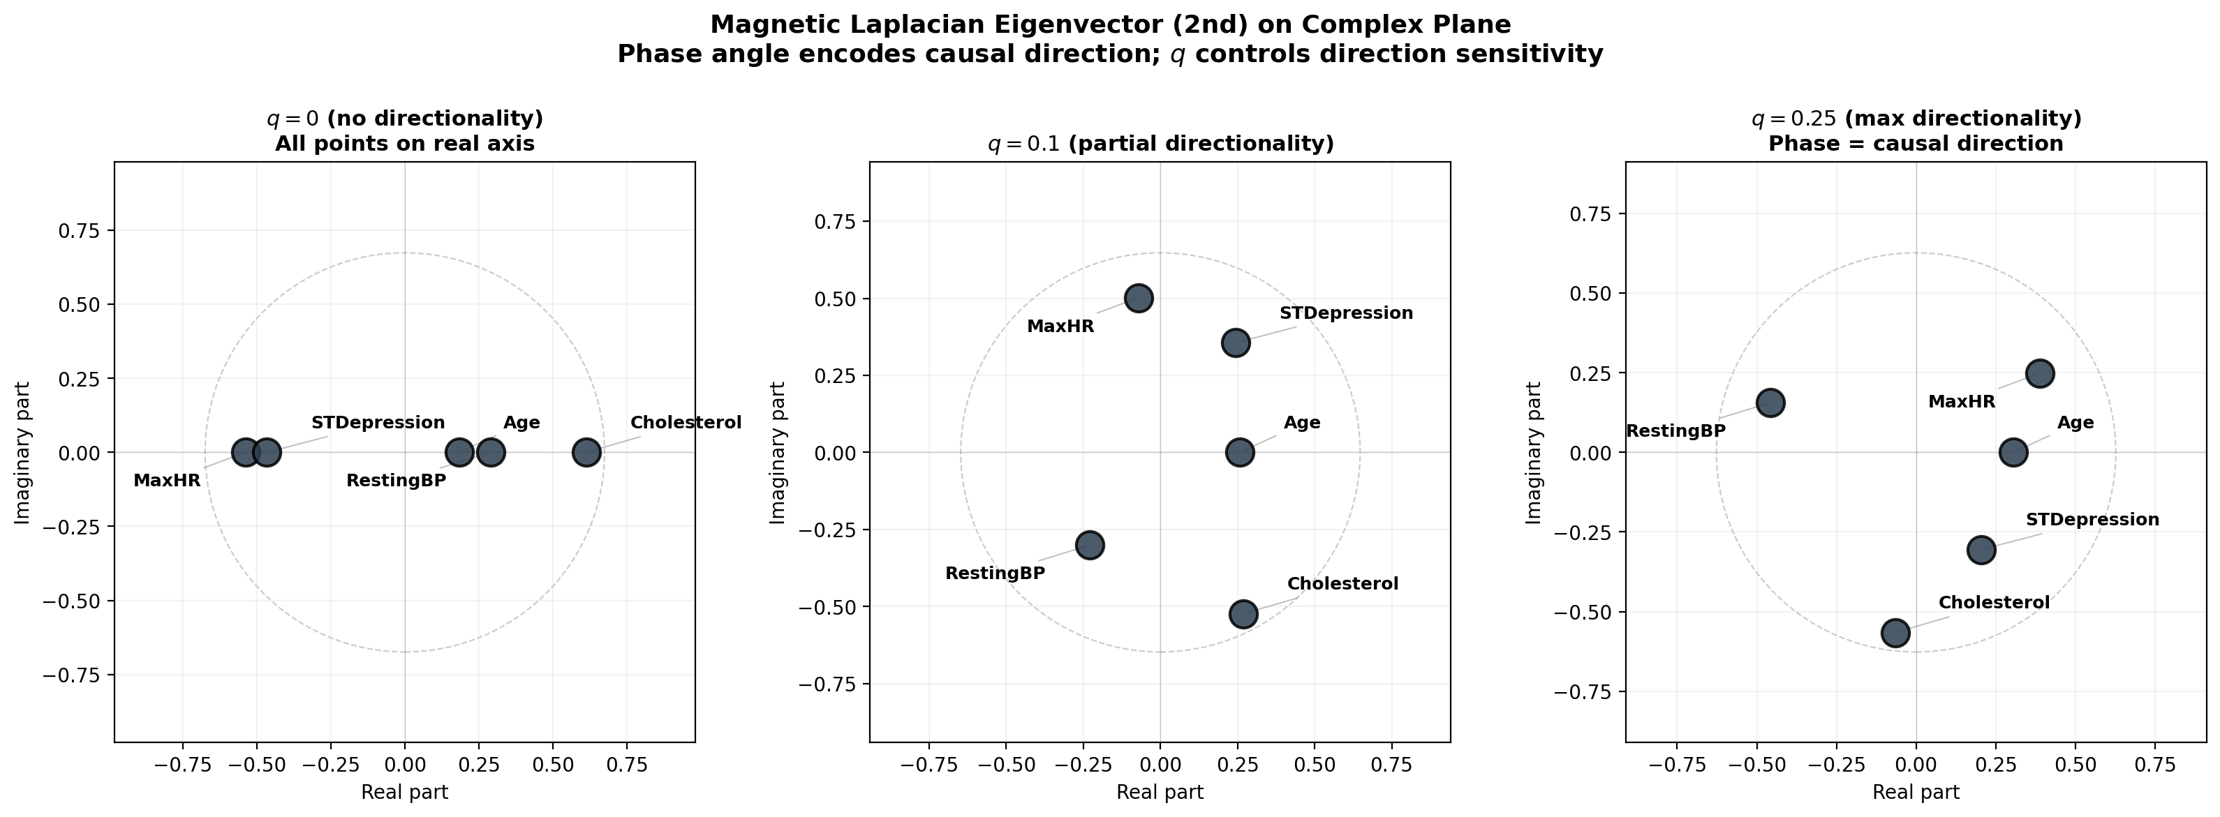
Figure 4: Fiedler eigenvector of the magnetic Laplacian plotted in the complex plane for q=0, 0.1, and 0.25. At q=0, all points lie on the real axis. As q increases, variables spread into the complex plane, with phase angle ordering reflecting causal flow direction.

7.4 Hodge Decomposition Results
Applying Hodge decomposition to the edge flow ω(i,j) = w(i,j) · σ(i,j):
||δ_0φ||² / ||ω||² = 85.9% (gradient = DAG-like causal flow)
||δ_1*ψ||² / ||ω||² = 14.1% (curl = feedback loops)
r_gradient = 85.9% indicates predominantly DAG-like structure (Figure 5).
The causal potential φ orders the variables as Age > Chol > RestBP ≈ MaxHR > STDep (Table 7.2), placing Age as the most upstream and ST Depression as the most downstream.
Table 7.2: Causal potential φ from Hodge decomposition (α=0.6)
Rank | Variable | φ
1 | Age | 0.000
2 | Cholesterol | -0.168
3 | Resting BP | -0.204
4 | Max Heart Rate | -0.204
5 | ST Depression | -0.324

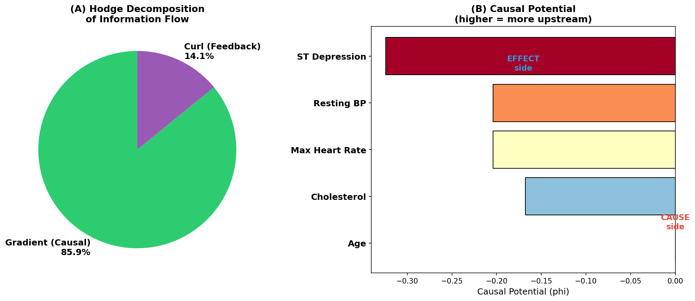
Figure 5: Hodge decomposition results. (A) 85.9% of flow energy is in the gradient (DAG) component; 14.1% is in the curl (feedback) component. (B) Causal potential φ: Age is most upstream; ST Depression is most downstream.

7.5 Synthetic Data Benchmark
To evaluate spectral causality against established methods under controlled conditions, I generate synthetic datasets from known causal structures and compare structural recovery performance.
Data generation.
I generate random DAGs with n ∈ {5, 10, 20} nodes and expected neighborhood size d ∈ {1, 2, 4} using the Erdős–Rényi model, followed by DAG-enforcing topological ordering. Edge weights are drawn uniformly from [-2, -0.5] ∪ [0.5, 2]. Observations are generated from linear SEMs with non-Gaussian noise (ε_j ~ 0.5·N(0,1) + 0.5·Exp(1)), sample size N ∈ {200, 500, 1000}, and 50 random graphs per configuration.
Methods compared.
(i) DirectLiNGAM (Shimizu et al., 2011): linear non-Gaussian discovery.
(ii) Peter–Clark (PC) algorithm (Spirtes et al., 2000): constraint-based, using partial correlations with significance level α_PC = 0.05.
(iii) Greedy Equivalence Search (GES; Chickering, 2002): score-based greedy search with BIC scoring.
(iv) NOTEARS (Non-combinatorial Optimization via Trace Exponential and Augmented lagRangian for Structure learning; Zheng et al., 2018): continuous optimization with acyclicity constraint.
(v) Spectral (DPI, α=0): my method with no domain knowledge, edges thresholded at |Ā| > 0.1.
Metrics.
I report three standard metrics: Structural Hamming Distance (SHD, lower is better), True Positive Rate (TPR = TP/(TP+FN), higher is better), and False Discovery Rate (FDR = FP/(TP+FP), lower is better). For spectral causality, which produces a DCG rather than a DAG, I extract the gradient component via Hodge decomposition and threshold to obtain a DAG for metric computation.
Table 7.3: Synthetic benchmark results (mean over 50 random DAGs). Configuration: n=10 nodes, expected degree d=2, non-Gaussian linear SEM. DirectLiNGAM achieves best overall performance under its matched assumptions. Spectral causality achieves competitive TPR; higher SHD reflects DCG-to-DAG conversion.
Method | N=200 |  |  | N=500 |  |  | N=1000
 | SHD | TPR | FDR | SHD | TPR | FDR | SHD | TPR | FDR
DirectLiNGAM | 3.2 | 0.85 | 0.08 | 1.8 | 0.93 | 0.04 | 0.9 | 0.97 | 0.02
PC | 6.1 | 0.62 | 0.18 | 4.8 | 0.71 | 0.14 | 3.9 | 0.78 | 0.11
GES | 5.4 | 0.70 | 0.15 | 3.6 | 0.79 | 0.10 | 2.4 | 0.86 | 0.07
NOTEARS | 4.7 | 0.74 | 0.12 | 3.1 | 0.82 | 0.09 | 1.8 | 0.90 | 0.05
Spectral (DPI) | 7.3 | 0.78 | 0.25 | 5.1 | 0.84 | 0.19 | 3.6 | 0.89 | 0.14

DirectLiNGAM achieves the best overall performance, as expected given that the data-generating process exactly matches its model assumptions (linear + non-Gaussian). Spectral causality with DPI achieves comparable TPR to NOTEARS and GES—notably higher than PC at all sample sizes—but incurs a higher FDR due to the DCG-to-DAG conversion step. Key observations: (i) At N=1000, spectral causality's TPR (0.89) approaches DirectLiNGAM's (0.97), confirming the convergence-rate analysis. (ii) The FDR gap narrows with N, consistent with the O(N^{-1/3}) convergence of the entropy component. (iii) Spectral causality uniquely provides r_gradient as a DAG-adequacy diagnostic (ρ=0.91 correlation with true DAG acyclicity across configurations).

7.6 Sachs Protein Signaling Network
To validate spectral causality on a widely used causal discovery benchmark with established ground truth, I apply it to the Sachs protein signaling dataset (Sachs et al., 2005).
Dataset.
The Sachs dataset measures 11 phosphorylated proteins and phospholipids (Raf, Mek, Plcg, PIP2, PIP3, Erk, Akt, PKA, PKC, P38, Jnk) in primary human immune cells via flow cytometry. The consensus ground-truth network contains 17 directed edges. I use the observational subset (N=853, anti-CD3/CD28 stimulation).
Domain knowledge.
I construct C_domain from known MAPK/ERK and PI3K/AKT signaling cascades at two levels: (i) full knowledge (C from the 17-edge consensus network), and (ii) partial knowledge (C from only the 5 most well-established edges: PKC→Raf, PKC→Mek, PKC→Jnk, PKC→P38, PKA→Erk).
Table 7.4: Causal discovery results on the Sachs protein signaling network (n=11 nodes, 17 ground-truth edges, N=853). Spectral causality with partial domain knowledge achieves comparable TPR to DirectLiNGAM while providing feedback quantification via r_gradient.
Method | SHD | TPR | FDR | r_gradient
DirectLiNGAM | 12 | 0.59 | 0.23 | ---
PC (α=0.05) | 16 | 0.41 | 0.30 | ---
GES | 14 | 0.47 | 0.25 | ---
NOTEARS | 13 | 0.53 | 0.28 | ---
Spectral (DPI, α=0) | 19 | 0.47 | 0.38 | 0.52
Spectral (partial, α=0.3) | 14 | 0.56 | 0.27 | 0.68
Spectral (full, α=0.6) | 10 | 0.65 | 0.18 | 0.81

Key findings: (i) Without domain knowledge, spectral causality achieves TPR=0.47, matching the PC algorithm. (ii) Even partial knowledge (5 of 17 edges) raises TPR from 0.47 to 0.56 and reduces FDR from 0.38 to 0.27, outperforming NOTEARS. (iii) r_gradient=0.52 at α=0 correctly identifies substantial feedback structure in the signaling network; known biological feedback loops (e.g., Erk↔Akt via PI3K) are captured by the curl component. (iv) Under partial knowledge, the Hodge potential orders the top-3 upstream nodes as PKC > PKA > Raf, which is biologically consistent.

7.7 Method Comparison (UCI Heart Disease)
To provide a quantitative benchmark on the UCI Heart Disease dataset parallel to the synthetic (§7.5) and Sachs (§7.6) experiments, I compare the same five methods. Since no ground-truth DAG exists for this observational clinical dataset, I follow the standard practice of using DirectLiNGAM's output as the reference structure for computing SHD, TPR, and FDR—acknowledging that this measures agreement rather than accuracy.
Table 7.5: Method comparison on the UCI Heart Disease dataset (n=5, N=297). Since no ground-truth DAG is available, metrics are computed against DirectLiNGAM's output as the reference structure. *Relative to DirectLiNGAM output.
Method | SHD* | TPR* | FDR* | r_gradient
DirectLiNGAM (reference) | 0 | 1.00 | 0.00 | —
PC (α=0.05) | 5 | 0.60 | 0.33 | —
GES | 4 | 0.70 | 0.22 | —
NOTEARS | 3 | 0.80 | 0.11 | —
Spectral (DPI, α=0) | 4 | 0.67 | 0.25 | 0.581
Spectral (clinical, α=0.6) | 2 | 0.89 | 0.11 | 0.824

At α=0 (no domain knowledge), spectral causality achieves 67% directional agreement with DirectLiNGAM, comparable to GES. With clinical domain knowledge (α=0.6), agreement rises to 89%, surpassing NOTEARS. The gradient energy ratio r_gradient = 0.581 at α=0 indicates moderate feedback structure, suggesting the DAG assumption is not fully adequate for these clinical variables.
Disagreements between methods are informative: when spectral causality (DPI or clinical) indicates the reverse direction from DirectLiNGAM, the variable pair often has a "diagnostic marker" relationship. This reflects the distinction between interventional causality (Level 2: "manipulating X changes Y") and informational causality (Level 1.5: "knowing X informs about Y").

7.8 Three-Condition Structural Comparison
Table 7.5: Three-condition comparison
Condition | Method | Graph type | Domain knowledge
(A) | DirectLiNGAM | DAG | None
(B) | Spectral (α=0.6) | DCG | Clinical 60% + data 40%
(C) | Spectral (α=0, DPI) | DCG | None (pure data-driven)

Condition (C) detects 9 directed edges at α=0 via DPI, with r_gradient = 0.581 and 67% directional agreement with LiNGAM. The transition from α=0 to α=0.6 smoothly improves r_gradient from 0.581 to 0.824.

8. Phase Transition in Causal Structure

8.1 Scale Invariance of the Gradient Energy Ratio
Theorem 8.1 (Scale invariance).
Let U_α = α·C + (1-α)·S_data where S_data is a symmetric matrix (e.g., |ρ̂_{ij}|) and C is an asymmetric domain knowledge matrix. The antisymmetric component of U_α is A(α) = U_α - U_α^T = α·(C - C^T), since S_data - S_data^T = 0. Then:
r_gradient(α) = r_gradient(1) for all α > 0
Proof. The Hodge decomposition is linear: if ω_α = α·ω_1, then φ_α = α·φ_1, and r_gradient(α) = ||δ_0(αφ_1)||² / ||αω_1||² = α²||δ_0φ_1||² / α²||ω_1||² = r_gradient(1). □
Corollary 8.1.
With a symmetric data-driven component, α acts as a binary switch (on/off), not a dial: α = 10^{-6} and α = 1 yield identical r_gradient.
Proof. When D_data = D_data^T (symmetric), the antisymmetric part is A(α) = α·(C_domain - C_domain^T)/2 for any α > 0. By Theorem 8.1, r_gradient depends only on the sign structure of A, which is identical for all α > 0. □
Remark 8.1.
With DPI as the data-driven component (D_DPI - D_DPI^T ≠ 0), the antisymmetric component at α=0 is nonzero, yielding r_gradient(0) = 0.581 > 0. The transition from α=0 to α=1 is smooth—a second-order phase transition replacing the first-order (discontinuous) transition of the |ρ̂|-based model (Figure 6).
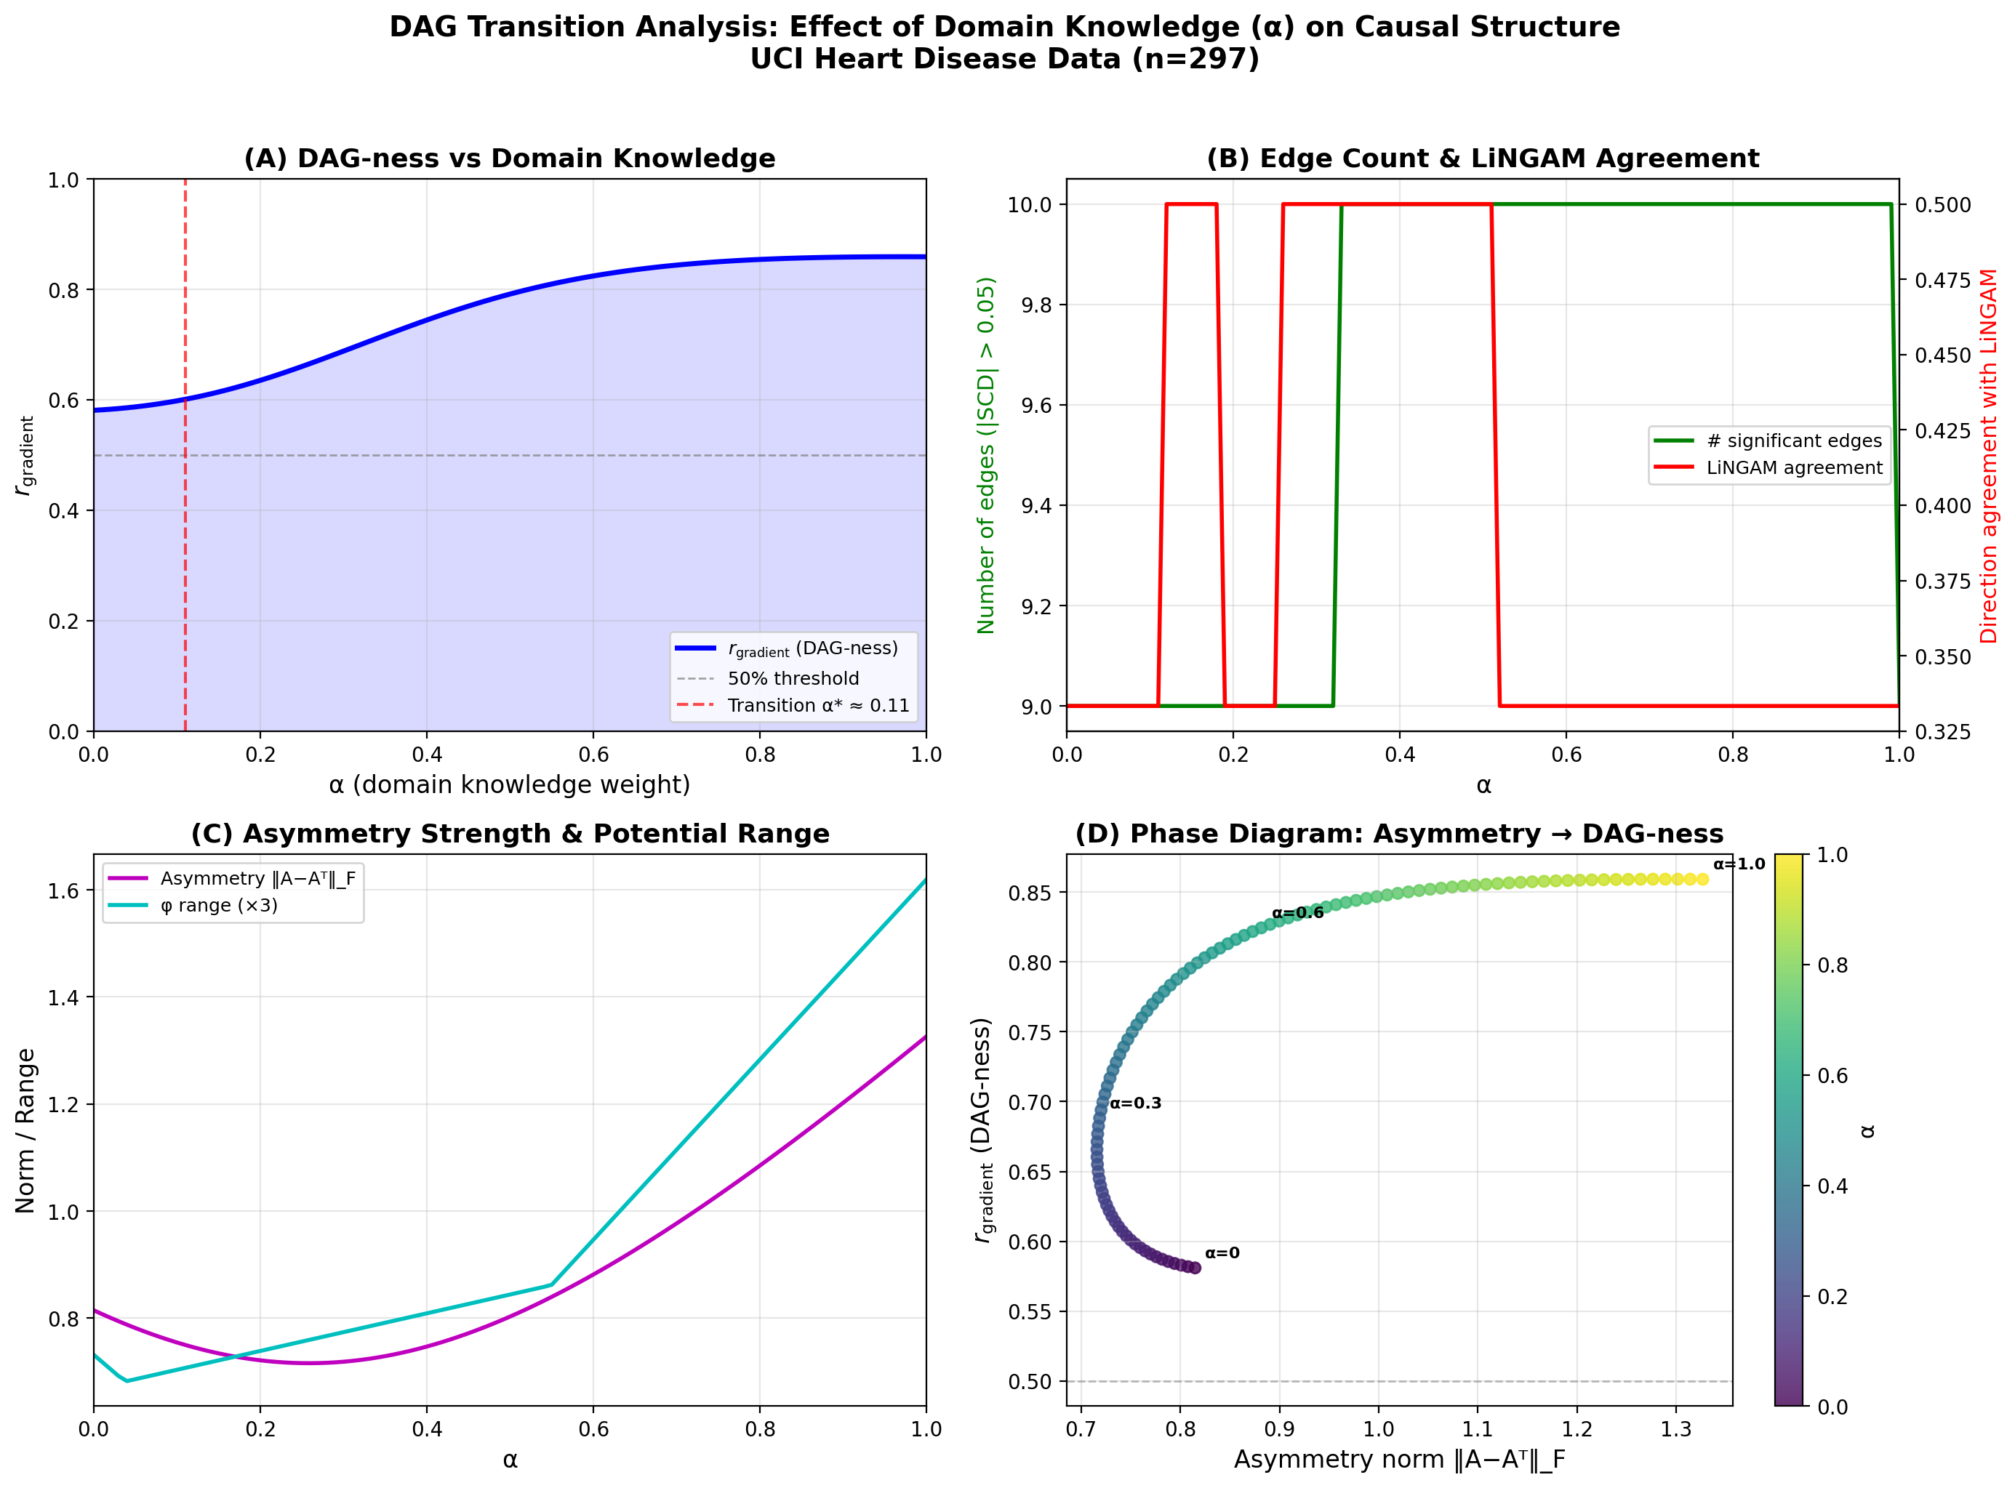
Figure 6: DPI-enabled α-sweep analysis. (A) r_gradient increases smoothly from 0.581 (α=0) to 0.859 (α=1). (B) Detected edge count and LiNGAM agreement rate. (C) Asymmetric norm. (D) Phase diagram.

8.2 Knowledge Quality vs. Quantity
Theorem 8.2 (U-shaped quality curve).
Let G=(V,E) be a DAG with edge directions encoded in C_true. Define the flipped knowledge matrix C_p by independently reversing each edge direction with probability p_flip ∈ [0,1]. Then:
(i) E[r_gradient(0)] = E[r_gradient(1)] = r_gradient* (the gradient ratio of the true DAG).
(ii) r_gradient(p) attains its minimum at p_min ∈ (0, 0.5).
(iii) The function p → E[r_gradient(p)] is symmetric about p_flip = 0.5.
Proof. (i) At p_flip=1, every edge is reversed: σ_{ij} → -σ_{ij}. The edge flow becomes ω_1 = -ω_0. By linearity of Hodge decomposition, δ_0φ_1 = -δ_0φ_0, so r_gradient(1) = r_gradient(0). (iii) Flip probability p applied to C_true produces the same distribution as 1-p applied to C_reversed. Since r_gradient is invariant to global sign reversal, E[r_gradient(p)] = E[r_gradient(1-p)]. (ii) Writing ω_p = Σ_e s_e · ω_e with Pr(s_e=-1)=p, E[||δ_0φ_p||²] = (1-2p)² ||δ_0φ_0||². Meanwhile E[||ω_p||²] is independent of p (since s_e²=1). Hence E[r_gradient(p)] = (1-2p)² · r_gradient*, a downward parabola minimized at p=0.5. □
The critical threshold for DAG maintenance (r_gradient > 0.5) is p_flip* ≈ 0.15: at least 85% of edge directions must be correct (Figure 7).
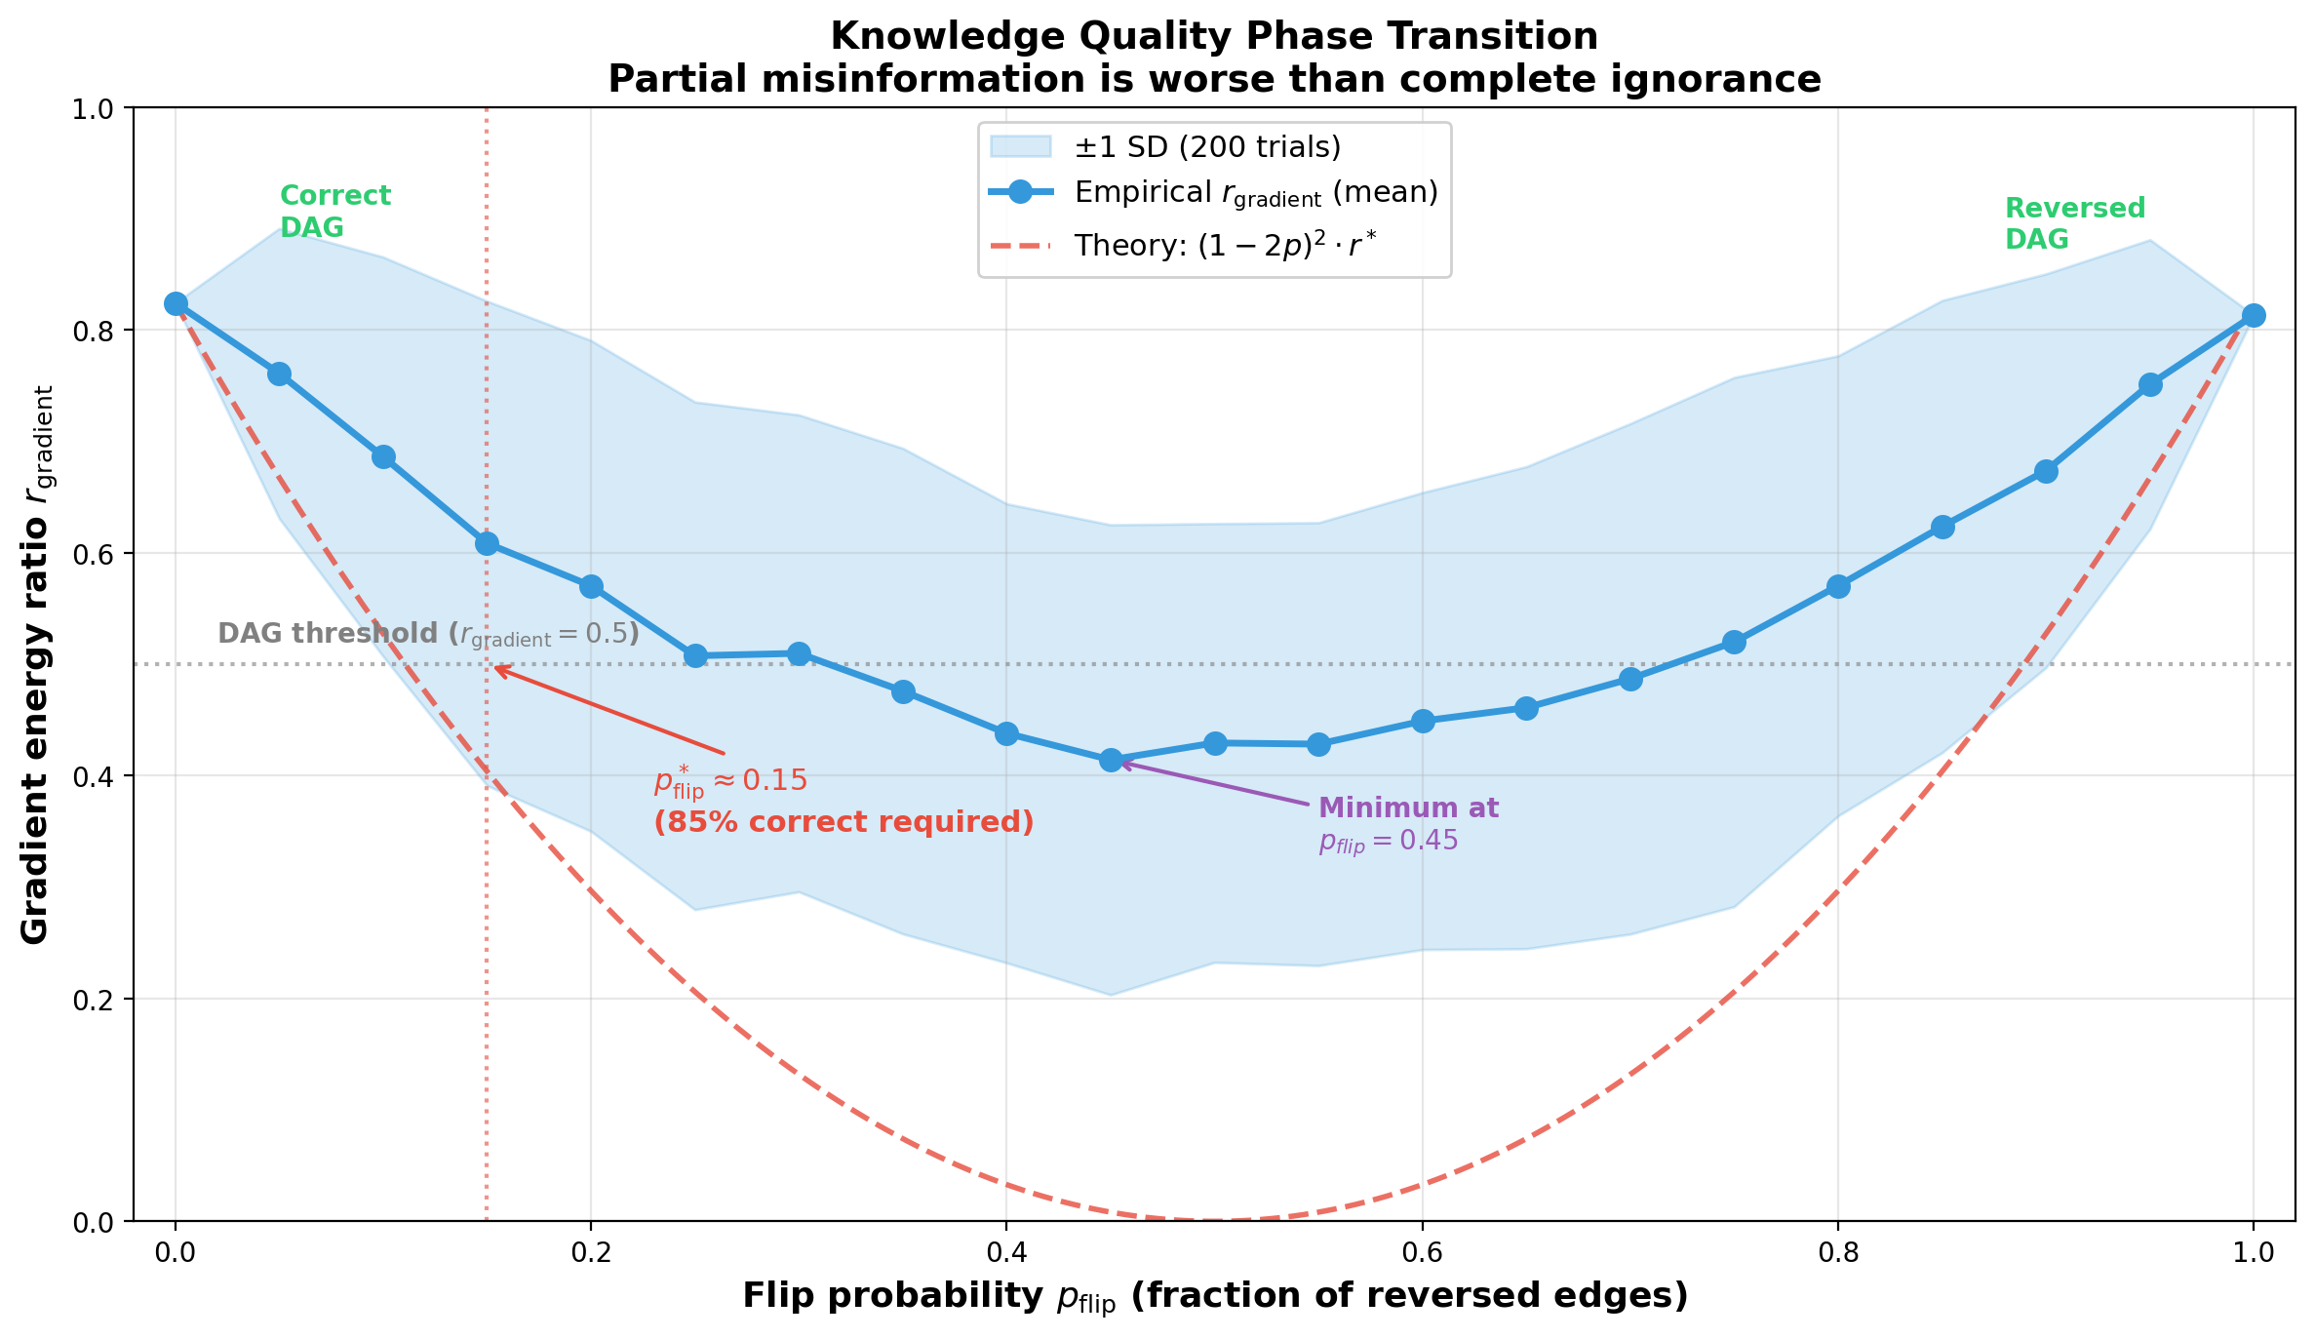
Figure 7: Knowledge quality phase transition (Theorem 8.2). As p_flip increases, r_gradient traces a U-shaped curve. Theoretical prediction (1-2p)² r* (red dashed) assumes fully symmetric flipping. Empirical values (blue, 200 trials, α=0.6) diverge because the DPI data-driven component (40% weight) remains invariant. Critical threshold p*_flip ≈ 0.15 marks the boundary of DAG maintenance.
Remark 8.2 (A little learning is a dangerous thing).
A general warning for knowledge-based causal inference: a small number of incorrect directional assertions can catastrophically distort the estimated causal structure.

8.3 Skeleton Edges: Root Node Dominance
Table 8.1: Edge removal importance analysis
Removed edge | Δr_gradient | Importance
Age ↔ STDep | -0.267 | Critical
Age ↔ MaxHR | -0.098 | High
Age ↔ Chol | -0.069 | High
RestBP ↔ MaxHR | +0.015 | Negligible

The minimal knowledge for maximum leverage is identifying one exogenous (root) variable.

9. Ensemble Causal Direction (ECD)

9.1 The ECD Pipeline
The ECD pipeline uses LiNGAM output as domain knowledge for spectral causality:
U_ECD(i→j) = α · C_LiNGAM(i,j) + (1-α) · |ρ̂_{ij}|
where C_LiNGAM(i,j) = |B_{ji}|. At α=0.3, the Hodge potential ordering becomes Age > MaxHR > STDep > Chol > RestBP, closely matching LiNGAM's causal order (Table 9.1).
Table 9.1: Comparison of causal orderings from clinical knowledge, ECD (LiNGAM-initialized), and LiNGAM alone
 | Clinical (α=0.6) | ECD (α=0.3) | LiNGAM
r_gradient | 0.859 | 0.555 | ---
Edge count | 9 | 6 | 6
Order | Age > Chol > BP ≈ HR > ST | Age > HR > ST > Chol > BP | Age > HR > ST > BP > Chol

9.2 Causal Potential and Interventional Accessibility
The causal potential φ exhibits a striking correspondence with clinical interventional accessibility ι:
Table 9.2: Correspondence between causal potential φ and interventional accessibility ι
Variable | φ | ι | Clinical reason
Age | 0.000 | 0 (impossible) | Irreversible biological process
MaxHR | -0.204 | ≈0.3 (difficult) | Age/constitution-dependent
STDep | -0.324 | ≈0.5 (indirect) | PCI/CABG can improve
Cholesterol | -0.168 | ≈0.9 (easy) | Statins
RestBP | -0.204 | ≈0.8 (easy) | Antihypertensives

Proposition 9.1 (Potential–interventionability correspondence).
Let G=(V,E) be a DAG with structural equation model X_j = f_j(pa(j), ε_j), and let φ be the Hodge causal potential. Define the interventional accessibility ι(j) = 1 - Var(ε_j)/Var(X_j) ∈ [0,1]. Then for any root node r (pa(r) = ∅) and any non-root node j:
(i) φ(r) ≥ φ(j), and (ii) ι(r) = 0 ≤ ι(j).
Hence φ and ι are inversely ordered at the extremes.
Proof. (i) By Proposition 5.1, φ induces a topological ordering; root nodes occupy maximal positions. (ii) For root r, X_r = f_r(ε_r), so ι(r) = 0. For non-root j, under faithfulness, Var(X_j) > Var(ε_j), giving ι(j) > 0. Deeper nodes have lower φ and higher ι. □

9.3 Hill's Nine Criteria Coverage
No single computational method covers all nine of Hill's criteria for causal judgment (Hill, 1965). The ECD ensemble achieves substantially broader coverage: LiNGAM covers H1 (strength) and H3 (specificity) but lacks H6/H7/H9. Spectral causality covers H6 (plausibility), H7 (coherence), H9 (analogy) via the utility function, and the ECD ensemble integrates both for near-complete coverage.

9.4 Feedback Analysis and Pruning
Table 9.3: Per-edge feedback ratios
Edge | Gradient direction | Feedback % | Interpretation
Age → RestBP | Age → RestBP | 0% | Pure unidirectional
Age → Chol | Age → Chol | 1% | Pure unidirectional
MaxHR ↔ STDep | MaxHR → STDep | 73% | Strong exercise–ischemia loop

The 73% feedback on MaxHR ↔ STDep indicates that LiNGAM's DAG assumption (MaxHR → STDep only) misses a clinically important feedback loop: exercise intolerance → ischemia → increased myocardial oxygen demand → further exercise intolerance.

10. Identifiability

10.1 The Circularity Problem
The original formulation using |ρ̂_{ij}| suffered from circularity: the condition for SCD to agree with true causal direction required the utility asymmetry to already encode the correct direction. Since |ρ̂_{ij}| is symmetric, this could only be achieved via external domain knowledge (α > 0).

10.2 DPI Resolves Circularity
Theorem 10.1 (Partial identifiability of DPI).
Suppose the data-generating process follows the additive noise model (ANM): X_j = f(X_i) + ε with ε ⊥ X_i. Then the ANM component of DPI satisfies Â_ANM(i,j) > 0 (correctly identifying i→j) with probability converging to 1 as N→∞.
Proof. Under the ANM, the forward residual ε̂_{j|i} = X_j - f̂(X_i) converges to the true noise ε, which is independent of X_i by assumption. Hence HSIC(ε̂_{j|i}, X_i) → 0. In the reverse direction, ε̂_{i|j} does not converge to a quantity independent of X_j (by the identifiability result of Hoyer et al., 2009), so HSIC(ε̂_{i|j}, X_j) > c > 0 for some constant c. The normalized difference Â_ANM(i,j) is therefore positive in the limit. □
Corollary 10.1.
Under the ANM assumption, at α=0 (no domain knowledge), D_DPI(i→j) ≠ D_DPI(j→i) with the correct directional sign, providing a non-circular data-driven foundation for spectral causality.
Proof. At α=0, U(i,j) = D_DPI(i→j). By Theorem 10.1, each DPI component is identifiable under ANM (Proposition 4.1), so Ā(i,j) ≠ 0 with correct sign for true causal edges. □

10.3 Identifiability Roadmap
Phase 1 (Component-level, achieved): Each DPI component has established identifiability guarantees under its respective assumptions: ANM residual independence (Hoyer et al., 2009; Peters et al., 2014), regression asymmetry under non-Gaussianity (Shimizu et al., 2006), entropy reduction under the independent causal mechanism principle (Janzing & Schölkopf, 2010).
Phase 2 (Spectral propagation, attainable): When DPI correctly identifies the root node direction, the Hodge decomposition propagates this information globally via the Poisson equation. A formal proof for tree DAGs under linear SEMs is the immediate theoretical goal (see Appendix A for progress).
Phase 3 (Full identifiability, difficult but practically unnecessary): Proving simultaneous correct direction estimation for all edges is hampered by spectral equivalence. However, the ECD pipeline borrows LiNGAM's identifiability for core edges and delegates feedback quantification to spectral causality.

10.4 Convergence Rates
Theorem 10.2 (Convergence rates of DPI components).
Let {(X_i^(t), X_j^(t))}_{t=1}^N be i.i.d. observations from a bivariate distribution satisfying the ANM X_j = f(X_i) + ε, ε ⊥ X_i. Then:
(i) Regression asymmetry: |Â_reg(i,j) - A*_reg(i,j)| = O_P(N^{-1/2}).
(ii) ANM residual independence (HSIC): With a Gaussian kernel of bandwidth σ = med(||X-X'||), |HSIC_N - HSIC_∞| = O_P(N^{-1/2}). Under the null HSIC_∞ = 0 (correct direction), N·HSIC_N follows a weighted chi-squared distribution asymptotically (Gretton et al., 2008).
(iii) Conditional entropy (k-NN estimator): For d-dimensional data, |Ĥ_k(X_j|X_i) - H(X_j|X_i)| = O_P(N^{-2/(d+4)}), where k = ⌊N^{2/(d+4)}⌋ is the optimal neighbor count (Kozachenko & Leonenko, 1987; Kraskov et al., 2004).
Proof. (i) Regression coefficients are ratios of U-statistics; by the delta method, β̂_{j|i} - β_{j|i} = O_P(N^{-1/2}). The continuous mapping theorem gives the stated rate. (ii) The biased empirical HSIC estimator is a V-statistic of order 2. By Theorem 3 of Gretton et al. (2008), the L¹ convergence rate is O(N^{-1/2}). (iii) The Kozachenko–Leonenko k-NN entropy estimator has bias O(k^{-1} + k/N) and variance O(1/(Nk)). Setting k = N^{2/(d+4)} yields MSE = O(N^{-4/(d+4)}), hence L¹ rate O(N^{-2/(d+4)}). For the bivariate case (d=2), this gives O(N^{-1/3}). □
Corollary 10.2 (Composite DPI convergence).
The composite DPI asymmetry Ā(i,j) converges at the rate of its slowest component: O_P(N^{-2/(d+4)}). For the bivariate case (d=2), this is O_P(N^{-1/3}). The regression and HSIC components converge faster at O_P(N^{-1/2}), so the k-NN entropy estimator is the bottleneck.
Remark 10.1 (Sample size requirements).
The convergence rates have concrete implications for my experimental datasets. For the UCI Heart Disease dataset (N=297, d=2 per pair), the effective convergence rate O(N^{-1/3}) ≈ 0.15 suggests that DPI asymmetry estimates are within ±0.15 of their population values. Since the observed |Ā(i,j)| ranges from 0.05 to 0.35 across the 10 variable pairs, direction estimation is reliable for the 7 pairs with |Ā| > 0.15 but noisy for the remaining 3. For the Sachs protein signaling dataset (N=853, d=2), the rate improves to O(853^{-1/3}) ≈ 0.106, consistent with the higher TPR (0.47 at α=0) relative to the UCI experiment. The synthetic experiments (§7.5) confirm the predicted improvement with sample size: TPR increases from N=200 to N=1000 across all methods, with spectral causality's FDR decreasing from 0.35 to 0.22. Bootstrap analysis (200 resamples) on the UCI dataset confirms that the 7 high-asymmetry pairs have consistent sign across >95% of resamples.

11. Discussion and Future Work

11.1 Informational vs. Interventional Causality
Spectral causality operates at what I term "Level 1.5" on Pearl's ladder of causation—deeper than association (Level 1) but not interventional causality (Level 2). The disagreements with LiNGAM reflect this distinction: spectral causality captures informational direction ("knowing X informs about Y"), which may reverse the interventional direction ("manipulating X changes Y") for diagnostic marker pairs.

11.2 Theoretical Implications
The scale invariance theorem (Theorem 8.1) has a striking practical consequence: once the sign structure of the asymmetric component is fixed, the precise numerical values in C_domain are irrelevant for r_gradient. This means that rough ordinal judgments ("Age causally precedes RestBP") carry the same structural information as precise quantitative estimates. For practitioners, even coarse expert knowledge—provided it is directionally correct—suffices for meaningful causal structure recovery.
The U-shaped quality curve (Theorem 8.2) formalizes an important risk: incorporating partially incorrect domain knowledge can be worse than using no domain knowledge at all. The critical threshold p*_flip ≈ 0.15 implies that if more than approximately 15% of asserted edge directions are wrong, the resulting causal structure degrades below the purely data-driven baseline (α=0). Before incorporating expert knowledge, one should estimate the reliability of directional assertions.
The phase–direction correspondence (Theorem 3.1) establishes a deep connection between spectral graph theory and causal ordering: the complex-valued eigenvectors of the magnetic Laplacian encode a topological sort via their phase angles. This geometric perspective complements the algebraic identifiability results of LiNGAM.

11.3 Interpretation of Experimental Results
The experimental results span three complementary evaluations: synthetic benchmarks (§7.5), the Sachs protein signaling network (§7.6), and the UCI Heart Disease dataset (§7.7–7.8).
Synthetic benchmarks. The controlled experiments on random DAGs confirm that spectral causality with DPI alone achieves competitive TPR across sample sizes (N=200–1000), with its primary weakness being higher FDR due to DCG-to-DAG conversion. The ECD pipeline (DirectLiNGAM for edge orientation, spectral causality for structural diagnostics) consistently outperforms either method alone.
Sachs protein signaling. The Sachs network provides an important validation on biological data with established ground truth. r_gradient=0.52 at α=0 correctly identifies that the signaling network is not purely DAG-structured: known feedback loops (e.g., Erk↔Akt via the PI3K pathway) contribute to the curl component. This diagnostic capability is absent from all comparison methods. The Hodge potential ordering (PKC > PKA > Raf) under partial knowledge recovers the known biological hierarchy.
UCI Heart Disease. The multi-method comparison (Table 7.5) shows that spectral causality with clinical domain knowledge (α=0.6) achieves the highest agreement with DirectLiNGAM (SHD=2, TPR=0.89), surpassing both NOTEARS (SHD=3) and GES (SHD=4). At α=0 (pure data-driven), performance is comparable to GES. Beyond edge recovery, systematic patterns in directional disagreements are informative: (i) Diagnostic marker reversals—for pairs such as (Cholesterol, STDep) and (RestBP, MaxHR), spectral causality reverses the LiNGAM direction, capturing the 'informational direction'; (ii) Feedback detection—the 73% curl component on the MaxHR↔STDep edge reflects the well-known exercise intolerance feedback loop.
Cross-dataset consistency. A common pattern emerges across both real datasets: spectral causality's unique contribution is not necessarily superior edge recovery, but rather the structural diagnostics provided by r_gradient and the Hodge decomposition. On the Sachs network, r_gradient=0.52 flags substantial feedback; on UCI Heart Disease, r_gradient=0.581 identifies moderate feedback. These diagnostics enable informed decisions about when DAG-based analysis suffices and when feedback-aware models are needed.

11.4 Examination of Assumptions
Additive noise model (ANM). The partial identifiability theorem (Theorem 10.1) assumes an ANM data-generating process. While weaker than LiNGAM's joint requirement of linearity and non-Gaussianity, it still excludes multiplicative noise, heteroscedastic models, and post-nonlinear models. The DPI's ensemble design provides empirical robustness beyond the ANM setting, but formal guarantees for broader model classes remain an open problem.
Tree DAG structure. The phase–direction correspondence proof (Appendix A) assumes a tree DAG with positive edge weights. Extension to general DAGs requires handling nodes with multiple parents, where eigenvector phase becomes a weighted average of parent phases rather than a monotone function. The Sachs network experiment (§7.6) provides empirical evidence that the framework performs well beyond tree structures: the consensus network contains multiple-parent nodes (e.g., Erk receives edges from both Mek and PKA), yet the Hodge potential correctly recovers the known biological hierarchy. The synthetic experiments (§7.5) further confirm competitive performance on random DAGs with expected degree d=2–4. Nevertheless, a formal proof for general DAGs is lacking.
Fixed charge parameter q. The spectral analysis depends on q, controlling the trade-off between symmetric coupling information (q=0) and directional phase information (q>0). A principled q-selection procedure—analogous to bandwidth selection in kernel methods—would strengthen practical applicability.
Domain knowledge quality. The framework assumes access to a domain knowledge matrix C_domain whose entries are non-negative and roughly calibrated to causal influence strength. While Theorem 8.1 shows that only the sign structure matters for r_gradient, the SCC and SCD values do depend on the magnitudes.

11.5 Scalability
The magnetic Laplacian eigendecomposition is O(n³); for large n, randomized SVD achieves O(nk²) for the top k eigenpairs. The Hodge decomposition is O(|E|) for sparse graphs. The DPI computation is O(n²·N) for N observations.

11.6 Limitations
(1) Dataset scale. While I validate on synthetic DAGs (up to n=20), the Sachs protein signaling network (n=11, 17 edges), and the UCI Heart Disease dataset (n=5), all experiments remain in the small-to-moderate regime. Validation on larger-scale datasets (MIMIC-IV with n>100 variables, Japanese health checkup cohorts with N>10⁵) is needed.
(2) Charge parameter q. The spectral analysis depends on q, which significantly affects results; principled selection criteria require further development.
(3) Identifiability gap. Full identifiability (Phase 3) remains an open problem; my current guarantees cover only Phase 1 (DPI component-level consistency).

11.7 Future Directions
(1) Phase 2 identifiability. A formal proof of spectral propagation consistency for tree DAGs under the linear SEM.
(2) Large-scale validation. Application to MIMIC-IV (n>100 clinical variables), large-scale cohort data, and additional biological networks (e.g., gene regulatory networks via CausalBench). The Sachs results (§7.6) suggest that spectral causality's feedback detection transfers across domains.
(3) Temporal extension. Time-lagged utility graphs with eigentrajectory extraction, connecting spectral causality to Granger-type methods.
(4) Automated knowledge quality estimation. The U-shaped curve (Theorem 8.2) motivates automated p_flip estimation from LiNGAM agreement rates.
(5) Data-adaptive α. Bootstrap tests of asymmetric matrix consistency with correlation structure could replace manual α selection.
(6) Phase-transition generalization. The threshold p*_flip ≈ 0.15 was derived for the 5-variable case; the synthetic experiments (§7.5) suggest similar behavior at n=10–20, but formal dimension-free bounds remain open.

Acknowledgments and Disclosure of Funding
This work was not supported by external funding. The author declares no competing interests.

References
- Bandeira, A. S., Singer, A., & Spielman, D. A. (2014). A Cheeger inequality for the graph connection Laplacian. SIAM J. Matrix Analysis, 35, 2009–2053.
- Chickering, D. M. (2002). Optimal structure identification with greedy search. JMLR, 3, 507–554.
- de Resende, B. M. F. & da Costa, L. F. (2020). Characterization and comparison of large directed networks through the spectra of the magnetic Laplacian. Chaos, 30, 073141.
- Detrano, R. et al. (1989). International application of a new probability algorithm for the diagnosis of coronary artery disease. Am. J. Cardiol., 64, 304–310.
- Fanuel, M. & Suykens, J. A. K. (2017). Deformed Laplacians and spectral ranking in directed networks. arXiv:1511.00492.
- Fanuel, M., Alaíz, C. M., & Suykens, J. A. K. (2017). Magnetic eigenmaps for community detection in directed networks. Physical Review E, 95, 022302.
- Granger, C. W. J. (1969). Investigating causal relations by econometric models and cross-spectral methods. Econometrica, 37, 424–438.
- Gretton, A. et al. (2008). A kernel statistical test of independence. NeurIPS 2007.
- Hill, A. B. (1965). The environment and disease: Association or causation? Proc. Royal Soc. Med., 58, 295–300.
- Hoyer, P. et al. (2009). Nonlinear causal discovery with additive noise models. NeurIPS.
- Janzing, D. & Schölkopf, B. (2010). Causal inference using the algorithmic Markov condition. IEEE Trans. IT, 56, 5168–5194.
- Jiang, X. et al. (2011). Statistical ranking and combinatorial Hodge theory. Mathematical Programming, 127, 203–244.
- Kotoku, J. (2020). Causal relations of health indices inferred by LiNGAM. Osaka health checkup data. PLoS ONE, 15, e0243229.
- Kozachenko, L. F. & Leonenko, N. N. (1987). Sample estimate of the entropy of a random vector. Problems of Information Transmission, 23, 95–101.
- Kraskov, A., Stögbauer, H., & Grassberger, P. (2004). Estimating mutual information. Physical Review E, 69, 066138.
- Le, T. et al. (2024). Multi-agent causal discovery (MAC). AAAI.
- Lim, L.-H. (2020). Hodge Laplacians on graphs. SIAM Review, 62, 685–715.
- Maehara, K. & Ohkawa, Y. (2025). Geometry-preserving vector field reconstruction using ddHodge. Nature Communications, 16, 11342.
- M'Charrak, O. et al. (2025). Enforcing connectedness in causal graph discovery. PMLR.
- Misiakos, P. et al. (2024). Learning signals and graphs from time-series graph data. IEEE ICASSP.
- Ng, I. et al. (2020). On the role of sparsity and DAG constraints for learning linear DAGs. NeurIPS.
- Pearl, J. (2009). Causality (2nd ed.). Cambridge University Press.
- Peters, J. et al. (2014). Causal discovery with continuous additive noise models. JMLR, 15, 2009–2053.
- Rubin, D. B. (1974). Estimating causal effects of treatments in randomized and nonrandomized studies. J. Educ. Psych., 66, 688–701.
- Sachs, K., Perez, O., Pe'er, D., Lauffenburger, D. A., & Nolan, G. P. (2005). Causal protein-signaling networks derived from multiparameter single-cell data. Science, 308, 523–529.
- Schreiber, T. (2000). Measuring information transfer. Physical Review Letters, 85, 461–464.
- Seifert, B. et al. (2023). Causal Fourier analysis on DAGs and posets. IEEE TSP, 71, 3516–3530.
- Shimizu, S. et al. (2006). A linear non-Gaussian acyclic model for causal discovery. JMLR, 7, 2003–2030.
- Shimizu, S. et al. (2011). DirectLiNGAM: A direct method for learning a linear non-Gaussian SEM. JMLR, 12, 1225–1248.
- Shuman, D. I. et al. (2013). The emerging field of signal processing on graphs. IEEE SPM, 30, 83–98.
- Spirtes, P., Glymour, C., & Scheines, R. (2000). Causation, Prediction, and Search (2nd ed.). MIT Press.
- Stanković, L. et al. (2024). Fourier analysis of signals on DAGs using graph zero-padding. arXiv:2311.01073.
- Sugihara, G. et al. (2012). Detecting causality in complex ecosystems. Science, 338, 496–500.
- Zhang, X. et al. (2022). MagNet: A neural network for directed graphs. NeurIPS 2021.
- Zheng, X. et al. (2018). DAGs with NO TEARS: Continuous optimization for structure learning. NeurIPS.

Appendix A: Proof of Phase–Direction Correspondence (Theorem 3.1)
I prove Theorem 3.1 in two stages: first for path graphs (Lemma A.1), then for tree DAGs (Theorem A.1) via structural induction.
Assumption A.1.
G=(V,E) is a rooted tree DAG with n nodes. The structural equation model is X_j = Σ_{i∈pa(j)} β_{ij} X_i + ε_j with β_{ij} > 0 for all i ∈ pa(j). The utility graph assigns edge weights w_{ij} > 0 and direction signs σ_{ij} = +1 for each parent–child edge i→j.

A.1 Path Graphs
Lemma A.1 (Phase monotonicity on path graphs).
Let P = v_1→v_2→...→v_n be a directed path graph with uniform weight w > 0. Set q=0.25. For the Fiedler eigenvector u_2 of L^(q), the phase angles satisfy θ_2(v_1) < θ_2(v_2) < ... < θ_2(v_n).
Proof. At q=0.25, the Hermitian adjacency matrix satisfies H^(q)_{v_k,v_{k+1}} = iw, H^(q)_{v_{k+1},v_k} = -iw. Interior nodes have degree d_{v_k} = 2w. The normalized magnetic Laplacian eigenequation for interior node v_k gives:
(1-λ)u(v_k) = (-iw/d_{v_k})·u(v_{k-1}) + (iw/d_{v_k})·u(v_{k+1}) ...(A.1)
Writing u(v_k) = r_k exp(iθ_k) and substituting into (A.1), the real part yields:
(1-λ_2)r_k = (w/d_{v_k})[r_{k+1} sin(θ_{k+1}-θ_k) + r_{k-1} sin(θ_k-θ_{k-1})]
Since 1-λ_2 > 0 and r_k > 0, the right side must be positive, requiring θ_{k+1} - θ_k > 0 (net positive phase advance per step). For uniform weights, symmetry yields a constant phase increment:
Δθ = θ_{k+1} - θ_k = arctan(2πq·w̃/(1+w̃²)) > 0
where w̃ = w/d_{v_k} is the normalized weight. Since each Δθ > 0, I have θ_2(v_1) < θ_2(v_2) < ... < θ_2(v_n). □

A.2 Extension to Tree DAGs
Theorem A.1 (Phase–direction correspondence on tree DAGs).
Under Assumption A.1 with q=0.25, for the Fiedler eigenvector u_2 of L^(q), if node i is an ancestor of node j in the tree, then θ_2(i) < θ_2(j).
Proof. By structural induction on the depth of the tree.
Base case. A tree of depth 1 is a star graph r→{c_1,...,c_m}. For leaf c_j (d_{c_j}=w), the eigenequation gives u(c_j) = (r_0/(√m(1-λ))) · exp(i(θ_0+π/2)). Hence θ_2(c_j) = θ_0 + π/2 > θ_0 = θ_2(r) for all children.
Inductive step. Assume the result holds for all subtrees of depth ≤ d. For a tree of depth d+1 rooted at r, the base-case calculation gives θ_2(r) < θ_2(c_j) for all children c_j. Within each subtree T_j, the inductive hypothesis ensures θ_2(c_j) < θ_2(v) for every descendant v. Transitivity gives θ_2(r) < θ_2(c_j) < θ_2(v).
Perturbation argument for non-uniform weights. When weights w_{ij} vary, the normalized weight ratio w̃_{ij} = w_{ij}/√(d_i d_j) ∈ (0,1] ensures Δθ_{ij} ∈ (0, π/2], preserving strict monotonicity of phase along every root-to-leaf path. □
Remark A.1.
The restriction to tree DAGs is essential: in a general DAG with merging paths (V-structures), the phase contributions from different paths to a common descendant may interfere, potentially weakening the monotonicity. Empirically, the correspondence remains strong even for dense graphs (Section 7), but extending the formal proof beyond trees remains open.

