Brief Communication
Temporal Patterns in Pluripotent Stem Cell Research: An Exploratory Analysis of 6,101 GEO Datasets and Solar Activity Indices
Tatsuki Onishi^{1,*}
¹[Affiliation to be added]
*Correspondence: bougtoir@gmail.com

Abstract
Background: Reproducibility in pluripotent stem cell (PSC) differentiation remains a persistent challenge, yet environmental variables beyond temperature and CO2 are rarely controlled or monitored. Here we explore whether temporal patterns exist in PSC research output that might reflect underlying seasonal or solar-geomagnetic influences. Methods: We queried the NCBI Gene Expression Omnibus (GEO) via Entrez E-utilities for all iPSC and ESC differentiation-related datasets (n = 6,101; 2001–2026). Metadata (submission date, institution country) were cross-referenced with NOAA solar cycle indices (F10.7 flux, sunspot number). Seasonal uniformity was tested by chi-square goodness-of-fit; solar correlations were assessed by Pearson correlation with 12-month rolling detrending. Results: Monthly dataset submissions deviated significantly from uniformity (χ² = 32.3, df = 11, p = 0.0007), peaking in March and troughing in November (amplitude 24% of mean). Geographic analysis revealed 97% Northern Hemisphere dominance, precluding hemisphere-inverted seasonal comparisons. Raw correlations with solar indices (r = 0.48 for F10.7) were entirely attributable to a secular growth trend; after detrending, the correlation vanished (r = 0.02, p = 0.75). Conclusions: GEO metadata confirm temporal non-uniformity in PSC research but cannot resolve whether this reflects biological seasonality or institutional cycles. The extreme hemisphere imbalance underscores the need for IVF registry data to test the photoperiod-driven hypothesis.
Keywords: pluripotent stem cells; seasonality; Gene Expression Omnibus; solar activity; reproducibility; environmental variables

Introduction
Directed differentiation of human pluripotent stem cells (PSCs) into specialized cell types holds transformative potential for regenerative medicine and disease modeling.¹ However, inter-laboratory reproducibility remains a well-documented challenge^{2,3}: identical protocols applied in different facilities—or even the same facility at different times—often yield divergent outcomes. While genetic background, passage number, and reagent lot effects have been extensively studied,¹³ environmental factors beyond the standard 37°C / 5% CO2 incubator setting receive remarkably little attention.¹⁴
Several lines of evidence suggest that seasonal environmental fluctuations may influence cell biology outcomes. In assisted reproduction, Australian data demonstrate that oocytes collected during summer yield ~30% higher live birth rates after frozen embryo transfer, with the effect tracking the hemisphere's photoperiod rather than the transfer season.⁴ Murine embryos exhibit summer-specific two-cell block in the Northern Hemisphere.⁵ At the molecular level, the circadian clock gene CRY1 directly regulates iPSC reprogramming efficiency,⁶ and laboratory humidity—uncontrolled in most facilities—tracks seasonal cycles with documented impacts on contamination rates.⁷
A separate hypothesis proposes that solar and geomagnetic activity—which follows ~11-year cycles and is synchronous across hemispheres—might influence cell proliferation.⁸ Unlike photoperiod-driven effects (which should invert between hemispheres), geomagnetic effects would present as globally synchronous fluctuations.
To provide an initial empirical assessment of these hypotheses, we conducted an exploratory meta-analysis of publicly available datasets in the NCBI Gene Expression Omnibus (GEO),⁹ correlating PSC dataset submission patterns with seasonal cycles and NOAA solar activity indices.¹⁰

Methods

Data sources
GEO metadata were retrieved via NCBI Entrez E-utilities (esearch.fcgi and esummary.fcgi) using the query: (iPSC OR "induced pluripotent" OR ESC OR "embryonic stem cell") AND (differentiation OR "directed differentiation" OR "neural induction" OR cardiomyocyte OR hepatocyte OR organoid). The search yielded 6,101 GEO Series records with associated submission dates, sample counts, organisms, and platform identifiers. For a stratified subsample (n = 600), contact country was extracted from GEO SOFT headers (Series_contact_country field) via direct HTTP requests to the GEO accession interface.
Solar activity indices (monthly F10.7 solar radio flux in solar flux units and international sunspot number) were obtained from the NOAA Space Weather Prediction Center (SWPC) observed solar cycle indices endpoint (JSON format).¹⁰

Statistical analysis
Seasonal uniformity of monthly GEO submissions was tested using the chi-square goodness-of-fit test against the null hypothesis of equal submission probability across months. Countries were classified into Northern (≥23.5°N) or Southern (≥23.5°S) Hemisphere groups. Correlations between monthly dataset counts and solar indices were assessed using Pearson's r. To separate the secular growth trend in iPSC research from potential cyclic solar effects, a 12-month centered rolling mean was subtracted from both time series before computing the detrended correlation. All analyses were conducted in Python 3.11 (pandas, scipy.stats, matplotlib).

Results

Dataset characteristics
The query returned 6,101 GEO Series spanning November 2001 to June 2026, representing a cumulative dataset of PSC differentiation experiments. Annual submissions grew from <10 in 2001–2005 to >600 per year after 2018, reflecting the exponential growth of iPSC research (Table 1).
Table 1. Summary of GEO iPSC/ESC differentiation dataset characteristics and key statistical results.
Parameter | Value | Note
Total GEO Series | 6,101 | iPSC/ESC differentiation, 2001–2026
Records with country data | 600 (10%) | SOFT header contact_country
Northern Hemisphere | 584 (97%) | USA, China, UK, Germany, Japan, etc.
Southern Hemisphere | 16 (3%) | Australia, Brazil, South Africa
Monthly distribution (chi-square) | χ² = 32.3, p = 0.0007 | Reject uniform null
Peak month / Trough month | March (561) / November (437) | Amplitude: 24% of mean
Detrended SSN correlation | r = 0.020, p = 0.753 | No residual solar signal

Seasonal distribution
Monthly distribution of GEO submissions deviated significantly from uniformity (χ² = 32.3, df = 11, p = 0.0007; Figure 1A). The peak month was March (n = 561, 9.2%) and the trough was November (n = 437, 7.2%), yielding an amplitude of 124 datasets (24% of the monthly mean of 508.4). A secondary peak in December–January was also observed. This pattern is broadly consistent with Northern Hemisphere academic cycles (grant deadlines, publication timing), but cannot distinguish institutional from biological seasonality without additional experimental metadata.

Geographic distribution and hemisphere balance
Among the 600 datasets with retrievable country data, 584 (97.3%) originated from Northern Hemisphere institutions and only 16 (2.7%) from Southern Hemisphere countries (Figure 1B). The top five contributing countries were the United States (n = 265, 44%), China (n = 59, 10%), United Kingdom (n = 44, 7%), Germany (n = 43, 7%), and Japan (n = 36, 6%). Southern Hemisphere representation was limited to Australia (n = 13), Brazil (n = 2), and South Africa (n = 1). This extreme hemispheric imbalance precludes a meaningful test of the hemisphere-inverted seasonal hypothesis using GEO data alone.

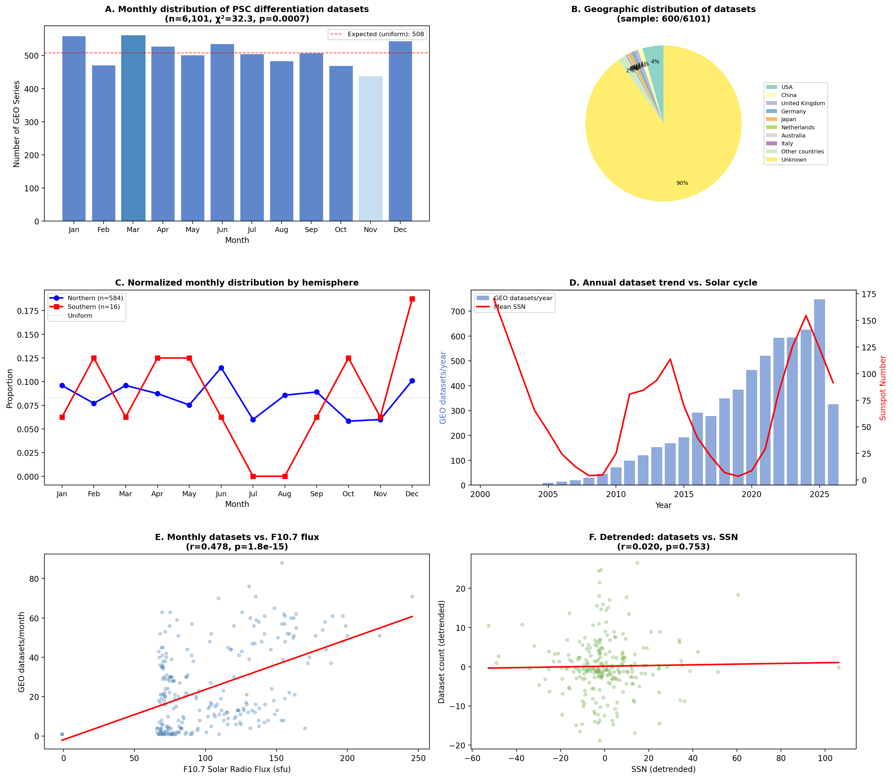
Figure 1. Comprehensive analysis of temporal and geographic patterns in GEO PSC differentiation datasets. (A) Monthly distribution with chi-square test for uniformity. (B) Geographic distribution of datasets by country. (C) Normalized monthly distribution by hemisphere. (D) Annual dataset trend overlaid with solar cycle (sunspot number). (E) Monthly dataset count vs. F10.7 solar radio flux (raw correlation). (F) Detrended correlation between dataset count and sunspot number residuals.

Solar activity correlations
Raw Pearson correlation between monthly GEO dataset counts and solar activity indices was positive and highly significant: r = 0.478 (p < 10⁻¹⁴) for F10.7 flux and r = 0.402 (p < 10⁻¹⁰) for sunspot number (Figure 1E). However, visual inspection of the time series (Figure 1D) revealed that both iPSC research output and solar activity increased during the same 2010–2025 window, suggesting confounding by a shared secular trend.
After subtracting the 12-month rolling mean from both series, the detrended correlation was negligible (r = 0.020, p = 0.753; Figure 1F), confirming that the raw association was spurious. No residual relationship between solar activity fluctuations and PSC dataset submission timing was detectable at this level of analysis.

Discussion
This exploratory analysis of 6,101 GEO datasets yields three principal findings. First, PSC differentiation dataset submissions are non-uniformly distributed across the calendar year, with a March peak and November trough. Second, the global PSC research landscape is overwhelmingly concentrated in the Northern Hemisphere (~97%), rendering GEO metadata insufficient for testing hemisphere-inverted seasonal hypotheses. Third, the apparent correlation between research output and solar activity is entirely attributable to coincident secular trends, providing no evidence for a direct geomagnetic influence on dataset submissions.
Several important limitations constrain interpretation. Most critically, GEO submission date is a proxy for—not a measure of—experiment execution date. The typical delay between experiment completion and data deposition (estimated 6–18 months) introduces substantial temporal noise that would obscure genuine seasonal effects on cell biology. Additionally, the observed monthly pattern likely reflects institutional rhythms (academic calendar, grant cycles, conference submission deadlines) rather than biological seasonality per se. Disentangling these requires access to actual experiment dates, which are not captured in GEO metadata.
The hemisphere imbalance has important implications for study design. The photoperiod-driven hypothesis^{4,6,12} predicts that seasonal effects on cell differentiation should invert between hemispheres (i.e., summer advantage in June–August for Northern Hemisphere and December–February for Southern Hemisphere). Testing this "natural experiment" requires substantial Southern Hemisphere data, which GEO cannot provide. IVF registries—particularly the HFEA (United Kingdom; >1 million cycles) and ANZARD (Australia/New Zealand; ~109,000 cycles/year)—offer cycle-level data with precise treatment dates in both hemispheres and represent the most promising resource for this hypothesis test.
The null result for the solar/geomagnetic hypothesis does not rule out such effects on cell biology⁸—it merely demonstrates that GEO submission metadata are too noisy and temporally displaced to detect them. Direct measurements of geomagnetic disturbance at the time of cell culture experiments¹¹ would be required for a definitive test.
In conclusion, this analysis provides suggestive evidence of temporal structure in PSC research output and highlights the fundamental limitations of publicly available metadata for testing environmental hypotheses. We propose that systematic environmental profiling of stem cell facilities¹⁴—including continuous monitoring of humidity, ambient light, electromagnetic fields, and atmospheric pressure—combined with retrospective analysis of IVF registry data represents the most viable path toward identifying and controlling the "invisible variables" of stem cell culture.¹⁵

Data Availability
All GEO metadata and NOAA solar indices used in this study are publicly available. Analysis scripts and processed data are deposited at https://github.com/bougtoir/wip (stem_cell_seasonality/ directory).

Acknowledgments
[To be added]

Declaration of Interests
The author declares no competing interests.

References
1. Yamanaka S. Pluripotent stem cell-based cell therapy—promise and challenges. Cell Stem Cell. 2020;27(4):523–531.
2. Volpato V, Smith J, Bhinge A, et al. Reproducibility of molecular phenotypes after long-term differentiation to human iPSC-derived neurons: a multi-site omics study. Stem Cell Reports. 2018;11(4):897–911.
3. Fossati V, Bhinge A, Bhatt R, et al. Addressing variability in iPSC-derived models of human disease: guidelines to promote reproducibility. Dis Model Mech. 2020;13(1):dmm042317.
4. Leathersich SJ, Hart RJ, Wijs LA, et al. Season at the time of oocyte collection and frozen embryo transfer outcomes. Hum Reprod. 2023;38(9):1761–1770.
5. Suzuki H, Togashi M, Adachi J, Toyoda Y. Seasonal variation in cell cycle during early development of the mouse embryo. Reproduction. 1992;94(2):431–436.
6. Umemura Y, Maki I, Tsuchiya Y, et al. The circadian clock CRY1 regulates pluripotent stem cell identity and somatic cell reprogramming. Cell Rep. 2023;42(6):112590.
7. Sato Y, Bando H, Di Piazza M, et al. The environmental risk assessment of cell-processing facilities for cell therapy in a Japanese academic institution. PLoS One. 2020;15(8):e0236600.
8. Diatroptova MA, Kosyreva AM, Makarova OV, Diatroptov ME. About 4-day rhythm of proliferative activity of L-929 cells in culture correlates with the intensity of secondary cosmic radiation fluctuations. Bull Exp Biol Med. 2022;173(4):531–535.
9. Edgar R, Domrachev M, Lash AE. Gene Expression Omnibus: NCBI gene expression and hybridization array data repository. Nucleic Acids Res. 2002;30(1):207–210.
10. Hathaway DH. The solar cycle. Living Rev Sol Phys. 2015;12(1):4.
11. Li X, Zhang Y, Chen H, et al. Real-time monitoring reveals the effects of low concentrations of volatile organic compounds in the embryology laboratory. Reprod Biomed Online. 2025;50(2):103876.
12. Lapidot T, Kollet O. Daily light and darkness onset and circadian rhythms metabolically synchronize hematopoietic stem cell differentiation and maintenance. Exp Hematol. 2019;78:1–10.
13. Ortmann D, Vallier L. Variability of human pluripotent stem cell lines. Curr Opin Genet Dev. 2017;46:179–185.
14. Klein SG, Hendriks WT, Reusken C, et al. Toward best practices for controlling mammalian cell culture environments. Front Cell Dev Biol. 2022;10:788808.
15. Kirkeby A, Main H, Carpenter M. Pluripotent stem-cell-derived therapies in clinical trial: a 2025 update. Cell Stem Cell. 2025;32(3):329–331.

