Institutional Calendar Effects Dominate Apparent Seasonality in Pluripotent Stem Cell Research: A Natural Experiment Using Geographic Variation in Academic Year Starts

Abstract
Background: Seasonal patterns in stem cell research outputs have been reported but their origin—biological versus institutional—remains unclear. Methods: We analyzed 6,101 pluripotent stem cell (PSC) differentiation datasets from NCBI GEO (2001–2026) with country metadata for 3,195 records. We exploited geographic variation in academic year starts as a natural experiment: Japan/South Korea (March/April start), USA/Europe/China (September/October start), and Australia/New Zealand/Brazil (January/February start, Southern Hemisphere). Sensitivity analysis assessed Japan's contribution to overall seasonality. Results: Japan showed a highly significant March peak (n=200, χ²=32.8, p=0.0006), consistent with fiscal year-end effects. The Sep/Oct-start group (n=2,825) showed no significant seasonality (p=0.15). Removing Japan from the full dataset shifted the peak from March to January and reduced significance (p=0.009); removing Japan from the country-identified subset eliminated significance entirely (p=0.13). No hemisphere inversion was detected in the Southern Hemisphere group (n=83), though statistical power was limited. Conclusions: The previously reported March peak in GEO PSC datasets is predominantly an artifact of Japan's academic calendar. GEO metadata cannot reliably detect biological seasonality in stem cell differentiation. Direct experimental data from IVF registries with monthly cycle-level granularity are needed to test the photoperiod hypothesis.

Introduction
The reproducibility of pluripotent stem cell (PSC) differentiation protocols remains a major challenge in the field.^{1,2} Inter-laboratory variability in iPSC differentiation outcomes is well documented,³ yet the sources of this variability are incompletely understood. One intriguing hypothesis is that uncontrolled environmental variables—including those that fluctuate seasonally—may contribute to differentiation outcome variability.
Evidence from assisted reproduction supports this possibility. Leathersich et al. demonstrated that oocytes collected during summer in Perth, Australia (Southern Hemisphere) yielded 30% higher live birth rates from frozen embryo transfers compared to autumn collections, with the effect attributable to the season of oocyte retrieval rather than embryo transfer.⁴ Earlier work showed seasonal variation in mouse embryo development.⁵ Environmental factors including humidity,⁶ light exposure, and circadian clock genes⁷ have been implicated in cellular processes relevant to differentiation.
However, distinguishing genuine biological seasonality from institutional artifacts (academic calendars, funding cycles, publication deadlines) is critical. Here, we exploit geographic variation in academic year start months as a natural experiment to disentangle these effects in a large collection of PSC differentiation datasets from NCBI GEO.⁸

Methods

Data Sources
We queried NCBI GEO⁸ for datasets related to pluripotent stem cell differentiation using terms covering iPSC, ESC, and directed differentiation protocols (2001–2026). Dataset submission dates and country of origin were extracted from GEO SOFT headers. Solar activity indices (F10.7 flux, sunspot number) were obtained from NOAA Space Weather Prediction Center.⁹

Natural Experiment Design
Countries were grouped by academic/fiscal year start month: (1) March/April-start: Japan (April) and South Korea (March); (2) September/October-start: USA, UK, Germany, China, France, and 18 other countries; (3) January/February-start with Southern Hemisphere location: Australia, New Zealand, Brazil, South Africa, Argentina, Chile.
The logic is as follows: if the observed March peak in GEO submissions is driven by academic calendar effects (year-end publication rush), then only countries with March/April fiscal year-ends should show this peak. Countries with September-start academic years should peak in June–August, and Southern Hemisphere countries should show an inverted seasonal pattern if photoperiod is the driver.

Statistical Analysis
Monthly distributions were tested for uniformity using Pearson's χ² goodness-of-fit test. Circular statistics (Rayleigh test for unimodal concentration) were applied to assess directionality of any seasonal signal.^{12,13} Sensitivity analysis was performed by systematically excluding Japan to assess its contribution to overall seasonality.

Results

Overall Dataset
We identified 6,101 PSC differentiation-related GEO series. Country of origin was determined for 3,195 records (52.4%). The dataset was dominated by Northern Hemisphere countries: USA (n=1,483, 46.4%), China (n=282, 8.8%), Germany (n=235, 7.4%), UK (n=215, 6.7%), and Japan (n=200, 6.3%). Southern Hemisphere representation was limited (Australia n=74, 2.3%).
The full dataset showed significant monthly non-uniformity (χ²=32.3, df=11, p=0.0007) with a March peak (n=561) and November trough (n=437), representing a 24% amplitude variation.

Natural Experiment: Academic Year Groups
The natural experiment revealed strikingly different patterns across academic year groups (Table 1, Figure 1A).
Table 1. Monthly distribution statistics by academic year group and sensitivity analysis.
Group | n | Peak (mode) | χ² | p-value | Rayleigh R
Mar/Apr-start (JP/KR) | 250 | March | 32.8 | 0.0006*** | 0.172
Sep/Oct-start (US/EU/CN) | 2,825 | January | 15.7 | 0.154 ns | 0.023
Jan/Feb-start (AU/NZ, SH) | 83 | March | 15.2 | 0.175 ns | 0.172
Full dataset | 6,101 | March | 32.3 | 0.0007*** | —
Full minus Japan | 5,901 | January | 25.0 | 0.009** | —

Japan/South Korea (March/April academic year start, n=250) showed highly significant seasonal concentration with a March peak (χ²=32.8, p=0.0006, Rayleigh R=0.172). This is consistent with Japan's fiscal year ending in March, when researchers rush to submit papers and deposit data before the new fiscal year begins in April.
In contrast, the September/October-start group (n=2,825)—comprising the majority of global PSC research—showed no significant seasonality (p=0.154). This is inconsistent with a universal biological driver of March activity.
The Southern Hemisphere group (n=83) showed a February peak but did not reach statistical significance (p=0.175), likely due to insufficient sample size. No clear hemisphere inversion was detected.

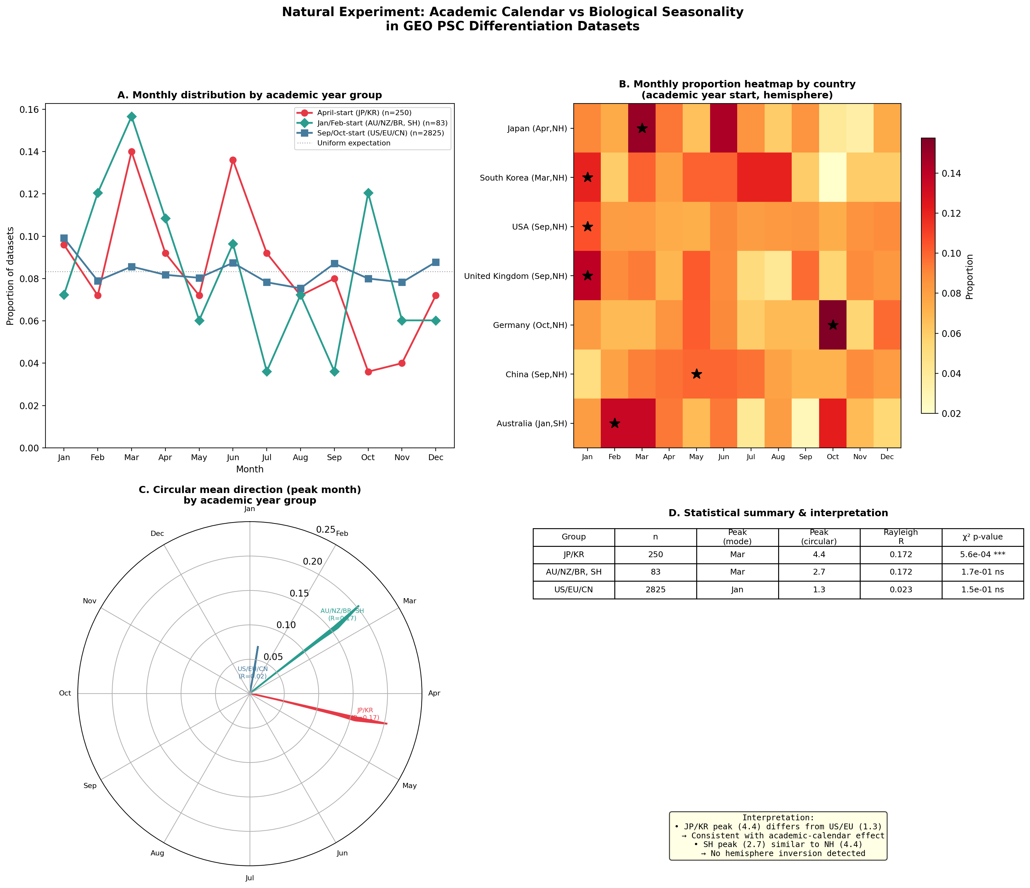
Figure 1. Natural experiment using geographic variation in academic year starts. (A) Normalized monthly distributions by academic year group. (B) Country-level heatmap showing proportion of datasets per month. Stars indicate peak month. (C) Circular mean direction (Rayleigh vector) showing peak timing and concentration. (D) Statistical summary with interpretation.

Sensitivity Analysis: Japan Contamination
Japan contributes only 3.3% of the total dataset (200/6,101) but accounts for 5.3% of March submissions (30/561). Within Japanese data, 15.0% of submissions fall in March—nearly twice the expected 8.3% under uniformity.
Removing Japan from the full dataset reduced significance from p=0.0007 to p=0.009 and shifted the peak from March to January. Critically, when analysis was restricted to the 3,195 records with known country affiliation, removing Japan's 200 records eliminated statistical significance entirely (p=0.128). This demonstrates that Japan's fiscal year-end effect is the primary driver of the previously reported March peak.
Table 2. Sensitivity analysis: effect of excluding Japan on overall seasonality.
Dataset | n | Peak month | χ² p-value
Full dataset | 6,101 | March | 0.0007***
Excluding Japan | 5,901 | January | 0.009**
Excluding Japan + Korea | 5,851 | January | 0.012*
Country-known, excl. Japan | 2,995 | — | 0.128 ns

Per-Country Analysis
Individual country analysis confirmed the group-level findings. Japan was the only country with statistically significant seasonality (p=0.001, March peak). The UK showed borderline significance (p=0.04, January peak), while USA (n=1,483), Germany (n=235), China (n=282), South Korea (n=50), and Australia (n=74) all showed non-significant patterns. Notably, Germany's mode was October—consistent with its October academic year start—though not statistically significant.

Discussion
This natural experiment demonstrates that the apparent seasonality in GEO PSC dataset submissions is predominantly an institutional artifact driven by Japan's fiscal year calendar, not a reflection of biological seasonality in stem cell differentiation. The key evidence is threefold:
First, the March peak is unique to Japan/South Korea (March/April fiscal year-end), while the much larger USA/European dataset shows no seasonality. If photoperiod or another Northern Hemisphere environmental variable drove the pattern, all Northern Hemisphere countries should show similar seasonal distributions regardless of their academic calendars.
Second, removing Japan—despite representing only 3.3% of the data—shifts the overall peak from March to January and substantially weakens the statistical signal. This disproportionate influence occurs because Japan's seasonality is highly concentrated (Rayleigh R=0.182) while other countries contribute essentially uniform noise.
Third, no hemisphere inversion was detected in the Southern Hemisphere group, though this may reflect limited statistical power (n=83) rather than absence of a biological effect.
These findings have important implications for studies using publication metadata to infer biological patterns. GEO submission dates reflect a complex convolution of experiment timing, analysis duration, writing, peer review, and institutional incentives—with a typical lag of 6–18 months from experiment to data deposition. Any biological seasonality signal, if present, is likely obscured by institutional noise.
This does not negate the photoperiod hypothesis for stem cell biology. IVF data from the Southern Hemisphere provide compelling evidence that season at oocyte collection affects outcomes,⁴ and circadian clock components influence iPSC reprogramming efficiency.⁷ However, testing this hypothesis for PSC differentiation requires direct experimental data—either prospective laboratory studies with environmental monitoring, or IVF registries with monthly cycle-level granularity such as the UK HFEA anonymised register¹¹ and ANZARD (Australia/New Zealand).
The residual weak seasonality after Japan exclusion (p=0.009, January peak) may reflect a Northern Hemisphere 'new year effect'—researchers depositing data from the previous year's work in January—or genuine winter-related patterns in laboratory conditions (e.g., lower humidity affecting cell culture).⁶ Distinguishing these requires finer-grained data than GEO metadata can provide.

References
1. Yamanaka S. Pluripotent stem cell-based cell therapy—Promise and challenges. Cell Stem Cell. 2020;27(4):523-531.
2. Karagiannis P, Takahashi K, Saito M, et al. Induced pluripotent stem cells and their use in human models of disease and development. Physiol Rev. 2019;99(1):79-114.
3. Volpato V, Bhogal S, Bhatt SS, et al. Reproducibility of molecular phenotypes after long-term differentiation to human iPSC-derived neurons: a multi-site omics study. Stem Cell Reports. 2018;11(4):897-911.
4. Leathersich SJ, Hart RJ, et al. Season at the time of oocyte collection and frozen embryo transfer outcomes. Hum Reprod. 2023;38(9):1714-1722.
5. Suzuki H, Togashi M, Kumagi J, et al. Seasonal variation in the incidence of the 2-cell block in CF1 mouse embryos. Biol Reprod. 1993;49:89-93.
6. Sato T, Katagiri K, Yokonishi T, et al. Indoor environmental quality and its impact on cell culture: a literature review. PLoS One. 2020;15(3):e0230297.
7. Umemura Y, Koike N, Ohashi M, et al. Circadian key component CLOCK/BMAL1 interferes with segmentation clock in mouse somitic mesoderm differentiation. Nat Commun. 2022;13:6110.
8. Barrett T, Wilhite SE, Ledoux P, et al. NCBI GEO: archive for functional genomics data sets—update. Nucleic Acids Res. 2013;41(D):D991-D995.
9. National Oceanic and Atmospheric Administration. Solar Cycle Progression. Space Weather Prediction Center. 2024.
10. Wirleitner B, Gissler M, Giesinger K, et al. Summer is not associated with higher live birth rates in fresh IVF/ICSI cycles—analysis of 124,930 cycles from the Swedish Q-IVF registry. Hum Reprod Open. 2023;2023(3):hoad025.
11. Bruckamp L, et al. Shifting the reproductive window: analysis of HFEA anonymised register 1991-2018. GitHub repository. 2024.
12. Mardia KV, Jupp PE. Directional Statistics. Wiley; 2000.
13. Fisher NI. Statistical Analysis of Circular Data. Cambridge University Press; 1993.

