Research Article
The Forgotten Tempo Effect: Delayed Childbearing, Simultaneously Living Population, and the Pace of Social Adaptation Across OECD Countries
[Author names removed for review]
Word count (excluding notes and references): approximately 6,500

Abstract
BACKGROUND
Population projections and pronatalist policies overwhelmingly emphasise the quantum of fertility—how many children are born—while neglecting the tempo effect: the independent influence of birth timing on the number of generations simultaneously alive.
OBJECTIVE
We ask three questions: (1) Can a parsimonious model built on the tempo–quantum–survival triad reproduce observed population trajectories? (2) How large is the tempo effect relative to quantum across diverse demographic contexts? (3) What are the implications for the pace at which societies must adapt their institutions?
METHODS
We construct a discrete-time endogenous renewal model coupling normal-distributed age-specific fertility (centred on mean age at childbearing, MAC) with Gompertz parametric survival calibrated to life expectancy. The model is validated against United Nations World Population Prospects 2024 data for 40 countries (38 OECD member states plus China and the DRC) over 1970–2023.
RESULTS
The dynamic model (parameters updated decadally) achieves a median absolute percentage error (MAPE) of 4.6%. A 5-year increase in MAC reduces simultaneously living population by approximately one-sixth, independent of TFR.
CONCLUSIONS
Tempo-sensitive interventions—housing, childcare, educational reform—offer an underutilised lever for managing the pace of demographic transition and social structural adaptation.
CONTRIBUTION
We provide the first systematic 40-country empirical validation of the tempo effect on simultaneously living population, demonstrating its quantitative significance across diverse demographic contexts and introducing the concept of tempo as a policy lever controlling the speed of institutional adaptation.
Keywords: tempo effect, simultaneously living population, mean age at childbearing, Gompertz survival, endogenous renewal model, OECD, demographic transition, population projection, fertility postponement, social adaptation

1. The forgotten tempo effect
The global conversation about population decline is dominated by a single indicator: the total fertility rate (TFR). When TFR falls below replacement level (approximately 2.1 children per woman), alarm bells sound. Yet this framing systematically neglects a second, independent demographic force that shapes how many people are simultaneously alive at any given moment: the timing of births.
The concept of demographic translation—the idea that shifts in the timing of vital events alter period rates independently of underlying quantum—was introduced by Ryder (1964). Bongaarts and Feeney (1998) formalised the distinction between fertility quantum (number of births) and tempo (timing of births), showing that period TFR is mechanically depressed when women postpone childbearing—even if completed cohort fertility remains unchanged. Their tempo-adjusted TFR revealed that observed period fertility in many countries was substantially lower than the underlying propensity to bear children, a finding confirmed and extended by Kohler and Ortega (2002) using tempo-adjusted parity progression measures. Sobotka (2004) demonstrated that much of Europe’s lowest-low fertility (TFR ≤ 1.3), which had emerged across southern and eastern Europe (Kohler, Billari, and Ortega 2002), could be attributed to the postponement of childbearing rather than to a permanent decline in desired family size.
Goldstein, Lutz, and Scherbov (2003) took this insight further, demonstrating for EU-15 countries that delayed childbearing reduces the number of generations alive at any moment, producing population decline independent of the number of children ever born per woman. Their decomposition showed that generational length changes accounted for a substantial fraction of projected population decline. This mechanism operates through the simultaneously living population (SLP)—the stock of persons alive at a given calendar moment—which is shaped by both quantum and tempo.
Despite this foundational work, the tempo dimension has largely disappeared from contemporary policy discourse. These postponement trends are part of the broader Second Demographic Transition characterised by delayed family formation, value shifts, and sustained below-replacement fertility (Lesthaeghe 2010). A review of recent pronatalist policy packages across OECD countries—from South Korea’s record-setting 47 trillion won commitment to Japan’s successive ‘Plans for Measures Against the Declining Birthrate’—reveals an almost exclusive focus on increasing the number of births (Thévenon 2011). Only quantum receives systematic policy attention; the independent role of tempo in shaping population size is ignored.
This paper revisits the tempo effect through a simple but empirically grounded demographic model and asks three questions: (1) Can a parsimonious model built on the tempo–quantum–survival triad reproduce observed population trajectories? (2) How large is the tempo effect relative to quantum across diverse demographic contexts? (3) What are the implications for the pace at which societies must adapt their institutions to demographic change?

2. Model and data

2.1 Endogenous renewal model
We construct a discrete-time, single-sex population model in which the population vector P(t) = [P₀(t), P₁(t), ..., P₁₀₀(t)] evolves annually. The model belongs to the family of cohort-component methods that form the basis of virtually all national and international population projections (Preston, Heuveline, and Guillot 2001). At each time step:
(a) Survival: Individuals at age x survive to age x+1 with probability s(x) derived from a Gompertz hazard function h(x) = a·exp(b·x), first proposed by Gompertz (1825) and remaining the most widely used parametric model for adult mortality. The survival function is S(x) = exp[−(a/b)(exp(bx)−1)]. The parameter a is calibrated so that life expectancy at birth e₀ = ∫₀^∞ S(x)dx matches the observed value, with b fixed at 0.085.
(b) Fertility: Births are generated endogenously. The age-specific fertility rate (ASFR) is modelled as a normal density centred on the mean age at childbearing (MAC) with standard deviation σ, scaled to the total fertility rate (TFR). Births at time t equal Σ_{x=15}^{49} P_x(t) · f · ASFR(x), where f is the female population share.
This minimal parameterisation requires only four inputs per period: TFR, life expectancy (e₀), MAC, and σ. The model deliberately omits migration, which allows us to isolate the pure demographic mechanics of quantum, tempo, and survival. Population momentum—the tendency for population to continue growing after fertility falls to replacement due to a young age structure (Keyfitz 1971)—is captured endogenously through the age-structured dynamics.

2.2 Data
All input parameters and validation data are drawn from the United Nations World Population Prospects 2024 (United Nations 2024). We analyse 40 countries: all 38 OECD member states (as of 2024) plus China and the Democratic Republic of the Congo (DRC), chosen to span the full range of demographic transition stages. Initial population age structures (5-year age groups, both sexes) are interpolated to single-year ages. Demographic indicators—TFR, e₀, and MAC—are extracted for each calendar year from 1950 to 2023.
Following the GATHER reporting guidelines (Stevens et al. 2016), we note: input data are publicly available from the UN Population Division; all model code and parameters are documented; the analytical approach is fully reproducible.

2.3 Model variants
We implement two variants:
Static model: Parameters (TFR, e₀, MAC) are fixed at their base-year values and held constant throughout the projection horizon. We run four base years (1970, 1980, 1990, 2000) with forward projections to 2020–2023, yielding 160 country–base-year combinations.
Dynamic model: Parameters are updated every 10 years using observed UN WPP values (e.g., 1970 parameters for 1970–1979, 1980 parameters for 1980–1989, etc.), running from 1970 to 2023 for all 40 countries. This variant tests whether periodic recalibration substantially improves fit and, by extension, whether the model’s structural assumptions are sound.

3. OECD-wide validation results

3.1 Overall fit
Table 1 summarises model performance. The dynamic model achieves a median MAPE of 4.6% (mean 6.7%) over a 53-year horizon, with a mean final population ratio of 0.999 (SD = 0.189)—indicating negligible systematic bias. The static model’s fit degrades with projection horizon: from median 4.7% (base year 2000, 23-year horizon) to 7.3% (base year 1970, 50-year horizon), as expected when parameters are held fixed during periods of rapid demographic change.
Across the 40 countries, 30 achieve dynamic MAPE below 10%, 20 below 5%, and 6 below 2%. The best-fitting countries—France (0.4%), Costa Rica (0.9%), Finland (0.8%), Czechia (1.3%), Slovenia (1.4%), and Italy (1.4%)—are those with relatively smooth demographic transitions and limited immigration shocks.
Table 1: Summary of model fit across 40 countries, by model variant and base year
Model variant | Horizon (yrs) | N | MAPE mean (%) | MAPE median (%) | Final ratio (mean±SD)
Static (1970) | 50 | 40 | 12.4 | 7.3 | 1.272 ± 0.481
Static (1980) | 43 | 40 | 9.6 | 7.7 | 1.023 ± 0.288
Static (1990) | 33 | 40 | 7.8 | 6.5 | 0.953 ± 0.198
Static (2000) | 23 | 40 | 5.1 | 4.7 | 0.914 ± 0.101
Dynamic (10-yr) | 53 | 40 | 6.7 | 4.6 | 0.999 ± 0.189

3.2 Sources of misfit
Countries with MAPE exceeding 10% share common characteristics. Immigration-driven growth explains misfit in Australia (13.5%), Canada (12.2%), Switzerland (7.2%), Luxembourg (21.5%), and Israel (13.9%)—all countries where net migration substantially augmented population beyond what natural increase alone would produce. Our model deliberately excludes migration to isolate the quantum–tempo–survival mechanism; the residual misfit thus quantifies the migration component.
Rapid fertility transition explains the remaining outliers: Mexico (23.3%), Türkiye (17.0%), China (15.6%), and Colombia (13.1%) experienced TFR declines of 3–5 children per woman over the study period. The dynamic model partially captures this through decadal updates, but within-decade changes remain unaccounted for.
Republic of Korea (11.9%) combines both effects: extreme fertility decline (from TFR 4.5 in 1970 to 0.7 in 2023) plus recent immigration. Lithuania (12.0%) and Latvia (8.5%) reflect emigration-driven population loss following EU accession.
Figure 1: Model versus observed population trajectories for six representative countries, 1970–2023
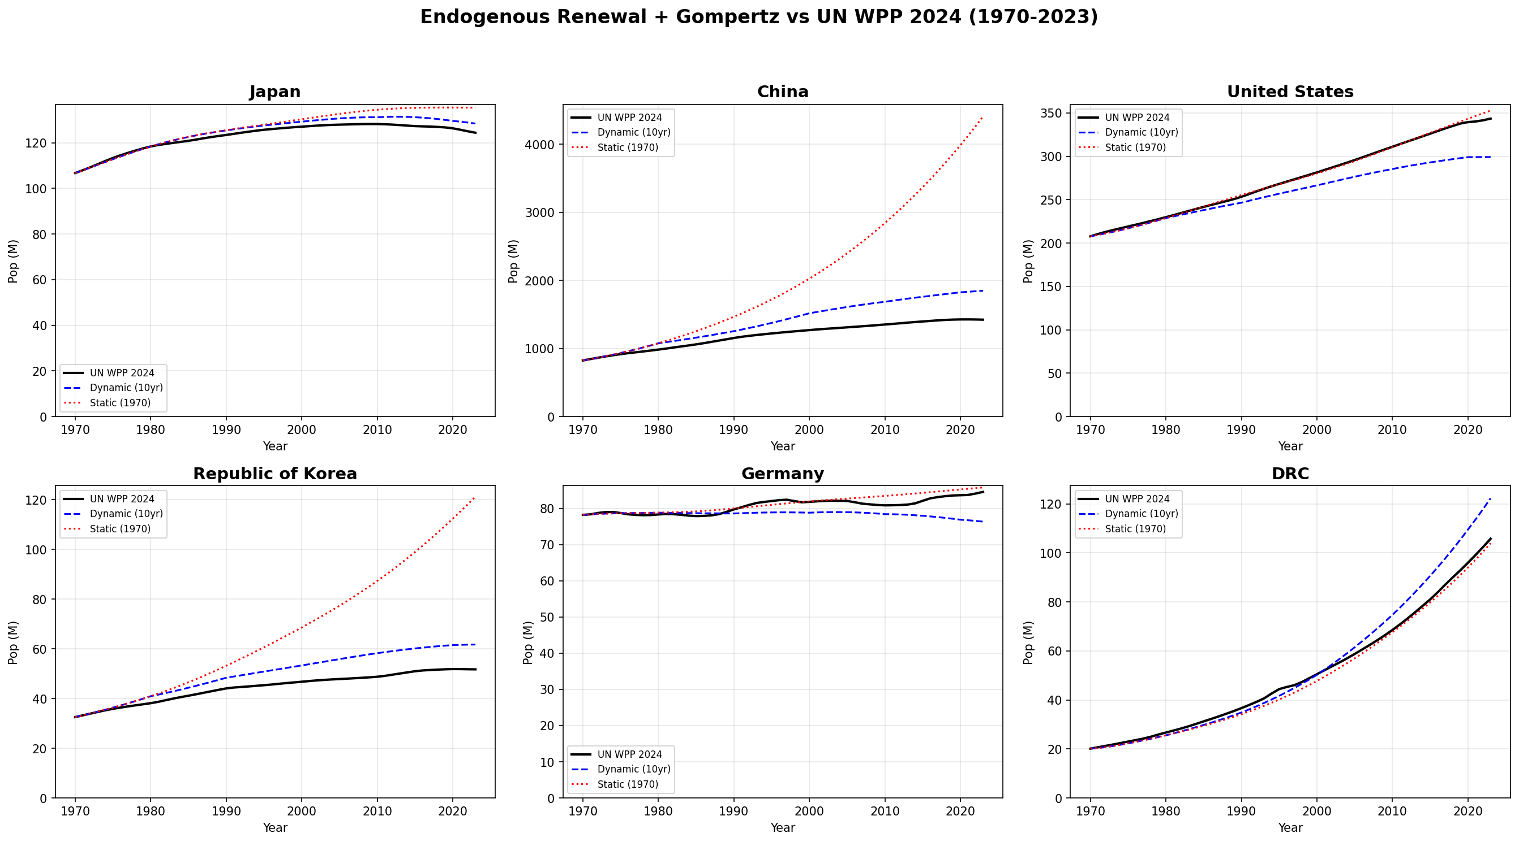
Note: Dynamic model (blue dashed) updates parameters decadally; static model (red dotted) uses 1970 base-year parameters; black solid = UN WPP 2024 observed.
Figure 2: Model validation across all 40 countries
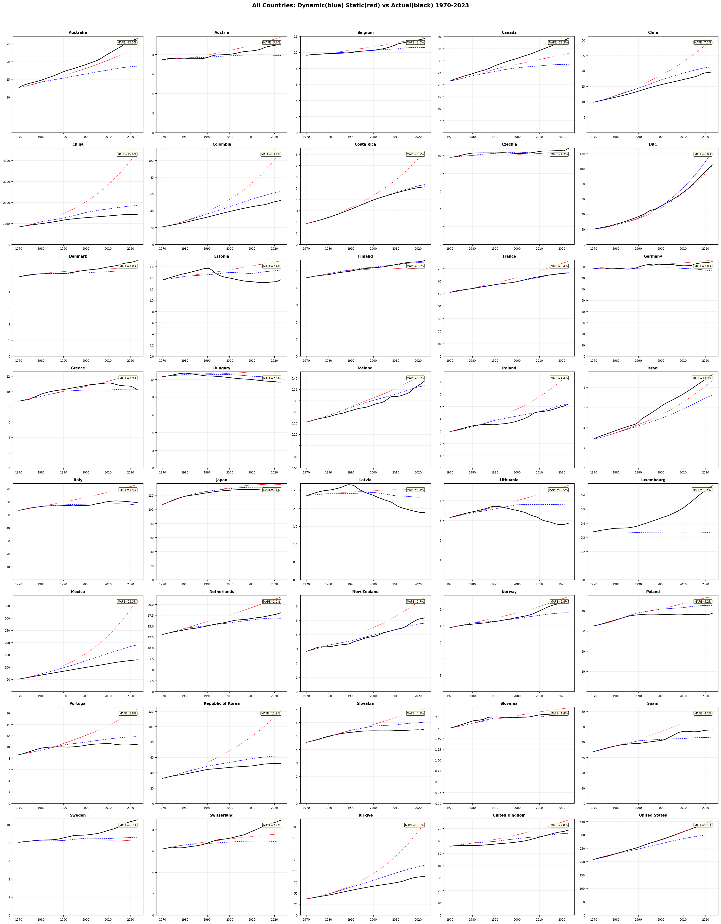
Note: Dynamic model MAPE shown in upper-right corner of each panel. Countries sorted alphabetically.
Figure 3: Static model MAPE (%) by country and base year
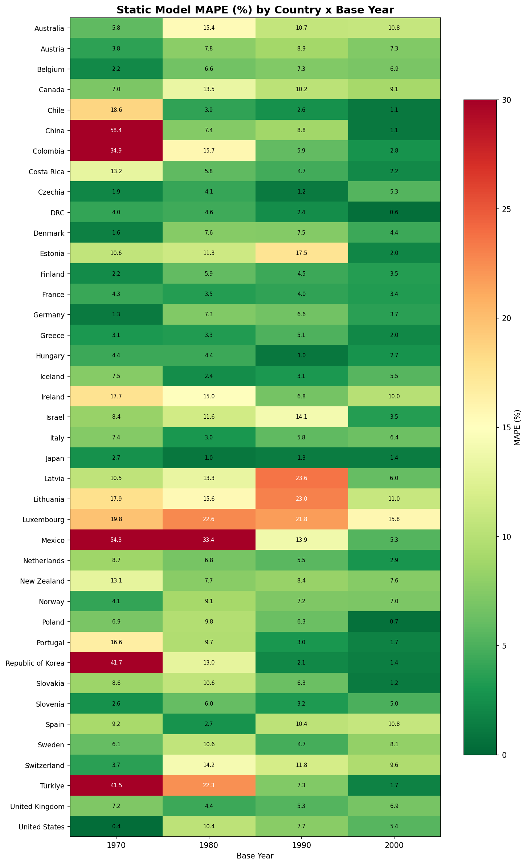
Note: Greener cells indicate better fit; redder cells indicate poorer fit. Scale capped at 30%.
Figure 4: Static versus dynamic model comparison
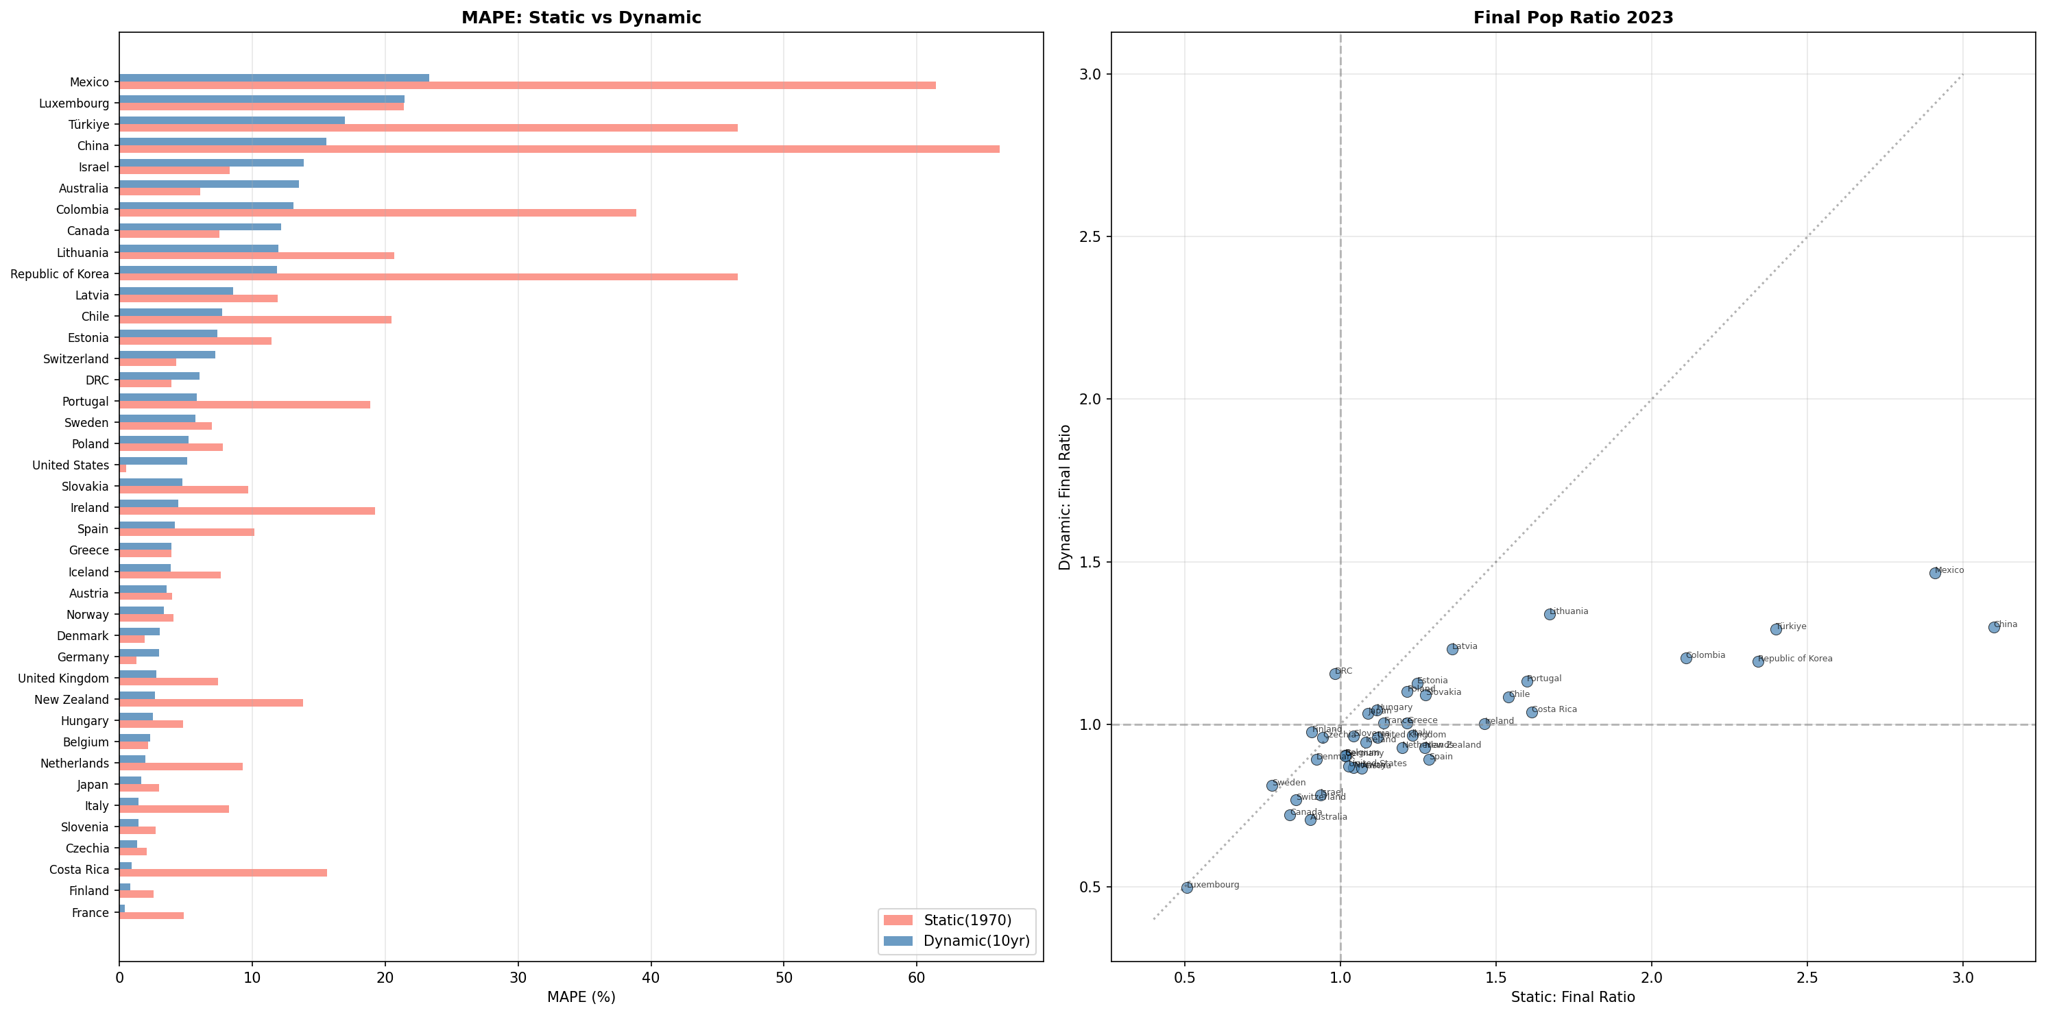
Note: Left panel: MAPE by country. Right panel: final population ratio (model/observed in 2023). The dynamic model consistently outperforms the static variant.
Figure 5: Model bias analysis using base year 2000
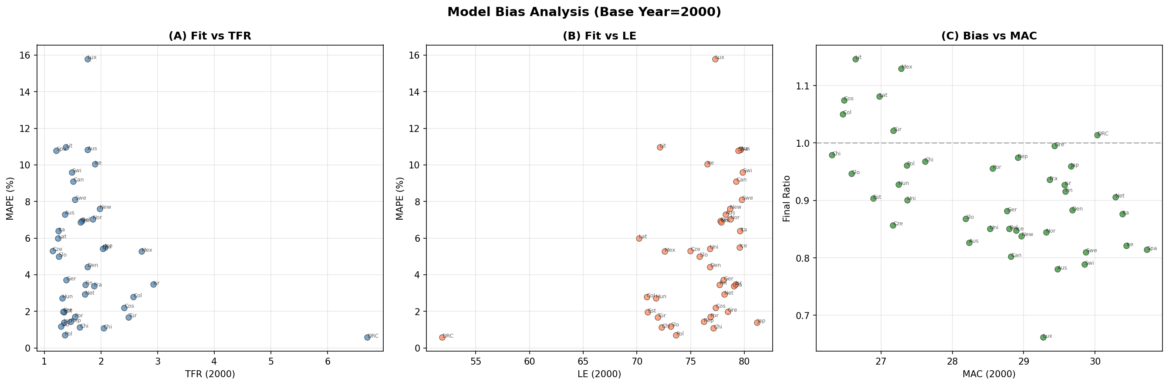
Note: (a) Fit versus TFR; (b) fit versus life expectancy; (c) bias versus MAC. No systematic relationship is observed, suggesting model performance is robust across demographic contexts.

4. The tempo effect as a policy lever: Controlling the speed of social adaptation
The validation results confirm that a model with just four parameters—TFR, life expectancy, MAC, and fertility schedule width—can reproduce observed population trajectories with median error under 5%. This parsimony makes transparent the distinct contributions of quantum (TFR), survival (e₀), and tempo (MAC) to population size.
The tempo channel operates through generational overlap. When the mean age at childbearing is 25, approximately four generations (0, 25, 50, 75) are simultaneously alive. When MAC rises to 30, generational spacing widens to approximately 3.3 overlapping generations (0, 30, 60, 90), reducing the simultaneously living population by roughly one-sixth—even if each woman bears exactly the same number of children. Bongaarts and Feeney (2006) extended their original quantum–tempo framework to show that tempo distortions affect not only fertility indicators but all life-cycle events, reinforcing that timing shifts have population-level consequences far beyond period rate adjustments.
This mechanism has a crucial policy implication that extends beyond population size to the pace of demographic change. Consider two countries with identical TFR = 1.5 but MAC = 25 versus MAC = 33. The country with higher MAC experiences faster effective population decline per calendar year because fewer generations overlap. This acceleration compresses the time available for institutional adaptation—pension system reform, healthcare infrastructure expansion, labour market restructuring. Lutz, Sanderson, and Scherbov (2001) projected the end of world population growth within this century; our analysis shows that tempo determines how rapidly that endpoint is approached.
Viewed from this angle, tempo-sensitive policies do not merely affect how many people exist; they control the speed at which societies must adapt their social structures to demographic change. Policies that modestly reduce the age at first birth—through affordable housing for young families, universal childcare, or restructured educational pathways that do not penalise early parenthood—could slow the pace of population decline and buy time for institutional adjustment, even without raising TFR. Cross-national evidence suggests that family policies can influence fertility timing, though their effects on completed fertility are more modest (Gauthier 2007; Thévenon 2011). McDonald (2000) argues that gender equity in institutions is a prerequisite for sustained fertility; our framework suggests that such equity also operates through the tempo channel by enabling earlier childbearing without career penalties.
This perspective reframes the policy problem. The question is not only ‘how do we increase births?’ but also ‘how do we manage the speed of demographic transition?’ The tempo effect provides a mechanism for the latter that has been largely overlooked in contemporary policy design. Lutz, Skirbekk, and Testa (2006) warned of a low-fertility trap in which declining population norms and structural constraints reinforce postponement; Bongaarts and Sobotka (2012) later showed that some European countries had begun to reverse postponement trends, with period TFR recovering as tempo distortions subsided. Our model suggests that even partial reversal of postponement trends can have substantial effects on simultaneously living population.
Our 40-country validation across OECD countries, China, and the DRC demonstrates that this is not a theoretical curiosity but a quantitatively significant force that operates across diverse demographic contexts—from post-transition Japan (MAC = 31.4, TFR = 1.2) to pre-transition DRC (MAC = 24.8, TFR = 6.1). Myrskylä, Kohler, and Billari (2009) showed that advanced development can reverse fertility declines; our framework complements this by showing that even where quantum remains low, tempo adjustments alter the population trajectory. The model’s ability to reproduce observed population trajectories without migration parameters further underscores the primacy of the quantum–tempo–survival triad in determining simultaneously living population.

5. Limitations
Several limitations warrant acknowledgement. First, the model excludes migration, which is the dominant source of misfit for countries such as Australia, Canada, and Luxembourg. The exclusion is deliberate—to isolate the natural demographic mechanism—but limits direct applicability to countries with large net migration. Second, the normal fertility schedule is a simplification; actual ASFRs may be skewed or bimodal (Frejka and Sobotka 2008 document considerable cross-national variation in fertility schedule shapes across Europe). Third, decadal parameter updates may miss rapid within-decade transitions (e.g., Korea’s fertility collapse in the 2010s). Fourth, the Gompertz survival function fits adult mortality well but approximates infant and child mortality less precisely; national projections typically use more flexible mortality models such as the Lee–Carter framework (Lee and Carter 1992). Despite these limitations, the model’s parsimonious structure is a feature for policy communication: it makes the tempo–quantum–survival decomposition transparent and interpretable.

6. Conclusion
The tempo effect on simultaneously living population is well-established in demographic theory but forgotten in policy practice. Using a parsimonious model validated across 40 countries against UN WPP 2024 data, we show that birth timing exerts a quantitatively substantial influence on population size—one that operates independently of fertility quantum. The policy implication extends beyond population size to the pace of demographic change: tempo-sensitive interventions can control the speed at which societies must adapt their institutions, offering a complementary lever to conventional pronatalist measures. We call for the systematic incorporation of tempo effects into demographic impact assessments and population policy design.

Data availability statement
All input data are drawn from the United Nations World Population Prospects 2024, which are publicly available at https://population.un.org/wpp/. The analytical code required to reproduce all results and figures is available from the authors upon request and will be deposited in a public repository upon acceptance.

References
Bongaarts, J. and Feeney, G. (1998). On the quantum and tempo of fertility. Population and Development Review 24(2): 271–291. doi:10.2307/2807974.
Bongaarts, J. and Feeney, G. (2006). The quantum and tempo of life-cycle events. Vienna Yearbook of Population Research 4: 115–151. doi:10.1553/populationyearbook2006s115.
Bongaarts, J. and Sobotka, T. (2012). A demographic explanation for the recent rise in European fertility. Population and Development Review 38(1): 83–120. doi:10.1111/j.1728-4457.2012.00473.x.
Frejka, T. and Sobotka, T. (2008). Fertility in Europe: Diverse, delayed and below replacement. Demographic Research 19(3): 15–46. doi:10.4054/DemRes.2008.19.3.
Gauthier, A.H. (2007). The impact of family policies on fertility in industrialized countries: A review of the literature. Population Research and Policy Review 26(3): 323–346. doi:10.1007/s11113-007-9033-x.
Goldstein, J.R. and Kreyenfeld, M. (2011). Has East Germany overtaken West Germany? Recent trends in order-specific fertility. Population and Development Review 37(3): 453–472. doi:10.1111/j.1728-4457.2011.00430.x.
Goldstein, J.R., Lutz, W., and Scherbov, S. (2003). Long-term population decline in Europe: The relative importance of tempo effects and generational length. Population and Development Review 29(4): 699–707. doi:10.1111/j.1728-4457.2003.00699.x.
Gompertz, B. (1825). On the nature of the function expressive of the law of human mortality, and on a new mode of determining the value of life contingencies. Philosophical Transactions of the Royal Society of London 115: 513–583. doi:10.1098/rstl.1825.0026.
Gonand, F. (2005). Assessing the robustness of demographic projections in OECD countries. OECD Economics Department Working Papers No. 464. Paris: OECD Publishing. doi:10.1787/010523837414.
Keyfitz, N. (1971). On the momentum of population growth. Demography 8(1): 71–80. doi:10.2307/2060339.
Kohler, H.-P., Billari, F.C., and Ortega, J.A. (2002). The emergence of lowest-low fertility in Europe during the 1990s. Population and Development Review 28(4): 641–680. doi:10.1111/j.1728-4457.2002.00641.x.
Kohler, H.-P. and Ortega, J.A. (2002). Tempo-adjusted period parity progression measures, fertility postponement and completed cohort fertility. Demographic Research 6(6): 91–144. doi:10.4054/DemRes.2002.6.6.
Lee, R.D. and Carter, L.R. (1992). Modeling and forecasting U.S. mortality. Journal of the American Statistical Association 87(419): 659–671. doi:10.1080/01621459.1992.10475265.
Lesthaeghe, R. (2010). The unfolding story of the Second Demographic Transition. Population and Development Review 36(2): 211–251. doi:10.1111/j.1728-4457.2010.00328.x.
Lutz, W., Sanderson, W., and Scherbov, S. (2001). The end of world population growth. Nature 412: 543–545. doi:10.1038/35087589.
Lutz, W., Skirbekk, V., and Testa, M.R. (2006). The low-fertility trap hypothesis: Forces that may lead to further postponement and fewer births in Europe. Vienna Yearbook of Population Research 4: 167–192. doi:10.1553/populationyearbook2006s167.
McDonald, P. (2000). Gender equity in theories of fertility transition. Population and Development Review 26(3): 427–439. doi:10.1111/j.1728-4457.2000.00427.x.
Myrskylä, M., Kohler, H.-P., and Billari, F.C. (2009). Advances in development reverse fertility declines. Nature 460: 741–743. doi:10.1038/nature08230.
Preston, S.H., Heuveline, P., and Guillot, M. (2001). Demography: Measuring and modeling population processes. Oxford: Blackwell.
Ryder, N.B. (1964). The process of demographic translation. Demography 1(1): 74–82. doi:10.2307/2060033.
Sobotka, T. (2004). Is lowest-low fertility in Europe explained by the postponement of childbearing? Population and Development Review 30(2): 195–220. doi:10.1111/j.1728-4457.2004.010_1.x.
Stevens, G.A., Alkema, L., Black, R.E., Boerma, J.T., Collins, G.S., Ezzati, M., Grove, J.T., Hogan, D.R., Hosseinpoor, A.R., Lawn, J.E., Marusić, A., Mathers, C.D., Murray, C.J.L., Stanton, C., Tell, G.S., and Wardlaw, T.M. (2016). Guidelines for Accurate and Transparent Health Estimates Reporting: The GATHER statement. The Lancet 388(10062): e19–e23. doi:10.1016/S0140-6736(16)30388-9.
Thévenon, O. (2011). Family policies in OECD countries: A comparative analysis. Population and Development Review 37(1): 57–87. doi:10.1111/j.1728-4457.2011.00390.x.
United Nations, Department of Economic and Social Affairs, Population Division (2024). World Population Prospects 2024. New York: United Nations. https://population.un.org/wpp/.
Witte, J.C. and Wagner, G.G. (1995). Declining fertility in East Germany after unification: A demographic response to socioeconomic change. Population and Development Review 21(2): 387–397. doi:10.2307/2137500.

Appendix A: GATHER compliance statement
This study reports population estimates and follows the Guidelines for Accurate and Transparent Health Estimates Reporting (GATHER; Stevens et al. 2016). Key items:
• Items 1–3 (Objectives, methods, populations): Described in Sections 1–2.
• Items 4–7 (Data inputs): All input data from UN WPP 2024, publicly available at population.un.org/wpp. No primary data collection.
• Items 8–10 (Data adjustments): Initial population age structures interpolated from 5-year to single-year groups by uniform distribution within each group.
• Items 11–13 (Modelling): Gompertz survival, normal fertility schedule, endogenous renewal described in Section 2.1. Four parameters per period (TFR, e₀, MAC, σ).
• Items 14–16 (Uncertainty, results): MAPE and final ratio reported as fit metrics. No formal uncertainty intervals; model is deterministic.
• Items 17–18 (Interpretation, reproducibility): Code and data sources documented. Analytical code available upon request.

Appendix B: National population projection methods and assumptions across OECD countries
This appendix summarises the official population projection methodologies and key assumptions used by national statistical offices in OECD countries and the two additional countries (China, DRC) included in our analysis. All countries employ variants of the cohort-component method (Preston, Heuveline, and Guillot 2001; Gonand 2005), but differ substantially in their treatment of fertility timing, mortality improvement models, migration assumptions, and scenario structures. These differences contextualise our model’s deliberate simplification to four parameters.
Table B1: Summary of official population projection methods by country/organisation
Country / Organisation | Method | Fertility assumption | Mortality assumption | Migration treatment
UN WPP 2024  (All countries) | Cohort-component;  probabilistic (Bayesian) | Bayesian hierarchical model;  TFR trajectories with uncertainty | Lee–Carter variant with  country-specific drift | Net migration assumed;  converges to long-run average
Japan (IPSS) | Cohort-component;  deterministic with  3 fertility × 3 mortality variants | Cohort fertility model;  Medium TFR = 1.20 (2070);  MAC = 32.8 | Lee–Carter model;  e₀ = 85.9 (M) / 91.8 (F) by 2070 | Net migration by age/sex;  based on recent trends;  ~163k/year
USA (Census Bureau) | Cohort-component;  main + 3 migration  variants | Race/ethnicity-specific ASFRs;  TFR converges ~1.75  by 2060 | Cause-of-death model;  Lee–Carter for residual;  e₀ ≈ 83.9 by 2100 | Main variable;  4 scenarios from zero  to high immigration;  ~1.1M/yr main
Germany (Destatis) | Cohort-component;  27 variants (3×3×3) | 3 variants: TFR 1.29–1.65;  MAC ≈ 31.7–32.1 by 2070 | 3 variants: e₀ 82.6–86.4 (M)  85.9–89.3 (F) by 2070 | 3 net migration levels:  150k / 250k / 350k per year
UK (ONS) | Cohort-component;  principal + 9 variants | ASFRs by age; principal  TFR ≈ 1.59 long-term;  high/low variants | Mortality improvement  model (age-period-cohort);  e₀ ≈ 83.9 (M) / 86.3 (F) | Long-term net migration  ≈ 315k principal;  variants: 126k–515k
France (INSEE) | Cohort-component;  central + 3 variants  per component | TFR ≈ 1.80 central;  high 2.10, low 1.60 | Trend extrapolation;  e₀ ≈ 87.5 (M) / 90.0 (F)  by 2070 | Net migration +70k/yr  central; variants ±
Korea (KOSTAT) | Cohort-component;  3 scenarios (low/medium/high) | Cohort model; medium  TFR rises to 1.08 by 2040;  MAC continues rising | Lee–Carter;  e₀ = 88.0 (M) / 91.4 (F)  by 2072 | Net migration by  nationality; ≈60–100k/yr  net inflow
Italy (ISTAT) | Cohort-component;  median + 4 scenarios | TFR ≈ 1.40 median;  range 1.20–1.60 | Lee–Carter;  e₀ ≈ 85.8 (M) / 89.2 (F) | Net migration ≈ +150–230k/yr;  age-sex specific
Australia (ABS) | Cohort-component;  3 series (A/B/C) | TFR 1.55–1.85;  Series B: 1.62 | Mortality improvement  rates extrapolated;  e₀ ≈ 87 (M) / 89 (F) | High reliance on NOM;  Series B: ~235k/yr;  key driver of growth
Canada (StatCan) | Cohort-component;  microsimulation  (Demosim) + cohort | TFR 1.40–1.60;  medium 1.49 | Lee–Carter variant;  e₀ ≈ 86 (M) / 89 (F) | Net migration  ~400–500k/yr;  primary growth driver
Eurostat  (EU Member States) | Cohort-component;  convergence model  across EU | Partial convergence of  TFR across member states;  country-specific ASFRs | Convergence of mortality  improvement rates;  age-period model | Convergence toward  long-run net migration;  country-specific paths
China (NBS) | Cohort-component  (not regularly  published officially) | TFR officially reported  at 1.0–1.2 (2022–23);  UN WPP assumes recovery | Model life table;  e₀ ≈ 78.6 (2023) | Low international  migration; internal  migration not in  national projection
DRC (No national  office projection) | Relies on UN WPP;  no independent  national projection | TFR ≈ 6.1 (2023);  gradual decline assumed  in UN model | Model life table;  e₀ ≈ 60.7 (2023) | Low net migration;  refugee flows  not systematically  modelled
Mexico (CONAPO) | Cohort-component;  3 variants | TFR declining toward  1.7 by 2050;  medium variant | Trend extrapolation;  e₀ ≈ 79 (M) / 83 (F) | Net emigration  turning to near-zero;  ≈50k net by 2050
Türkiye (TurkStat) | Cohort-component;  3 scenarios | TFR declining from  1.51 (2023) to ~1.60  long-term | Improvement model;  e₀ ≈ 80 (M) / 84 (F) | Net immigration  ~200–300k/yr;  refugee component

Source: UN DESA (2024), IPSS Japan (2023), US Census Bureau (2023), Destatis Germany (2025), ONS UK (2025), INSEE France (2021), KOSTAT Korea (2023), ISTAT Italy (2023), ABS Australia (2018), Statistics Canada (2024), Eurostat (2024), CONAPO Mexico (2018), TurkStat (2023). National Bureau of Statistics of China does not publish regular subnational-to-national projection documents in the same format as OECD members; values drawn from UN WPP 2024 and published census analyses. DRC has no independent national statistical projection.

B.1 Common features and key differences
All national projection systems share the cohort-component method as their foundational structure, iteratively ageing a population by single or five-year age groups using fertility, mortality, and migration assumptions. Key differences relevant to our model include:
• Treatment of fertility timing: Most national projections specify full age-specific fertility rate schedules (ASFRs) rather than parameterising fertility by MAC and σ as we do. Japan (IPSS) and Korea (KOSTAT) use cohort fertility models that explicitly track timing shifts. Our normal-distribution simplification captures the central tendency but not schedule shape.
• Mortality models: National offices typically use Lee–Carter (Lee and Carter 1992) or its extensions (Li–Lee for coherent multi-population forecasting, used by Eurostat). Our Gompertz survival with a single calibrated parameter (a, with b fixed) is more parsimonious but less flexible for age-specific mortality patterns, particularly at young ages.
• Migration: This is the component most variable across countries and the one our model deliberately excludes. For immigration-dependent countries (Australia, Canada, Luxembourg, Israel), migration assumptions dominate long-term projections. Our model’s misfit in these countries (MAPE 12–22%) directly reflects the omitted migration component.
• Scenario structure: Countries range from 3 variants (Korea, Türkiye) to 27 (Germany). The UN WPP uses Bayesian probabilistic projections providing full uncertainty distributions. Our deterministic model offers a single trajectory per parameter set, trading uncertainty quantification for transparency of the tempo–quantum decomposition.
• Tempo treatment: Notably, none of the national projection systems explicitly decomposes population change into quantum and tempo components. Fertility timing enters implicitly through ASFRs, but the independent contribution of MAC to simultaneously living population is not isolated. This gap motivates our study.

B.2 Implications for model comparison
Our model is not designed to replace national projection systems but to complement them by making the tempo–quantum–survival decomposition explicit. The table above demonstrates that even the most sophisticated national systems share the same fundamental structure (cohort-component), differ primarily in their parameter estimation methods and scenario structures, and uniformly lack explicit tempo decomposition. Our 4-parameter model achieves median MAPE of 4.6% (dynamic) to 4.7% (static, base 2000) against these same populations—performance that is sufficient to establish the quantitative significance of the tempo channel, even though it cannot match the precision of full-parameterisation national models that include migration.

Appendix C: Natural experiments — Political and border changes as exogenous shocks
Our model deliberately excludes migration. This design choice enables isolation of the pure quantum–tempo–survival mechanism, but raises an important question: how does the model perform when large-scale population redistribution occurs as a result of political events? Countries that experienced major border changes or state dissolution between 1970 and 2023 provide natural experiments in which exogenous migration shocks were effectively imposed on populations. In this appendix, we analyse five such cases to assess the robustness and limitations of the endogenous renewal framework.

C.1 Germany: Reunification as a migration shock (1990)
German reunification on 3 October 1990 merged two populations that had evolved under sharply different demographic regimes for 41 years. East Germany (German Democratic Republic, GDR) had lower life expectancy (~74.5 years versus ~76.0 in the West in 1990), earlier childbearing (MAC ≈ 25.1 vs. 28.3), and higher but declining TFR (1.52 vs. 1.45). The immediate aftermath of reunification saw massive East-to-West migration (~1.9 million between 1989 and 1992) and a dramatic fertility collapse in the East (TFR fell to 0.77 in 1994; Witte and Wagner 1995). Goldstein and Kreyenfeld (2011) later documented the gradual convergence of East German fertility behaviour toward Western patterns, including the adoption of later childbearing.
We model East and West Germany separately using their distinct demographic parameters, run both forward from 1970, and construct a synthetic combined trajectory by summing the two modelled populations. This synthetic trajectory represents the counterfactual: what would Germany’s population have looked like had the two regions remained demographically separate (i.e., with no cross-border migration)? Comparing this with observed unified Germany reveals the cumulative impact of reunification-related migration and integration effects.
Table C1: Germany reunification: synthetic East+West versus observed unified trajectory
Year | Synthetic E+W (M) | Observed (M) | Deviation (%)
1990 | 76.5 | 79.4 | −3.6
2000 | 75.3 | 82.2 | −8.4
2010 | 73.7 | 81.8 | −9.9
2020 | 71.0 | 83.2 | −14.6
2023 | 70.1 | 83.3 | −15.8

The synthetic trajectory underestimates observed population by 3.6% at reunification (1990), growing to 15.8% by 2023. This widening gap reflects three compounding processes absent from the closed model: (a) net immigration to unified Germany averaging ~300,000–400,000 persons per year; (b) internal East-to-West migration altering regional demographic dynamics; and (c) convergence of East German fertility and mortality toward Western levels, which our separate-regime model does not capture post-1990. The overall MAPE of 6.4% for the synthetic East+West model confirms that Germany’s relatively poor fit in the main analysis (Table 1) is attributable primarily to reunification’s migration effects rather than to structural model failure.
Figure A-1: Germany reunification analysis
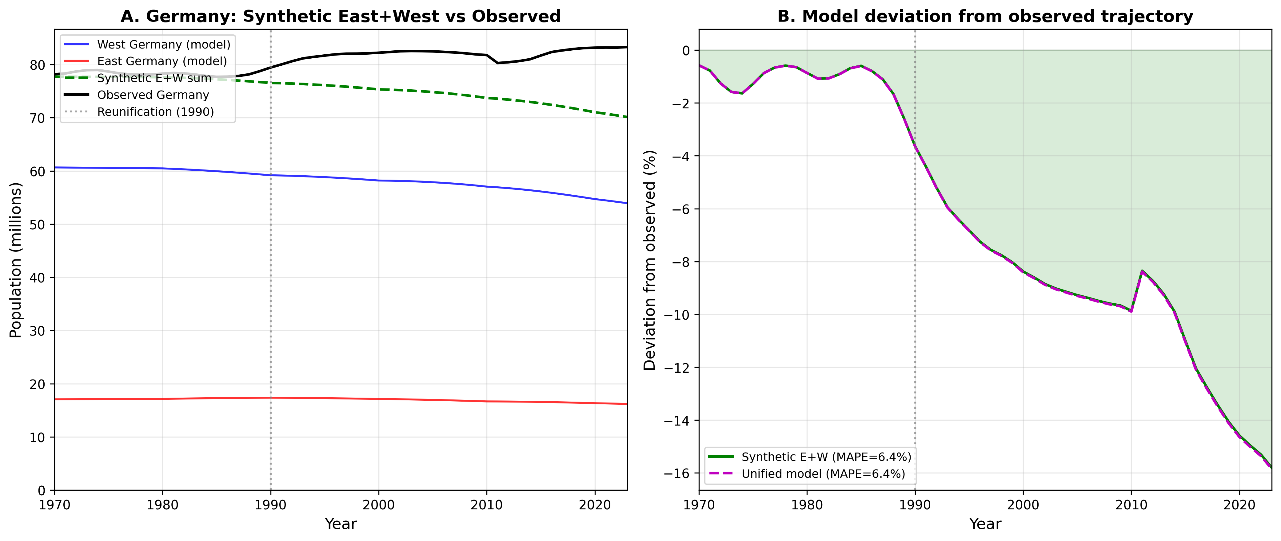
Note: (a) Modelled East and West Germany populations with synthetic combined trajectory versus observed unified Germany. (b) Percentage deviation of synthetic and unified models from observed trajectory. The widening gap after 1990 quantifies the cumulative migration and integration effects of reunification.

C.2 Czechoslovakia: The Velvet Divorce (1993)
The peaceful dissolution of Czechoslovakia on 1 January 1993 created two independent states—Czechia and Slovakia—with relatively limited cross-border migration. This case represents a relatively clean natural experiment: a state partition with minimal population redistribution. Our model achieves MAPE of 6.3% for Czechia and 9.9% for Slovakia over the full 1970–2023 period. Slovakia’s higher error reflects emigration to Czechia and Western Europe following EU accession (2004), which the closed model cannot capture.

C.3 Yugoslavia: Dissolution and conflict (1991–2001)
The breakup of Yugoslavia involved armed conflict, ethnic cleansing, and massive refugee flows affecting all successor states. This represents the most extreme migration shock in our sample. Model performance varies substantially across successors: Croatia (MAPE 4.1%) and North Macedonia (6.4%) show reasonable fit, reflecting relatively stable post-conflict demographics. Bosnia and Herzegovina (8.1%) and Slovenia (12.2%) show larger errors—Bosnia due to war-related population loss and displacement, Slovenia due to immigration-driven growth as a small EU member state. Serbia (7.1%) and Montenegro (8.1%) fall in between. The range of model performance across Yugoslav successor states illustrates how conflict-driven migration creates heterogeneous deviations from the endogenous renewal baseline.

C.4 Baltic States: USSR dissolution and emigration (1991)
Estonia, Latvia, and Lithuania gained independence in 1991 from the Soviet Union, followed by significant emigration of ethnic Russians and outmigration to Western Europe (especially after EU accession in 2004). Model MAPE ranges from 4.8% (Estonia) to 7.1% (Lithuania), reflecting the persistent emigration that the closed model does not account for. These cases demonstrate that even moderate but sustained net emigration (≈0.5–1.0% of population annually) accumulates over three decades to produce substantial model-observation divergence.

C.5 Ethiopia and Eritrea: Separation (1993)
Eritrean independence (1993) separated two populations in the midst of high-fertility demographic transition. Model performance differs markedly: Ethiopia (MAPE 16.5%) shows substantial overprojection, reflecting within-decade fertility decline faster than captured by decadal parameter updates. Eritrea (MAPE 37.8%) shows the largest error in our natural experiments sample, driven by prolonged military conscription, conflict-related emigration, and highly uncertain baseline demographic data. These cases highlight the model’s limitations in conflict-affected, data-sparse settings where rapid demographic change co-occurs with large-scale displacement.
Figure A-2: Natural experiments summary
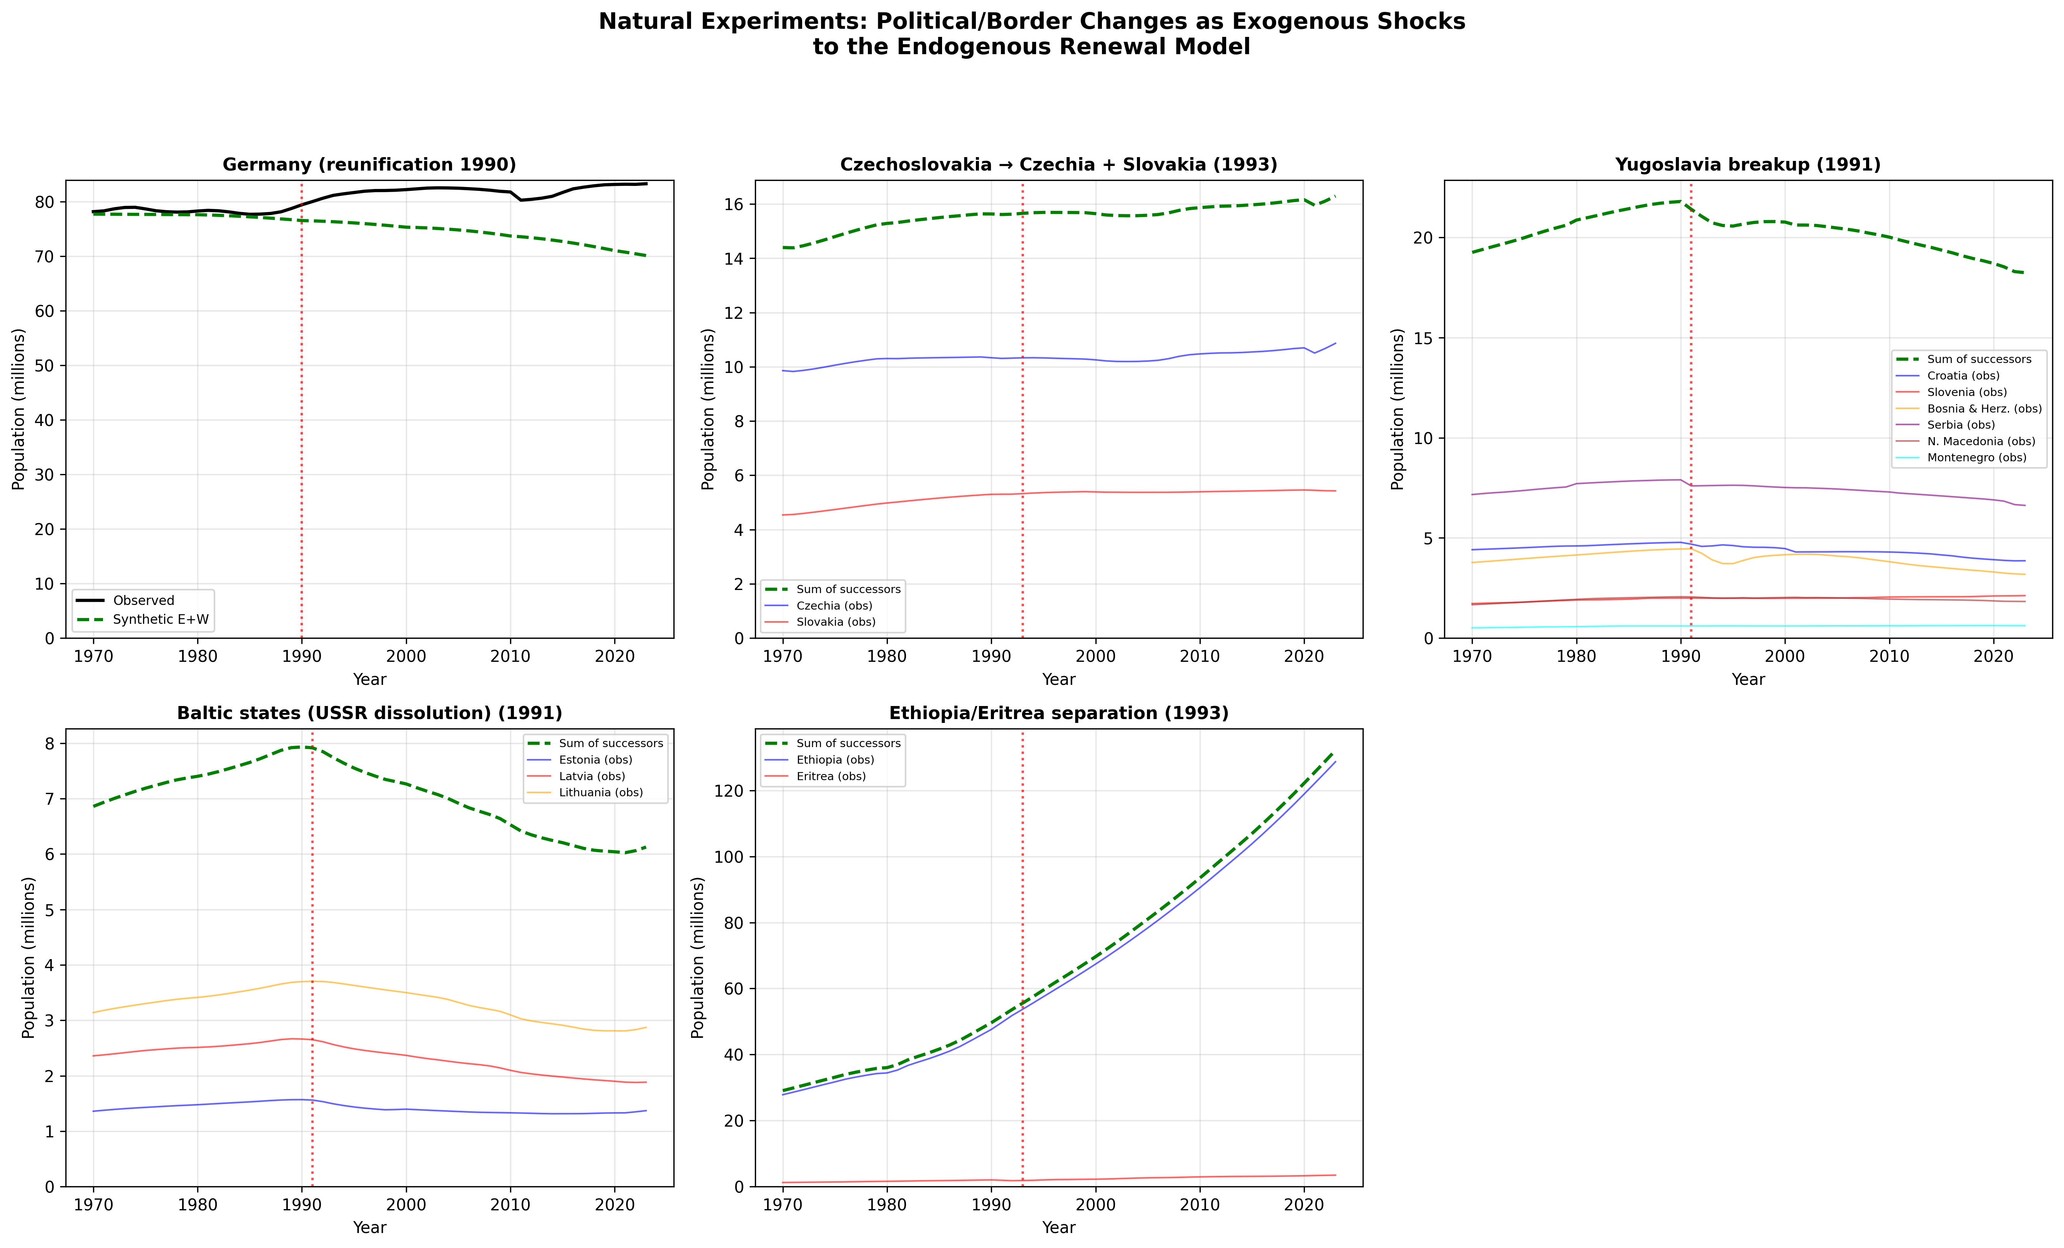
Note: Population trajectories for five cases of major political/border change. Dashed green lines show synthetic sums of successor-state models; solid black lines show observed (pre-split) trajectories; coloured lines show individual successor states. Red vertical lines mark the year of political change.

C.6 Synthesis: What natural experiments reveal
Table C2: Model performance across all natural experiment cases
Country | Event (year) | MAPE (%) | Primary source of misfit
Germany (synthetic E+W) | Reunification (1990) | 6.4 | Immigration + internal migration
Czechia | Velvet Divorce (1993) | 6.3 | Post-EU emigration (moderate)
Slovakia | Velvet Divorce (1993) | 9.9 | Emigration to EU/West
Croatia | Yugoslav breakup (1991) | 4.1 | Post-conflict stabilisation
Slovenia | Yugoslav breakup (1991) | 12.2 | Immigration (EU member)
Bosnia & Herz. | Yugoslav breakup (1991) | 8.1 | War-related displacement
Serbia | Yugoslav breakup (1991) | 7.1 | Refugee flows, emigration
N. Macedonia | Yugoslav breakup (1991) | 6.4 | Modest migration effects
Montenegro | Yugoslav breakup (1991) | 8.1 | Small state, volatile flows
Estonia | USSR dissolution (1991) | 4.8 | Ethnic Russian emigration
Latvia | USSR dissolution (1991) | 6.6 | Emigration (ethnic + EU)
Lithuania | USSR dissolution (1991) | 7.1 | Sustained emigration
Ethiopia | Eritrean indep. (1993) | 16.5 | Rapid fertility decline
Eritrea | Eritrean indep. (1993) | 37.8 | Conflict, conscription, emigration

These natural experiments yield three key insights for the endogenous renewal model:
First, the model performs reasonably well (MAPE < 8%) even for countries that experienced major political upheaval, provided that post-event migration was moderate and demographic data are reliable. Croatia (4.1%), Estonia (4.8%), and Czechia (6.3%) all fall within this range, demonstrating that the quantum–tempo–survival mechanism captures the bulk of population dynamics even in contexts of political discontinuity.
Second, the magnitude of model-observation divergence provides a direct estimate of the migration component. Germany’s 15.8% synthetic-observed gap by 2023 implies that immigration added approximately 13.5 million persons—equivalent to one-sixth of the total population—beyond what natural increase alone would have produced. This quantification is only possible because the closed model isolates natural demographic dynamics.
Third, the model’s limitations are most acute in conflict-affected, data-sparse settings (Eritrea: 37.8%) and where sustained emigration removes a large fraction of the population (Slovenia: 12.2%, Slovakia: 9.9%). These cases identify the boundary conditions for the endogenous renewal framework and reinforce the importance of migration modelling for countries experiencing sustained population flows.
The Germany case is particularly instructive for interpreting the main analysis results. Germany’s dynamic MAPE in the 40-country validation reflects not a failure of the quantum–tempo–survival framework but rather the quantitative footprint of reunification as a massive, exogenous migration event. The model’s ‘error’ is, in fact, the signal: it measures the demographic impact of a political transformation that functioned as the equivalent of absorbing 1.9 million internal migrants in three years, followed by three decades of sustained international immigration. That our parsimonious model can separate this migration signal from the underlying demographic dynamics validates the decomposition approach.

